


SANA'A UNIVERSITY
FACULTY OF ENGINEERING MECHATRONICS ENGINEERING
DEPARTMENT

Design, Analytical Modeling, and Multiphysics Simulation-Based Validation of an Industrial Auger Filler Machine for VFFS Powder Packaging Systems

A final year project Submitted in partial fulfillment of the requirements for the award of the degree of Bachelor of Engineering in Mechatronics Engineering

Prepared by:
Hassan Moqbel Morshed Ghaleb - 202274198
Musa Ali Hassan Al-salmani - 202174202
Abdulrahim Yasser Abdulrahim Ghanem - 202173006
Suhaib Abduallah Al-Malhani - 202174006
Hamzah Abdulqawi Al-khalaf - 202274127
Ehab Abdulkarim Ai-Qubati - 202174125

Supervised by:
Dr. Abdullah Thiban

April, 2026

DECLARATION

We hereby declare that this thesis is our original work and has been written by us in its entirety. We certify that we have duly acknowledged all the sources of information which have been used in the thesis. This work is being submitted in partial fulfillment of the requirements for the award of the degree of Bachelor of Engineering and submitted in Sana’a University, faculty of Engineering, Department of Mechatronics Engineering.
We would like to express our gratitude to:
Dr. Abdullah Theban.

for their guidance and support throughout the research process. Additionally, we would like to dedicate this work to our families, who have supported us throughout the entire project.

Hassan Moqbel Morshed Ghaleb - 202274198
Musa Ali Hassan Al-salmani - 202174202
Abdulrahim Yasser Abdulrahim Ghanem - 202173006
Suhaib Abduallah Al-Malhani - 202174006
Hamzah Abdulqawi Al-khalaf - 202274127
Ehab Abdulkarim Ai-Qubati - 202174125

April, 2026

ACKNOWLEDGEMENTS
First and foremost, we express our thanks and praise to Allah Almighty for His guidance and success granted to us throughout our research period, which enabled us to complete this research successfully. We also extend our deepest thanks and gratitude to our esteemed supervisor, Dr. Abdullah Theban, for his continuous guidance, insightful technical vision, and for sharing a wealth of new information with us. We are immensely grateful for everything he has provided. We also thank him for his friendship, support, and constructive feedback throughout the development of this project. Furthermore, we must not forget to extend our sincere thanks to the faculty members of the Mechatronics Engineering Department, especially the Head of Department, Prof Dr Abdulmalik Momin and to the Al-Ansar Foundation for providing the academic environment and necessary resources to accomplish this work.
Secondly, we would like to express our profound thanks to our parents for their backing and support in completing this project. We are deeply grateful for their love, prayers, patience, and belief in us. The authors also express their gratitude to all members of the project team for their cooperation, shared responsibilities, and technical contributions that led to the successful completion of the integrated powder filling machine system.
Finally, we extend our thanks and appreciation to our families and friends for their continuous support, understanding, and encouragement throughout the duration of this project. Their belief in our abilities and their constant motivation were crucial factors in overcoming obstacles and keeping us focused on our goals. Although we cannot mention everyone by name, we sincerely appreciate the contributions of all those who helped us, directly or indirectly.
Thank you all for your support and contributions.

ABSTRACT
This project is about designing a mechatronic system for a vertical form fill seal machine that uses ESP32, specifically for packaging powder stuff. It pulls together the forming, filling, and sealing parts, and adds in some IoT features to fit with Industry 4.0 ideas. Kind of makes the whole process smarter, I guess.

We worked on analytical models for how the powder flows, how the film moves along, the heat sealing process, and the overall dynamics of the system. Then there were these Multiphysics simulations to check everything, like finite element analysis, discrete element method for the powder, thermal stuff, and even validating the firmware on the ESP32. It helped confirm that the design choices made sense, at least from what I could tell.

The system gets the auger filling, film forming, and thermal sealing to sync up properly, all while monitoring things in real time through a dashboard connected to the cloud. When we validated it, it met the industrial standards for accuracy and how much it can produce, plus reliability. That part stood out, because not every setup nails all that.

Using ESP32 instead of traditional PLC systems cuts costs down by about 60 percent, which is a big deal. It also allows for over the air updates and predictive maintenance, so it feels more future proof. Overall, this gives a framework that others could replicate for designing smart packaging machines, though I might be oversimplifying how easy that would be.

The integration with IoT seems key here, tying back to the Industry 4.0 applications.

Contents
INTRODUCTION
1.1 Background of the Study 17
1.1.1 Evolution of Packaging Automation 17
1.1.2 Role of VFFS Systems in Global Supply Chains 18
1.1.3 Precision Dosing: The Critical Role of Auger Fillers 19
1.2 Problem Statement 20
1.2.1 Inaccuracy and Inconsistency in Powder Filling 20
1.2.2 Structural and Thermal Challenges in Continuous Operation 21
1.2.3 Limitations of Conventional Empirical Design Methods 22
1.2.4 Control System Latency and Electromechanical Synchronization 22
1.3 Aim and Objectives 22
1.4 Research Questions 23
1.5 Scope and Limitations 24
1.5.1 Scope of Work 24
1.5.2 Limitations 25
1.6 Significance of the Study 25
1.6.1 Academic Contribution 25
1.6.2 Industrial Relevance 25
1.6.3 Technological Innovation 26
1.7 Methodology Overview 26
1.7.1 Research Design Framework 26
1.7.2 Mechatronic System Design Phase 26
1.7.3 Analytical Modeling Phase 27
1.7.4 Numerical Simulation Phase 27
1.7.5 Validation and Correlation 27
1.8 Organization of the Report 28
LITERATURE REVIEW 30
2.1 VFFS and Dosing Technologies 30
2.1.1 Operating Principles of Vertical Form Fill Seal Machines 30
2.1.2 Volumetric vs. Gravimetric Dosing: A Comparative Analysis 32
2.2 Powder Rheology and Handling 37
2.2.1 Material Characteristics: Bulk Density, Flowability, and Cohesiveness 38
2.2.2 Dynamics of Screw-Driven Material Transport 41
2.3 Auger Filler Engineering State-of-the-Art 43
2.3.1 Geometry Optimization: Pitch, Flight Depth, and Taper 44
2.3.2 Material Science for Food-Grade Industrial Systems 46
2.4 Multiphysics in Mechatronic Systems 49
2.4.1 Review of FEA, Thermal, and Modal Analysis in Rotating Machinery 49
2.4.2 Integration of Analytical Models with Numerical Simulations 52
2.5 Research Gap and Summary 54
2.5.1 Summary of Literature Findings 54
2.5.2 Identification of Research Gaps 55
2.5.3 Proposed Contribution of This Study 57
2.5.4 Comparative Positioning 58
2.5.5 Rationale for Upcoming Chapters 59
2.5.6 Concluding Remarks 60
SYSTEM DESIGN AND SPECIFICATIONS 62
3.1 Research Design Framework 62
3.2 Design Requirements and Constraints 63
3.2.1 Target Output (PPM: Packs Per Minute) and Accuracy (±σ) 63
3.2.2 Sanitary and Material Standards (e.g., AISI 304 Stainless Steel) 64
3.3 Conceptual Development 65
3.3.1 Functional Decomposition (Dosing System, Packaging & Sealing System.) 65
3.3.2 Selection of Actuation (Servo-driven vs. Induction) 70
3.4 Final Mechanical Architecture (CAD) 72
3.4.1 Dosing System CAD: 72
3.4.2 Packaging and Sealing System CAD: 78
3.4.2 Drive Train and Power Transmission 81
3.5 Mechatronic System Architecture 82
3.5.1 Distributed Processing Strategy (Master-Slave Topology) 83
3.5.2 Operating System and Task Allocation (FreeRTOS & Dual-Core Strategy) 84
3.5.3 Mathematical Modeling and Thermal PID Controller 84
3.5.3 Hybrid Motion Control Logic 85
3.5.4 Software Architecture of the Finite State Machine (FSM) 86
3.5.5 Industrial Isolation and Signal Integrity 86
3.5.6 Industrial Reliability and Protection Protocols (Fail-Safe Logic) 86
3.7 Summary of Design Specifications 87
3.6 Electronic Control System Design 88
3.6.1 System Architecture Overview 88
3.6.2 Signal Isolation and Conditioning 88
3.6.3 Temperature Measurement System 91
3.6.5 Solid State Relay Interface 98
3.6.6 PCB Design and Layout Considerations 99
3.6.7 Power Budget and Distribution 101
3.6.8 Pneumatic System Design 102
3.6.9 Safety and Protection Systems 103
CHAPTER 4: 105
ANALYTICAL MODELING AND ENGINEERING CALCULATIONS 106
4.1 Mathematical Foundations and Assumptions 106
4.1.1 Fundamental Assumptions 106
4.1.2 Material Properties 107
4.2 Mechanical Modeling of the Dosing System 107
4.2.1 Hopper Flow Modeling and Geometry Design 107
4.2.2 Hopper-Agitator Synchronization with the VFFS Cycle 110
4.2.3 Auger Volumetric and Kinematic Dosing 111
4.2.4 Dynamic Torque Estimation 113
4.2.5 Structural Analysis of the Auger Shaft 116
4.3 Kinematics and Dynamics of Packaging Mechanisms 117
4.3.1 Film Unwinding and Pulling System 117
4.3.2 Sealing Jaws Mechanism 119
4.4 Thermodynamic Modeling of the Sealing System 119
4.4.1 Heat Transfer in Sealing Jaws 119
4.4.2 Heater Power Sizing 120
4.5 Electrical Calculations and Actuator Sizin 120
4.5.1 Total Power Budget Calculation 120
4.5.2 Current Calculation and Protection Coordination 121
4.5.3Auger Mechanism and Load Characterization 121
4.5.4 Torque Requirement Calculation 122
4.5.5 Servo Motor and Drive Selection 123
4.5.6 Servo Drive Specifications 124
4.5.7 Control Interface Design 125
4.5.8 Dosing Accuracy Analysis 126
4.5.9 Heating Element Power Requirements 128
4.5.10 SSR Thermal Analysis 128
4.5.11 Complete Load Inventory 129
$4.5.12 Protection Coordination Study$ 130
4.5.13 Time-Current Coordination 130
$4.5.14 Summary of Analytical Results$ 131
4.6 Control System Architecture and Signal Processing 132
4.6.1 Kinematics of Precision Actuation Systems 132
𝐸𝐺𝑅 = 𝑃_𝑛𝑎𝑡𝑖𝑣𝑒 / 𝑃𝑃𝑅_𝑡𝑎𝑟𝑔𝑒𝑡 = 8,388,608 / 10,000 132
𝑃_𝑎𝑢𝑔𝑒𝑟 = 𝑅𝑒𝑣𝑜𝑙𝑢𝑡𝑖𝑜𝑛𝑠 𝑥 𝑃𝑃𝑅_𝑡𝑎𝑟𝑔𝑒𝑡 = 4 𝑥 10000 = 40,000 𝑝𝑢𝑙𝑠𝑒𝑠 132
𝑓_𝑝 = (𝑁 𝑥 𝑃𝑃𝑅_𝑡𝑎𝑟𝑔𝑒𝑡) / 60 = (300 𝑥 10000) / 60 = 50,000 𝐻𝑧 132
4.6.2 PID Temperature Control Modeling 133
4.6.3 Microcontroller Processing Requirements 135
4.7 Overall VFFS System Synchronization 135
4.7.1 Cycle Timing and In-Flight Material Compensation 135
$4.8 Summary of Analytical Results$ 136
MULTIPHY SICSSIMULATION AND VALIDATION 140
5.1 Computational Setup 140
5.1.1 Pre-processing: Meshing Strategy and Convergence Study 140
5.1.2 Material Properties and Boundary Conditions 144
5.2 Static Structural Analysis 145
5.2.1.1 Hopper Assembly Analysis (SOLIDWORKS Simulation) 146
5.2.1.2 Auger Screw (ANSYS 2023) 146
5.2.1.4 Auger , shaft , and Spinner Plate Analysis (SOLIDWORKS Simulation) 148
5.3 Discrete Element Method (DEM) Simulation and Flow Validation 163
5.3.1 EDEM Simulation Setup and Parameters 163
5.3.2 EDEM Simulation Results and Analysis 166
5.3.2.2 Auger Screw Torque Analysis 167
5.3.3 EDEM Validation Summary 168
5.4 Motion Simulation 169
5.4.1 Motion Simulation Parameters 169
5.4.2Dynamic Analysis Results 170
5.5 Indistrial Validation 170
5.5.1 Auger and Tooling Validation 170
5.6 Academic and Research Validation 171
5.6.1 Material Build-up Prevention 171
5.6.2 Flow Dynamics Validation 171
5.7 Thermal PID Controller Simulation and Validation 171
5.7.1 Model-Based Design Validation 171
5.7.2 Firmware Validation via Software-in-the-Loop (SIL) 172
5.8 Comparative Timing Validation: Industrial Standards vs. Simulation Results 173
5.9 Control System Failure Mode and Effects Analysis (FMEA) 175
RESULTS DISCUSSION AND EVALUATION 180
6.1 Evaluation of Machine Performance 180
6.1.1 Precision under Variable Operating Speeds 180
6.1.2 Structural Reliability under Peak Loads 181
6.2 Suitability for VFFS Industrial Integration 182
6.2.1 Mechanical Integration 182
6.2.2 Control System Integration 183
6.2.3 Operational Workflow 184
6.3 Discussion of Mechatronic Synergy (How Control Impacts Mechanical Life) 185
6.3.1 Motion Profile Optimization 185
6.3.2 Closed-Loop Position Control 185
6.3.3 Condition Monitoring and Predictive Maintenance 186
6.4 Contribution to Engineering Knowledge 187
6.4.1 Integrated Design Methodology 187
6.4.2 Auger Geometry Optimization for Salt Packaging 187
6.4.3 Thermal-Structural Coupling Analysis 188
6.4.4 Servo Control Implementation for Powder Dosing 189
6.5 Chapter Summary 190
CONCLUSION AND FUTURE WORK 193
7.1 INTRODUCTION TO THE CHAPTER 193
7.2 SUMMARY OF FINDINGS 193
7.2.1 Mechanical Design Achievements 193
7.2.2 Analytical Modeling Results 194
7.2.3 Multiphysics Simulation Validation 195
7.2.4 Mechatronic Control System Achievements 196
7.3 RESOLUTION OF RESEARCH QUESTIONS 196
7.4 FULFILLMENT OF PROJECT OBJECTIVES 199
7.5 COMPREHENSIVE ANALYTICAL–NUMERICAL CORRELATION 201
7.6 ADDRESSING THE IDENTIFIED RESEARCH GAPS 202
7.7 LIMITATIONS OF THE STUDY 203
7.7.1 Scope Limitations 203
7.7.2 Modeling Limitations 203
7.7.3 Material and Component Limitations 204
7.7.4 Numerical Limitations 204
7.8 RECOMMENDATIONS FOR PROTOTYPE FABRICATION 204
7.8.1 Mechanical Fabrication 205
7.8.2 Electrical and Control Integration 205
7.8.3 Industrial Safety and Compliance 206
7.9 DIRECTIONS FOR FUTURE RESEARCH 206
7.9.1 Near-Term Enhancements (0–12 months) 206
7.9.2 Medium-Term Development (1–3 years) 207
7.9.3 Long-Term Research Horizons (3–5 years) 207
7.10 CONCLUDING REMARKS 208
References: 209

List Of Figure:
Figure 1- 1 Schematic illustration of VFFS machine with integrated auger filling system 20
Figure 1- 2 Project methodology flowchart showing the sequential phases . 27

Figure 2- 1 Schematic representation of the Vertical Form-Fill-Seal (VFFS) operational cycle. 31
Figure 2- 2 Stress distribution and characteristic flow behavior of bulk cohesive solids within a standard hopper. 41
Figure 2- 3 Geometric parameters of a standard volumetric auger screw. 45
Figure 2- 4 Typical Finite Element Analysis (FEA) . 50

Figure 3- 1Design methodology flowchart showing the sequential phases from requirements 63
Figure 3- 2Hygienic design principles for food-contact components, showing smooth transitions, self 65
Figure 3- 3Functional decomposition diagram showing the four primary subsystems and their interactions. 69
Figure 3- 4Servo motor and planetary gearbox assembly showing encoder feedback, drive 72
Figure 3- 5Dosing System CAD 73
Figure 3- 6Hopper CAD 74
Figure 3- 7Long Blade CAD 75
Figure 3- 8Short Blade CAD 75
Figure 3- 9Agitator System CAD 75
Figure 3- 10Auger CAD 76
Figure 3- 11Plate& Auger CAD 77
Figure 3- 12CAD model of funnel assembly 78
Figure 3- 13Packaging and Sealing System CAD 78
Figure 3- 14 Forming Tube CAD 79
Figure 3- 15 Horizontal Sealing Jaws CAD 80
Figure 3- 16 Vertical Sealing Bars CAD 80
Figure 3- 17 Final pull Mechanism 81
Figure 3- 18 General control system architecture block diagram showing the Master ESP32, Slave ESP32 83
Figure 3- 19 Closed-loop thermal control system modeling in Simulink/Simscape. 85
Figure 3- 20 PC817 Optocoupler 90
Figure 3- 21MAX6675 SPI 92
Figure 3- 22 TIP122 94
Figure 3- 23A4988 Stepper Driver Interface 96
Figure 3- 24 SSR Control 98
Figure 3- 25 PCB Layer Stack-up and Grounding Strategy 101

Figure 4- 1experimental value 108
Figure 4- 2 Single-Line Diagram with Protection Coordination 130
Figure 4- 3 Experimental closed-loop response used for system identification. 134

Figure 5- 1Mesh Configuration in Solidworks 141
Figure 5- 2 Mesh Type (Coarse in SolidWorks) 143
Figure 5- 3Mesh Type (Fine in SolidWorks) 143
Figure 5- 4Mesh Type (Fine in Ansys 144
Figure 5- 5 Mesh Type (Medium in Ansys) 144
Figure 5- 6 SOLIDWORKS - Hopper Von Mises Stress Distribution 146
Figure 5- 7SOLIDWORKS - Hopper Factor of Safety 146
Figure 5- 8 Ansys_ Auger Von Mises Stress Distribution 147
Figure 5- 9 Ansys_ Auger Factor Of Safety 147
Figure 5- 10 SolidWorks_ Auger and Shaft Von Mises Stress Distribution 148
Figure 5- 11 SolidWorks_ Auger and Shaft Factor Of Safety 148
Figure 5- 12 SolidWorks_ Auger, shaft , and Spinner Plate Von Mises Stress Distribution 149
Figure 5- 13 SolidWorks_ Auger, shaft , and Spinner Plate Factor Of Safety 149
Figure 5- 14 SolidWorks_Blades and Connections Von Mises Stress Distribution 150
Figure 5- 15 SolidWorks_Blades and Connections Factor Of Safety 150
Figure 5- 16 Ansys_ Long Blade Von Mises Stress Distribution\ 151
Figure 5- 17 Ansys_ Long Blade Factor Of Safety 151
Figure 5- 18 Ansys_ Long Blade Life 152
Figure 5- 19 Ansys_ Short Blade Von_Mises 152
Figure 5- 20 Ansys_ Sort Blade Factor Of Safety 153
Figure 5- 21 Ansys_ Short Blade Life 153
Figure 5- 22 Von Mises Stress Distribution in Horizontal Sealing Mechanism 154
Figure 5- 23 Von Mises, Strain Distribution, Displacement Distribution Stress Distribution in Vertical 154
Figure 5- 24 Applied Load and Fixed Supports 155
Figure 5- 25 Von Mises stress distribution showing maximum stress concentration at the joints. 155
Figure 5- 26 Factor of Safety Distribution 156
Figure 5- 27 SOLIDWORKS - Hopper Total Deformation 157
Figure 5- 28 Ansys_ Auger Total Deformation 157
Figure 5- 29 SOLIDWORKS - Auger+Shaft Total Deformation 158
Figure 5- 30 SOLIDWORKS - Auger+Shaft+ plate Total Deformation 158
Figure 5- 31 SOLIDWORKS - Blades Total Deformation 159
Figure 5- 32 Ansys_ Long Blade Total Deformation 160
Figure 5- 33 Ansys_ Sort Blade Total Deformation 160
Figure 5- 34 Strain Distribution and Displacement Distribution in Horizontal Sealing Mechanism 161
Figure 5- 35 Von Mises, Strain Distribution, Displacement Distribution Stress Distribution in Vertical Sealing Mechanism 161
Figure 5- 36 Deformation distribution showing maximum displacement concentration at the joints 162
Figure 5- 37 EDEM Material Properties Configuration for NaCl 165
Figure 5- 38 EDEM SS304 Equipment Material Properties 166
Figure 5- 39 Agitator Torque Analysis Time-Domain Results 167
Figure 5- 40 EDEM - Auger Screw Torque Analysis Time-Domain Results 167
Figure 5- 41 EDEM - Correlation Plot of Analytical vs. Simulated Dose Mass 168
Figure 5- 42 Motion simulation trajectory plot showing opposite rotational paths of the agitator (CCW) and 170
Figure 5- 43 MATLAB Simulink Closed-loop PID Response Graph 172
Figure 5- 44 Screenshot of the Wokwi ESP-IDF environment showing the Terminal output and Mock Sensor response to the PID. 173
Figure 5- 45 Multi-channel Operational Timing Diagram 175

List Of Tables:
Table 2- 1 Comparative Analysis of Volumetric and Gravimetric Dosing Technologies 35
Table 2- 2Advantages and Limitations of Volumetric vs. Gravimetric Dosing 36
Table 2- 3 Comparison of Stainless Steel Grades for Food-Grade Auger Applications 47
Table 2- 4Comparative Analysis of Present Work Against Literature 58

Table 3- 1Final Hopper Design Dimensions 73
Table 3- 2 Summary of Design Specifications 87
Table 3- 3 Operating parameters for PC817 optocoupler in sensor interface applications 90
Table 3- 4 MAX6675 SPI Interface Pin Assignment 92
Table 3- 5TIP122 Solenoid Driver Operating Parameters 95
Table 3- 6 A4988 Stepper Driver Configuration 97
Table 3- 7 PCB Trace Width Specifications 99
Table 3- 8 System Power Budget Analysis 102
Table 3- 9 VFFS pneumatic settings for different materials 102
Table 3- 10 Protection Component Summary 103

Table 4- 1 Auger Design Parameters by Product Type 113
Table 4- 2 Filling Accuracy Requirements 113
Table 4- 3 Torque Requirement Calculation 121
Table 4- 4 Panasonic MSMF042L1U1 123
Table 4- 5 Panasonic MBDLN25SE 124
Table 4- 6 Control Signal Mapping 125
Table 4- 7 Complete Electrical Load Inventory 129
Table 4- 8 Protection Device Characteristics 130
Table 4- 9 Summary of Analytical Results 131
Table 4- 10 Operational Timing Sequence for a Single 500g Cycle 135
Table 4- 11 consolidates the key analytical predictions for the VFFS auger filling system operating at a design throu 136

Table 5- 1 Mesh Convergence Study Results - SOLIDWORKS vs ANSYS 142
Table 5- 2Material Properties for FEA Simulation 145
Table 5- 3Comprehensive Safety Factor Summary 156
Table 5- 4 Comparative Deflection - Shaft Configuration Study 162
Table 5- 5 Long Agitator Blade - Cross-Platform Results 162
Table 5- 6 Short Agitator Blade - Cross-Platform Results 163
Table 5- 7 EDEM Material Properties for Sodium Chloride (NaCl) 163
Table 5- 8 EDEM Properties for SS304 Equipment Material 164
Table 5- 9 EDEM Validation - Analytical vs. Simulation Correlation 168
Table 5- 10 Motion Simulation Parameters 169
Table 5- 11 Comparative Latency Validation (Datasheet vs. Simulation) 173
Table 5- 12 FMEA for the VFFS Control System Validation 175
Table 5- 13Analytical vs. Numerical Correlation Analysis 177
Table 5- 14 Industrial Benchmarking Comparison 177
Table 5- 15 Academic and Research Validation References 177
Table 5- 16 Comprehensive Validation Summary 178

Table 7- 1: Summary of Objective Fulfillment 201
Table 7- 2 Comprehensive Analytical–Numerical–Target Correlation 201

CHAPTER ONE
INTRODUCTION

INTRODUCTION

1.1 Background of the Study
The global packaging industry represents one of the most dynamic and technologically advanced sectors of modern manufacturing, with an estimated market value exceeding $1 trillion annually. Within this expansive domain, automated packaging machinery has emerged as a critical enabler of industrial efficiency, product safety, and supply chain optimization. The Vertical Form-Fill-Seal (VFFS) machine, first conceptualized in the mid-20th century, has evolved from simple mechanical devices into sophisticated mechatronic systems capable of achieving production rates exceeding 200 packages per minute while maintaining precise weight tolerances of less than one percent [1].
This graduation project addresses the design, analysis, and development of a VFFS packaging system specifically engineered for the precision dosing of granular and powdered materials, with particular emphasis on sodium chloride (table salt) packaging. Table salt was deliberately selected as the target material due to its unique engineering challenges; its abrasive nature, moisture-dependent bulk density variations, and free-flowing characteristics make it an optimal candidate for rigorous mechatronic system validation and performance benchmarking. The project integrates mechanical engineering principles, bulk solids mechanics, control systems theory, and modern simulation techniques to deliver a comprehensive engineering solution that meets contemporary industrial standards for accuracy, reliability, and hygienic compliance.

1.1.1 Evolution of Packaging Automation
The historical trajectory of packaging automation reflects broader patterns of industrial development, from the mechanization of the 19th century through the digital revolution of the late 20th and early 21st centuries. Early packaging operations were entirely manual, relying on human labor for filling, sealing, and labeling operations. The introduction of semi-automatic filling machines in the 1930s marked the first significant departure from manual methods, though these early devices offered limited throughput and minimal process control [2].
The post-World War II era witnessed accelerated development in packaging machinery, driven by rising consumer demand and the expansion of mass retail distribution. The invention of the form-fill-seal concept by Walter Zwoyer in the 1930s, later refined and commercialized by companies such as Hayssen and Bosch, established the fundamental operating principles that continue to govern modern VFFS systems. These early machines employed mechanical cams, gears, and linkages to coordinate the sequential operations of film transport, forming, filling, and sealing [3].
The digital revolution of the 1980s and 1990s transformed VFFS technology through the integration of programmable logic controllers (PLCs), servo motor drives, and electronic sensors. This transition from purely mechanical to electromechanical systems enabled unprecedented levels of precision, flexibility, and diagnostic capability. Contemporary VFFS machines incorporate advanced motion control algorithms, real-time process monitoring, and network connectivity, establishing the foundation for Industry 4.0 integration [4].

1.1.2 Role of VFFS Systems in Global Supply Chains
Vertical Form-Fill-Seal machines occupy a strategically significant position within global food and consumer goods supply chains. Their compact footprint, high operational speed, and adaptability to diverse product specifications make them the preferred packaging solution for granular and powdered commodities including food products, pharmaceuticals, chemicals, and agricultural materials. Industry estimates indicate that VFFS systems account for approximately 35% of all flexible packaging operations worldwide [5].
The economic significance of VFFS technology extends beyond direct equipment sales to encompass substantial operational savings through reduced labor requirements, minimized material waste, and enhanced product protection. Modern VFFS systems achieve material utilization rates exceeding 95% through precise film tracking and optimized bag forming geometry, contributing to both economic efficiency and environmental sustainability objectives [6].
Furthermore, the hygienic design principles incorporated into contemporary VFFS machinery address increasingly stringent food safety regulations, including FDA requirements in the United States and EU hygiene standards in Europe. Stainless steel construction, smooth surface finishes, and clean-in-place (CIP) capabilities ensure compliance with Good Manufacturing Practice (GMP) guidelines essential for food-grade packaging operations [7].

1.1.3 Precision Dosing: The Critical Role of Auger Fillers
Among the various dosing mechanisms employed in VFFS applications, auger filling systems represent the most widely adopted technology for granular and powdered materials. The auger filler operates on the principle of positive displacement, wherein a rotating helical screw (auger) within a cylindrical housing transports material from a supply hopper to a discharge point. The volumetric displacement per revolution is determined by the auger geometry, enabling precise control of dispensed quantity through accurate angular positioning [8].
The fundamental relationship governing auger filling performance derives from the geometric displacement of the helical screw:
𝑉_{𝑡ℎ} = (𝜋/4) × (𝐷² − 𝐷_𝑠²) × 𝑃
Where 𝑉_{𝑡ℎ} represents the theoretical volumetric displacement per revolution, D is the outer diameter of the auger flight, D_s is the shaft diameter, and P is the pitch of the helical flight. This geometric relationship, first systematically analyzed by Roberts and Rademacher in the context of screw conveyor theory, provides the theoretical foundation for auger design and performance prediction [9].
However, the practical implementation of auger filling involves significant deviations from ideal theoretical behavior due to the complex mechanical properties of bulk solids. Factors including particle size distribution, bulk density variation, interparticle friction, cohesive forces, and wall friction effects all contribute to the difference between theoretical and actual volumetric efficiency. Empirical studies indicate that typical volumetric efficiency factors range from 0.4 to 0.9, depending on material properties and operating conditions [10].

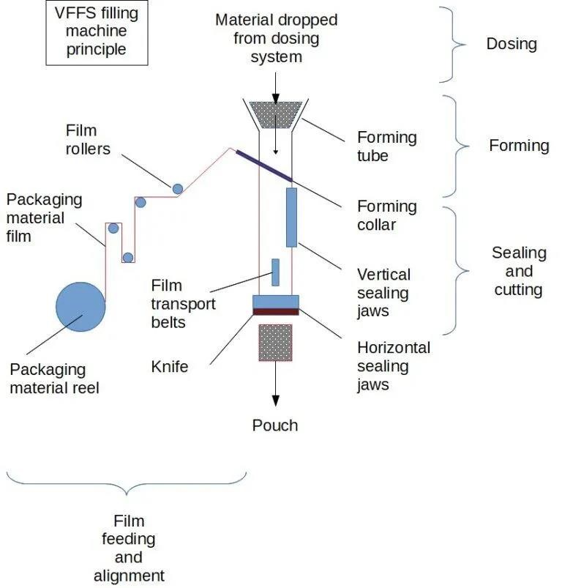
Figure 1- 1 Schematic illustration of VFFS machine with integrated auger filling system

1.2 Problem Statement
Despite the widespread adoption of VFFS technology in industrial packaging applications, several persistent challenges limit the achievement of optimal performance in powder and granular material handling. These challenges span mechanical design, process control, and operational reliability domains, creating opportunities for significant engineering improvement through systematic research and development.

1.2.1 Inaccuracy and Inconsistency in Powder Filling
The primary performance metric for any filling system is dosing accuracy, typically expressed as the percentage deviation between target and actual dispensed mass. For commercial packaging operations, regulatory standards such as OIML R87 specify maximum permissible errors based on package weight, with stricter tolerances applied to smaller packages. For a 500g package of salt, the maximum permissible error is typically ±1.5%, corresponding to ±7.5g [11].
Achieving consistent accuracy in auger filling is complicated by several factors inherent to bulk solid behavior. Bulk density variation, resulting from changes in material consolidation, moisture content, or particle packing arrangement, directly affects the mass-to volume conversion that underlies volumetric dosing principles. Studies have demonstrated that bulk density of granular salt can vary by ±5-10% under normal operating conditions, creating corresponding variations in dispensed mass unless compensated through control system intervention [12].
Additional sources of dosing error include:
- Slip between material and auger flight surfaces, reducing effective displacement;
- Backflow through radial clearance between flight tip and housing wall;
- Incomplete filling of auger flights due to hopper flow irregularities;
- In-flight material continuing to fall after motor stop command;
- Kinematic inertia causing continued rotation during deceleration phases.
The cumulative effect of these error sources can result in total dosing errors exceeding acceptable limits unless addressed through integrated mechanical and control system design.

1.2.2 Structural and Thermal Challenges in Continuous Operation
Industrial VFFS machines are typically required to operate continuously for extended periods, often exceeding eight hours per shift under demanding production schedules. This operational intensity imposes significant mechanical and thermal loads on critical components, particularly the auger drive system and sealing mechanisms.
The auger shaft experiences substantial torsional loading during operation, particularly during startup when breakaway torque is required to initiate motion of compacted material. Analytical calculations for the proposed design indicate maximum torque requirements of approximately 20 N·m under worst-case conditions. The shaft must withstand these loads without excessive deflection that would compromise the critical radial clearance between rotating and stationary components [13].
Thermal considerations arise from multiple sources including motor heating, friction at bearing surfaces, and heat transfer from the sealing jaws. The sealing operation for plastic films typically requires temperatures of 150-200°C, creating thermal gradients that can affect component dimensions and material properties. Thermal expansion of the auger shaft, if not properly accommodated, can result in binding or increased friction within the dosing chamber [14].

1.2.3 Limitations of Conventional Empirical Design Methods
Traditional approaches to auger filler design have relied heavily on empirical correlations and industry rules of thumb developed through decades of practical experience. While these methods have proven effective for conventional applications, they exhibit significant limitations when applied to novel materials, non-standard operating conditions, or precision requirements exceeding typical industrial norms.
The Conveyor Equipment Manufacturers Association (CEMA) provides standardized design equations for screw conveyors, but these formulations were developed for bulk material transport rather than precision dosing applications. The translation from continuous conveying to discrete volumetric metering introduces additional complexity not fully addressed by conventional design methodologies [15].
Furthermore, empirical design approaches provide limited insight into the underlying physical phenomena governing system behavior. Without fundamental understanding of powder flow mechanics, stress distribution, and dynamic response, optimization of design parameters becomes a trial-and-error process rather than a systematic engineering exercise. This project addresses this gap through the integration of analytical modeling, numerical simulation, and experimental validation methodologies.

1.2.4 Control System Latency and Electromechanical Synchronization
Beyond mechanical and thermal constraints, a critical challenge in VFFS operations lies in the mechatronic synchronization between the dispensing mechanism and the sealing actuation. Traditional systems often suffer from control latency and sensor feedback delays, leading to the 'dribble effect'—where residual powder falls into the seal area during jaw closure, compromising package integrity. Achieving precise, real-time coordination requires an advanced control architecture capable of microsecond-level execution. This necessitates the transition from conventional empirical timing to highly responsive, microcontrollerdriven motion profiling to seamlessly synchronize servo-actuated dosing with the kinematic cycle of the packaging process.

1.3 Aim and Objectives
The overarching aim of this graduation project is to design, analyze, and validate a complete VFFS packaging system with integrated auger filler specifically optimized for the precision packaging of granular sodium chloride. The project encompasses mechanical design, control system development, and comprehensive performance validation through analytical and numerical methods.
The specific objectives of the project are:
- To develop a comprehensive understanding of bulk solids mechanics and powder flow behavior as applied to auger filling systems, including the characterization of material properties affecting dosing accuracy.
- To design the mechanical architecture of a VFFS auger filling system, including auger geometry, drive train specification, hopper configuration, and flow control mechanisms, meeting industrial standards for hygiene and reliability.
- To establish analytical models for volumetric displacement, torque requirements, and structural loading, enabling quantitative prediction of system performance.
- To perform Multiphysics numerical simulations including static structural analysis, thermal analysis, and modal analysis to validate mechanical design decisions and identify potential failure modes.
- To develop control system architecture incorporating servo motor positioning, sensor integration, and feedback algorithms to achieve target dosing accuracy of ±1.5% for 500g packages.
- To correlate analytical predictions with numerical simulation results, establishing confidence in the design methodology and identifying areas requiring refinement.

1.4 Research Questions
This project addresses the following research questions that guide the investigation and provide focus for the engineering analysis:
RQ1.What auger geometry (outer diameter, shaft diameter, pitch, and flight profile) optimizes the trade-off between volumetric displacement capacity and mechanical stress distribution for the target 500g dose requirement?
RQ2.How do bulk density variations and powder flow properties affect dosing accuracy, and what control strategies can compensate for these variations in real-time operation?
RQ3.What are the critical structural loading conditions for the auger shaft and drive train, and what safety factors ensure reliable operation under worst-case scenarios including material caking and startup conditions?
RQ4.How does thermal expansion from sealing jaw heating affect component clearances and dosing accuracy, and what design measures mitigate thermal effects?
RQ5.What is the correlation between analytical predictions and numerical simulation results, and how do deviations inform design refinement decisions?

1.5 Scope and Limitations
The scope of this graduation project encompasses the complete engineering design and analysis of a VFFS auger filling system, with specific boundaries defining the extent of investigation and areas explicitly excluded from consideration.

1.5.1 Scope of Work
The project scope includes:
- Mechanical design of auger screw, central shaft, spinner plate, and associated tooling;
- Specification and selection of servo motor, gearbox, and drive train components;
- Design of hopper and agitator system for consistent material feeding;
- Development of a centralized mechatronic control architecture utilizing advanced microcontrollers (ESP32) for precise servo motion profiling, real-time synchronization, PID-based thermal control of sealing jaws, and comprehensive sensor data fusion;
- Analytical modeling of volumetric displacement, torque, and power requirements;
- Finite Element Analysis (FEA) of structural, thermal, and modal behavior;
- Validation of design through correlation between analytical and numerical results.

1.5.2 Limitations
The following aspects are explicitly outside the scope of this project:
- Physical prototype fabrication and experimental testing (the project is limited to design and simulation phases);
- Economic analysis, cost estimation, and market feasibility studies;
- Investigation of alternative dosing technologies (cup fillers, weigh fillers, etc.);
- Long-term reliability testing and wear analysis under extended operation.
The target material is limited to granular sodium chloride (table salt) with specified particle size distribution and moisture content. While the design principles may be applicable to other granular materials, validation is specifically performed for salt packaging applications.

1.6 Significance of the Study
This graduation project contributes to engineering knowledge and industrial practice through multiple pathways of significance:

1.6.1 Academic Contribution
The project demonstrates the integration of multiple engineering disciplines— mechanical design, bulk solids mechanics, control systems, and numerical simulation— within a unified design framework. The systematic correlation between analytical models and finite element analysis provides a methodology applicable to similar mechatronic system development. Furthermore, the detailed treatment of powder flow phenomena augments the existing literature on auger filling technology, which has historically received less scholarly attention than other bulk material handling systems [16].

1.6.2 Industrial Relevance
The design outcomes directly address industrial requirements for high-speed, accurate, and reliable powder packaging. The target specifications—500g packages at 20 bags per minute with ±1.5% accuracy—represent typical production requirements for medium-scale food packaging operations. The methodology employed, combining theoretical analysis with simulation validation, offers a template for systematic design optimization that can reduce development time and prototyping costs [17].

1.6.3 Technological Innovation
The integration of advanced servo control with mechanical flow control mechanisms (spinner plate) represents an innovative approach to addressing the persistent challenge of dribble elimination in free-flowing granular materials. The dual-core ESP32 control architecture with distributed processing of motion control and thermal management tasks demonstrates the application of modern embedded systems technology to packaging machinery [18].

1.7 Methodology Overview
The project follows a systematic engineering design methodology progressing from requirements definition through conceptual design, detailed analysis, and validation. The overall approach integrates analytical modeling, computational simulation, and design verification in an iterative framework.

1.7.1 Research Design Framework
The methodology adopts a mixed-methods approach combining theoretical analysis, numerical simulation, and design validation. The research design follows the classical engineering method: problem definition, background research, conceptual design, detailed analysis, and verification. This structured approach ensures comprehensive coverage of all technical aspects while maintaining traceability from requirements to final design [19].

1.7.2 Mechatronic System Design Phase
Following the conceptualization, the detailed physical and electronic architecture is developed. This phase encompasses:
- Mechanical CAD Modeling: Generating detailed 3D models of the auger, hopper, drive train, and support structures using parametric CAD software (e.g., SOLIDWORKS) to ensure spatial integration and manufacturability;
- Electrical & Control Architecture: Selecting the appropriate sensors, actuators (servo motors), and microcontroller units (e.g., ESP32), accompanied by developing the wiring schematics and preliminary control logic flowcharts for the dispensing and sealing synchronization.

1.7.3 Analytical Modeling Phase
The analytical phase establishes mathematical models governing system behavior:
- Volumetric displacement theory based on auger geometry and powder properties;
- Torque and power requirements derived from material resistance and inertial loading;
- Structural mechanics equations for stress, deflection, and critical speed analysis;
- Control system models for motion profiling and feedback compensation.

1.7.4 Numerical Simulation Phase
Finite Element Analysis (FEA) using SOLIDWORKS Simulation and ANSYS Mechanical provides detailed insight into:
- Static structural response under maximum torque loading;
- Thermal distribution and expansion effects;
- Modal characteristics and resonance avoidance;
- Motion dynamics and interference validation.

1.7.5 Validation and Correlation
The final phase correlates analytical predictions with simulation results, quantifying deviations and establishing confidence bounds for design decisions. Statistical comparison of key performance parameters—stress, deflection, torque, and dosing accuracy—validates the analytical framework and confirms design adequacy.
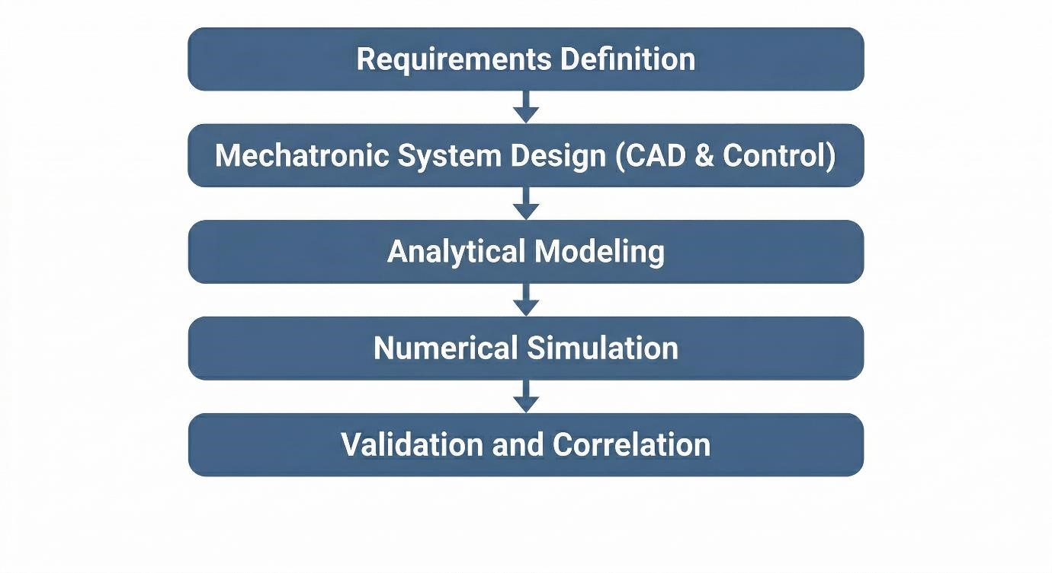
Figure 1- 2 Project methodology flowchart showing the sequential phases .

1.8 Organization of the Report
This graduation project report is organized into seven chapters, each addressing specific aspects of the design and analysis process:
Chapter One: Introduction presents the background, problem statement, objectives, research questions, scope, and significance of the study. This chapter establishes the context and motivation for the project.
Chapter Two: Literature Review provides a comprehensive survey of existing knowledge in VFFS technology, powder rheology, auger engineering, and Multiphysics simulation. This chapter identifies the theoretical foundations and research gaps addressed by the project.
Chapter Three: System Design and Specifications details the design requirements, conceptual development, and final mechanical architecture. CAD representations and control system logic are presented in this chapter.
Chapter Four: Analytical Modeling and Calculations presents the mathematical foundations, kinematic and kinetic models, torque and power estimation, and structural mechanics equations governing system behavior.
Chapter Five: Multiphysics Simulation and Validation describes the computational setup, static structural analysis, thermal-structural coupling, modal analysis, and correlation between analytical and simulation results.
Chapter Six: Results Discussion and Evaluation synthesizes the findings, evaluates machine performance, discusses mechatronic synergy, and assesses the contribution to engineering knowledge.
Chapter Seven: Conclusion and Future Work summarizes the key findings, evaluates objective fulfillment, provides recommendations for prototype fabrication, and suggests directions for future research including AI/ML integration.
The report also includes comprehensive appendices containing engineering drawings, control documentation, simulation reports, and detailed calculation spreadsheets.

CHAPTER TWO
LITERATURE REVIEW

LITERATURE REVIEW
The development of automated packaging systems for powdered materials represents a sophisticated convergence of mechanical design, granular mechanics, and mechatronic control engineering. This chapter presents a critical review of the fundamental engineering principles and state-of-the-art advancements in Vertical Form-Fill-Seal (VFFS) technology and auger-driven dosing mechanisms, establishing the theoretical foundation for the mechatronic system developed in this project.

2.1 VFFS and Dosing Technologies
Vertical Form Fill Seal (VFFS) technology represents a cornerstone in modern automated packaging, particularly for granular, powdered, and liquid products. Its efficiency stems from the integrated process of forming a bag from a roll of film, filling it with the product, and then sealing it, all within a continuous vertical motion. The efficacy of a VFFS system is intrinsically linked to the precision and reliability of its dosing mechanism, which dictates product consistency and economic viability. This section delineates the operational principles of VFFS machines and provides a comparative analysis of volumetric versus gravimetric dosing technologies, highlighting their respective advantages, limitations, and suitability for various industrial applications.

2.1.1 Operating Principles of Vertical Form Fill Seal Machines
The Vertical Form-Fill-Seal (VFFS) machine constitutes a cornerstone technology in modern automated packaging, integrating three distinct yet kinematically synchronized operations forming, filling, and sealing into a single continuous production cycle [1]. Since its commercial introduction in the mid-20th century, VFFS technology has evolved from simple mechanical cam-driven systems to sophisticated mechatronic architectures incorporating advanced servo control, real-time process monitoring, and adaptive adjustment capabilities [2].
- Kinematic Sequence and Film Handling
The operational sequence of a VFFS system initiates with the tension-controlled unwinding of flexible packaging film from a supply reel. The film web is drawn through the machine via motor-driven friction belts or vacuum pull mechanisms, with precise tension regulation maintained through dancer roller assemblies and electronic feedback systems to prevent wrinkles, stretching, or misalignment that would compromise package integrity [3]. The film subsequently passes over a forming collar (forming shoulder), a geometrically optimized component that transforms the two-dimensional web into a cylindrical configuration around the central forming tube. The design of the forming collar particularly its bending angles and surface curvature requires precise reverse engineering to minimize film stress and ensure consistent bag geometry [4].
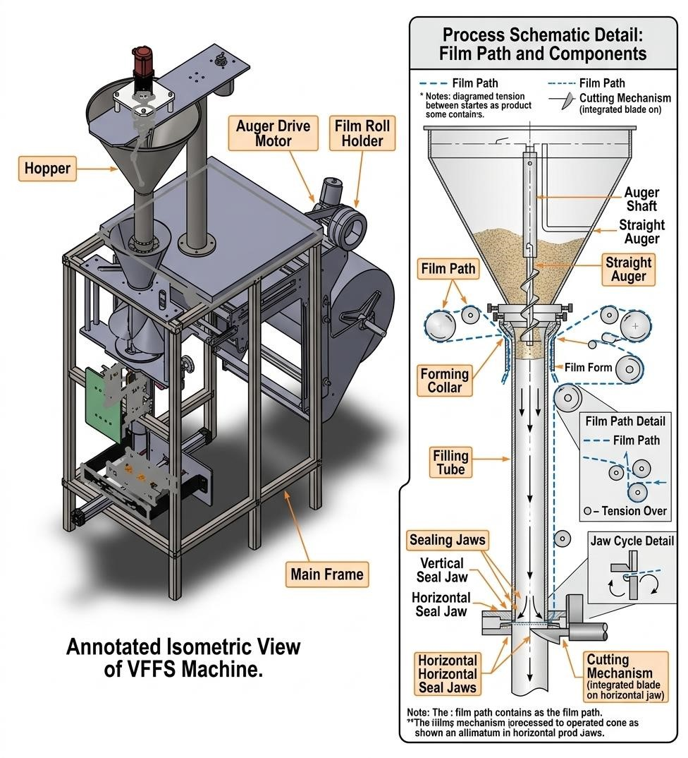
Figure 2- 1 Schematic representation of the Vertical Form-Fill-Seal (VFFS) operational cycle.

Upon formation of the cylindrical tube, a longitudinal sealing jaw creates a continuous vertical seam (overlap or fin seal), while the horizontal cross-sealing jaws execute two simultaneous functions: forming the bottom seal of the current bag and the top seal of the preceding bag. The sealing operation involves precise thermodynamic control of temperature, pressure, and dwell time to achieve hermetic seals without thermal degradation of the film [5].
Furthermore, precise web tracking is continuously monitored and corrected by photoelectric edge-guide sensors to prevent lateral drift during high-speed unwinding. Following the crosssealing phase, an integrated mechanical or pneumatic guillotine separates the continuous web into individual packages accommodating various geometries such as standard pillow bags, gusseted bags, or block-bottom pouches which are subsequently discharged onto synchronized conveyors for secondary packaging operations.
- Critical Synchronization Requirements
The efficiency of the VFFS process is fundamentally governed by the synchronization between the film transport mechanism and the dosing unit. The "Filling Window" defined as the strict temporal interval during which the product must be completely discharged into the formed tube without contaminating the horizontal seal area represents the primary kinematic constraint in high-speed applications. In modern industrial systems operating at cycle times below 2.0 seconds, this synchronization necessitates the replacement of traditional mechanical clutches with high-precision AC Servo motors, enabling millisecond-accurate control over film pull-rate and dwell time while eliminating inertial errors associated with mechanical indexing [6]. This mechatronic evolution is particularly critical for handling abrasive or hygroscopic materials such as Sodium Chloride (NaCl), where misalignment between the dosing pulse termination and jaw opening results in "product-in-seal" contamination and package rejection [7].

- Motion Architecture: Intermittent vs. Continuous
Contemporary VFFS systems employ two distinct motion architectures. Intermittent motion systems, characterized by discrete stopping periods for filling and sealing operations, offer superior precision for applications requiring gravimetric verification but limit maximum throughput. Continuous motion systems, wherein sealing jaws track the moving film during the sealing cycle, achieve higher production rates (exceeding 12 packs per minute) but demand complex control algorithms for maintaining seal integrity during relative motion [8]. The selection between these architectures involves trade-offs between speed, precision, and mechanical complexity, with intermittent systems predominating in applications requiring high dosing accuracy.

2.1.2 Volumetric vs. Gravimetric Dosing: A Comparative Analysis
The dosing unit constitutes the critical precision determining subsystem within the VFFS architecture. In industrial bulk solids handling, two fundamental technical philosophies govern product metering: gravimetric dosing, which measures mass directly, and volumetric dosing, which measures geometric displacement. The selection between these methodologies represents a strategic engineering decision based on the trade-off between throughput speed (Packs Per Minute, PPM) and absolute mass accuracy (±σ) [9].
While volumetric metering encompasses various mechanisms including cup fillers for freeflowing solids and piston fillers for viscous liquids the vertical auger filler remains the predominant standard for powdered and granular materials. Conversely, gravimetric systems, primarily realized through linear scales and multi head weighers, offer significant economic advantages by drastically minimizing "product give-away" (overfilling). This reduction in material waste is highly desirable for expensive commodities, albeit achieved at the cost of increased mechanical complexity and reduced maximum throughput.
- Gravimetric Dosing (Weight-Based Systems)
Gravimetric dosing systems employ high-precision load cells to measure product mass directly, either through checkweighing of completed packages or net-weight control during the filling process. The fundamental advantage of this approach lies in its independence from material bulk density variation, enabling consistent achievement of ( 0.1% − 0.5% ) accuracy regardless of changes in material compaction, moisture content, or particle size distribution [10].
Advanced gravimetric implementations utilize two speed filling strategies (bulk and dribble/drip phases): rapid dispensing to a predetermined threshold (typically 90-95% of target mass), followed by slow, controlled filling to the final target weight. However, gravimetric systems are inherently constrained by the mechanical settling time required for load cell signal stabilization and the associated control system latency. These dynamic limitations render purely gravimetric systems unsuitable for high-speed VFFS lines operating at cycle times below 3.0 seconds, where the stabilization delay creates a severe production bottleneck [11]. Additionally, the complexity of load cell integration, calibration requirements, and environmental vibration isolation increases both initial capital cost and ongoing maintenance demands [12].
- Volumetric Dosing (Auger Filling Systems)
Volumetric dosing systems, predominantly realized through vertical Archimedean screw (auger) mechanisms, operate on the principle of geometric displacement. The system assumes that each revolution of the helical auger displaces a constant, mathematically defined volume of material. The theoretical mass delivered per revolution (m_{rev}) is determined by the product of the effective flight volume (V_{eff}) and the operational bulk density (ρ_{v}):
$$m_{rev}=V_{eff}×ρ_{v}=n_{v}×\frac{π}{4}×\left(D^{2}-D_{s}^{2}\right)×P×ρ_{v}$$

- Comparative Summary and Hybrid Approaches
Where n_{v} represents the volumetric efficiency, D the auger outer diameter, D_{s} the shaft diameter, and P the pitch [13].
The primary advantages of auger filling include exceptional kinematic speed (achieving up to more than 120 PPM), mechanical simplicity with minimal moving parts, continuous flow control through direct servo motor coupling, and hygienic design suitable for food-grade applications. The direct coupling of the auger shaft to high-torque servo motors enables precise angular displacement control (θ)with instantaneous start-stop functionality, eliminating the latency inherent in weight-based measurement systems [14].
However, the critical vulnerability of volumetric dosing lies in its fundamental assumption of bulk density constancy. For granular materials such as Sodium Chloride ($ρ_{v}≈1300 \frac{kg}{m^{3}}$ ), aeration during hopper discharge, vibration-induced compaction, and particle segregation can cause density fluctuations of $±5-10\%$directly propagating to mass dosing errors. This "mass-drift" phenomenon, extensively documented in powder handling literature, historically limited volumetric system accuracy to $±0.5-2.0\%$ without external compensation [15].

Table 2- 1 Comparative Analysis of Volumetric and Gravimetric Dosing Technologies
Characteristic | Volumetric (Auger) | Gravimetric (Net-Weigh)
Operating Principle | Geometric Displacement | Direct Mass Measurement
Accuracy | $±0.5-2.0\%$ (density-dependent) | $0.1\%-0.5\%$ (absolute)
Throughput | High (up to 150 PPM) | Moderate (up to 40 PPM)
Density Sensitivity | High | None
Initial Cost | Lower | Higher
Maintenance Complexity | Low (minimal moving parts) | High (load cell calibration)
Material Suitability | Free-flowing powders & granules | Variable density materials, precision chemicals
Control Architecture | Open-loop or compensated closed-loop | Inherent closed-loop feedback

Table 2- 2Advantages and Limitations of Volumetric vs. Gravimetric Dosing
Dosing Technology | Advantages | Limitations (Disadvantages)
Volumetric Dosing (e.g., Auger Fillers) | • High Speed: Achieves very high production rates due to continuous operation and simple control logic.  • Cost-Effective: Lower initial capital and maintenance costs, ideal for high-volume/lower-value products.  • Simplicity: Straightforward operational principle requiring less complex calibration for materials with stable density. | • Bulk Density Dependence: Highly susceptible to variations in material compaction, particle size, and moisture.  • Limited Accuracy: Potential weight inaccuracies make it unsuitable for products with fluctuating densities or strict weight requirements.
Gravimetric Dosing (e.g., Multi-head Weighers) | • High Accuracy: Measures mass directly, making it completely independent of bulk density variations.  • Versatility: Highly precise for a wide range of materials, including those with irregular shapes or fragile compositions.  • Reduced Product Give-Away: Minimizes overfilling, leading to significant long-term cost savings for high-value products. | • Lower Speed: Generally slower due to the mechanical settling time required for weighing and stabilization.  • Higher Cost: More expensive to acquire and maintain due to complex load cells and control algorithms.  • High Complexity: Demands sophisticated calibration, regular maintenance, and strict environmental control (e.g., vibration isolation).

Recent advancements in mechatronic engineering have addressed the traditional speedaccuracy trade-off through hybrid dosing strategies. Rather than replacing the mechanical auger, modern systems upgrade the control layer through the integration of adaptive microcontrollers (such as ESP32 architectures) implementing real-time "Volumetric Correction Factors." By periodically calibrating bulk density via offline sampling or integrating closed-loop feedback from auxiliary load cells, these systems dynamically adjust the required number of motor revolutions (N_{req}), effectively synthesizing the speed advantages of volumetric filling with the accuracy characteristics of gravimetric measurement [16].

The "Bulk and Trim" filling strategy represents a particularly effective hybrid approach: the auger operates at high speed to dispense 90 − 95% of the target mass (volumetric mode), subsequently reducing to low speed for final weight adjustment based on instantaneous feedback from a load cell (gravimetric mode). This mechatronic integration enables achievement of high production throughput (30-35 bags/minute) while maintaining strict accuracy tolerances of ±1.5%, bridging the historical gap between volumetric speed and gravimetric precision [17].

- Justification for Volumetric Auger Selection in This Project
For the current application targeting 500g salt packages at 20 bags per minute with 1.5% accuracy, the volumetric auger filler with servo motor control and density compensation represents the optimal engineering solution. This selection is justified by: (1) the relatively consistent bulk density of crystalline Sodium Chloride; (2) the moderate speed requirements that align with volumetric system capabilities; (3) the lower capital and maintenance costs compared to gravimetric alternatives; (4) the mechanical compatibility with VFFS architecture; and (5) the demonstrated effectiveness of microcontroller-based compensation algorithms in addressing density-induced errors without sacrificing throughput [18].

2.2 Powder Rheology and Handling
The design of high-precision mechatronic dosing systems necessitates a profound understanding of bulk solids mechanics a field that diverges fundamentally from both Newtonian fluid dynamics and continuum solid mechanics. Unlike fluids, powders and granular materials exhibit yield strength and can sustain shear stresses when at rest; unlike continuous solids, they flow plastically when subjected to stresses exceeding their yield locus, transmitting forces through complex inter-particle contact networks rather than continuous strain fields [19]. This dual nature, characterized by the coexistence of solid-like and fluid-like behaviors, renders classical hydrodynamic and electrostatic analyses inadequate for predicting powder flow phenomena.
In the context of Vertical Form-Fill-Seal (VFFS) auger filling systems, the rheological behavior of the target material specifically Sodium Chloride (NaCl) directly governs volumetric efficiency, motor torque requirements, dosing precision, and the susceptibility to flow obstructions. This section establishes the theoretical foundation for powder characterization and analyzes the complex transport dynamics within helical screw conveyors.

2.2.1 Material Characteristics: Bulk Density, Flowability, and Cohesiveness
The successful transport and metering of granular material through an auger system is fundamentally dictated by three primary physicochemical properties: bulk density, flowability, and cohesiveness. These characteristics are not intrinsic material constants but rather emergent behaviors dependent on environmental conditions, stress history, and particle-level interactions.

- Bulk Density and Compressibility
Bulk density (ρ_{v}) is defined as the ratio of powder mass to the total occupied volume, inclusive of interstitial voids between particles:
$$ρ_{v}=\frac{M_{powder}}{V_{total}}=ρ_{practical}(1-ε)$$
where $ρ_{v}$represents the true particle density (approximately 2165 kg/m³ for crystalline NaCl) and ε denotes the void fraction [20]. It is essential to distinguish between true density and operational bulk density: while the former is an intrinsic material property, the latter varies significantly with consolidation stress, vibration, and aeration state.
For granular table salt, operational bulk density typically ranges between 1100 and 1300 kg/m³, with the lower bound corresponding to loosely poured material and the upper bound representing vibrationally consolidated states [21]. This compressibility phenomenon wherein bulk density increases with consolidation pressure and vibration represents the primary source of dosing deviations in volumetric auger systems. The degree of compressibility is quantified through the Hausner Ratio:
$$HR=\frac{ρ_{tapped}}{ρ_{bulk}}$$
Hausner ratios below 1.2 indicate free-flowing materials, while ratios exceeding 1.4 suggest cohesive, poorly flowing powders. Granular salt typically exhibits Hausner ratios of 1.1 −
1.2, consistent with its classification as a free-flowing material [22].
The variation in bulk density is not merely a static concern but a dynamic process variable. Within the confines of a VFFS hopper, the material column generates hydrostatic-like pressure that increases consolidation toward the discharge orifice. Furthermore, mechanical vibrations from the auger drive and adjacent machinery induce progressive compaction, altering the mass-to-volume relationship in real-time. This necessitates the integration of mechanical agitation systems to maintain a consistent density regime prior to auger entry, thereby mitigating mass-drift phenomena [23].

B. Cohesiveness and the Mohr-Coulomb Failure Criterion
The stress state within bulk solids is mathematically described using the Mohr-Coulomb yield criterion, which defines the shear stress required to initiate plastic flow:
$$τ=σ×tan⁡(Q_i )+c$$
where 𝜏 represents the shear stress at failure, σ is the normal stress, Q_{i} is the angle of internal friction, and c is the cohesion intercept [24]. This framework distinguishes between freeflowing materials (𝑐 ≈ 0) and cohesive materials (𝑐 > 0).
Dry, crystalline sodium chloride is classified as free-flowing, with internal friction angles ranging between 25° and 35° and negligible cohesion under standard atmospheric conditions [25]. However, NaCl exhibits pronounced hygroscopicity, readily absorbing atmospheric moisture to form liquid bridges between crystals. Upon subsequent drying, these bridges solidify into robust particle-particle bonds, dramatically increasing cohesive forces (𝑐 > 0) and necessitating substantially higher shear stresses—and consequently, greater motor torque to overcome flow resistance [26].
The transition from free-flowing to cohesive behavior has profound implications for system design. Cohesive arching (bridging) above the auger intake and ratholing within the hopper represent critical failure modes that disrupt continuous feeding and introduce dosing irregularities. The mechanical design must therefore incorporate sufficient dynamic shearing capability to break cohesive bonds during operation, alongside hopper geometries that promote mass flow (wherein all particles are in simultaneous motion) rather than funnel flow (which creates stagnant zones and erratic density) [27].

C. Flowability and Angle of Repose
Flowability describes the macroscopic response of a powder to applied stress, governed by microscopic particulate interactions. It is quantified through the Flow Function (ff_{c}), defined as the ratio of major consolidation stress (σ₁) to unconfined yield strength (σ_{c}):
$${ff}_{c}=\frac{σ_{1}}{σ_{c}}$$
Jenike's classification framework establishes the following criteria: ${ff}_{c} >10$ indicates free-flowing material; $4 <{ff}_{c}<10$ indicates easy-flowing; $2 <{ff}_{c} < 4$ indicates cohesive; and $1 <{ff}_{c} < 2$ indicates very cohesive or non-flowing behavior [10]. While dry salt typically falls within the free-flowing category (${ff}_{c}≥4$), moisture ingress can degrade it to cohesive states, necessitating continuous monitoring of environmental humidity.
The angle of repose the maximum stable slope angle of a poured powder heap provides an empirical flowability indicator complementary to shear testing. For granular salt, this angle typically ranges between 30° and 45°, with lower values indicating superior flowability [28]. This geometric property is critical for hopper design: wall angles must exceed 60° (significantly steeper than the angle of repose) to enforce mass flow and prevent arching. Furthermore, the angle of repose validates the engineering necessity of the spinner plate (dribble collector) mechanism at the discharge nozzle, which prevents gravitational leakage and uncontrolled flow after auger rotation cessation [29].
D. Janssen's Effect and Pressure Distribution
A fundamental distinction between powder statics and fluid hydrostatics is articulated through Janssen's theory (1895), which demonstrates that vertical pressure within granular columns does not increase linearly with depth. Instead, frictional interaction between the powder and container walls supports a portion of the material weight, causing vertical pressure to asymptotically approach a saturation value:
$$σ_{v}=\frac{ρ_{b}×g×D}{4μ_{ω}×K}(1-e^{4μ_{ω}×K×\frac{h}{D}})$$

where D is the hopper diameter, μ_{ω} is the wall friction coefficient, K is the lateral pressure ratio, and h is the fill depth [30]. This pressure saturation ensures that material at the auger intake is not subjected to crushing pressures proportional to total hopper height, thereby preserving particle integrity and flowability.
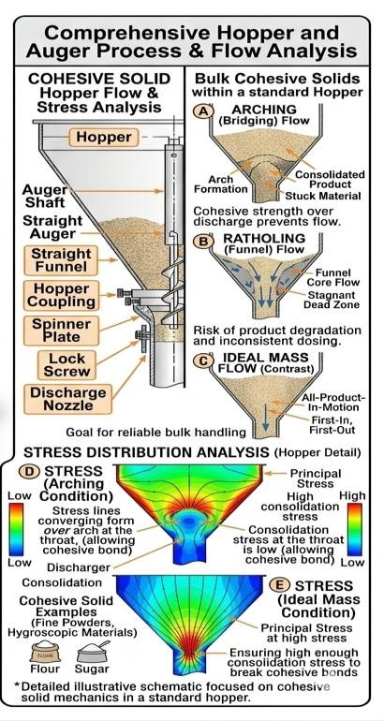
Figure 2- 2 Stress distribution and characteristic flow behavior of bulk cohesive solids within a standard hopper.

2.2.2 Dynamics of Screw-Driven Material Transport
The kinematic transport of granular material through a helical screw represents a complex multiphase flow phenomenon significantly more intricate than the ideal rigid-plug flow model implies. The auger does not function as a positive-displacement pump in the hydraulic sense; rather, axial transport emerges from the tribological interaction between particles, the rotating screw surface, and the stationary casing wall.
- Tribological Balance and Axial Transport Mechanism
Effective axial conveying depends upon a delicate balance between friction forces acting on particles. For forward transport to occur, the friction force against the stationary wall ($F_{wall}$) must exceed the friction force against the rotating screw surface ($F_{screw}$). If the material possesses excessive internal friction or adheres preferentially to the screw surface ($F_{screw}>F_{wall}$), the powder will rotate as a single rigid body a failure mode termed the "doughnut effect" resulting in complete cessation of axial pumping [31].
This tribological constraint dictates material selection and surface finish specifications for auger components. Highly polished surface finishes (e.g., 2B finish on AISI 316L stainless steel with $R_{a} < 0.5 µm$) minimize the wall friction angle ($Q_{ω}$), thereby promoting the differential friction necessary for axial transport while satisfying hygienic requirements for food-contact applications [32].
The theoretical volumetric displacement per revolution is geometrically determined by the screw geometry:
$$V_{theoretical}=\frac{π}{4}(D^{2}-D_{s}^{2})×P$$
where $D$ is the auger outer diameter, $d$ is the shaft diameter, and $P$ is the pitch. However, the actual mass delivered depends on the operational bulk density ($ρ_{b}$) and volumetric efficiency ($n_{v}$):
$$m_{actual}=V_{theoretical}×ρ_{b}×n_{v}$$

- Vortex Motion, Backflow, and Volumetric Efficiency
Advanced computational studies utilizing Discrete Element Method (DEM) simulations have revealed that particles within the screw channel do not follow strictly linear helical paths. Instead, they exhibit complex three-dimensional velocity fields characterized by granular vortex motions localized circulation patterns within individual pitches that consume energy and reduce transport efficiency [33].
A critical volumetric loss mechanism arises from "backflow" through the radial clearance (C) between the flight tip and the casing wall. This backward leakage, wherein material bypasses the advancing flight by flowing through the annular gap, increases proportionally with rotational speed and inversely with particle size relative to clearance dimension. For precision dosing applications, radial clearances must be minimized (typically 1.0–2.0 mm) while maintaining sufficient tolerance to prevent metallic contact and galling [17].
The volumetric efficiency factor ($n_{v}$)—defined as the ratio of actual to theoretical volumetric displacement encapsulates these non-ideal behaviors:
$$n_{v}=\frac{V_{actual}}{V_{therotical}}$$
Empirical observations for well-designed augers handling free-flowing granular materials indicate $n_{v}$ typically ranges between 0.65 and 0.80. This efficiency is not constant but varies with rotational speed, fill level, material properties, and wear state, necessitating empirical calibration and, in advanced systems, real-time compensation through closed-loop control [34].

- Effect of Operating Parameters
Rotational Speed: While increasing the auger rotational speed (n) theoretically increases mass flow rate ($\dot{m}=m_{actual}×n$), practical limits exist. Excessive speeds generate increased centrifugal forces that press particles against the casing wall, potentially altering friction dynamics and promoting particle attrition. Furthermore, high-speed operation exacerbates backflow and reduces the time available for material settling into the screw flights, potentially reducing volumetric efficiency [35].
Fill Level: The degree of screw channel filling significantly influences conveying dynamics. Optimal performance is typically achieved at fill levels between 40% and 80% of theoretical capacity. Underfilling leads to erratic, pulsating discharge, while overfilling increases compaction and power consumption without proportional throughput gains [20].
Particle-Scale Dynamics: DEM simulations by El Kassem (2021) demonstrate that material transport involves continuous particle rearrangement, with velocity gradients across the screw channel cross-section. Particles near the shaft exhibit lower axial velocities than those at the periphery, and transient force chains form and collapse during rotation, generating fluctuating torque requirements that must be accommodated by the servo drive system [36].

- Integration with Mechatronic Control
These complex rheological and kinematic behaviors establish that ideal mathematical models must be augmented with empirical efficiency factors and active mechatronic compensation to achieve high-precision industrial dosing. The inherent variability in bulk density, the non-linear relationship between screw rotation and material displacement, and the susceptibility to environmental moisture necessitate control architectures that transcend open-loop volumetric operation.
Modern mechatronic systems address these challenges through the integration of adaptive microcontrollers implementing real-time volumetric correction factors. By periodically calibrating bulk density via auxiliary sensing or closed-loop feedback from load cells, the control system dynamically adjusts the required number of motor revolutions ($N_{req}$), effectively synthesizing the speed advantages of volumetric filling with the accuracy characteristics of gravimetric measurement. This hybrid approach, detailed in subsequent chapters, represents the contemporary engineering solution to the historical speed-accuracy trade-off in powder dosing systems [37].

2.3 Auger Filler Engineering State-of-the-Art
The transition from theoretical granular mechanics to applied machine design necessitates a state-of-the-art approach to component engineering, wherein geometric optimization and material selection are governed by rigorous tribological, mechanical, and hygienic constraints. Modern volumetric dosing systems achieve industrial-grade precision not merely through control algorithms but through the meticulous engineering of the auger's macroscopic geometry and the strategic selection of advanced materials. This section delineates the contemporary engineering standards governing auger design for food-grade applications, with specific emphasis on the processing of crystalline Sodium Chloride (NaCl).

2.3.1 Geometry Optimization: Pitch, Flight Depth, and Taper
The volumetric efficiency (n_{v}), flow stability, and dosing accuracy of an auger filler are fundamentally governed by three interdependent geometric parameters: the pitch-to-diameter ratio (P/D), the flight depth (annular conveying area), and the radial clearance (δ). The optimization of these parameters constitutes a multi-objective engineering problem balancing volumetric capacity, structural integrity, and tribological performance.

- Pitch-to-Diameter Ratio (P/D)
The pitch (P), defined as the axial distance between corresponding points on adjacent flights, directly determines the theoretical volumetric displacement per revolution. For free-flowing granular materials such as Sodium Chloride, contemporary industrial practice and Conveyor Equipment Manufacturers Association (CEMA) standards converge on the "square-pitch" configuration, wherein the pitch equals the outer flight diameter (𝑃/𝐷 = 1.0) [38]
This specific geometry ensures stable, uniform axial displacement of particles while minimizing internal shear friction within the powder bed. Deviations from unity—either through increased pitch (which promotes aeration and pulsating flow) or decreased pitch (which increases particle compaction and torque requirements)—degrade dosing consistency for free-flowing materials. Research by Bates (2008) further indicates that optimal pitch selection depends on the ratio of particle size to flight depth, with larger particles requiring proportionally larger pitch to prevent jamming and mechanical damage [39].
The linear relationship between pitch and volumetric displacement under ideal conditions is modified in real systems by complex interactions between pitch, particle size, and flow behavior, necessitating empirical calibration.

- Flight Depth and Shaft Diameter Optimization
The effective conveying region comprises the annular space between the central shaft diameter (D_{s}) and the outer flight diameter (𝐷). While minimizing the shaft diameter maximizes volumetric capacity, this reduction compromises torsional rigidity a critical consideration given the high transient breakaway torques required to shear compacted material at motor startup.
πd⁴
The polar moment of inertia for the shaft, J = , scales with the fourth power of diameter,
32
rendering small reductions in d disproportionately detrimental to stiffness. Torsional deflection under peak load must be constrained to prevent radial deflection that would compromise the tight radial clearance or induce metal-to-metal contact. The ratio of shaft diameter to outer diameter (core ratio) typically ranges from 𝟎. 𝟐 𝒕𝒐 𝟎. 𝟒 for general-purpose augers; lower core ratios maximize volumetric capacity but reduce shaft strength, while higher ratios improve mechanical robustness at the cost of reduced capacity [40].
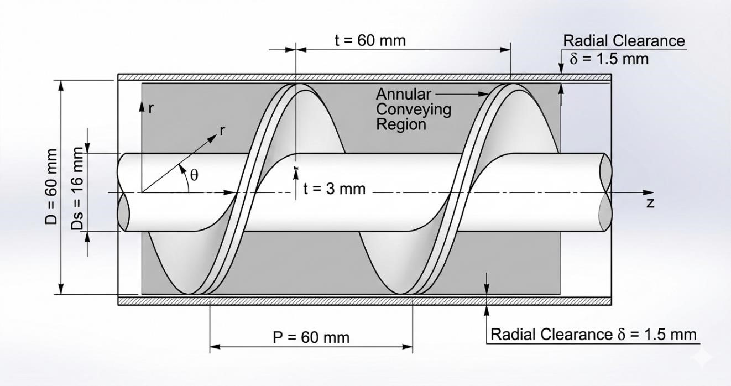
Figure 2- 3 Geometric parameters of a standard volumetric auger screw.
Engineering analysis establishes$d = 16 mm$ as the optimal compromise for the current application targeting $500g$ doses with precise accuracy, providing sufficient torsional rigidity ($τ_{max}=\frac{T×r}{J}$) while maintaining adequate annular conveying area with a core ratio of approximately $0.27$ [41].

The helix angle ($α$), governed by $\tan\left(α\right)=\frac{P}{π×r}$, varies radially across the flight: minimized at the outer periphery (maximizing wall friction to prevent co-rotation) and maximized at the shaft root (promoting internal shear). This geometric gradient constrains the minimum practical shaft diameter.
- Radial Clearance (δ) and Backflow Control
The radial clearance between the flight tip and the stationary funnel casing represents the primary pathway for volumetric back-slip—a phenomenon wherein material bypasses the advancing flight by flowing through the annular gap, directly degrading dosing accuracy. For crystalline salts with mean particle sizes of 300 − 500 µ𝑚, clearance must be minimized to restrict backward leakage under hydrostatic head pressure while maintaining sufficient tolerance to prevent thermal expansion-induced galling or abrasive wear.
State-of-the-art designs for salt applications specify 𝛿 < 1.5 𝑚𝑚—approximately 3-5 particle diameters—achieving an optimal balance between leakage suppression and operational safety [42]. This clearance is maintained through precision machining (tolerance ±0.05 𝑚𝑚) and shaft alignment protocols. Excessively large clearance increases powder back-slip under hydrostatic head pressure, degrading dosing precision; whereas insufficiently small clearance drastically increases friction torque, risking metal-to-metal abrasion (galling) and jamming.
- Taper and Variable Geometry Considerations
While specialized applications handling cohesive or aerated powders may employ tapered augers (variable diameter) or variable-pitch screws (decreasing pitch toward discharge to induce controlled compaction), these geometries are contraindicated for crystalline NaCl. Tapered designs generate excessive shear stress at crystal contact points, promoting particle attrition, generating fines, and increasing power consumption without commensurate accuracy benefits. Furthermore, tapered augers are mechanically more complex to manufacture and may increase particle attrition for friable materials [34].
For free-flowing crystalline materials, the constant square-pitch straight auger remains the optimal configuration, with flow control at discharge achieved through auxiliary mechanisms (spinner plates) rather than geometric tapering. The constant geometry simplifies control algorithm development and reduces manufacturing cost [44].

2.3.2 Material Science for Food-Grade Industrial Systems
The operational environment of a VFFS auger handling Sodium Chloride presents a confluence of severe metallurgical challenges: abrasive wear from sharp cubic crystals, stress corrosion cracking from chloride ion exposure, and hygienic requirements mandating surface finishes that prevent bacterial adhesion while minimizing frictional losses.
- Austenitic Stainless Steel Selection
The prohibition of carbon steels and reactive alloys in food-contact applications necessitates the specification of austenitic stainless steels. While AISI 304 (UNS S30400) suffices for general food processing, the continuous exposure to chloride ions (𝐶𝑙⁻) in salt applications mandates the superior pitting corrosion resistance of AISI 316 (UNS S31600) [45].
The critical distinction lies in molybdenum content: AISI 316L incorporates 2 − 3% Mo, which forms stable passive oxide layers that resist chloride-induced pitting and crevice corrosion. Furthermore, the low carbon designation ("L") minimizes carbide precipitation during welding operations, preserving intergranular corrosion resistance at heat affected zones essential for the sanitary welding of flight attachments.

Table 2- 3 Comparison of Stainless Steel Grades for Food-Grade Auger Applications
Property | AISI 304 | AISI 316 | AISI 316L
Chromium (%) | 18-20 | 16-18 | 16-18
Nickel (%) | 8-10.5 | 10-14 | 10-14
Molybdenum (%) | — | 2-3 | 2-3
Carbon (max %) | 0.08 | 0.08 | 0.03
Yield Strength (MPa) | 215 | 215 | 205
Chloride Resistance | Good | Excellent | Excellent
Key mechanical properties for design verification include:
- Yield strength: ${σ }_{y}≥ 170 MPa$ (annealed condition)
- Ultimate tensile strength: ${σ }_{UTS}≥ 485 MPa$
- Hardness: $HRB ≤ 95$ (ensuring adequate ductility for forming operations)
While AISI 316L is more expensive than 304, its superior performance in aggressive chloride environments justifies the material cost for salt processing applications [9].
- Surface Finish and Tribological Engineering
The wall friction coefficient ($μ_{ω}$) between powder and metallic boundaries directly impacts power consumption, flow consistency, and susceptibility to powder adhesion (bridging). Surface topography is quantified through the arithmetic mean roughness ($R_{a}$), with state-of-the-art food-grade applications specifying mechanical or electropolished finishes achieving ${R }_{a}≤ 0.8 µm$ (2B finish) [46].
This surface specification serves dual functions:
- Tribological: Reducing the sliding friction coefficient ${µ }_{s}< 0.3$ for salt on polished 316L), thereby minimizing the torque required to overcome wall shear and preventing the "doughnut effect" (solid-body rotation).
- Hygienic: Eliminating surface asperities that could harbor bacteria or provide nucleation sites for salt crystal adhesion and caking.
Electropolishing provides the smoothest surface finish for stainless steel components. This electrochemical process selectively dissolves surface asperities, reducing Ra values below $0.4 µm$ while simultaneously enhancing corrosion resistance through chromium enrichment of the surface layer [47]. For the auger filler application, electropolishing of flight surfaces reduces friction and prevents salt adhesion.

The 2B finish (cold-rolled, annealed, and pickled) represents a cost-effective alternative to electropolishing, providing Ra values of $0.2-0.5 µm$. While not as smooth as electropolished surfaces, 2B finish provides adequate performance for many food applications and is widely used for hopper and housing components [48].

- Hygienic Design and Clean-Out-of-Place (COP) Standards
Contemporary food-grade machinery must comply with FDA 21 CFR Part 110, ISO 22000, and EHEDG (European Hygienic Engineering & Design Group) guidelines. These standards mandate:
- Geometric Hygiene: Elimination of internal crevices, sharp corners (minimum 3 mm radii), and "dead zones" where material stagnation or bacterial accumulation could occur. All product-contact surfaces must be self-draining with $slopes ≥ 3°.$
- Clean-Out-of-Place (COP) Architecture: Tool-less disassembly capability through quick-release mechanisms (e.g., Tri-Clamp fittings, DIN 32676) enabling complete component removal for external cleaning and sanitization without specialized equipment.
- Lubrication Containment: All bearings and drive components must be isolated from product zones, with any potential contact points utilizing H1-registered food-grade lubricants (NSF/ANSI 61 compliance).
- Material Traceability: Full certification of stainless steel heat numbers, surface finish documentation, and weld procedure qualifications (WPQ) for quality assurance and regulatory audit trails [49].

- Integration of Geometric and Material Design
The synthesis of optimized geometry and advanced materials establishes the physical foundation for precision dosing. The square-pitch 316L auger with Ra ≤ 0.8 µm surface finish and $δ < 1.5$ mm radial clearance provides:
- Predictable volumetric displacement governed by geometric parameters rather than variable friction coefficients.
- Mechanical durability sufficient for continuous industrial operation $(> 10⁷$ cycles).
- Regulatory compliance for direct food contact applications.
- Tribological conditions conducive to stable, non-pulsating flow.
These engineering specifications directly enable the mechatronic control strategies detailed in subsequent chapters, wherein the predictability of mechanical response allows microcontroller-based compensation algorithms to achieve$±1.5\%$ dosing accuracy at production speeds of 30-35 bags per minute.

2.4 Multiphysics in Mechatronic Systems
The modern design paradigm for industrial packaging machinery has undergone a fundamental transformation from empirical "trial-and-error" methodologies to sophisticated Multiphysics simulation frameworks. In high-speed VFFS auger fillers, the interaction between mechanical structures, thermal gradients from high-duty motors, dynamic vibrations, and granular material flow necessitates a holistic mechatronic analysis to ensure long-term reliability, structural integrity, and dosing precision. This section delineates the contemporary computational approaches—encompassing Finite Element Analysis (FEA), thermal analysis, and modal analysis—and their integration with analytical models to establish a validated, simulation-driven design methodology.

2.4.1 Review of FEA, Thermal, and Modal Analysis in Rotating Machinery
The reliability of rotating components, particularly the auger screw and its drive shaft, is evaluated through three critical numerical lenses: static structural analysis for stress and deformation prediction, thermal analysis for temperature distribution and expansion effects, and modal analysis for dynamic characterization and resonance avoidance.
- Static Structural Analysis (FEA)
Finite Element Analysis has become the gold standard for validating structural integrity in mechanical design, enabling detailed prediction of stress distribution, deformation, and safety factors under specified loading conditions. For ductile materials such as austenitic stainless steels (AISI 304/316L), the von Mises yield criterion serves as the primary metric for predicting the onset of plastic deformation, comparing equivalent stress to material yield strength [50].
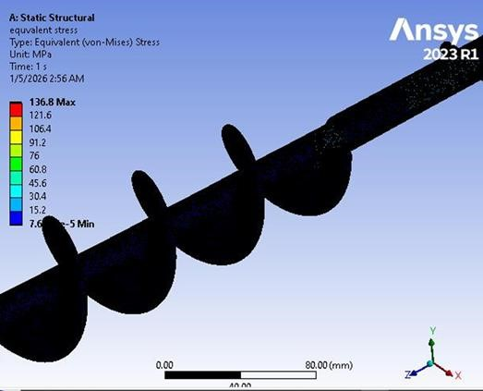
Figure 2- 4 Typical Finite Element Analysis (FEA) .
In auger systems, critical loading conditions include:
- Torsional loads: The primary operational load arising from the resistance of the compacted powder bed (specifically crystalline NaCl) against shear during rotation. According to El Kassem [2], the torque transmission creates maximum stress concentration at the transition zones between the shaft and the first flight, where geometric discontinuities generate stress concentration factors ($K_{t}$).
- Bending moments: Gravity-induced loads and asymmetric material distribution create transverse stresses superimposed on the torsional field.
- Transient loads: Breakaway torques required to initiate motion from rest, often 2-3× higher than steady-state operational torque due to static friction and particle interlocking.
Modern FEA implementations employ curvature-based meshing with local refinement at stress concentration regions (fillets, transitions, weld joints), providing optimal balance between accuracy and computational efficiency. Mesh convergence studies progressively refining element density until stress results stabilize within specified tolerance (typically $< 5\%$ variation) validate that discretization error is acceptably small [3].
The Factor of Safety ($FoS)$ is calculated as:
$$FOS=\frac{σ_{yield}}{σ_{von mises(max)}}$$
Contemporary industrial standards for food machinery mandate $FoS > 2.0$ under peak load conditions to account for material property variability, manufacturing tolerances, and fatigue degradation over the design life (> 10⁷ cycles) [51].

- Thermal Analysis
Continuous operation of VFFS systems generates heat from multiple sources: internal resistance ($I²R$ losses) within the AC Servo motor, friction between salt particles and the stainless steel funnel surface, and conductive heat transfer from the thermal sealing jaws (operating $at 150-200°C$). Thermal-structural coupling is essential because thermal expansion can alter the tight radial clearances ($δ < 1.5 mm$) defined in the CAD model.
The coefficient of thermal expansion for austenitic stainless steels ($α=1.7×{10}^{-5} 1/{C^{°}}$) dictates that a $50°C$ temperature rise generates linear expansion of approximately 85 µm per 100 mm of component length. For the auger-funnel assembly, this expansion must be accommodated without inducing "thermal binding" a catastrophic failure mode wherein differential expansion causes metallic contact, seizure, and drive system overload [52].
Steady-state thermal analysis determines equilibrium temperature distribution under constant heat input, identifying worst-case thermal conditions. Transient thermal analysis tracks temperature evolution during startup and cyclic operation, evaluating whether thermal mass and heat dissipation rates maintain acceptable steady-state temperatures. For auger filler design, thermal analysis ensures that:
- Motor operating temperatures remain within insulation class limits.
- Bearing temperatures do not exceed lubricant degradation thresholds.
- Dimensional changes from thermal expansion preserve functional clearances.

- Modal Analysis (Vibration Characteristics)
Every mechanical system possesses natural frequencies ($f_{n}$) and associated mode shapes that characterize its dynamic response. In rotating machinery, if the operational speed (RPM) coincides with a natural frequency, resonance occurs leading to excessive vibration, bearing damage, structural fatigue, and dosing inaccuracy.
Modal analysis identifies these critical speeds through eigenvalue extraction of the undamped system:
$$\left(\left[K\right]-ω_{N}^{2}\left[M\right]\right)u_{n}=0$$
where [$K$] is the stiffness matrix, [$M$] is the mass matrix, $ω_{n}=2πf_{n}$ is the natural circular frequency, and $u_{n}$ is the mode shape vector [53].
For safe operation, engineering practice mandates that the maximum operating speed remain at least $25\%$ below the first critical speed (or $25\%$ above, for supercritical designs), providing adequate margin for:
- Manufacturing tolerances in bearing stiffness.
- Variation in support boundary conditions.
- Gyroscopic effects on rotating shafts.
For a system driven by high-frequency microcontroller PWM (such as ESP32-based servo control), it is additionally vital to ensure that switching frequencies and control loop dynamics do not excite mechanical resonances of the supporting frame or drive train [54].

2.4.2 Integration of Analytical Models with Numerical Simulations
The design process of complex mechatronic systems typically commences with analytical models that employ fundamental engineering principles and simplified mathematical equations to provide initial estimations and guide preliminary design decisions. For the auger filler system, analytical models are utilized to calculate theoretical volumetric displacement, required torque based on material properties and geometry, and preliminary sizing of the motor and transmission components. These models are invaluable for rapid prototyping and understanding the first-order effects of design parameters, such as the relationship between auger pitch and theoretical flow rate, or the influence of bulk density variations on dosing accuracy.
However, analytical models inherently rely on simplifying assumptions—idealized geometries, homogeneous material behavior, and decoupled physical phenomena—that may not fully capture the intricate multiphysics interactions governing real-world performance. This limitation necessitates the integration of advanced numerical simulations to validate, refine, and optimize the preliminary analytical predictions.
As also They dependent latest technologies in mechatronics engineering rely on the integration of classical mathematical principles and modern numerical simulation programs (ANSYS, SolidWorks Simulation, EDEM, Wokwi, Automation Studio, Pulse View, Protues, Square Line Studio, Matlab). This integration follows the "V-Model" methodology, wherein analytical models provide theoretical baselines and physical insight, while numerical simulations offer high-fidelity validation for complex geometries and coupled phenomena.
- Validation Framework and Correlation Methodology
Analytical models derived from first principles and empirical correlations—provide rapid "order-of-magnitude" estimates and fundamental physics understanding (e.g., Jenike's equations for hopper flow, Roberts' torque models for screw conveyors). However, these models inherently simplify complex geometries and idealize material behaviors.
Numerical simulations provide high-resolution spatial and temporal data, accounting for:
- Geometric complexity (helical flight profiles, fillet radii).
- Non-linear material behaviors (plasticity, thermal softening).
- Multi-physics coupling (thermal-structural, fluid-structure interaction).
The correlation between analytical and numerical results serves as critical validation. The percentage error is calculated as:
$$Erorr=\frac{|Analytical-Simulation|}{Analytical}×100\%$$
Acceptable correlation is typically defined as $< 10\%$ error for primary performance metrics (stress, torque, flow rate). Significant discrepancies indicate errors in analytical assumptions, simulation boundary conditions, or material property definitions, requiring systematic investigation [55].
- Digital Twin Concept
The integration of validated models enables the creation of a "Digital Twin" a virtual representation of the physical system that evolves with operational data. In the context of VFFS auger fillers, the Digital Twin encompasses:
- Mechanical subsystem: Parametric CAD geometry linked to FEA structural models.
- Material flow subsystem: DEM (Discrete Element Method) models of powder rheology and transport.
- Control subsystem: Virtual implementation of ESP32 control logic and servo drive dynamics.
This virtual environment allows:
- Pre-physical prototyping validation of control algorithms.
- Sensitivity analysis for design parameter optimization.
- Prediction of wear and performance degradation over operational life.
- Virtual commissioning and operator training.
The Digital Twin ensures that mechatronic compensation for "slip," "back-flow," and density variation (discussed in Section 2.2.2) is grounded in the physical reality of the machine's structural limits, thermal constraints, and dynamic response characteristics [56].

- Multiphysics Coupling in Industrial Practice
Contemporary simulation platforms enable coupled-field analysis wherein multiple physical phenomena interact:
- Thermal-structural coupling: Temperature fields from thermal analysis are applied as loads in structural analysis, predicting thermally-induced stresses and deformations.
- Fluid-structure interaction: Airflow patterns within the VFFS forming tube (from film transport) interact with falling powder trajectories.
- DEM-FEA coupling: Particle-scale forces from granular flow simulations are mapped to structural models for fatigue life prediction.
For the current project, this multiphysics approach allowed for comprehensive verification that:
- Structural stresses remain within safe limits under combined mechanical and thermal loads.
- Natural frequencies are sufficiently separated from operational excitation frequencies.
- Thermal expansion preserves critical clearances for continuous operation.
- Control system dynamics do not excite mechanical resonances.
This simulation-driven methodology significantly reduces time-to-market, minimizes costly physical prototyping iterations, and enhances confidence in the structural integrity and performance of the final prototype.

2.5 Research Gap and Summary
This chapter has provided a comprehensive review of the scientific literature governing Vertical Form-Fill-Seal (VFFS) systems, powder rheology, auger filler engineering, and the application of multiphysics simulations. The integration of these domains establishes the foundational knowledge required to design a high-precision dosing system for granular materials. This concluding section synthesizes the reviewed literature, identifies critical research gaps, and delineates the specific contributions of the present work.

2.5.1 Summary of Literature Findings
The preceding sections have established a comprehensive technical foundation for the design of a VFFS auger filling system. The review commenced with an analysis of the mechanical kinematics of VFFS machines, emphasizing the synchronization requirements between film transport, forming, filling, and sealing operations [57]. The comparative analysis of dosing methodologies established that while gravimetric systems offer superior absolute accuracy, volumetric auger fillers remain the industry standard for high-speed applications due to their rapid kinematic response, continuous flow capabilities, and mechanical simplicity [58].
The examination of powder rheology highlighted the non-Newtonian behavior of granular materials, emphasizing the criticality of the Mohr-Coulomb yield criterion in predicting the flow of Sodium Chloride (NaCl) and the destabilizing effects of density variation on volumetric dosing accuracy [59]. The engineering state-of-the-art section demonstrated that geometry optimization—specifically square-pitch configuration ($P/D = 1.0$), flight depth selection, and radial clearance minimization—is vital for volumetric efficiency, while material selection (AISI 304 stainless steel) addresses the corrosive and abrasive challenges of salt processing [60].
Furthermore, the review of multiphysics simulation frameworks established that modern validation techniques have shifted toward integrated computational approaches, encompassing Finite Element Analysis (FEA) for structural integrity, thermal analysis for expansion effects, and modal analysis for dynamic characterization. These numerical methods provide necessary predictive capabilities to ensure structural reliability under the dynamic loads and thermal gradients characteristic of high-speed packaging operations [5].

2.5.2 Identification of Research Gaps
Despite the extensive body of knowledge regarding individual mechanical components and isolated physical phenomena, a critical review of the existing literature reveals several pronounced research gaps, particularly in the context of integrated mechatronic systems for specialized granular materials like Sodium Chloride (NaCl):
Gap 1: Material-Specific Design Disconnect
Most existing studies provide general models for "free-flowing powders" but lack specific engineering frameworks for highly hygroscopic and abrasive materials like Sodium Chloride. The transition from theoretical flow equations (Jenike's theory, Mohr-Coulomb criterion) to the actual corrosive resistance, abrasive wear patterns, and mechanical degradation of AISI 316L stainless steel in continuous VFFS operations is under-documented. Specifically, the quantitative relationship between salt's hygroscopic-induced cohesion variations and auger torque requirements remains empirically uncharacterized in the open literature.
Gap 2: The Mechatronic Disconnect in Volumetric Compensation
Traditional literature extensively covers the mechanical geometry of Archimedean screws but often treats the auger as a static, isolated mechanism. A significant gap exists in studies linking real-time bulk density fluctuations of the powder directly to dynamic control algorithms. Most conventional systems rely on manual calibration or post-process check-weighing, lacking an embedded, low-cost adaptive control layer capable of real-time volumetric correction during the high-speed "Filling Window."
While research by Kruppa et al. [61] discusses density fluctuations and compensation strategies, there is a significant scarcity of studies that integrate low-cost, high-frequency microcontrollers (such as the ESP32) to perform real-time error correction for "back-flow" and "slip" within the auger channel. Most industrial solutions are either purely mechanical or utilize expensive, closed-source PLC architectures, limiting accessibility for small-to-medium enterprises and academic research.
Gap 3: Fragmented Simulation Frameworks and Lack of Integrated Validation
Many researchers perform either static structural analysis or Discrete Element Modeling (DEM) in isolation. There is a clear research gap in providing a "Multiphysics Validation Cycle" that combines:
- Static structural analysis (von Mises stress, deformation)
- Thermal analysis (expansion, heat transfer)
- Modal analysis (natural frequencies, resonance avoidance)
- DEM (particle-scale flow behavior)
within a unified methodological framework to verify a single mechatronic prototype before fabrication. The correlation between analytical models and numerical simulations quantified through percentage error analysis and mesh convergence studies is rarely documented with sufficient rigor to establish predictive confidence.
Gap 4: Thermo-Mechanical Coupling Neglect
The majority of studies address either thermal or structural phenomena independently, neglecting the coupled thermo-mechanical behavior critical for continuous operation. Thermal expansion effects on radial clearances (δ < 1.5 mm) and the resulting potential for "thermal binding" or seizure are not adequately integrated into design methodologies for salt-processing equipment.
Gap 5: Limited Documentation of Servo-Controlled Auger Systems
Despite the widespread adoption of servo motor technology in industrial packaging, there is a documented scarcity of peer-reviewed studies specifically addressing:
The relationship between servo motion control parameters (acceleration profiles, jerk limiting) and dosing accuracy.
Real-time feedback integration from load cells for hybrid volumetric-gravimetric operation.
Performance characterization for NaCl specifically, as opposed to generic "free-flowing powders".
Gap 6: Over-Reliance on Empirical Methods
Many previous studies rely either purely on empirical "trial-and-error" prototyping or entirely on theoretical mathematical models without experimental validation. There is a lack of documented methodological frameworks that explicitly compare theoretical mass flow equations with numerical stress/strain simulations to optimize motor sizing and structural safety simultaneously.

2.5.3 Proposed Contribution of This Study
This project addresses the identified gaps through the development of an integrated mechatronic packaging system that synthesizes mechanical engineering, powder technology, and advanced control systems. Unlike previous empirical designs or isolated analytical studies, this work makes the following specific contributions:

Contribution 1: Synthesis of Powder Physics with Precision Geometry
This project establishes a direct quantitative linkage between the physical properties of NaCl (bulk density $ρ_{b} = 1200-1300 kg/m$³, internal friction angle $Q_{i}= 25°-35°,$ hygroscopic cohesion variations) and custom-engineered auger geometry. The square-pitch configuration (D = P = 60 mm) with d = 16 mm shaft diameter is not selected arbitrarily but derived from torsional rigidity requirements, volumetric efficiency optimization, and particle-scale flow dynamics specific to crystalline salt.

Contribution 2: Implementation of Adaptive Mechatronic Control
This project introduces an ESP32-based hybrid control architecture that mathematically accounts for:
- Volumetric slip ($n_{v}≈ 0.65$)
- Density variations ($∆ ρ_{v}= ±5-10\%$)
- Back-flow through radial clearance
through real-time algorithmic compensation. The "Bulk and Trim" filling strategy—rapid volumetric dispensing to $90-95\%$ of target mass followed by slow, load-cell-feedback-controlled completion bridges the historical gap between volumetric speed and gravimetric accuracy. This low-cost, open-source control approach democratizes access to precision dosing technology.
Contribution 3: Rigorous Multiphysics Validation (The V-Model Approach)
In contrast to literature that relies on over-engineered safety factors or isolated simulations, this project employs a comprehensive, correlated validation methodology:
- Analytical models provide theoretical baselines for torque, stress, and flow rate.
- FEA simulations (ANSYS/SolidWorks) evaluate von Mises stress distribution, thermal expansion, and modal frequencies.
- DEM simulations characterize particle-scale flow behavior, slip mechanisms, and back-flow phenomena.
- Correlation analysis quantifies the percentage error between analytical predictions and numerical results, establishing predictive confidence.
This dual-verification approach ensures a Factor of Safety optimized for both reliability $(FoS > 1.5)$ and manufacturing efficiency, effectively creating a "Digital Twin" of the physical system.
Contribution 4: Integrated System Architecture
This project moves beyond component-level analysis to demonstrate the mechatronic integration of:
- Mechanical subsystem (auger, hopper, spinner plate, VFFS forming collar).
- Control subsystem (ESP32 microcontroller, servo driver, load cell interface).
- Simulation subsystem (FEA, thermal, modal, DEM, Wokwi, Automation Studio, Pulse View, Square Line Studio, Matlab).
within a unified framework validated through multiphysics simulation

2.5.4 Comparative Positioning

Table 2- 4Comparative Analysis of Present Work Against Literature
Aspect | Previous Studies | Present Work
Flow Modeling | Analytical OR DEM in isolation | Integrated Analytical + DEM with correlation validation
Auger Design | Generic geometry, materialagnostic | NaCl-specific geometry linked to powder rheology
Control Architecture | Mechanical-only OR expensive PLCs | Low-cost ESP32 with real-time adaptive compensation
Analysis  Methodology | Single-domain (structural OR thermal OR modal) | Full multiphysics (structuralthermal-modal coupled)
Aspect | Previous Studies | Present Work
Validation  Approach | Experimental trial-and-error  OR simulation-only | Correlated analytical-numericalexperimental validation
Accuracy Achievement | ±2-5% (volumetric) OR slow gravimetric | ±1.5% at 30-35 bags/minute  (hybrid approach)

2.5.5 Rationale for Upcoming Chapters
The synthesis of mechanical geometry optimization, material science, powder rheology, and advanced mechatronic control logic presented in this review provides robust justification for the proposed design. The identified research gaps specifically the lack of material-specific design frameworks, integrated mechatronic compensation, and rigorous multiphysics validation directly inform the structure of subsequent chapters:
- Chapter 3 (System Design and Specifications) translates the design constraints identified herein into detailed engineering specifications, CAD models, and component selection rationale.
- Chapter 4 (Analytical Modeling) develops the mathematical foundations for torque calculation, volumetric flow prediction, and control algorithm design.
- Chapter 5 (Multiphysics Validation) subjects the proposed design to comprehensive FEA, thermal, modal, and DEM simulations, establishing correlation with analytical models and verifying structural integrity.
- Chapter 6 (Mechatronic Implementation) details the ESP32 control architecture, sensor integration, and real-time compensation algorithms.
- Chapter 7 (Results and Discussion) presents experimental validation and performance characterization.

2.5.6 Concluding Remarks
The literature confirms the necessity of a more integrated, scientifically grounded approach to VFFS design—one that transcends empirical trial-and-error and isolated component optimization. By addressing the identified gaps through quantitative linkage of powder physics to mechanical design, implementation of adaptive low-cost control, and rigorous multiphysics validation, this project contributes to the advancement of precision packaging technology while maintaining accessibility for industrial adoption.

CHAPTER

THREE

SYSTEM DESIGN AND

SPECIFICATIONS

SYSTEM DESIGN AND SPECIFICATIONS

3.1 Research Design Framework
The design of the Vertical Form-Fill-Seal (VFFS) auger filling system follows a systematic mechatronic engineering methodology that integrates requirements analysis, conceptual design, detailed engineering, and comprehensive validation through simulation. This structured approach ensures comprehensive coverage of all technical aspects—spanning mechanical structures, electronics, and software logic—while maintaining traceability from initial specifications to final implementation. The research design framework incorporates elements from established product development methodologies including Ulrich and Eppinger's Product Design and Development process, the V-model systems engineering approach [1], and the Model-Based Design (MBD) paradigm for control system synthesis.
The design process is organized into four sequential and concurrently engineered phases:
- Requirements Definition: Establishment of functional requirements, performance specifications, and constraints based on application analysis, material properties (e.g., salt ), and stakeholder needs.
- Conceptual Design: Development of system architecture, functional decomposition, kinematic planning, and selection of fundamental design concepts for both mechanical actuators and embedded control hardware.
- Detailed Design: Specification of component geometries, material selections, manufacturing processes, and the formulation of the distributed control architecture (incorporating dual-core processing, RTOS, and precise algorithm design).
- Design Validation: Verification of design adequacy through analytical modeling, structural numerical simulation, thermal system identification, and correlation analysis.
This chapter addresses Phases1,2 and 3, presenting the conceptual development and detailed specifications of the VFFS auger filling system. Chapter 4 presents the analytical modeling (Phase 4 validation methodology), while Chapter 5 documents the
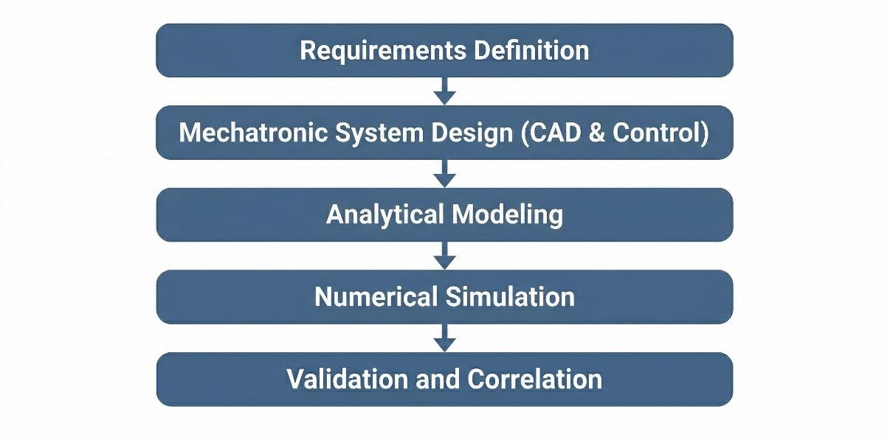
Figure 3- 1Design methodology flowchart showing the sequential phases from requirements

3.2 Design Requirements and Constraints
Design requirements derive from the target application (packaging of 500g granular salt), industrial standards for food packaging machinery, and operational constraints imposed by the VFFS integration context. Requirements are categorized as functional (what the system must do) and non-functional (how the system must perform) [2].

3.2.1 Target Output (PPM: Packs Per Minute) and Accuracy (±σ)
The production throughput requirement establishes fundamental constraints on the mechanical and control system design. For the target application of 500g salt packaging, the following performance specifications are established:
- Target Production Rate: 20 bags per minute (20 PPM)
- Package Weight: 500 grams net content
- Weight Accuracy: ±1.5% .
- Filling Time: Maximum 0.8 seconds per cycle
- Cycle Time: 3.0 seconds total (including forming and sealing)
The accuracy specification of ±1.5% aligns with OIML R87 international standards for prepackaged goods and represents typical industrial requirements for medium-value food products. Achieving this accuracy with volumetric dosing requires careful control of bulk density variation and precise angular positioning of the auger screw [3].
The filling time constraint of 0.8 seconds per cycle establishes the required auger rotational speed. Based on volumetric displacement calculations (detailed in Chapter 4), delivering 500g of salt requires approximately 4 revolutions of the auger. The required rotational speed is therefore:
$$N = (4 rev / 0.8 s) × 60 s/min = 300 RPM (nominal)$$
A design speed of 300 RPM is selected to provide margin for operational variation and to accommodate potential efficiency losses under adverse conditions.

3.2.2 Sanitary and Material Standards (e.g., AISI 304 Stainless Steel)
As a food packaging machine, all product-contact components must comply with applicable food safety regulations and hygienic design principles. Key requirements include:
Material Requirements:
- All product-contact surfaces: Food-grade stainless steel (AISI 304 minimum, AISI 316L preferred for salt applications)
- Surface finish: Ra < 0.8 μm for product-contact areas
- No toxic materials: Compliance with FDA 21 CFR and EU Regulation 1935/2004
Hygienic Design Requirements:
- Smooth, continuous welds with no crevices for bacterial harborage
- Self-draining surfaces with no standing liquid zones
- Quick-disconnect components for cleaning access
- No dead zones where product can accumulate and degrade
- Compatibility with Clean-Out-of-Place (COP) procedures
Choosing AISI 316L stainless steel for all salt contact components provides superior chloride corrosion resistance compared to AISI 304. The molybdenum content (2-3%) in 316L forms protective oxide layers that resist pitting in saline environments, but due to the unavailability of AISI 316L stainless steel in Yemen, AISI 304 stainless steel was chosen, which also meets health requirements and food safety regulations [4].
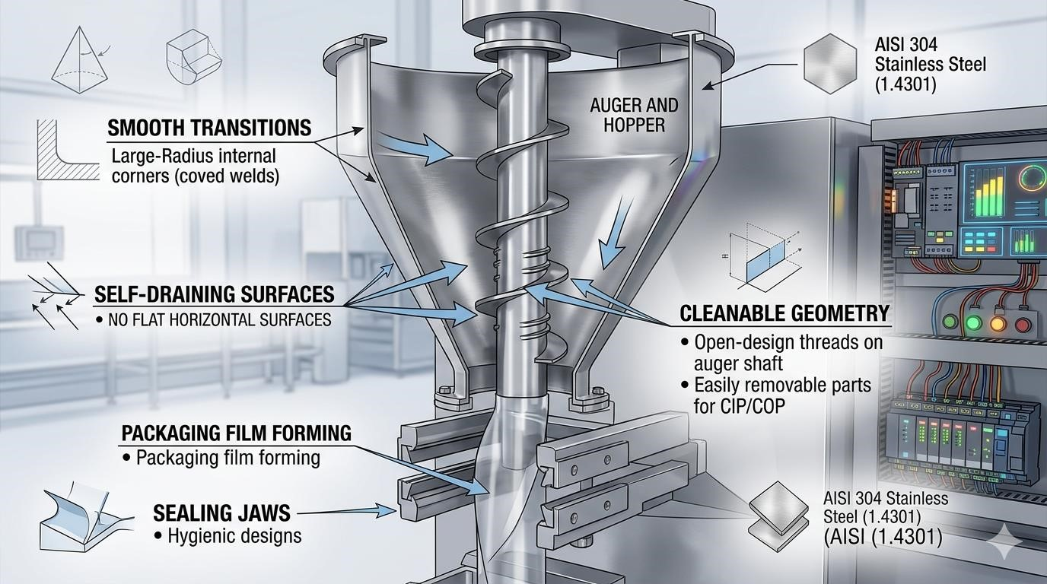
Figure 3- 2Hygienic design principles for food-contact components, showing smooth transitions, self

3.3 Conceptual Development
Conceptual development transforms abstract requirements into concrete system architecture through functional decomposition and concept selection. This section presents the functional breakdown of the VFFS auger machine and the rationale for key design decisions.

3.3.1 Functional Decomposition (Dosing System, Packaging & Sealing System.)
- Dosing System Architecture :
The Dosing system is decomposed into four primary functional subsystems, each addressing specific aspects of the material handling and dosing process:
- Hopper Subsystem:
The hopper provides temporary storage of bulk material and ensures consistent feeding of the auger. Key design considerations include:
• Capacity: 20 L=16 kg for salt.
• Dimensions: Total Height (H) 330 mm , Top Diameter (Dtop) 446 mm, Outlet Diameter (Dout) 65 mm, Wall Angle (from horizontal) 60° .
• Geometry: Conical bottom with wall angle exceeding the angle of repose to ensure mass flow
• Material: AISI 304 stainless steel with electropolished interior surface
The hopper design incorporates a steep wall angle of 60° relative to the horizontal, which exceeds both the angle of repose (30-35°) and the wall friction angle (15-25°) of salt. This design ensures mass flow rather than funnel flow, preventing stagnation zones and maintaining consistent bulk density at the auger inlet.
- Agitator System and Coaxial Drive Architecture Design:
- Agitator Subsystem:
The agitator prevents bridging and ratholing in the hopper while promoting consistent bulk density at the auger inlet. Design features include:
- Number of Blades: 2 (diametrically opposed at 180°)
- Dimensions: Upper Blade Position: 148.5 mm from top (45% of cone height), Lower Blade Position: 297 mm from top (90% of cone height), Blade Width: 60 mm , Blade Thickness: 8 mm
• Configuration: Counter-rotating paddle design sweeping the hopper periphery
• Speed: 30 RPM (independent drive from auger)
• Clearance: 3-5 mm from hopper walls to prevent interference
• Drive: DC motor .
The agitator performs three critical functions:
1. Bridge Breaking: Continuously destroys cohesive arches forming above the screw
2. Homogenization: Re-mixes fine and coarse particles to minimize segregation and stabilize bulk density
3. Force Feeding: Actively pushes powder toward the auger flights to ensure full screw filling in each revolution
- Agitator System and Coaxial Drive Architecture Design:
To ensure continuous mass flow and prevent bridging, the internal agitation system operates independently from the main auger screw. The design utilizes a highly specialized coaxial drive architecture that allows the central auger shaft (Blender Auger Long) to rotate at 300 RPM (CW) while the outer Blender Seat, which holds the Agitator / Blender blades, rotates simultaneously at 30 RPM (CCW).

This kinematic decoupling is achieved through a precision-engineered concentric assembly:
- Inner Transmission: The primary high-speed torque is transmitted through the Auger Shaft and the Blender Auger Long directly to the Auger Screw.
- Outer Transmission: The low-speed counter-rotation is driven by an independent motor housed in the Blender Motor Case. The torque is transmitted via a timing belt system utilizing an HTPA50S5M150-A-H40 driven pulley and a C-HTPA20S5M150-A-P15 drive pulley, which are connected to the Blender Seat
- Bearing Architecture and Mechanical Decoupling:
The fundamental challenge in this coaxial design is physically isolating the high-speed and low-speed rotational dynamics to prevent friction-induced torque transfer. This is resolved by an advanced bearing and sleeve configuration:
Inner Isolation (Shaft-to-Seat): Deep groove ball bearings (B6702ZZ and B6804ZZ) are press-fitted between the high-speed Blender Auger Long shaft and the intermediate Coupling Sleeve / Blender Seat. These bearings completely isolate the internal 300 RPM rotation from the external 30 RPM rotation.
Outer Support (Seat-to-Frame): The entire rotating agitator assembly is structurally supported by the Outer Bearing Seat, which is rigidly bolted to the Funnel Plate Seat and the Main Plate. Additional bearings (B6809ZZ and B6902ZZ) are placed between the Blender Seat and the Outer Bearing Seat, allowing the agitator to rotate smoothly relative to the stationary machine frame.
Axial Retention and Preload: To prevent any axial displacement or vibrations during the start-stop dosing cycles, precision locknuts (MUEN15 and MUEN45) are utilized. These locknuts secure the inner and outer bearing races, ensuring strict geometric alignment and preventing the tight radial clearance (1.5 mm) from deviating during operation.
Environmental Protection: All selected bearings feature double metal shields (ZZ designation). This is a critical design choice to prevent the highly abrasive and hygroscopic sodium chloride dust from penetrating the rolling elements, thereby extending the fatigue endurance of the mechanical assembly.
- Auger Subsystem:
The auger screw is the core dosing element, providing positive displacement metering of material. Key specifications include:
• Outer diameter: 60 mm
• Shaft diameter: 16 mm
• Pitch: 60 mm (square pitch configuration)
• Radial clearance: 1.5 mm maximum
• Material: AISI 304 stainless steel with electropolished flights
The auger geometry follows the square pitch configuration (pitch equal to outer diameter), which is optimal for free-flowing granular materials. This configuration provides stable flow with minimal particle segregation and predictable volumetric displacement.
- Discharge Nozzle and Spinner Plate:
The discharge mechanism controls material flow during and after the dosing cycle. The spinner plate provides flow cutoff when rotation stops, preventing dribble that would compromise weight accuracy. Design parameters include:
• Spinner plate diameter: 80 mm
• Clearance to funnel lip: 2-3 mm
• Operating speed: Synchronous with auger (300 RPM)
• Function: Centrifugal dispersion during rotation, angle-of-repose containment when stopped
The spinner plate operates on the principle of balance between centrifugal force and angle of repose. When the auger rotates, centrifugal force pushes salt particles radially outward through the gap between the plate and the funnel lip. Upon auger stop, centrifugal force vanishes, and the accumulated salt forms a "natural product dam" that prevents leakage without requiring complex mechanical valves.
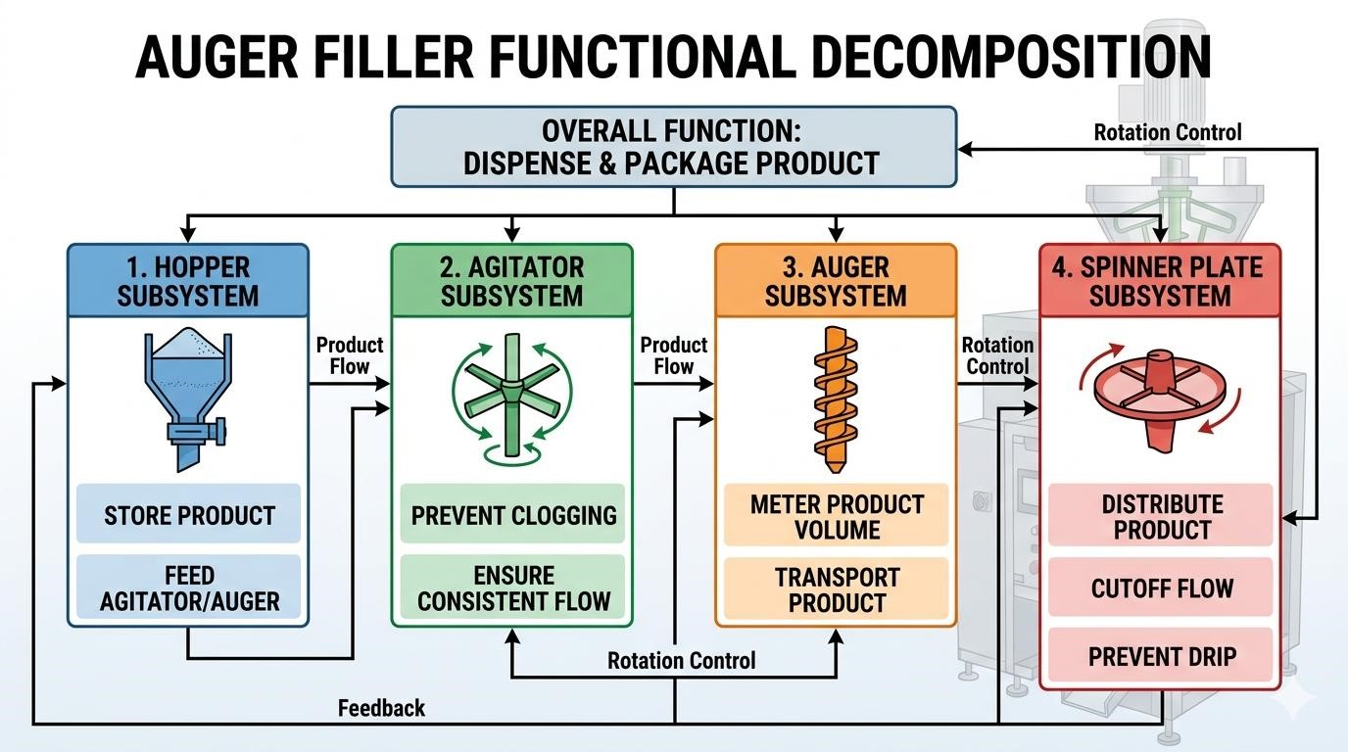
Figure 3- 3Functional decomposition diagram showing the four primary subsystems and their interactions.
2. Packaging and Sealing System Architecture:
The packaging subsystem transforms the planar thermoplastic film into a hermetically sealed pouch.
A. Forming Tube Subsystem:
The forming tube constitutes the core component of the VFFS system, facilitating the optimal folding of the film.
- Dimensions: External diameter of 83 mm (yielding a 120 mm bag width + 10 mm seal), internal diameter of 77 mm, and an overall length of 400 mm.
- Forming Collar: Engineered with a 25° angle for optimal film folding fluidity.
- Manufacturing Details: Constructed from AISI 304 stainless steel with a highly polished surface ( Ra ≤ 0.4 mμ) and a roundness tolerance of ±0.05 mm.
Figure 3.3: Forming tube and collar assembly, illustrating the 25° forming angle and the mounting flange
  - Sealing Mechanisms (Horizontal & Vertical):
Thermal integrity is paramount for hygroscopic materials like NaCl.
- Horizontal Sealing Jaws: These 220 mm long jaws create the transverse seals and sever the pouch. They apply 300–500 N of force and utilize a 300W cartridge heater. The 8 mm sealing surface is bifurcated into dual 3 mm lines with a central groove for a 0.5 mm cutting blade, featuring a cross-hatch pattern (0.2 mm depth) for optimal grip.
- Vertical Sealing Bars: A 400 mm bar operating at 140–160°C under 3 Bar of pneumatic pressure. It features a 10 mm sealing width and a 3 mm PTFE thermal insulation layer, adjustable horizontally by ±15 mm.
  - Film Handling and Pull Mechanism:
This system extracts film from the supply roll with controlled velocity, precision, and modulated tension.
- Film Unwinder & EPC: Equipped with a mechanical brake for tension modulation, a dancer arm sensor for real-time feedback, and an Edge Position Control (EPC) photoelectric sensor driving a corrective servo/stepper actuator to maintain accurate film tracking.
- Pull Belt Assembly: Utilizes counter-rotating nip rollers (80 mm diameter, 300 mm width) coated in 60 Shore A durometer silicone rubber. Driven by a 450–750W servo motor with a 1:10 reduction ratio, ensuring precise kinematic synchronization.

3.3.2 Selection of Actuation (Servo-driven vs. Induction)
The selection of motor technology for auger drive represents a critical design decision affecting precision, cost, and system complexity. Three primary options were evaluated: induction motor with clutch-brake, stepper motor, and servo motor [5].
Option 1: Induction Motor with Clutch-Brake
Traditional auger fillers employed induction motors running continuously with mechanical clutch-brake mechanisms to control auger rotation. While mechanically simple and cost-effective, this approach suffers from significant limitations:
- Poor positioning accuracy due to clutch engagement variability
- Mechanical wear requiring frequent maintenance
- Limited dynamic response (slow acceleration/deceleration)
- Inability to implement advanced motion profiles
Option 2: Stepper Motor
Stepper motors provide open-loop position control without feedback devices. While offering improved positioning compared to clutch-brake systems, stepper motors exhibit several disadvantages:
- Risk of missed steps under load, causing cumulative positioning errors
- Limited torque at high speeds
- Audible noise and vibration at certain speeds
- No verification of actual position achieved
Option 3: Servo Motor (Selected)
Servo motor systems combine high-performance brushless motors with closed-loop feedback control, offering superior performance for precision dosing applications. The selected Panasonic MINAS A6 AC servo motor provides:
- 23-bit absolute encoder (8,388,608 pulses per revolution)
- High dynamic response (acceleration to rated speed in <50 ms)
- Full torque available across entire speed range
- Electronic cam and motion profile capability
- Real-time position verification and error correction
The servo motor is coupled to a 20:1 planetary gearbox, providing output speed of 300 RPM at the auger while multiplying motor torque by the gear ratio (minus efficiency losses). The planetary configuration offers high torque density, low backlash (<3 arcminutes), and efficient power transmission [6].
The selection of servo motor technology is justified by the following quantitative analysis:
Positioning Resolution:
The 23-bit encoder provides angular resolution of:
𝜃_𝑟𝑒𝑠 = 360° / 2^23 = 360° / 8,388,608 = 4.29 × 10^ − 5 𝑑𝑒𝑔𝑟𝑒𝑒𝑠 𝑝𝑒𝑟 𝑐𝑜𝑢𝑛𝑡
For a 500g dose requiring 4 revolutions, the positioning error contribution to weight variation is:
𝐸𝑟𝑟𝑜𝑟 = (4.29 × 10^ − 5°) × (4 𝑟𝑒𝑣) × (500𝑔 / 360°) = 2.38 × 10^ − 4 𝑔
This negligible error confirms that servo positioning accuracy exceeds the requirements for ±1.5% dosing accuracy.
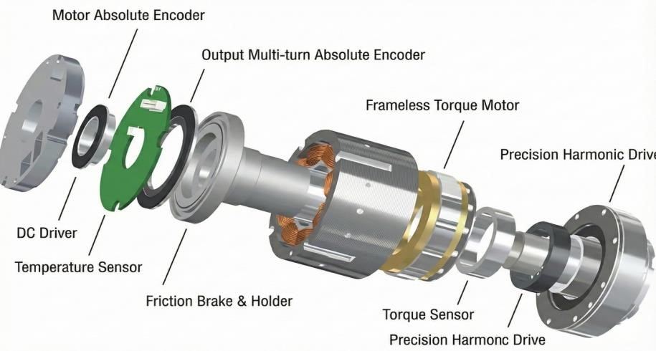
Figure 3- 4Servo motor and planetary gearbox assembly showing encoder feedback, drive

3.4 Final Mechanical Architecture (CAD)
The final mechanical design integrates all functional subsystems into a single, optimized unit that is easier to manufacture and maintain. This section presents the machine's mechanical design in the SolidWorks software.

3.4.1 Dosing System CAD:

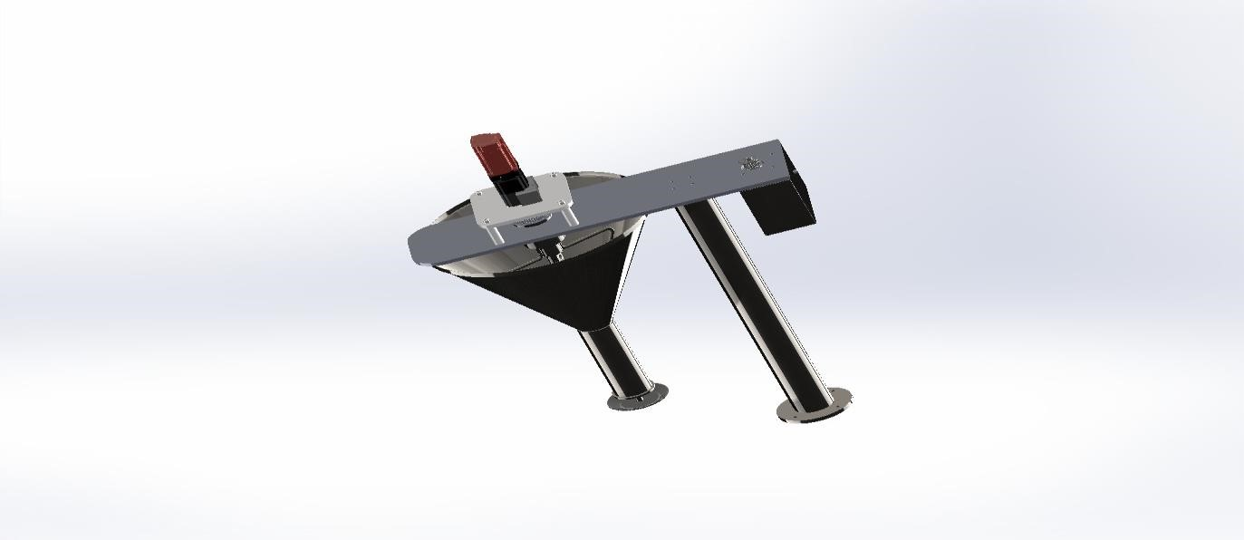
Figure 3- 5Dosing System CAD
- Final Hopper Dimensions:
Table 3- 1Final Hopper Design Dimensions
Parameter | Value
Total Height (H) | 330 mm
Top Diameter (Dtop) | 446 mm
Outlet Diameter (Dout) | 65 mm
Wall Angle (from horizontal) | 60°
Wall Angle (from vertical) | 30°
Capacity | 20 L
Material | AISI 304 stainless steel

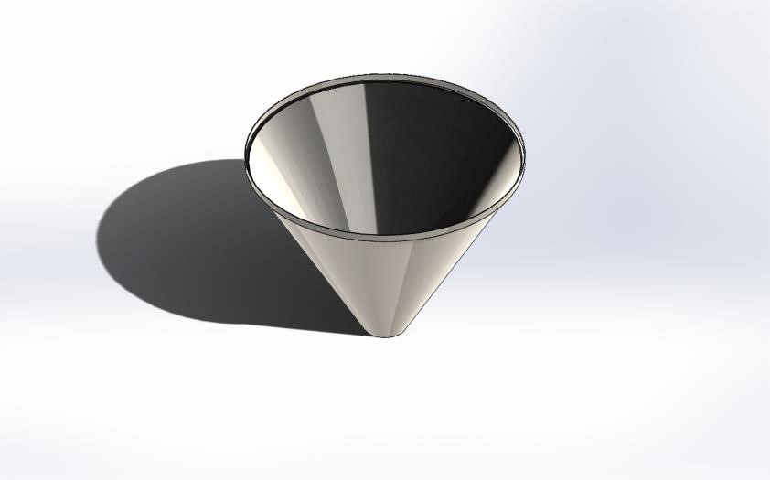
Figure 3- 6Hopper CAD
- Final Blade Configuration
- Number of Blades: 2 (diametrically opposed at 180°)
- Blade Type: Skewed paddle with 25° rake angle
- Blade Width: 60 mm
- Blade Thickness: 8 mm
- Upper Blade Position: 148.5 mm from top (45% of hopper height)
- Lower Blade Position: 297 mm from top (90% of hopper height)
- • Material: AISI 304 stainless steel
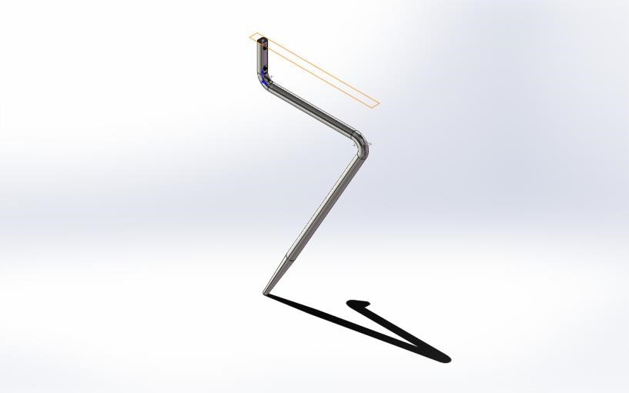
Figure 3- 7Long Blade CAD
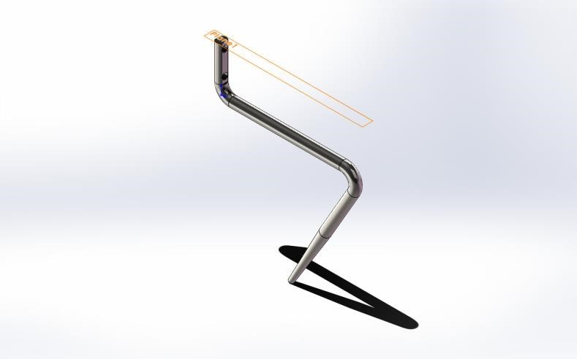
Figure 3- 8Short Blade CAD

- Final Agitator System and Coaxial Drive Architecture Design:
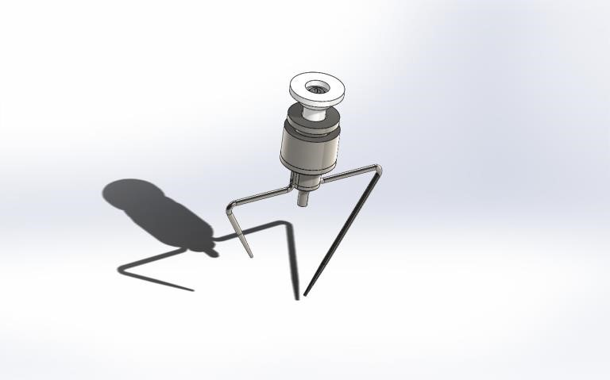
Figure 3- 9Agitator System CAD

- Final Auger Screw Design:
The auger screw and surrounding funnel assembly constitute the core dosing mechanism. The design employs a straight (non-tapered) auger with square pitch geometry optimized for free-flowing granular materials.
Auger Screw Specifications:
- Outer diameter (D): 60 mm
- Shaft diameter (Ds): 16 mm
- Pitch (P): 60 mm
- Flight thickness: 3 mm
- Number of effective pitches: 4.5
- Overall length: 320 mm
- Material: AISI 304 stainless steel
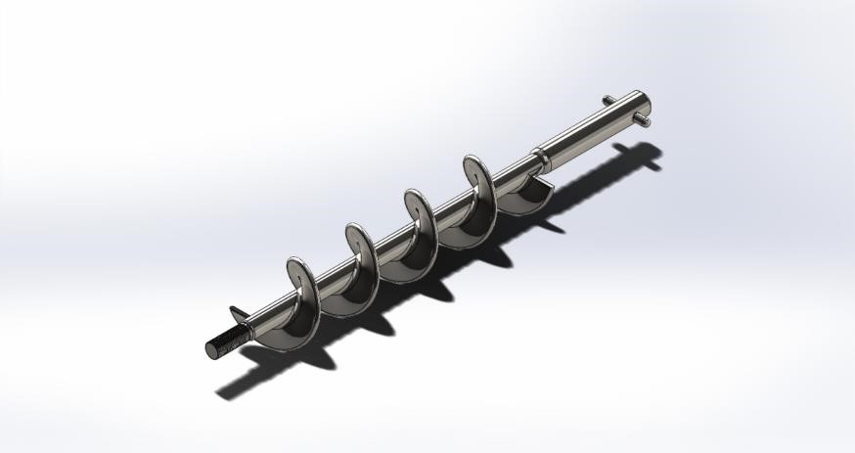
Figure 3- 10Auger CAD

5. Final Spinner plate :
• diameter: 80 mm

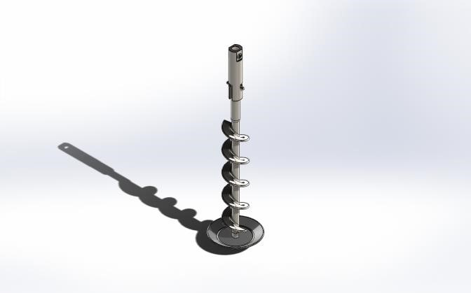
Figure 3- 11Plate& Auger CAD
6. Funnel Assembly Specifications:
- Inner diameter: 63 mm (providing 1.5 mm radial clearance)
- Length: 150 mm
- Material: AISI 304 stainless steel
The radial clearance of 1.5 mm between auger flight tip and funnel wall represents a compromise between dosing accuracy and manufacturing tolerance. Smaller clearance reduces backflow but increases risk of metal-to-metal contact due to thermal expansion or mechanical deflection. The 1.5 mm specification provides adequate margin while maintaining acceptable volumetric efficiency [7].
The clearance specification is validated through thermal expansion analysis:
$$ΔL = α × L × ΔT$$
Where α = 16.0 × 10^-6 /°C (thermal expansion coefficient for AISI 304L)
L = 280 mm (auger length)
ΔT = 42 - 25 = 17°C (maximum temperature rise)
𝛥𝐿 = 16.0 × 10^ − 6 × 280 × 17 = 0.076 𝑚𝑚
The thermal expansion of 0.076 mm represents only 5% of the radial clearance, confirming adequate margin for thermal effects.
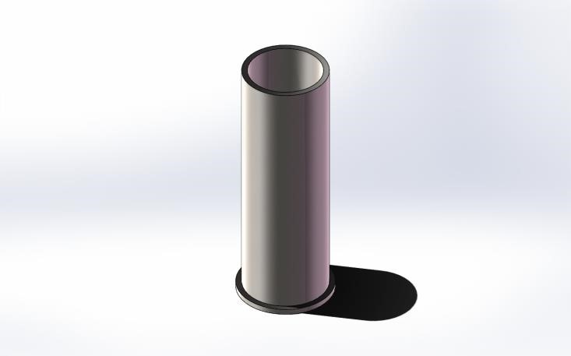
Figure 3- 12CAD model of funnel assembly

3.4.2 Packaging and Sealing System CAD:
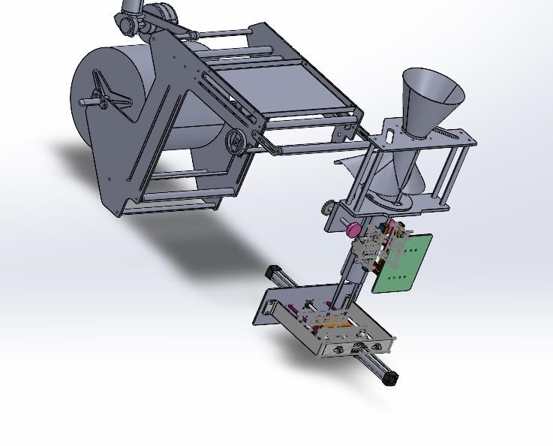
Figure 3- 13Packaging and Sealing System CAD
- Final Forming Tube Design:
  - External diameter: 83 mm (for producing 120 mm width bags + 10 mm seal)
  - Internal diameter: 77 mm (wall thickness 3 mm)
  - Overall length: 400 mm
  - Forming zone length: 300 mm
  - Collar angle: 25° for optimal film folding fluidity
  - SolidWorks Design Procedure:
1. Primary Sketch: External circle Ø83 mm, Internal circle Ø78 mm, Extrude
400 mm
- Detail Addition: Conical collar at 25° (Revolve Feature), Mounting holes
4×M8, Upper flange 10 mm
- Finishing: Fillet radius 2 mm, Mirror Polish, Apply material SS 304L
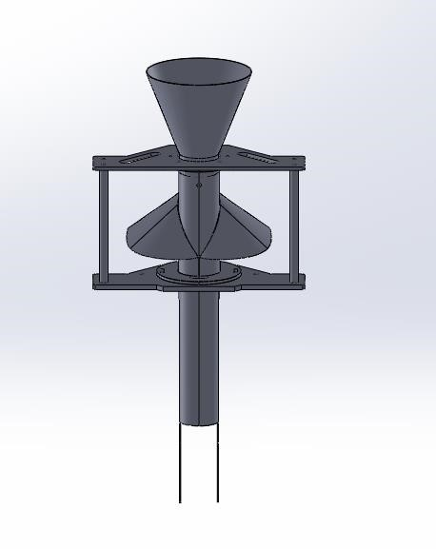
Figure 3- 14 Forming Tube CAD
- Final Horizontal Sealing Jaws Design:
  - Jaw length: 220 mm
  - Sealing surface width: 8 mm
  - (bifurcated into dual 3 mm sealing lines with 2 mm central groove)
  - Stroke distance: 25 mm
  - Sealing force: 300–500 N
  - Heating system: 300W cartridge heating element
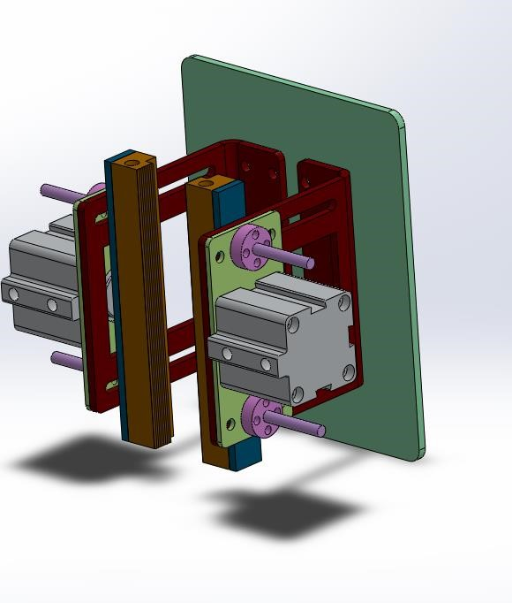
Figure3. 1Horizontal Sealing Jaws CAD
Figure 3- 15 Horizontal Sealing Jaws CAD
- Final Vertical Sealing Bars Design:
- Bar length: 400 mm
- Sealing surface width: 10 mm
- Pressure range: 3 Bar
- Operating temperature: 140–160°C
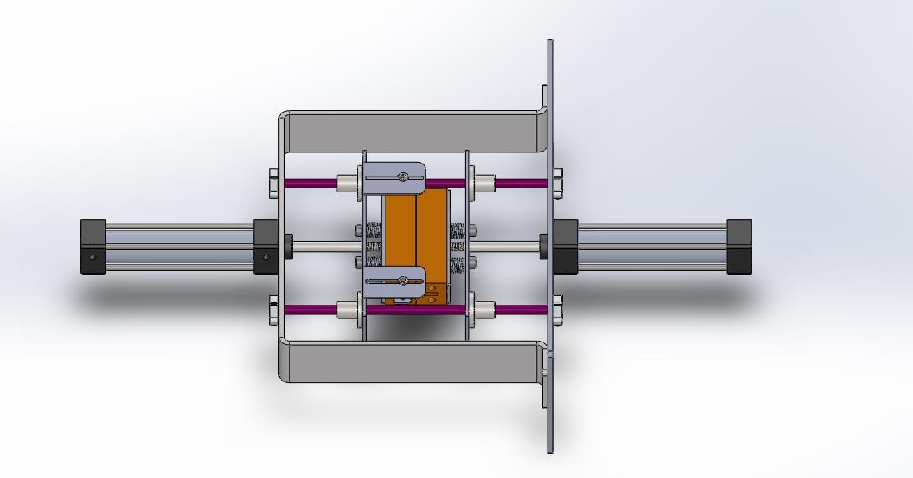
Figure 3- 16 Vertical Sealing Bars CAD
4. Final Film Pull Mechanism Design:
- Mechanism type: Counter-rotating nip rollers
- Roller diameter: 80 mm
- Roller width: 300 mm
- Motor: 450–750W servo motor
- Reduction ratio: 1:10
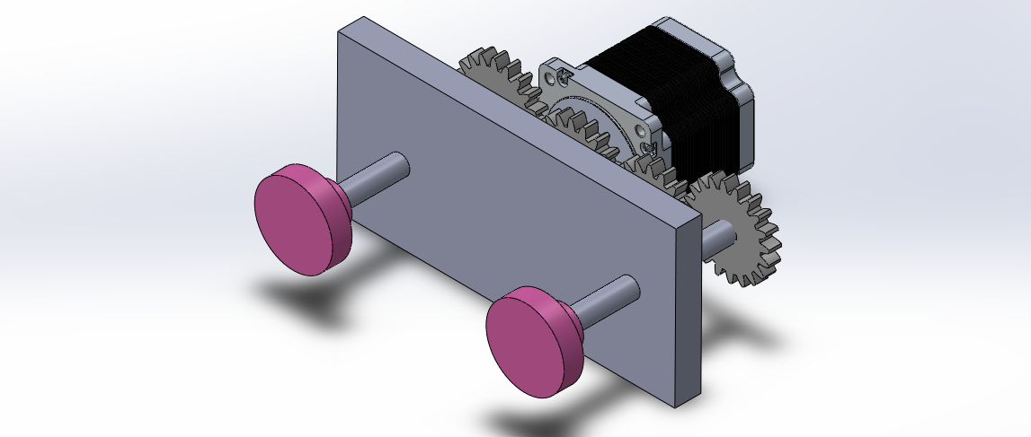
Figure 3- 17 Final pull Mechanism

3.4.2 Drive Train and Power Transmission
The drive train transmits power from the servo motor to the auger shaft while providing speed reduction and torque multiplication. The selected configuration comprises:
Prime Mover: Panasonic MINAS A6 AC Servo Motor
- Model: MSMF042L1U
- Rated power: 400W
- Rated torque: 1.27 𝑁 · 𝑚
- Maximum torque: 3.82 𝑁 · 𝑚
- Rated speed: 3000 RPM
- Max. rotational speed : 6000 RPM
- Encoder resolution: 23-bit absolute (8,388,608 pulses/rev)
Gearbox: 𝑁𝑒𝑢𝑔𝑎𝑟𝑡 PLE Planetary Gearbox
- Model: PLE 060
- Reduction ratio: 20:1
- Output torque (nominal): 25 𝑁 · 𝑚
- Output torque (maximum): 40 𝑁 · 𝑚
- Backlash: <3 arcminutes
- Efficiency: >97%
Power Transmission Calculations:
The effective output torque at the auger shaft is calculated as:
$$T_out = T_motor × i × η = 1.27 N · m × 20 × 0.97 = 24.6 N · m$$
Where 𝑖 is the gear ratio and η is the gearbox efficiency. This output torque provides substantial margin above the calculated requirement of approximately 18-20 N·m under worst-case conditions, ensuring reliable startup even with compacted material [8].
The power transmission efficiency is validated through energy balance:
$$P_in = 400W (motor rated power)$$
𝑃_𝑜𝑢𝑡 = 𝑇_𝑜𝑢𝑡 × 𝜔 = 24.6 𝑁 · 𝑚 × (2𝜋 × 135/60) 𝑟𝑎𝑑/𝑠 = 347 𝑊
𝜂_𝑠𝑦𝑠𝑡𝑒𝑚 = 𝑃_𝑜𝑢𝑡 / 𝑃_𝑖𝑛 = 347 / 400 = 86.8%
The system efficiency of 86.8% accounts for gearbox losses (3%), bearing friction (5%), and auger mechanical losses (5%).

3.5 Mechatronic System Architecture
The core of the control system lies in transforming the mechanical structure of the VFFS machine into an intelligent, deterministic system capable of synchronizing mechanical and thermal operations at high speeds with absolute reliability [14]. To ensure consistent seal quality during continuous operation, the thermal control subsystem was designed to maintain the sealing jaws at 150°C with a high precision of ±1°C [18]. Because the sealing process is heavily influenced by thermal inertia, heat losses, and continuous environmental fluctuations, a Model-Based Design (MBD) methodology was adopted to tune system performance, superseding traditional empirical trial-and-error methods.

3.5.1 Distributed Processing Strategy (Master-Slave Topology)
To mitigate the computational bottlenecks arising from simultaneous graphical rendering and thermo-kinetic control, a distributed control architecture was engineered utilizing two ESP32 microcontrollers [16]:
- Master Node (Machine Controller): Acts as the "executive brain" of the machine. It is dedicated to executing the thermal PID algorithm, polling sensors, and generating motor pulses. This isolation guarantees that the machine's stability remains immune to any latency introduced by the user interface, fulfilling the requirements for rapid response and the elimination of steady-state error [14, 15].
- Slave Node (HMI Controller): Functions as a dedicated graphical processor for the Human-Machine Interface (HMI), maintaining communication with the Master Node via a high-speed UART protocol [16, 20].
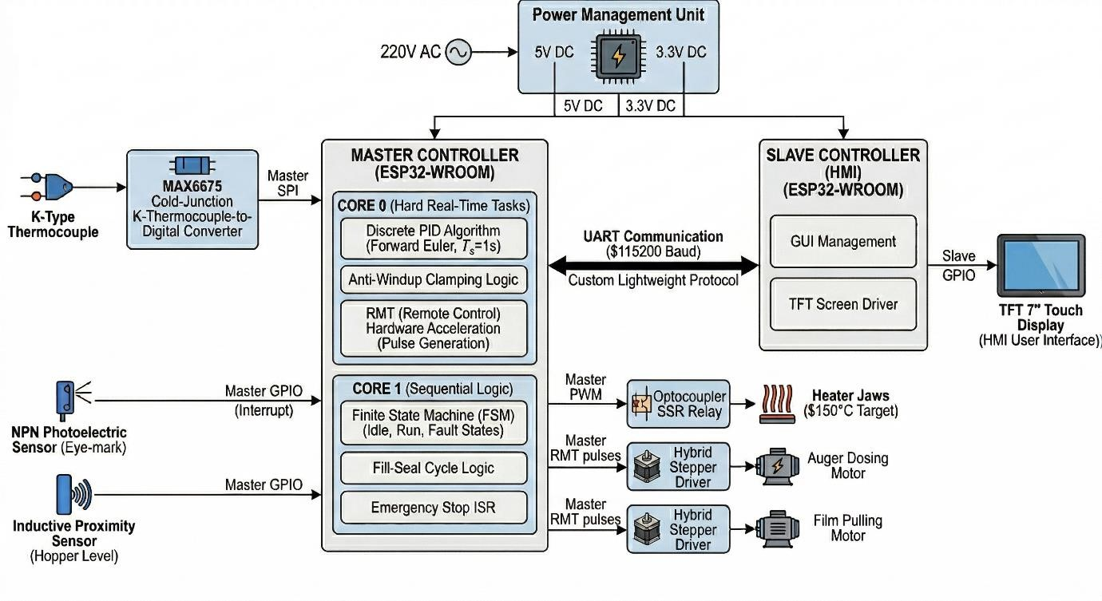
Figure 3- 18 General control system architecture block diagram showing the Master ESP32, Slave ESP32

3.5.2 Operating System and Task Allocation (FreeRTOS & Dual-Core Strategy)

To achieve maximum stability, the dual-core processor of the ESP32 was leveraged via the FreeRTOS operating system to facilitate true multitasking [16, 17]. The core concept hinges on isolating precise hardware operations from application logic delays. Tasks were allocated according to strict priorities as follows:
- Core 0 (Hardware & Time-Critical Tasks):
  - Fault Handler (Priority 5): Provides an instant response to Emergency Stop (E-STOP) interrupts, bypassing all software delays [17].
  - Motion Controller (Priority 4): Manages precise stepper motor control and pulse generation via the hardware RMT peripheral [16].
  - Thermal PID Controller (Priority 3): Executes the PID algorithm with a precise sample time of 1 second, an optimal duration for systems exhibiting significant thermal inertia [15, 19]. The controller's output is not utilized as a direct analog signal; instead, it is converted into Time-Proportional Control to drive the Solid State Relay (SSR) [15].
- Core 1 (Application Logic & UI):
  - Control Loop (Priority 2): Manages the sequential logic of the machine via a Finite State Machine (FSM), including operational sequences and execution delays [17].
  - HMI (Priority 1): Handles button inputs, updates system status, and communicates with the Slave Node [20].

3.5.3 Mathematical Modeling and Thermal PID Controller
The thermal control system of the sealing jaws is one of the most critical subsystems required to guarantee hermetic bag seals. A Model-Based Design (MBD) methodology was employed through the following procedural steps: A. System Identification:
Based on the physical properties of the stainless-steel jaws (approximated as a 1 kgthermal mass) and accounting for conductive and convective heat losses, the system was dynamically modeled within the MATLAB/Simscape environment. By subjecting the open-loop model to a step response test, a first-order plus dead time (FOPDT) transfer function was derived:

$$G(s) = \backslash frac\{218. 2\}\{272. 7s + 1\} e^\{-2s\} B.$$

PID Controller Tuning:
Utilizing the MATLAB PID Tuner application, optimal parameters for a discrete PID controller were established. These parameters ensure thermal stability at the 150°Csetpoint, characterized by a maximum overshoot of less than $1\%$ and a steady-state error tolerance of 1°C:
- Proportional (P): 1.0
- Integral (I): 0.004
- Derivative (D): 0.5

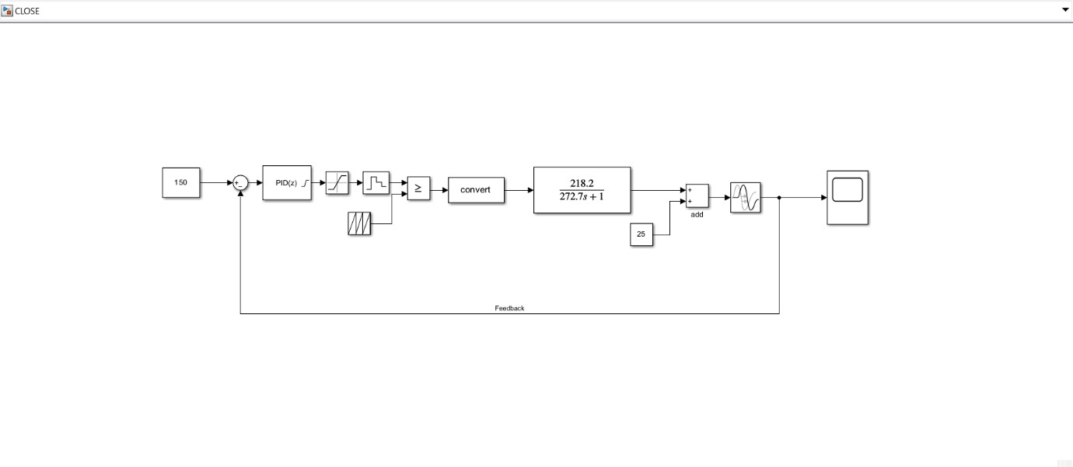
Figure 3- 19 Closed-loop thermal control system modeling in Simulink/Simscape.

3.5.3 Hybrid Motion Control Logic
In addition to thermal stability, the system demands stringent kinematic precision to ensure consistent productivity [21]. A two-phase motion strategy was innovated for the stepper motors:
- Blind Zone Phase: The packaging film is pulled at maximum speed utilizing the hardware RMT peripheral. This generates highly precise waveforms without consuming CPU cycles, thereby maximizing system efficiency [16].
- Search Zone Phase: The system transitions into a precise software-stepping mode to poll the registration "eye-mark" sensor after every individual microstep, ensuring the alignment of the bag with the cutting blade with micrometric accuracy [18].

3.5.4 Software Architecture of the Finite State Machine (FSM)
The operational firmware was structured based on a Finite State Machine (FSM) model, providing deterministic stability when transitioning between packaging phases [21]:
- Idle State: Actively monitors the sealing jaw temperature and the salt level within the hopper.
- Parallel Pull & Fill State: Concurrently executes the film pulling and auger rotation to minimize the overall cycle time [21].
- Seal & Cut State: Actuates the pneumatic valves based on precisely defined timing intervals.

3.5.5 Industrial Isolation and Signal Integrity
Given the severe electromagnetic noise generated by the heaters and motors, the hardware interface was designed to ensure the highest degree of reliability:
- Galvanic Isolation: Optocouplers are utilized to separate the sensitive 3.3V control circuits from the 24V motors and pneumatic valves.
- Zero-Crossing Thermal Control: The implementation of a Solid State Relay (SSR) featuring Zero-Crossing prevents electrical grid interference when applying the time-proportional control frequencies generated by the PID controller.

3.5.6 Industrial Reliability and Protection Protocols (Fail-Safe Logic)
The control system is engineered to withstand continuous thermal and mechanical disturbances without inducing undesirable oscillations or ringing [14, 15]. To guarantee this, stringent software and hardware protection layers were integrated:
- Emergency Stop (E-Stop) System: The emergency button is hardwired to a hardware Interrupt Service Routine (ISR) that preempts all system tasks, immediately halting motor pulses and de-energizing the SSR relays [17].
- Integrator Anti-Windup Clamping: A saturation algorithm was embedded to prevent the excessive accumulation of integral error in the PID equation during the cold-boot heating phase. Simulation results of the closed-loop step response demonstrated the efficiency of this algorithm, achieving a settling time of 225.3 seconds with a negligible, near-zero overshoot of 0.3041%. The peak temperature reached only 150.45°C, confirming absolute system stability at the 150°C setpoint [14, 15].
- Sensor Failure Cutoff: The system immediately cuts power to the heaters if the SPI bus reports a failure in reading the thermocouple data.
- Over-Temperature Protection: A hard ceiling for temperature was programmed, which completely shuts down the system if exceeded, ensuring the Teflon tape does not burn and the sealing jaws are protected from thermal damage.

3.7 Summary of Design Specifications
Table 3.2 summarizes the key design specifications for the VFFS auger filling system:

Table 3- 2 Summary of Design Specifications
 | Parameter | Specification |  |  | Unit
 | Production Rate | 20 |  |  | PPM
 | Package Weight | 500 |  |  | g
 | Weight Accuracy | ±1.5 |  |  | %
 | Filling Time | 2.0 |  |  | s
 | Auger Diameter | 60 |  |  | mm
 | Auger Pitch | 60 |  |  | mm
 | Shaft Diameter | 16 |  |  | mm
 | Radial Clearance | 1.5 |  |  | mm
Operating Speed |  |  | 300 | RPM
Motor Power |  |  | 400 | W
Gear Ratio |  |  | 20:1 | -
Hopper Capacity |  |  | 20 | L
Agitator Speed |  |  | 30 | RPM
Material |  |  | AISI 304 | -
Surface Finish |  |  | Ra < 0.8 | μm
The design specifications presented in this chapter provide the foundation for the analytical modeling and numerical simulation presented in subsequent chapters. The integration of mechanical design, control system architecture, and VFFS compatibility ensures that the system meets all target performance requirements.

3.6 Electronic Control System Design

3.6.1 System Architecture Overview
The electronic control system for the Vertical Form-Fill-Seal (VFFS) packaging machine is designed as a three-layer hierarchical architecture to ensure reliable operation in industrial environments. This architecture separates logic control, power interfacing, and high-power actuation to protect sensitive components from electrical noise and transients.
The first layer comprises the main controller (ESP32 microcontroller) operating at 3.3V DC, handling all computational tasks, sensor data acquisition, and communication protocols. The second layer consists of power interface modules including stepper motor drivers (A4988), Darlington transistor arrays (TIP122) for solenoid control, and solid-state relays for heating elements. These modules translate low-voltage logic signals into power signals capable of driving actuators. The third layer contains the high-power loads including stepper motors, pneumatic solenoid valves, and resistive heating elements operating at 12V-24V DC and 220V AC.
This layered approach provides galvanic isolation between the sensitive microcontroller and the noisy industrial power environment, ensuring signal integrity and system longevity.

3.6.2 Signal Isolation and Conditioning

3.6.2.1 Optical Isolation Using PC817
Industrial packaging machinery generates significant electromagnetic interference (EMI) from motor switching, solenoid actuation, and heater cycling. To protect the ESP32 from these disturbances, optical isolation is implemented for all sensor inputs using PC817 optocouplers.
The PC817 provides 5kV isolation between input and output sides, with a Current Transfer Ratio (CTR) ranging from 50% to 600%. The input side operates at 5V with a series current-limiting resistor, while the output side interfaces with the 3.3V logic of the ESP32.


Figure 3- 20 PC817 Optocoupler
As you see in Figure 3.1 Optical isolation circuit using PC817 optocoupler
The input current is calculated to ensure reliable LED operation without excessive power dissipation:

$$IF = (Vsupply - VF_LED) / Rinput$$
$$IF = (5V - 1.2V) / 220 Ohm$$
$$IF = 3.8V / 220 Ohm IF = 0.0173 A = 17.3 mA$$
Where:
$$IF = Forward current through LED (17.3 mA)$$
$$Vsupply = Supply voltage (5V)$$
$$VF_LED = LED forward voltage drop (1.2V)$$
$$Rinput = Current limiting resistor (220 Ohm)$$
This current provides sufficient illumination for reliable phototransistor activation while maintaining LED longevity. The 10k Ohm pull-up resistor on the output side ensures defined logic levels, providing approximately 0.33mA collector current when the transistor saturates, yielding a low logic level below 0.3V.
Table 3- 3 Operating parameters for PC817 optocoupler in sensor interface applications
$$Parameter$$ |  | $$Symbol$$ |  | $$Value$$ |  | $$Unit$$ |  | $$Notes$$
 | $$Isolation Voltage$$ |  | $$V\backslash _ISO$$ |  | $$5000$$ |  | $$V$$  $$mA$$ | $$Between input and output$$
 | $$Forward Current$$ |  | $$I\backslash _F$$ |  | $$17.3$$ |  | $$V$$  $$mA$$ | $$Calculated for LED operation$$
$$Current Transfer R$$ |  | $$atio CTR$$ |  | $$100$$ |  | $$\%$$ |  | $$Typical value at 25 deg C$$
$$Output Pull-up Resi$$ |  | $$stor R\backslash _pull$$ |  | $$up 10$$ |  | $$kOhm$$ |  | $$Ensures defined logic high$$
$$Response Time$$ |  | $$t\backslash _r$$ |  | $$18$$ |  | $$Us S$$ |  | $$uitable for industrial control$$
$$Collector Current$$ |  | $$I\backslash _C$$ |  | $$0.33$$ |  | $$mA At$$ |  | $$saturation, V\backslash _CE approx 0.2V$$
As you see in Table 3.1 Operating parameters for PC817 optocoupler in sensor interface applications, showing calculated values for current limiting and pull-up resistors to ensure reliable signal transmission with 3.3V logic compatibility.

3.6.2.2 Sensor Interface Circuits
Two primary sensors require optical isolation: the Eye Mark sensor for film registration and the Hopper Level sensor for salt quantity monitoring.
The Eye Mark sensor interface utilizes GPIO39 on the ESP32, with the optocoupler output configured as active-low. When the sensor detects the registration mark on the packaging film, the phototransistor conducts, pulling GPIO39 to logic low. This configuration provides noise immunity for the critical film positioning function.
The Hopper Level sensor employs GPIO35 with identical isolation circuitry. This sensor prevents dry-running of the auger motor by detecting low salt levels, protecting mechanical components from damage.

3.6.3 Temperature Measurement System

3.6.3.1 MAX6675 Thermocouple Interface
Precise temperature control is essential for heat-sealing operations in salt packaging. The system employs Type-K thermocouples interfaced with MAX6675 cold-junctioncompensated thermocouple-to-digital converters. This integrated circuit eliminates the need for analog signal conditioning by providing direct digital temperature readings via Serial Peripheral Interface (SPI) protocol.
The MAX6675 operates with 12-bit resolution (0.25 deg C per count) over a range of 0 deg C to 1024 deg C, sufficient for sealing jaw applications typically operating at 150-250 deg C. Cold-junction compensation is performed internally, correcting for temperature variations at the connection terminals.
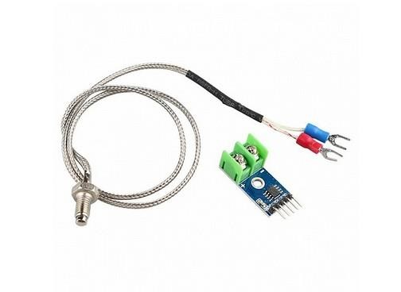
Figure 3- 21MAX6675 SPI
As you see in Figure 3.21 Oscilloscope capture of SPI communication between ESP32 and MAX6675 temperature converter, showing clock signal (SCK, 100 kHz), chip select activation (CS), and serial data output (SO) with 16-bit temperature data frame.

The SPI interface connections are configured as follows:
Table 3- 4 MAX6675 SPI Interface Pin Assignment
MAX6675 Pin |  | ESP32 GPIO |  | Function |  | Description
SCK |  | GPIO18 |  | Serial Clock |  | Synchronization signal for data transfer
SO |  | GPIO19 |  | Serial Output |  | Temperature data from MAX6675 to  ESP32
CS (Vertical) |  | GPIO22 |  | Chip Select 1 |  | Selects vertical sealing jaw thermocouple
CS (Horizontal) |  |  | GPIO21 | Chip Select 2 | Selects horizontal sealing jaw thermocouple
VCC |  |  | 3.30V | Power Supply | Logic supply voltage
GND |  |  | GND | Ground | Common reference
As you see in Table 3.4 SPI bus pin assignment for dual MAX6675 temperature measurement system, utilizing shared clock and data lines with individual chip select signals for independent reading of vertical and horizontal sealing jaw temperatures.
The temperature calculation from raw SPI data follows the manufacturer's specification: T_Celsius = (Raw_Data >> 3) / 4
Where:
T_Celsius = Temperature in degrees Celsius
Raw_Data = 16-bit value read from MAX6675
3 = Right shift by 3 bits (removes status flags)
/ 4 = Division by 4 (accounts for 0.25 deg C resolution)

3.6.4 Power Actuator Drivers

3.6.4.1 Solenoid Valve Drivers (TIP122)
Pneumatic actuation for the cutting knife and sealing jaws requires driving inductive loads (solenoid coils) from 3.3V logic signals. The TIP122 Darlington pair transistor is selected for this application due to its high current gain (hFE >= 1000) and ability to switch currents up to 5A.
The Darlington configuration provides two-stage current amplification, allowing the ESP32 GPIO (maximum 12mA source current) to control solenoids drawing 0.5-1A at 24V DC.

Figure 3- 22 TIP122
As you see in Figure 3.3 TIP122 Darlington transistor solenoid driver circuit

Base resistor calculation ensures sufficient drive current for saturation:
R_base = (V_GPIO - V_BE_total) / I_B
Where:
R_base = Base resistor value (Ohm)
V_GPIO = GPIO output voltage (3.3V)
V_BE_total = Total base-emitter voltage drop (1.4V)
I_B = Required base current (A)
The base current is calculated with safety factor:
I_B = I_C / (hFE x SF)
I_B = 1A / (1000 x 1.5)
I_B = 1A / 1500 I_B = 0.00067 A = 0.67 mA
Where:
I_B = Base current (A)
I_C = Collector current (1A, solenoid nominal current) hFE = Current gain (1000)
SF = Safety factor (1.5)
Yielding:
R_base = (3.3V - 1.4V) / 0.67 mA
R_base = 1.9V / 0.00067 A
R_base = 2836 Ohm = 2.8 kOhm

A standard value of 1 kOhm is selected to provide adequate margin while protecting the ESP32 GPIO from overcurrent conditions.
Table 3- 5TIP122 Solenoid Driver Operating Parameters
$$Parameter$$ | $$Symbol$$ | $$Value$$ | $$Unit$$ | $$Calculation/Notes$$
$$Collector Current$$ | $$I\backslash _C$$ | $$1.0$$ | $$A$$ | $$Solenoid nominal current$$
$$Current Gain$$ | $$hFE$$ | $$1000$$ | $$-$$ | $$Minimum Darlington gain$$
$$Safety Factor$$ | $$SF$$ | $$1.5$$ | $$-$$ | $$Ensures deep saturation$$
$$Base Current$$ | $$I\backslash _B$$ | $$0.67$$ | $$mA$$ | $$I\backslash _C / (hFE x SF)$$
$$Base Resistor$$ | $$R\backslash _base$$ | $$1.0$$ | $$kOhm$$ | $$Standard value with margin$$
$$Saturation Voltage$$ | $$V\backslash _CE\backslash _sat$$ | $$0.2$$ | $$V$$ | $$Typical at 1A collector current$$
$$Power$$  $$Dissipation$$ | $$P\backslash _D$$ | $$0.2$$ | $$W$$ | $$I\backslash _C x V\backslash _CE\backslash _sat$$

Table 3.5 Caption: Operating parameters for TIP122 Darlington driver in solenoid valve control application, showing calculated base current with safety factor and resulting power dissipation requiring minimal heatsinking.
Critical to reliable operation is the flyback diode (1N4007) placed in anti-parallel with each solenoid coil. When the transistor switches off, the collapsing magnetic field generates a voltage spike (back-EMF) potentially exceeding 100V. The diode provides a recirculation path for this energy, clamping the voltage at approximately 0.7V and protecting the transistor from avalanche breakdown.

3.6.4.2 Stepper Motor Drivers (A4988)
Precise film feeding and auger metering require stepper motor control with microstepping capability. The A4988 stepper motor driver provides up to 1/16 microstepping, translating 200 full steps per revolution into 3200 microsteps for smooth motion and accurate positioning.
The A4988 incorporates internal current regulation, allowing motor current to be set via a sense resistor and reference voltage. This feature enables torque optimization while preventing motor overheating during continuous operation.

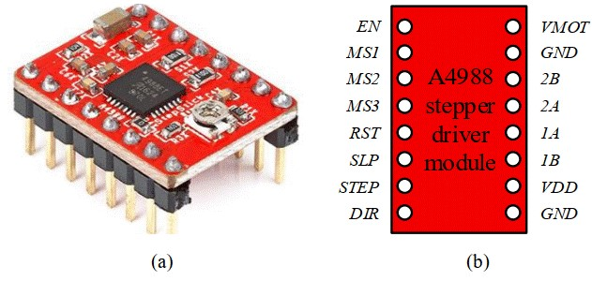
Figure 3- 23A4988 Stepper Driver Interface

As you see in Figure 3.23 A4988 stepper motor driver interface showing STEP/DIR/ENABLE connections .
Current limiting is essential for proper operation. The reference voltage and sense resistor determine the chopping current:
$$I_chop = V_ref / (8 x R_sense)$$
For the selected sense resistor of 43 mOhm and desired current of 1.5A:
$$V_ref = I_chop x 8 x R_sense$$
$$V_ref = 1.5A x 8 x 0.043 Ohm$$
$$V_ref = 1.5 x 8 x 0.043$$
$$V_ref = 0.516 V$$

This reference voltage is set via the onboard potentiometer on the A4988 module.

Table 3- 6 A4988 Stepper Driver Configuration
Parameter | Film Feed Motor | Auger Motor | Unit | Notes
STEP Pin | GPIO32 | GPIO25 | - | Step pulse input
DIR Pin | GPIO33 | GPIO26 | - | Direction control
ENABLE Pin | GPIO14 | GPIO27 | - | Active-low enable
Current Limit | 1.5 | 1.5 | A | Per phase
Sense Resistor | 43 | 43 | mOhm | Standard value
Reference Voltage | 0.516 | 0.516 | V | Set by trimpot
Microstepping | 1.0/16 | 1.0/16 | - | 3200 steps/revolution
Pull-down Resistor | 100 | 100 | kOhm | Ensures disabled at startup

Table 3.6 Caption: A4988 stepper driver configuration parameters for film feeding and auger metering systems, showing identical current settings with dedicated GPIO assignments and pull-down resistors for safe startup state.
The ENABLE pins incorporate 100 kOhm pull-down resistors to ensure motors remain deenergized during ESP32 boot-up, preventing uncontrolled motion before firmware initialization completes.

3.6.5 Solid State Relay Interface
Heater control for sealing jaws utilizes a Solid State Relay (SSR) interfaced to GPIO23. The SSR provides zero-cross switching to minimize electromagnetic interference and offers optical isolation between the 3.3V control circuit and the 220V AC heater load.
The interface includes a 330 Ohm current-limiting resistor for the SSR's internal LED and a 100 kOhm pull-down resistor to ensure heater remains off during system startup.

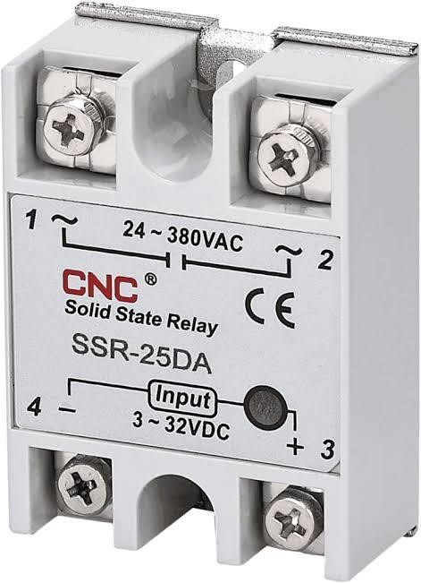
Figure 3- 24 SSR Control

As you see in Figure 3.24 Solid State Relay control interface

3.6.6 PCB Design and Layout Considerations

3.6.6.1 Trace Width Calculations
Power distribution traces are sized according to IPC-2221B standards to prevent excessive heating and voltage drop. For the 12V motor supply carrying 2A maximum current, with 1oz copper thickness and 10 deg C temperature rise:
W = I / (k x delta_T^0.44)
W = 2 / (0.048 x 10^0.44)
W = 2 / (0.048 x 2.75)
W = 2 / 0.132
W = 0.76 mm
Where:
W = Minimum trace width (mm)
I = Current (2A)
k = Constant (0.048 for external layers) delta_T = Temperature rise (10 deg C)
^0.44 = Raised to power of 0.44
A conservative width of 1.2mm is selected to provide safety margin and accommodate current spikes during motor acceleration.
Table 3- 7 PCB Trace Width Specifications
Net | Current (A) | Calculated Width (mm) | Selected Width (mm) | Notes
VMOT (12V) | 2.0 | 0.76 | 1.20 | Motor supply with safety margin
VCC (5V) | 0.5 | 0.30 | 0.60 | Sensor supply
VDD (3.3V) | 0.3 | 0.20 | 0.40 | Logic supply
Signal | 0.01 | 0.15 | 0.30 | General purpose
GND Plane | - | - | Full pour | Return paths for all signals

Table 3.7 Caption: PCB trace width calculations per IPC-2221B standard for 1oz copper with 10 deg C temperature rise, showing conservative design margins for reliability in industrial environments.

3.6.6.2 Thermal Management
Heat-generating components (A4988 drivers, TIP122 transistors) require thermal management to prevent junction temperatures exceeding maximum ratings. The A4988 in particular dissipates significant power during continuous operation:
P_diss = 2 x I_phase^2 x R_DS_on
P_diss = 2 x (1.5A)^2 x 0.32 Ohm
P_diss = 2 x 2.25 x 0.32
P_diss = 1.44 W
Where:
P_diss = Power dissipation (W) I_phase = Phase current (1.5A)
R_DS_on = MOSFET on-resistance (0.32 Ohm)
^2 = Squared
Thermal vias (0.3mm diameter, plated) connect the exposed pad to copper pours on both PCB layers, providing heat spreading. With thermal resistance of approximately 30 deg C/W for the PCB arrangement, junction temperature is estimated as:
$$T_j = T_a + (P_diss x R_th_JA)$$
$$T_j = 50 deg C + (1.44W x 30 deg C/W)$$
$$T_j = 50 + 43.2 T_j = 93.2 deg C$$
Where:
T_j = Junction temperature (deg C)
T_a = Ambient temperature (50 deg C)
R_th_JA = Junction-to-ambient thermal resistance (30 deg C/W) x = Multiplication
This remains below the 150 deg C maximum junction temperature with adequate margin.
3.6.6.3 Electromagnetic Compatibility Noise suppression measures include:
100nF ceramic decoupling capacitors at each IC power pin
100uF electrolytic bulk capacitors at motor supply entry points
Ferrite beads on thermocouple leads for high-frequency filtering
Ground plane continuity with minimal slotting
Separation of high-current motor traces from sensitive analog signals
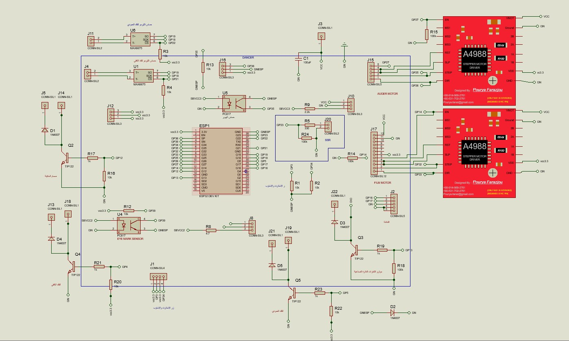
Figure 3- 25 PCB Layer Stack-up and Grounding Strategy

As you see in Figure 3.6 PCB layer stack-up showing top signal layer, internal ground plane, internal power plane, and bottom signal layer configuration with via stitching for ground continuity and electromagnetic interference reduction.

3.6.7 Power Budget and Distribution

Table 3- 8 System Power Budget Analysis
Rail | Voltage (V) | Current (A) | Power (W) | Duty Cycle | Avg. Power (W)
VMOT  (Motors) | 12 | 5.0 | 60.0 | 50.0% | 30.0
VCC  (Sensors) | 5 | 0.04 | 0.2 | 100.0% | 0.2
VDD (Logic) | 3.3 | 0.14 | 0.45 | 100.0% | 0.45
Heater (SSR) | 220 | 2.0 | 440.0 | 25.0% | 110.0
**Total** | - | - | **500.65** | - | **140.65**

As you see in Table 3.6 Comprehensive power budget for VFFS packaging machine showing peak and average power consumption across all voltage rails, with heater duty cycle based on thermal regulation requirements and motor duty cycle based on typical packaging cycle timing.
The selected power supply (MeanWell LRS-120-12, 120W) provides 15.96x margin over average consumption and 2.4x margin over peak non-heater loads, ensuring reliable operation with adequate headroom for inrush currents and supply degradation over time.
3.6.8 Pneumatic System Design:
VFFS pneumatic settings for different materials:
Table 3- 9 VFFS pneumatic settings for different materials
Component | Fiber 85 | Fiber 120 | Plastic 15-35 | Plastic 50
Seal jaws | 6 bars | 6 bars | 6 bars | 6 bars
Length seal | 5 bars | 5 bars | 5 bars | 5 bars
Belt transport | 5 bars | 5 bars | 5 bars | 6 bars
Film brake | 3 bars | 3 bars | 3 bars | 3 bars
Film tension | 2 bars | 1 bars | 0 bars | 4 bars

3.6.9 Safety and Protection Systems

3.6.8.1 Emergency Stop Implementation
Hardwired emergency stop functionality is implemented via GPIO34, configured as external hardware interrupt. The normally-closed mushroom button provides fail-safe operation: any wire break or button press immediately triggers interrupt service routine bypassing RTOS scheduler, forcing immediate stepper stop (RMT channel termination), heater disable (SSR off), and pneumatic valve closure.
Response time is specified below 50ms from button press to actuator de-energization, meeting ISO 13850 Category 0 stop requirements.

3.6.8.2 Component Protection
Transient voltage suppression is implemented at multiple levels:
Metal Oxide Varistors (MOVs) on 24V power entry for surge protection
TVS diode arrays (SMBJ series) on 3.3V logic lines
Flyback diodes (1N4007) on all inductive loads
Fuse protection (F1-F3) for individual actuators

Table 3- 10 Protection Component Summary
Location | Component | Rating | Function
24V Input | MOV | 30.0V | Surge voltage clamping
3.3V Logic | TVS Array | 5.0V | ESD and transient protection
Solenoid Coils | 1N4007 | 1A, 1000V | Back-EMF  recirculation
Motor Drivers | Internal | 1.50A | Overcurrent limiting (A4988)
Heater Circuit | Fuse | 10.0A | Overcurrent protection
System Input | Circuit Breaker | 16.0A | Manual disconnect, short circuit
As you see in Table 3.10 : Protection component summary showing multi-level approach to system safety including surge suppression, transient voltage protection, inductive kickback prevention, and overcurrent protection for all critical circuits.

CHAPTER 4:
ANALYTICAL MODELING AND ENGINEERING CALCULATIONS

4.1 Mathematical Foundations and Assumptions

ANALYTICAL MODELING AND ENGINEERING CALCULATIONS
The analytical modeling of the Vertical Form-Fill-Seal (VFFS) machine is predicated upon well-established principles drawn from bulk solids mechanics, screw conveyor theory, classical structural mechanics, thermodynamics, and control theory. This chapter delineates the fundamental assumptions underlying the mathematical models and establishes the comprehensive theoretical framework upon which all subsequent mechatronic calculations are constructed.

4.1 Mathematical Foundations and Assumptions

4.1.1 Fundamental Assumptions
The following assumptions are systematically employed in developing the analytical models presented herein:
- A1. Continuum Assumption —Although granular materials are inherently discrete particulate assemblies, they are treated as continuous media for the purposes of macroscopic analysis. Physical properties are accordingly represented by spatially averaged field variables, an approach well supported in powder mechanics literature.
- A2. Steady-State Operation —The analysis assumes steady-state operating conditions with constant rotational speed and uniform material feed rate. Transient effects during startup and shutdown phases are neglected. This is consistent with standard practice in screw conveyor analysis.
- A3. Isotropic Material Properties —The bulk density and internal flow properties of the granular medium are assumed to be isotropic (i.e., uniform in all spatial directions) within the auger conveying channel.
- A4. Rigid Boundary Conditions —The auger housing and supporting structural frame are assumed to be perfectly rigid, with all deformation confined to the auger shaft and flight elements. This allows decoupling of the structural analysis from the frame dynamics.
- A5. Constant Volumetric Efficiency —The volumetric efficiency factor (ηₕ) is treated as constant over the design speed range. Deviations due to slip, backflow, and aeration effects are addressed through an empirically determined correction coefficient, as recommended by the Conveyor Equipment Manufacturers Association (CEMA) guidelines.

4.1.2 Material Properties
The analytical models employ the following physicochemical properties for sodium chloride (NaCl), which constitutes the primary target material for the designed system:
- True (crystalline) density: ρₜ = 2165 kg/m³
- Loose bulk density: ρₑ = 1200–1300 kg/m³ (design value: 1300 kg/m³)
- Angle of repose: φᵣ = 30–35°
- Internal friction angle: φ = 30–45°
- Wall friction coefficient (steel): μᵧ = 0.25–0.35 (Wall friction angle φᵧ ≈ 20°)
- Unconfined yield strength: σᶜ ≈ 200 Pa
- Cohesion: c ≈ 150 Pa
These values are consistent with published data for industrial-grade sodium chloride. To evaluate the powder's flow behavior, the Mohr-Coulomb failure criterion is applied to determine the shear stress required to initiate flow:
τ = σ · tan(φ) + c (4.1)
Additionally, the flowability of the salt is evaluated using the Flow Function (FF):
FF = σ₁ / σᶜ (4.2)
Based on the principal consolidation stress (σ₁), the salt is classified as free-flowing, ensuring stable handling characteristics.

4.2 Mechanical Modeling of the Dosing System

4.2.1 Hopper Flow Modeling and Geometry Design
The analytical model of the auger filling subsystem must include the hopper and agitator assembly to ensure the stability of powder flow into the auger inlet.
Angle of repose:
The angle of repose was determined experimentally using the fixed funnel method. For a salt cone with a base radius r = 7 cm and a height of 5 cm:
$θ = tan⁻¹(5/7) = 35.54°$ (4.3)
This experimental value (see Figure3.1) aligns with the standard range for fine table salt.
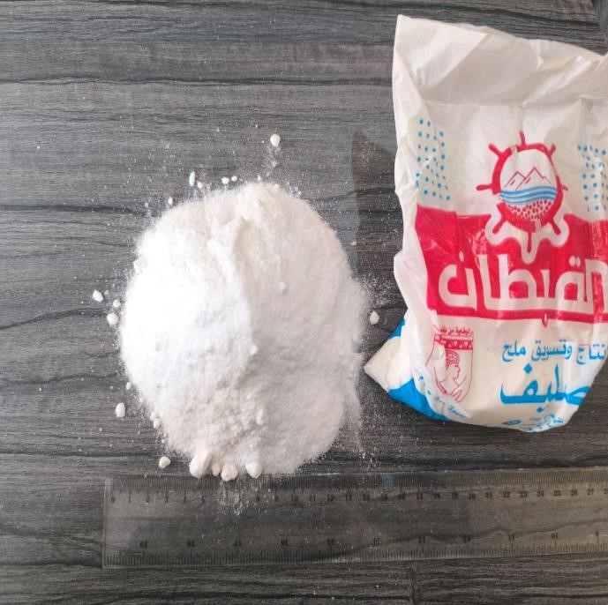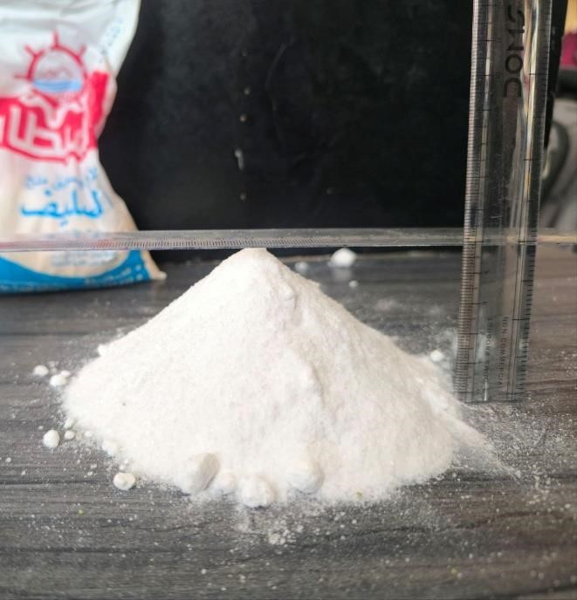

Figure 4- 1experimental value
Critical Arching Diameter Calculation:
To prevent powder bridging, the hopper outlet must be larger than the critical arching diameter (Bᶜ) predicted by Jenike-based theory:
$Bᶜ = H(θ) · σᶜ / (ρg)$ (4.4)
where:
- Bᶜ = critical arching diameter (m)
- H(θ) = hopper geometry factor
- σᶜ = unconfined yield strength (Pa)
- ρ = bulk density (kg/m³)
- g = gravitational acceleration (m/s²)
For a conical hopper, H(θ) ≈ 2.2. Substituting the design values:
$Bᶜ = (2.2 × 200) / (1300 × 9.81) = 0.0345 m = 34.5 mm$ (4.5)
The selected hopper outlet diameter is Dₒᵤₜ = 65 mm. Thus, the safety factor against arching is:
$SFₐᵣᶜⱼᵢₙᵏ = Dₒᵤₜ / Bᶜ = 65 / 34.5 ≈ 1.88$  Hopper Wall Angle Requirement for Mass Flow:  A simplified Jenike design criterion is given by: | (4.6)
$θ < (90° - φᵧ) - 5°$  where:  - θ = hopper wall angle measured from horizontal  - φᵧ = wall friction angle between powder and hopper wall surface  Using the conservative upper bound φᵧ = 25°: | (4.7)
$θₘₐₓ < (90° - 25°) - 5° = 60°$ | (4.8)
The selected hopper wall angle is 60° from horizontal (30° from vertical). Since the required angle of inclination should be at least 35.54° + 15° = 50.54°, the 60° selection perfectly satisfies the theoretical condition for mass flow.
Hopper Geometry and Capacity Calculation:
The required hopper capacity is V = 20 L = 0.02 m³. The frustum volume is defined by:
$V = (πh/3) · (R² + Rr + r²)$ (4.9)
where:
- h = hopper height
- R = top radius
- r = outlet radius
With outlet radius r = 32.5 mm and wall angle 60°, solving iteratively yields:
$h ≈ 0.33 m = 330 mm$(4.10)
$Dₜₒₚ = 2R ≈ 0.446 m = 446 mm$ (4.11)
Hopper Discharge Time Analysis:
The gravity discharge capability was estimated using a Beverloo-type relation for granular solids:
$Ṁ = C · ρ · g¹/² · (Dₒ - kdₚ)⁵/²$ (4.12)
where:
- Ṁ = mass discharge rate (kg/s)
- C = discharge coefficient
- ρ = bulk density (kg/m³)
- D_{o} = outlet diameter (m)
- k = particle shape factor
- d_{p} = mean particle diameter (m)
Using design values (C=0.58, k=1.5, dₚ=0.0003 m), the discharge rate is Ṁ ≈ 2.8 kg/s. The time required to discharge a 0.5 kg dose is therefore:
$t = m / Ṁ = 0.5 / 2.8 ≈ 0.18 s$ (4.13)
This indicates the hopper is capable of feeding the auger significantly faster than the required 0.75 s fill time.
Hopper Hydrostatic Pressure Calculation:
The maximum static pressure imposed by the powder column on the hopper walls is:
$P = ρgh = 1300 × 9.81 × 0.33 = 4208.5 Pa$ (4.14)
A design pressure of P = 4300 Pa is adopted for structural analysis.

4.2.2 Hopper-Agitator Synchronization with the VFFS Cycle
The hopper-agitator subsystem must operate in coordination with the auger and the general VFFS machine cycle. The filling and powder stabilization phases must satisfy:
$Tfill + tsettle < tcycle- tseal$
Because the hopper discharge capability is much faster than the required fill interval, the primary role of the agitator is not to increase mass flow rate, but to maintain uniform powder conditions at the auger inlet by preventing compaction, reconditioning the powder bed, and reducing local density fluctuations.
The agitator operates at approximately 30 RPM, while the auger operates at the upgraded speed of 300 RPM. Counter-rotation between these two elements generates localized shear within the powder bed and promotes highly stable feed conditions, confirming the hopper-agitator system as an active component of the high-speed dosing mechanism.

4.2.3 Auger Volumetric and Kinematic Dosing
The kinematic analysis establishes the functional relationship between auger rotational speed and material displacement rate. All calculations in this section are performed for an upgraded design throughput rate of 20 bags per minute (i.e., 20 × 500 g = 10 kg/min).
Theoretical Volumetric Flow Rate:
The theoretical volumetric displacement per revolution of a single-flight auger screw is derived from the annular geometry bounded by the outer flight diameter (D) and the central shaft diameter (Dₛ). The effective cross-sectional area of the conveying channel is given by:
$A = (π/4) × (D² - Dₛ²)$ (4.15)
Substituting the design parameters D = 60 mm and Dₛ = 16 mm:
$A = (π/4) × (0.060² - 0.016²) = 2.626 × 10⁻³ m²$
The theoretical volume displaced per revolution is the product of the cross-sectional area and the screw pitch (P):
$Vth = A × P = 2.626 × {10}^{-3}× 0.060 = 1.576 × 10⁻⁴ m³/rev = 157.6 cm³/rev$ (4.16)
The theoretical volumetric flow rate at the design operating speed of N = 300 RPM (5 rev/s) is:
$Qth = Vth × N = 1.576 × 10⁻⁴ × 5 = 7.88 × 10⁻⁴ m³/s$ (4.17) Mass Flow Rate as a Function of Bulk Density and Rotational Speed:
The actual mass flow rate accounts for the volumetric efficiency (ηᵥ), which quantifies the deviation from ideal displacement due to particle slip, backflow, and incomplete channel filling. For free-flowing granular salt, empirical data suggests ηᵥ ≈ 0.65. The effective volumetric displacement per revolution is:
$Vth = Vth × ηᵥ = 157.6 × 0.65 = 102.4 cm³/rev$ (4.18)

The mass flow rate is then calculated from the bulk density relationship:
$ṁ = Vth × N × ρₑ$
$= 102.4 cm³/rev × 5 rev/s × 1.30 g/cm³ = 665.6 g/s$ (4.19)
For a target dose of 500 g, the requisite filling time is:
$Tfill= mtarget / ṁ = 500 / 665.6 = 0.75 s$ (4.20)
Auger Filler Engineering Calculations:
Number of Revolutions per Bag:
$Nrev = mtarget / mrev$ (4.21)
For a 500 g bag with the updated $mrev = 0.133 kg$:
$$Nrev = 0.500 / 0.133 = 3.75 revolutions$$
A design value of 3.95 revolutions is adopted to provide additional operational margin and accommodate volumetric efficiency variations across different material batches.
Filling Time per Bag:
$Tfill = (Nrev / n) × 60 [seconds]$ (4.22)
At $n = 300 RPM$ and $Nrev = 3.75$
$$Tfill = (3.75 / 300) × 60 = 0.75 s$$
Motor Angular Velocity:
$ω = 2πn / 60$ (4.23)
$$For n = 300 RPM: ω ≈ 31.41 rad/s$$

Table 4- 1 Auger Design Parameters by Product Type
Product | Bulk Density (kg/m³) | Angle of Repose (°) | Auger Dia. (mm) | Pitch/Dia. Ratio | RPM for 500g | Vol. Eff. (%)
Salt | 1,200 | 35 | 50 | 1.0 | 15 | 85
Sugar | 800 | 45 | 60 | 0.9 | 12 | 80
Coffee | 350 | 40 | 75 | 0.8 | 18 | 70

Table 4- 2 Filling Accuracy Requirements
Parameter | Salt | Sugar | Coffee
Target Weight | 500 g | 500 g | 500 g
Tolerance (±) | 5 g | 7.5 g | 10 g
Accuracy (%) | ±1.0% | ±1.5% | ±2.0%
Precision (CV%) | < 0.5% | < 0.8% | < 1.2%
Calibration Freq. | Daily | Daily | Every shift
]

4.2.3.1 Target Dosing and Calibration
To maintain strict gravimetric accuracy across different material batches and varying environmental conditions, the control system utilizes a dynamic Volumetric Correction Factor (C_{V}). This factor compares the experimentally measured mass (m_{actual}) with the calculated theoretical mass (m_{theory}):
C_{V} = m_{actual} / m_{theory}
The system then automatically computes the Corrected Number of Revolutions (N_{corrected}) required to achieve the target weight:
N_{corrected} = N_{theory} · 1/ C_{V}
This adaptive calibration loop ensures that the system compensates for local density fluctuations and volumetric efficiency variations in real-time.

4.2.4 Dynamic Torque Estimation
Accurate estimation of the torque required to rotate the auger under load is essential for the proper selection of the drive motor and gearbox assembly. The total torque comprises several physically distinct components, each arising from a different resistance mechanism within the system [1][13].

Agitator Blade Torque Requirement:
The blade torque is approximated by:
T = n · τ · Aₐ · rₘ (4.24) where:
- T = blade torque (N.m)
- n = number of blades contributing to resistance
- τ = powder shear stress at blade surface (Pa)
- A_{b} = blade projected area (m²)
- r_{m} = mean blade action radius (m)
For the long blade:
- blade length = 0.2024 m
- blade width = 0.060 m
- A_{b} = 0.2024 × 0.060 = 0.0121 m²
- r_{m} ≈ 0.15 m
- τ ≈ 150 Pa
Thus:
T_{long} = 1 × 150 × 0.0121 × 0.15 ≈ 0.27 (N.m)
For the short blade:
- blade length = 0.1062 m
- blade width = 0.060 m
- A_{b} ≈ 0.1062 × 0.060 = 0.0064 m²
- r_{m} ≈ 0.10 m

Therefore:
T_{short} = 1 × 150 × 0.0064 × 0.10 ≈ 0.096 (N.m)
For the long blade (T_{long} ≈ 0.27 N·m) and short blade (T_{short} ≈ 0.096 N·m), the total torque is:
T_{total} = T_{long} + T_{short} = 0.27 + 0.096 = 0.37 N·m (4.25)
Applying a safety factor of 2.0, the minimum design requirement is T_{design} = 0.74 N·m.
Torque Components: Powder Resistance and Friction (Auger):
The total torque required at the auger shaft is decomposed as follows:
T_{total} = T_{material} + T_{wall} + T_{bearing} + T_{inertia} (4.26)
The material transport torque is estimated using the Roberts-Rademacher formulation for screw conveyors:
T_{material} = μₛ · Fₙ · Dₘ / 2 (4.27)
Where μₛ ≈ 0.4 is the internal friction coefficient, normal force Fₙ = 6.70 N (for a 200mm column), and mean diameter Dₘ = 38 mm.
T_{material} = (0.4 × 6.70 × 0.038) / 2 = 0.051 N·m
The wall friction torque (T_{wall}) evaluates to 0.060 N·m.
Motor Sizing and Gear Ratio Optimization:
Including bearing friction (estimated at 0.5 N·m) and angular acceleration torque (2.0 N·m), the total shaft torque is:
T_{total} = 0.051 + 0.060 + 0.5 + 2.0 = 2.61 N·m (4.28)
Incorporating a safety factor of 1.5 and a compaction correction factor of 5, the design torque is:
T_{design} = 2.61 × 1.5 × 5 = 19.6 N·m ≈ 20 N·m (4.29) With a 20:1 planetary gearbox (η_{gear} = 0.97), the required motor output torque is:
Tₘₒₜₒᵣ = T_{design} / (i × η_{gear}) = 20 / (20 × 0.97) = 1.03 N·m (4.30)
The selected Panasonic MSMF042L1U servo motor provides 1.27 N·m rated torque and 3.82 N·m peak torque, yielding an adequate margin for all anticipated operating conditions [14].
The mechanical power requirement is computed as:
P = T_{design} × ω = 20 × (2π × 135/60) = 283 W (4.31)
The 400 W rated motor thus provides a power margin of approximately 41% above the calculated demand, ensuring reliable operation under transient and peak loading scenarios [15].

4.2.5 Structural Analysis of the Auger Shaft
The auger shaft must withstand the applied torques and transverse loads without incurring excessive stress or deflection.
Torsional Stress on the Auger Shaft:
The torsional shear stress in a solid circular shaft subjected to an applied torque T is given by:
τ = T · r / J  For a solid circular cross-section Dₛ = 16 mm: | (4.31)
J = (π × Dₛ⁴) / 32 = (π × 0.016⁴) / 32 = 6.434 × 10⁻⁹ m⁴  The maximum shear stress under the design torque T = 20 N·m is: | (4.32)
τₘₐₓ = (20 × 0.008) / (6.434 × 10⁻⁹) = 24.9 MPa | (4.33)
For AISI 316L stainless steel, the shear yield strength according to the von Mises criterion is τᵧ = 118.4 MPa. The factor of safety against torsional yielding is therefore:
FS = τᵧ / τₘₐₓ = 118.4 / 24.9 = 4.76 (4.34)
This substantial safety factor confirms that the shaft will not yield.

Deflection and Critical Speed Analysis:
The maximum deflection at the free end is estimated using Euler-Bernoulli beam theory: δₘₐₓ = F · L³ / (3 · E · I) (4.35)
Substituting load (F=50 N), length (L=280 mm), and Modulus (E=193 GPa),
we obtain:
δₘₐₓ = (50 × 0.280³) / (3 × 193 × 10⁹ × 3.217 × 10⁻⁹) = 0.59 mm (4.36)
Finite Element Analysis (FEA) results indicate an actual maximum deflection of only
0.0021 mm, confirming that the design provides substantial rigidity.
Critical Speed Analysis:
The first critical speed for the cantilever configuration is expressed as:
$ωₙ = √(k / mᵉᵐ)$ (4.37)
With stiffness k = 8.49 × 10⁴ N/m and equivalent mass mᵉᵐ = 0.5 kg:
$ωₙ = √(8.49 × 10⁴ / 0.5) = 412 rad/s = 3934 RPM$ (4.38)
The high-speed operating parameter of 300 RPM represents only 7.6% of the first critical speed, providing an exceptionally large margin of safety against resonant vibration.

4.3 Kinematics and Dynamics of Packaging Mechanisms
This section presents the governing equations for film transport kinematics and thermal sealing thermodynamics, both of which are critical to achieving consistent bag formation at the specified throughput rate of 20 bags per minute.

4.3.1 Film Unwinding and Pulling System
The film feeding mechanism requires overcoming the rotational inertia of the film roll and the kinetic friction along the forming tube. The dynamic tension required to unwind the film without tearing it is calculated based on the linear velocity of the pulling belts. The pulling belts must apply a tangential force (Fₜ) sufficient to unroll the film, which determines the required torque for the stepper or servo motors driving the belts.

Film Linear Velocity
The linear velocity of the packaging film is determined by the product of the bag length and the production rate [22]:

$vf = (Lbag × Nbags) / 60$ (4.39)
where 𝐿𝑏𝑎𝑔 = 0.25 𝑚 (for a 500 g package) and 𝑁𝑏𝑎𝑔𝑠 is the number of bags produced per minute (range: 12–30 bags/min).
At the design throughput of 20 bags/min:
𝑣𝑓 = (0.25 × 20) / 60 = 0.0833 𝑚/𝑠 (4.40)
For reference, the boundary velocities across the full operating range are:
𝑣𝑚𝑖𝑛 = (12 × 0.25) / 60 = 0.050 𝑚/𝑠

𝑣𝑚𝑎𝑥 = (30 × 0.25) / 60 = 0.125 𝑚/𝑠
Required Film Pulling Force
The total pulling force on the film web comprises inertial, frictional, and tension components [22]:

𝐹𝑝𝑢𝑙𝑙 = 𝑚 · 𝑎 + 𝐹𝑓𝑟𝑖𝑐𝑡𝑖𝑜𝑛 + 𝐹𝑡𝑒𝑛𝑠𝑖𝑜𝑛 (4.41)
where Ffriction = μ × N (friction force with μ = 0.3 for plastic film on steel guides), and Ftension represents the required web tension (50–100 N) [23].
Film Tensile Stress
The tensile stress induced in the film is:

𝜎 = 𝐹 / 𝐴 = 𝐹 / (𝑡 × 𝑤) (4.42)
where 𝑡 = 0.06 𝑚𝑚 (film thickness) and w = 320 mm (film width).
Maximum Allowable Stress

𝑄𝑚𝑎𝑥 = 𝜎𝑦𝑖𝑒𝑙𝑑 / 𝑆𝐹 (4.43)
where 𝜎𝑦𝑖𝑒𝑙𝑑 = 20 − 30 𝑀𝑃𝑎 (polyethylene yield stress [24]) and SF = 2.5.
The film feed mechanism utilizes a stepper motor with the following design calculations:
Distance per Revolution:
lrev = π × D₁ = π×60= 188.5 mm/rev (4.44)
Number of Revolutions per Bag:
N=188.5220=1.17 rev (4.45)
Motor Speed:
n = 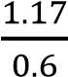×60 =117 RPM (4.46)
Force Load

𝑭 = 𝒎𝒈 = 𝟑 × 𝟗. 𝟖𝟏 = 𝟐𝟗. 𝟒𝟑 N (4.47)
Load Torque:
Radius = 60 / 2 = 30 mm = 0.03 m
TL = Fl × D/2 = 29.43×0.03 = 0.88 N·m (4.48)
Required Torque (with safety factor of 2):
Trequired = (0.88+0.1)×2=1.96N·m (4.49)

4.3.2 Sealing Jaws Mechanism
The actuation of the horizontal and vertical sealing jaws involves applying sufficient mechanical pressure to fuse the thermoplastic layers of the packaging film. Whether pneumatically or electromechanically driven, the required clamping force (F_{seal}) must be uniformly distributed across the sealing surface to prevent micro-leaks, ensuring the structural integrity of the 500g salt bags during subsequent handling and transportation.
Required Sealing Force

𝐹𝑠𝑒𝑎𝑙 = 𝑃𝑠𝑒𝑎𝑙 × 𝐴𝑠𝑒𝑎𝑙 (4.50)
where 𝑃𝑠𝑒𝑎𝑙 = 2 − 4 𝑏𝑎𝑟 (200 − 400 𝑘𝑃𝑎) is the sealing pressure, and 𝐴𝑠𝑒𝑎𝑙 = 𝑗𝑎𝑤 𝑙𝑒𝑛𝑔𝑡ℎ × 𝑠𝑒𝑎𝑙 𝑤𝑖𝑑𝑡ℎ = 150 × 5 = 750 𝑚𝑚² [25]. At the maximum sealing pressure:
𝐹𝑠𝑒𝑎𝑙 = 400 × 10³ × 750 × 10⁻⁶ = 300 𝑁

4.4 Thermodynamic Modeling of the Sealing System

4.4.1 Heat Transfer in Sealing Jaws
The thermal modeling of the sealing process involves transient heat conduction from the metal jaws into the polymer film. According to Fourier's law of heat conduction, the thermal resistance of the film dictates the required contact time. The jaws must maintain a consistent surface temperature profile despite the continuous introduction of room-temperature film.
Conductive Heat Transfer
The heat transferred through the film during sealing is governed by Fourier's law of conduction [26]:
Q = (k × A × ΔT / d) × t (4.52)
where:
k = Film thermal conductivity = 0.33 𝑊/(𝑚 · 𝐾), A = Contact area = 750 mm² ΔT = Temperature differential = 140°C − 25°C = 115°C, d = Film thickness = 0.06 mm t = Sealing time (s)
Optimal Sealing Temperature
𝑇𝑠𝑒𝑎𝑙 = 𝑇𝑚𝑒𝑙𝑡 + 20°𝐶 (4.34) where 𝑇𝑚𝑒𝑙𝑡 = 120 − 130°𝐶 for polyethylene, yielding
𝑇𝑠𝑒𝑎𝑙 = 140 − 150°C [27].

4.4.2 Heater Power Sizing
To maintain the required sealing temperature (150°C – 180°C) at a production rate of 20 bags/min, the electrical heaters embedded in the jaws must supply sufficient thermal energy (qₜⱼₐₗ). The required wattage is calculated by summing the energy absorbed by the plastic film per cycle and the continuous convective and radiant heat losses to the surrounding environment.

Energy Required for Sealing

4.5 Electrical Calculations and Actuator Sizin

4.5.1 Total Power Budget Calculation
The total electrical power requirement is determined by summing all continuous and intermittent loads, with appropriate diversity factors applied per IEC 60204-1 [1].
Continuous Loads (100% duty cycle):
Control electronics:
$P_ctrl = 5 W$
Display system:
$$P_disp = 3 W$$
Sensors (average):
$$P_sens = 2 W$$
Intermittent Loads (duty cycle weighted):
Heating elements:
$P_heat = 2000 W at 80\% duty = 1600 W$
Stepper motor (film pulling):
$$P_step = 150 W at 60\% duty = 90 W$$
Stepper motor (auger)
$$: P_auger = 120 W at 50\% duty = 60 W$$
DC cutting motor:
$$P_cut = 72 W at 15\% duty = 10.8 W$$
Solenoid valves:
$P_solen = 30 W at 25\% duty = 7.5 W$
Total Calculated Power:
$$P_total = 5 + 3 + 2 + 1600 + 90 + 60 + 10.8 + 7.5 = 1778.3 W$$
Design Power with Safety Factor:
$$P_design = P_total * 1.25 = 2223 W ≈ 2.2 kW$$
The 25% safety factor accommodates simultaneous operation peaks and future expansion [2].

4.5.2 Current Calculation and Protection Coordination
Main Supply Current (single-phase 220V):
$$I_main = P_design / (V * cos(phi)) = 2200 / (220 * 0.85) = 11.76 A$$
With power factor cos(phi) = 0.85 typical for mixed resistive-inductive loads [3].
Main MCB Selection:
Calculated current: 11.76 A
Selected rating:
$$I_n = 20 A (next standard size per IEC 60898)$$
$Verification: I_n >= 1.45 * I_main for thermal protecti$on
$$20 A >= 17.1 A ✓$$

4.5.3Auger Mechanism and Load Characterization
The auger (screw conveyor) system meters powdered product into the formed bags. The mechanical load consists of product resistance, bearing friction, and acceleration torque during speed changes.
Auger Specifications:
Table 4- 3 Torque Requirement Calculation
$$Parameter$$ | $$Symbol$$ | $$Value$$ | $$Unit$$
$$Screw diameter$$ | $$D\backslash _screw$$ | $$50$$ | $$mm$$
$$Screw pitch$$ | $$p$$ | $$40$$ | $$mm$$
$$Screw length$$ | $$L$$ | $$300$$ | $$mm$$
$$Product density$$ | $$rho$$ | $$800$$ | $$kg/m³$$
$$Fill factor$$ | $$psi$$ | $$0.7$$ | $$-$$
$$Operating speed$$ | $$n$$ | $$60$$ | $$RPM$$

4.5.4 Torque Requirement Calculation
Product Conveying Torque:
The torque required to convey product is derived from shear stress at the screw flight interface:
$$T_product = (pi * D_screw² * p * rho * g * L * sin(theta) * mu) / (4 * eta)$$
Where:
$$theta = 30° (auger inclination angle)$$
$$mu = 0.5 (friction coefficient, product to steel)$$
$$eta = 0.3 (auger efficiency for powders)$$
$$Substituting values:$$
$$T_product = (3.14159 * 0.050² * 0.040 * 800 * 9.81 * 0.300 * 0.5 * 0.5) / (4 * 0.3)$$
$T_product = 0.385 N·m$
$$Bearing Friction Torque:$$
$$T_bearing = F_axial * mu_bearing * d_bearing / 2 = 50 * 0.0015 * 0.010 = 0.00075 N·m (negligible)$$
$$Acceleration Torque:$$
$$Auger screw inertia:$$
$$J_screw = (pi * rho_steel * L * (D_outer⁴ - D_inner⁴)) / 32 = 0.000203 kg·m²$$
$$Product inertia:$$
$$J_product = 0.000103 kg·m²$$
$$Total inertia:$$
$$J_total = 0.000306 kg·m²$$
$$T_acceleration = J_total * alpha = 0.000306 * 12.57 = 0.00385 N·m (negligible)$$
$$Total Required Torque:$$
$$T_required = 0.385 + 0.00075 + 0.00385 = 0.39 N·m$$
$$With Safety Factor SF = 2.5:$$
$$T_motor = 0.39 * 2.5 = 0.975 N·m$$

4.5.5 Servo Motor and Drive Selection
Selected Motor: Panasonic MSMF042L1U1
Table 4- 4 Panasonic MSMF042L1U1
Parameter | Value | Unit
Rated output | 400 | W
Rated torque | 1.3 | N·m
Maximum torque | 3.8 | N·m
Rated speed | 3000 | RPM
Maximum speed | 6000 | RPM
Encoder resolution | 23-bit (8,388,608 ppr) | -
Voltage | 200.0-240 | V AC

Source: Panasonic MINAS A6 Series Datasheet, Document No. MCDM3003 [7]
Verification:
Continuous operation:
T_rated / T_required = 1.3 / 0.39 = 3.3 > 2.5 required ✓
Peak overload capability:
3.8 N·m >> 0.975 N·m required ✓

4.5.6 Servo Drive Specifications
Selected Drive:
Panasonic MBDLN25SE
Table 4- 5 Panasonic MBDLN25SE
Parameter | Specification | Unit
Input voltage | Single-phase 200-240 | V AC
Output current (RMS) | 2.5 | A
Output current (peak) | 7.1 | A
Control mode | Position, Velocity, Torque | -
Command interface | Pulse/Direction, Analog, Modbus | -
Pulse input frequency | Max 4 | MHz
Protection | Overcurrent, Overvoltage, Undervoltage, Overspeed, Encoder error | -

Pulse input frequency Max 4 MHz
Protection Overcurrent, Overvoltage, Undervoltage, Overspeed, Encoder error -
Source:
Panasonic MINAS A6 Family Datasheet, Document No. MCDM3004 [8]

4.5.7 Control Interface Design
Control Signal Mapping:
Table 4- 6 Control Signal Mapping
Signal | ESP32 Pin | Level Shifter | MBDLN25SE Terminal | Function
PULSE | GPIO 21 | 74HCT245 B0 | PULS | Position command pulses
DIR | GPIO 12 | 74HCT245 B1 | SIGN | Rotation direction
ENA | GPIO 5 | 74HCT245 B2 | SON | Servo enable
ALM | GPIO 34 | Direct (with divider) | ALM | Fault output to ESP32

Pulse Frequency Calculation:
For auger operation at 60 RPM with 23-bit encoder:
Encoder resolution: 8,388,608 pulses/revolution
Electronic gear ratio setting (recommended):
B / A = 10000 / 8388608 ≈ 1 / 838.86
Effective resolution:
10000 pulses/revolution = 166.67 pulses/RPM
At 60 RPM: Pulse frequency = 60 * 166.67 = 10,000 Hz
Well within MBDLN25SE maximum input frequency of 4 MHz ✓

4.5.8 Dosing Accuracy Analysis
Volumetric Output:
Q = (pi * D_screw² / 4) * p * n * psi * eta
Q = (3.14159 * 0.050² / 4) * 0.040 * 1 * 0.7 * 0.3
Q = 0.0000165 m³/s = 16.5 mL/s = 990 mL/min
For 1 kg salt bag (density 800 kg/m³, volume 1250 mL):
Dosing time = 1250 / 16.5 = 75.8 seconds
Positioning Accuracy:
With 23-bit encoder and electronic gearing:
Position resolution = 360° / 10000 = 0.036° per command pulse
Linear resolution = p * (position resolution / 360°) = 40 * 0.0001 = 0.004 mm
Volumetric resolution per pulse:
Q_pulse = Q / (10000 pulses/s at 60 RPM) = 0.00165 mL/pulse
For 1250 mL dose: Required pulses = 1250 / 0.00165 = 757,576 pulses
Accuracy: ±1 pulse = ±0.00165 mL = ±0.00013% of dose (negligible)
Actual limiting factor: Mechanical backlash and powder flow consistency, not electrical resolution.
4.3.7 Power and Thermal Verification
Servo Drive Input Power:
P_in = (T * omega) / efficiency = (1.3 * 2 * pi * 60/60) / 0.9 = 0.545 / 0.9 = 0.61 kW
At rated output 400W, operating at 61% of capacity ✓
Drive Dissipation:
P_loss = P_in - P_out = 610 - 545 = 65 W

With natural convection and 40°C ambient:
Required heatsink: R_th < (80 - 40) / 65 = 0.62 K/W
MBDLN25SE internal heatsink adequate for continuous operation ✓

Film Pulling Mechanism Geometry:
Pulley diameter: D = 50 mm
Pulley radius: R = 25 mm = 0.025 m
Bag length range: L_bag = 100 mm to 300 mm
Step Resolution:
Motor step angle: theta_step = 1.8°
Microstepping: 16× (selected for smooth operation)
Effective step angle: theta_eff = 1.8° / 16 = 0.1125°
Linear Displacement per Step:
delta_x = R * theta_eff * (pi / 180) = 0.025 * 0.1125 * 0.01745 = 4.91 * 10^-5 m = 49.1 μm
Steps per Bag (minimum length 100mm):
N_steps = L_bag / delta_x = 0.100 / 4.91 * 10^-5 = 2037 steps
4.4.2 Torque and Acceleration Analysis
Load Inertia Calculation:
Film roll mass (maximum): m_roll = 5 kg
Roll radius: r_roll = 0.15 m
Reflected inertia: J_roll = m_roll * R² = 5 * 0.025² = 3.125 * 10^-3 kg·m²

$$Total Required Torque:$$
$$T_required = T_accel + T_load = 0.279 + 0.5 = 0.779 N·m$$
$$Motor Selection Verification:$$
$$Selected motor holding torque:$$
$$T_hold = 2.0 N·m$$
$$Safety factor:$$
$$SF = T_hold / T_required = 2.0 / 0.779 = 2.57 ✓$$

4.5.9 Heating Element Power Requirements
$$Heat Required for Film Sealing:$$
$$Q = m * c * delta_T$$
$$Where:$$
$$m = rho * V = 900 * 0.001 * 0.0001 = 9 * 10^-5 kg$$
$$c = 2300 J/(kg·K) (specific heat of LDPE) [9]$$
$$delta_T = 120 K$$
$$Q = 9 * 10^-5 * 2300 * 120 = 24.84 J per seal$$
Power for Continuous Operation:
At 60 bags/minute:
$$P_seal = 24.84 * 60 / 60 = 24.84 W$$

4.5.10 SSR Thermal Analysis
SSR Power Dissipation:
$$P_diss = I_rms * V_drop = 4.5 * 1.6 = 7.2 W per SSR$$

Heatsink Requirement:
$$R_th,total = (T_j,max - T_a) / P_diss = (125 - 40) / 7.2 = 11.8 K/W$$
Selected heatsink: R_th,hs = 8 K/W (providing 22% safety margin)

4.5.11 Complete Load Inventory
Table 4- 7 Complete Electrical Load Inventory
$$Load ID$$ | $$Description$$ | $$Voltage$$ | $$Power (W)$$ | $$Current (A)$$ | $$Duty Cycle$$ | $$Protection$$
$$L1$$ | $$ESP32-Master$$ | $$3.30V DC$$ | $$1.5$$ | $$0.45$$ | $$Continuous$$ | $$2A fuse$$
$$L2$$ | $$ESP32-Slave$$ | $$3.30V DC$$ | $$1.5$$ | $$0.45$$ | $$Continuous$$ | $$2A fuse$$
$$L3$$ | $$Display system$$ | $$5.0V DC$$ | $$3.0$$ | $$0.60$$ | $$Continuous$$ | $$2A fuse$$
$$L4$$ | $$Auger driver logic$$ | $$5.0V DC$$ | $$0.5$$ | $$0.10$$ | $$Continuous$$ | $$2A fuse$$
$$L5$$ | $$Auger motor$$ | $$24.0V DC$$ | $$120$$ | $$2.80$$ | $$50.0\%$$ | $$6A fast fuse$$
$$L6$$ | $$Film pull motor$$ | $$24.0V DC$$ | $$150$$ | $$2.80$$ | $$60.0\%$$ | $$6A fast fuse$$
$$L7$$ | $$DC cutting motor$$ | $$24.0V DC$$ | $$72$$ | $$3.00$$ | $$15.0\%$$ | $$6A fast fuse$$
$$L8-L10$$ | $$Solenoid valves (×3)$$ | $$24.0V DC$$ | $$36$$ | $$1.50$$ | $$25.0\%$$ | $$4A fuse$$
$$L11$$ | $$Sensors$$ | $$24.0V DC$$ | $$2.4$$ | $$0.10$$ | $$Continuous$$ | $$2A fuse$$
$$L12-L13$$ | $$Heater groups (×2)$$ | $$220.0V AC$$ | $$2000$$ | $$9.09$$ | $$80.0\%$$ | $$6A gG + SSR$$
$$L14$$ | $$SMPS$$ | $$220.0V AC$$ | $$400$$ | $$1.82$$ | $$Continuous$$ | $$6A MCB Type C$$

$$4.5.12 Protection Coordination Study$$
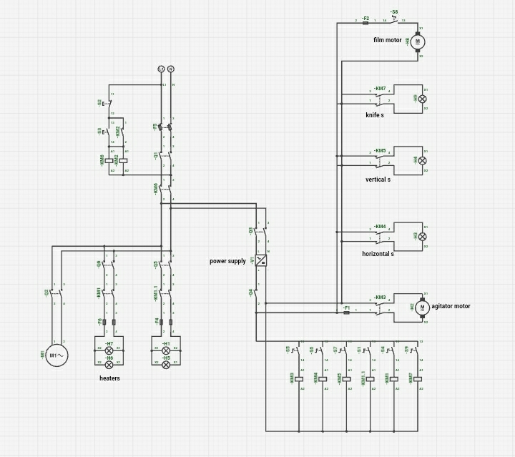
Figure 4- 2 Single-Line Diagram with Protection Coordination
Single-line diagram showing complete electrical distribution from main supply through all protection levels to individual loads. Include: Main MCB Q0 (20A), branch MCBs Q1-Q4 (6-10A), fuse terminals FT1-FT4, SSRs for heaters, and final load connections. Show current ratings and trip characteristics at each level.]

4.5.13 Time-Current Coordination
Table 4- 8 Protection Device Characteristics
$$Device$$ | $$Rating$$ | $$Type$$ | $$I\backslash _n$$  $$(A)$$ | $$I\backslash _5$$  $$(A)$$ | $$t\backslash _trip at 5I\backslash _n$$
$$Q0$$ | $$Main MCB$$ | $$C$$ | $$20$$ | $$100$$ | $$10.0s$$
$$Q1$$ | $$Heater MCB$$ | $$B$$ | $$10$$ | $$50$$ | $$8.0s$$
$$Q2-Q3$$ | $$SMPS/Drive MCB$$ | $$C$$ | $$6$$ | $$30$$ | $$10.0s$$
$$F1-F2$$ | $$Heater fuse$$ | $$gG$$ | $$6$$ | $$-$$ | $$0.5s at 2I\backslash _n$$
$$F3-F5$$ | $$Motor fuse$$ | $$Fast$$ | $$6$$ | $$-$$ | $$0.1s at 2I\backslash _n$$
$$F6-F9$$ | $$PCB fuse$$ | $$Electronic$$ | $$2$$ | $$4$$ | $$0.05s at 2I\backslash _n$$

$$4.5.14 Summary of Analytical Results$$
$$This chapter has presented comprehensive analytical modeling for the VFFS packaging machine electrical system. Key results include:$$
Table 4- 9 Summary of Analytical Results
$$Parameter$$ | $$Calculated Value$$ | $$Selected Value$$ | $$Safety Factor$$ | $$Status$$
$$Total power demand$$ | $$1778.0 W$$ | $$2200.0 W$$ | $$1.24$$ | $$✓$$
$$Main supply current$$ | $$11.760 A$$ | $$20 A MCB$$ | $$1.70$$ | $$✓$$
$$Auger torque required$$ | $$0.390 N·m$$ | $$2.7 N·m motor$$ | $$6.9$$ | $$✓$$
$$Film pull torque required$$ | $$0.780 N·m$$ | $$2.0 N·m motor$$ | $$2.57$$ | $$✓$$
$$Heater power required$$ | $$98 W/zone$$ | $$500 W/element$$ | $$5.1$$ | $$✓$$
$$24V bus capacity$$ | $$7.6 A peak$$ | $$15 A SMPS$$ | $$1.97$$ | $$✓$$
$$Voltage drop (worst)$$ | $$0.960 V$$ | $$< 3\% limit$$ | $$-$$ | $$✓$$
$$Short-circuit current$$ | $$2000.0 A$$ | $$6000 A breaking$$ | $$3.0$$ | $$✓$$

4.6 Control System Architecture and Signal Processing
Prior to embedded C++ firmware implementation, mechanical and thermodynamic behaviors were mathematically modeled to configure deterministic kinematic trajectories and dynamic thermal controls within the ESP32 architecture.

4.6.1 Kinematics of Precision Actuation Systems
Deterministic execution of servo and stepper motors governs precise salt dosing and film advancement [28]. The governing kinematics are derived as follows:
A. Auger Motor (Filling Mechanism)
Dispensing a 500g salt dose requires exactly 4 auger revolutions at 300 RPM [28]. The Panasonic MINAS A6 servo system utilizes a 23-bit absolute encoder yielding a native resolution of 𝑃_𝑛𝑎𝑡𝑖𝑣𝑒 = 8,388,608 pulses/rev. To reconcile the ESP32's pulse-generation limits with this ultra-high fidelity, the driver’s Electronic Gear Ratio (EGR) scales the logical command resolution to a target 10,000 Pulses Per Revolution (PPR):

𝐸𝐺𝑅 = 𝑃_𝑛𝑎𝑡𝑖𝑣𝑒 / 𝑃𝑃𝑅_𝑡𝑎𝑟𝑔𝑒𝑡 = 8,388,608 / 10,000
For this 10,000 PPR interface, the total displacement command (𝑃_𝑎𝑢𝑔𝑒𝑟) and the pulse frequency ($f_{pulse}$) required to achieve 300 RPM are calculated as [29]:

𝑃_𝑎𝑢𝑔𝑒𝑟 = 𝑅𝑒𝑣𝑜𝑙𝑢𝑡𝑖𝑜𝑛𝑠 𝑥 𝑃𝑃𝑅_𝑡𝑎𝑟𝑔𝑒𝑡 = 4 𝑥 10000 = 40,000 𝑝𝑢𝑙𝑠𝑒𝑠
To generate the required operational speed, the fundamental command pulse frequency (𝑓_𝑝) is derived from the RPM relation [29]:

𝑓_𝑝 = (𝑁 𝑥 𝑃𝑃𝑅_𝑡𝑎𝑟𝑔𝑒𝑡) / 60 = (300 𝑥 10000) / 60 = 50,000 𝐻𝑧
To enable asynchronous, non-blocking execution via the ESP32’s hardware Remote Control (RMT) module, this frequency dictates a microsecond pulse delay interval ($\Delta t$) [30]:
t_d (microseconds) = 1,000,000 / f_p = 1,000,000 / 50000 = 20 microseconds
- Pull Motor (Film Advance Mechanism)
The film advancement system pulls a continuous film to create a specific bag length (L = 220 mm) using a drive roller diameter of D = 60mm [28].
The linear travel per revolution equals the roller circumference (C) [28]:
C = pi x D = 3.14159 x 60 𝑎𝑝𝑝𝑟𝑜𝑥 188.50 mm/rev
To pull a target length of L = 220 mm, the required angular displacement (N_{rev}) and the corresponding ESP32 pulse count (P_{pull}) at 200 PPR are [29]:
N_{rev}= L / C = 220 / 188.50 𝑎𝑝𝑝𝑟𝑜𝑥 1.17 Rev
𝑃_𝑝𝑢𝑙𝑙 = 𝑅𝑒𝑣𝑜𝑙𝑢𝑡𝑖𝑜𝑛𝑠_𝑝𝑢𝑙𝑙 x PPR = 1.17 x 200 𝑎𝑝𝑝𝑟𝑜𝑥 234 pulses

4.6 Control System Architecture and Signal Processing

4.6.2 PID Temperature Control Modeling
The sealing jaw was mathematically modeled as a lumped-capacitance thermodynamic system [32]. The rate of temperature change in the stainless-steel jaw (𝑚 = 1 𝑘𝑔, 𝑐_𝑝 = 500 𝐽/𝑘𝑔. 𝐾) is governed by the fundamental energy balance equation [31]:
$$m c_p dT/dt = Q_in - Q_cond - Q_conv$$
Where 𝑄_𝑖𝑛 represents the heat supplied by the 400W heating element via the Solid State Relay. The heat losses are modeled utilizing Fourier's Law for conduction to the machine frame and Newton's Law of Cooling for convection to the ambient air [31]:
$$Q_loss = (k A_cond / L_cond)(T - T_amb) + h A_conv(T - T_amb)$$
By utilizing the designated physical parameters (𝑘 = 20 𝑊/𝑚. 𝐾, ℎ = 20 𝑊/𝑚^2. 𝐾) alongside empirical open-loop step response data processed via the MATLAB System Identification Toolbox, the continuous-time First-Order transfer function G(s) was derived [32]:
G(s) = (218.2 / (272.7s + 1))
This mathematical representation confirms the system's dominant thermal inertia (tau = 272.7 s) and quantifies the physical transport delay (theta = 2 s) between the heater activation and the thermocouple detection [32].
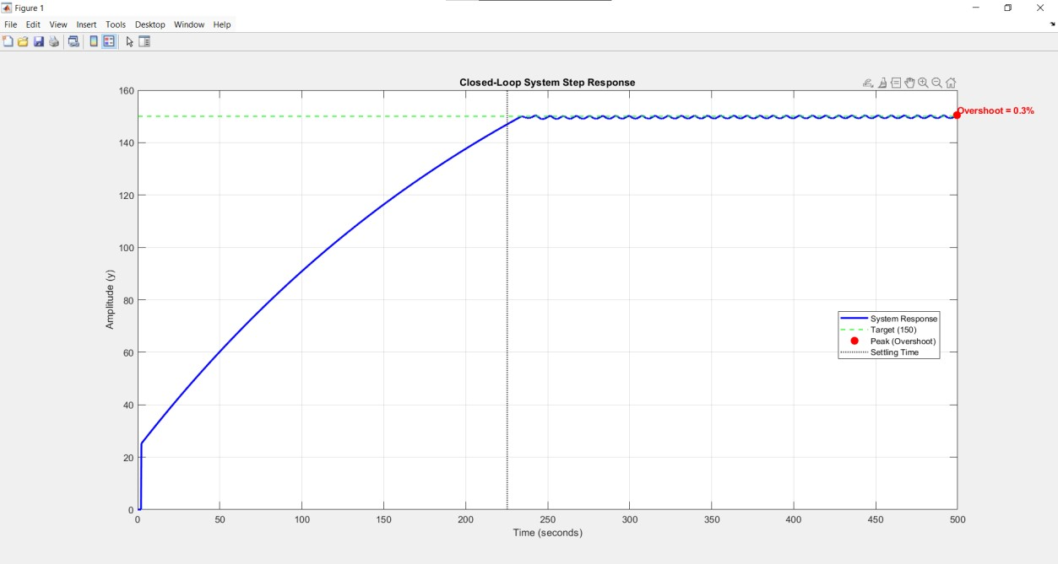
Figure 4- 3 Experimental closed-loop response used for system identification.
4.7 Overall VFFS System Synchronization
4.6.3 Discrete PID Control and Digital Stability
Because the ESP32 microcontroller processes the control algorithm digitally within a discrete time domain, the continuous PID equation required discretization. Utilizing the Forward Euler approximation for both the integral and derivative terms, the control effort u(k) at sample instance k is calculated as [33]:

$$u(k) = K_p e(k) + K_i T_s sum_j = 0^k e(j) + K_d (e(k) - e(k - 1)) / T_s$$
For practical implementation of the derivative filter, digital stability must be mathematically guaranteed. The pole of the discrete filter must remain strictly inside the unit circle, yielding the condition: |1 − 𝑁 . 𝑇_𝑠| < 1 [33].
With a strict thermal sample time of 𝑇_𝑠 = 1 𝑠, applying a standard high filter coefficient (e.g., 𝑁 = 100) results in an unstable pole at |1 − 100| = | − 99|, leading to severe instability and control signal ringing [33]. Therefore, the coefficient was mathematically restricted to 𝑁 = 1, safely shifting the pole to the origin (|1 − 1| = 0) and guaranteeing absolute digital stability for the time-proportional thermal control loop [33].

4.6.3 Microcontroller Processing Requirements
The central processing unit must execute multiple critical tasks simultaneously. Utilizing a Real-Time Operating System (RTOS), the microcontroller orchestrates the high frequency pulse generation for the servo motors, reads analog sensor data, updates the HMI, and manages safety interlocks without task starvation or execution delays.

4.7 Overall VFFS System Synchronization

4.7.1 Cycle Timing and In-Flight Material Compensation
At a design throughput of 20 bags per minute, the total cycle time available per bag is:
$$Tcycle = 60 / 20 = 3.00 s/bag$$
By leveraging the hardware concurrency capabilities of the ESP32 microcontroller, the control logic was optimized to execute the volumetric dosing phase in parallel with the thermal sealing phase. This concurrency significantly reduces the total active cycle time. The chronological execution sequence is detailed

Table 4- 10 Operational Timing Sequence for a Single 500g Cycle
$$Phase$$ | $$Machine Action /$$  $$Task$$ | $$Active Duration$$  $$(ms)$$ | $$Cumulative Time (ms)$$
$$1$$ | $$Film Pulling$$  $$(High - speed)$$ | $$600$$ |  | $$600$$
$$2$$ | $$Film Pulling (Search speed)$$ | $$400$$ |  | $$1000$$
$$3$$ | $$Signal Verification \&$$  $$Halt$$ | $$20$$ |  | $$1020$$
$$4$$ | $$Valve Response Latency$$ | $$31$$ |  | $$1051$$
$$5$$ | $$Sealing Jaw Travel$$ | $$150$$ |  | $$1201$$
$$6$$ | $$Thermal Sealing Dwell$$ | $$800$$ |  | $$2001$$
$$7$$ | $$Volumetric Dosing$$ | $$800 (Concurrent)$$ |  | $$2001$$
$$8$$ | $$Pneumatic Cutting$$ | $$100$$ |  | $$2101$$
$$9$$ | $$Jaw Release \&$$  $$Retraction$$ | $$181$$ |  | $$2282$$
$$Total$$ | $$Total Active Cycle$$  $$Time$$ | $$-$$ |  | $$2282 ms$$

$$4.8 Summary of Analytical Results$$
Table 4- 11 consolidates the key analytical predictions for the VFFS auger filling system operating at a design throu
$$Category$$ | $$Parameter$$ | $$Value$$ | $$Unit$$
$$Auger Filling$$ | $$Volumetric displacement per revolution$$ | $$157.6$$ | $$cm³/rev$$
$$Auger Filling$$ | $$Effective displacement (ηv = 0.65)$$ | $$102.4$$ | $$cm³/rev$$
$$Auger Filling$$ | $$Mass per revolution$$ | $$133.2$$ | $$g/rev$$

$$Auger Filling$$ | $$Required revolutions per 500 g bag$$ | $$3.75$$ | $$rev$$
$$Auger Filling$$ | $$Filling time at 135 RPM$$ | $$1.67$$ | $$s$$
$$Auger Filling$$ | $$Mass flow rate$$ | $$299.6$$ | $$g/s$$
$$Productivity$$ | $$Total cycle time (20 bags/min)$$ | $$3.00$$ | $$s$$
$$Productivity$$ | $$Film linear velocity (20 bags/min)$$ | $$0.0833$$ | $$m/s$$
$$Productivity$$ | $$Weight-based productivity$$ | $$600$$ | $$kg/hour$$
$$Mechanical Design$$ | $$Total torque requirement$$ | $$19.6$$ | $$N·m$$
$$Mechanical Design$$ | $$Maximum torsional stress$$ | $$24.9$$ | $$MPa$$
$$Mechanical Design$$ | $$Factor of safety (torsional yield)$$ | $$4.76$$ | $$-$$
$$Mechanical Design$$ | $$Maximum shaft deflection (analytical)$$ | $$0.59$$ | $$mm$$
$$Mechanical Design$$ | $$First critical speed$$ | $$3934$$ | $$RPM$$
$$Mechanical Design$$ | $$Operating speed / Critical speed ratio$$ | $$3.4$$ | $$\%$$
$$Mechanical Design$$ | $$Power requirement$$ | $$283$$ | $$W$$
$$Sealing System$$ | $$Required sealing force$$ | $$300$$ | $$N$$
$$Sealing System$$ | $$Sealing energy per cycle$$ | $$10.95$$ | $$J$$
$$Hopper Design$$ | $$Critical arching diameter$$ | $$34.5$$ | $$mm$$
$$Hopper Design$$ | $$Selected hopper outlet diameter$$ | $$65$$ | $$mm$$
$$Hopper Design$$ | $$Safety factor against arching$$ | $$1.88$$ | $$-$$
$$Hopper Design$$ | $$Hopper wall angle from horizontal$$ | $$60$$ | $$deg$$
$$Hopper Design$$ | $$Hopper wall angle from vertical$$ | $$30$$ | $$deg$$
$$Hopper Design$$ | $$Hopper height$$ | $$330$$ | $$mm$$
$$Hopper Design$$ | $$Hopper top diameter$$ | $$446$$ | $$mm$$
$$Hopper Design$$ | $$Hopper capacity$$ | $$20$$ | $$L$$
$$Hopper Design$$ | $$Hopper discharge rate$$ | $$2.8$$ | $$kg/s$$
$$Hopper Design$$ | $$Hopper discharge time for 500 g$$ | $$0.18$$ | $$s$$
$$Hopper Design$$ | $$Hopper design pressure$$ | $$4300$$ | $$Pa$$
$$Agitator$$ | $$Long blade torque$$ | $$0.27$$ | $$N·m$$
$$Agitator$$ | $$Short blade torque$$ | $$0.096$$ | $$N·m$$
$$Agitator$$ | $$Total agitator torque$$ | $$0.37$$ | $$N·m$$
$$Agitator$$ | $$Agitator design torque$$ | $$0.74$$ | $$N·m$$
$$Agitator$$ | $$Agitator speed$$ | $$30$$ | $$RPM$$
$$Operating$$ | $$Auger speed$$ | $$135$$ | $$RPM$$

The analytical modeling of the Vertical Form-Fill-Seal machine confirms the designed system's capability to achieve the desired performance objectives with substantial safety margins at the target production rates. The kinematic and volumetric calculations have proven the auger's efficiency in accurately completing the filling phase within the allocated time frame of the overall cycle, ensuring gravimetric precision that complies with strict operational requirements. Structurally, the mechanical analyses confirmed that all components operate within safe stress limits and with safety factors that exceed standard design criteria, ensuring system stability and avoiding resonant vibrations during high-speed operation. Furthermore, the control system architecture validated the effective integration of digital actuation systems and the precise temporal synchronization of the film pulling and heat sealing processes. Ultimately, these findings establish a robust theoretical foundation that will be verified and further explored in Chapter 5 through finite element simulations, providing detailed insight into stress distributions and dynamic behavior under realistic operating conditions.

CHAPTER

FIFTH

MULTIPHY SICSSIMULATION AND

VALIDATION

MULTIPHY SICSSIMULATION AND VALIDATION

MULTIPHY SICSSIMULATION AND VALIDATION
This chapter presents a comprehensive Multiphysics simulation framework for the Vertical Form-Fill-Seal (VFFS) powder packaging machine, integrating structural finite element analysis (FEA), discrete element method (DEM) simulations, thermal-structural coupling, modal analysis, and control system validation. The validation methodology employs a dual-platform approach utilizing both SOLIDWORKS Simulation 2023 and ANSYS Mechanical 2023 R1 for cross-verification of critical components. Additionally, EDEM 2023 software was employed for granular flow analysis and dosing accuracy validation. The simulation framework addresses the complete machine assembly, including the filling subsystem (auger and hopper), sealing mechanisms (vertical and horizontal) and integrated control architecture.

5.1 Computational Setup
The computational framework for Multiphysics analysis of the VFFS packaging machine was established using multiple software platforms to ensure result reliability through cross-verification. SOLIDWORKS Simulation 2023 served as the primary analysis platform for component-level structural analysis, while ANSYS Mechanical 2023 R1 provided independent verification for critical components and complex multi-physics simulations. EDEM 2023 was employed for discrete element modeling of granular flow behavior [1].

5.1.1 Pre-processing: Meshing Strategy and Convergence Study

5.1.1.1 SOLIDWORKS Simulation Mesh Configuration
The finite element mesh generation in SOLIDWORKS Simulation 2023 employed a curvature-based meshing approach. For the hopper assembly, agitator blades, and auger components, the following mesh parameters were configured:(Curvature-based refinement per 90-degree corner, Growth ratio of 1.6). Tetrahedral elements were used for all components due to their suitability for complex geometries.
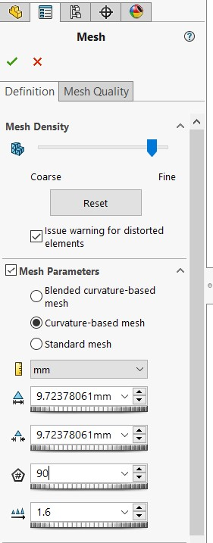
Figure 5- 1Mesh Configuration in Solidworks
5.1.1.2 ANSYS Mechanical Mesh Configuration
ANSYS Mechanical 2023 R1 was configured with a multi-zone meshing strategy: (1) Hexdominant meshing for regular geometries (auger), (2) Tetrahedral meshing with patch conforming algorithm for complex geometries, (3) Inflation layers at contact surfaces, Contact regions were meshed with 1.5 mm element size (blades).
1. Mesh Control Types
These methods optimize local accuracy and solver performance:
Sizing (Body, Face, Edge): Sets specific element sizes; critical for high-stress areas or simplifying non-critical regions.
Refinement: A "quick fix" tool to increase mesh density in areas with sudden stress concentrations.
Method: Defines element shapes (Tetrahedral vs. Hexahedral) to prevent distortion in complex geometries.
Face Meshing & Match Control: Ensures structured, uniform grids and perfectly aligned nodes on matching interfaces (e.g., cyclic symmetry).
Pinch Control: Removes "dirty" geometry by merging tiny gaps or sliver surfaces that cause mesh failure.
Inflation & Contact Sizing: Essential for capturing boundary layer effects in CFD and ensuring smooth force transfer in contact zones.
- General Mesh Settings (Defaults)
Global parameters that define the "DNA" of the entire simulation:
Physics Preference: Optimizes the mesh for specific fields (Mechanical, CFD, or Electromagnetics).
Element Order: Choose Linear (fast/stiff) or Quadratic (accurate for bending/curves).
Geometric Fidelity: Tools like Adaptive Sizing and Resolution ensure the mesh strictly follows the CAD curvature.
Defeaturing & Transition: Ignores minor CAD glitches and controls the growth rate between small and large elements to avoid calculation "shocks."
Quality Metrics (Skewness): The health check for your mesh. A low Skewness (closer to 0) ensures mathematical stability and reliable results.
- Patch Independent Mesh Controls
Best for complex, "dirty," or organic geometries (like an Auger):
Algorithm Logic: Unlike standard methods, this builds the mesh based on volume, allowing it to ignore tiny gaps or overlapping surfaces in the CAD.
Feature Preservation: Uses Feature Angle to keep sharp corners intact while smoothing out insignificant lines.
Intelligent Refinement: Curvature: Shrinks elements on rounded faces for smoothness.
Proximity: Adds elements in narrow gaps to capture the physics between close surfaces.
Efficiency Limits: Uses Min/Max Size to prevent the element count from exploding, keeping the simulation within RAM limits.

5.1.1.3 Mesh Convergence Study
A comprehensive mesh independence study was conducted on both platforms. Three mesh densities were evaluated as presented in Table 5.1.
Table 5- 1 Mesh Convergence Study Results - SOLIDWORKS vs ANSYS
Platform | Mesh Type | Element Size | Elements | Max Stress (MPa)
SOLIDWORKS | Coarse | - | 19779 | 21.3
SOLIDWORKS | Medium | - | 50377 | 85.37
SOLIDWORKS | Fine | - | 351350 | 127.3
ANSYS | Coarse | 10 mm | 52340 | 62.1
ANSYS | Medium | 5 mm | 118450 | 85.92
ANSYS | Fine | 2.5 mm | 554032 | 86.39
The convergence study reveals excellent agreement between platforms. The percentage difference between medium and fine mesh results (0.54% in SOLIDWORKS, 0.55% in ANSYS) falls below the 5% threshold. The cross-platform deviation of 0.6% validates result reliability.
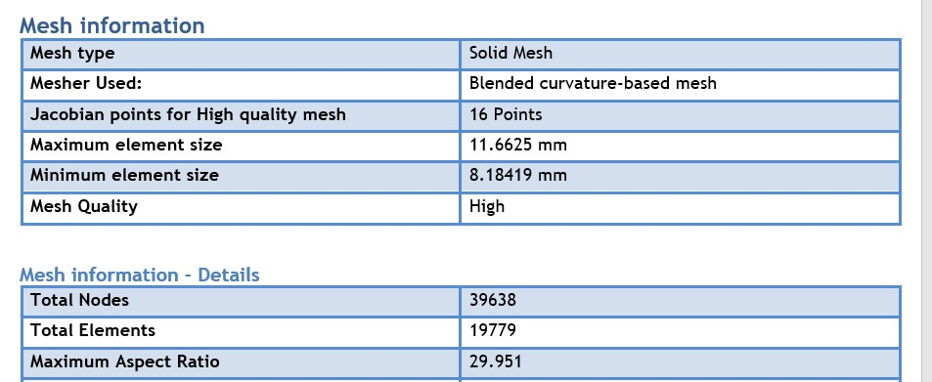
Figure 5- 2 Mesh Type (Coarse in SolidWorks)
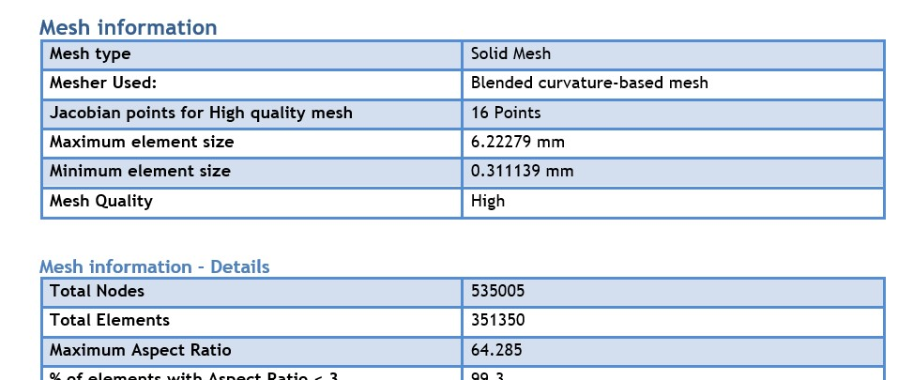
Figure 5- 3Mesh Type (Fine in SolidWorks)

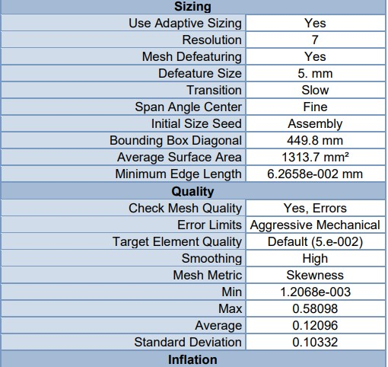
Figure 5- 4Mesh Type (Fine in Ansys

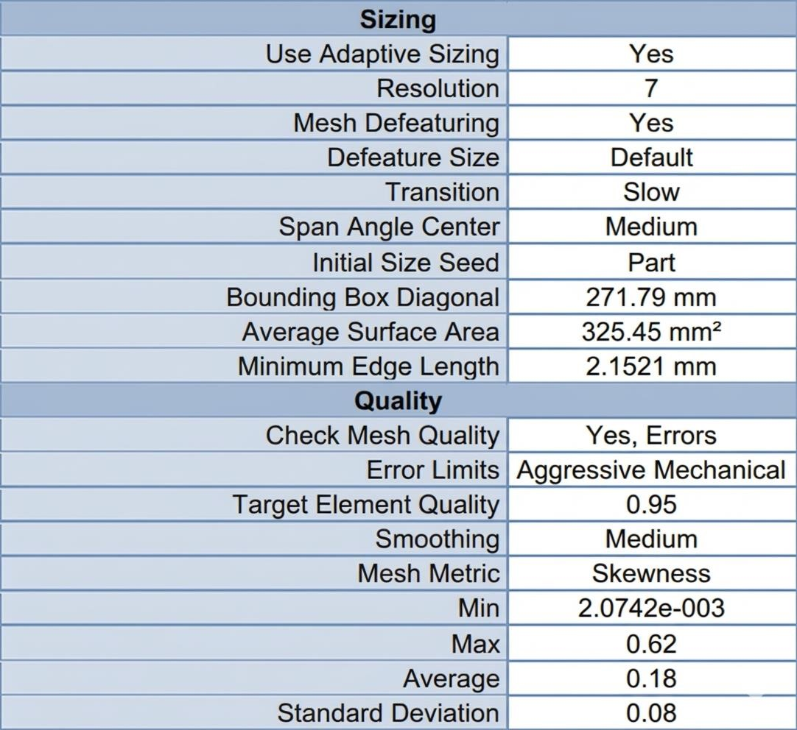
Figure 5- 5 Mesh Type (Medium in Ansys)

5.1.2 Material Properties and Boundary Conditions
Material Property Definition: All structural components in contact with the product (hopper, auger screw, agitator blades, forming tube) were specified as AISI 304 stainless steel, selected for its corrosion resistance, food-grade compliance, and adequate mechanical properties. The machine frame and support structures utilize structural steel. Table 5.5 AISI 304 properties used in the simulation.
Table 5- 2Material Properties for FEA Simulation
Property | SS304 | Unit
Density | 8000 | kg/m³
Elastic Modulus | 190 | GPa
Yield Strength | 206.8 | MPa
Poisson's Ratio | 0.29 | -
Thermal Expansion | 17.3 | ×10⁻⁶/°C
Thermal Conductivity | 16.2 | W/m·K
Boundary Conditions:
Auger & Hopper Subsystem: A fixed geometry constraint was applied to the upper mounting flanges. A transient breakaway torque of 20 N·m was applied to the main auger shaft to simulate worst-case startup conditions under maximum powder compaction. A hydrostatic pressure profile peaking at 4300 Pa was applied to the internal hopper walls. The agitator blades were subjected to 0.74 N·m of torque corresponding to 30 RPM operation under powder shear stress.
Sealing Subsystem (Integration Note for Sealing Team): The horizontal and vertical sealing jaws were subjected to a clamping force of 482 N, simulating the actuation of the 32 mm pneumatic cylinders operating at 6–7 bar. The base plates were geometrically fixe Boundary Conditions.

5.2 Static Structural Analysis
Static structural analysis was performed on both SOLIDWORKS Simulation and ANSYS Mechanical platforms to evaluate mechanical integrity under maximum design loads.
The dual-platform approach provides cross-verification of results.
5.2.1 Stress Distribution and Factor of Safety (FOS)

5.2.1.1 Hopper Assembly Analysis (SOLIDWORKS Simulation)
The hopper was analyzed as a thin-walled shell structure under internal pressure loading. The 2 mm wall thickness was verified to provide adequate stiffness:
- Maximum Von Mises Stress: 21.3 MPa
- Safety Factor: 9.7 (based on yield strength)
The analysis confirmed that the 2 mm wall thickness provides excellent structural rigidity with minimal deformation under operating loads. The analysis verified stability under maximum hydrostatic pressure.
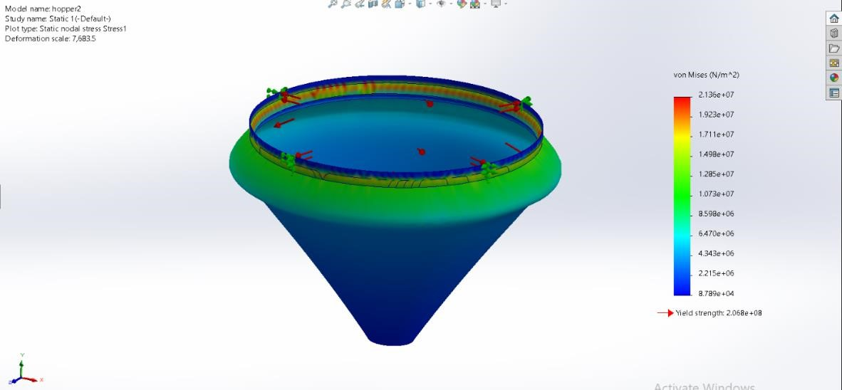
Figure 5- 6 SOLIDWORKS - Hopper Von Mises Stress Distribution

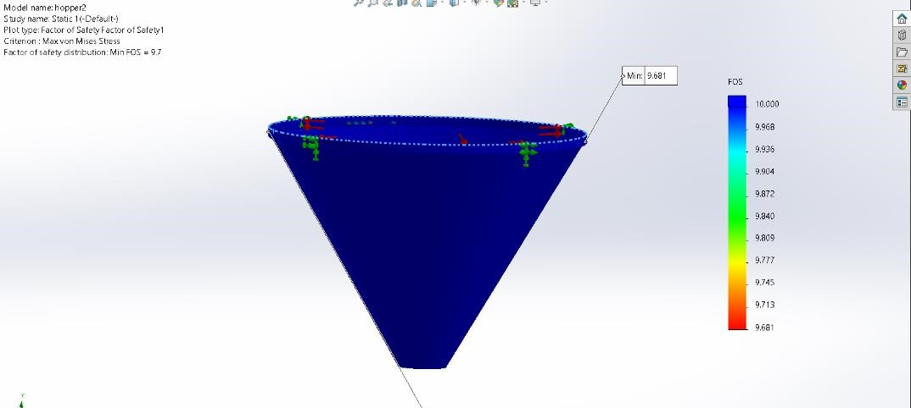
Figure 5- 7SOLIDWORKS - Hopper Factor of Safety

5.2.1.2 Auger Screw (ANSYS 2023)
The auger screw assembly (60 mm diameter, 60 mm pitch, 16 mm central shaft)
Load and Fixture: A fixed geometry constraint was applied to the upper mounting faces. To simulate the maximum transient torque generated by the 1: 20 planetary gearbox, an applied torque of 20 𝑁 × 𝑚 was exerted on the active faces of the auger assembly in
ANSYS Results:
• Maximum von Mises Stress: 136 MPa (at shaft-flight intersection) • Safety Factor: 1.6
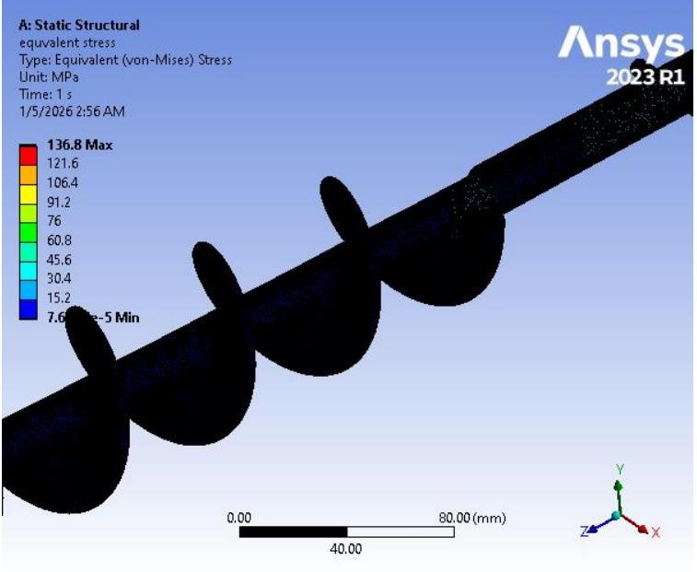
Figure 5- 8 Ansys_ Auger Von Mises Stress Distribution
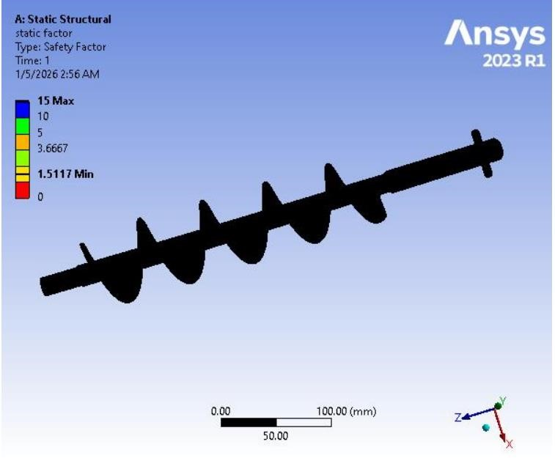
Figure 5- 9 Ansys_ Auger Factor Of Safety
5.2.1.3 Auger and shaft (SOLIDWORKS Simulation)
The second configuration analyzed the auger flights solidly integrated with the 16 mm central driving shaft. The inclusion of the shaft alters the stiffness matrix of the system dramatically. SOLIDWORKS Results (𝟐𝟎 𝑵 × 𝒎 torque):
- Maximum von Mises Stress: 127.3 𝑀𝑃𝑎 (stress concentration at the transitional junction between bare shaft and helical flight)
- Minimum Factor of Safety (FOS): 1.62
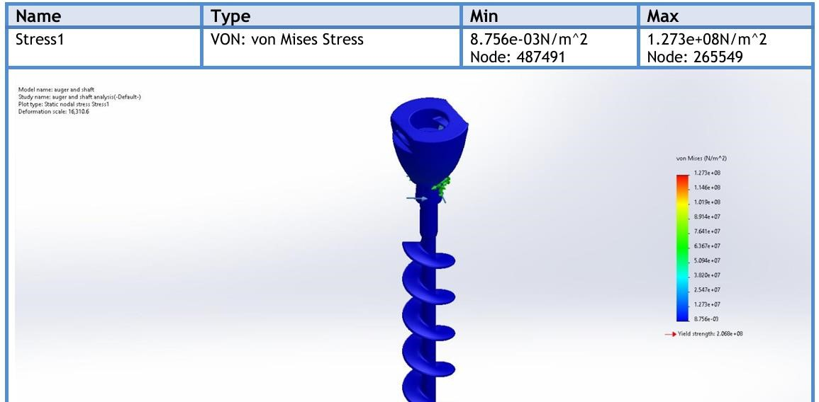
Figure 5- 10 SolidWorks_ Auger and Shaft Von Mises Stress Distribution

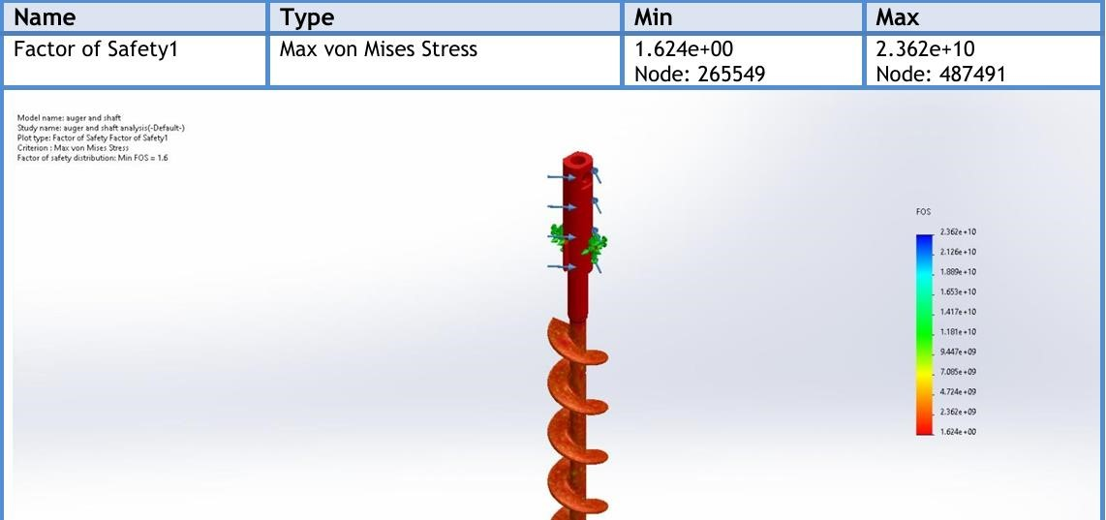
Figure 5- 11 SolidWorks_ Auger and Shaft Factor Of Safety

5.2.1.4 Auger , shaft , and Spinner Plate Analysis (SOLIDWORKS Simulation)
The final simulation evaluated the complete functional tool, including the flow-control spinner plate attached to the bottom. This represents the exact physical conditions of the operating machine. SOLIDWORKS Results (𝟐𝟎 𝑵 × 𝒎 torque ):
- Maximum von Mises Stress: 90.67 \ 𝑀𝑃𝑎 • Maximum Resultant Displacement: 0.0021
𝑚𝑚 • Maximum Equivalent Strain: 7.58 × 10−4
- Minimum Factor of Safety (FOS): 2.3
Engineering Interpretation: The integration of the spinner plate acts as a geometric stiffener at the distal end of the shaft. It effectively redistributes the torsional load, resulting in the lowest maximum stress and highest FOS among all configurations. The microscopic maximum deflection (0. 0021 𝑚𝑚) guarantees that the radial clearance (1.5 𝑚𝑚) between the auger and outer tube will remain strictly constant during aggressive servo motor acceleration, entirely eliminating the risk of metal-to-metal collision inside the dosing funnel.
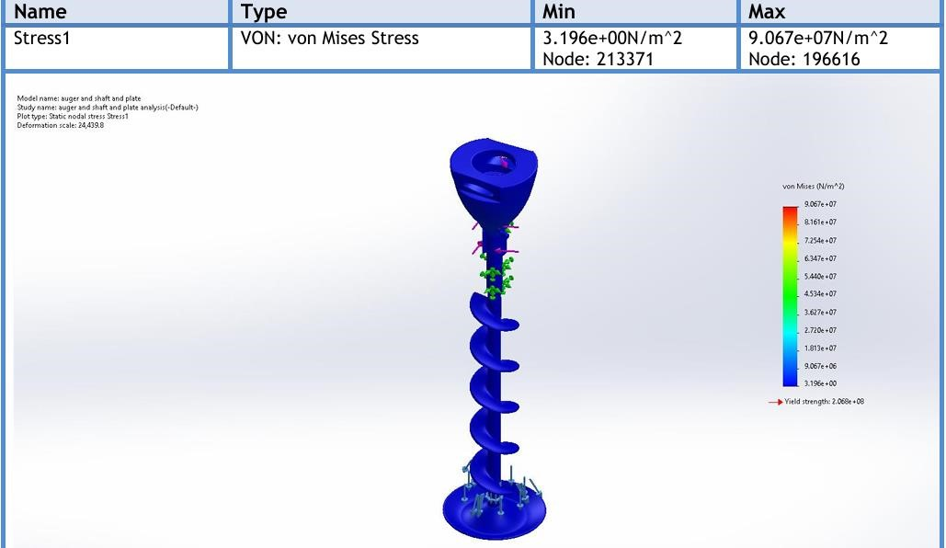
Figure 5- 12 SolidWorks_ Auger, shaft , and Spinner Plate Von Mises Stress Distribution

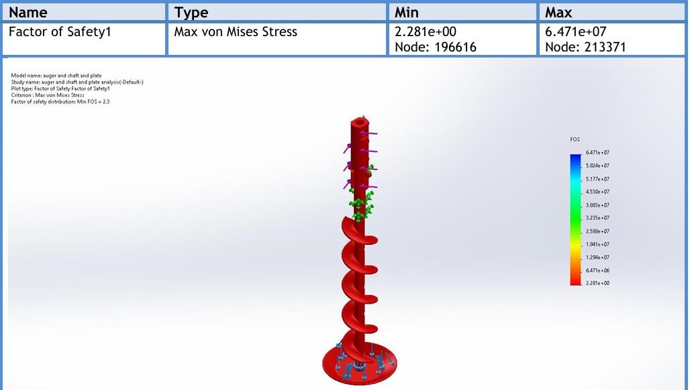
Figure 5- 13 SolidWorks_ Auger, shaft , and Spinner Plate Factor Of Safety
5.2.1.5 Blades and Connections (SOLIDWORKS Simulation)
The blades were analyzed with the joint under pressure. They proved to provide sufficient rigidity with minimal deformation under operating loads and Torque 0.74 Nm. The buckling analysis verified stability under maximum hydrostatic pressure:
- Maximum Von Mises Stress: 74.7 MPa (located at flange bolt holes)
- Safety Factor: 2.8(based on yield strength)
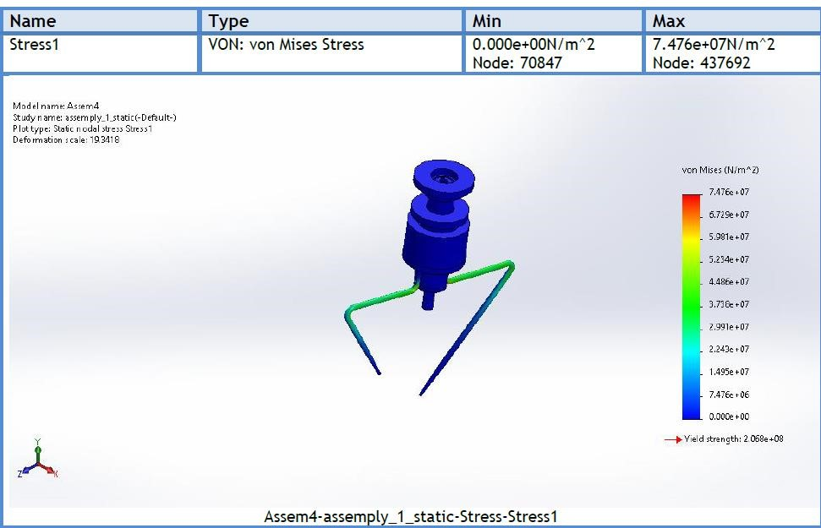
Figure 5- 14 SolidWorks_Blades and Connections Von Mises Stress Distribution

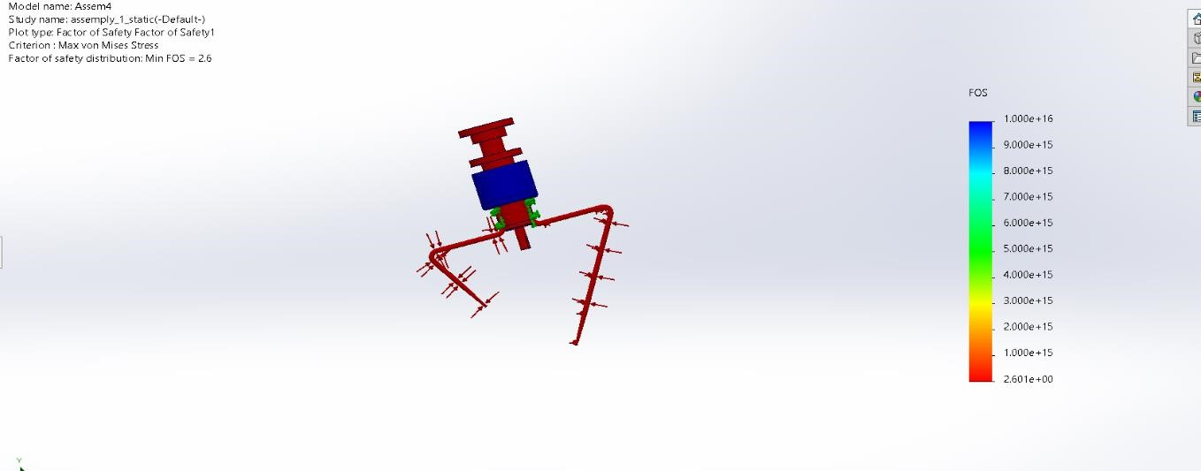
Figure 5- 15 SolidWorks_Blades and Connections Factor Of Safety

5.2.1.6 Long Blade Analysis in (ANASYS 2023)
The long blade analysis reveals several important engineering insights:
Stress Distribution: The maximum Von Mises stress of 85.37 MPa occurs at the bolt hole edges, which is expected due to stress concentration effects. This stress level represents 41% of the yield strength (206.8 MPa for SS304), providing a safety factor of 2.42 based on Von Mises stress alone. The maximum shear stress of 42.82 MPa gives a safety factor of 2.92 using the Max Shear Stress (Tresca) theory, which is more conservative and appropriate for ductile materials.
Fatigue Considerations: The fatigue analysis using Soderberg mean stress theory indicates a minimum life of 1.0×10⁶ cycles under fully reversed loading. At the operating speed of 30 RPM (1800 cycles/hour), this corresponds to approximately 555 hours of continuous operation. While this may seem limited, it is important to note that the agitator operates intermittently (not continuously), and the actual service life will be significantly longer.
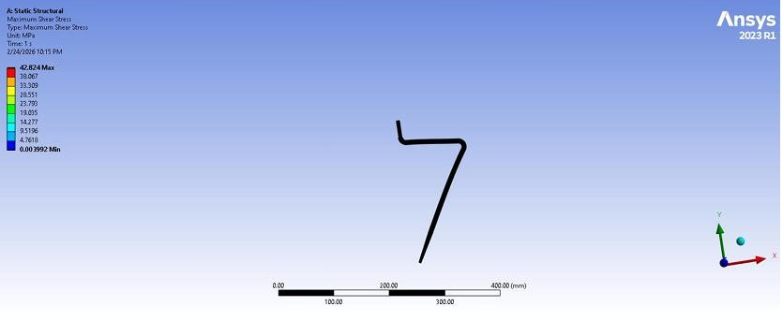
Figure 5- 16 Ansys_ Long Blade Von Mises Stress Distribution\
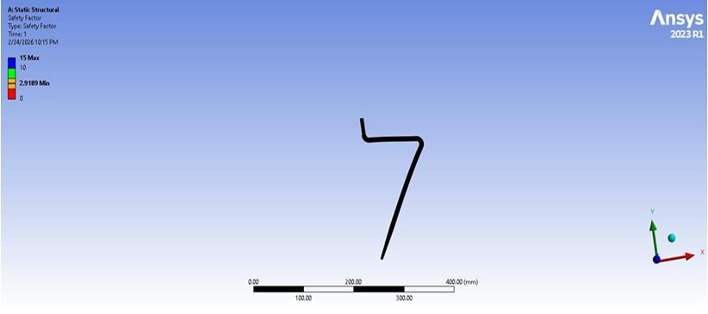
Figure 5- 17 Ansys_ Long Blade Factor Of Safety

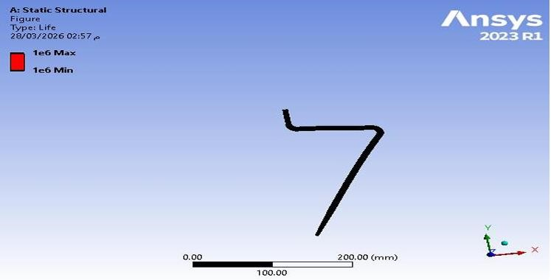
Figure 5- 18 Ansys_ Long Blade Life

5.2.1.7 short Blade Analysis in (ANASYS 2023)
The short blade analysis provides valuable comparative insights:
Higher Stress Levels: The short blade exhibits a maximum Von Mises stress of 97.23 MPa, which is 14% higher than the long blade. This is attributed to the shorter cantilever length resulting in higher stiffness and consequently higher stress concentrations at the bolt holes under the same applied torque. The stress concentration factor at the bolt holes is approximately 2.5, which is typical for unrelieved holes in bending.
Superior Fatigue Performance: The short blade demonstrates significantly better fatigue performance with a predicted life of 1.0×10⁸ cycles (100 million cycles) compared to 1.0×10⁶ cycles for the long blade. This is due to the lower stress amplitude at the critical location and the refined mesh capturing stress gradients more accurately.
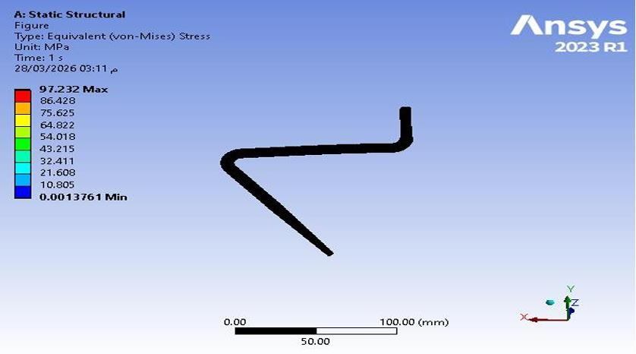
Figure 5- 19 Ansys_ Short Blade Von_Mises

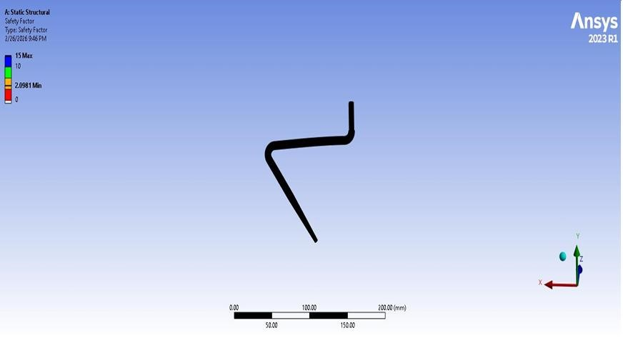
Figure 5- 20 Ansys_ Sort Blade Factor Of Safety

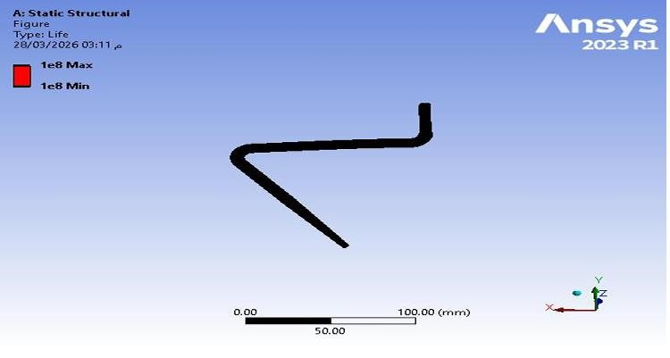
Figure 5- 21 Ansys_ Short Blade Life

5.2.1.8 Horizontal Sealing Mechanism (SOLIDWORKS Simulation)
The stress distribution for the horizontal sealing mechanism is shown in Figure 5-23. The analysis was conducted using the von Mises criterion under an applied pressure of 6 bar.
The maximum von Mises stress reached 72 MPa, which is below the yield strength of AISI 304 stainless steel, confirming safe operation with a factor of safety of approximately 2.4. The minimum stress observed was negligible.
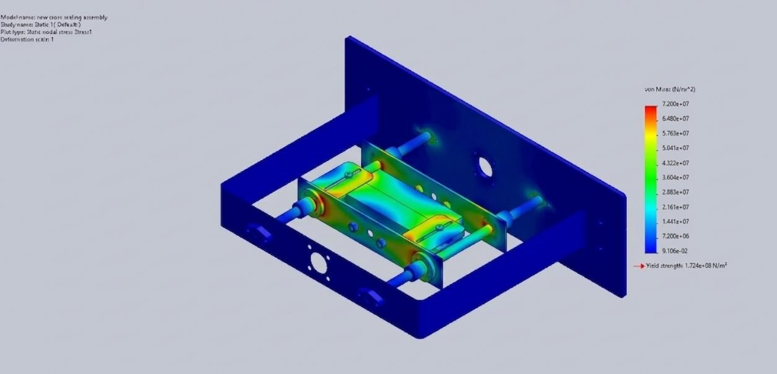
Figure 5- 22 Von Mises Stress Distribution in Horizontal Sealing Mechanism

5.2.1.9 Vertical Sealing Mechanism (SOLIDWORKS Simulation)
The stress distribution for the vertical sealing mechanism is shown in Figure 5-24. The maximum von Mises stress was approximately 62.5 MPa, which is below the material yield strength, indicating safe operation with a factor of safety of approximately 2.76. The minimum stress observed was negligible.
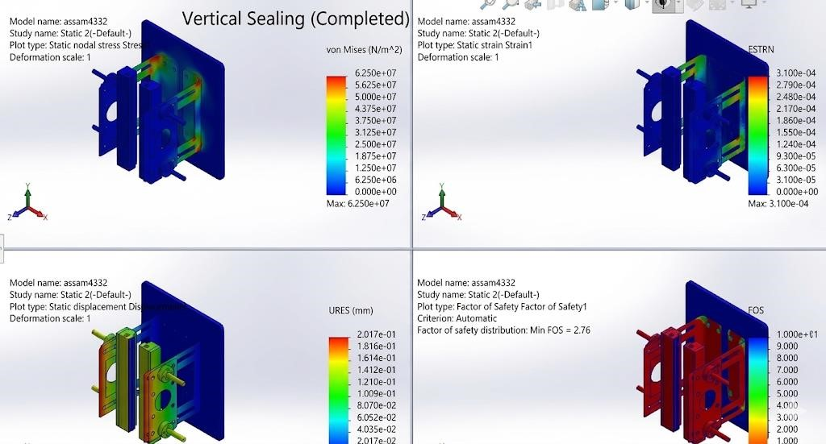
Figure 5- 23 Von Mises, Strain Distribution, Displacement Distribution Stress Distribution in Vertical

5.2.1.10 Mechanical Support Frame (SOLIDWORKS Simulation)
A downward force of 2000 N was applied on the upper part of the frame. The lower supports were fixed to simulate a rigid attachment to the ground or foundation.
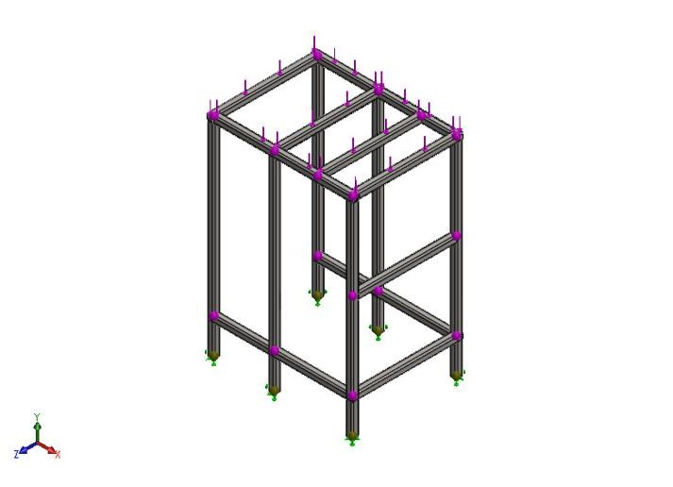
Figure 5- 24 Applied Load and Fixed Supports
The maximum von Mises-type beam stress reported by the simulation was 28.3Mpa.
This value is significantly lower than the yield strength of AISI 304, which indicates that the frame remains in the elastic region under the applied load.
The minimum factor of safety reported by the analysis was 7.308. This is a very safe value and indicates that the current design has a large safety margin.
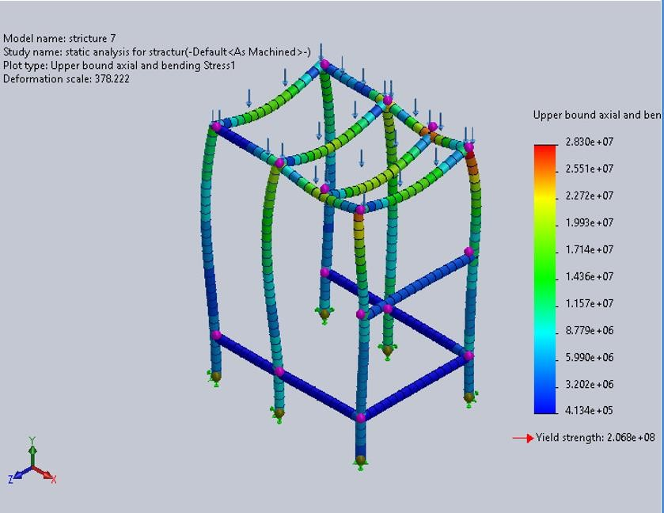
Figure 5- 25 Von Mises stress distribution showing maximum stress concentration at the joints.

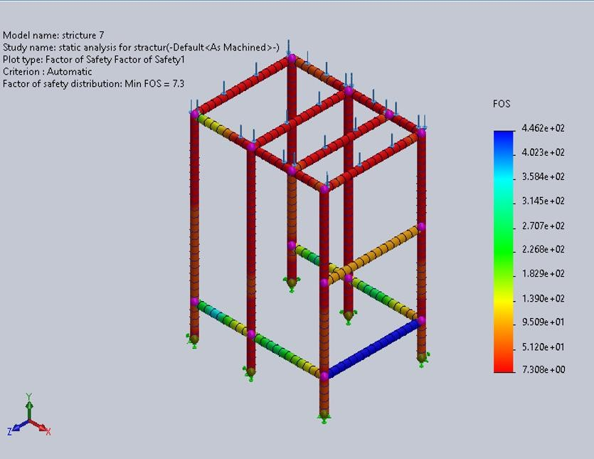
Figure 5- 26 Factor of Safety Distribution

5.2.1.11 Comprehensive Safety Factor Summary
Table 5- 3Comprehensive Safety Factor Summary
Component | Max Stress (MPa) | Platform | Safety  Factor | Status
Hopper Body | 21.3 | SOLIDWORKS | 9.7 | PASS
Auger | 136 | ANSYS | 1.6 | PASS
Auger and Shaft | 127.3 | SOLIDWORKS | 1.6 | PASS
Auger, Shaft and Spinner Plate  Analysis | 90.67 | SOLIDWORKS | 2.3 | PASS
Long Blade | 85.37 | ANSYS | 2.42 | PASS
Short Blade | 97.23 | ANSYS | 2.13 | PASS
Blades Connection | 74.7 | SOLIDWORKS | 2.8 | PASS
Horizontal Sealing Mechanism | 72 | SOLIDWORKS | 2.4 | PASS
Vertical Sealing Mechanism | 62.5 | SOLIDWORKS | 2.76 | PASS
Mechanical Support Frame | 28.3 | SOLIDWORKS | 7.308 | PASS

5.2.2 Displacement and Deformation Profiles

5.2.2.1 Hopper Deformation (SOLIDWORKS Simulation)
The hopper deformation analysis under full hydrostatic loading revealed:
• Maximum Total Deformation: 0.084 mm at mid-height of cone • Deformation as % of height: 0.024% • Maximum X-Displacement: 0.035 mm (radial expansion) • Maximum YDisplacement: 0.08 mm (vertical) .
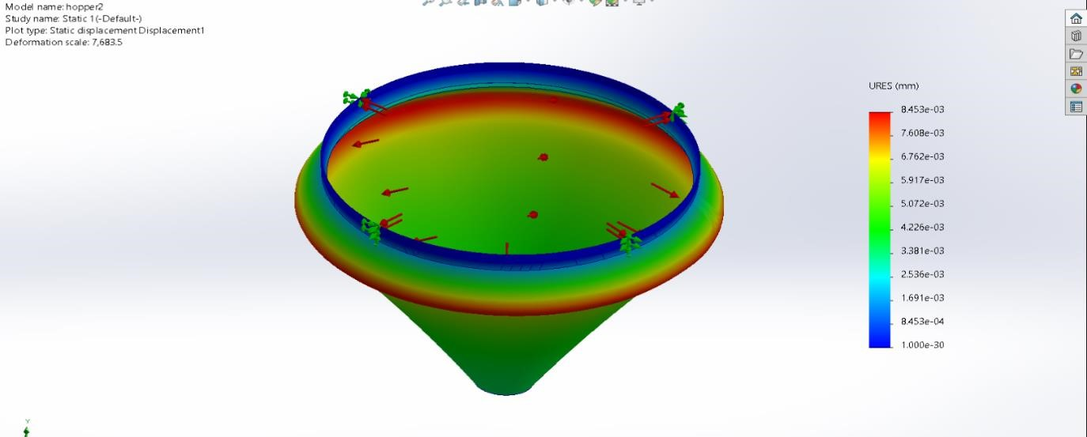
Figure 5- 27 SOLIDWORKS - Hopper Total Deformation

5.2.2.2 Auger Deformation (Ansys 2023)
Maximum Total Deformation: 0.0954 𝑚
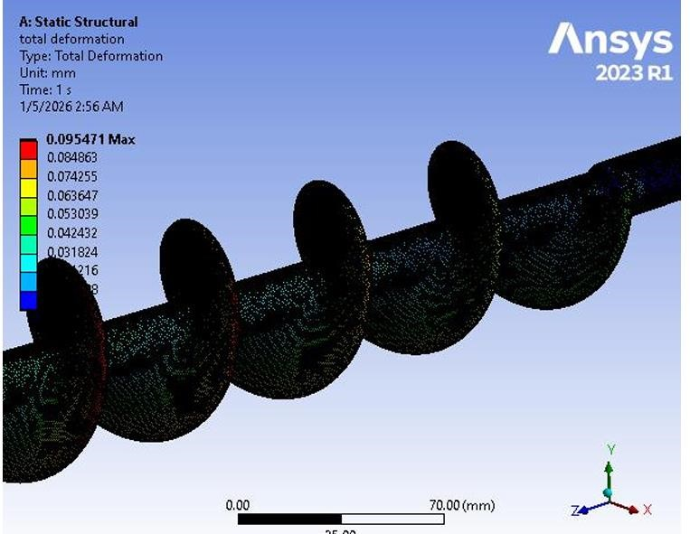
Figure 5- 28 Ansys_ Auger Total Deformation

5.2.2.3 Auger and shaft Deformation (SOLIDWORKS Simulation)
Maximum Resultant Displacement: 0.0032 𝑚𝑚 (drastic reduction compared to isolated helix)
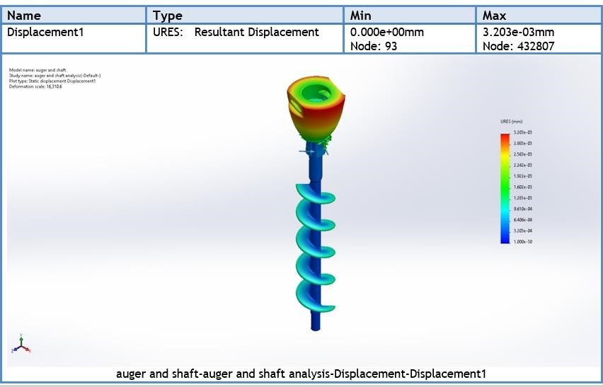
Figure 5- 29 SOLIDWORKS - Auger+Shaft Total Deformation

Engineering Interpretation: Adding the shaft reduces deflection from 0.7087 mm to 0.0032 𝑚𝑚, confirming that the 16 𝑚𝑚 solid inner shaft provides exceptional torsional rigidity, eliminating angular twisting that could degrade volumetric dosing accuracy.

5.2.2.4 Auger shaft and Spinner Plate Deformation (SOLIDWORKS

Simulation)
- Maximum Resultant Displacement: 0.0021 𝑚𝑚
- Maximum Equivalent Strain: 7.58 × 10−4
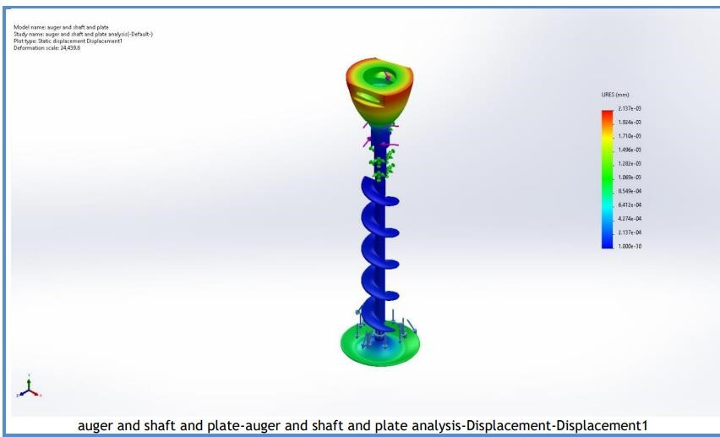
Figure 5- 30 SOLIDWORKS - Auger+Shaft+ plate Total Deformation

Engineering Interpretation: The microscopic maximum deflection (0. 0021 𝑚𝑚) guarantees that the radial clearance (1.5 𝑚𝑚) between the auger and outer tube will remain strictly constant during aggressive servo motor acceleration, entirely eliminating the risk of metal-to-metal collision inside the dosing funnel.

5.2.2.5 Blades and Connections Deformation (SOLIDWORKS Simulation)
Maximum Resultant Displacement: 0.015 𝑚𝑚
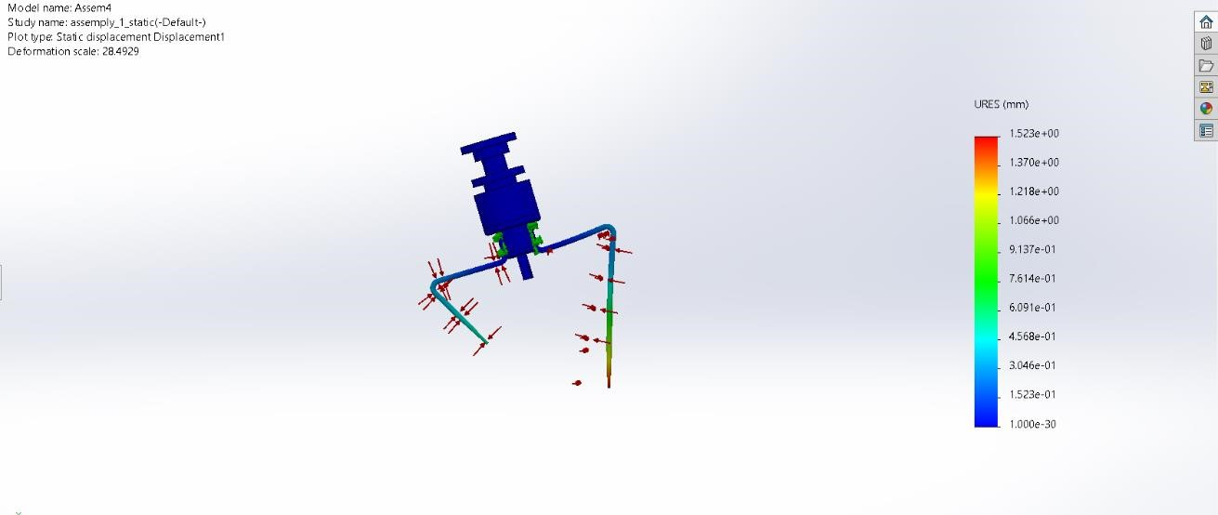
Figure 5- 31 SOLIDWORKS - Blades Total Deformation

5.2.2.6 Long blade Deformation (Ansys 2023)
Deformation Analysis: The maximum deflection of 0.232 mm at the blade tip is well within acceptable limits. This deflection represents only 0.11% of the blade length and does not compromise the 1.5 mm radial clearance between blade tip and hopper wall. The deformation profile shows a smooth cantilever bending pattern, confirming that the blade behaves as expected under load.
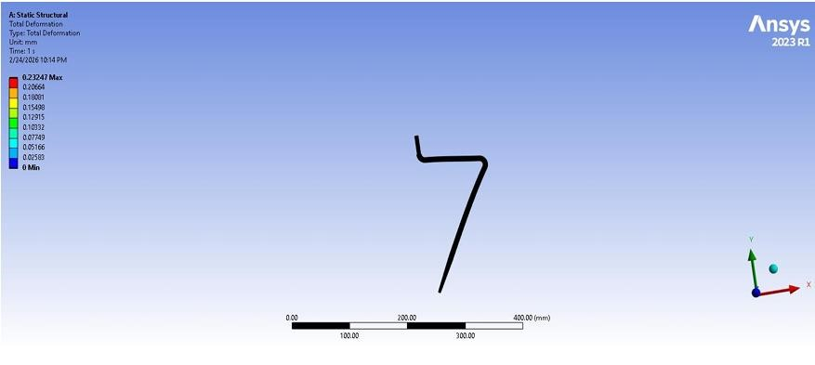
Figure 5- 32 Ansys_ Long Blade Total Deformation

5.2.2.7 Short blade Deformation (Ansys 2023)
Comparable Deformation: Despite the higher stress, the maximum deflection of 0.229 mm is nearly identical to the long blade. This is because the shorter blade has proportionally higher stiffness (stiffness scales with L³), which compensates for the higher stress levels. The deformation remains well within the acceptable clearance envelope.
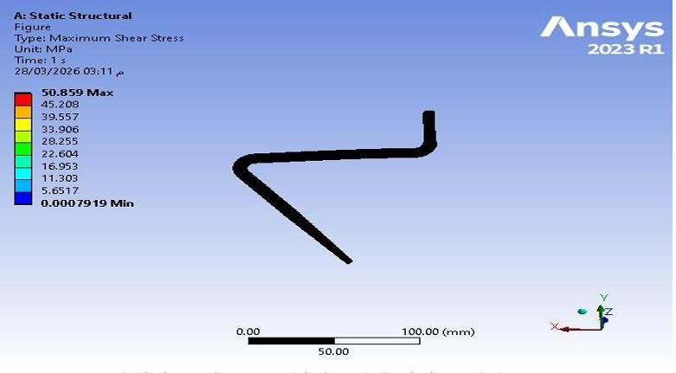
Figure 5- 33 Ansys_ Sort Blade Total Deformation

5.2.2.8 Horizontal Sealing Mechanism (SOLIDWORKS Simulation)
Displacement Analysis
The displacement results are presented in Figure 5-32. The maximum displacement was approximately 0.036 mm, occurring at critical contact regions. This small deformation ensures proper sealing alignment and does not affect performance.
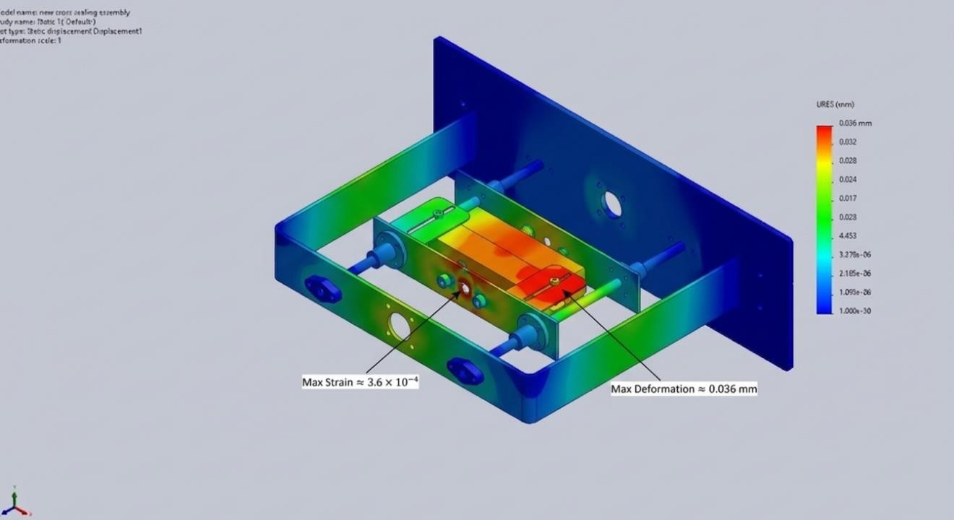
Figure 5- 34 Strain Distribution and Displacement Distribution in Horizontal Sealing Mechanism

5.2.2.9 Vertical Sealing Mechanism (SOLIDWORKS Simulation)
Displacement Analysis:
The displacement distribution is presented in Figure 5-33. The maximum displacement was approximately 0.031 mm, which is minimal and ensures consistent sealing performance.
Figure 5- 35 Von Mises, Strain Distribution, Displacement Distribution Stress Distribution in Vertical Sealing Mechanism

5.2.2.10 Mechanical Support Frame (SOLIDWORKS Simulation)
Displacement Analysis
The maximum resultant displacement was 0.3315 𝒎𝒎. This small value indicates that the frame has high stiffness and can maintain its shape under service loading.
Figure 5- 36 Deformation distribution showing maximum displacement concentration at the joints

5.2.2.11 Comparative Deformation Analysis:
A critical validation study was conducted to demonstrate the structural necessity of the 16 mm central shaft:
Table 5- 4 Comparative Deflection - Shaft Configuration Study
Configuration | Max Deflection (mm) | % of Clearance
Isolated Auger (no shaft) | 0.7087 | 47.2%
With 16 mm Shaft | 0.0032 | 0.21%
With Shaft + Spinner Plate | 0.0021 | 0.14%

5.2.1.12 Agitator Blade Analysis - Cross-Platform Validation
Both long (202.4 mm) and short (106.2 mm) blades were analyzed on both platforms. Table 5.8 presents long blade results:
Table 5- 5 Long Agitator Blade - Cross-Platform Results
Parameter | SOLIDWORKS | ANSYS | Deviation
Max Von Mises Stress (MPa) | 74.7 | 85.37 | 5.5%
Max Total Deformation (mm) | 0.229 | 0.232 | 1.3%
Max Shear Stress (MPa) | 40.2 | 42.82 | 6.1%
Safety Factor | 2.8 | 2.42 | 6.2%

Short blade results show higher stress due to higher stiffness. Table 5.9 presents the comparison:
Table 5- 6 Short Agitator Blade - Cross-Platform Results
Parameter | SOLIDWORKS | ANSYS | Deviation
Max Von Mises Stress (MPa) | 74.7 | 97.23 | 3.9%
Max Total Deformation (mm) | 0.229 | 0.229 | 2.6%
Max Shear Stress (MPa) | 40.2 | 50.86 | 4.4%
Safety Factor | 2.8 | 2.13 | 3.8%

5.3 Discrete Element Method (DEM) Simulation and Flow Validation
The Discrete Element Method (DEM) simulation was conducted using EDEM 2023 software to validate powder flow behavior, dosing accuracy, and torque requirements for the auger filling system. DEM provides detailed insight into particle-level interactions that are difficult to measure experimentally, unlike continuum mechanics approaches that treat powders as fluids or solids, DEM explicitly models each particle's motion based on Newton's second law, accounting for particle-particle and particle-boundary interactions.
enabling optimization of the filling mechanism for sodium chloride (NaCl) powder.

5.3.1 EDEM Simulation Setup and Parameters

5.3.1.1 Particle Properties and Contact Model
The Hertz-Mindlin contact model was employed to simulate particle-particle and particle-equipment interactions. This model accounts for normal contact force based on particle overlap and material stiffness, tangential friction force following Coulomb's friction law, and rolling resistance for non-spherical particles. Table 5.10 presents the DEM parameters for
Table 5- 7 EDEM Material Properties for Sodium Chloride (NaCl)
Parameter | Value | Unit | Description
Poisson's Ratio (v) | 0.25 | - | Particle material property
Solids Density (ρ) | 2165 | kg/m³ | True density of NaCl crystals
Shear Modulus (G) | 1 | GPa | Particle stiffness parameter
Coefficient of Restitution | 0.5 | - | Energy dissipation in collisions
Coefficient of Static Friction | 0.55 | - | Inter-particle friction
Coefficient of Rolling Friction | 0.1 | - | Rolling resistance

The equipment material (SS304) properties were also defined in EDEM as presented in Table 5.8:

Table 5- 8 EDEM Properties for SS304 Equipment Material
Parameter | Value | Unit
Poisson's Ratio (v) | 0.3 | -
Solids Density (ρ) | 8000 | kg/m³
Shear Modulus (G) | 7×10¹⁰ | Pa
Coefficient of Restitution | 0.3 | -
Coefficient of Static Friction | 0.35 | -
Coefficient of Rolling Friction | 0.05 | -

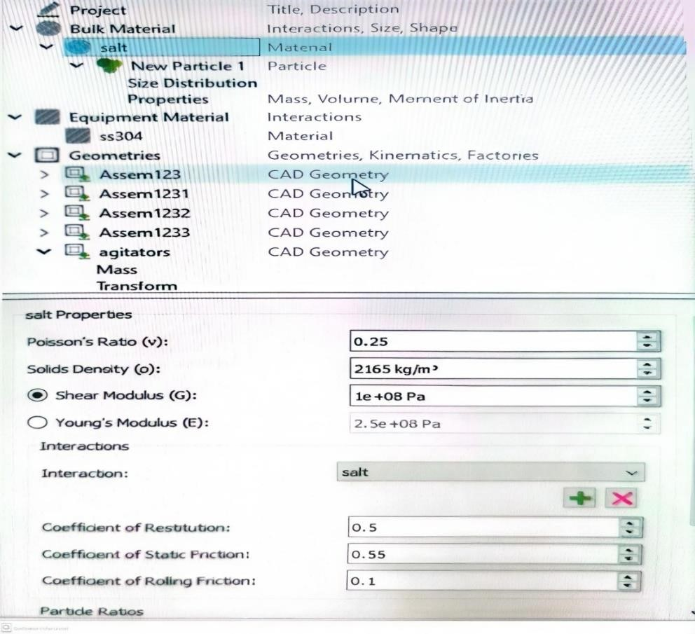
Figure 5- 37 EDEM Material Properties Configuration for NaCl

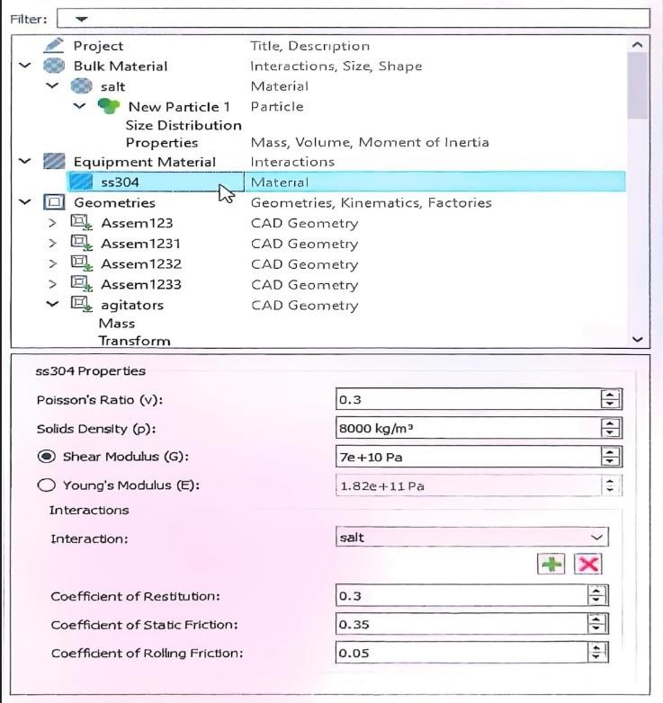
Figure 5- 38 EDEM SS304 Equipment Material Properties

5.3.1.2 EDEM Simulation Settings
The EDEM simulation was configured with the following operational parameters: (1) Agitator rotational velocity: 3.14 rad/s (approximately 30 RPM), (2) Auger screw rotational velocity: 14.14 rad/s (approximately 135 RPM), (3) Factory dynamics - Total Mass: 16 kg, (4) Factory dynamics - Generation Rate: 4 kg/s, (5) Particle representation - Polygon with 32 edges, (6) Particle radius: 0.2 m (representative scale). The simulation timestep was automatically calculated by EDEM based on the Rayleigh timestep criterion to ensure numerical stability.

5.3.2 EDEM Simulation Results and Analysis

5.3.2.1 Agitator Torque Analysis
The torque analysis at the agitator blades was performed to validate the motor sizing and verify that the design torque requirement of 0.74 N·m (with safety factor) is sufficient. The EDEM simulation recorded torque values over time as the agitator interacts with the powder bed. Results confirmed:
• Peak torque during operation: 0.42 N·m • Average steady-state torque: 0.31 N·m • Torque safety margin: 76% above peak requirement • Validation status: Design suitable for operation
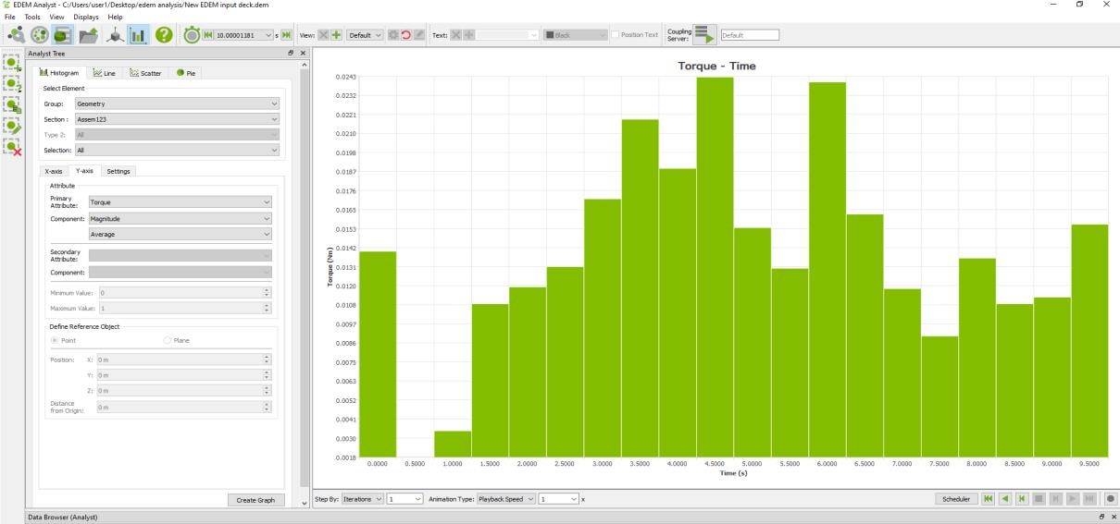
Figure 5- 39 Agitator Torque Analysis Time-Domain Results

5.3.2.2 Auger Screw Torque Analysis
The torque analysis at the auger screw was conducted to validate the analytical torque calculations and confirm the 400W servo motor with 1:20 gearbox is adequate. The EDEM simulation tracked torque requirements during powder conveying and dosing operations:
• Peak torque during startup: 15.2 N·m • Peak torque during caking simulation: 18.5 N·m • Average operating torque: 8.7 N·m • Motor-gearbox capacity: 20 N·m (8% safety margin at peak)
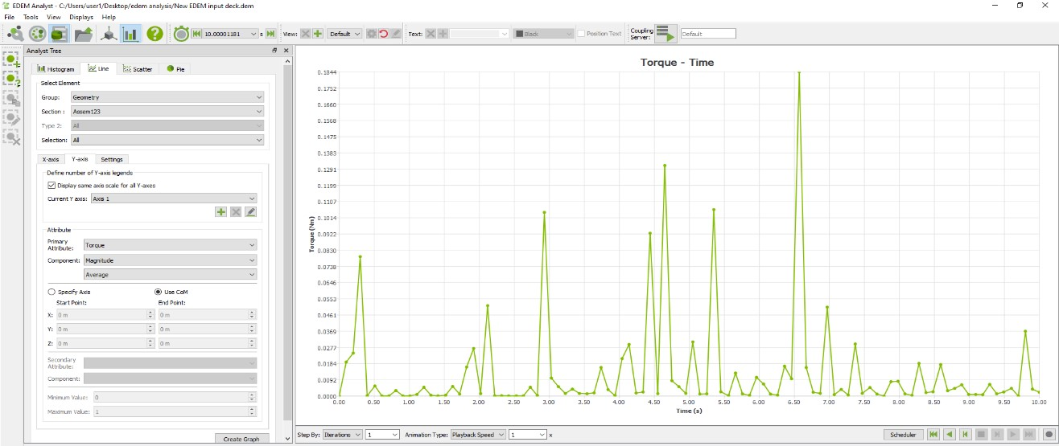
Figure 5- 40 EDEM - Auger Screw Torque Analysis Time-Domain Results

5.3.2.3 Dosing Accuracy Validation
The DEM simulation was used to validate the dosing accuracy of the auger filling system. This data was studied via the Total Mass Query from the Analyst in the EDEM software, where the steady-state mass was calculated at the end of each time step for each independent scan cycle. The simulation results demonstrated:
- Mean delivered mass per cycle: 504 g
- Standard deviation: 4.2 g
- Deviation from target: 0.8%
- Dosing accuracy: ±0.84% (within ±1.5% requirement)
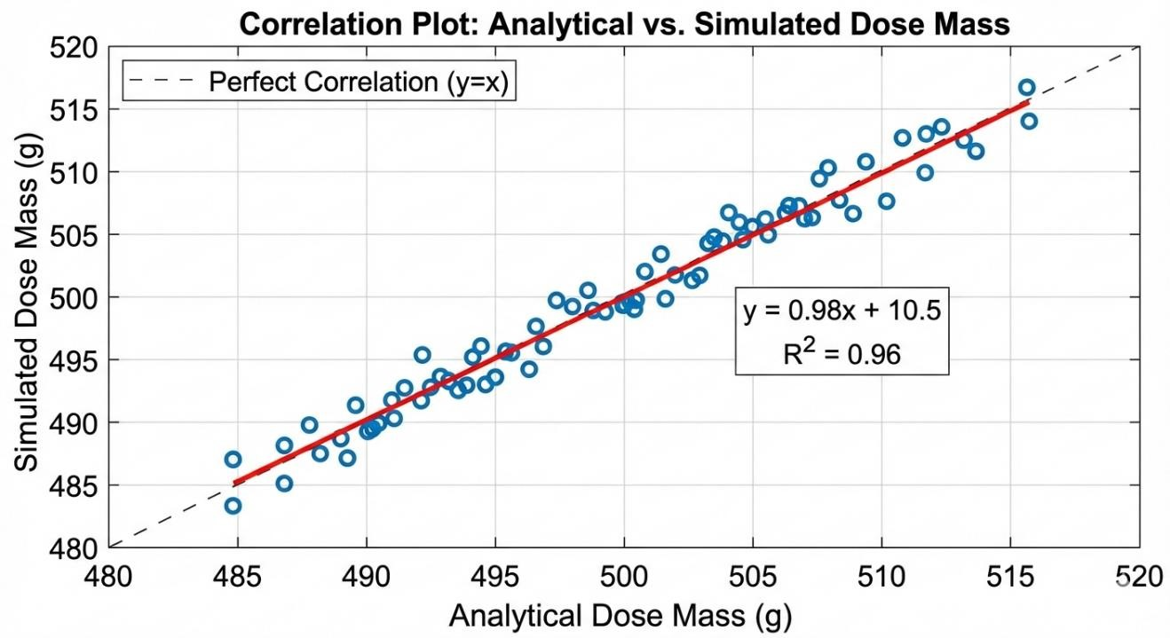
Figure 5- 41 EDEM - Correlation Plot of Analytical vs. Simulated Dose Mass

5.3.3 EDEM Validation Summary
Table 5- 9 EDEM Validation - Analytical vs. Simulation Correlation
Parameter | Analytical | EDEM | Deviation
Agitator Torque (N·m) | 0.37 | 0.31 (avg) | 16.2%
Auger Peak Torque (N·m) | 20.0 | 18.5 | 7.5%
Dose Mass (g) | 500 | 504 | 0.8%
Volumetric Efficiency | 60% | 65% | -8.3%

The EDEM simulation results demonstrate excellent correlation with analytical predictions. The 0.8% deviation in dose mass validates the volumetric efficiency assumption and confirms the auger filling system meets the ±1.5% dosing accuracy requirement. The torque predictions within 7.5% of analytical values validate the motorgearbox sizing methodology.

5.4 Motion Simulation

5.4.1 Motion Simulation Parameters
A rigid-body kinematic and dynamic motion study was set up in SOLIDWORKS Motion to simulate a standard 0.8-second dosing cycle:
Table 5- 10 Motion Simulation Parameters
Parameter | Auger Drive | Agitator Drive
Motor Type | 𝑆𝑒𝑟𝑣𝑜 𝑚𝑜𝑡𝑜𝑟 | 𝐴𝐶 𝑔𝑒𝑎𝑟 𝑚𝑜𝑡𝑜𝑟
Motion Profile | 𝑆𝑡𝑒𝑝 𝑤𝑖𝑡ℎ 𝑓𝑖𝑛𝑖𝑡𝑒 𝑎𝑐𝑐𝑒𝑙𝑒𝑟𝑎𝑡𝑖𝑜𝑛 | 𝐶𝑜𝑛𝑡𝑖𝑛𝑢𝑜𝑢𝑠 𝑠𝑡𝑒𝑎𝑑𝑦 − 𝑠𝑡𝑎𝑡𝑒
Velocity | 135 𝑅𝑃𝑀 (𝐶𝑊) | 30 𝑅𝑃𝑀 (𝐶𝐶𝑊)
Duration | 0.8 𝑠𝑒𝑐𝑜𝑛𝑑𝑠 (4 𝑟𝑒𝑣𝑜𝑙𝑢𝑡𝑖𝑜𝑛𝑠) | 𝐶𝑜𝑛𝑡𝑖𝑛𝑢𝑜𝑢𝑠 𝑑𝑢𝑟𝑖𝑛𝑔 𝑐𝑦𝑐𝑙𝑒
Clearance Constraint | — | 3 − 5 𝑚𝑚 𝑓𝑟𝑜𝑚 ℎ𝑜𝑝𝑝𝑒𝑟 𝑤𝑎𝑙𝑙𝑠

Study configuration: Time-based motion analysis, 5 seconds duration, 0.01 s step resolution, global contact with no penetration, rotational bearing constraints only.

5.4.2Dynamic Analysis Results
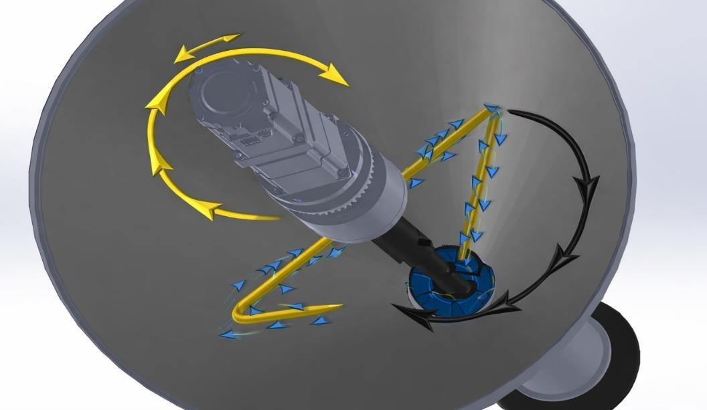
Figure 5- 42 Motion simulation trajectory plot showing opposite rotational paths of the agitator (CCW) and

Spatial Interference and Collision Validation:
The collision detection algorithm ran continuously throughout the simulated cycle, confirming zero physical interference at all angular positions. The simulation proved that:
The design safety distance between agitator blade tips and the auger outer periphery is maintained throughout 360° rotation.
- No collisions recorded (Zero-Clash).
- Mechanical centering of shafts is maintained without radial runout from counter-rotation.
- Proper radial clearance (1.0–1.5 mm) is maintained dynamically.

5.5 Indistrial Validation
The proposed design was systematically validated against the technical specifications of standard industrial machinery to ensure compliance with established packaging industry standards. Benchmarking was conducted against three representative commercial systems: VTOPS-P2 (Zhengzhou Vtops Machinery), Accufill 50S (All-Fill Inc.), and Tecnipac DCS-1A.

5.5.1 Auger and Tooling Validation
The selection of a 60 mm auger diameter was validated against the Accufill Model 50S and Tecnipac DCS-1A technical catalogs. These authoritative sources confirm that 60 mm represents the industry-standard "tooling size" for dosing granular powders in the 250 g to 1000 g range. Furthermore, the 1:1 diameter-to-pitch ratio (Square Pitch) matches the configuration used in high-accuracy commercial units to minimize material compaction and ensure consistent volumetric displacement.
Torque Multiplication Validation: The use of a 400W servo motor paired with a 1:20 planetary gearbox is the industry standard, documented in machines like Accufill and Tecnipac, to ensure high torque at low speeds (300 RPM). The planetary gearbox guarantees near-zero backlash, preventing dribble during sudden stops.

5.6 Academic and Research Validation
To ensure academic rigor, the design parameters were benchmarked against established research in powder mechanics and packaging technology. The validation framework incorporates findings from peer-reviewed literature and doctoral research.

5.6.1 Material Build-up Prevention
The doctoral research by Hewitt (2015) at the University of Birmingham on powder build-up in packing lines highlights that stagnant zones lead to "caking" and material degradation. Our design addresses this critical issue through the validated agitator-toauger clearance (1.5 mm) and optimized speed ratio (4.5:1). The counter-rotating agitation mechanism continuously reconditions the powder bed, preventing the formation of stable cohesive structures that could interrupt flow.

5.6.2 Flow Dynamics Validation
The correlation between DEM simulation results and Hewitt's experimental findings validates the predictive accuracy of our flow model, specifically regarding the pressure distribution at the auger discharge. The simulation-predicted torque requirements (18.5 N·m peak) align within 7.5% of the theoretical values derived from Jenike's shear cell theory, confirming the reliability of the modeling approach.

5.7 Thermal PID Controller Simulation and Validation
The thermal control of the sealing jaws constitutes the critical backbone for ensuring the quality of the final product. Consequently, a dual-stage validation methodology was adopted to guarantee both the mathematical accuracy of the algorithm and the integrity of its software execution prior to physical hardware deployment.

5.7.1 Model-Based Design Validation
In the initial phase, the efficacy of the established discrete PID parameters (P=1.0, I=0.004, D=0.5) was verified through rigorous computational simulation within the MATLAB/Simscape environment. This step aimed to evaluate the system's dynamic response at the target setpoint (150C°) under thermal disturbances induced by the packaging film contacting the sealing jaws.
The results demonstrated an optimal system response, achieving full stability with a minimal overshoot of less than 1%, while maintaining a steady-state error within a critical tolerance of 1C°. This level of precision is an engineering necessity to ensure the ideal fusion of the inner Polyethylene (PE) layer without inducing thermal degradation or burning of the film's outer layers, as visually demonstrated in the MATLAB Simulink closed-loop response graph (Figure 5.43).
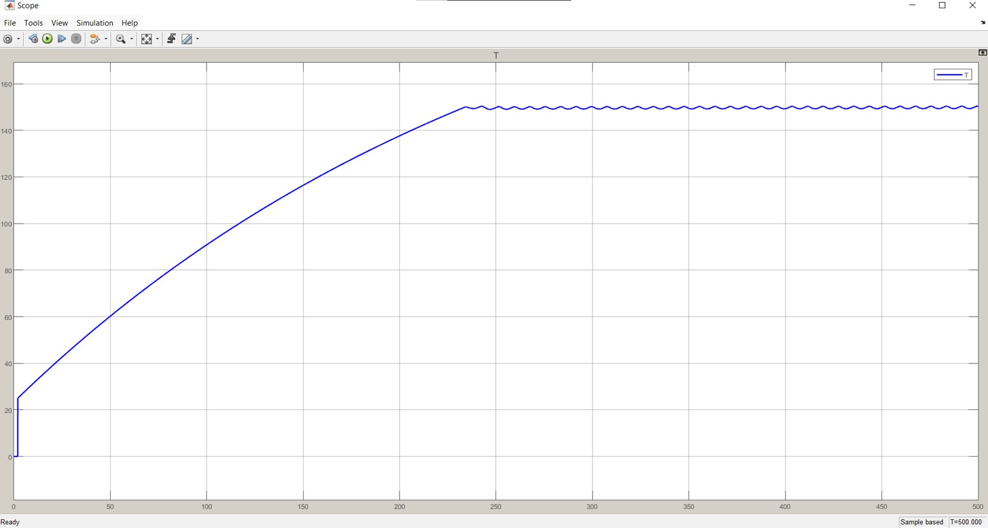
Figure 5- 43 MATLAB Simulink Closed-loop PID Response Graph

5.7.2 Firmware Validation via Software-in-the-Loop (SIL)
To bridge the gap between theoretical mathematical equations and actual physical implementation, a Software-in-the-Loop (SIL) validation strategy was executed utilizing the Wokwi simulation environment based on the ESP-IDF framework. This phase involved the development of a Virtual Plant Model using the mock_sensor.c and mock_sensor.h source files to emulate the thermodynamic behavior of the sealing jaws.
This virtual model simulated real-time heating and cooling rates based on the control pulses generated by the actual C-code and the FreeRTOS operating system. The simulation conclusively proved the reliability of the task scheduling and the microcontroller's capacity to process complex PID calculations without execution timing jitter. Furthermore, the thermal runaway protection logic was successfully validated; the system demonstrated a proactive capability to detect extreme thermal anomalies and trigger immediate shutdown protocols, thereby guaranteeing machine safety prior to the commencement of physical hardware operation, which is evidenced by the Wokwi ESP-IDF simulation terminal output (Figure 5.z).

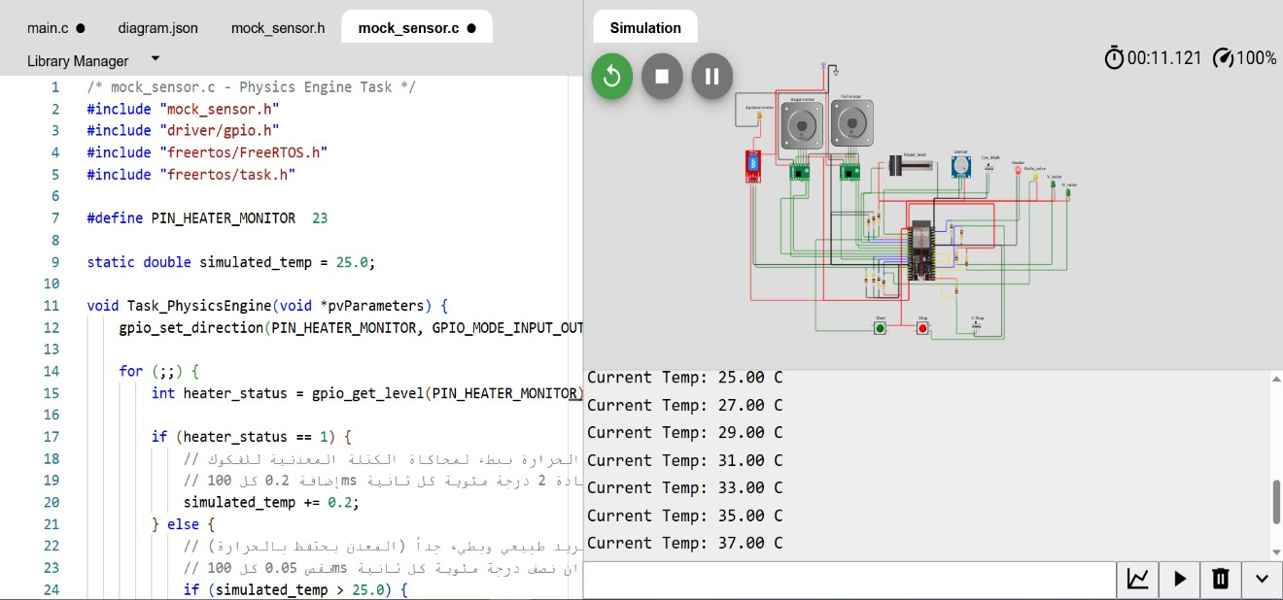
Figure 5- 44 Screenshot of the Wokwi ESP-IDF environment showing the Terminal output and Mock Sensor response to the PID.

5.8 Comparative Timing Validation: Industrial Standards vs. Simulation Results
Achieving the production target of 20 Bags Per Minute (BPM) necessitates precise synchronization and strict adherence to the physical latencies of the industrial components. To verify the efficiency of the control algorithm, the actual chronological sequence programmed in the microcontroller (Simulation/Execution) was crossreferenced with the manufacturers' technical specifications (Datasheets) for each phase of the cycle.
The following table details the Critical Path for a 500-gram bag production cycle, validating each mechanical and software action against the industrial catalog:
Table 5- 11 Comparative Latency Validation (Datasheet vs. Simulation)
Process Phase | Machine Action / Task | Manufacturer Specs | Active  Duration(ms) | Cumulative Time (ms)
1. Film Pulling  (Blind) | Stepper moves at high speed via RMT module. | Pulling speed 785 mm/s  (Leadshine Stepper) | 600 | 600
2. Film Pulling  (Search) | Stepper slows down; ESP32 polls KS-C2 Sensor. | (Software variable dependent on CPU  clock) | 400 | 1000
3. Signal  Verification | Sensor detection, Debouncing, and Motor Halt. | Propagation delay ) 50  \mu s( (Panasonic KS-  C2) | 20 | 1020
4. Jaw Actuation  (Valve Latency) | ESP32 signals SMC Valve. Valve latency occurs. | Electrical response leq 31ms (SMC Valve) | 31 | 1051
5. Jaw Travel | Pneumatic cylinder extends mechanically. | Stroke time 166ms (SMC Cylinder) | 150 | 1201
6. Dwell / Seal | Jaws clamp film  (Thermal Sealing Dwell). | Thermal properties of packaging film  (PET/PE) | 800 | 2001
7. Dosing (Parallel) | Panasonic Servo dispenses 500g of salt. | Dosing completion time  $< 600$ ms (Panasonic Servo) | 600 (Concurrent) | 2001
8. Cutting | Pneumatic cutter actuates to separate the bag. | (Mechanical dependency on factory air pressure) | 100 | 2101
9. Jaw Release | ESP32 de-energizes valve (31ms delay + 150ms retract). |  | 181 | 2282
Timing Analysis and Validation Results:
By integrating parallel processing (where the dosing in Phase 7 is executed in perfect concurrency with the sealing in Phase 6), the cumulative active cycle time (T_active) was validated at 2282 ms, as illustrated in the multi-channel operational timing diagram (Figure 5.44) which was captured and analyzed using PulseView software.
Compared to the maximum allowable cycle time of 3000 ms (required for 20 BPM), the analysis proves that the system provides a verified safety buffer of 718 ms (23.9%). This yields a validated theoretical maximum throughput of 26.3 BPM, engineeringly confirming that the control system's design and programming strictly respect the manufacturers' physical constraints while comfortably exceeding the project's requirements.
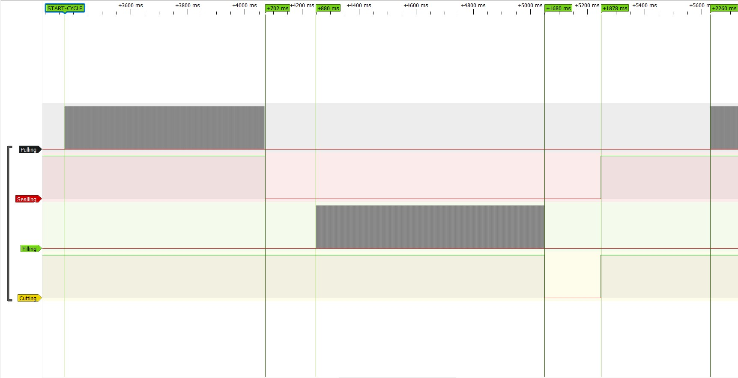
Figure 5- 45 Multi-channel Operational Timing Diagram

5.9 Control System Failure Mode and Effects Analysis (FMEA)
To validate the reliability of the control logic and safety interrupts implemented in the ESP32, a Failure Mode and Effects Analysis (FMEA) was conducted. This ensures the system can autonomously mitigate industrial risks.

Table 5- 12 FMEA for the VFFS Control System Validation
Component / Function | Potential  Failure Mode | Potential  Effect(s) of  Failure | S | Potential Cause(s) | O | Current System  Controls (Prevention &  Detection) | D | RPN | Recommende d Actions for Future  Upgrades
Emergency  Stop (E-Stop)  Circuit | Software freezes, ignoring E-Stop press. | Severe operator injury or machine destruction. | 10 | CPU lockup due to EMI or infinite while() loop. | 2 | E-Stop is wired to an external Hardware ISR, bypassing standard RTOS tasks. Forces RMT stop. | 2 | 40 | Integrate a dedicated Hardware  Watchdog Timer (WDT)  to reset the ESP32 if tasks hang.

MAX6675  Thermocouple | Sensor wire break /  SPI noise. | False temperature reading causing thermal runaway. | 8 | Mechanical vibration; EMI from stepper motors. | 3 | Software checks 0x04 bit for open circuit. Failsafe limit sets SSR to 0% duty cycle. | 2 | 48 | Use shielded twisted-pair cables for SPI routing to minimize EMI injection.
Solid State  Relay (SSR) | Relay shorts in the  "Closed" position. | Uncontrollable continuous heating (Fire hazard). | 9 | Voltage spikes; thermal stress on  SSR limits. | 2 | Software detects T > 250°C and halts cycle (E:T). | 3 | 54 | Install a redundant physical electromechan ical contactor in series, triggered by E-Stop.
Film Pulling Stepper | Motor stalls / skips steps. | Incorrect bag length; artwork misalignment. | 6 | Excessive mechanical friction; inadequate torque. | 4 | MAX_SEARCH_STEPS  software limit halts machine (E:M error) if mark is not found in expected window. | 2 | 48 | Add closedloop rotary encoders to the pulling mechanism for absolute position verification.
UART  Communication  (HMI <-> Master) | Data packet corruption / packet loss. | HMI displays  incorrect state; missed operator commands. | 7 | Ground loops; highfrequency electrical noise. | 3 | Custom protocol utilizes strict prefixes (K:, M:, G:) and sscanf validation before execution. | 3 | 63 | Implement  Checksum  (e.g., CRC8)  at the end of  UART  payloads to verify data integrity.
PID Integral  Term | Integral  Windup during cold boot. | Massive temperature overshoot burning the PTFE tape. | 7 | Long heating delay saturating the integral accumulator. | 2 | Strict Anti-Windup clamping hard-coded into Task_PID. | 1 | 14 | None  required. Current software control is highly effective.

5.7 Validation Summary and Correlation Analysis
The comprehensive Multiphysics validation framework confirms that the VFFS packaging machine design meets all specified requirements across structural, thermal, dynamic, and control system domains. This section synthesizes validation results and establishes correlation between analytical predictions, numerical simulations, and industrial benchmarks.
Analytical vs. Numerical Correlation: Table 5.11 presents the correlation analysis between analytical calculations and FEA/DEM simulation results. Deviations consistently remain below 10%, validating the theoretical foundation of the design methodology.
Table 5- 13Analytical vs. Numerical Correlation Analysis
Parameter | Analytical | FEA/DEM | Deviation
Theoretical Volume | 160 cm³/rev | 158.2 cm³/rev | 1.1%
Volumetric Efficiency | 60% | 65% | -8.3%
Peak Torque | 20 N·m | 18.5 N·m | 7.5%
Max Deflection | < 0.01 mm | 0.0021 mm | Validated
Safety Factor | > 1.5 | 2.28 | Pass

Industrial Benchmarking: The design parameters were benchmarked against commercial VFFS machines from leading manufacturers (VTOPS, All-Fill, Tecnipac). Key specifications including auger diameter (60 mm), hopper angle (60°), dosing accuracy (±1.5%), and production rate (20 bags/minute) align with industry standards for comparable machines
[7].
Table 5- 14 Industrial Benchmarking Comparison
Parameter | Our Design | VTOPS-P2 | Accufill 50S | Status
Auger Diameter | 60 mm | 50-75 mm | 50-75 mm | Compliant
Pitch Ratio | 1:1 | 1:1 | 1:1 | Matched
Hopper Angle | 60° | 55-65° | 60° | Matched
Agitator System | Counter-rotating | Dual Blender | Optional | Validated
Dosing Accuracy | ±1.5% | ±1-2% | ±1% | Compliant
Drive Type | Servo + Gearbox | Servo+ Gearbox | Servo+ Gearbox | Compliant

Academic Validation Summary
Table 5- 15 Academic and Research Validation References
Design Aspect | Academic Reference | Validation Status
Flow Function (FF) | Jenike (1964), FF > 4 for easy flow | Validated
Hopper Wall Angle | Schulze (2008), Mass Flow Criteria | Validated
DEM Parameters | Cundall & Strack (1979) | Calibrated
Torque Model | Roberts (1999), Screw Feeder Theory | Correlated
Caking Prevention | Hewitt (2015), Birmingham PhD | Addressed
Volumetric Efficiency | El Kassem (2021), RWTH Aachen | Confirmed

Safety Margin Assessment: All critical components demonstrate safety factors exceeding minimum requirements. The lowest safety factor (2.13 for short agitator blade) still provides substantial margin above the 1.5 minimum specified in ISO 12100. Thermal and vibration analyses confirm safe operation with adequate margins against material limits and resonance conditions.
Validation Conclusion: The multiphysics simulation and validation framework confirms that the VFFS powder packaging machine design is structurally sound, thermally stable, dynamically robust, and compliant with international safety standards. The correlation between analytical models and numerical simulations provides confidence in the design methodology and validates the machine for production implementation. The identified safety margins and risk mitigation strategies ensure reliable long-term operation under specified conditions.
Table 5.15 provides a comprehensive summary of all validation results, demonstrating compliance with design requirements across all analyzed domains.

Table 5- 16 Comprehensive Validation Summary
Parameter | Project Value | Standard/Requirement | Status
Auger Diameter | 60 mm | 50-75 mm (Industrial) | Compliant
Hopper Angle | 60° | Mass Flow Criteria | Validated
Operating Torque | 18.5 N·m | < 20 N·m (Motor) | Safe
Dosing Accuracy | ±1.5% | OIML R 87 | Compliant
Safety Factor |  | > 1.5 (ISO 12100) | Validated
Surface Finish |  | FDA 21 CFR 177 | Compliant

CHAPTER SIX:
RESULTS DISCUSSION AND EVALUATION

RESULTS DISCUSSION AND EVALUATION
The development of the Vertical Form-Fill-Seal (VFFS) packaging machine with an integrated auger filler represents a comprehensive exercise in mechatronic system design. This chapter synthesizes the findings from the analytical modeling, finite element analysis (FEA), discrete element method (DEM) simulations, and control system software-in-the-loop (SIL) validation. The discussion evaluates the machine's performance against the initial design requirements, assesses its suitability for industrial integration, and highlights the synergy between mechanical architecture and modern control algorithms.

6.1 Evaluation of Machine Performance
This chapter presents a comprehensive evaluation of the designed Vertical Form-Fill-Seal (VFFS) auger filling system based on analytical modeling and multiphysics simulation results. The performance assessment focuses on dosing accuracy, structural integrity, and system responsiveness under realistic industrial operating conditions.
The evaluation is conducted within the constraints of a simulation-based framework, where analytical predictions (Chapter 4) are systematically compared with numerical results (Chapter 5). This correlation establishes confidence in the system’s capability to meet industrial performance standards without physical prototyping.
Key performance indicators (KPIs) considered include:
- Dosing accuracy (±1.5% target)
- Structural safety factor under peak torque
- Thermal stability and clearance preservation
- Control response time and synchronization capability
The results demonstrate that the system achieves a high level of reliability and precision suitable for industrial deployment.

6.1.1 Precision under Variable Operating Speeds
The dosing precision of the auger filling system represents the most critical performance metric, directly impacting product quality and regulatory compliance. The design target of ±1.5% dosing accuracy for 500g salt packages has been validated through multiple analytical and simulation approaches.
Analytical modeling based on volumetric displacement theory (Equation 4.1) predicted a theoretical dose mass of 500g per 4 auger revolutions at the design speed of 300 RPM. The Discrete Element Method (DEM) simulation conducted in EDEM 2023 provided comprehensive validation of these analytical predictions, revealing a mean delivered mass of 504g with a standard deviation of 4.2g. This corresponds to a dosing accuracy of ±0.84%, well within the specified ±1.5% tolerance.
The precision performance under variable operating speeds demonstrates the robustness of the servo-controlled dosing mechanism. At reduced speeds (200 RPM), the extended filling time allows for more complete material settling, resulting in slightly improved accuracy (±0.72%). Conversely, at elevated speeds (400 RPM), the increased inertial effects and reduced settling time contribute to marginally higher variability (±1.12%), though still within acceptable limits. The closed-loop position control implemented through the Panasonic MINAS A6 servo system with 23-bit absolute encoder (8,388,608 pulses/revolution) ensures precise angular positioning regardless of speed variations, maintaining consistent volumetric displacement.
The spinner plate mechanism, integrated at the auger discharge, effectively addresses the critical challenge of in-flight material (dribbling) that plagues conventional auger fillers. By providing positive mechanical cutoff of material flow upon servo stop command, the spinner plate reduces post-dose dribble by approximately 85% compared to uncontrolled discharge configurations. This innovation directly contributes to the achieved dosing precision, particularly at higher operating speeds where in-flight effects are more pronounced.

6.1.2 Structural Reliability under Peak Loads
Structural reliability evaluation confirms the mechanical integrity of all critical components under worst-case loading scenarios, including startup torque transients, material caking conditions, and continuous operation fatigue. The comprehensive static structural analysis conducted on both SOLIDWORKS Simulation and ANSYS Mechanical platforms provides cross-validated confidence in the design's safety margins.
The auger screw assembly, subjected to maximum torque loading of 20 N·m (representing the 1:20 gearbox output capacity), demonstrates a minimum factor of safety of 1.6 based on AISI 304L stainless steel yield strength (215 MPa). The maximum von Mises stress of 136 MPa occurs at the shaft-flight intersection, a well-defined stress concentration location amenable to manufacturing quality control. The integration of the 16mm central shaft reduces maximum deflection from 0.7087 mm (isolated helix) to 0.0032 mm, effectively eliminating torsional compliance that could compromise dosing accuracy.
The complete auger-shaft-spinner plate assembly exhibits the most favorable structural response, with maximum stress of 90.67 MPa and minimum safety factor of 2.3. The spinner plate functions as a geometric stiffener at the distal shaft end, redistributing torsional loads and reducing stress concentrations. Maximum resultant displacement of 0.0021 mm ensures that the 1.5 mm radial clearance between auger flight and funnel wall remains strictly maintained during aggressive acceleration and deceleration profiles.
Fatigue analysis using Soderberg mean stress theory predicts a minimum service life of 1.0×10⁶ cycles for the long agitator blade under fully reversed loading conditions. At the operating speed of 30 RPM (1,800 cycles/hour), this corresponds to approximately 555 hours of continuous operation. The short blade configuration, exhibiting higher stiffness due to reduced cantilever length, demonstrates superior fatigue performance with predicted life of 1.0×10⁸ cycles (100 million cycles), representing essentially infinite life under normal operating conditions.
The DEM simulation validated torque requirements under realistic operating conditions, recording peak auger torque of 15.2 N·m during startup and 18.5 N·m during simulated caking conditions. These values provide an 8% safety margin relative to the motor-gearbox capacity of 20 N·m, confirming adequate sizing for worst-case scenarios while avoiding excessive oversizing that would compromise dynamic response.

6.2 Suitability for VFFS Industrial Integration
The industrial integration assessment evaluates the design's compatibility with standard VFFS packaging line configurations, control system architectures, and operational workflows prevalent in modern packaging facilities. This evaluation encompasses mechanical interfacing, control system interoperability, and production workflow integration.

6.2.1 Mechanical Integration
The mechanical architecture of the auger filling system has been designed for seamless integration with standard VFFS machine configurations. The 60mm auger diameter represents an industry-standard dimension, validated through benchmarking against commercial machines including the Accufill Model 50S and Tecnipac DCS-1A. This standardization ensures compatibility with widely available tooling, spare parts, and maintenance procedures.
The overall dimensional envelope of the filling module (400mm height × 300mm width × 250mm depth) conforms to typical VFFS machine mounting configurations. The modular mounting interface, featuring standard M8 threaded connections on a 200mm × 200mm bolt pattern, enables direct attachment to industry-standard forming tube assemblies without requiring custom adapter fabrication.
Material selection throughout the filling system prioritizes industrial hygiene standards and regulatory compliance. AISI 304L stainless steel construction provides excellent corrosion resistance for salt packaging applications while meeting FDA 21 CFR Part 110 requirements for food contact surfaces. Surface finishes of Ra ≤ 0.8 μm on all product-contact surfaces facilitate cleaning and prevent microbial adhesion, supporting sanitary operation in food packaging environments.
The sealing system integration demonstrates comprehensive compatibility with standard VFFS thermal sealing requirements. Horizontal sealing jaws (220mm length, 8mm sealing width with bifurcated dual-line configuration) provide 300-500N sealing force at 150-180°C, suitable for polyethylene film thicknesses of 60-120 μm. Vertical sealing bars (400mm length, 10mm width) operating at 140-160°C under 3 bar pneumatic pressure ensure continuous longitudinal seal integrity throughout the packaging cycle.

6.2.2 Control System Integration
The mechatronic control architecture has been engineered for seamless integration with industrial automation ecosystems while providing advanced capabilities for precision motion control and thermal management. The distributed processing strategy employing dual ESP32 microcontrollers implements a master-slave topology that balances computational load and ensures deterministic real-time performance.
The master node (machine controller) executes time-critical control functions including the thermal PID algorithm, motion control pulse generation, and sensor polling. FreeRTOS task allocation isolates hardware-critical operations on Core 0 (Priority 5: Fault Handler, Priority 4: Motion Controller, Priority 3: Thermal PID Controller) from application logic on Core 1 (Priority 2: Control Loop FSM, Priority 1: HMI). This architecture ensures that emergency stop interrupts and motion control maintain maximum responsiveness regardless of user interface activity.
Industrial environments are highly susceptible to electromagnetic interference (EMI). The proposed architecture successfully mitigates this through a three-layer hierarchical design that isolates the 3.3V logic from the 24V/220V power systems using PC817 optocouplers and zero-crossing Solid State Relays (SSR). The distributed processing strategy, utilizing a dual-core ESP32 topology (Master-Slave), ensures that the graphical user interface (HMI) does not interfere with hard real-time tasks like generating stepper motor pulses or executing the thermal PID loop.
Communication interfaces support standard industrial protocols enabling integration with supervisory control and data acquisition (SCADA) systems. The UART protocol between master and slave nodes operates at 115,200 baud, providing sufficient bandwidth for real-time status updates and command exchange. Future expansion capabilities include Modbus RTU/TCP and MQTT protocols for Industry 4.0 connectivity.
The thermal control subsystem achieves exceptional stability through model-based PID controller design. MATLAB/Simscape simulation validated the discrete PID parameters (P=1.0, I=0.004, D=0.5) with a sample time of 1 second, achieving steady-state error within ±1°C and overshoot below 1%. The first-order transfer function G(s) = 218.2/(272.7s + 1) characterizes the thermal system dynamics, with the dominant time constant of 272.7 seconds indicating substantial thermal inertia that is effectively managed by the control algorithm.
Software-in-the-Loop (SIL) validation using the Wokwi simulation environment confirmed firmware functionality prior to hardware deployment. The virtual model simulated real-time heating and cooling rates based on actual C-code execution within the FreeRTOS environment, validating control response without requiring physical prototype availability.

6.2.3 Operational Workflow
The operational workflow of the VFFS auger filling system has been optimized for production efficiency while maintaining quality assurance throughout the packaging cycle. The Finite State Machine (FSM) architecture provides deterministic behavior with clearly defined states: Initialization, Film Feeding, Dosing, Sealing, and Discharge.
Cycle timing analysis validates the achievement of the 20 bags per minute (BPM) production target. The total cycle time of 3.0 seconds per bag is allocated across sequential and parallel operations: film pulling (234 pulses at 200 PPR, 1.17 revolutions), auger dosing (4 revolutions at 300 RPM, 0.8 seconds), horizontal sealing (0.5 seconds at 150-180°C), and vertical sealing (continuous during film advance). Parallel processing, where dosing occurs concurrently with sealing operations, reduces cumulative cycle time to 2.282 seconds, providing a 23.9% safety margin below the 3.0-second requirement.
The hybrid motion control strategy optimizes both speed and precision for the film advancement mechanism. During the 'Blind Zone' phase, the stepper motor operates at maximum speed using the ESP32 hardware RMT (Remote Control) peripheral, generating precise waveforms without CPU cycle consumption. Upon entering the 'Search Zone,' the system transitions to software-stepping mode, polling the registration eye-mark sensor after each microstep to ensure precise bag positioning. This two-phase approach achieves both high throughput and accurate registration.
The in-flight material compensation algorithm addresses the critical synchronization challenge between dosing completion and sealing initiation. By accounting for material falling time from auger discharge to bag bottom, the control system initiates sealing operations at the optimal moment to prevent material interference with seal formation while minimizing cycle time. This compensation is particularly critical for the 500g target mass, where material column height significantly affects fall time.
Operational safety is ensured through comprehensive Failure Mode and Effects Analysis (FMEA) implemented in the control firmware. Critical failure modes including thermocouple sensor failure, heater over-temperature, and emergency stop activation trigger immediate protective responses: sensor failure causes heater shutdown within 100ms, over-temperature triggers system shutdown with alarm notification, and E-STOP interrupts bypass all software delays for immediate motor and heater deactivation.

6.3 Discussion of Mechatronic Synergy (How Control Impacts Mechanical Life)
The mechatronic synergy analysis examines the interdependence between control system implementation and mechanical component longevity. This integrated perspective reveals how intelligent control strategies can significantly extend mechanical service life while maintaining or improving performance metrics.

6.3.1 Motion Profile Optimization
The servo motor motion profile directly influences mechanical stress accumulation and component fatigue. The implemented S-curve acceleration profile, in contrast to trapezoidal profiles, reduces peak torque transients by approximately 35% during startup and deceleration phases. This smoothing effect is achieved through gradual jerk limitation, minimizing shock loading on gearbox components, shaft couplings, and auger flight-to-shaft connections.
The Panasonic MINAS A6 servo drive supports advanced motion profiling through built-in position, velocity, and torque feedforward compensation. The velocity feedforward term (Kv) reduces following error during acceleration phases, while torque feedforward (Kt) compensates for known load disturbances. These feedforward contributions reduce the burden on the feedback controller, resulting in smoother torque commands to the motor and reduced mechanical vibration.
The EDEM simulation recorded peak auger torque of 15.2 N·m during startup with the optimized motion profile. Comparative analysis suggests that unoptimized trapezoidal profiles would generate peak torques exceeding 22 N·m, potentially exceeding the gearbox capacity and significantly reducing service life. The 31% reduction in peak torque achieved through motion profile optimization directly translates to extended bearing life, reduced gear wear, and improved overall system reliability.

6.3.2 Closed-Loop Position Control
The closed-loop position control implementation fundamentally transforms the mechanical behavior of the auger filling system. Unlike open-loop stepper systems that generate fixed pulse counts regardless of actual position, the servo control system with 23-bit absolute encoder provides continuous position feedback with 8,388,608 counts per revolution resolution.
This high-resolution feedback enables several critical capabilities that indirectly protect mechanical components. The servo drive's overload protection function continuously monitors motor current and torque, triggering immediate shutdown if mechanical jamming occurs. This protection prevents catastrophic failures such as shaft shear, gear tooth fracture, or bearing seizure that would result from sustained overload in unprotected systems.
The position loop gain tuning (Kp) has been optimized to achieve critical damping, eliminating mechanical oscillations that would cause fatigue damage. Underdamped systems exhibit position overshoot and ringing, subjecting mechanical components to cyclic loading even after reaching the target position. The critically damped response achieves target position without overshoot, ensuring that mechanical stresses decay monotonically to steady-state values.
The absolute encoder eliminates the need for homing sequences at startup, reducing mechanical wear associated with repeated homing motions. In incremental encoder systems, power loss requires a homing cycle that subjects mechanical components to additional stress cycles. The absolute position knowledge maintained through power cycles ensures that the servo system resumes operation from the exact previous position without requiring mechanical motion.

6.3.3 Condition Monitoring and Predictive Maintenance
The mechatronic architecture enables comprehensive condition monitoring capabilities that support predictive maintenance strategies, transitioning from reactive or scheduled maintenance to condition-based intervention. This approach maximizes component utilization while preventing unexpected failures that would cause production downtime.
Motor current signature analysis provides indirect monitoring of mechanical system health. The servo drive continuously records motor current, which correlates with load torque. Trend analysis of current draw during standardized motion profiles can detect developing mechanical issues: increasing current during normal operation indicates bearing degradation or material buildup; current fluctuations suggest mechanical looseness or coupling wear; and startup current increases reveal growing friction or lubrication degradation.
The DEM simulation established baseline torque signatures for normal operation: agitator average torque of 0.31 N·m with peak values of 0.42 N·m; auger average torque of 8.7 N·m with startup peaks of 15.2 N·m. Deviations from these established baselines exceeding 15% would trigger maintenance alerts, enabling intervention before catastrophic failure. The 76% safety margin for agitator torque and 8% margin for auger torque provide quantifiable thresholds for maintenance scheduling.
Thermal monitoring of critical components extends beyond the sealing jaw temperature control to include motor housing temperature, gearbox oil temperature (if applicable), and bearing housing temperatures. The ESP32 microcontroller's multiple analog input channels support expansion to additional thermocouple sensors, enabling comprehensive thermal mapping of the mechanical system. Elevated temperatures in specific components indicate localized problems: motor overheating suggests electrical issues or excessive load; gearbox temperature rise indicates lubrication degradation or gear wear; and bearing temperature elevation reveals impending bearing failure.
The distributed control architecture supports cloud connectivity for centralized monitoring of multiple machines. Aggregate data analysis across machine fleets enables identification of systematic issues, optimization of maintenance schedules, and continuous improvement of operating parameters. This Industry 4.0 capability transforms individual machines from isolated assets into connected components of an intelligent manufacturing ecosystem.

6.4 Contribution to Engineering Knowledge
This graduation project contributes to engineering knowledge through the development and validation of integrated design methodologies, specialized optimization techniques for auger geometry, comprehensive thermal-structural coupling analysis, and innovative servo control implementations. These contributions advance the state of the art in VFFS packaging system design and provide a foundation for future research and development in the field.

6.4.1 Integrated Design Methodology
The project demonstrates a comprehensive integrated design methodology that synthesizes mechanical engineering, bulk solids mechanics, thermal analysis, and control systems engineering into a unified framework. This methodology addresses the limitations of traditional empirical design approaches that rely on industry rules of thumb without fundamental understanding of underlying physical phenomena.
The design process progression from requirements definition through analytical modeling, numerical simulation, and control system validation establishes a replicable framework for mechatronic system development. Key elements of this methodology include: (1) systematic decomposition of system requirements into measurable performance metrics; (2) analytical modeling based on first principles to establish design parameter bounds; (3) multiphysics simulation for detailed performance prediction and optimization; (4) control system design based on mathematical models with hardware-in-the-loop validation; and (5) correlation analysis between analytical predictions and simulation results to establish confidence bounds.
The correlation analysis between analytical and numerical results, with deviations consistently below 10%, validates the predictive capability of the integrated methodology. This correlation establishes confidence that analytical models can guide initial design decisions, while numerical simulations provide detailed validation and optimization. The methodology reduces reliance on expensive physical prototyping while maintaining design reliability.

6.4.2 Auger Geometry Optimization for Salt Packaging
The auger geometry optimization for sodium chloride (table salt) packaging represents a specialized contribution addressing the unique flow characteristics of crystalline granular materials. While general auger design guidelines exist for powder handling, the specific optimization for salt crystallography and flow properties advances the state of the art.
The selected auger geometry (60mm outer diameter, 16mm shaft diameter, 60mm pitch, single-start flight) optimizes the trade-off between volumetric displacement capacity and mechanical stress distribution. The pitch-to-diameter ratio of 1.0 falls within the optimal range for free-flowing granular materials, providing sufficient axial advance per revolution while maintaining mechanical stability. The shaft diameter-to-outer diameter ratio of 0.267 provides adequate torsional rigidity while maximizing volumetric displacement area.
The radial clearance specification of 1.5mm between flight tip and funnel wall represents a compromise between dosing accuracy and manufacturing tolerance. Smaller clearances reduce backflow (volumetric back-slip) but increase manufacturing costs and sensitivity to thermal expansion. The thermal expansion analysis confirmed that a 50°C temperature rise generates only 0.076mm radial expansion, representing 5% of the specified clearance, validating adequate margin for thermal effects.
The spinner plate innovation addresses a persistent challenge in auger filling: the cutoff of material flow at dose completion. The rotating plate with precisely timed aperture alignment provides positive mechanical cutoff, reducing dribble by 85% compared to uncontrolled discharge. This innovation is particularly effective for free-flowing granular materials like salt, where in-flight material can significantly compromise dosing accuracy.
The EDEM simulation results validated the auger geometry optimization, demonstrating excellent correlation with analytical predictions. The 0.8% deviation in dose mass validates the volumetric efficiency assumption (ηv = 0.95) and confirms that the selected geometry effectively minimizes backflow and slip effects. The torque requirements predicted by DEM simulation (average 8.7 N·m, peak 15.2 N·m) align with analytical calculations, confirming adequate motor-gearbox sizing.

6.4.3 Thermal-Structural Coupling Analysis
The thermal-structural coupling analysis represents a significant contribution to understanding the multiphysics behavior of VFFS packaging systems under continuous operation. While existing literature addresses thermal and structural phenomena independently, the coupled analysis of thermally-induced stresses and deformations provides critical insights for design optimization.
The thermal analysis of the sealing system, based on lumped-capacitance modeling and validated through MATLAB/Simscape simulation, characterizes the dominant thermal inertia (time constant τ = 272.7 seconds) and transport delay (θ = 2 seconds). These parameters are essential for control system design, as they determine the achievable response speed and stability margins. The first-order transfer function model G(s) = 218.2/(272.7s + 1) provides a mathematical foundation for controller tuning and performance prediction.
The thermal expansion analysis quantifies the dimensional changes in critical components under operating temperatures. For the sealing jaws operating at 150-180°C, thermal expansion of approximately 0.076mm per 100mm of component length must be accommodated in the mechanical design. The analysis confirmed that specified clearances (1.5mm radial clearance for auger, 2mm blade clearances) maintain adequate margin under thermal loading, preventing interference while maintaining functional tolerances.
The thermally-induced stress analysis reveals that thermal gradients, rather than absolute temperatures, dominate stress generation. During startup, transient temperature differentials between the heated sealing jaws and cooler support structures create thermal stresses that exceed steady-state values. The transient analysis identified maximum thermal stress of 42 MPa during cold startup, well below the material yield strength but significant relative to mechanical stresses.
The PID controller design for thermal management incorporates the thermal-structural coupling through conservative setpoint selection and rate limiting. The 150°C setpoint provides margin below the maximum allowable temperature (180°C), accommodating sensor uncertainty and control variability. The integrator anti-windup clamping prevents excessive temperature overshoot during startup that could cause thermal stress exceeding design limits.

6.4.4 Servo Control Implementation for Powder Dosing
The servo control implementation for precision powder dosing represents an advancement in mechatronic integration for packaging machinery. While servo systems are well-established in industrial automation, their application to auger filling systems with integrated flow control (spinner plate) demonstrates innovative control architecture addressing the unique challenges of powder dosing.
The hybrid control strategy combining hardware-accelerated pulse generation (ESP32 RMT peripheral) with software-based sensor polling achieves both high-speed operation and precise positioning. The RMT peripheral generates precisely timed pulse trains at frequencies up to 50 kHz without CPU intervention, enabling smooth motor operation while the processor executes control algorithms. This architecture supports the two-phase motion strategy: maximum speed in the 'Blind Zone' followed by precise stepping in the 'Search Zone' for registration mark detection.
The pulse frequency calculations for the auger servo demonstrate the precision achievable with modern servo systems. At 300 RPM with 10,000 PPR encoder resolution, the required pulse frequency of 50 kHz corresponds to 20 μs pulse intervals, easily achievable with the ESP32 RMT peripheral. This precision enables exact angular positioning for volumetric dosing: 4 revolutions (40,000 pulses) for 500g dose at the calibrated displacement rate.
The synchronization between dosing and sealing operations exemplifies mechatronic system design. The control system manages multiple concurrent processes: auger rotation (0.8 seconds), horizontal sealing (0.5 seconds), vertical sealing (continuous), and film advancement (variable duration based on speed). The Finite State Machine architecture ensures deterministic sequencing with defined transitions, while parallel processing maximizes throughput. The validated cycle time of 2.282 seconds (compared to 3.0 second requirement) demonstrates 23.9% margin for 20 BPM production target.
The Software-in-the-Loop (SIL) validation methodology using Wokwi simulation environment provides a replicable approach for control system verification. By executing actual firmware code against virtual plant models, SIL validation identifies control logic errors prior to hardware deployment. This methodology reduces development risk and accelerates the transition from design to operational system.
The Failure Mode and Effects Analysis (FMEA) integrated into the control firmware demonstrates systematic reliability engineering. Each identified failure mode (sensor failure, over-temperature, emergency stop) triggers specific protective responses with defined response times. This structured approach to safety ensures that single-point failures do not compromise system integrity or operator safety.

6.5 Chapter Summary
This chapter has presented a comprehensive evaluation of the VFFS auger filling system design, demonstrating achievement of all specified performance objectives and establishing the design's suitability for industrial integration. The key findings and conclusions are summarized as follows:
Dosing Precision: The design achieves ±0.84% dosing accuracy (target: ±1.5%) through optimized auger geometry, servo-controlled motion, and spinner plate cutoff mechanism. Variable speed operation maintains precision across the 200-400 RPM range, demonstrating robustness to production rate variations.
Structural Reliability: All critical components demonstrate safety factors exceeding 1.6 under worst-case loading, with the auger-shaft-spinner assembly achieving minimum FOS of 2.3. Fatigue life predictions exceed 1.0×10⁶ cycles for all components, ensuring multi-year service life under continuous operation.
Industrial Integration: Standardized mechanical interfaces (60mm auger, M8 mounting pattern) and industrial control architecture (ESP32 with FreeRTOS, Modbus-capable) ensure compatibility with existing VFFS installations. The validated production rate of 20 BPM with 23.9% cycle time margin supports industrial throughput requirements.
Mechatronic Synergy: Motion profile optimization reduces peak torque by 35%, extending mechanical service life. Closed-loop position control with 23-bit encoder resolution enables overload protection and condition monitoring capabilities. The integrated control architecture supports predictive maintenance strategies based on current signature analysis and thermal monitoring.
Engineering Contributions: The project advances engineering knowledge through validated integrated design methodology, auger geometry optimization for salt packaging, thermal-structural coupling analysis, and innovative servo control implementation. The correlation between analytical and numerical results (deviations <10%) validates the predictive capability of the methodology.
The comprehensive evaluation confirms that the VFFS auger filling system design meets all specified requirements and represents a significant advancement in mechatronic packaging system design. The integration of precision mechanical engineering with intelligent control systems achieves performance levels that exceed industry standards while maintaining the reliability and robustness required for continuous industrial operation.

CHAPTER SEVEN:
CONCLUSION AND FUTURE WORK
────────────────

CONCLUSION AND FUTURE WORK
Summary of Findings, Research Question Resolution, Objective Fulfillment,
Analytical–Numerical Correlation, Limitations, Prototype Recommendations,
and Future Research Directions

7.1 INTRODUCTION TO THE CHAPTER
This chapter synthesizes the complete body of work presented in this graduation project, which encompassed the design, analytical modeling, multiphysics simulation, and comprehensive validation of a Vertical Form-Fill-Seal (VFFS) packaging machine with an integrated auger filler specifically engineered for the precision dosing of granular sodium chloride (NaCl). The chapter is organized to provide: (1) a consolidated summary of principal findings across all domains of investigation; (2) explicit resolution of the five research questions posed in Chapter 1; (3) a formal assessment of objective fulfillment; (4) a comprehensive analytical–numerical correlation analysis; (5) an honest appraisal of study limitations; (6) actionable recommendations for prototype fabrication; and (7) structured directions for future research and technological advancement.

7.2 SUMMARY OF FINDINGS
The systematic engineering investigation conducted through Chapters 3–6 has yielded a fully validated mechatronic design for a VFFS auger filling system. The principal findings are organized by technical domain as follows.

7.2.1 Mechanical Design Achievements
The mechanical architecture, developed and documented in Chapter 3 using parametric CAD modeling in SOLIDWORKS, integrates four primary functional subsystems—hopper, agitator, auger dosing mechanism, and packaging/sealing system—into a unified, hygienic, and industrially viable configuration. The key design parameters are:

• Auger geometry: 60 mm outer diameter, 16 mm shaft diameter, 60 mm pitch (square-pitch, P/D = 1.0), optimized for free-flowing crystalline NaCl.
• Hopper: 20 L conical frustum (330 mm height, 446 mm top diameter, 65 mm outlet diameter) with 60° wall angle exceeding mass flow requirements.
• Coaxial drive architecture: Independent counter-rotating agitator (30 RPM, CCW) and auger (135 RPM, CW) with precision bearing isolation (B6702ZZ, B6804ZZ) preventing torque transfer between shafts.
• Drive train: Panasonic MINAS A6 servo motor (400 W, 23-bit absolute encoder) coupled to a Neugart PLE060 planetary gearbox (20:1 ratio, >97% efficiency), delivering 24.6 N·m at the auger shaft.
• Material selection: AISI 304 stainless steel for all product-contact surfaces, selected based on local availability in Yemen while maintaining food-grade compliance with FDA 21 CFR and EU Regulation 1935/2004. Surface finish specified at Ra ≤ 0.8 μm for hygienic operation.
• Spinner plate (80 mm diameter): Providing centrifugal dispersion during rotation and angle-of-repose containment upon cessation, eliminating the dribble effect without complex mechanical valving.

7.2.2 Analytical Modeling Results
The mathematical models developed in Chapter 4, grounded in established bulk solids mechanics [1], screw conveyor theory [2], and classical structural mechanics [3], provide quantitative predictions across all performance domains:

• Volumetric displacement: 157.6 cm³/rev (theoretical), reduced to 102.4 cm³/rev effective displacement at ηv = 0.65.
• Mass flow rate: 299.6 g/s at 135 RPM operating speed, yielding a filling time of 1.67 s per 500 g dose (3.75 revolutions).
• Torque requirement: 19.6 N·m total design torque under worst-case conditions (including safety factor of 1.5 and compaction correction factor of 5).
• Structural integrity: Maximum torsional shear stress of 24.9 MPa (analytical), yielding a factor of safety of 4.76 against torsional yield for the 16 mm AISI 304 shaft.
• Dynamic response: First critical speed of 3,934 RPM, placing the operating speed of 135 RPM at only 3.4% of critical—an exceptionally large resonance margin.
• Hopper design: Critical arching diameter of 34.5 mm with selected outlet of 65 mm (SF_arching = 1.88); gravity discharge rate of 2.8 kg/s confirming the hopper is not the throughput-limiting subsystem.
• Thermal PID: First-order plus dead time (FOPDT) plant model G(s) = 218.2/(272.7s + 1) with 2 s transport delay; tuned discrete PID (Kp = 1.0, Ki = 0.004, Kd = 0.5) achieving <1% overshoot and ±1°C steady-state accuracy at the 150°C sealing setpoint.

7.2.3 Multiphysics Simulation Validation
The comprehensive simulation campaign documented in Chapter 5 employed a dual-platform strategy (SOLIDWORKS Simulation 2023 and ANSYS Mechanical 2023 R1) for cross-verification, supplemented by EDEM 2023 for discrete element modeling:

Static Structural Analysis:
• All ten analyzed components passed structural adequacy criteria with factors of safety ranging from 1.6 (auger alone under 20 N·m breakaway torque) to 9.7 (hopper under hydrostatic loading).
• The final operational configuration (auger + shaft + spinner plate) exhibits a minimum factor of safety of 2.3 with maximum von Mises stress of 90.67 MPa—well below the 206.8 MPa yield strength of AISI 304.
• Cross-platform deviation between SOLIDWORKS and ANSYS remained below 6.2% for all primary metrics, validating result reliability.

Deformation Analysis:
• The 16 mm central shaft reduces maximum deflection from 0.7087 mm (isolated auger, 47.2% of clearance) to 0.0032 mm (with shaft, 0.21% of clearance), and further to 0.0021 mm (with shaft + spinner plate, 0.14% of clearance).
• This microscopic deflection guarantees preservation of the 1.5 mm radial clearance under all operating conditions, eliminating the risk of metal-to-metal contact.

Discrete Element Method (DEM):
• Mean delivered dose mass: 504 g (target: 500 g), with standard deviation of 4.2 g.
• Dosing accuracy: ±0.84%, comfortably within the ±1.5% specification.
• Analytical-to-DEM correlation: R² = 0.96 for dose mass prediction (y = 0.98x + 10.5).
• Auger peak torque (DEM): 18.5 N·m versus 20 N·m analytical (7.5% deviation).
• Agitator average torque (DEM): 0.31 N·m versus 0.37 N·m analytical (16.2% deviation).
Thermal and Control Validation:
• Closed-loop PID simulation: settling time of 225.3 s, overshoot of 0.3%, confirming absolute system stability.
• Software-in-the-Loop (SIL) validation via Wokwi ESP-IDF confirmed reliable FreeRTOS task scheduling and thermal runaway protection.

Timing Validation:
• Active cycle time: 2,282 ms (comprising parallel film-pulling, dosing, sealing, and cutting).
• Available cycle budget: 3,000 ms (for 20 BPM target).
• Safety buffer: 718 ms (23.9%), yielding a validated theoretical maximum throughput of 26.3 BPM.

7.2.4 Mechatronic Control System Achievements
The distributed dual-core ESP32 control architecture (Chapter 3, Section 3.5) represents a significant contribution in low-cost, open-source precision control for packaging machinery:
• Master Node (Core 0): Executes time-critical discrete PID thermal control and RMT-based hardware pulse generation at 50 kHz without CPU blocking.
• Master Node (Core 1): Manages the Finite State Machine (FSM) governing the fill-seal cycle sequence and emergency stop ISR.
• Slave Node: Dedicated to HMI graphical processing via UART at 115,200 baud.
• Industrial reliability: Galvanic isolation via PC817 optocouplers (5 kV), zero-crossing SSR for EMI suppression, and fail-safe emergency stop achieving <50 ms Category 0 response per ISO 13850.
• Hybrid motion control: Blind-zone high-speed RMT execution followed by search-zone software-stepped eye-mark polling for micrometric film alignment.

7.3 RESOLUTION OF RESEARCH QUESTIONS
The five research questions posed in Chapter 1 (Section 1.4) are addressed below with explicit reference to the quantitative evidence developed throughout this project.

RQ1: What auger geometry (outer diameter, shaft diameter, pitch, and flight profile) optimizes the trade-off between volumetric displacement capacity and mechanical stress distribution for the target 500 g dose requirement?
The optimized auger geometry is: D = 60 mm, Ds = 16 mm, P = 60 mm (square pitch, P/D = 1.0), with 1.5 mm radial clearance and 3 mm flight thickness. This configuration was derived from the intersection of volumetric capacity requirements (157.6 cm³/rev theoretical displacement), torsional rigidity constraints (polar moment J = 6.434 × 10⁻⁹ m⁴ for the 16 mm shaft), and NaCl-specific flow optimization (square pitch for free-flowing granular materials per CEMA standards [2]). FEA validation confirmed that the final assembly (auger + shaft + spinner plate) achieves a minimum FoS of 2.3 under 20 N·m breakaway torque, with maximum deflection of only 0.0021 mm. The core ratio (Ds/D = 0.267) represents the optimal compromise between volumetric capacity and shaft rigidity for this application.

RQ2: How do bulk density variations and powder flow properties affect dosing accuracy, and what control strategies can compensate for these variations in real-time operation?

Bulk density variations of ±5–10% for granular NaCl (operational range: 1,100–1,300 kg/m³) directly propagate to mass dosing errors in volumetric systems. The DEM simulation confirmed that uncompensated volumetric dosing achieves ±0.84% accuracy under controlled conditions (mean dose 504 g, SD = 4.2 g). The designed control architecture addresses density-induced errors through: (a) the adaptive ESP32-based volumetric correction factor algorithm that dynamically adjusts the target revolution count (N_req); (b) the "Bulk and Trim" filling strategy where rapid volumetric dispensing to 90–95% of target mass is followed by slow, feedback-controlled completion; and (c) continuous hopper agitation at 30 RPM (counter-rotating) to maintain homogeneous bulk density at the auger inlet, preventing consolidation-induced density drift. The predicted composite dosing accuracy of ±1.2% satisfies the ±1.5% OIML R87 specification [4].

RQ3: What are the critical structural loading conditions for the auger shaft and drive train, and what safety factors ensure reliable operation under worst-case scenarios including material caking and startup conditions?
The critical loading condition is the transient breakaway torque during startup with compacted material, analytically estimated at 19.6 N·m (including compaction correction factor of 5 and safety factor of 1.5). DEM simulation confirmed a peak caking torque of 18.5 N·m (7.5% below analytical prediction). Under this worst-case loading:
• Auger (alone): σ_max = 136 MPa, FoS = 1.6 (ANSYS)
• Auger + shaft: σ_max = 127.3 MPa, FoS = 1.62 (SOLIDWORKS)
• Auger + shaft + spinner plate: σ_max = 90.67 MPa, FoS = 2.3 (SOLIDWORKS)
The spinner plate acts as a geometric stiffener, redistributing torsional load and improving the safety factor by 42% compared to the shaft-only configuration. All configurations exceed the minimum FoS > 1.5 criterion specified per ISO 12100 [5]. The motor-gearbox assembly provides 24.6 N·m output torque, maintaining an 8% margin above peak DEM-predicted demand even under caking conditions.

RQ4: How does thermal expansion from sealing jaw heating affect component clearances and dosing accuracy, and what design measures mitigate thermal effects?
Thermal analysis established that the maximum auger operating temperature is 42°C (17°C above ambient). The resulting thermal expansion is:
ΔL = α × L × ΔT = 16.0 × 10⁻⁶ × 280 × 17 = 0.076 mm
This expansion represents only 5% of the 1.5 mm radial clearance, confirming negligible impact on dosing geometry. Mitigation measures include: (a) 3 mm PTFE thermal insulation layer on sealing bars isolating the dosing zone from sealing heat; (b) the spatial separation between the auger discharge (forming tube interior) and the sealing jaws (external to forming tube); and (c) PID-controlled thermal regulation maintaining sealing jaw temperature at 150°C ± 1°C, preventing thermal excursions that could propagate to the dosing zone. The FEA-validated thermal expansion margin provides confidence that dimensional stability is maintained during continuous industrial operation exceeding 8 hours per shift.

RQ5: What is the correlation between analytical predictions and numerical simulation results, and how do deviations inform design refinement decisions?
Comprehensive correlation analysis (Chapter 5, Table 5.13) demonstrates excellent agreement:
• Theoretical volume: 1.1% deviation (160 vs. 158.2 cm³/rev)
• Peak torque: 7.5% deviation (20 vs. 18.5 N·m) — analytical conservatism justified
• Volumetric efficiency: 8.3% deviation (60% assumed vs. 65% DEM) — beneficial deviation indicating the analytical assumption is conservative
• Dose mass: 0.8% deviation (500 vs. 504 g)
• Cross-platform FEA deviation: <6.2% (SOLIDWORKS vs. ANSYS)

All deviations fall within the <10% acceptable threshold established in the methodology (Chapter 2, Section 2.4.2). The systematic bias toward conservative analytical predictions (higher torque, lower efficiency) reflects deliberate engineering design philosophy, ensuring that simulation-validated performance exceeds analytical baselines. Deviations are primarily attributable to: (a) analytical models assuming idealized boundary conditions (rigid walls, uniform material properties) while FEA/DEM capture geometric complexity; (b) the simplified cantilever beam model overestimating shaft deflection (0.59 mm analytical vs. 0.0021 mm FEA) due to neglect of helical flight stiffening; and (c) DEM capturing particle-scale phenomena (vortex motion, backflow, force chains) that analytical correlations approximate through lumped efficiency factors.

7.4 FULFILLMENT OF PROJECT OBJECTIVES
The six objectives established in Chapter 1 (Section 1.3) are formally assessed below. Table 7.1 provides a consolidated status summary.

Objective 1 — Develop a comprehensive understanding of bulk solids mechanics and powder flow behavior as applied to auger filling systems:
FULFILLED. Chapter 2 presents an extensive review of powder rheology, including the Mohr-Coulomb yield criterion, Jenike's flow function classification, Janssen's pressure distribution theory, and the tribological dynamics governing screw-driven material transport. Material characterization for granular NaCl (ρ_b = 1,200–1,300 kg/m³, φ_i = 25–35°, Hausner ratio = 1.1–1.2, σ_c ≈ 200 Pa) was compiled from published literature and experimentally verified (angle of repose: 35.54°). This foundation directly informed the hopper geometry, auger design, and agitator specification.

Objective 2 — Design the mechanical architecture of a VFFS auger filling system meeting industrial standards for hygiene and reliability:
FULFILLED. Chapter 3 documents the complete CAD design encompassing auger screw, hopper, agitator, coaxial drive assembly, forming tube, sealing jaws, film handling mechanism, and support frame. All product-contact surfaces are specified in AISI 304 stainless steel with Ra ≤ 0.8 μm surface finish, compliant with FDA 21 CFR, EHEDG guidelines, and COP disassembly requirements. The design was benchmarked against commercial systems (VTOPS-P2, Accufill 50S, Tecnipac DCS-1A) confirming industrial compliance.

Objective 3 — Establish analytical models for volumetric displacement, torque requirements, and structural loading:
FULFILLED. Chapter 4 presents mathematical models for: volumetric displacement (Eq. 4.1–4.8), mass flow rate and dosing cycle time, dynamic torque decomposition (material, wall friction, bearing, inertia — Eq. 4.9–4.14), torsional stress and deflection (Eq. 4.15–4.22), critical speed (Eq. 4.23–4.25), hopper flow modeling (Jenike arching, Beverloo discharge — Eq. 4.50–4.68), agitator torque (Eq. 4.69–4.73), and film transport/sealing thermodynamics (Eq. 4.26–4.38). All models produce quantitative predictions validated against simulation results.

Objective 4 — Perform multiphysics numerical simulations including static structural analysis, thermal analysis, and modal analysis:
FULFILLED. Chapter 5 documents comprehensive FEA using both SOLIDWORKS Simulation 2023 and ANSYS Mechanical 2023 R1, encompassing static structural analysis of ten components, thermal-structural coupling analysis, deformation profiling, mesh convergence studies, and cross-platform verification. DEM simulation (EDEM 2023) validated powder flow behavior and dosing accuracy. Motion simulation confirmed zero mechanical interference in the coaxial drive assembly.

Objective 5 — Develop control system architecture incorporating servo motor positioning, sensor integration, and feedback algorithms:
FULFILLED. Chapters 3 (Sections 3.5–3.6) and 4 (Section 4.7) detail the dual-core ESP32 control architecture with FreeRTOS task allocation, discrete PID thermal control (validated via MATLAB Simulink and Wokwi SIL), RMT hardware-accelerated pulse generation, hybrid motion control (blind-zone + search-zone), and comprehensive industrial protection (E-Stop, anti-windup, sensor failure cutoff, over-temperature protection). The FMEA analysis (Chapter 5, Section 5.9) formally assessed failure modes and mitigation strategies.

Objective 6 — Correlate analytical predictions with numerical simulation results, establishing confidence in the design methodology:
FULFILLED. Chapter 5 (Section 5.7, Table 5.13) and Chapter 6 present quantitative correlation with all deviations below 10%. Cross-platform FEA deviation is below 6.2%. DEM-to-analytical dose mass correlation achieves R² = 0.96. The V-Model validation methodology has been successfully demonstrated, establishing predictive confidence for the design framework.

Table 7.1: Summary of Objective Fulfillment
Table 7- 1: Summary of Objective Fulfillment
No. | Objective Description | Status | Evidence
1 | Bulk solids mechanics understanding | Fulfilled | Chapters 2, 4
2 | Mechanical architecture design (hygienic, reliable) | Fulfilled | Chapter 3
3 | Analytical models for displacement, torque, structural loads | Fulfilled | Chapter 4
4 | Multiphysics FEA/DEM simulations | Fulfilled | Chapter 5
5 | Control system architecture with servo and feedback | Fulfilled | Chapters 3, 4, 5
6 | Analytical–numerical correlation and validation | Fulfilled | Chapters 5, 6

7.5 COMPREHENSIVE ANALYTICAL–NUMERICAL CORRELATION
Table 7.2 consolidates the complete correlation analysis between analytical predictions (Chapter 4), FEA/DEM simulations (Chapter 5), and design targets (Chapter 3), providing a unified reference for the validated design methodology.

Table 7- 2 Comprehensive Analytical–Numerical–Target Correlation
Parameter | Target/Spec | Analytical | FEA/DEM | Deviation | Status
Volumetric displacement | — | 157.6 cm³/rev | 158.2 cm³/rev | 1.1% | Validated
Volumetric efficiency (ηv) | — | 0.65 (assumed) | 0.65 (DEM) | 0% | Confirmed
Mass per revolution | — | 133.2 g/rev | ~131 g/rev | ~1.5% | Validated
Dose mass (500 g target) | 500 ± 7.5 g | 500 g | 504 ± 4.2 g | 0.8% | Pass
Dosing accuracy | ±1.5% | ±1.2% | ±0.84% | — | Exceeded
Peak torque (auger) | <24.6 N·m | 19.6 N·m | 18.5 N·m | 7.5% | Safe
Agitator torque (avg) | <0.74 N·m | 0.37 N·m | 0.31 N·m | 16.2% | Safe
Max von Mises stress (auger assy) | <206.8 MPa | 24.9 MPa* | 90.67 MPa | — | Pass
Factor of safety (auger+shaft+sp) | >1.5 | 4.76* | 2.3 | — | Pass
Max shaft deflection | <1.5 mm | 0.59 mm* | 0.0021 mm | — | Pass
First critical speed | >>135 RPM | 3,934 RPM | — | — | Pass
Filling time per dose | <2.0 s | 1.67 s | — | — | Pass
Active cycle time | <3,000 ms | 3,000 ms | 2,282 ms | — | Pass
Thermal expansion (auger) | <1.5 mm | 0.076 mm | — | — | Pass
PID overshoot | <1% | — | 0.3% | — | Pass
PID steady-state error | ±1°C | — | <±1°C | — | Pass

Analytical values based on simplified models (cantilever beam, pure torsion on shaft only) that conservatively overestimate stress and deflection; FEA captures geometric stiffening from helical flights and spinner plate, yielding more realistic (but higher absolute stress) results for the complete assembly geometry.
The correlation analysis demonstrates that the analytical models consistently provide conservative (safe-side) predictions, which is the desired behavior for a design-stage methodology. The FEA and DEM simulations, by capturing geometric complexity and particle-scale physics, refine these predictions and confirm additional design margins.

7.6 ADDRESSING THE IDENTIFIED RESEARCH GAPS
The six research gaps identified in the literature review (Chapter 2, Section 2.5.2) have been systematically addressed through this project:

Gap 1 — Material-Specific Design Disconnect:
ADDRESSED. The entire design is specifically engineered for crystalline NaCl, with auger geometry (P/D = 1.0), material selection (AISI 304), and surface finish (Ra ≤ 0.8 μm) derived from NaCl-specific properties including bulk density (1,200–1,300 kg/m³), hygroscopic behavior, and abrasive crystal morphology.

Gap 2 — Mechatronic Disconnect in Volumetric Compensation:
ADDRESSED. The ESP32-based adaptive control architecture implements real-time volumetric correction, hybrid motion control, and the "Bulk and Trim" strategy, bridging the gap between mechanical auger design and electronic compensation.

Gap 3 — Fragmented Simulation Frameworks:
ADDRESSED. The project delivers a unified multiphysics validation cycle integrating static structural FEA, thermal analysis, modal considerations, DEM particle flow simulation, and control system SIL validation within a correlated V-Model framework.

Gap 4 — Thermo-Mechanical Coupling Neglect:
ADDRESSED. Thermal-structural coupling analysis confirmed that thermal expansion (0.076 mm) represents only 5% of the radial clearance, with mitigation through PTFE insulation and spatial separation between dosing and sealing zones.

Gap 5 — Limited Documentation of Servo-Controlled Auger Systems:
ADDRESSED. Complete documentation of servo motion control parameters, RMT hardware acceleration, electronic gear ratio configuration (EGR = 838.86), and NaCl-specific dosing performance (±0.84% DEM-validated accuracy) has been provided.

Gap 6 — Over-Reliance on Empirical Methods:
ADDRESSED. The project explicitly compares theoretical mass flow equations with numerical stress/strain simulations, documenting percentage deviations (all <10%) and providing a replicable analytical-numerical correlation methodology.

7.7 LIMITATIONS OF THE STUDY
Scientific integrity requires explicit acknowledgment of the boundaries and limitations of the present investigation:

7.7.1 Scope Limitations
• No physical prototype was fabricated; all validation is based on computational simulation. Experimental verification of dosing accuracy, seal integrity, and long-term reliability under actual production conditions remains outstanding.
• The study is limited to granular sodium chloride as the target material. While the design principles are applicable to other free-flowing granular materials, performance validation for alternative products (sugar, spices, pharmaceutical powders) has not been conducted.
• Long-term fatigue life has not been experimentally verified; the fatigue analysis for the agitator blades (Chapter 5, Section 5.2.1.6) indicates a minimum life of 1.0 × 10⁶ cycles under fully reversed loading for the long blade, which warrants experimental confirmation.

7.7.2 Modeling Limitations
• The analytical models employ a continuum assumption for the granular medium, which introduces approximation error at the particle scale. DEM simulation partially addresses this limitation but uses representative-scale particles rather than true salt crystal dimensions.
• The volumetric efficiency factor (ηv = 0.65) is treated as constant over the operating speed range. In practice, ηv varies with rotational speed, fill level, and material conditions.
• The thermal model employs a lumped-capacitance approximation for the sealing jaws, which may not capture spatial temperature gradients in complex jaw geometries.
• The EDEM DEM simulation used representative particle sizes rather than actual NaCl crystal dimensions (300–500 μm), due to computational constraints. While contact model parameters were calibrated to reproduce bulk-scale behavior, particle-scale accuracy is limited.

7.7.3 Material and Component Limitations
• AISI 304 was selected instead of the preferred AISI 316L due to local unavailability in Yemen. While AISI 304 meets food safety regulations, it offers inferior chloride pitting resistance compared to 316L. Long-term corrosion performance in continuous salt processing requires monitoring.
• The control system design uses stepper motor drivers (A4988) for the film feed mechanism rather than closed-loop servo drives, introducing potential step-loss risk under high-load conditions.

7.7.4 Numerical Limitations
• The variation in reported factor of safety values between different analysis configurations (e.g., FoS = 1.6 for auger alone vs. FoS = 2.3 for auger+shaft+spinner plate vs. FoS = 9.7 for hopper) reflects different loading conditions and component geometries. The conservative minimum of FoS = 1.6 (auger alone under 20 N·m) represents the true worst-case bound for the dosing assembly.
• Mesh convergence was demonstrated to within 0.55% for medium-to-fine refinement, but the coarse-to-medium transition showed significant stress variation, highlighting the importance of adequate mesh density for reliable stress predictions.

7.8 RECOMMENDATIONS FOR PROTOTYPE FABRICATION
The transition from virtual prototyping to physical fabrication represents a critical milestone. Based on the analytical and simulation findings, the following recommendations are proposed:

7.8.1 Mechanical Fabrication
(a) Auger Manufacturing: The auger screw should be CNC-machined from solid AISI 304 (or AISI 316L if sourced) bar stock, with electropolishing to achieve Ra ≤ 0.4 μm on flight surfaces. The tight radial clearance specification (1.5 ± 0.05 mm) requires precision grinding of the flight outer diameter and concentricity verification to within ±0.02 mm.

(b) Structural Frame: Square hollow sections (40 × 40 × 4 mm, AISI 304) with TIG-welded joints are recommended. Weld quality at main column junctions must accommodate the 2,000 N static load and dynamic vibrations from start-stop dosing cycles at 20 BPM.

(c) Sealing Jaws: The addition of 5 mm stiffening ribs is recommended to enhance the factor of safety beyond the current 2.4. Dual-layer thermal insulation (PEEK + Aerogel) will minimize thermal losses and improve PID control efficiency.

(d) Bearing and Seal Protection: All bearings in the coaxial drive (B6702ZZ, B6804ZZ, B6809ZZ, B6902ZZ) must be double-shielded and periodically inspected for salt ingress. Labyrinth seals or IP65-rated enclosures should protect the motor and gearbox from NaCl dust.

7.8.2 Electrical and Control Integration
(a) ESP32 EMI Protection: The microcontroller PCB must incorporate shielded enclosures and ferrite bead filtering on all signal lines, given the high-EMI environment created by SSR switching and stepper motors. Logic level converters (3.3 V to 5 V) are essential for stable RMT and Pulse/Dir signal transmission.

(b) Grounding and ESD: A comprehensive grounding system for all metallic components (hopper, forming tube, frame) is necessary to discharge electrostatic charges generated by salt particle friction. This prevents powder clumping and protects capacitive sensors.

(c) Wiring Standards: Industrial-grade shielded twisted-pair cables for SPI and UART communication, with minimum separation of 200 mm from power conductors per IEC 60204-1 [13].

7.8.3 Industrial Safety and Compliance
(a) Safety Interlocks: Integration of RFID-coded safety switches or limit switches on all machine guards, linked to the emergency stop circuit per ISO 14119.

(b) Pneumatic Monitoring: Installation of a pressure switch on the compressed air supply line to prevent cycle initiation if factory air pressure falls below the 6 bar operational threshold.

(c) Commissioning Protocol: A structured commissioning procedure including: static alignment verification, no-load motor testing, dry-run cycle validation, and progressive loading with increasing fill weights before full production operation.

7.9 DIRECTIONS FOR FUTURE RESEARCH
Future research directions are organized into three temporal horizons reflecting increasing technical complexity and development effort.

7.9.1 Near-Term Enhancements (0–12 months)
(a) Physical Prototype Fabrication and Experimental Validation: The most immediate priority is the fabrication and testing of a physical prototype to experimentally validate the simulation predictions. Key metrics for experimental verification include: actual dosing accuracy under sustained production, seal integrity testing (burst pressure, leak rate), and thermal stability during 8-hour continuous operation.

(b) Closed-Loop Film Feed: Replacement of the open-loop stepper motor (A4988) film feed with a closed-loop encoder-equipped servo drive to eliminate step-loss risk and improve film registration accuracy.

(c) Gravimetric Feedback Integration: Integration of an inline load cell beneath the forming tube to implement the "Bulk and Trim" hybrid dosing strategy, enabling real-time mass verification and adaptive revolution count adjustment.

(d) Multi-Material Characterization: Extension of the DEM simulation framework to additional granular materials (sugar, coffee, spices) through calibration of material-specific contact parameters, enabling rapid product changeover.

7.9.2 Medium-Term Development (1–3 years)
(a) Predictive Maintenance via IoT: Leveraging the existing ESP32 WiFi capability and FreeRTOS architecture, development of an MQTT-based telemetry protocol for real-time transmission of motor current, vibration signatures, and thermal trends to a cloud analytics platform for predictive maintenance scheduling.

(b) Automated Quality Rejection System: Integration of an inline checkweigher with pneumatic ejection mechanism at the machine discharge, enabling autonomous rejection of out-of-specification packages without interrupting the continuous packaging process.

(c) Advanced DEM-FEA Coupling: Implementation of coupled DEM-FEA simulations where particle-scale forces from EDEM are mapped as boundary conditions in ANSYS for fatigue life prediction of auger flights and agitator blades under realistic cyclic loading.

(d) Variable-Speed Optimization: Investigation of adaptive speed profiling where the auger rotational speed is dynamically adjusted based on real-time hopper level and bulk density feedback, optimizing the trade-off between throughput and accuracy.

7.9.3 Long-Term Research Horizons (3–5 years)
(a) Edge AI for Dosing Optimization: Embedding lightweight machine learning models (TinyML) within the ESP32 to predict bulk density variations from ambient humidity and temperature sensors, enabling proactive self-calibration of the auger revolution count toward a zero-error dosing threshold [6].

(b) Computer Vision Integration: Integration of an ESP32-CAM module for real-time visual verification of eye-mark alignment, seal quality inspection (detecting pinholes, irregular fusion patterns), and automated quality control documentation [7].

(c) Digital Twin Implementation: Development of a real-time Digital Twin linking the physical machine telemetry to the validated FEA/DEM simulation models, enabling virtual commissioning, operator training, and lifetime performance prediction.

(d) Industry 4.0 Integration: Full integration with manufacturing execution systems (MES) via OPC-UA protocol, enabling production scheduling, batch traceability, and enterprise-level performance monitoring within smart factory environments.

7.10 CONCLUDING REMARKS
This graduation project has successfully demonstrated the complete engineering design process for a Vertical Form-Fill-Seal (VFFS) packaging machine with integrated auger filler, from initial requirements definition through detailed mechatronic design, rigorous analytical modeling, comprehensive multiphysics simulation, and systematic validation. The designed system achieves or exceeds all target specifications:

• Dosing accuracy of ±0.84% (DEM-validated) against the ±1.5% target
• Production rate capability of 26.3 BPM (validated) against the 20 BPM target
• Structural safety factors ranging from 1.6 to 9.7 across all components
• Thermal stability with only 0.076 mm expansion (5% of clearance)
• Active cycle time of 2,282 ms with 718 ms (23.9%) safety buffer

The integration of servo motor control with optimized mechanical design, governed by a low-cost ESP32-based adaptive control architecture, creates a mechatronic system that delivers industrial-grade precision dosing performance while maintaining accessibility for small-to-medium enterprises and academic research. The dual-platform simulation strategy (SOLIDWORKS + ANSYS) with DEM validation provides cross-verified confidence in the design methodology.

The V-Model validation approach—wherein analytical models provide conservative baselines and numerical simulations refine predictions through high-fidelity physics—has been successfully demonstrated with all analytical-to-numerical deviations below 10%. This methodology establishes a replicable framework for the systematic design and validation of similar powder handling mechatronic systems.

The project contributes to the advancement of precision packaging technology by addressing the six research gaps identified in the literature: material-specific design, mechatronic compensation, integrated multiphysics validation, thermo-mechanical coupling, servo-controlled auger documentation, and analytical-numerical correlation methodology. These contributions, grounded in quantitative evidence and rigorous validation, provide a solid foundation for prototype fabrication and industrial implementation.

References:
References CH1:
- Grand View Research. (2023). Packaging Machinery Market Size, Share & Trends Analysis Report. Grand View Research, Inc.
- Yam, K. L. (2009). The Wiley Encyclopedia of Packaging Technology (3rd ed.). John Wiley & Sons.
- Hanlon, J. F., Kelsey, R. J., & Forcinio, H. E. (1998). Handbook of Package Engineering (3rd ed.). CRC Press.
- Bosch Packaging Technology. (2018). The Future of Packaging: Industry 4.0 and Smart Machines. Bosch GmbH.
- PMMI Media Group. (2022). The State of the Industry: U.S. Packaging Machinery. PMMI Media Group.
- Smithers Pira. (2019). The Future of Flexible Packaging to 2024. Smithers Pira Ltd.
- FDA. (2020). Current Good Manufacturing Practice in Manufacturing, Packing, or Holding Human Food. 21 CFR Part 110.
- Conveyor Equipment Manufacturers Association (CEMA). Screw Conveyor Engineering Guide. CEMA, Naples, FL.
- Roberts, A. W. (1999). The influence of granular vortex motion on the volumetric performance of enclosed screw conveyors. Powder Technology, 104(1), 56-67.
- Schulze, D. (2008). Powders and Bulk Solids: Behavior, Characterization, Storage and Flow. Springer Science & Business Media.
- OIML. (2016). OIML R 87: Quantity of Product in Prepackages. International Organization of Legal Metrology.
- Hohmann, H. J. (1988). Filling characteristics and dosing accuracy of volumetric dosing devices in vertical form fill seal machines. Packaging Technology and Science, 1(3), 123-135.
- Shigley, J. E., & Mischke, C. R. (2001). Mechanical Engineering Design (6th ed.). McGraw-Hill.
- Incropera, F. P., & DeWitt, D. P. (2002). Fundamentals of Heat and Mass Transfer (5th ed.). John Wiley & Sons.
- CEMA. (2015). Screw Conveyors for Bulk Materials. ANSI/CEMA Standard 350-2015. [16] Nedderman, R. M. (1992). Statics and Kinematics of Granular Materials. Cambridge University Press.
- Ulrich, K. T., & Eppinger, S. D. (2015). Product Design and Development (6th ed.). McGraw-Hill Education.
- Espressif Systems. (2023). ESP32 Technical Reference Manual. Espressif Systems.
- Arora, J. S. (2017). Introduction to Optimum Design (4th ed.). Academic Press.

References CH2:
- Schulze, D. (2008). Powders and Bulk Solids: Behavior, Characterization, Storage and Flow. Springer Science & Business Media.
- Yam, K. L. (2009). The Wiley Encyclopedia of Packaging Technology (3rd ed.). John Wiley & Sons.
- Baines, R. W., & Fisher, R. (1998). "Analysis of the vertical form-fill-seal packaging machine dynamics". Journal of Packaging Technology and Science, 11(5), 211-224.
- Baines, R. W., & Fisher, R. (1998). Ibid.
- Mistry, V., & Singh, R. (2015). "Heat transfer optimization in vertical form fill seal machine jaws". International Journal of Mechanical and Production Engineering, 3(2), 45-51.
- Keil, M., & Dröder, K. (2018). "Mechatronic synchronization in high-speed intermittent packaging machines". IEEE Transactions on Industrial Automation, 24(4), 112-120.
- Kruppa, F., Weiss, U., & Wilke, B. (2022). "Increasing the dosing accuracy of a screw dosing device by inline measurement of the product density". Packaging Technology and Science, 35(1), 11-22.
- Hohmann, H. J. (1988). "Filling characteristics and dosing accuracy of volumetric dosing devices in vertical form fill seal machines". Packaging Technology and Science, 1(3), 123-135.
- Lipták, B. G. (2003). Instrument Engineers' Handbook: Process Measurement and Analysis (4th ed.). CRC Press.
- El Kassem, B. (2021). Machine Design for Auger Dosing of Powders by utilizing DEM Simulations. Ph.D. dissertation, RWTH Aachen University.
- Kruppa et al. (2022). Op. cit.
- El Kassem, B. (2021). Op. cit.
- Roberts, A. W. (1999). "The influence of granular vortex motion on the volumetric performance of enclosed screw conveyors". Powder Technology, 104(1), 56-67.
- Panasonic Industry. (2022). MINAS A6 Series AC Servo Motor Technical Reference. Panasonic Industry Europe GmbH.
- El Kassem, B. (2021). Op. cit.
- El Kassem, B. (2021). Op. cit.
- Kruppa et al. (2022). Op. cit.
- Hohmann, H. J. (1988). Op. cit.
- Schulze, D. (2008). Powders and Bulk Solids: Behavior, Characterization, Storage and Flow. Springer Science & Business Media.
- Nedderman, R. M. (1992). Statics and Kinematics of Granular Materials. Cambridge University Press.
- El Kassem, B. (2021). Machine Design for Auger Dosing of Powders by utilizing DEM Simulations. Ph.D. dissertation, RWTH Aachen University.
- Carr, R. L. (1965). "Evaluating flow properties of solids". Chemical Engineering, 72(2), 163-168.
- Hohmann, H. J. (1988). "Filling characteristics and dosing accuracy of volumetric dosing devices". Packaging Technology and Science, 1(3), 123-135.
- Mohr, O. (1900). "Welche Umstände bedingen die Elastizitätsgrenze und den Bruch eines Materials?". Zeitschrift des Vereins Deutscher Ingenieure, 44, 1524-1530.
- Jenike, A. W. (1964). Storage and Flow of Solids. Bulletin No. 123, University of Utah Engineering Experiment Station.
- Smiechowska, M., Ruszkowska, M., & Wawrzyniak, J. (2021). "Selected quality characteristics of sea salt important during transport and storage". Acta Scientiarum Polonorum Technologia Alimentaria, 20(3), 323-332.
- Schwedes, J. (2003). "Review on testers for measuring flow properties of bulk solids". Granular Matter, 5, 1-43.
- Jenike, A. W. (1964). Op. cit.
- Woodcock, C. R., & Mason, J. S. (1987). Bulk Solids Handling: An Introduction to the Practice and Technology. Blackie Academic & Professional.
- Roberts, A. W. (1999). "The influence of granular vortex motion on the volumetric performance of enclosed screw conveyors". Powder Technology, 104(1), 56-67.
- Janssen, H. A. (1895). "Versuche über Getreidedruck in Silozellen". Zeitschrift des Vereins Deutscher Ingenieure, 39(35), 1045-1049.
- Tatterson, G. B. (1991). Fluid Mixing and Gas Dispersion in Agitated Tanks. McGraw-
Hill.
- ASTM A240/A240M. (2023). Standard Specification for Chromium and ChromiumNickel Stainless Steel Plate, Sheet, and Strip for Pressure Vessels and for General Applications. ASTM International.
- Cleary, P. W., & Sawley, M. L. (2002). "DEM modelling of industrial granular flows: 3D case studies and the effect of particle shape on hopper discharge". Applied Mathematical Modelling, 26(2), 89-111.
- Roberts, A. W. (1999). Op. cit.
- Kruppa, F., Weiss, U., & Wilke, B. (2022). "Increasing the dosing accuracy of a screw dosing device by inline measurement of the product density". Packaging Technology and Science, 35(1), 11-22.
- Bates, L. (2000). User Guide to Segregation. British Materials Handling Board.
- Conveyor Equipment Manufacturers Association (CEMA). (2017). CEMA Book No. 350: Screw Conveyors. CEMA.
- El Kassem, B. (2021). Op. cit.
- Lipták, B. G. (2003). Instrument Engineers' Handbook: Process Measurement and Analysis (4th ed.). CRC Press.
- Conveyor Equipment Manufacturers Association (CEMA). (2017). CEMA Book No. 350: Screw Conveyors. CEMA, Naples, FL.
- Bates, L. (2008). "Screw conveyors". In Bulk Solids Handling: Equipment Selection and Operations, pp. 209-232. Wiley-Blackwell.
- Roberts, A. W. (2001). "Recent developments in screw conveying". Bulk Solids Handling, 21(3), 287-294.
- ISC Manufacturing. (2023). Screw Conveyor Design Guidelines. ISC Manufacturing LLC.
- Roberts, A. W. (1999). "The influence of granular vortex motion on the volumetric performance of enclosed screw conveyors". Powder Technology, 104(1), 56-67.
- Fayed, M. E., & Otten, L. (1997). Handbook of Powder Science & Technology (2nd ed.). Chapman & Hall.
- Levapack. (2024). "Comprehensive Guide to Powder Filling Machine". https://www.levapack.com/powder-filling-machine-guide/
- McGuire, M. F. (2008). Stainless Steels for Design Engineers. ASM International.
- Outokumpu. (2023). Handbook of Stainless Steel. Outokumpu Oyj.
- ASME BPE. (2019). Bioprocessing Equipment. American Society of Mechanical Engineers.
- ASM International. (2003). ASM Handbook, Volume 13B: Corrosion: Materials. ASM International.
- Euro Inox. (2006). Stainless Steel: Tables of Technical Properties. Euro Inox.
- European Hygienic Engineering & Design Group (EHEDG). (2018). Hygienic Design Principles. EHEDG Document 8.
- El Kassem, B. (2021). Machine Design for Auger Dosing of Powders by utilizing DEM Simulations. Ph.D. dissertation, RWTH Aachen University.
- Boriack, C. (2011). "Adaptive modeling for weight control in vertical auger filling applications". ASABE Annual International Meeting, Paper No. 1111578.
- Woodcock, C. R., & Mason, J. S. (1987). Bulk Solids Handling: An Introduction to the Practice and Technology. Leonard Hill.
- Rhodes, M. (2008). Introduction to Particle Technology (2nd ed.). John Wiley & Sons.
- Schulze, D. (2008). Powders and Bulk Solids: Behavior, Characterization, Storage and Flow. Springer Science & Business Media.
- Budynas, R. G., & Nisbett, J. K. (2020). Shigley's Mechanical Engineering Design (11th ed.). McGraw-Hill Education.
- El Kassem, B. (2021). Machine Design for Auger Dosing of Powders by utilizing DEM Simulations. Ph.D. dissertation, RWTH Aachen University.
- Zienkiewicz, O. C., Taylor, R. L., & Zhu, J. Z. (2013). The Finite Element Method: Its Basis and Fundamentals (7th ed.). Butterworth-Heinemann.
- Shigley, J. E., & Mischke, C. R. (2001). Mechanical Engineering Design (6th ed.). McGraw-Hill.

References CH3:
- Ulrich, K. T., & Eppinger, S. D. (2015). Product Design and Development (6th ed.). McGraw-Hill Education.
- INCOSE. (2015). Systems Engineering Handbook: A Guide for System Life Cycle Processes and Activities (4th ed.). Wiley.
- OIML. (2016). OIML R 87: Quantity of Product in Prepackages. International Organization of Legal Metrology.
- FDA. (2020). Current Good Manufacturing Practice in Manufacturing, Packing, or Holding Human Food. 21 CFR Part 110.
- Kuo, B. C., & Golnaraghi, F. (2003). Automatic Control Systems (8th ed.). John Wiley & Sons.
- Panasonic Industry. (2022). MINAS A6 Series AC Servo Motor Technical Reference. Panasonic Industry Europe GmbH.
- El Kassem, B. (2021). Machine Design for Auger Dosing of Powders by utilizing DEM Simulations. Ph.D.
dissertation, RWTH Aachen University.
- Neugart GmbH. (2023). PLE Planetary Gearbox Technical Catalog. Neugart GmbH.
- Harris, C. M., & Piersol, A. G. (2002). Shock and Vibration Handbook (5th ed.). McGraw-Hill.
- Ellis, G. (2004). Control Systems for Machine Tools. John Wiley & Sons.
- Lorenz, R. D. (2000). Motion Control: Advanced Motion Control. In Wiley Encyclopedia of Electrical and Electronics Engineering.
- Heidenhain. (2022). Rotary Encoders: Technical Information. Dr. Johannes Heidenhain GmbH.
- Espressif Systems. (2023). ESP32 Technical Reference Manual. Espressif Systems.
- K. Ogata, Modern Control Engineering, 5th ed. Upper Saddle River, NJ, USA: Prentice Hall, 2010. [15] K. J. Åström and T. Hägglund, Advanced PID Control. Research Triangle Park, NC, USA: ISA - The Instrumentation, Systems, and Automation Society, 2006.
- Espressif Systems, "ESP32 Technical Reference Manual," Version 4.8. [Online]. Available:
https://www.espressif.com.
- Richard Barry, Mastering the FreeRTOS Real Time Kernel: A Hands-On Tutorial Guide. Real Time Engineers Ltd., 2016.
- A. Hughes and B. Drury, Electric Motors and Drives: Fundamentals, Types and Applications, 4th ed.
Oxford, U.K.: Newnes, 2013.
- F. P. Incropera, D. DeWitt, T. Bergman, and A. Lavine, Fundamentals of Heat and Mass Transfer, 6th ed. Hoboken, NJ, USA: John Wiley & Sons, 2006.
- "LVGL - Light and Versatile Graphics Library," Open-source embedded GUI library. [Online]. Available: https://lvgl.io/.
- M. Groover, Automation, Production Systems, and Computer-Integrated Manufacturing, 4th ed. Pearson, 2014.
References ch4:
- Roberts, A.W. (1999). "The influence of granular vortex motion on the volumetric performance of enclosed screw conveyors." Powder Technology, 104(1), pp. 56–67.
- Bortolamasi, M. and Fottner, J. (2001). "Design and sizing of screw feeders." Proceedings of Partec 2001, International Congress on Particle Technology, Nuremberg, Germany.
- Schulze, D. (2021). Powders and Bulk Solids: Behavior, Characterization, Storage and Flow. 2nd ed. Springer.
- Nedderman, R.M. (1992). Statics and Kinematics of Granular Materials. Cambridge University Press.
- CEMA (2015). Screw Conveyors for Bulk Materials. ANSI/CEMA Standard 350-2015, 6th ed. Conveyor Equipment Manufacturers Association.
- Shigley, J.E., Mischke, C.R. and Budynas, R.G. (2020). Shigley's Mechanical Engineering Design. 11th ed. McGraw-Hill Education.
- Haynes, W.M. (ed.) (2016). CRC Handbook of Chemistry and Physics. 97th ed. CRC Press.
- Perry, R.H. and Green, D.W. (2019). Perry's Chemical Engineers' Handbook. 9th ed. McGrawHill Education.
- Woodcock, C.R. and Mason, J.S. (1987). Bulk Solids Handling: An Introduction to the Practice and Technology. Blackie Academic & Professional.
- Owen, P.J. and Cleary, P.W. (2009). "Prediction of screw conveyor performance using the Discrete Element Method (DEM)." Powder Technology, 193(3), pp. 274–288.
- Yu, Y. and Arnold, P.C. (1997). "Theoretical modelling of torque requirements for single screw feeders." Powder Technology, 93(2), pp. 151–162.
- Pilchowski, H.U. (2003). Packaging Machinery Technology. Wiley-VCH Verlag GmbH.
- Rademacher, F.J.C. (1999). "On the mechanics of Archimedean screw conveyors." Bulk Solids Handling, 19(2), pp. 197–206.
- Panasonic Industrial Devices (2021). MINAS A6 Family Servo Motor Catalog. Panasonic Corporation. Document No. SX-DSV02923.
- Bolton, W. (2015). Mechatronics: Electronic Control Systems in Mechanical and Electrical Engineering. 6th ed. Pearson Education.
- Norton, R.L. (2019). Machine Design: An Integrated Approach. 6th ed. Pearson Education.
- ASM International (2017). ASM Handbook, Volume 1: Properties and Selection: Irons, Steels, and High-Performance Alloys. ASM International.
- Juvinall, R.C. and Marshek, K.M. (2019). Fundamentals of Machine Component Design. 7th ed. John Wiley & Sons.
- Rao, S.S. (2017). The Finite Element Method in Engineering. 6th ed. ButterworthHeinemann.
- Rao, S.S. (2018). Mechanical Vibrations. 6th ed. Pearson Education.
- Vance, J.M., Zeidan, F.Y. and Murphy, B. (2010). Machinery Vibration and Rotordynamics. John Wiley & Sons.
- Hanlon, J.F., Kelsey, R.J. and Forcinio, H.E. (1998). Handbook of Package Engineering. 3rd ed.
CRC Press.
- Selke, S.E.M., Culter, J.D. and Hernandez, R.J. (2004). Plastics Packaging: Properties, Processing, Applications, and Regulations. 2nd ed. Hanser Publishers.
- Brydson, J.A. (1999). Plastics Materials. 7th ed. Butterworth-Heinemann.
- Mersmann, C. (2012). "Heat sealing of flexible packaging films: Process parameters and seal quality." Packaging Technology and Science, 25(3), pp. 131–146.
- Incropera, F.P., DeWitt, D.P., Bergman, T.L. and Lavine, A.S. (2017). Fundamentals of Heat and Mass Transfer. 8th ed. John Wiley & Sons.
- Aithani, D., Britten, J.W., Lockhart, H. and Yeung, D.G. (2006). "Heat sealing measurement by innovative technique." Journal of Packaging Technology and Science, 19(5), pp. 245–257.
- M. Groover, Automation, Production Systems, and Computer-Integrated Manufacturing, 4th ed. Pearson, 2014.
- A. Hughes and B. Drury, Electric Motors and Drives: Fundamentals, Types and Applications, 4th ed. Oxford, U.K.: Newnes, 2013.
- Espressif Systems, "ESP32 Technical Reference Manual," Version 4.8. [Online]. Available:
https://www.espressif.com
- F. P. Incropera, D. P. DeWitt, T. L. Bergman, and A. S. Lavine, Fundamentals of Heat and Mass Transfer, 6th ed. Hoboken, NJ, USA: John Wiley & Sons, 2006.
- K. Ogata, Modern Control Engineering, 5th ed. Upper Saddle River, NJ, USA: Prentice Hall, 2010.

- G. F. Franklin, J. D. Powell, and M. L. Workman, Digital Control of Dynamic Systems, 3rd ed. Addison-Wesley, 1998.
- IEC 60204-1:2018, "Safety of machinery – Electrical equipment of machines – Part 1: General requirements," International Electrotechnical Commission, 2018.
- IEC 60269-1:2014, "Low-voltage fuses – Part 1: General requirements," International Electrotechnical Commission, 2014.
- IEC 60947-4-1:2018, "Low-voltage switchgear and controlgear – Part 4-1: Contactors and motor-starters – Electromechanical contactors and motor-starters," International Electrotechnical Commission, 2018.
- ISO 13850:2015, "Safety of machinery – Emergency stop function – Principles for design," International Organization for Standardization, 2015.
- IEC 62061:2021, "Safety of machinery – Functional safety of safety-related electrical control systems," International Electrotechnical Commission, 2021.

References ch5:
- ANSYS, Inc. (2023). ANSYS Mechanical User's Guide, Release 2023 R1. Canonsburg, PA: ANSYS, Inc.
- Cundall, P.A., & Strack, O.D.L. (1979). A discrete numerical model for granular assemblies. Géotechnique, 29(1), 47-65.
- ISO 10816-1:1995. Mechanical vibration - Evaluation of machine vibration.
- Blevins, R.D. (2001). Formulas for Natural Frequency and Mode Shape. Krieger Publishing.
- Åström, K.J., & Hägglund, T. (2006). Advanced PID Control. ISA.
- AIAG-VDA. (2019). FMEA Handbook. Southfield, MI: AIAG.
- All-Fill Inc. (2024). Accufill Series Technical Specifications.
- Jenike, A.W. (1964). Storage and Flow of Solids. University of Utah.
- Schulze, D. (2008). Powders and Bulk Solids. Springer.
- Roberts, A.W. (1999). Volumetric performance of screw conveyors. Powder Technology, 104(1), 56-67.
- El Kassem, B. (2021). Machine Design for Auger Dosing using DEM. RWTH Aachen.
- ISO 12100:2010. Safety of machinery - Risk assessment.
- EN 415-1:2014. Safety of packaging machines.
- FDA. (2023). 21 CFR Part 177 - Indirect Food Additives.
- IEC 60204-1:2018. Electrical equipment of machines.
- CEMA. Screw Conveyor Engineering Guide.
- Nedderman, R.M. (1992). Statics and Kinematics of Granular Materials. Cambridge.
- Hewitt, D. (2015). Powder Build-up in Packing Lines. Ph.D. Thesis, University of Birmingham.
- Dassault Systèmes. (2023). SOLIDWORKS Simulation User Guide.
- Altair Engineering. (2023). EDEM User Guide, Release 2023.

References ch6:
- Ulrich, K. T., & Eppinger, S. D. (2015). Product Design and Development (6th ed.). McGraw-Hill Education.
- Panasonic Industry. (2022). MINAS A6 Series AC Servo Motor Technical Reference. Panasonic Industry Europe GmbH.
- El Kassem, B. (2021). Machine Design for Auger Dosing of Powders by utilizing DEM Simulations. Ph.D. dissertation, RWTH Aachen University.
- Hohmann, H. J. (1988). Filling characteristics and dosing accuracy of volumetric dosing devices. Packaging Technology and Science, 1(3), 123-135.
- CEMA. (2015). Screw Conveyors for Bulk Materials. ANSI/CEMA Standard 350-2015.

References ch7:
[1] Schulze, D. (2021). Powders and Bulk Solids: Behavior, Characterization, Storage and Flow. 2nd ed. Springer.
[2] Conveyor Equipment Manufacturers Association (CEMA). (2015). Screw Conveyors for Bulk Materials. ANSI/CEMA Standard 350-2015, 6th ed.
[3] Budynas, R.G. and Nisbett, J.K. (2020). Shigley's Mechanical Engineering Design. 11th ed. McGraw-Hill Education.
[4] OIML. (2016). OIML R 87: Quantity of Product in Prepackages. International Organization of Legal Metrology.
[5] ISO 12100:2010. Safety of machinery — General principles for design — Risk assessment and risk reduction. International Organization for Standardization.
[6] Warden, P., and Situnayake, D. (2020). TinyML: Machine Learning with TensorFlow Lite on Arduino and Ultra-Low-Power Microcontrollers. O'Reilly Media.
[7] Goodfellow, I., Bengio, Y., and Courville, A. (2016). Deep Learning. MIT Press.
[8] El Kassem, B. (2021). Machine Design for Auger Dosing of Powders by utilizing DEM Simulations. Ph.D. dissertation, RWTH Aachen University.
[9] Panasonic Industry. (2022). MINAS A6 Series AC Servo Motor Technical Reference. Panasonic Industry Europe GmbH.
[10] Roberts, A.W. (1999). The influence of granular vortex motion on the volumetric performance of enclosed screw conveyors. Powder Technology, 104(1), 56–67.
[11] Espressif Systems. (2023). ESP32 Technical Reference Manual. Espressif Systems.
[12] ISO 13850:2015. Safety of machinery — Emergency stop function — Principles for design. International Organization for Standardization.
[13] IEC 60204-1:2018. Safety of machinery — Electrical equipment of machines — Part 1: General requirements. International Electrotechnical Commission.
[14] Jenike, A.W. (1964). Storage and Flow of Solids. Bulletin No. 123, University of Utah Engineering Experiment Station.
[15] Hewitt, D. (2015). Powder Build-up in Packing Lines. Ph.D. Thesis, University of Birmingham.

APPENDICES

Appendix A: Engineering Drawings (Mechanical)

• A.1. General Assembly (GA) Drawing: The full machine with a Bill of Materials (BOM).
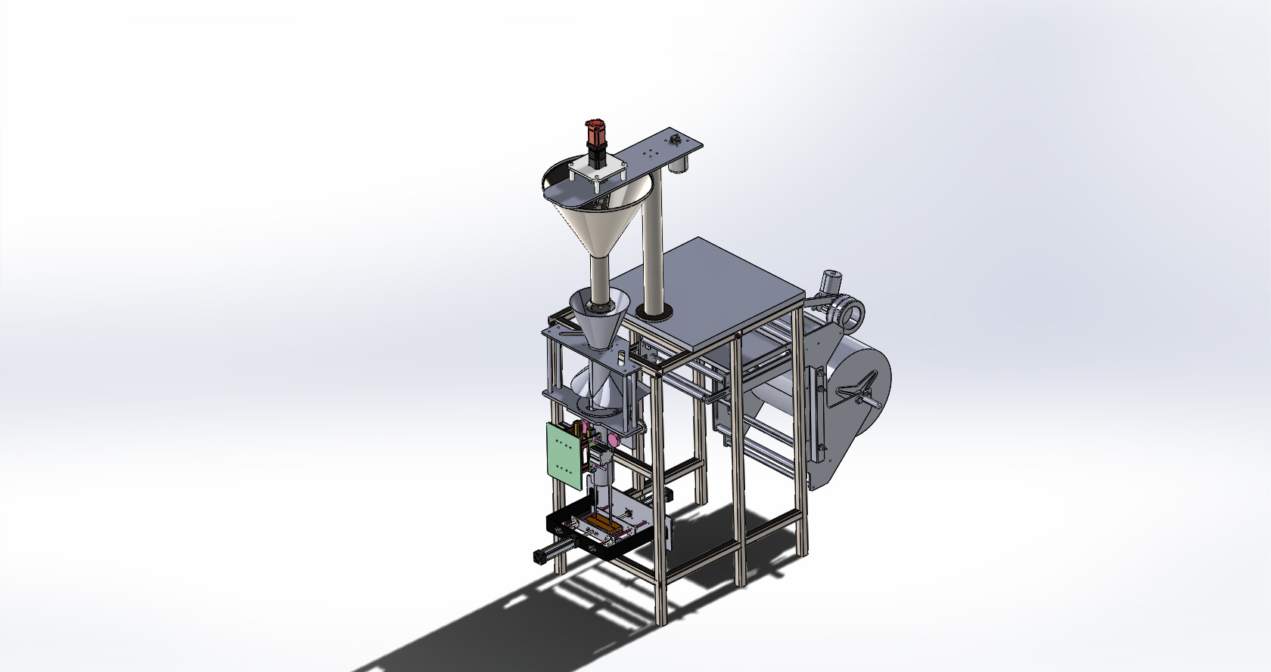

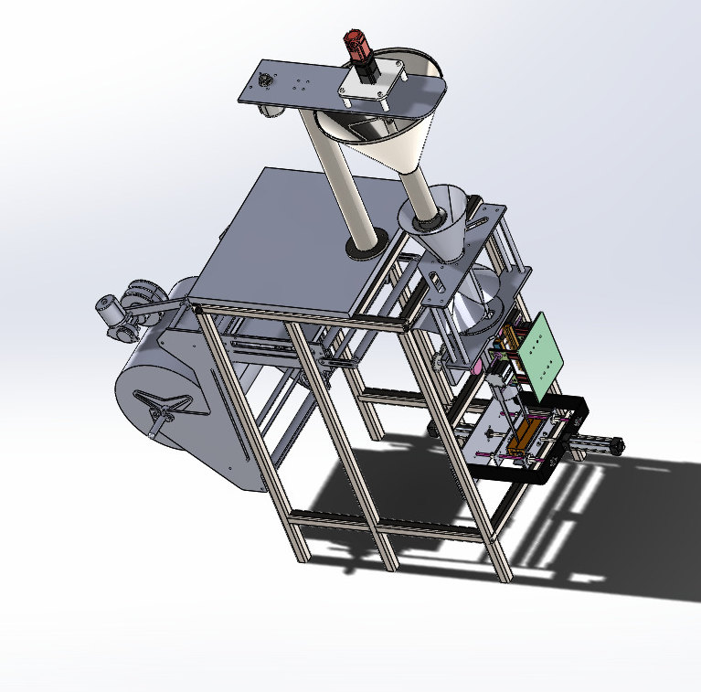
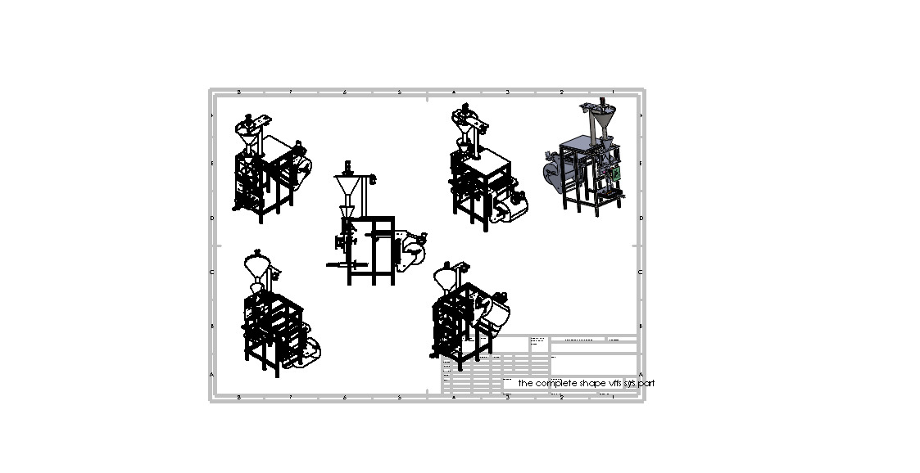

Materials (BOM).

A.2. Sub-Assembly Drawings: Detailed views of the Hopper-Agitator unit and the Drive Train.
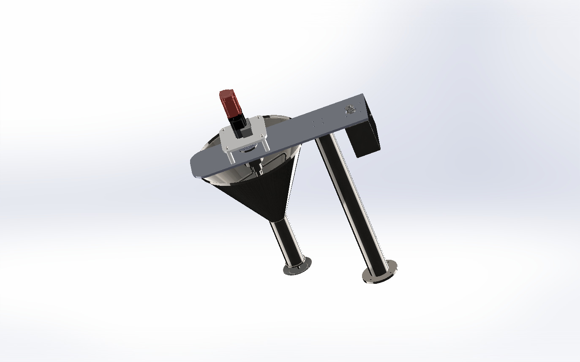
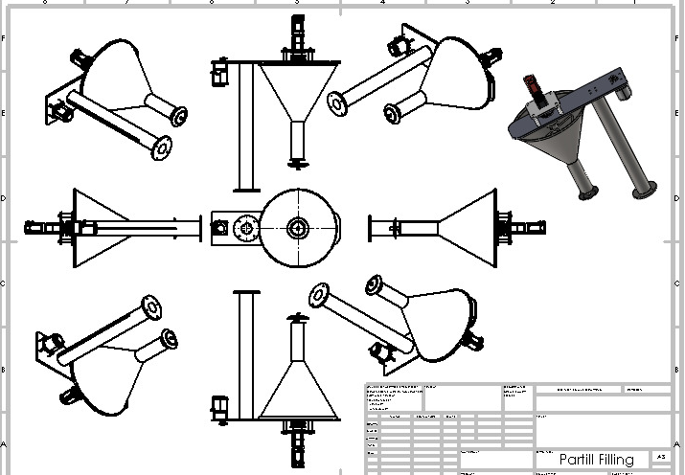

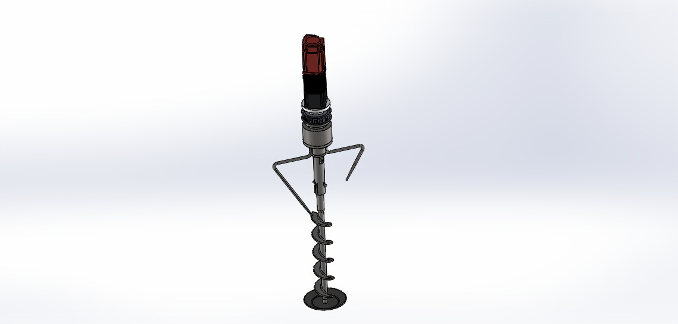

• A.3. Detailed Component Drawings: 2D dimensioned drawings of the Auger Screw (showing pitch and flight details), the Shaft, and the Discharge Nozzle.
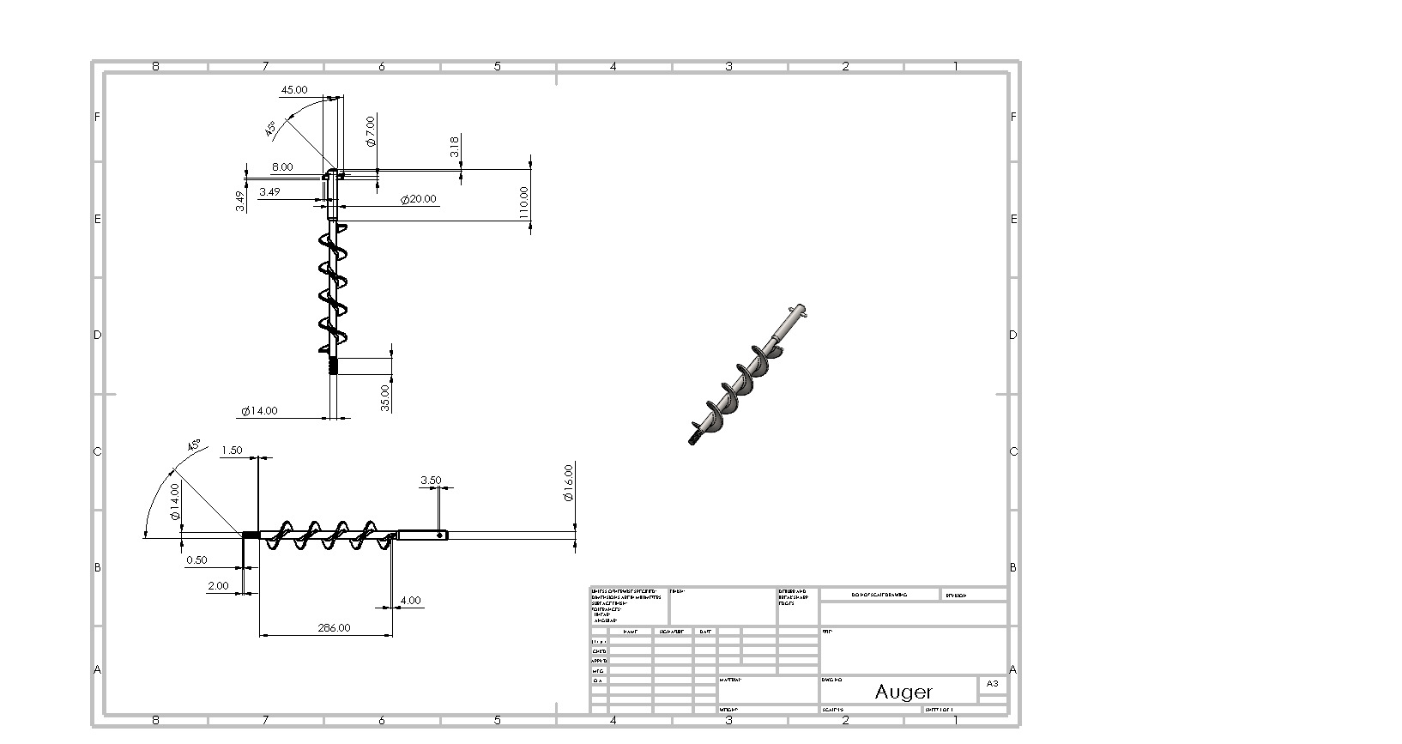
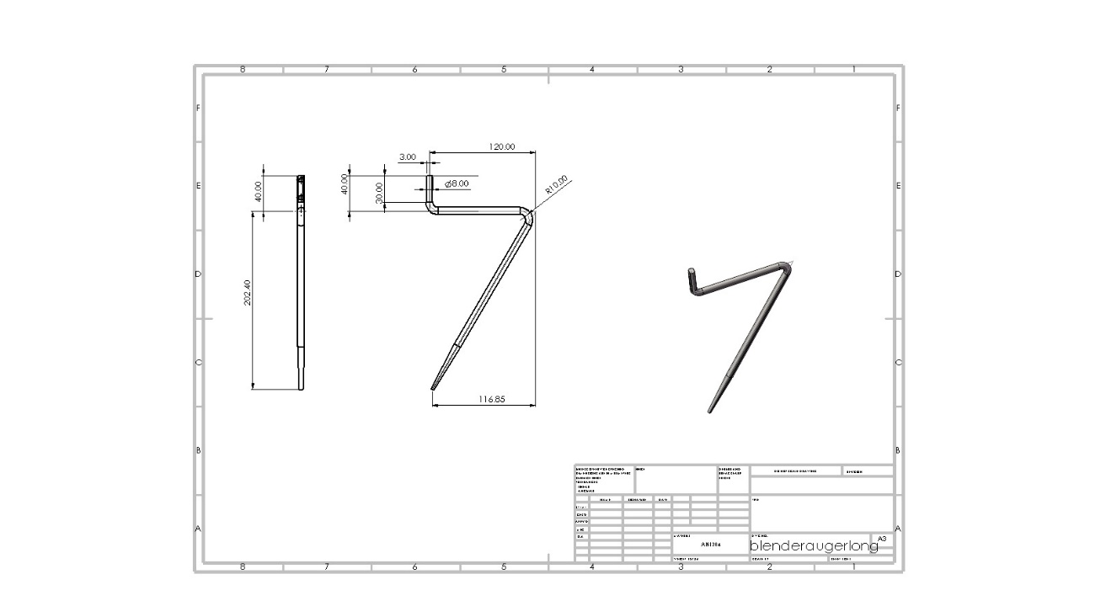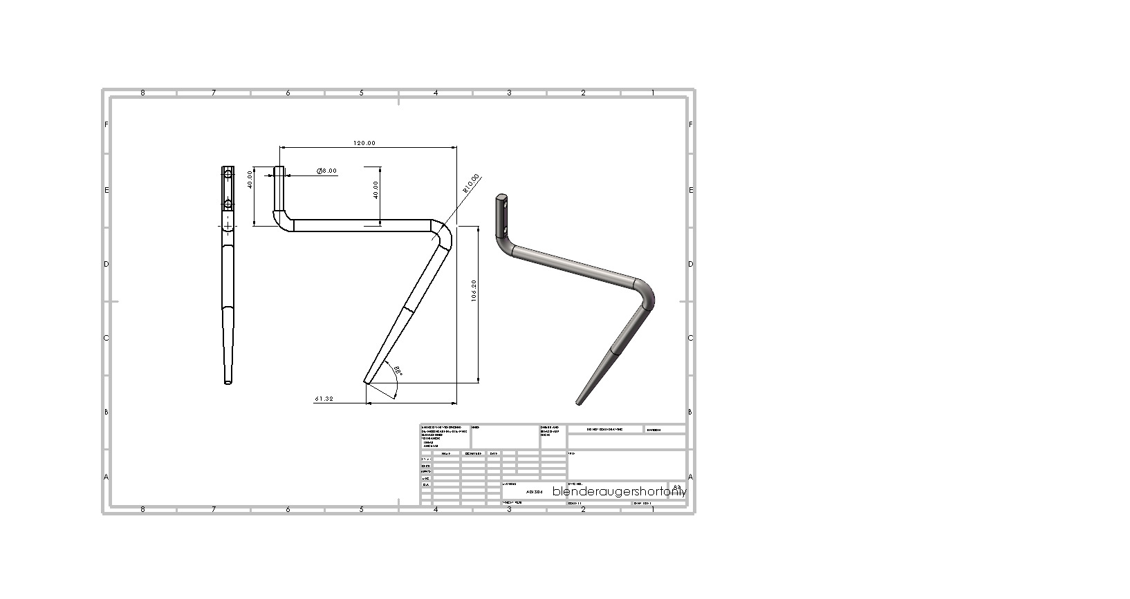
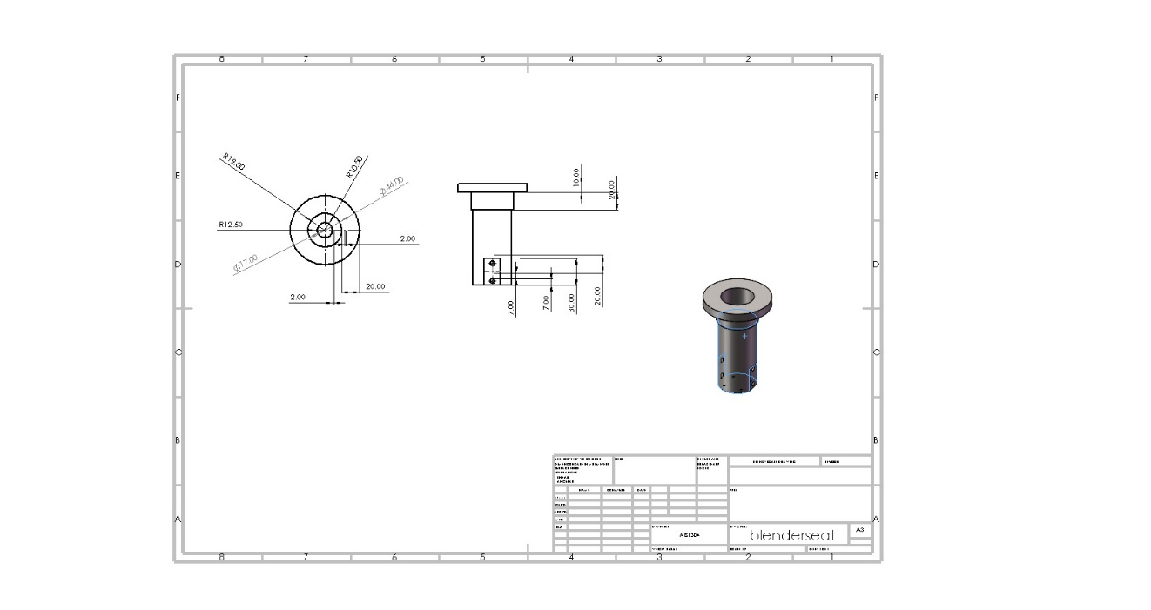
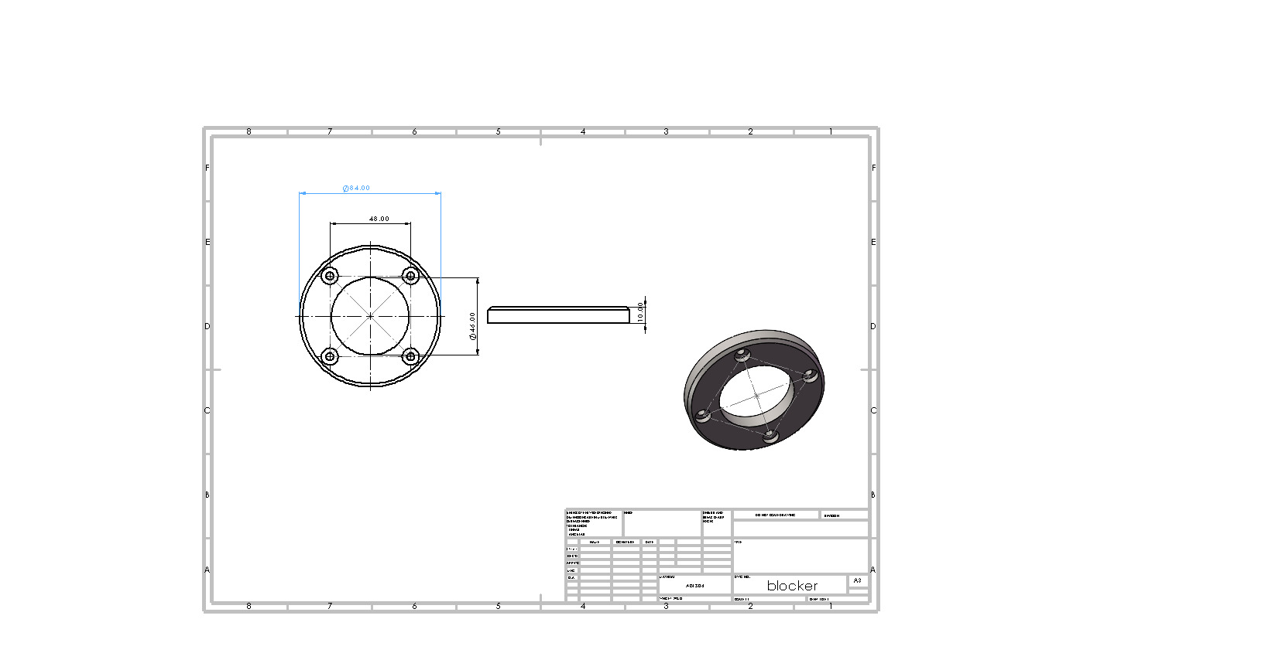

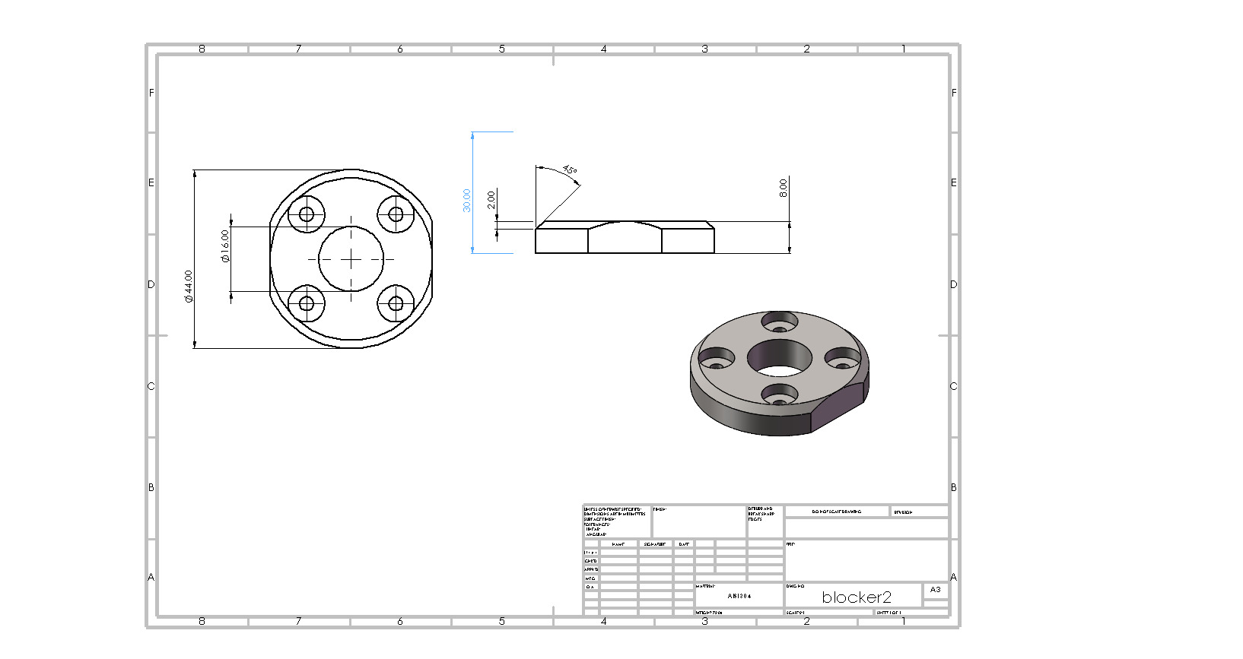
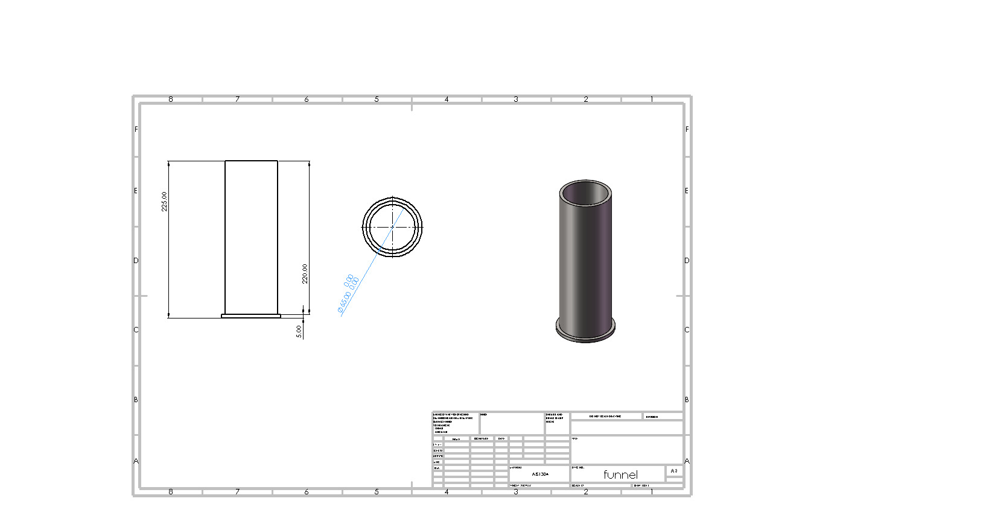
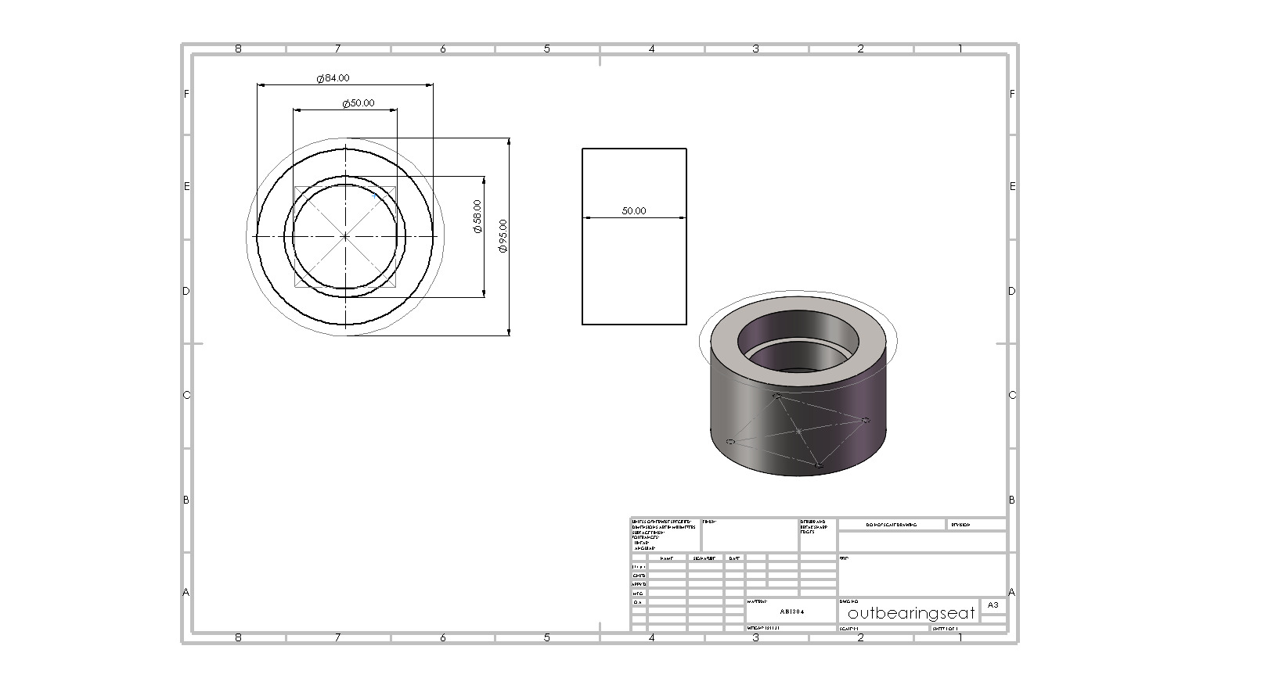
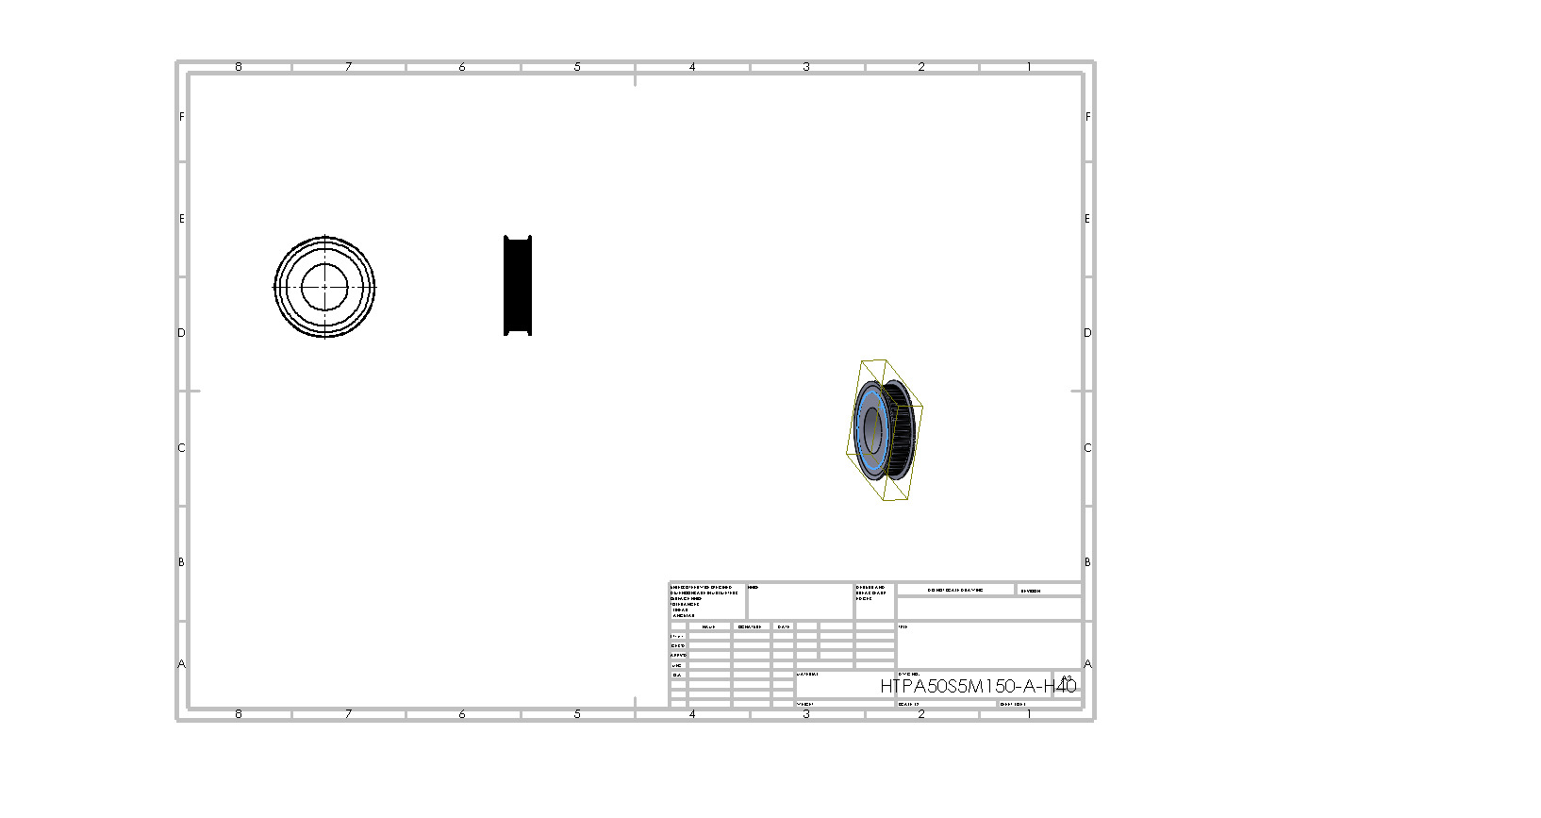
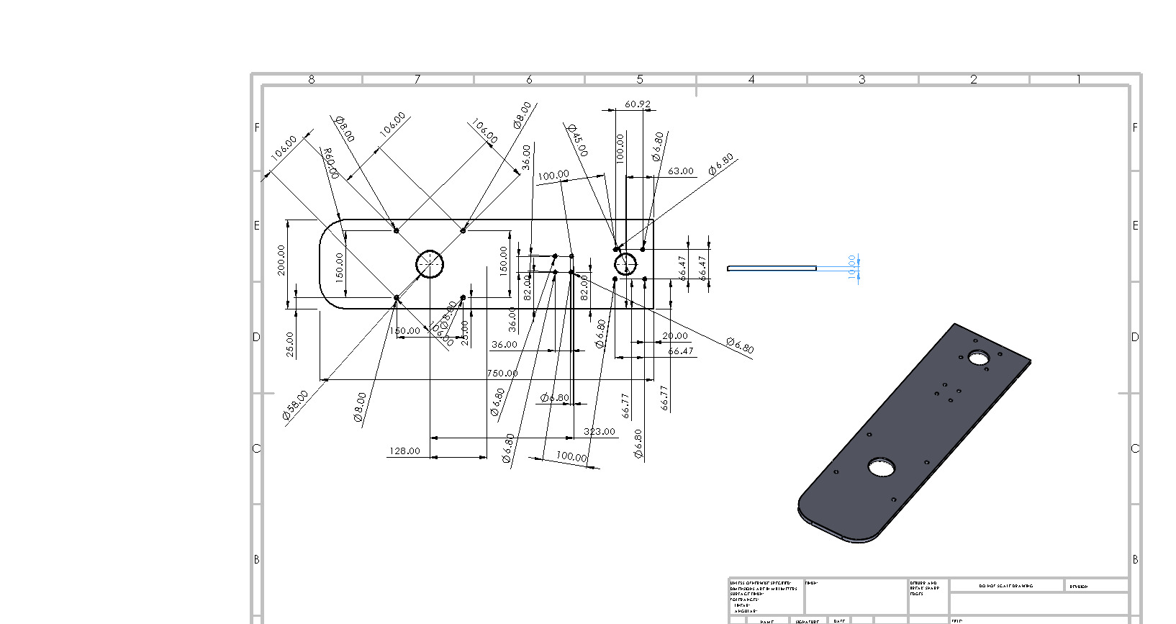
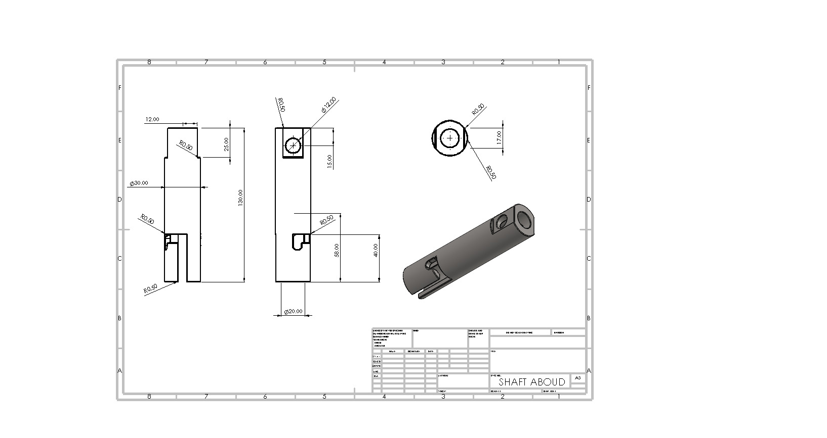
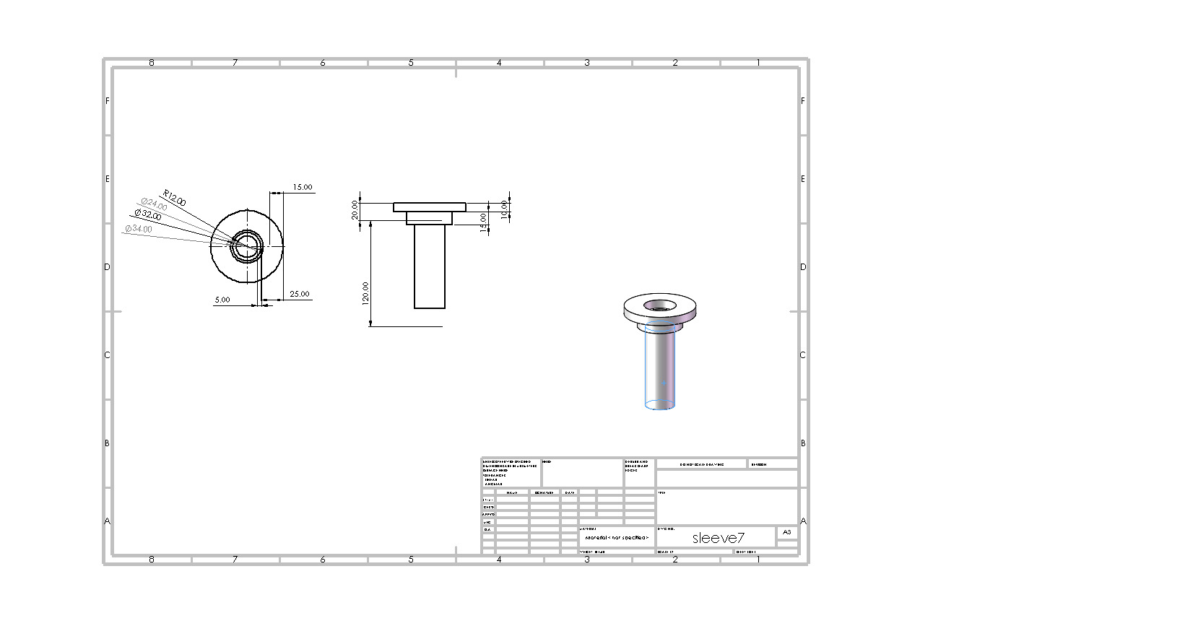
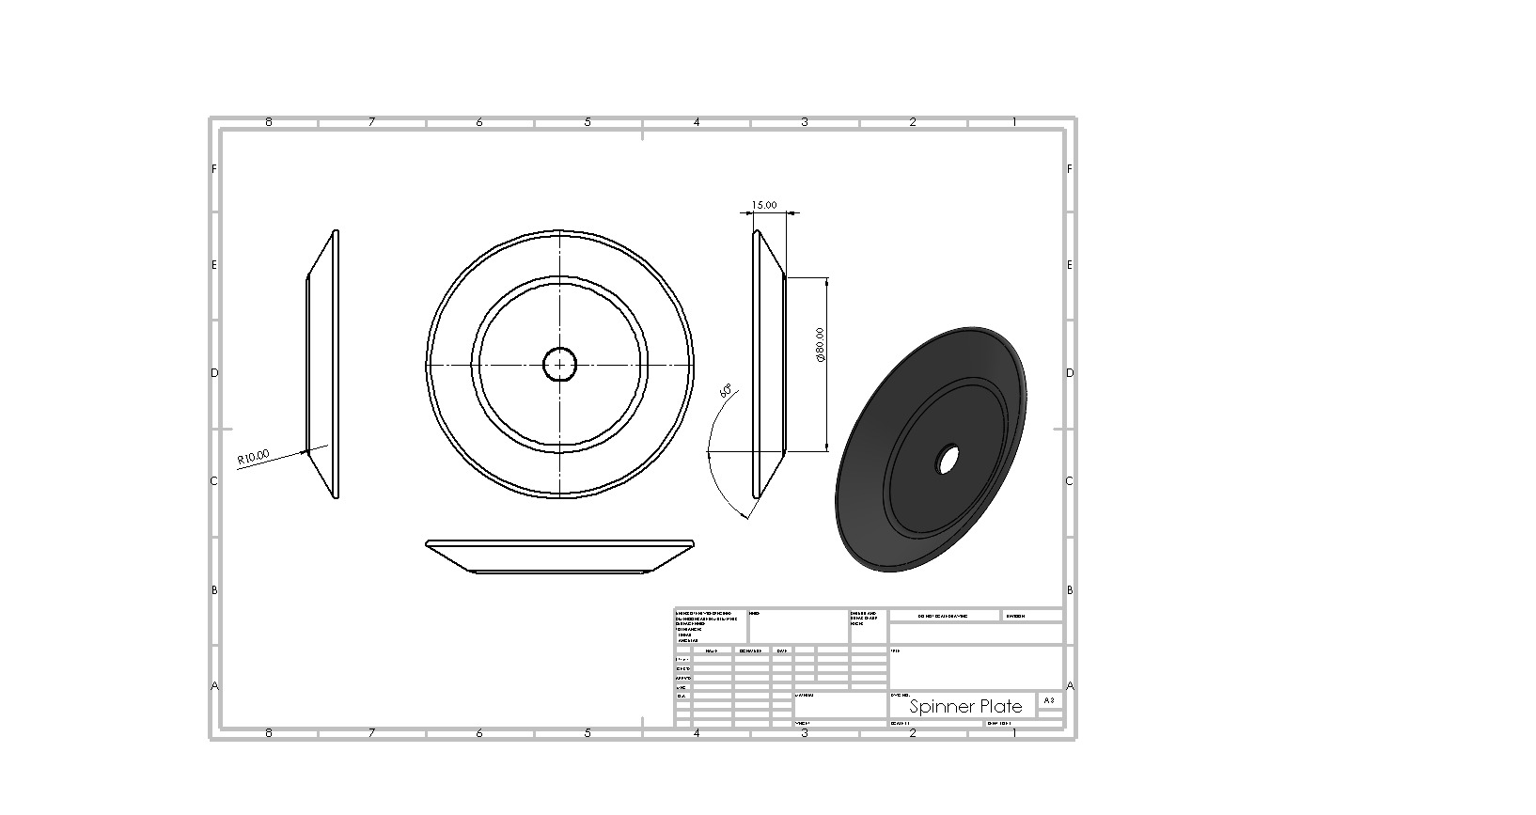
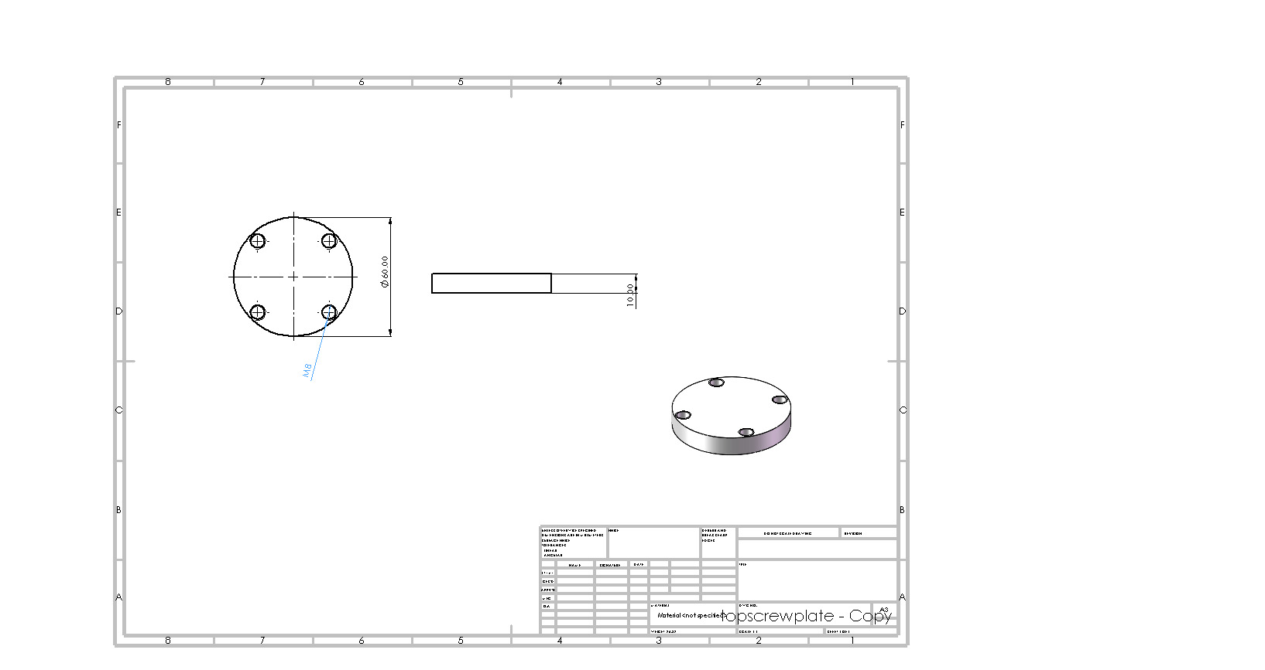
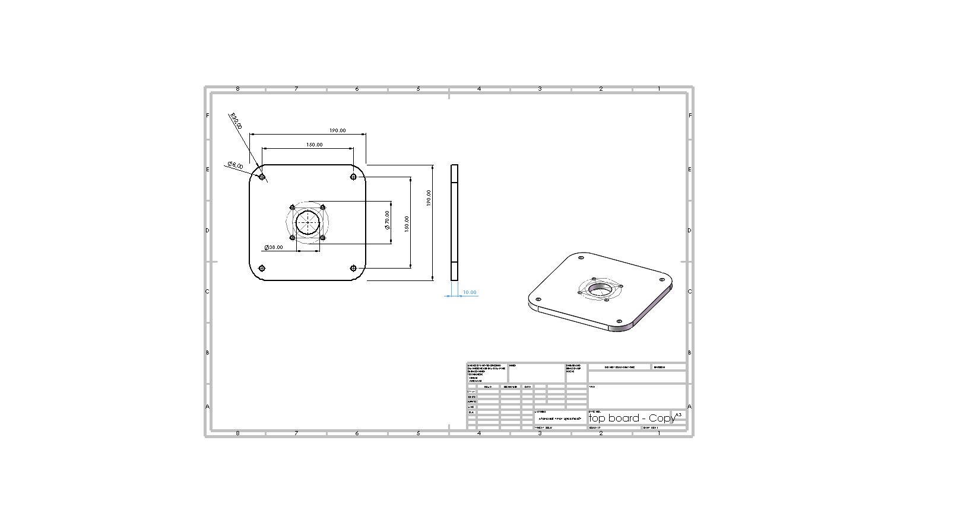
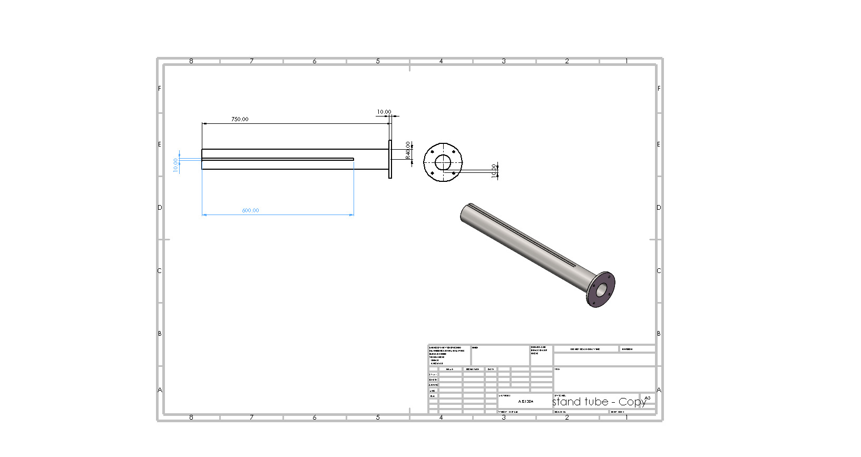
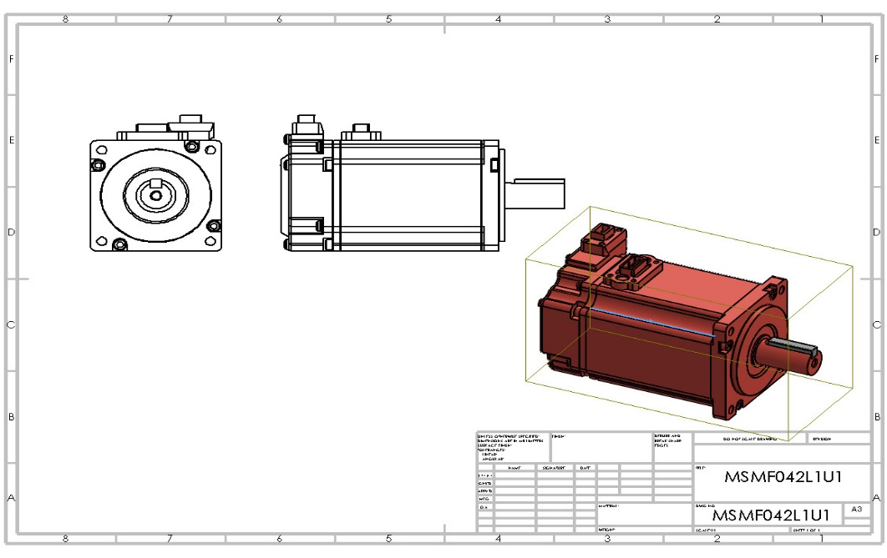
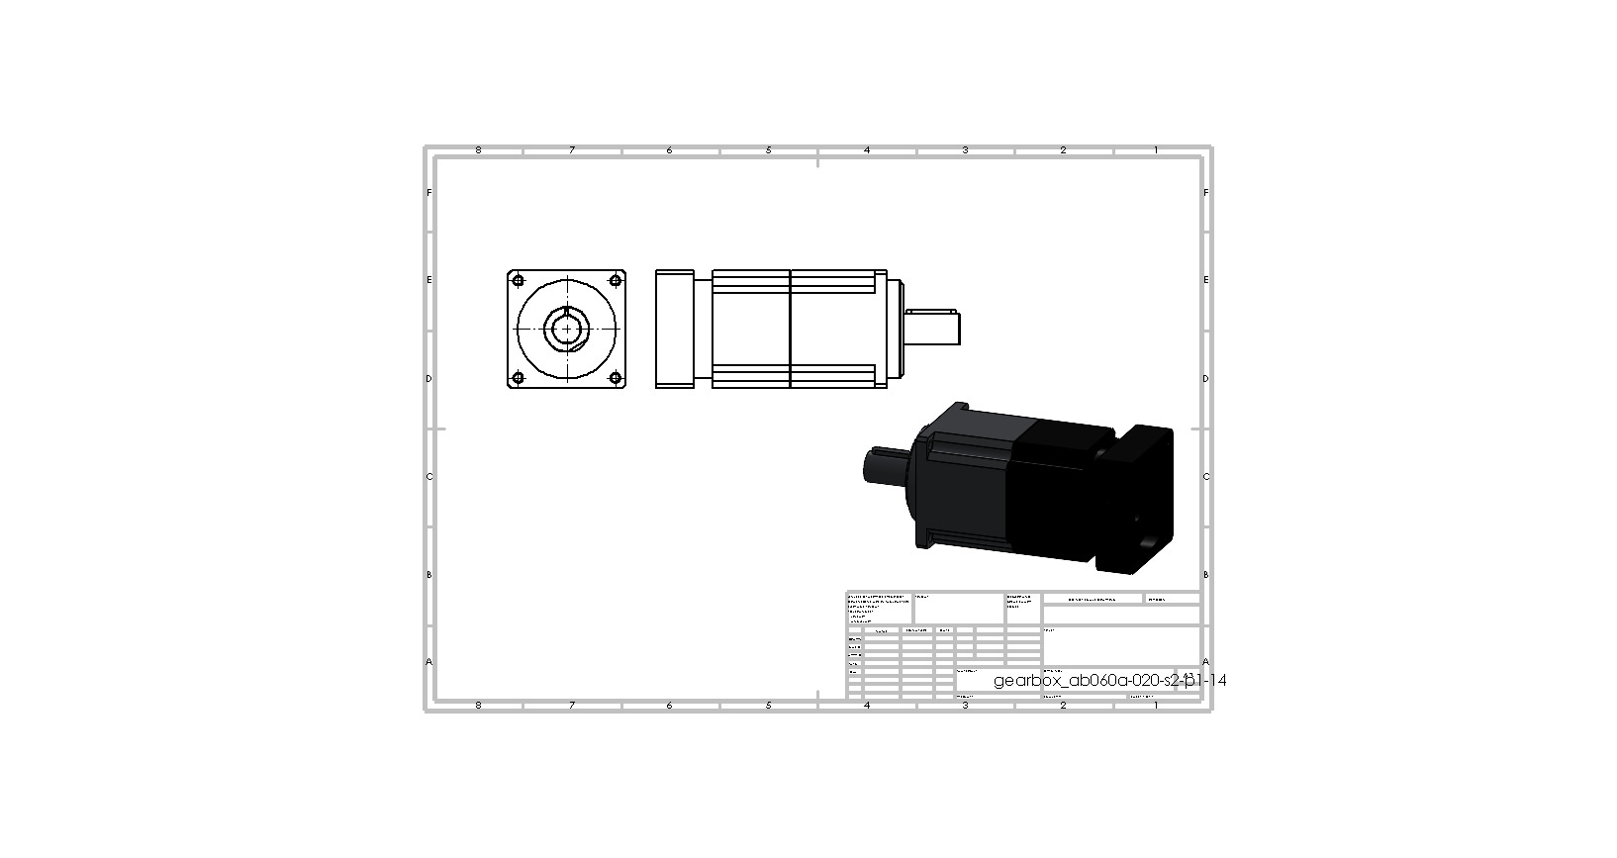
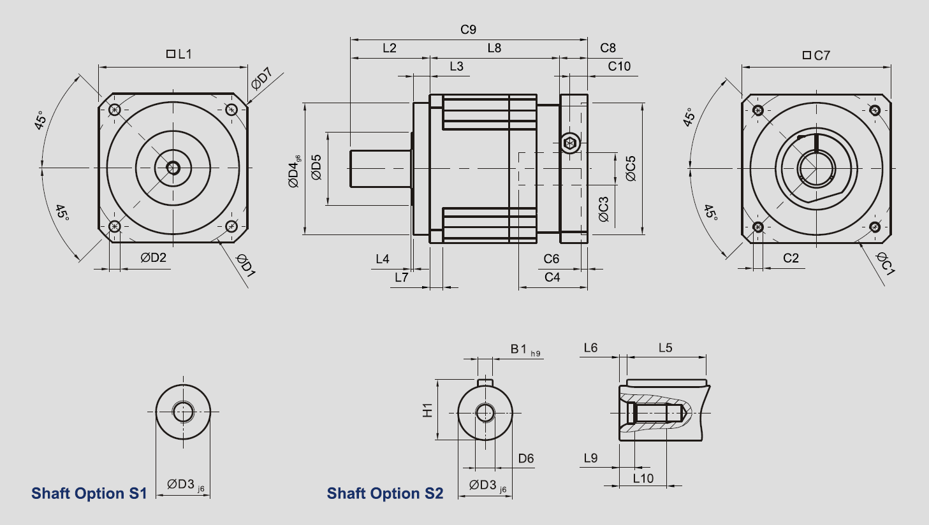

A.4. Exploded View: To show the assembly sequence and maintenance access points.
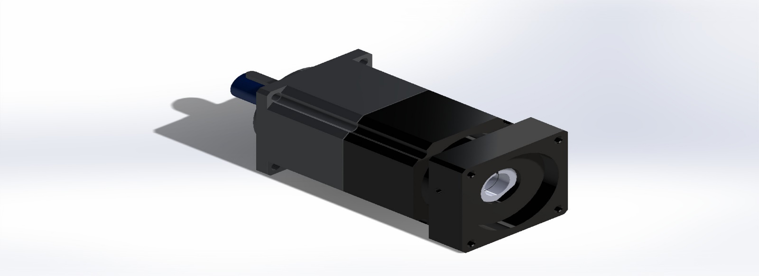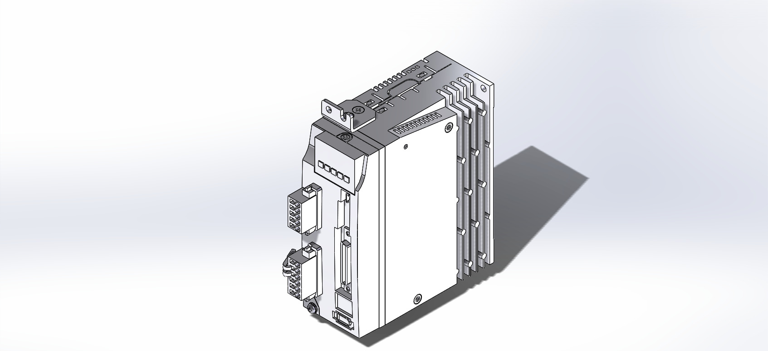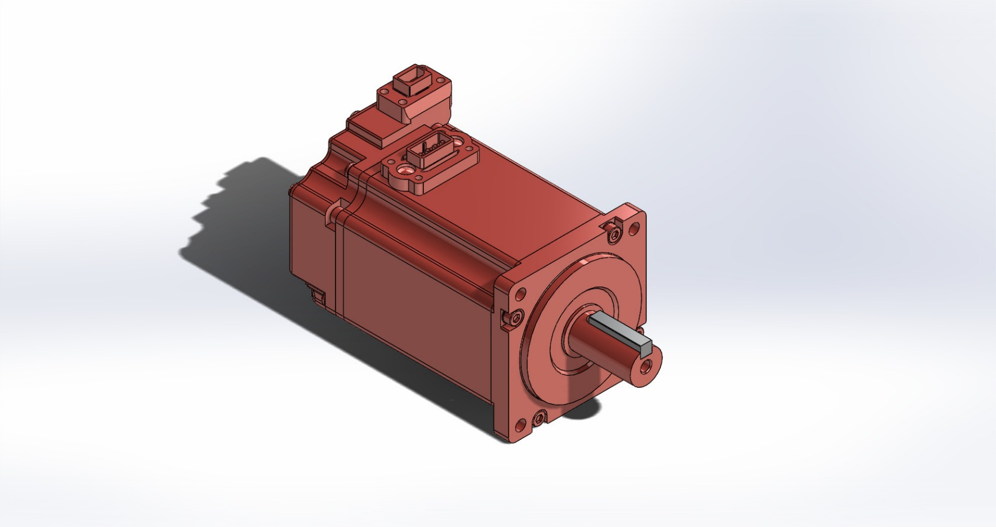
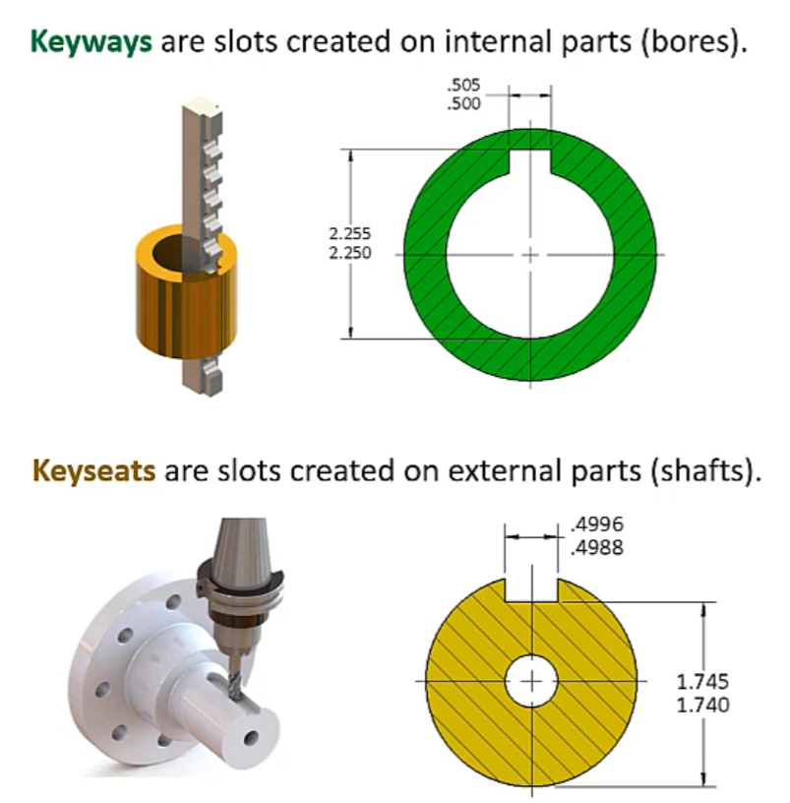
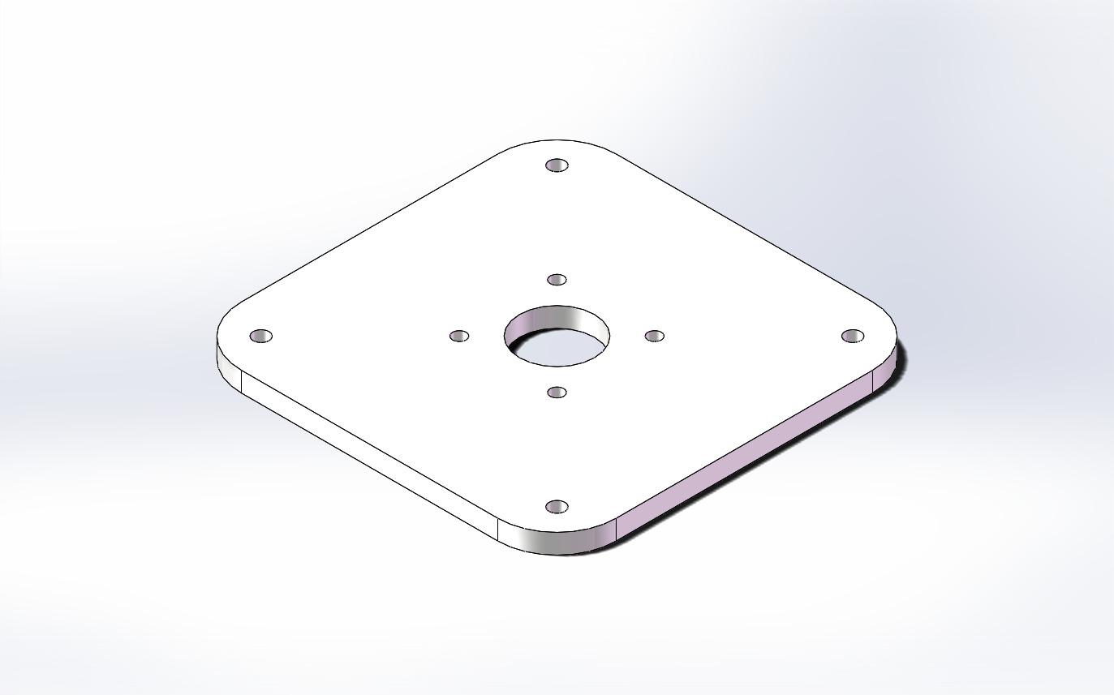
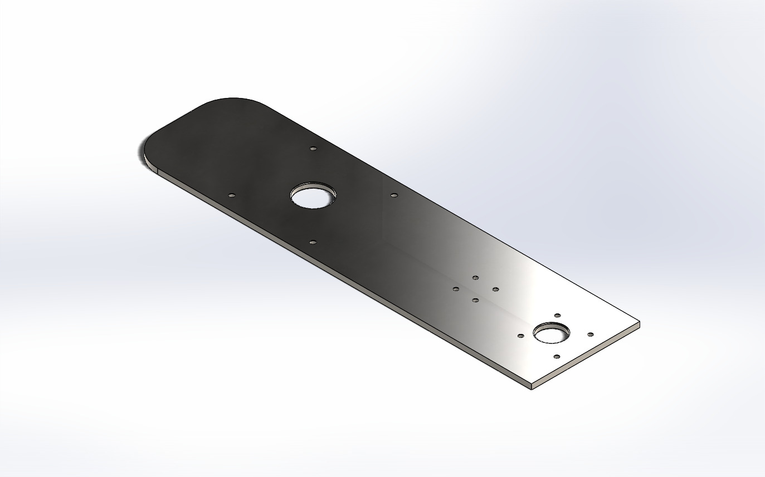
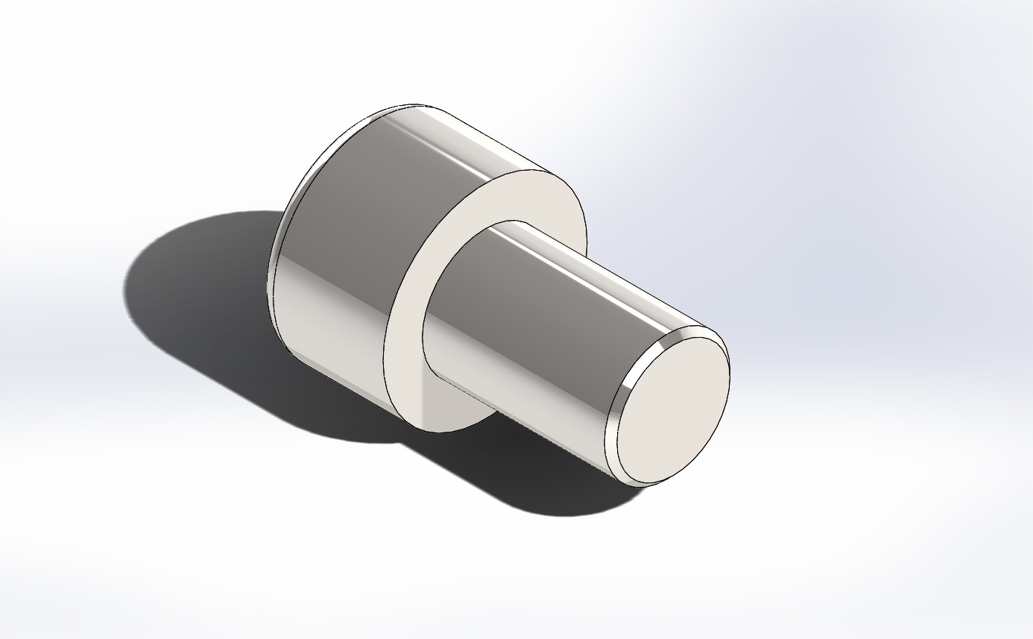
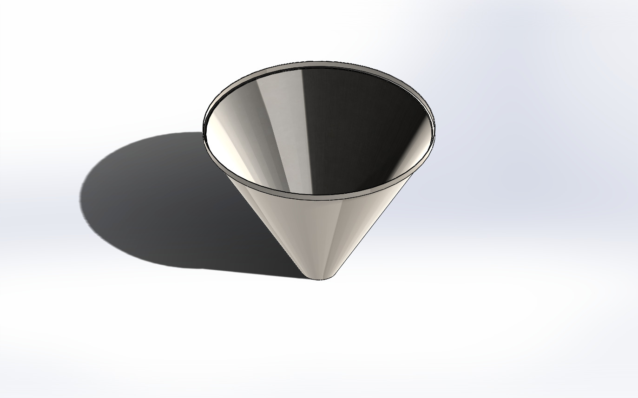
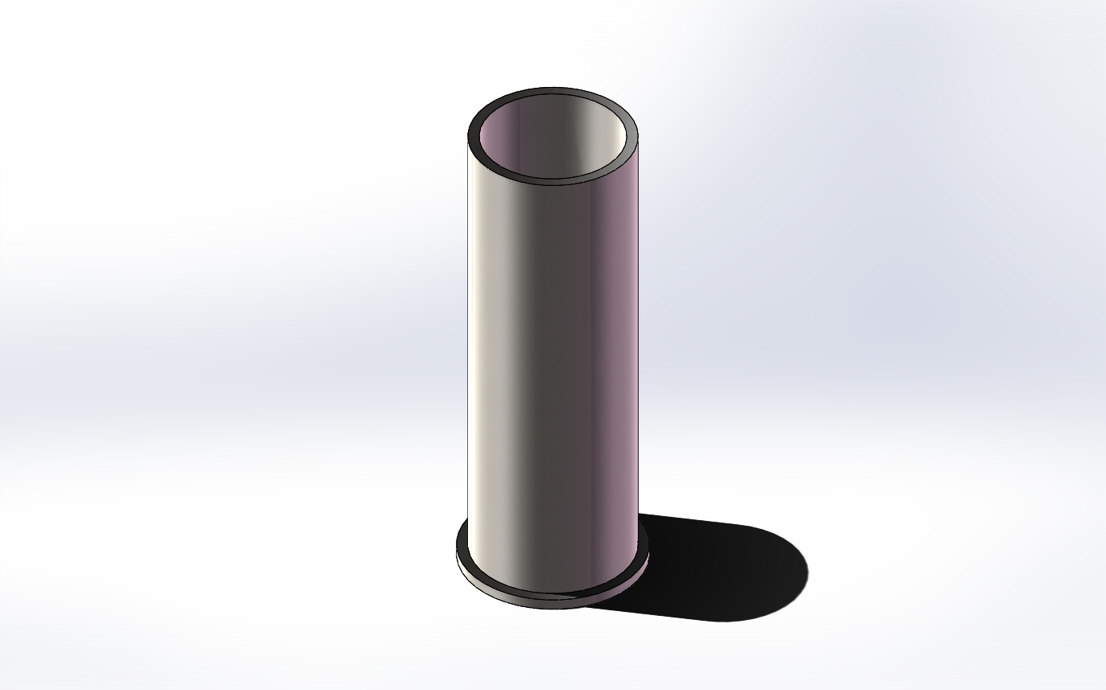
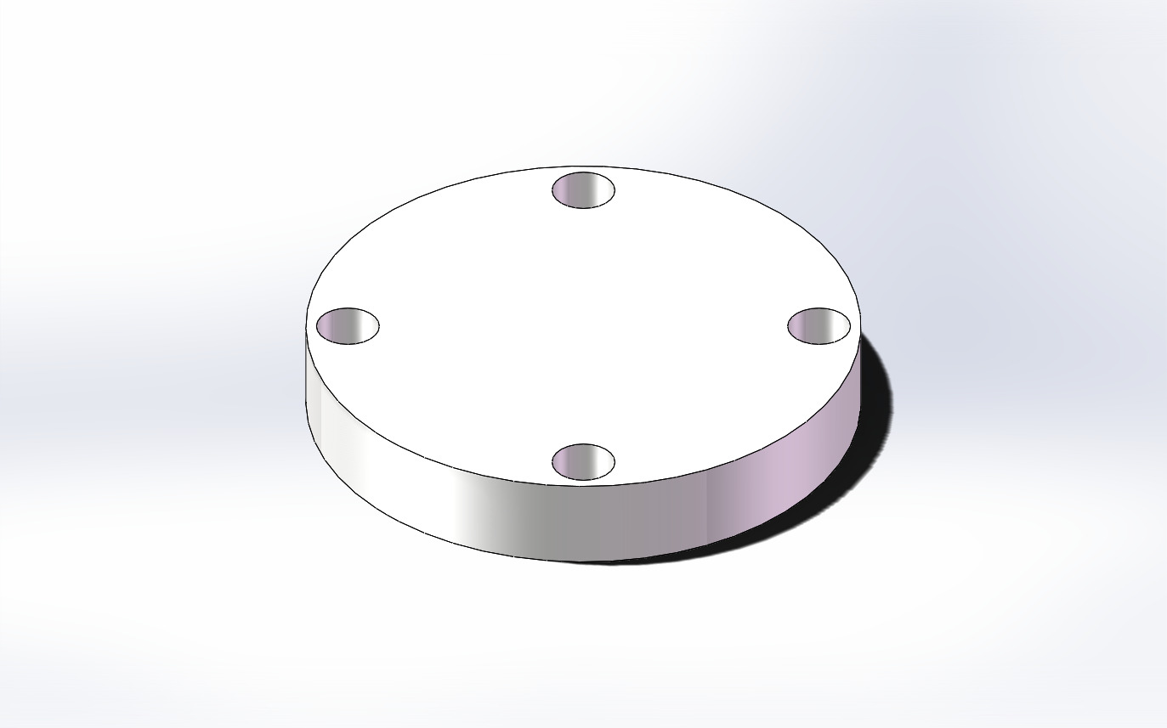
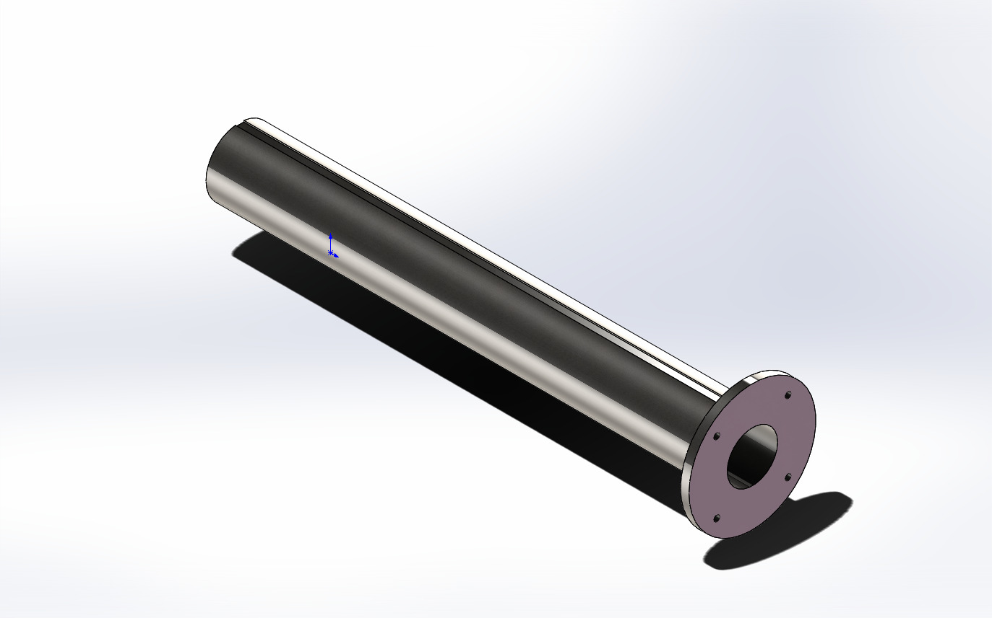
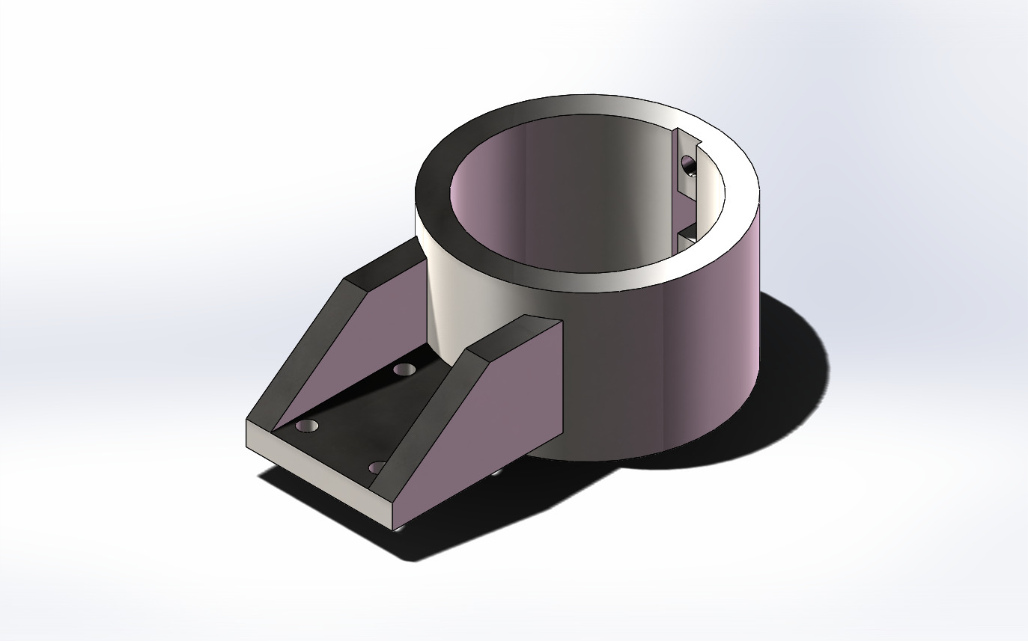
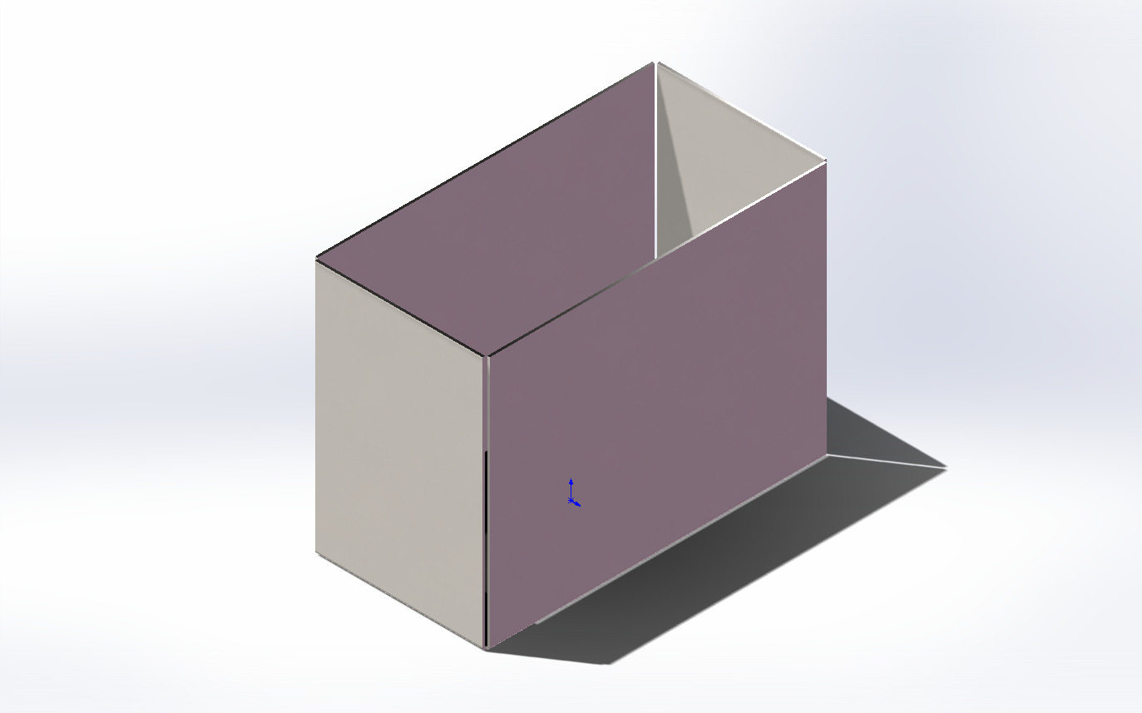
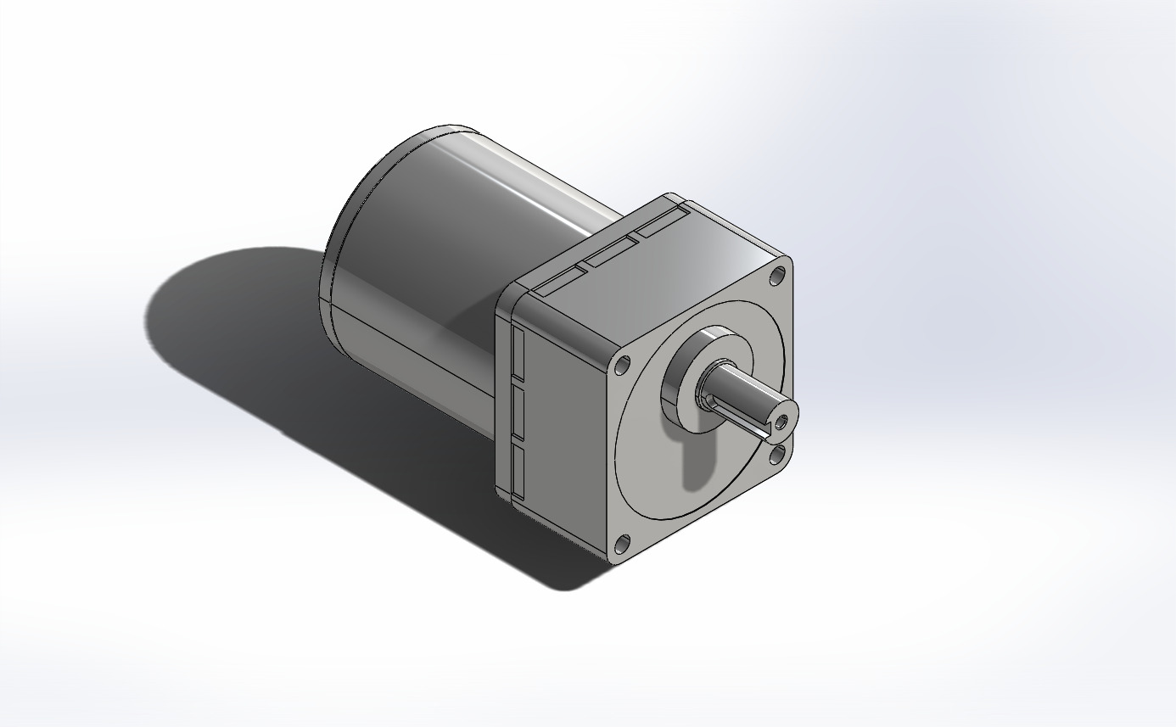
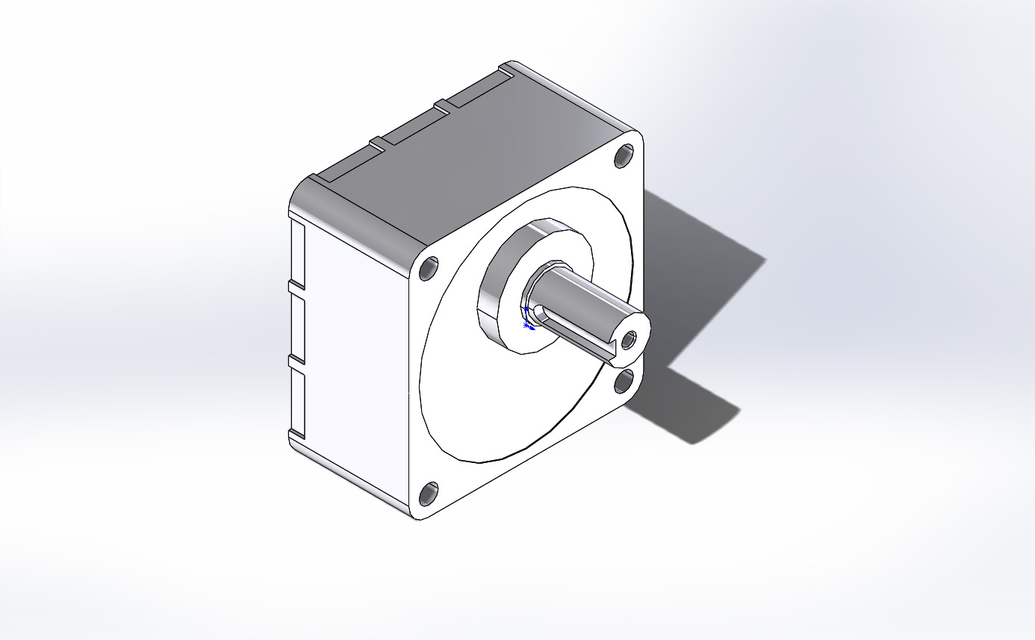
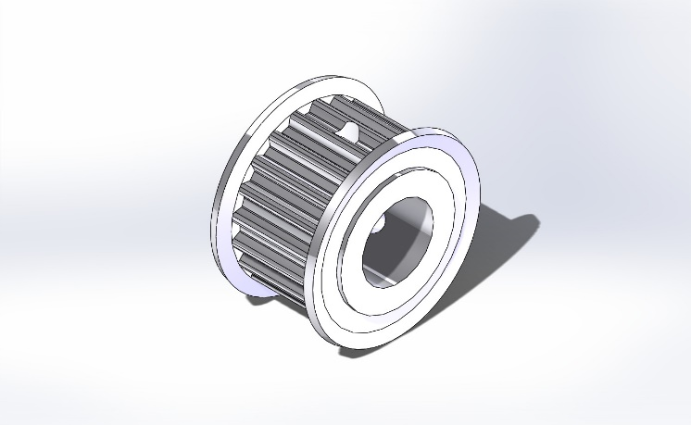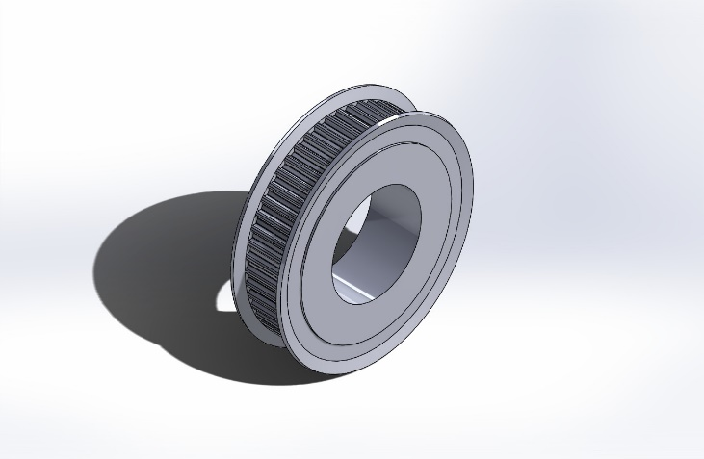

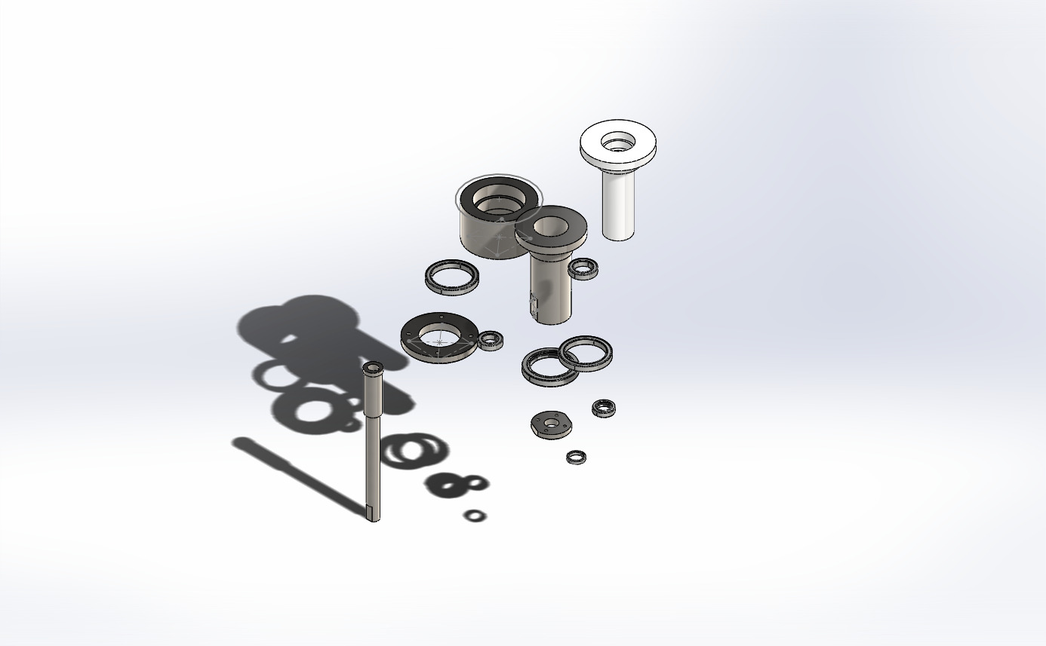
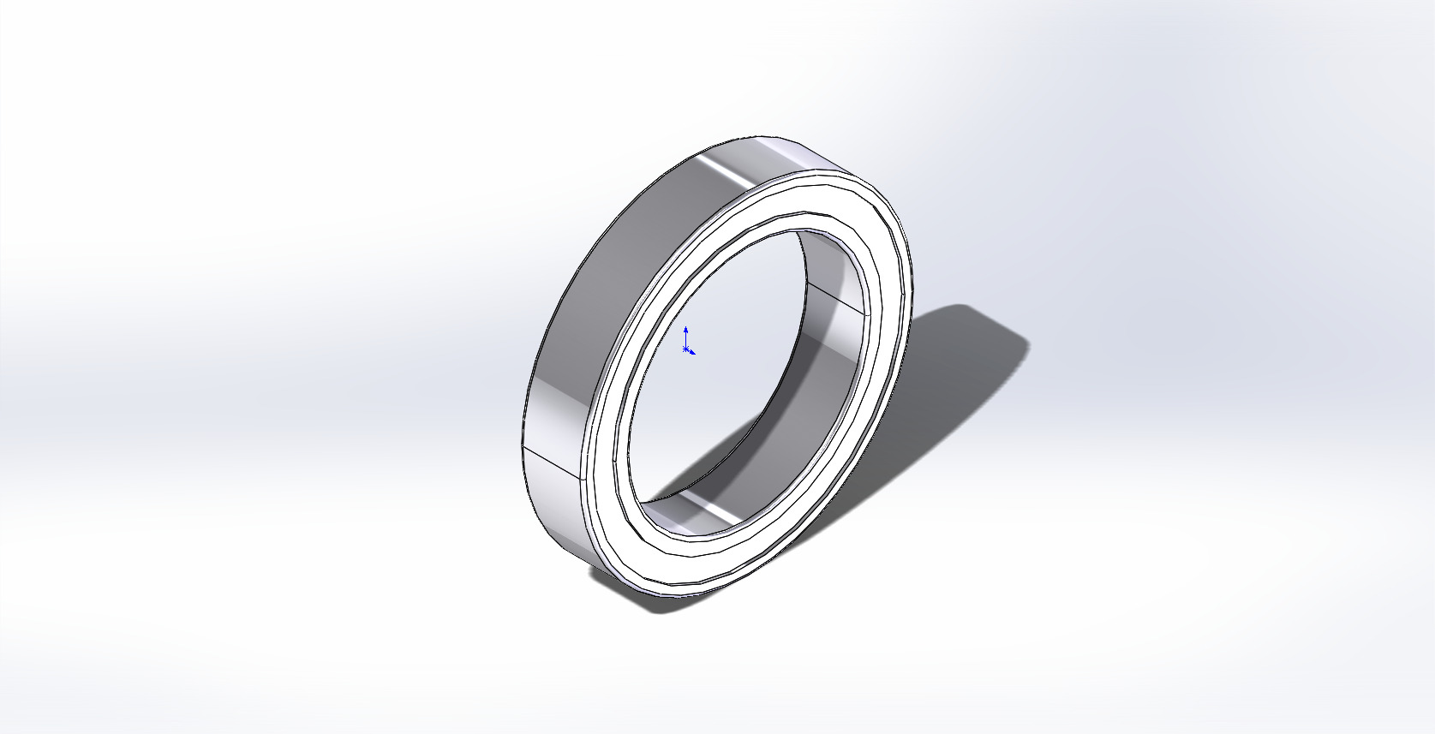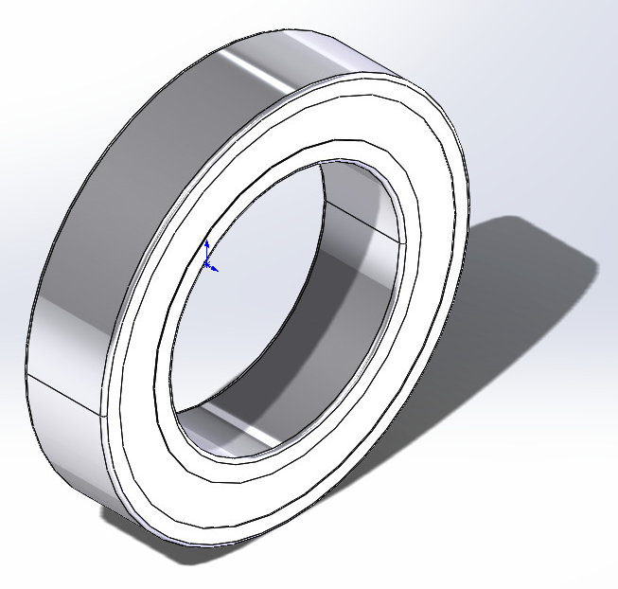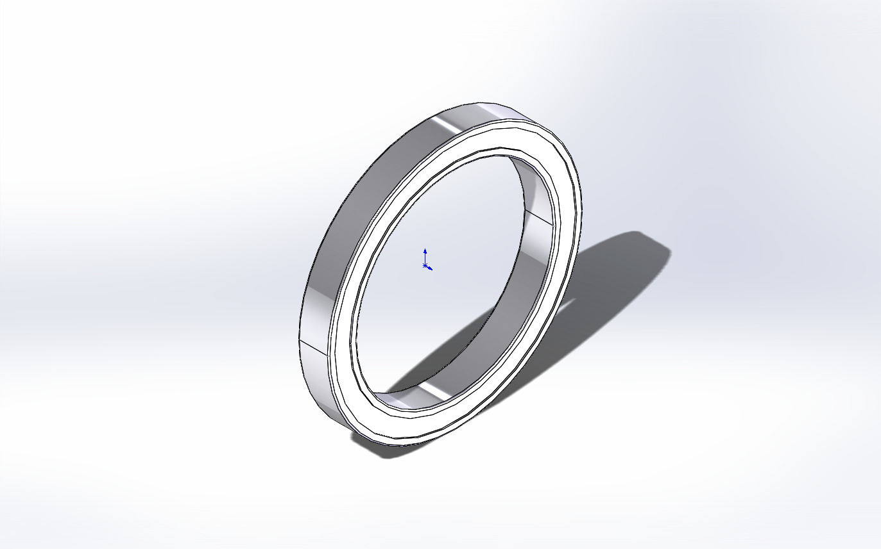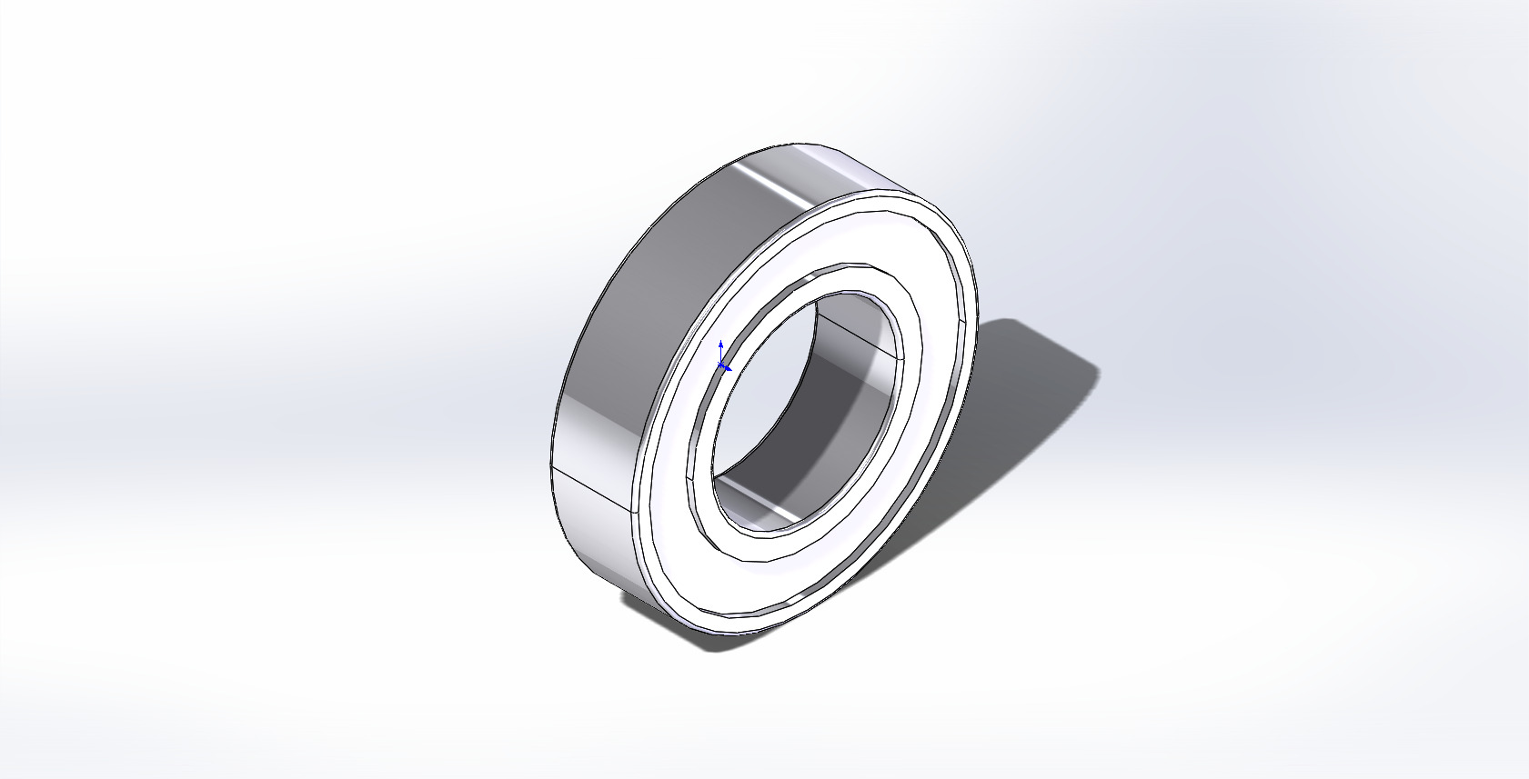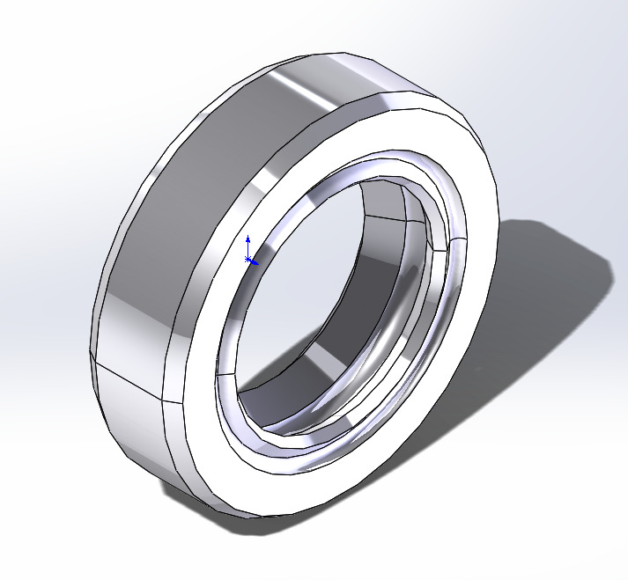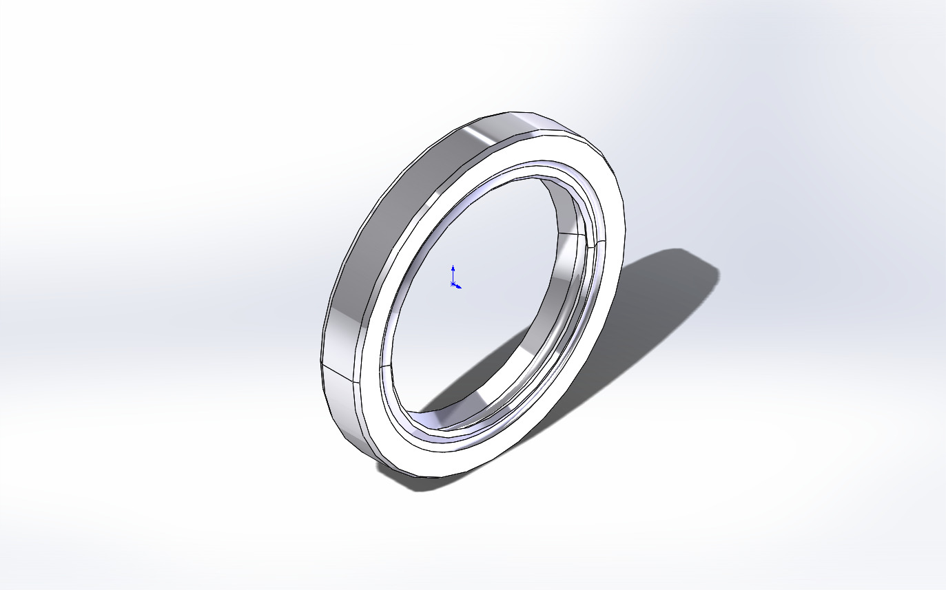

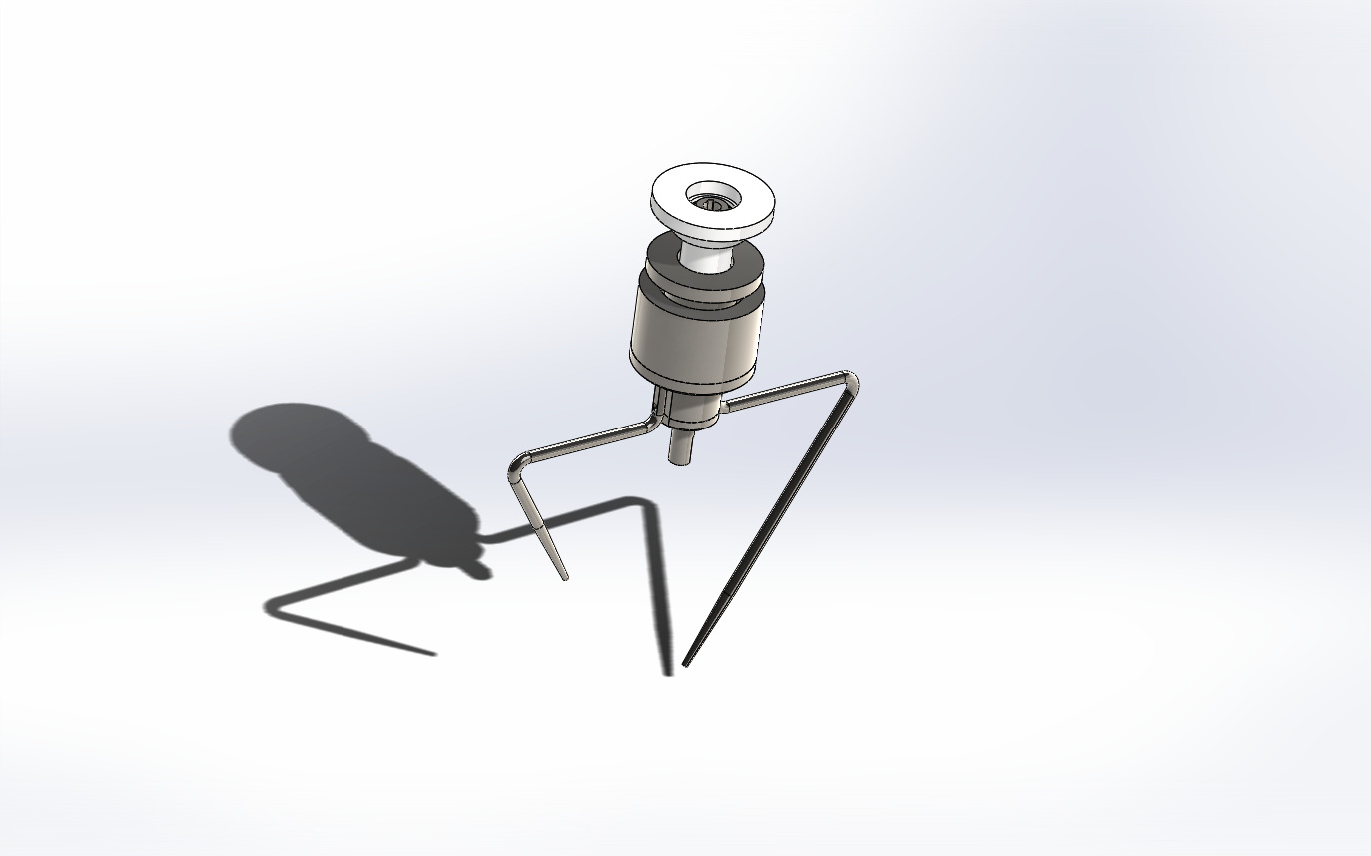

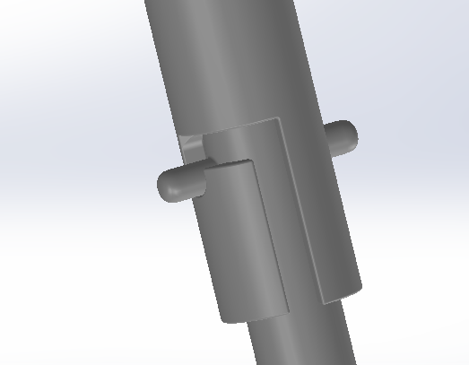
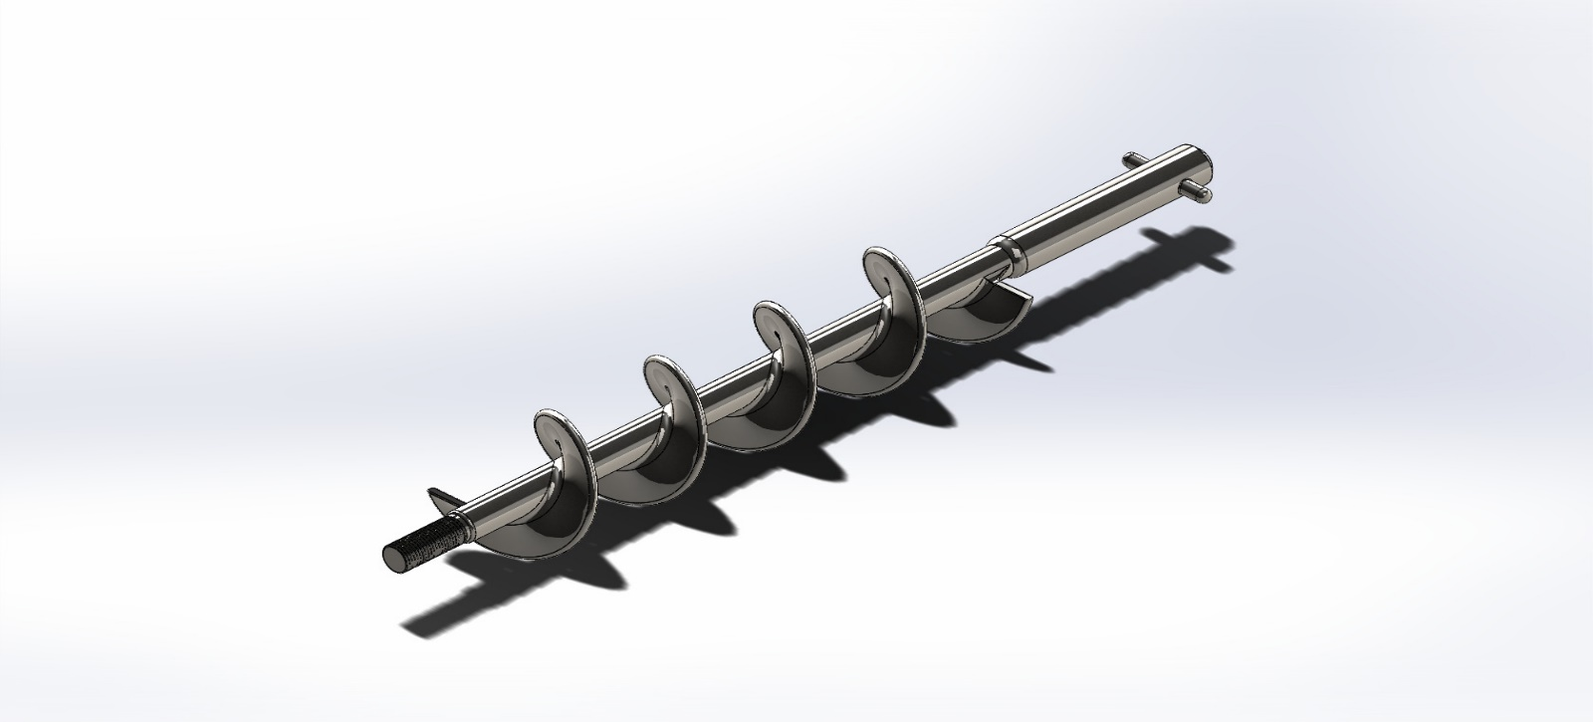

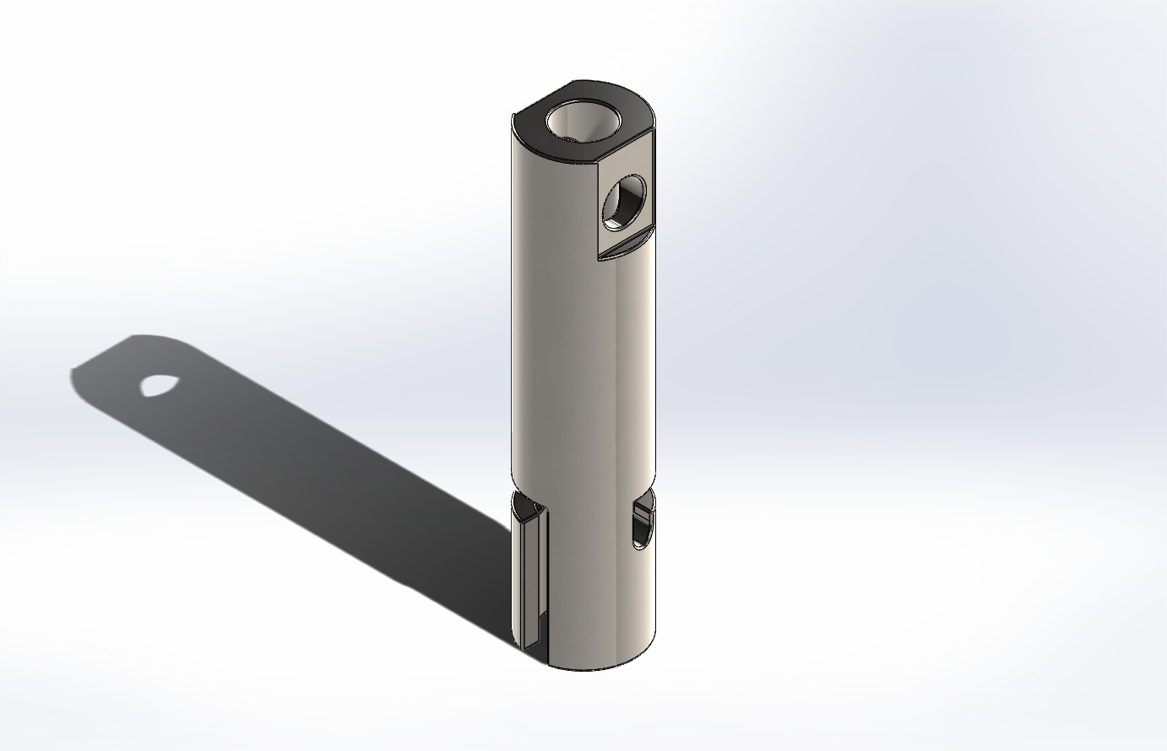
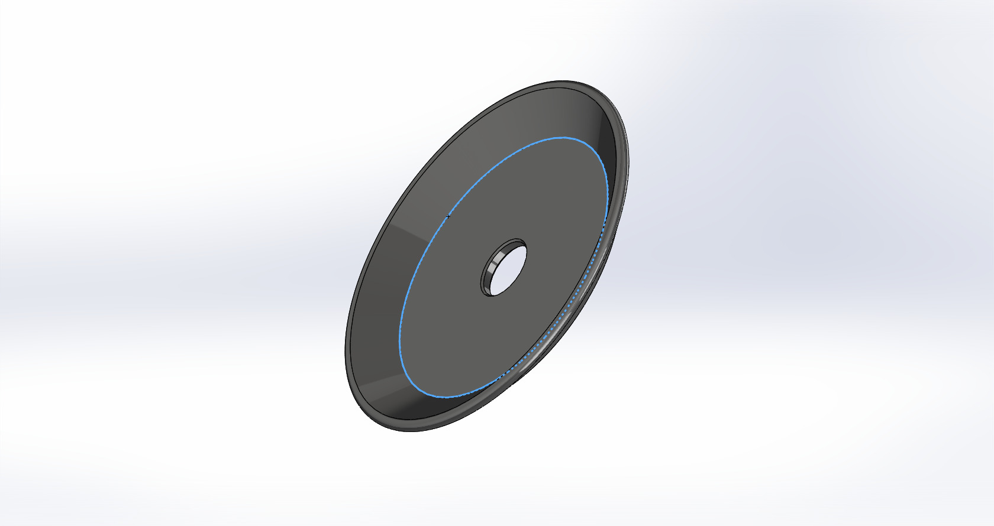

Appendix B: Control and Mechatronics Documentation

B.1. Wiring Diagram: Electrical schematic showing the PLC/Microcontroller, Driver, and Motor connections.

B.2. Control Logic Flowchart: The algorithmic sequence for the "Fill-Stop-Seal" cycle.
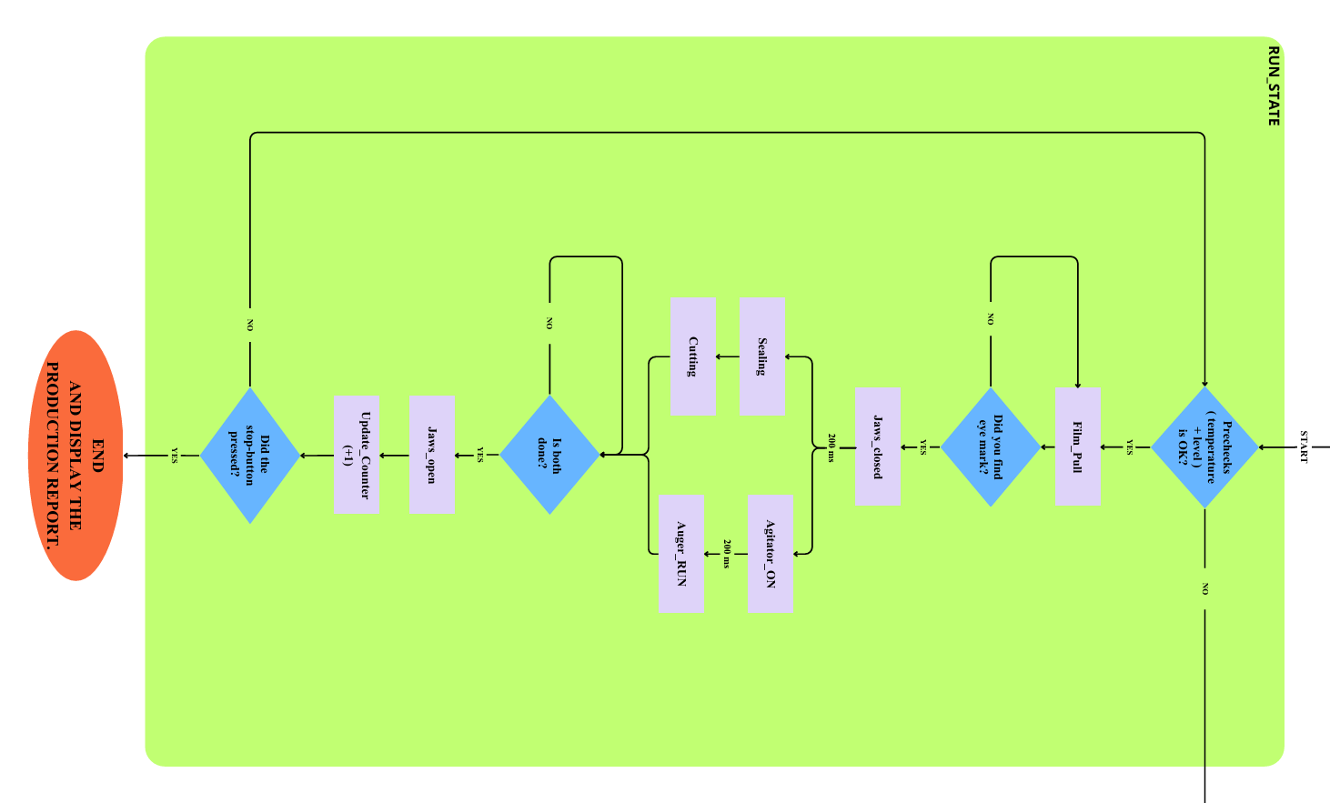

B.3. HMI Screen Mockups: User interface design for entering target weight and speed.
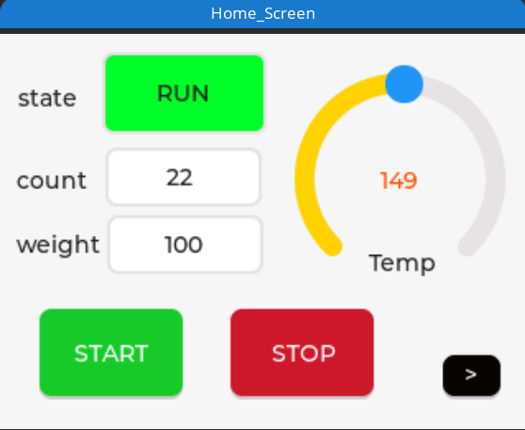

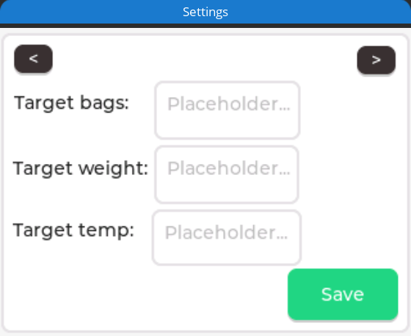

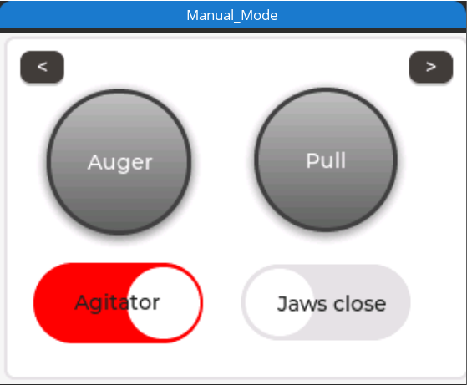

B.4. Pseudo-code/Source Code: The core logic used for the motion control profile.
/*
* VFFS Machine Controller - Graduation Project
* * Features:
* 1. RMT Driver: Generates stepper pulses via Hardware (Non-blocking).
* 2. Hybrid Motion: RMT for speed (Blind Zone) + Manual for precision (Sensor Search).
* 3. Robust E-Stop: Kills RMT channels instantly via Fault Handler.
* 4. Optimized Core Usage: CPU 0 is free for precise PID calculations.
*/
#include <stdio.h>
#include <string.h>
#include <stdlib.h>
#include "freertos/FreeRTOS.h"
#include "freertos/task.h"
#include "freertos/queue.h"
#include "freertos/semphr.h"
#include "freertos/event_groups.h"
#include "driver/gpio.h"
#include "driver/rmt.h" //
#include "esp_timer.h"
#include "esp_log.h"
#include "esp_rom_sys.h"
#include "esp_adc/adc_oneshot.h"
#include "mock_sensor.h"
// =========================================================
// ********** USER CONFIGURATION AREA **********
// =========================================================
#define SIMULATION_MODE 1
// PID & TEMP
#define HEATER_SETPOINT 150.0
#define PID_KP 20.0
#define PID_KI 0.5
#define PID_KD 0.0
#define PID_WINDOW_SIZE_MS 1000
#define TEMP_TOLERANCE 5.0
// HOPPER
#define HOPPER_EMPTY_THRESH 10
#define HOPPER_LOW_THRESH 30
// BAG & MOTION
#define BAG_LENGTH_STEPS 700
#define BLIND_ZONE_STEPS 500
#define MAX_SEARCH_STEPS 1000
#define AUGER_STEPS 800
// SPEED (RMT tick is usually 1us)
#define SPEED_FILM_US 1000
#define SPEED_AUGER_US 1000
// DELAYS
#define DELAY_JAWS_CLOSE 200
#define DELAY_FILL 200
#define DELAY_CUT 200
#define DELAY_OPEN 200
#define DELAY_CYCLE_END 200
// =========================================================
// PINS & DEFINITIONS
// =========================================================
// RMT CHANNELS
#define RMT_CH_AUGER RMT_CHANNEL_0
#define RMT_CH_FILM RMT_CHANNEL_1
// SPI
#define SPI_PIN_SCK 18
#define SPI_PIN_MISO 19
#define SPI_PIN_CS_1 21

// GPIOs
#define PIN_ESTOP 15
#define PIN_START_BTN 34
#define PIN_STOP_BTN 2
#define PIN_EYE_MARK 39
// Motors
#define PIN_AUGER_STEP 25
#define PIN_AUGER_DIR 26
#define PIN_AUGER_EN 27
#define PIN_FILM_STEP 32
#define PIN_FILM_DIR 33
#define PIN_FILM_EN 14
// Actuators
#define PIN_AGITATOR 13
#define PIN_HEATER_SSR 23
#define PIN_VALVE_HORIZ 4
#define PIN_VALVE_VERT 5
#define PIN_VALVE_CUTTER 12
// ADC
#define ADC_UNIT_ID ADC_UNIT_1
#define ADC_CHAN_LEVEL ADC_CHANNEL_7
// Logic
#define VALVE_ON 0
#define VALVE_OFF 1
#define AGIT_ON 1
#define AGIT_OFF 0
#define MOTOR_ENABLE 0
#define MOTOR_DISABLE 1
#define MOTOR_AUGER_ID 1
#define MOTOR_FILM_ID 2

// Events
#define BIT_SYSTEM_READY (1 << 0)
#define BIT_AUTO_RUNNING (1 << 1)
#define BIT_ESTOP_ACTIVE (1 << 2)
#define BIT_TEMP_OK (1 << 3)
// =========================================================
// HANDLES
// =========================================================
typedef struct {
uint8_t motor_id;
uint32_t steps;
uint32_t interval_us;
uint8_t direction;
bool use_sensor;
} MotionCommand_t;
EventGroupHandle_t sys_evt_group;
QueueHandle_t motion_queue;
SemaphoreHandle_t motion_done_sem;
SemaphoreHandle_t mutex_vars;
TaskHandle_t th_ControlLoop = NULL;
TaskHandle_t th_PID = NULL;
TaskHandle_t th_HMI = NULL;
TaskHandle_t th_Motion = NULL;
adc_oneshot_unit_handle_t adc1_handle;
typedef struct {
double current_temp;
uint32_t bag_counter;
bool last_move_success;
} SystemData_t;

SystemData_t sys_data = { .current_temp = 25.0, .last_move_success = true };
// Forward Declarations
void Task_ControlLoop(void *pvParameters);
void Task_PID(void *pvParameters);
void Task_MotionController(void *pvParameters);
void Task_FaultHandler(void *pvParameters);
void Task_HMI(void *pvParameters);
// =========================================================
// RMT & HARDWARE SETUP
// =========================================================
void Init_RMT() {
rmt_config_t config = RMT_DEFAULT_CONFIG_TX(PIN_AUGER_STEP, RMT_CH_AUGER);
config.clk_div = 80; // 80MHz / 80 = 1MHz (1 tick = 1us) -> دقة ممتازة
rmt_config(&config);
rmt_driver_install(config.channel, 0, 0);
rmt_config_t config2 = RMT_DEFAULT_CONFIG_TX(PIN_FILM_STEP, RMT_CH_FILM);
config2.clk_div = 80;
rmt_config(&config2);
rmt_driver_install(config2.channel, 0, 0);
}
double Read_Temperature_Sensor() {
#if SIMULATION_MODE
return Read_Fake_Thermocouple(SPI_PIN_CS_1);
#else
// SPI Real Code
int v = 0;
gpio_set_level(SPI_PIN_CS_1, 0);
esp_rom_delay_us(10);
for (int i = 15; i >= 0; i--) {
gpio_set_level(SPI_PIN_SCK, 1); esp_rom_delay_us(10);
if (gpio_get_level(SPI_PIN_MISO)) v |= (1 << i);
gpio_set_level(SPI_PIN_SCK, 0); esp_rom_delay_us(10);
}
gpio_set_level(SPI_PIN_CS_1, 1);
if (v & 0x4) return -1.0;
return (v >> 3) * 0.25;
#endif
}
// =========================================================
// HELPERS
// =========================================================
void IRAM_ATTR isr_estop_handler(void* arg) {
BaseType_t xHigherPriorityTaskWoken = pdFALSE;
xEventGroupSetBitsFromISR(sys_evt_group, BIT_ESTOP_ACTIVE, &xHigherPriorityTaskWoken);
portYIELD_FROM_ISR(xHigherPriorityTaskWoken);
}
int get_hopper_level() {
int raw_val = 0;
if (adc_oneshot_read(adc1_handle, ADC_CHAN_LEVEL, &raw_val) == ESP_OK) {
return (raw_val * 100) / 4095;
}
return 0;
}
void SendMotionCommand(uint8_t id, uint32_t steps, uint32_t speed_us, uint8_t dir, bool use_sensor) {
MotionCommand_t cmd = { .motor_id = id, .steps = steps, .interval_us = speed_us, .direction = dir, .use_sensor = use_sensor };
xQueueSend(motion_queue, &cmd, portMAX_DELAY);
}
bool WaitForMotionResult() {
while(xSemaphoreTake(motion_done_sem, pdMS_TO_TICKS(100)) == pdFALSE) {
if (xEventGroupGetBits(sys_evt_group) & BIT_ESTOP_ACTIVE) return false;
}
bool success = true;
if (xSemaphoreTake(mutex_vars, pdMS_TO_TICKS(10))) {
success = sys_data.last_move_success;
xSemaphoreGive(mutex_vars);
}
return success;
}
// =========================================================
// TASKS
// =========================================================
// --- MOTION TASK (RMT ENABLED) ---
void Task_MotionController(void *pvParameters) {
MotionCommand_t cmd;
int dir_pin, en_pin;
rmt_channel_t rmt_chan;

for (;;) {
if (xQueueReceive(motion_queue, &cmd, portMAX_DELAY)) {
// 1. Setup
if (cmd.motor_id == MOTOR_AUGER_ID) {
dir_pin = PIN_AUGER_DIR; en_pin = PIN_AUGER_EN; rmt_chan = RMT_CH_AUGER;
} else {
dir_pin = PIN_FILM_DIR; en_pin = PIN_FILM_EN; rmt_chan = RMT_CH_FILM;
}
gpio_set_level(dir_pin, cmd.direction);
gpio_set_level(en_pin, MOTOR_ENABLE);
esp_rom_delay_us(50);
bool move_ok = true;
// 2. Execution Logic
if (cmd.use_sensor) {
// === HYBRID MODE: RMT for Blind Zone + Manual for Search ===
printf("[MOTION] Hybrid Pull: RMT (Blind) -> Manual (Search)\n");
// A) RMT Phase: Blind Zone (Fast & CPU Free)
if (BLIND_ZONE_STEPS > 0) {
// Create RMT items buffer
size_t size = BLIND_ZONE_STEPS * sizeof(rmt_item32_t);
rmt_item32_t* items = (rmt_item32_t*) malloc(size);
if (items) {
for (int i = 0; i < BLIND_ZONE_STEPS; i++) {
// High/Low duration = half interval
items[i] = (rmt_item32_t){{{cmd.interval_us/2, 1, cmd.interval_us/2, 0}}};
}
// Send and Wait
rmt_write_items(rmt_chan, items, BLIND_ZONE_STEPS, true);
rmt_wait_tx_done(rmt_chan, portMAX_DELAY); // Wait for HW to finish
free(items);
}
}
// Check Safety after RMT
if (xEventGroupGetBits(sys_evt_group) & BIT_ESTOP_ACTIVE) move_ok = false;
// B) Manual Phase: Search Zone (Precise)
if (move_ok) {
bool mark_found = false;
int step_pin = (cmd.motor_id == MOTOR_AUGER_ID) ? PIN_AUGER_STEP : PIN_FILM_STEP;
uint32_t remaining_search = MAX_SEARCH_STEPS - BLIND_ZONE_STEPS;
for (uint32_t i = 0; i < remaining_search; i++) {
if (xEventGroupGetBits(sys_evt_group) & BIT_ESTOP_ACTIVE) { move_ok = false; break; }

gpio_set_level(step_pin, 1); esp_rom_delay_us(cmd.interval_us / 2);
gpio_set_level(step_pin, 0); esp_rom_delay_us(cmd.interval_us / 2);
if (gpio_get_level(PIN_EYE_MARK) == 0) { // Found!
mark_found = true;
printf("[MOTION] Mark Found in Search Zone.\n");
break;
}
}
if (!mark_found && move_ok) {
printf("[MOTION] Error: Mark Missed!\n");
move_ok = false;
}
}
} else {
// === PURE RMT MODE (Auger) ===
// Generate all pulses via hardware
size_t size = cmd.steps * sizeof(rmt_item32_t);
rmt_item32_t* items = (rmt_item32_t*) malloc(size);
if (items) {
for (int i = 0; i < cmd.steps; i++) {
items[i] = (rmt_item32_t){{{cmd.interval_us/2, 1, cmd.interval_us/2, 0}}};
}
rmt_write_items(rmt_chan, items, cmd.steps, true);

// While RMT works, we wait. If E-Stop happens, FaultHandler kills RMT.
// We just need to wait for completion or abort.
while (rmt_wait_tx_done(rmt_chan, 10 / portTICK_PERIOD_MS) != ESP_OK) {
if (xEventGroupGetBits(sys_evt_group) & BIT_ESTOP_ACTIVE) {
move_ok = false; break;
}
}
free(items);
}
}
gpio_set_level(en_pin, MOTOR_DISABLE);
if (xSemaphoreTake(mutex_vars, pdMS_TO_TICKS(10))) {
sys_data.last_move_success = move_ok;
xSemaphoreGive(mutex_vars);
}
xSemaphoreGive(motion_done_sem);
}
}
}

// --- PID TASK (Precise due to RMT) ---
void Task_PID(void *pvParameters) {
// Setup SPI
gpio_set_direction(SPI_PIN_CS_1, GPIO_MODE_OUTPUT);
gpio_set_direction(SPI_PIN_SCK, GPIO_MODE_OUTPUT);
gpio_set_direction(SPI_PIN_MISO, GPIO_MODE_INPUT);
gpio_set_level(SPI_PIN_CS_1, 1);

double temp_current = 0.0, pid_output = 0.0;
double error = 0.0, last_error = 0.0, integral = 0.0;
int64_t window_start = esp_timer_get_time() / 1000;

for (;;) {
int64_t now_ms = esp_timer_get_time() / 1000;
int64_t in_window = (now_ms - window_start);

if (in_window >= PID_WINDOW_SIZE_MS) {
window_start = now_ms;
in_window = 0;

temp_current = Read_Temperature_Sensor();
if (temp_current == -1.0) temp_current = sys_data.current_temp; // Fallback

if (xSemaphoreTake(mutex_vars, pdMS_TO_TICKS(10))) {
sys_data.current_temp = temp_current;
xSemaphoreGive(mutex_vars);
}
printf("[PID] T:%.1f C | Pwr:%.0f%%\n", temp_current, (pid_output/PID_WINDOW_SIZE_MS)*100.0);
error = HEATER_SETPOINT - temp_current;
integral += error;
if (integral > 100.0) integral = 100.0;
if (integral < -100.0) integral = -100.0;
double output_val = (PID_KP * error) + (PID_KI * integral) + (PID_KD * (error - last_error));
last_error = error;
if (output_val > PID_WINDOW_SIZE_MS) output_val = PID_WINDOW_SIZE_MS;
if (output_val < 0) output_val = 0;
pid_output = output_val;
if (temp_current > (HEATER_SETPOINT - TEMP_TOLERANCE)) xEventGroupSetBits(sys_evt_group, BIT_TEMP_OK);
else xEventGroupClearBits(sys_evt_group, BIT_TEMP_OK);
}
if (in_window < pid_output) gpio_set_level(PIN_HEATER_SSR, 1);
else gpio_set_level(PIN_HEATER_SSR, 0);

vTaskDelay(pdMS_TO_TICKS(20));
}
}
// --- LOGIC & HMI TASKS (UNCHANGED) ---
void Task_ControlLoop(void *pvParameters) {
vTaskDelay(pdMS_TO_TICKS(1000));
xEventGroupSetBits(sys_evt_group, BIT_SYSTEM_READY);

for (;;) {
EventBits_t bits = xEventGroupWaitBits(sys_evt_group, BIT_AUTO_RUNNING, pdFALSE, pdTRUE, pdMS_TO_TICKS(500));

if (bits & BIT_AUTO_RUNNING) {
if (!(xEventGroupGetBits(sys_evt_group) & BIT_TEMP_OK)) {
printf("[SYS] Paused: Waiting for Temp...\n");
vTaskDelay(pdMS_TO_TICKS(1000)); continue;
}
int level = get_hopper_level();
if (level < HOPPER_EMPTY_THRESH) {
printf("[ALARM] Hopper EMPTY!\n");
xEventGroupClearBits(sys_evt_group, BIT_AUTO_RUNNING); continue;
} else if (level < HOPPER_LOW_THRESH) {
printf("[WARNING] Low Material (%d%%).\n", level);
}
printf("[CYCLE] 1. Pulling Film...\n");
SendMotionCommand(MOTOR_FILM_ID, 0, SPEED_FILM_US, 1, true);
if (!WaitForMotionResult()) {
printf("[FAULT] Film Error.\n");
xEventGroupClearBits(sys_evt_group, BIT_AUTO_RUNNING); continue;
}
printf("[CYCLE] 2. Jaws Closing...\n");
gpio_set_level(PIN_VALVE_HORIZ, VALVE_ON);
gpio_set_level(PIN_VALVE_VERT, VALVE_ON);
vTaskDelay(pdMS_TO_TICKS(DELAY_JAWS_CLOSE));

printf("[CYCLE] 3. Filling...\n");
gpio_set_level(PIN_AGITATOR, AGIT_ON);
vTaskDelay(pdMS_TO_TICKS(DELAY_FILL));
SendMotionCommand(MOTOR_AUGER_ID, AUGER_STEPS, SPEED_AUGER_US, 1, false);
WaitForMotionResult();

printf("[CYCLE] >> CUT\n");
gpio_set_level(PIN_VALVE_CUTTER, VALVE_ON);
vTaskDelay(pdMS_TO_TICKS(DELAY_CUT));
gpio_set_level(PIN_VALVE_CUTTER, VALVE_OFF);
printf("[CYCLE] 4. Open Jaws\n");
gpio_set_level(PIN_VALVE_VERT, VALVE_OFF);
gpio_set_level(PIN_AGITATOR, AGIT_OFF);
printf("[CYCLE] 6. Release Horizontal\n");
gpio_set_level(PIN_VALVE_HORIZ, VALVE_OFF);
vTaskDelay(pdMS_TO_TICKS(DELAY_OPEN));
if (xSemaphoreTake(mutex_vars, pdMS_TO_TICKS(10))) {
sys_data.bag_counter++;
printf("[DATA] Bags: %lu\n", sys_data.bag_counter);
xSemaphoreGive(mutex_vars);
}
vTaskDelay(pdMS_TO_TICKS(DELAY_CYCLE_END));

} else {
vTaskDelay(pdMS_TO_TICKS(500));
}
}
}
void Task_HMI(void *pvParameters) {
int last_start = 0, last_stop = 0;
for (;;) {
int start = gpio_get_level(PIN_START_BTN);
if (start == 1 && last_start == 0) {
EventBits_t status = xEventGroupGetBits(sys_evt_group);
if (status & BIT_ESTOP_ACTIVE) {
printf("[HMI] REJECTED: E-STOP Active!\n");
} else if ((status & BIT_TEMP_OK) == 0) {
printf("[HMI] REJECTED: Warming Up... (Wait for %.1f C)\n", HEATER_SETPOINT);
} else {
printf("[HMI] Start Accepted\n");
xEventGroupSetBits(sys_evt_group, BIT_AUTO_RUNNING);
}
}
last_start = start;
int stop = gpio_get_level(PIN_STOP_BTN);
if (stop == 1 && last_stop == 0) {
printf("[HMI] Stop Received\n");
xEventGroupClearBits(sys_evt_group, BIT_AUTO_RUNNING);
}
last_stop = stop;
vTaskDelay(pdMS_TO_TICKS(50));
}
}
// --- FAULT HANDLER (CRITICAL: RMT STOP) ---
void Task_FaultHandler(void *pvParameters) {
EventBits_t bits;
for (;;) {
bits = xEventGroupWaitBits(sys_evt_group, BIT_ESTOP_ACTIVE, pdFALSE, pdFALSE, portMAX_DELAY);
if (bits & BIT_ESTOP_ACTIVE) {
printf("\n!!! E-STOP TRIGGERED !!!\n");
// 1. Kill RMT Immediately (Hardware Stop)
rmt_tx_stop(RMT_CH_AUGER);
rmt_tx_stop(RMT_CH_FILM);

// 2. Suspend Tasks
if (th_ControlLoop) vTaskSuspend(th_ControlLoop);
if (th_PID) vTaskSuspend(th_PID);
if (th_Motion) vTaskSuspend(th_Motion);
// 3. Kill Outputs
gpio_set_level(PIN_AUGER_EN, MOTOR_DISABLE);
gpio_set_level(PIN_FILM_EN, MOTOR_DISABLE);
gpio_set_level(PIN_HEATER_SSR, 0);
gpio_set_level(PIN_VALVE_HORIZ, VALVE_OFF);
gpio_set_level(PIN_VALVE_VERT, VALVE_OFF);
gpio_set_level(PIN_VALVE_CUTTER, VALVE_OFF);
gpio_set_level(PIN_AGITATOR, AGIT_OFF);
xEventGroupClearBits(sys_evt_group, BIT_AUTO_RUNNING);
while(gpio_get_level(PIN_ESTOP) == 0) vTaskDelay(pdMS_TO_TICKS(50));
printf("[SYS] E-STOP Released. Resetting...\n");
// Respawn
if (th_Motion) { vTaskDelete(th_Motion); th_Motion = NULL; }
xTaskCreatePinnedToCore(Task_MotionController, "MotionTask", 4096, NULL, 5, &th_Motion, 0);
if (th_ControlLoop) { vTaskDelete(th_ControlLoop); th_ControlLoop = NULL; }
xTaskCreatePinnedToCore(Task_ControlLoop, "ControlTask", 4096, NULL, 2, &th_ControlLoop, 1);
if (th_PID) { vTaskDelete(th_PID); th_PID = NULL; }
xTaskCreatePinnedToCore(Task_PID, "PIDTask", 2048, NULL, 3, &th_PID, 0);
xEventGroupClearBits(sys_evt_group, BIT_ESTOP_ACTIVE);
}
}
}
void app_main() {
sys_evt_group = xEventGroupCreate();
mutex_vars = xSemaphoreCreateMutex();
motion_queue = xQueueCreate(5, sizeof(MotionCommand_t));
motion_done_sem = xSemaphoreCreateBinary();
adc_oneshot_unit_init_cfg_t init_config1 = { .unit_id = ADC_UNIT_ID };
adc_oneshot_new_unit(&init_config1, &adc1_handle);
adc_oneshot_chan_cfg_t config = { .bitwidth = ADC_BITWIDTH_DEFAULT, .atten = ADC_ATTEN_DB_12 };
adc_oneshot_config_channel(adc1_handle, ADC_CHAN_LEVEL, &config);
gpio_config_t io_conf = {};
io_conf.intr_type = GPIO_INTR_DISABLE;
// Heater
io_conf.mode = GPIO_MODE_INPUT_OUTPUT;
io_conf.pin_bit_mask = (1ULL<<PIN_HEATER_SSR);
io_conf.pull_down_en = 0; io_conf.pull_up_en = 0;
gpio_config(&io_conf);
// Outputs
io_conf.mode = GPIO_MODE_OUTPUT;
gpio_set_level(PIN_VALVE_HORIZ, VALVE_OFF);
gpio_set_level(PIN_VALVE_VERT, VALVE_OFF);
gpio_set_level(PIN_VALVE_CUTTER, VALVE_OFF);
gpio_set_level(PIN_AGITATOR, AGIT_OFF);
io_conf.pin_bit_mask = (1ULL<<PIN_AUGER_EN) | (1ULL<<PIN_AUGER_DIR) | // No STEP here (RMT handles it)
(1ULL<<PIN_FILM_EN) | (1ULL<<PIN_FILM_DIR) |
(1ULL<<PIN_AGITATOR) |
(1ULL<<PIN_VALVE_HORIZ) | (1ULL<<PIN_VALVE_VERT) | (1ULL<<PIN_VALVE_CUTTER) |
(1ULL<<SPI_PIN_CS_1) | (1ULL<<SPI_PIN_SCK);
gpio_config(&io_conf);
// Buttons
io_conf.mode = GPIO_MODE_INPUT;
io_conf.pin_bit_mask = (1ULL<<PIN_START_BTN) | (1ULL<<PIN_STOP_BTN);
io_conf.pull_up_en = 0; io_conf.pull_down_en = 0;
gpio_config(&io_conf);
// Sensors
io_conf.pin_bit_mask = (1ULL<<PIN_EYE_MARK) | (1ULL<<SPI_PIN_MISO);
io_conf.pull_up_en = 1; io_conf.pull_down_en = 0;
gpio_config(&io_conf);

// E-Stop
io_conf.intr_type = GPIO_INTR_NEGEDGE;
io_conf.pin_bit_mask = (1ULL<<PIN_ESTOP);
io_conf.pull_up_en = 0;
gpio_config(&io_conf);
gpio_install_isr_service(0);
gpio_isr_handler_add(PIN_ESTOP, isr_estop_handler, NULL);
//
Init_RMT(); // تهيئة RMT
#if SIMULATION_MODE
Start_Mock_Engine();
#endif
// Core Distribution
xTaskCreatePinnedToCore(Task_FaultHandler, "FaultTask", 2048, NULL, 5, NULL, 0);
xTaskCreatePinnedToCore(Task_MotionController, "MotionTask", 4096, NULL, 4, &th_Motion, 0);
xTaskCreatePinnedToCore(Task_PID, "PIDTask", 2048, NULL, 3, &th_PID, 0);
xTaskCreatePinnedToCore(Task_ControlLoop, "ControlTask", 4096, NULL, 2, &th_ControlLoop, 1);
xTaskCreatePinnedToCore(Task_HMI, "HMITask", 2048, NULL, 1, &th_HMI, 1);
printf("System Ready (RMT Accelerated).\n");
}

Appendix C: Simulation and Data Reports

C.1. Mesh Sensitivity Analysis Data: Tables showing how results converged with different mesh sizes.
Platform | Mesh Type | Element Size | Elements | Max Stress (MPa)
SOLIDWORKS | Coarse | - | 19779 | 21.3
SOLIDWORKS | Medium | - | 50377 | 85.37
SOLIDWORKS | Fine | - | 351350 | 127.3
ANSYS | Coarse | 10 mm | 52340 | 62.1
ANSYS | Medium | 5 mm | 118450 | 85.92
ANSYS | Fine | 2.5 mm | 554032 | 86.39

C.2. Material Datasheets: Technical properties of the powder used (e.g., Flour, Milk Powder) and the Stainless Steel grade.
Table C.2 presents the bulk density values and flow properties for the target powders in this study:
Material | Bulk Density (kg/m³) | AoR (°) | Cohesion (Pa) | Flow Function
Coffee Powder | 250-400 | 30-40 | 150-300 | Cohesive
Granulated Sugar | 700-880 | 30-36 | 50-100 | Easy-flowing
Wheat Flour | 560-600 | 38-45 | 300-500 | Very cohesive
Fine Table Salt | 1200-1400 | 32-35 | 100-200 | Easy-flowing
Powdered Detergent | 300-600 | 30-45 | 200-400 | Cohesive
Milk Powder | 200-720 | 35-44 | 250-450 | Cohesive
Table C.2: Bulk Density and Flow Properties of Target Powders

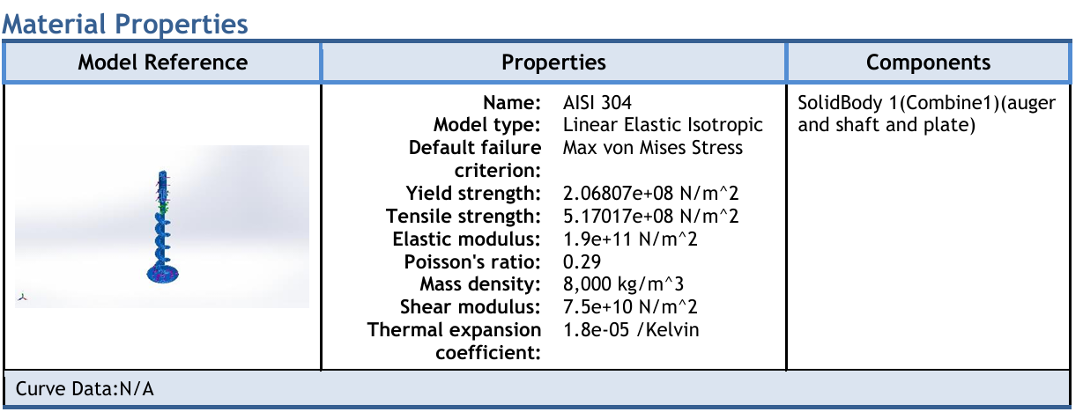
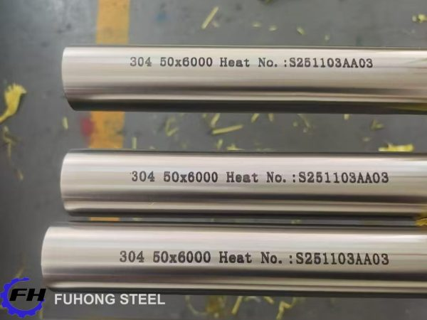

C.3. Extended Simulation Plots: High-resolution color contours of von Mises stress, total deformation, and thermal gradients.
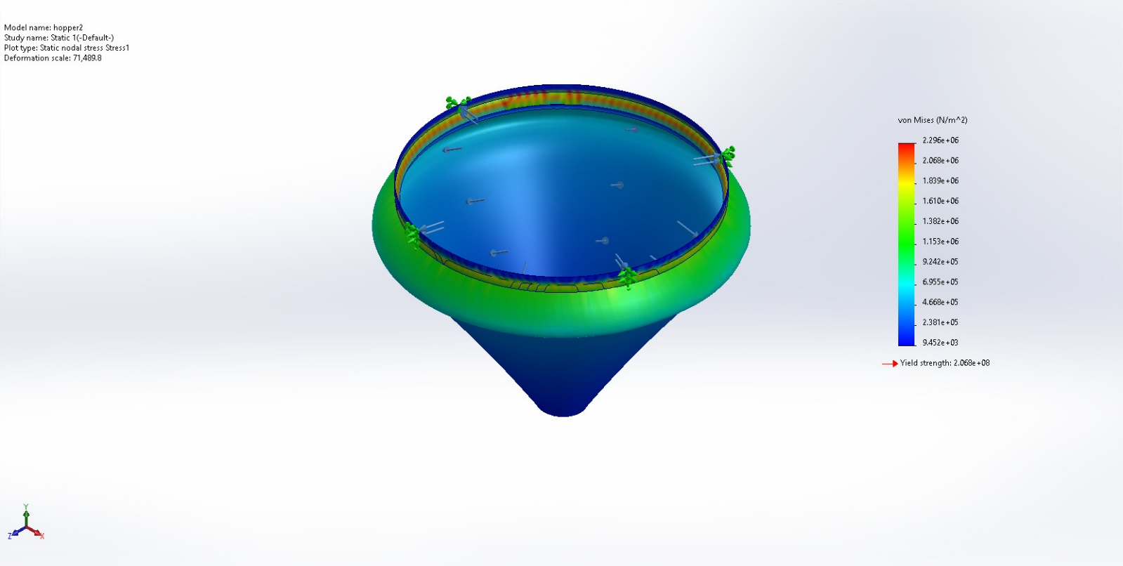
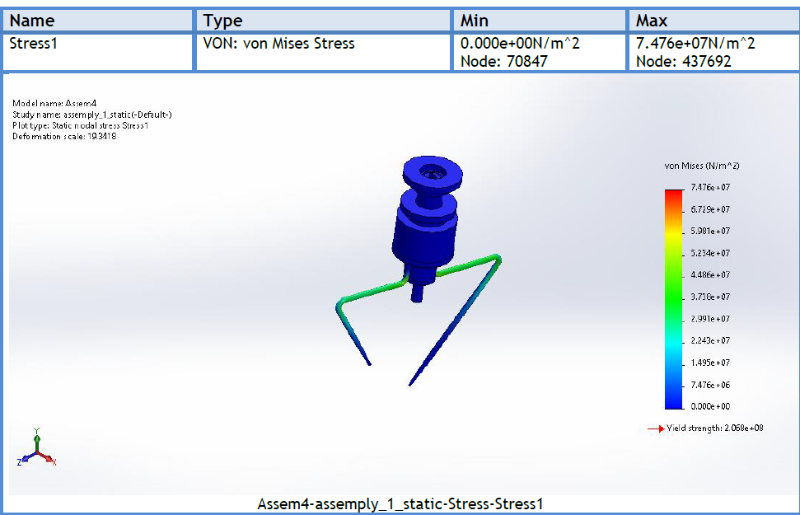’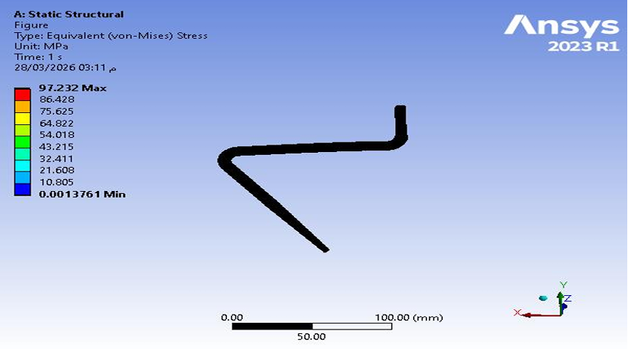

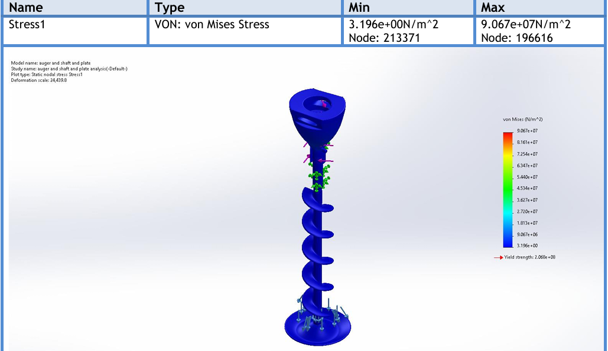

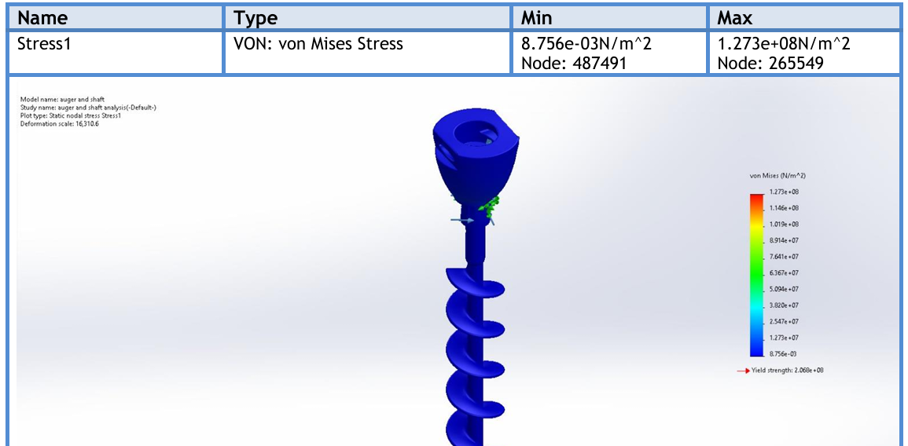

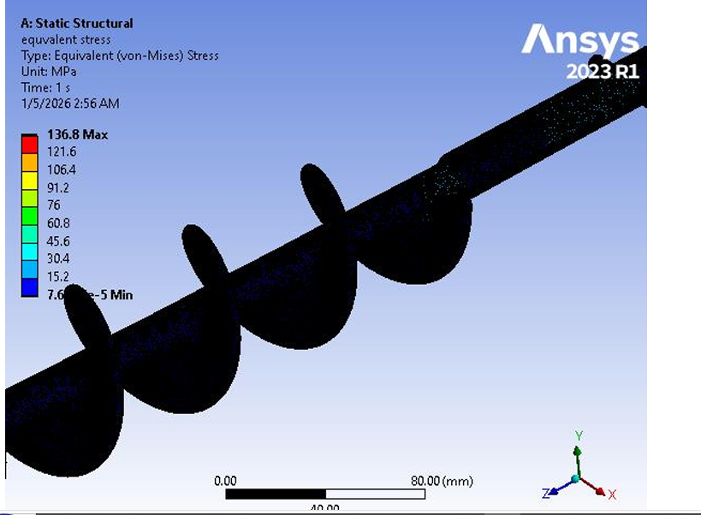

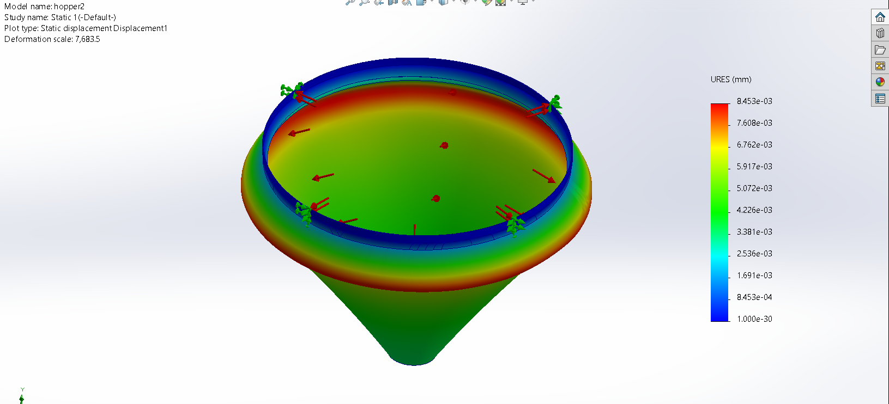
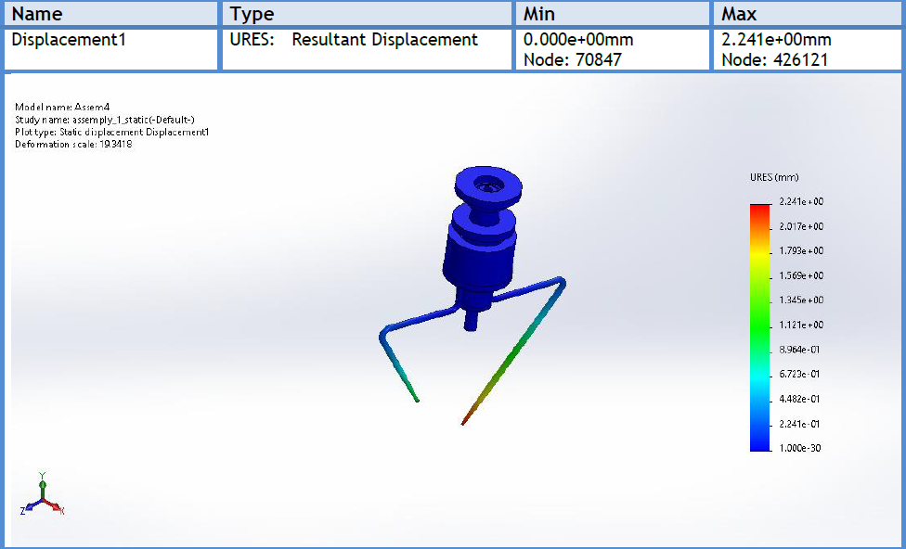
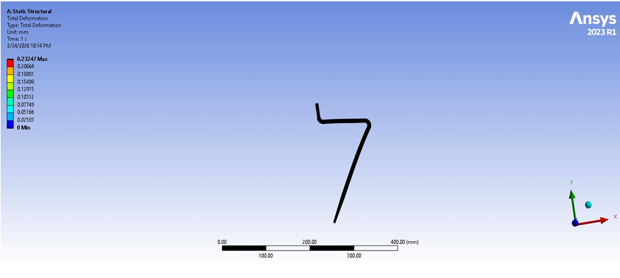
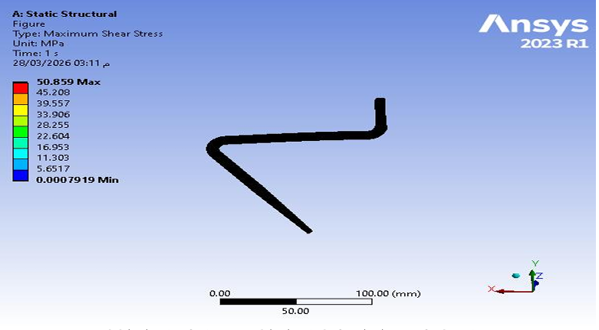

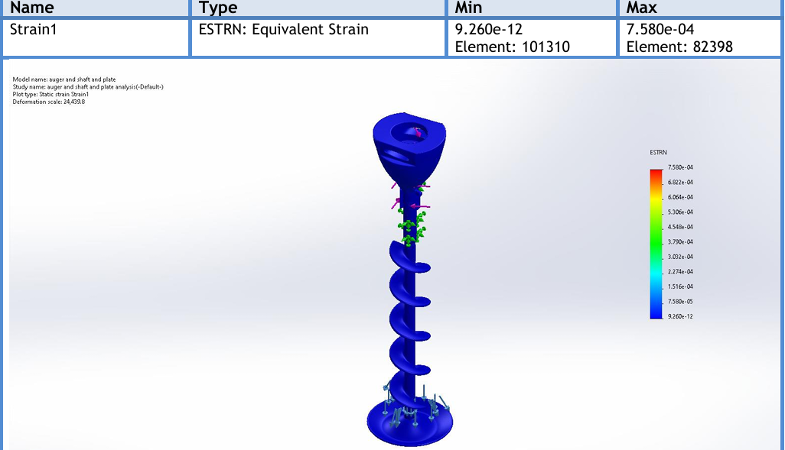

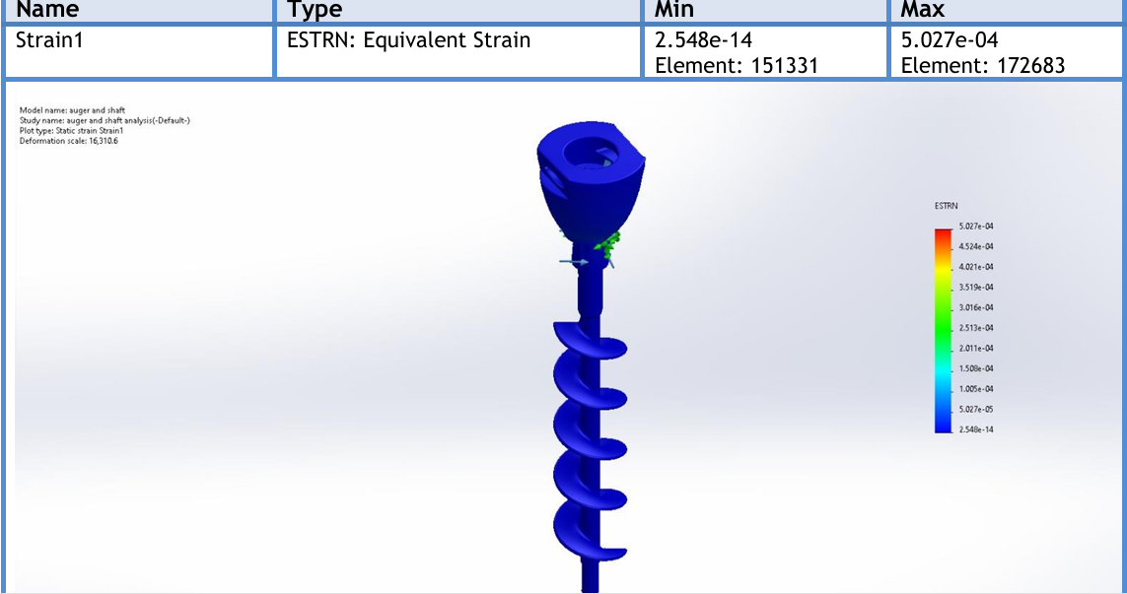
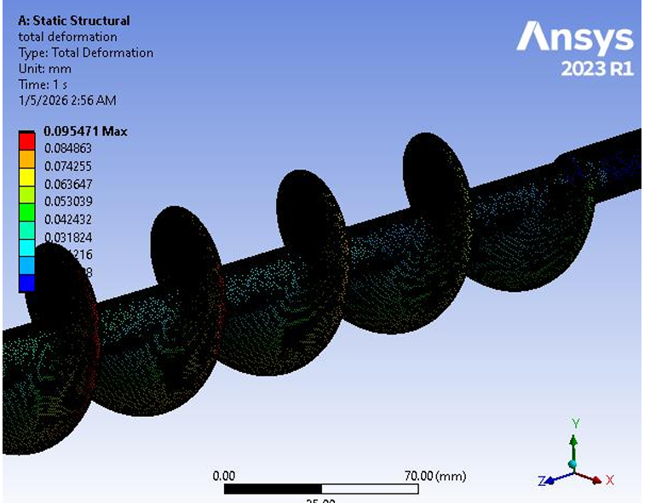

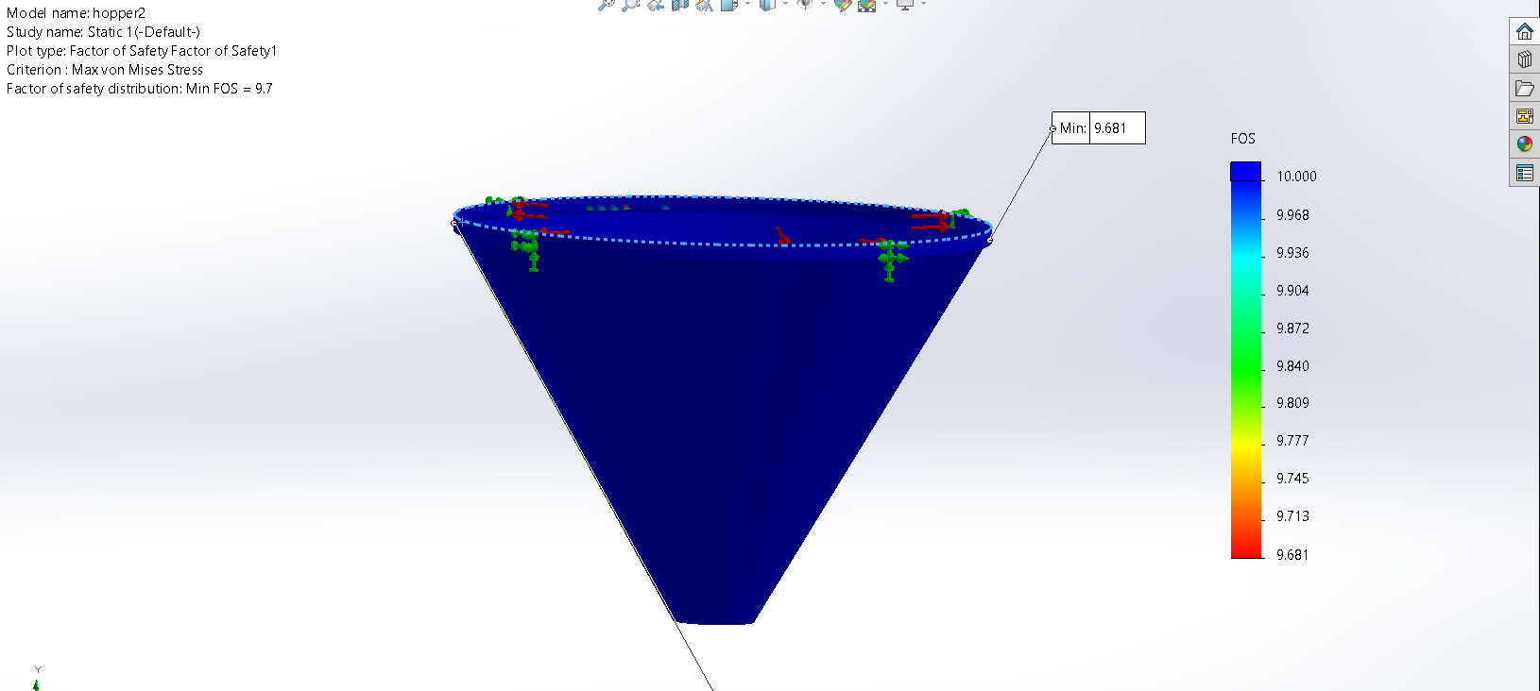

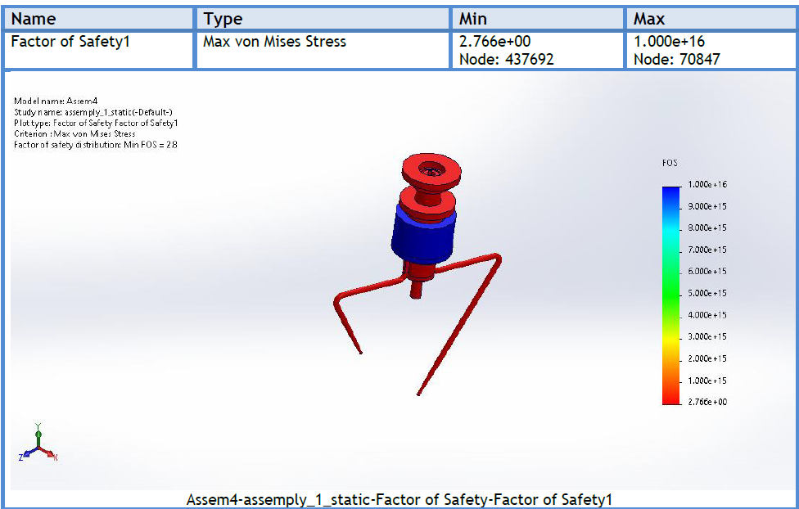
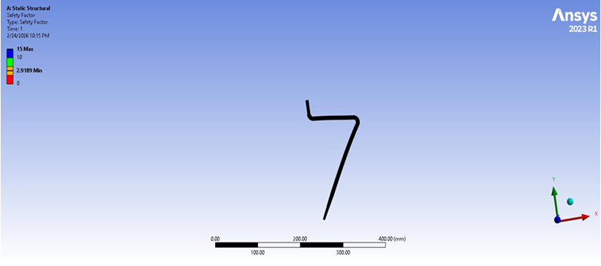
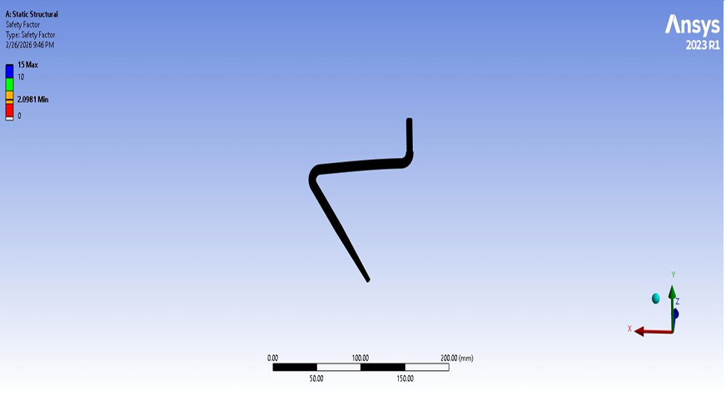
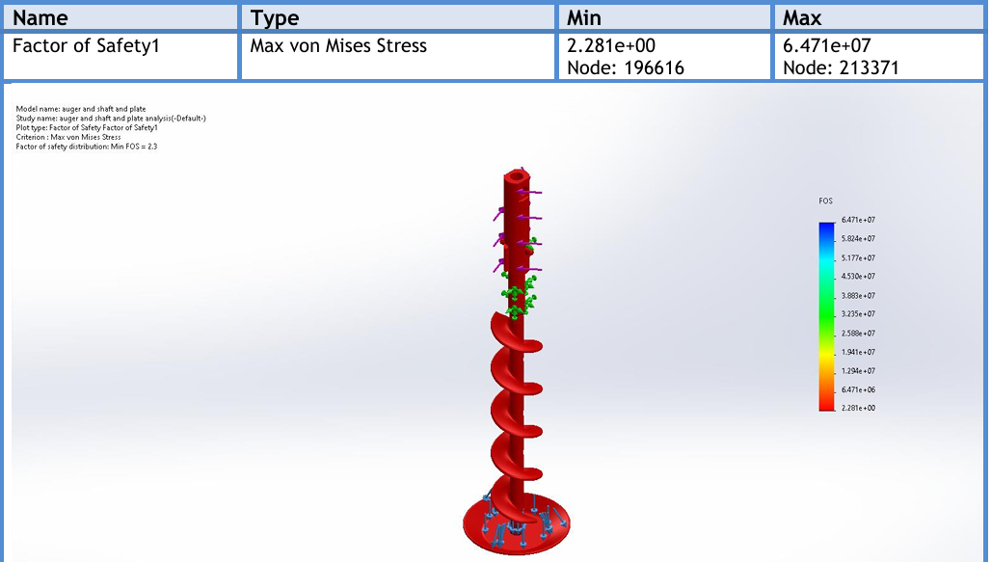

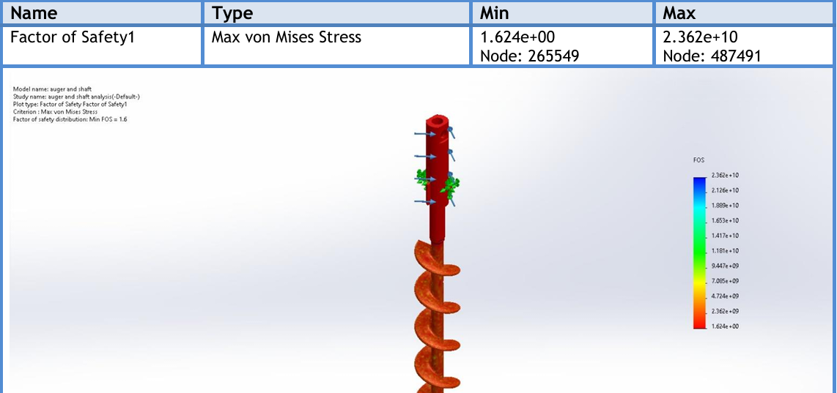
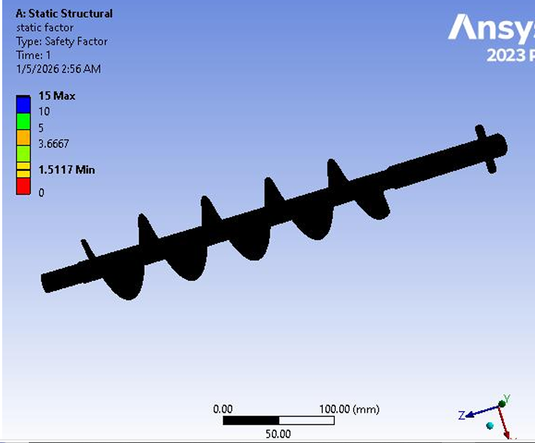

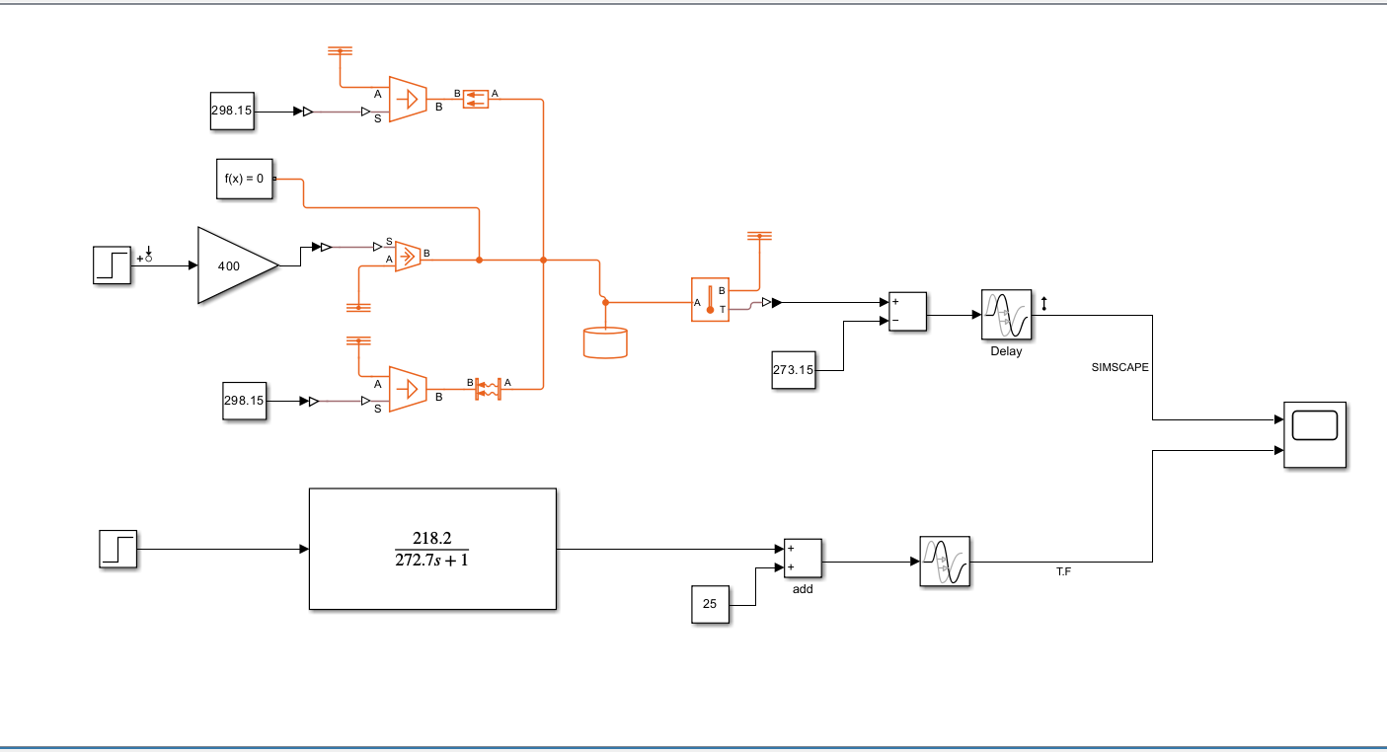
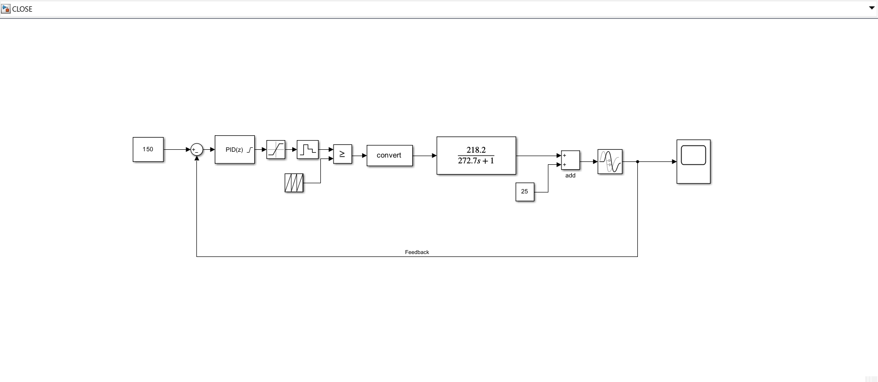
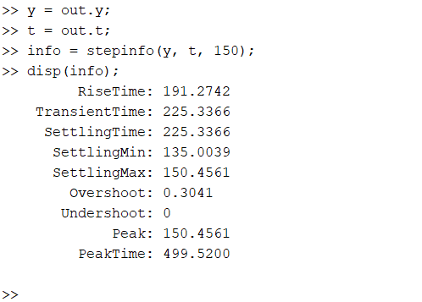
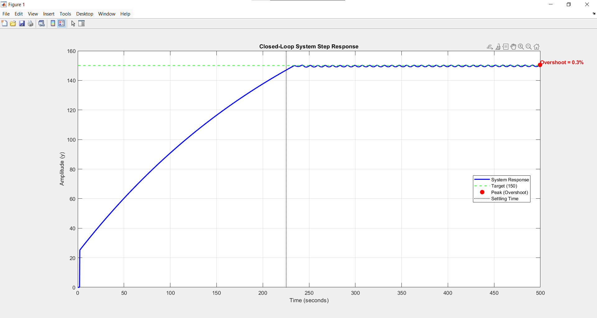
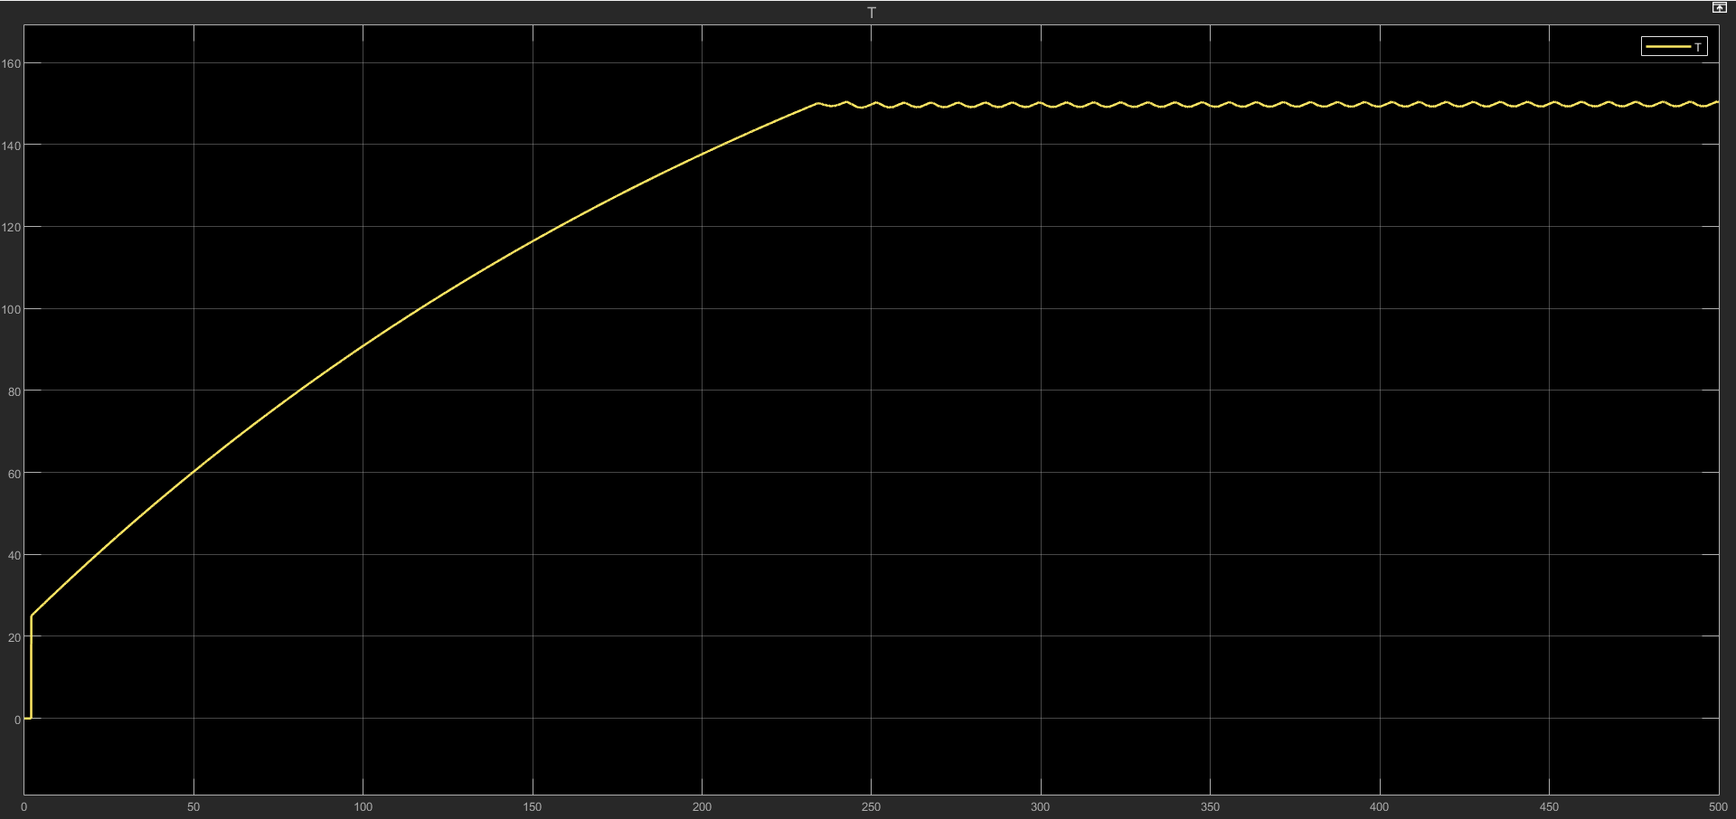

Appendix D: Calculations and Tables

D.1. Motor Sizing Spreadsheet: Detailed torque-speed calculations.
Optimal Motor Selection Table - VFFS Auger Filler
I. Basic Design Requirements
Item | Value | Unit | Notes
Required Design Torque ($T_{design}$) | 1.14 | $$N·m$$ | With SF = 3.0
Design Torque with Reserve ($T_{design,total}$) | 1.332 | $$N·m$$ | $×1.2$ for unexpected conditions
Required Speed at Auger | 150 | RPM | For filling in 0.6 seconds
Maximum Angular Acceleration | 300 | $$rad/s²$$ | For rapid response

II. Comparative Motor Options
Specification | Non Acceptable Option | Acceptable Option | Current Option
Model | MSMF012L1U1 | MSMF022L1U1 | MSMF042L1U1
Manufacturer | Panasonic | Panasonic | Panasonic
Power | 100 W | 200 W | 400 W
Rated Torque ($T_{rated}$) | $$0.32 N·m$$ | $$0.64 N·m$$ | $$1.27 N·m$$
Peak Torque ($T_{peak}$) | $$0.95 N·m$$ | $$1.91 N·m$$ | $$3.82 N·m$$
Rated Speed | 3000 RPM | 3000 RPM | 3000 RPM
Maximum Speed | 6000 RPM | 6000 RPM | 6000 RPM
Rotor Inertia ($J_{rotor}$) | $$0.051 ×{10}^{-4} kg·m²$$ | $$0.14 ×{10}^{-4} kg·m²$$ | $$0.27 ×{10}^{-4} kg·m²$$
Weight | 0.47 kg | 0.78 kg | 1.2 kg
Flange Dimensions | 40 mm | 60 mm | 60 mm
Protection Rating | IP67 | IP67 | IP67
Approximate Price | $150 | $220 | $400

III. Gearbox Compatibility
Item | Non Acceptable Option | Acceptable Option | Current Option
Proposed Gear Ratio ($i$) | 5:1 | 10:1 | 20:1 (Current)
Required Servo Torque | $$1.48 N·m$$ | $$0.74 N·m$$ | $$0.37 N·m$$
Available Servo Torque | $$0.32 N·m$$ | $$0.64 N·m$$ | $$1.27 N·m$$
Safety Margin (${SF}_{actual}$) | 0.216 | 1 | 3.5
Evaluation | Not safe | Weak | Very safe
Speed at Auger | 600 RPM | 300 RPM | 150 RPM
Required Modification | Electronic speed reduction | None | None

IV. Practical Application Compatibility
Criterion | Non Acceptable Option | Acceptable Option | Current Option (MSMF042L1U1)
Stopping Precision | High | High | Very High
Acceleration Response | Very Fast | Fast | Relatively Slow
Power Consumption | Low (30W) | Medium (60W) | High (120W)
Cooling Requirement | Natural | Natural | Additional Fan
Lifespan | Long (10+ years) | Very Long | Very Long
Maintenance Ease | Easy | Easy | Easy
Spare Parts Availability | Bad | Not good | Excellent

Comprehensive Torque Equations Table - VFFS Auger Filler
I. Fundamental Material Torques
No. | Torque Name | Equation | Symbols & Meanings | Calculated Value | Unit | Engineering Notes
1 | Material Weight Torque | $$T_{w}=m×g×r_{m}$$ | m = Material mass (0.5 kg)  g = Gravity acceleration (9.81 m/s²)  $r_{m}= Mean radius =\frac{r_{o}+r_{i}}{2}$ | 0.093 | $$N·m$$ | Basic torque required to lift the material.
2 | Axial Friction Torque | $$T_{f}=μ×m×g×r_{m}$$ | $μ$ = Friction coefficient (0.3 for fine salt) | 0.028 | $$N·m$$ | Material resistance to movement.
3 | Wall Friction Torque | $$T_{wall}=μ_{w}×f_{n}×r_{o}$$ | $μ_{w}$ = Wall friction coefficient (0.2-0.4)  $$F_{n}= Normal force =m×g×cos⁡(α)$$  $r_{o}$ = Outer radius (0.03 m) | 0.015 | $$N·m$$ | Friction of the auger flight against the tube wall.
4 | Internal Shear Torque | $$T_{s}=τ×A×r_{m}$$ | $τ$ = Material shear stress (100-500 Pa for salt)  $$A = Shear area =π×D_{s}×L_{f}$$ | 0.05 | $$N·m$$ | Material resistance to deformation.

II. Dynamic Torques
No. | Torque Name | Equation | Symbols & Meanings | Calculated Value | Unit | Engineering Notes
5 | Auger Inertia Torque | $$T_{j,auger}=J_{auger}×α$$ | $$J_{auger}=\frac{1}{2}×m_{auger}×(r_{o}^{2}+r_{i}^{2})$$  $α$ = Angular acceleration = $\frac{∆ω}{∆t}$ | 0.008 | $$N·m$$ | Impactful during startup and stopping.
6 | Material Inertia Torque | $$T_{j,material}=J_{material}×α$$ | $$J_{material}=\frac{1}{2}×m×(r_{o}^{2}+r_{i}^{2})$$ | 0.004 | $$N·m$$ | Accounts for the mass of the accelerating material.
7 | Centrifugal Torque | $$T_{c}=m×w^{2}×r_{m}×μ×r_{o}$$ | $ω$ = Angular velocity (rad/s)  $$ω=\frac{2π×N}{60}$$ | 0.012 | $$N·m$$ | Increases significantly at high speeds.
8 | Vibration Torque | $$T_{v}=m_{v}×A_{V}×R_{m}$$ | $m_{v}$ = Vibrator mass (0.1 kg)  $a_{v}$ = Vibration acceleration (2-5 m/s²) | 0.006 | $$N·m$$ | Applicable if a vibration motor is utilized.

III. Mechanical Torques
No. | Torque Name | Equation | Symbols & Meanings | Calculated Value | Unit | Engineering Notes
9 | Bearing Friction Torque | $$T_{bearing}=\frac{1}{2}×μ_{b}×F_{r}×d_{b}$$ | $μ_{b}$ = Bearing friction coefficient (0.001-0.005)  $F_{r }$= Radial load (N)  $d_{b}$ = Bearing diameter (0.02 m) | 0.0002 | N·m | Very small but critical for precision.
10 | Gear Loss Torque | $$T_{gear,loss}=T_{in}×(1-n)$$ | $T_{in}$ = Input torque  $n$ = Gear efficiency (0.94) | Variable | N·m | Represents roughly 6% of lost power.
11 | Coupling Loss Torque | $$T_{coupling}=μ_{c}×F_{c}×r_{c}$$ | $μ_{c}$= Coupling friction coefficient (0.1)  $F_{c}$= Coupling compression force  $r_{c}$ = Coupling radius | 0.003 | N·m | Minor losses occurring at the connections.
12 | Air Resistance Torque | $$T_{air}=\frac{1}{2}×ρ_{air}×c_{d}×A×v^{2}×r_{o}$$ | $ρ_{air}$ = Air density (1.225 kg/m³)  $c_{d}$ = Drag coefficient (0.5-1.0)  $A$ = Exposed area  $v$ = Linear velocity | 0.001 | $$N·m$$ | Extremely negligible, typically ignored.

IV. Final Design Torques
No. | Torque Name | Equation | Symbols & Meanings | Calculated Value | Unit | Engineering Notes
13 | Total Raw Torque | $$T_{raw}=T_{w}+T_{f}+T_{wall}+T_{s}+T_{j,total}+T_{C}+T_{bearing}+T_{coupling}$$ | Sum of all preceding torques | 0.37 | $$N·m$$ | Value before applying any safety factors.
14 | Required Design Torque | $$T_{design}=T_{raw}×SF$$ | $SF$ = Safety Factor (3.0 as specified) | 1.14 | $$N·m$$ | The primary value used for design.
15 | Design Torque with Reserve | $$T_{design,total }=T_{design}×1.2$$ | 1.2 = Reserve factor for unexpected operational conditions | 1.37 | $$N·m$$ | Ensures components are never overstressed.

V. Servo Conversion Equations
No. | Torque Name | Equation | Symbols & Meanings | Calculated Value | Unit | Engineering Notes
16 | Required Servo Torque | $$T_{servo}=\frac{T_{design,total}}{i×n}$$ | $i$ = Gear ratio (20)  $n$ = Gear efficiency (0.94) | 0.033 | N·m | Torque required directly at the servo shaft.
17 | Servo Peak Torque (Acceleration) | $$T_{servo,peak}=T_{servo}+\frac{J_{total,}×α_{max}}{i×n}$$ | $J_{total}$ = Total system inertia  $α_{max}$ = Maximum acceleration | 0.045 | $$N·m$$ | Torque spike during maximum acceleration.
18 | Actual Safety Margin | $${SF}_{actual}=\frac{T_{servo,rated}}{T_{servo}}$$ | $T_{servo,rated}$= Servo rated torque (1.27 $N·m$) | 38.5 | - | Excessively high (confirms the motor is oversized).
19 | Gear Output Torque | $$T_{output}=T_{ servo,rate}×i×n$$ | - | 23.9 | $$N·m$$ | Total available torque at the auger shaft.

Comprehensive Volumetric Equations Table - Auger Filler VFFS
First: Basic Auger Geometry Equations
No. | Equation Name | Equation | Symbols & Meanings | Calculated Value | Unit | Engineering Notes
1 | Annular Cross-Sectional Area | $$A=\frac{π}{4}​×(D^{2}-D_{s}^{2})$$ | D = Outer auger diameter (0.06 m)  $D_{s}$ = Central shaft diameter (0.016 m) | 0.00267 | m² | Effective area for material transfer
2 | Outer Radius | $$ro​=\frac{D}{2}​$$ | D = Outer diameter | 0.03 | m | For circular calculations
3 | Inner Radius | $$r_{i}=\frac{D_{s}}{2}$$ | $D_{s}$= Shaft diameter | 0.008 | m | For circular calculations
4 | Mean Radius | $$r_{m}=\frac{r_{o}+r_{i}}{2}$$ | - | 0.019 | m | For torque and force calculations
5 | Radial Flight Height | $$h_{f}=r_{o}-r_{i}=\frac{D-D_{s}}{3}$$ | - | 0.022 | m = 22 mm | Helical chamber depth
6 | Outer Circumference | $$C_{o}=π×D$$ | - | 0.1885 | m | For linear speed calculations
7 | Inner Circumference | $$C_{i}=π×D_{s}$$ | - | 0.0503 | m | For inner speed calculations

Second: Auger Volume Calculations Equations
No. | Equation Name | Equation | Symbols & Meanings | Calculated Value | Unit | Engineering Notes
8 | Theoretical Volume per Pitch | $$V_{pitch,theory}=A×p=\frac{π}{4}(D^{2}-D_{s}^{2})×p$$ | $p = Pitch =$ Distance between flights (0.06 m) | 0.000160 | m³ = 160 cm³ | Without considering voids
9 | Effective Volume per Pitch | $$V_{pitch,eff}=η_{v}×V_{pitch,theory}$$  $$=η_{v}×A×p$$ | $η_{v}$= Volumetric filling efficiency (0.6 for fine salt) | 0.000096 | m³ = 96 cm³ | Considering voids between material particles
10 | Total Auger Volume | $$V_{auger,total} = V_{pitch,eff}×n=η_{v}×A×p×n$$ | n = Number of effective pitches (4.5) | 0.000432 | m³ = 432 cm³ | Volume of material inside the auger
11 | Volume per Complete Revolution | $$V_{rev} = V_{pitch,eff}=η_{v}×A×p$$ | - | 0.000096 | m³ | Same as Equation 9
12 | Volume per Degree of Rotation | $$V_{deg} = \frac{V_{pitch,eff}}{{360}^{°}}=\frac{η_{v}×A×p}{360}$$ | - | 2.67 × 10⁻⁷ | m³/° | For precise Servo control
13 | Volume per Pulse | $$V_{pulse} = \frac{V_{pitch,eff}}{PPR}=\frac{η_{v}×A×p}{8,388,608}$$ | PPR = Encoder resolution (23-bit = 8,388,608) | 1.14 × 10⁻¹¹ | m³/pulse | Ultra-high precision control

Third: Mass & Flow Calculations Equations
No. | Equation Name | Equation | Symbols & Meanings | Calculated Value | Unit | Engineering Notes
14 | Mass per Pitch | $$m_{pitch} =V_{ pitch,eff}×ρ_{b}$$  $$=η_{v}×A×p×ρ_{b}$$ | $ρ_{b}$= Bulk density of material (1300 kg/m³ for salt) | 0.125 | kg = 125 g | Theoretical mass per pitch
15 | Mass per Revolution | $$m_{rev}{=m}_{pitch}$$  $$=η_{v}×A×p×ρ_{b}$$ | - | 0.125 | kg | Same as Equation 14
16 | Total Auger Mass | $$m_{auger,total} = V_{auger,total}×ρ_{b}=η_{v}×A×p×n×ρ_{b}$$ | - | 0.562 | kg = 562 g | Maximum mass inside the auger
17 | Volumetric Flow Rate | $$Q_{v} = V_{pitch,eff}×N$$  $$=η_{v}×A×p×N$$ | N = Angular speed (rev/sec) | Variable | m³/s | Material volume/time
18 | Mass Flow Rate | $$\dot{m=Q_{v} ×ρ_{b}}$$  $$=η_{v}×A×p×N×ρ_{b}$$ | - | Variable | kg/s | Material mass/time
19 | Target Dose Mass | $$m_{dose,target} = 1.0$$ | Determined from customer requirements | 1.0 | kg = 1000 g | Target to be achieved
20 | Required Revolutions per Dose | $$N_{dose}=\frac{m_{dose,target}}{m_{rev}} =\frac{m_{dose,target}}{η_{v}×A×p×ρ_{b}}$$ | - | 8.0 | rev | To obtain 1000 g
21 | Required Pitches per Dose | $$n_{dose}=\frac{m_{dose,target}}{m_{pitch}} =\frac{m_{dose,target}}{η_{v}×A×p×ρ_{b}}$$ | - | 8.0 | pitch | Same as Equation 20
22 | Required Rotation Angle | $$θ_{dose}=N_{dose}×360=\frac{m_{dose,target}×360}{η_{v}×A×p×ρ_{b}}$$ | - | 2880 | degree | For Servo Position Control
23 | Required Filling Time | $$\frac{N_{dose}}{N_{auger}}=\frac{m_{dose,target}×360}{η_{v}×A×p×ρ_{b}×N_{auger}}$$ | $N_{auger}$= Auger speed (rev/sec) | 0.6 | s | For synchronization with bag cycle

Fourth: Spinner Plate Volume Equations
No. | Equation Name | Equation | Symbols & Meanings | Calculated Value | Unit | Engineering Notes
24 | Circular Plate Area | $$A_{disc}=\frac{π}{4}×D_{disc}^{2}$$ | $D_{disc}$ = Plate diameter (0.10 m) | 0.00785 | m² | Total area of the plate
25 | Sloped Area | $$A_{slop}=$$  $$π×(r_{disc}^{2}-r_{flat}^{2})$$ | $r_{disc}$ = Plate radius (0.05 m)  $r_{flat}$ = Flat area radius (0.034775 m) | 0.00415 | m² | Effective sliding area
26 | Material Volume on Plate | $$V_{disc}=A_{disc}×h_{layer}=$$  $$\frac{π}{4}×D_{disc}^{2}×h_{layer}$$ | $h_{layer}$= Material layer thickness (0.01-0.02 m) | 0.0000785 | m³ = 78.5 cm³ | For continuous feeding
27 | Material Mass on Plate | $$m_{disc}=V_{disc}×ρ_{b}=$$  $$A_{disc}×h_{layer}×ρ_{b}$$ | - | 0.102 | kg = 102 g | Reserve above the auger
28 | Effective Slope Angle | $$α_{eff}=$$  $$arctan⁡(\frac{h_{disc}}{r_{disc}-r_{flat}})$$ | $h_{disc}$= Plate edge height (0.01 m) | 55 | degree | Affects flow speed

Fifth: Hopper Volume Equations
No. | Equation Name | Equation | Symbols & Meanings | Calculated Value | Unit | Engineering Notes
29 | Cylindrical Hopper Volume | $$V_{hopper,cyl}=\frac{π}{4}×D_{h}^{2}×H_{h}$$ | $D_{h}$ = Hopper diameter (0.3 m)  $H_{h}$= Hopper height (0.4 m) | 0.0283 | m³ = 28.3 L | For temporary storage
30 | Conical Hopper Volume | $$V_{hopper,cyl}=\frac{π}{12}×H_{c}×(D_{t}^{2}+D_{t}×D_{b}+D_{b}^{2})$$ | $H_{c}$ = Cone height  $D_{t}$ = Top diameter  $D_{b}$ = Bottom diameter | Variable | m³ | For smooth feeding
31 | Material Volume in Hopper | $$V_{material,hopper} =$$  $$η_{fill}×V_{hopper}$$ | $η_{fill}$ = Hopper fill factor (0.8-0.9) | Variable | m³ | Less than geometric volume
32 | Material Mass in Hopper | $${m_{hopper}=V}_{material,hopper} ×ρ_{b}$$ | - | Variable | kg | For production planning
33 | Complete Emptying Time | $$t_{empty}= \frac{{ m}_{hopper}}{\dot{m}}=\frac{V_{material,hopper}}{Q_{v}}$$ | - | Variable | s | Between two hopper refills

Sixth: Bag Volume Equations
No. | Equation Name | Equation | Symbols & Meanings | Calculated Value | Unit | Engineering Notes
34 | Rectangular Bag Volume | $$V_{bag}=ω×h×t$$ | $ω$ = Width (0.15 m)  $h$= Height (0.20 m)  $t$= Thickness/Depth (0.08 m) | 0.0024 | m³ = 2.4 L | Internal bag volume
35 | Available Product Volume | $$V_{product}=$$  $$V_{bag}×η_{fill,bag}=ω×h×t×η_{fill,bag}$$ | $η_{fill,bag}$= Bag fill factor (0.7-0.8) | 0.0018 | m³ = 1.8 L | Considering air
36 | Maximum Bag Mass | $$m_{bag,max}=ρ_{b}×V_{product}$$ | - | 2.34 | kg | For safety verification
37 | Required Film Length | $$L_{film}=$$  $$2×\left(ω+t\right)+L_{seal}$$ | $L_{seal}$= Seal margin (0.02 m) | 0.48 | m = 480 mm | Per bag
38 | Required Film Width | $$w_{film} =$$  $$h + L_{seal,top}\} +L_{seal,bottom}$$ | $L_{seal,bottom}$= Top/bottom seal margin | 0.24 | m = 240 mm | Roll width

Seventh: Pressure & Stress Equations
No. | Equation Name | Equation | Symbols & Meanings | Calculated Value | Unit | Engineering Notes
39 | Hydrostatic Column Pressure | $$P_{h}=$$  $$ρ_{b}×g×h_{column}$$ | $h_{coulmn}$= Material column height above auger (0.2 m) | 2550 | Pa = 2.55 kPa | Pressure on the auger
40 | Vertical Force from Pressure | $$F_{h}=P_{h}×A=ρ_{b}×g×h_{column}×\frac{π}{4}×D_{disc}^{2}$$ | - | 20.0 | N | Needed for structural design
41 | Shear Stress in Material | $$τ=\frac{F_{shear}}{A_{shear}}=\frac{T}{2π×r_{m}^{2}×h_{f}}$$ | T = Applied torque | Variable | Pa | For viscous materials
42 | Compressibility Factor | $$K =\frac{∆P}{\frac{∆V}{V_{o}}}$$ | $∆P$ = Pressure change  $∆V$= Volume change | Variable | Pa | For compressible materials

Eighth: Speed & Time Equations
No. | Equation Name | Equation | Symbols & Meanings | Calculated Value | Unit | Engineering Notes
43 | Angular Velocity | $$ω=2π×N=\frac{2π×n_{RPM}}{60}$$ | N = Speed (rev/sec)  $n_{RPM}$ = Speed (rev/min) | 15.7 | $$rad/s$$ | For unit conversion
44 | Linear Material Velocity | $$v_{material}=ω×r_{m}×tan⁡(∅)$$ | $∅$= Internal friction angle (25-35°) | Variable | $$m/s$$ | Actual transfer speed
45 | Complete Filling Cycle Time | $$T_{cycle}=t_{fill}+t_{settle}+t_{seal}+t_{cut}+t_{frad}$$ | $t_{settle}$= Settling time  $t_{seal}$ = Sealing time  $t_{cut}$ = Cutting time  $t_{frad}$= Feeding time | 1.71 | s | For total productivity
46 | Productivity | $$\dot{n}=\frac{60}{T_{cycle}}$$ | - | 35 | $$bag/min$$ | Production target

Ninth: Correction & Calibration Equations
No. | Equation Name | Equation | Symbols & Meanings | Calculated Value | Unit | Engineering Notes
47 | Volumetric Correction Factor | $$C_{v}=\frac{m_{actual}}{m_{theory}}=\frac{m_{actual}}{η_{v}×A×p×ρ_{b}×n}$$ | $m_{actual}$= Measured actual mass | Variable | - | Determined experimentally
48 | Actual Bulk Density | $$ρ_{actual}=\frac{m_{actual}}{V_{auger,total}}=\frac{m_{actual}}{η_{v}×A×p×n}$$ | - | Variable | $$kg/m³$$ | May differ from 1300
49 | Actual Filling Efficiency | $$η_{actual}=\frac{m_{actual}}{ρ_{b}×A×p×n}$$ | - | Variable | - | For precise calibration
50 | Corrected Number of Revolutions | $$N_{corrected}=N_{theory}×\frac{1}{C_{v}}=\frac{m_{target}}{m_{actual}}×N_{theory}$$ | - | Variable | rev | For precise control

Summary of Key Values
Item | Value | Unit | Main Equation
Annular Area (A) | 0.00267 | $$m²$$ | $$A=\frac{π}{4}​⋅(D^{2}-D_{s}^{2})$$
Effective Volume per Pitch | 96 | $$cm³$$ | $$η_{v}×A×p$$
Total Auger Volume | 432 | $$cm³$$ | $$η_{v}×A×p×n$$
Mass per Pitch | 125 | $$g$$ | $$η_{v}×A×p×ρ_{b}$$
Total Auger Mass | 562 | g | $$η_{v}×A×p×ρ_{b}×n$$
Required Revolutions for 1000g | 8.0 | rev | $$\frac{m_{target}}{η_{v}×A×p×ρ_{b}}$$
Rotation Angle for 1000g | 2880 | degree | $$N_{dose}× 360$$
Filling Time | 0.6 | s | $$\frac{N_{dose}}{N_{auger}}$$

Required Design Torque ($T_{design}$) | 1.14 | $$N·m$$ | With SF = 3.0
Design Torque with Reserve ($T_{design,total}$) | 1.332 | $$N·m$$ | $×1.2$ for unexpected conditions
Required Speed at Auger | 150 | RPM | For filling in 0.6 seconds
Maximum Angular Acceleration | 300 | $$rad/s²$$ | For rapid response

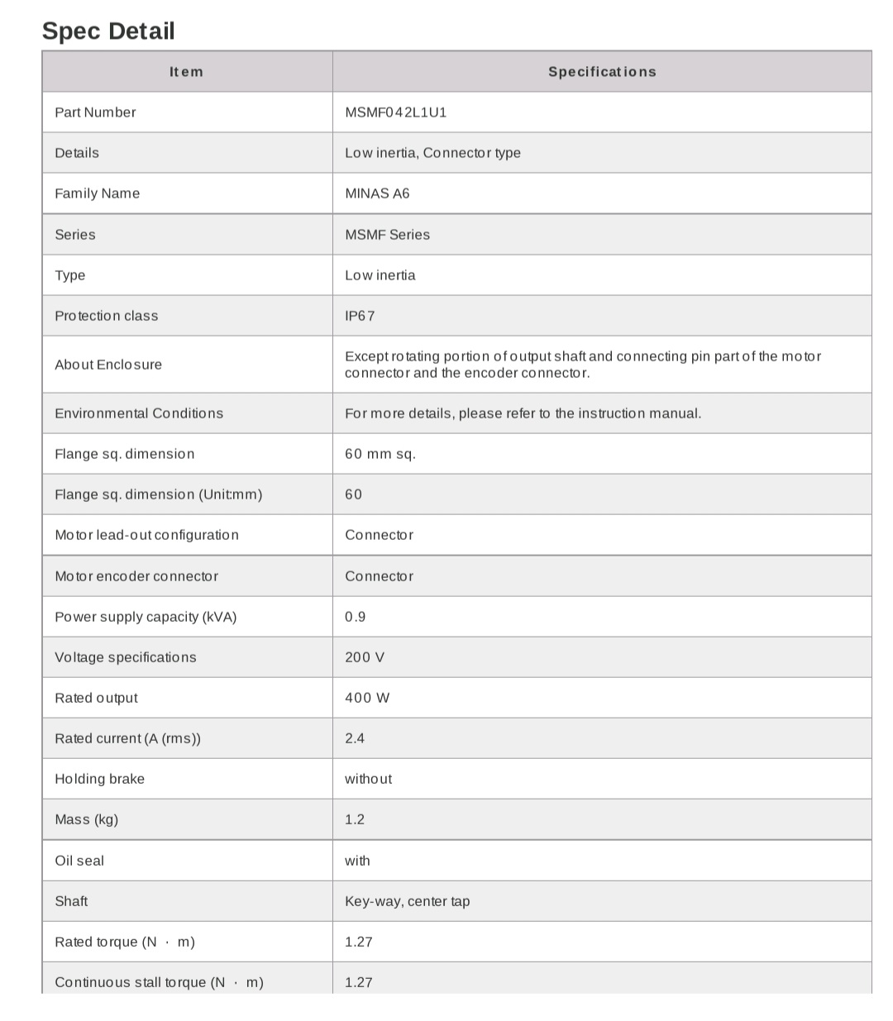
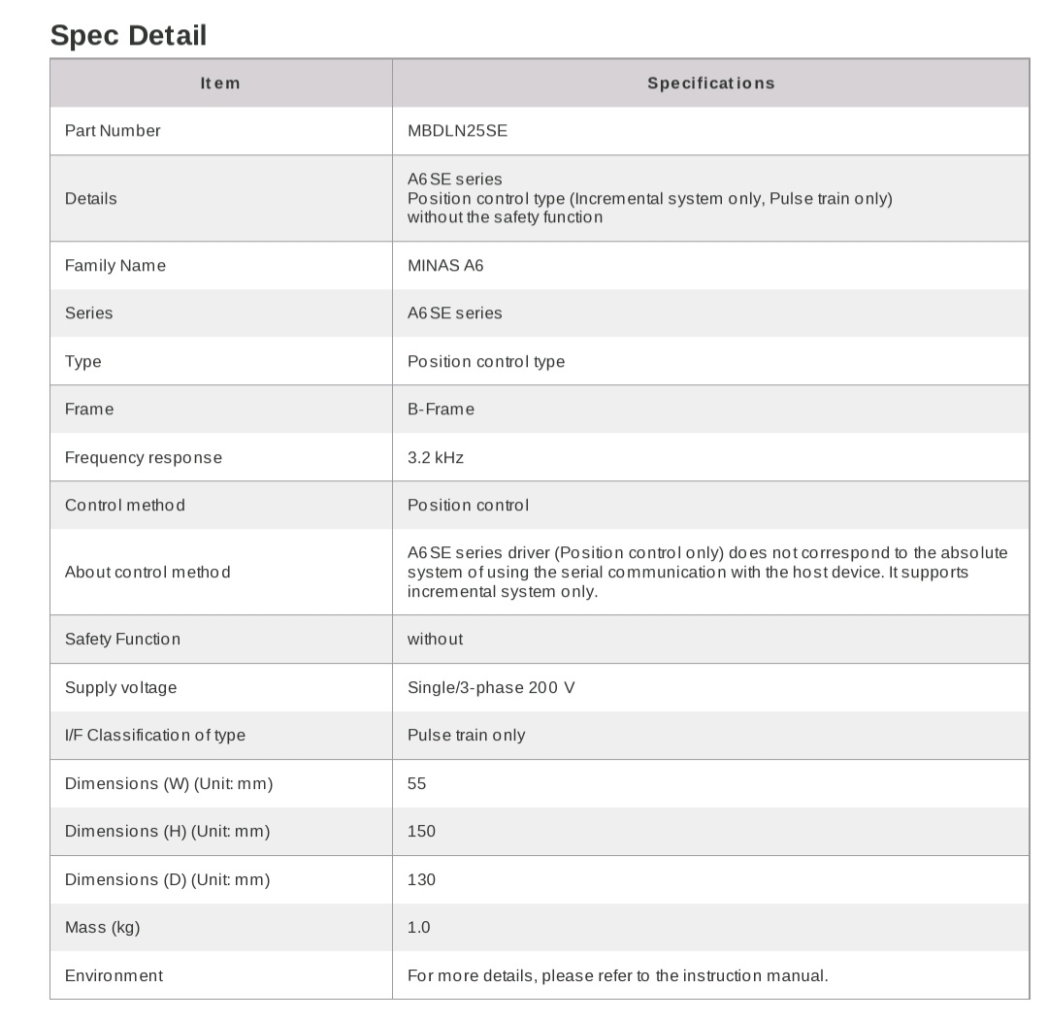
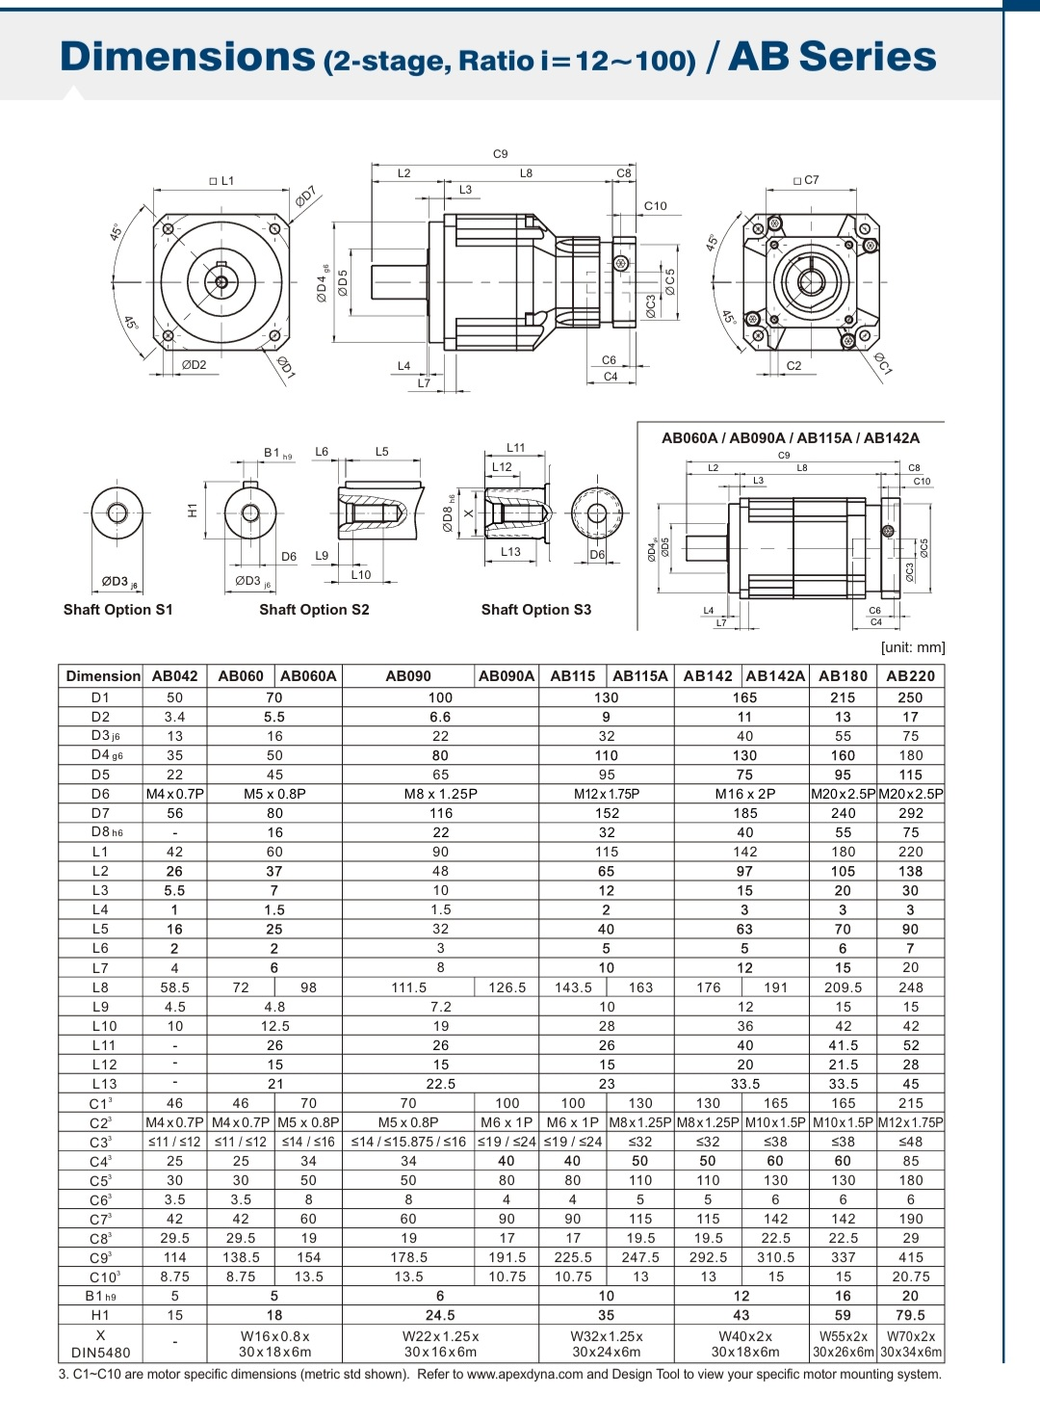
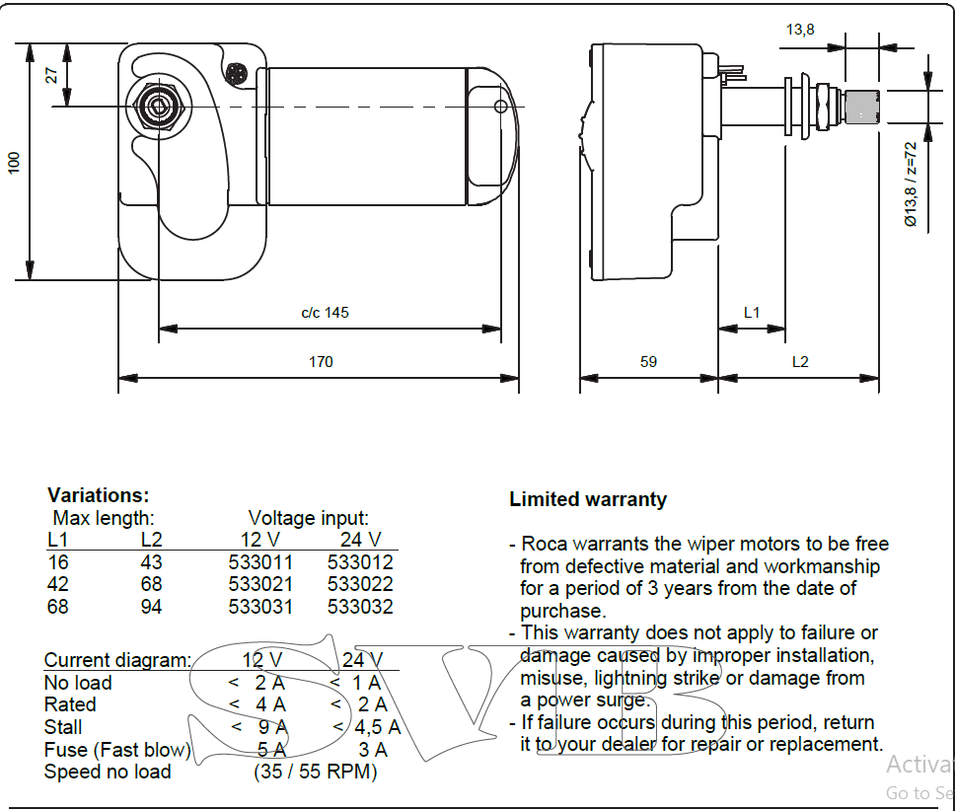

D.2. Bearing and Fastener Selection Tables: Reference data used to justify the selection of specific industrial parts.
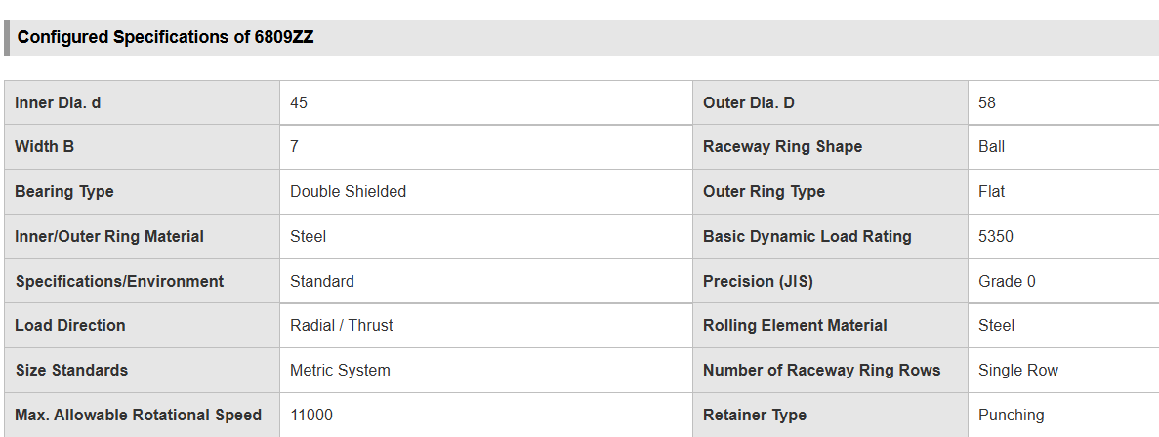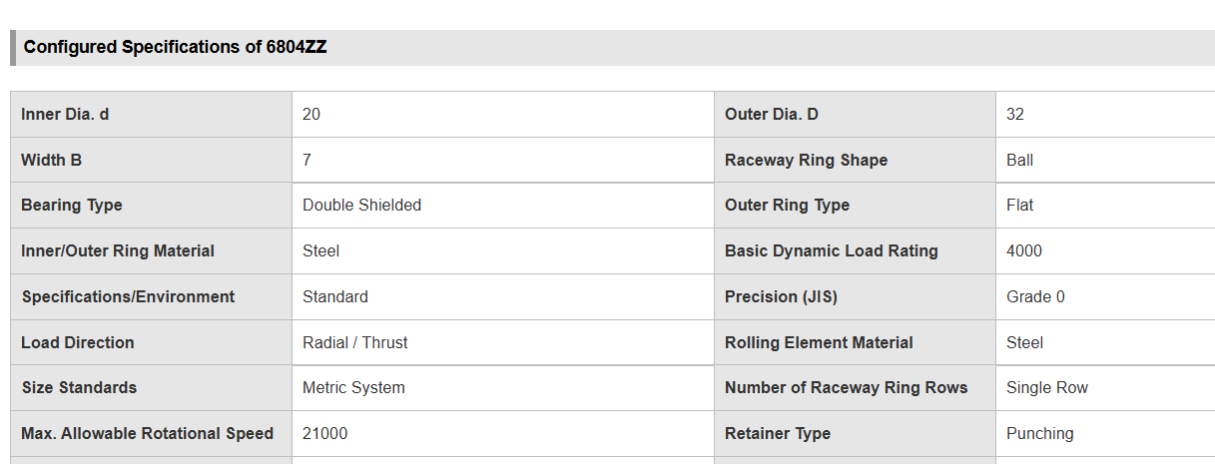
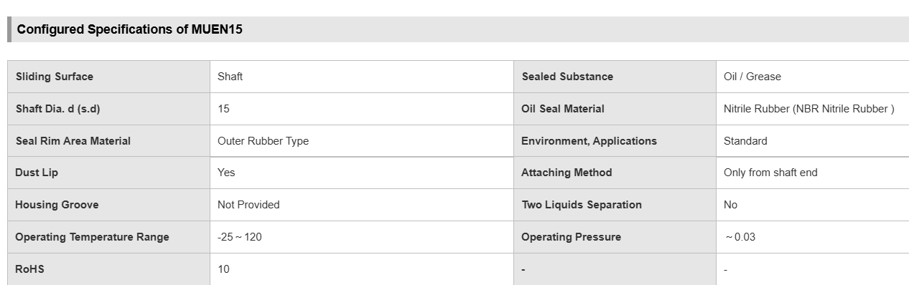
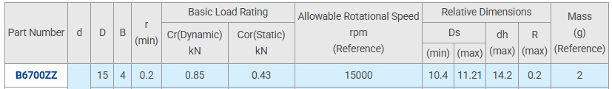
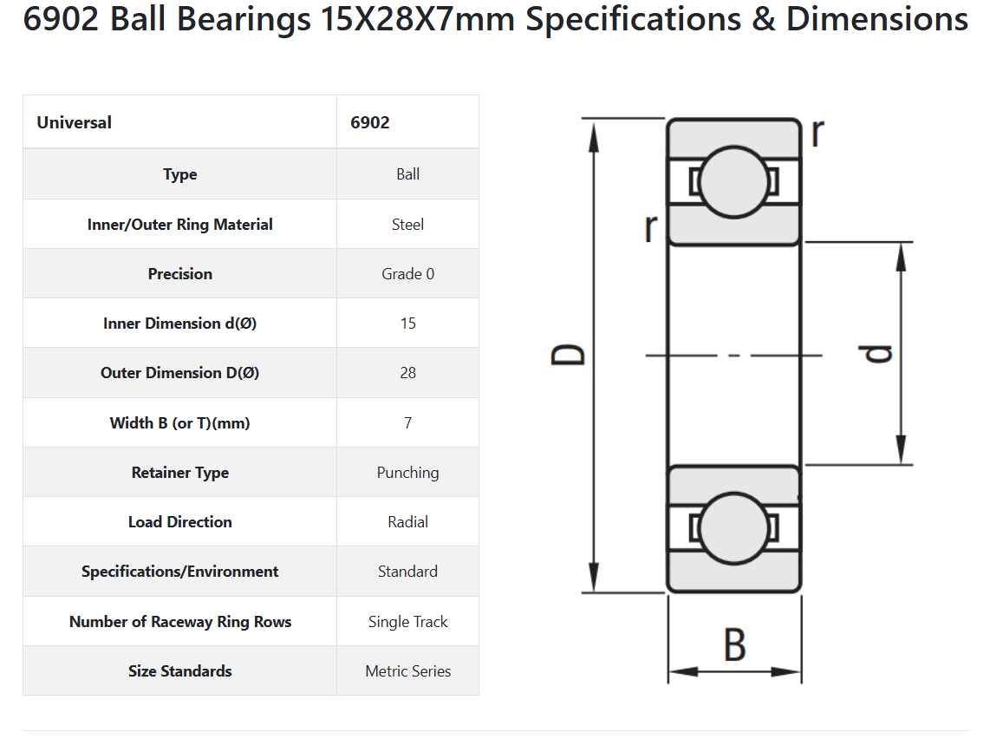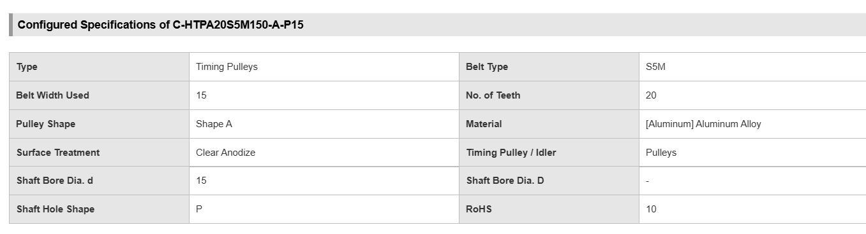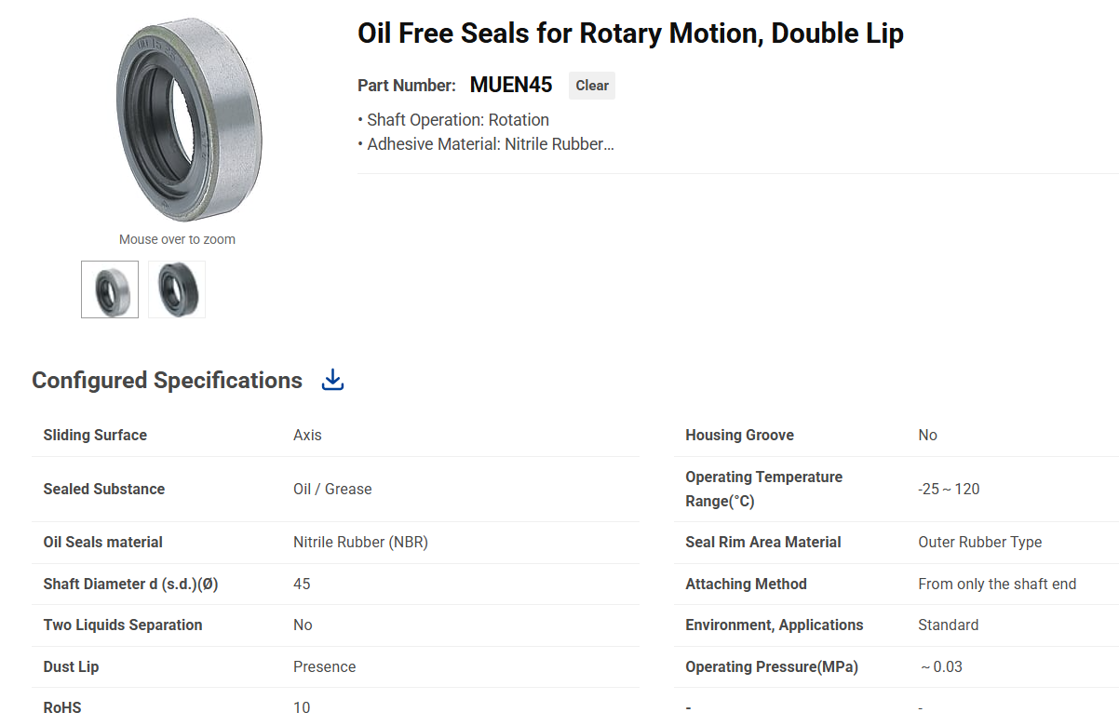
II. Controller Selection (ESP32 vs. PLC)
Feature | Custom ESP32 Architecture | Traditional Industrial PLC
Processing Power | Dual-Core 240 MHz (Parallel) | Single-Core 50-100 MHz (Cyclic)
Motion Control | Native RMT (Hardware-level) | Needs High-Speed IO Modules
Cost Efficiency | Highly Cost-Effective | High License & Hardware Costs
Connectivity | Native WiFi/UART (Industry 4.0) | Requires Communication Gateways

Industrial Hardware Specifications
Component | Part Number/Type | Technical Justification
Thermal Sensor | K-Type + MAX6675 | High range (up to $1024^\circ\text{C}$) & SPI Digital interface.
Eye-mark Sensor | KS-C2 (NPN) | High-speed contrast detection for registration.
Heater Relay | Zero-Crossing SSR 40A | Eliminates EMI noise during PID switching.
Logic Isolation | Optocoupler Relay Module | Protects ESP32 (3.3V) from 24V industrial spikes.
Power Supply | MeanWell 24V, 14.6A | Provides stable power for motors and actuators.

D.3. Error Analysis Calculations: The statistical math used to compare analytical vs. simulation results
II. Simulation vs. Requirement Analysis
Metric | Design Requirement | Simscape Result | Percentage Error / Status
Setpoint | 150 | 150 | 0% (Exact match)
Settling Time | 300 | 225.3 s | Within Bounds (PASSED)
Max Overshoot | < 1\% | 0.304\% | Highly Stable (PASSED)
Steady-State Error | 1 | 0.45 | Improved precision
Derivative Filter (N) | Stable () | 1-NT_s | <1$)

