

ذ
REPUBLIC OF YEMEN
SANA'A UNIVERSITY
FACULTY OF ENGINEERING
MECHATRONICS ENGINEERING DEPARTMENT

PLC TAGGING BASED ON COLOR

Done by:
Hassan Moqbel Morshed 202274198
Musa AL_salmani 202174202

Systems (parallel).
Supervised by:
Dr. Marowan Noaman
ENG. Mohammed Al-zaqheer

Contents
Introduction 3
Objectives 3
Theory 3
System Analysis 3
System Requirements: 4
Flowchart 5
Simulation 6
Discussion 6
Conclusion and recommendations 6

Introduction
This project represents a practical application for automating the process of sorting products by color in industrial environments. The system is based on a 1200-PLC S7 module with an advanced vision system to automatically identify and sort products. The system provides an effective solution for factories that require accurate and fast sorting of products.

Objectives
- Design of a high-precision automatic sorting system for products by color.
- Achieve a processing rate of 30 pieces/minute.
- Provide an easy-to-use control interface.
- Ensure the reliability and security of the process.
- Reducing human intervention in the sorting process

Theory
The system is based on the following principles:

- Machine vision technology for color detection.
- Programmable Logic Control (PLC)
- Mechanical transmission systems.
- Pneumatic control systems
- HMI integration with PLC.

System Analysis

1. Description of the process:
- Product entry on the main belt.
- Check the product color by vision sensor.
- Directing green products to the secondary belt.
- Blue products continue on the main belt.
- Assemble and deliver products to their final locations.

2. Main components:
- Main conveyor belt
- Secondary conveyor belt for green products
- Vision Sensor
- Pneumatic Pusher
- Two-Axis Pick & Place Robotic Arm
- Photoelectric sensors
- electrical control panel.

3. Technical Specifications:
- Console
- PLC: Siemens S7-1200 (CPU 1211C DC/ DC/DC)
- Working memory: 50 KB
- Power supply: 24VDC
- Communication ports: PROFINET

- HMI screen

- Comfort Type TP700
- Screen resolution: 800 x 480 pixels
- PROFINET: Connection

4. Sensors and Actuators Analysis:

i. Sensors
- Automatic vision sensor
- Type RGB Color Sensor
- Accuracy 0.1mm
- Response Time: 1ms
- Operating voltage: 24VDC

2. Photoelectric sensors
- Type Diffuse
- Detection range(100mm-10)
- Operating voltage: 24VDC
- Sensors(4)

ii. Triggers

- Belt drives
Type is a DC Geared Motor
Capacity (0.5HP)
Speed (1440RPM)
Number (2)

2. air motive
Operating pressure: 6 bar
Thrust force: 100N
Response time: 50ms

iii. Estimated cost

- PLC S7-1200: $800

- HMI TP700: $2,000
- Vision sensor $1,500

- Conveyor belts: $3,000

- Air Motivator: $500

- Robotic arm: $4,000

- Photoelectric sensors: $400

- Control panel and cables $800

- Estimated Total: $13,000

System Requirements:

- Digital Inputs:

Start_PB: (I0.0) Start button
Stop_PB: (I0.1) Stop button
Emergency_Stop: (I0.2) Emergency button
Vision_Sensor: (I0.3) Vision sensor
Conv1_Sensor1: ( I0.4) Main belt sensor 1
Conv1_Sensor2: (I0.5) Main belt sensor 2
Conv2_Sensor1: (I0.6) Secondary belt sensor 1
Conv2_Sensor2: ( I0.7) Secondary belt sensor 2
Pick_Place_Home: ( I1.0) Main arm position
Pick_Place_End: ( I1.1) End arm position

- Digital Outputs:
Main_Conv: (Q0.0) Main belt operation
Secondary_Conv: (Q0.1) Secondary belt operation
Pusher_Forward: (Q0.2) Pusher advance
Pusher_Backward: (Q0.3) Pusher return
Pick_X_Forward: (Q0.4) X forward movement
Pick_X_Backward: (Q0.5) X backward movement
Pick_Y_Up: (Q0.6) Y up movement
Pick_Y_Down: (Q0.7) Y down movement

- Counters and Timers:
Blue_Counter: C1
Green_Counter: C2
Pusher_Timer: T1
Pick_Place_Timer: T2

Flowchart

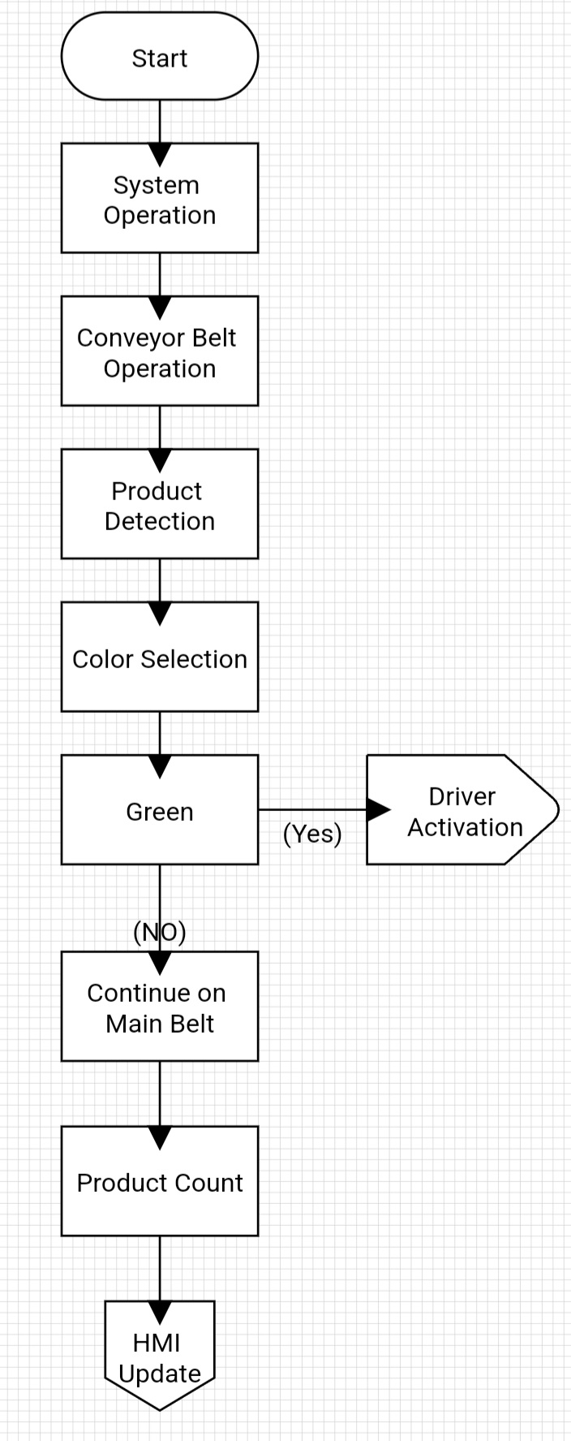

Simulation

- For software simulation 1 PLCSIM

- Factory I/O For 3D simulation

- WinCC Runtime for HMI simulation

Discussion

1. HMI and Factory I/O Connectivity Issues
- Problem: HMI not connecting with Factory I/O.
- Causes:
- Mismatched tag addresses.
- Incorrect TIA Portal settings.
- Licensing issues.
- Solutions:
- Standardized tag names.
- Reconfigured network settings.
- Updated software licenses.

2. System Response Delays
- Problem: Delays in actuator responses.
- Causes:
- Long PLC scan cycles.
- Resource contention.
- Slow sensor signal processing.
- Solutions:
- Optimized algorithms.
- Reduced scan cycle time.
- Used interrupts for critical functions.

Conclusion and recommendations

i. Results

- Classification accuracy up to 99%.

- Processing speed: 30pcs/min.

- User-friendly control interface.

i. Recommendations

- Add an automated reporting system

- Possibility of expansion Additional colors

- Connect the system to a central database.

- Adding an alarm system for preventive maintenance.

IMAGES

FACTORY IO IMAGE

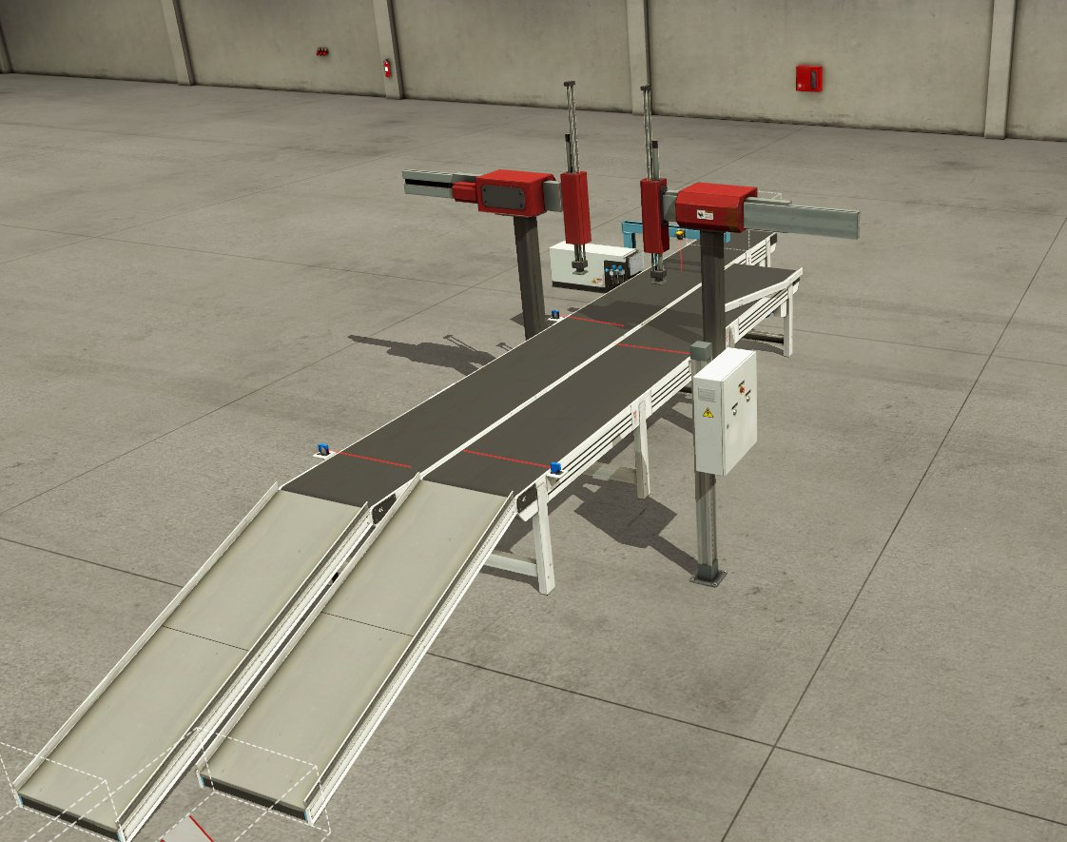

HMI IMAGE

