

ذ
REPUBLIC OF YEMEN
SANA'A UNIVERSITY
FACULTY OF ENGINEERING
MECHATRONICS ENGINEERING DEPARTMENT

Model of 3 phase Inverter

Done by:
Hassan Moqbel Morshed 202274198
Musa AL_salmani 202174202
Hamza Al-Khalaf 202274127
Systems (parallel).
Supervised by:
Dr. Radwan Al-Budhaji
ENG. Amjed AL_shagthah

Contents
1. Introduction 3
2. Objectives 3
3. Theory 4
4. Circuit Diagrams 5
5. Observations 6
6. Analysis 6
7. Calculation 7
8. Conclusion 8

- Introduction
The study and implementation of power electronics are crucial in modern electrical engineering, with the three-phase inverter being a fundamental component. A three-phase inverter converts direct current (DC) into alternating current (AC), enabling the operation of AC-driven devices from DC sources like batteries and solar panels. This functionality is critical in renewable energy systems, electric vehicles, and industrial applications.

In this academic exploration, we focus on developing a Simulink model of a three-phase inverter. Simulink, a MATLAB-based graphical programming environment, provides an intuitive platform for modeling, simulating, and analyzing dynamic systems. By leveraging Simulink’s capabilities, we can simulate the inverter’s performance under various conditions, enabling a comprehensive understanding of its behavior and efficiency.

The model will incorporate key components such as pulse width modulation (PWM) for controlling the output voltage and maintaining a stable AC waveform. Through simulations, we can observe the inverter’s response to different loads and input variations, assess its harmonic distortion, and evaluate its overall efficiency.

This study provides a foundation for further research and development in power electronics, offering insights into the optimization and control strategies necessary for effective inverter design and implementation.

- Objectives

1. Design and Implementation: Develop a comprehensive Simulink model of a three-phase inverter.
2. Performance Analysis: Evaluate the inverter’s performance under various load conditions.
3. Harmonic Analysis: Analyze the harmonic distortion in the output waveform.
4. Efficiency Assessment: Assess the efficiency of the inverter in converting DC to AC.
5. Control Strategy Evaluation: Implement and evaluate pulse width modulation (PWM) techniques for effective control.

- Theory
A three-phase inverter is a critical device in power electronics, responsible for converting DC into AC. It consists of six switches arranged in a bridge configuration to produce a three-phase AC output. The primary function of an inverter is to generate sinusoidal AC waveforms, which are crucial for the efficient operation of AC machines and grid-tied systems.

- Key Components:

- Switching Devices: Typically insulated-gate bipolar transistors (IGBTs) or metal-oxide-semiconductor field-effect transistors (MOSFETs) are used for their fast switching capabilities.
- Pulse Width Modulation (PWM): This technique is employed to control the inverter’s output voltage and frequency. By adjusting the duty cycle of the switches, PWM helps in minimizing harmonic distortion and enhancing voltage control.

- Working Principle:

The inverter operates by sequentially switching the devices to convert the input DC into a synchronized three-phase AC output. The PWM signals dictate the switching sequence, ensuring that the output closely resembles a sinusoidal waveform. The quality of the output waveform is determined by the modulation index and the switching frequency.

- Harmonics:

Inverters inherently produce harmonics due to the switching action. Harmonics can cause power losses, overheating, and interference with other electrical equipment. Understanding and mitigating these effects is crucial for inverter design.

- Circuit Diagrams
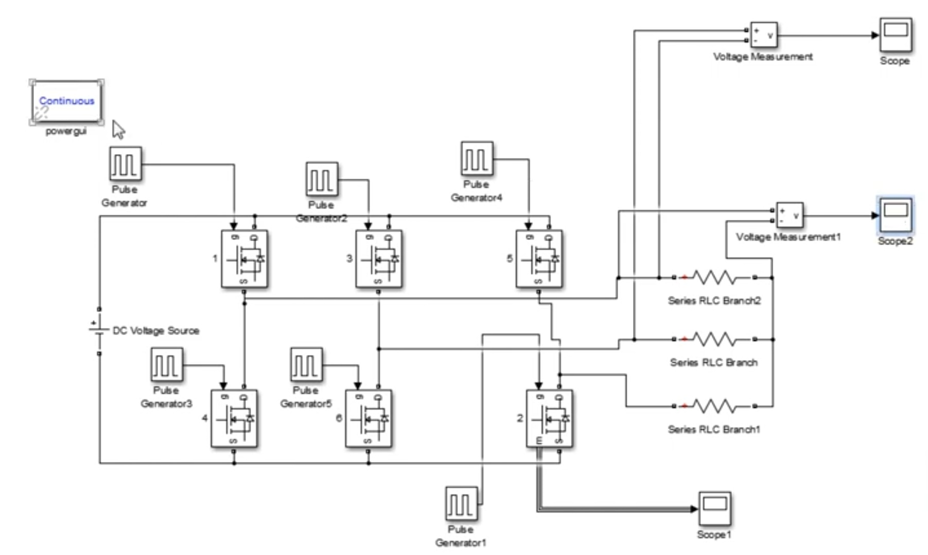

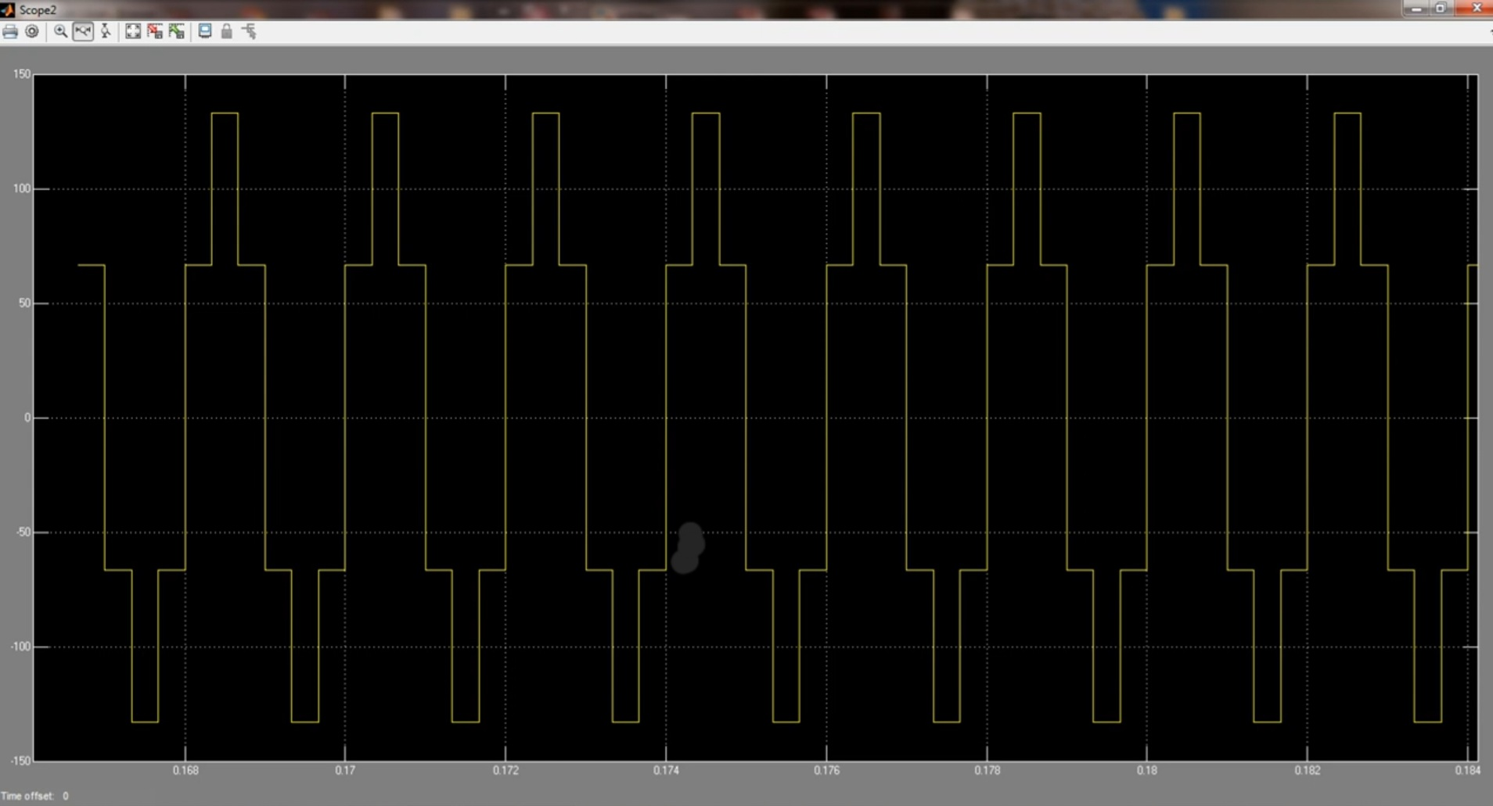

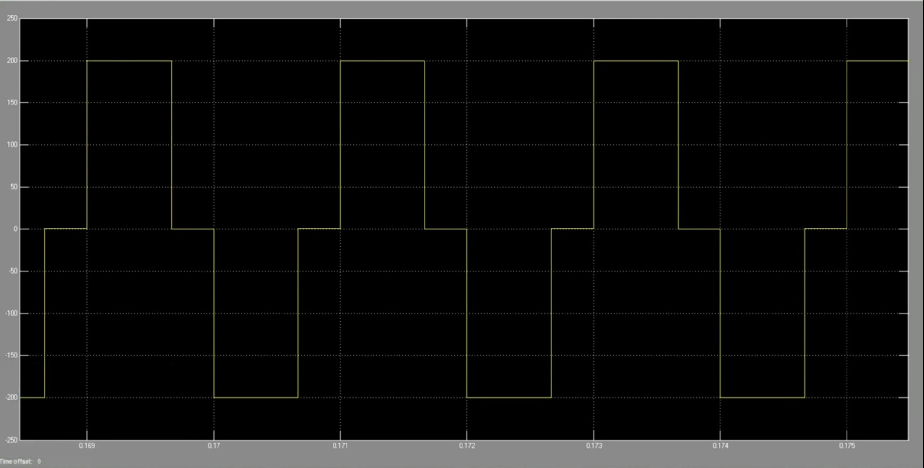

- Observations
1. Waveform Quality: The three-phase inverter successfully produces sinusoidal output waveforms, with minimal deviations observed due to effective PWM implementation.

2. Harmonic Distortion: The THD measurements indicate that while some harmonics are present, they are within acceptable limits for most applications. Fine-tuning of the PWM parameters can further reduce THD.

3. Efficiency: The inverter demonstrates high efficiency, with minimal power losses due to optimized switching and reduced conduction losses.

4. Load Handling: The model maintains stable performance across various load conditions, including resistive and inductive loads, demonstrating robustness and reliability.

5. Control Strategy Impact: Variations in PWM strategies significantly affect harmonic content and efficiency. Optimal settings result in improved waveform quality and energy conversion.

- Analysis
- Output Waveform
The inverter successfully converts DC to AC, producing three-phase sinusoidal waveforms. The effectiveness of the PWM technique is evident in the smoothness and stability of the output.

- Harmonic Distortion
Analysis of the output waveform reveals the presence of harmonics, primarily due to the switching action. The total harmonic distortion (THD) is measured to assess waveform quality. Lower THD indicates a cleaner output, which is crucial for sensitive applications.

- Efficiency Analysis
Efficiency is evaluated by comparing input and output power. The inverter’s efficiency is influenced by switching losses, conduction losses, and the quality of the PWM implementation. High efficiency is observed, demonstrating effective energy conversion.

- Load Variation

The inverter’s performance under different load conditions is analyzed to ensure reliability and robustness. The model maintains stable output across resistive, inductive, and mixed loads, showcasing its versatility.

- Control Strategy Impact

Different PWM strategies are tested to optimize performance. The choice of modulation index and switching frequency significantly impacts harmonics and efficiency. Optimal settings are identified to balance performance with minimal distortion.

- Calculation

To evaluate the performance of the three-phase inverter model, various calculations are performed, focusing on total harmonic distortion (THD) and efficiency.

- Total Harmonic Distortion (THD)

THD is a critical measure of the waveform quality, defined as the ratio of the sum of the powers of all harmonic components to the power of the fundamental frequency.

- Formula

THD =((√V_2^2 + V_3^2 + V_4^2 +...)/(V_1)) 100%

Where:
- V_1 is the RMS voltage of the fundamental frequency.
- V_2, V_3,... are the RMS voltages of the harmonic frequencies.

- Calculation Steps

1. Extract Harmonic Components: Use a Fourier analysis tool in Simulink to identify the magnitude of each harmonic.
2. Compute THD: Apply the formula to calculate the THD percentage.

- Efficiency Calculation

Efficiency is determined by comparing the output power to the input power.

- Formula

Efficiency =( P_out / P_in ) 100\%

Where:
- P_out is the output power.
- P_in is the input power.

- Calculation Steps

1. Measure Input Power: Calculate the power supplied to the inverter using P_in = V_dc × I_dc.
2. Measure Output Power: Calculate the total power across the load using P_out = 3 × V_ph × I_ph × cos(phi) ,
where V_ph, and I_ph are the phase voltage and current, and \( \phi \) is the phase angle.
3. Compute Efficiency: Use the formula to determine the inverter’s efficiency.

- Phase Difference

In a balanced three-phase system, the phase difference between each phase is (120°). This means that if Phase A is at (0^°), then Phase B is at (120°), and Phase C is at (240°) (or -120°)).

- Line-to-Line and Line-to-Neutral Voltages

For a balanced three-phase system:

- Line-to-Neutral Voltage (V_LN)): This is the voltage from any phase to the neutral point.
- Line-to-Line Voltage (V_LL): This is the voltage between any two phases.

The relationship between these voltages in a star (Y) connection is given by:
V_LL =(√3) × V_LN

- Power Calculations

The total power in a three-phase system can be calculated using:

- Active Power (P):
P =(√3) × V_LL × I_L × cos(phi)
Where \(I_L\) is the line current and \(\phi\) is the phase angle between the current and voltage.

- Reactive Power (Q):
Q =(√3) × V_LL × I_L × sin(phi)

- Apparent Power (S):
S =((√3) × V_LL × I_L )

- Power Factor p_f:
P_f = cos(phi) =( P / S)

- Conclusion
The simulation provides valuable insights into the operational characteristics of a three-phase inverter. By analyzing waveform quality, harmonic content, and efficiency, we gain a deeper understanding of the inverter’s capabilities and limitations, paving the way for further optimization in practical applications.

