School of Engineering, Applied Sciences, and Technology

BCS 206 – Information Structures

Project

Course Learning Outcomes | Project
CLO1. Specify the appropriate data structures to solve specific data-representation and algorithmic problems.
CLO2. Design complex algorithms including trees, queues, maps and hash tables, stacks, and graphs.
CLO3. Implement complex structures including queues, dictionary, trees and text processing algorithms | X
CLO4. Solve real-life and business problems using appropriate data structures. | X
CLO5. Exhibit effective writing and presentation skills in a team work project. | X

Team Members
ID | Student Name | Q&A / 10 | Code & Report / 10 | Total / 20
20220002085 | Hassan Mujtaba
20230003487 | Anfal Talib
20230003918 | Hans Misquitta
20220002483 | Yijie Huang
20230003736 | Khashir Mokhammad Rakhim

Index:
- Introduction - 3
- Description - 3
- Program – 5-11
- Code explanation – 12-13
- Output – 13-15

Introduction:
A web scraper designed to extract course details from the CUD portal through the use of local learning machines and online AI. It relies on a prompt to complete the task and then save the data into a csv file which can be accessed. Streamlit is used to develop a user interface to make the application provide seamless usage and ease.

Description:
The AI agent is provided a task containing steps to open the browser and navigate the website before extracting data and finally saving that same data. The login details and API key are stored in an env file. Streamlit allows the user to enter login details as well as the option to use either a cloud based AI or LLM.
Libraries used:
- Browser_use – Used to allow AI agents to interact and extract data from the web browser.
- langchain_google_genai – Allows the usage of Gemini through API.
- Pydantic – Define data models by parsing and ensuring error handling of data.
- Typing – To improve readability of code.
- Dotenv – Access .env file data.
- langchain_ollama – Used to access OLLama locally by connecting langchain to ollama.
The following picture provides a high level overview of how the file structure of this project interacts with each other
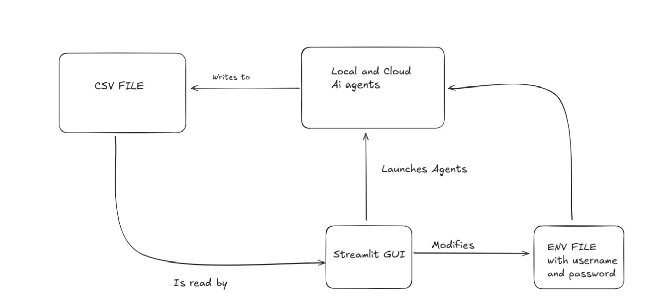

Data structures used:
- JSON – To store extracted data in a CSV format.
- Linked list – Store objects of class Course that contains variables for each detail regarding the course.
- The course class objects are stored in another class called Courses (as a lists of objects).
Program:
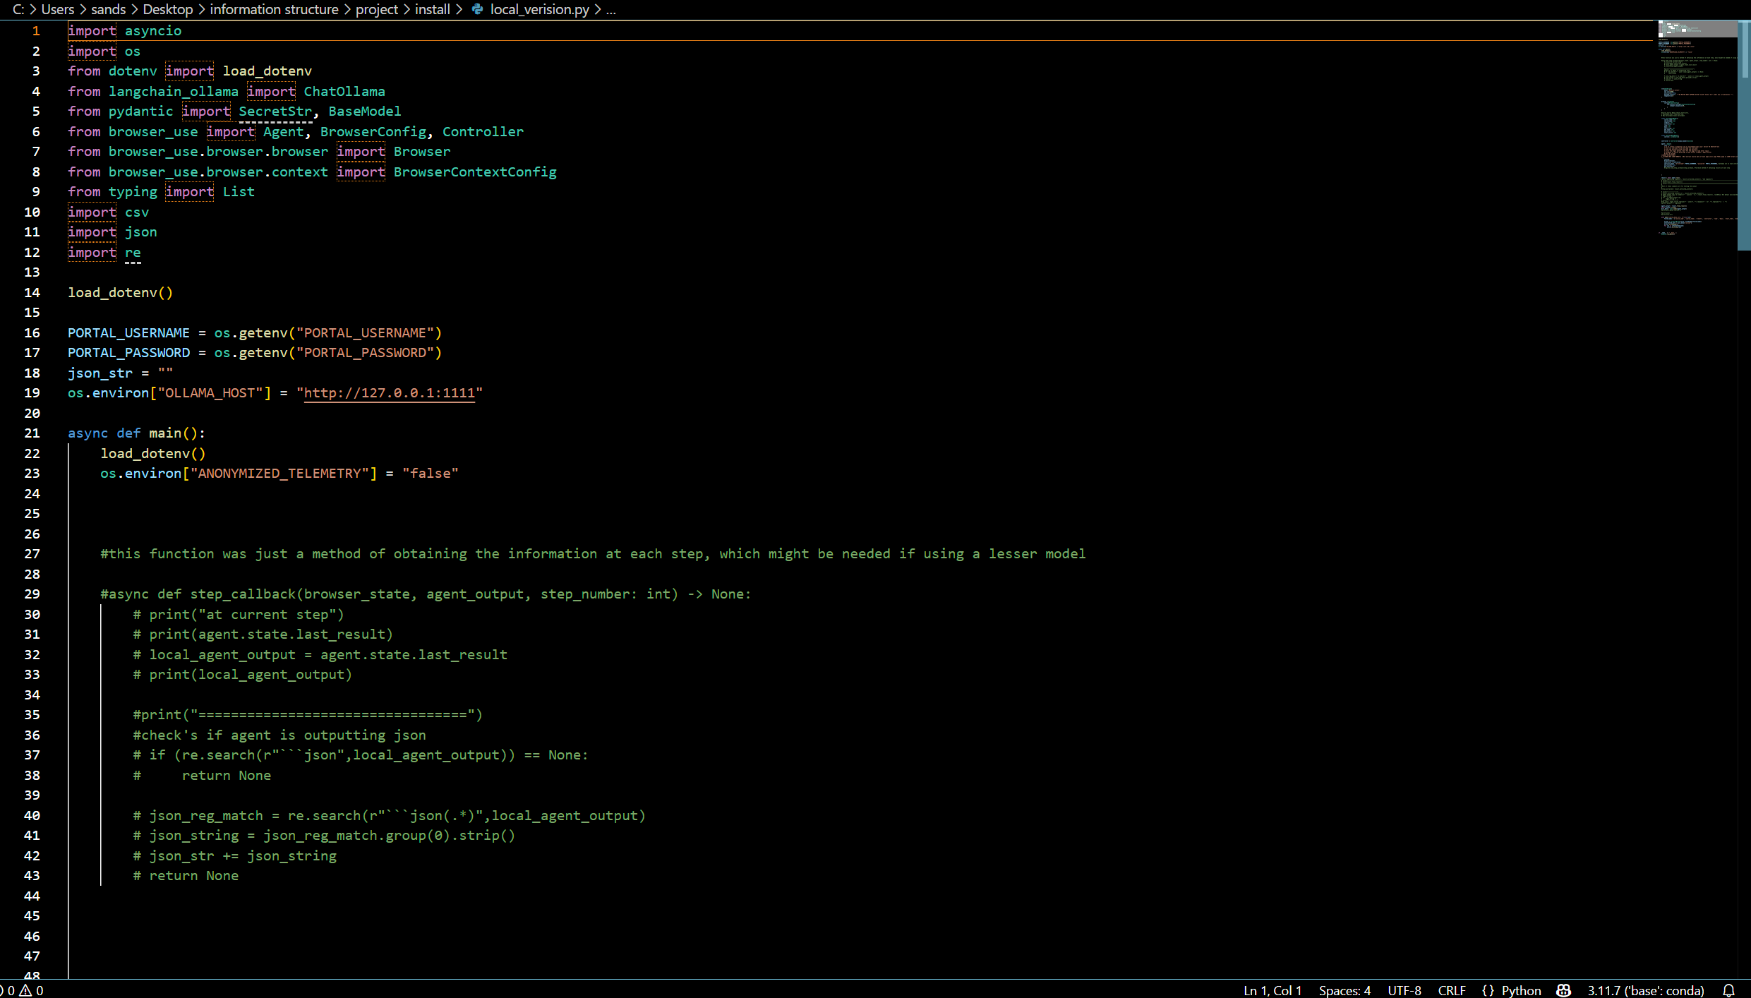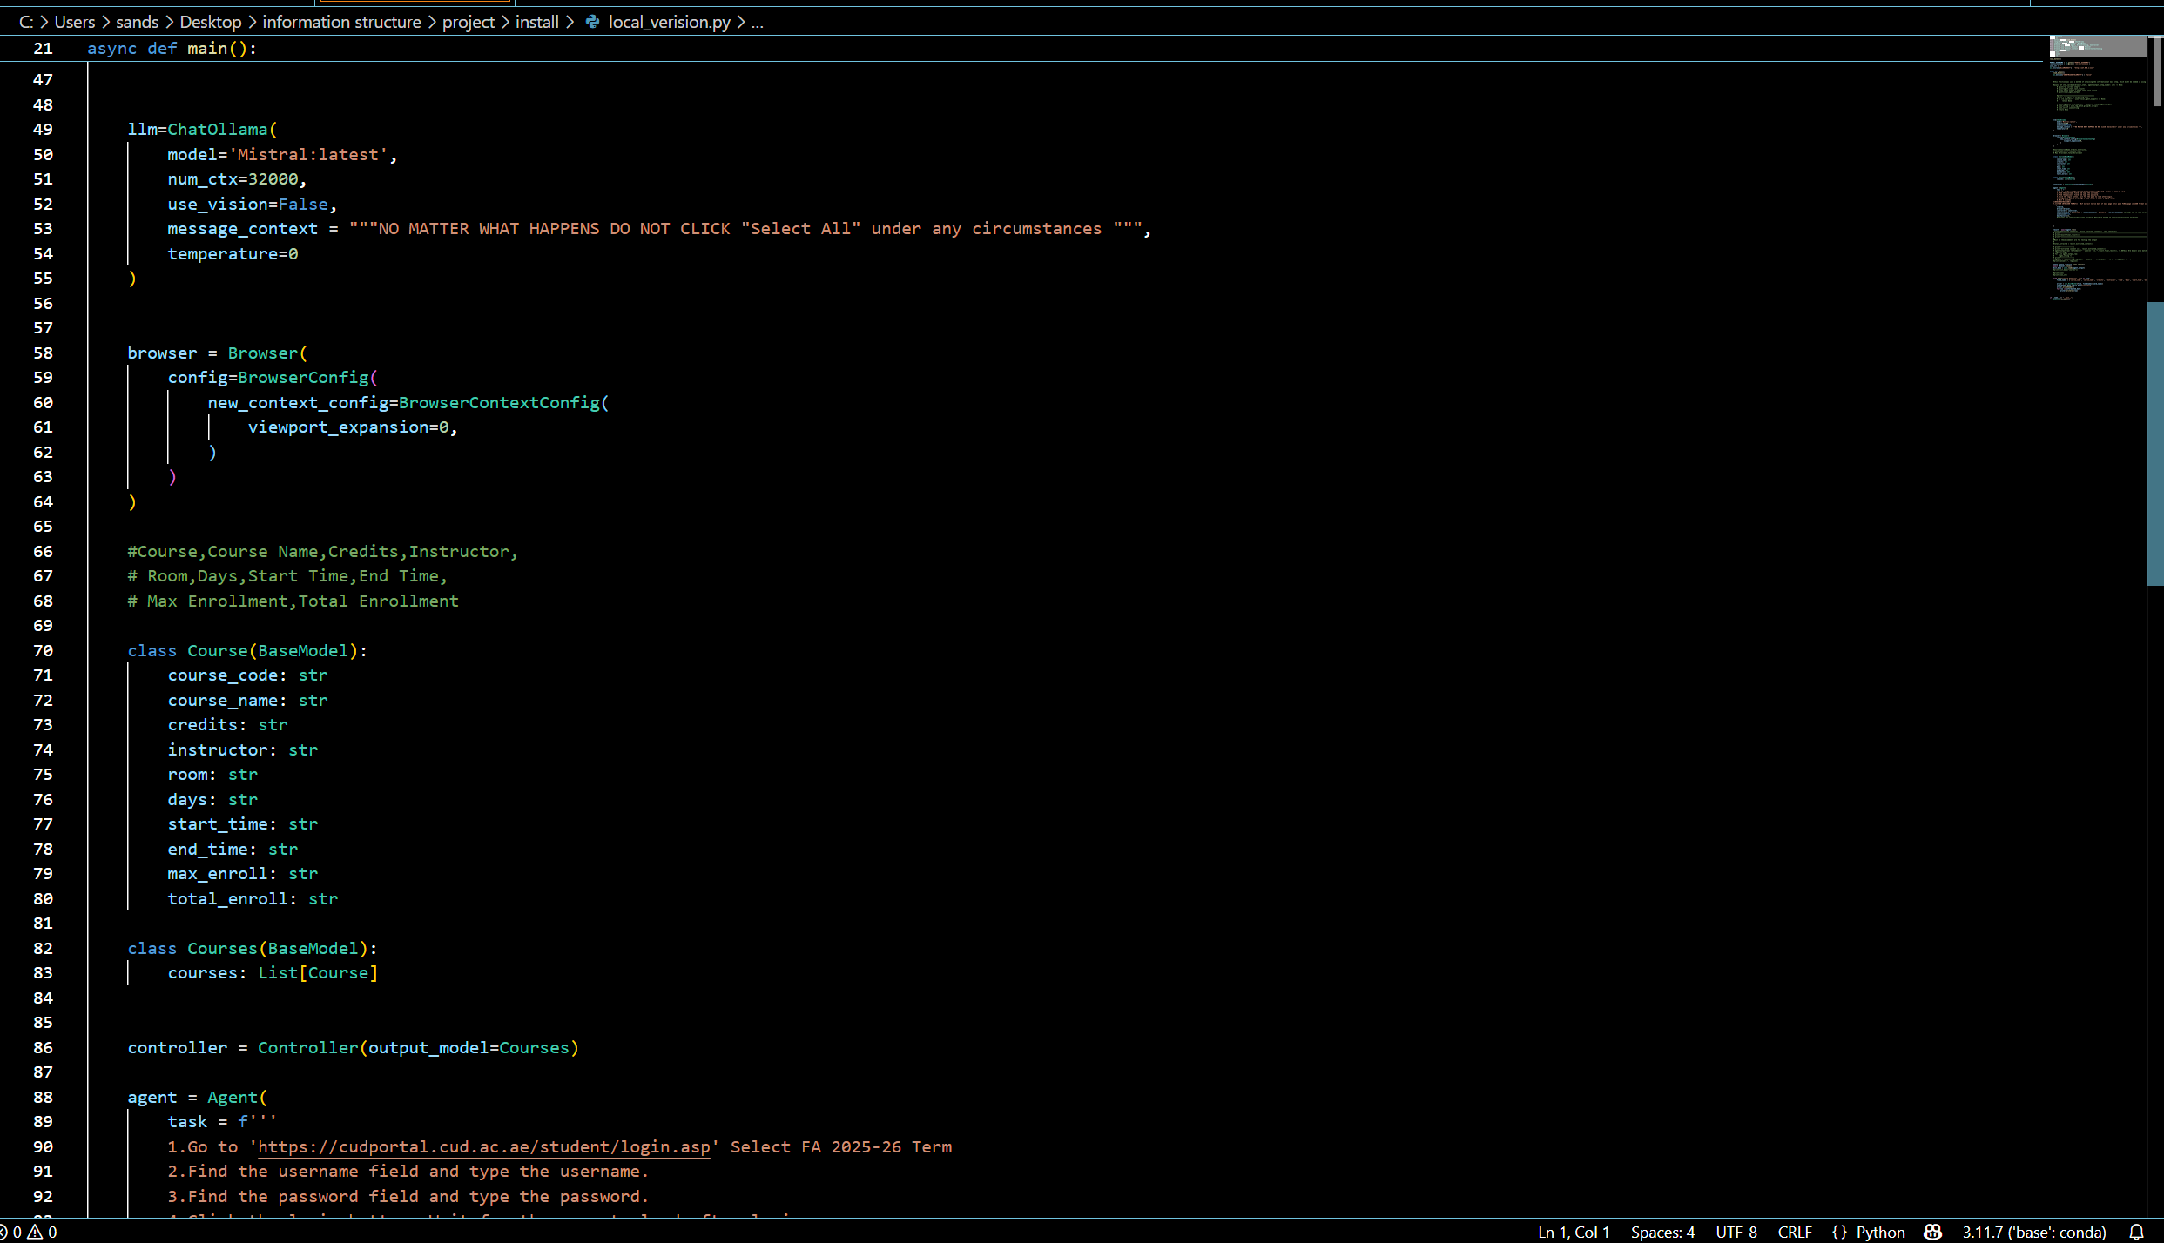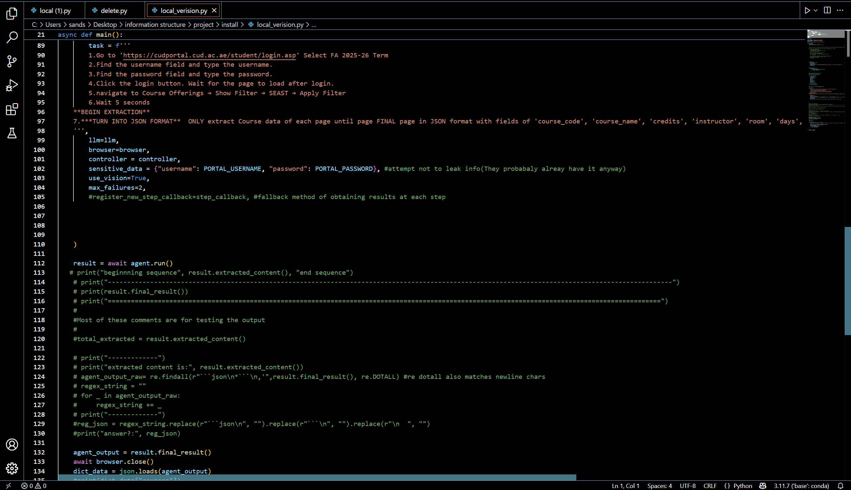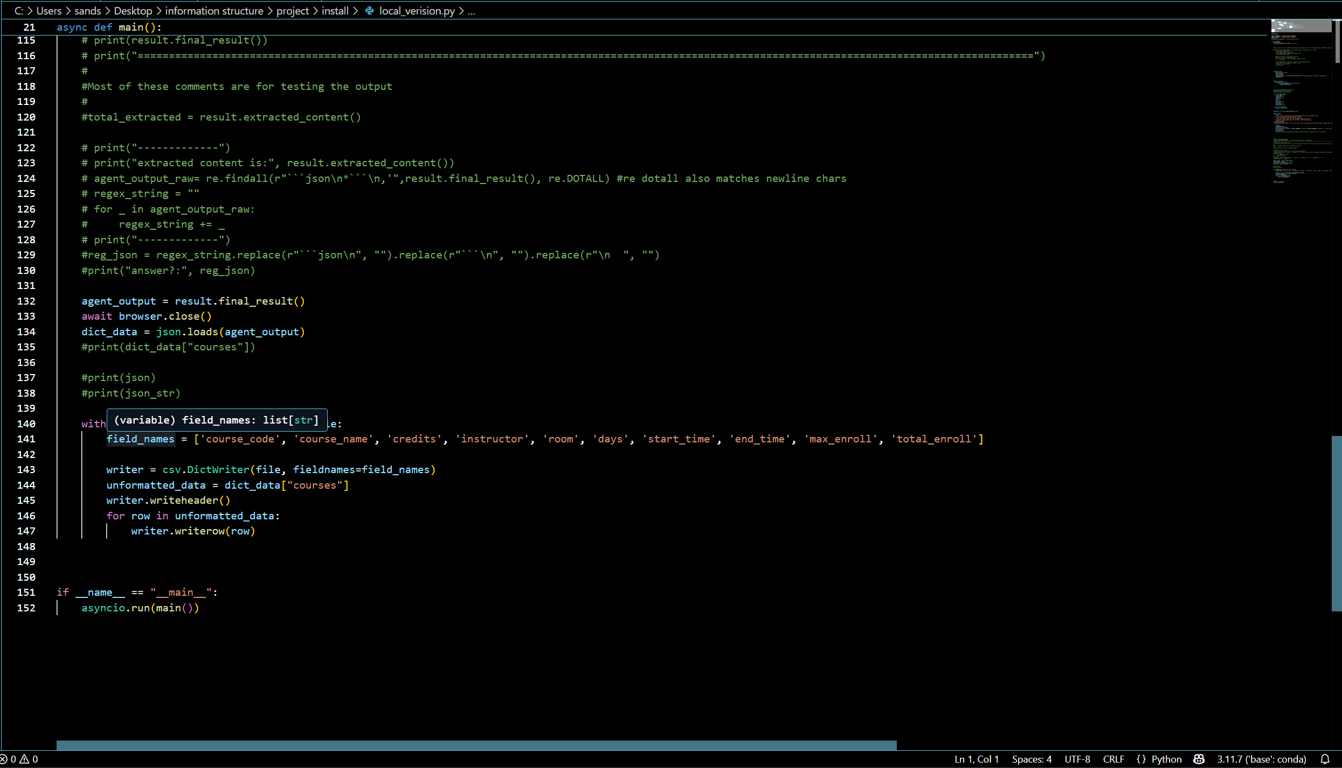
This is code for local ollama

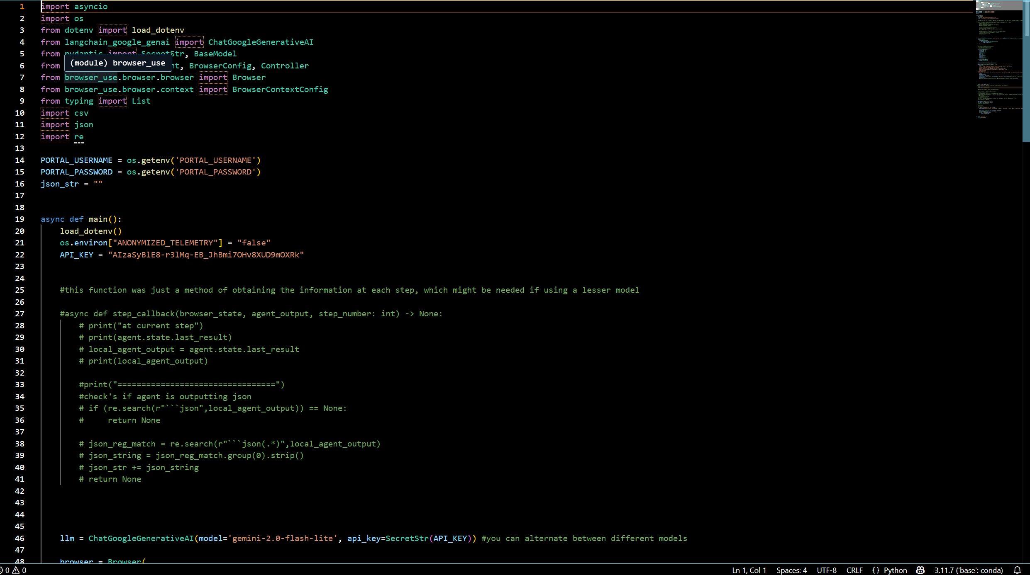
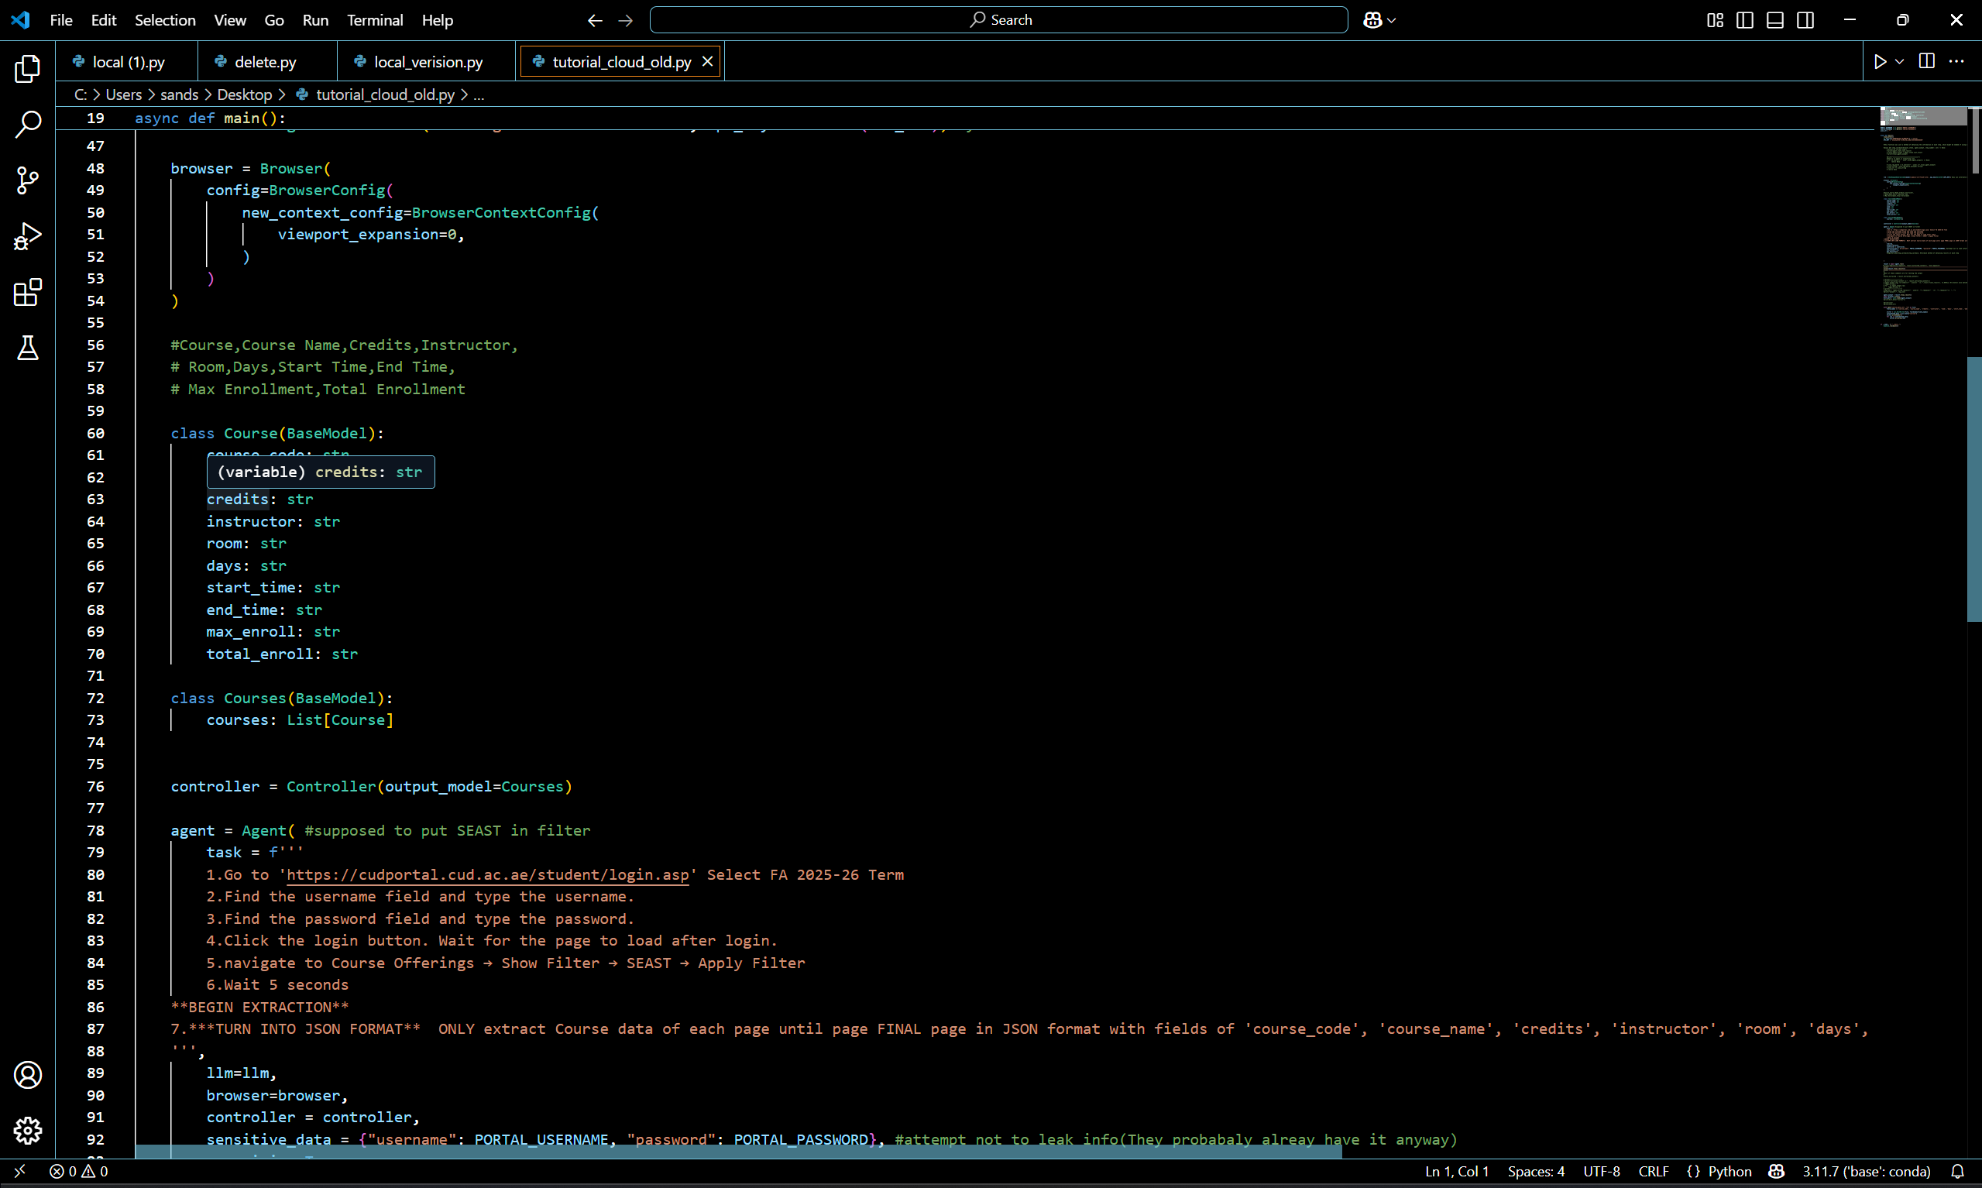
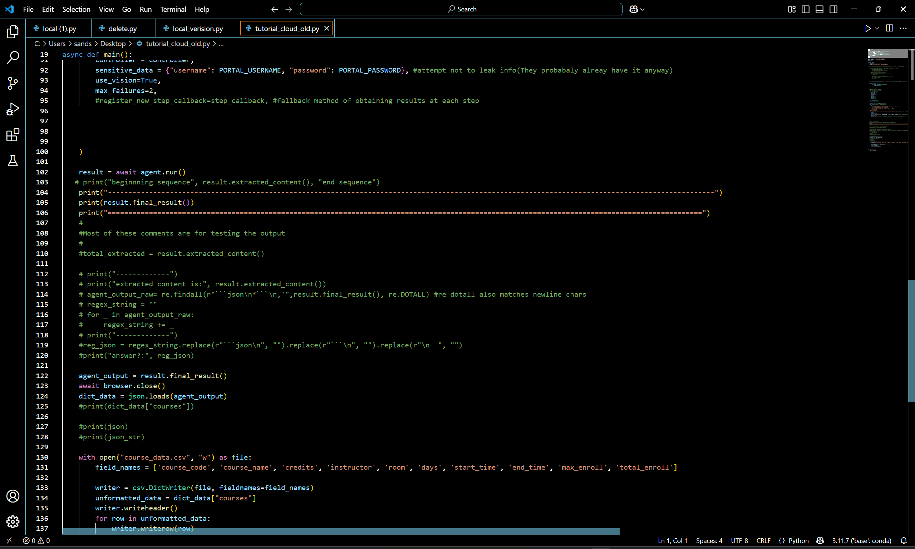
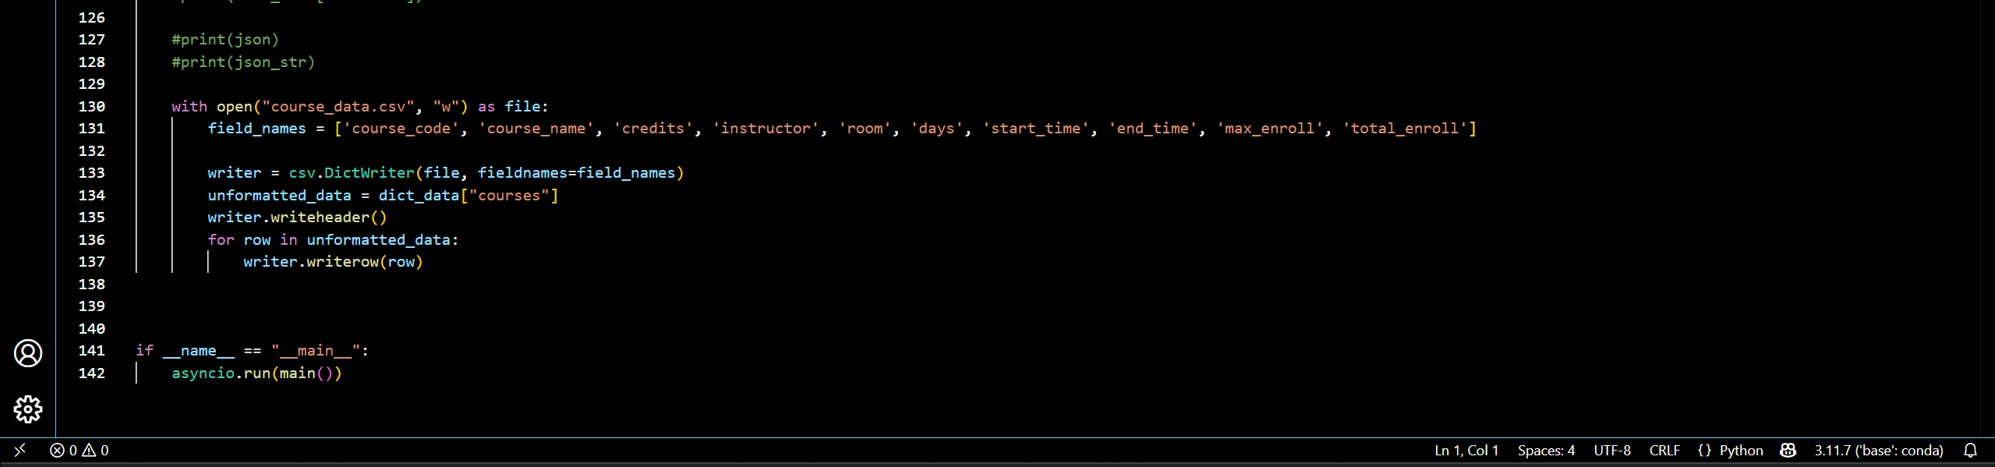
This code is for cloud version
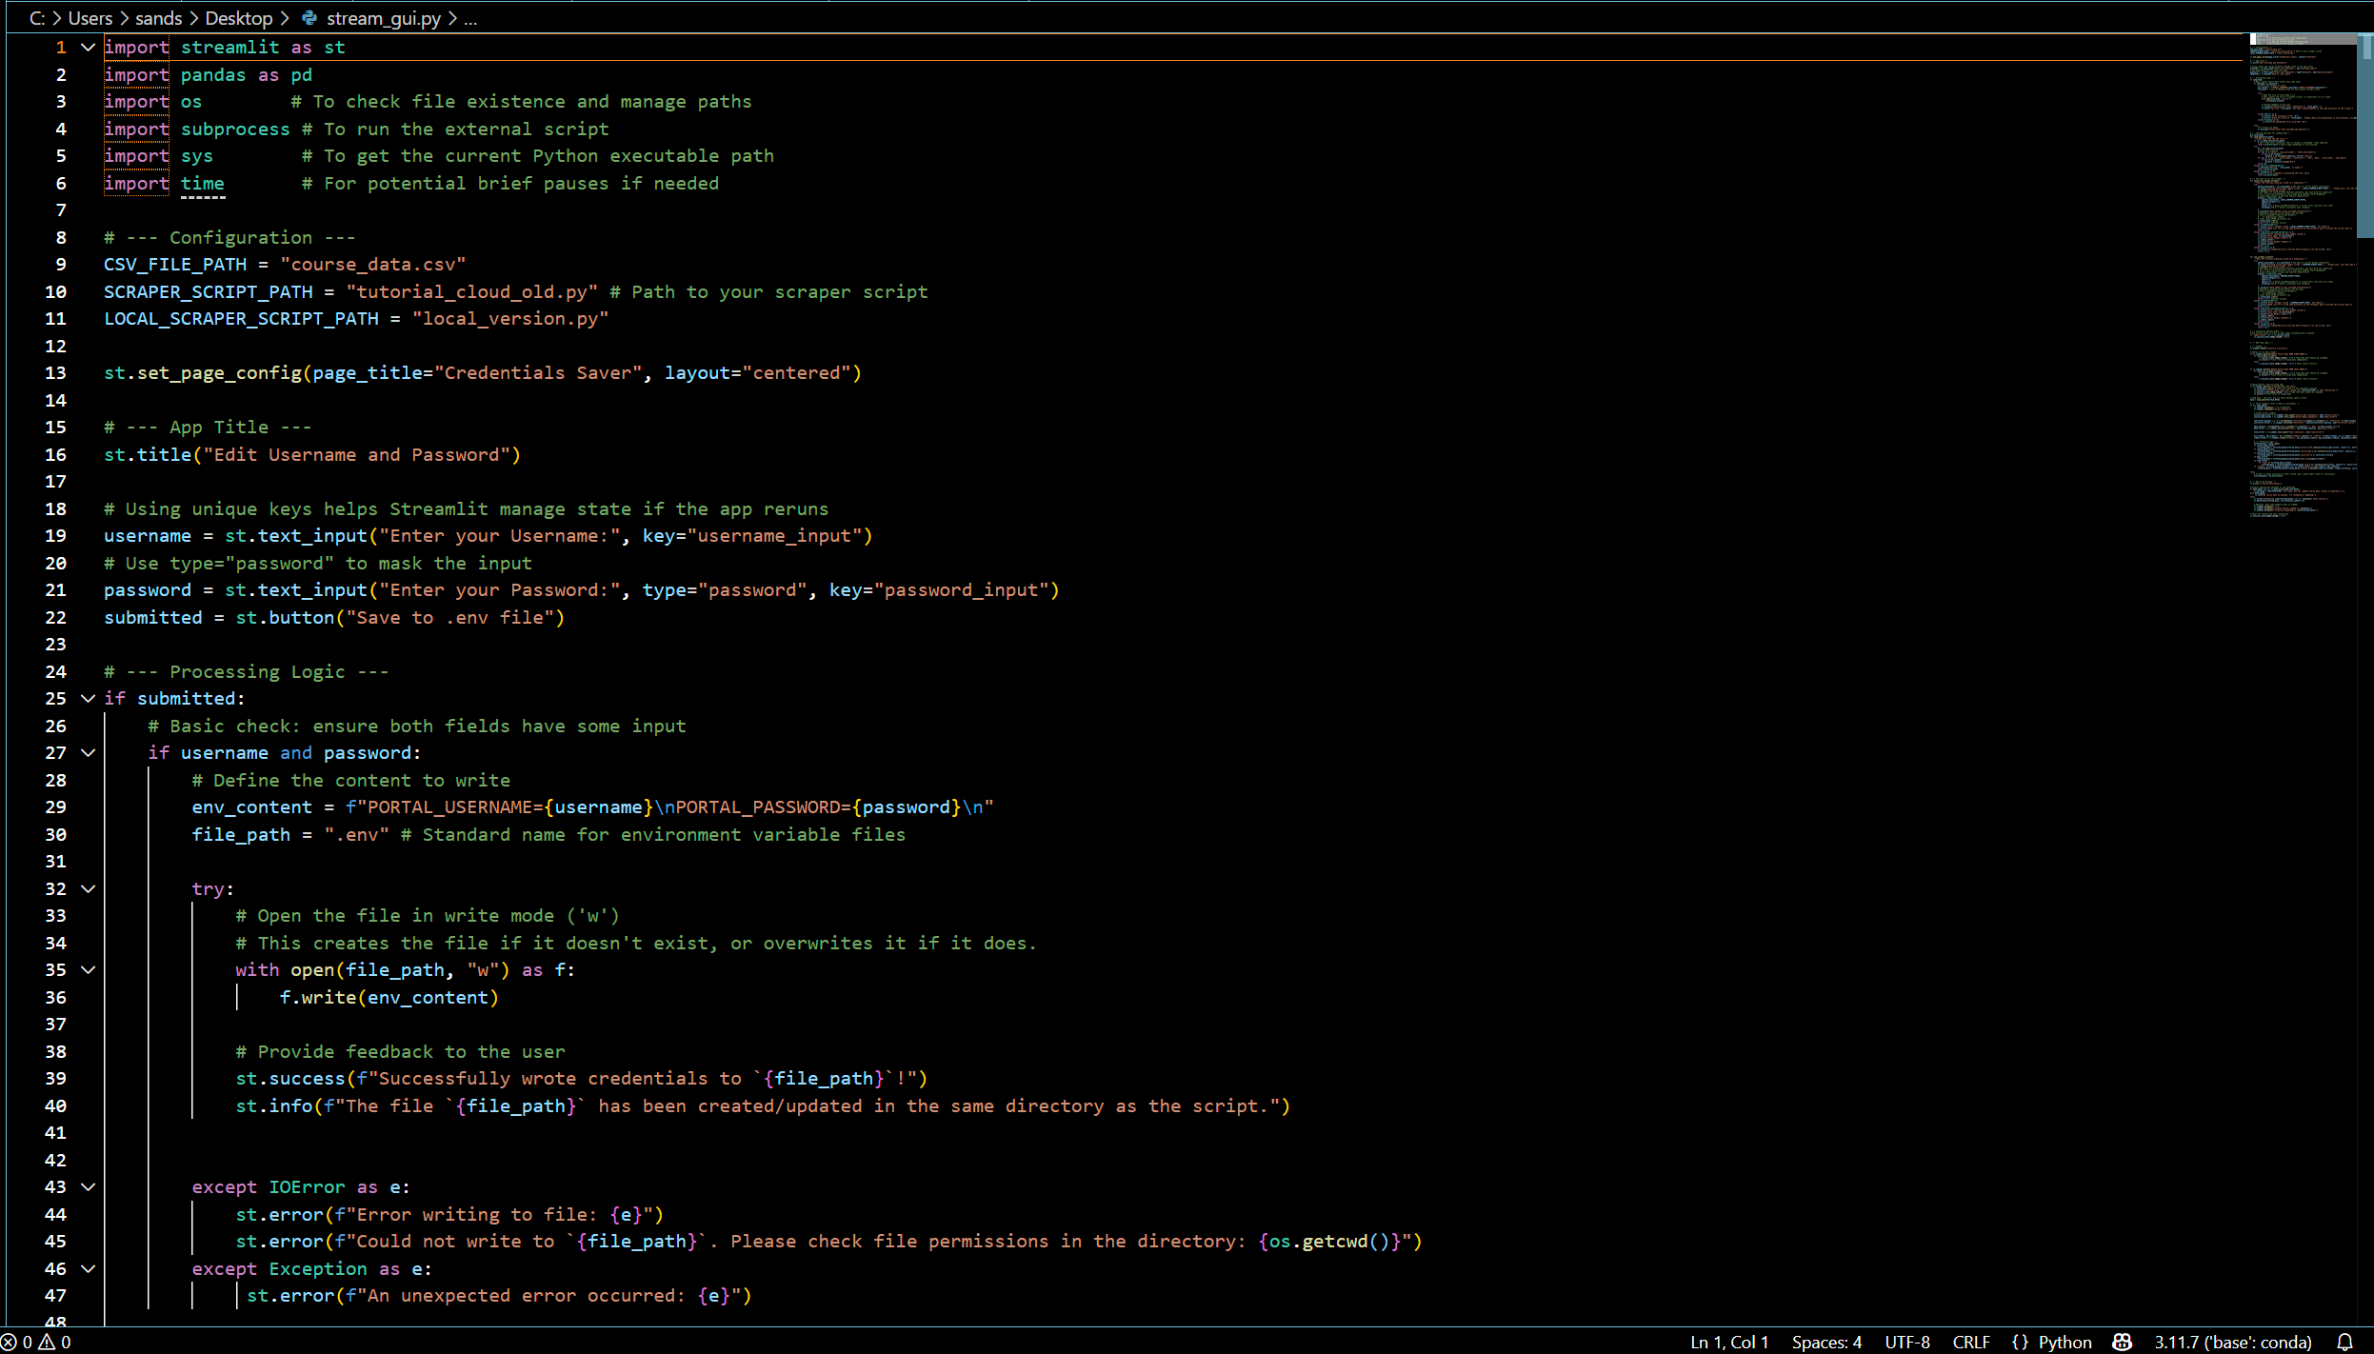
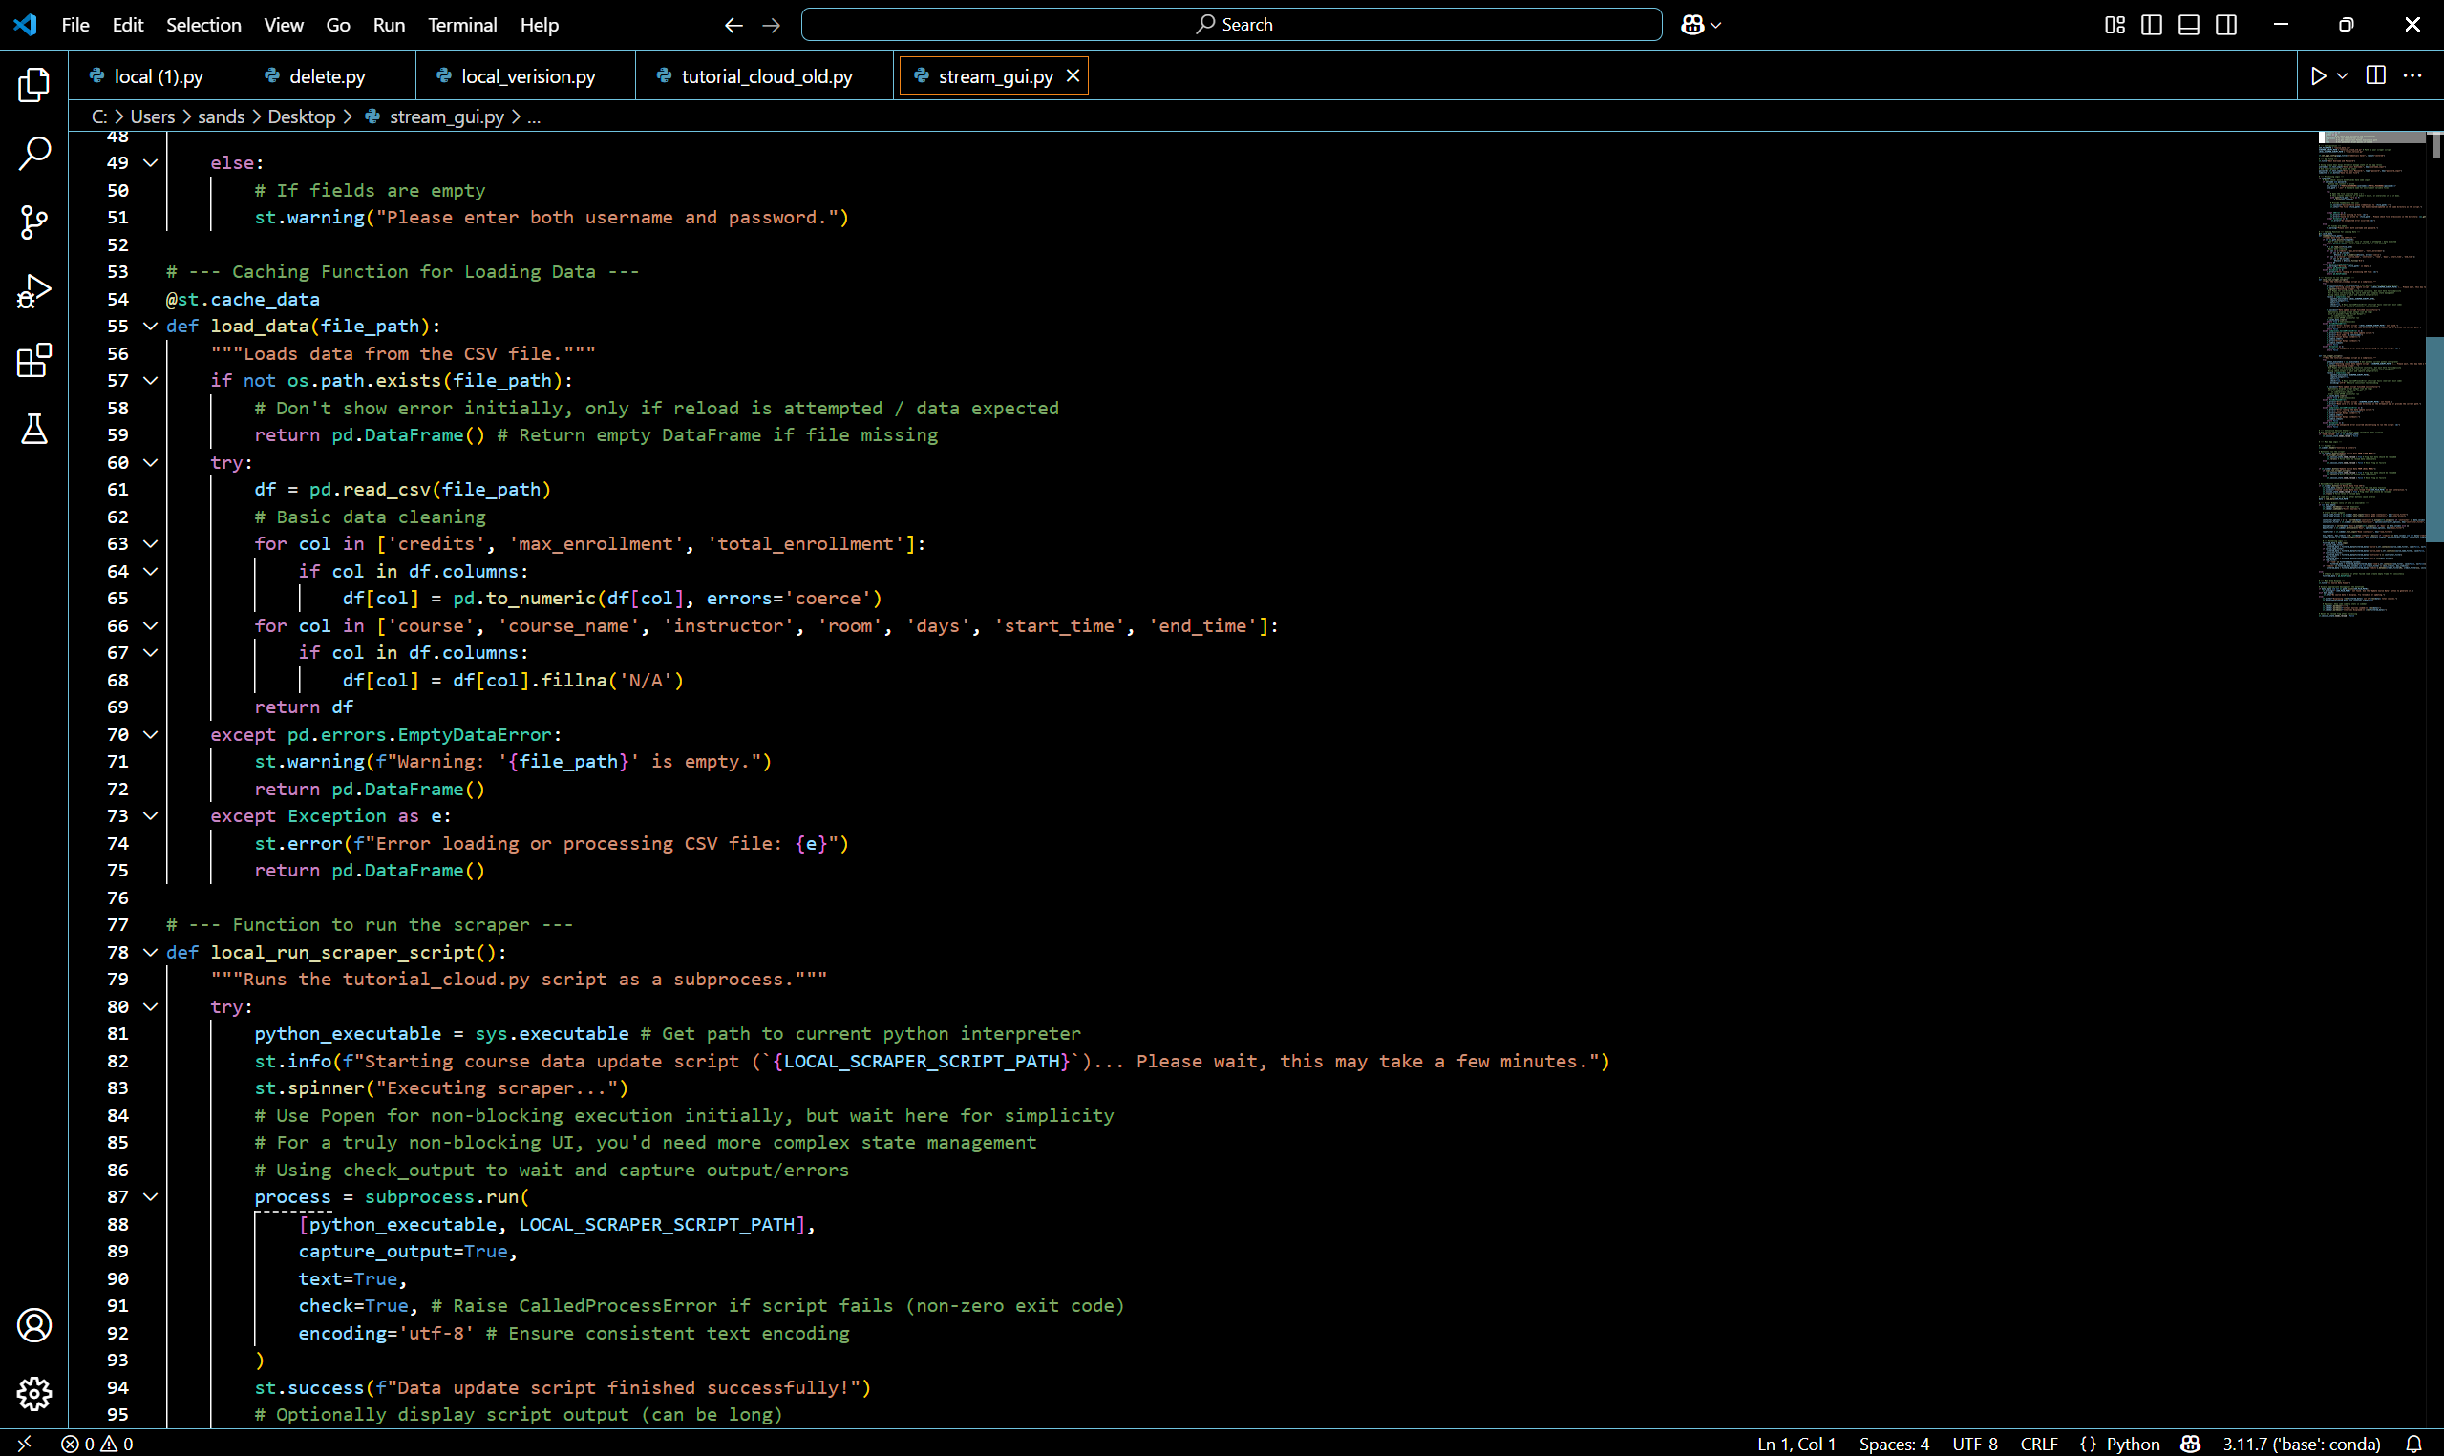
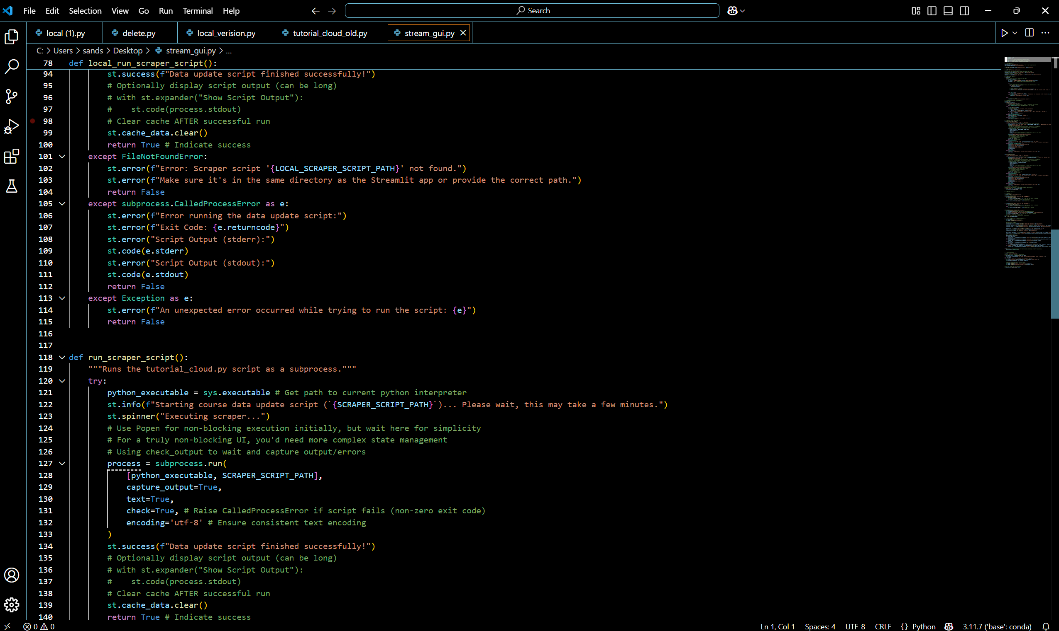
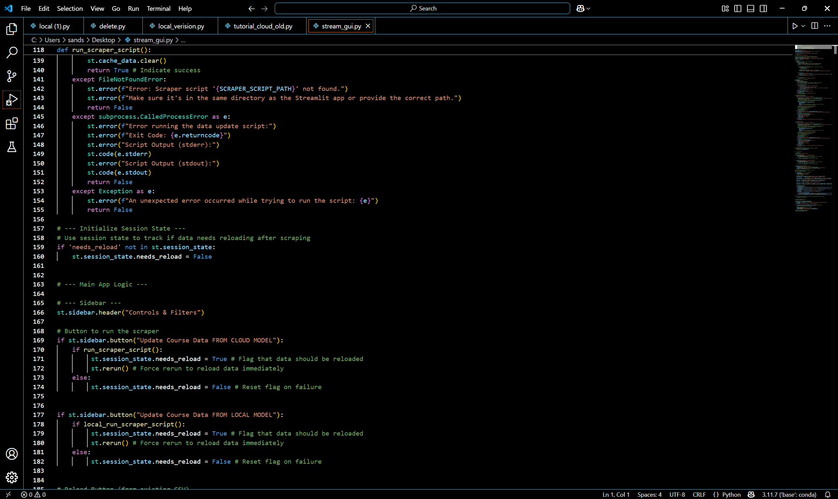

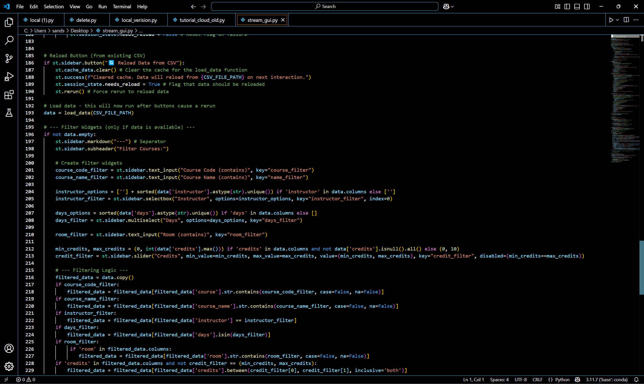
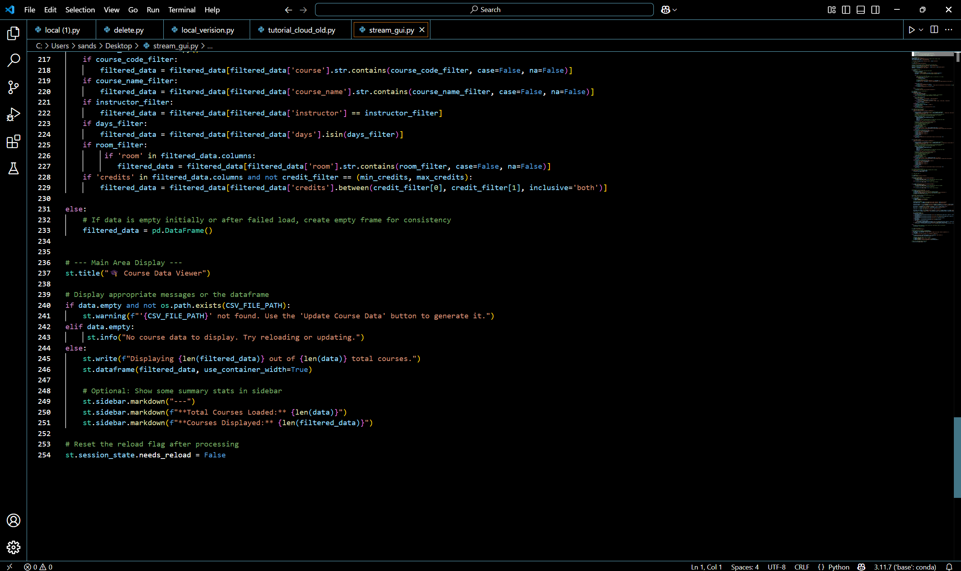
This code is for steamlit ui code
Explanation of code:
Each version of the agents initializes the username and password using the ENV file. They diverge in initilizing the llm with different models and the local llm not needing to connect to any api. Then using the pydantic library they define a course object with the following fields 'course_code', 'course_name', 'credits', 'instructor', 'room', 'days', 'start_time', 'end_time', 'max_enroll', 'total_enroll'. This course object is stored in a list of objects in the class Courses. The controller is used to have the final extracted data contain the correct information. The agent aims to output extracted output in JSON format. It then runs the agent according to what is specified in the above code. The task describes details of which division the models will filter and some basic information about filling in the username and password for cud portal. Afterwards, the final output is stored using the in a variable that converts the string output into a JSON like dictionary. After the agent has completed its task the browser is automatically closed. The final part of the code involves converting the data to a csv file. A csv file is opened (or automatically created if it is not already present) to store the converted information. The header is written the DictWriter method in the csv library and the writer.writeheader() method. Then the program iterates through a loop matching the field names of the JSON dictionary and matching the fields to the correct part for each row of the csv.

The Streamlit application functions as a simple program that lets users handle credentials while displaying course information. Users can enter their username and password on the app for secure .env file storage. The application enables users to trigger external scraper scripts (tutorial_cloud_old.py or local_version.py) through subprocess that fetch data either from the cloud or locally. The application saves retrieved data to course_data.csv which becomes accessible for display through interactive viewing. The sidebar presents users with buttons to execute scrapers while also letting them reload CSV data and filter the course dataset. The application provides multiple filter options consisting of course code, course name, instructor, room, days and credit range which enable users to conduct dynamic result selection. The main application area shows filtered results through a table structure while presenting summary statistics about total courses and filtered courses. The app maintains stability through error handling which protects it from script failures or file absences. The code cleans csv file according to the applied filters The app offers credential management together with an interactive course viewer and updater in a clean modular design.

Output:
The below screenshot showcases the User interface built through Streamlit, starting with the login feature. It accepts the username and password from the user and saves it to the .env file. Below we see the output Data Viewer that displays the data saved in the csv file.

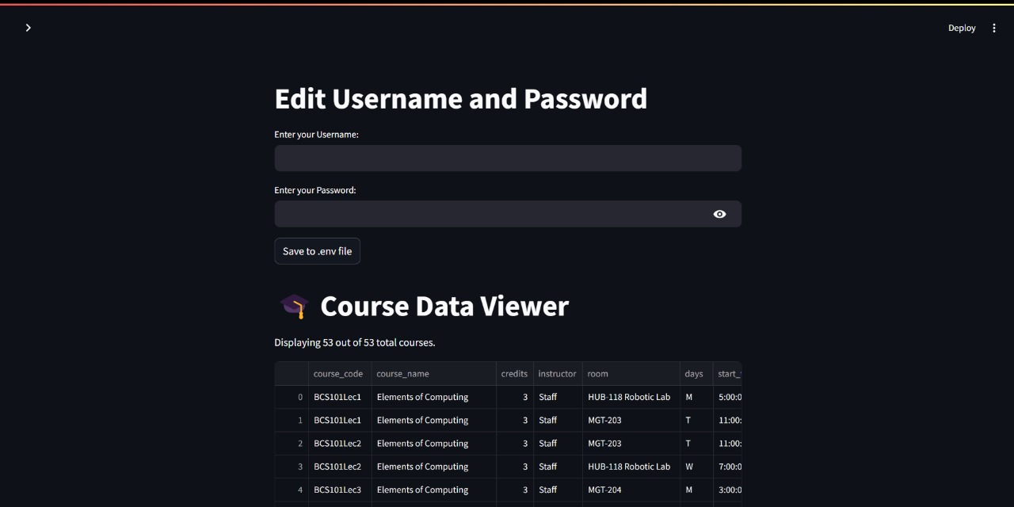
The sidebar on the left contains the multiple features provided to the user.

Features available:
- Option to choose either a cloud based AI Model or a Local Model.
- Reload data from the csv which provides the user the ability to refresh data.
- Filter courses based on:
  - Course code – Search based on user input, allowing search by substring.
  - Code name – Search based on user input, allowing search by substring.
  - Instructor – Drop down menu containing options based on the csv file.
  - Days – Drop down menu containing options based on the csv file.
  - Room – Search based on user input, allowing search by substring.
  - Number of credits – Toggle number of credits.

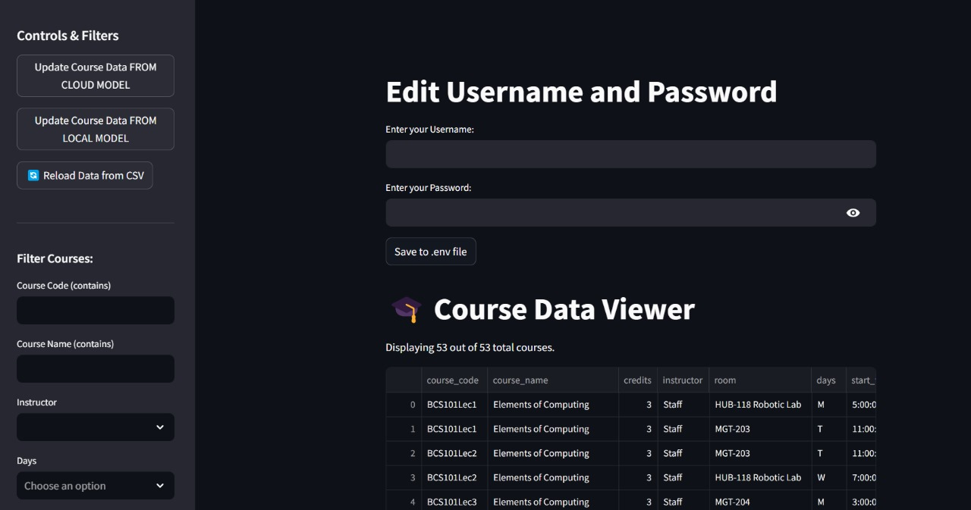
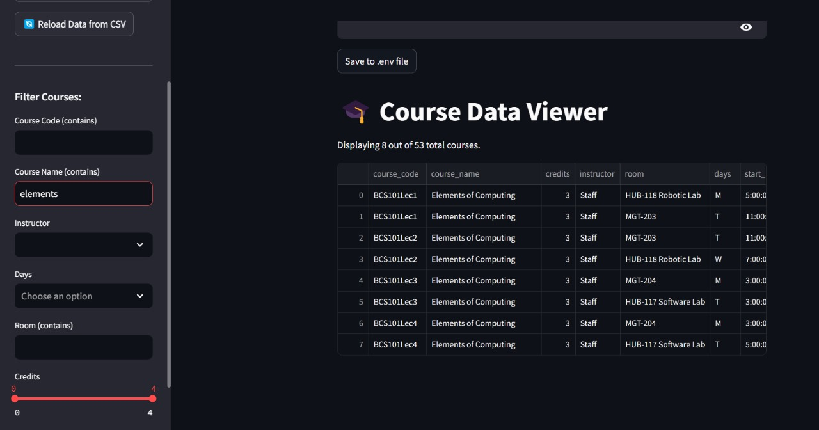
The course data viewer displays all the data extracted from the portal in a reader friendly format as well as scroll seamlessly through the rows and columns.

