
RIPHAH INTERNATIONAL UNIVERSITY ISLAMABAD

Faculty of Computing, BSSE (6-1), Spring 2026

Semester Project – Software Design & Architecture

Team Members:
Sap ID: | Name:
54481 | Hassan Zahid
54523 | Malik Hamza Shahid
SDA-Pro
Security Incident Response & Threat Mitigation Platform
Software Design & Architecture — Semester Project
GitHub repository LinkGitHub Repository Link: https://github.com/Hassan-Zahid-07/SDA-Pro

Field | Details
Project Type | Java and React based SDA semester project with working prototype and dashboard evidence
Core Domain | Security Operations Center (SOC), alert triage, threat enrichment, incident response
Implementation Style | Plain Java core implementation with a React-based SOC web dashboard and documented architecture evidence
Architecture Styles | SOA, MVC, Layered Architecture, Event-Driven Architecture
Design Patterns | All 12 required design patterns implemented and annotated in code

Prepared as a complete academic deliverable with source code, UML, ADRs, API documentation, testing evidence, and Git-ready repository structure.

Table of Contents
- 1. Executive Summary
- 2. Project Requirements and Compliance
- 3. Repository Structure and Documentation Evidence
- 4. System Architecture
4.1 SOC Analyst Web Dashboard (React MVC Prototype)
- 5. Design Pattern Implementation
- 6. End-to-End System Flow
- 7. Testing and Execution Evidence
- 8. Version Control Readiness
- 9. Acceptance Criteria Matrix
- 10. Conclusion
- Appendix A: Visual Evidence and Screenshots

1. Executive Summary
SDA-Pro is a Security Operations Center (SOC) prototype designed to demonstrate practical software design and architecture concepts in a realistic cybersecurity domain. The system ingests alerts from multiple security sources, normalizes them into a canonical model, enriches them through a configurable processing pipeline, creates incidents, executes response actions, and publishes real-time updates to observers such as the Java dashboard, audit logger, notification dispatcher, metrics collector, and the React-based SOC web dashboard.
The core backend prototype is implemented in plain Java so the focus remains on architecture, class responsibilities, object collaboration, and design pattern usage instead of framework configuration. A separate React-based SOC dashboard module has been added under soc-dashboard/ to provide a professional GUI, demonstrate MVC separation, and visually present alert streams, incident queues, lifecycle states, response actions, threat intelligence results, and audit events.
Assessment Area | Current Position
Implementation | Working Java prototype with mock connectors, in-memory repositories, end-to-end demo flow, and React SOC dashboard prototype
Documentation | README, ADRs, API contracts, UML diagrams, evidence folders, report, and presentation
Architecture | Clear separation into service packages representing SOA, Java MVC evidence, React MVC dashboard, layered, and event-driven design
Testing | Manual run evidence and smoke test output available through demo-output.txt and terminal screenshots
Git Repository | Repository contains .gitignore, documentation structure, and clean files.

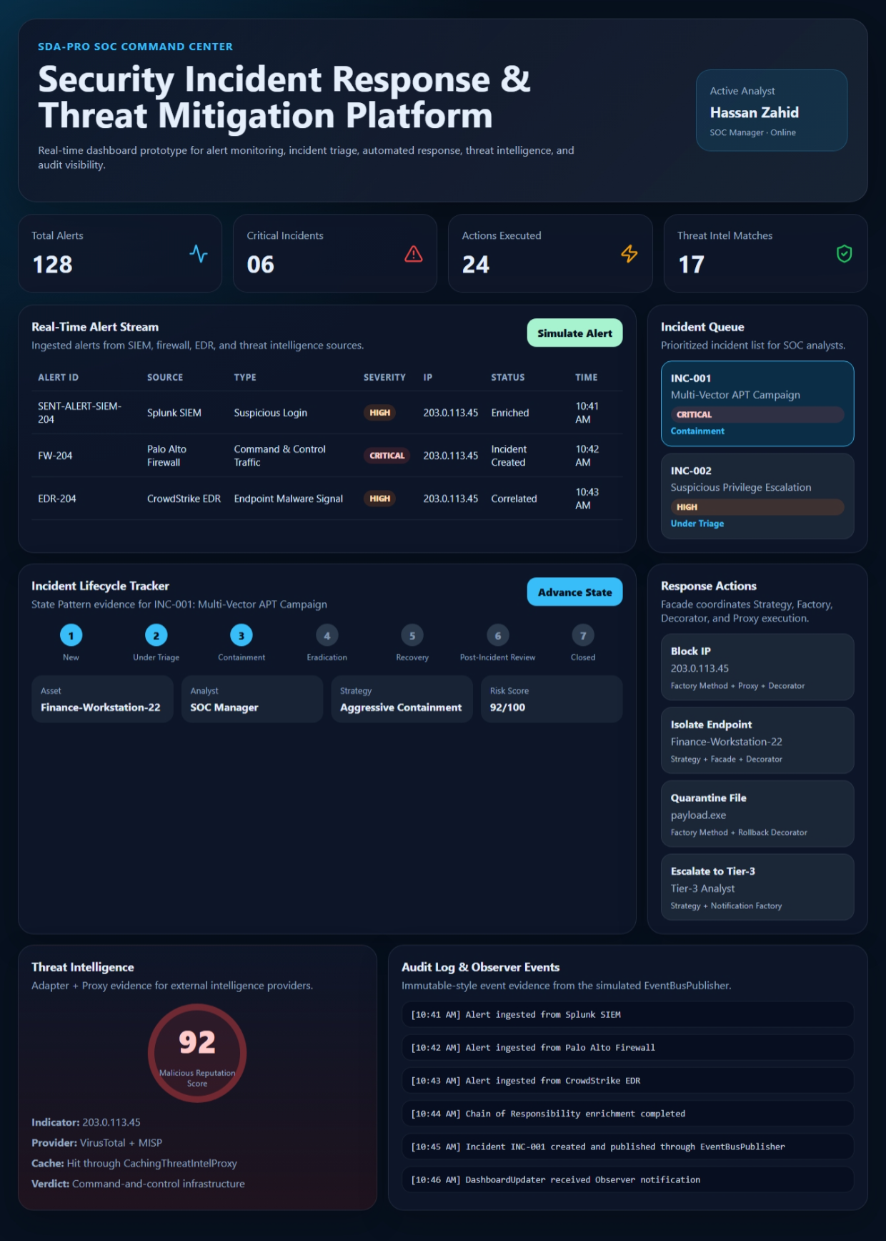

2. Project Requirements and Compliance
The project was evaluated against the three main submission expectations given for the semester project: proper implementation, well-structured documentation, and effective version control management through Git repositories.
- All required design patterns are present in the code and are annotated with clear pattern comments.
- The demo output verifies multiple alert sources and all major processing stages.
- The documentation folders provide traceability from requirements to code and diagrams.

3. Repository Structure and Documentation Evidence
The repository is organized so that source code, documentation, evidence, test output, and submission artifacts are easy to locate. This improves readability for the evaluator and supports the requirement of well-structured documentation.
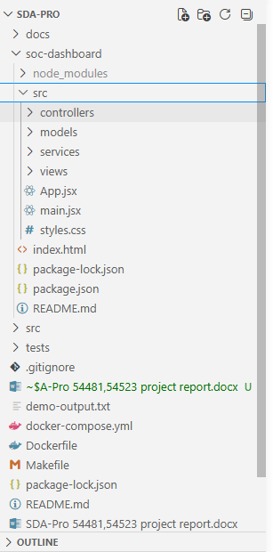
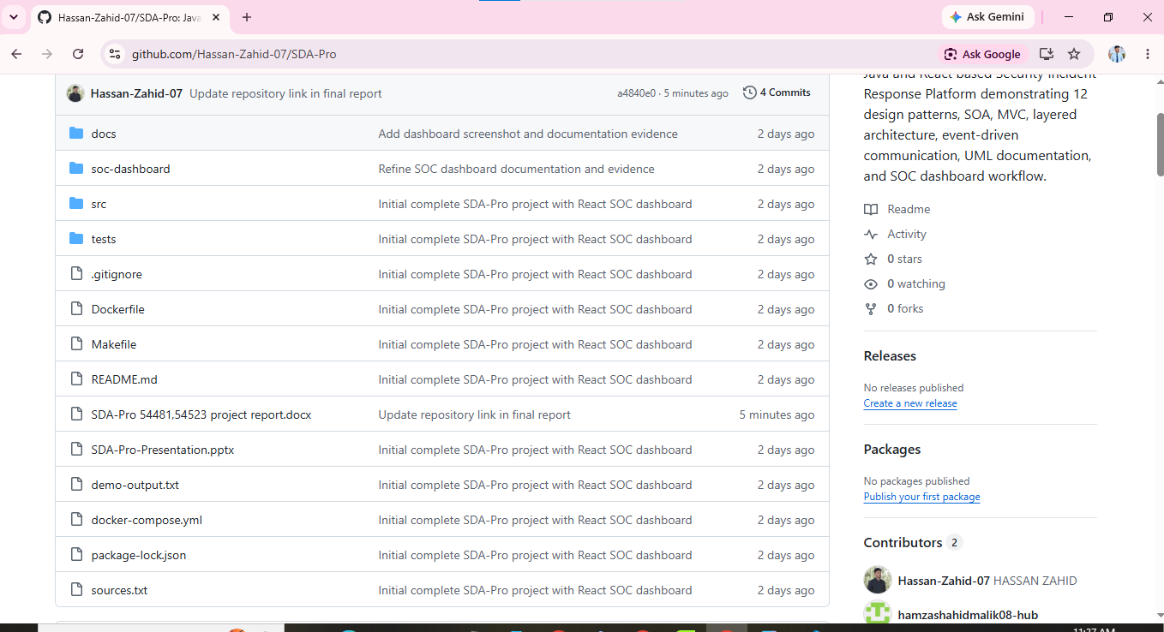

Figure 1: Project repository structure showing docs, screenshots, source packages, tests, Docker files, Makefile, README, report, and presentation.

3.1 Documentation Folder Organization
The documentation folder is divided into ADRs, API contracts, evidence, screenshots, and UML artifacts. This layout makes the project easy to review because every architectural claim has a supporting document or screenshot.
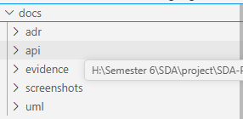
Figure 2: Documentation folder containing adr, api, evidence, screenshots, and uml subfolders.

Folder | Purpose
docs/adr | Architecture Decision Records explaining major design choices
docs/api | Service contracts and API-level communication evidence
docs/uml | Class, component, and sequence diagrams
docs/evidence | Supporting proof for implementation and submission
docs/screenshots | Visual execution and structure screenshots used in the final report

4. System Architecture
SDA-Pro applies four required architecture styles: Service-Oriented Architecture, MVC, Layered Architecture, and Event-Driven Architecture. These styles are not only documented in diagrams; they are reflected in the package structure and runtime flow of the Java project.
Architecture Style | Application in SDA-Pro | Evidence
SOA | Core capabilities are separated as service-oriented packages such as ingestion, enrichment, incident, response, threat intelligence, notification, audit, and dashboard. | src package structure and component diagram
MVC | The project contains Java MVC dashboard evidence and a separate React web dashboard organized into controllers, models, views, and services. | src/dashboard/controllers, models, views; soc-dashboard/src/controllers, models, views, services
Layered Architecture | Domain objects, service logic, adapters, events, and repositories are separated by responsibility. | package hierarchy and source folders
Event-Driven Architecture | Domain events are published by EventBusPublisher and consumed by dashboard, audit, notification, and metrics observers. | events package and demo output

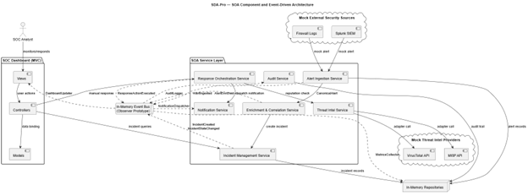

4.1 SOC Analyst Web Dashboard (React MVC Prototype)
To make the SOC monitoring workflow more intuitive and presentation-ready, a React-based web dashboard was added under the soc-dashboard/ directory. This dashboard does not replace the Java implementation; it complements it by providing a professional user interface for the same SOC workflow. It visualizes total alerts, critical incidents, executed actions, threat-intelligence matches, real-time alert streams, incident queue, incident lifecycle tracker, response actions, threat intelligence results, and audit/observer events.
The dashboard follows a clear MVC-inspired structure. Controllers manage user actions and simulated state transitions, models represent alert, incident, response action, and audit data, views render the dashboard interface, and services simulate event-driven updates through a mock event bus.
The implementation evidence is organized as follows:
- Controller layer: soc-dashboard/src/controllers/DashboardController.js handles simulated analyst actions and state changes.
- Model layer: soc-dashboard/src/models/*.js stores alert, incident, response action, and audit log data.
- View layer: soc-dashboard/src/views/*.jsx renders overview cards, alert stream, incident queue, lifecycle tracker, response actions, threat intelligence, and audit logs.
- Service layer: soc-dashboard/src/services/mockEventBus.js simulates Observer/Event-Driven updates without affecting the Java backend.
- Application entry and styling: App.jsx, main.jsx, and styles.css compose the interface and provide a clean SOC command-center design.
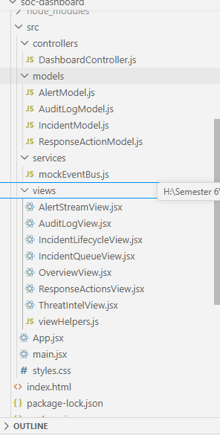
Figure 3A: React SOC dashboard source structure showing controllers, models, services, views, App.jsx, main.jsx, and styles.css.
Figure 3: Component diagram showing SOA services, dashboard, event-driven communication, mock external sources, and in-memory repositories.

5. Design Pattern Implementation
The project implements all 12 required design patterns. Each pattern was applied because it solves a specific domain problem in the SOC workflow. This avoids forced pattern usage and makes the design easier to explain during presentation or viva.
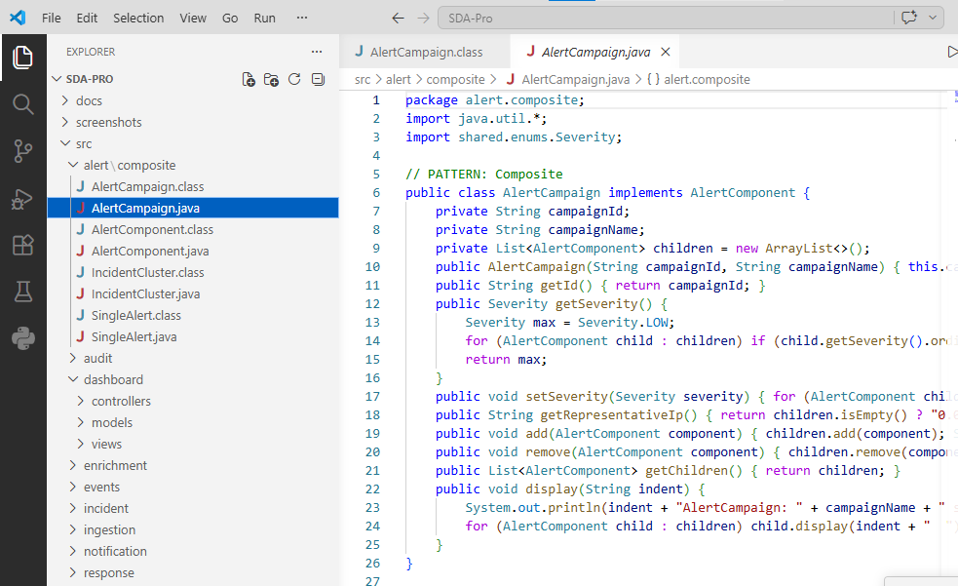
Figure 4: Code evidence showing the Composite pattern annotation in AlertCampaign.java and package organization around implemented patterns.
# | Pattern | Main Evidence | Reason for Use
1 | Singleton | IngestionConfigManager, ThreatIntelCache, EventBusPublisher | Shared configuration, cache, and event publisher
2 | Factory Method | AlertNormalizerFactory, ResponseActionFactory | Create correct normalizer/action at runtime
3 | Abstract Factory | EnrichmentProviderFactory, NotificationFactory | Create related families of providers/notifiers
4 | Composite | AlertComponent, SingleAlert, AlertCampaign, IncidentCluster | Treat single alerts and grouped campaigns uniformly
5 | Facade | IncidentResponseFacade | Hide response orchestration complexity from callers
6 | Adapter | SplunkAdapter, FirewallAdapter, CrowdStrikeAdapter, VirusTotalAdapter, MISPAdapter | Convert external formats into project interfaces
7 | Decorator | AuditLogDecorator, ApprovalGateDecorator, RollbackDecorator, MetricsDecorator | Add behavior around response actions dynamically
8 | Proxy | Caching, RateLimit, AccessControl, AuthorizedResponseActionProxy | Control expensive calls and authorization
9 | State | NewState through ClosedState | Enforce legal incident lifecycle transitions
10 | Chain of Responsibility | Deduplication, GeoIP, ThreatIntel, AssetContext, Classification | Process alerts through independent enrichment stages
11 | Observer | DashboardUpdater, AuditLogger, NotificationDispatcher, MetricsCollector | Keep subscribers loosely coupled to publishers
12 | Strategy | Aggressive, Balanced, Conservative, WatchAndWait | Choose response behavior based on severity and context

6. End-to-End System Flow
The running demo follows the main SOC scenario from external alert collection to automated response. The flow proves that the design patterns are collaborating in a meaningful workflow rather than existing as isolated classes.
- Alert ingestion begins through mock external adapters for Splunk SIEM, Palo Alto Firewall, and CrowdStrike EDR.
- AlertNormalizerFactory converts each source-specific alert into a canonical alert model.
- Composite grouping places alerts into AlertCampaign or IncidentCluster structures.
- The enrichment pipeline applies deduplication, GeoIP, threat intelligence, asset context, and classification stages.
- IncidentManagementService creates and transitions incidents through the defined state lifecycle.
- IncidentResponseFacade coordinates strategy selection, action creation, decorators, proxies, and event publishing.
- EventBusPublisher notifies dashboard, audit, notification, and metrics subscribers.
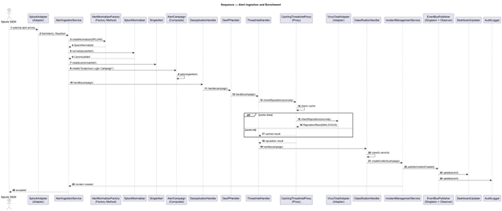
Figure 5: Sequence diagram for alert ingestion, normalization, enrichment, correlation, and incident creation.
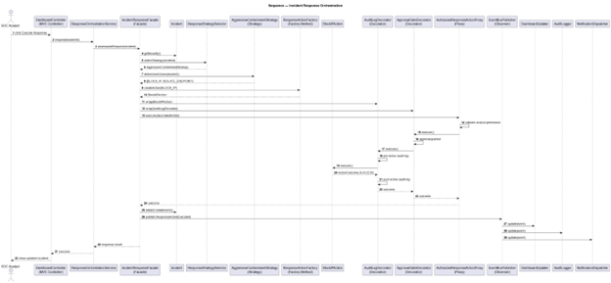
Figure 6: Sequence diagram for incident response orchestration using Facade, Strategy, Decorator, Proxy, State, and Observer.

7. Testing and Execution Evidence
The project was compiled and executed successfully. The demo output confirms that all major steps run in sequence, including three-source ingestion, enrichment, observer notifications, incident creation, and automated response actions.
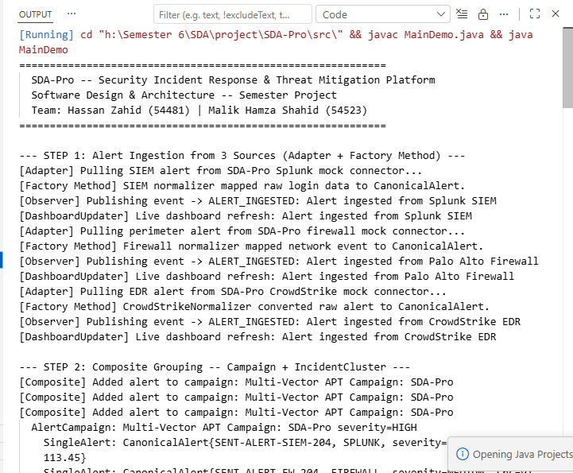
Figure 7: Terminal execution evidence showing the SDA-Pro demo starting and processing alerts from three sources.
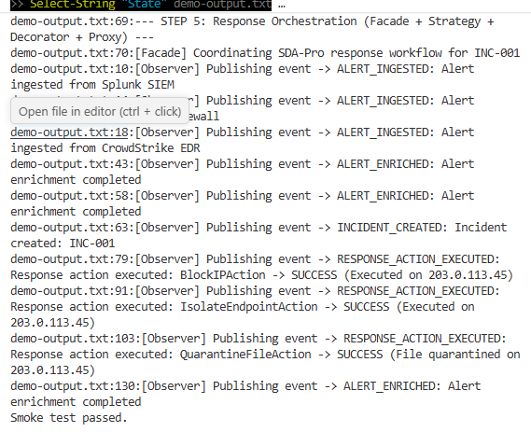
Figure 8: Smoke test evidence showing required pattern keywords found in demo-output.txt and final “Smoke test passed” message.

7.1 Commands Used for Local Verification
Verification Step | PowerShell Command
Compile Java source files | Get-ChildItem -Recurse src -Filter *.java | ForEach-Object { $_.FullName } > sources.txt  javac -d out @sources.txt
Run main demo | java -cp out MainDemo | Tee-Object -FilePath demo-output.txt
Smoke test checks | Select-String "Adapter" demo-output.txt  Select-String "Factory Method" demo-output.txt  Select-String "Composite" demo-output.txt  Select-String "Chain" demo-output.txt  Select-String "State" demo-output.txt  Select-String "Facade" demo-output.txt  Select-String "Observer" demo-output.txt  Write-Output "Smoke test passed."

8. Version Control Readiness
The project was prepared for GitHub-based version control and collaboration. The official repository is hosted under the Hassan-Zahid-07 account and includes the complete source code, documentation, UML artifacts, screenshots, report, presentation, Docker configuration, Makefile, Java backend, and React SOC dashboard. The second team member was added as a collaborator so both members can contribute through separate commits.
- Submission readiness: clean repository structure with source code, documentation, dashboard, test evidence, report, and presentation.
- Collaboration evidence: commit history and contributor list show project updates from team accounts.
- Branch used: main branch for final submission, with feature branches available for future improvements.
- Repository access: private repository with collaborator access for team contribution and academic review.
- Repository URL: https://github.com/Hassan-Zahid-07/SDA-Pro

9. Acceptance Criteria Matrix
Acceptance Criterion | Evidence in Project | Status
Alerts from 2+ sources ingested and normalized | Splunk SIEM, Palo Alto Firewall, CrowdStrike EDR shown in demo output | Pass
Chain of Responsibility pipeline with at least 3 handlers | Deduplication, GeoIP, ThreatIntel, AssetContext, Classification | Pass
Composite grouping into campaigns/clusters | AlertCampaign and IncidentCluster classes | Pass
Incident lifecycle states | New, UnderTriage, Containment, Eradication, Recovery, PostIncidentReview, Closed | Pass
At least 2 response strategies | Aggressive, Balanced, Conservative, WatchAndWait | Pass
2+ threat intel adapters through proxy | VirusTotal and MISP adapters with caching/rate-limit/access-control proxies | Pass
Dashboard updates through Observer/Event-Driven pattern | DashboardUpdater receives EventBusPublisher notifications; React SOC dashboard visualizes alert stream, incident queue, lifecycle, response actions, threat intel, and audit events | Pass
All 12 patterns annotated in code | // PATTERN comments visible in source files | Pass
Architecture documented | UML diagrams, ADRs, README, API docs, dashboard evidence, and repository screenshots | Pass
System compiles and runs | Terminal demo and smoke test screenshots | Pass

Appendix A: Visual Evidence and Screenshots
This appendix contains additional visual evidence added to make the report easier to verify. The screenshots show the repository structure, documentation, UML diagrams, implementation evidence, and execution output.
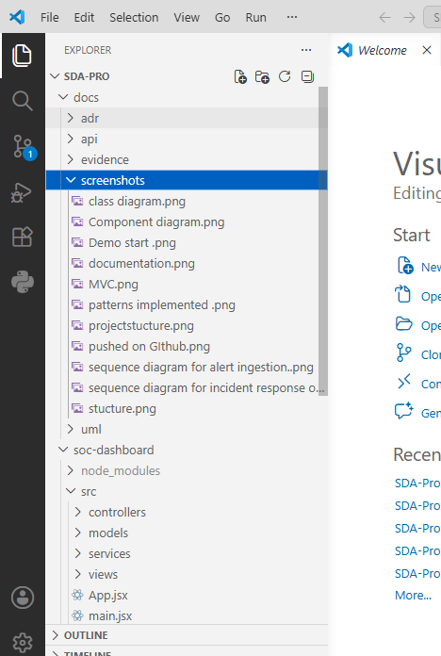
Appendix Figure A1: High-level docs folder structure from VS Code.
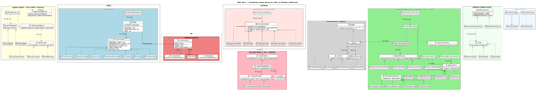
Appendix Figure A2: UML class diagram covering all required patterns.

Appendix Figure A3: SOA component and event-driven architecture diagram.

Appendix Figure A4: Alert ingestion and enrichment sequence diagram.

Appendix Figure A5: Incident response orchestration sequence diagram.

