**EXPERIMENT NO.4**

**COMBINATIONAL CIRCUIT DESIGN USING K-MAPS**

SUBMITTED TO:

Dr. Ubaid Ullah Fayyaz

SUBMITTED BY:

Hassan Muavia

2022-EE-162

**UNIVERSITY OF ENGINEERING & TECHNOLOGY, LAHORE**

**Truth Table:**

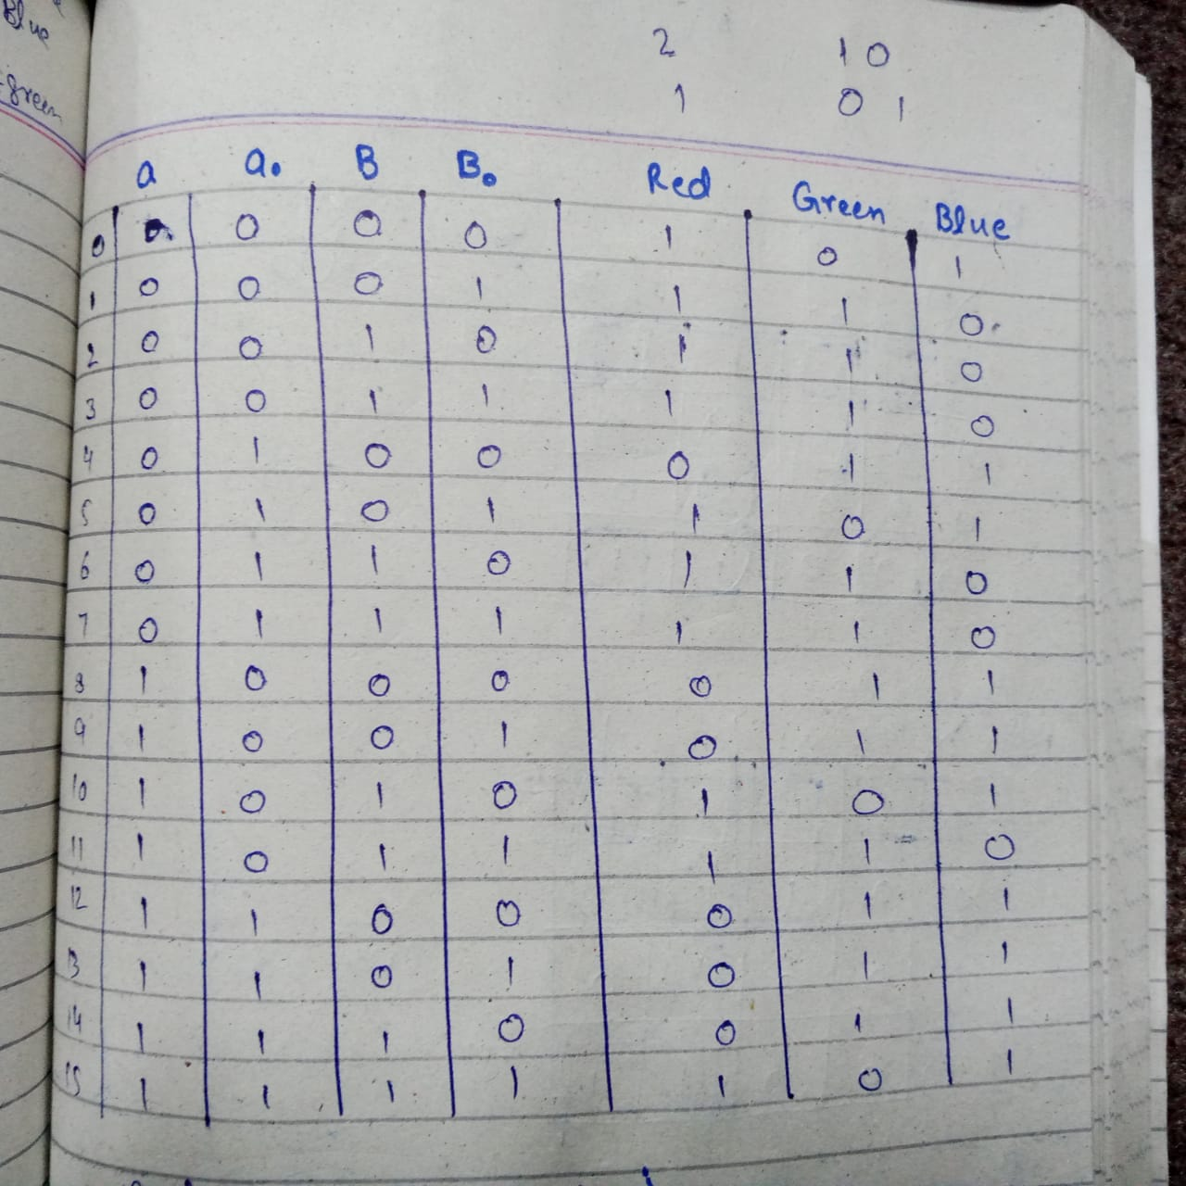

**K-maps:**

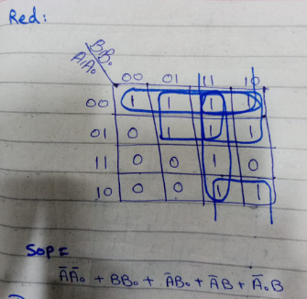

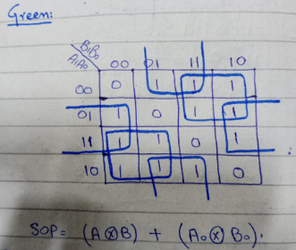

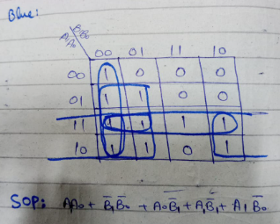

**Circuit Diagram:**

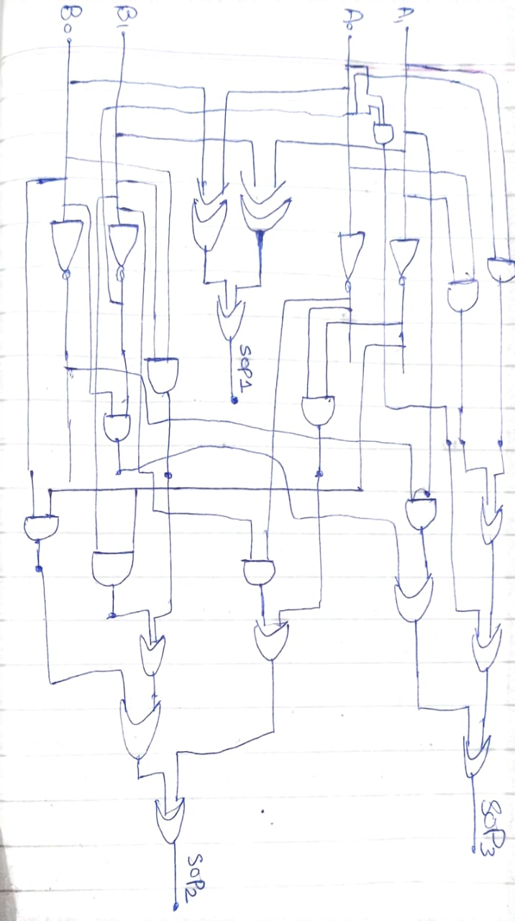

**Circuit diagram using vivado:**

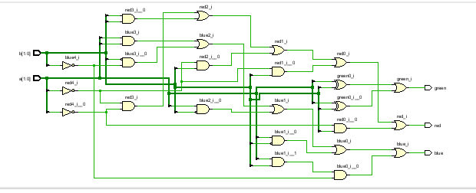

Delay in synthesis:

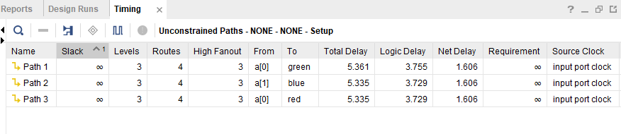

**Resource Utilization:**

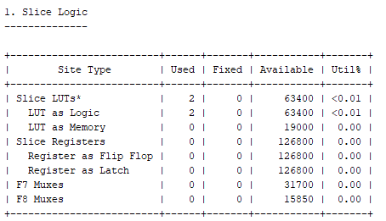

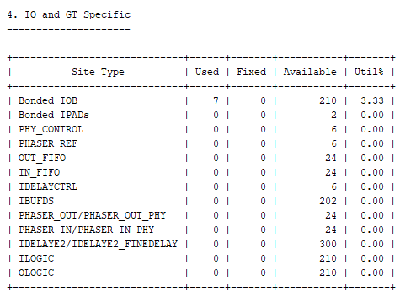

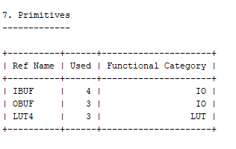

**System Verilog Code:**

