**EXPERIMENT NO. 5**

**COMBINATIONAL CIRCUIT DESIGN USING K-MAPS**

SUBMITTED TO:

Dr. Ubaid Ullah Fayyaz

SUBMITTED BY:

Hassan Muavia

2022-EE-162

**UNIVERSITY OF ENGINEERING & TECHNOLOGY,**

**LAHORE**

**Truth Table:**

|  |  |  |  |  |  |  |  |  |  |  |  |
| --- | --- | --- | --- | --- | --- | --- | --- | --- | --- | --- | --- |
| **charachters** | **A2** | **A1** | **A0** | **an. 0** | **an. 1** | **an. 2** | **an.3** | **an.4** | **an.5** | **an.6** | **an.7** |
| 0 | 0 | 0 | 0 | 0 | 1 | 1 | 1 | 1 | 1 | 1 | 1 |
| 1 | 0 | 0 | 1 | 1 | 0 | 1 | 1 | 1 | 1 | 1 | 1 |
| 2 | 0 | 1 | 0 | 1 | 1 | 0 | 1 | 1 | 1 | 1 | 1 |
| 3 | 0 | 1 | 1 | 1 | 1 | 1 | 0 | 1 | 1 | 1 | 1 |
| 4 | 1 | 0 | 0 | 1 | 1 | 1 | 1 | 0 | 1 | 1 | 1 |
| 5 | 1 | 0 | 1 | 1 | 1 | 1 | 1 | 1 | 0 | 1 | 1 |
| 6 | 1 | 1 | 0 | 1 | 1 | 1 | 1 | 1 | 1 | 0 | 1 |
| 7 | 1 | 1 | 1 | 1 | 1 | 1 | 1 | 1 | 1 | 1 | 0 |

|  |  |  |  |  |  |  |  |  |  |  |  |
| --- | --- | --- | --- | --- | --- | --- | --- | --- | --- | --- | --- |
| **characters** | **A3** | **A2** | **A1** | **A0** | **seg a** | **seg b** | **seg c** | **seg d** | **seg e** | **seg f** | **seg g** |
| 0 | 0 | 0 | 0 | 0 | 0 | 0 | 0 | 0 | 0 | 0 | 1 |
| 1 | 0 | 0 | 0 | 1 | 1 | 0 | 0 | 1 | 1 | 1 | 1 |
| 2 | 0 | 0 | 1 | 0 | 0 | 0 | 1 | 0 | 0 | 1 | 0 |
| 3 | 0 | 0 | 1 | 1 | 0 | 0 | 0 | 0 | 1 | 1 | 0 |
| 4 | 0 | 1 | 0 | 0 | 1 | 0 | 0 | 1 | 1 | 0 | 0 |
| 5 | 0 | 1 | 0 | 1 | 0 | 1 | 0 | 0 | 1 | 0 | 0 |
| 6 | 0 | 1 | 1 | 0 | 0 | 1 | 0 | 0 | 0 | 0 | 0 |
| 7 | 0 | 1 | 1 | 1 | 0 | 0 | 0 | 1 | 1 | 1 | 1 |
| 8 | 1 | 0 | 0 | 0 | 0 | 0 | 0 | 0 | 0 | 0 | 0 |
| 9 | 1 | 0 | 0 | 1 | 0 | 0 | 0 | 0 | 1 | 0 | 0 |
| A | 1 | 0 | 1 | 0 | 0 | 0 | 0 | 1 | 0 | 0 | 0 |
| B | 1 | 0 | 1 | 1 | 1 | 1 | 0 | 0 | 0 | 0 | 0 |
| C | 1 | 1 | 0 | 0 | 0 | 1 | 1 | 0 | 0 | 0 | 1 |
| D | 1 | 1 | 0 | 1 | 1 | 0 | 0 | 0 | 0 | 1 | 0 |
| E | 1 | 1 | 1 | 0 | 0 | 1 | 1 | 0 | 0 | 0 | 0 |
| F | 1 | 1 | 1 | 1 | 0 | 1 | 1 | 1 | 0 | 0 | 0 |

**K-maps:**

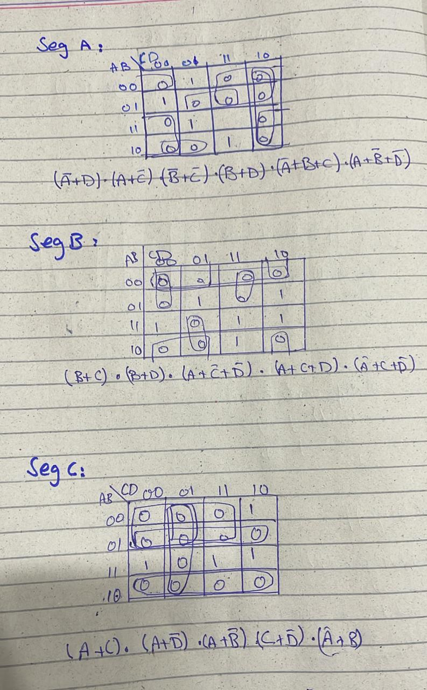

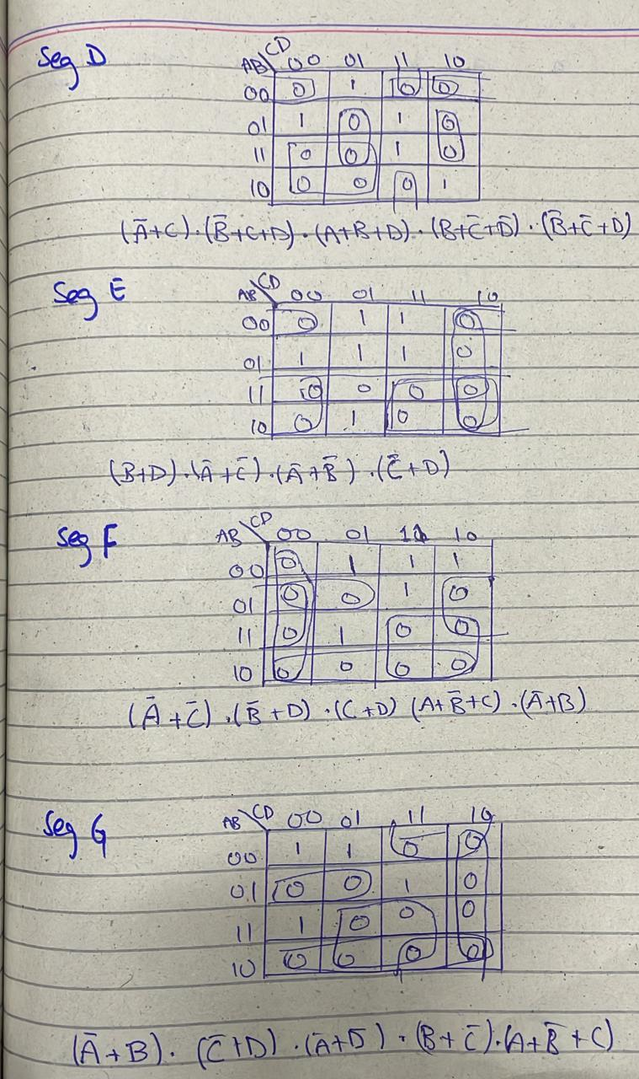

**Circuit diagram using vivado:**

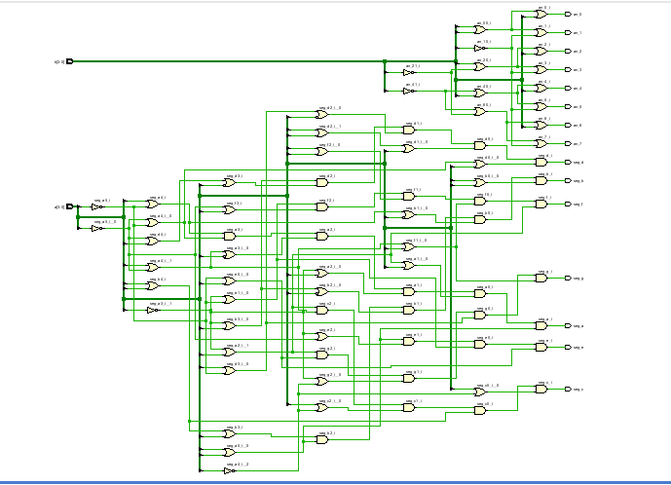

**Combinational delay in synthesis:**

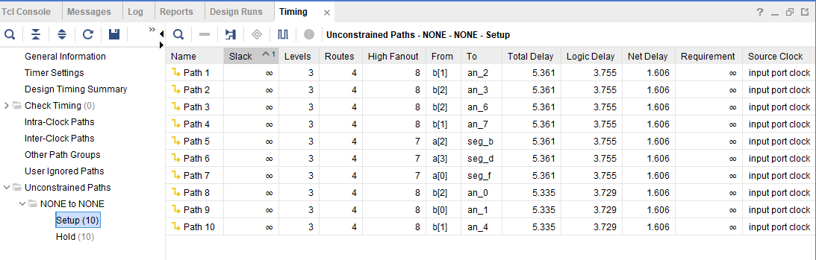

**Utilization Summary:**

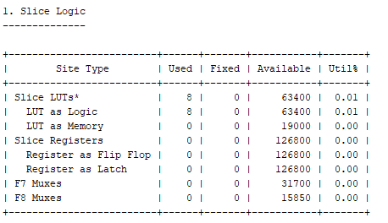

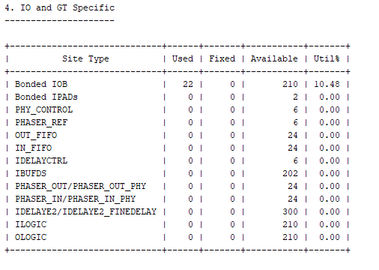

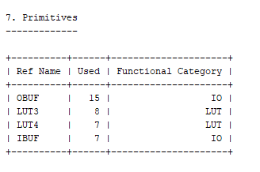

**Combinational Delay in Implementation:**

