OPSPILOT AI
Final Startup Product Blueprint
AI-Powered Company Knowledge & Controlled Operations Platform
Product strategy • Requirements • Architecture • Data/API design • Security • AI/RAG • Delivery roadmap
Planning baseline: 3-person team | 8-week academic MVP | Zero-budget development | Commercial product roadmap

Document Purpose and Scope Boundary
This document is the consolidated product and engineering blueprint for OpsPilot AI. It defines the broader startup-ready platform and separates that target-state vision from the minimum deliverable that can realistically be implemented and evaluated in eight weeks by three people using free/open-source tools.
Important scope decision: incident management, incident lifecycle, automated incident investigation, and incident remediation are future scope only. They are not core MVP features. The platform is centered on company knowledge, evidence-grounded assistance, controlled tools, human approval, and governance.
The term “startup-ready” in this blueprint means that the product model, modular architecture, security boundaries, extensibility, operational requirements, and commercial roadmap are designed for a path toward a sellable service. It does not mean that the eight-week MVP is automatically production-ready for enterprise customers.

1. Executive Summary
OpsPilot AI gives organizations a controlled AI layer over internal knowledge and approved business tools. Employees can ask questions against company documents and receive evidence-backed answers with citations. Authorized users can also ask the assistant to perform defined tasks through a tool registry, with server-side permissions, approval gates for sensitive actions, verification, and audit trails.
The differentiated product proposition is not simply a chat interface over PDFs. It is a multi-tenant knowledge and operations workspace that combines permission-aware retrieval, transparent evidence, policy-governed tool use, human oversight, and traceable outcomes. The MVP proves these foundations in a local demo environment; later releases add connectors, enterprise identity, deeper workflow orchestration, analytics, billing, and managed deployment.

1.1 Product principles
- Evidence before confidence: answer from authorized sources, cite claims, and abstain when evidence is insufficient.
- Least privilege by default: users, retrieval, tools, and administrators receive only the access they require.
- Model proposes; application authorizes: the LLM never defines its own permissions or approves its own actions.
- Human control for consequential changes: sensitive or state-changing actions require explicit policy and approval.
- Auditable outcomes: record who requested, who approved, what was executed, and whether the result was verified.
- Modular monolith first: optimize for a coherent and testable product before introducing microservices.
- Provider separation: isolate model, embedding, storage, identity, and integration vendors behind adapters.
- Build the core path completely before adding breadth.

2. Product Strategy and Target Customers

2.1 Target customer profile
Segment | Pain point | Initial use cases | Priority
Small and mid-sized businesses (SMBs) | Policies and process knowledge is scattered; staff repeatedly ask the same questions. | Employee handbook Q&A, SOP search, onboarding assistance, internal FAQ. | Primary initial segment
Software/SaaS teams | Runbooks, architecture notes, API docs, and team procedures are fragmented. | Technical documentation Q&A, safe read-only diagnostics, developer workflow assistance. | Strong early adopter
Customer support and service teams | Agents need consistent answers from product and policy documents. | Internal answer suggestions, policy lookup, escalation guidance. | Good second vertical
Professional services and operations teams | Procedures and client-specific knowledge are difficult to find and govern. | Project knowledge search, approved task automation, operational checklists. | Potential segment
Larger regulated enterprises | Need strict identity, audit, retention, residency, and governance controls. | Permission-aware knowledge assistant and approved workflows. | Later, after security/compliance investment

2.2 Ideal first customer
Start with a small organization or technical team that has a limited collection of internal PDFs, Markdown files, policies, and SOPs, and that wants a private assistant without granting it unrestricted access to systems. Keep the first use case narrow enough to measure: answer common questions with correct citations and support one tightly controlled sandbox task.

2.3 Buyer, user, and value proposition
Persona | Primary need | Value proposition
Economic buyer / owner | Reduce repeated questions and knowledge-search time without losing control. | A shared, permission-aware AI workspace with measurable quality and auditability.
Workspace admin | Manage users, roles, sources, and policy. | Central administration and traceable governance.
Employee / operator | Find correct answers quickly. | Answers linked to actual source passages, not opaque model assertions.
Approver | Control risky changes without blocking routine work. | Review the exact action payload and retain a decision record.
Auditor / security reviewer | Understand data access and action history. | Searchable, tenant-scoped audit events and evaluation evidence.

2.4 Product positioning
Position OpsPilot AI as a governed company knowledge assistant that can grow into controlled operations automation. Avoid positioning it as a general autonomous agent or as an incident-response product in the initial release. The defensible foundation is permission-aware knowledge, verified citations, explicit policy enforcement, and transparent tool execution.

3. Product Capability Map
Capability area | MVP (P0) | Next releases | Long-term / enterprise
Workspace and identity | Sign-in, organizations, memberships, basic roles | Invitations, profile/settings, admin activity | SSO/OIDC, MFA, SCIM, domain controls
Knowledge management | PDF/TXT/Markdown upload, status, list/delete | Tags, folders, versions, re-index, retention controls | Connector sync, ACL synchronization, legal hold
AI assistant | RAG Q&A, citations, abstention, basic history | Feedback, search filters, conversation sharing | Multiple models, multilingual support, advanced retrieval
Tools and workflows | Tool registry, read-only tools, one sandbox write action | Small workflow builder, scheduled tasks, one MCP connector | Connector marketplace, workflow versioning, robust queue/worker
Governance | RBAC, approval for designated action, audit trail | Policy editor, export, notifications | Advanced policy engine, separation of duties, SIEM integration
Analytics and evaluation | Basic RAG evaluation and audit view | Usage/latency charts, CSV exports | Team-level quality, cost controls, custom evaluation suites
Platform operations | Docker Compose, health checks, local storage | Managed deployment, backups, monitoring | SLOs, multi-region strategy, disaster recovery
Commercial | No billing in MVP | Pilot onboarding and manual usage limits | Plans, billing, metering, enterprise procurement
Incident management | Out of scope | Discovery only if validated by users | Optional separate module built on core governance

4. Scope Definition: Academic MVP vs Startup Product

4.1 Eight-week MVP goal
Demonstrate one secure end-to-end path: organization and membership → document ingestion → grounded answer with citations → typed tool proposal → approval where required → sandbox execution → postcondition verification → audit and evaluation report.

4.2 MVP P0 requirements
- Authentication and organization membership; every tenant-owned request is checked server-side.
- Basic roles: owner/admin, contributor, member, approver, and read-only auditor where practical.
- Upload PDF, TXT, and Markdown with file size/type checks, checksum, processing status, and failure visibility.
- Parse, chunk, embed locally, and index into PostgreSQL/pgvector.
- Permission-aware RAG retrieval; citations point to real source passages; weak evidence triggers abstention.
- A minimal chat UI with loading, error, empty, and retry states.
- Server-owned tool registry with typed input/output schemas and explicit permission rules.
- At most one low-risk state-changing sandbox action; approval binds to the exact payload and expires.
- Idempotent execution and postcondition verification; outcomes are verified, failed, or inconclusive.
- Audit events for document changes, queries/tool calls, approvals, and execution.
- A fixed evaluation dataset and report; automated tests for authorization and cross-tenant isolation.
- Reproducible local setup with Docker Compose and synthetic demo data.

4.3 Optional P1 (only after P0 is stable)
- One small MCP integration that uses the same authorization and audit path.
- CSV export, basic usage/latency chart, and in-app approval notification.
- One model/embedding comparison using the same labelled evaluation set.
- Tags and document versioning if the core flow is already stable.

4.4 Explicit exclusions
- Incident management, incident severity/lifecycle, incident dashboards, incident investigations, and incident-specific remediation.
- Production infrastructure access, real production write actions, arbitrary shell execution, unrestricted SQL, and arbitrary outbound HTTP.
- A general drag-and-drop workflow builder, large integration marketplace, autonomous agent swarm, and complex long-running orchestration.
- Subscription billing, mobile applications, SSO/SCIM, multi-region deployment, and formal compliance certification.
- Training a foundation model from scratch or depending on paid API credits.

5. UX and Information Architecture
Keep the interface minimal and operational. Prefer one coherent component system, clear hierarchy, restrained color, whitespace, visible source evidence, and explicit state labels. Do not hide permission failures or failed ingestion behind generic success states.
Navigation area | MVP screen / behavior | Later additions
Workspace switcher | Select active organization; show role/context | Invitations, organization settings
Overview | Counts for documents, recent questions, pending approvals, recent audit activity | Usage/quality trends
Knowledge | Upload, list, status, metadata, delete/retire, retry failed ingestion | Tags, versions, connector sync
Assistant | Question input, answer, citations/source drawer, abstention, loading/error states | Feedback, conversation search, share controls
Tools & workflows | Available tool catalogue, proposal detail, execution status | Workflow builder and schedules
Approvals | Pending action, exact payload, requester, risk reason, approve/reject | Delegation, policy rules, notifications
Audit | Filterable tenant-scoped event list and event detail | Exports, SIEM, retention controls
Evaluation | Dataset version, test totals, metrics, representative failures | Regression history, model comparisons
Administration | Members and roles; safe organization configuration | SSO, retention, billing, connector management

5.1 Critical UX states
- Knowledge source: queued, processing, indexed, failed, deleting, or unavailable.
- Assistant: retrieving, generating, answered, insufficient evidence, permission denied, provider unavailable, or timed out.
- Tool proposal: draft, rejected by policy, awaiting approval, approved, expired, executing, verified, failed, or inconclusive.
- Always show citations in a source panel with filename, page/section where available, and cited excerpt.
- Destructive or sensitive decisions require a clear summary of the exact effect, target, and parameters.

6. Recommended Technology Stack
Layer | Recommendation | Why it fits | Upgrade path
Web frontend | React + Vite + TypeScript | Fast iteration; mature ecosystem; suitable for an SPA | SSR only if later required
UI system | Tailwind CSS + shadcn/ui | Composable components, accessible patterns, consistent styling | Shared design tokens/component package
Server-state | TanStack Query | Caching, retries, invalidation, loading/error state handling | Keep API contracts stable
Backend API | Python + FastAPI + Pydantic | Strong fit for AI integration and typed API contracts | Split workers/services only when needed
ORM/migrations | SQLAlchemy + Alembic | Explicit schema evolution and database access | Migration CI and release discipline
Database | PostgreSQL + pgvector | Relational records and vector retrieval in one operational system | Managed PostgreSQL when funded
LLM runtime | Ollama local model adapter | Local-first, no paid API dependency for demo | Add hosted providers behind adapter
Embeddings | sentence-transformers / all-MiniLM-L6-v2 | Small, locally runnable baseline | Evaluate alternatives against dataset
Document parsing | PyMuPDF + standard text/Markdown parsers | Simple local ingestion pipeline | Add OCR for scanned PDFs later
File storage | Private local volume behind storage interface | Works for local MVP | S3-compatible object storage
Background work | Persisted task records + app-managed worker initially | Avoids early infrastructure overhead | Dedicated queue/worker when workload warrants
Testing | Pytest + HTTPX; Vitest + Testing Library; Playwright | Backend, UI, and end-to-end coverage | Add load/security tooling later
Deployment | Docker Compose + GitHub Actions free allowance | Reproducible local development and CI | Managed container platform and observability
API docs | FastAPI OpenAPI/Swagger | Generated contract documentation | Versioned public API documentation

6.1 Design choices to avoid
- Do not start with microservices. Use a modular monolith with clear internal boundaries.
- Do not add a separate vector database when pgvector is sufficient for the initial workload.
- Do not make a paid LLM API necessary for the core demo.
- Do not add a queue broker, Kubernetes, a complex agent framework, or a workflow engine before the end-to-end path requires it.
- Do not couple application logic directly to one LLM, embedding model, storage provider, or identity vendor.

7. System Architecture
Use a modular monolith for the first release. Modules can live in one backend deployment and one repository while keeping ownership and dependencies explicit. This is easier to develop, secure, test, and deploy with three people. Separate ingestion workers or service boundaries only after measured throughput, reliability, or organizational needs justify them.
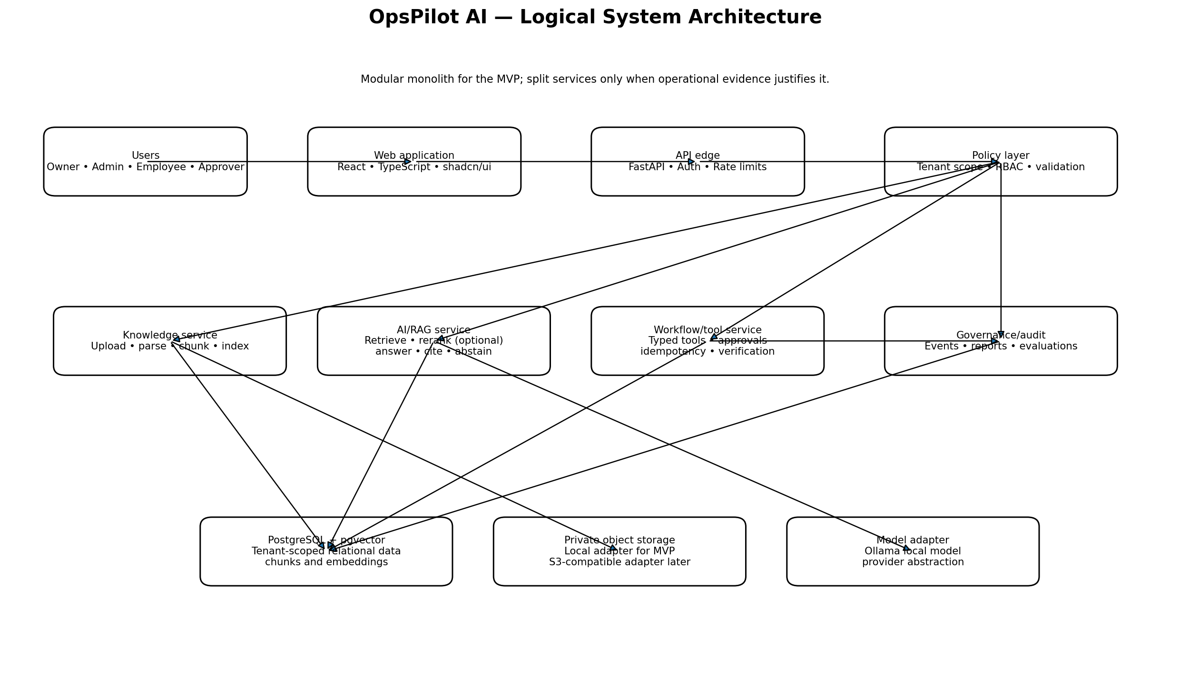
Figure 1. Logical architecture: client, API/security boundary, domain modules, persistence, and model adapter.

7.1 Backend module boundaries
Module | Responsibilities | Must not do
Identity & tenancy | User identity, memberships, role checks, active organization context | Trust client-supplied tenant IDs without membership validation
Knowledge | Upload validation, parsing jobs, chunking, indexing, source lifecycle | Expose private file paths or index unauthorized data
Retrieval & answer | Authorized retrieval, prompt construction, generation, citation validation, abstention | Treat model output as trusted or skip authorization filters
Tool registry | Tool schemas, tool discovery, input validation, permission checks, execution adapters | Allow model-created arbitrary tools
Approvals | Action hashes, approver eligibility, expiry, decision state, separation of duties | Approve a changed payload or execute after expiry
Audit & evaluation | Append-only business events, redaction, evaluation runs, reports | Store secrets or unbounded raw document contents in logs
Platform | Configuration, health checks, rate limits, background task lifecycle | Hide errors or allow unbounded work

7.2 Request boundary
Browser
-> FastAPI route
-> authenticate identity
-> resolve organization membership and role
-> validate request schema and limits
-> call domain service
-> enforce resource-level access
-> call model/storage/tool adapter if allowed
-> persist state + audit event
-> return typed response
Authorization must be enforced in the backend service layer, not just in route visibility or frontend navigation. Use consistent helpers and negative tests for every tenant-owned resource family.

8. Deployment Architecture
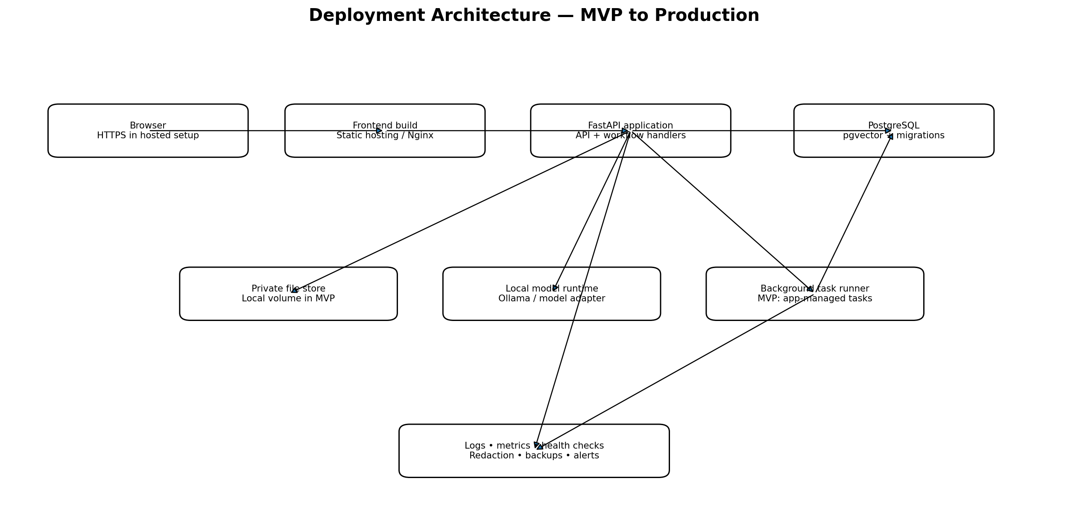
Figure 2. Deployment shape: local Docker Compose for MVP; managed services and stronger operations controls later.

8.1 Local MVP deployment
- docker-compose services: frontend/dev server (or static build), FastAPI, PostgreSQL with pgvector, and local model runtime where resources permit.
- Use named volumes for database and uploaded files; keep all runtime secrets in an ignored environment file.
- Provide health endpoints and startup checks so the API waits for database readiness.
- Seed only synthetic company documents and fake service state; never use real customer or production data.
- Document model download/storage requirements and minimum machine resources. If local inference is too slow on a student's machine, tests use a deterministic fake provider while the demo model is run on the most capable available machine.

8.2 Production deployment target
- HTTPS termination, secure headers, managed identity/secrets, network restrictions, and rate limiting.
- Managed PostgreSQL with encryption, automated backups, tested restore, connection pooling, and migration discipline.
- Private object storage with encryption, retention policy, malware scanning, and access logging.
- A dedicated worker/queue for ingestion and long-running workflows when needed.
- Structured logs, traces, latency/error metrics, alerts, cost/usage monitoring, and redaction.
- Documented RPO/RTO, incident response for the platform itself, rollback strategy, and release gates.
- Tenant isolation testing and security review before onboarding real customer documents.

9. Knowledge Ingestion and RAG Design
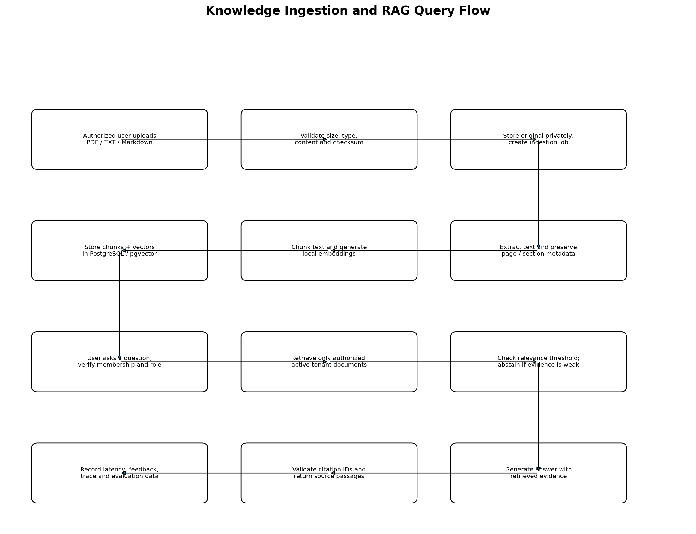
Figure 3. Ingestion and query path. Authorization filtering occurs before evidence reaches the model.

9.1 Ingestion pipeline
- Authenticate uploader and validate organization membership and upload permission.
- Validate extension, MIME type, size, content signature where possible, and parsing limits.
- Calculate checksum and store original file in private storage.
- Create a persisted ingestion job and show queued/processing state.
- Extract text; preserve page and section metadata; report empty or unreadable content clearly.
- Chunk by headings/paragraph boundaries with bounded chunk size and overlap.
- Generate embeddings through an adapter and persist model/version metadata.
- Index vectors and mark the document indexed only after successful completion.
- On failure, retain safe error metadata and permit controlled retry; avoid partially indexed documents appearing as complete.
- On deletion, immediately exclude the document from retrieval, then remove stored content and vectors according to the retention policy.

9.2 Query pipeline
- Authenticate the user and resolve active organization membership.
- Apply the same authorization rules used by document viewing to the retrieval candidate set.
- Embed the query and retrieve top-k authorized chunks using vector similarity; optional lexical/hybrid search is a later optimization.
- Optionally rerank results only if evaluation shows a meaningful improvement.
- Use a documented relevance threshold and minimum evidence policy.
- Construct a prompt that separates system policy from untrusted retrieved content.
- Generate an answer that references retrieved evidence; avoid asking the model to invent citation IDs.
- Validate each returned citation against the retrieved chunk IDs and source metadata.
- Return answer, citations, abstention state, and request identifier; record redacted telemetry.

9.3 Quality and limitations
- Citations improve inspectability but do not automatically prove that every claim is correct; measure citation support explicitly.
- Scanned PDFs may require OCR, which is not required for the MVP.
- Chunking and embedding quality should be evaluated against a labelled set, not selected by intuition alone.
- Do not send a user's question to a provider that is not approved for that organization's data policy.
- Conversation history must not bypass document-level permissions when a user's membership or document access changes.

10. Tool Orchestration and Human Governance
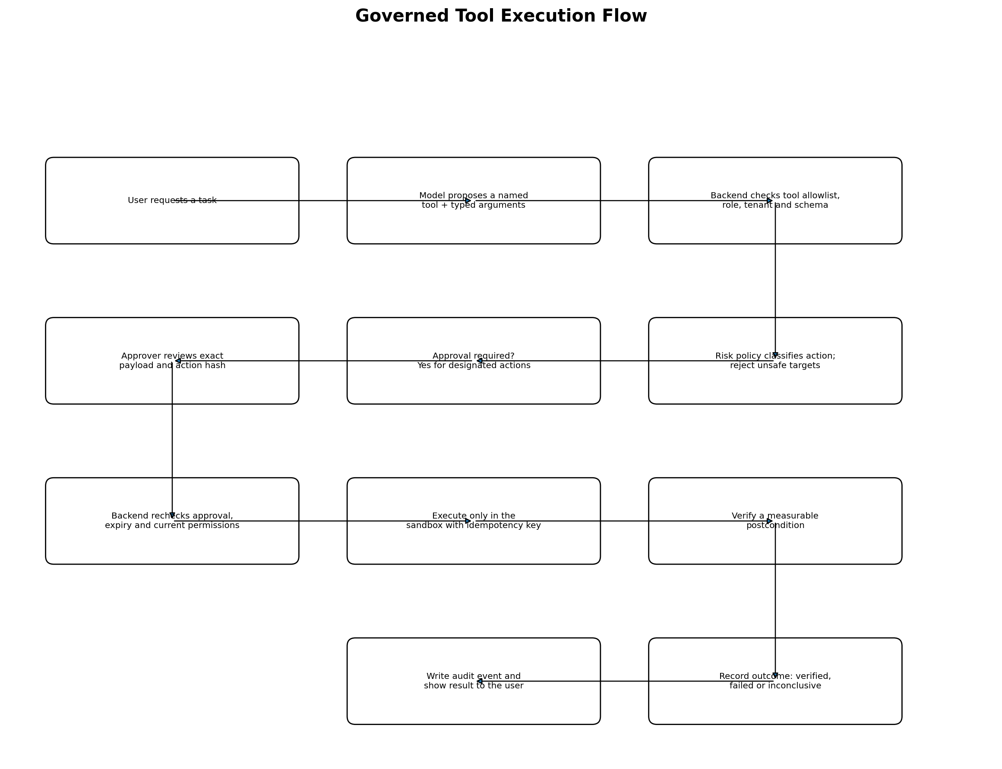
Figure 4. A model proposal is not authorization. The server applies policy, approvals, execution limits, verification, and audit.

10.1 Tool contract
ToolDefinition {
name: stable identifier
description: user-facing purpose
input_schema: strict typed schema
output_schema: typed and size-limited result
required_permissions: server-owned permission set
risk_class: read_only | sandbox_write | sensitive
timeout_seconds: bounded integer
idempotency_supported: boolean
target_policy: allowlisted targets/environments
}

10.2 Approval semantics
- Create a canonical representation of the exact action name, target, and arguments; hash it and store the hash with the approval request.
- The approver must be authorized and, where feasible, must not be the requester for high-risk actions.
- Approval expires and cannot be reused for a modified action payload.
- At execution time, re-check user/org authorization, policy version, approval status, expiry, target, and action hash.
- Use idempotency keys so a retry does not duplicate a state change.
- Verify an observable postcondition and persist verified, failed, or inconclusive outcome.
- The MVP action operates only on a synthetic local sandbox. No production credentials or targets are allowed.

10.3 MCP strategy
MCP is an integration protocol, not a substitute for authorization. Treat each MCP server as an untrusted external integration boundary: explicitly register it, constrain its tools and arguments, define data egress, apply timeouts, and route all sensitive operations through the same server-side policy and audit path. Implement one small MCP integration only after the internal tool registry is proven.

11. Security, Privacy, and Trust Model
Threat | Control | Required verification
Cross-tenant data leakage | Server-side organization membership checks; tenant_id/org_id filters in every query; resource-level checks | Negative tests across documents, chunks, conversations, tools, approvals, reports, and audit
Broken role enforcement | Central policy helpers and deny-by-default behavior | Role matrix tests for every protected operation
Prompt injection in documents | Treat retrieved content as data; delimit evidence; never let it alter tool policy | Adversarial documents/questions in evaluation suite
Unsafe tool call | Allowlist, strict schemas, risk classification, target constraints, human approval | Invalid tool, invalid argument, wrong target, and no-approval tests
Approval tampering/replay | Action hash, expiry, single-use state transition, execution-time re-check | Changed payload, expired approval, repeated request tests
Sensitive data in logs | Structured redaction, size limits, no secret logging | Log review and tests for known secret patterns
Malicious upload | Type/size limits, parsing limits, private storage, later malware scanning | Invalid file, oversized file, malformed PDF tests
Abuse/cost exhaustion | Rate limits, token/context caps, timeouts, bounded retries | Load and limit tests appropriate to MVP
Account/session compromise | Secure session/token handling, CSRF protections where applicable, secure cookie settings | Auth/session tests and security review
Supply-chain/config leak | Pinned dependencies where practical, secret scanning, .env.example without secrets | CI checks and repository scan

11.1 Privacy and retention baseline
- Collect only account, organization, document, and usage data needed for the product.
- Publish clear data handling and deletion behavior before any external pilot.
- Do not use customer documents to train models by default.
- Define how deleting a document affects originals, chunks, embeddings, derived summaries, and backups.
- Document model provider, region, retention, and data-use terms before enabling hosted model APIs.
- Provide export and deletion workflows before moving beyond a controlled pilot.
This blueprint is not a legal compliance certification. Before serving regulated or enterprise customers, obtain jurisdiction-specific legal/security review and validate contractual, privacy, and sector requirements.

12. Data Model and Relationships
Entity | Key fields | Relationship / control
users | id, email, identity_subject, status, created_at | Identity is separate from organization role.
organizations | id, name, slug, settings_json, created_at | Root tenant boundary.
memberships | id, organization_id, user_id, role, status | Unique (organization_id, user_id); role is scoped to one organization.
documents | id, organization_id, uploaded_by, filename, storage_key, checksum, status, version | Every read and mutation checks organization and permission.
document_chunks | id, organization_id, document_id, chunk_index, text, page/section, embedding, model_version | Chunk organization must match parent document organization.
conversations | id, organization_id, user_id, title, created_at | Access policy applies to history and derived context.
messages | id, conversation_id, role, content, citations_json, created_at | Citations point to actual chunks/source metadata.
tool_definitions | name, version, input_schema, output_schema, risk_class, enabled | Server-owned registry; not tenant-controlled arbitrary code.
tool_runs | id, organization_id, actor_user_id, tool_name, args_json, status, idempotency_key | Tenant-scoped; redact sensitive result data.
approval_requests | id, organization_id, tool_run_id, action_hash, status, expires_at, approver_id | Approval binds to exact payload and valid policy state.
audit_events | id, organization_id, actor_user_id, event_type, resource_id, correlation_id, payload_redacted | Append-only application behavior; tightly restricted mutation.
evaluation_runs | id, dataset_version, model_version, metrics_json, created_at | Results reproducible by dataset/model version.

12.1 Data-model rules
- Use UUIDs or another non-guessable identifier consistently; identifiers are not a substitute for authorization.
- Add foreign keys, unique constraints, indexes, and appropriate cascade/retention behavior.
- Index organization_id and common filter fields on tenant-owned tables.
- Consider PostgreSQL row-level security later as defense in depth; it does not replace application authorization tests.
- Version prompt templates, embedding models, and tool definitions where their behavior affects reproducibility.

13. API Design
Use versioned REST endpoints under /api/v1. FastAPI OpenAPI output is the initial contract. Define typed request/response schemas, consistent errors, pagination, correlation IDs, and rate limits. Keep internal IDs and secrets out of model-facing prompts.
Method + path | Purpose | Authorization / validation
GET /api/v1/me | Current user and organization memberships | Authenticated
POST /api/v1/organizations | Create organization | Authenticated; create owner membership transactionally
GET /api/v1/organizations/{orgId}/members | List members | Owner/admin; verify membership
POST /api/v1/organizations/{orgId}/members | Invite/add member | P0 may use admin-created demo users; invitations can be P1
PATCH /api/v1/organizations/{orgId}/members/{memberId} | Change role/status | Owner/admin; prevent privilege escalation
POST /api/v1/organizations/{orgId}/documents | Upload document | Contributor role; type/size/content limits
GET /api/v1/organizations/{orgId}/documents | List documents and status | Tenant-scoped; paginated
GET /api/v1/organizations/{orgId}/documents/{id} | Document metadata/detail | Resource-level authorization
DELETE /api/v1/organizations/{orgId}/documents/{id} | Retire/delete document | Authorized role; immediately exclude from retrieval
POST /api/v1/organizations/{orgId}/knowledge/query | Ask a question | Tenant-scoped retrieval, request limits, citation validation
GET /api/v1/organizations/{orgId}/conversations | List permitted conversations | Tenant and user/role scope
GET /api/v1/organizations/{orgId}/tools | List permitted tool catalogue | Return only enabled tools allowed for user
POST /api/v1/organizations/{orgId}/tool-runs/propose | Create typed proposal | Allowlist, schema, role, risk and target checks
GET /api/v1/organizations/{orgId}/approvals | List pending approvals | Approver role
POST /api/v1/organizations/{orgId}/approvals/{id}/decision | Approve/reject action | Check expiry, hash, approver role and separation-of-duties policy
GET /api/v1/organizations/{orgId}/tool-runs/{id} | Read execution status | Tenant-scoped; redact results
GET /api/v1/organizations/{orgId}/audit-events | List audit events | Role-filtered and paginated
GET /api/v1/organizations/{orgId}/reports/rag-evaluation | Read evaluation summary | Authorized member/evaluator
GET /health/live and /health/ready | Process/database readiness | No sensitive configuration in response

13.1 API conventions
- Use 401 for unauthenticated, 403 for authenticated but unauthorized, 404 for inaccessible resources where enumeration risk matters, 409 for invalid state transitions, 422 for schema validation, and 429 for rate limits.
- Return a correlation/request ID on responses and include it in logs.
- Make long-running ingestion and tool execution asynchronous with status resources.
- Use optimistic concurrency or explicit state-transition checks for approval decisions.
- Do not accept arbitrary SQL, shell commands, URL targets, or executable code in tool payloads.

14. Core Workflow State Machines

14.1 Document lifecycle
UPLOADED -> QUEUED -> PROCESSING -> INDEXED
| |
v v
FAILED DELETING -> DELETED
Rules:
- FAILED is visible and retryable only through a controlled action.
- Only INDEXED documents are eligible for retrieval.
- Deletion excludes the document from retrieval immediately.
- Re-indexing records the parser/chunker/embedding versions used.

14.2 Tool/action lifecycle
PROPOSED -> POLICY_REJECTED
|
+-> AWAITING_APPROVAL -> REJECTED
| -> EXPIRED
v
APPROVED -> EXECUTING -> VERIFIED
-> FAILED
-> INCONCLUSIVE
Rules:
- No direct path from PROPOSED to EXECUTING for actions that require approval.
- Execution re-checks current permissions, policy, expiry, target, and action hash.
- A repeated idempotency key must not duplicate the state change.

14.3 User question flow
Question -> authenticate -> authorize organization
-> retrieve authorized evidence -> relevance check
-> [weak evidence?] abstain / clarify
-> generate answer -> validate citations -> respond
-> record redacted telemetry and optional feedback

15. Observability, Reliability, and Operations
- Structured logs: timestamp, severity, request/correlation ID, actor/tenant identifiers where safe, module, duration, and error category.
- Never log API secrets, access tokens, raw prompts containing sensitive data, or full document text by default.
- Metrics: request rate, error rate, p50/p95 latency, ingestion failures, retrieval duration, model duration, token/context size, approval age, tool outcome, and queue/task age.
- Health: liveness and readiness; readiness checks required dependencies without revealing secrets.
- Reliability: timeouts, bounded retries with jitter where appropriate, idempotent writes, and explicit partial-failure states.
- Backups: local MVP backup/restore instructions; production target includes automated backups and tested restoration.
- Versioning: track app version, migration version, model/embedding version, prompt version, and tool schema version.
- Release: lint, type-check, unit/API tests, tenant-isolation tests, build, and selected end-to-end test must pass in CI.

16. Testing and AI Evaluation Strategy

16.1 Software test layers
Layer | Coverage | Exit condition
Unit | Chunking, validators, policy rules, action hashing, state transitions, citation validation | Deterministic tests pass
API integration | Auth, org membership, upload, retrieval, approvals, tool runs, audit | Happy and failure paths pass
Tenant isolation | Cross-tenant IDs, search, list, detail, history, audit, tool/approval access | All unauthorized reads/writes denied
Frontend | Upload, chat/citations, loading/error states, approvals, role-aware navigation | Critical flows usable and no runtime errors
End-to-end | Upload → indexed → answer/citation → proposal → approval → sandbox execution → audit | One repeatable local demo passes
AI evaluation | Answerable, unanswerable, injection, citation, and tool-policy cases | Results documented; known failures listed
Operational | Fresh setup, migration, health checks, failure/retry, backup/restore notes | A teammate can reproduce the environment

16.2 Minimum evaluation set
- 10 answerable questions with known supporting passages.
- 5 unanswerable or ambiguous questions where abstention/clarification is expected.
- 5 prompt-injection examples in uploaded documents or user questions.
- 5 cross-tenant negative access cases.
- 3 action policy cases: valid approved action, rejected/expired approval, and verification failure.

16.3 Metrics
- Retrieval Recall@k or relevance judged against labelled source passages.
- Citation precision/support: whether each cited passage actually supports the material claim.
- Abstention quality on unsupported questions.
- Tool schema validity and correct policy rejection for invalid actions.
- End-to-end latency, ingestion success rate, and failure categories.
- User feedback is useful qualitative evidence, not a substitute for a labelled evaluation set.
Report dataset size, methods, versions, measured results, examples of failures, and limitations. Do not claim that a small evaluation proves production-grade reliability.

17. Eight-Week Implementation Roadmap
Week | Focus | Deliverables / exit criteria
1 | Foundation and contracts | Freeze scope; repository; architecture and threat model; wireframes; API schemas; Docker Compose; CI skeleton.
2 | Identity and tenancy | Authentication, organizations, memberships, roles, centralized authorization, tenant-negative tests.
3 | Knowledge ingestion | Upload validation, private storage, parsing, chunking, embeddings, index lifecycle, visible failure/retry.
4 | RAG assistant | Permission-aware retrieval, citations, abstention, chat UI, initial labelled evaluation dataset.
5 | Tool governance | Typed tool registry, one sandbox action, approval binding/expiry, idempotency, verification, audit.
6 | Integration and reporting | Complete vertical slice, basic overview, audit/evaluation views, robust error/loading states.
7 | Hardening and evaluation | Security regression tests, injection cases, cross-tenant suite, RAG results, bug fixes.
8 | Submission and demo | Feature freeze, clean setup, report, diagrams, slides, screenshots, recorded/rehearsed demo.

17.1 Scope control rule
If the team falls behind, remove optional charts, CSV export, MCP, tags, and conversation-sharing before cutting tenant isolation, citation validation, approval safety, auditability, or the end-to-end demonstration. Incident management is not to be pulled into the MVP.

18. Three-Member Team Model
Owner | Primary responsibility | Shared obligations
Member A — Frontend/UX | React/TypeScript, design system, navigation, upload/status, assistant/citations, approvals, audit/evaluation screens, UI tests. | API contract review, code review, weekly integrated demo, final report.
Member B — Backend/platform | FastAPI, database schema/migrations, auth/RBAC, tenant isolation, document APIs, tool/approval policies, audit, Docker/CI. | Security tests, integration support, release checks, documentation.
Member C — AI/RAG | Parsing/chunking, embedding adapter, pgvector retrieval, prompt/citation/abstention logic, model adapter, evaluation dataset/report. | Model failure analysis, latency tests, integration, demo rehearsal.
These are primary ownership areas, not isolated silos. Each feature is complete only when integrated, reviewed, and tested across its dependencies.

19. First Five Working Days
- Day 1: Confirm this scope, create repository and branches, assign owners, add README, .gitignore, .env.example, and acceptance checklist.
- Day 2: Agree on ER diagram, authorization rules, API request/response schemas, error format, and first wireframes.
- Day 3: Run frontend, FastAPI, PostgreSQL/pgvector, and local model adapter; apply initial migrations and health checks.
- Day 4: Implement the first vertical slice: sign in, create/select organization, upload a synthetic document, and display processing status.
- Day 5: Merge all work, run API and cross-tenant tests, demo the integrated path, and plan the next sprint based on actual blockers.

20. Commercialization and Startup Roadmap

20.1 Validation before scaling
- Interview 8–12 people in the target segment about repeated internal questions, source systems, trust requirements, and current workarounds.
- Ask for concrete examples of questions employees ask repeatedly and what a correct answer must cite.
- Run a concierge pilot using synthetic or explicitly authorized documents; do not ingest customer data without agreed handling terms.
- Measure time-to-answer, citation usefulness, abstention behavior, repeated-question reduction, and user trust.
- Prioritize integrations based on repeated customer requests, not on the novelty of a connector.

20.2 Suggested staged roadmap
Stage | Product focus | Exit criteria
Stage 0 — Academic MVP (8 weeks) | Local multi-tenant knowledge assistant, citations, governed sandbox tool, audit/evaluation | Repeatable demo; security and evaluation evidence; complete documentation
Stage 1 — Design-partner pilot | One customer segment, onboarding, feedback, basic retention/export, improved retrieval | Several recurring real workflows validated; acceptable quality and user adoption
Stage 2 — Paid beta | Managed deployment, billing/metering, usage limits, support workflow, backups/monitoring | Clear buyer, repeatable onboarding, willingness to pay, support process
Stage 3 — Production SaaS | SSO/MFA, stronger policy administration, connector sync, reliability/SLOs, security review | Security, operational and contractual requirements met for target segment
Stage 4 — Platform expansion | Workflow builder, integration catalogue, analytics, optional incident module | Customer evidence supports expansion and economics

20.3 Business model hypotheses
Model | Potential structure | Considerations
Per workspace | Base fee per organization/workspace with usage limits | Simple to explain; must align with customer value and support cost.
Per active user | Monthly fee by active seat | Familiar SaaS model; may discourage broad internal adoption.
Usage-based | Metered document processing/model/tool usage | Reflects variable cost but requires transparent metering and budgets.
Hybrid | Workspace fee plus included seats/usage and overage | Flexible, but more complex to explain and implement.
Do not choose final pricing before interviews and cost measurements. A zero-budget student MVP can validate workflow value, but local inference costs, managed hosting, support, security work, and paid model usage must be modeled before commercial launch.

20.4 Early go-to-market
- Choose one initial segment rather than selling to every company.
- Demonstrate a measurable workflow with citations and permissions rather than marketing a generic chatbot.
- Use a short pilot with agreed documents, success metrics, and feedback cadence.
- Publish a transparent data-handling/security summary and known limitations before asking for sensitive documents.
- Build integrations only when a design partner confirms the use case and the connector's data access is approved.

21. Future Scope

21.1 Platform expansion
- Connectors for approved document repositories and collaboration systems, including incremental sync and source ACL mapping.
- SSO/OIDC, MFA, SCIM, invitations, granular roles, custom retention, export, and deletion workflows.
- Workflow definitions with versioning, retries, timeout policies, manual checkpoints, and execution history.
- Additional MCP integrations behind the same policy gateway.
- Usage metering, budgets, model routing, and organization-level limits.
- Managed deployment, backup/restore, monitoring, alerting, and service-level objectives.
- Model/embedding evaluations, feedback loops, and regression testing.

21.2 Incident management is future scope
A future Operations/Incident module may add incident records, severity and assignment, diagnostic evidence gathering, monitoring integrations, remediation proposals, approved remediation, verification, and incident analytics. This should be an optional module built on the existing knowledge, identity, tool, approval, workflow, and audit foundations. Do not add incident entities, navigation, or dedicated incident workflows to the MVP unless the product direction is explicitly changed after validation.

22. Risks and Mitigations
Risk | Impact | Mitigation
LLM quality or local speed is insufficient | Poor demo experience or unreliable answers | Use small local model; deterministic fake provider for tests; cap context; document model limitations.
RAG retrieval quality is weak | Incorrect or unsupported answers | Build labelled dataset early; improve extraction/chunking/retrieval before adding agents.
Scope creep | Incomplete product by deadline | P0/P1 gate; weekly demos; incident module explicitly excluded.
Cross-tenant leak | Severe security and trust failure | Centralized authorization; negative tests on every tenant-owned resource.
Unsafe tool execution | Unexpected state changes | Allowlist, typed schemas, approval hash, expiry, sandbox-only target, idempotency and verification.
Integration bottlenecks | Late merge failures | API contracts in Week 1, small PRs, continuous integration, weekly integrated demo.
No budget for hosted services | Deployment/model dependency blocked | Local-first stack; synthetic data; no paid API in core acceptance criteria.
No product-market fit | Technically sound project with weak commercial demand | Customer interviews and narrow design-partner pilot before broad feature expansion.

23. Definition of Done and Acceptance Criteria
☐ A user can sign in and access only organizations in which they have active membership.
☐ An authorized user uploads a supported file and sees processing status, failure reasons, and retry behavior.
☐ An answerable question returns an answer with validated citations to the correct source passages.
☐ An unsupported question abstains or asks for clarification rather than fabricating a confident answer.
☐ Cross-tenant tests deny access to documents, chunks, conversations, tool runs, approvals, audit events, and reports.
☐ Only registered tools with valid typed arguments can be invoked.
☐ A state-changing sandbox action cannot execute if required approval is absent, rejected, expired, modified, or unauthorized.
☐ The sandbox action is idempotent and records verified, failed, or inconclusive status.
☐ Audit events can be inspected by authorized roles and do not leak secrets.
☐ The evaluation report includes dataset size, methods, metrics, examples, and limitations.
☐ A teammate can run the application from documented instructions without paid API credentials.
☐ The final submission includes source, architecture diagrams, data model, API documentation, tests, report, slides, and demo script.

24. Academic Submission Package
- Abstract, problem statement, objectives, scope, literature/context review, and proposed solution.
- Software requirements specification: functional and non-functional requirements.
- Use-case diagram, system architecture, deployment diagram, ER/data model, sequence/workflow diagrams.
- Technology selection rationale and threat model.
- Implementation details for document ingestion, RAG, citation validation, policy checks, approvals, and sandbox execution.
- Testing methodology, test cases, tenant-isolation evidence, AI evaluation results, and failure analysis.
- Results, limitations, ethical/privacy considerations, future scope, and conclusion.
- Screenshots, setup guide, API docs, slides, and repeatable demonstration script.

25. Final Recommendation
Build OpsPilot AI as a modular, permission-aware knowledge platform first. Deliver a small number of capabilities completely: secure organization boundaries, reliable document ingestion, evidence-grounded answers with citations and abstention, one governed sandbox tool path, approvals where required, verification, audit, and evaluation. This creates both a credible academic submission and a foundation for a commercial product.
Do not attempt to deliver the full startup roadmap in eight weeks. Use the roadmap to keep the architecture extensible, validate the target customer and value proposition early, and expand only when the core flow is reliable. Incident management remains a future optional module, not part of the MVP.

