STOCHASTIC MODELS

Case Study Project — Part 2

Traffic Intensity of Patients and Physicians in the
Emergency Department:
A Queueing Approach for Physician Utilization

— Hospital Emergency Department Patient Flow —

Reference Paper:
Chaou, C.-H., Chen, H.-H., Tang, P., Yen, A. M.-F., Wu, K.-H., Hsiao, C.-T., & Chiu, T.-F. (2018).
Traffic Intensity of Patients and Physicians in the Emergency Department:
A Queueing Approach for Physician Utilization.
The Journal of Emergency Medicine. https://doi.org/10.1016/j.jemermed.2018.07.024

Course: Stochastic Models (DS323 / DS361)
Instructor: Dr. Olivia Morad
Academic Year 2025 – 2026

Part 1 — General Introduction to the Application

1.1 Emergency Departments and the Crowding Problem
Hospital Emergency Departments (EDs) serve as the primary gateway for acute medical care. Over the past decade, increasing patient volumes and a widening range of medical services have led to a critical operational challenge: ED crowding. Crowded EDs are directly associated with prolonged waiting times, patient dissatisfaction, and — most critically — deterioration in clinical outcomes. The core operational difficulty is that patient arrivals are highly unpredictable, exhibiting natural stochastic variability across hours of the day, days of the week, and seasonal patterns.

Managing the ED workforce — particularly physician staffing — in the face of this variability is a complex problem. The fundamental question faced by every ED administrator is: 'Are we staffing the right number of physicians at the right times?' Without a rigorous analytical framework, staffing decisions are made on intuition or historical averages, leading either to chronic physician shortages during peak hours or costly overstaffing during quiet periods.

1.2 Why Stochastic Models? The Role of Queueing Theory
Queueing theory provides the mathematical foundation for modeling service systems where customers (patients) arrive randomly, wait for service, and are served by one or more servers (physicians). The arrival of patients to an ED follows a Poisson process — the most natural model for random events occurring at a constant average rate — while the service (physician management) time is modeled by an Exponential distribution. Together, these assumptions define the celebrated M/M/c model: Markovian arrivals, Markovian service, and c parallel servers.

The power of queueing models lies in their analytical tractability: from a small number of measurable parameters (arrival rate λ, service rate μ, and number of servers c), we can derive a rich set of system performance metrics, including average waiting time, expected queue length, and — most importantly — server (physician) utilization. These metrics form the empirical basis for evidence-based staffing policy decisions.

1.3 The Specific Application Context
The application studied in the selected research paper is the Emergency Department of Chang Gung Memorial Hospital — a 3,600-bed urban tertiary medical center and teaching hospital in Taiwan with approximately 150,000 annual ED visits. The study analyzed all registered ED patients across the full calendar year 2013, yielding a dataset of 148,581 patients after exclusions. The ED serves three distinct patient populations:

- Adult Non-Trauma patients: constituting 59.4% of all visits.
- Pediatric Non-Trauma patients (<18 years): constituting 23.2% of all visits.
- Trauma patients: constituting 17.4% of all visits.

Each population is managed in a designated area within the ED by a specialized physician team, making them effectively independent queues that can be analyzed separately. This multi-entity structure enables granular, time-stratified analysis of physician utilization — a level of precision that traditional, aggregate approaches cannot provide.

1.4 Significance and Relevance
This application is highly significant for several reasons. First, it directly addresses a real-world operational problem with measurable public health consequences. Second, it demonstrates a rigorous end-to-end application of M/M/c queueing models — from data collection and parameter estimation to performance metric derivation and policy recommendations. Third, it connects naturally to the broader Markov Chain framework studied in this course, as the M/M/c model is fundamentally a continuous-time Markov chain whose state classification properties govern whether the system reaches a steady state. Finally, the rich findings — including the discovery of a critical physician shortage in the pediatric section during evening hours — illustrate how quantitative modeling can reveal actionable operational insights.

Part 2 — The Model Developed in the Research Paper

2.1 Study Design and Data
The study employed a retrospective administrative electronic data analysis design. The dataset encompasses all patients who registered at the ED of Chang Gung Memorial Hospital from January to December 2013. Patients with missing time-point records were excluded (6,716 patients; 4.3%), leaving a final analysis sample of 148,581 patients. The Taiwan Triage Acuity System (TTAS) — a five-level triage classification — was used by trained triage nurses to assign patients to one of the three specialized areas upon arrival.

Four time-point variables were precisely recorded for each patient in the hospital's electronic medical record system: (1) triage time — when the nurse completed triage information input; (2) physician time — when the primary physician issued the first medical order; (3) discharge time — when the patient left the ED; and (4) observation time — when the patient was transferred to the observation room. From these, the key time variables were derived:

- Waiting time = Physician time − Triage time (mean: 0.23 h, SD: 0.24 h)
- Service time = Discharge time − Physician time, or Observation time − Physician time for admitted patients (mean: 2.31 h, SD: 3.89 h)
- Disposition time = Waiting time + Service time (mean: 2.54 h, SD: 3.90 h)

2.2 Patient Population Descriptive Summary

Characteristic | Total (n=148,581) | Adult Non-Trauma (n=88,249) | Pediatric (n=34,472) | Trauma (n=25,860)
Mean Age (years) | 39.8 ± 27.2 | 54.0 ± 19.7 | 4.39 ± 4.12 | 38.2 ± 22.8
Male Sex | 54.3% | 51.2% | 56.5% | 61.6%
Mean Waiting Time (h) | 0.23 ± 0.24 | 0.19 ± 0.20 | 0.34 ± 0.28 | 0.21 ± 0.24
Mean Service Time (h) | 2.31 ± 3.89 | 2.02 ± 3.09 | 2.54 ± 4.23 | 3.00 ± 5.43
Mean Disposition Time (h) | 2.54 ± 3.90 | 2.21 ± 3.11 | 2.88 ± 4.24 | 3.21 ± 5.45
Discharged | 71.7% | 67.4% | 77.1% | 79.3%
Admitted | 27.9% | 32.0% | 22.9% | 20.4%
Day Shift Arrival | 40.0% | 43.7% | 28.7% | 42.2%
Evening Shift Arrival | 40.2% | 37.6% | 43.5% | 45.0%
Night Shift Arrival | 19.8% | 18.7% | 27.7% | 12.8%

Table 1: Descriptive statistics of the 148,581 ED patients analyzed. Notably, pediatric patients show a markedly different arrival pattern, with 43.5% of visits occurring during the evening shift — a pattern that drives the utilization surge analyzed in Section 2.5.

2.3 The M/M/c Queueing Model Formulation
2.3.1 Model Overview
The research applies an M/M/c queueing model to the ED, where:

- M (Markovian Arrivals): Patient inter-arrival times follow an Exponential distribution, equivalently the number of patients arriving per unit time follows a Poisson distribution with rate parameter λ (patients/hour).
- M (Markovian Service): Physician service times (management times) follow an Exponential distribution with rate parameter μ (patients/hour per server).
- c (Parallel Servers): There are c total servers, computed as c = n × s, where n is the actual physician count (attending = 1, resident = 0.5) and s = 6 is the number of patients simultaneously managed by one physician (reflecting the multi-tasking nature of emergency medicine, consistent with literature showing a median of 7 simultaneous patients per physician).

To comply with the homogeneity assumption of the M/M/c model, each 24-hour day was divided into 24 one-hour time windows. Within each window, the arrival rate λ and the physician count n are treated as constant, enabling separate M/M/c analyses for each hourly period. This time-stratified approach captures the strong diurnal fluctuations inherent to ED operations.

2.3.2 State Space and Transition Structure
The M/M/c model defines a continuous-time stochastic process. The system state at any time t is defined as:

X(t) = number of patients in the system at time t (waiting + being served)

The state space is the set of non-negative integers S = {0, 1, 2, 3, ...}. The transition rates between states are governed by the birth-death structure:

- Birth rate (patient arrival) from state n: λ_n = λ for all n ≥ 0
- Death rate (service completion) from state n:
- μ_n = n · μ for 0 ≤ n < c (only n servers are busy)
- μ_n = c · μ for n ≥ c (all c servers are busy)

2.3.3 Key Performance Metrics
The physician (server) utilization is the central metric of this study:

ρ = λ / (c · μ) = Traffic Intensity

This represents the average proportion of time each physician is occupied with patient management. For the system to reach a steady state, the stability condition ρ < 1 must hold. When ρ ≥ 1, the queue grows without bound — a critical finding when analyzing the pediatric section during peak hours.

Steady-state probabilities (when ρ < 1) are given by the Erlang-C formula. The probability of exactly n patients in the system is:

P(n) = (λ/μ)^n / n! · P₀ for 0 ≤ n < c
P(n) = (λ/μ)^n / (c! · c^(n-c)) · P₀ for n ≥ c

Additional system performance indicators derived from the model include:

Metric | Symbol | Interpretation
Expected number of patients waiting in queue | Lq | Average queue length
Expected number of patients in system | L = Lq + λ/μ | Total system occupancy
Average waiting time in queue (Little's Law) | Wq = Lq / λ | Mean time before seeing physician
Average time in system | W = Wq + 1/μ | Total patient time in ED
Server utilization | ρ = λ/(cμ) | Physician occupancy rate

Table 2: Performance metrics derived from the M/M/c queueing model for the ED system.

2.4 Markov Chain State Classification of the M/M/c ED Model
A fundamental insight is that the M/M/c queueing model is a continuous-time Markov chain (CTMC). Its memoryless (Markovian) property means that the future evolution of the system depends only on the current state (number of patients present) — not on how the system arrived at that state. This section applies the state classification framework from Lecture 9 to formally characterize the properties of this chain.

2.4.1 State Reachability
State j is reachable from state i if there exists a sequence of transitions with positive probability leading from i to j (i.e., p_ij^(n) > 0 for some n ≥ 1). In the M/M/c ED model:

- From any state n, the system can move to state n+1 with rate λ > 0 (a patient arrives).
- From any state n ≥ 1, the system can move to state n−1 with positive rate (a service completion).
- Therefore, every state j ∈ {0, 1, 2, ...} is reachable from every state i by a finite sequence of arrivals and departures.

2.4.2 Closed Sets and Absorbing States
A subset S of the state space is closed if once the chain enters S, it cannot leave (p_ij = 0 for all i ∈ S, j ∉ S). An absorbing state is a single-element closed set where p_ii = 1.

In the M/M/c ED model, there are no absorbing states. State 0 (empty ED) is not absorbing because new patients arrive with rate λ > 0, causing immediate transitions to state 1. No individual state satisfies the absorbing condition. The only closed set is the entire state space S = {0, 1, 2, ...} itself.

2.4.3 Irreducibility
A Markov chain is irreducible if its entire state space is a single irreducible closed set — that is, every state is reachable from every other state. Since all states in the M/M/c ED model are mutually reachable (Section 2.4.1), the chain is irreducible. There are no closed proper subsets; the chain cannot be trapped in any subset of states. This means that the chain is not reducible.

2.4.4 Periodicity and Aperiodicity
A state i is periodic with period d ≥ 2 if the system can only return to state i in a number of steps that is a multiple of d. Formally, d = GCD{n > 0 : p_ii^(n) > 0}.

In the M/M/c ED model operating in continuous time, a patient can arrive and then immediately depart (e.g., from state 0 → 1 → 0), or two patients can arrive before one departs (0 → 1 → 2 → 1 → 0), and so on. The return times to state 0 form the set {1, 2, 3, ...}, whose GCD is 1. Therefore, d = 1, and all states in the chain are aperiodic. This is a direct consequence of the Poisson arrival process and Exponential service times, both of which operate without fixed periodic structure.

2.4.5 Recurrence, Transience, and Ergodicity
A state i is recurrent if the system returns to i with probability 1 (p_i = 1), and transient if p_i < 1. The classification depends on the traffic intensity ρ:

Condition | State Classification | System Behaviour | Application to ED
ρ < 1 (stable) | Positive Recurrent | System returns to any state in finite expected time. Steady-state distribution exists. | Normal operating conditions — queue does not grow indefinitely. Steady-state metrics (L, W, Lq, Wq) are well-defined.
ρ = 1 (critical) | Null Recurrent | System returns to any state with probability 1, but expected return time is infinite. | Critical threshold — system is on the boundary of instability.
ρ > 1 (unstable) | Transient | System drifts to infinity with positive probability. Queue grows without bound. | Pediatric section at 11 PM (ρ = 1.4) — physician shortage, growing waiting list.

Table 3: Markov chain state classification of the M/M/c ED model as a function of the traffic intensity ρ.

A state i is ergodic if it is both aperiodic (d = 1) and positive recurrent. Since the M/M/c chain is aperiodic throughout and positive recurrent when ρ < 1, all states are ergodic under normal operating conditions (ρ < 1). An irreducible Markov chain in which all states are ergodic is called an ergodic chain — and this is precisely the character of the ED model under stable staffing conditions.

2.4.6 Limiting (Steady-State) Probabilities
For an irreducible, aperiodic (ergodic), and positive recurrent Markov chain, the limiting probabilities:

πⱼ = lim(n→∞) P(X(t) = j) = lim(n→∞) p_ij^(n)

exist, are strictly positive, are independent of the initial state, and represent the long-run fraction of time spent in each state j. These are precisely the steady-state probabilities P(n) derived from the Erlang-C formula in Section 2.3.3. Their existence and uniqueness depend entirely on the ergodicity of the chain (ρ < 1), confirming the critical importance of maintaining physician utilization below 1 in ED operations.

2.4.7 Summary: Chain Classification for the ED Model

Property | Status | Justification
Irreducible | YES | All states are mutually reachable via arrivals and service completions
Reducible | NO | No closed proper subsets exist
Absorbing States | NONE | No state has p_ii = 1; patients always arrive (λ > 0)
Periodic | NO | Return times to any state have GCD = 1
Aperiodic | YES (d = 1) | Poisson arrivals + Exponential service ensure aperiodicity
Recurrent (ρ < 1) | Positive Recurrent | Finite expected return times; steady-state distribution exists
Recurrent (ρ ≥ 1) | Null Recurrent / Transient | Infinite expected return time / queue grows without bound
Ergodic (ρ < 1) | YES | Aperiodic + Positive Recurrent → unique steady-state probabilities
Steady-State Distribution | Exists iff ρ < 1 | Erlang-C formula gives P(n) for all n ∈ {0, 1, 2, ...}

Table 4: Complete Markov chain classification summary for the M/M/c Hospital ED model.

2.5 Results and Key Findings
2.5.1 Overall System Performance
The overall steady-state performance of the ED system was computed from the M/M/c model using the empirically measured parameters. The mean waiting time was 0.23 hours (approximately 14 minutes) — notably short due to the Taiwanese medical culture of near-immediate physician contact after triage. The mean service time was 2.31 hours, and the mean disposition time was 2.54 hours.

The probability distribution of the total number of patients in the system (all entities combined, whole-day steady state) showed a maximum probability at approximately 39 patients, with probabilities falling below 0.001 at 22 patients (lower bound) and 58 patients (upper bound). This provides ED management with a stochastic capacity envelope for planning.

2.5.2 Hourly Physician Utilization by Patient Entity
The most clinically and operationally significant finding emerges from the time-stratified hourly analysis of physician utilization (ρ) across the three patient entities. The overall statistics are summarized below:

Patient Entity | Mean Utilization (ρ) | Std. Deviation | Range | Key Observation
Adult Non-Trauma | 0.75 | ± 0.17 | 0.4 – 1.0 | Moderate, stable utilization throughout the day
Pediatric Non-Trauma | 0.75 | ± 0.28 | 0.4 – 1.4 | Critical surge at 11 PM: ρ = 1.4 (UNSTABLE)
Trauma | 0.53 | ± 0.18 | 0.2 – 0.6 | Consistently low — intentional conservative staffing

Table 5: Hourly physician utilization statistics by patient entity (p = 0.0004 for difference between groups).

2.5.3 Critical Finding: Pediatric Physician Shortage at 11 PM
The most significant finding of the study is the physician utilization surge in the pediatric non-trauma section during late evening hours. From 9 PM to midnight, physician utilization approaches and exceeds 1.0, reaching ρ = 1.4 at 11 PM. In Markov chain terms, this represents a transition from an ergodic (positive recurrent) regime to a transient regime — the steady-state distribution no longer exists, and the queue grows without bound.

The behavioral mechanism is clear: most working parents bring ill children to the ED after completing their office hours. This generates a sharp, predictable increase in pediatric arrival rate λ in the late evening, while the physician count n (and therefore c) remains constant or even decreases on the evening shift. The utilization formula ρ = λ/(cμ) thus increases sharply with λ, breaching the stability boundary.

The actionable implication is direct: pediatric physician staffing should be augmented during the 9 PM – midnight window to restore ρ below 1 and return the chain to its ergodic regime.

2.5.4 Trauma Section: Evidence of Overstaffing
In contrast to the pediatric section, the trauma area exhibited consistently low physician utilization (ρ = 0.53 ± 0.18, ranging between 0.2 and 0.6 throughout the day). While a lower utilization for trauma is operationally justified — trauma patients are less predictable and more immediately life-threatening, requiring reserve physician capacity for sudden surges — the magnitude of understaffing relative to the other areas suggests potential for resource optimization. Some portion of trauma physician time could be strategically reallocated, particularly during low-volume overnight hours.

2.5.5 Trauma Area Time-Stratified Patient Distribution
The time-stratified probability distribution of patients in the trauma area was explicitly analyzed. The busiest period was 12 PM, with a mean of approximately 11 patients and the highest distributional variance. By contrast, the 6 AM distribution showed a mean of approximately 2 patients, with a 10% probability of zero patients. This temporal profile provides concrete guidance for shift scheduling, enabling proactive rather than reactive staffing adjustments.

Part 3 — Further Work: Building on the Research

3.1 Address the Pediatric Evening Physician Shortage
The most immediate and impactful further work is translating the identified pediatric physician shortage (ρ = 1.4 at 11 PM) into a concrete, quantitative staffing recommendation. Using the M/M/c model, the minimum number of additional pediatric physicians required to restore system stability (ρ < 1) at each critical hour can be computed explicitly.

Specifically, the required physician count n* at hour h is the smallest integer such that:

n* = ⌈ λ_h / (s · μ · ρ_target) ⌉ with ρ_target < 1

Setting ρ_target = 0.80 (a widely recommended utilization ceiling for clinical settings), the required physician hours for each evening hour from 6 PM to midnight can be computed and translated into a revised evening-shift staffing schedule. This represents a direct, actionable deliverable for hospital administration.

3.2 Resource Reallocation: From Trauma Overstaffing to Pediatric Shortage
The study revealed that trauma physicians are systematically underutilized (ρ ≈ 0.53 on average). A natural further extension is to model a cross-entity resource-sharing policy: during the pediatric utilization surge (9 PM – midnight), could a trauma physician be temporarily assigned to assist in the pediatric section?

This can be formalized as a two-queue system optimization problem, where the total physician count across trauma and pediatric sections is fixed, and the allocation between sections is optimized dynamically to minimize a combined performance objective (e.g., total expected waiting time, or maximum utilization across sections). Markov Decision Process (MDP) frameworks — a natural extension of the Markov Chain models studied in this course — provide the mathematical toolkit for this type of dynamic resource allocation problem.

3.3 Extension to a Queueing Network
The current model treats each of the three patient entities (adult, pediatric, trauma) as independent M/M/c queues. In reality, the ED operates as a queueing network: patients flow through multiple stages — triage → waiting area → physician treatment → observation room → discharge or admission. Extending the model to a Jackson network or a more general open queueing network would capture the dependencies between these stages, including the well-known 'boarding problem', where patients awaiting an inpatient bed clog the observation room and create backpressure on the treatment area.

Such a network extension would allow analysis of bottleneck identification, performance optimization across the entire patient flow path, and the effect of inpatient bed availability on ED crowding — a critical operational question not addressed in the original paper.

3.4 Triage-Level Stratification
The current study aggregates patients within each entity regardless of triage severity level (TTAS levels 1–5). A natural extension is to develop separate M/M/c sub-models for each triage level within each entity. Since high-acuity patients (levels 1–2) are typically seen immediately and have distinct service time distributions compared to low-acuity patients (levels 4–5), a level-stratified model would produce more precise utilization estimates and more targeted staffing recommendations.

This stratification is also operationally important because a utilization surge driven by level-4 minor illness patients (a common cause of ED overuse in the Taiwanese context discussed in the paper) warrants a different policy response than a surge driven by level-1 critical emergencies.

3.5 Real-Time Dynamic Staffing Using Continuous Monitoring
The study used historical 2013 data to build a static model for planning purposes. A compelling further direction is the development of a real-time, adaptive staffing system. By continuously monitoring the current arrival rate λ(t) and computing the real-time utilization ρ(t) = λ(t)/(c(t) · μ), an alert system could be triggered when ρ approaches 0.9, prompting on-call physician activation before the queue becomes unstable.

This framework transforms the M/M/c model from a retrospective planning tool into a prospective operational control system. The Markov Chain state classification provides the theoretical foundation: the system administrator's goal is to maintain the chain in its ergodic (ρ < 1) regime at all times, dynamically adjusting c to counteract fluctuations in λ.

3.6 Generalizability: Application to Other ED Settings
The authors acknowledge that the single-center design limits generalizability. A direct further step is replicating the model in multiple ED settings — including smaller community EDs, EDs with higher LWBS rates, or EDs in different healthcare systems — to assess whether the M/M/c model parameters and the identified utilization patterns generalize. If robust patterns emerge (e.g., pediatric evening surges appear consistently), this would support the development of universal ED staffing guidelines grounded in queueing theory.

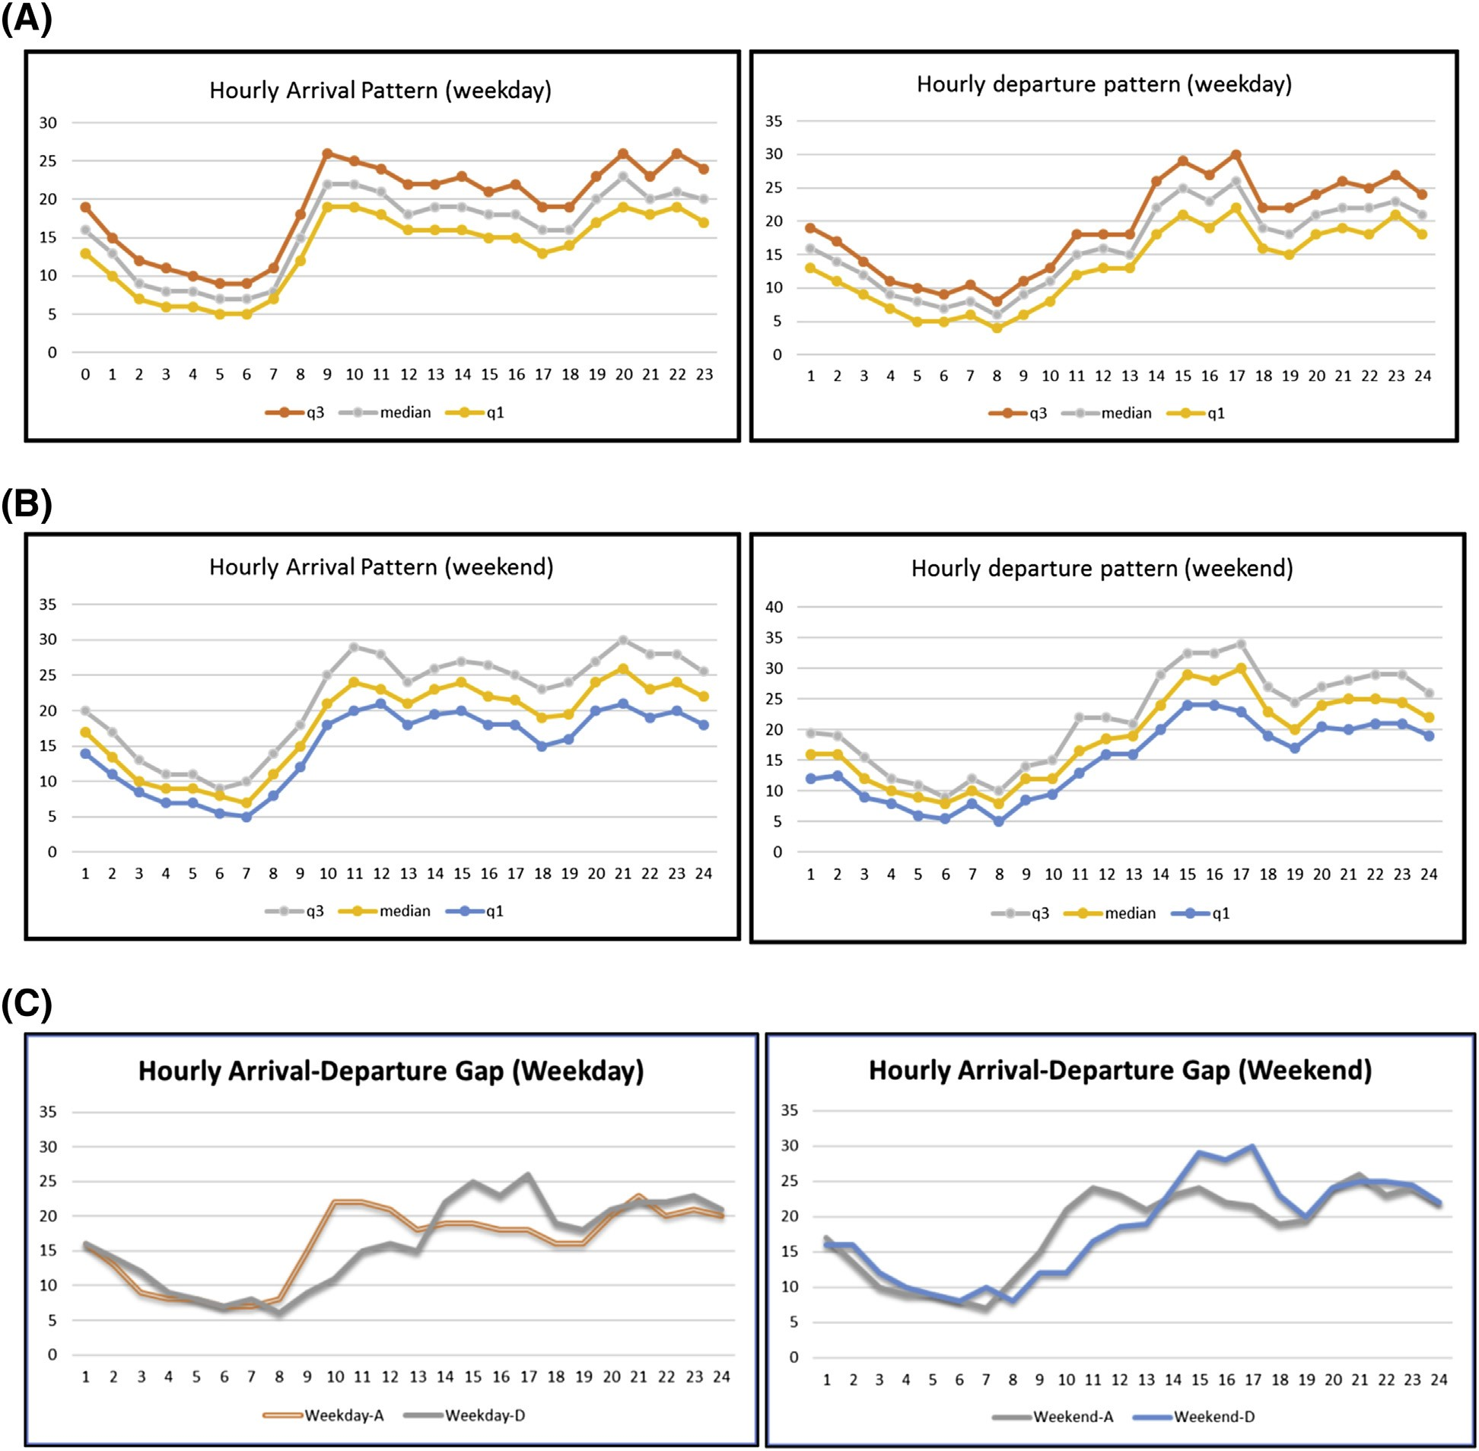

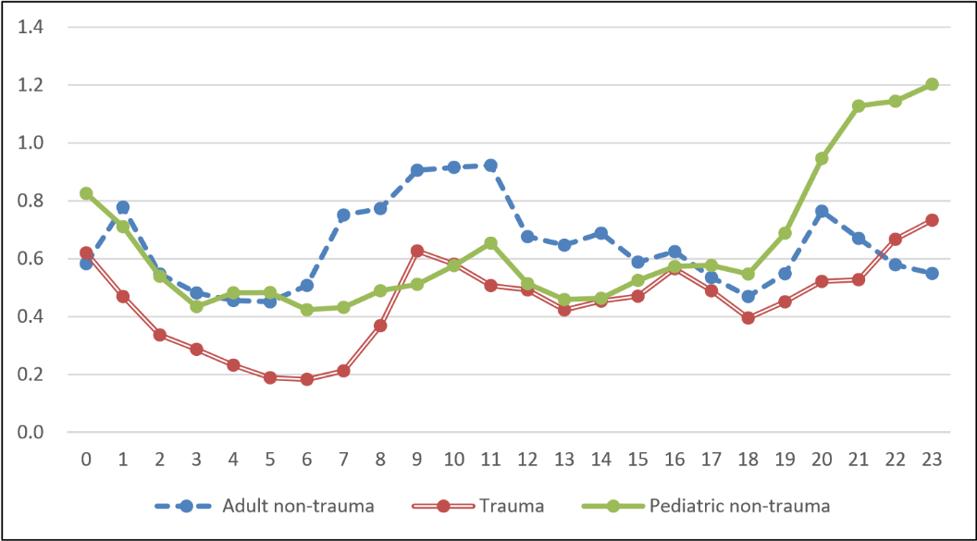

Figure 2. Diagram of the hourly physician utilization (r = l/cm) of (A) all patients, and (B) stratified by specialties. The physician utilization represents the average proportion of time in which the physicians are managing the patients. The utilization should be
less than one for the system to reach a steady state.

Student | ID
ملك منصور إبراهيم | 20230418
رحمة صلاح الدين محمود | 20230137
حسن عبد الله حسن | 20230123
جنة محمد إبراهيم | 20221044
مصطفى محمد عامر | 20201168

References

Chaou, C.-H., Chen, H.-H., Tang, P., Yen, A. M.-F., Wu, K.-H., Hsiao, C.-T., & Chiu, T.-F. (2018). Traffic intensity of patients and physicians in the emergency department: A queueing approach for physician utilization. The Journal of Emergency Medicine. https://doi.org/10.1016/j.jemermed.2018.07.024

Morad, O. (2021). Stochastic Models: Lecture 1 — Introduction to Stochastic Processes. Course Lecture Slides, DS323/DS361.

Morad, O. (2021). Stochastic Models: Lecture 6 — Multi-Server Queueing Models (M/M/∞, M/M/c). Course Lecture Slides, DS323/DS361.

Morad, O. (2016). Stochastic Models: Lecture 9 — Markov Chains / States Classification. Course Lecture Slides, DS323/DS361.

Green, L. V., Soares, J., Giglio, J. F., & Green, R. A. (2006). Using queueing theory to increase the effectiveness of emergency department provider staffing. Academic Emergency Medicine, 13(1), 61–68.

Stewart, W. J. (2009). Probability, Markov Chains, Queues, and Simulation. Princeton University Press.

Wiler, J. L., Griffey, R. T., & Olsen, T. (2011). Review of modeling approaches for emergency department patient flow and crowding research. Academic Emergency Medicine, 18(12), 1371–1379.

