**Lab Task 1: Design an IP Address Scheme**

1. The network 172.16.10.0/24 was divided into eight subnets, as outlined below:

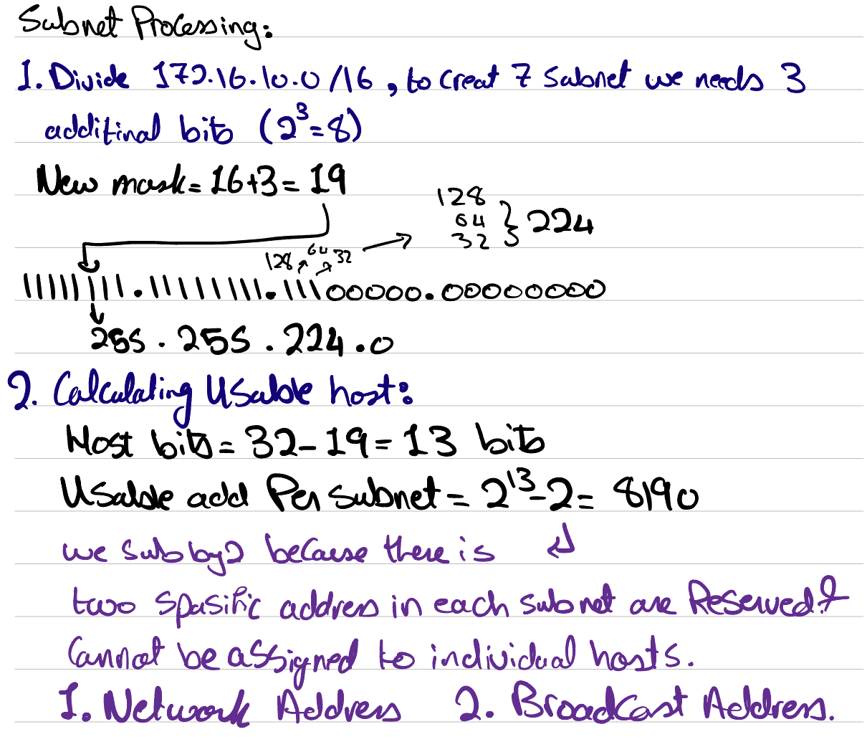

1. The value of the new subnet mask is 255.255.255.224.
2. 30 usable hosts exist per subnet.

|  |  |  |  |
| --- | --- | --- | --- |
| **Subnet Number** | **Network Address** | **Usable Host Address Range** | **Broadcast Address** |
| 1 | 172.16.10.0 | 172.16.10.1 - 172.16.10.30 | 172.16.10.31 |
| 2 | 172.16.10.32 | 172.16.10.33 - 172.16.10.62 | 172.16.10.63 |
| 3 | 172.16.10.64 | 172.16.10.65 - 172.16.10.94 | 172.16.10.95 |
| 4 | 172.16.10.96 | 172.16.10.97 - 172.16.10.126 | 172.16.10.127 |
| 5 | 172.16.10.128 | 172.16.10.129 - 172.16.10.158 | 172.16.10.159 |
| 6 | 172.16.10.160 | 172.16.10.161 - 172.16.10.190 | 172.16.10.191 |
| 7 | 172.16.10.192 | 172.16.10.193 - 172.16.10.222 | 172.16.10.223 |
| 8 | 172.16.10.224 | 172.16.10.225 - 172.16.10.254 | 172.16.10.255 |

**Lab Task 2: Implement VLANs and Trunk**  
*(Listed commands were executed on S1-Office1 and S2-Office1.)*

1. en  
   conf t  
   vlan 10  
   name Management  
   exit  
   vlan 20  
   name Marketing  
   exit  
   vlan 30  
   name Accounting  
   exit  
   vlan 100  
   name Native  
   exit
2. int range fa0/1-10  
   switchport mode access  
   switchport access vlan 10  
   exit  
   int range fa0/11-20  
   switchport mode access  
   switchport access vlan 20  
   exit  
   int range fa0/21-24  
   switchport mode access  
   switchport access vlan 30  
   exit
3. 1. *On S1-Office1:*int gi0/2  
      switchport mode trunk  
      switchport trunk native vlan 100  
      exit  
      do sho vlan brief  
      do sho int trunk
   2. *On S2-Office1:*int gi0/1  
      switchport mode trunk  
      switchport trunk native vlan 100  
      exit  
      do sho vlan brief  
      do sho int trunk
4. int range fa0/1-24  
   switchport nonegotiate  
   exit  
   do wr

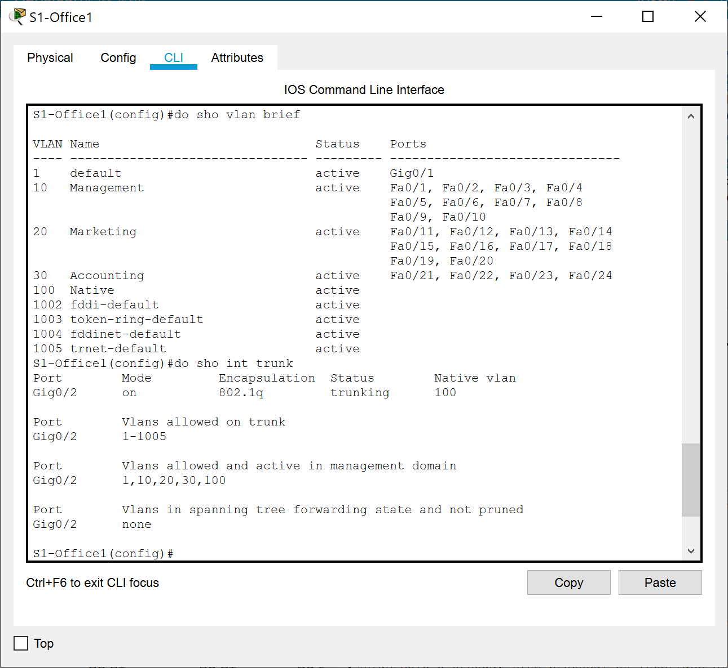

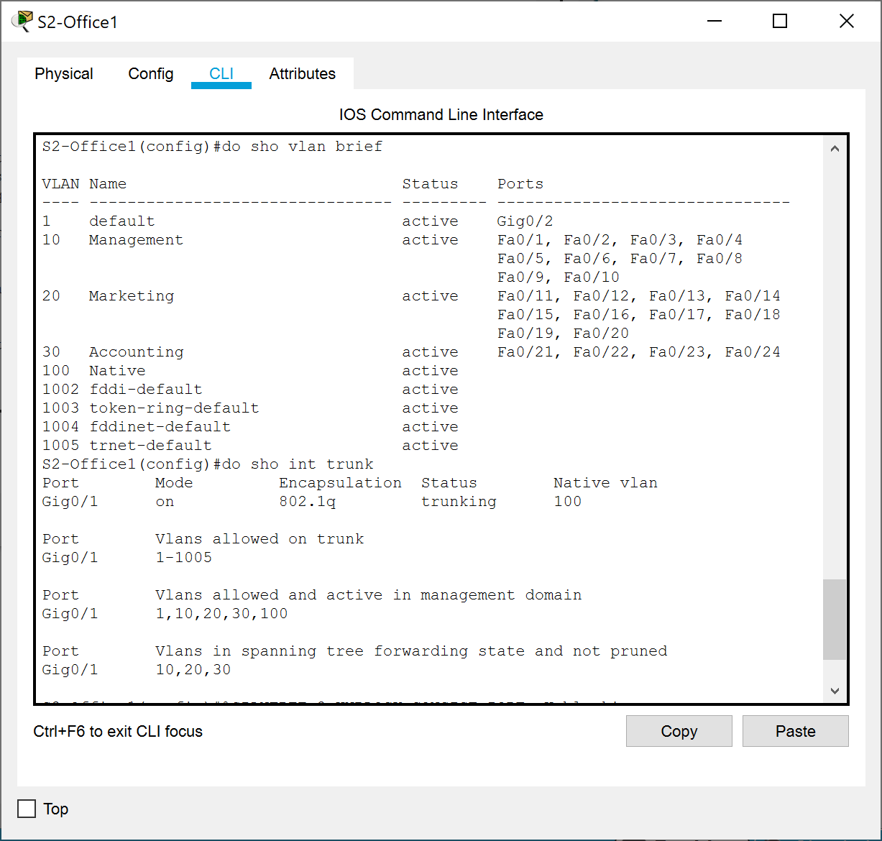

**Lab Task 3: Assign IP Addresses**

1. Address 172.16.10.1 (from subnet 1) was assigned to the R3 / S1-Office3 link.  
   *On R3:*en  
   conf t  
   int gi0/0  
   ip address 172.16.10.1 255.255.255.224  
   desc To S1-Office3  
   no shut  
   exit
2. Address 172.16.10.33 (from subnet 2) was assigned to the R3 / S1-Office2 link.  
   *On R3:*int gi0/1  
   ip address 172.16.10.33 255.255.255.224  
   desc To S1-Office2  
   no shut  
   exit
3. For the R1 / R2 WAN link, addresses from subnet 3 were used. Address 172.16.10.65 was assigned on the R1 side, and address 172.16.10.66 was assigned on the R2 side.  
   *On R1:*en  
   conf t  
   int se0/0/1  
   ip addr 172.16.10.65 255.255.255.224  
   desc To R2  
   no shut  
   ex  
   *On R2:*en  
   conf t  
   int se0/0/1  
   ip addr 172.16.10.66 255.255.255.224  
   desc To R1  
   no shut  
   ex
4. For the R1 / R3 WAN link, addresses from subnet 4 were used. Address 172.16.10.97 was assigned on the R1 side, and address 172.16.10.98 was assigned on the R3 side.  
   *On R1:*int se0/0/0  
   ip addr 172.16.10.97 255.255.255.224  
   desc To R3  
   no shut  
   ex  
   do wr  
   *On R3:*  
   int se0/0/0  
   ip addr 172.16.10.98 255.255.255.224  
   desc To R1  
   no shut  
   ex
5. For the R2 / R3 WAN link, addresses from subnet 5 were used. Address 172.16.10.129 was assigned on the R2 side, and address 172.16.10.130 was assigned on the R3 side.  
   *On R2:*int se0/0/0  
   ip addr 172.16.10.129 255.255.255.224  
   desc To R3  
   no shut  
   ex  
   do wr  
   *On R3:*  
   int se0/0/1  
   ip addr 172.16.10.130 255.255.255.224  
   desc To R2  
   no shut  
   ex  
   do wr
6. The last usable addresses on subnet 6 were assigned to end devices on VLAN 10 on the Office 1 LAN. The first usable address in subnet 6, 172.16.10.161, was set as the default gateway.
   1. CEO1: 172.16.10.189
   2. CEO2: 172.16.10.190
7. The last usable addresses on subnet 7 were assigned to end devices on VLAN 20 on the Office 1 LAN. The first usable address in subnet 7, 172.16.10.193, was set as the default gateway.
   1. Copywriter1: 172.16.10.221
   2. Copywriter2: 172.16.10.222
8. For Dialer:
   1. Dialer1: 172.16.10.253
   2. Dialer2: 172.16.10.254
9. IP addresses were assigned to end devices in Offices 2 and 3:
   1. FOR Office
      1. Employee 1: 172.16.10.60
      2. Employee 2: 172.16.10.61
      3. Guest: 172.16.10.62
   2. The last usable addresses on subnet 1 were assigned to end devices on the Office 3 LAN. The first usable address in subnet 1, 172.16.10.1, was set as the default gateway (as configured in step 1).
      1. Email Server: 172.16.10.28
      2. Syslog / NTP Server: 172.16.10.29
      3. Admin: 172.16.10.30

|  |  |
| --- | --- |
| **IP Address Usage Summary** | |
| **Subnet** | **Use** |
| 1 | Office 3 LAN |
| 2 | Office 2 LAN |
| 3 | R1 / R2 WAN link |
| 4 | R1 / R3 WAN link |
| 5 | R2 / R3 WAN link |
| 6 | VLAN 10 (Management) |
| 7 | VLAN 20 (Marketing) |
| 8 | VLAN 30 (Accounting) |

**Lab Task 4: Configure R1 for Inter-VLAN Routing***(Listed commands were executed on R1, unless otherwise stated.)*

1. en  
   conf t  
   int gi0/0  
   no shut  
   ex
2. *(The commands below cover lab steps 2 through 4)*  
   int gi0/0.10  
   encapsulation dot1q 10  
   ip addr 172.16.10.161 255.255.255.224  
   ex  
   int gi0/0.20  
   encapsulation dot1q 20  
   ip addr 172.16.10.193 255.255.255.224  
   ex  
   int gi0/0.30  
   encapsulation dot1q 30  
   ip addr 172.16.10.225 255.255.255.224  
   ex
3. do sho run

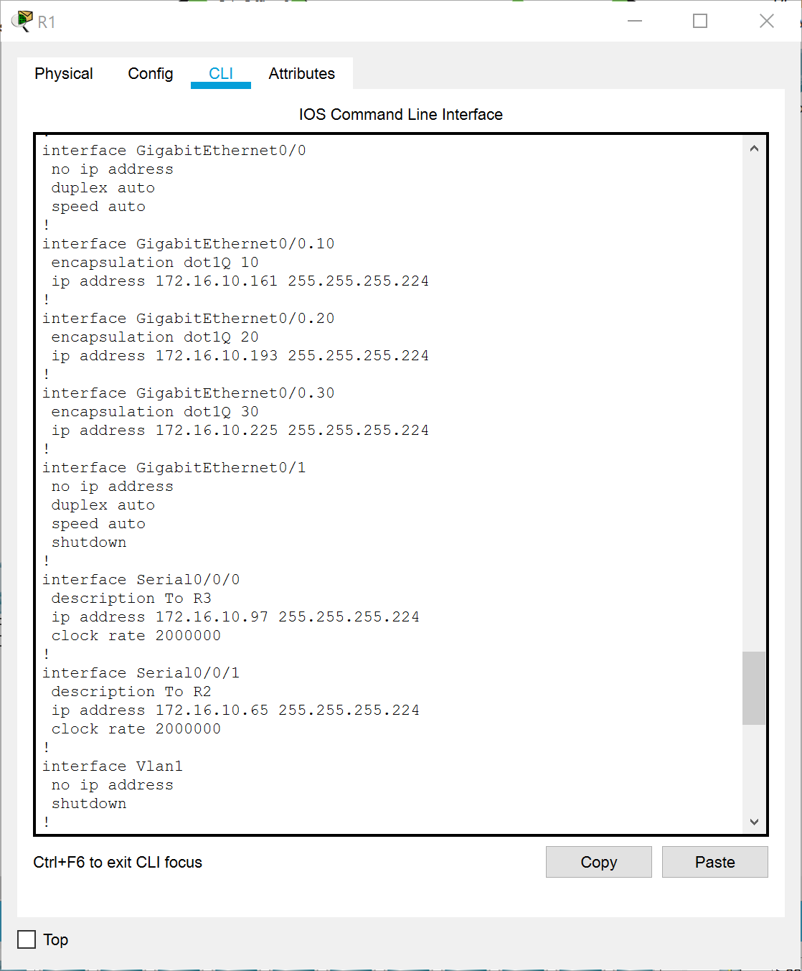

1. *On S1-Office1:*  
   en  
   conf t  
   int gi0/1  
   switchport mode trunk  
   switchport trunk native vlan 100  
   no shut  
   ex
2. *On S1-Office1:* do sho int trunk
3. I was able to successfully ping Copywriter1 and Dialer1 from the CEO1 PC.

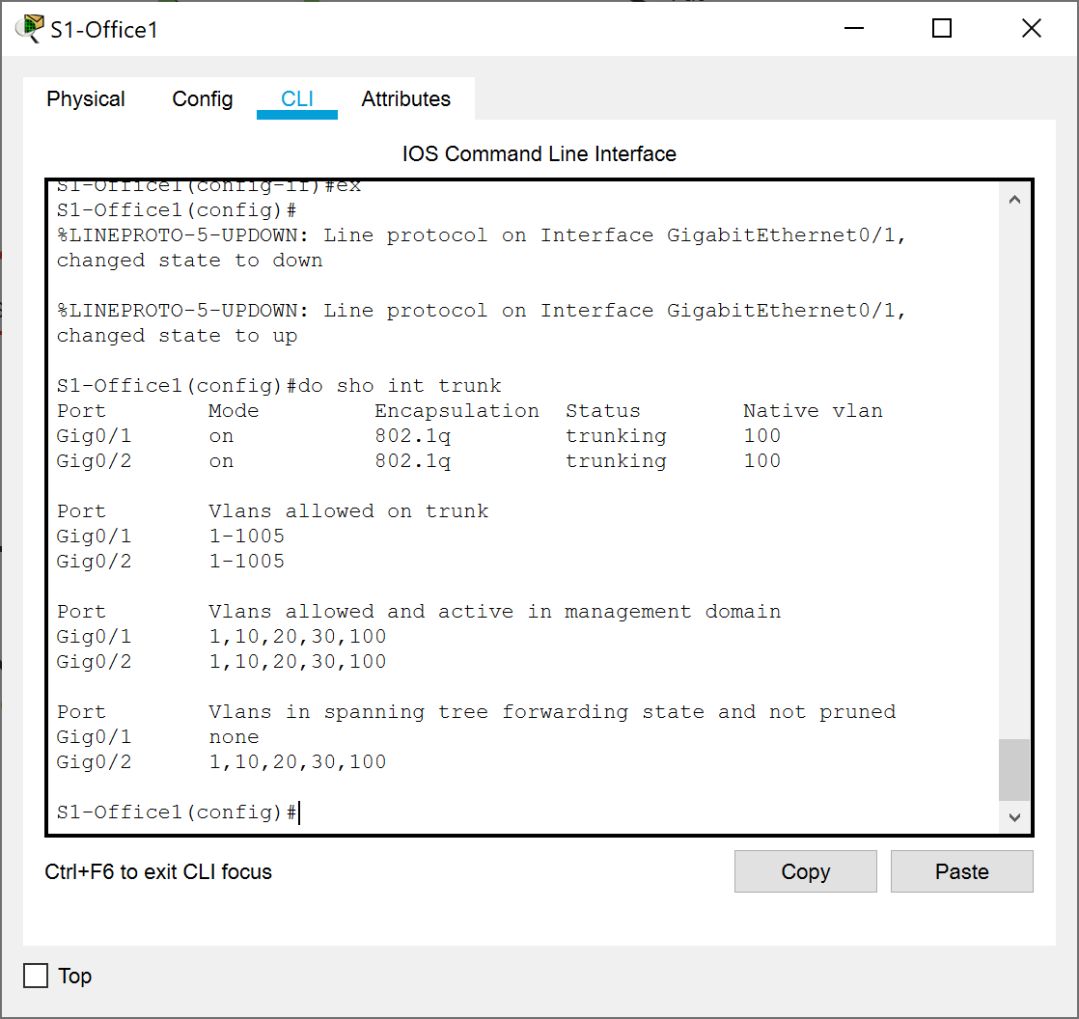

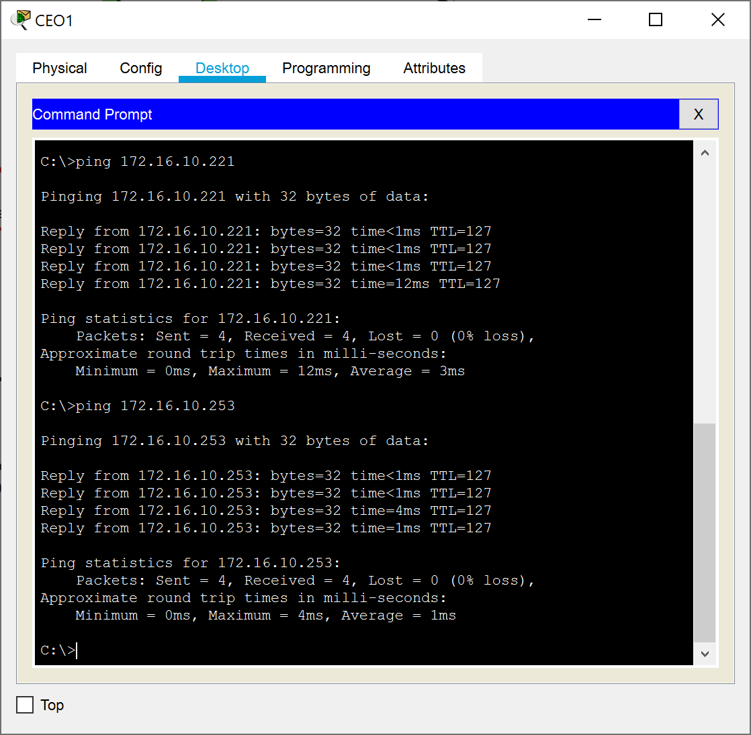

**Lab Task 5: Static Routing for network devices**

**Lab Task 6: Configure OSPF***(Listed commands were executed on R1, R2, and R3, unless otherwise stated)*

1. en  
   conf t  
   int se0/0/0  
   no shut  
   ex  
   int se0/0/1  
   no shut  
   ex
2. *On R3 only:*int range gi0/0-1  
   no shut  
   ex
3. router ospf 1  
   auto-cost reference-bandwidth 1000 *On R1:*  
   router-id 1.1.1.1  
   network 172.16.10.64 0.0.0.31 area 0  
   network 172.16.10.96 0.0.0.31 area 0  
   network 172.16.10.160 0.0.0.31 area 0  
   network 172.16.10.192 0.0.0.31 area 0  
   network 172.16.10.224 0.0.0.31 area 0  
   *On R2:*router-id 2.2.2.2  
   network 172.16.10.64 0.0.0.31 area 0  
   network 172.16.10.128 0.0.0.31 area 0  
   *On R3:*router-id 3.3.3.3  
   network 172.16.10.96 0.0.0.31 area 0  
   network 172.16.10.128 0.0.0.31 area 0  
   network 172.16.10.32 0.0.0.31 area 0  
   network 172.16.10.0 0.0.0.31 area 0
4. *On R1:*  
   passive-int gi0/0  
   passive-int gi0/0.10  
   passive-int gi0/0.20  
   passive-int gi0/0.30  
   *On R3:*passive-int gi0/0  
   passive-int gi0/1
5. ex  
   ex  
   sho ip route ospf  
   sho ip ospf neighbor  
   sho ip protocols  
   wr

**Lab Task 6: Initial and Security Settings for Network Devices**  
*(Listed commands were executed on all routers and switches)*

1. en  
   conf t  
   username Admin password ACDC1973
2. line console 0  
   login local  
   exit
3. enable password beatles1960
4. service password-encryption
5. banner motd #Access to this device is for authorized personnel only!#  
   ex  
   wr  
   ex

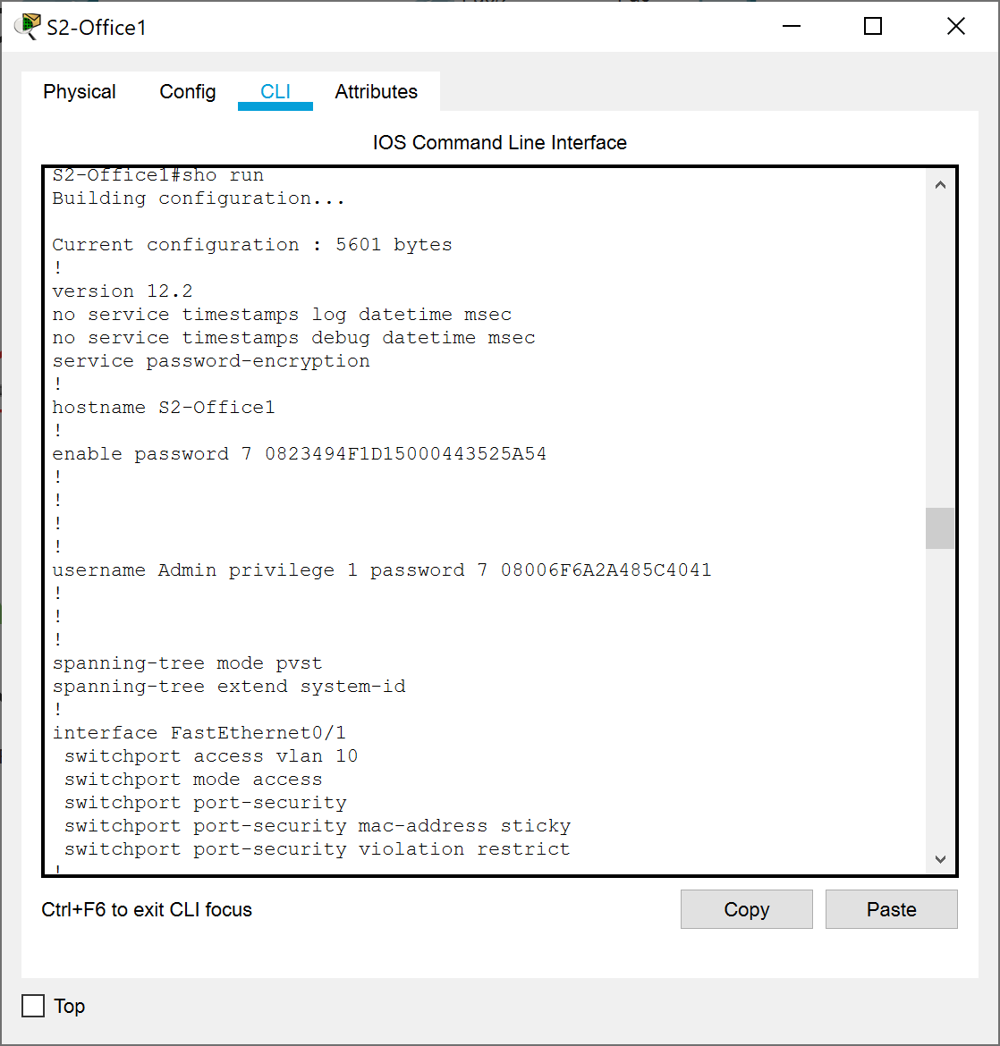

**Lab Task 7: Secure Remote Access***(Listed commands were executed on R1, R2, and R3)*

1. ip domain-name Cyber.com
2. crypto key generate rsa  
   2048
3. ip ssh version 2
4. line vty 0 4  
   login local  
   motd-banner  
   transport input ssh  
   exit
5. ex  
   sho ip ssh  
   sho run  
   wr

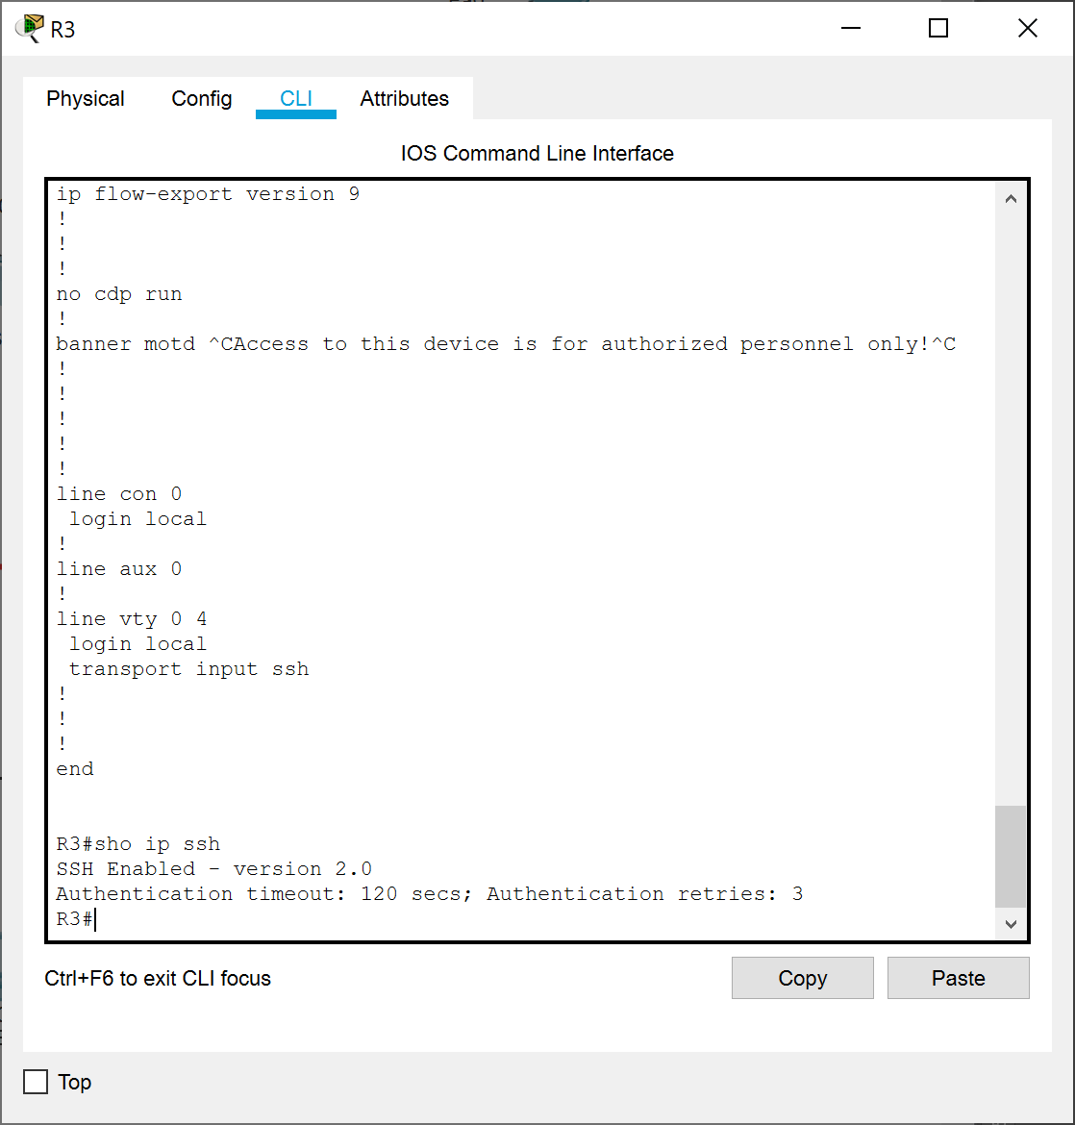

1. Using the command ssh -l Admin *IP-Address*, I was able to successfully SSH into the routers.

