DevOps Final Project:

Submission Screenshots Guide
Student: Hassan Khozema - Reg No: 2312234
Screenshot 1: GitHub Repo (Public + Correct Name)
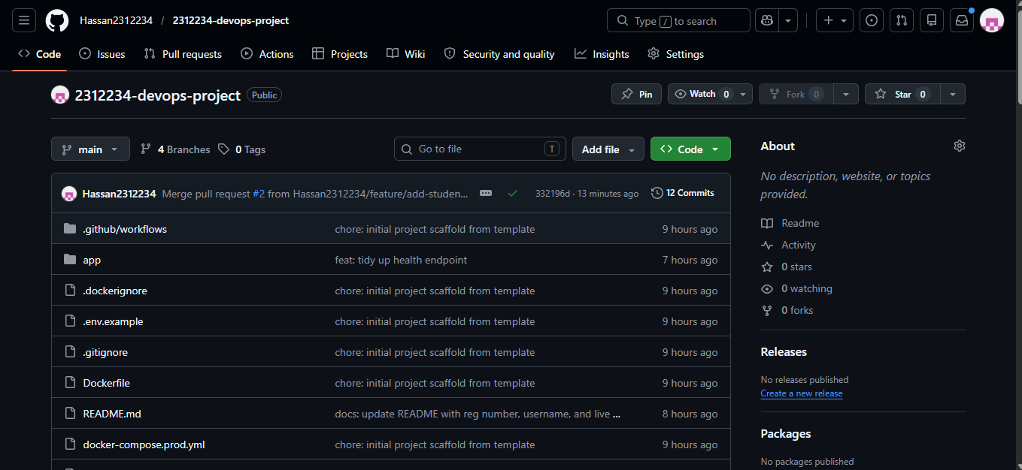

Screenshot 2: Green CI Pipeline
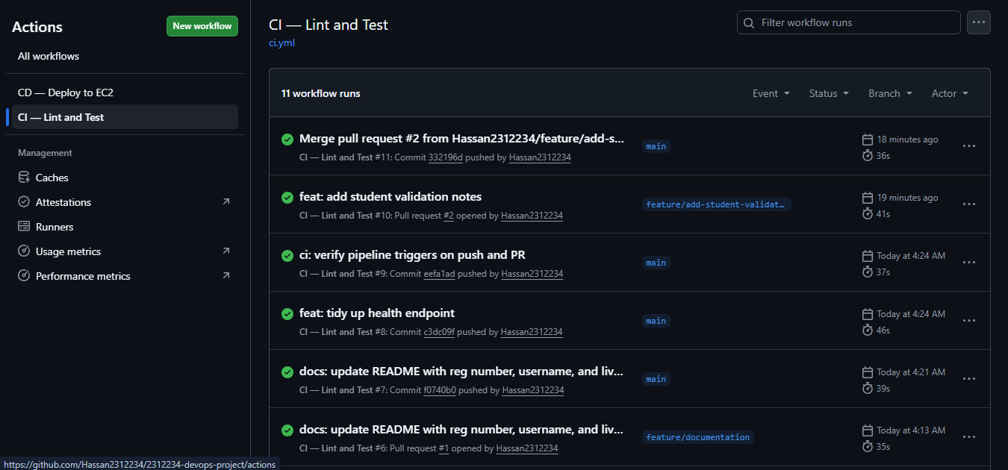

Screenshot 3: Green CD Pipeline
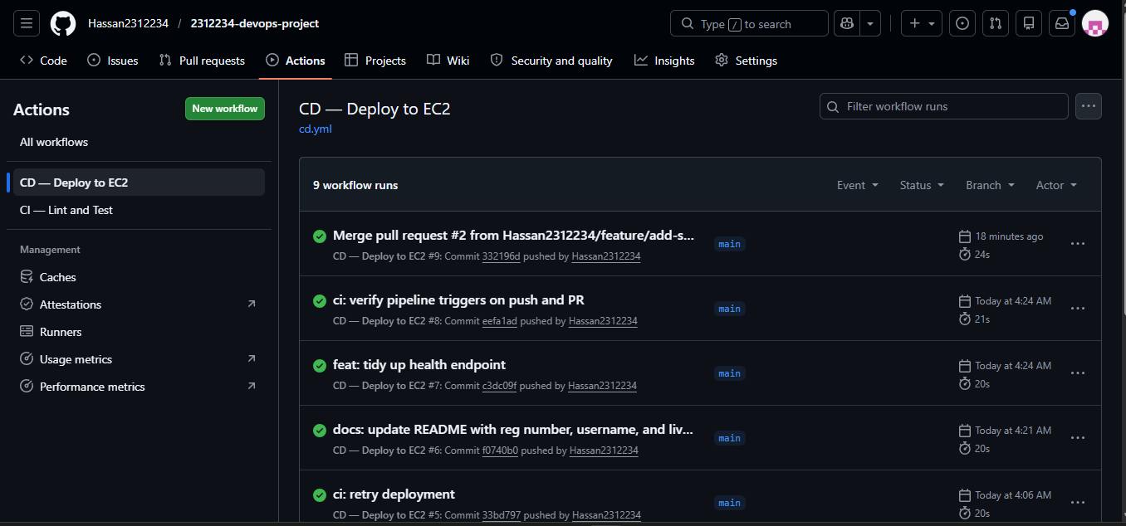

Screenshot 4: Live App Health Check (Browser)
http://32.198.188.69:8000/health
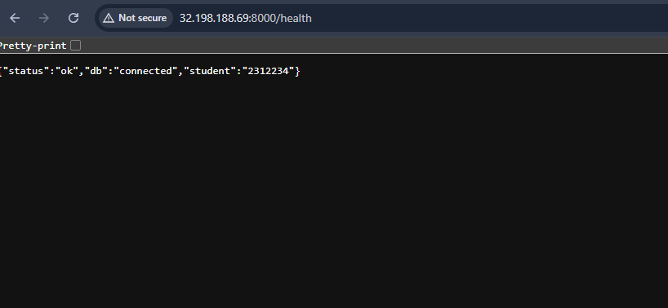

Screenshot 5: POST Student (Terminal)

Screenshot 6: GET Students (Data Persists)
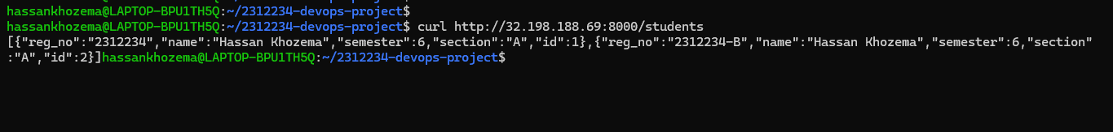

Screenshot 7: EC2 Instance Running (AWS Console)
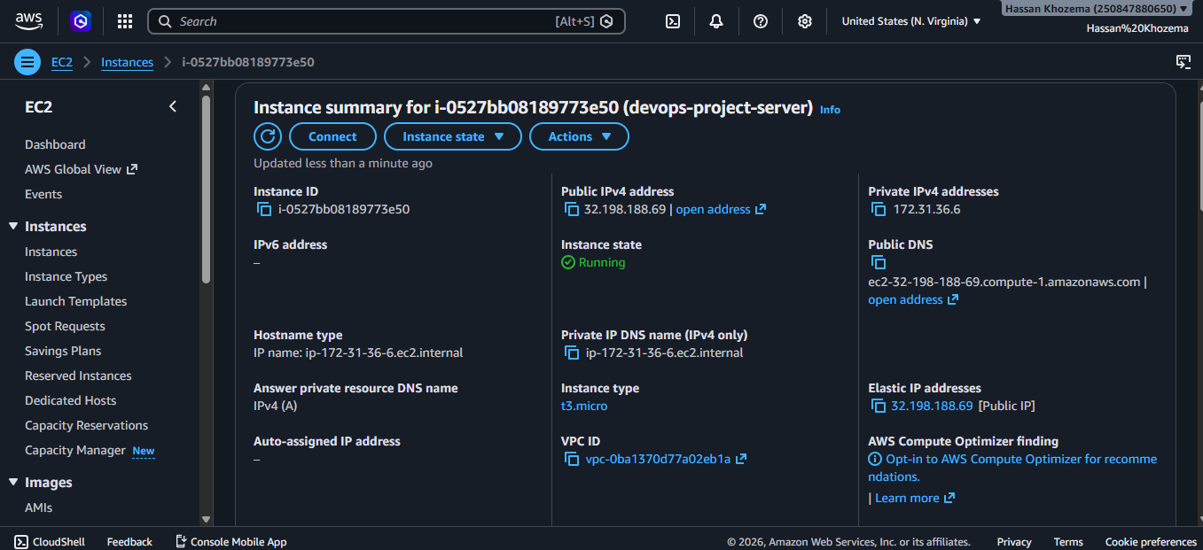

Screenshot 8: Git Log (10+ Commits)
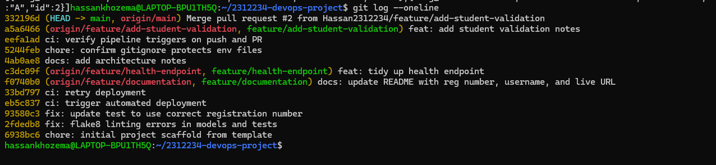

Screenshot 9: Merged Pull Requests
