**1- Overall system design and architecture:**

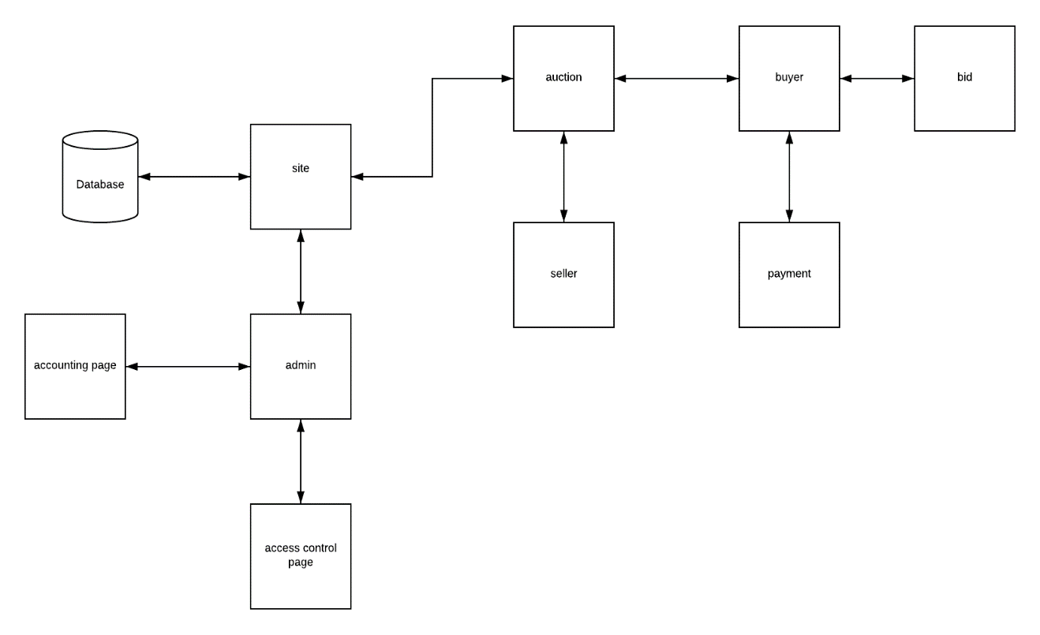

**2- Class and method design:**

**Method name:** create account

**Client:** user (buyer, seller)

**Programming language:** VB

**Description:**

user enter his info like (first name, last name, e-mail, payment method, birth date, gender, region, phone number) to create account.

**Pseudocode:**

User must enter all the necessary fields, if he misses a field or entered wrong info a message box will appear with error message for the field, else if there was any duplication in the unique fields, error message will appear for that field, else account will be created and info will be saved in database.

**Method name:** log-in

**Client:** user (buyer, seller, admin)

**Programming language:** VB

**Description:** user enter his username and password to go to his page.

**Pseudocode:** user enters his user and pass, if he enters false username or pass error message will appear, else if he misses field error message will appear, else he will be directed to his home page.

**Method name:** create auction

**Client:** user (seller)

**Programming language:** VB

**Description:** seller enter a product with details and the starting bid to create an auction.

**Pseudocode:** seller enters product with its details, if he misses field error message will appear, else an auction will be created.

**Method:** payment

**Client:** buyer

**Programming language:** VB

**Description:** buyer will be directed to payment page to make his payment.

**Pseudocode:** buyer will enter his payment method and card info, if he entered wrong information error message will appear, else if he misses a field error message will appear, else payment will start processing.

**Method:** bid

**Client:** buyer

**Programming language:** VB

**Description:** buyer will start bidding for products he wishes to buy

**Pseudocode:** buyer will put a bid, if the bid is lower than current bid or equal to the current bid error message will appear, else use the new bid

**Method:** search

**Client:** user

**Programming language:** VB

**Description:** user use search to search for any product, seller or category

**Pseudocode:** user write in the search box for what he wants to find and a list that contain that name will appear

**3- ERD:** 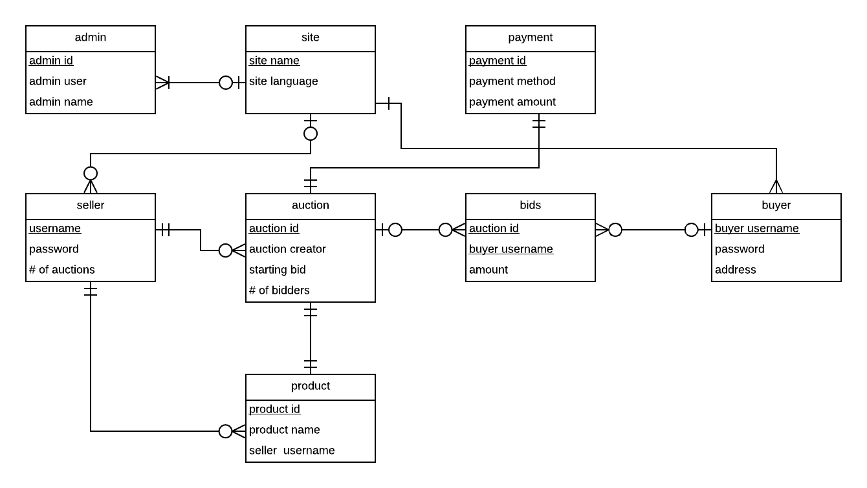

admin

|  |  |  |  |  |
| --- | --- | --- | --- | --- |
| Admin ID | Admin username | Admin pass | Admin name |  |

site

|  |  |  |  |  |
| --- | --- | --- | --- | --- |
| Site name | Admin ID | Site language |  |  |

payment

|  |  |  |  |  |
| --- | --- | --- | --- | --- |
| Payment ID | Site name | Seller ID | Payment method | Payment amount |

seller

|  |  |  |  |  |
| --- | --- | --- | --- | --- |
| Seller ID | Seller username | Seller pass | Seller name |  |

auction

|  |  |  |  |  |  |
| --- | --- | --- | --- | --- | --- |
| Auction ID | Seller ID | Seller name | Starting bid | # of bidders | Time of auction |

bids

|  |  |  |  |  |
| --- | --- | --- | --- | --- |
| Auction ID | Buyer ID | Buyer name | amount |  |

Buyer

|  |  |  |  |  |
| --- | --- | --- | --- | --- |
| Buyer ID | Buyer username | Buyer pass | Buyer name |  |

product

|  |  |  |  |  |
| --- | --- | --- | --- | --- |
| Product ID | Seller ID | Product name | Seller name |  |