|  |  |
| --- | --- |
| **E** | 16 us |
| **P** | 50 ms |
| **D** | 50 ms |

|  |  |
| --- | --- |
| **E** | 16 us |
| **P** | 50 ms |
| **D** | 50 ms |

**Tasks and System Parameters**

Task2: Button2_Monitor

Task1: Button1_Monitor

Task4: Uart_Reciever

Task3: Periodic_Transmitter

|  |  |
| --- | --- |
| **E** | 14 us |
| **P** | 100ms |
| **D** | 100ms |

|  |  |
| --- | --- |
| **E** | 22 us |
| **P** | 20 ms |
| **D** | 20 ms |

Task6: LOAD2

|  |  |
| --- | --- |
| **E** | 12 ms |
| **P** | 100ms |
| **D** | 100ms |

Task5: LOAD1

|  |  |
| --- | --- |
| **E** | 5 ms |
| **P** | 10 ms |
| **D** | 10 ms |

• Hyperperiod (H) = 100 ms

• CPU Load (U)= = 62.188 %

**System Schedulability**

**1) Rate-Monotonic Utilization Bound: -**

URM = n (21/n -1) = 6*(21/6 -1) = 0.73477

U ≤ URM, so the system is schedulable

**2) Time Demand Analysis: -**

|  |  |  |
| --- | --- | --- |
| **Task** | **Calculations** | **Schedulable?** |
| LOAD 1 |  | YES |
| Receiver |  | YES |
| Button 1 |  | YES |
| Button 2 |  | YES |
| Transmitter |  | YES |
| Load 2 |  | YES |

The System is schedulable, and the results are as expected. As the analytical method results match the simulation, then the results indicate a successful implementation.

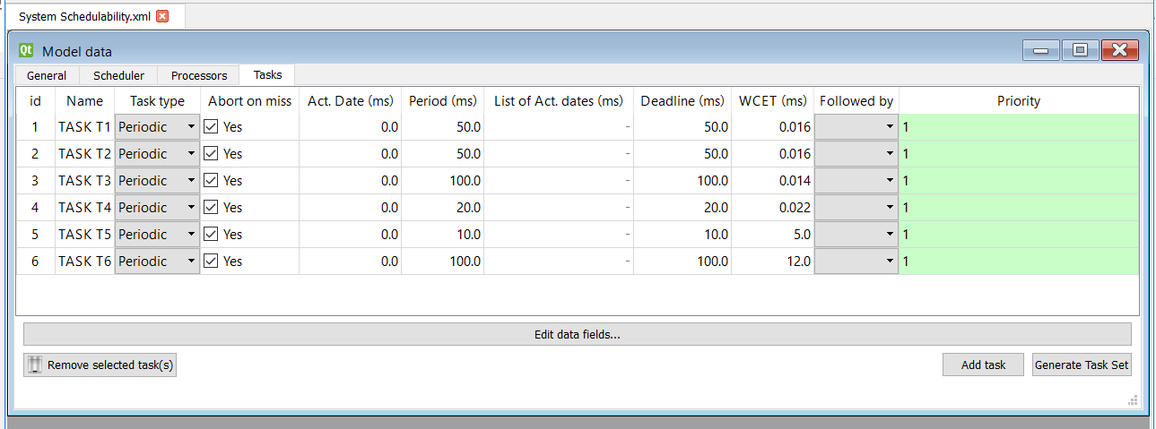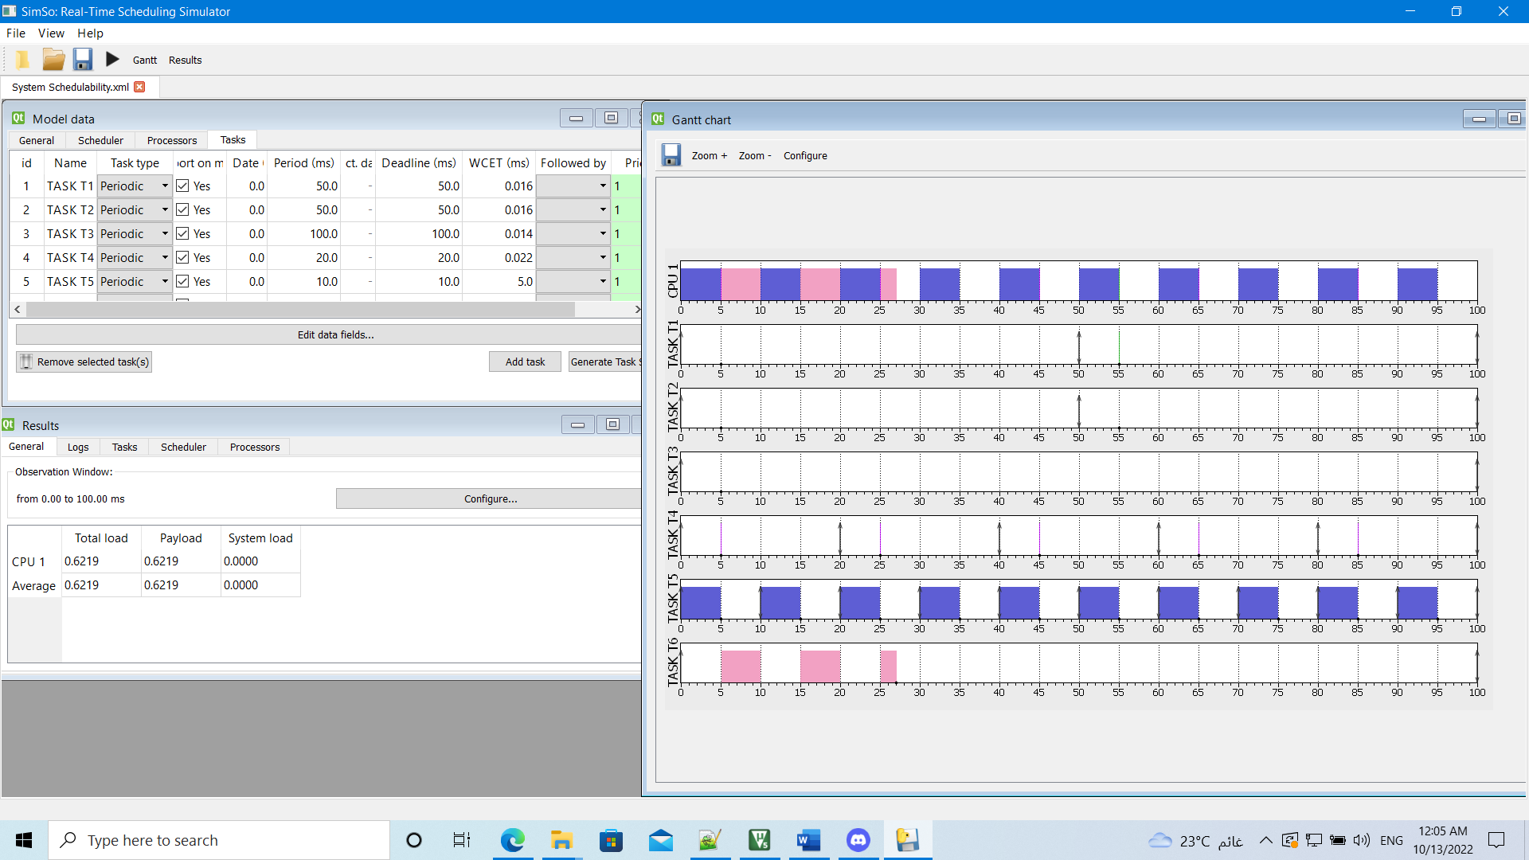

Figure : Task set configurations

Figure 2: CPU load and system simulation using Gantt chart

**System offline simulation**

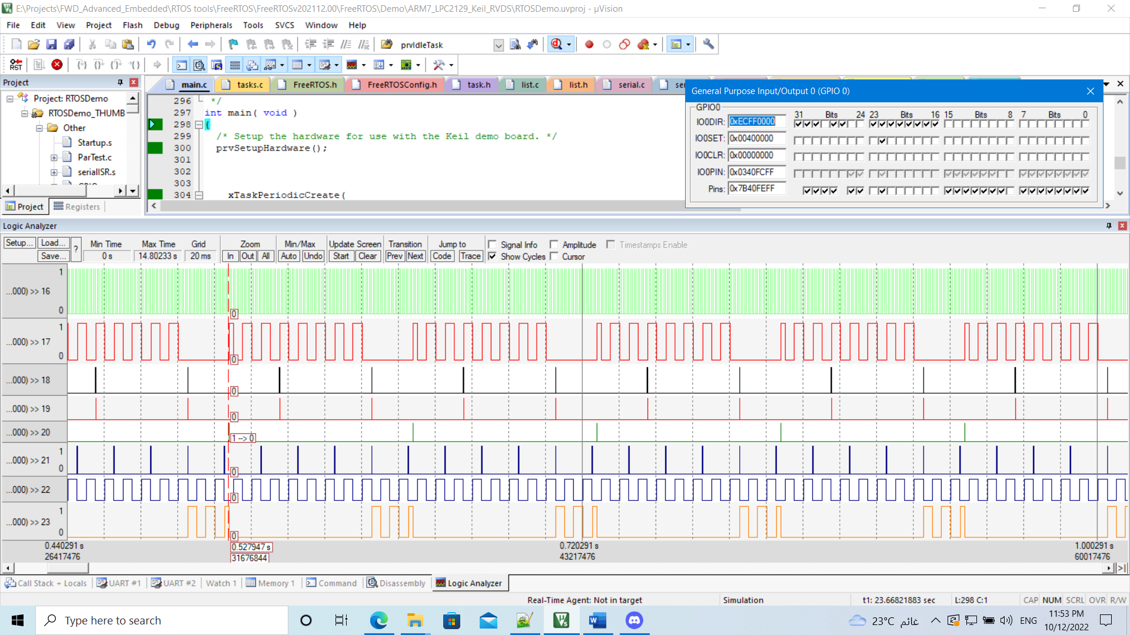

Figure 3: System real execution plot using Logic Analyzer

**Tasks Execution Plot**

|  |  |
| --- | --- |
| **Task** | **GPIO PIN** |
| Tick | PORT0.PIN16 |
| Idle Task | PORT0.PIN17 |
| Button1_Monitor | PORT0.PIN18 |
| Button2_Monitor | PORT0.PIN19 |
| Periodic_Transmitter | PORT0.PIN20 |
| Uart_Receiver | PORT0.PIN21 |
| LOAD1 | PORT0.PIN22 |
| LOAD2 | PORT0.PIN23 |

Table : GPIO Pins assigned to Tasks to plot on Logic Analyzer

Figure 4: Task1 execution time

Figure 7: Task4 execution time

Figure 6: Task3 execution time

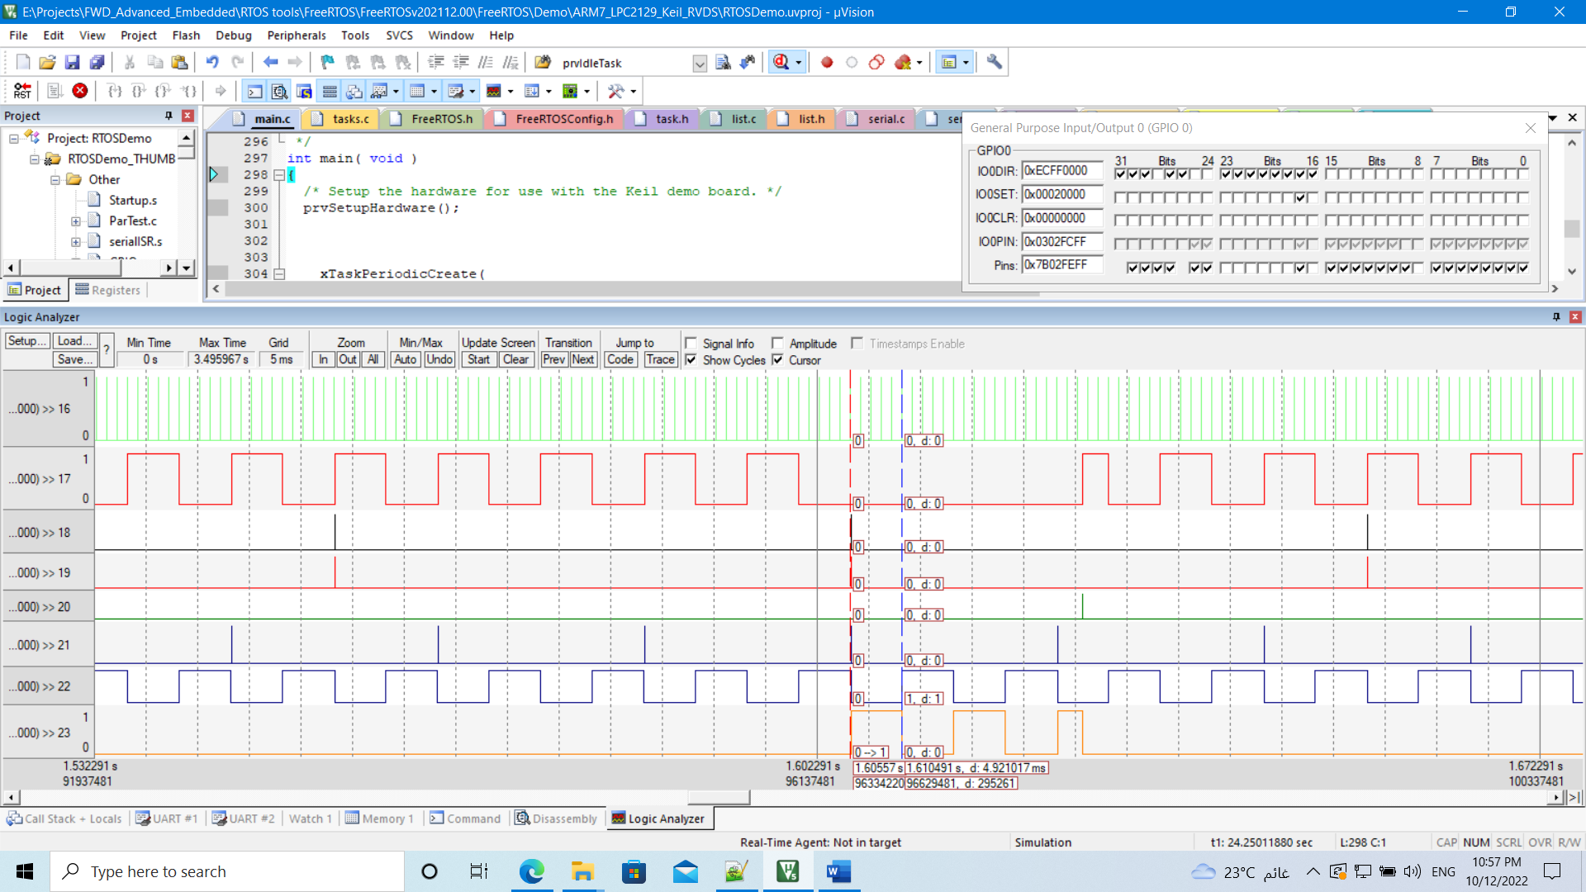

Figure 5: Task2 execution time

Figure 9: Task6 execution time

Figure 8: Task5 execution time