Forward Kinematics:

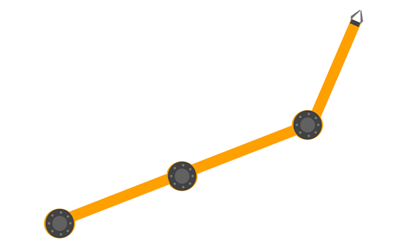

r5=Y, Φ4=°90

r4=X, Ø4=°0

Ø1

r3

r2

r1

Ø3

Ø2

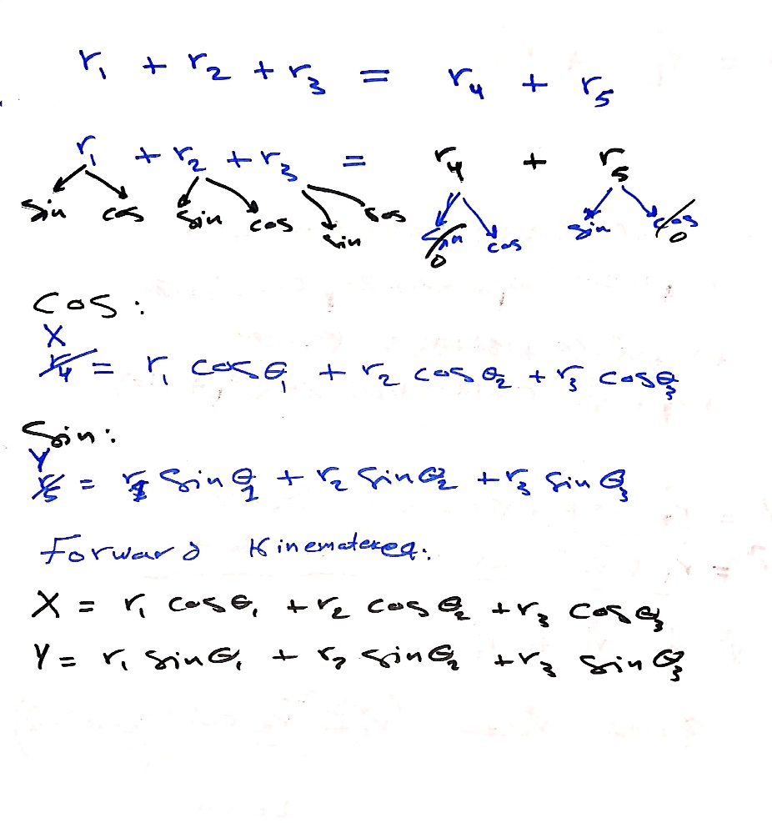

Inverse Kinematics:



r5=Y, Φ4=°270

r4=X, Φ4=°180

r2

Φ3

Φ1

Φ2

r3

r1

Ø2

Ø1

