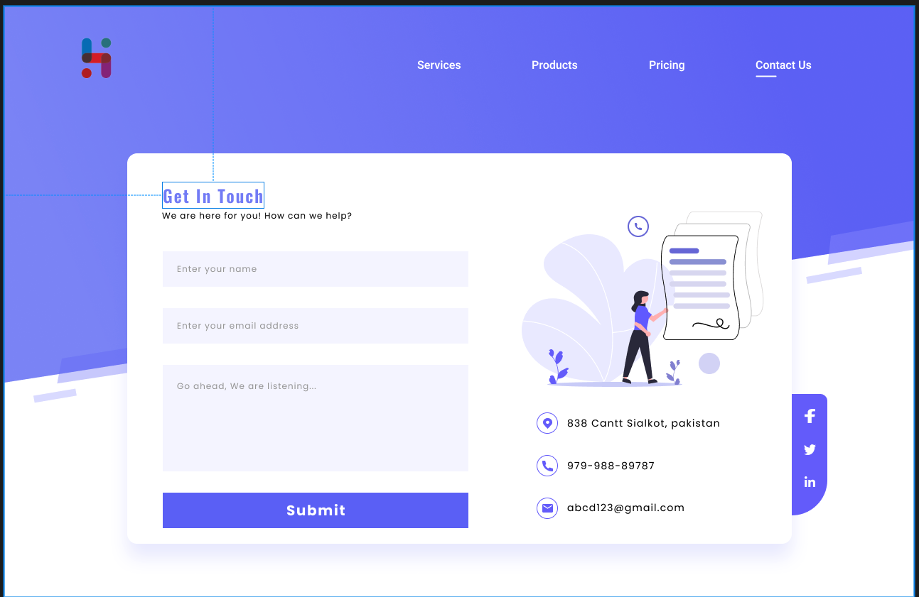

[https://www.figma.com](https://www.figma.com/file/V3qtjwtjdKFl7kWYW4s41q/Contact-From-(Community)?node-id=0%3A59&mode=dev)

This design is for the communication page only.

The other pages are designed by me.