ري: Rayy
  - Smart IoT plant that expresses its feelings with emoji and sound: full project documentation
Table of Contents

Project overview
Graduation project. Rayy (ري, “watering / quenching thirst”) turns the plant’s live readings (soil moisture, light and temperature) into emoji faces shown in the web dashboard and the Android app, and sound alerts (a different buzzer melody for each feeling). It sends its data to the cloud (Firebase), and a web dashboard and an Android app show it. Power comes from a simple 5 V USB power bank (or phone charger).
😊 Happy | 😫 Thirsty | 🥴 Too wet | 🥵 Too hot | 🥶 Cold | 😞 Needs light | 😴 Sleeping

1. Start here
👉 docs/00-step-by-step-guide.md: the complete guide from buying the parts to the final demo, step by step.
🧭 docs/Rayy-Setup-Guide-by-Part.docx: for each part (Firebase, Web, ESP32, Android): files and paths, apps to install, what is downloaded, configuration and complete steps.
📘 docs/Rayy-Build-Guide.docx: Word guide with every step in order (what comes after what) and what every file is for.
📄 docs/Rayy-Documentation.docx: all the documentation in one Word file (for the report).

2. What is in this folder
Folder / file | What it contains
docs/ | Full project documentation (chapters 00 → 10 + Word file + diagrams)
firmware/Rayy/ | ESP32 program (Arduino IDE): sensors, emoji faces, buzzer melodies, Firebase
web/ | Web dashboard (HTML + CSS + JavaScript, Arabic / English)
android/Rayy/ | Android Studio project Rayy (Kotlin + Jetpack Compose, Arabic / English)
firebase/database.rules.json | Security rules for the Realtime Database
firebase.json | Firebase Hosting + rules deploy configuration
tests/ | Unit tests of the plant “mood” logic (run on a PC)

3. Documentation index
- Step-by-step guide (start here)
- Requirements and system analysis
- Hardware components (bill of materials) and power
- Wiring and assembly
- Database: why Firebase, and the step-by-step setup
- ESP32 firmware: installation, how the code works, the melodies
- Web application
- Android application
- Calibration and testing
- 6-week project plan and team roles
- Graduation report outline, presentation and future work

4. System architecture
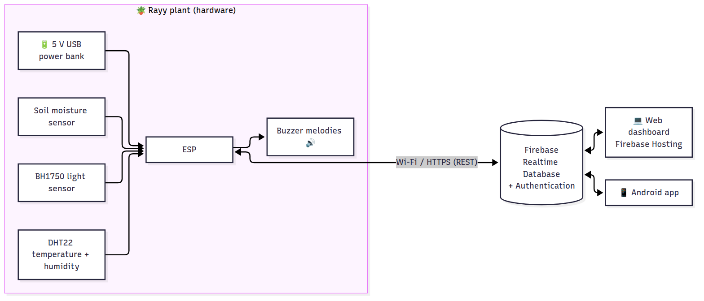
- The ESP32 reads the sensors every 2 s, chooses a mood and plays its melody. There is no screen on the plant: the emoji face is shown in the web dashboard and the Android app. Without internet the plant still decides its mood and plays its melodies; the apps update again when the connection is back.
- Every 30 s it uploads the live data. Every 5 min it saves a history point. Each time the mood changes it writes an event. It also downloads the config (thresholds, quiet hours, mute) set from the apps.
- The web and Android apps sign in with Firebase Authentication and update in real time. They can change the settings and press “Play” to make the plant play a melody.

5. Quick start (summary)
- Buy the parts (docs/02) and wire them (docs/03).
- Create the Firebase project (docs/04).
- Edit firmware/Rayy/config.h (Wi-Fi + Firebase) and upload it with the Arduino IDE (docs/05).
- Paste your Firebase web config into web/firebase-config.js and run firebase deploy (docs/06).
- Put google-services.json in android/Rayy/app/, open android/Rayy/ in Android Studio and press ▶ (docs/07).
- Calibrate the soil sensor and run the tests (docs/08).
💡 Try the web dashboard without any hardware: run python -m http.server 8000 inside web/ and open http://localhost:8000/?demo=1. It shows simulated plant data.

00 · Step-by-Step Guide: Build the Whole Project from Zero
Follow these steps in order. Each step says what to do, how long it takes, and how to check that it worked. More detail for each step is in the other chapters (01–10).
Step | What you build | Time
1 | Buy the components | 1–3 days
2 | Install the software on the computer | 1 hour
3 | Create the Firebase project (database + login + hosting) | 30 min
4 | Wire the hardware on a breadboard | 2 hours
5 | Configure and upload the ESP32 code | 30 min
6 | Calibrate the soil sensor | 15 min
7 | Run and publish the web dashboard | 30 min
8 | Build and install the Android app | 1 hour
9 | Test everything | 2 hours
10 | Final assembly on the pot, report, presentation | 1–2 weeks

Step 1: Buy the components
Full list with explanations and prices: 02-hardware-bom.md. The main items are:
- ESP32 DevKit V1 + a USB data cable (micro-USB or USB-C, depending on the board)
- Capacitive soil moisture sensor v1.2
- DHT22 (temperature + humidity) module
- BH1750 (GY-302) light sensor module
- Passive buzzer (module or bare) + 100 Ω resistor
- Push button
- Breadboard + jumper wires (male-male and female-male)
- 5 V USB power bank (or any 5 V USB phone charger)
- A small potted plant 🌿
✅ Check: you have every item in the list before you start step 4.

Step 2: Install the software
On a Windows / macOS / Linux computer:
- Arduino IDE 2.x: https://www.arduino.cc/en/software
- USB driver for the ESP32 (only if the board is not detected): CP210x (https://www.silabs.com/developers/usb-to-uart-bridge-vcp-drivers) or CH340, depending on the chip near the USB port.
- In Arduino IDE: File → Preferences → Additional boards manager URLs, paste https://espressif.github.io/arduino-esp32/package_esp32_index.json, then Tools → Board → Boards Manager → search esp32 → install “esp32 by Espressif Systems” (3.x).
- Tools → Manage Libraries → install:
  - DHT sensor library by Adafruit (click “Install all”)
  - BH1750 by Christopher Laws
  - ArduinoJson by Benoit Blanchon (version 7)
- Android Studio Panda (2025.3.1) or newer: https://developer.android.com/studio (for the Android app; the project uses Gradle 9.1.0 + AGP 9.0.1 and runs on Java 17–25)
- Node.js LTS: https://nodejs.org, then in a terminal: npm install -g firebase-tools (to publish the website)
- Python 3 (optional, to run the website on your computer) or the VS Code Live Server extension.
✅ Check: in Arduino IDE, Tools → Board shows “esp32 → ESP32 Dev Module”.

Step 3: Create the Firebase project
Detailed with screenshots-style instructions: 04-firebase-setup.md. In short:
- https://console.firebase.google.com → Add project → project name Rayy. Firebase makes a unique project ID from it (for example rayy-1a2b3); that is normal.
- Authentication → Get started → Email/Password → Enable. In Users, add:
  - device@rayy.app + password (used by the ESP32)
  - team@rayy.app + password (used to log in to the web and Android apps)
- Realtime Database → Create database → location Belgium (europe-west1) → locked mode. Copy the database URL. In the Rules tab, paste the content of firebase/database.rules.json → Publish.
- Project settings → Your apps → Web (</>) → register → copy the firebaseConfig values.
- Project settings → Your apps → Android → package name com.rayy.app, app nickname Rayy → download google-services.json.
✅ Check: the Realtime Database page shows your URL, and Authentication → Users shows 2 users.

Step 4: Wire the hardware
Unplug the USB cable while wiring. Follow 03-wiring.md and the diagram:
!Wiring
Module | Pin → ESP32
Soil sensor | VCC → 3V3 · GND → GND · AOUT → GPIO34
DHT22 | + → 3V3 · − → GND · OUT → GPIO4
BH1750 | VCC → 3V3 · GND → GND · SDA → GPIO21 · SCL → GPIO22 · ADDR → GND
Buzzer | (+) → 100 Ω → GPIO25 · (−) → GND
Button | one leg → GPIO13 · other leg → GND
Tip: on the breadboard, connect the ESP32 3V3 pin to one “+” row and GND to one “−” row, then connect all modules’ VCC/GND to these rows.
✅ Check: look at every VCC and GND twice. A reversed VCC/GND can burn a module.

Step 5: Configure and upload the ESP32 code
- Open firmware/Rayy/Rayy.ino in Arduino IDE (all the other files open as tabs).
- In the config.h tab, fill in:
- #define WIFI_SSID "YourWiFi" // 2.4 GHz network or phone hotspot
#define WIFI_PASSWORD "YourPassword"
#define FIREBASE_API_KEY "AIza..." // apiKey from step 3.4
#define FIREBASE_DB_URL "https://rayy-xxxx-default-rtdb.europe-west1.firebasedatabase.app"
#define FIREBASE_USER_EMAIL "device@rayy.app"
#define FIREBASE_USER_PASS "the device password"
- Connect the ESP32 with the USB cable. Select Tools → Board → ESP32 Dev Module and Tools → Port (COM…).
- Click Upload (→). If it says “Connecting…” for a long time, hold the BOOT button on the board.
- Open Tools → Serial Monitor at 115200 baud.
✅ Check: * You hear the “hello” melody. * The Serial Monitor shows [cloud] signed in to Firebase and a line of readings every 2 seconds. * In the Firebase console → Realtime Database, plants/plant01/live appears and updates every 30 s.

Step 6: Calibrate the soil sensor
- Keep the Serial Monitor open. Hold the soil sensor in the air: note the raw value (e.g. 3050).
- Put the sensor in a glass of water (up to the white line): note the raw value (e.g. 1280).
- Put these numbers in config.h: SOIL_RAW_DRY 3050, SOIL_RAW_WET 1280, then upload again.
✅ Check: dry soil shows about 10–25 %, and freshly watered soil about 60–80 %.

Step 7: Web dashboard
- Open web/firebase-config.js and paste your firebaseConfig values from step 3.4.
- Try it on your computer:
- cd web
python -m http.server 8000
- Open http://localhost:8000 and log in with team@rayy.app. (Before configuring Firebase, http://localhost:8000/?demo=1 shows fake data.)
- Publish it on the internet:
- cd rayy
firebase login
firebase use --add # choose your project
firebase deploy --only hosting,database
- Your dashboard is now at https://<project-id>.web.app.
✅ Check: the website shows the plant’s emoji (e.g. 😫 when the soil sensor is in dry air), and the badge says “Online”.

Step 8: Android app
- Unzip the project into a folder whose path has English letters only, for example E:\Rayy-Project (not E:\Ray ري\...). Android Studio refuses to build in folders with Arabic letters in the path.
- Copy google-services.json (step 3.5) into android/Rayy/app/.
- Android Studio → File → Open → choose the android/Rayy folder (the project name shows as Rayy) → wait for “Gradle sync” to finish (the first time it downloads Gradle 9.1.0).
- Connect your phone (enable Developer options → USB debugging) or create an emulator → press ▶ Run.
- To get an installable file: Build → Build App Bundle(s) / APK(s) → Build APK(s). The file is at android/Rayy/app/build/outputs/apk/debug/app-debug.apk.
✅ Check: after login, the app shows the live emoji and values. “Play” makes the buzzer play.

Step 9: Test everything
Use the test table in 08-testing-calibration.md. The most important tests:
- Take the soil sensor out of the soil → 😫 face + “thirsty” melody + apps show “Thirsty”.
- Put it back into wet soil → 😊 face + “thank you” melody.
- Cover the light sensor during the day → 😞 “needs light”.
- Turn off the Wi-Fi → the face and sounds still work; the apps show “Offline”.

Step 10: Final assembly, report and presentation
- Move the circuit from the breadboard to a small perfboard (solder) or keep a mini breadboard inside a box.
- Put it in a small box with holes for the buzzer and the USB cable. Fix the box to the pot. Keep the DHT22 and BH1750 outside the box.
- Power it with the power bank (it lasts about 2–3 days with 10,000 mAh; recharge it like a phone) or with a USB phone charger permanently.
- Write the report using 10-report-outline.md, and follow the plan in 09-project-plan.md.

01 · Requirements and System Analysis

1.1 Project idea (from the proposal)
An interactive plant that expresses its feelings with emoji and sound using Internet of Things (IoT) technology. The plant’s live readings (soil moisture, light and temperature) become digital facial expressions (emoji) and sound alerts (melodies).
Scope decision: to focus on the main idea, the solar energy part of the original proposal is replaced by a simple 5 V USB power bank / charger, and the sound is made by a buzzer that plays a different melody for each mood. (Update the proposal text with your supervisor if needed. Solar power is listed as future work.)
Importance
- Keeps plants alive: it watches watering and soil moisture so the plant never reaches drought or death.
- Environmental awareness and smart interaction: a fun, innovative way to “talk” with plants through IoT, emoji and sound alerts.
- Learning value: it combines sensors, embedded programming, cloud databases, web and mobile development in one system.
Duration: 6 weeks. Team: 6 members.

1.2 Objectives
- Measure soil moisture, light intensity, air temperature and humidity automatically.
- Show the plant’s state as an emoji face in the web dashboard and the Android app (no screen on the plant).
- Play sound alerts: a different buzzer melody for each mood (sad melody when thirsty, happy melody after watering…).
- Send the data to the cloud (Firebase) and show it on a web dashboard and an Android app.
- Run from a simple 5 V USB power bank (portable) or a USB charger.
- Let the user change the plant thresholds, mute the sound, and play a sound on the plant from the apps.

1.3 Why the ESP32 (and not the ESP8266)
Need of this project | ESP32 | ESP8266
Analog input for the soil sensor | ✅ 18 ADC channels (12-bit) | ⚠️ only 1 ADC pin (10-bit, 0–1 V on some boards)
HTTPS (Firebase) memory | ✅ 520 KB RAM | ⚠️ 80 KB, often unstable with TLS
PWM for buzzer melodies, I2C, many GPIO | ✅ plenty | ⚠️ few free pins
Dual-core CPU (smooth face animation + Wi-Fi) | ✅ 240 MHz × 2 | ❌ single core 80 MHz
Price | ~ same | ~ same
➡️ Use the ESP32 DevKit V1 (ESP-WROOM-32).

1.4 Functional requirements
ID | Requirement
FR-1 | The system shall read soil moisture (%) every 2 seconds.
FR-2 | The system shall read light intensity (lux), air temperature (°C) and humidity (%).
FR-3 | The system shall decide the plant mood: happy, thirsty, drowning (too wet), hot, cold, needs light, sleeping.
FR-4 | The web and Android apps shall display the emoji face of the current mood.
FR-5 | The system shall play a buzzer melody when the mood changes, and repeat a complaint every 30 min (configurable).
FR-6 | The system shall stay silent during quiet hours (default 22:00–07:00) and when muted.
FR-7 | The system shall upload the live readings to Firebase every 30 s, a history point every 5 min, and an event on each mood change.
FR-8 | The system shall keep showing the face and playing sounds when there is no internet (offline mode).
FR-9 | The system shall report its Wi-Fi signal strength and online/offline status.
FR-10 | The web and Android apps shall require a login (email + password).
FR-11 | The apps shall show the emoji mood, all live values, online/offline status, last-update time.
FR-12 | The apps shall show a 24-hour history chart and the “plant diary” (list of mood changes).
FR-13 | The apps shall let the user play a chosen melody on the plant (“Play”) and mute it.
FR-14 | The web app shall let the user edit thresholds (moisture, temperature, light) and quiet hours.
FR-15 | The apps shall support Arabic and English.
FR-16 | A push button on the plant plays the current mood’s melody.

1.5 Non-functional requirements
ID | Requirement
NFR-1 | Availability: the face and sounds must work even without Wi-Fi/internet (local decision on the ESP32).
NFR-2 | Energy: low consumption (≈ 0.5 W); ≥ 2 days on a 10,000 mAh power bank.
NFR-3 | Security: only signed-in users can read or write the database (Firebase rules). Passwords are never stored in the apps.
NFR-4 | Performance: live data appears in the apps less than 35 s after a change.
NFR-5 | Usability: the apps are simple, bilingual, and work on phones (responsive design).
NFR-6 | Cost: total hardware cost around 150–340 SAR.
NFR-7 | Maintainability: clear modular code, configuration in one file (config.h).
NFR-8 | Safety: only safe low voltage (5 V USB). The electronics are protected from water in a box.

1.6 Hardware requirements (summary; details in 02)
ESP32 DevKit V1 · capacitive soil moisture sensor v1.2 · BH1750 light sensor · DHT22 temperature/humidity sensor · passive buzzer + 100 Ω resistor · push button · breadboard + wires · 5 V USB power bank (or USB charger) · small enclosure.

1.7 Software requirements
Part | Tool / technology
Firmware | Arduino IDE 2.x + “esp32 by Espressif” core 3.x, C++
Arduino libraries | DHT sensor library, Adafruit Unified Sensor, BH1750 (Christopher Laws), ArduinoJson 7
Cloud / database | Firebase: Realtime Database, Authentication (email/password), Hosting
Web app | HTML5, CSS3, JavaScript (ES modules), Firebase JS SDK 10, Chart.js 4
Android app | Android Studio (Koala or newer), Kotlin, Jetpack Compose (Material 3), Firebase Android SDK (BoM 33)
Tools | Node.js + firebase-tools (deploy), Git (optional)

1.8 Users and use cases
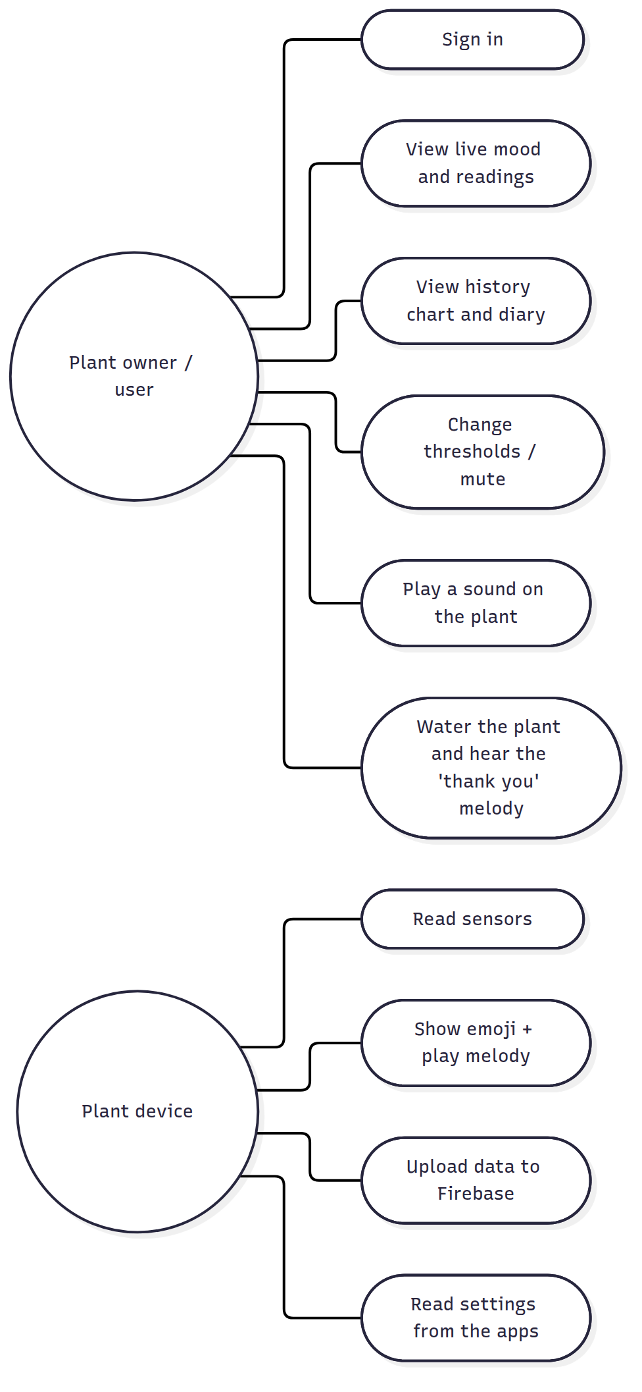

1.9 Mood rules (the “brain” of the plant)
Rules are checked in this order (the first that matches wins). Thresholds can be changed from the web app.
Priority | Condition (defaults) | Mood | Face | Melody
1 | soil moisture < 30 % | Thirsty | 😫 | 1: sad “help!” notes (played twice)
2 | soil moisture > 85 % | Too wet (drowning) | 🥴 | 2: fast “bubbling” notes
3 | temperature > 35 °C | Hot | 🥵 | 3: alarm beeps
4 | temperature < 10 °C | Cold | 🥶 | 4: “shivering” trill
5 | night (18:00–06:00) | Sleeping | 😴 | 8: lullaby (once)
6 | day and light < 200 lux | Needs light | 😞 | 5: “where is the sun?”
7 | otherwise | Happy | 😊 | 6: happy arpeggio / 7: joyful “thank you” after watering
- Hysteresis: a problem is “solved” only when the value is better by a margin (5 % moisture, 1 °C, 50 lux). This stops the face from flickering around a threshold.
- Sound: a melody plays when the mood changes. A complaint repeats every 30 min. The plant is silent during quiet hours or when muted. Melody 9 is the start-up “hello”.

1.10 Context diagram
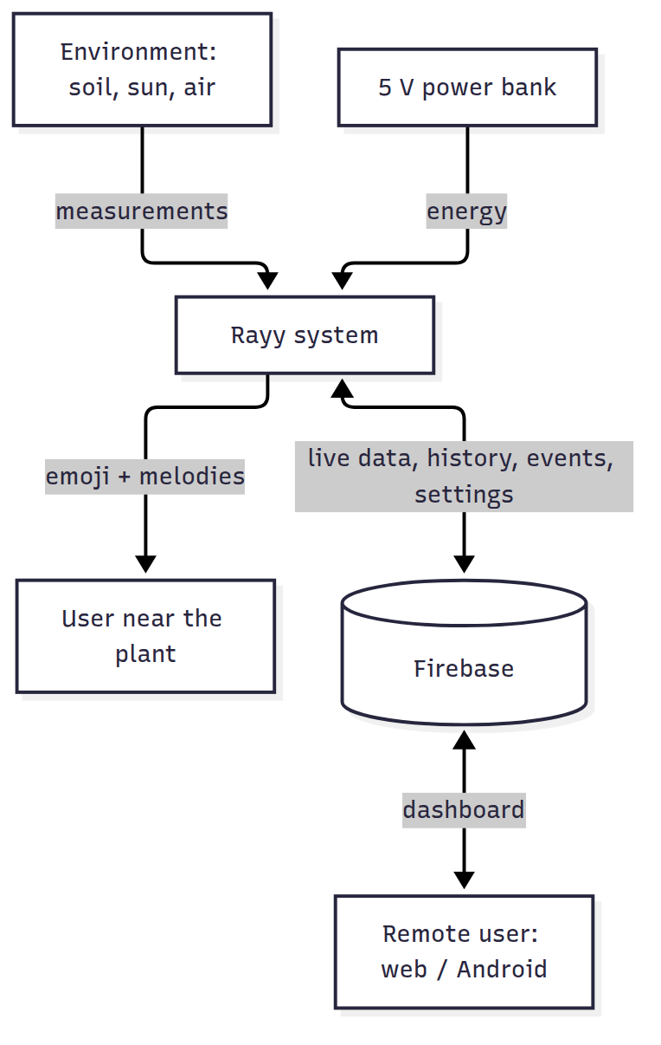

02 · Hardware Components (Bill of Materials)
The project focuses on the main idea: a plant that shows its feelings with emoji and sound. It is powered by a simple 5 V USB power bank (or a USB phone charger) connected to the ESP32’s USB port, so no solar panel, battery charger or voltage converter is needed.

2.1 Bill of materials
Prices are approximate (SAR) and depend on the shop. Buy 1 spare sensor in case one is damaged.
# | Component | Exact model / spec to ask for | Qty | Purpose | ≈ SAR
1 | Microcontroller | ESP32 DevKit V1 (ESP-WROOM-32, 30 or 38 pin) | 1 | Brain + Wi-Fi | 35–55
2 | USB cable | Micro-USB or USB-C data cable (to match the board) | 1 | Programming + power | 10
3 | Soil moisture sensor | Capacitive soil moisture sensor v1.2 (analog). Not the resistive fork type; it rusts | 1 (+1 spare) | Soil water % | 10–20
4 | Light sensor | BH1750 (GY-302) I2C module | 1 | Light in lux | 10–20
5 | Temperature + humidity | DHT22 / AM2302 module (3 pins) | 1 | Air temp + humidity | 20–35
6 | Buzzer | Passive buzzer (module KY-006 or bare 12 mm passive buzzer) | 1 | Sound alerts (melodies) | 3–8
7 | Resistor | 100 Ω (for the buzzer) (+10 kΩ only if the DHT22 is a bare 4-pin sensor) | 1–2 | Protection | 1
8 | Push button | 6 × 6 mm tactile button | 1 | Play the mood melody | 1–3
9 | Breadboard + wires | 830-point breadboard, jumper wires M-M and F-M | 1 set | Connections | 20–35
10 | Power | 5 V USB power bank (5,000–10,000 mAh) or a 5 V USB phone charger | 1 | Power | 0–60
11 | Enclosure | Small plastic box (≈ 100 × 70 × 40 mm) with holes for the buzzer and the USB cable, or a 3D-printed case | 1 | Protection | 10–30
12 | Plant | Small potted plant (basil, mint, pothos…) | 1 | 🌿 | 15–30
 |  |  |  | Total (approx.) | ≈ 135 – 305
Passive vs active buzzer: buy a passive buzzer. It can play different notes, so it can play melodies. An active buzzer only makes one fixed “beep”. The passive one usually has no sticker on top, and its bottom shows the green circuit board.

2.2 Why each component
- ESP32: it has built-in Wi-Fi to send data to Firebase, an ADC to read the analog soil sensor, and PWM to play notes on the buzzer. It is cheap and programmed with the Arduino IDE. (The ESP8266 has only one analog pin and less memory for secure HTTPS, so the ESP32 is the better choice.)
- Capacitive soil sensor: it has no exposed metal in the soil, so it does not corrode like cheap resistive sensors.
- BH1750: it gives real lux values, which are better than an LDR for deciding “needs light”.
- DHT22: it is more accurate than the DHT11 (±0.5 °C) and has a wider range. That is useful in Saudi summers.
- Passive buzzer: this is the “voice” of the plant. Each mood has its own melody (sad melody when thirsty, happy melody when watered, alarm when hot, lullaby at night…). It costs a few riyals and needs only one wire.

2.3 Power consumption
Part | Current @ 5 V (average)
ESP32 with Wi-Fi connected | ≈ 70 mA
ESP32 board (regulator, USB chip, LED) | ≈ 10 mA
Sensors (soil + DHT22 + BH1750) | ≈ 7 mA
Buzzer (only while playing, a few seconds) | ≈ 1 mA average
Total | ≈ 88 mA ≈ 0.45 W
- A 10,000 mAh power bank stores ≈ 37 Wh. With ≈ 85 % conversion efficiency, that gives about 31 Wh ÷ 0.5 W ≈ 60 hours (≈ 2.5 days). A 5,000 mAh bank lasts about 1 day.
- For permanent use, plug the ESP32 into any 5 V USB phone charger.
- ⚠️ Some power banks turn off automatically when the current is low (less than ~100 mA). If yours turns off after a few seconds, use another one (many have a “low-current / always-on” mode), or use a phone charger.

2.4 Optional extras (if time allows)
- Multimeter, useful for checking connections.
- DFPlayer Mini MP3 module + speaker, to play recorded spoken sentences (“I’m thirsty!”) instead of melodies. This is listed as future work in 10.
- Water pump + relay for automatic watering (future work).

03 · Wiring and Assembly
!Wiring diagram
(Vector version: images/wiring-diagram.svg)

3.1 ESP32 pin map
ESP32 pin | Connected to | Notes
USB port | 5 V power bank / charger | Powers the whole project
3V3 | VCC of soil sensor, DHT22, BH1750 | Total < 50 mA
GND | GND of every module | All grounds together
GPIO34 | Soil sensor AOUT | Analog input (ADC1)
GPIO4 | DHT22 OUT / DATA
GPIO21 | I2C SDA: BH1750
GPIO22 | I2C SCL: BH1750
GPIO25 | 100 Ω → buzzer (+) | PWM melodies
GPIO13 | Push button → GND | Internal pull-up is used
GPIO2 | On-board blue LED | Solid = connected to Firebase, blinking = offline
Analog sensors must use ADC1 pins (GPIO32–39). ADC2 pins stop working when Wi-Fi is on.

3.2 Module by module

Capacitive soil moisture sensor v1.2
Sensor pin | ESP32
VCC | 3V3
GND | GND
AOUT | GPIO34
Push the sensor into the soil up to the white line only. The electronics at the top must stay dry (cover the top edge with nail polish, hot glue or heat-shrink to protect it from water).

DHT22 (module with 3 pins)
Sensor pin | ESP32
+ (VCC) | 3V3
OUT (DATA) | GPIO4
− (GND) | GND
If you have the bare 4-pin DHT22: pin 1 = VCC, pin 2 = DATA (add a 10 kΩ resistor between DATA and 3V3), pin 3 = not connected, pin 4 = GND. Keep it outside the box, in the shade.

BH1750 light sensor (GY-302)
Sensor pin | ESP32
VCC | 3V3
GND | GND
SCL | GPIO22
SDA | GPIO21
ADDR | GND (address 0x23)
Point it up, next to the plant leaves.

Passive buzzer
Buzzer pin | ESP32
+ (or S on a 3-pin module) | 100 Ω resistor → GPIO25
− | GND
middle pin of a 3-pin module (if present) | not needed (or 3V3)
The 100 Ω resistor limits the current from the ESP32 pin. For a louder sound (optional): drive the buzzer with an NPN transistor (2N2222 / S8050): GPIO25 → 1 kΩ → base, emitter → GND, collector → buzzer (−), buzzer (+) → 5 V (VIN pin).

Push button
One leg → GPIO13, the diagonal leg → GND.

3.3 Power
Connect the ESP32 USB port to a 5 V USB power bank or a USB phone charger with the same cable you use for programming. The board’s regulator makes 3.3 V for the sensors. Do not connect any other power source at the same time.

3.4 Assembly steps (recommended order)
- ESP32 + buzzer first. Upload the firmware and check that the “hello” melody plays at start-up.
- Open the Serial Monitor (115200 baud) to see the messages.
- Add the BH1750 and DHT22 and check the readings in the Serial Monitor (115200 baud).
- Add the soil sensor and calibrate it (08).
- Add the button: a press plays the current mood’s melody.
- Final version: solder onto a small perfboard (or use a mini breadboard) and put it in a box fixed to the pot: holes for the buzzer, a hole for the USB cable, and the soil sensor cable going into the pot. The DHT22 and BH1750 stay outside the box.

3.5 Typical problems
Problem | Cause / solution
BH1750 not found | Check SDA/SCL. Run the “I2C scanner” example sketch: you should see 0x23
DHT22 reads nan | Wrong pin, or missing pull-up on a bare sensor
Soil % always 0 or 100 | Not calibrated (see 08)
No sound | Active buzzer instead of passive, wrong pin, or (+)/(−) reversed
Board not detected by the PC | Charge-only USB cable (use a data cable) or missing CP210x/CH340 driver
Project turns off on the power bank | The power bank auto-shuts-off at low current; use another one or a phone charger

04 · Database: Why Firebase, and Step-by-Step Setup

4.1 Which database should we use? (recommendation)
Yes: use Firebase for the whole project. One free Firebase project gives everything this project needs:
Need | Firebase service | Free “Spark” plan
Store the live data, history, events and settings | Realtime Database | 1 GB stored, 10 GB/month download, 100 simultaneous connections
Login for the web and Android apps (and the ESP32) | Authentication (email/password) | Free
Publish the web dashboard on the internet (https://your-project.web.app) | Hosting | 10 GB storage, 360 MB/day transfer
Android app connection | Firebase Android SDK | Free
Why Firebase Realtime Database fits this project best
- Real time: when the ESP32 writes new data, the web page and the Android app update instantly, with no refresh.
- No server to build: we don’t need PHP, Node.js or a hosted MySQL server. The ESP32 talks to Firebase directly over HTTPS.
- One database for the 3 parts: the ESP32 (REST API), the web (JavaScript SDK) and Android (Kotlin SDK).
- Free for this size: the plant writes ≈ 3,000 small messages a day (≈ 1 MB/day). That is far below the limits.
- Secure: rules allow only signed-in users (firebase/database.rules.json).
- Very well documented, popular for graduation projects, and available in Saudi Arabia.
Alternatives we compared
Option | Verdict
Firebase Realtime Database | ✅ Chosen: simplest for IoT, real time, free
Cloud Firestore | Good too, but the REST API from the ESP32 is more complex (typed JSON), and it is billed per read
MySQL + PHP (XAMPP / hosting) | Needs a server and hosting, a REST API you write yourself, and polling instead of real time; more work in 6 weeks
ThingSpeak / Blynk | Fast for charts, but limited custom apps, free-plan limits, and less “own system” for a graduation project
Supabase (PostgreSQL) | Good, but less ESP32 material and more setup
Are we “allowed” to use Firebase? Technically yes: the free plan is enough, and nothing in this project needs a paid plan (no Cloud Functions are used). Whether external cloud services are accepted is your college’s/supervisor’s decision. Most IoT graduation projects use Firebase, and it is a professional Google platform, so it is usually accepted. Explain in your report that you chose it because it gives real-time sync + authentication + hosting in one platform (the reasons above).

4.2 Database structure
plants/
plant01/ ← PLANT_ID (one per ESP32)
live/ ← overwritten every 30 s by the ESP32
moisture: 46 (%)
temperature: 27.4 (°C)
humidity: 38 (%)
lux: 5400
soil_raw: 2190 (for calibration)
mood: "happy" happy | thirsty | drowning | hot | cold | need_light | sleepy
rssi: -61 (Wi-Fi signal)
ip: "192.168.1.23"
uptime_s: 86400
ts: 1767000000000 (server time, milliseconds)
history/
-Nx1a2b3.../ { moisture, temperature, humidity, lux, mood, ts } ← every 5 min
events/
-Nx9z8y7.../ { mood: "thirsty", message: "I am thirsty, please water me!", ts } ← on mood change
config/ ← written by the web / Android app, read by the ESP32
name: "Basil"
moisture_min: 30 moisture_max: 85
temp_min: 10 temp_max: 35
lux_min: 200
quiet_start: 22 quiet_end: 7
muted: false
command/ ← "Play" button (melody 1..9); deleted by the ESP32 after playing
play: 1

4.3 Step-by-step setup (≈ 20 minutes)

Step 1: Create the project
- Go to https://console.firebase.google.com and sign in with a Google account (use a team account).
- Add project → project name Rayy → you can disable Google Analytics → Create project. Firebase builds a unique project ID from the name (for example rayy-1a2b3, shown under the name field). The ID appears in your database URL and web address; the project name shown everywhere stays Rayy.

Step 2: Authentication
- Left menu Build → Authentication → Get started.
- Sign-in method tab → Email/Password → Enable → Save.
- Users tab → Add user and create:
  - device@rayy.app with a strong password. The ESP32 uses this account (put it in config.h).
  - One account for each team member / user, e.g. team@rayy.app. The web and Android apps use these. (The email does not need to exist; Firebase does not send emails for users added by hand.)

Step 3: Realtime Database
- Build → Realtime Database → Create database.
- Location: Belgium (europe-west1) (closest to Saudi Arabia) or United States.
- Start in locked mode → Enable.
- Copy the database URL shown at the top, e.g. https://rayy-1234-default-rtdb.europe-west1.firebasedatabase.app.
- Rules tab → delete everything → paste the content of firebase/database.rules.json → Publish.

Step 4: Web app keys
- ⚙️ Project settings → General → under “Your apps” click the </> (Web) icon.
- Nickname Rayy Web → Register app.
- Copy the firebaseConfig = { apiKey: ..., ... } values into web/firebase-config.js. Check that databaseURL is your URL from step 3.
- The same Web API Key (apiKey) goes into FIREBASE_API_KEY in firmware/Rayy/config.h.
The web apiKey is not a secret. It only identifies the project. The data is protected by Authentication + Rules, so publishing it is normal.

Step 5: Android app
- Project settings → General → Add app → Android.
- Android package name: com.rayy.app (it must be exactly this; it is set in android/Rayy/app/build.gradle.kts), app nickname Rayy → Register.
- Download google-services.json and copy it to android/Rayy/app/google-services.json. (Download it after creating the Realtime Database, so it contains the database URL.)
- Next → Next → Continue to console. The Gradle steps are already done in this project.

Step 6: Hosting (publish the web dashboard)
On a computer with Node.js LTS installed:
npm install -g firebase-tools
firebase login
cd rayy # this folder (contains firebase.json)
firebase use --add # choose your project, alias "default"
firebase deploy --only hosting,database
The dashboard is now online at https://<project-id>.web.app 🎉 (open it from any phone or PC).

4.4 Testing the database without the ESP32
In the Firebase console → Realtime Database → Data tab, you can add data by hand to test the apps: click + next to the root → plants → plant01 → live → add moisture: 20, mood: "thirsty", ts: 1767000000000. The apps show 😫 immediately.
You can also simulate the ESP32 with curl (REST API, the same one the firmware uses):
API_KEY=YOUR_WEB_API_KEY
DB=https://YOUR-DB-URL
# 1) login as the device user, get an idToken
TOKEN=$(curl -s "https://identitytoolkit.googleapis.com/v1/accounts:signInWithPassword?key=$API_KEY" \
-H 'Content-Type: application/json' \
-d '{"email":"device@rayy.app","password":"CHANGE_ME_123","returnSecureToken":true}' \
| python3 -c 'import sys,json;print(json.load(sys.stdin)["idToken"])')
# 2) write live data
curl -X PUT "$DB/plants/plant01/live.json?auth=$TOKEN" \
-d '{"moisture":22,"temperature":29.5,"humidity":35,"lux":4200,"mood":"thirsty","ts":{".sv":"timestamp"}}'

4.5 Security (for the report)
- Every request needs a valid ID token from Firebase Authentication. Anonymous internet users get Permission denied.
- The rules also validate values (moisture 0–100, muted is boolean).
- Passwords are stored by Google (hashed), never in the database.
- The ESP32 uses HTTPS. For simplicity it does not verify the certificate (setInsecure()). For a commercial product, load Google’s root certificate (mentioned as future work).
- Possible improvement: give the device account write access only to live/history/events, and users write access only to config/command (using the account UID in the rules).

05 · ESP32 Firmware
Code: firmware/Rayy/. It was compiled successfully for ESP32 Dev Module with esp32 core 3.0.7 (≈ 84 % flash, 14 % RAM, no warnings).

5.1 Install the tools
- Install Arduino IDE 2.x: https://www.arduino.cc/en/software.
- USB driver if the board is not detected: CP210x (Silicon Labs) or CH340, depending on the chip near the USB port.
- File → Preferences → Additional boards manager URLs, paste: https://espressif.github.io/arduino-esp32/package_esp32_index.json
- Tools → Board → Boards Manager → search esp32 → install “esp32 by Espressif Systems” (version 3.x).
- Tools → Manage Libraries → install:
Library (search name) | Author
DHT sensor library | Adafruit (accept “install all”: Adafruit Unified Sensor)
BH1750 | Christopher Laws
ArduinoJson | Benoit Blanchon (version 7.x)
The code uses the esp32 core 3.x buzzer functions (ledcAttach, ledcWriteTone). With the old core 2.x the compile fails, so update the core in the Boards Manager.

5.2 Configure and upload
- Open firmware/Rayy/Rayy.ino (the other files open as tabs).
- Edit config.h: Wi-Fi name/password, FIREBASE_API_KEY, FIREBASE_DB_URL (no / at the end), the device user email/password, and PLANT_ID.
- Tools → Board → esp32 → ESP32 Dev Module, Port = the COM port of the board.
- Click Upload (→). If you see Failed to connect… Timed out waiting for packet header, hold the BOOT button on the ESP32 until “Connecting…” turns into “Writing…”.
- Tools → Serial Monitor at 115200 baud shows:
=== Rayy (ري) smart plant ===
[sound] melody 9
[wifi] 192.168.1.23
[cloud] signed in to Firebase
soil=46% (raw 2190) temp=27.4C hum=38% lux=5400 mood=happy wifi=1 cloud=1
[mood] happy -> thirsty
[sound] melody 1
Note: the ESP32 supports 2.4 GHz Wi-Fi only. A phone hotspot works well for demos.
After uploading, unplug the USB cable from the computer and plug the ESP32 into the power bank. The program starts by itself.

5.3 Code structure
File | Responsibility
Rayy.ino | Main program: setup(), loop(), timing, button
config.h | All settings (Wi-Fi, Firebase, intervals, soil calibration, time zone)
pins.h | Pin map
mood.h / mood.cpp | The plant “brain”: readings → mood, and which melody to play (pure C++, unit-tested)
sensors.h / .cpp | Soil (ADC + calibration), DHT22, BH1750
status.h | The current plant state (readings, mood, Wi-Fi/cloud, mute) shared with the cloud upload
sound.h / .cpp | Buzzer: 9 melodies played in the background (non-blocking), so the face keeps moving
cloud.h / .cpp | Wi-Fi reconnect, NTP clock (Riyadh time), Firebase login (REST), upload live/history/events, read config/command

5.4 Program flow
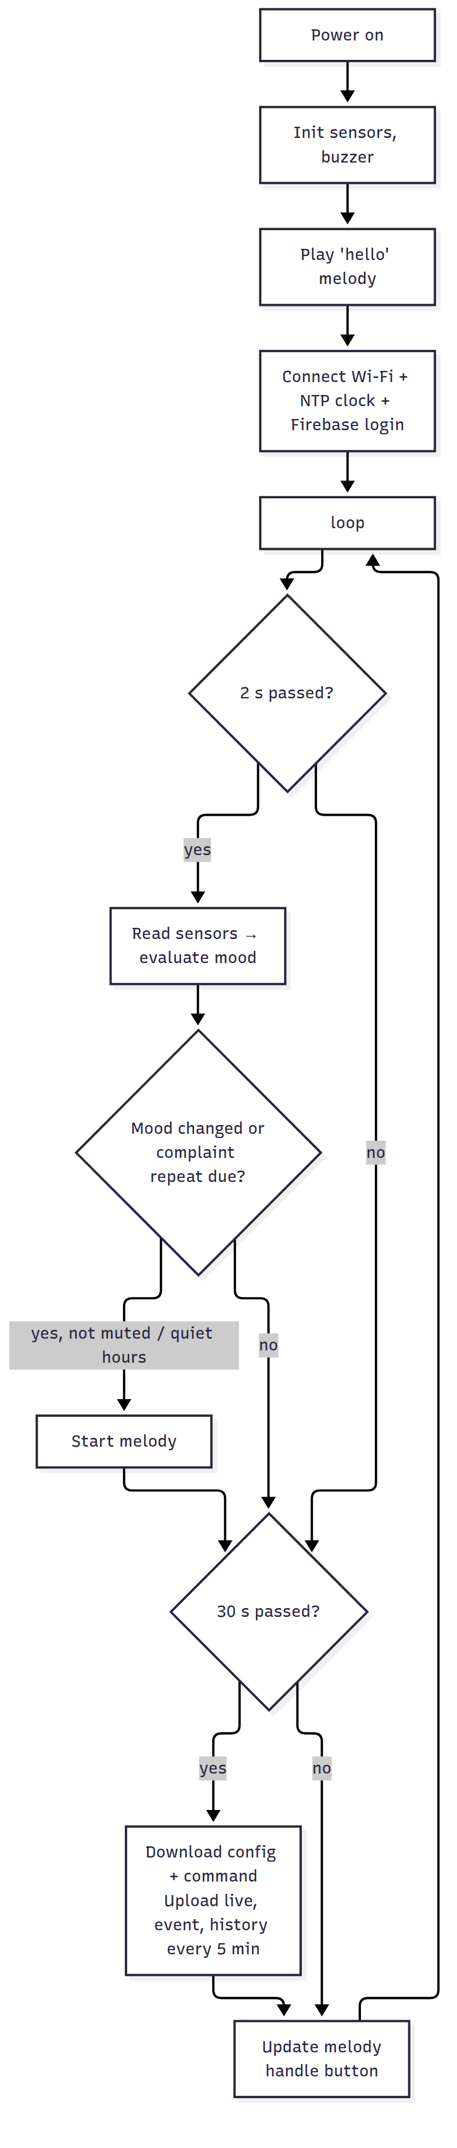

5.5 The sound alerts (buzzer melodies)
A passive buzzer plays a note when the ESP32 sends it a square wave with the note’s frequency (PWM). sound.cpp contains each melody as a list of (frequency, duration) notes, for example the “thank you” melody: G5 120 ms, C6 120 ms, E6 120 ms, G6 200 ms, …. The soundLoop() function moves to the next note when the time of the current note is over, so the melody plays without stopping the face animation or the sensors.
# | Melody | When
1 | Sad “help!” (played twice) | Thirsty 😫
2 | Fast bubbling notes | Too wet 🥴
3 | Alarm beeps | Hot 🥵
4 | Shivering trill | Cold 🥶
5 | Rising notes then a low note (“where is the sun?”) | Needs light 😞
6 | Happy arpeggio | Becomes happy 😊
7 | Joyful “thank you” | Happy after watering
8 | Slow lullaby | Night starts 😴
9 | Short “hello” | Power on
You can compose your own melodies by changing the notes in sound.cpp.

5.6 How the cloud connection works (REST API)
The firmware uses plain HTTPS requests (HTTPClient + ArduinoJson) instead of a big Firebase library. This makes the code small and easy to explain:
- Login: POST https://identitytoolkit.googleapis.com/v1/accounts:signInWithPassword?key=API_KEY with the email/password. The answer contains an idToken valid for 1 hour (the firmware renews it after 50 min).
- Write live: PUT {DB_URL}/plants/plant01/live.json?auth=idToken with a JSON body. "ts": {".sv": "timestamp"} asks Firebase to insert the server time.
- Add history / event: POST …/history.json creates a new child with a unique, time-ordered key.
- Read settings: GET …/config.json. Read a command: GET …/command.json, then DELETE it.

5.7 The emoji faces (in the apps, not on the plant)
The project has no screen. The ESP32 sends the mood name (happy, thirsty, …) to Firebase and the web dashboard and Android app show the matching emoji: 😊 happy · 😫 thirsty · 🥴 too wet · 🥵 hot · 🥶 cold · 😞 needs light · 😴 sleeping. On the plant itself, the mood is expressed by the melody of the buzzer. A press on the push button plays the current mood’s melody.

5.8 Changing behaviour
- Thresholds, quiet hours, mute: from the web app (no re-upload needed). The ESP32 reads them every 30 s.
- Intervals, soil calibration: config.h.
- Add a new mood: add it to enum Mood, evaluateMood(), moodName(), a melody in sound.cpp, and the texts in the apps.

5.9 Unit tests of the mood logic (on a PC)
cd tests
g++ -std=c++17 -I../firmware/Rayy test_mood.cpp ../firmware/Rayy/mood.cpp -o test_mood
./test_mood # → "33 checks, 0 failures"

06 · Web Application (Dashboard)
Code: web/: index.html, style.css, app.js, firebase-config.js. No build step is needed: it is plain HTML/CSS/JavaScript.

6.1 Features
- Login with Firebase Authentication (email + password).
- Mood card: big animated emoji, title and message. It turns orange when the plant needs something.
- Live cards: soil moisture (with bar), temperature, air humidity, light (lux), Wi-Fi signal.
- Online / offline badge: online if the plant sent data during the last 2 minutes.
- History chart (24 h) with a selector: moisture / temperature / humidity / light (Chart.js).
- Plant diary: the last 30 mood changes, with time.
- Play a sound on the plant: choose a melody → “Play”. The plant’s buzzer plays it within 30 s.
- Plant settings: name, thresholds, quiet hours, mute. They are saved in Firebase and the ESP32 applies them.
- Arabic (RTL) / English switch, dark mode automatic, responsive on phones.
- Demo mode with simulated data (no Firebase needed), useful for designing and presenting.
!Dashboard (Arabic, demo data)

6.2 Run it on your computer
The page uses JavaScript modules, so open it through a small local web server, not by double-clicking it:
cd rayy/web
python -m http.server 8000 # or: npx serve .
Open http://localhost:8000/?demo=1 (demo) or http://localhost:8000 (real data after configuring Firebase). In VS Code, the Live Server extension also works.

6.3 Connect it to your Firebase
Edit web/firebase-config.js and paste the firebaseConfig from Firebase (04, step 4). Keep PLANT_ID = "plant01", the same as in the firmware. While apiKey still starts with YOUR_, the page stays in demo mode.

6.4 Publish it online
cd rayy
firebase deploy --only hosting
→ https://<project-id>.web.app. Users must sign in with an account created in Firebase Authentication.

6.5 How the code works (app.js)
- firebaseSource() loads the Firebase SDK (v10, from Google’s CDN), signs in, and subscribes with onValue() to: live, history (last 288 points = 24 h), events (last 30) and config. Firebase pushes every change to the page in real time (WebSocket), so no refresh is needed.
- demoSource() makes the same calls with simulated data.
- renderLive(), renderChart(), renderEvents() and fillSettings() update the page.
- saveConfig() → update(plants/plant01/config), speak(n) → set(plants/plant01/command, {play: n}) (melody number 1–9).
- All the texts are in the TEXT.ar / TEXT.en dictionaries, so translation is easy.

07 · Android Application
Code: android/Rayy/, a native Android app in Kotlin + Jetpack Compose (Material 3) using the official Firebase Android SDK (Authentication + Realtime Database). It shows the same data as the web dashboard in a simple, phone-friendly design. It is in Arabic or English automatically, following the phone language.
Screen | Contents
Login | Email + password (the same accounts as the web)
🏠 Plant | Big emoji + mood message, last update, online/offline, moisture, temperature, humidity, light, Wi-Fi signal; Play button with the melody list; Mute switch
📈 History | Last 24 hours line chart. Choose moisture / temp / humidity / light. Min / average / max
📔 Diary | List of mood changes with emoji and time
Minimum Android version: 7.0 (API 24). Target: API 34.

7.1 Requirements
- Android Studio Panda (2025.3.1) or newer: https://developer.android.com/studio. It includes the JDK and Android SDK. The project uses Gradle 9.1.0 + Android Gradle Plugin 9.0.1 + Kotlin 2.2.21, which run on Java 17 up to Java 25, so the Java that comes with a recent Android Studio works without changing any setting.
- The google-services.json file from your Firebase project (04, step 5).

7.2 Open, build and run
⚠️ Folder path: English letters only. Put the project in a folder whose full path has no Arabic letters, for example E:\Rayy-Project\android\Rayy. A path like E:\Ray ري\... gives the error “Your project path contains non-ASCII characters”. The project includes android.overridePathCheck=true in gradle.properties to skip this check, but other build tools can still fail on such paths, so moving the folder is the safe fix.
- Copy google-services.json into android/Rayy/app/. Without it the build fails with “File google-services.json is missing”.
- Android Studio → File → Open → select the android/Rayy folder (Android Studio shows the project name Rayy) → wait for “Gradle sync” to finish (the first time it downloads Gradle 9.1.0 and the libraries, so an internet connection is required).
- Connect a phone with USB debugging enabled (Settings → About phone → tap “Build number” 7 times → Developer options → USB debugging), or create an emulator (Device Manager).
- Press ▶ Run. Sign in with a user from Firebase Authentication.
Make an APK to install on any phone: Build → Build App Bundle(s) / APK(s) → Build APK(s) → android/Rayy/app/build/outputs/apk/debug/app-debug.apk. Send it to the phone and install it (“allow unknown sources”).
“The project is using an incompatible version of the Android Gradle plugin”: your Android Studio is older than Panda (2025.3.1). Update Android Studio (Help → Check for Updates).
If the app shows no data but the web does, your database is probably not in the US region. Put its URL in DATABASE_URL in app/src/main/java/com/rayy/app/Model.kt.

7.3 Code structure
android/Rayy/ ← open this folder in Android Studio (project "Rayy")
├── settings.gradle.kts, build.gradle.kts, gradle.properties, gradlew (Gradle 9.1.0, AGP 9.0.1, Kotlin 2.2.21, Google Services 4.4.4)
└── app/
├── build.gradle.kts dependencies: Firebase BoM 33.1.0, Compose BoM 2024.09.00
├── google-services.json ← YOU add this file
└── src/main/
├── AndroidManifest.xml INTERNET permission
├── java/com/rayy/app/
│ ├── MainActivity.kt shows Login or Main screen
│ ├── PlantViewModel.kt Firebase login + real-time listeners (StateFlow)
│ ├── Model.kt data classes + PLANT_ID + parsing of snapshots
│ └── ui/
│ ├── LoginScreen.kt
│ ├── MainScreen.kt bottom navigation: Plant / History / Diary
│ ├── LineChart.kt small chart drawn with Canvas
│ ├── Moods.kt mood → emoji + texts, time format
│ └── Theme.kt green Material 3 theme (light / dark)
└── res/values/strings.xml (English) · res/values-ar/strings.xml (Arabic)
How it works: PlantViewModel listens to Firebase with addValueEventListener on live, history (limitToLast(288)), events (limitToLast(30)) and config, and puts the results in StateFlows. The Compose screens collect these flows and redraw automatically when the plant sends new data. “Play” writes command/play, and “Mute” writes config/muted.

7.4 Notes
- PLANT_ID in Model.kt must match the firmware (plant01).
- This app code was written for this project, but it could not be compiled in the environment where it was written (the Android SDK download was blocked there). Build it in Android Studio. If Studio asks to update the Android Gradle Plugin or Kotlin version, accept it: the code uses only standard, stable APIs.
- Possible extensions: push notifications when the plant is thirsty (Firebase Cloud Messaging + Cloud Functions; needs the paid “Blaze” plan, so it is listed as future work), a home-screen widget, and a settings screen like the web.

08 · Calibration and Testing

8.1 Calibrate the soil moisture sensor (important!)
Every capacitive sensor gives slightly different raw values. Calibrate it before you trust the percentages:
- Upload the firmware and open the Serial Monitor (115200). Each line shows soil=..% (raw XXXX).
- Hold the sensor in the air, dry. Note the raw value (e.g. 3050). This is SOIL_RAW_DRY.
- Put the sensor in a glass of water up to the white line. Note the raw value (e.g. 1280). This is SOIL_RAW_WET.
- Write both numbers in config.h and upload again.
- Check: dry soil should read about 10–25 %, and soil just after watering about 60–80 %.
The raw value is also uploaded to Firebase (live/soil_raw), so you can see it in the Firebase console too.

8.2 Choose thresholds for your plant
Plant type | Thirsty below | Too wet above | Light min (lux) | Hot above
Basil / mint (herbs) | 35 % | 85 % | 1000 | 35 °C
Pothos / indoor plants | 25 % | 80 % | 200 | 32 °C
Cactus / succulents | 10 % | 50 % | 2000 | 40 °C
Change them from the web app → Plant settings (no re-upload needed).

8.3 Test plan
# | Test | Steps | Expected result | ✔
T1 | Start-up | Plug in the power bank | “hello” melody; Serial Monitor shows the readings
T2 | Wi-Fi + Firebase | Watch the Serial Monitor | [cloud] signed in to Firebase, blue LED solid
T3 | Thirsty | Pull the soil sensor out (dry air) | 😫 face, melody 1, web + app show “Thirsty” within 30 s
T4 | Thank you | Put the sensor back in wet soil | 😊 face, melody 7 “thank you”, diary event
T5 | Too wet | Sensor in a glass of water | 🥴 face, melody 2
T6 | Hot | Warm the DHT22 with your hand / a hair dryer (carefully) > 35 °C | 🥵 face, melody 3
T7 | Cold | DHT22 near an ice pack < 10 °C | 🥶 face, melody 4
T8 | Needs light | Cover the BH1750 with your hand during the day | 😞 face, melody 5
T9 | Night | Set “day end” earlier or wait until 18:00 | 😴 face, lullaby once, no sounds in quiet hours
T10 | Repeat | Keep the plant thirsty for 30 min | The melody repeats once every 30 min
T11 | Mute | Web → mute → make it thirsty | Emoji in the apps changes, no sound
T12 | Play from app | Web/app → choose a melody → Play | The plant plays it within 30 s
T13 | Settings | Change “Thirsty below” to 60 % | The plant becomes thirsty within 30 s
T14 | Offline | Turn off the router | Face and sounds still work, LED blinks, web shows “Offline”; data resumes automatically when the router is back
T15 | Button | Press the button | The plant plays the current mood melody
T16 | Security | Open <database-url>/plants.json in a browser (not signed in) | Permission denied
T17 | Power bank | Run on a 10,000 mAh power bank | Works for ≈ 2 days
T18 | Android | Install the APK, sign in | The same values as the web, updated in real time
T19 | Unit tests | tests/test_mood | 33 checks, 0 failures
Record the results (photos, screenshots, history charts) for the report’s Testing and Results chapter.

09 · 6-Week Project Plan and Team Roles

9.1 Team roles (6 members)
Role | Main responsibility
Team leader + integration | Planning, meetings, purchasing, final integration, presentation
Hardware & wiring | Sensors, buzzer, button, breadboard → final board, enclosure
Firmware (ESP32) | Arduino code, calibration, mood logic, melodies
Firebase + web | Firebase project, rules, web dashboard, hosting
Android | Android app, building and testing the APK
Documentation + testing | Test plan, screenshots, report writing, demo video
Everyone tests the system and writes their own part of the report.

9.2 Weekly plan
Week | Goals | Deliverables
1 | Approve the proposal. Study the docs. Order the components. Create the Firebase project and accounts. Install Arduino IDE + Android Studio | Components bought, Firebase ready
2 | Breadboard: ESP32 + buzzer (melodies), then BH1750, DHT22 and the soil sensor. Calibrate the soil sensor | Melodies and readings working
3 | Mood logic, Wi-Fi + Firebase upload, button. Test with the Firebase console | Data visible in Firebase
4 | Web dashboard (publish on Firebase Hosting). Android app (build the APK) | Web + Android with live data
5 | Final assembly in a box on the pot. 2-day test on the power bank. Fix bugs | Finished prototype
6 | Run the full test plan (08), write the report, slides, demo video, rehearse | Final report, presentation, demo
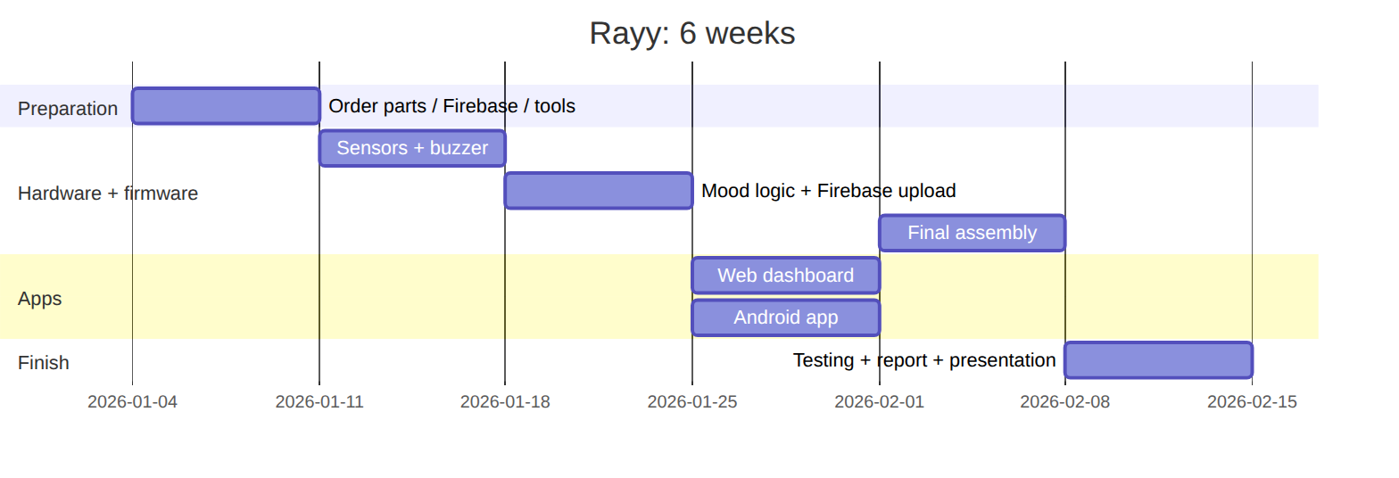 (Change the dates to your semester.)

9.3 Risks and mitigation
Risk | Mitigation
Components arrive late | Order in week 1 from a local shop. Buy a spare sensor
Burned module (wrong polarity) | Check VCC/GND twice before plugging in the USB cable
College Wi-Fi blocks devices / needs a login page | Use a phone hotspot (2.4 GHz) for the demo
Power bank turns off by itself | Use one with an “always-on” mode or a USB phone charger
Android build problems | Use the web dashboard (it also works on phones) as a backup, and build the APK early (week 4)
Firebase settings wrong | Test with the curl commands in 04 and the web demo mode

10 · Graduation Report Outline, Presentation and Future Work

10.1 Suggested report chapters
- Introduction: the idea, the problem (plants die from forgotten watering and wrong light/temperature), objectives (01 §1.2), importance (from the proposal), scope, and report organization.
- Background / literature review: IoT, microcontrollers (ESP32 vs ESP8266 vs Arduino UNO), sensors (capacitive vs resistive soil sensors, BH1750 vs LDR, DHT22 vs DHT11), cloud platforms (Firebase vs others, 04), buzzers and PWM sound, and similar existing products (smart pots, plant monitors).
- System analysis: functional and non-functional requirements, use-case diagram, context diagram, mood rules (01).
- System design:
  - block diagram / architecture (README)
  - hardware design: component selection (02), wiring diagram + pin table (03), power consumption (02 §2.3)
  - software design: firmware flowchart (05 §5.4), database structure (04 §4.2), security rules, user-interface designs (web + Android screenshots)
- Implementation: photos of each step, important code snippets (mood engine, Firebase REST, face drawing), web and Android implementation, enclosure.
- Testing and results: the test plan with results (08), calibration tables, 24-hour charts (moisture, temperature, light), power-bank running time, screenshots.
- Conclusion and future work.
- References and appendices (full code, BOM with prices, user manual).

10.2 Presentation and demo tips
- Start with the story: “Plants can’t talk… until now 🌱😊”.
- Live demo: pull out the soil sensor → the plant plays its sad “thirsty” melody and the emoji changes on the web dashboard and the phone at the same time → water it → the joyful “thank you” melody 😊. This is the most impressive moment.
- Press “Play” from the phone in front of the committee: the plant plays the melody.
- Show the history chart of a full day (prepare it the day before) to show how the soil dries over time.
- Bring a backup video of the demo and a charged power bank. Use a phone hotspot.

10.3 Future work
- 💦 Automatic watering: a small 5 V pump + relay/MOSFET when the plant is thirsty, with a water-tank level sensor.
- 🔔 Push notifications on the phone (Firebase Cloud Messaging + Cloud Functions).
- 🌈 A small screen on the plant (e.g. colour TFT ST7789) to show the emoji next to the plant too.
- 🧠 AI: predict when the plant will need water from the history, or detect plant diseases with a camera (ESP32-CAM).
- 🗣️ Spoken sentences instead of melodies with a DFPlayer Mini MP3 module + speaker (recorded voice: “I’m thirsty!”), and voice commands with a microphone.
- ☀️ Solar power: solar panel + Li-ion battery + charger so the plant is fully independent and eco-friendly.
- 🔐 Certificate validation for HTTPS, per-user rules, and multiple plants per user.
- 🔋 A custom PCB and a 3D-printed pot with the electronics built in.
- 🌍 Multi-plant dashboard for schools / greenhouses.

