Smart Emoji Plant
  - Solar-powered IoT plant that expresses its feelings with emoji and voice: full project documentation
Table of Contents

00 · Project overview
Graduation project. The plant turns its live readings (soil moisture, light and temperature) into emoji faces on a small screen and voice messages from a speaker. It sends its data to the cloud, where a web dashboard and an Android app show it. It runs on solar energy.
😊 Happy | 😫 Thirsty | 🥴 Too wet | 🥵 Too hot | 🥶 Cold | 😞 Needs light | 😴 Sleeping

1. What is in this folder
Folder / file | What it contains
docs/ | Full project documentation (read it in order 01 → 10)
firmware/SmartPlant/ | ESP32 program (Arduino IDE): sensors, emoji faces, voice, Firebase
web/ | Web dashboard (HTML + CSS + JavaScript, Arabic / English)
android/ | Android application (Kotlin + Jetpack Compose, Arabic / English)
firebase/database.rules.json | Security rules for the Realtime Database
firebase.json | Firebase Hosting + rules deploy configuration
sound/ | The voice messages to record and copy to the micro-SD card
tests/ | Unit tests of the plant “mood” logic (run on a PC)

2. Documentation index
- Requirements and system analysis
- Hardware components (bill of materials) and power budget
- Wiring and assembly
- Database: why Firebase, and the step-by-step setup
- ESP32 firmware: installation and how the code works
- Web application
- Android application
- Calibration and testing
- 6-week project plan and team roles
- Graduation report outline, presentation and future work

3. System architecture
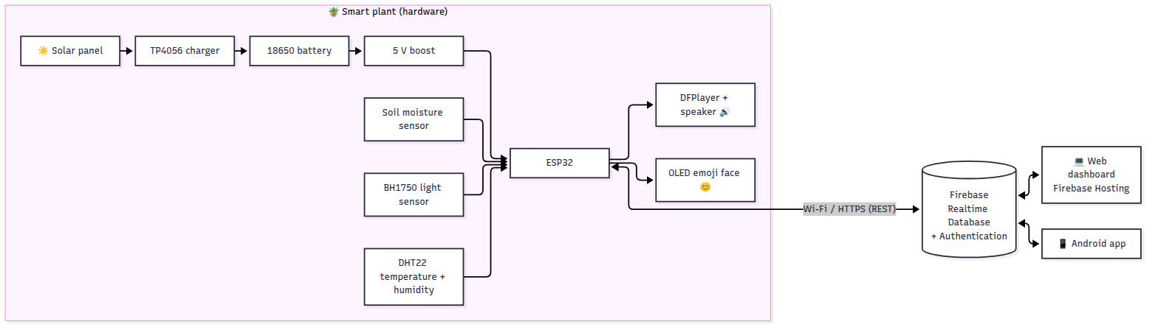
- The ESP32 reads the sensors every 2 s, chooses a mood, draws the emoji and plays a voice message. It works without internet too: the face and voice keep working, and only the cloud upload stops.
- Every 30 s it uploads the live data. Every 5 min it saves a history point. Each time the mood changes it writes an event. It also downloads the config (thresholds, mute, volume) set from the apps.
- The web and Android apps sign in with Firebase Authentication and update in real time. They can change the settings and press “Speak now”, and the plant talks.

4. Quick start (summary)
- Buy the parts in docs/02 and wire them as in docs/03.
- Create the Firebase project as in docs/04.
- Edit firmware/SmartPlant/config.h (Wi-Fi + Firebase) and upload it with the Arduino IDE (docs/05).
- Paste your Firebase web config into web/firebase-config.js and deploy it with firebase deploy (docs/06).
- Put google-services.json in android/app/, open android/ in Android Studio and press ▶ (docs/07).
- Record the voice files (sound/), copy them to the micro-SD card, and calibrate the soil sensor (docs/08).
💡 Try the web dashboard without any hardware: open web/index.html?demo=1 through a local web server (see docs/06). It shows simulated plant data.

01 · Requirements and System Analysis

1.1 Project idea (from the proposal)
An interactive plant that expresses its feelings with emoji and sound. It runs on solar power and uses Internet of Things (IoT) technology. The plant’s live readings (soil moisture, light and temperature) become digital facial expressions (emoji) and voice alerts. A sustainable solar energy system powers it.
Importance
- Keeps plants alive: it watches watering and soil moisture so the plant never reaches drought or death.
- Environmental awareness and smart interaction: a fun, innovative way to “talk” with plants through IoT, emoji and voice alerts.
- Sustainability: it runs entirely on solar energy, so it is eco-friendly and saves energy.
Duration: 6 weeks. Team: 6 members.

1.2 Objectives
- Measure soil moisture, light intensity, air temperature and humidity automatically.
- Show the plant’s state as an animated emoji face on a display next to the plant.
- Play voice messages (“I’m thirsty!”, “Thank you!”, …) when the plant needs something.
- Send the data to the cloud (Firebase) and show it on a web dashboard and an Android app.
- Power the whole system with a solar panel + rechargeable battery.
- Let the user change the plant thresholds, mute the voice, and make the plant speak from the apps.

1.3 Why the ESP32 (and not the ESP8266)
Need of this project | ESP32 | ESP8266
Analog inputs (soil sensor, battery voltage, solar voltage = 3 analog signals) | ✅ 18 ADC channels | ❌ only 1 ADC pin
Hardware serial port for the DFPlayer (voice) | ✅ 3 UARTs | ⚠️ 1 UART (used by USB)
HTTPS (Firebase) memory | ✅ 520 KB RAM | ⚠️ 80 KB, often unstable with TLS
Deep sleep to save battery | ✅ | ✅
Price | ~ same | ~ same
➡️ Use the ESP32 DevKit V1 (ESP-WROOM-32). The ESP8266 would need an extra ADC chip and software serial.

1.4 Functional requirements
ID | Requirement
FR-1 | The system shall read soil moisture (%) every 2 seconds.
FR-2 | The system shall read light intensity (lux), air temperature (°C) and humidity (%).
FR-3 | The system shall decide the plant mood: happy, thirsty, drowning (too wet), hot, cold, needs light, sleeping.
FR-4 | The system shall display an animated emoji face for the mood on the OLED screen, and a data screen.
FR-5 | The system shall play a voice message when the mood changes, and repeat a complaint every 30 min (configurable).
FR-6 | The system shall stay silent during quiet hours (default 22:00–07:00) and when muted.
FR-7 | The system shall upload the live readings to Firebase every 30 s, a history point every 5 min, and an event on each mood change.
FR-8 | The system shall measure the battery and solar panel voltage and report the battery % and charging state.
FR-9 | The system shall enter ECO mode (deep sleep 15 min between readings) when the battery is low.
FR-10 | The web and Android apps shall require a login (email + password).
FR-11 | The apps shall show the emoji mood, all live values, online/offline status, last-update time.
FR-12 | The apps shall show a 24-hour history chart and the “plant diary” (list of mood changes).
FR-13 | The apps shall let the user make the plant speak a chosen message (“Speak now”) and mute it.
FR-14 | The web app shall let the user edit thresholds (moisture, temperature, light), quiet hours and volume.
FR-15 | The apps shall support Arabic and English.
FR-16 | A push button on the plant: short press = change screen, long press = speak the current mood.

1.5 Non-functional requirements
ID | Requirement
NFR-1 | Availability: the face and voice must work even without Wi-Fi/internet (local decision on the ESP32).
NFR-2 | Energy: the device must run day and night on solar power (≥ 1 day of battery autonomy).
NFR-3 | Security: only signed-in users can read or write the database (Firebase rules). Passwords are never stored in the apps.
NFR-4 | Performance: live data appears in the apps less than 35 s after a change.
NFR-5 | Usability: the apps are simple, bilingual, and work on phones (responsive design).
NFR-6 | Cost: total hardware cost around 250–450 SAR.
NFR-7 | Maintainability: clear modular code, configuration in one file (config.h).
NFR-8 | Safety: protected Li-ion charger, fuse-free low voltage (≤ 7 V), battery kept out of direct sun.

1.6 Hardware requirements (summary; details in 02)
ESP32 DevKit V1 · capacitive soil moisture sensor v1.2 · BH1750 light sensor · DHT22 temperature/humidity sensor · 0.96” OLED SSD1306 (I2C) · DFPlayer Mini + micro-SD + 3 W speaker · push button · 6 V 5–6 W solar panel · TP4056 charger (with protection) · 2 × 18650 Li-ion + holder · MT3608 5 V boost · switch · 1N5819 diode · resistors (100 kΩ ×3, 47 kΩ, 1 kΩ) · 100 nF capacitor · wires, breadboard/PCB, enclosure.

1.7 Software requirements
Part | Tool / technology
Firmware | Arduino IDE 2.x + “esp32 by Espressif” core 3.x, C++
Arduino libraries | Adafruit SSD1306, Adafruit GFX, DHT sensor library, Adafruit Unified Sensor, BH1750 (Christopher Laws), DFRobotDFPlayerMini, ArduinoJson 7
Cloud / database | Firebase: Realtime Database, Authentication (email/password), Hosting
Web app | HTML5, CSS3, JavaScript (ES modules), Firebase JS SDK 10, Chart.js 4
Android app | Android Studio (Koala or newer), Kotlin, Jetpack Compose (Material 3), Firebase Android SDK (BoM 33)
Tools | Node.js + firebase-tools (deploy), Audacity (voice recording), Git

1.8 Users and use cases
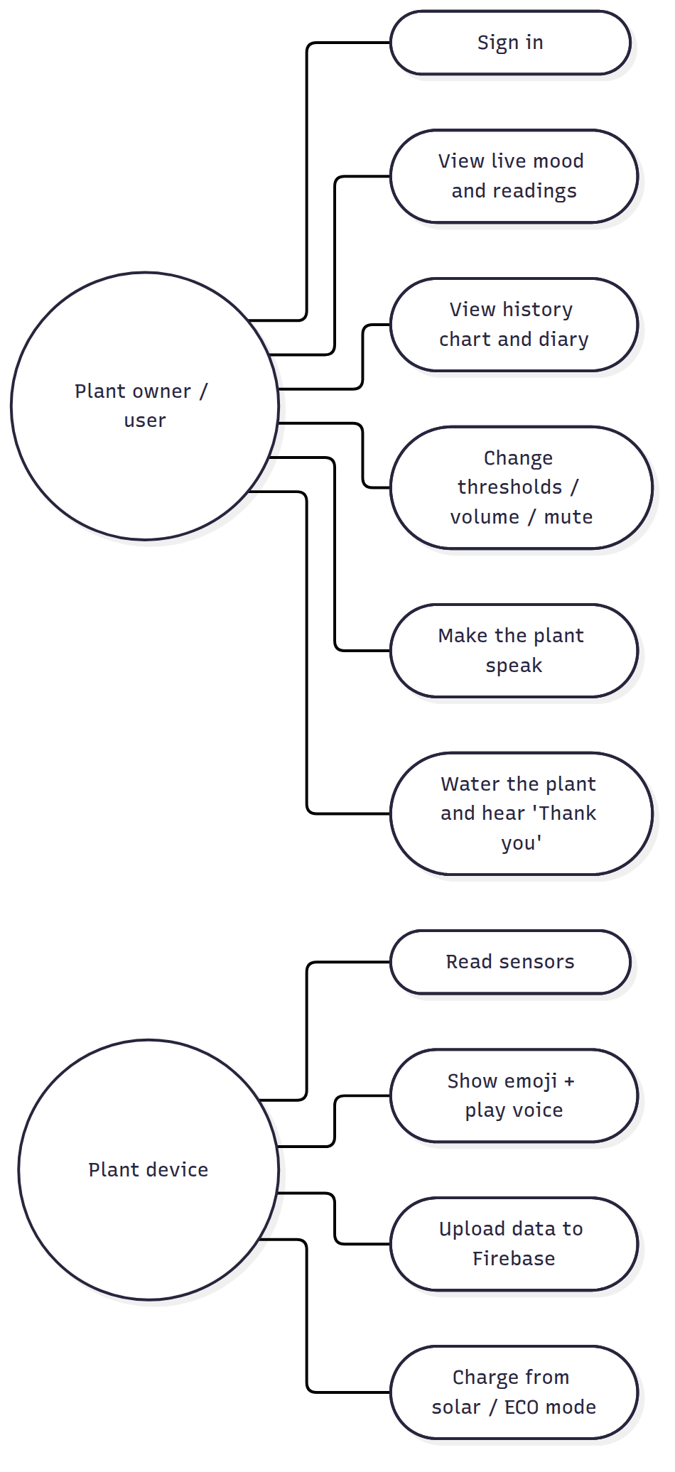

1.9 Mood rules (the “brain” of the plant)
Rules are checked in this order (the first that matches wins). Thresholds can be changed from the web app.
Priority | Condition (defaults) | Mood | Face | Voice track
1 | soil moisture < 30 % | Thirsty | 😫 | 0001
2 | soil moisture > 85 % | Too wet (drowning) | 🥴 | 0002
3 | temperature > 35 °C | Hot | 🥵 | 0003
4 | temperature < 10 °C | Cold | 🥶 | 0004
5 | night (18:00–06:00) | Sleeping | 😴 | 0008 (once)
6 | day and light < 200 lux | Needs light | 😞 | 0005
7 | otherwise | Happy | 😊 | 0006 / 0007 “Thank you” after watering
- Hysteresis: a problem is “solved” only when the value is better by a margin (5 % moisture, 1 °C, 50 lux). This stops the face from flickering around a threshold.
- Voice: the plant plays a voice message when the mood changes. A complaint repeats every 30 min. The plant is silent during quiet hours or when muted.

1.10 Context diagram
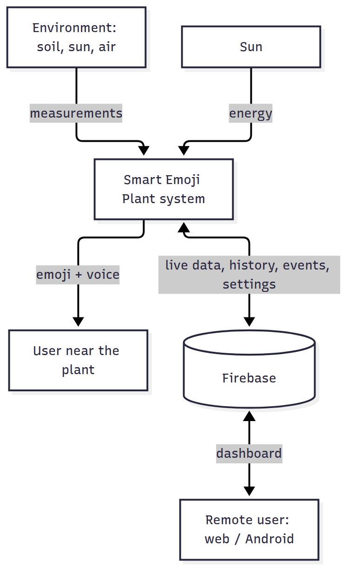

02 · Hardware Components (Bill of Materials) and Power Budget

2.1 Bill of materials
Prices are approximate (SAR, 2025–2026) and depend on the shop. Buy 1–2 spare sensors in case one is damaged.
# | Component | Exact model / spec to ask for | Qty | Purpose | ≈ SAR
1 | Microcontroller | ESP32 DevKit V1 (ESP-WROOM-32, 30 or 38 pin, CP2102 or CH340 USB) | 1 | Brain + Wi-Fi | 35–55
2 | Soil moisture sensor | Capacitive soil moisture sensor v1.2 (analog). Not the resistive fork type; it rusts | 1 (+1 spare) | Soil water % | 10–20
3 | Light sensor | BH1750 (GY-302) I2C module | 1 | Light in lux | 10–20
4 | Temperature + humidity | DHT22 / AM2302 module (3 pins, with pull-up) | 1 | Air temp + humidity | 20–35
5 | Display | 0.96” OLED SSD1306 128×64, I2C (4 pins). A 1.3” SSD1306 or 2.42” SSD1309 I2C also works | 1 | Emoji face | 15–35
6 | MP3 player | DFPlayer Mini (YX5200 / MP3-TF-16P) | 1 | Voice messages | 10–20
7 | Memory card | micro-SD 1–16 GB, FAT32 | 1 | Voice MP3 files | 15–25
8 | Speaker | 3 W, 4 Ω or 8 Ω, 40–50 mm | 1 | Sound | 10–20
9 | Solar panel | 6 V, 5–6 W (≈ 1 A) mono-crystalline, with wires | 1 | Energy | 40–80
10 | Charger | TP4056 module with protection (DW01 + 8205; has B+/B− and OUT+/OUT−), USB-C | 1 | Charges battery safely | 5–10
11 | Battery | 18650 Li-ion 3.7 V, 2600–3500 mAh, genuine brand (Samsung, LG, Panasonic, Sony) | 2 | Energy storage | 30–60
12 | Battery holder | 2 × 18650 holder (wire it in parallel) or 2 single holders | 1 | — | 5–10
13 | Boost converter | MT3608 DC-DC step-up (2 A), set to 5.0 V | 1 | 3.7 V → 5 V | 5–10
14 | Diode | 1N5819 Schottky (1 A) | 1 | Stops battery draining into panel at night | 1
15 | Switch | SPDT slide or rocker switch | 1 | Power on/off | 2–5
16 | Push button | 6 × 6 mm tactile or 12 mm panel button | 1 | Screen / speak | 1–5
17 | Resistors | 100 kΩ ×3, 47 kΩ ×1, 1 kΩ ×1, (10 kΩ ×1 if DHT22 is a bare 4-pin sensor) | — | Dividers, DFPlayer RX | 2–5
18 | Capacitors | 100 nF ceramic ×2, 470–1000 µF / 10 V electrolytic ×1 | — | ADC filter, DFPlayer supply | 2–5
19 | Wiring | Breadboard (testing), jumper wires M-M / M-F, then perfboard / PCB + header pins, soldering kit | — | Connections | 20–40
20 | Enclosure | Waterproof ABS box (≈ 150 × 100 × 70 mm) with a window for the OLED, or a 3D-printed case; cable glands | 1 | Protection | 15–40
21 | Plant | Small potted plant (e.g. basil, mint, pothos) | 1 | 🌿 | 15–30
 |  |  |  | Total (approx.) | ≈ 270 – 520

Optional / nice to have
- Multimeter (essential for setting the MT3608 to 5.0 V and calibrating): 30–60 SAR.
- USB power bank + USB cable: powers the project during development before the solar part is ready.
- CN3791 MPPT 6 V solar charger instead of TP4056: more efficient with solar panels (≈ 25 SAR).
- Water pump + relay for automatic watering (see future work in 10).

2.2 Why each component
- Capacitive soil sensor: it has no exposed metal in the soil, so it does not corrode like the cheap resistive sensors.
- BH1750: it gives real lux values, which are better than an LDR for deciding “needs light”. It shares the I2C bus with the OLED.
- DHT22: it is more accurate than the DHT11 (±0.5 °C) and has a wider range (−40…80 °C). That matters in Saudi summers.
- OLED SSD1306: it has high contrast, uses little power, needs only 2 data wires (I2C), and makes clear emoji drawings.
- DFPlayer Mini: it plays real recorded voice (Arabic or English) from an SD card. Its built-in 3 W amplifier drives a speaker directly.
- TP4056 + 18650 + MT3608: this is the classic, cheap and safe solar power chain. The TP4056 protection board stops over-charge, over-discharge and short circuit.

2.3 Power budget (energy calculation)
Load | Current @ 5 V (average)
ESP32 with Wi-Fi connected (modem sleep) | ≈ 60 mA
ESP32 board regulator + USB chip + power LED | ≈ 10 mA
OLED (face drawn, ~30 % pixels on) | ≈ 12 mA
DFPlayer idle (+ a few seconds of voice per hour) | ≈ 18 mA
Soil sensor + DHT22 + BH1750 | ≈ 7 mA
Total | ≈ 107 mA @ 5 V ≈ 0.54 W
- With the boost converter (~85 % efficiency), the battery provides about 0.63 W, or ≈ 15 Wh per day.
- Battery: 2 × 3000 mAh × 3.7 V ≈ 22 Wh, which gives about 35 hours without any sun (more than one night plus a cloudy day).
- Solar panel: 6 W × ≈ 5.5 peak-sun-hours (Riyadh average) × 0.6 (losses: TP4056 not MPPT, angle, dust, heat) ≈ 20 Wh/day. That is more than the 15 Wh/day the device uses, so ✅ the system is energy-positive.
- If the battery still drops below 3.45 V (for example, after several cloudy days or a dusty panel), the firmware enters ECO mode. The screen turns off and the ESP32 deep-sleeps, waking every 15 minutes to measure and upload. It returns to normal mode by itself when the solar panel recharges the battery.
⚠️ The panel must see the sun. Indoor light is ~100× weaker than sunlight and cannot charge the battery. If the plant is indoors, put the panel on a window or outside with a long cable (the plant can stay inside).

2.4 Safety notes
- Use only protected TP4056 modules and good-quality 18650 cells. Never short-circuit a cell.
- Put both cells in parallel (+ to +, − to −) only when they are at the same voltage (charge both fully first).
- Li-ion must not be charged above 45 °C. In summer, keep the battery box in the shade and ventilated, and never put it under the solar panel in direct sun.
- Do not use a 9 V or 12 V panel with the TP4056 (maximum input is 8 V).
- Turn the power switch OFF while the ESP32 is connected to the computer by USB.

03 · Wiring and Assembly
!Wiring diagram
(Vector version: images/wiring-diagram.svg)

3.1 ESP32 pin map
ESP32 pin | Connected to | Notes
VIN | 5 V rail (MT3608 VOUT+) | The board’s own regulator makes 3.3 V
GND | GND rail | All grounds together
3V3 | 3.3 V rail | Feeds the sensors and OLED (total < 100 mA)
GPIO34 | Soil sensor AOUT | Input-only ADC1 pin
GPIO35 | Battery divider middle point | Input-only ADC1 pin
GPIO39 (VN) | Solar divider middle point | Input-only ADC1 pin
GPIO4 | DHT22 DATA/OUT
GPIO21 | I2C SDA: OLED + BH1750 | Shared bus
GPIO22 | I2C SCL: OLED + BH1750 | Shared bus
GPIO17 (TX2) | 1 kΩ resistor → DFPlayer RX | The resistor removes noise / buzzing
GPIO16 (RX2) | DFPlayer TX
GPIO13 | Push button → GND | Internal pull-up is used
GPIO2 | On-board blue LED | Solid = connected to Firebase, blinking = offline
Analog sensors must use ADC1 pins (GPIO32–39). ADC2 pins stop working when Wi-Fi is on.

3.2 Module by module

Capacitive soil moisture sensor v1.2
Sensor pin | Connect to
VCC | 3.3 V
GND | GND
AOUT | GPIO34
Push the sensor into the soil up to the white line only. The electronics at the top must stay dry. To make it waterproof, cover the top edge and the electronics with nail polish, hot glue or heat-shrink.

DHT22 (module with 3 pins)
Sensor pin | Connect to
+ (VCC) | 3.3 V
OUT (DATA) | GPIO4
− (GND) | GND
If you have the bare 4-pin DHT22: pin 1 = VCC, pin 2 = DATA (add a 10 kΩ resistor DATA → 3.3 V), pin 3 = not connected, pin 4 = GND. Place it in the shade, not inside the closed box (the electronics heat the box).

BH1750 light sensor (GY-302)
Sensor pin | Connect to
VCC | 3.3 V
GND | GND
SCL | GPIO22
SDA | GPIO21
ADDR | GND (address 0x23)
Point it up, next to the plant leaves, and keep it out of the shadow of the box.

OLED 0.96” SSD1306 I2C
OLED pin | Connect to
VCC | 3.3 V
GND | GND
SCL | GPIO22
SDA | GPIO21
Some OLEDs have the pins in the order GND-VCC-SCL-SDA and others VCC-GND-SCL-SDA. Read the labels! If the I2C address is 0x3D instead of 0x3C (rare), change it in display.cpp.

DFPlayer Mini + speaker
DFPlayer pin | Connect to
VCC | 5 V rail (with a 470–1000 µF capacitor between VCC and GND close to the module)
GND (either GND pin) | GND
RX | 1 kΩ resistor → GPIO17
TX | GPIO16
SPK_1 and SPK_2 | the two speaker wires
Do not connect a speaker pin to GND. The amplifier output is bridged.

Push button
One leg → GPIO13, the other leg → GND.

3.3 Power section (solar → battery → 5 V)
- Solar panel + → 1N5819 diode (stripe side towards the TP4056) → TP4056 IN+. Solar panel − → TP4056 IN−.
- TP4056 B+ / B− → battery holder + / − (2 × 18650 in parallel).
- TP4056 OUT+ → switch → MT3608 VIN+. TP4056 OUT− → MT3608 VIN−.
- Before connecting anything to the MT3608 output, turn the switch on, measure VOUT with a multimeter and turn the small brass screw until it reads 5.0 V (counter-clockwise usually lowers the voltage).
- MT3608 VOUT+ → 5 V rail (ESP32 VIN + DFPlayer VCC). MT3608 VOUT− → GND rail.

Voltage measurement dividers
- Battery: B+ → 100 kΩ → middle point → 100 kΩ → GND. Middle point → GPIO35, plus a 100 nF capacitor from the middle point to GND. A full battery (4.2 V) gives 2.1 V at the pin.
- Solar: panel + (before the diode) → 100 kΩ → middle point → 47 kΩ → GND. Middle point → GPIO39. A 7.2 V open-circuit panel gives 2.3 V at the pin (safe; the maximum is 3.3 V).
⚠️ Programming: turn the power switch OFF when the ESP32 is plugged into the computer. Otherwise USB 5 V and the boost converter both feed the same pin. During development you can power everything from USB only. The firmware detects “no battery” (< 2.5 V on GPIO35) and shows 100 %.

3.4 Assembly steps (recommended order)
- Breadboard test (week 2): connect the ESP32 + OLED only, then upload the firmware with the battery parts not connected. Check that the face appears.
- Add the BH1750 and DHT22 and check the readings in the Serial Monitor (115200 baud).
- Add the soil sensor and calibrate it (08).
- Add the DFPlayer + speaker + SD card and check that the “hello” voice plays at start.
- Build the power chain separately. Set the MT3608 to 5.0 V, then connect it to the ESP32 VIN.
- Move everything to a perfboard / soldered PCB with header pins, so modules can be replaced.
- Enclosure: OLED behind a window at the front, speaker grill holes, the button on the side, cable glands for the soil sensor and solar cable, and ventilation holes. Mount the solar panel at about 25° tilt facing south (best average angle for Riyadh).

3.5 Typical problems
Problem | Cause / solution
OLED stays black | SDA/SCL swapped, VCC/GND swapped, or address 0x3D
BH1750 not found | Check SDA/SCL. Run an “I2C scanner” sketch: you should see 0x23 and 0x3C
DHT22 reads nan | Wrong pin, missing pull-up (bare sensor), or reading faster than every 2 s
Soil % always 0 or 100 | Not calibrated (see 08), or the sensor is on a non-ADC1 pin
DFPlayer silent | SD card not FAT32, files not in the /mp3 folder, not named 0001.mp3, TX/RX swapped
Buzzing sound | Missing 1 kΩ resistor or missing capacitor on DFPlayer VCC; use short wires
ESP32 resets when playing sound | 5 V supply too weak: check the MT3608 and the battery, and add the 1000 µF capacitor
Battery % wrong | Calibrate BATTERY_CAL in config.h with a multimeter

04 · Database: Why Firebase, and Step-by-Step Setup

4.1 Which database should we use? (recommendation)
Yes: use Firebase for the whole project. One free Firebase project gives everything this project needs:
Need | Firebase service | Free “Spark” plan
Store the live data, history, events and settings | Realtime Database | 1 GB stored, 10 GB/month download, 100 simultaneous connections
Login for the web and Android apps (and the ESP32) | Authentication (email/password) | Free
Publish the web dashboard on the internet (https://your-project.web.app) | Hosting | 10 GB storage, 360 MB/day transfer
Android app connection | Firebase Android SDK | Free
Why Firebase Realtime Database fits this project best
- Real time: when the ESP32 writes new data, the web page and the Android app update instantly, with no refresh.
- No server to build: we don’t need PHP, Node.js or a hosted MySQL server. The ESP32 talks to Firebase directly over HTTPS.
- One database for the 3 parts: the ESP32 (REST API), the web (JavaScript SDK) and Android (Kotlin SDK).
- Free for this size: the plant writes ≈ 3,000 small messages a day (≈ 1 MB/day). That is far below the limits.
- Secure: rules allow only signed-in users (firebase/database.rules.json).
- Very well documented, popular for graduation projects, and available in Saudi Arabia.
Alternatives we compared
Option | Verdict
Firebase Realtime Database | ✅ Chosen: simplest for IoT, real time, free
Cloud Firestore | Good too, but the REST API from the ESP32 is more complex (typed JSON), and it is billed per read
MySQL + PHP (XAMPP / hosting) | Needs a server and hosting, a REST API you write yourself, and polling instead of real time; more work in 6 weeks
ThingSpeak / Blynk | Fast for charts, but limited custom apps, free-plan limits, and less “own system” for a graduation project
Supabase (PostgreSQL) | Good, but less ESP32 material and more setup
Are we “allowed” to use Firebase? Technically yes: the free plan is enough, and nothing in this project needs a paid plan (no Cloud Functions are used). Whether external cloud services are accepted is your college’s/supervisor’s decision. Most IoT graduation projects use Firebase, and it is a professional Google platform, so it is usually accepted. Explain in your report that you chose it because it gives real-time sync + authentication + hosting in one platform (the reasons above).

4.2 Database structure
plants/
plant01/ ← PLANT_ID (one per ESP32)
live/ ← overwritten every 30 s by the ESP32
moisture: 46 (%)
temperature: 27.4 (°C)
humidity: 38 (%)
lux: 5400
battery_pct: 87
battery_v: 4.02
solar_v: 6.3
charging: true
soil_raw: 2190 (for calibration)
mood: "happy" happy | thirsty | drowning | hot | cold | need_light | sleepy
rssi: -61 (Wi-Fi signal)
ip: "192.168.1.23"
uptime_s: 86400
ts: 1767000000000 (server time, milliseconds)
history/
-Nx1a2b3.../ { moisture, temperature, humidity, lux, battery_pct, mood, ts } ← every 5 min
events/
-Nx9z8y7.../ { mood: "thirsty", message: "I am thirsty, please water me!", ts } ← on mood change
config/ ← written by the web / Android app, read by the ESP32
name: "Basil"
moisture_min: 30 moisture_max: 85
temp_min: 10 temp_max: 35
lux_min: 200
quiet_start: 22 quiet_end: 7
volume: 25 muted: false
command/ ← "Speak now" button; deleted by the ESP32 after playing
play: 1

4.3 Step-by-step setup (≈ 20 minutes)

Step 1: Create the project
- Go to https://console.firebase.google.com and sign in with a Google account (use a team account).
- Add project → name it smart-plant → you can disable Google Analytics → Create project.

Step 2: Authentication
- Left menu Build → Authentication → Get started.
- Sign-in method tab → Email/Password → Enable → Save.
- Users tab → Add user and create:
  - device@smartplant.app with a strong password. The ESP32 uses this account (put it in config.h).
  - One account for each team member / user, e.g. team@smartplant.app. The web and Android apps use these. (The email does not need to exist; Firebase does not send emails for users added by hand.)

Step 3: Realtime Database
- Build → Realtime Database → Create database.
- Location: Belgium (europe-west1) (closest to Saudi Arabia) or United States.
- Start in locked mode → Enable.
- Copy the database URL shown at the top, e.g. https://smart-plant-1234-default-rtdb.europe-west1.firebasedatabase.app.
- Rules tab → delete everything → paste the content of firebase/database.rules.json → Publish.

Step 4: Web app keys
- ⚙️ Project settings → General → under “Your apps” click the </> (Web) icon.
- Nickname smart-plant-web → Register app.
- Copy the firebaseConfig = { apiKey: ..., ... } values into web/firebase-config.js. Check that databaseURL is your URL from step 3.
- The same Web API Key (apiKey) goes into FIREBASE_API_KEY in firmware/SmartPlant/config.h.
The web apiKey is not a secret. It only identifies the project. The data is protected by Authentication + Rules, so publishing it is normal.

Step 5: Android app
- Project settings → General → Add app → Android.
- Android package name: com.smartplant.app → Register.
- Download google-services.json and copy it to android/app/google-services.json. (Download it after creating the Realtime Database, so it contains the database URL.)
- Next → Next → Continue to console. The Gradle steps are already done in this project.

Step 6: Hosting (publish the web dashboard)
On a computer with Node.js LTS installed:
npm install -g firebase-tools
firebase login
cd smart-plant-iot # this folder (contains firebase.json)
firebase use --add # choose your project, alias "default"
firebase deploy --only hosting,database
The dashboard is now online at https://<project-id>.web.app 🎉 (open it from any phone or PC).

4.4 Testing the database without the ESP32
In the Firebase console → Realtime Database → Data tab, you can add data by hand to test the apps: click + next to the root → plants → plant01 → live → add moisture: 20, mood: "thirsty", ts: 1767000000000. The apps show 😫 immediately.
You can also simulate the ESP32 with curl (REST API, the same one the firmware uses):
API_KEY=YOUR_WEB_API_KEY
DB=https://YOUR-DB-URL
# 1) login as the device user, get an idToken
TOKEN=$(curl -s "https://identitytoolkit.googleapis.com/v1/accounts:signInWithPassword?key=$API_KEY" \
-H 'Content-Type: application/json' \
-d '{"email":"device@smartplant.app","password":"CHANGE_ME_123","returnSecureToken":true}' \
| python3 -c 'import sys,json;print(json.load(sys.stdin)["idToken"])')
# 2) write live data
curl -X PUT "$DB/plants/plant01/live.json?auth=$TOKEN" \
-d '{"moisture":22,"temperature":29.5,"humidity":35,"lux":4200,"battery_pct":80,"mood":"thirsty","ts":{".sv":"timestamp"}}'

4.5 Security (for the report)
- Every request needs a valid ID token from Firebase Authentication. Anonymous internet users get Permission denied.
- The rules also validate values (moisture 0–100, volume 0–30, muted is boolean).
- Passwords are stored by Google (hashed), never in the database.
- The ESP32 uses HTTPS. For simplicity it does not verify the certificate (setInsecure()). For a commercial product, load Google’s root certificate (mentioned as future work).
- Possible improvement: give the device account write access only to live/history/events, and users write access only to config/command (using the account UID in the rules).

05 · ESP32 Firmware
Code: firmware/SmartPlant/. It was compiled successfully for ESP32 Dev Module with esp32 core 3.0.7 (≈ 85 % flash, 15 % RAM).

5.1 Install the tools
- Install Arduino IDE 2.x: https://www.arduino.cc/en/software.
- USB driver if the board is not detected: CP210x (Silicon Labs) or CH340, depending on the chip near the USB port.
- File → Preferences → Additional boards manager URLs, paste: https://espressif.github.io/arduino-esp32/package_esp32_index.json
- Tools → Board → Boards Manager → search esp32 → install “esp32 by Espressif Systems” (version 3.x).
- Tools → Manage Libraries → install:
Library (search name) | Author
Adafruit SSD1306 | Adafruit (accept “install all” dependencies → Adafruit GFX, BusIO)
DHT sensor library | Adafruit (also installs Adafruit Unified Sensor)
BH1750 | Christopher Laws
DFRobotDFPlayerMini | DFRobot
ArduinoJson | Benoit Blanchon (version 7.x)

5.2 Configure and upload
- Open firmware/SmartPlant/SmartPlant.ino (the other files open as tabs).
- Edit config.h: Wi-Fi name/password, FIREBASE_API_KEY, FIREBASE_DB_URL (no / at the end), the device user email/password, and PLANT_ID.
- Tools → Board → esp32 → ESP32 Dev Module, Port = the COM port of the board.
- Click Upload (→). If you see Failed to connect… Timed out waiting for packet header, hold the BOOT button on the ESP32 until “Connecting…” turns into “Writing…”.
- Tools → Serial Monitor at 115200 baud shows:
=== Smart Emoji Plant ===
[wifi] 192.168.1.23
[cloud] signed in to Firebase
soil=46% (raw 2190) temp=27.4C hum=38% lux=5400 batt=4.02V 87% mood=happy wifi=1 cloud=1
[mood] happy -> thirsty
[voice] playing /mp3/0001.mp3
Note: the ESP32 supports 2.4 GHz Wi-Fi only. A phone hotspot works well for demos.

5.3 Code structure
File | Responsibility
SmartPlant.ino | Main program: setup(), loop(), timing, button, ECO mode
config.h | All settings (Wi-Fi, Firebase, intervals, calibration)
pins.h | Pin map
mood.h / mood.cpp | The plant “brain”: readings → mood, and which voice to play (pure C++, unit-tested)
sensors.h / .cpp | Soil (ADC + calibration), DHT22, BH1750, battery and solar voltage, battery %
display.h / .cpp | OLED: 7 animated emoji faces, status bar (moisture, temp, Wi-Fi, battery), data screen
voice.h / .cpp | DFPlayer Mini: volume, play track /mp3/000N.mp3
cloud.h / .cpp | Wi-Fi reconnect, NTP clock (Riyadh time), Firebase login (REST), upload live/history/events, read config/command

5.4 Program flow
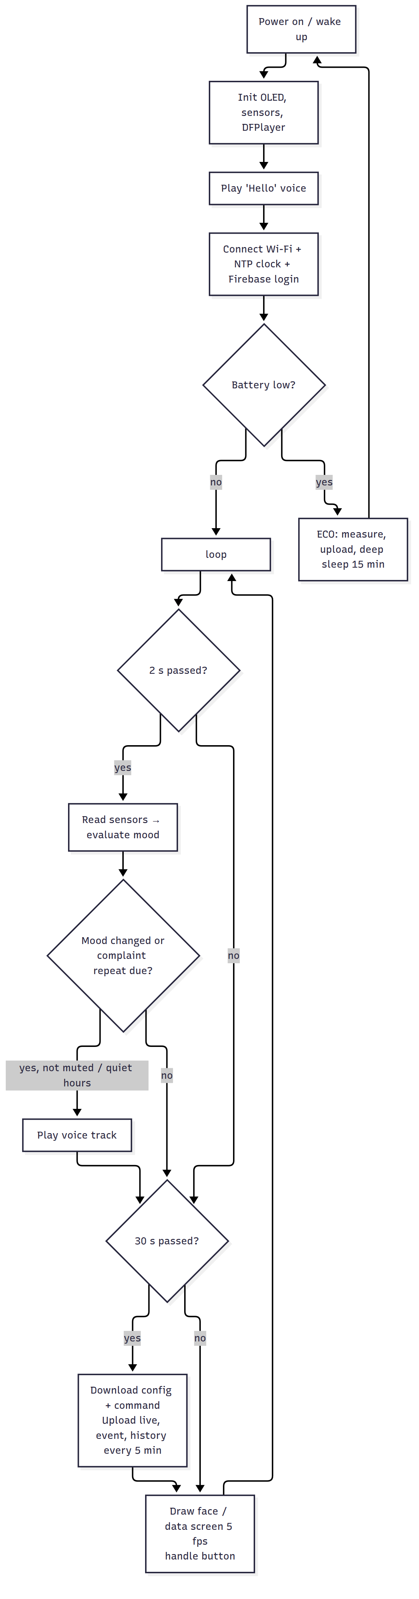

5.5 How the cloud connection works (REST API)
The firmware uses plain HTTPS requests (HTTPClient + ArduinoJson) instead of a big Firebase library. This makes the code small and easy to explain:
- Login: POST https://identitytoolkit.googleapis.com/v1/accounts:signInWithPassword?key=API_KEY with the email/password. The answer contains an idToken valid for 1 hour (the firmware renews it after 50 min).
- Write live: PUT {DB_URL}/plants/plant01/live.json?auth=idToken with a JSON body. "ts": {".sv": "timestamp"} asks Firebase to insert the server time.
- Add history / event: POST …/history.json creates a new child with a unique, time-ordered key.
- Read settings: GET …/config.json. Read a command: GET …/command.json, then DELETE it.

5.6 The emoji faces
The faces are drawn with code (circles, arcs, lines), so no image files are needed. They are animated at 5 frames/s: the happy face blinks, the water drop falls, the sweat drop moves, the “Zz” rises, and the cold face shivers. The screen switches between the face and the data screen every 6 s (or with a short button press).
Mood | Drawing
😊 Happy | Round eyes with shine, smile, cheeks, small leaf, blinking
😫 Thirsty | Sad eyebrows, open mouth with tongue, falling water drop, “WATER!”
🥴 Too wet | X eyes, wavy mouth, drops, “Too wet”
🥵 Hot | Squinting eyes, panting mouth, sweat drop, sun
🥶 Cold | Shaking eyes, chattering zig-zag teeth, snowflake
😞 Needs light | Sad eyes, frown, light bulb, “Light?”
😴 Sleeping | Closed eyes, small “o” mouth, rising “z Z”

5.7 Changing behaviour
- Thresholds, quiet hours, volume, mute: from the web app (no re-upload needed). The ESP32 reads them every 30 s.
- Intervals, calibration, ECO voltage: config.h.
- Add a new mood: add it to enum Mood, evaluateMood(), moodName(), a face in displayFace(), a voice track, and the texts in the apps.

5.8 Unit tests of the mood logic (on a PC)
cd tests
g++ -std=c++17 -I../firmware/SmartPlant test_mood.cpp ../firmware/SmartPlant/mood.cpp -o test_mood
./test_mood # → "33 checks, 0 failures"

06 · Web Application (Dashboard)
Code: web/: index.html, style.css, app.js, firebase-config.js. No build step is needed: it is plain HTML/CSS/JavaScript.

6.1 Features
- Login with Firebase Authentication (email + password).
- Mood card: big animated emoji, title and message. It turns orange when the plant needs something.
- Live cards: soil moisture (with bar), temperature, air humidity, light (lux), battery % + volts + charging, solar panel volts, Wi-Fi signal.
- Online / offline badge: online if the plant sent data during the last 2 minutes.
- History chart (24 h) with a selector: moisture / temperature / humidity / light / battery (Chart.js).
- Plant diary: the last 30 mood changes, with time.
- Make the plant speak: choose a voice message → “Speak now”. The plant plays it within 30 s.
- Plant settings: name, thresholds, quiet hours, volume, mute. They are saved in Firebase and the ESP32 applies them.
- Arabic (RTL) / English switch, dark mode automatic, responsive on phones.
- Demo mode with simulated data (no Firebase needed), useful for designing and presenting.
!Dashboard (Arabic, demo data)

6.2 Run it on your computer
The page uses JavaScript modules, so open it through a small local web server, not by double-clicking it:
cd smart-plant-iot/web
python -m http.server 8000 # or: npx serve .
Open http://localhost:8000/?demo=1 (demo) or http://localhost:8000 (real data after configuring Firebase). In VS Code, the Live Server extension also works.

6.3 Connect it to your Firebase
Edit web/firebase-config.js and paste the firebaseConfig from Firebase (04, step 4). Keep PLANT_ID = "plant01", the same as in the firmware. While apiKey still starts with YOUR_, the page stays in demo mode.

6.4 Publish it online
cd smart-plant-iot
firebase deploy --only hosting
→ https://<project-id>.web.app. Users must sign in with an account created in Firebase Authentication.

6.5 How the code works (app.js)
- firebaseSource() loads the Firebase SDK (v10, from Google’s CDN), signs in, and subscribes with onValue() to: live, history (last 288 points = 24 h), events (last 30) and config. Firebase pushes every change to the page in real time (WebSocket), so no refresh is needed.
- demoSource() makes the same calls with simulated data.
- renderLive(), renderChart(), renderEvents() and fillSettings() update the page.
- saveConfig() → update(plants/plant01/config), speak(n) → set(plants/plant01/command, {play: n}).
- All the texts are in the TEXT.ar / TEXT.en dictionaries, so translation is easy.

07 · Android Application
Code: android/, a native Android app in Kotlin + Jetpack Compose (Material 3) using the official Firebase Android SDK (Authentication + Realtime Database). It shows the same data as the web dashboard in a simple, phone-friendly design. It is in Arabic or English automatically, following the phone language.
Screen | Contents
Login | Email + password (the same accounts as the web)
🏠 Plant | Big emoji + mood message, last update, online/offline, moisture, temperature, humidity, light, battery (+ charging), solar, Wi-Fi; Speak button with message list; Mute switch
📈 History | Last 24 hours line chart. Choose moisture / temp / humidity / light / battery. Min / average / max
📔 Diary | List of mood changes with emoji and time
Minimum Android version: 7.0 (API 24). Target: API 34.

7.1 Requirements
- Android Studio (Koala 2024.1 or newer): https://developer.android.com/studio. It includes the JDK and Android SDK.
- The google-services.json file from your Firebase project (04, step 5).

7.2 Open, build and run
- Copy google-services.json into android/app/. Without it the build fails with “File google-services.json is missing”.
- Android Studio → File → Open → select the android folder → wait for “Gradle sync” to finish (the first time it downloads Gradle 8.9 and the libraries, so an internet connection is required).
- Connect a phone with USB debugging enabled (Settings → About phone → tap “Build number” 7 times → Developer options → USB debugging), or create an emulator (Device Manager).
- Press ▶ Run. Sign in with a user from Firebase Authentication.
Make an APK to install on any phone: Build → Build App Bundle(s) / APK(s) → Build APK(s) → android/app/build/outputs/apk/debug/app-debug.apk. Send it to the phone and install it (“allow unknown sources”).
If the app shows no data but the web does, your database is probably not in the US region. Put its URL in DATABASE_URL in app/src/main/java/com/smartplant/app/Model.kt.

7.3 Code structure
android/
├── settings.gradle.kts, build.gradle.kts, gradle.properties, gradlew (Gradle 8.9, AGP 8.5, Kotlin 2.0)
└── app/
├── build.gradle.kts dependencies: Firebase BoM 33, Compose BoM 2024.09
├── google-services.json ← YOU add this file
└── src/main/
├── AndroidManifest.xml INTERNET permission
├── java/com/smartplant/app/
│ ├── MainActivity.kt shows Login or Main screen
│ ├── PlantViewModel.kt Firebase login + real-time listeners (StateFlow)
│ ├── Model.kt data classes + PLANT_ID + parsing of snapshots
│ └── ui/
│ ├── LoginScreen.kt
│ ├── MainScreen.kt bottom navigation: Plant / History / Diary
│ ├── LineChart.kt small chart drawn with Canvas
│ ├── Moods.kt mood → emoji + texts, time format
│ └── Theme.kt green Material 3 theme (light / dark)
└── res/values/strings.xml (English) · res/values-ar/strings.xml (Arabic)
How it works: PlantViewModel listens to Firebase with addValueEventListener on live, history (limitToLast(288)), events (limitToLast(30)) and config, and puts the results in StateFlows. The Compose screens collect these flows and redraw automatically when the plant sends new data. “Speak” writes command/play, and “Mute” writes config/muted.

7.4 Notes
- PLANT_ID in Model.kt must match the firmware (plant01).
- This app code was written for this project, but it could not be compiled in the environment where it was written (the Android SDK download was blocked there). Build it in Android Studio. If Studio asks to update the Android Gradle Plugin or Kotlin version, accept it: the code uses only standard, stable APIs.
- Possible extensions: push notifications when the plant is thirsty (Firebase Cloud Messaging + Cloud Functions; needs the paid “Blaze” plan, so it is listed as future work), a home-screen widget, and a settings screen like the web.

08 · Calibration and Testing

8.1 Calibrate the soil moisture sensor (important!)
Every capacitive sensor gives slightly different raw values. Calibrate it before you trust the percentages:
- Upload the firmware and open the Serial Monitor (115200). Each line shows soil=..% (raw XXXX).
- Hold the sensor in the air, dry. Note the raw value (e.g. 3050). This is SOIL_RAW_DRY.
- Put the sensor in a glass of water up to the white line. Note the raw value (e.g. 1280). This is SOIL_RAW_WET.
- Write both numbers in config.h and upload again.
- Check: dry soil should read about 10–25 %, and soil just after watering about 60–80 %.
The raw value is also uploaded to Firebase (live/soil_raw), so you can calibrate from the web console too.

8.2 Calibrate the battery voltage
- Measure the battery with a multimeter (e.g. 3.98 V).
- Compare it with batt= in the Serial Monitor (e.g. 3.90 V).
- Set BATTERY_CAL = 3.98 / 3.90 = 1.02 in config.h. Do the same for SOLAR_CAL if needed.

8.3 Choose thresholds for your plant
Plant type | Thirsty below | Too wet above | Light min (lux) | Hot above
Basil / mint (herbs) | 35 % | 85 % | 1000 | 35 °C
Pothos / indoor plants | 25 % | 80 % | 200 | 32 °C
Cactus / succulents | 10 % | 50 % | 2000 | 40 °C
Change them from the web app → Plant settings (no re-upload needed).

8.4 Test plan
# | Test | Steps | Expected result | ✔
T1 | Start-up | Power on | OLED “Smart Plant / Starting…”, “Hello” voice, face appears
T2 | Wi-Fi + Firebase | Watch Serial Monitor | [cloud] signed in to Firebase, LED solid
T3 | Thirsty | Pull the soil sensor out (dry air) | 😫 face, voice 0001 “I’m thirsty”, web + app show “Thirsty” within 30 s
T4 | Thank you | Put the sensor back in wet soil | 😊 face, voice 0007 “Thank you”, diary event
T5 | Too wet | Sensor in a glass of water | 🥴 face, voice 0002
T6 | Hot | Warm the DHT22 with a hair dryer (carefully) > 35 °C | 🥵 face, voice 0003
T7 | Cold | DHT22 near an ice pack < 10 °C | 🥶 face, voice 0004
T8 | Needs light | Cover the BH1750 with your hand during the day | 😞 face, voice 0005
T9 | Night | Set “day end” earlier or wait until 18:00 | 😴 face, “good night” once, no other complaints in quiet hours
T10 | Repeat | Keep the plant thirsty for 30 min | The voice repeats once every 30 min
T11 | Mute | Web → mute → make it thirsty | Face changes, no sound, “M” shown on OLED
T12 | Speak now | Web/app → choose track → Speak | The plant plays it within 30 s
T13 | Settings | Change “Thirsty below” to 60 % | The plant becomes thirsty within 30 s
T14 | Offline | Turn off the router | Face/voice still work, LED blinks, the web shows “Offline”; after the router is back, data resumes automatically
T15 | Button | Short press / long press | Screen changes / plant says its current mood
T16 | Security | Open the database URL …/plants.json in a browser (not signed in) | Permission denied
T17 | Solar charging | Put the panel in the sun | charging: true, battery % increases during the day
T18 | Night autonomy | Leave it running for 24 h outdoors | It works through the night; the history chart shows the battery curve
T19 | ECO mode | Use a nearly empty battery (< 3.45 V) | “Low battery / ECO mode”, wakes every 15 min, event in the diary
T20 | Android | Install the APK, sign in | The same values as the web, updated in real time
T21 | Unit tests | tests/test_mood | 33 checks, 0 failures
Record the results (photos, screenshots, history charts) for the report’s Testing and Results chapter.

09 · 6-Week Project Plan and Team Roles

9.1 Team roles (6 members)
Role | Main responsibility
Team leader + integration | Planning, meetings, purchasing, final integration, presentation
Hardware & wiring | Sensors, OLED, DFPlayer, breadboard → soldered board, enclosure
Solar & power | Solar panel, TP4056, batteries, MT3608, power measurements, safety
Firmware (ESP32) | Arduino code, calibration, mood logic, voice messages
Web + Firebase | Firebase project, rules, web dashboard, hosting
Android + documentation | Android app, screenshots, report writing, demo video
Everyone records voices, tests the system, and writes their own part of the report.

9.2 Weekly plan
Week | Goals | Deliverables
1 | Approve the proposal. Study the docs. Order the components. Create the Firebase project and accounts. Install Arduino IDE + Android Studio. Record the voice messages | BOM bought, Firebase ready, voice MP3 files
2 | Breadboard: ESP32 + OLED (faces), BH1750, DHT22, soil sensor. Calibrate the soil sensor | Faces and readings on the Serial Monitor
3 | DFPlayer + speaker. Mood logic. Wi-Fi + Firebase upload. Button | Plant talks, data visible in the Firebase console
4 | Web dashboard (deploy to Hosting). Android app (build APK) | Working web + Android with live data
5 | Solar power chain + batteries, ECO mode. Solder onto perfboard, enclosure, mount on the pot. 24 h outdoor test | Fully solar-powered prototype
6 | Run the full test plan (08), fix bugs, write the report, slides, demo video, rehearse | Final report, presentation, demo
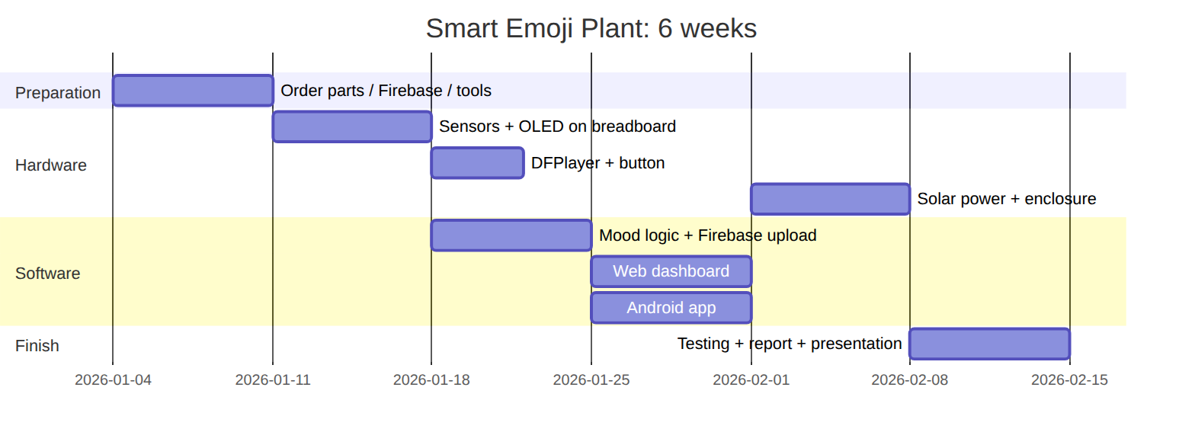 (Change the dates to your semester.)

9.3 Risks and mitigation
Risk | Mitigation
Components arrive late | Order in week 1 from a local shop. Buy spare sensors
Burned module (wrong polarity) | Check VCC/GND twice. Set the MT3608 to 5.0 V before connecting it
College Wi-Fi blocks devices / needs a login page | Use a phone hotspot (2.4 GHz) for the demo
Not enough sun during the demo | Fully charge the batteries the day before (TP4056 has a USB-C input)
Android build problems | Use the web dashboard (it works on phones too) as a backup, and build the APK early (week 4)
Firebase settings wrong | Test with the curl commands in 04 and the demo mode of the web

10 · Graduation Report Outline, Presentation and Future Work

10.1 Suggested report chapters
- Introduction: the idea, the problem (plants die from forgotten watering and wrong light/temperature), objectives (01 §1.2), importance (from the proposal), scope, and report organization.
- Background / literature review: IoT, microcontrollers (ESP32 vs ESP8266 vs Arduino UNO), sensors (capacitive vs resistive soil sensors, BH1750 vs LDR, DHT22 vs DHT11), cloud platforms (Firebase vs others, 04), solar energy and Li-ion batteries, and similar existing products (smart pots, plant monitors).
- System analysis: functional and non-functional requirements, use-case diagram, context diagram, mood rules (01).
- System design:
  - block diagram / architecture (README)
  - hardware design: component selection (02), wiring diagram + pin table (03), power budget and solar sizing (02 §2.3)
  - software design: firmware flowchart (05 §5.4), database structure (04 §4.2), security rules, user-interface designs (web + Android screenshots)
- Implementation: photos of each step, important code snippets (mood engine, Firebase REST, face drawing), web and Android implementation, enclosure.
- Testing and results: the test plan with results (08), calibration tables, 24-hour charts (moisture, battery/solar), energy measurements, screenshots.
- Conclusion and future work.
- References and appendices (full code, BOM with prices, user manual).

10.2 Presentation and demo tips
- Start with the story: “Plants can’t talk… until now 🌱😊”.
- Live demo: pull out the soil sensor → the plant shouts “I’m thirsty!” and the face changes on the OLED, the web and the phone at the same time → water it → “Thank you!” 😊. This is the most impressive moment.
- Press “Speak now” from the phone in front of the committee.
- Show the history chart of a full day (prepare it the day before) to prove that the solar system works day and night.
- Bring a backup video of the demo and a charged power bank. Use a phone hotspot.

10.3 Future work
- 💦 Automatic watering: a small 5 V pump + relay/MOSFET when the plant is thirsty, with a water-tank level sensor.
- 🔔 Push notifications on the phone (Firebase Cloud Messaging + Cloud Functions).
- 🌈 Colour TFT display (ST7789 240×240) with colourful animated emoji.
- 🧠 AI: predict when the plant will need water from the history, or detect plant diseases with a camera (ESP32-CAM).
- 🗣️ Voice commands (“How are you, plant?”) with a microphone.
- 🔐 Certificate validation for HTTPS, per-user rules, and multiple plants per user.
- ⚡ An MPPT solar charger (CN3791) for higher efficiency, and a custom PCB.
- 🌍 Multi-plant dashboard for schools / greenhouses.

11 · Voice messages (DFPlayer Mini micro-SD card)

Files to create
Record each sentence (1–4 seconds). You can record your own voices, which makes the project more personal, or use a text-to-speech website. Save them as MP3 files with exactly these names:
File | When it plays | Arabic (suggested) | English
0001.mp3 | Thirsty | أنا عطشانة! أرجوك اسقني ماء 💧 | I’m thirsty! Please water me.
0002.mp3 | Too wet | كفاية ماء! أنا غرقانة | Too much water! I’m drowning.
0003.mp3 | Too hot | الجو حار جداً! انقلني لمكان أبرد | It’s too hot! Move me somewhere cooler.
0004.mp3 | Cold | أشعر بالبرد! أحتاج مكاناً أدفأ | I feel cold! I need a warmer place.
0005.mp3 | Needs light | أحتاج إلى ضوء الشمس ☀️ | I need some sunlight.
0006.mp3 | Happy again | أنا سعيدة، كل شيء ممتاز 😊 | I’m happy, everything is perfect!
0007.mp3 | After watering | شكراً لأنك سقيتني! | Thank you for watering me!
0008.mp3 | Night starts | تصبحون على خير 😴 | Good night!
0009.mp3 | Power on | مرحباً! أنا نبتتك الذكية 🌱 | Hello! I am your smart plant.
0010.mp3 | (Speak now / low battery) | بطاريتي ضعيفة، أحتاج إلى الشمس | My battery is low, I need the sun.

Copy them to the SD card
- Format the micro-SD card as FAT32 (cards up to 32 GB).
- Create a folder named mp3 (lower-case) in the root of the card.
- Copy the files into it: /mp3/0001.mp3, /mp3/0002.mp3, …
- Put the card into the DFPlayer before powering on.

Recording tips
- Use a phone voice recorder in a quiet room, then trim and export to MP3 with Audacity (free): Effect → Normalize (−1 dB) to make all files equally loud, then File → Export → MP3 (128 kbps, mono is fine).
- Speak slowly and with a “cute” plant character. Add a short sound effect (a water drop or a yawn) if you like.
- The volume can be changed from the web app (0–30, default 25).

