ري: Rayy
  - Smart IoT plant that expresses its feelings with emoji and sound: full project documentation (MySQL + XAMPP version)
Table of Contents

🌱 ري (Rayy): smart farming that shows the feelings of your crops (MySQL + XAMPP version)
Graduation project. ري (Rayy, “watering / quenching thirst”) is a smart-farming system. One account manages many crops (زراعات): a strawberry field, tomatoes, mint, palm seedlings… A sensor device placed in a crop turns its live readings (soil moisture, light and temperature) into emoji faces in the web dashboard and the Android app, and sound alerts (a different buzzer melody for each feeling).
- Every crop has a crop type with its ideal values (12 types included).
- The sensor device can be moved from one crop to another from the apps.
- Anyone can create an account; the admin manages users.
- The data is stored in MySQL on a computer running XAMPP (Apache + PHP + MySQL). The device is powered by a 5 V USB power bank.
😊 Happy | 😫 Thirsty | 🥴 Too wet | 🥵 Too hot | 🥶 Cold | 😞 Needs light | 😴 Sleeping

1. Start here
👉 docs/00-step-by-step-guide.md: the complete guide from buying the parts to the final demo, step by step.
🗄️ docs/04-database-mysql-xampp.md: XAMPP, the MySQL tables, the PHP API, security and useful SQL.
📄 docs/Rayy-Documentation-MySQL.docx: all the documentation in one Word file.

2. What is in this folder
Folder / file | What it contains | Where it goes
database/rayy.sql | Creates the MySQL database rayy: 12 tables, crop library, admin user, device rayy-01 | phpMyAdmin → Import
server/rayy/ | Web dashboard (HTML/CSS/JS) + PHP API (api/) | Copy to C:\xampp\htdocs\rayy
firmware/Rayy/ | ESP32 program (Arduino IDE): sensors, moods, buzzer melodies, HTTP to the API | Upload to the ESP32
android/Rayy/ | Android Studio project Rayy (Kotlin + Jetpack Compose, Arabic / English) | Build in Android Studio
tests/ | Unit tests of the “mood” logic (PC) + automatic test of the PHP API (test_api.sh, 44 checks) | —
docs/ | Full documentation (chapters 00 → 10 + Word file + diagrams) | —

3. Documentation index
- Step-by-step guide (start here)
- Requirements and system analysis
- Hardware components (bill of materials) and power
- Wiring and assembly
- Database: MySQL with XAMPP, the PHP API and the setup
- ESP32 firmware: installation, how the code works, the melodies
- Web application
- Android application
- Calibration and testing
- 6-week project plan and team roles
- Graduation report outline, presentation and future work

4. System architecture
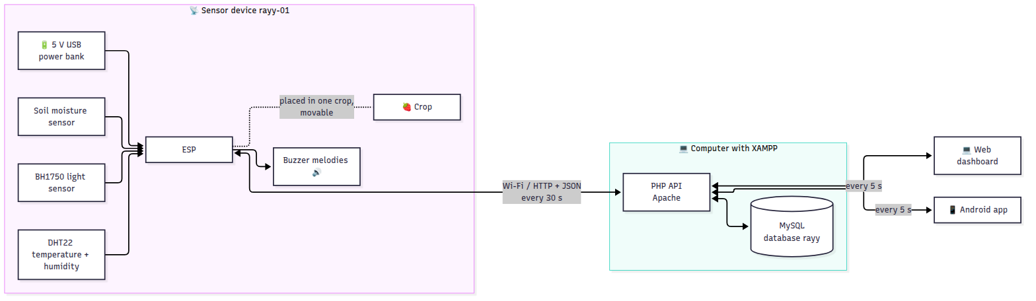
- The user adds crops in the apps; each crop gets the ideal values of its crop type.
- The ESP32 device is placed in one crop and chosen in the apps. It reads the sensors every 2 s, chooses the crop’s mood with that crop’s thresholds and plays its melody. There is no screen on the device: the emoji is shown in the apps. Without the server the device still decides the mood and plays its melodies.
- Every 30 s it sends one HTTP request to api/device.php: the live values, a history point every 5 min and an event when the mood changes, all saved for the crop it is on now. The answer brings back that crop’s thresholds and any “Play” request. Moving the device to another crop in the app takes effect within 30 s.
- The web and Android apps: create account / sign in, My crops, crop page (live values, chart, diary, settings, device), Devices (move a device), and Users for the admin. They ask for new data every 5–10 s.
- The XAMPP computer, the ESP32 and the phone must be on the same Wi-Fi; no internet is required.

5. Quick start (summary)
- Buy the parts (docs/02) and wire them (docs/03).
- Install XAMPP, start Apache and MySQL, copy server/rayy to C:\xampp\htdocs\, and import database/rayy.sql in http://localhost/phpmyadmin (docs/04).
- Find the computer’s IP (ipconfig, e.g. 192.168.1.10).
- Edit firmware/Rayy/config.h (Wi-Fi, SERVER_URL = "http://192.168.1.10/rayy/api", DEVICE_ID, DEVICE_KEY) and upload it with the Arduino IDE (docs/05).
- Open http://192.168.1.10/rayy/, sign in with admin@rayy.app / Rayy@2026 (or create an account), add your crops and move the device to the crop where it is placed (docs/06).
- Set SERVER_URL in android/Rayy/app/src/main/java/com/rayy/app/Model.kt, open android/Rayy/ in Android Studio and press ▶ (docs/07).
- Calibrate the soil sensor and run the tests (docs/08).
💡 See the dashboard without any hardware: open server/rayy/index.html directly in the browser (demo data), or send fake readings with the curl command in docs/04 §4.4.

00 · Step-by-Step Guide: Build the Whole Project from Zero (MySQL + XAMPP version)
In this version the data is stored in a MySQL database on a computer that runs XAMPP (Apache + PHP + MySQL). The ESP32, the website and the Android app talk to a small PHP API. The computer, the ESP32 and the phone must be on the same Wi-Fi network, and the computer must stay on while you use the system.
ري is a smart-farming system for many crops: you add your crops (strawberry field, tomatoes, mint …) in the apps, place the sensor device in one crop, and move it to another crop whenever you want.
Follow these steps in order. Each step says what to do, how long it takes, and how to check that it worked. More detail for each step is in the other chapters (01–10).
Step | What you build | Time
1 | Buy the components | 1–3 days
2 | Install the software on the computer | 1 hour
3 | Install XAMPP, create the MySQL database, copy the server files | 30 min
4 | Wire the hardware on a breadboard | 2 hours
5 | Configure and upload the ESP32 code | 30 min
6 | Calibrate the soil sensor | 15 min
7 | Open the web dashboard (served by Apache) | 10 min
8 | Build and install the Android app | 1 hour
9 | Test everything | 2 hours
10 | Final assembly on the pot, report, presentation | 1–2 weeks

Step 1: Buy the components
Full list with explanations and prices: 02-hardware-bom.md. The main items are:
- ESP32 DevKit V1 + a USB data cable (micro-USB or USB-C, depending on the board)
- Capacitive soil moisture sensor v1.2
- DHT22 (temperature + humidity) module
- BH1750 (GY-302) light sensor module
- Passive buzzer (module or bare) + 100 Ω resistor
- Push button
- Breadboard + jumper wires (male-male and female-male)
- 5 V USB power bank (or any 5 V USB phone charger)
- A crop to test with: a pot or a small planting (strawberry, mint, tomato …) 🌿
✅ Check: you have every item in the list before you start step 4.

Step 2: Install the software
On a Windows / macOS / Linux computer:
- Arduino IDE 2.x: https://www.arduino.cc/en/software
- USB driver for the ESP32 (only if the board is not detected): CP210x (https://www.silabs.com/developers/usb-to-uart-bridge-vcp-drivers) or CH340, depending on the chip near the USB port.
- In Arduino IDE: File → Preferences → Additional boards manager URLs, paste https://espressif.github.io/arduino-esp32/package_esp32_index.json, then Tools → Board → Boards Manager → search esp32 → install “esp32 by Espressif Systems” (3.x).
- Tools → Manage Libraries → install:
  - DHT sensor library by Adafruit (click “Install all”)
  - BH1750 by Christopher Laws
  - ArduinoJson by Benoit Blanchon (version 7)
- Android Studio Panda (2025.3.1) or newer: https://developer.android.com/studio (for the Android app; the project uses Gradle 9.1.0 + AGP 9.0.1 and runs on Java 17–25)
- XAMPP (Apache + MySQL/MariaDB + PHP 8): https://www.apachefriends.org → install it in C:\xampp (default).
- A code editor (optional): VS Code https://code.visualstudio.com.
✅ Check: in Arduino IDE, Tools → Board shows “esp32 → ESP32 Dev Module”.

Step 3: XAMPP, the MySQL database and the server files
Details: 04-database-mysql-xampp.md. In short:
- Open the XAMPP Control Panel → press Start next to Apache and MySQL (both turn green).
- Copy the folder server/rayy from the project into C:\xampp\htdocs\ → you get C:\xampp\htdocs\rayy\index.html and C:\xampp\htdocs\rayy\api\....
- Open http://localhost/phpmyadmin → Import → choose database/rayy.sql → Import. The database rayy is created with 12 tables, the crop library (12 crop types), two example crops, the device rayy-01 and the admin user admin@rayy.app (password Rayy@2026).
- Find the computer’s IP address: Windows → cmd → ipconfig → “IPv4 Address”, e.g. 192.168.1.10. The ESP32 and the phone use this address.
- Allow Apache through the Windows Firewall (Windows asks the first time Apache starts → tick Private networks → Allow).
✅ Check: http://localhost/rayy/ shows the login page, and phpMyAdmin shows the database rayy with 12 tables. From the phone’s browser (same Wi-Fi), http://192.168.1.10/rayy/ also opens the login page.

Step 4: Wire the hardware
Unplug the USB cable while wiring. Follow 03-wiring.md and the diagram:
!Wiring
Module | Pin → ESP32
Soil sensor | VCC → 3V3 · GND → GND · AOUT → GPIO34
DHT22 | + → 3V3 · − → GND · OUT → GPIO4
BH1750 | VCC → 3V3 · GND → GND · SDA → GPIO21 · SCL → GPIO22 · ADDR → GND
Buzzer | (+) → 100 Ω → GPIO25 · (−) → GND
Button | one leg → GPIO13 · other leg → GND
Tip: on the breadboard, connect the ESP32 3V3 pin to one “+” row and GND to one “−” row, then connect all modules’ VCC/GND to these rows.
✅ Check: look at every VCC and GND twice. A reversed VCC/GND can burn a module.

Step 5: Configure and upload the ESP32 code
- Open firmware/Rayy/Rayy.ino in Arduino IDE (all the other files open as tabs).
- In the config.h tab, fill in:
- #define WIFI_SSID "YourWiFi" // 2.4 GHz network or phone hotspot
#define WIFI_PASSWORD "YourPassword"
#define SERVER_URL "http://192.168.1.10/rayy/api" // computer IP from step 3.4
#define DEVICE_KEY "rayy-device-key-2026" // same key as in database/rayy.sql
#define DEVICE_ID "rayy-01" // this sensor device
- The crop the device measures is not written here: you choose it in the apps (step 7), so the same device can be moved from crop to crop. ⚠️ Do not write localhost here: for the ESP32, “localhost” is the ESP32 itself.
- Connect the ESP32 with the USB cable. Select Tools → Board → ESP32 Dev Module and Tools → Port (COM…).
- Click Upload (→). If it says “Connecting…” for a long time, hold the BOOT button on the board.
- Open Tools → Serial Monitor at 115200 baud.
✅ Check: * You hear the “hello” melody. * The Serial Monitor shows [server] connected to http://…/rayy/api and a line of readings every 2 seconds ending with server=1. * The Serial Monitor shows [server] measuring crop 1: فراولة البيت المحمي (the example strawberry crop). * In phpMyAdmin → rayy → table live_status, the row of crop 1 changes every 30 s (press Browse again).

Step 6: Calibrate the soil sensor
- Keep the Serial Monitor open. Hold the soil sensor in the air: note the raw value (e.g. 3050).
- Put the sensor in a glass of water (up to the white line): note the raw value (e.g. 1280).
- Put these numbers in config.h: SOIL_RAW_DRY 3050, SOIL_RAW_WET 1280, then upload again.
✅ Check: dry soil shows about 10–25 %, and freshly watered soil about 60–80 %.

Step 7: Web dashboard
The website is already installed: Apache serves it from C:\xampp\htdocs\rayy.
- On the computer open http://localhost/rayy/, on a phone or another computer in the same Wi-Fi open http://192.168.1.10/rayy/.
- Sign in with admin@rayy.app / Rayy@2026 (or press Create account to make a new user).
- My crops → + Add crop → name (e.g. “My strawberries”), crop type (the ideal values are filled automatically) and location → Save.
- Open the crop → Sensor device of this crop → choose rayy-01 → Move to this crop. Within 30 s the device measures this crop and uses its thresholds. (Or use the Devices page.)
- Admin only: the Users page creates users, changes roles and deletes users.
- Without the server (only to see the design), open index.html directly or add ?demo=1: it shows fake data.
✅ Check: the crop card shows the crop’s emoji (e.g. 😫 when the soil sensor is in dry air), and the crop page says “Online”. The values refresh every 5 seconds.

Step 8: Android app
- Unzip the project into a folder whose path has English letters only, for example E:\Rayy-Project (not E:\Ray ري\...). Android Studio refuses to build in folders with Arabic letters in the path.
- Open android/Rayy/app/src/main/java/com/rayy/app/Model.kt and set the computer’s address: const val SERVER_URL = "http://192.168.1.10/rayy/api" (for the Android emulator on the same computer use http://10.0.2.2/rayy/api).
- Android Studio → File → Open → choose the android/Rayy folder (the project name shows as Rayy) → wait for “Gradle sync” to finish (the first time it downloads Gradle 9.1.0).
- Connect your phone (enable Developer options → USB debugging) or create an emulator → press ▶ Run.
- To get an installable file: Build → Build App Bundle(s) / APK(s) → Build APK(s). The file is at android/Rayy/app/build/outputs/apk/debug/app-debug.apk.
✅ Check: you can create an account and sign in; My crops shows every crop with its emoji; tapping a crop shows its live values; Move to this crop moves the device; “Play” makes the buzzer play. The admin sees a Users tab.

Step 9: Test everything
Use the test table in 08-testing-calibration.md. The most important tests:
- Take the soil sensor out of the soil → 😫 face + “thirsty” melody + apps show “Thirsty”.
- Put it back into wet soil → 😊 face + “thank you” melody.
- Cover the light sensor during the day → 😞 “needs light”.
- Stop Apache in XAMPP → the melodies still work on the device, the LED blinks; start it again → the data comes back.
- Move the device to another crop (e.g. cactus) → within 30 s the device uses the cactus thresholds (dry soil is now “happy”); the strawberry history stays in its own crop.
- Run the automatic API test: bash tests/test_api.sh http://localhost/rayy/api → 44 passed, 0 failed.

Step 10: Final assembly, report and presentation
- Move the circuit from the breadboard to a small perfboard (solder) or keep a mini breadboard inside a box.
- Put it in a small box with holes for the buzzer and the USB cable. Fix the box to the pot. Keep the DHT22 and BH1750 outside the box.
- Keep the XAMPP computer on and in the same Wi-Fi during the demo.
- Power it with the power bank (it lasts about 2–3 days with 10,000 mAh; recharge it like a phone) or with a USB phone charger permanently.
- Write the report using 10-report-outline.md, and follow the plan in 09-project-plan.md.

01 · Requirements and System Analysis

1.1 Project idea (from the proposal)
ري (Rayy) is a smart-farming system that turns the feelings of crops into emoji and sound using Internet of Things (IoT) technology. It is not made for one plant: a farmer, a school or a family can manage many crops (زراعات) in one account — for example a strawberry field in a greenhouse, tomatoes on a farm, mint in a garden. A sensor device placed in a crop measures soil moisture, light and temperature, and ري turns them into digital facial expressions (emoji) and sound alerts (melodies) for the whole crop.
- Every crop has a crop type (strawberry, tomato, cucumber, mint, date palm, cactus …) that gives its ideal values; the user can adjust them.
- The graduation project uses one sensor device. It can be moved from one crop to another from the apps; the history of every crop is kept.
- Anyone can create an account from the web or the Android app; an admin manages all users.
Scope decision: to focus on the main idea, the solar energy part of the original proposal is replaced by a simple 5 V USB power bank / charger, and the sound is made by a buzzer that plays a different melody for each mood. (Update the proposal text with your supervisor if needed. Solar power is listed as future work.)
Importance
- Smart farming: it watches the watering and the environment of every crop so crops never reach drought, over-watering, heat or cold damage, and it saves water by watering only when needed.
- Environmental awareness and smart interaction: a fun, innovative way to “talk” with crops through IoT, emoji and sound alerts.
- Learning value: it combines sensors, embedded programming, cloud databases, web and mobile development in one system.
Duration: 6 weeks. Team: 6 members.

1.2 Objectives
- Measure soil moisture, light intensity, air temperature and humidity of a crop automatically.
- Show the state of each crop as an emoji face in the web dashboard and the Android app (no screen on the device).
- Play sound alerts: a different buzzer melody for each mood (sad melody when thirsty, happy melody after watering…).
- Save the data in a MySQL database (XAMPP server: Apache + PHP + MySQL) and show it on a web dashboard and an Android app.
- Run from a simple 5 V USB power bank (portable) or a USB charger.
- Manage many crops: add a crop with its type (ideal values filled automatically), edit its thresholds, delete it.
- Move the sensor device from one crop to another from the apps.
- Let anyone create an account from the web or Android app; let the admin create users, change roles and delete users.
- Mute the sound and play a sound on the device from the apps.

1.3 Why the ESP32 (and not the ESP8266)
Need of this project | ESP32 | ESP8266
Analog input for the soil sensor | ✅ 18 ADC channels (12-bit) | ⚠️ only 1 ADC pin (10-bit, 0–1 V on some boards)
HTTP / JSON networking memory | ✅ 520 KB RAM | ⚠️ 80 KB, often unstable with TLS
PWM for buzzer melodies, I2C, many GPIO | ✅ plenty | ⚠️ few free pins
Dual-core CPU (smooth face animation + Wi-Fi) | ✅ 240 MHz × 2 | ❌ single core 80 MHz
Price | ~ same | ~ same
➡️ Use the ESP32 DevKit V1 (ESP-WROOM-32).

1.4 Functional requirements
ID | Requirement
FR-1 | The system shall read soil moisture (%) every 2 seconds.
FR-2 | The system shall read light intensity (lux), air temperature (°C) and humidity (%).
FR-3 | The system shall decide the crop mood, using the thresholds of the crop the device is assigned to: happy, thirsty, drowning (too wet), hot, cold, needs light, sleeping.
FR-4 | The web and Android apps shall display the emoji face of the current mood.
FR-5 | The system shall play a buzzer melody when the mood changes, and repeat a complaint every 30 min (configurable).
FR-6 | The system shall stay silent during quiet hours (default 22:00–07:00) and when muted.
FR-7 | The system shall upload the live readings to the server (PHP API → MySQL) every 30 s, a history point every 5 min, and an event on each mood change.
FR-8 | The system shall keep showing the face and playing sounds when there is no internet (offline mode).
FR-9 | The system shall report its Wi-Fi signal strength and online/offline status.
FR-10 | The web and Android apps shall require a login (email + password).
FR-11 | The apps shall show the emoji mood, all live values, online/offline status, last-update time.
FR-12 | The apps shall show a 24-hour history chart and the “crop diary” (list of mood changes) of each crop.
FR-13 | The apps shall let the user play a chosen melody on the crop’s device (“Play”) and mute it.
FR-14 | The apps shall let the user edit a crop’s name, type, location, thresholds (moisture, temperature, light) and quiet hours.
FR-15 | The apps shall support Arabic and English.
FR-16 | A push button on the device plays the current mood’s melody.
FR-17 | The system shall manage many crops per user; each crop has a type from a crop library (12 types) with ideal values.
FR-18 | The apps shall show a list of the user’s crops with the emoji, main values and device of each crop.
FR-19 | The user shall be able to move a sensor device to another crop (or unassign it); readings then belong to the new crop and the device uses its thresholds.
FR-20 | Anyone shall be able to create a user account from the web or Android app.
FR-21 | An admin shall be able to create users (user or admin), change roles and delete users; an admin sees all crops and devices.
FR-22 | A user shall be able to add a device with its device ID and key; only an admin can register a new device ID.

1.5 Non-functional requirements
ID | Requirement
NFR-1 | Availability: the face and sounds must work even without Wi-Fi/internet (local decision on the ESP32).
NFR-2 | Energy: low consumption (≈ 0.5 W); ≥ 2 days on a 10,000 mAh power bank.
NFR-3 | Security: only signed-in users (token) can read or change data through the PHP API; the ESP32 uses a device key; passwords are stored as bcrypt hashes; all SQL uses prepared statements.
NFR-4 | Performance: live data appears in the apps less than 35 s after a change.
NFR-5 | Usability: the apps are simple, bilingual, and work on phones (responsive design).
NFR-6 | Cost: total hardware cost around 150–340 SAR.
NFR-7 | Maintainability: clear modular code, configuration in one file (config.h).
NFR-8 | Safety: only safe low voltage (5 V USB). The electronics are protected from water in a box.

1.6 Hardware requirements (summary; details in 02)
ESP32 DevKit V1 · capacitive soil moisture sensor v1.2 · BH1750 light sensor · DHT22 temperature/humidity sensor · passive buzzer + 100 Ω resistor · push button · breadboard + wires · 5 V USB power bank (or USB charger) · small enclosure.

1.7 Software requirements
Part | Tool / technology
Firmware | Arduino IDE 2.x + “esp32 by Espressif” core 3.x, C++
Arduino libraries | DHT sensor library, Adafruit Unified Sensor, BH1750 (Christopher Laws), ArduinoJson 7
Server / database | XAMPP: Apache 2.4 web server, PHP 8 (PDO) API, MySQL / MariaDB database, phpMyAdmin
Web app | HTML5, CSS3, JavaScript (ES modules, fetch), Chart.js 4 (included locally)
Android app | Android Studio (Panda or newer), Kotlin, Jetpack Compose (Material 3), coroutines, HttpURLConnection + org.json
Tools | phpMyAdmin (in XAMPP), VS Code, Git (optional)

1.8 Users and use cases
Actor | Who | Can do
User (farmer, student, family) | Creates an account from the web or Android app | Manage own crops and devices
Admin | Created by rayy.sql or by another admin | Everything a user can + see all crops/devices, create users, change roles, delete users, register new devices
Sensor device (ESP32) | rayy-01 | Measure the crop it is assigned to, decide the mood, play melodies, send data
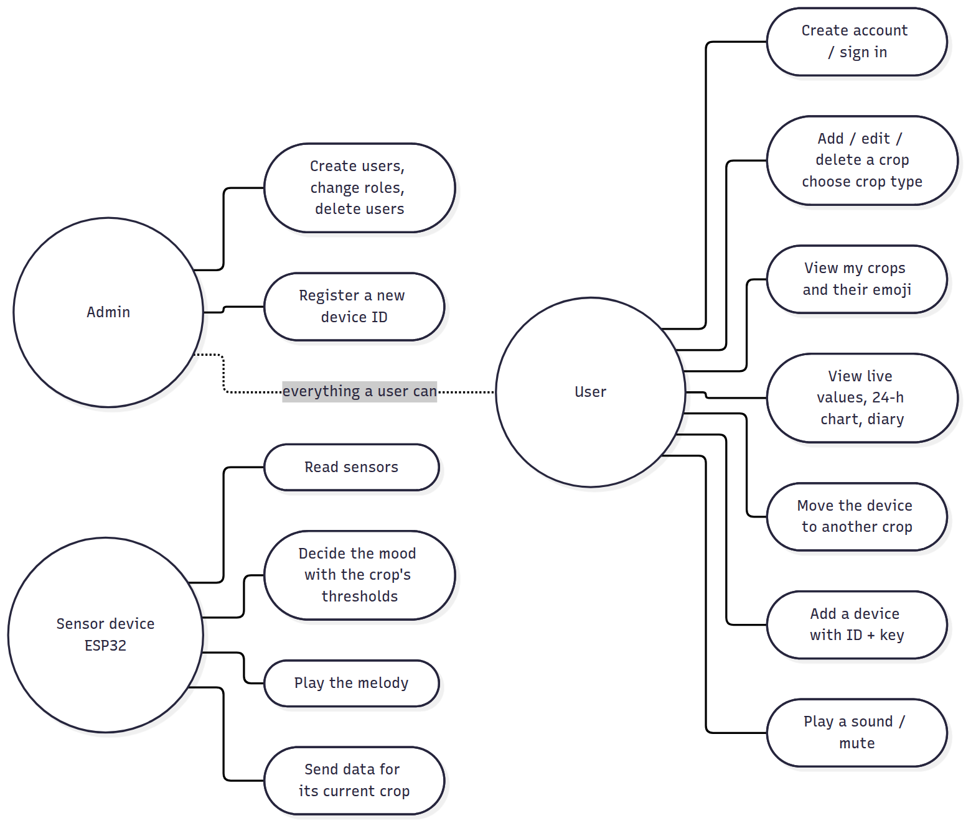

Class diagram (domain model)
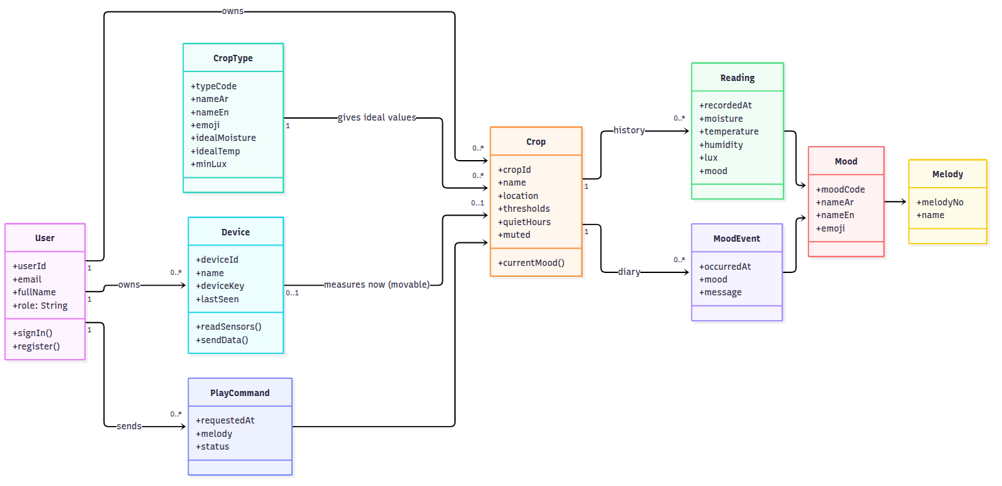

1.9 Mood rules (the “brain” of the device)
Rules are checked in this order (the first that matches wins). The thresholds are those of the crop the device is assigned to (they come from its crop type and can be changed in the apps).
Priority | Condition (defaults) | Mood | Face | Melody
1 | soil moisture < 30 % | Thirsty | 😫 | 1: sad “help!” notes (played twice)
2 | soil moisture > 85 % | Too wet (drowning) | 🥴 | 2: fast “bubbling” notes
3 | temperature > 35 °C | Hot | 🥵 | 3: alarm beeps
4 | temperature < 10 °C | Cold | 🥶 | 4: “shivering” trill
5 | night (18:00–06:00) | Sleeping | 😴 | 8: lullaby (once)
6 | day and light < 200 lux | Needs light | 😞 | 5: “where is the sun?”
7 | otherwise | Happy | 😊 | 6: happy arpeggio / 7: joyful “thank you” after watering
- Hysteresis: a problem is “solved” only when the value is better by a margin (5 % moisture, 1 °C, 50 lux). This stops the face from flickering around a threshold.
- Sound: a melody plays when the mood changes. A complaint repeats every 30 min. The device is silent during quiet hours or when the crop is muted. Melody 9 is the start-up “hello”.

1.10 Context diagram
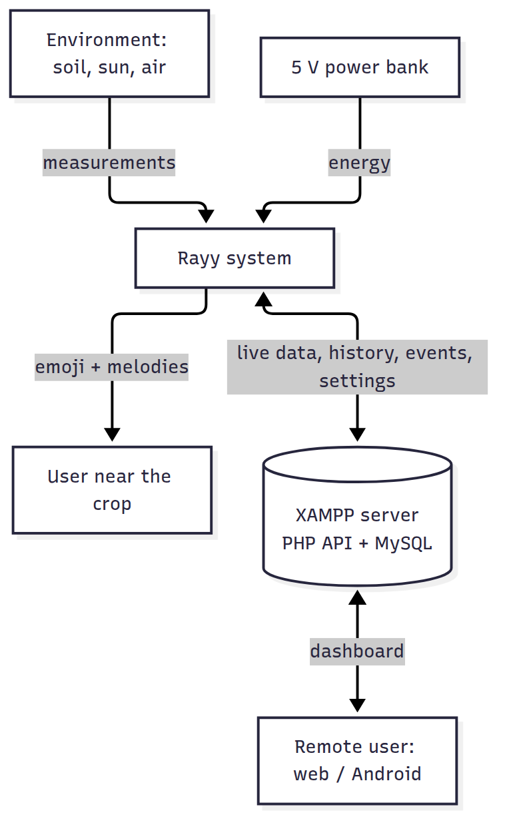

02 · Hardware Components (Bill of Materials)
The project focuses on the main idea: a smart-farming system that shows the feelings of each crop with emoji and sound. This list is for one sensor device, which can be moved from crop to crop; add one set (items 1–11) per extra device. It is powered by a simple 5 V USB power bank (or a USB phone charger) connected to the ESP32’s USB port, so no solar panel, battery charger or voltage converter is needed.

2.1 Bill of materials
Prices are approximate (SAR) and depend on the shop. Buy 1 spare sensor in case one is damaged.
# | Component | Exact model / spec to ask for | Qty | Purpose | ≈ SAR
1 | Microcontroller | ESP32 DevKit V1 (ESP-WROOM-32, 30 or 38 pin) | 1 | Brain + Wi-Fi | 35–55
2 | USB cable | Micro-USB or USB-C data cable (to match the board) | 1 | Programming + power | 10
3 | Soil moisture sensor | Capacitive soil moisture sensor v1.2 (analog). Not the resistive fork type; it rusts | 1 (+1 spare) | Soil water % | 10–20
4 | Light sensor | BH1750 (GY-302) I2C module | 1 | Light in lux | 10–20
5 | Temperature + humidity | DHT22 / AM2302 module (3 pins) | 1 | Air temp + humidity | 20–35
6 | Buzzer | Passive buzzer (module KY-006 or bare 12 mm passive buzzer) | 1 | Sound alerts (melodies) | 3–8
7 | Resistor | 100 Ω (for the buzzer) (+10 kΩ only if the DHT22 is a bare 4-pin sensor) | 1–2 | Protection | 1
8 | Push button | 6 × 6 mm tactile button | 1 | Play the mood melody | 1–3
9 | Breadboard + wires | 830-point breadboard, jumper wires M-M and F-M | 1 set | Connections | 20–35
10 | Power | 5 V USB power bank (5,000–10,000 mAh) or a 5 V USB phone charger | 1 | Power | 0–60
11 | Enclosure | Small plastic box (≈ 100 × 70 × 40 mm) with holes for the buzzer and the USB cable, or a 3D-printed case | 1 | Protection | 10–30
12 | Crop to test with | A pot or small planting (strawberry, mint, tomato…) | 1 | 🌿 | 15–30
 |  |  |  | Total (approx.) | ≈ 135 – 305
Passive vs active buzzer: buy a passive buzzer. It can play different notes, so it can play melodies. An active buzzer only makes one fixed “beep”. The passive one usually has no sticker on top, and its bottom shows the green circuit board.

2.2 Why each component
- ESP32: it has built-in Wi-Fi to send data to the server (MySQL), an ADC to read the analog soil sensor, and PWM to play notes on the buzzer. It is cheap and programmed with the Arduino IDE. (The ESP8266 has only one analog pin and less memory for secure HTTPS, so the ESP32 is the better choice.)
- Capacitive soil sensor: it has no exposed metal in the soil, so it does not corrode like cheap resistive sensors.
- BH1750: it gives real lux values, which are better than an LDR for deciding “needs light”.
- DHT22: it is more accurate than the DHT11 (±0.5 °C) and has a wider range. That is useful in Saudi summers.
- Passive buzzer: this is the “voice” of the crop. Each mood has its own melody (sad melody when thirsty, happy melody when watered, alarm when hot, lullaby at night…). It costs a few riyals and needs only one wire.

2.3 Power consumption
Part | Current @ 5 V (average)
ESP32 with Wi-Fi connected | ≈ 70 mA
ESP32 board (regulator, USB chip, LED) | ≈ 10 mA
Sensors (soil + DHT22 + BH1750) | ≈ 7 mA
Buzzer (only while playing, a few seconds) | ≈ 1 mA average
Total | ≈ 88 mA ≈ 0.45 W
- A 10,000 mAh power bank stores ≈ 37 Wh. With ≈ 85 % conversion efficiency, that gives about 31 Wh ÷ 0.5 W ≈ 60 hours (≈ 2.5 days). A 5,000 mAh bank lasts about 1 day.
- For permanent use, plug the ESP32 into any 5 V USB phone charger.
- ⚠️ Some power banks turn off automatically when the current is low (less than ~100 mA). If yours turns off after a few seconds, use another one (many have a “low-current / always-on” mode), or use a phone charger.

2.4 Optional extras (if time allows)
- Multimeter, useful for checking connections.
- DFPlayer Mini MP3 module + speaker, to play recorded spoken sentences (“I’m thirsty!”) instead of melodies. This is listed as future work in 10.
- Water pump + relay for automatic watering (future work).

03 · Wiring and Assembly
!Wiring diagram
(Vector version: images/wiring-diagram.svg)

3.1 ESP32 pin map
ESP32 pin | Connected to | Notes
USB port | 5 V power bank / charger | Powers the whole project
3V3 | VCC of soil sensor, DHT22, BH1750 | Total < 50 mA
GND | GND of every module | All grounds together
GPIO34 | Soil sensor AOUT | Analog input (ADC1)
GPIO4 | DHT22 OUT / DATA
GPIO21 | I2C SDA: BH1750
GPIO22 | I2C SCL: BH1750
GPIO25 | 100 Ω → buzzer (+) | PWM melodies
GPIO13 | Push button → GND | Internal pull-up is used
GPIO2 | On-board blue LED | Solid = connected to the server, blinking = offline
Analog sensors must use ADC1 pins (GPIO32–39). ADC2 pins stop working when Wi-Fi is on.

3.2 Module by module

Capacitive soil moisture sensor v1.2
Sensor pin | ESP32
VCC | 3V3
GND | GND
AOUT | GPIO34
Push the sensor into the soil up to the white line only. The electronics at the top must stay dry (cover the top edge with nail polish, hot glue or heat-shrink to protect it from water).

DHT22 (module with 3 pins)
Sensor pin | ESP32
+ (VCC) | 3V3
OUT (DATA) | GPIO4
− (GND) | GND
If you have the bare 4-pin DHT22: pin 1 = VCC, pin 2 = DATA (add a 10 kΩ resistor between DATA and 3V3), pin 3 = not connected, pin 4 = GND. Keep it outside the box, in the shade.

BH1750 light sensor (GY-302)
Sensor pin | ESP32
VCC | 3V3
GND | GND
SCL | GPIO22
SDA | GPIO21
ADDR | GND (address 0x23)
Point it up, next to the leaves of the crop.

Passive buzzer
Buzzer pin | ESP32
+ (or S on a 3-pin module) | 100 Ω resistor → GPIO25
− | GND
middle pin of a 3-pin module (if present) | not needed (or 3V3)
The 100 Ω resistor limits the current from the ESP32 pin. For a louder sound (optional): drive the buzzer with an NPN transistor (2N2222 / S8050): GPIO25 → 1 kΩ → base, emitter → GND, collector → buzzer (−), buzzer (+) → 5 V (VIN pin).

Push button
One leg → GPIO13, the diagonal leg → GND.

3.3 Power
Connect the ESP32 USB port to a 5 V USB power bank or a USB phone charger with the same cable you use for programming. The board’s regulator makes 3.3 V for the sensors. Do not connect any other power source at the same time.

3.4 Assembly steps (recommended order)
- ESP32 + buzzer first. Upload the firmware and check that the “hello” melody plays at start-up.
- Open the Serial Monitor (115200 baud) to see the messages.
- Add the BH1750 and DHT22 and check the readings in the Serial Monitor (115200 baud).
- Add the soil sensor and calibrate it (08).
- Add the button: a press plays the current mood’s melody.
- Final version: solder onto a small perfboard (or use a mini breadboard) and put it in a box fixed to the pot: holes for the buzzer, a hole for the USB cable, and the soil sensor cable going into the pot. The DHT22 and BH1750 stay outside the box.

3.5 Typical problems
Problem | Cause / solution
BH1750 not found | Check SDA/SCL. Run the “I2C scanner” example sketch: you should see 0x23
DHT22 reads nan | Wrong pin, or missing pull-up on a bare sensor
Soil % always 0 or 100 | Not calibrated (see 08)
No sound | Active buzzer instead of passive, wrong pin, or (+)/(−) reversed
Board not detected by the PC | Charge-only USB cable (use a data cable) or missing CP210x/CH340 driver
Project turns off on the power bank | The power bank auto-shuts-off at low current; use another one or a phone charger

04 · Database: MySQL with XAMPP (Apache + PHP)

4.1 The idea: one system “ري” for many crops
ري (Rayy) is a smart-farming system, not a single plant. One account can manage many crops (زراعات): a strawberry field in a greenhouse, tomatoes on a farm, mint in a garden… The emoji shows how the whole crop feels.
Concept | Table | Example
User | users | Sara (user), the teacher (admin)
Crop type (library of ideal values) | crop_types | 🍓 Strawberry: moisture 60–85 %, 10–28 °C, ≥ 5000 lux
Crop (a planting the user manages) | crops | “Strawberry – greenhouse 1”, type strawberry, its own thresholds
Device (the ESP32 sensor unit) | devices | rayy-01, now measuring “Strawberry – greenhouse 1”
Device move history | device_assignments | rayy-01 was on strawberries 1–10 Oct, then moved to mint
- A new crop gets the ideal values of its type automatically; the user can still change them.
- The graduation project has one device. It is placed in a crop and chosen in the app; when it is moved to another crop, the readings go to the new crop and the ESP32 automatically uses the new crop’s thresholds. The history of the old crop is kept.
- More devices can be added later (one per crop) with no change to the code.
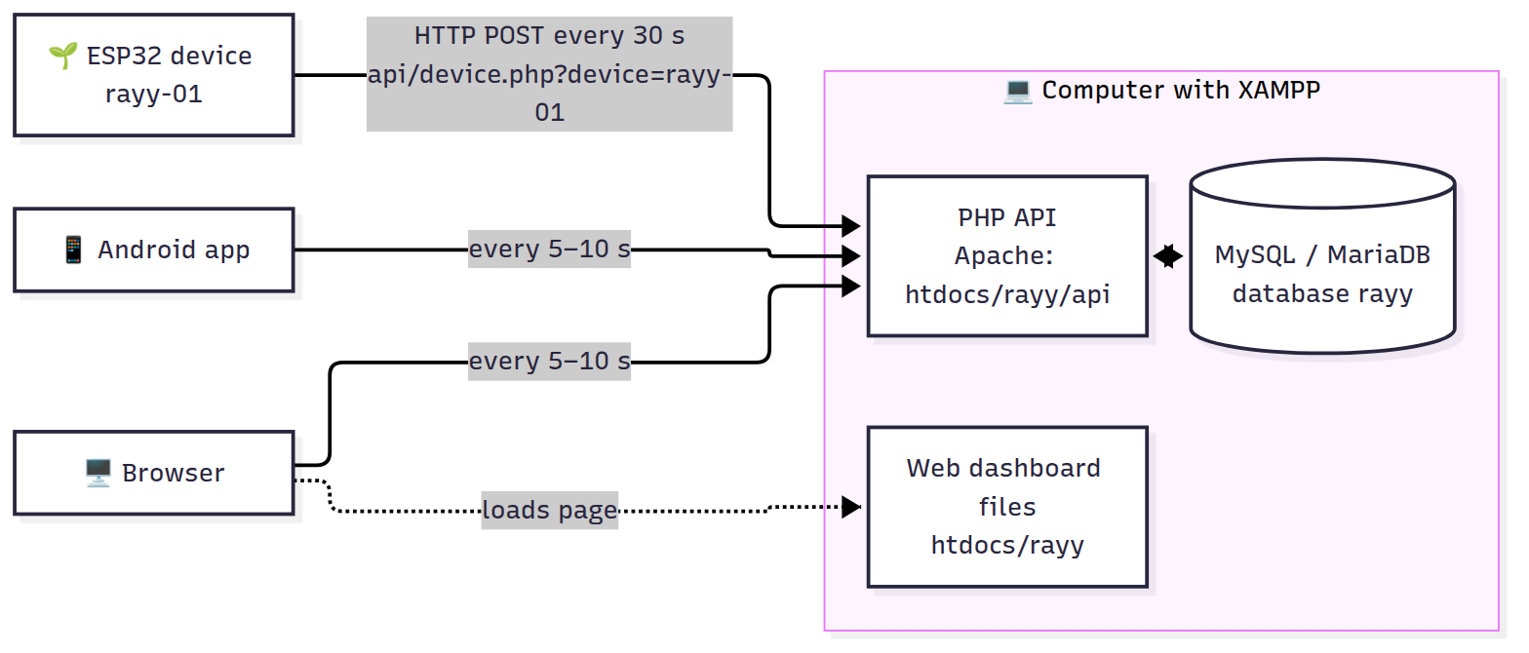

Firebase version vs XAMPP version
 | Firebase (other version) | MySQL + XAMPP (this version)
Where the data lives | Google cloud | Your computer (C:)
Internet needed | Yes | No: a local Wi-Fi is enough
Computer must stay on | No | Yes, during use and the demo
Access from anywhere | Yes | Only in the same Wi-Fi (or with online hosting, 4.7)
Real-time updates | Instant (push) | Every 5 s (polling), good enough for crops
Database type | NoSQL (JSON tree) | Relational SQL: ERD, normalization and SQL map 1-to-1 to real tables
Cost | Free plan | Free

4.2 Tables (database rayy, 12 tables, 3NF)
Script: database/rayy.sql.
Table | Primary key | What it stores
users | user_id | Users; password as bcrypt hash; role admin or user
crop_types | type_code | Library: 12 crop types with Arabic/English name, emoji and ideal values
crops | crop_id | The crops: owner, type, name, location, thresholds, quiet hours, mute
devices | device_id | ESP32 units: SHA-256 of the device key, owner, crop it measures now, last seen
device_assignments | assignment_id | History of moves: device, crop, who moved it, from, until
live_status | crop_id | Latest values of each crop (overwritten every 30 s)
readings | reading_id | History of each crop, one row every 5 min (24-hour chart)
mood_events | event_id | Crop diary: one row per mood change
play_commands | command_id | “Play” requests from the apps: pending → played
moods | mood_code | 7 moods: names, emoji, melody (fixed data)
melodies | melody_no | 9 buzzer melodies (fixed data)
api_tokens | token_hash | Login sessions of the apps (7 days)
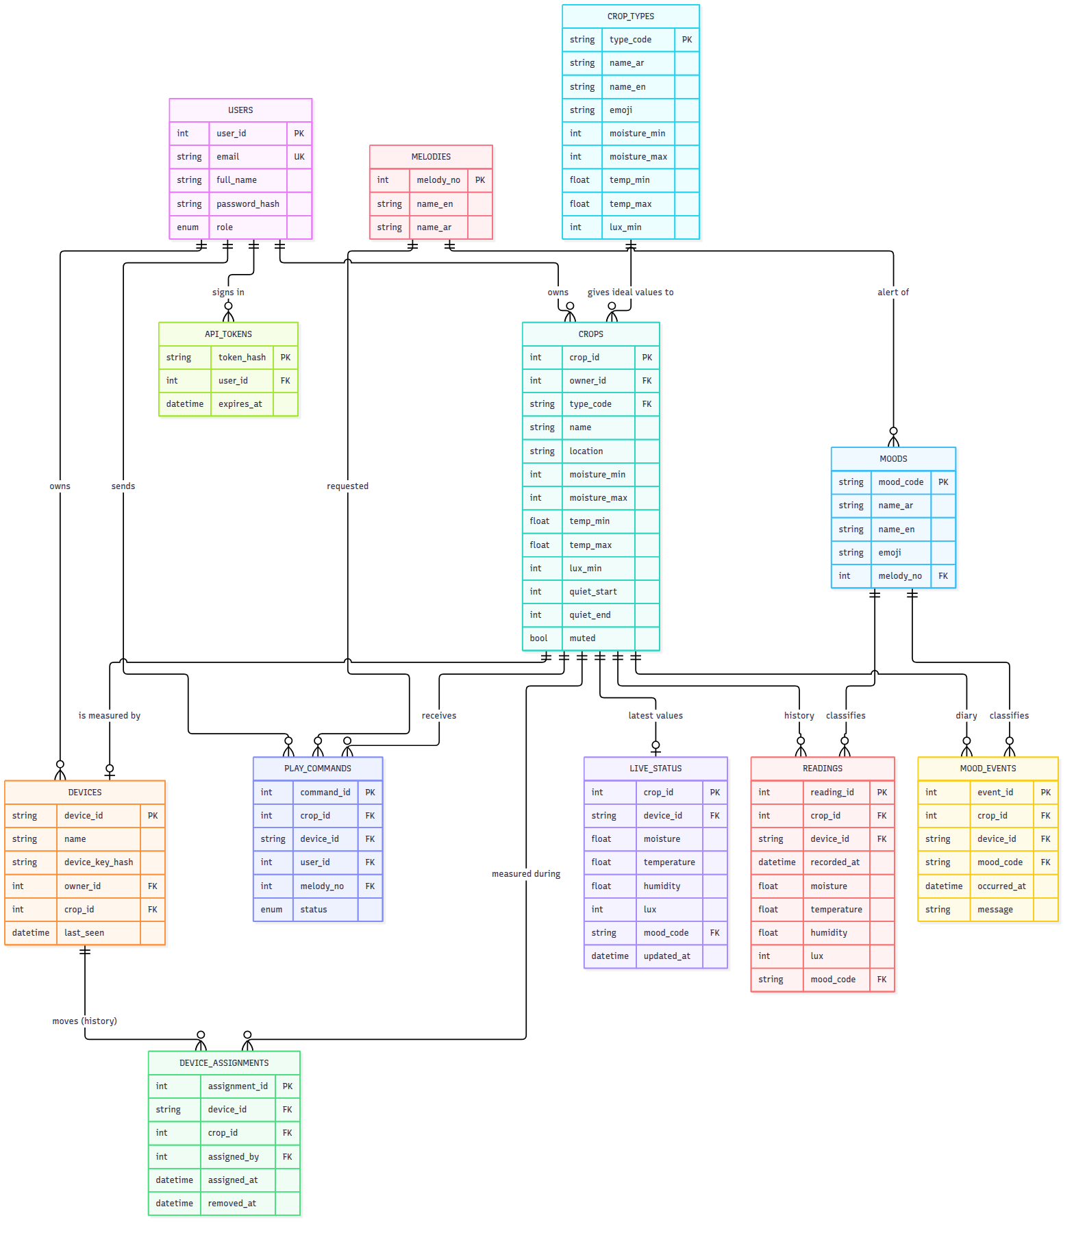

4.3 The PHP API (server/rayy/api)
All answers are JSON {"ok": true, ...} or {"ok": false, "error": "..."}. The apps send the login token in the header X-Auth-Token; the ESP32 sends its key in X-Device-Key.
File | Method | Who | What it does
register.php | POST | anyone (web, Android) | Create an account (role user) and sign in
login.php / logout.php / me.php | POST / POST / GET | web, Android | Sign in → token; sign out; who am I
crop_types.php | GET | anyone | The crop library (for the “add crop” form)
crops.php | GET / POST | user | My crops with mood, values and device (admin: all crops) / add a crop
crop_update.php?crop=ID | POST | owner, admin | Change name, type (loads its ideal values), location, thresholds, mute
crop_delete.php?crop=ID | POST | owner, admin | Delete a crop (its device becomes free)
live.php?crop=ID | GET | owner, admin | Latest values + settings + device of one crop (every 5 s)
history.php?crop=ID | GET | owner, admin | Points of the last 24 h
events.php?crop=ID | GET | owner, admin | Diary of the crop
command.php?crop=ID | POST | owner, admin | “Play” melody 1–9 on the crop’s device
devices.php | GET / POST | user | My devices (admin: all) / add a device with its ID + key (admin: register a new ID)
device_assign.php | POST | device owner, admin | Move a device to another crop (or unassign it)
users.php | GET / POST | admin only | List users / create user (any role) / change role / delete user
device.php?device=ID | POST | the ESP32 | Saves live (+ history + event) for the crop the device is on now; answers with that crop’s thresholds, the next “Play” melody and the server hour
config.php, lib.php | — | — | Database settings; shared code (PDO, JSON, token and permission checks)
Permissions: a user sees and changes only their own crops and devices. An admin sees everything and manages users. Anyone can create a user account; only an admin can create another admin.
Example (ESP32 → server):
POST /rayy/api/device.php?device=rayy-01
X-Device-Key: rayy-device-key-2026
Content-Type: application/json
{"moisture":46,"temperature":27.4,"humidity":38,"lux":5400,"mood":"happy","soil_raw":2190,
"rssi":-61,"ip":"192.168.1.23","uptime_s":86400,"history":true}
Answer (the device is on the strawberry crop):
{"ok":true,"crop":{"crop_id":1,"name":"فراولة البيت المحمي"},
"config":{"name":"فراولة البيت المحمي","location":"Greenhouse 1","type_code":"strawberry","moisture_min":60,
"moisture_max":85,"temp_min":10,"temp_max":28,"lux_min":5000,"quiet_start":22,"quiet_end":7,"muted":false},
"play":0,"hour":14}
If the device is not assigned to any crop, the answer is "crop":null and nothing is saved.

4.4 Step-by-step setup (≈ 20 minutes)

Step 1: Install and start XAMPP
- Download XAMPP for Windows (PHP 8.x) from https://www.apachefriends.org and install it in C:\xampp.
- Open the XAMPP Control Panel → Start Apache and Start MySQL. Both must turn green.
- If Apache does not start (“port 80 in use”, often by Skype/IIS): Config → Apache (httpd.conf) → change Listen 80 to Listen 8080; then every address becomes http://<ip>:8080/rayy/....

Step 2: Copy the website + API
Copy the folder server/rayy into C:\xampp\htdocs\ so that you get C:\xampp\htdocs\rayy\index.html:
C:\xampp\htdocs\rayy\
index.html style.css app.js lib\chart.umd.min.js ← web dashboard
api\config.php lib.php device.php login.php ... ← PHP API
⚠️ If http://localhost/rayy/ says Not Found, the folder is in the wrong place (for example htdocs\Rayy-Project-MySQL\... or htdocs\rayy\rayy\...).

Step 3: Create the database
- Open http://localhost/phpmyadmin.
- Tab Import → Choose file → database/rayy.sql → Import (bottom of the page).
- On the left you now see the database rayy with 12 tables. (Importing again resets all data.)
The script also creates:
What | Value | Change it?
Admin user | admin@rayy.app / Rayy@2026 | Yes: change the password (4.6)
Crop types | 12 types (strawberry, tomato, cucumber, pepper, lettuce, mint, basil, date palm, rose, cactus, indoor plant, other) | Add your own with SQL (4.6)
Example crops | “فراولة البيت المحمي” (strawberry), “نعناع الحديقة” (mint) | Delete or rename them in the app
Device | rayy-01, key rayy-device-key-2026, on the strawberry crop | For a real deployment change the key in rayy.sql and config.h

Step 4: Database password (only if you set one)
XAMPP’s MySQL user is root with an empty password. If you set a password, write it in C:\xampp\htdocs\rayy\api\config.php (DB_PASS).

Step 5: Allow other devices in the same Wi-Fi
- Find the computer IP: cmd → ipconfig → IPv4 Address (e.g. 192.168.1.10).
- Windows Defender Firewall → allow Apache HTTP Server on Private networks (Windows asks the first time).
- Set the Wi-Fi network on the computer to Private (Settings → Network → Wi-Fi → properties).
- Tip: in the router, reserve this IP for the computer (DHCP reservation) so it does not change.
✅ Check: from the phone’s browser open http://192.168.1.10/rayy/ → the login page appears.

Step 6: Test the API without the ESP32 (optional)
In cmd on the computer:
curl -X POST "http://localhost/rayy/api/device.php?device=rayy-01" -H "X-Device-Key: rayy-device-key-2026" -H "Content-Type: application/json" -d "{\"moisture\":20,\"temperature\":27,\"humidity\":40,\"lux\":3000,\"mood\":\"thirsty\",\"history\":true}"
The answer is {"ok":true,...}, and the strawberry crop shows 😫 “Thirsty” in the apps within 5 s.
Full automatic test: bash tests/test_api.sh http://localhost/rayy/api (in Git Bash) runs 44 checks (accounts, crops, devices, moving the device, permissions). Import rayy.sql again before and after it.

4.5 Security
- Passwords are stored only as bcrypt hashes (password_hash / password_verify), minimum 8 characters.
- Login tokens are random 64-character values; the database stores only their SHA-256. They expire after 7 days.
- The ESP32 uses its own device key (stored as SHA-256); it can only send data for its current crop.
- A user can only see and change their own crops and devices; admins manage everything.
- Every query uses PDO prepared statements → no SQL injection. Inputs are validated (ranges, names, emails).
- Foreign keys (with ON DELETE CASCADE / SET NULL), transactions and a CHECK constraint keep the data consistent.
- Limitation: plain http:// inside the local network (no certificate). For use over the internet, use online hosting with https (see 4.7).

4.6 Useful SQL (phpMyAdmin → SQL tab)
-- Change a password. First create the hash in cmd:
-- C:\xampp\php\php.exe -r "echo password_hash('NewPassword1', PASSWORD_BCRYPT);"
UPDATE users SET password_hash = '$2y$10$...' WHERE email = 'admin@rayy.app';
-- Add a crop type to the library
INSERT INTO crop_types (type_code, name_ar, name_en, emoji, moisture_min, moisture_max, temp_min, temp_max, lux_min)
VALUES ('eggplant', 'باذنجان', 'Eggplant', '🍆', 55, 80, 18, 32, 7000);
-- Daily average of a crop over the last week (for the report)
SELECT DATE(recorded_at) AS day, ROUND(AVG(moisture), 1) AS avg_moisture,
MIN(temperature) AS min_temp, MAX(temperature) AS max_temp
FROM readings WHERE crop_id = 1 AND recorded_at >= NOW() - INTERVAL 7 DAY
GROUP BY DATE(recorded_at) ORDER BY day;
-- How often was each crop thirsty?
SELECT c.name, COUNT(*) AS thirsty_times
FROM mood_events e JOIN crops c ON c.crop_id = e.crop_id
WHERE e.mood_code = 'thirsty' GROUP BY c.crop_id ORDER BY thirsty_times DESC;
-- Where was the device, and when? (moves between crops)
SELECT a.device_id, c.name AS crop, a.assigned_at, a.removed_at
FROM device_assignments a JOIN crops c ON c.crop_id = a.crop_id ORDER BY a.assigned_at;
-- Delete history older than 30 days
DELETE FROM readings WHERE recorded_at < NOW() - INTERVAL 30 DAY;
Export data for the report: select a table → Export → format CSV for MS Excel.

4.7 Using it outside the local Wi-Fi (optional)
- Online PHP/MySQL hosting (many have free plans): upload server/rayy with FTP, import rayy.sql with their phpMyAdmin, write their database user/password in api/config.php, and use http(s)://your-domain/rayy/api in config.h and Model.kt. (For https:// the ESP32 code must use WiFiClientSecure.)
- Or a tunnel such as ngrok to the XAMPP computer, for a quick demo.

4.8 Common problems
Problem | Solution
Page shows words like navCrops, myCrops or “Missing crop id” | The browser kept an old app.js from a previous version: press Ctrl + F5 (or clear the browsing data) once. The project now adds ?v= to its files and a .htaccess so this does not happen again
http://localhost/rayy/ → Not Found | The folder is not at C:\xampp\htdocs\rayy\index.html (see Step 2)
Apache will not start | Port 80 is used by another program: change Listen 80 to Listen 8080 (and add :8080 to the URLs)
MySQL will not start | Another MySQL is running (port 3306): stop it in Windows Services, or change the port in my.ini and config.php
Database connection failed | MySQL is stopped, or the database was not imported, or a wrong password in config.php
Phone / ESP32 cannot open http://192.168.x.x/rayy/ | Different Wi-Fi network, Windows Firewall blocking Apache, or the IP changed (ipconfig again)
ESP32: [server] error -1 | Wrong SERVER_URL (localhost? missing /rayy/api?), or Apache stopped
ESP32: [server] error 401 | DEVICE_ID / DEVICE_KEY in config.h do not match the devices table
ESP32: “not assigned to a crop yet” | Open the app → the crop → “Move to this crop”, or Devices → Move
Crop shows “No data yet” | No device is on this crop: move the device to it
Login says “Wrong email or password” | Use admin@rayy.app / Rayy@2026, or reset the hash (4.6)
Arabic text shows as ??? | Import rayy.sql again with phpMyAdmin (it contains SET NAMES utf8mb4)

05 · ESP32 Firmware
Code: firmware/Rayy/. It was compiled successfully for ESP32 Dev Module with esp32 core 3.0.7 (≈ 84 % flash, 14 % RAM, no warnings).

5.1 Install the tools
- Install Arduino IDE 2.x: https://www.arduino.cc/en/software.
- USB driver if the board is not detected: CP210x (Silicon Labs) or CH340, depending on the chip near the USB port.
- File → Preferences → Additional boards manager URLs, paste: https://espressif.github.io/arduino-esp32/package_esp32_index.json
- Tools → Board → Boards Manager → search esp32 → install “esp32 by Espressif Systems” (version 3.x).
- Tools → Manage Libraries → install:
Library (search name) | Author
DHT sensor library | Adafruit (accept “install all”: Adafruit Unified Sensor)
BH1750 | Christopher Laws
ArduinoJson | Benoit Blanchon (version 7.x)
The code uses the esp32 core 3.x buzzer functions (ledcAttach, ledcWriteTone). With the old core 2.x the compile fails, so update the core in the Boards Manager.

5.2 Configure and upload
- Open firmware/Rayy/Rayy.ino (the other files open as tabs).
- Edit config.h: Wi-Fi name/password, SERVER_URL = http://<IP of the XAMPP computer>/rayy/api (no / at the end, never localhost), DEVICE_KEY (same as in database/rayy.sql), and DEVICE_ID (rayy-01). The crop is chosen in the apps, not in the code.
- Tools → Board → esp32 → ESP32 Dev Module, Port = the COM port of the board.
- Click Upload (→). If you see Failed to connect… Timed out waiting for packet header, hold the BOOT button on the ESP32 until “Connecting…” turns into “Writing…”.
- Tools → Serial Monitor at 115200 baud shows:
=== Rayy (ري) smart farming: device rayy-01 ===
[sound] melody 9
[wifi] 192.168.1.23
[server] connected to http://192.168.1.10/rayy/api
soil=46% (raw 2190) temp=27.4C hum=38% lux=5400 mood=happy wifi=1 server=1
[mood] happy -> thirsty
[sound] melody 1
Note: the ESP32 supports 2.4 GHz Wi-Fi only. A phone hotspot works well for demos.
After uploading, unplug the USB cable from the computer and plug the ESP32 into the power bank. The program starts by itself.

5.3 Code structure
File | Responsibility
Rayy.ino | Main program: setup(), loop(), timing, button
config.h | All settings (Wi-Fi, server address, device key, intervals, soil calibration, time zone)
pins.h | Pin map
mood.h / mood.cpp | The crop “brain”: readings → mood, and which melody to play (pure C++, unit-tested)
sensors.h / .cpp | Soil (ADC + calibration), DHT22, BH1750
status.h | The current state of the measured crop (readings, mood, Wi-Fi/cloud, mute) shared with the server upload
sound.h / .cpp | Buzzer: 9 melodies played in the background (non-blocking), so the face keeps moving
cloud.h / .cpp | Wi-Fi reconnect, clock (NTP or server hour), one HTTP request to api/device.php: upload live/history/events, receive settings + “Play” command

5.4 Program flow
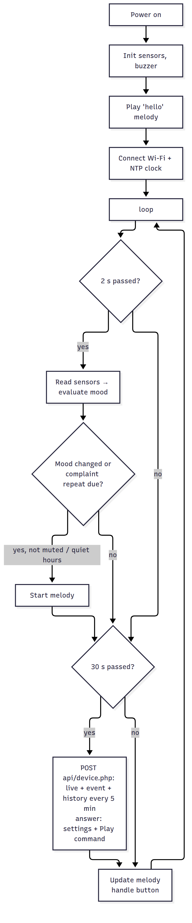

5.5 The sound alerts (buzzer melodies)
A passive buzzer plays a note when the ESP32 sends it a square wave with the note’s frequency (PWM). sound.cpp contains each melody as a list of (frequency, duration) notes, for example the “thank you” melody: G5 120 ms, C6 120 ms, E6 120 ms, G6 200 ms, …. The soundLoop() function moves to the next note when the time of the current note is over, so the melody plays without stopping the face animation or the sensors.
# | Melody | When
1 | Sad “help!” (played twice) | Thirsty 😫
2 | Fast bubbling notes | Too wet 🥴
3 | Alarm beeps | Hot 🥵
4 | Shivering trill | Cold 🥶
5 | Rising notes then a low note (“where is the sun?”) | Needs light 😞
6 | Happy arpeggio | Becomes happy 😊
7 | Joyful “thank you” | Happy after watering
8 | Slow lullaby | Night starts 😴
9 | Short “hello” | Power on
You can compose your own melodies by changing the notes in sound.cpp.

5.6 How the server connection works (HTTP + PHP + MySQL)
The firmware uses plain HTTP requests (HTTPClient + ArduinoJson) to the PHP API on the XAMPP computer. Every 30 s it makes one request that does everything:
- POST {SERVER_URL}/device.php?device=rayy-01 with the header X-Device-Key and a JSON body: the live values, "history": true every 5 minutes, and "event": {...} when the mood changed.
- The PHP code saves them in MySQL (tables live_status, readings, mood_events).
- The answer says which crop the device is assigned to now, with that crop’s thresholds (crops table), the next “Play” melody (play_commands table, 0 = none) and the server hour.
- The ESP32 applies the settings, plays the melody, and uses the server hour as its clock if the Wi-Fi has no internet (no NTP time), so “night” still works on a local network.
If the request fails (Apache stopped, wrong IP), the device keeps working alone (moods + melodies), the blue LED blinks, and the diary event / history point is sent again with the next request.

Moving the device to another crop
The firmware does not know crop names or crop IDs. When the user moves the device in the apps (device_assign.php), the next answer of device.php names the new crop and brings its thresholds. The Serial Monitor prints [server] measuring crop 2: نعناع الحديقة, and from then on the moods are decided with the new crop’s values (e.g. a cactus is happy in dry soil, a strawberry is thirsty). If the device is not assigned to any crop, it prints not assigned to a crop yet and keeps its last thresholds.

5.7 The emoji faces (in the apps, not on the device)
The project has no screen. The ESP32 sends the mood name (happy, thirsty, …) to the server (MySQL) and the web dashboard and Android app show the matching emoji: 😊 happy · 😫 thirsty · 🥴 too wet · 🥵 hot · 🥶 cold · 😞 needs light · 😴 sleeping. On the device itself, the mood is expressed by the melody of the buzzer. A press on the push button plays the current mood’s melody.

5.8 Changing behaviour
- Thresholds, quiet hours, mute: from the web app (no re-upload needed). The ESP32 reads them every 30 s.
- Intervals, soil calibration: config.h.
- Add a new mood: add it to enum Mood, evaluateMood(), moodName(), a melody in sound.cpp, and the texts in the apps.

5.9 Unit tests of the mood logic (on a PC)
cd tests
g++ -std=c++17 -I../firmware/Rayy test_mood.cpp ../firmware/Rayy/mood.cpp -o test_mood
./test_mood # → "33 checks, 0 failures"

06 · Web Application (Dashboard)
Code: server/rayy/: index.html, style.css, app.js, lib/chart.umd.min.js, and the PHP API in api/. No build step is needed: it is plain HTML/CSS/JavaScript served by Apache (XAMPP) from C:\xampp\htdocs\rayy. The name of the application is always ري (Rayy); inside it each user manages many crops.

6.1 Pages
Page (address) | Who | What you can do
Sign in / Create account | everyone | Sign in, or create a new account (name, email, password ≥ 8 characters)
My crops (#crops) | user, admin | Cards of all my crops: emoji of the current feeling, crop type, location, moisture / temperature / light, the device on it. + Add crop: name, crop type (shows its ideal values), location. The admin sees all crops with their owner
Crop page (#crop/1) | owner, admin | Big emoji + message, live values, sensor device of this crop (move a device here / remove it), 24-hour chart, crop diary, play a melody, crop settings (name, type, location, thresholds, quiet hours, mute; choosing a type fills its ideal values), delete the crop
Devices (#devices) | user, admin | Each device: which crop it measures, last connection, Move to another crop / unassign. Add a device with its ID + key (admin: register a new device ID)
Users (#users) | admin only | Create a user (user or admin), change roles, delete users; number of crops and devices per user
Also: Arabic (RTL) / English switch, dark mode automatic, responsive on phones, a red banner when the server cannot be reached, and demo mode (open index.html directly or add ?demo=1).
!My crops (admin)
!A crop page
!Devices page
!Users page (admin)

6.2 Open it
From | Address
The XAMPP computer | http://localhost/rayy/
A phone / laptop in the same Wi-Fi | http://192.168.1.10/rayy/ (the computer’s IP, see ipconfig)
Demo (no server) | open index.html directly, or add ?demo=1
First sign-in: admin@rayy.app / Rayy@2026 (created by database/rayy.sql). New users press Create account.

6.3 How the code works (app.js)
- Routing: the part after # in the address chooses the page (#crops, #crop/3, #devices, #users), so the browser’s back button works.
- API calls: realCall() uses fetch() and sends the login token in the header X-Auth-Token (the token is kept in the browser, so a refresh does not ask to sign in again). On HTTP 401 the page goes back to sign-in.
- Polling: My crops refreshes every 10 s; an open crop refreshes live.php every 5 s, events.php every 15 s and history.php every 5 min. The settings form is refilled only when the settings really changed.
- Crop types: loaded once from crop_types.php; choosing a type fills its ideal values in the form.
- Demo mode: demoServer() is a small fake API inside the browser with three crops, used when there is no server.
- All texts are in the TEXT.ar / TEXT.en dictionaries; all user text is escaped before it is shown (no HTML injection).

6.4 How the PHP API works
See 04 · Database §4.3 for every file. In short, each PHP file: 1. includes lib.php (database connection with PDO, JSON helpers, token and permission checks), 2. checks the method (GET/POST), the login token, and that the user owns the crop / device (or is admin), 3. runs prepared SQL statements on MySQL (inside a transaction when several tables change), 4. returns JSON.

07 · Android Application
Code: android/Rayy/, a native Android app in Kotlin + Jetpack Compose (Material 3) that talks to the PHP API on the XAMPP computer (MySQL database) with plain HTTP + JSON. It needs no extra library for the server: it uses HttpURLConnection and org.json, which are built into Android. It does everything the web dashboard does, in a phone-friendly design. The app name is always ري (Rayy); inside it the user manages many crops. It is in Arabic or English automatically, following the phone language.
Screen | Contents
Sign in / Create account | Email + password, or create a new account (name, email, password ≥ 8)
🌾 My crops (bottom tab) | One card per crop: emoji of its current feeling, type, location, moisture / temperature / light, its device. + Add crop (name, crop type with its ideal values, location). The admin sees all crops and their owners
Crop page (tap a crop) | Tabs Crop · History · Diary. Crop: big emoji + message, online/offline, live values, sensor device of this crop (move a device here / remove it), Play a melody, Mute, crop settings (name, type → ideal values, location, thresholds, quiet hours), delete the crop. History: 24-hour chart + min/avg/max. Diary: mood changes
📡 Devices (bottom tab) | Each device with the crop it measures and its last connection; Move to another crop / unassign; Add a device with its ID + key (admin: register a new ID)
👥 Users (bottom tab, admin only) | Create a user (user or admin), change a user’s role, delete a user
Minimum Android version: 7.0 (API 24). Target: API 34.

7.1 Requirements
- Android Studio Panda (2025.3.1) or newer: https://developer.android.com/studio. It includes the JDK and Android SDK. The project uses Gradle 9.1.0 + Android Gradle Plugin 9.0.1 + Kotlin 2.2.21, which run on Java 17 up to Java 25, so the Java that comes with a recent Android Studio works without changing any setting.
- The XAMPP computer running (Apache + MySQL) and the phone in the same Wi-Fi (04).

7.2 Open, build and run
⚠️ Folder path: English letters only. Put the project in a folder whose full path has no Arabic letters, for example E:\Rayy-Project\android\Rayy. A path like E:\Ray ري\... gives the error “Your project path contains non-ASCII characters”. The project includes android.overridePathCheck=true in gradle.properties to skip this check, but other build tools can still fail on such paths, so moving the folder is the safe fix.
- Open app/src/main/java/com/rayy/app/Model.kt and set the address of the XAMPP computer:
- const val SERVER_URL = "http://192.168.1.10/rayy/api" // the computer's IPv4 address (cmd → ipconfig)
- For the Android emulator running on the same computer use http://10.0.2.2/rayy/api.
- Android Studio → File → Open → select the android/Rayy folder (Android Studio shows the project name Rayy) → wait for “Gradle sync” to finish (the first time it downloads Gradle 9.1.0 and the libraries, so an internet connection is required).
- Connect a phone with USB debugging enabled (Settings → About phone → tap “Build number” 7 times → Developer options → USB debugging), or create an emulator (Device Manager).
- Press ▶ Run. Sign in with admin@rayy.app / Rayy@2026 (from database/rayy.sql), or tap Create an account.
Make an APK to install on any phone: Build → Build App Bundle(s) / APK(s) → Build APK(s) → android/Rayy/app/build/outputs/apk/debug/app-debug.apk. Send it to the phone and install it (“allow unknown sources”).
“The project is using an incompatible version of the Android Gradle plugin”: your Android Studio is older than Panda (2025.3.1). Update Android Studio (Help → Check for Updates).
“Server not reachable” on the login screen: check SERVER_URL in Model.kt, that the phone is in the same Wi-Fi, that Apache is green in XAMPP, and that http://192.168.1.10/rayy/ opens in the phone’s browser. The app uses http:// (not https) on the local network; android:usesCleartextTraffic="true" in the manifest allows it.

7.3 Code structure
android/Rayy/ ← open this folder in Android Studio (project "Rayy")
├── settings.gradle.kts, build.gradle.kts, gradle.properties, gradlew (Gradle 9.1.0, AGP 9.0.1, Kotlin 2.2.21)
└── app/
├── build.gradle.kts dependencies: Compose BoM 2024.09.00, coroutines 1.8.1
└── src/main/
├── AndroidManifest.xml INTERNET permission + cleartext HTTP for the local server
├── java/com/rayy/app/
│ ├── MainActivity.kt shows Sign-in or the app
│ ├── RayyViewModel.kt all data + actions: accounts, crops, devices, users, polling (StateFlow)
│ ├── ApiClient.kt HTTP + JSON calls to the PHP API (token header)
│ ├── Model.kt SERVER_URL + data classes (User, CropType, Crop, DeviceInfo …) + JSON parsing
│ └── ui/
│ ├── LoginScreen.kt sign in / create account
│ ├── AppScreen.kt top bar + bottom tabs, "My crops" list, add-crop dialog
│ ├── CropScreen.kt crop page: Crop / History / Diary, device, settings
│ ├── ManageScreens.kt Devices page, Users page (admin)
│ ├── Common.kt Picker (drop-down), Field, Section helpers
│ ├── LineChart.kt small chart drawn with Canvas
│ ├── Moods.kt mood → emoji + texts, time format
│ └── Theme.kt green Material 3 theme (light / dark)
└── res/values/strings.xml (English) · res/values-ar/strings.xml (Arabic)
How it works: RayyViewModel signs in with api/login.php or api/register.php and keeps the token (SharedPreferences, so the app stays signed in; me.php checks it at start-up). It polls the API with coroutines: the crops list every 10 s; for an open crop live.php every 5 s, events.php every 15 s and history.php every 5 min. Results go into StateFlows that the Compose screens collect, so they redraw automatically. Buttons call crops.php (add), crop_update.php (settings, mute), crop_delete.php, command.php (Play), devices.php, device_assign.php (move) and users.php (admin). If the token expires (HTTP 401), the app goes back to sign-in.

7.4 Notes
- Only SERVER_URL in Model.kt must be set. Crops and devices are chosen inside the app.
- While writing this project, the network code (ApiClient, Model) was run against the real PHP API + MySQL, and all the Kotlin code (ViewModel and every Compose screen) was compiled against the Compose 1.7 / Material 3 1.3 libraries. The full Android build (APK) could not run in that environment (Android SDK download blocked), so build it once in Android Studio. If Studio asks to update the Android Gradle Plugin or Kotlin version, accept it.
- Possible extensions: notifications when a crop is thirsty (WorkManager checking crops.php), a home-screen widget, photos of each crop.

08 · Calibration and Testing

8.1 Calibrate the soil moisture sensor (important!)
Every capacitive sensor gives slightly different raw values. Calibrate it before you trust the percentages:
- Upload the firmware and open the Serial Monitor (115200). Each line shows soil=..% (raw XXXX).
- Hold the sensor in the air, dry. Note the raw value (e.g. 3050). This is SOIL_RAW_DRY.
- Put the sensor in a glass of water up to the white line. Note the raw value (e.g. 1280). This is SOIL_RAW_WET.
- Write both numbers in config.h and upload again.
- Check: dry soil should read about 10–25 %, and soil just after watering about 60–80 %.
The raw value is also uploaded to MySQL (table live_status, column soil_raw), so you can see it in phpMyAdmin too.

8.2 Thresholds of each crop
You do not need to choose the numbers yourself: when you add a crop, its crop type fills the ideal values from the library (crop_types table):
Crop type | Thirsty below | Too wet above | Cold below | Hot above | Light min (lux)
🍓 Strawberry | 60 % | 85 % | 10 °C | 28 °C | 5000
🍅 Tomato | 50 % | 80 % | 15 °C | 32 °C | 8000
🥒 Cucumber | 60 % | 85 % | 18 °C | 32 °C | 6000
🫑 Pepper | 50 % | 80 % | 18 °C | 32 °C | 7000
🥬 Lettuce | 60 % | 85 % | 7 °C | 24 °C | 3000
🌿 Mint | 55 % | 85 % | 10 °C | 30 °C | 2000
🌱 Basil | 45 % | 80 % | 15 °C | 32 °C | 3000
🌴 Date palm (young) | 30 % | 70 % | 15 °C | 45 °C | 10000
🌹 Rose | 45 % | 75 % | 12 °C | 30 °C | 5000
🌵 Cactus | 10 % | 40 % | 10 °C | 40 °C | 5000
🪴 Indoor plant | 40 % | 80 % | 15 °C | 30 °C | 200
🌾 Other | 30 % | 85 % | 10 °C | 35 °C | 200
After calibrating the soil sensor, adjust them for your real crop from the app → crop page → Crop settings (no re-upload needed). The values are typical for growing in Saudi Arabia and should be checked with the agriculture teacher or a local farmer.

8.3 Test plan
# | Test | Steps | Expected result | ✔
T1 | Start-up | Plug in the power bank | “hello” melody; Serial Monitor shows the readings
T2 | Wi-Fi + server | Watch the Serial Monitor | [server] connected to …/rayy/api, server=1, blue LED solid
T3 | Thirsty | Pull the soil sensor out (dry air) | 😫 face, melody 1, web + app show “Thirsty” within 30 s
T4 | Thank you | Put the sensor back in wet soil | 😊 face, melody 7 “thank you”, diary event
T5 | Too wet | Sensor in a glass of water | 🥴 face, melody 2
T6 | Hot | Warm the DHT22 with your hand / a hair dryer (carefully) > 35 °C | 🥵 face, melody 3
T7 | Cold | DHT22 near an ice pack < 10 °C | 🥶 face, melody 4
T8 | Needs light | Cover the BH1750 with your hand during the day | 😞 face, melody 5
T9 | Night | Set “day end” earlier or wait until 18:00 | 😴 face, lullaby once, no sounds in quiet hours
T10 | Repeat | Keep the crop thirsty for 30 min | The melody repeats once every 30 min
T11 | Mute | Web → mute → make it thirsty | Emoji in the apps changes, no sound
T12 | Play from app | Web/app → choose a melody → Play | The device plays it within 30 s
T13 | Settings | Change “Thirsty below” to 60 % | The crop becomes thirsty within 30 s
T14 | Offline | Turn off the router | Face and sounds still work, LED blinks, web shows “Offline”; data resumes automatically when the router is back
T15 | Button | Press the button | The device plays the current mood melody
T16 | Security | Open http://<ip>/rayy/api/crops.php in a browser (not signed in) | Not signed in
T17 | Power bank | Run on a 10,000 mAh power bank | Works for ≈ 2 days
T18 | Android | Install the APK, sign in | The same crops and values as the web, updated every 5 s
T19 | Unit tests | tests/test_mood | 33 checks, 0 failures
T20 | Create account | Web or Android → Create account | Signed in as a new user with no crops
T21 | Add crops | Add a strawberry crop and a cactus crop | Each crop gets the ideal values of its type
T22 | Move the device | Crop page → Move to this crop (strawberry), soil sensor in dry soil | 😫 thirsty
T23 | Same soil, other crop | Move the device to the cactus crop, same dry soil | Within 30 s: 😊 happy (cactus likes dry soil); strawberry keeps its history
T24 | Permissions | Sign in as a normal user | Sees only own crops and devices, no Users tab
T25 | Admin | Sign in as admin → Users | Create a user, make them admin, delete them
T26 | API test | bash tests/test_api.sh http://localhost/rayy/api (fresh rayy.sql) | 44 passed, 0 failed
Record the results (photos, screenshots, history charts) for the report’s Testing and Results chapter.

09 · 6-Week Project Plan and Team Roles

9.1 Team roles (6 members)
Role | Main responsibility
Team leader + integration | Planning, meetings, purchasing, final integration, presentation
Hardware & wiring | Sensors, buzzer, button, breadboard → final board, enclosure
Firmware (ESP32) | Arduino code, calibration, mood logic, melodies
Database + web | XAMPP, MySQL database (phpMyAdmin), PHP API, web dashboard
Android | Android app, building and testing the APK
Documentation + testing | Test plan, screenshots, report writing, demo video
Everyone tests the system and writes their own part of the report.

9.2 Weekly plan
Week | Goals | Deliverables
1 | Approve the proposal. Study the docs. Order the components. Install XAMPP, import the MySQL database. Install Arduino IDE + Android Studio | Components bought, database ready
2 | Breadboard: ESP32 + buzzer (melodies), then BH1750, DHT22 and the soil sensor. Calibrate the soil sensor | Melodies and readings working
3 | Mood logic, Wi-Fi + upload to the PHP API, button. Test with phpMyAdmin | Data visible in MySQL
4 | Web dashboard (on Apache). Android app (build the APK) | Web + Android with live data
5 | Final assembly in a box on the pot. 2-day test on the power bank. Fix bugs | Finished prototype
6 | Run the full test plan (08), write the report, slides, demo video, rehearse | Final report, presentation, demo
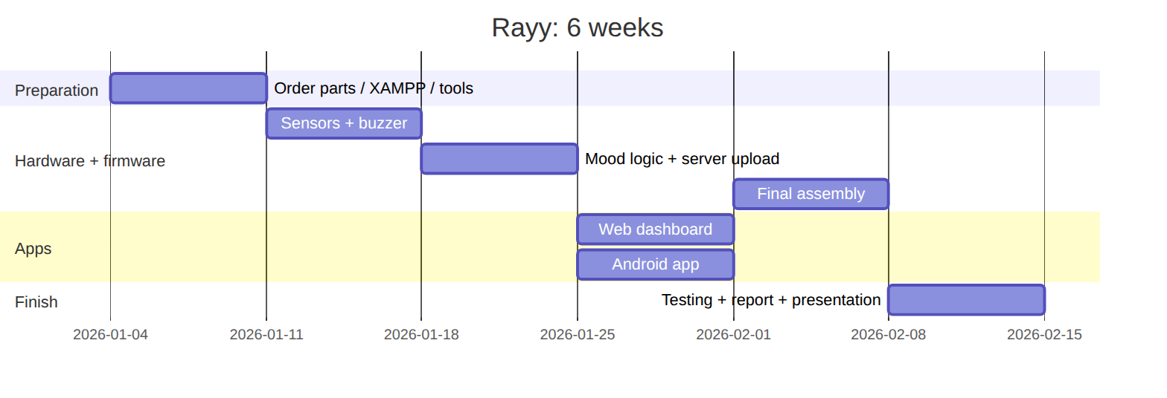 (Change the dates to your semester.)

9.3 Risks and mitigation
Risk | Mitigation
Components arrive late | Order in week 1 from a local shop. Buy a spare sensor
Burned module (wrong polarity) | Check VCC/GND twice before plugging in the USB cable
College Wi-Fi blocks devices / needs a login page | Use a phone hotspot (2.4 GHz) for the demo
Power bank turns off by itself | Use one with an “always-on” mode or a USB phone charger
Android build problems | Use the web dashboard (it also works on phones) as a backup, and build the APK early (week 4)
Server settings wrong (IP, firewall) | Test with the curl command in 04 §4.4 and from the phone’s browser
XAMPP computer off or IP changed during the demo | Keep the laptop plugged in, reserve its IP in the router, or use a phone hotspot for all devices

10 · Graduation Report Outline, Presentation and Future Work

10.1 Suggested report chapters
- Introduction: the idea, the problem (crops are damaged by forgotten or excessive watering and wrong light/temperature, and water is wasted), smart farming, objectives (01 §1.2), importance (from the proposal), scope, and report organization.
- Background / literature review: IoT, microcontrollers (ESP32 vs ESP8266 vs Arduino UNO), sensors (capacitive vs resistive soil sensors, BH1750 vs LDR, DHT22 vs DHT11), databases and servers (MySQL / XAMPP vs cloud platforms like Firebase, 04 §4.1), buzzers and PWM sound, and similar existing products (smart pots, farm monitoring systems).
- System analysis: functional and non-functional requirements, use-case diagram, context diagram, mood rules (01).
- System design:
  - block diagram / architecture (README)
  - hardware design: component selection (02), wiring diagram + pin table (03), power consumption (02 §2.3)
  - software design: firmware flowchart (05 §5.4), database: ERD, relational model, normalization and the real MySQL tables (04 §4.2), the PHP API (§4.3), security rules, user-interface designs (web + Android screenshots)
- Implementation: photos of each step, important code snippets (mood engine, ESP32 HTTP request, PHP API with prepared statements, SQL queries), web and Android implementation, enclosure.
- Testing and results: the test plan with results (08), calibration tables, 24-hour charts (moisture, temperature, light), power-bank running time, screenshots.
- Conclusion and future work.
- References and appendices (full code, BOM with prices, user manual).

10.2 Presentation and demo tips
- Start with the story: “Crops can’t talk… until now 🌱😊”. Show My crops with several crops (strawberry, tomato, mint).
- Live demo: pull out the soil sensor → the device plays its sad “thirsty” melody and the emoji changes on the web dashboard and the phone at the same time → water it → the joyful “thank you” melody 😊. This is the most impressive moment.
- Press “Play” from the phone in front of the committee: the device plays the melody.
- Move the device from the strawberry crop to the cactus crop in the app: with the same dry soil the emoji changes from 😫 to 😊, because each crop has its own ideal values.
- Create a new account from the phone, and show the admin Users page.
- Show the history chart of a full day (prepare it the day before) to show how the soil dries over time.
- Bring a backup video of the demo and a charged power bank. Use a phone hotspot.

10.3 Future work
- 💦 Automatic watering: a small 5 V pump + relay/MOSFET when a crop is thirsty (one valve per crop), with a water-tank level sensor.
- 🔔 Push notifications on the phone (e.g. Firebase Cloud Messaging, or a PHP script that sends e-mail / Telegram messages).
- 🌈 A small screen on the device (e.g. colour TFT ST7789) to show the emoji next to the crop too.
- 🧠 AI: predict when each crop will need water from the history, or detect plant diseases with a camera (ESP32-CAM).
- 🗣️ Spoken sentences instead of melodies with a DFPlayer Mini MP3 module + speaker (recorded voice: “I’m thirsty!”), and voice commands with a microphone.
- ☀️ Solar power: solar panel + Li-ion battery + charger so each device is fully independent in the field and eco-friendly.
- 🔐 HTTPS hosting, sharing a crop with other users (family / farm workers), e-mail password reset.
- 🔋 A custom PCB and a 3D-printed pot with the electronics built in.
- 🌍 Several devices per crop (large fields), a map of the farm, and reports per season.

