Critical Path Networks

Final Report

Prepared for:


Prepared by:

T-R-I-O

Cathy Flaherty
Liz Major
Tim Gabrielson

Executive Summary

The goal of this project was to design an easy to use user-interface that would give project managers an easy tool to assist them in project scheduling. Trio Schedule 1.0 allows the user to define tasks, define the precedence of these tasks, and input their associated times to calculate the critical path in a variety of ways. The user can easily create and modify tasks, create and modify precedence, and solve the network for the optimistic, pessimistic, likely, or probable critical paths. Information on each task is displayed when the user chooses the “Task Information” button and delete capabilities are available using the “Modify Task” and “Modify Precedence” buttons.

When a user solves their network, the critical path they have chosen to solve for is then displayed in a dialogue box as well as highlighted in green on the display. This makes it very simple to visualize where the focus needs to be to keep a project on track.

Trio Schedule 1.0 is a very useful tool that allows users to easily design and modify a network of tasks. Its unique functionality allows the user to analyze the effects of unexpected events that could essentially change the focus of a project. The current edition of this program allows for basic functionality in solving critical path networks and has room for other capabilities that may further assist project managers in project scheduling. We have included in our Final Report some future directions that would be useful in this tool, but given time restraints we were unable to fully implement these.
Table of Contents

Executive Summary i
0 Abstract - 1 -
1 Introduction - 2 -
1.1 Background - 2 -
1.2 Purpose - 2 -
1.4 Goal - 3 -
2 Requirements - 4 -
2.1 Overview - 4 -
2.2 Algorithm - 4 -
2.3 Implementation - 4 -
2.4 Testing - 6 -
2.5 Cost and Time - 6 -
3 Design - 7 -
3.1 Design Introduction - 7 -
3.2 Project Management - 7 -
3.3 Design Overview - 8 -
3.4 Project Design - 8 -
3.4.1 Algorithm - 8 -
3.4.2 Display: Network Definition Screen - 9 -
3.4.3 Display: Diagrams - 9 -
3.4.4 Display: Organization - 11 -
3.5 Implementation - 11 -
3.6 Design Summary - 12 -
4 Implementation - 13 -
4.1 Time Minimizing Algorithm - 13 -
4.1.1 Overview - 13 -
4.1.2 Nodes and Arcs - 13 -
4.1.3 Longest Path - 14 -
4.1.4 Algorithm - 14 -
4.2 Slack Algorithm - 16 -
4.2.1 Overview - 16 -
4.2.2 Finding Slacks - 16 -
4.2.3 Slack Values - 17 -
4.3 Probability - 17 -
4.3.1 Overview - 17 -
4.3.2 Calculations - 18 -
4.3.3 Unique Curves - 20 -
4.4 Graphical Interface - 21 -
4.4.1 Overview - 21 -
4.4.2 Steps for Algorithm Design - 22 -
4.4.3 Algorithm Implementation - 23 -
4.4.4 Additions - 24 -
4.5 Saving - 25 -
4.5.1 Overview - 25 -
4.5.2 Save Changes - 26 -
4.5.3 Serialization - 26 -
5 Scope and Project Progression - 27 -
6 Conclusion and Future Direction - 28 -
References - 29 -

Table of Figures

Figure 1: Tool flow - 5 -
Figure 2: A Normal Curve - 18 -
Figure 3: Various Normal Curves - 20 -
Figure 4: Example of Diagram Flow - 21 -

0 Abstract

Medtronic is looking for help for its managers with project scheduling. Medtronic is specifically interested in improving the accuracy of project scheduling through increased ability to mitigate project time associated risk. We will accept user-defined tasks, precedence of those tasks, and various times associated with the tasks (optimistic, estimated, pessimistic, etc.). Then, using a network structure, find the critical path (that is, the longest path) and the sensitivity of the network. This will allow the managers to know which projects are important to work on now, and which (due to the constraints of the system) allow for time delays without delaying the project itself. Additionally, it will give managers the capability to alter the network and analyze the effects of unexpected events.

This was implemented using a graphical user interface, employing Java. It also allows for changing the parameters to analyze the system for any of the various task times.

1 Introduction

1.1 Background

Medtronic, Inc. is the world leader in medical technology offering products, therapies, and services that enhance or extend the lives of millions of people around the world. Medtronic’s technology has been used for years to treat conditions in many different fields including cardiac, vascular, neurological, orthopedic, spinal, and ear nose and throat. The specific Medtronic field we are working with specializes in orthopedic navigation systems. They have developed two different kinds of navigation systems used to aid surgeons in such procedures as knee replacements, hip replacements, and many different neurological surgeries. These two navigational systems use optical and electromagnetic technology for precision and accuracy in the operating room.

1.2 Purpose

Medtronic has asked us to develop a tool used to aide their project managers. Many commercial programs used today, e.g. Microsoft Project, do not allow for sensitivity analysis; something that would prove very useful to many projects. These sensitivity capabilities would allow for “what ifs” in a project plan, and let project managers know where to focus to get the project done in a timely manner.

The purpose of this paper is to explain the goals, requirements, design, and implementation of an easy to use user-interface that will help with efficiency in project planning.

Goal

The goal of this project is to create a useful project management tool that will allow the user to create and maintain a network structure of tasks needed for the completion of various projects. As a team, we will design an easy to use user-interface that solves for the critical path of a network and allows for sensitivity analysis. This will be completed by the project deadline of June 22, 2005 and presented within days of this deadline.

2 Requirements

2.1 Overview

The critical path network analysis gives insight into the management of projects, specifically pertaining to Medtronic, a medical technology company. More precisely, the program finds the length of time necessary for a project as well as which tasks are more critical and which tasks have more time flexibility. The design of this tool must be applicable to a wide scope of projects and must include several possible parameters for the implementation of a project. The tool interface must provide deletion and insertion capabilities, parameter adjustment capabilities, and other network analysis options to the user. The tool must also be PC based and possibly interface with Microsoft Project.

2.2 Algorithm

In order to implement the project management tool, the algorithm must be designed to account for all of the required inputs including text, numbers, and precedence values. The algorithm must compare this data and output a diagram of the critical path and a number for the time and variance of the critical path.

2.3 Implementation

The architecture of this tool is comprised of two main interface screens. Before the first screen there will be a brief introduction to the tool. The first main screen allows for network definitions including the task title, the expected time and variance of the task, and the precedence of the task; and the second interface provides the solution to the project (i.e., the diagram of the critical path, and the time and variance of the critical path). Multiple miscellaneous capabilities must be included, such as help menus and links to redefine the network. Figure 1 depicts the possible flow for this tool (where Network Display and Definition, and Output are the primary interface screens), incorporating the designed algorithm, and Appendix A depicts an example of a network diagram. The main issues regarding the architecture of this tool involve how user friendly it is; it must be simple yet show necessary details pertinent to each individual user. The algorithm must also be easy to maintain and improve, and it must run efficiently. The team will implement the tool as a group in order to maintain unity and ensure a variety of ideas for the solution.

Introduction
Network Display and Definition
Define Task

Define Precedence
Define Times
Error Checking
Algorithm
Output
Exit

Figure 1: Tool flow

2.4 Testing

In order to design a project that meets the needs and requirements of the client, the tool must be tested and reevaluated. This must be done several times during the implementation stages, keeping the progress of the product on track, and enabling errors and other necessary changes to be fixed.

2.5 Cost and Time

Development of this tool will entail no costs; software and informational texts have been acquired from advisors, if not already owned, to aid in this design. Design of the tool and algorithm is projected to be completed by May 31st 2005, and implementation of the tool is projected to be completed by June 13th 2005.

3 Design

3.1 Design Introduction

The three major divisions of our work in developing a critical path project scheduling program are overview, design, and implementation. During the overview period, we will figure out the goals of the client and the specifications for our project. The work of conceptualizing, refining, and organizing our program, so that it is both intuitive and effective, is part of the design phase. Next, implementation requires that we move from our design to a working program through writing code, testing it, and demonstrating it as well as looking for suggestions from others and improvements in general. By comprehensively completing our overview, design, and implementation, we will be able to produce a quality product that aids our client, Medtronic, Inc., in accurately scheduling projects.

3.2 Project Management

The overview will consist of getting the specifications and requirements from the client and will take one week. Design will take a week and a half; this will include design of the algorithm and design of the display. Lastly, implementation will take about three weeks due to implementation cycles. Some of the design and implementation will occur simultaneously, as prototyping can evince needs for an altered or expanded design. The details of the project management of this project can be viewed in Appendix B, Figure 1.

3.3 Design Overview

In the overview we define the project. The goal in our case is to design a project scheduling tool that will not only find a critical path (and in so doing minimize the time it takes to finish a project) but also allow for sensitivity analysis. This sensitivity analysis is perhaps the most important part of our project in that it makes it unique from similar programs. Our program will take as inputs tasks; the pessimistic, likely, and optimistic times of those tasks; and the precedence of the tasks. It will output a graphical representation of the network with a highlighted critical path. For the sensitivity work, we will allow any of the inputted time parameters to be used to calculate the critical path. Additionally, the user will be allowed to find the probable critical paths using an expected time and variance. Also, we will allow for easy changes to the network to try “what if” scenarios. An open-source development environment, jEdit, will be used to write our Java code.

3.4 Project Design

The design of this tool will consist of the creation of a critical path algorithm, and the design of a user interface display for the algorithm; the interface includes the design of the network definition, the diagrams, and the organization of the screens.

3.4.1 Algorithm

The algorithm solves a given network for a critical path and computes sensitivity of this path to “what-if” scenarios. The sensitivity will be analyzed from three different perspectives. First, by allowing the user to choose the optimistic, pessimistic, or likely time of tasks, the algorithm will convey the sensitivity of the critical path with respect to the different time estimates. Second, the variance between the possible paths will give rise to the probable critical paths, showing the time differences between these, and therefore, the sensitivity of the critical path. Third, sensitivity can by analyzed by allowing for temporary changes once the solution is found. The initial solution will serve as a base, and the user will be able to add tasks and risk items that may occur throughout their project and affect the critical path. The algorithm used is a variation of Dijkstra's which finds the longest path as opposed to the shortest path.

3.4.2 Display: Network Definition Screen

The design of the network definition for the user interface display consists of the information necessary to build a diagram of the network. These items include the names of the tasks, the times of the tasks, and the precedence of the tasks. The names will serve as identifiers for specific tasks. The times will include pessimistic, optimistic, and likely times in order to provide sensitivity analysis. The precedence between defined tasks will define the task order in the network diagram. The user will be prompted for all three of these items in order to properly display and analyze the network. This will be an interactive screen where the user may enter the information, and the network will be immediately displayed based on the definitions by the user. We will attempt to allow for different task relationships such as finish-to-start, finish-to-finish, start-to-finish, and start-to-start. However, this may require an altered network structure.

3.4.3 Display: Diagrams

The design of the diagrams for the user interface display consists of several components including the number of tasks, the connection between the tasks, hierarchy in the network, and the platform of the diagram. The diagram must be able to display any number of tasks necessary for the completion of the user’s project. Therefore the display of the diagram will have the capability to show each of these tasks in an organized fashion. Each task will be considered a node and its depiction will resemble a node. The connection between the nodes will be arrows; each arrow will show the direction from a task to any tasks that cannot be started until the first is finished. The arrows (in conjunction with the nodes) will produce a diagram of the network. Several functions and classes may be necessary in order to allow for these functionalities of circles and arrows.

Design of hierarchy is important because thousands of tasks may be defined, making it difficult to show all of these simultaneously. Therefore, the tasks will be grouped; for complex tasks there will be subtasks grouped into a sub-network. These sub-networks will not be displayed in the solution unless the user chooses to view them. Nodes that contain sub networks will be displayed in a different manner (e.g., color) and have some kind of functionality to view the sub-network (e.g., zoom options or the detection of the cursor over nodes). Completing the display of the diagrams is the design of the platform. As the user inputs the network definitions for each task, that task will be displayed on the right of the definitions screen via display functions. The addition of each task, based on the information the user inputs, will display a user defined network. Collisions of nodes and arrows will be accounted for when necessary. Once the user completes the definition, error checking will make sure all inputs are valid and the algorithm will compute the critical path. The calculation will lead to the display of the network and the critical path. The nodes, arrows, and times will not be interactive; adjustments may only be made by textual input and deletion capabilities via prompts and buttons.

3.4.4 Display: Organization

There are many different factors to consider when organizing this program. One of these is the connection between screens; this includes any interaction between the inputs from the user and the output of the diagram. It may also include different dialog boxes displaying information or prompting the user for input, such as modifying tasks and precedence of tasks. Another consideration is the actual organization of these screens; placement of the buttons, capabilities of the graph, and the display of the information of each task are some examples of what will be included on the screen. We also need to account for the user options in our program, giving the user the capability to undo, vary parameters, make temporary network changes, and various other options.

3.5 Implementation

The implementation of the critical path project scheduling program is a cyclic process. First, we will get the design approved with our clients and advisor. Then we will begin writing the code necessary to run the program. A series of tests will be performed on the code to make sure there are not any errors or other problems with the program. When we feel we have met the needs of our client, we will present the product to the client and advisors and get feedback on how we can improve what we have. We will then start this cycle again, taking into account any feedback and suggestions we receive. This will be done until the client, as well as the team, is satisfied with our work.

3.6 Design Summary

To adequately build a program that is both functional and useful, we found that dividing the project into the overview, design, and implementation is the most effective way to stay on track. We must be familiar with the project itself and know what the client wants before we can start the design process. Once we enter the design process, we must brainstorm every aspect of what we want the program to do and how to do it. If we are successful in building an approved design, we can begin to write the working model. In the end, we will have a very useful tool that aids our client, Medtronic, Inc., in accurately scheduling projects.

4 Implementation

4.1 Time Minimizing Algorithm

4.1.1 Overview

Finding out how to finish all the tasks in a project in the least amount of time possible is the basic objective of our own project. In order to explain how to accomplish this, we will look at the project scheduling network structure, an intuitive explanation of how our time-minimizing algorithm works, and the algorithm itself.

4.1.2 Nodes and Arcs

The network is made up of nodes and arcs. The nodes are used to represent tasks, and the arcs indicate precedence of those tasks. Associated with each task are an optimistic, expected, and pessimistic time. Having a source node and a terminal node to which all the tasks must in some way be linked requires that the network be fully connected. All nodes in the project must be part of a path through the network from source to terminal. The network should only have positive times associated with the tasks. When solving the problem only one of the three times associated with each task is used, and this time alone is associated with the arc that emanates from it.

4.1.3 Longest Path

Given such a structure, our algorithm finds the longest (in terms of time) path through the network, and this gives the minimum time to complete the project. All tasks must be completed; therefore, the longest chain of dependent tasks represents the longest continuous course of action. Since other tasks may be worked on simultaneously, the longest path determines to project time showing where delay can be allowed and where it cannot. A delay on the longest path, also called the critical path, will delay the whole project. Delays along non-critical paths are less likely to do harm.

4.1.4 Algorithm

Our critical-path algorithm itself is a variant of Dijkstra’s algorithm, which finds a shortest path. The algorithm uses the network structure to find two pieces of information for each task—the maximum distance to that task and the predecessor task. The maximum distance is the longest possible path to that task, and the predecessor is the task directly preceding it along that path. (The predecessor should, therefore, be the beginning point for the final arc of the path, and the task itself should be the ending point.) By finding the maximum distance to the terminal node, we find the overall maximum distance, which is the minimum time. Using the predecessor of the terminal node, we find the node before it along the critical path. Using that node’s predecessor, we can find the node before it—all the way back to the source node. This will give the critical path itself, while the distance at the terminal node gives the minimum time for completing the project.

To do this, we initialize all the nodes’ distances and predecessors to -1, physically an impossible value for each. The source node alone begins with something different than this, namely a distance of 0 (which it must have by definition). The source node’s predecessor is never changed from -1, and this gives an easy way to check if we are at the beginning of the network. We also assume a set of unchecked nodes, S, and place all nodes in it.

We then loop through a routine until all nodes have been removed from S. In the routine, we do the following. One, find the node—call it i—with the maximum distance currently. (The first time through this will be the source node.) Two, remove i from S. Three, update all the other distance labels as applicable using the distance of i (check to update even if the distance has not changed). For all the arcs emanating from i, compare the sum of i’s distance and the time on the arc with the current distance on the end node—call the node j. Take the maximum of the sum and the old distance, and set that as the new distance of j. For all the js that have been updated, set their predecessor to i. Also, for these same updated nodes, use the above technique (recursively) to update the nodes depending on them. This will allow the changes to any node trickle through the network. Then begin the loop again at step three.

Once this loop has removed all the nodes from S, the solution has been found. The terminal node’s distance is the minimum time it will take to finish the project, and the critical path can be found by following the predecessors of tasks.
(See Appendix C, Document 1 for the pseudocode of the algorithm.)

4.2 Slack Algorithm

4.2.1 Overview

There are a number of ways we plan to allow for sensitivity analysis of our critical path, and this is really what separates our program from other project scheduling tools. (Sensitivity analysis, briefly, allows a user to understand other possible outcomes of the network if certain time parameters are varied.) One of the ways we will allow for this is displaying on the screen slacks along other paths. In order to explain the slack algorithm and what it tells you, we will look at the slacks and what they mean physically, as well as how to find the slacks.

4.2.2 Finding Slacks

A slack is the amount of time some part of the project can be delayed without delaying the project as a whole. That is concomitant to saying how much less time it takes to complete some part of the network than it does to complete the critical path in the same part of the network. Slack is associated with all non-critical paths that begin and end on a critical path. Since all the networks are fully connected, this means that all nodes are either part of the critical path or part of at least one non-critical path containing slack.

Thus, to find the slacks we do the following. For ease of explanation, assume two variables, currentSlack and difference, which are initialized to 0. After solving the network for the critical path, we loop through all the tasks and find all the nodes that are non-critical and have a critical node preceding them. Note that the potential preceding nodes of some node, n, are not limited only to the predecessor of n, as defined by our critical-path algorithm. Instead, the preceding nodes are the beginning nodes for all the arcs that terminate at n. Then, for one of these nodes, i, find all the arcs emanating from it. Let j be any one of the nodes at which these arcs end. For each j, redefine difference = distance of j – distance of i – time of i. (Note that the time of i is the same thing as the time on the arc [i, j] itself.) Redefine currentSlack = currentSlack (the old value) + difference. Then, if j is terminal, currentSlack is the slack on the path. If j is not terminal, repeat the process by making j the next i (that is, a recursive call) until an arc does end at a critical node.

4.2.3 Slack Values

Using this algorithm, slacks can be displayed on all non-critical paths in our network. Low slack values indicate a high likelihood of becoming a critical path—that is, of delaying the network if delay is encountered. A high slack value indicates that delays along that path are unlikely to influence the overall project time. Thus, slacks are very beneficial tools in analyzing the sensitivity of the project scheduling network.
(See Appendix C, Document 2 for the pseudocode of the algorithm.)

4.3 Probability

4.3.1 Overview

Solving the sensitivity analysis for the critical path network program took into account a few different options. One of these was allowing the user to specify how they wanted the network to be solved (i.e., the optimistic, pessimistic, likely, or probable critical paths). To solve any of these, user input was needed. For the probable critical path solution, the user inputs the optimistic and pessimistic times, allowing our program to solve for the mean and the variance of completion time for a particular task. After researching many distributions, we found that we could use the normal distribution to find the probabilities associated with each time. This makes each arc an independent normal distribution. The normal distribution, graphically, is a symmetric bell shaped curve where the maximum value is the mean. Figure 2 show the normal distribution curve where μ is the mean and σ is the standard deviation.

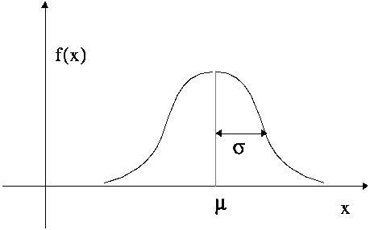

Figure 2: A Normal Curve

4.3.2 Calculations

The probabilities calculated by the normal distribution follow a formula in the following form:
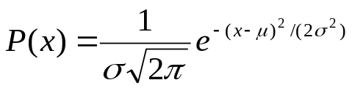 [1]
This will calculate the probability that the likely time, the variable χ, is actually realistic. To implement the probable critical paths in our program, we developed a class called Probability that takes the user input and calculates the probabilities on all of the paths of the network. There are actually two cases for this. If the user does input a likely time, which can actually be anywhere on the curve between the optimistic and pessimistic times, then the value of χ will have this value and the probability will be calculated using the formula. If the user does not enter a likely time, our program assumes that the likely time is the mean and the formula simplifies and then solves accordingly.

4.3.3 Unique Curves

Each arc will have a unique distribution curve depending on the spread of the variance. This is where the critical path of the network could change significantly. Figure 3 shows some different characteristics of the normal distribution. The critical path is chosen simply by using the expected/likely time value; it does not account for the different fluctuations that might occur in different tasks. For instance, if a certain task has a fairly small expected time but the optimistic and pessimistic times have a large spread, the probability of the expected time actually being the realistic time is less likely than a time that has a smaller difference in optimistic and pessimistic times. This would allow the user to know a more realistic approach to focus on in their project.

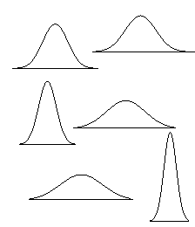

Figure 3: Various Normal Curves

4.4 Graphical Interface

4.4.1 Overview

Display of the diagrams requires an algorithm that will properly place each task on the screen and depict the flow between the tasks. The flow indicates the precedence of the tasks. The task definitions by the user will be entered into the algorithm, and a printed network based on these definitions will result from the algorithm. Circles were used to represent tasks with the task name printed underneath and arrows represent the flow with the times printed along the line; these times correspond to the time needed to complete the preceding task that is at the beginning of the arrow. The left of the screen is the beginning of the project being managed, and the right end of the screen is the end of the project. This diagram is an acyclic, directed tree where it collapses back down to one circle. It will be printed out via a grid without printing the incrementing values in the horizontal and vertical directions. Figure 4 depicts an example of this.
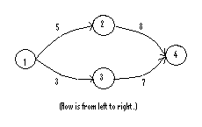
Figure 4: Example of Diagram Flow

There was also design required to determine whether the algorithm was called after the definition of each task by the user, or after every task has been defined; this is important when determining how and when to define and update variables. Also, several more functionalities of the algorithm may be implemented, time permitting.

4.4.2 Steps for Algorithm Design

Once a diagram visual was designed, the algorithm for displaying this was designed. The first step was to figure out how to determine positions of the nodes. A grid was used where the top left corner is the origin. There is uniform spacing both horizontally and vertically in order to simplify position calculations and avoid collisions of nodes.

The next step was to find functions that draw circles, lines, and text boxes. Since they already existed then they did not need to be designed, and design of the display algorithm had to include the parameters and calculate the values needed for these functions. A function was found for printing each of the three different types of output: the circle function needed parameters for the position of the top left corner of the rectangle to draw the circle in as well as its height and width; the line function needed the beginning and ending horizontal and vertical positions; and the function that draws strings needed the string and the horizontal and vertical distances of where to start outputting the string.

The next step was to figure out what other variables are necessary for the display. Since the screen is a limited size, there must be variables that keep track of how many tasks are at a particular horizontal and vertical distance in order to allocate space on the screen for every node.

The last component of the design of this algorithm was to calculate the values for these necessary variables. These values are found relative the preceding node’s rank (i.e., its relative horizontal position), where the source node is initialized to 0. This involves looping through the list of arcs to determine the beginning node of the arc that ends at a particular node. Once this beginning node is found, the current node’s rank is set to the beginning node’s rank incremented by one. This must be done for each node. The order (i.e., its relative vertical position) of each node is found via its rank by counting the number of nodes at a particular rank. This involves looping through the nodes and counting the number of nodes at each rank (there is also a list of possible ranks). The order of the current task is set to the number of tasks already at that rank. Figure 5 depicts a diagram with corresponding ranks and orders.
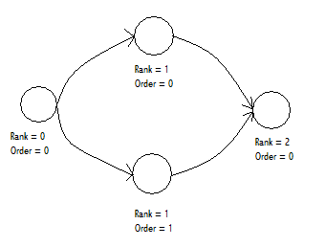
Figure 5: Example of ranks and orders

The rank and order values are then used to calculate the uniform horizontal and vertical spacing for the entire network diagram.

4.4.3 Algorithm Implementation

After designing the pseudocode for these steps (which can be viewed in Appendix C, Document 3) implementation of the algorithm to hard code was carried out. The first step taken in programming was typing out the basic steps previously discussed into code, adding variables where thought to be necessary. It was quickly determined that there must be variables defined within the task class and others defined within the algorithm; the location of definition was decided as a result of whether the variable was specific for each task or independent of what the current task is. Additionally, it was decided that the algorithm be used after each task is defined by the user, in order to display the entire network each time. This complies with the original design where the network is displayed continuously as the user enters tasks, as opposed to only displaying the network after the user is completely finished defining all of the tasks. Next, programming of the display steps into individual functions was carried out, again keeping track of defining and updating variables. The calculation of the rank was the most complex function as it consisted of several nested loops. Lastly, the code was tested manually. Once it appeared to display properly, the code was tested in unison with the entire user interface.

4.4.4 Additions

There are multiple types of collisions that may occur in these diagrams, such as task times and long task names. The task times are not printed in the current program, but if they were to be printed, algorithms must be designed that correct any collisions of these times. For collision of names there is the option of printing the task ids (instead of the names) above the nodes as well as a list to the side of the diagram that shows the corresponding names and ids. Another option is to print the name inside the node which would not only prevent name collisions but also improve clarity of what name corresponds with what node. This may be implemented by simply researching a proper function. In addition to the improvement of collision correction, several other functionalities may be added. One such addition is arrowhead-character and curvature to the arcs, as they are currently just straight lines with no obvious directionality; direction of flow is only determined by reading the screen from left to right. This may also be implemented via research of possible functions. Another desirable addition is the correlation of the length of the arcs between the tasks and the time values between the tasks; currently the circles are uniformly spaced, so the arc length does not indicate time, the only indicator of the time is the number printed next to the arc. Implementation of this could be quite cumbersome due to necessary alterations in several different calculations; almost every calculation related to the location of nodes is carried out using the fact that the nodes are spaced uniformly, so varying these will significantly increase complexity of the entire algorithm.

4.5 Saving

4.5.1 Overview

To be a useful tool, our program would need the ability to save the data that a user inputs. It would allow the user to make and save changes and be able to access the changed data the next time the user would like to view it. To do this, the user would need to click on the ‘Save’ button that would send the program to the Saved class. The Saved class uses a method in Java called serialization. Serialization is the process of saving an object's state to a sequence of bytes, as well as the process of rebuilding those bytes into a live object at some future time.

4.5.2 Save Changes

For our program, this will not only allow the user to make changes to a network and read the output, but also allow access of the new network at some later time. This functionality also allows the user to make changes to a base network, but not save the changes to this base network unless the “save changes” button has been clicked. This is a useful tool if the user simply wants to view how certain changes in the process will affect the project but not change the entire network permanently.

4.5.3 Serialization

To serialize our program, we included two other classes called SaveFile and OpenFile. The OpenFile class reads in the data (i.e., the arc and task arrays) and writes them in a file that the user will name. The SaveFile class can access the file and run the critical path application with the data that has been stored in the file.

5 Scope and Project Progression

Every item discussed in our design was attempted, however, not all of them were implemented. We successfully implemented insertion and deletion capabilities along with the network definitions options and a proper display of the diagrams. The items that can be implemented given time are hierarchy of sub-networks, the allocation of resources and people for networks, and nodes in the networks that are not only finish-to-start (i.e., finish-to-finish, start-to-finish, and start-to-start). By researching possibilities, we designed the project so that these items could be implemented relatively easily.

Almost every task we managed for the project was completed in the allotted time, including the implementation cycles. The only alterations were the design of the display algorithm for diagrams, which took closer to a full week, and the demonstration of our project to our client was done on the Tuesday following the Monday that we had planned for. Neither of these changes affected what we were able to ultimately accomplish for our product.

6 Conclusion and Future Direction

We were able to meet the basic needs of the client by using a number of different java classes. Eighteen classes were used to implement and run this project management tool. (See Appendix D; Diagram 1 for class structure). Unfortunately, there are a handful of functionalities not completely added that we would like to be implemented in this product including the following: hierarchy of sub-networks, the allocation of resources and people for networks, and nodes in the networks that are not only finish-to-start (i.e., finish-to-finish, start-to-finish, and start-to-start). Hierarchy of sub-networks will allow thousands of tasks to be accounted for in a network and for them to be displayed in a clear way, where only a certain number (say ten) are displayed and a number of those have sub-networks that the user can view via a zoom or a new window function. Allocating resources and people among the tasks in a network will allow the user to picture the allocation of the tasks easier and will be beneficial to the temporary changes analysis of networks. Lastly, the three other node relationships are useful in networks as not all tasks are only related via a finish-to-start relationship; this will allow the user to manage the project in a more timely way.

References

"mathworld," Wolfram Research. http://mathworld.wolfram.com/Dijkstras
Algorithm.html. Cited on 20 June 2005. Last updated 1999.

"mathworld," Wolfram Research. http//mathworld.wolfram.com/NormalDistribution.html. Cited on 20 May 2005. Last updated 1999.

“Object Serialization.” http://java.sun.com/docs/books/tutorial/essential/io/serialization.html. Cited on 16 June 2005

Russel, Stuart J. and Peter Norvig. Artificial Intelligence; A Modern Approach. Upper Saddle River, New Jersey: Pearson Education Inc. 2003. Second Edition.

“Serialization.” http://www.mines.edu/~crader/cs443/Code/Java.html#Serialization. Cited on 16 June 2005

Appendix A: Example network

12
12
4
4
6
15
7
15
9
9
5
Circles depict tasks, arrows indicate precedence of tasks, and numbers on arcs indicate associated time with preceding task. The times do not actually appear on the program diagram, but this reflects how they are stored.

Appendix B, Figure 1

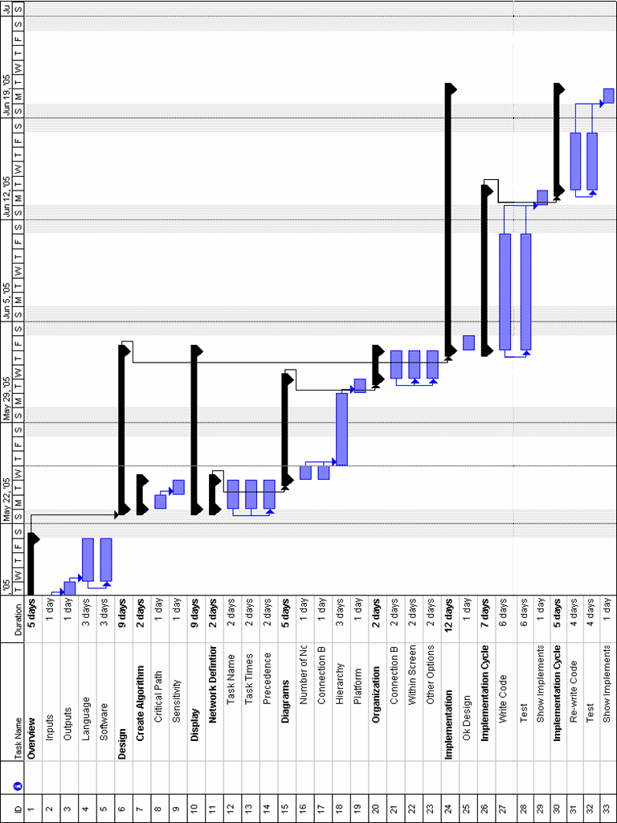
Figure 1: Gantt Chart for our time allotments

Appendix C, Document 1: Critical Path Algorithm Pseudocode

Let n be the number of tasks,
i and j be any one of the tasks,
source be the beginning node of the network,
S be a set of the unchecked tasks,
d[i] be the distance at any i (where ‘distance’ is the longest amount of time to arrive at i), pred[i] be the predecessor of i,
A[i] be a set of all arcs emanating from i,
(i, j) be an arc from i to j,
time[(i, j)] be the time on the arc (i, j), and
Update( i ) be a function that takes as a parameter a task.

S := {1, 2, … , n}
d[i] := -1 for all i ≠ source
d[source] := 0
pred[i] := -1

while |S| < n, do
let i be an element of S which satisfies d[i] = max( d[j] such that j is an element of S )
S := S – {i}
Update( i )

Update( i )
for each (i, j) in A[i] do
if d[j] < d[i] + time[(i, j)] then
d[j] = d[i] + time[(i, j)] and
pred[j] = i
Update( j )

Appendix C, Document 2: Slack Algorithm Pseudocode

Note: This is run after a critical path has been found.

Let i and j be any one of the tasks,
C be the set of critical nodes,
d[i] be the distance at any i (where ‘distance’ is the longest amount of time to arrive at i),
(i, j) be an arc from i to j,
time[(i, j)] be the time on the arc (i, j),
curSlack be an integer that records the current slack, and
Slack( i, curSlack ) be a function that takes as a parameter a task and an integer.

for all tasks j do
if j is not an element of C and there exists an arc (i, j) such that i is an element of C then
Slack( i, 0 )

Slack( k, curSlack )
for all arcs (i, j) do
if k == i then
curSlack := curSlack + d[j] – d[i] – time[(i, j)]
if j is an element of C then
slack on path := curSlack
else then
Slack( j, curSlack )

Appendix C, Document 3: Diagram Algorithm Pseudocode

* Draw Network (send the task and arc arrays that have already been updated)
* Define & initialize variables: screen width & height, and circle radius; then array of precedence (arcs), array of tasks (ids), number of tasks, number of arcs; then array of tasks with same precedence, and array of critical tasks
* Update variables: horizontal spacing, position of the source & terminal nodes, position of the intermediate nodes
* Display the arcs
* Display the tasks

Appendix D, Diagram 1: Class Structure

TrioSchedule
Opening
Definition
Diagram
TaskGUI
TaskModifyGUI
PrecedenceGUI
PrecedenceModifyGUI
TaskInfoGUI
SolveInfoGUI
SolveGUI
SaveFile
OpenFile
PrepareForAlg
Algorithm
Saved
File Directory
Arc
Task
…are used throughout—defining basic structure of network

