7PAM2000 -Applied Data Science Assignment 2: Statistics and trend

Exploring Statistics and Trends in World Bank Data

**Abstract -** This report explores the trends and correlation between various indicators, such as urban, population growth and energy production, value added in GDP by agriculture, forestry, and fishing, and CO2 emission using bar plots, time series plots, and confusion matrix on World Bank data. The report emphasizes the use of appropriate visualizations, including time series, to effectively communicate and explain the findings. By analyzing the data and presenting a narrative, the report aims to "tell a story" and provide insights into the relationships between different indicators. The report also evaluates the overall quality of the analysis and the use of appropriate coding practices.

**CO2 Production GDP** - This bar plot shows the contribution of agriculture, forestry, and fishing in the GDP of Germany, the USA, the UK, Nigeria, China, Brazil, and Australia for 4 years (i.e. 1997, 2003, 2009, and 2015). The plot shows that these industries contribute to Nigeria’s GDP maximum as compared to other countries.

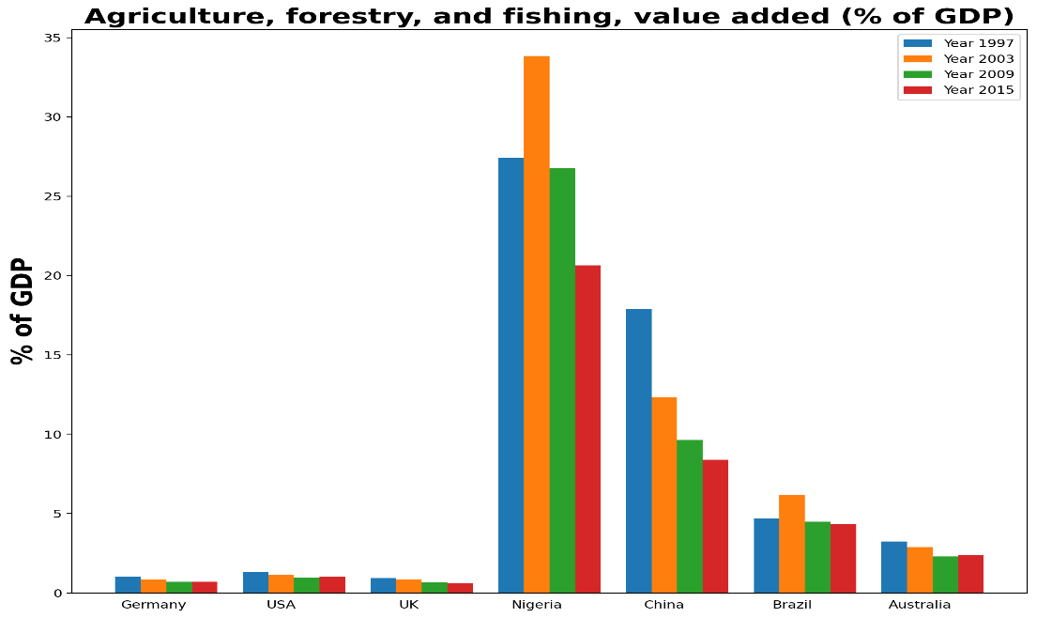

Figure : annual value added in GDP from Agriculture, forestry, and fishing

**Urban Population Growth -** This bar plot presents the urban population growth annually for countries (Germany, USA, UK, Nigeria, China, Brazil, and Australia) for 4 years (i.e. 1997, 2003, 2009, and 2015). In the UK, Australia, and Germany the growth increased whereas, in Nigeria and China, the growth decreased. Whereas the highest annual urban population growth (%) recorded in Germany is in 2015, 1997 in the USA, 2015 in the UK, 2003 in Nigeria, 2003 in China, 1997 in Brazil, and 2009 in Australia.

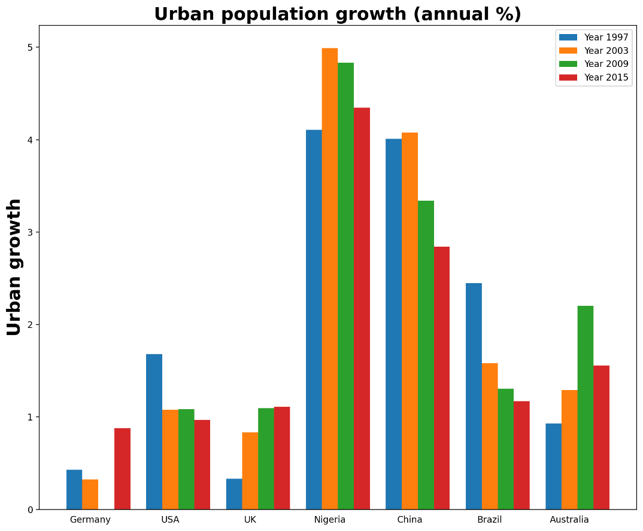

Figure 2: annual Urban population growth of Germany, USA, UK, Nigeria, China, Australia and Brazil

**CO2 emission (metric tons per capita) -** The below trend represents the CO2 emissions of greenhouse gases from 1997 to 2015 in countries (Germany, the USA, the UK, Nigeria, China, and Brazil). The trend shows that Nigeria's and China's contribution to GHG emissions increased significantly and slightly respectively, on the other hand, Germany, the USA, and Brazil's emissions decreased whereas, the UK's contribution remains uniform throughout the period.

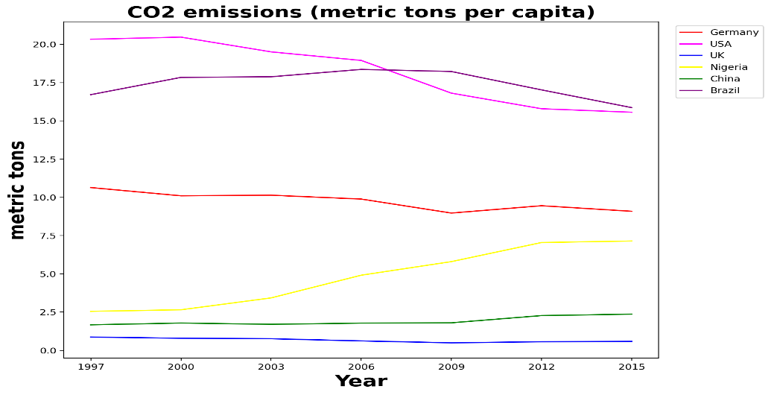

Figure 3: CO2 emission in metric tons by Germany, USA, UK, Nigeria, China, and Brazil from 1997 to 2015

**Energy Production -** The below trend shows the energy production from 1997 to 2015 for 6 countries (Germany, USA, UK, Nigeria, China, and Brazil). The UK increased their energy production after 2003, whereas China increased after 2009. The remaining countries have a uniform trend with slight variation from 1997 to 2015.

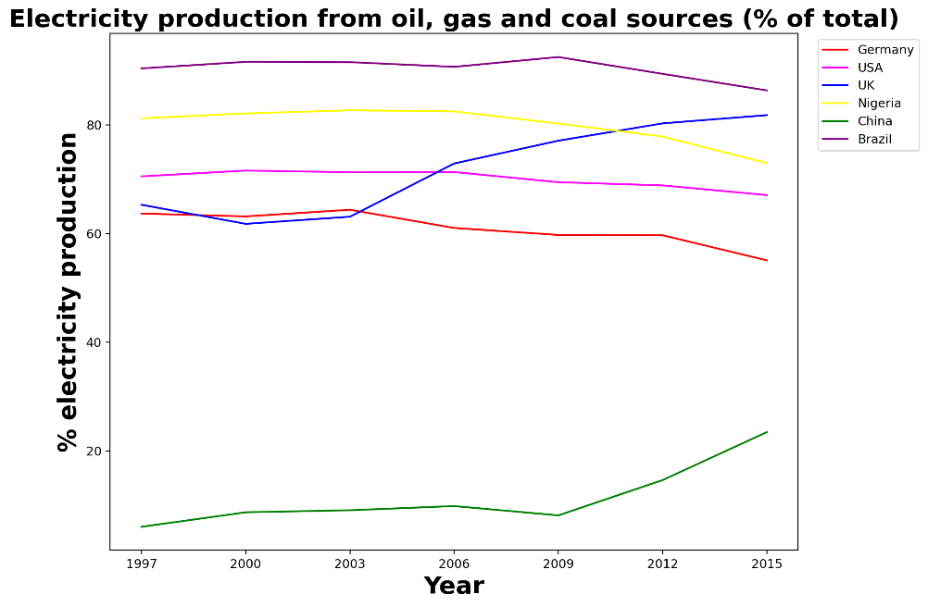

Figure : Electricity production (%)from energy sources i.e. (oil, gas, and coal)

**Statistics and Values -** The distribution has an average value of 3.958 and a standard deviation of 2.9762. The skewness is slightly positive, indicating a slight right skew. The kurtosis is relatively low, indicating fewer extreme values than a normal distribution. These results suggest that the sample mean and standard deviation are reliable estimates of the data parameters.

|  |  |
| --- | --- |
| Statistic | Value |
| Skewness | 0.021943 |
| Kurtosis | 0.010719 |
| Average | 3.958 +/- 0.0297 |
| Std. Dev | 2.9762 +/- 0.0212 |
| Skewness | 0.0219 +/- 0.024 |
| Kurtosis | 0.0107 +/- 0.043 |

**Correlation Between Indicators for Germany –** the below confusion matrix shows the relationship (from 0 to 1) between 6 indicators as labelled on the x-axis and y-axis. The relationship shows that forest areas and CO2 emission are inversely proportional.

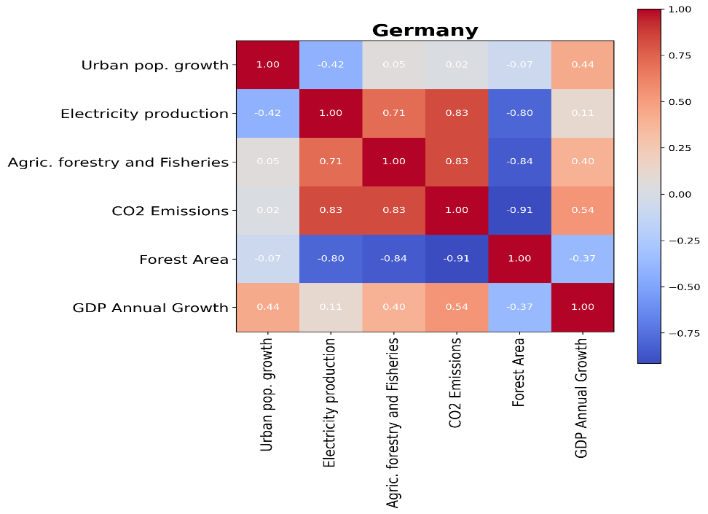

Figure : Correlation of Urban population growth, electricity production, agriculture forestry and fishing, CO2 emission, forest area, and GDP Annual Growth for Germany

**Name:**  Hassan Faraz Khan

**Student ID:** 21089475

**Subject:** Applied Data Science 1

**Date:** 4/April/2023

**Data Source:** https://data.worldbank.org/

**Repository Link:** https://github.com/HassanFrazKhan/ADS1_Assignment2.git