ONLINE ACCESSORIES SHOP · EGYPT
Accessories Store
Project plan, database schema and file formats
Delivery by Egypt Post or representative · Admin dashboard · Free-tier hosting
Version 1.0 · October 2026
What is inside
1 Summary
2 Pages and navigation
3 Roles and permissions
4 Database design
5 How the pages talk to the database
6 Admin tools
7 Delivery and payment
8 Free hosting
9 Project structure and file formats
10 Build roadmap
11 Pre-launch checklist
12 Open decisions
Appendix A SQL files (complete and tested)
Appendix B How this was checked

The SQL as one file
The six SQL files in Appendix A are also delivered as one runnable file, accessories_store_schema.sql, so you do not have to copy code out of Word.

1. Summary
This document turns the planning conversation into a build-ready reference for an online accessories shop in Egypt. It covers the pages, roles, database, admin tools, delivery rules, free hosting setup, project files and build order. The complete SQL is in Appendix A.

Goal | Sell accessories (earrings, chains, rings, bracelets and more) across Egypt.
Customers | Browse by category, fill a cart as a guest, log in to check out, and choose Egypt Post or a representative for delivery.
Admin | Add and edit products, set stock, manage orders and delivery fees, and watch revenue on a dashboard.
Front end | React + TypeScript + Vite, built as a static site (any other front-end stack works with the same database).
Back end | Supabase: PostgreSQL database, login, image storage and row-level security. No server of your own.
Hosting | Cloudflare Pages for the site and the Supabase free plan for data. No monthly cost; a custom domain is optional.
Payment | Cash on delivery to start. Online payment can be added later.
Still to decide | Arabic, English or both; real delivery fees; shop name and logo; custom domain (section 12).

2. Pages and navigation
Figure 1 shows how people move through the site. Customers and admins use the same login; the role stored in the database decides which side they see.
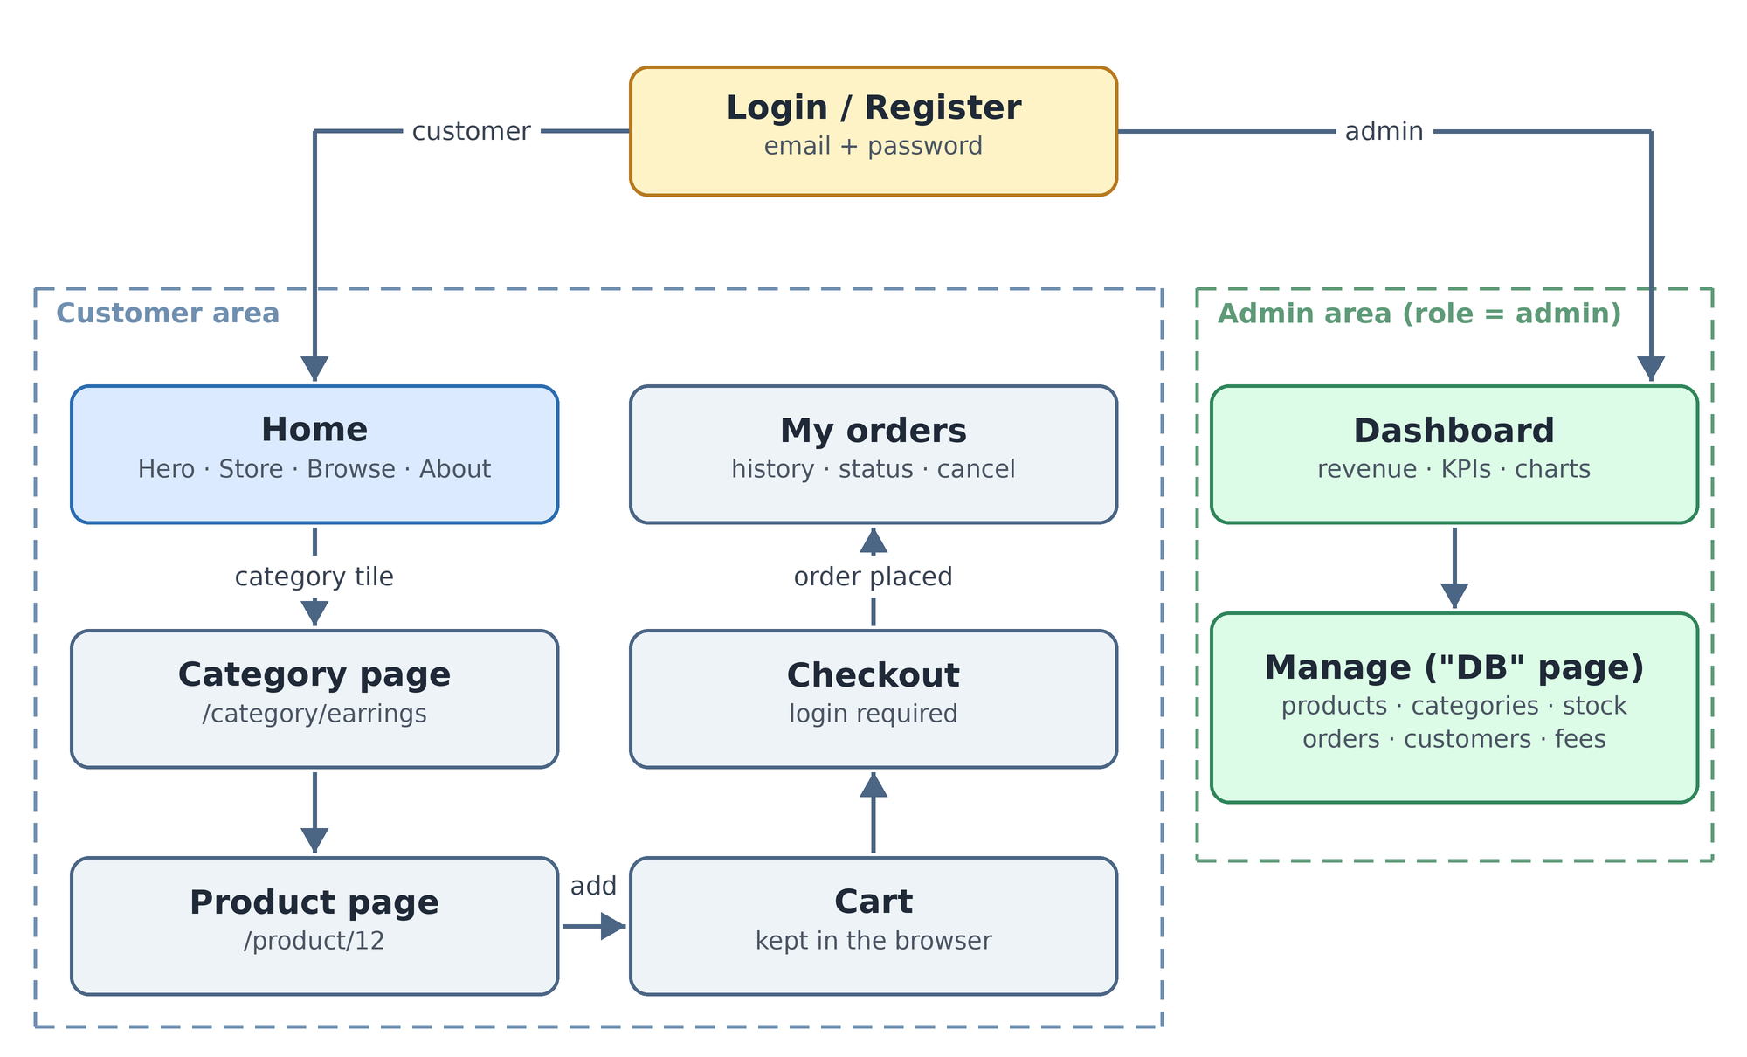
Figure 1. Site map: customer area and admin area
Page | Route | Who | What it does
Home | / | Everyone | Navbar, 50%-off intro, category image tiles, best sellers and the full shop, About.
Category | /category/:slug | Everyone | Products in one category. In-stock items first, a "show sold out" toggle, sort by price or popularity.
Product | /product/:id | Everyone | Photos, price and discount, stock badge, quantity, add to cart.
Cart | /cart | Everyone | Items, quantities and subtotal. Kept in the browser, so guests can fill it.
Login / Register | /login | Guests | Email and password sign-up and login.
Checkout | /checkout | Logged in | Address, delivery method and fee, place the order.
My orders | /account/orders | Logged in | Order history, status, tracking details, cancel while pending.
Dashboard | /admin | Admin | Revenue, orders, best sellers, low stock.
Manage | /admin/products and the other /admin/... screens | Admin | The friendly "DB" screens: products, categories, orders, customers, delivery fees.
Product, Checkout and My orders were not in the original page list; a shop needs them.

Home page layout
- Navbar (sticky): logo, search, category links, cart with item count, login or account, and the dark/light theme button.
- Intro: the "50% off" banner with a button that scrolls to the sale items.
- Store: an Amazon-style grid of category image tiles (earrings, chains, rings, bracelets...). Tapping a tile opens that category page.
- Browse: the whole shop with best sellers first, plus filters for category, in stock and price.
- About: the shop story, delivery options and contact details, followed by the footer.
The theme button flips a data-theme attribute on the page and saves the choice in the browser. The first visit follows the device setting. Define every colour as a CSS variable so each theme is just one set of values.

3. Roles and permissions
Capability | Guest | Customer | Admin
Browse the catalogue and see stock status | Yes | Yes | Yes (also hidden products)
Fill a cart | Yes | Yes | Yes
Place an order | – | Yes | Yes
See own orders, total spent and favourite item | – | Yes | Yes
Save favourites | – | Yes | Yes
Edit own name, phone and address | – | Yes | Yes
Cancel own pending order | – | Yes | Yes
Manage products, categories, stock and delivery fees | – | – | Yes
See all orders and customers; change order status | – | – | Yes
Open the dashboard | – | – | Yes
Promote or demote users | – | – | Yes

Rule
Roles are enforced in the database. Hiding admin pages in the interface is only a convenience: anyone can open the browser console, so the database itself must refuse admin actions from non-admins (Appendix A.2).

4. Database design
Figure 2 shows the eight tables and how they connect. Blue tables hold the shop data; green tables hold delivery rules. Only key columns are drawn; the full definitions are in Appendix A.1.
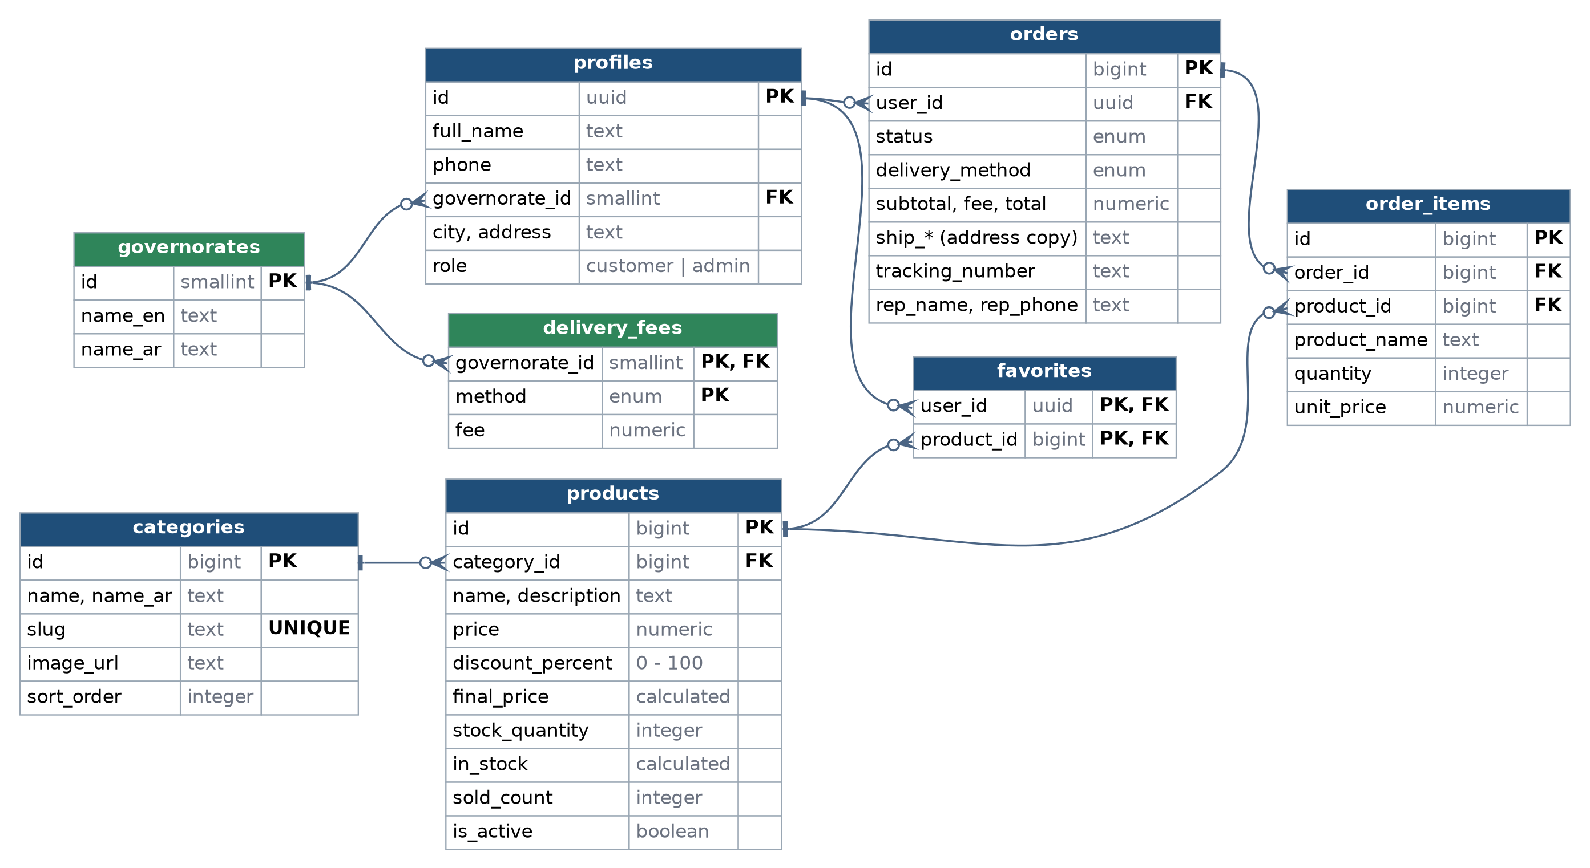
Figure 2. Database tables and relationships (PK = primary key, FK = foreign key)

Tables at a glance
Table | Purpose
profiles | One row per user, linked to Supabase login. Holds name, phone, default address and the role (customer or admin).
categories | Earrings, chains, rings and so on, with a slug (for the web address), an image and a display order.
products | Name, price, discount, stock, active flag and images. It calculates final_price and in_stock itself; sold_count is kept current by the order functions.
orders | One row per order: status, delivery method, totals, a copy of the delivery address, and the admin’s tracking or representative details.
order_items | The lines of each order, with the product name and the price at the time of purchase.
favorites | Which user saved which product (the heart button).
governorates | Egypt’s 27 governorates in English and Arabic.
delivery_fees | Which delivery method is available in which governorate, and its fee.

Design rules built into the schema
- Roles are protected. profiles.role cannot be edited from the website and is never read from sign-up data. The first admin is set by hand in the SQL editor (Appendix A.5).
- Statistics are calculated, not stored. "How much they buy" and "favourite item" come from the customer_stats view, so they cannot drift out of sync. A customer sees only their own row; an admin sees everyone.
- Stock is a number. "In stock" means stock_quantity > 0. It drops automatically when an order is placed and returns when an order is cancelled. Set it to 0 to mark an item sold out.
- One function creates orders. place_order() locks the product rows, checks stock, takes prices from the database, adds the delivery fee and writes everything in one step. Two buyers cannot take the last item, and a browser cannot send its own prices.
- History never changes. order_items stores the product name and the price paid, and orders stores a copy of the address, so editing a product or profile later does not rewrite old orders.
- Deactivate, do not delete. A product that was ordered cannot be deleted; switch is_active off to hide it.
- Delivery availability is data. No row in delivery_fees means that method is not offered in that governorate. Fees are not pre-filled, so nothing ships for free by accident.
- Best sellers without exposing orders. products.sold_count lets the public Browse section rank by popularity without reading private order data.
- No national ID numbers. Delivery does not need them and they add privacy risk. Collect only name, phone and address.

Changes since the first sketch
- Added governorates and delivery_fees so fees and availability are data, not code.
- Added sold_count, final_price and in_stock on products; product_name and a delivery-address copy on orders; rep_phone and city.
- Added optional Arabic columns (name_ar, description_ar). Remove them if the shop is single-language.

5. How the pages talk to the database
The browser uses the Supabase JavaScript client (@supabase/supabase-js). Reading data uses from(...); sensitive actions call database functions with rpc(...). Row-level security checks every call against the logged-in user. Every call below starts with supabase.
Page or action | Call
Home: categories | from('categories').select('id,name,slug,image_url').order('sort_order')
Home: best sellers | from('products').select('*').order('sold_count', { ascending: false }).limit(12)
Category page | from('products').select('*, categories!inner(slug)').eq('categories.slug', slug)
Product page | from('products').select('*').eq('id', id).single()
Register and login | auth.signUp({ email, password, options: { data: { full_name, phone } } })  auth.signInWithPassword({ email, password })
Who am I? | from('profiles').select('full_name, role').eq('id', user.id).single()
Delivery options | from('delivery_fees').select('method, fee').eq('governorate_id', id)
Place order | rpc('place_order', { ... }) (example below)
My orders | from('orders').select('*, order_items(*)').order('created_at', { ascending: false })
Cancel order | rpc('cancel_my_order', { p_order_id: id })
Favourite, my stats | from('favorites').insert({ user_id, product_id })  from('customer_stats').select('*').eq('user_id', user.id).single()
Admin dashboard | rpc('admin_dashboard', { p_from: '2026-10-01', p_to: '2026-10-31' })
Admin products | from('products').insert({ ... }) and .update({ ... }).eq('id', id)
Admin orders | from('orders').update({ status, tracking_number, rep_name, rep_phone }).eq('id', id)
Admin customers, roles | from('customer_stats').select('*') and rpc('admin_set_role', { p_user_id, p_role })
Photos | storage.from('product-images').upload(path, file), then getPublicUrl(path)

Example: placing an order
const { data: orderId, error } = await supabase.rpc('place_order', {
p_items: cart.map((l) => ({ product_id: l.productId, quantity: l.quantity })),
p_delivery_method: 'egypt_post', // or 'representative'
p_ship_name: form.name,
p_ship_phone: form.phone,
p_governorate_id: form.governorateId, // 1 to 27
p_ship_city: form.city,
p_ship_address: form.address,
p_notes: form.notes ?? null,
});
if (error) showToast(error.message); // e.g. Only 2 left in stock for ...
else navigate('/account/orders');

Things to remember
- Do not send final_price or in_stock when updating a product. They are calculated, and PostgreSQL rejects attempts to write them.
- Messages raised by the functions (for example "Only 2 left in stock") arrive in error.message; show them to the customer.
- Store photos in the product-images bucket as {product_id}/{random-name}.webp and keep the path or public URL in image_url.
- Revenue counts orders that are delivered. "Booked" counts every order that is not cancelled, because cash on delivery can be refused at the door.

6. Admin tools

Dashboard
One call, admin_dashboard(from, to), returns everything below as JSON, so the page makes a single request. Days are counted in Cairo time.
- KPI cards: orders, pending orders, booked total, delivered revenue, average order value.
- Daily chart: booked versus delivered amounts over the chosen date range.
- Orders by status, by delivery method and by governorate.
- Top 10 products, top 5 customers, and a low-stock list (3 units or fewer).

Manage screens (the "DB" page)
Screen | What the admin can do | Uses
Products | Add and edit: category (dropdown), price, discount, quantity, photos, active toggle. Edit stock inline in the list. | products, categories, storage
Categories | Add, rename, reorder and set the tile image. | categories
Orders | Filter by status. Move through pending, confirmed, shipped, delivered. Enter a tracking number or assign a representative. Cancel (stock returns). | orders, order_items
Customers | Name, phone, orders, total spent, favourite item. Promote to admin. | customer_stats, admin_set_role
Delivery | Table of governorate, method and fee. Delete a row to switch a method off there. | delivery_fees

Order lifecycle
- pending: placed by the customer. Stock is already reserved. The customer can still cancel.
- confirmed: the admin has checked the order and, if needed, called the customer.
- shipped: a tracking number (Egypt Post) or a representative has been entered.
- delivered: cash collected. This is the moment revenue counts.
An order can be cancelled from any state. Stock returns automatically and a cancelled order cannot be reopened.

7. Delivery and payment
- Two methods. Egypt Post (national mail) and representative (your own courier or rider).
- Fee by governorate. Each governorate and method pair has a fee in delivery_fees. A representative may serve only some governorates, such as Alexandria: add rows only where you can deliver.
- At checkout the customer picks a governorate, sees which methods are available with their fees, and the total updates.
- After the order the admin enters the tracking number (Egypt Post) or the representative’s name and phone.
- Payment is cash on delivery at first. It needs no payment gateway. Online payment (for example Paymob or Fawry) can be added later by extending payment_method.
- Refused or returned orders. Set the order to cancelled and the stock returns. If the goods are not resellable, lower the stock by hand.

8. Free hosting
The site is a set of static files served by Cloudflare Pages. In the browser, the app talks directly to Supabase for login, data and photos. Security lives in the database rules, so there is no server of your own to run or pay for.
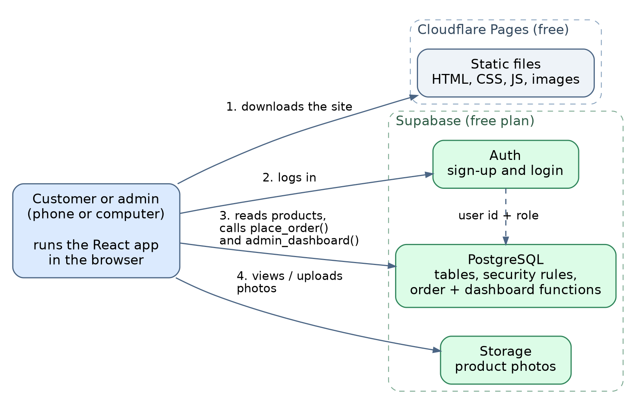
Figure 3. How the pieces connect
Layer | Service | Free-plan facts (checked October 2026) | Watch out
Site | Cloudflare Pages | Static hosting with a free *.pages.dev address. Reported to allow commercial projects on the free tier. About 500 builds per month and 20,000 files per site. | Re-read Cloudflare’s terms before launch.
Data, login, photos | Supabase Free | 2 projects, 500 MB database, 1 GB file storage, 50,000 monthly active users. | Projects pause after one week without activity.
Domain | Optional | The free pages.dev address is fine for launch. | A custom domain is the only paid extra.

Not suitable for a shop
- Vercel Hobby plan: personal, non-commercial use only. Commercial use needs the Pro plan at $20 per user per month.
- GitHub Pages: its rules do not allow running an online business or e-commerce site on it.

Watch-outs
- Supabase pause. A shop with steady visitors will not notice. During a quiet launch, a scheduled request (for example a weekly GitHub Actions job) keeps the project awake, or upgrade.
- Backups. Export products, orders and customers as CSV regularly; give the admin screens an Export button. A free tier is not a backup plan.
- Limits change. Check each pricing page before you commit.
- Photos. Resize to about 1200 px wide WebP (roughly 200 KB) before upload so 1 GB goes a long way.
- Search engines. A browser-rendered store ranks less well in Google than a server-rendered one. Fine for launch; category pages can be pre-rendered later.

Upgrade path
If the shop outgrows the free plan, Supabase Pro costs about $25 per month, removes the inactivity pause and raises the limits (8 GB database, 100 GB file storage).
Plan details were checked on 5 October 2026 against GitHub’s documentation and published summaries of the Vercel, Supabase and Cloudflare plans. Limits and prices change; confirm on vercel.com/pricing, supabase.com/pricing, docs.github.com (GitHub Pages limits) and developers.cloudflare.com/pages.

9. Project structure and file formats
A suggested layout for the code. Each file type below is what you will actually edit.
accessories-store/
|-- README.md
|-- package.json
|-- index.html Vite entry page
|-- vite.config.ts
|-- tsconfig.json
|-- .env.example template; copy to .env.local (never commit it)
|-- .gitignore
|-- public/
| |-- favicon.svg
| '-- images/ hero and category tile pictures (.webp)
|-- supabase/
| '-- sql/ 01_schema.sql ... 06_storage.sql
|-- scripts/
| '-- export-csv.mjs optional: back up products, orders, customers
|-- docs/
| '-- Accessories_Store_Project_Plan.docx
'-- src/
|-- main.tsx app start
|-- App.tsx routes
|-- lib/ supabase.ts, cart.ts, format.ts (EGP prices)
|-- context/ AuthContext, ThemeContext, CartContext
|-- components/ Navbar, ThemeToggle, CategoryTile, ProductCard
|-- pages/
| |-- Home.tsx Category.tsx Product.tsx Cart.tsx Checkout.tsx
| |-- Login.tsx MyOrders.tsx
| '-- admin/ Dashboard.tsx Products.tsx Categories.tsx Orders.tsx
| Customers.tsx DeliveryFees.tsx
|-- types/ database.types.ts (generated by Supabase CLI)
'-- styles/ index.css (colour variables for light and dark)

Format | Extensions | Used for | Notes
SQL | .sql | Database schema, security rules, functions, starter data. | Run the six files in order in the Supabase SQL editor.
TypeScript, TSX | .ts, .tsx | App logic, React components and pages. | database.types.ts is generated, not hand-written.
HTML | .html | The Vite entry page (index.html). | One file; the app itself is JavaScript.
CSS | .css | Layout and the light/dark theme variables. | Tailwind CSS can be used instead.
JSON | .json | package.json, tsconfig.json, exported data.
Environment | .env, .env.local, .env.example | Supabase URL and public key. | Never commit .env.local. Never put the service-role (secret) key in front-end code.
Markdown | .md | README and notes.
Images | .webp, .svg, .png, .jpg | Photos (WebP), logo and icons (SVG), source images (PNG or JPG). | Resize before upload: about 1200 px wide, roughly 200 KB.
CSV | .csv | Backups and optional bulk import of products. | Save as UTF-8 with BOM so Excel shows Arabic correctly.
YAML | .yml | Optional scheduled jobs (keep-alive, weekly export). | GitHub Actions workflows.
Word | .docx | This plan.

Environment file
VITE_SUPABASE_URL=https://YOUR-PROJECT.supabase.co
VITE_SUPABASE_ANON_KEY=your-public-anon-key
The public (anon or publishable) key is meant for the browser because row-level security protects the data. The service-role (secret) key must never reach the browser.

10. Build roadmap
Phase | Work | Done when
0 | Decisions: language, categories, delivery fees, shop name and logo. | Section 12 is filled in.
1 | Create the Supabase project, run SQL files 01 to 06, add delivery fees, make the first admin. | The security tests in section 11 pass.
2 | App skeleton: Vite + React + TypeScript, navbar with theme toggle, Supabase client, login and role. | You can sign up, log in and see your role.
3 | Storefront: home, category, product and cart pages. | A guest can browse and fill a cart on a phone.
4 | Checkout: address form, delivery choice, place_order, My orders. | An order appears for the customer and reduces stock.
5 | Admin screens: products and stock first, then categories, orders, customers, fees. | The admin can run the shop without touching SQL.
6 | Dashboard charts from admin_dashboard. | Revenue, orders and low stock are visible.
7 | Deploy to Cloudflare Pages, test on phones, set up exports, soft launch. | Friends place real test orders end to end.

11. Pre-launch checklist

Security tests (two customer accounts and one admin)
- As a customer, try to change your own role from the browser console. It must fail.
- Call admin_dashboard as a customer. It must answer "Admins only".
- Open the admin pages as a customer. You are redirected and the data calls fail too.
- Change an order ID in a request to read another customer’s order. Nothing comes back.
- Try to insert a row into orders directly. It is refused.
- Send a cart with a different price. The price paid is still the database price.
- Search the built site for the service-role key. It must not be there.

Functional tests
- Two browsers buy the last unit at the same moment: one succeeds, the other sees a stock message.
- Cancel a pending order: stock returns and the order cannot be reopened.
- Choose a delivery method that is not offered in the governorate: checkout refuses it clearly.
- Place an order on a phone in Arabic and in English; right-to-left layout looks right.
- Switch dark and light themes on every page.
- Export a CSV and open it in Excel: Arabic text is readable.

12. Open decisions
Decision | Options | Suggestion
Language | Arabic only, English only, or both | Both if possible. Build with right-to-left support from day one, even if the first launch is single-language.
Shop name and logo | – | Needed for the navbar, favicon and About section.
Delivery fees | One fee per method, or per governorate | Per governorate. Start with the places you sell to most and add more later.
Representative coverage | Which governorates | Add rows only where a representative can really deliver.
Returns policy | Refused at the door, exchange, none | Decide the wording for the About page.
Online payment | Later, or at launch | Later, once the first orders prove demand.
Custom domain | pages.dev or a paid domain | Launch on pages.dev; buy a domain when ready.

Appendix A. SQL files
Run the files in this order, once, in the Supabase SQL editor (or any PostgreSQL 15+ database that has an auth.users table). File 06 works only on Supabase. All six are also in accessories_store_schema.sql.

A.1 01_schema.sql
Types, tables, indexes and triggers (profile creation on sign-up, updated_at).
-- =====================================================================
-- 01_schema.sql : accessories store - types, tables, indexes, triggers
-- Target: PostgreSQL 15+ (Supabase). Run files 01 -> 05 in order, once.
-- =====================================================================

-- ---------- Types ----------
create type public.user_role as enum ('customer', 'admin');
create type public.order_status as enum ('pending', 'confirmed', 'shipped',
'delivered', 'cancelled');
create type public.delivery_method as enum ('egypt_post', 'representative');
-- Only cash on delivery for now. Add more later with:
-- alter type public.payment_method add value 'card';
create type public.payment_method as enum ('cod');

-- ---------- Delivery lookup ----------
create table public.governorates (
id smallint primary key,
name_en text not null unique,
name_ar text not null
);

-- One row = "this method is available in this governorate for this fee".
-- No row = not available there.
create table public.delivery_fees (
governorate_id smallint not null references public.governorates (id)
on delete cascade,
method public.delivery_method not null,
fee numeric(10,2) not null check (fee >= 0),
primary key (governorate_id, method)
);

-- ---------- Users (extends Supabase auth.users) ----------
create table public.profiles (
id uuid primary key references auth.users (id) on delete cascade,
full_name text not null default '',
phone text,
governorate_id smallint references public.governorates (id),
city text,
address text,
role public.user_role not null default 'customer',
created_at timestamptz not null default now()
);

-- ---------- Catalogue ----------
create table public.categories (
id bigint generated always as identity primary key,
name text not null,
name_ar text,
slug text not null unique
check (slug ~ '^[a-z0-9]+(-[a-z0-9]+)*$'),
image_url text,
sort_order integer not null default 0,
created_at timestamptz not null default now()
);

create table public.products (
id bigint generated always as identity primary key,
category_id bigint not null references public.categories (id)
on delete restrict,
name text not null,
name_ar text,
description text,
description_ar text,
price numeric(10,2) not null check (price >= 0),
discount_percent smallint not null default 0
check (discount_percent between 0 and 100),
-- calculated by the database; never send these two from the client
final_price numeric(10,2) generated always as
(round(price * (100 - discount_percent) / 100.0, 2)) stored,
stock_quantity integer not null default 0 check (stock_quantity >= 0),
in_stock boolean generated always as (stock_quantity > 0) stored,
-- kept up to date by place_order() / cancellation, so the public
-- "best sellers" ranking never needs to read private order data
sold_count integer not null default 0 check (sold_count >= 0),
is_active boolean not null default true,
image_url text,
extra_images text[] not null default '{}',
created_at timestamptz not null default now(),
updated_at timestamptz not null default now()
);
create index products_category_idx on public.products (category_id)
where is_active;
create index products_sold_idx on public.products (sold_count desc);

-- ---------- Orders ----------
create table public.orders (
id bigint generated always as identity primary key,
user_id uuid not null references public.profiles (id)
on delete restrict,
status public.order_status not null default 'pending',
delivery_method public.delivery_method not null,
payment_method public.payment_method not null default 'cod',
subtotal numeric(10,2) not null check (subtotal >= 0),
shipping_fee numeric(10,2) not null check (shipping_fee >= 0),
total numeric(10,2) not null,
-- address is copied here so history never changes when a profile does
ship_name text not null,
ship_phone text not null,
ship_governorate text not null,
ship_city text,
ship_address text not null,
notes text,
-- filled in by the admin
tracking_number text, -- Egypt Post
rep_name text, -- representative delivery
rep_phone text,
created_at timestamptz not null default now(),
updated_at timestamptz not null default now(),
constraint orders_total_matches check (total = subtotal + shipping_fee)
);
create index orders_user_idx on public.orders (user_id, created_at desc);
create index orders_status_idx on public.orders (status, created_at desc);

create table public.order_items (
id bigint generated always as identity primary key,
order_id bigint not null references public.orders (id) on delete cascade,
product_id bigint not null references public.products (id)
on delete restrict,
product_name text not null, -- name at purchase time
quantity integer not null check (quantity > 0),
unit_price numeric(10,2) not null check (unit_price >= 0), -- price paid
unique (order_id, product_id)
);
create index order_items_product_idx on public.order_items (product_id);

create table public.favorites (
user_id uuid not null references public.profiles (id) on delete cascade,
product_id bigint not null references public.products (id) on delete cascade,
created_at timestamptz not null default now(),
primary key (user_id, product_id)
);

-- ---------- Triggers ----------
create or replace function public.set_updated_at()
returns trigger
language plpgsql
as $$
begin
new.updated_at := now();
return new;
end;
$$;

create trigger products_set_updated_at before update on public.products
for each row execute function public.set_updated_at();
create trigger orders_set_updated_at before update on public.orders
for each row execute function public.set_updated_at();

-- Create a profile row whenever someone signs up.
-- The role is NEVER read from sign-up data: users control that data.
create or replace function public.handle_new_user()
returns trigger
language plpgsql
security definer
set search_path = public
as $$
begin
insert into public.profiles (id, full_name, phone)
values (new.id,
coalesce(new.raw_user_meta_data ->> 'full_name', ''),
new.raw_user_meta_data ->> 'phone');
return new;
end;
$$;

create trigger on_auth_user_created
after insert on auth.users
for each row execute function public.handle_new_user();

A.2 02_security.sql
The admin check, row-level security, grants and policies.
-- =====================================================================
-- 02_security.sql : admin check, row-level security, grants, policies
-- =====================================================================

-- True when the logged-in user has role = 'admin'. SECURITY DEFINER lets it
-- read profiles without tripping over the profiles policies themselves.
create or replace function public.is_admin()
returns boolean
language sql
stable
security definer
set search_path = public
as $$
select exists (
select 1 from public.profiles
where id = (select auth.uid()) and role = 'admin'
);
$$;

revoke all on function public.is_admin() from public;
grant execute on function public.is_admin() to anon, authenticated;

-- ---------- Turn on RLS for every table ----------
alter table public.governorates enable row level security;
alter table public.delivery_fees enable row level security;
alter table public.profiles enable row level security;
alter table public.categories enable row level security;
alter table public.products enable row level security;
alter table public.orders enable row level security;
alter table public.order_items enable row level security;
alter table public.favorites enable row level security;

-- ---------- Grants: start from zero, then add only what is needed ----------
revoke all on all tables in schema public from anon, authenticated;
grant usage on schema public to anon, authenticated;

-- public catalogue
grant select on public.categories, public.products,
public.governorates, public.delivery_fees
to anon, authenticated;

-- admin writes (still gated by the policies below)
grant insert, update, delete on public.categories, public.products,
public.governorates, public.delivery_fees
to authenticated;

-- profiles: the role column is NOT in this list, so it cannot be edited
grant select on public.profiles to authenticated;
grant update (full_name, phone, governorate_id, city, address)
on public.profiles to authenticated;

-- orders: customers read; admins may change fulfilment fields only
grant select on public.orders to authenticated;
grant update (status, tracking_number, rep_name, rep_phone)
on public.orders to authenticated;
grant select on public.order_items to authenticated;

grant select, insert, delete on public.favorites to authenticated;

-- ---------- Policies ----------
-- governorates, delivery_fees, categories: everyone reads, admins write
create policy "public read governorates" on public.governorates
for select to anon, authenticated using (true);
create policy "admin write governorates" on public.governorates
for all to authenticated
using (public.is_admin()) with check (public.is_admin());

create policy "public read delivery fees" on public.delivery_fees
for select to anon, authenticated using (true);
create policy "admin write delivery fees" on public.delivery_fees
for all to authenticated
using (public.is_admin()) with check (public.is_admin());

create policy "public read categories" on public.categories
for select to anon, authenticated using (true);
create policy "admin write categories" on public.categories
for all to authenticated
using (public.is_admin()) with check (public.is_admin());

-- products: visitors see active ones, admins see everything
create policy "read active products" on public.products
for select to anon, authenticated
using (is_active or public.is_admin());
create policy "admin write products" on public.products
for all to authenticated
using (public.is_admin()) with check (public.is_admin());

-- profiles: own row (admins: all rows); edit own row only
create policy "read own profile" on public.profiles
for select to authenticated
using (id = (select auth.uid()) or public.is_admin());
create policy "update own profile" on public.profiles
for update to authenticated
using (id = (select auth.uid()))
with check (id = (select auth.uid()));

-- orders and items: customers read their own, admins read all.
-- There is no INSERT policy on purpose: orders are created only by
-- place_order() (03_functions.sql), which computes the totals itself.
create policy "read own orders" on public.orders
for select to authenticated
using (user_id = (select auth.uid()) or public.is_admin());
create policy "admin update orders" on public.orders
for update to authenticated
using (public.is_admin()) with check (public.is_admin());

create policy "read items of visible orders" on public.order_items
for select to authenticated
using (exists (
select 1 from public.orders o
where o.id = order_items.order_id
and (o.user_id = (select auth.uid()) or public.is_admin())
));

-- favorites: each user manages only their own
create policy "manage own favorites" on public.favorites
for all to authenticated
using (user_id = (select auth.uid()))
with check (user_id = (select auth.uid()));

A.3 03_functions.sql
Order placement, cancellation with restock, role changes and the admin dashboard.
-- =====================================================================
-- 03_functions.sql : order logic, cancellation, roles, admin dashboard
-- =====================================================================

-- ---------- Cancelled orders put the stock back ----------
create or replace function public.orders_status_guard()
returns trigger
language plpgsql
security definer
set search_path = public
as $$
begin
if old.status = 'cancelled' and new.status <> 'cancelled' then
raise exception 'A cancelled order cannot be re-opened';
end if;

if new.status = 'cancelled' and old.status <> 'cancelled' then
update public.products p
set stock_quantity = p.stock_quantity + oi.quantity,
sold_count = greatest(p.sold_count - oi.quantity, 0)
from public.order_items oi
where oi.order_id = new.id
and oi.product_id = p.id;
end if;
return new;
end;
$$;

create trigger orders_status_guard
before update of status on public.orders
for each row execute function public.orders_status_guard();

-- ---------- Place an order (the ONLY way an order gets created) ----------
-- p_items example: [{"product_id": 12, "quantity": 2}, {"product_id": 7,
-- "quantity": 1}]. Prices, fees and totals are all calculated here.
create or replace function public.place_order(
p_items jsonb,
p_delivery_method public.delivery_method,
p_ship_name text,
p_ship_phone text,
p_governorate_id smallint,
p_ship_city text,
p_ship_address text,
p_notes text default null
)
returns bigint
language plpgsql
security definer
set search_path = public
as $$
declare
v_user uuid := auth.uid();
v_gov_name text;
v_fee numeric(10,2);
v_order_id bigint;
v_subtotal numeric(10,2) := 0;
v_expected integer;
v_found integer := 0;
r record;
begin
if v_user is null then
raise exception 'Please log in to place an order' using errcode = '28000';
end if;

if jsonb_typeof(p_items) is distinct from 'array'
or jsonb_array_length(p_items) = 0 then
raise exception 'Your cart is empty';
end if;

if exists (select 1 from jsonb_array_elements(p_items) e
where (e ->> 'product_id') is null
or (e ->> 'quantity') is null) then
raise exception 'Each cart line needs a product_id and a quantity';
end if;

if coalesce(trim(p_ship_name), '') = ''
or coalesce(trim(p_ship_phone), '') = ''
or coalesce(trim(p_ship_address), '') = '' then
raise exception 'Name, phone and address are required';
end if;

-- is this delivery method offered in that governorate, and at what fee?
select g.name_en, f.fee
into v_gov_name, v_fee
from public.governorates g
join public.delivery_fees f
on f.governorate_id = g.id and f.method = p_delivery_method
where g.id = p_governorate_id;
if not found then
raise exception 'This delivery method is not available in that governorate';
end if;

select count(*) into v_expected
from (select (e ->> 'product_id')::bigint
from jsonb_array_elements(p_items) e
group by 1) s;

insert into public.orders
(user_id, delivery_method, subtotal, shipping_fee, total,
ship_name, ship_phone, ship_governorate, ship_city, ship_address,
notes)
values (v_user, p_delivery_method, 0, v_fee, v_fee,
trim(p_ship_name), trim(p_ship_phone), v_gov_name,
nullif(trim(p_ship_city), ''), trim(p_ship_address),
nullif(trim(p_notes), ''))
returning id into v_order_id;

-- lock the product rows so two buyers cannot take the last item
for r in
select p.id, p.name, p.final_price, p.stock_quantity, p.is_active, l.qty
from (select (e ->> 'product_id')::bigint as product_id,
sum((e ->> 'quantity')::integer)::integer as qty
from jsonb_array_elements(p_items) e
group by 1) l
join public.products p on p.id = l.product_id
order by p.id
for update of p
loop
v_found := v_found + 1;
if not r.is_active then
raise exception '"%" is no longer available', r.name;
end if;
if r.qty <= 0 then
raise exception 'Quantity must be at least 1';
end if;
if r.stock_quantity < r.qty then
raise exception 'Only % left in stock for "%"', r.stock_quantity, r.name;
end if;

insert into public.order_items
(order_id, product_id, product_name, quantity, unit_price)
values (v_order_id, r.id, r.name, r.qty, r.final_price);

update public.products
set stock_quantity = stock_quantity - r.qty,
sold_count = sold_count + r.qty
where id = r.id;

v_subtotal := v_subtotal + r.final_price * r.qty;
end loop;

if v_found <> v_expected then
raise exception 'Your cart contains a product that does not exist';
end if;

update public.orders
set subtotal = v_subtotal,
total = v_subtotal + v_fee
where id = v_order_id;

return v_order_id;
end;
$$;

-- ---------- Customer cancels their own pending order ----------
create or replace function public.cancel_my_order(p_order_id bigint)
returns void
language plpgsql
security definer
set search_path = public
as $$
begin
update public.orders
set status = 'cancelled'
where id = p_order_id
and user_id = (select auth.uid())
and status = 'pending';
if not found then
raise exception 'Order not found, or it can no longer be cancelled';
end if;
end;
$$;

-- ---------- Admin: change someone's role ----------
create or replace function public.admin_set_role(p_user_id uuid,
p_role public.user_role)
returns void
language plpgsql
security definer
set search_path = public
as $$
begin
if not public.is_admin() then
raise exception 'Admins only' using errcode = '42501';
end if;
if p_user_id = (select auth.uid()) and p_role <> 'admin' then
raise exception 'You cannot remove your own admin role';
end if;
update public.profiles set role = p_role where id = p_user_id;
end;
$$;

-- ---------- Admin dashboard: one call returns everything ----------
-- booked_total = all non-cancelled orders; delivered_total = money actually
-- received (cash on delivery can be refused at the door). Days use Cairo time.
create or replace function public.admin_dashboard(
p_from date default (current_date - 29),
p_to date default current_date
)
returns jsonb
language plpgsql
stable
security definer
set search_path = public
as $$
declare
v_result jsonb;
begin
if not public.is_admin() then
raise exception 'Admins only' using errcode = '42501';
end if;

with o as (
select * from public.orders
where (created_at at time zone 'Africa/Cairo')::date
between p_from and p_to
)
select jsonb_build_object(
'range', jsonb_build_object('from', p_from, 'to', p_to),

'kpis', (
select jsonb_build_object(
'orders', count(*) filter (where status <> 'cancelled'),
'pending', count(*) filter (where status = 'pending'),
'booked_total',
coalesce(sum(total) filter (where status <> 'cancelled'), 0),
'delivered_total',
coalesce(sum(total) filter (where status = 'delivered'), 0),
'avg_order',
coalesce(round(avg(total) filter (where status <> 'cancelled'), 2), 0)
) from o),

'daily', (
select coalesce(jsonb_agg(to_jsonb(d) order by d.day), '[]'::jsonb)
from (select (created_at at time zone 'Africa/Cairo')::date as day,
count(*) filter (where status <> 'cancelled') as orders,
coalesce(sum(total) filter (where status <> 'cancelled'), 0)
as booked_total,
coalesce(sum(total) filter (where status = 'delivered'), 0)
as delivered_total
from o group by 1) d),

'by_status', (
select coalesce(jsonb_object_agg(status, n), '{}'::jsonb)
from (select status, count(*) as n from o group by status) s),

'by_method', (
select coalesce(jsonb_agg(to_jsonb(m) order by m.orders desc), '[]'::jsonb)
from (select delivery_method as method, count(*) as orders,
sum(total) as total
from o where status <> 'cancelled' group by 1) m),

'by_governorate', (
select coalesce(jsonb_agg(to_jsonb(g) order by g.orders desc), '[]'::jsonb)
from (select ship_governorate as governorate, count(*) as orders,
sum(total) as total
from o where status <> 'cancelled' group by 1) g),

'top_products', (
select coalesce(jsonb_agg(to_jsonb(t) order by t.units desc), '[]'::jsonb)
from (select oi.product_id, oi.product_name as name,
sum(oi.quantity) as units,
sum(oi.quantity * oi.unit_price) as sales
from o join public.order_items oi on oi.order_id = o.id
where o.status <> 'cancelled'
group by 1, 2
order by units desc limit 10) t),

'top_customers', (
select coalesce(jsonb_agg(to_jsonb(c) order by c.total desc), '[]'::jsonb)
from (select o.user_id, p.full_name as name, count(*) as orders,
sum(o.total) as total
from o join public.profiles p on p.id = o.user_id
where o.status <> 'cancelled'
group by 1, 2
order by total desc limit 5) c),

'low_stock', (
select coalesce(jsonb_agg(to_jsonb(l) order by l.stock), '[]'::jsonb)
from (select id as product_id, name, stock_quantity as stock
from public.products
where is_active and stock_quantity <= 3
order by stock_quantity, name limit 20) l)
) into v_result;

return v_result;
end;
$$;

-- ---------- Who may call what ----------
revoke all on function public.place_order(jsonb, public.delivery_method, text,
text, smallint, text, text, text) from public, anon;
grant execute on function public.place_order(jsonb, public.delivery_method, text,
text, smallint, text, text, text) to authenticated;

revoke all on function public.cancel_my_order(bigint) from public, anon;
grant execute on function public.cancel_my_order(bigint) to authenticated;

revoke all on function public.admin_set_role(uuid, public.user_role)
from public, anon;
grant execute on function public.admin_set_role(uuid, public.user_role)
to authenticated;

revoke all on function public.admin_dashboard(date, date) from public, anon;
grant execute on function public.admin_dashboard(date, date) to authenticated;

-- trigger functions are never meant to be called directly
revoke all on function public.set_updated_at() from public, anon, authenticated;
revoke all on function public.handle_new_user() from public, anon, authenticated;
revoke all on function public.orders_status_guard() from public, anon, authenticated;

A.4 04_views.sql
The customer statistics view.
-- =====================================================================
-- 04_views.sql : per-customer statistics (calculated, never stored)
-- =====================================================================

-- "How much they buy" and "favourite item", worked out from real orders.
-- security_invoker = true means row-level security still applies:
-- a customer sees only their own row, an admin sees everyone.
create or replace view public.customer_stats
with (security_invoker = true) as
select
p.id as user_id,
p.full_name,
p.phone,
p.role,
coalesce(s.orders_count, 0) as orders_count,
coalesce(s.total_spent, 0) as total_spent,
f.product_id as favorite_product_id,
f.product_name as favorite_product_name
from public.profiles p
left join (
select user_id, count(*) as orders_count, sum(total) as total_spent
from public.orders
where status <> 'cancelled'
group by user_id
) s on s.user_id = p.id
left join lateral (
select oi.product_id, oi.product_name
from public.orders o
join public.order_items oi on oi.order_id = o.id
where o.user_id = p.id and o.status <> 'cancelled'
group by oi.product_id, oi.product_name
order by sum(oi.quantity) desc, oi.product_id
limit 1
) f on true;

grant select on public.customer_stats to authenticated;

A.5 05_seed.sql
Governorates (required), demo catalogue (optional) and the first-admin snippet.
-- =====================================================================
-- 05_seed.sql : starter data
-- Part A is required. Part B is demo data - delete it before launch.
-- =====================================================================

-- ---------- Part A (required): Egypt's 27 governorates ----------
insert into public.governorates (id, name_en, name_ar) values
(1, 'Cairo', 'القاهرة'),
(2, 'Giza', 'الجيزة'),
(3, 'Alexandria', 'الإسكندرية'),
(4, 'Qalyubia', 'القليوبية'),
(5, 'Port Said', 'بورسعيد'),
(6, 'Suez', 'السويس'),
(7, 'Dakahlia', 'الدقهلية'),
(8, 'Sharqia', 'الشرقية'),
(9, 'Gharbia', 'الغربية'),
(10, 'Monufia', 'المنوفية'),
(11, 'Beheira', 'البحيرة'),
(12, 'Kafr El Sheikh', 'كفر الشيخ'),
(13, 'Damietta', 'دمياط'),
(14, 'Ismailia', 'الإسماعيلية'),
(15, 'Faiyum', 'الفيوم'),
(16, 'Beni Suef', 'بني سويف'),
(17, 'Minya', 'المنيا'),
(18, 'Asyut', 'أسيوط'),
(19, 'Sohag', 'سوهاج'),
(20, 'Qena', 'قنا'),
(21, 'Luxor', 'الأقصر'),
(22, 'Aswan', 'أسوان'),
(23, 'Red Sea', 'البحر الأحمر'),
(24, 'New Valley', 'الوادي الجديد'),
(25, 'Matrouh', 'مطروح'),
(26, 'North Sinai', 'شمال سيناء'),
(27, 'South Sinai', 'جنوب سيناء');

-- Delivery fees are deliberately NOT seeded: no row means "not available",
-- so the shop cannot accidentally ship for free. Add real fees in the admin
-- screen, or in SQL, for example (replace the numbers with your own):
-- insert into public.delivery_fees (governorate_id, method, fee)
-- select id, 'egypt_post', 60 from public.governorates;
-- insert into public.delivery_fees (governorate_id, method, fee)
-- values (3, 'representative', 40); -- representative: Alexandria only

-- ---------- Part B (optional): demo catalogue ----------
insert into public.categories (name, name_ar, slug, sort_order) values
('Earrings', 'أقراط', 'earrings', 1),
('Chains', 'سلاسل', 'chains', 2),
('Rings', 'خواتم', 'rings', 3),
('Bracelets', 'أساور', 'bracelets', 4);

insert into public.products
(category_id, name, price, discount_percent, stock_quantity)
select c.id, v.name, v.price, v.discount, v.stock
from (values
(1, 'earrings', 'Pearl drop earrings', 250, 50, 12),
(2, 'earrings', 'Gold hoop earrings', 400, 0, 5),
(3, 'chains', 'Thin gold chain', 650, 20, 8),
(4, 'chains', 'Layered silver chain', 520, 0, 0),
(5, 'rings', 'Stackable ring set', 300, 50, 15),
(6, 'bracelets', 'Charm bracelet', 350, 10, 6)
) as v(ord, slug, name, price, discount, stock)
join public.categories c on c.slug = v.slug
order by v.ord;

-- ---------- Your first admin ----------
-- 1) Sign up on the website with your own email.
-- 2) Run this once in the Supabase SQL editor (it runs as the owner, so the
-- column restrictions for website users do not apply):
-- update public.profiles
-- set role = 'admin'
-- where id = (select id from auth.users where email = 'you@example.com');

A.6 06_storage.sql
Product image bucket and its policies (Supabase only).
-- =====================================================================
-- 06_storage.sql : product image bucket (Supabase only)
-- Everyone can view the images; only admins can add, replace or delete.
-- Set a file-size limit and image-only types on the bucket in the dashboard.
-- =====================================================================

insert into storage.buckets (id, name, public)
values ('product-images', 'product-images', true)
on conflict (id) do nothing;

create policy "admin list product images" on storage.objects
for select to authenticated
using (bucket_id = 'product-images' and public.is_admin());

create policy "admin upload product images" on storage.objects
for insert to authenticated
with check (bucket_id = 'product-images' and public.is_admin());

create policy "admin replace product images" on storage.objects
for update to authenticated
using (bucket_id = 'product-images' and public.is_admin())
with check (bucket_id = 'product-images' and public.is_admin());

create policy "admin delete product images" on storage.objects
for delete to authenticated
using (bucket_id = 'product-images' and public.is_admin());

Appendix B. How this was checked
The SQL was run on PostgreSQL 16 with small stand-ins for Supabase’s auth and storage schemas, using separate roles for visitors, customers and the admin. It has not yet been run on a live Supabase project: run the files on a new project first and repeat the security tests in section 11. Supabase’s real login service, storage service and REST layer were not available in the test setup.
Scenario | Result
Sign-up creates a profile; a role sent in sign-up data is ignored | Passed
Visitors read active products only; they cannot read orders or profiles or call place_order | Passed
A customer edits their own profile but cannot change the role column | Passed
place_order takes prices from the database, adds the fee, updates stock and sold_count | Passed
Oversell, out of stock, unknown product, empty or invalid cart, zero or negative quantity, missing address, unavailable method | Rejected with a clear message; nothing written
Duplicate cart lines for one product | Merged into one line
Two buyers racing for the last units | Second buyer waits, then gets a stock message
Customers insert or update orders and products directly | Refused
Customers see only their own orders, items and statistics; the admin sees all | Passed
Admin updates status, tracking and representative fields only; cancelling restocks; reopening is blocked | Passed
Customer cancels own pending order; shipped orders and other people’s orders are refused | Passed
admin_dashboard works for the admin and refuses customers | Passed
admin_set_role: self-demotion blocked, customers refused | Passed
Admin creates categories and products; generated columns protected; invalid slug rejected | Passed
Favourites are private to each user | Passed
Visitors have read-only access to the four public tables and nothing else | Passed

