# CDR _ Analysis

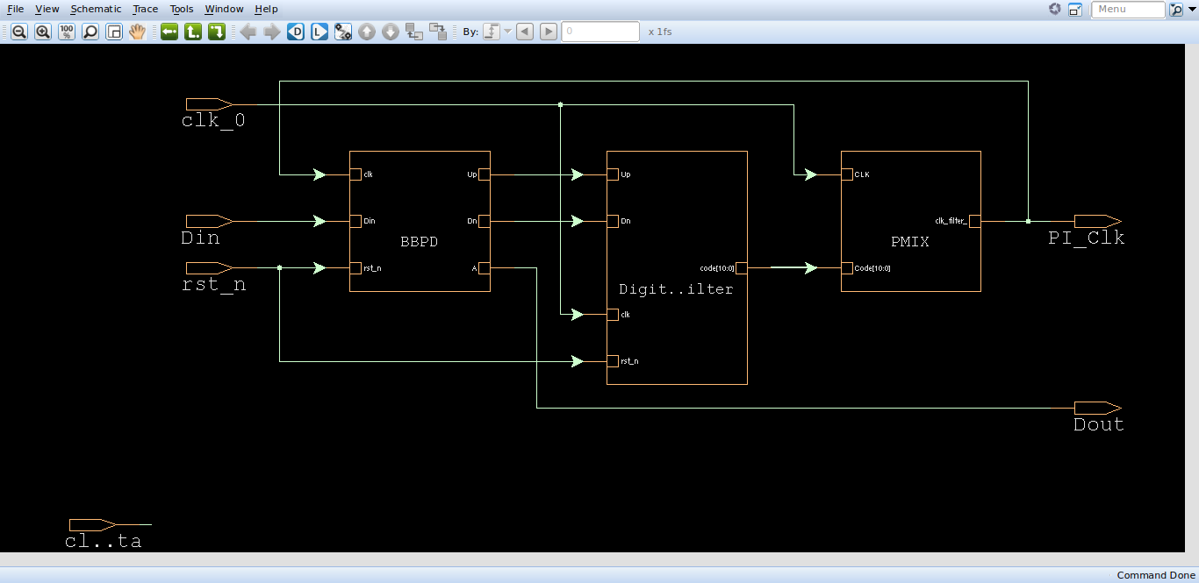

1. 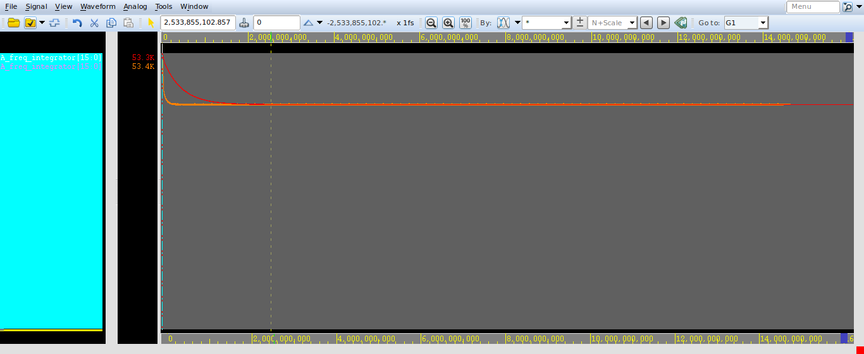**Same width = 15 , data_rate = 99.9ps**

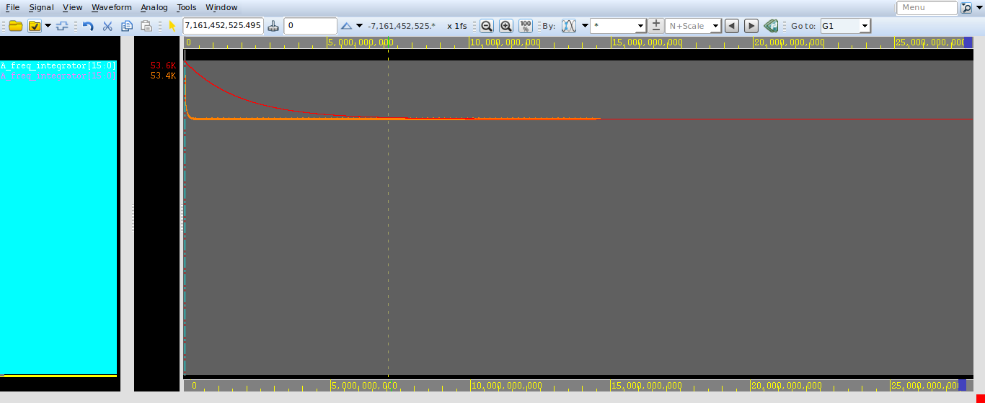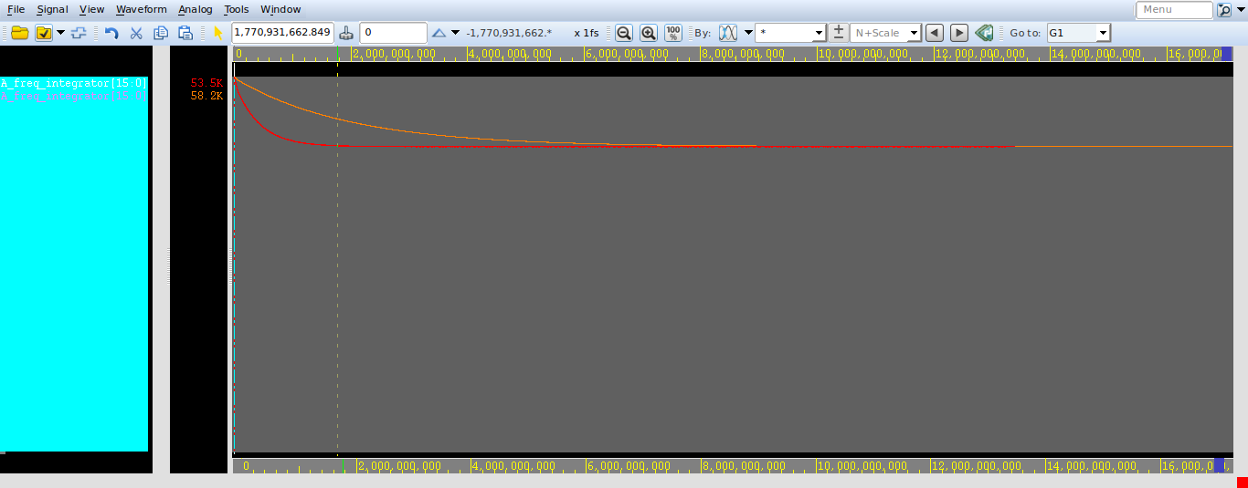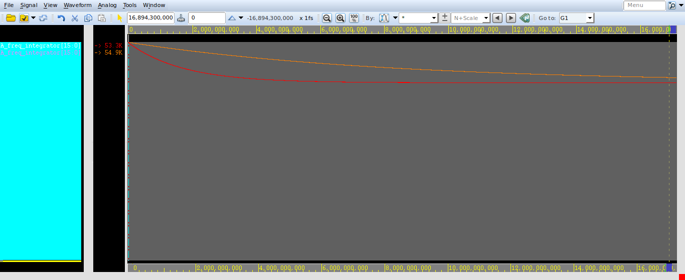

1. **Same width = 15 , data_rate = 100.1 , frug = 2, phug = 50**

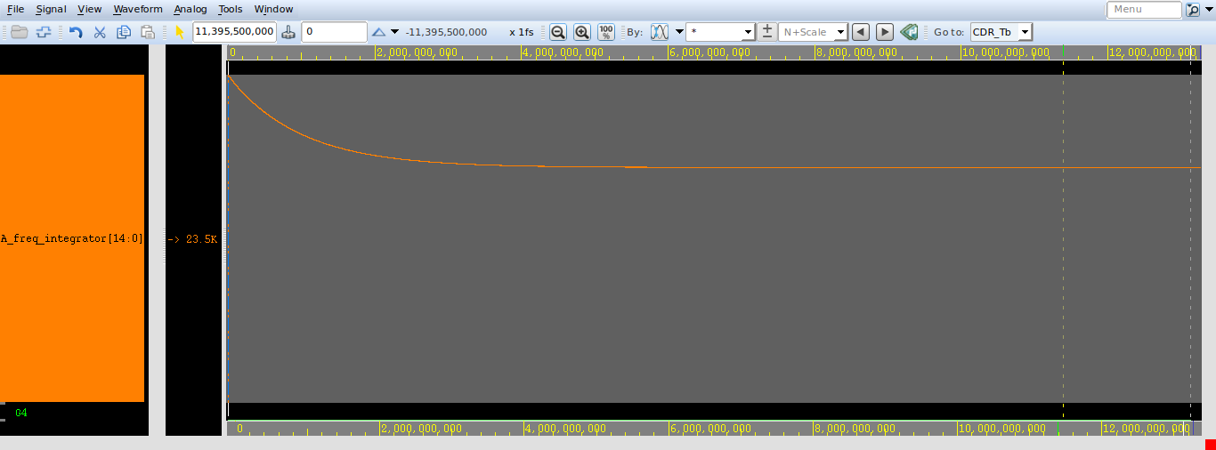

1. **Same width = 15 , data_rate = 100.1 , frug = 8, phug = 8**

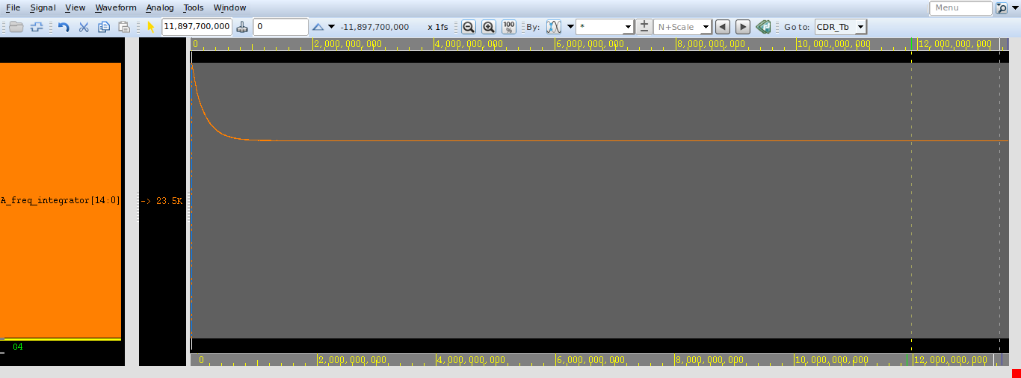

1. **Same width = 15 , data_rate = 100.1 , frug = 50, phug = 8**

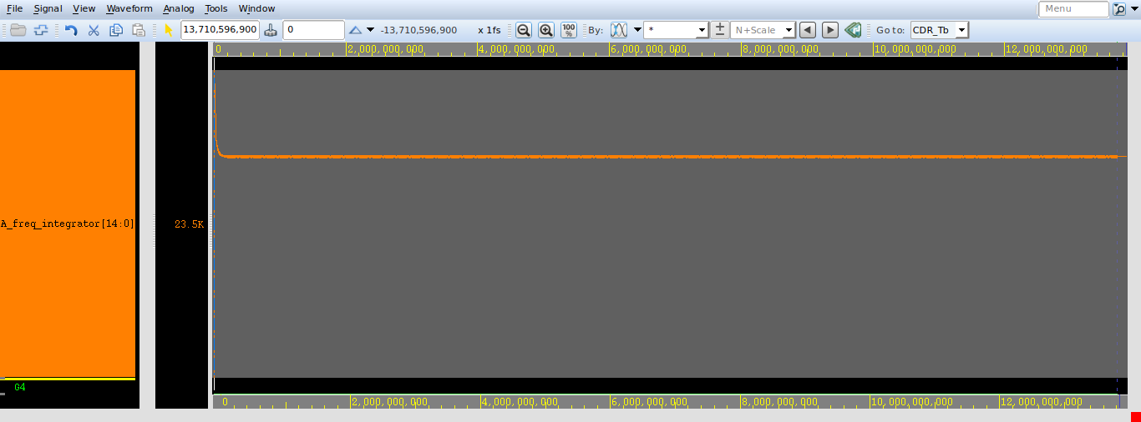

1. **Same width = 15 , data_rate = 100.1 , frug = 100, phug = 2**

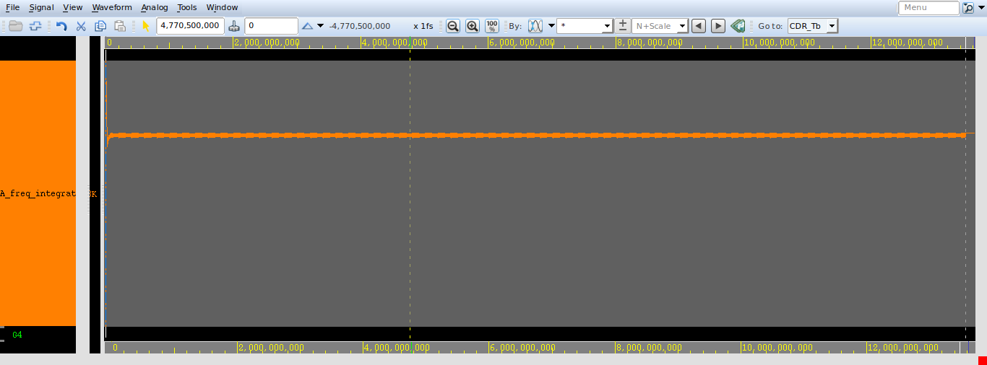

1. **Compare frug = 2 , phug = 50 with frug = 8 , phug = 8**

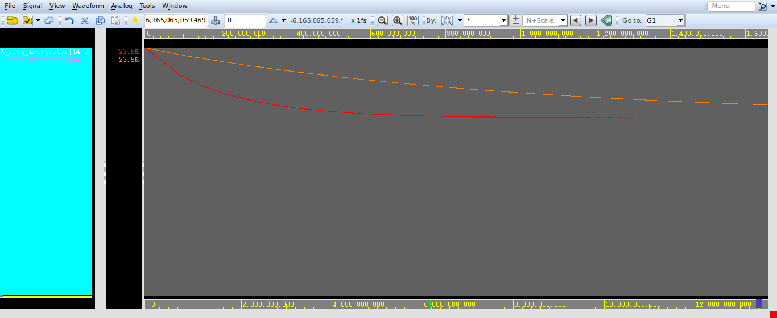

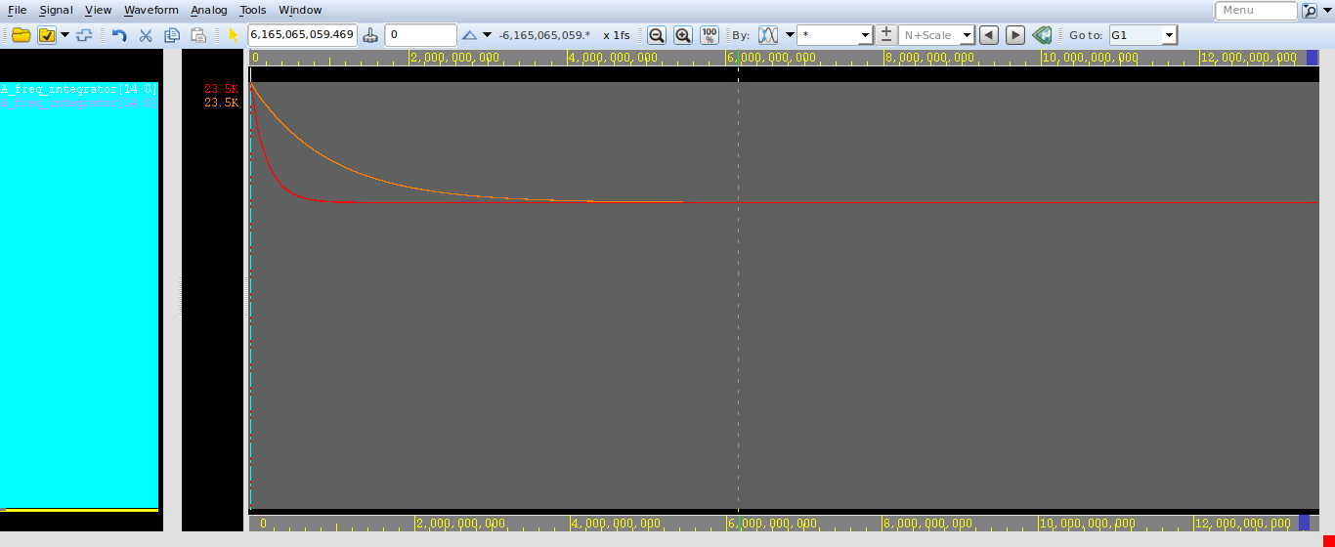

1. **Compare frug = 50 , phug = 8 with frug = 2 , phug = 50**

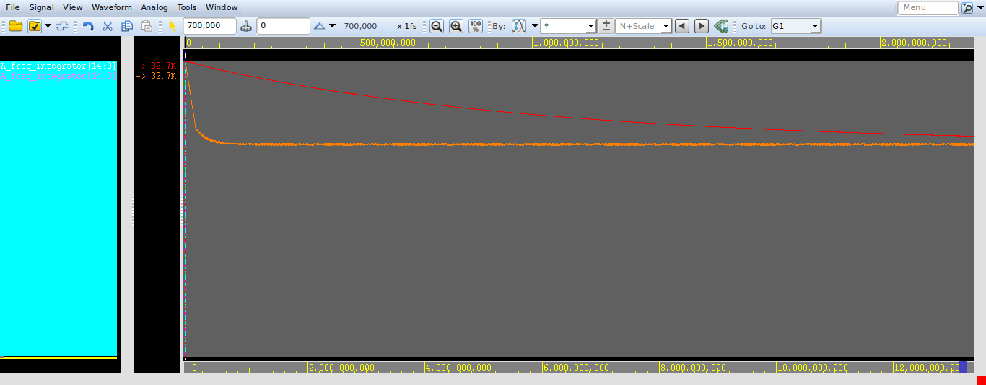

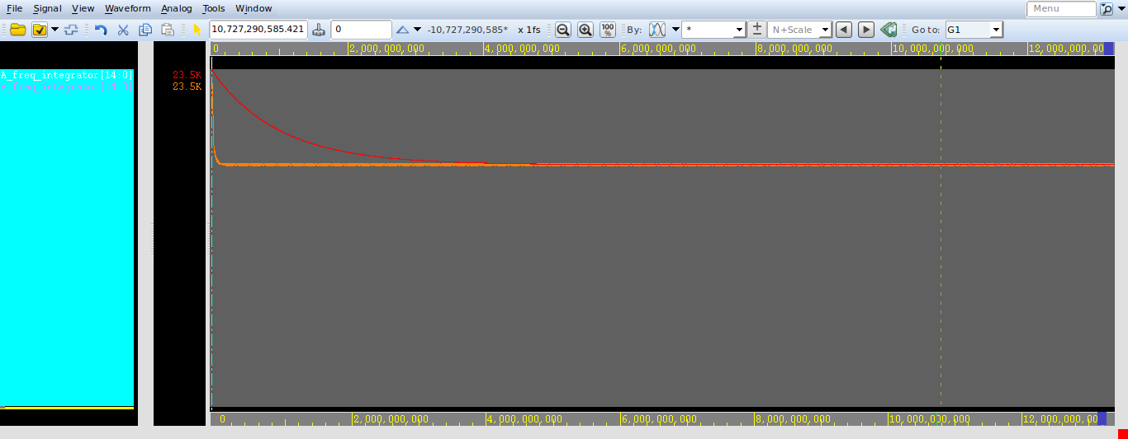

1. **Compare frug = 50 , phug = 8 with frug = 8 , phug = 8**

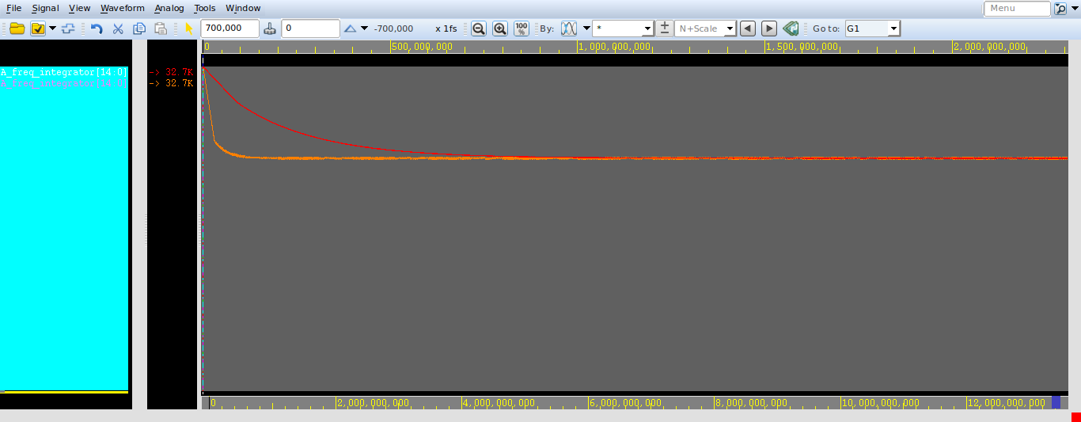

1. **Compare frug = 100 , phug = 2 with frug = 8 , phug = 8**

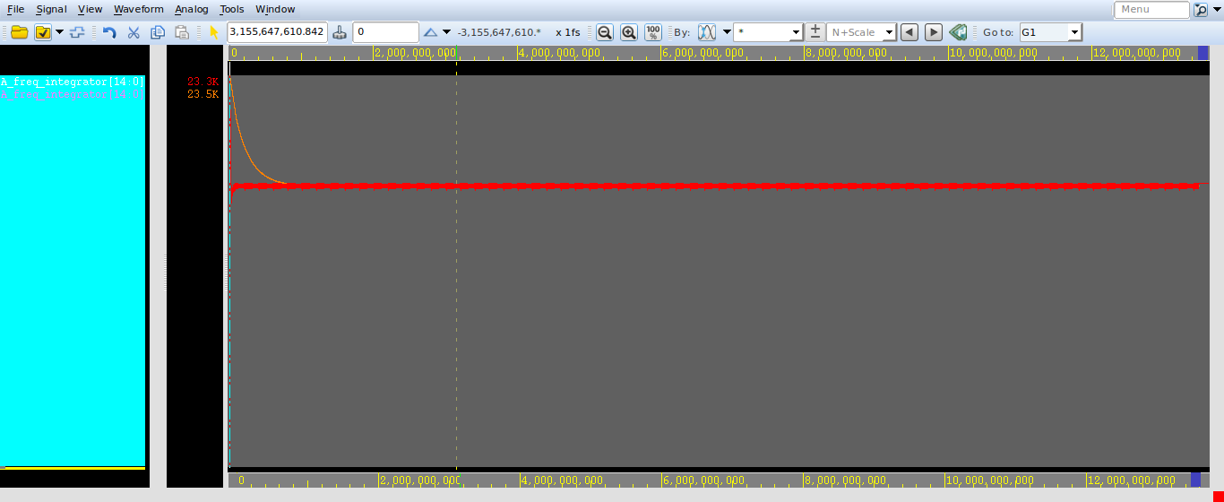

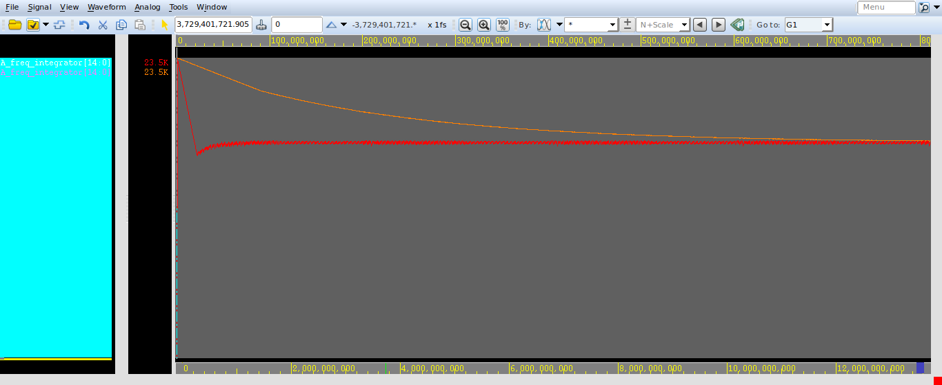

1. **FreqWidth = 20, PhaseWidth = 16 , data_rate = 99.9 , frug = 8, phug= 8**

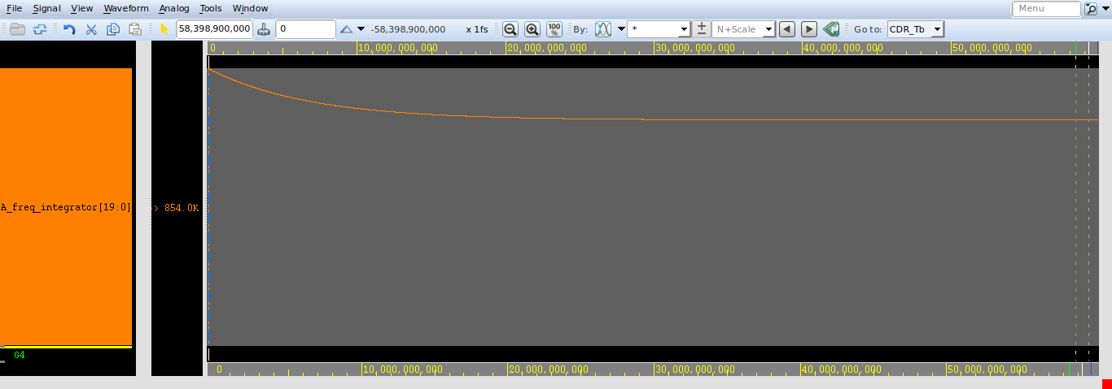

1. **FreqWidth = 20, PhaseWidth = 16 , data_rate = 99.9 , frug = 2, phug=50**

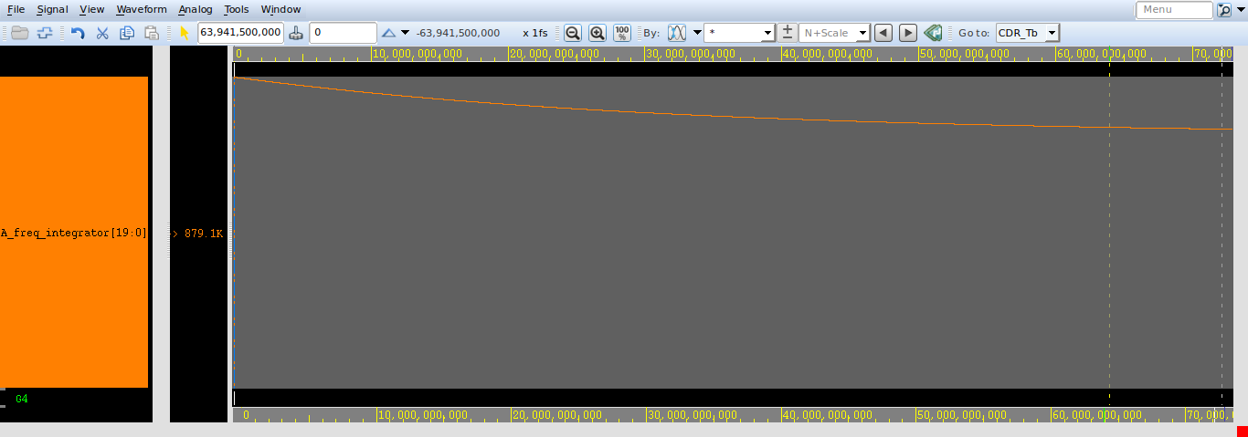

1. **FreqWidth = 20, PhaseWidth = 16 , data_rate = 99.9 , frug = 100, phug=20**

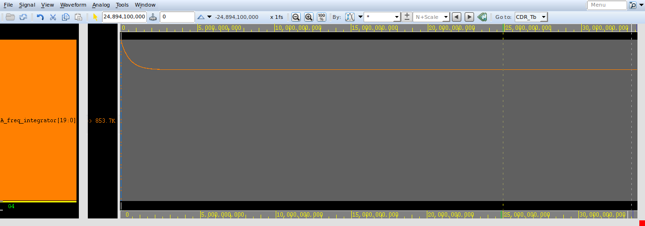

1. **FreqWidth = 20, PhaseWidth = 16 , data_rate = 99.9 , frug = 20, phug=100**

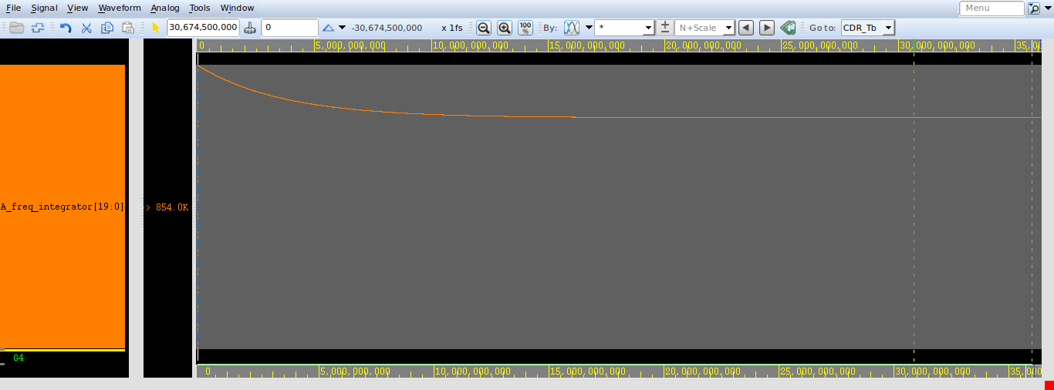

1. **Compare frug = 8,phug =8 with frug = 50, phug= 8**

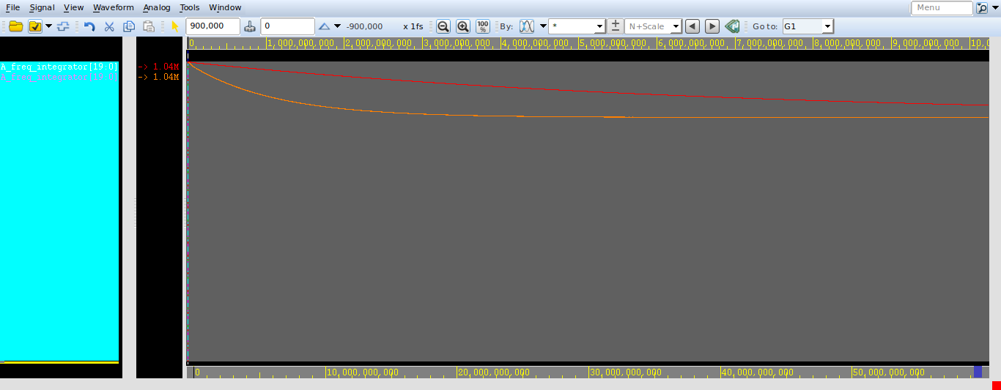

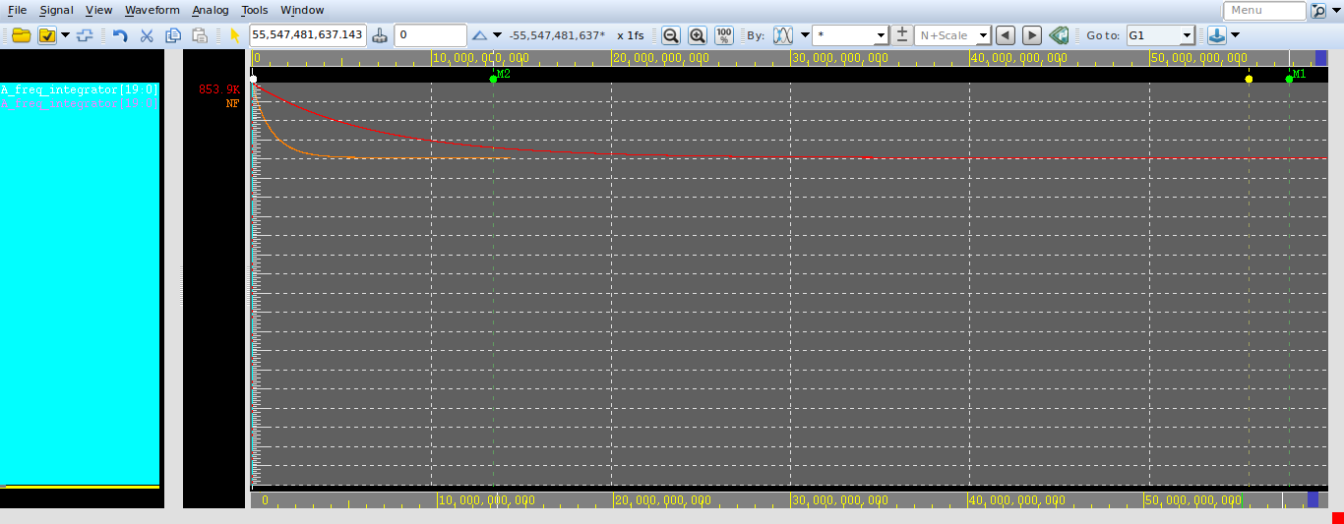

1. **Compare frug = 8,phug =8 with frug = 20, phug= 100**

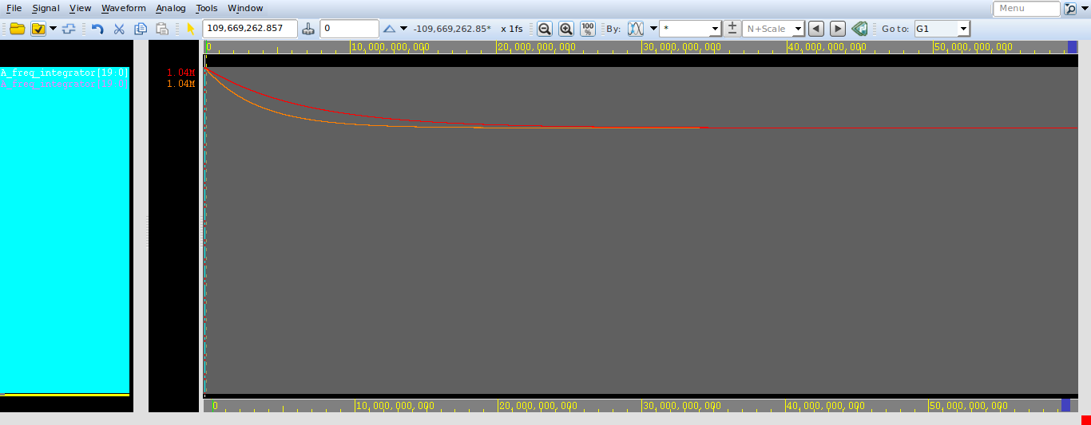

1. **Compare frug = 50 ,phug =8 with frug = 2, phug= 50**

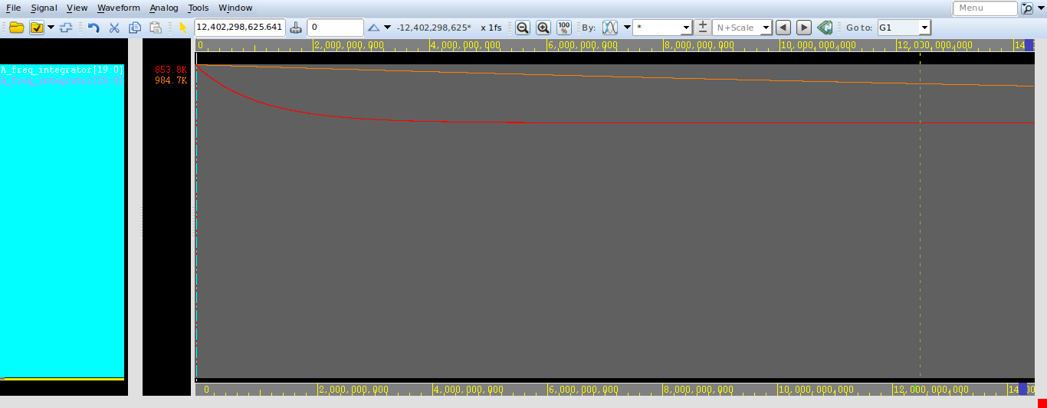

1. **Compare frug = 100,phug =20 with frug = 8, phug= 8**

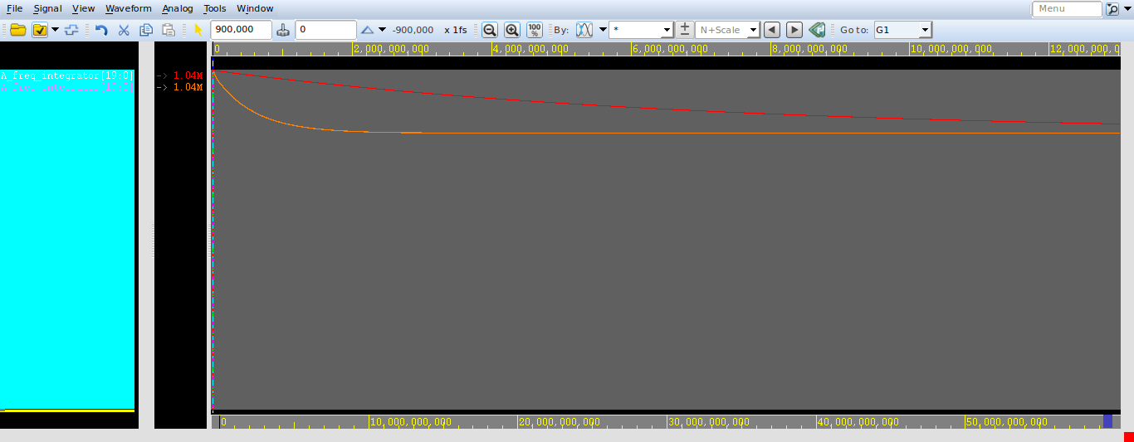

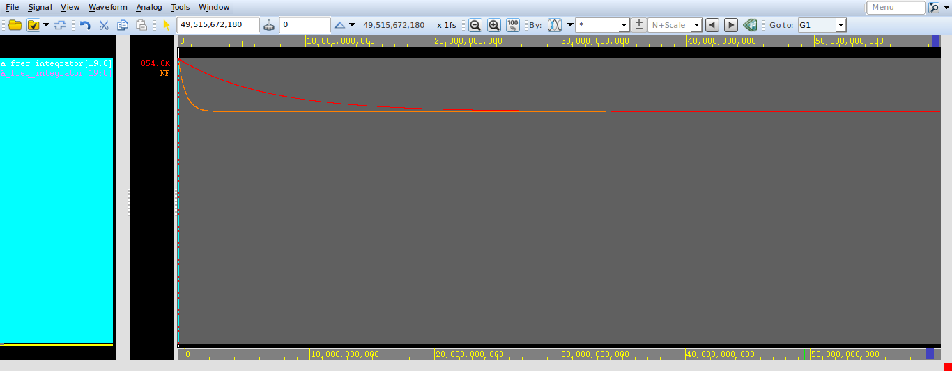

1. **Compare frug = 100,phug =20 with frug = 50, phug= 8**

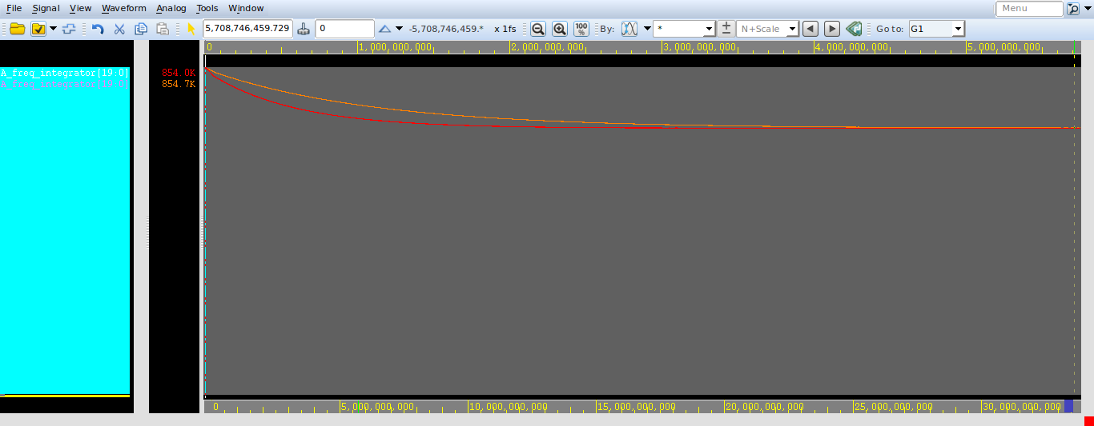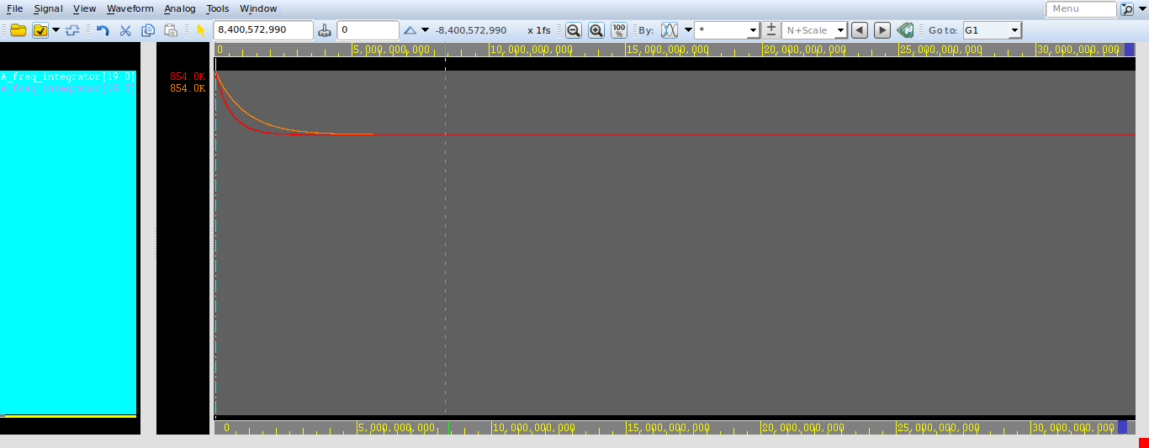

1. **FreqWidth = 20, PhaseWidth = 16 , data_rate = 100.1 , frug = 8, phug= 8**

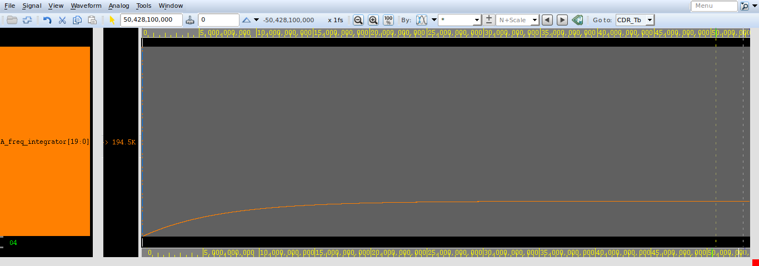

1. **FreqWidth = 20, PhaseWidth = 16 , data_rate = 100.1 , frug = 2, phug=50**

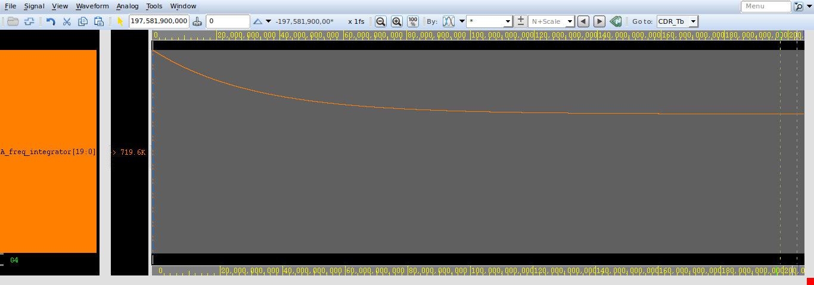

1. **FreqWidth = 20, PhaseWidth = 16 , data_rate = 100.1 , frug = 20, phug=100**

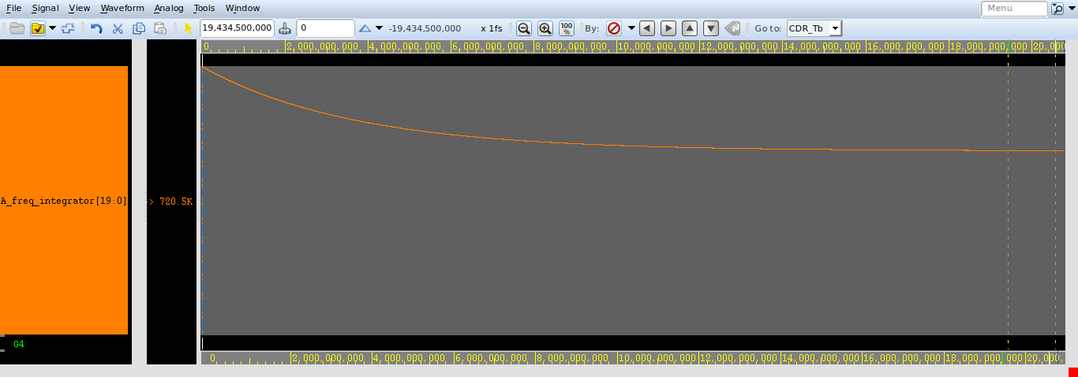

1. **FreqWidth = 20, PhaseWidth = 16 , data_rate = 100.1 , frug = 50, phug=8**

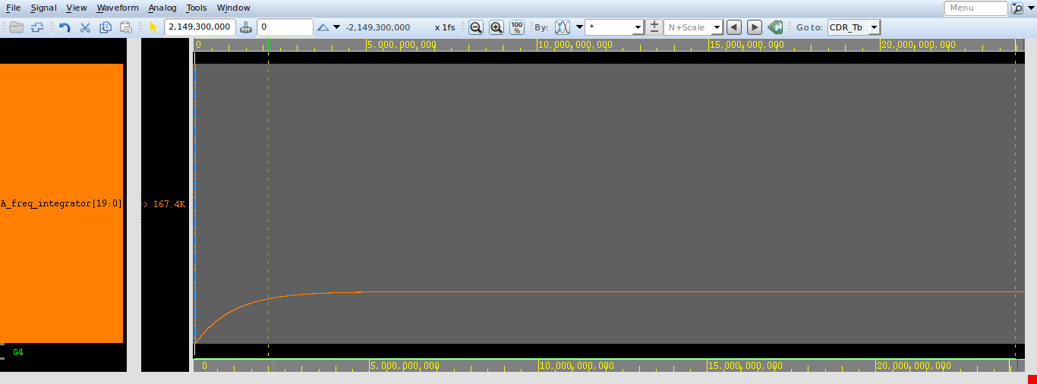

1. **FreqWidth = 20, PhaseWidth = 16 , data_rate = 100.1 , frug=100, phug=2**

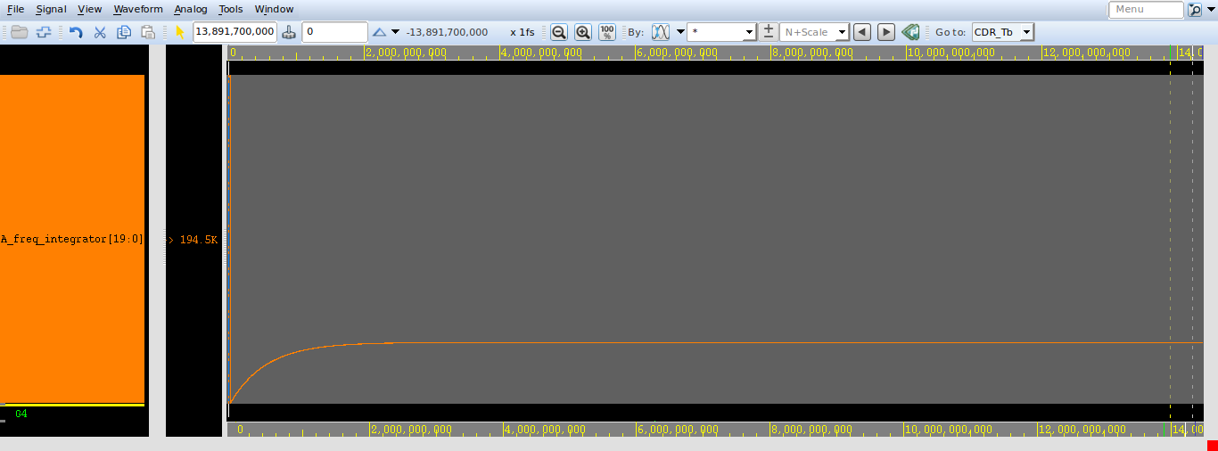

1. **Compare frug = 8,phug =8 with frug = 50, phug= 8**

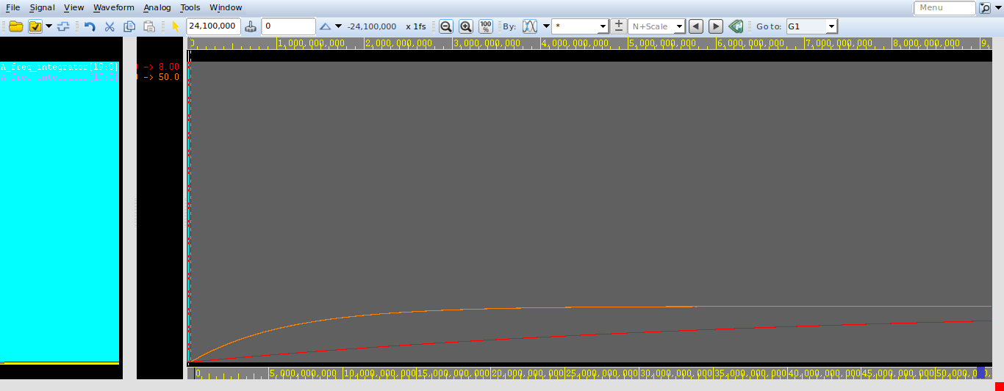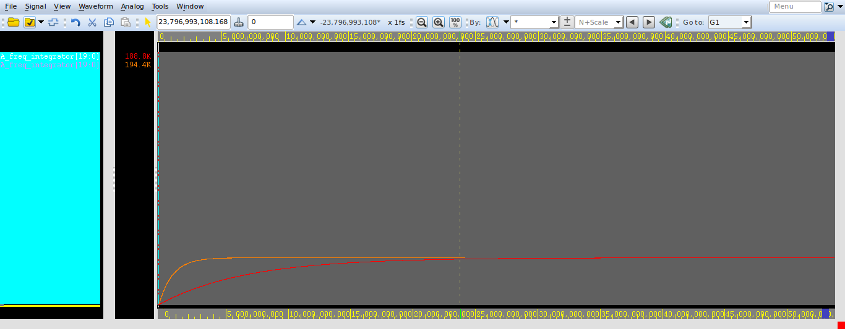

1. **Compare frug = 20, phug = 100 with frug = 8, phug = 8**

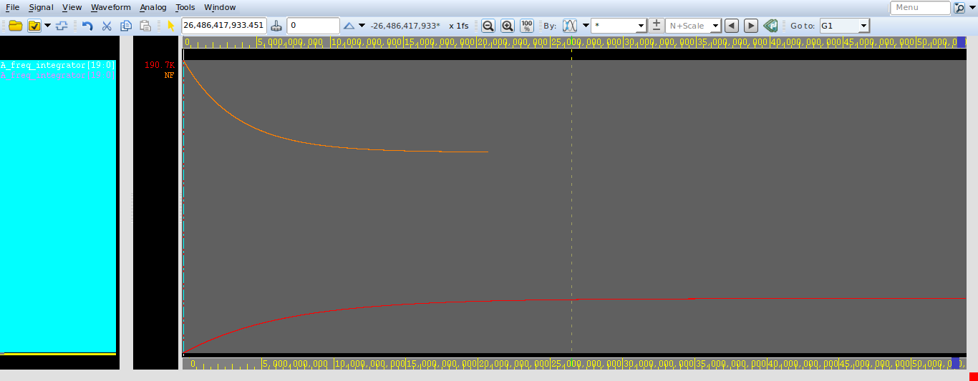

1. **Compare frug = 20, phug =100 with frug = 2, phug =50**

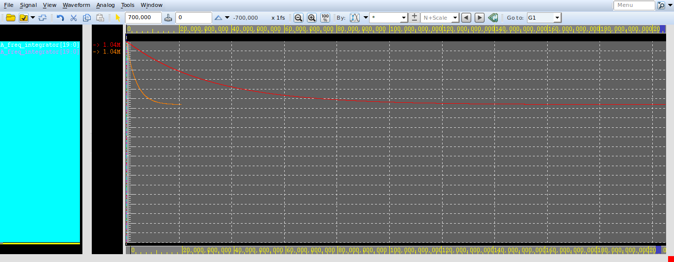

1. **Compare frug = 100, phug =2 with frug =8, phug =8**

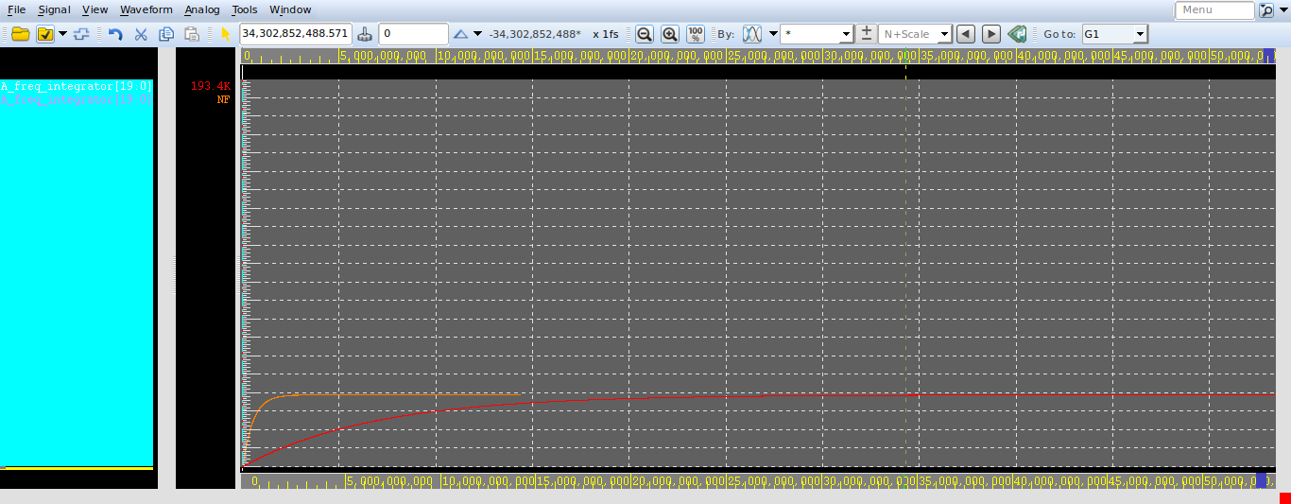

1. **Compare frug = 100, phug =2 with frug = 50, phug =8**

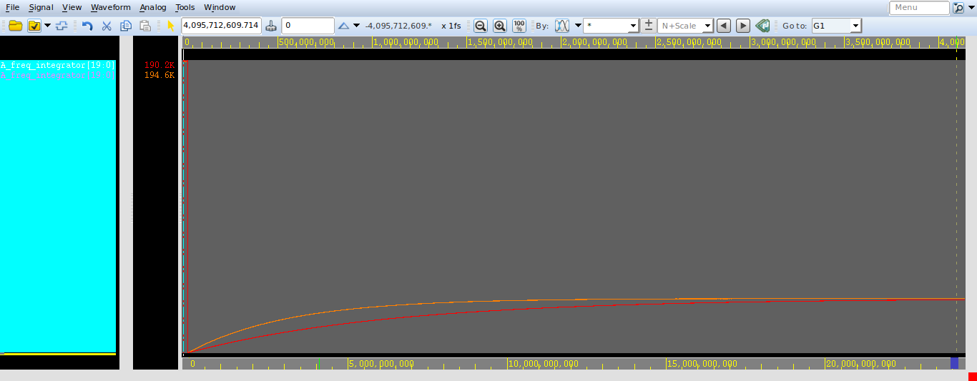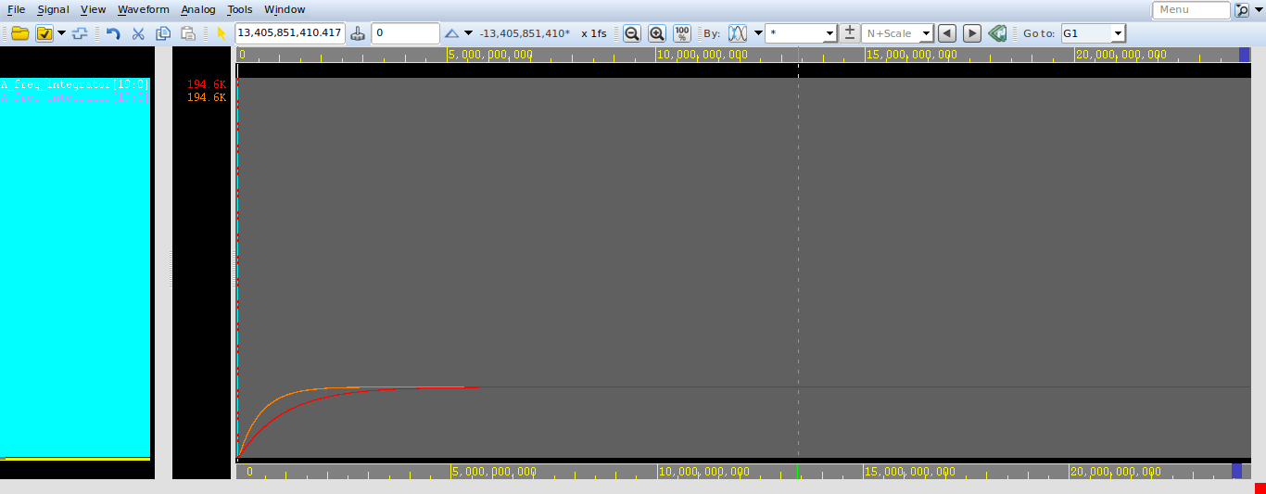

1. **FreqWidth = 24, PhaseWidth = 16 , data_rate = 99.9 , frug = 8, phug= 8**

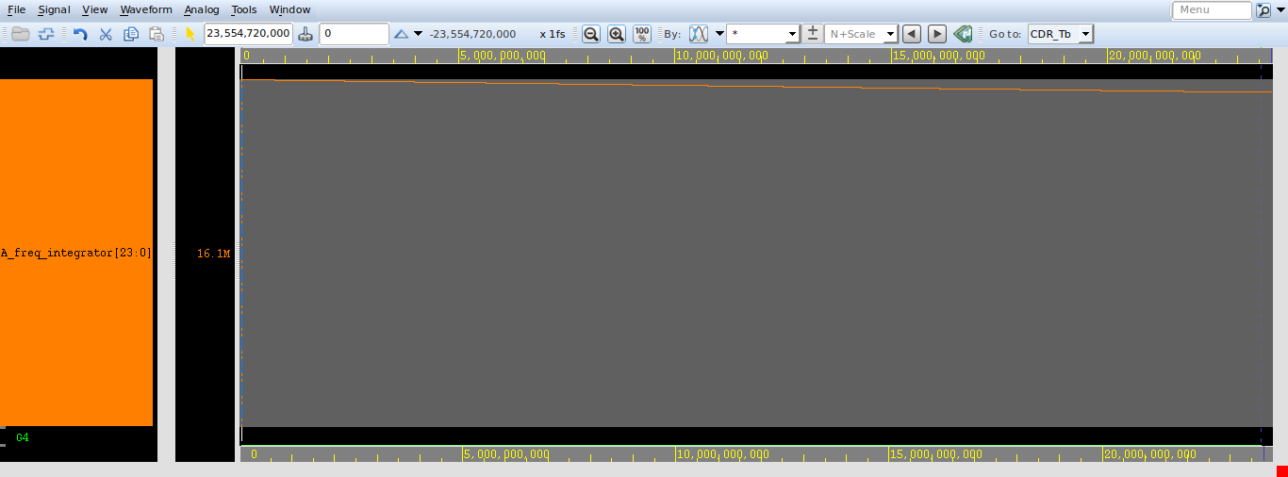

1. **FreqWidth = 20, PhaseWidth = 16 , data_rate = 99.9 , frug = 2, phug= 50**

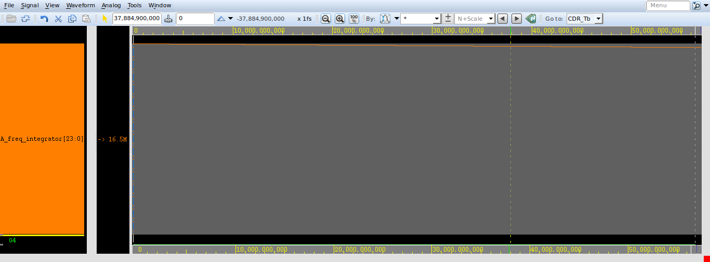

1. **FreqWidth = 20, PhaseWidth = 16 , data_rate = 99.9 , frug = 20, phug=100**

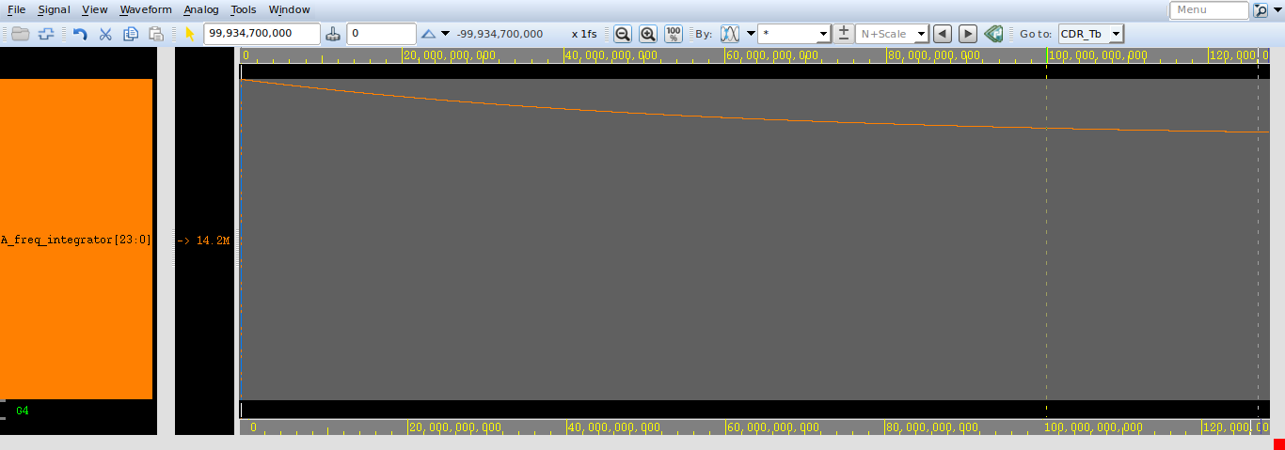

1. **FreqWidth = 20, PhaseWidth = 16 , data_rate = 99.9 , frug = 80, phug=500**

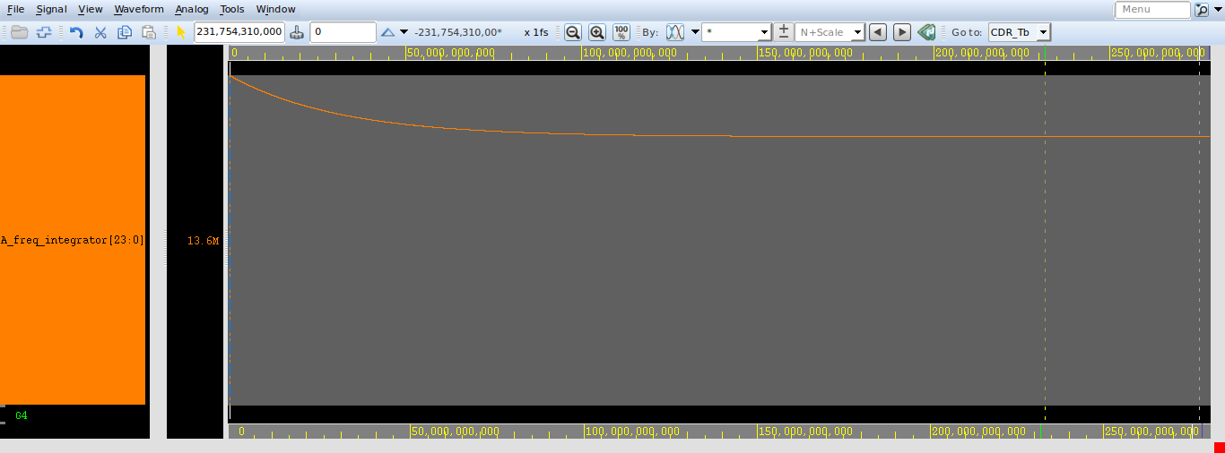

1. **FreqWidth = 20, PhaseWidth = 16 , data_rate = 99.9 , frug = 200, phug=1000**

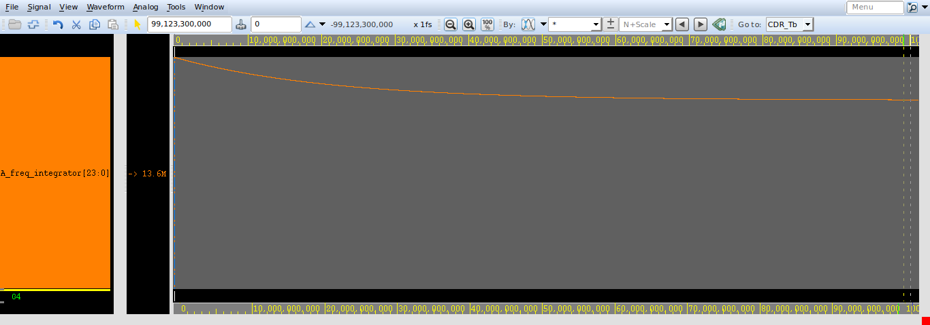

1. **FreqWidth = 20, PhaseWidth = 16 , data_rate = 99.9 , frug=500, phug=80**

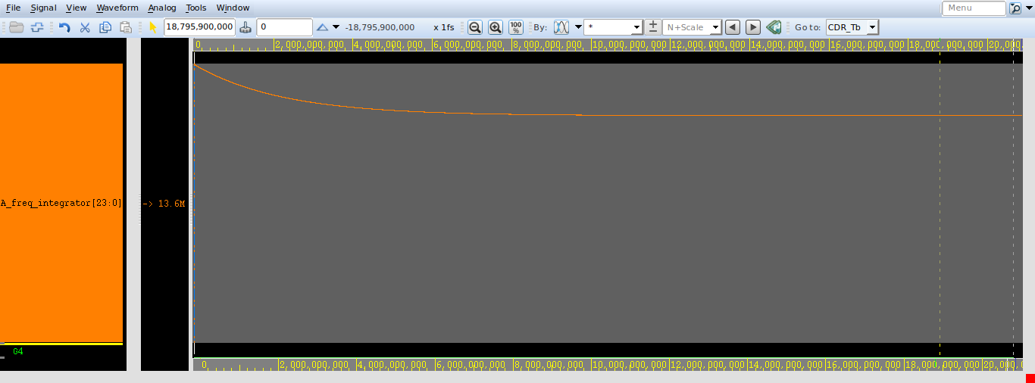

1. **FreqWidth = 20, PhaseWidth = 16 , data_rate = 99.9 , frug = 800, phug=800**

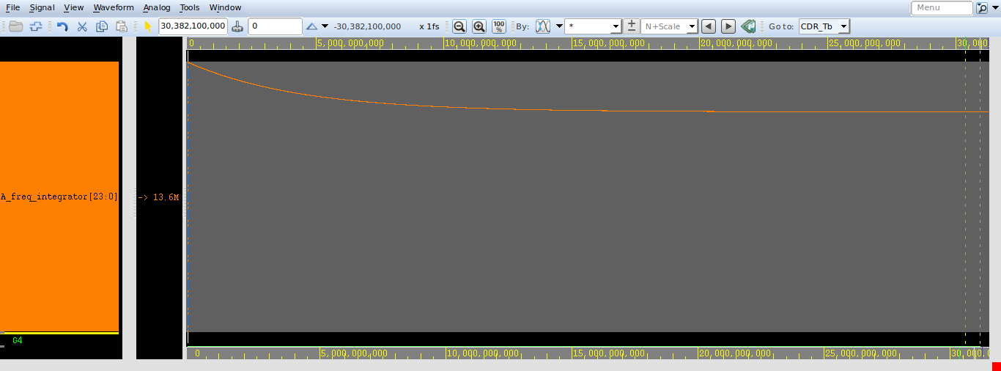

1. **FreqWidth = 20, PhaseWidth = 16 , data_rate = 99.9 , frug =1000, phug=200**

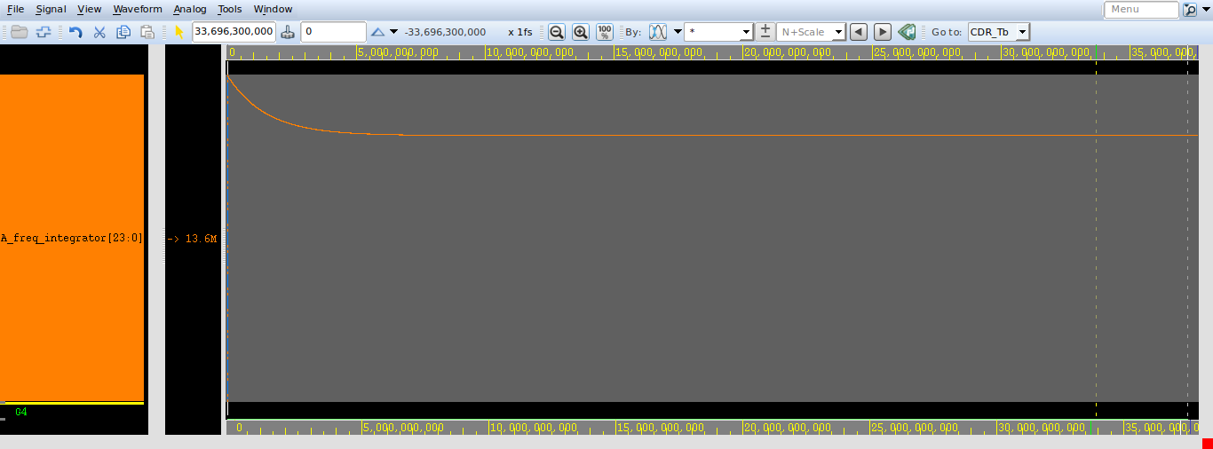

1. **Compare frug = 80, phug =500 with frug =800, phug =800**

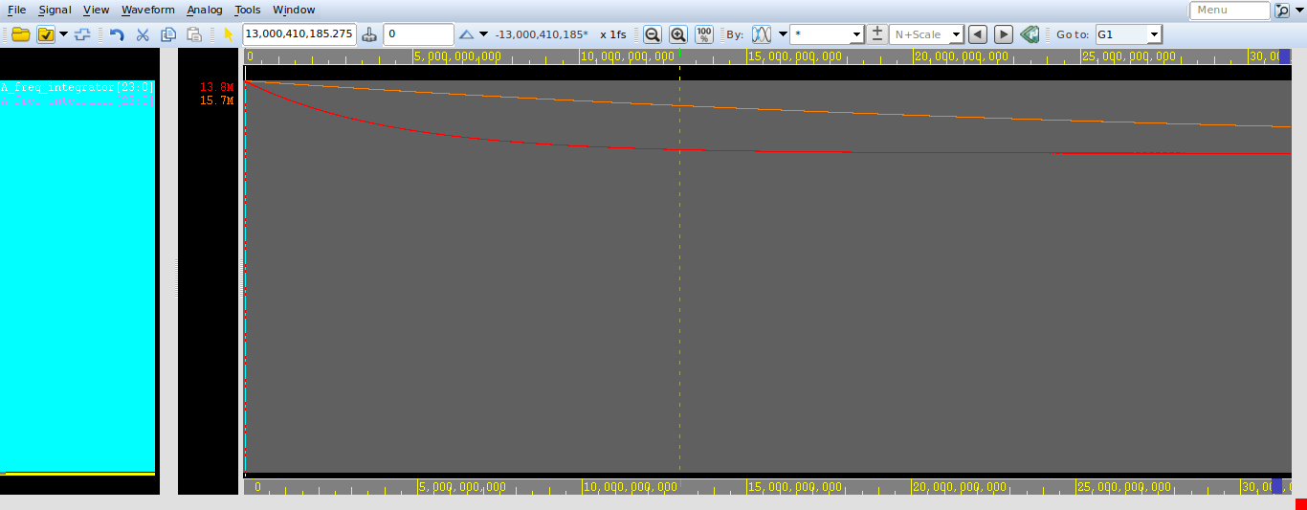

1. **Compare frug = 200, phug =1000 with frug =800, phug =800**

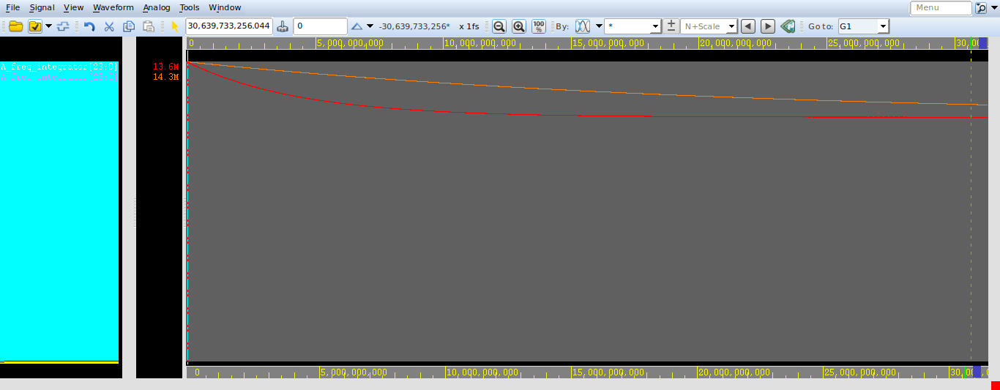

1. **Compare frug = 80, phug =500 with frug =200, phug =1000**

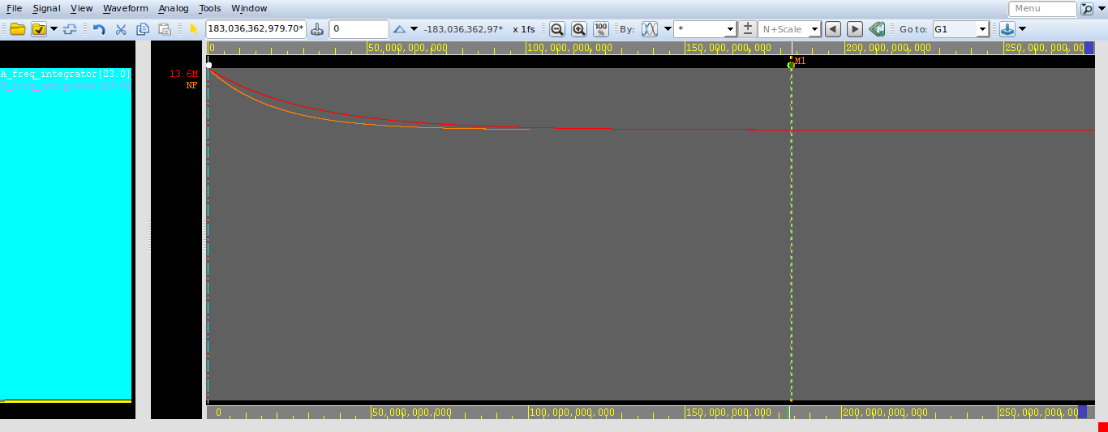

1. **Compare frug = 500, phug =80 with frug =800, phug =800**

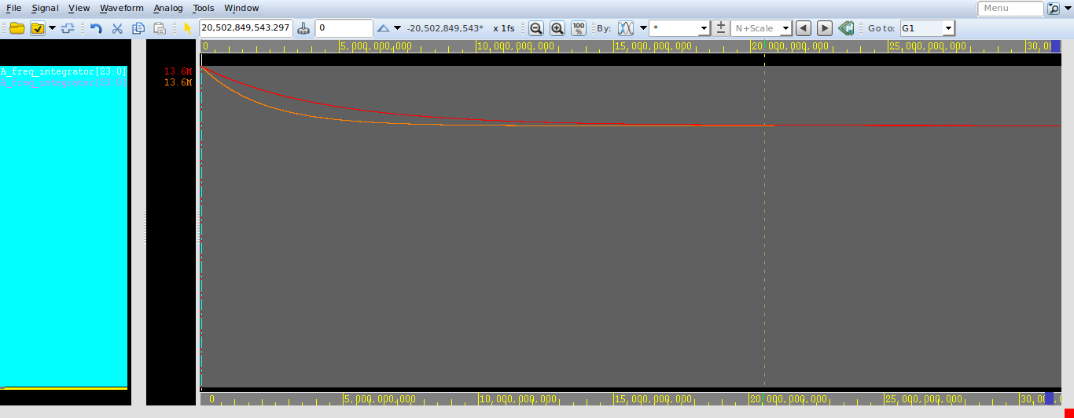

1. **Compare frug = 80, phug =500 with frug =1000, phug =200**

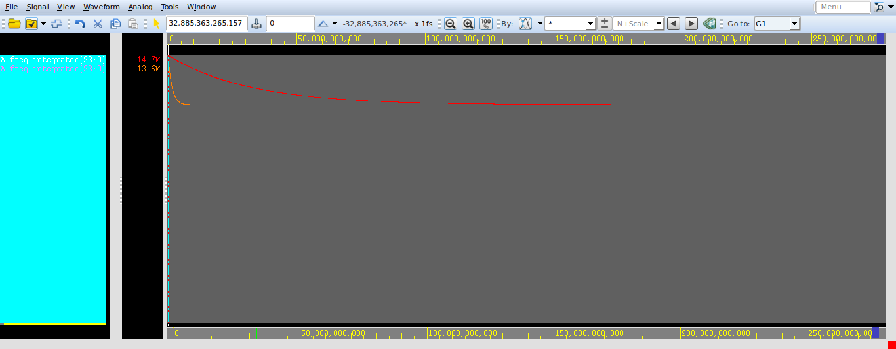

1. **Compare frug = 1000, phug =200 with frug =200, phug =1000**

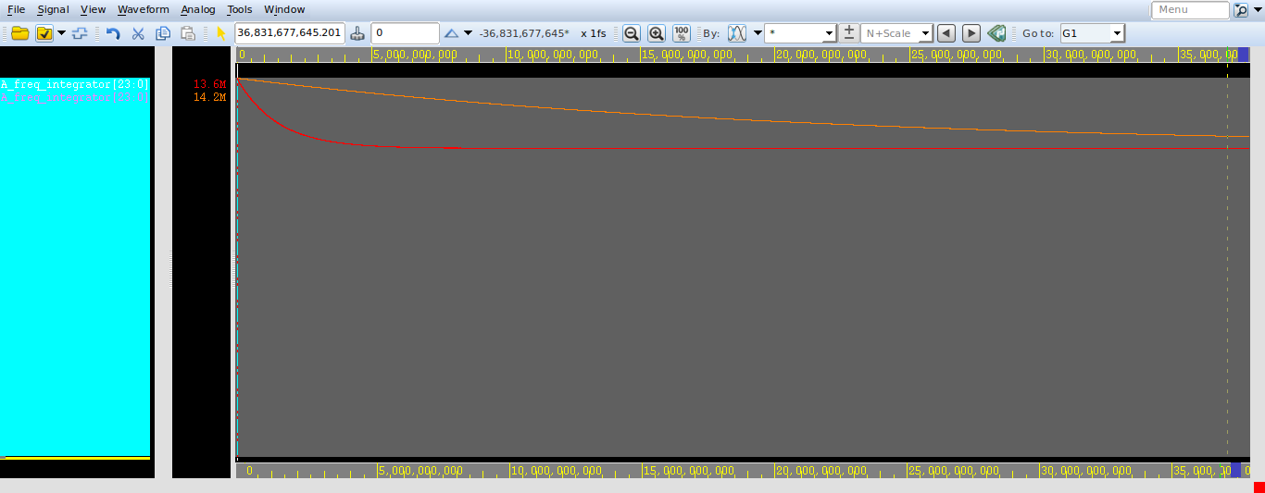

1. **Compare frug =1000, phug =200 with frug =500, phug =80**

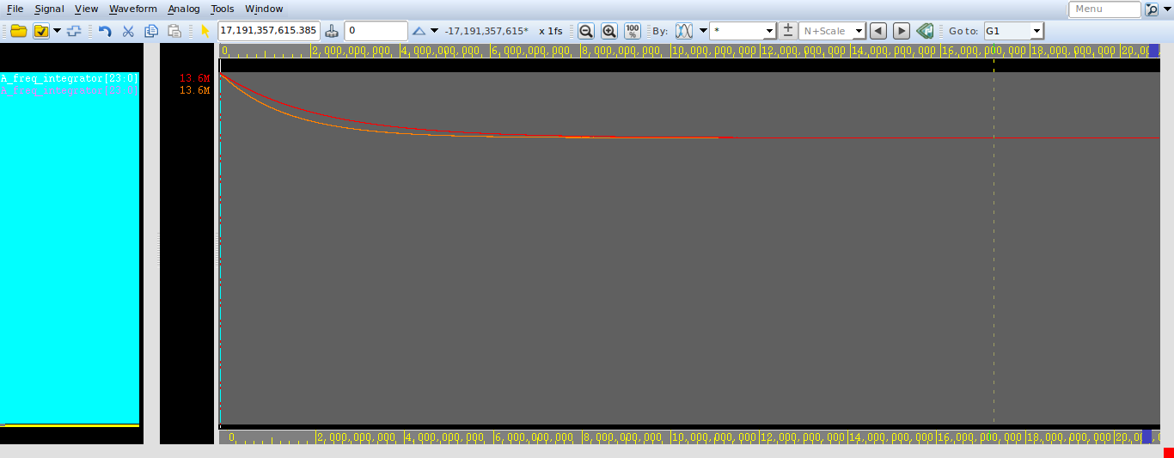

1. **Compare frug = 1000, phug =200 with frug =800, phug =800**

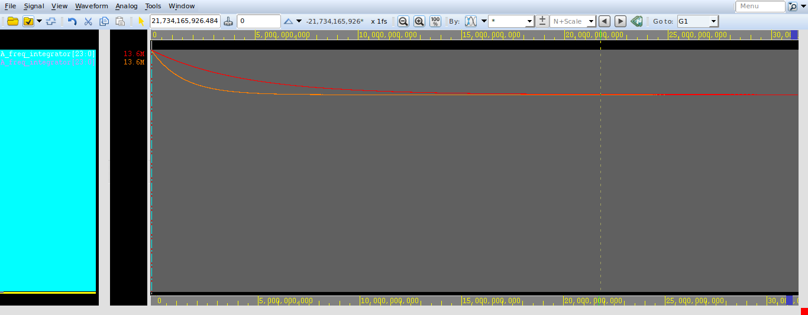

1. **FreqWidth = 24, PhaseWidth = 16 , data_rate = 100.1 , frug = 80, phug=500**

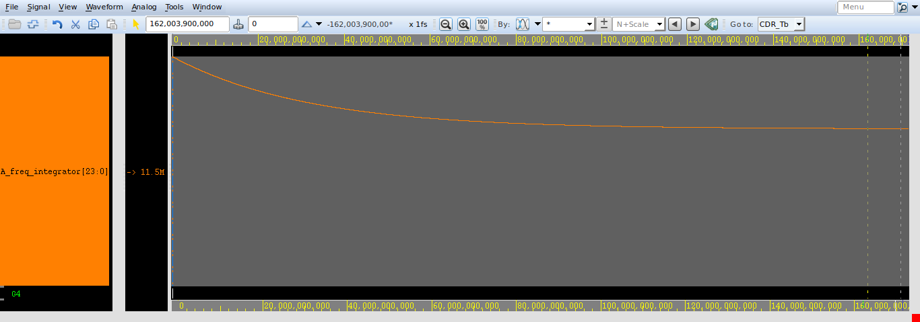

1. **FreqWidth = 24, PhaseWidth = 16 , data_rate = 100.1 , frug = 500, phug=80**

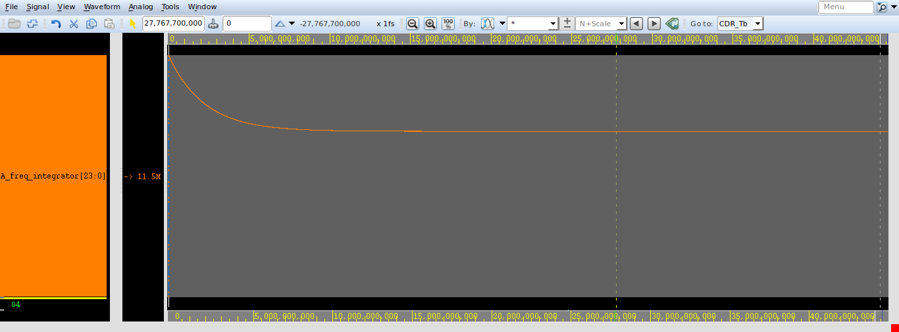

1. **FreqWidth = 24, PhaseWidth = 16 , data_rate = 100.1 , frug = 800, phug=800**

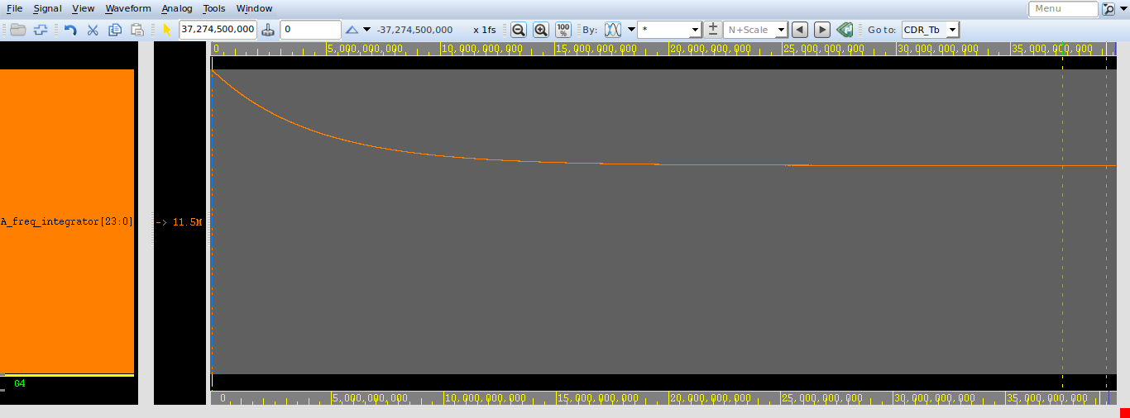

1. **FreqWidth = 24, PhaseWidth = 16 , data_rate = 100.1 , frug = 1000, phug=200**

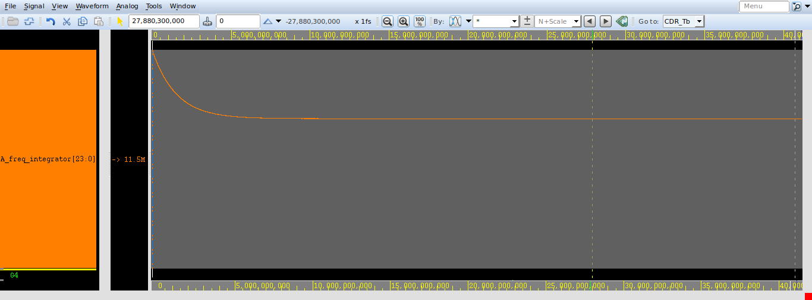

1. **Compare frug = 80, phug =500 with frug =800, phug =800**

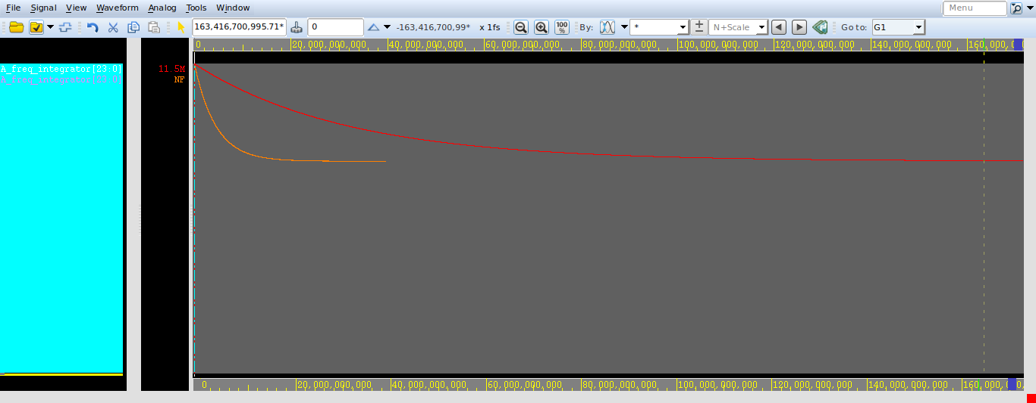

1. **Compare frug = 80, phug =500 with frug =500, phug =80**

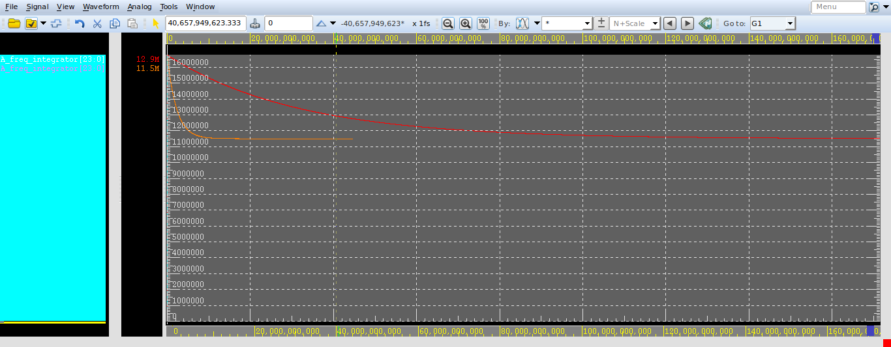

1. **Compare frug = 500, phug =80 with frug =1000, phug =200**

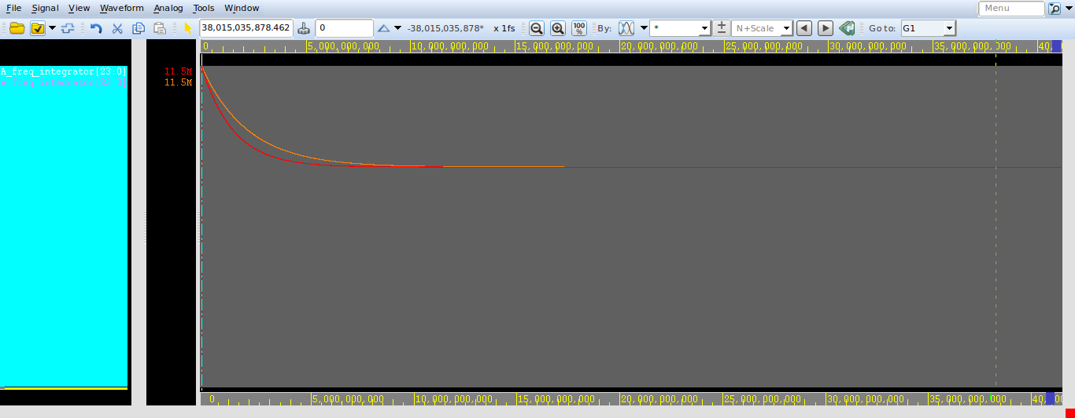

1. **Compare frug = 500, phug =80 with frug =800, phug =800**

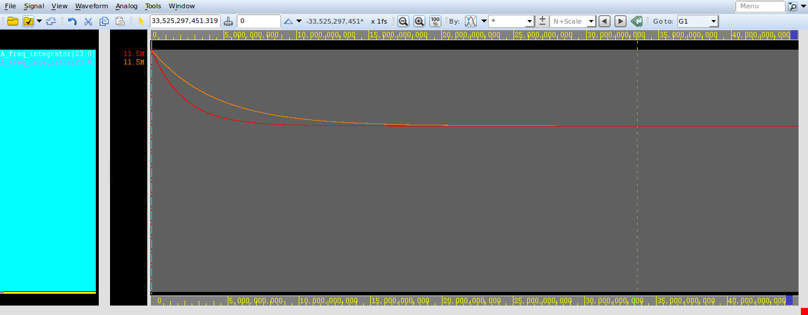

1. **Compare frug = 800, phug =800 with frug =1000, phug =200**

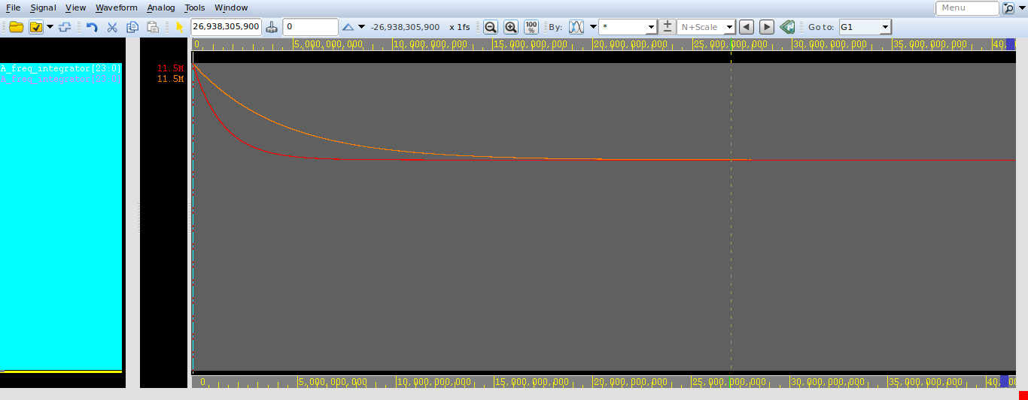

1. **Compare frug = 80, phug =500 with frug =1000, phug =200**

