**Elastic**

**Buffer**

**UVM**

**Verification**

**Waveforms**

* **Walking Ones**

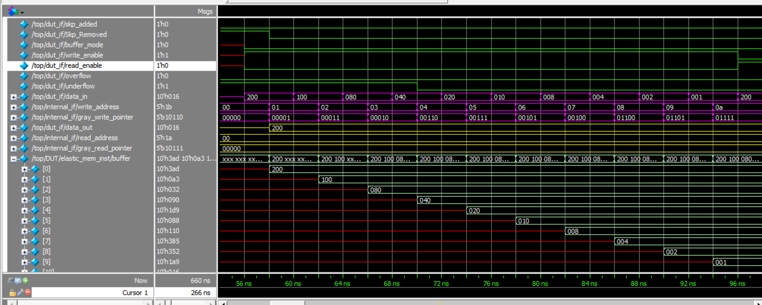

* **Under Flow**

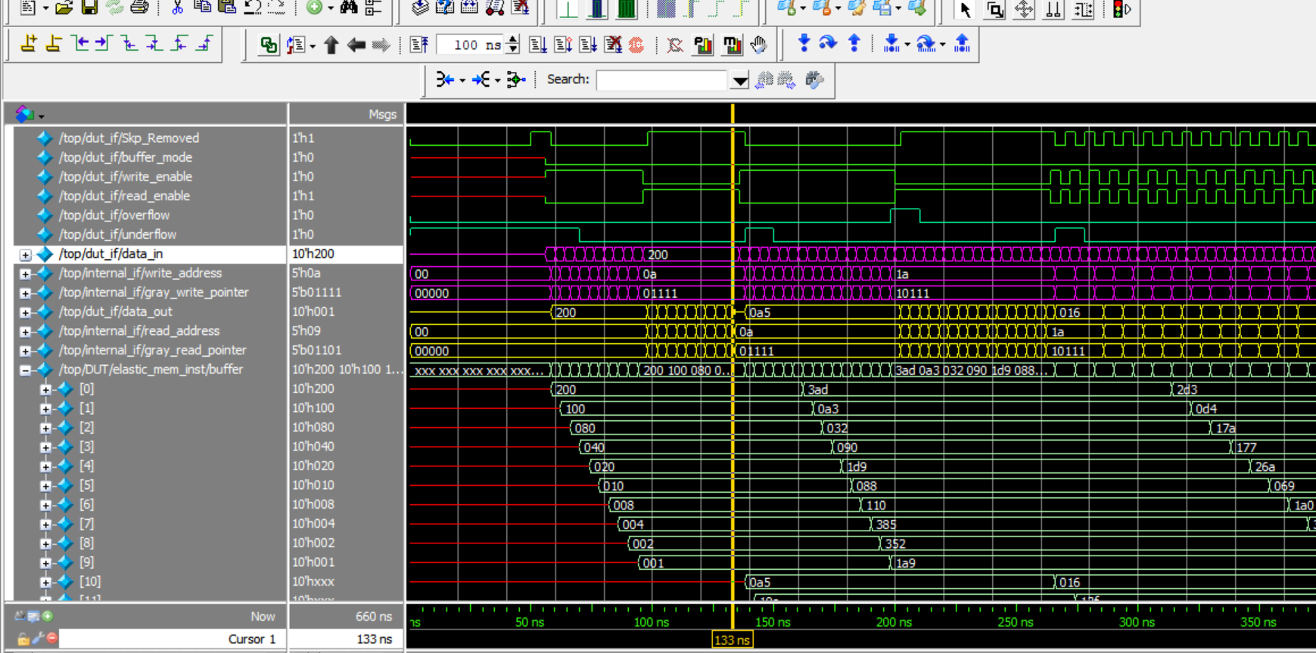

* 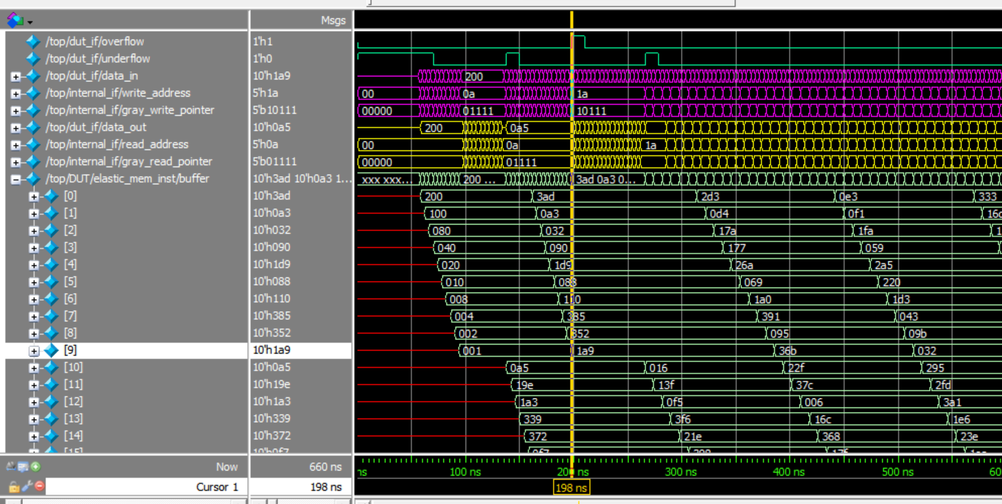**Overflow**

|  |  |  |  |  |  |  |  |
| --- | --- | --- | --- | --- | --- | --- | --- |
| **Test**  **feature** |  |  | **Inputs** |  |  | **Expected Output** | **Actual**  **Output** |
|  | buffer_mode | write_  enable | read_  enable | rst_n | data_in | data_out | data_out |
| w | 0 | 1 | 0 | 1 | 0x001 | **-** | **-** |
| a | 0 | 1 | 0 | 1 | 0x200 | **-** | **-** |
| l | 0 | 1 | 0 | 1 | 0x100 | **-** | **-** |
| k | 0 | 1 | 0 | 1 | 0x080 | **-** | **-** |
| i | 0 | 1 | 0 | 1 | 0x040 | **-** | **-** |
| n | 0 | 1 | 0 | 1 | 0x020 | **-** | **-** |
| g | 0 | 1 | 0 | 1 | 0x010 | **-** | **-** |
| 1 | 0 | 1 | 0 | 1 | 0x008 | **-** | **-** |
| ’ | 0 | 1 | 0 | 1 | 0x004 | **-** | **-** |
| s | 0 | 1 | 0 | 1 | 0x002 | **-** | **-** |
|  |  |  |  |  |  |  |  |
| R | 0 | 0 | 1 | 1 | 0x002 | 0x001 | 0x200 |
| E | 0 | 0 | 1 | 1 | 0x002 | 0x200 | 0x100 |
| A | 0 | 0 | 1 | 1 | 0x002 | 0x100 | 0x080 |
| D | 0 | 0 | 1 | 1 | 0x002 | 0x080 | 0x040 |
|  | 0 | 0 | 1 | 1 | 0x002 | 0x040 | 0x020 |
|  | 0 | 0 | 1 | 1 | 0x002 | 0x020 | 0x010 |
|  | 0 | 0 | 1 | 1 | 0x002 | 0x010 | 0x008 |
|  | 0 | 0 | 1 | 1 | 0x002 | 0x008 | 0x004 |
| O | 0 | 0 | 1 | 1 | 0x002 | 0x004 | 0x002 |
| P | 0 | 0 | 1 | 1 | 0x002 | 0x002 | 0x001 |
|  | 0 | 0 | 1 | 1 | 0x002 | 0x001 | xxxx |
|  |  |  |  |  |  |  |  |

|  |  |  |  |  |  |  |  |
| --- | --- | --- | --- | --- | --- | --- | --- |
| **Test**  **feature** |  |  | **Inputs** |  |  | **Expected Output** | **Actual**  **Output** |
|  | buffer_mode | write_enable | read_enable | rst_n | data_in | Overflow | Overflow |
| O | 0 | 1 | 0 | 1 | R | 1 | 0x200 |
| V | 0 | 1 | 0 | 1 | A | 1 | 0x100 |
| E | 0 | 1 | 0 | 1 | N | 1 | 0x080 |
| R | 0 | 1 | 0 | 1 | D | 1 | 0x040 |
|  | 0 | 1 | 0 | 1 | O | 1 | 0x020 |
|  | 0 | 1 | 0 | 1 | M | 1 | 0x010 |
| F | 0 | 1 | 0 | 1 | S | 1 | 0x008 |
| L | 0 | 1 | 0 | 1 | T | 1 | 0x004 |
| O | 0 | 1 | 0 | 1 | I | 1 | 0x002 |
| W | 0 | 1 | 0 | 1 | M | 1 | 0x001 |
|  | 0 | 1 | 0 | 1 | U | 1 | XXXX |

