Assignment 01: Build and Deploy a Small Application
Software Engineering — DevOps & Continuous Integration (CI/CD)

Student Name | Muhammad Hassan Khalid
Roll Number | FA25-BCS-132
Course & Assignment | Software Engineering — Assignment 01
Chosen Application | To-Do List Application (TaskFlow)
GitHub Repository | https://github.com/HassanKhalidKM/se-assignment-01
Live Deployed URL | https://hassankhalidkm.github.io/se-assignment-01/

1. Application Name and Purpose
• Application Name: TaskFlow
• Category: To-Do List Application (Option 1 from assignment prompt)
• Purpose: TaskFlow is an intuitive, single-page productivity web application designed to help individuals organize, track, and complete daily tasks. Developed with vanilla web standards (HTML5, CSS3, ES8 JavaScript), it requires no external libraries or build-step dependencies, making it ultra-lightweight, resilient, and instantly accessible on desktop and mobile browsers.
2. Main Features
• Task Creation: Quickly create tasks with real-time feedback via text input and Enter key or Add button.
• Status Toggling: Mark tasks as completed or active with instant animated strike-through styling and checkbox indicators.
• Task Filtering: Dynamic filter tabs allow users to view 'All', 'Active' (incomplete), or 'Completed' tasks.
• Persistent Storage: All tasks and their status automatically sync with the browser's localStorage API, ensuring data survives page reloads.
• Live Metrics Badge: The application header displays a dynamic counter showing remaining pending tasks.
• Accessibility & Fluid Design: Incorporates semantic HTML5 landmarks, ARIA roles/labels for assistive technologies, and a responsive dark theme.
3. DevOps Flow Followed
The project strictly adhered to modern DevOps principles by automating the build, validation, and deployment pipeline using Git and GitHub Actions. Every change pushed to the main branch triggers automated quality gates before proceeding to production deployment.
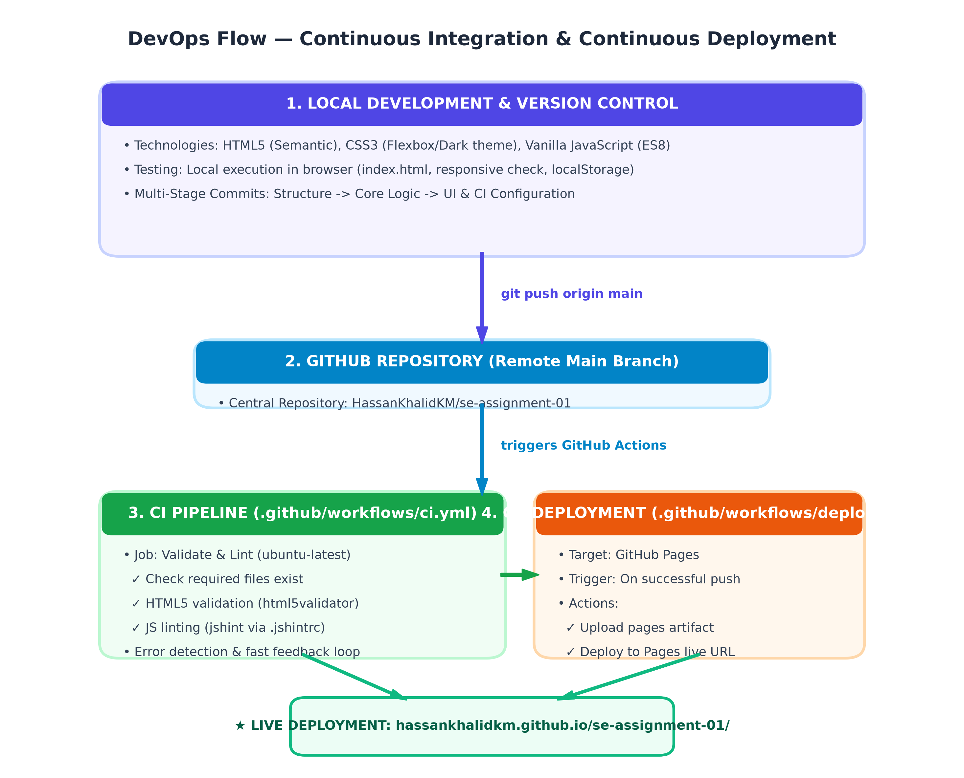
Figure 1: Automated DevOps Pipeline Architecture (Continuous Integration & Continuous Deployment)
4. Problems Faced and How They Were Solved
• Linter False Positives (JSHint): Running jshint with overly strict default command-line flags flagged standard browser runtime variables (such as localStorage and document) as undefined. This was resolved by creating a dedicated .jshintrc configuration file specifying esversion: 8, browser: true, and registering required globals.
• Deliberate Break & Fix Cycle (Step 9): To rigorously demonstrate CI failure without permanently breaking the repository, an intentional syntax error (var broken = (;) was introduced and pushed to trigger a failed CI run. Once evidence was captured, the syntax was restored and pushed to produce a green verified build.
• GitHub Pages Deployment Workflow Setup: By default, GitHub Pages expects deployment from a dedicated branch. To deploy directly from GitHub Actions artifacts, repository settings were updated to set Source to 'GitHub Actions', and permissions (pages: write, id-token: write) were granted in deploy.yml.
5. What You Learned from Continuous Integration (CI)
• Automated Quality Assurance: CI acts as an impartial safety net. Syntax errors, missing files, or bad markup are trapped immediately before impacting end users.
• Fast Feedback Loop: Developers receive automated failure reports within seconds of pushing, pinpointing exact files and lines containing regressions.
• Deterministic Environments: Running tests on standardized Ubuntu virtual environments eliminates discrepancies caused by differing developer operating systems.
• Seamless CI/CD Hand-off: Successfully passing CI builds can automatically feed directly into CD deployment pipelines (such as GitHub Pages), eliminating manual deployment friction.
6. Required Deliverables & Screenshots
Screenshot 1: Running Application (Local browser verification)
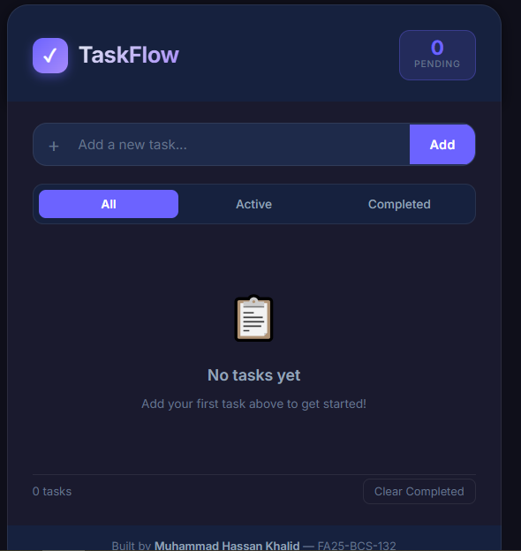

Screenshot 2: Git Commit History (Multi-stage meaningful commits)
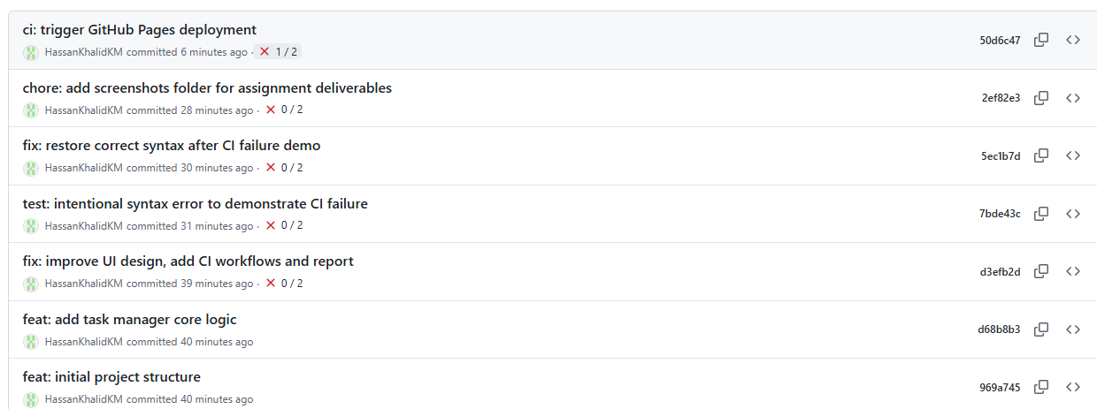

Screenshot 3: Failed CI Workflow (Intentional syntax error caught by GitHub Actions)
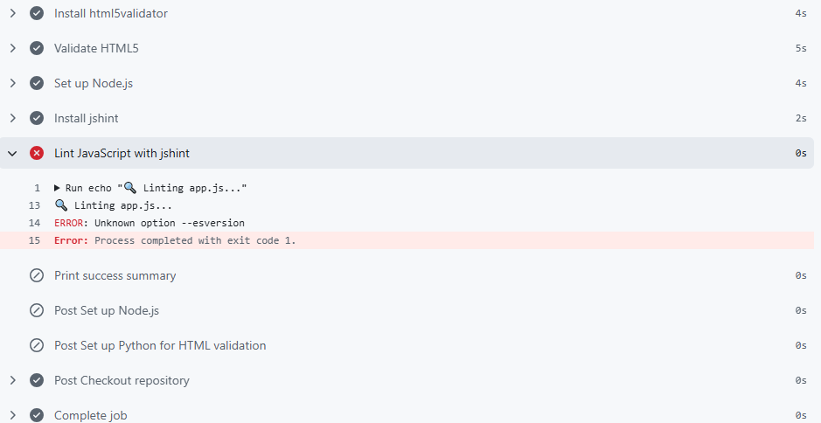

Screenshot 4: Successful CI Workflow (Clean build after applying fix)
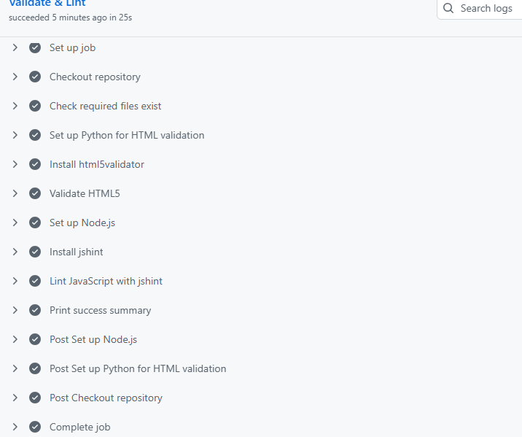

Screenshot 5: Deployed Application (Live on GitHub Pages)
