**Part2**

Using packet tracer, implement a network that has the following components:

1. **At least five routers**
2. **At least 7 subnets**
3. **At least 12 PCs**
4. **At least 4 switches**
5. **Use RIP routing protocol**

We are going to start off by first downloading our software that we are going to use which is cisco packet tracer then after opening it and using the components we need in order to build out network we got the following result:

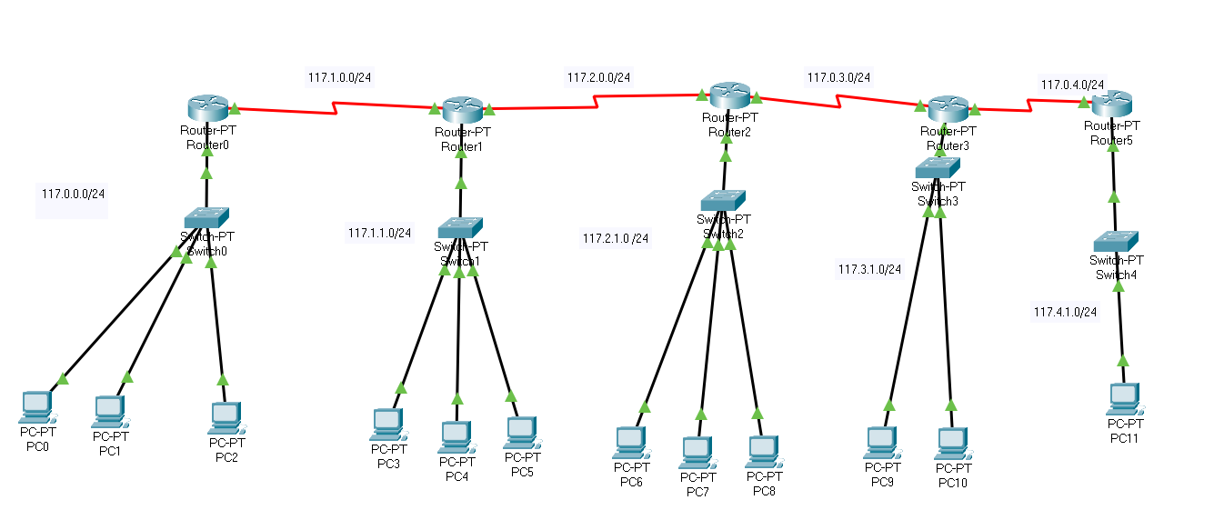

**Configuration:**

Now that we have built our network i need to configure its settings depending on the ips that we gave it so the first thing we did is create different subnets and because i'm a student with a college id starting with 117 so our first network was 117.0.0.0 and each network was different as follows:

First network 117.0.0.0

Second network 117.1.0.0

Third network 117.1.1.0

Fourth network 117.2.0.0

Fifth network 117.2.1.0

Sixth network 117.3.0.0

Seventh network 117.3.1.0

With network 117.4.0.0

And finally the ninth network 117.4.1.0

Of Course all of them have the same subnet mask which is /24 which corresponds to 255.255.255.0

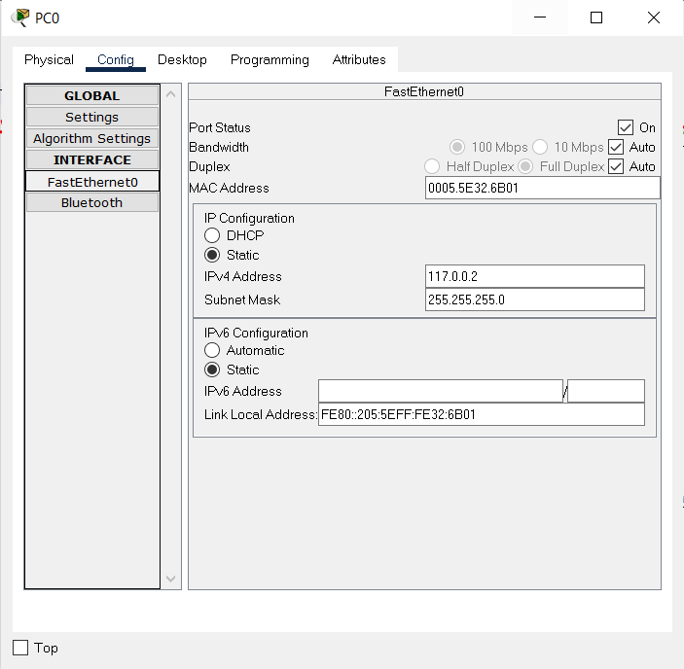Now in our second step of the configuration we opened each pc the give it the gateway of the router and the its own ip as follows: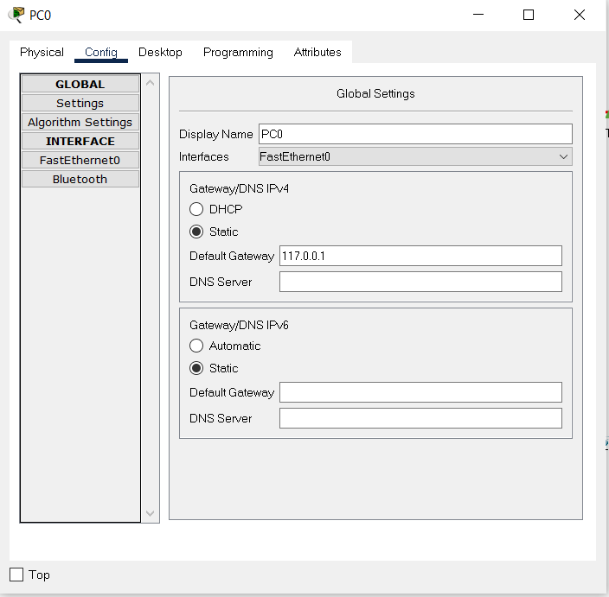

# 

# 

# 

You can see how we. gave the gateway the ip address of 117.0.0.1 and this is how we always configure the router ip as and the network is always with a zero at the end for example our first network is 117.0.0.0.

After we have configured our pc as we have seen we move into our routers which are the important factor in our project, so what we do is open our routers and assigning a ip address as we have discussed and then in able for the router to be able to talk to each other we need to configure something that is call se 2/0 and se 3/0 (serial) and this has its own network and at the end of each line is a router which has a different ip in the same network for example our second network which is 117.1.0.0/24 this network is used to connect 2 routers together as follows:

# 

# 

# 

# 

# 

# 

# 

# 

# 

# 

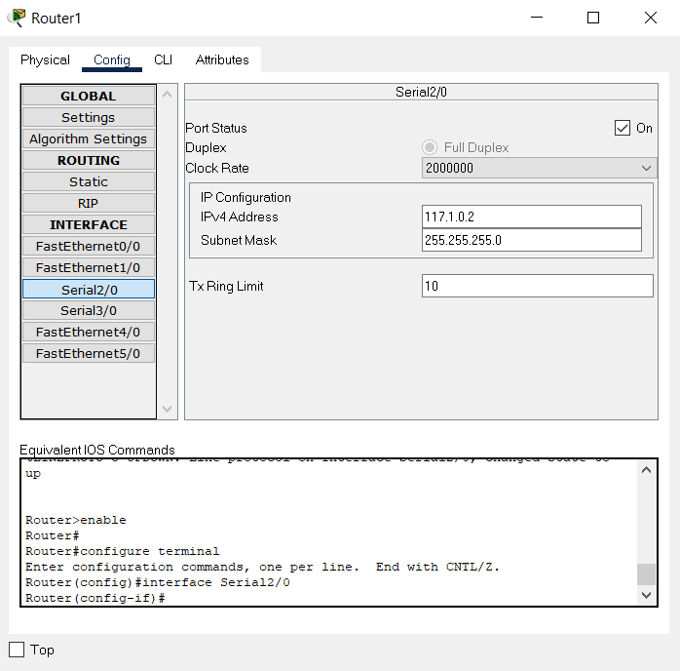

# 

This is a very important step and out whole project is revolved around it which is the ROUTING INFORMATION PROTOCOL (RIP) in short the rip can be defined as:

The one of the oldest [distance-vector routing protocols](https://en.wikipedia.org/wiki/Distance-vector_routing_protocol) which employs the [hop count](https://en.wikipedia.org/wiki/Hopcount) as a [routing metric](https://en.wikipedia.org/wiki/Metrics_(networking)). RIP prevents [routing loops](https://en.wikipedia.org/wiki/Routing_loop_problem) by implementing a limit on the number of [hops](https://en.wikipedia.org/wiki/Hop_(networking)) allowed in a path from source to destination. The largest number of hops allowed for RIP is 15, which limits the size of networks that RIP can support.

**How it works and how did we configure it into our network :**

Using the rip protocol in order to connect different networks together and in order for a pc in different network to communicate with a pc in a whole different network, all we needed to do is to open up the configuration settings in each router and use the rip option , so the rip works in a way where you need to give the router the networks that are connected to it directly and that's it so we go into the rip settings at give the connected network as follows :

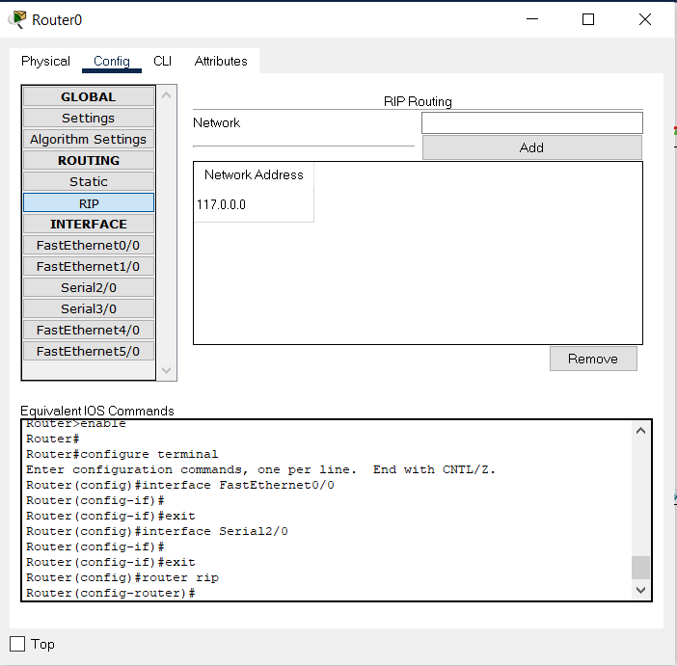

Finally after we did all of the steps on each pc and on each router we can test our network out by going into the cmd that is in a random pc and pinging another pc as follows:

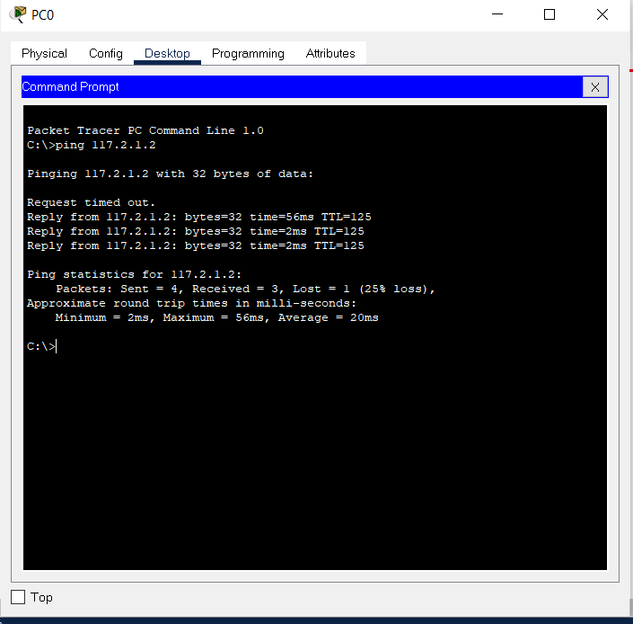

And we can use another way in order to test out our network as follows:

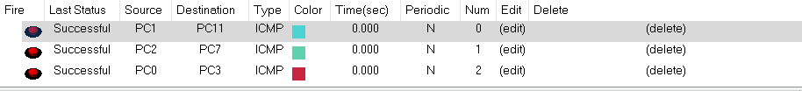

We used pc4 with 117.1.1.2 IP address to ping different PC's in different subnets

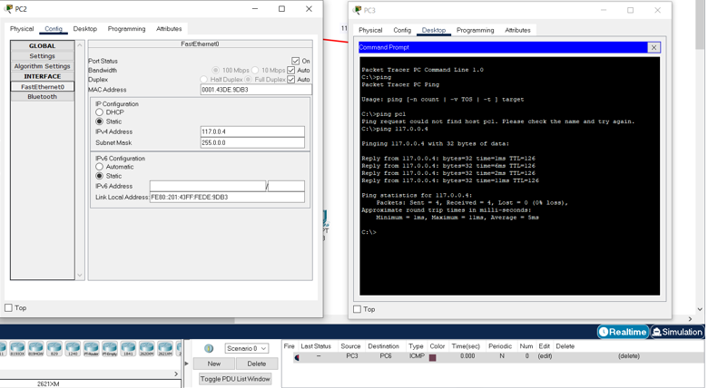

We used pc 6 with 24.146.3.4 IP address to ping different PC's in different subnets

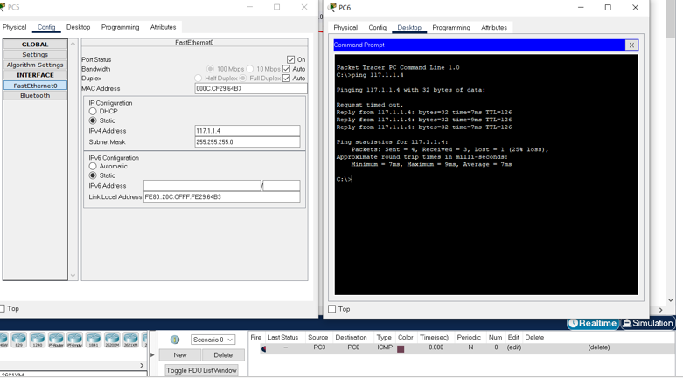

We used pc 9 with 117.3.1.2 IP address to ping different PC's in different subnets.

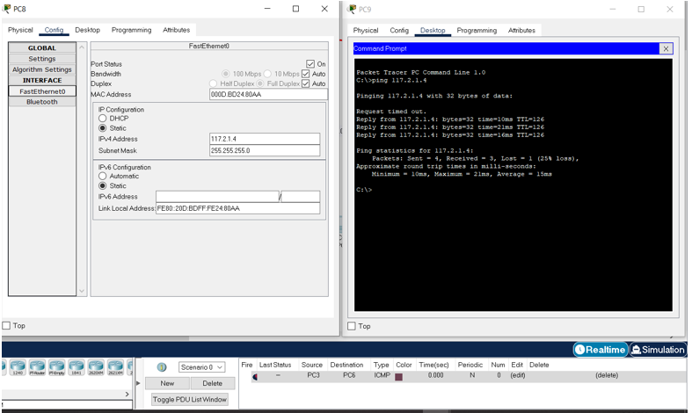

We used pc 11 with 117.4.1.1 IP address to ping different PC's in different subnets.

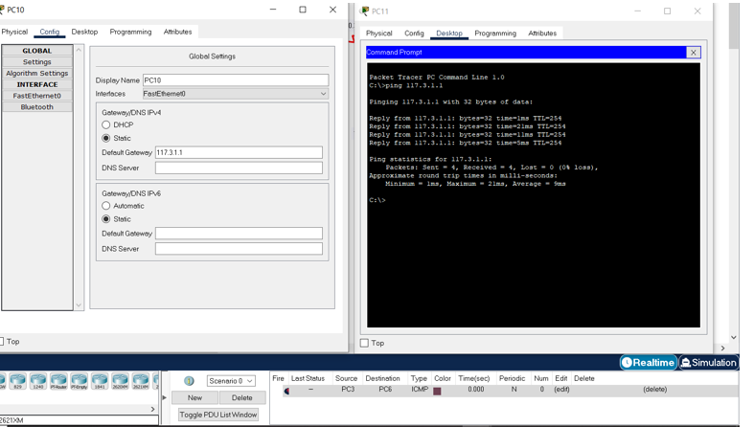

And finally, We used pc 11 with a 117.4.1.1 IP address to ping different PC's in different subnets.

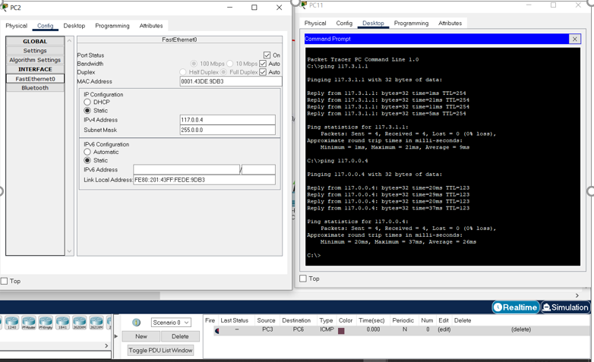

**CONCLUSION:**

In conclusion we can setup a network but we have to create different subnets in order for it to work and configure each pc depending on that network and we also always give the network a zero at the last and the gateway a one and finally we must use some sort of a protocol in order for the routers to communicate with each other successfully.