******COMSATS University Islamabad (Lahore** **Campus)**

**Department of Computer Science**

**Assignment <2>– FALL 2023**

|  |  |  |  |  |  |
| --- | --- | --- | --- | --- | --- |
| Course Title: | Computer Vision | Course Code: | CSC455 | Credit Hours: | 3(3,0) |
| Course Instructor: | Dr. Allah Bux Sargana | Programme Name: | BSCS | |  |
| **Due Date:** | **28-10-2023** | **Due Date** | **5-11-23** | **Marks** | **25** |
| **Important Instructions / Guidelines:**   1. **Zero tolerance for plagiarism:** Plagiarism from any sources, including internet sources and your fellow students (except allowed sources by the instructor), will result in ZERO marks. 2. **Submission requirements:**    1. Word document: this page with code and screenshots of results (Input & output)    2. Source Code (complete project folder)    3. Submit all of the above files in a zip folder    4. All files and folders must be named the same as your registration number 3. **Late submission policy:** deduction @ of 20% of total marks per day 4. **Implementation language:** Python | | | | | |

**Question No 1. Marks: 10+30+10 =50**

***CLO: <2>; Bloom Taxonomy Level: <Applying>***

***Note: Consider the currency recognition problem given in Assignment 1. You are required to develop a Convolution Neural Network (CNN) based solution for the same problem.***

Working on Intelligent Systems to meet real-life needs in this age of technology is a highly significant area of Computer Vision. Specifically, intelligent systems of paper currency recognition are inevitable for modern banking services. Currency Recognition is the process of classifying the banknote to one of the classes it belongs to. Paper currency recognition systems have many applications in many areas, such as Automated Teller Machines (ATMs), Auto-Seller Machines, Money exchange agencies, and other organizations involving financial transactions. Hence, it is very important to have automated currency recognition intelligent systems to carry out successful financial transactions. In this assignment, you are required to develop a simple yet functional currency recognition system for Pakistani banknotes. Pakistani currency consists of seven classes: PKR 500, 1000, and 5000 banknotes. Your system is expected to recognize the type of a given banknote. In this regard, consider the following steps for developing the system.

1. **User Interface:**

Build a graphical user interface (GUI) where you can input the query image and display the matching image and its class. If you use a simple interface rather than a GUI, you will get only 4/10 marks.

1. **Development of Currency Recognition System:**

Design and develop a convolution neural network for currency recognition. Please note that credit for this section highly depends on the performance of the developed model.

1. **Dataset:**  
   In Assignment 1, you were given the currency images dataset for experiments. In this assignment, you are required to increase the dataset size by applying augmentation techniques and capturing currency images with your mobile cameras. At least you should add 150 images of currency, including all three classes in equal numbers, and apply four types of augmentation to existing and newly added images.

**Project Working:**

1. Python
2. CNN using TensorFlow
3. GUI using FLASK and HTML

* Total 391 Images in Dataset after adding some custom Images. Resized all the images to (180, 180, 3) and Train the CNN model.
* After training the Model, save its working and Weight, Bais in CurrencyNote.H5 file.

Here the Input and Output Screenshots:

**Input:**

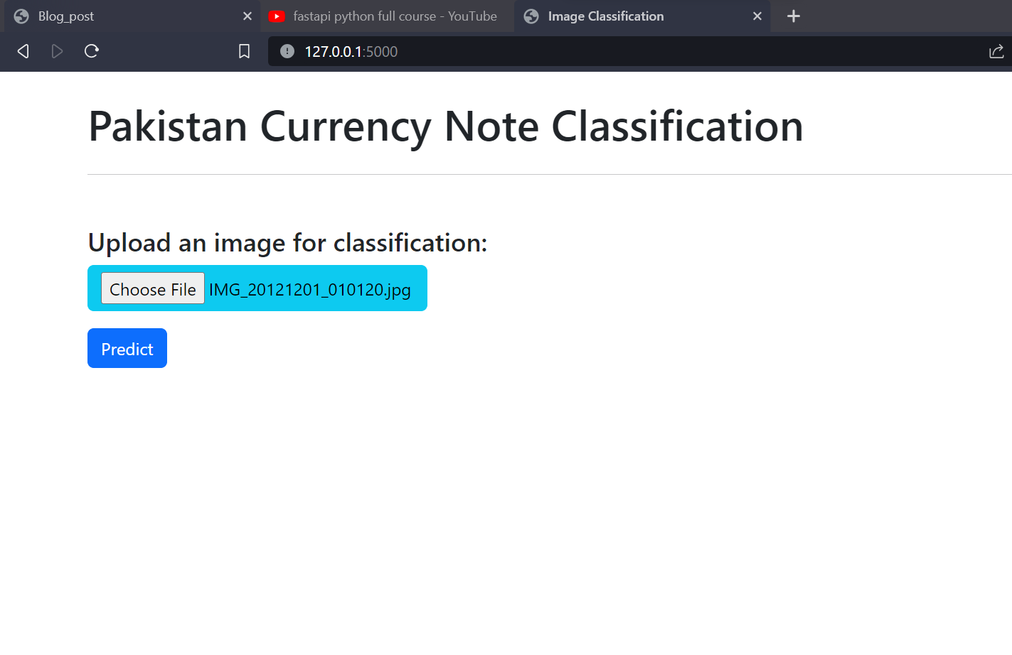

**Output:**

