******COMSATS University Islamabad (Lahore** **Campus)**

**Department of Computer Science**

**Assignment <3>– FALL 2023**

|  |  |  |  |  |  |
| --- | --- | --- | --- | --- | --- |
| Course Title: | Computer Vision | Course Code: | CSC455 | Credit Hours: | 3(3,0) |
| Course Instructor: | Dr. Allah Bux Sargana | Program Name: | BSCS | |  |
| **Due Date:** | **23-11-2023** | **Due Date** | **3-12-23** | **Marks** | **50** |
| **Important Instructions / Guidelines:**   1. **Zero tolerance for plagiarism:** Plagiarism from any sources, including internet sources and your fellow students (except allowed sources by the instructor), will result in ZERO marks. 2. **Submission requirements:**    1. Word document: this page with code and screenshots of results (Input & output)    2. Source Code (complete project folder)    3. Submit all of the above files in a zip folder    4. All files and folders must be named the same as your registration number 3. **Late submission policy:** deduction @ of 20% of total marks per day 4. **Implementation language:** Python | | | | | |

**Question No 1. Marks: 50**

***CLO: <4>; Bloom Taxonomy Level: <Analyzing>***

**In continuation of Assignment 2, delve into the currency recognition problem. Employ the Scale-Invariant Feature Transform (SIFT) and Histogram of Oriented Gradients (HOG) algorithms for robust feature extraction and representation. Subsequently, apply SVM and KNN for efficient classification of banknotes. Analyze and compare the results obtained through these feature descriptors and classifiers.**

Working on Intelligent Systems to meet real-life needs in this age of technology is a highly significant area of Computer Vision. Specifically, intelligent systems of paper currency recognition are inevitable for modern banking services. Currency Recognition is the process of classifying the banknote to one of the classes to which it belongs. Paper currency recognition systems have many applications in many areas, such as Automated Teller Machines (ATMs), Auto-Seller Machines, Money exchange agencies, and other organizations involving financial transactions. Hence, it is essential to have automated currency recognition intelligent systems to carry out successful financial transactions. In this assignment, you are required to develop a simple yet functional currency recognition system for Pakistani banknotes. Pakistani currency consists of seven classes: PKR 500, 1000, and 5000 banknotes. Your system is expected to recognize the type of banknote given. In this regard, consider the following steps for developing the system.

1. **User Interface:**

Build a graphical user interface (GUI) where you can input the query image and display the matching image and its class.

1. **Dataset:**  
   Use the same dataset that you developed in Assignment 2.

**Project Working:**

1. Python
2. **SIFT** using Scikit-Learn and **HOG** using scikit-Image.
3. Apply the Classifier models on extracted features, **KNN** and **SVM** used.
4. GUI using FLASK and HTML

* Total 391 Images in Dataset after adding some custom Images. Resized all the images to (100, 100, 3).
* Then Extracted Features using SIFT and HOG.
* After that, I combined both extracted features and prepared the training and testing data.
* Labels of classes are my target data.
* I trained two classification model KNN and SVM, on training data.
* After training the Model, saved the model in PK1 file format using joblib.

**Accuracy of Models:**

**KNN** : 0.69 🡺 69%

**SVM**: 0.56 🡺 56 %

Note: But results are much better for **SVM** as compare to **KNN.**

**Application GUI:**

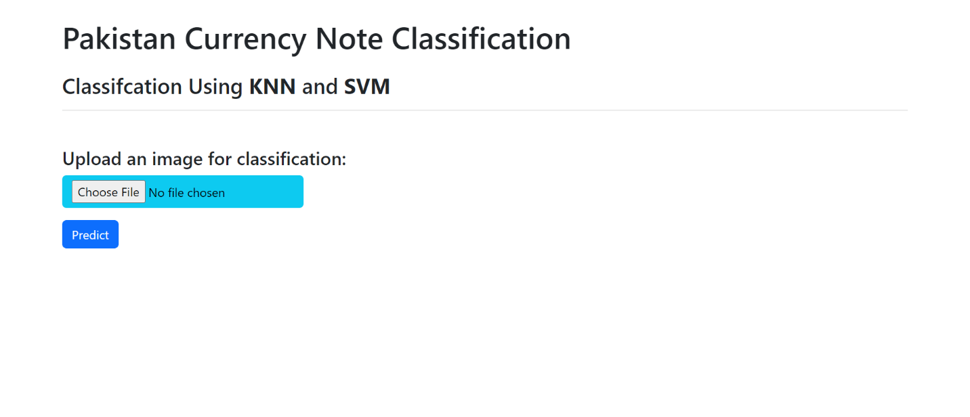

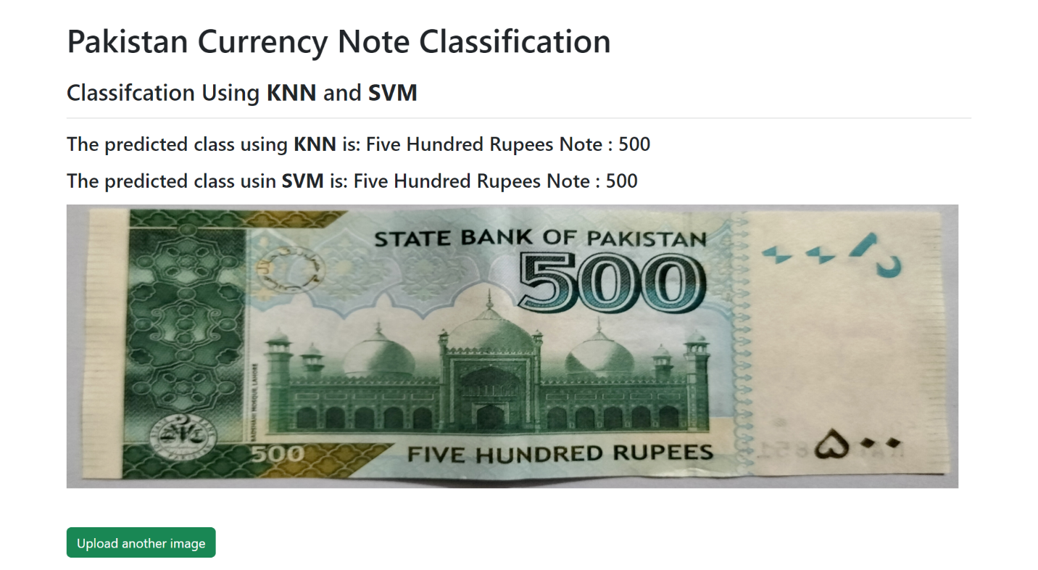

**Another Example**

Showing **SVM** predicts Right and **KNN** as showing 1000 on 5000 image predicts wrong.

