Data file will be empty as I excluded the models because it’s too big

But you can find the trained model

Steps to run the project

1. Extract sub_xgb_new.rar to get the trained model Under genifytask folder open searchmodel.py file and update line 12 with the path of the trained model on your machine
2. Type python manage.py runserver to run the project and test the api
3. To run the training script open trainingscript.py and update line 203 with the path of the data file on your machine type python trainingscript.py

Here you can find three different query response pairs

1. When the client code found in the trained model

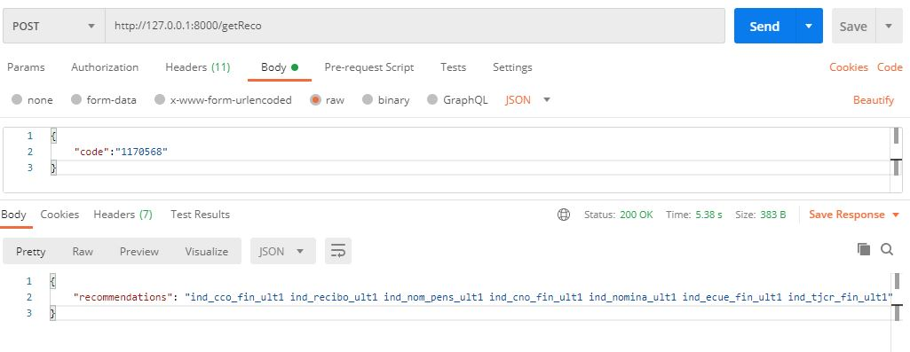

1. If the json ‘code’ not found in the body of the request will return bad request 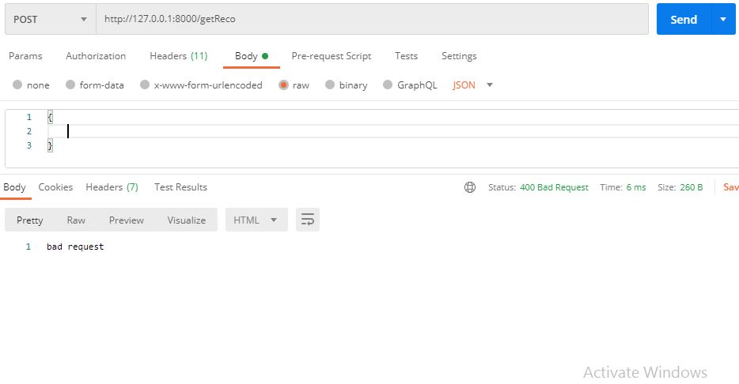
2. If the code not found in the trained model the request wil return not found 