Creation and save/load Functionality:
Save / Load:
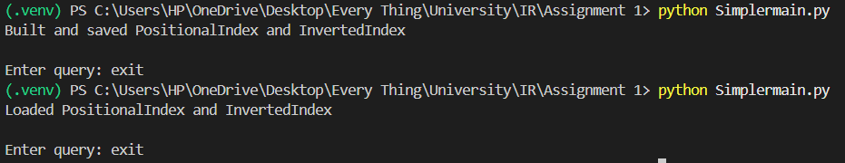
Inverted Index:
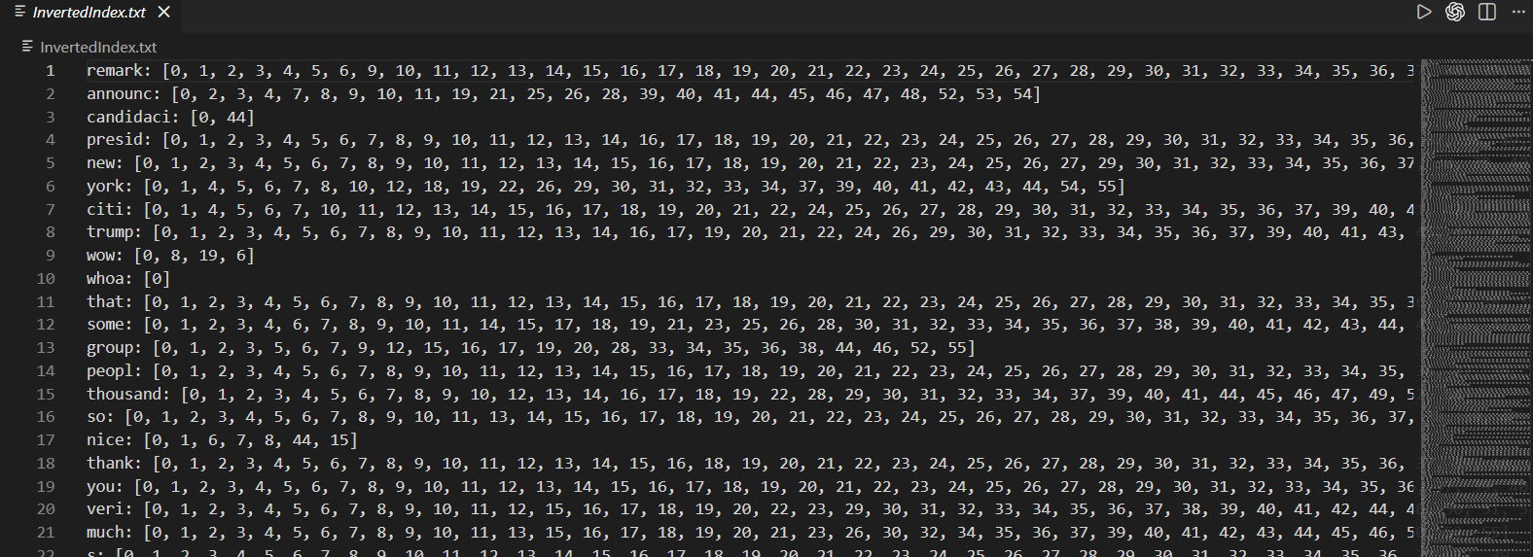
Positional Index:
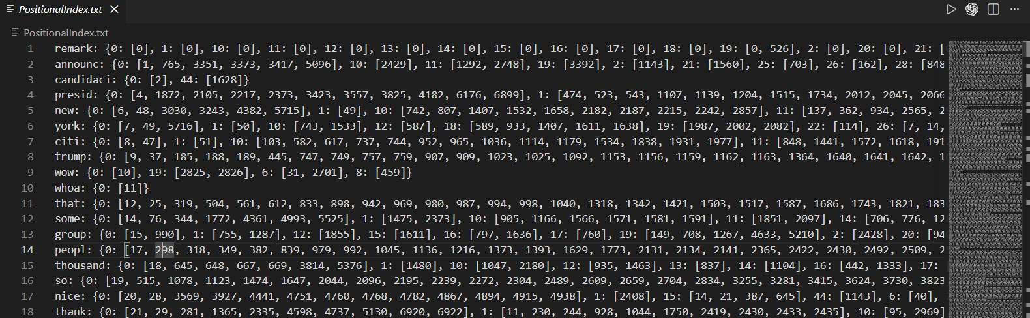

Result copied from CLI for checking:
[PASS] Test 1: running
Got : [0, 1, 2, 3, 4, 5, 6, 8, 9, 10, 11, 12, 16, 17, 18, 19, 20, 21, 22, 24, 25, 26, 27, 28, 30, 32, 33, 34, 35, 36, 37, 39, 40, 41, 44, 45, 46, 47, 50, 51, 52, 53]

[PASS] Test 2: not hammer
Got : [0, 1, 2, 3, 4, 5, 6, 7, 8, 9, 10, 11, 12, 13, 14, 15, 22, 23, 26, 28, 29, 30, 31, 32, 37, 38, 41, 44, 47, 48, 52, 55]

[PASS] Test 3: actions AND wanted
Got : [0, 1, 2, 3, 5, 7, 9, 12, 15, 16, 17, 19, 24, 26, 28, 29, 31, 37, 39, 40, 41, 42, 51, 53, 54]

[PASS] Test 4: united OR plane
Got : [0, 1, 2, 3, 4, 5, 6, 7, 8, 9, 10, 11, 12, 13, 16, 17, 18, 19, 20, 21, 22, 24, 25, 26, 27, 28, 29, 30, 31, 32, 33, 34, 35, 36, 37, 38, 39, 40, 41, 43, 44, 45, 46, 47, 48, 49, 50, 51, 52, 54, 55]

[PASS] Test 5: pakistan OR afghanistan OR aid
Got : [1, 3, 4, 9, 16, 17, 18, 22, 29, 37, 39, 40, 41, 42]

[FAIL] Test 6: biggest AND ( near OR box )
Expected: [4, 6, 18, 43, 44, 45, 46, 47, 50, 51, 53, 54]
Got : [2, 4, 6, 7, 16, 18, 26, 30, 35, 36, 39, 40, 41, 43, 44, 45, 46, 47, 48, 49, 50, 51, 52, 53, 54]
Extra : [2, 7, 16, 26, 30, 35, 36, 39, 40, 41, 48, 49, 52]

[PASS] Test 7: box AND ( united OR year )
Got : [4, 9, 18, 23, 25, 44, 45, 46, 47, 50, 54]

[PASS] Test 8: biggest AND ( plane OR wanted OR hour)
Got : [0, 1, 2, 4, 6, 7, 8, 16, 18, 19, 26, 30, 35, 36, 37, 39, 40, 41, 42, 43, 44, 45, 46, 47, 48, 49, 50, 51, 52, 53, 54]

[PASS] Test 9: NOT (united_set AND plane_set)
Got : [3, 4, 5, 6, 7, 8, 9, 10, 11, 12, 13, 14, 15, 16, 18, 20, 21, 22, 23, 28, 31, 37, 38, 39, 40, 41, 42, 43, 44, 45, 46, 47, 48, 49, 50, 51, 53, 54, 55]

[FAIL] Test 10: Hillary Clinton
Expected: [1, 2, 3, 4, 5, 6, 7, 8, 9, 10, 11, 12, 14, 16, 17, 18, 19, 20, 21, 22, 24, 25, 26, 27, 28, 29, 30, 31, 32, 33, 34, 35, 36, 37, 39, 40, 41, 42, 43, 44, 45, 46, 47, 48, 49, 50, 51, 52, 53, 54]
Got : [1, 2, 3, 4, 5, 6, 7, 8, 9, 10, 11, 12, 14, 16, 17, 18, 19, 20, 21, 22, 24, 25, 26, 27, 28, 29, 30, 31, 32, 33, 34, 35, 36, 37, 38, 39, 40, 41, 42, 43, 44, 45, 46, 47, 48, 49, 50, 51, 52, 53, 54]
Extra : [38]

[PASS] Test 11: after years /1
Got : [6, 7, 44]

[PASS] Test 12: develop solutions /1
Got : [5, 32]

[PASS] Test 13: keep out /2
Got : [20, 24, 39, 40, 51]

Command Line interface:
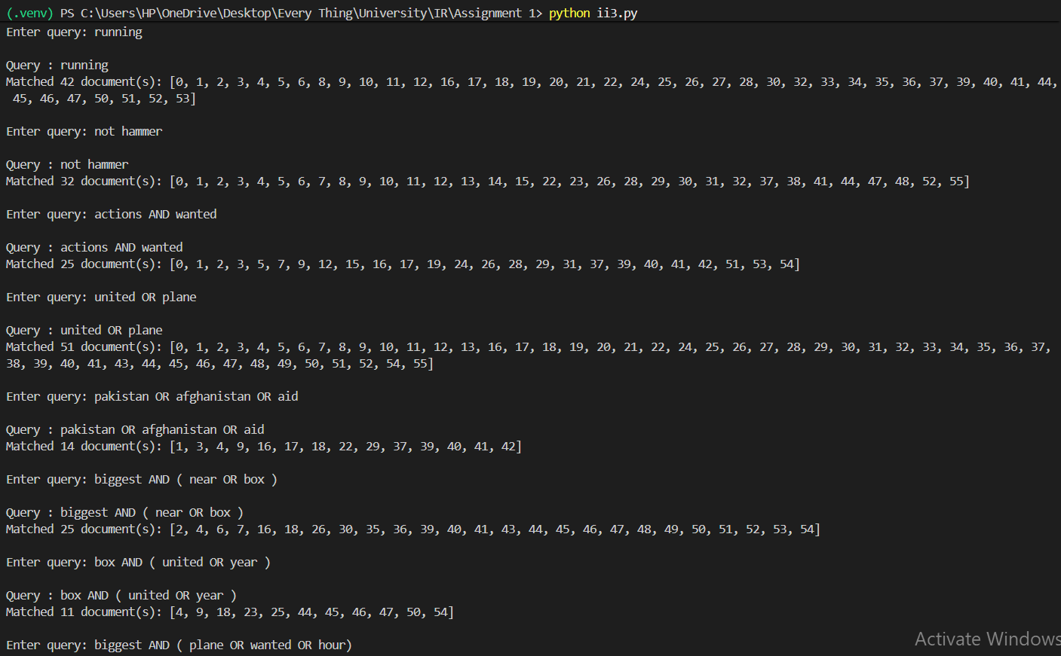
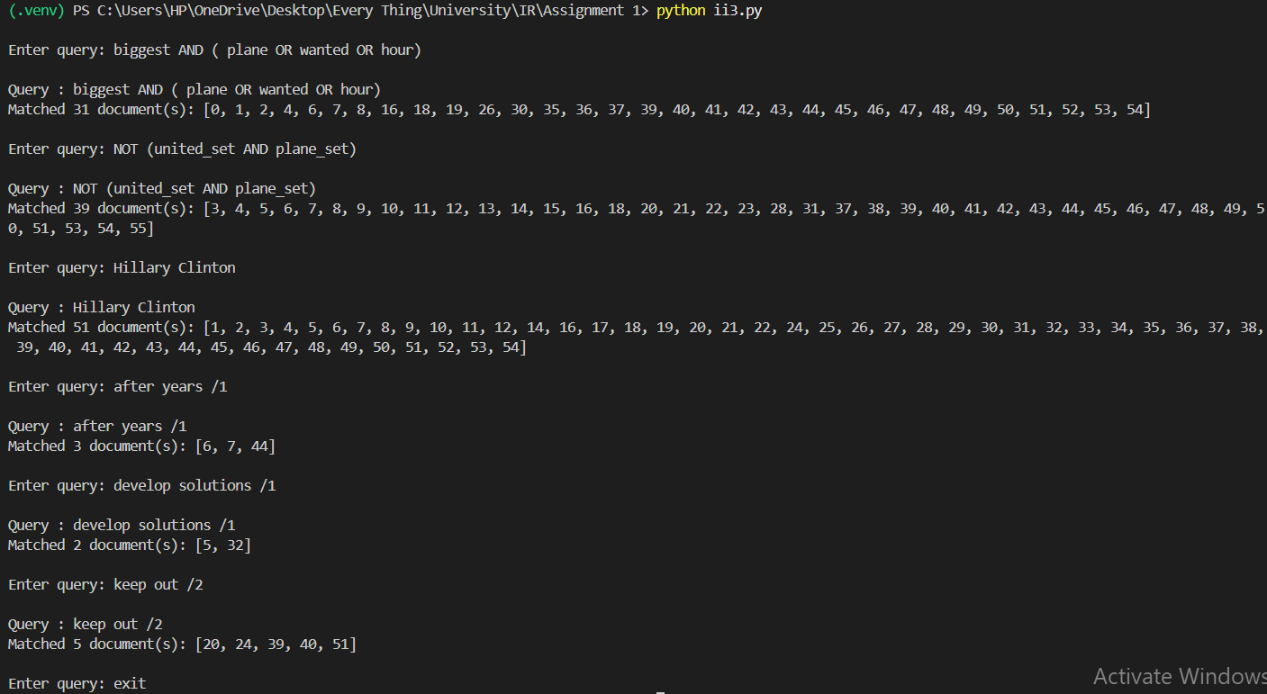

Script to compare result from queries.txt:
Note:
- Test 6 & 10 is supposed to be passed as when manually checked files do contain words that satisfy the condition (proof at end).
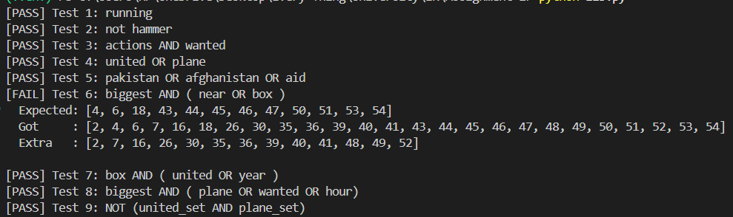
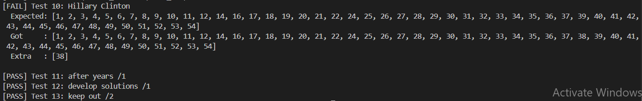
Final Result:
Look:
Note: Text is picture is looking much smaller than actual size on website
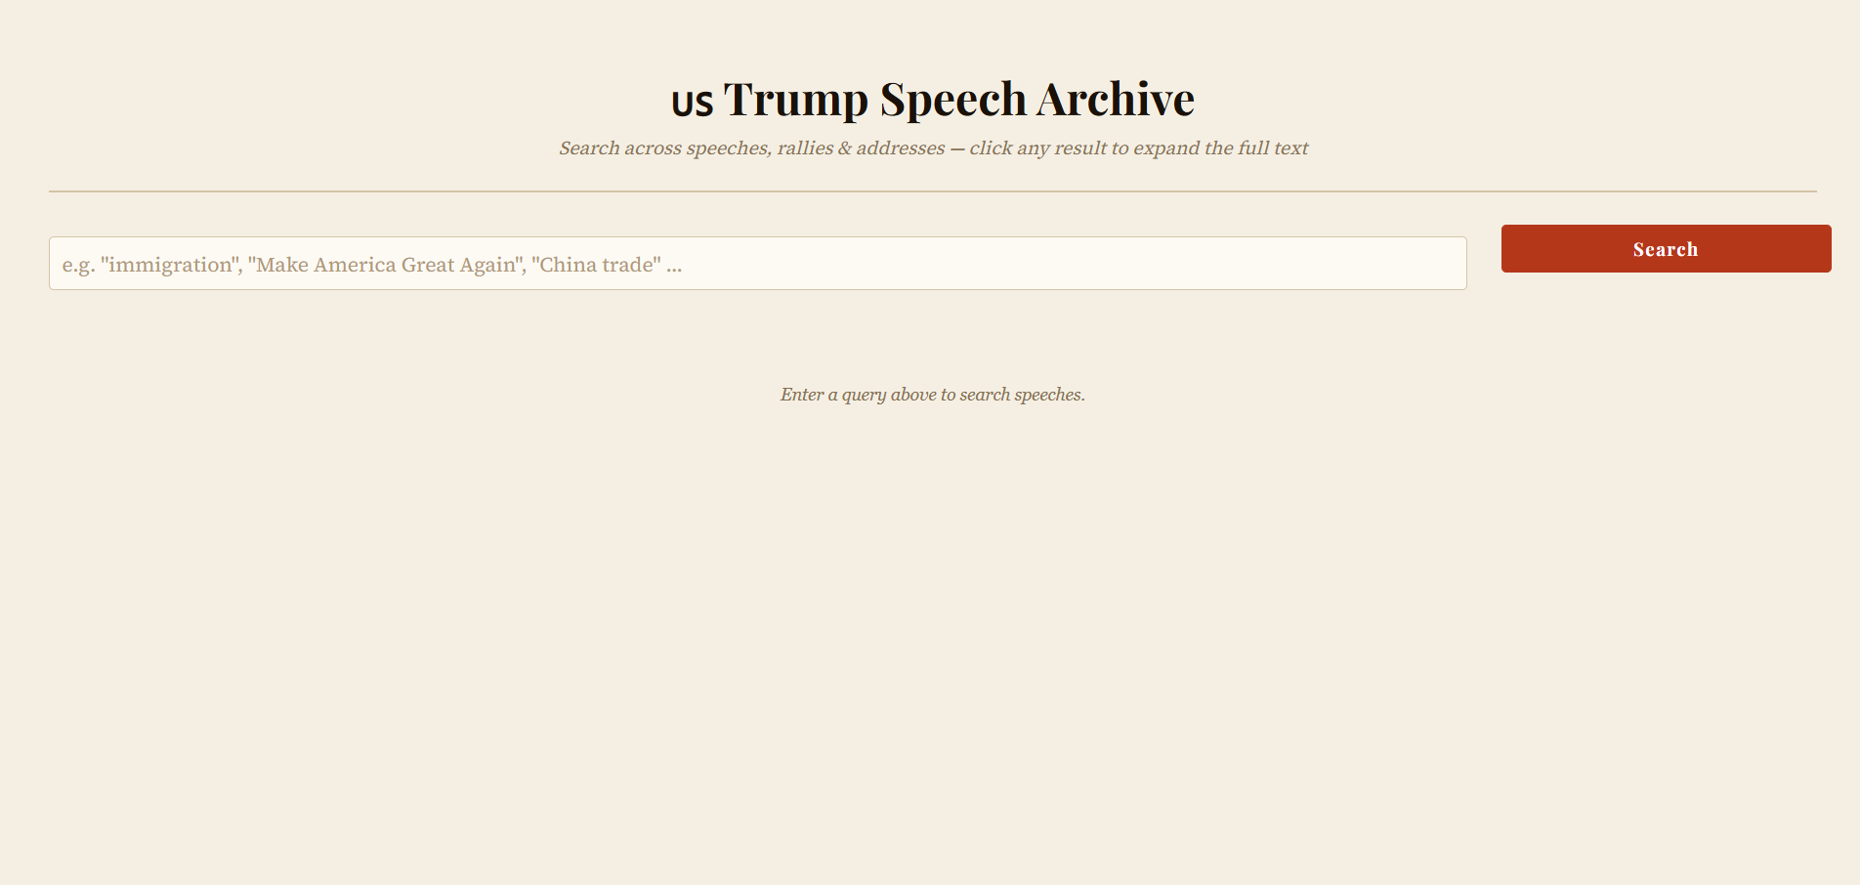
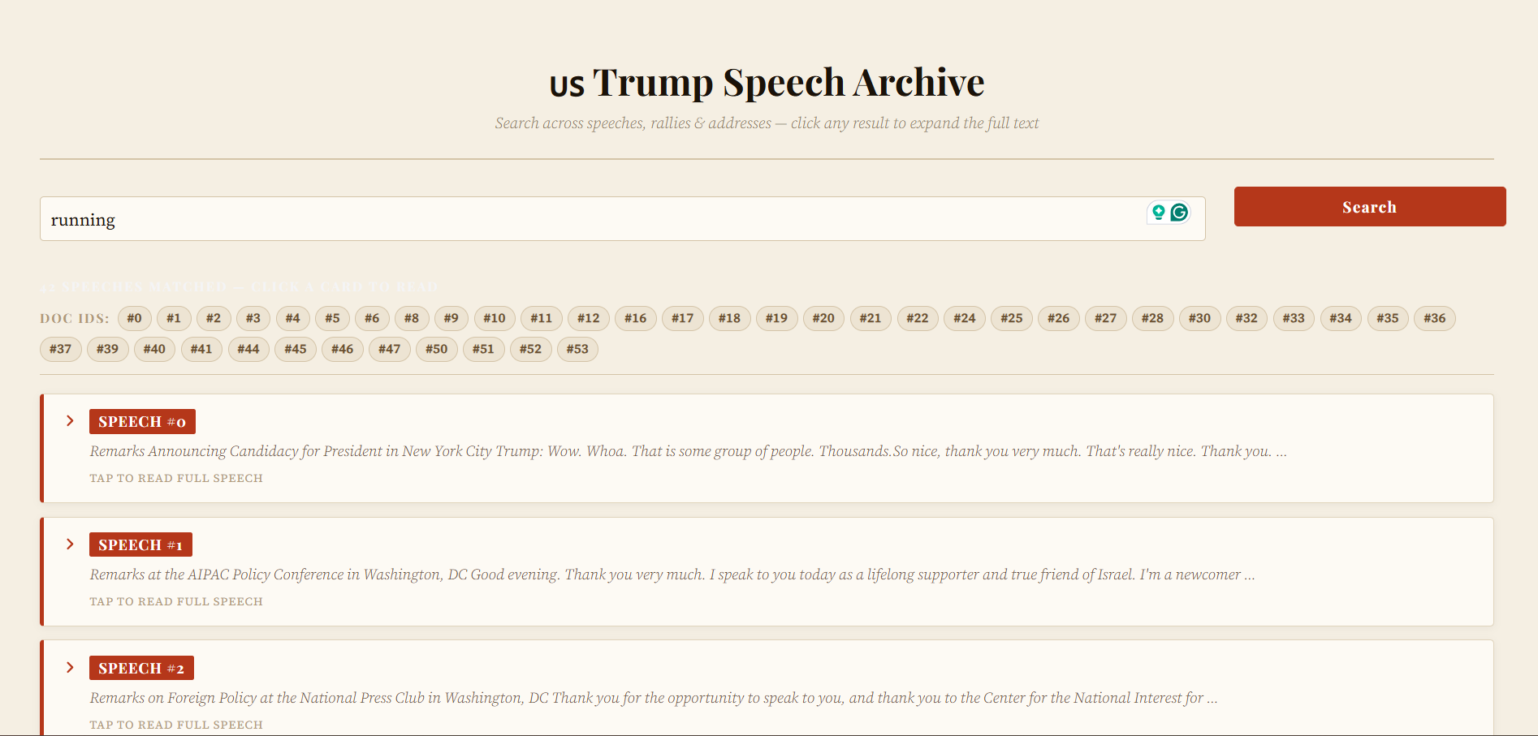
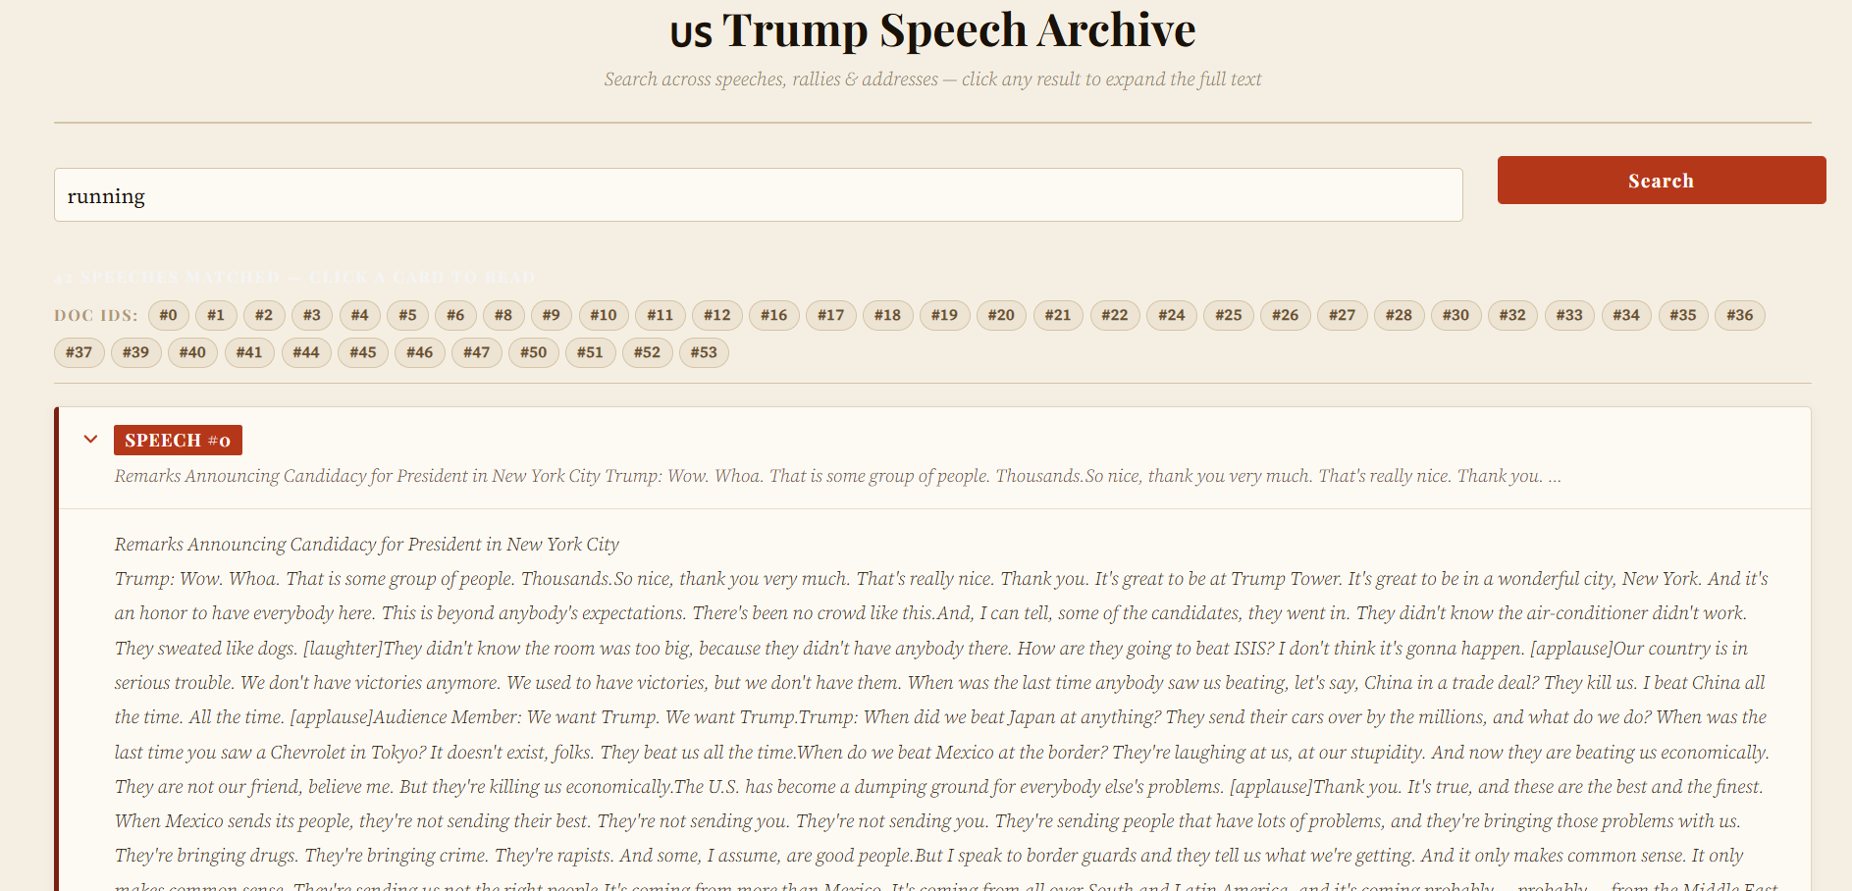
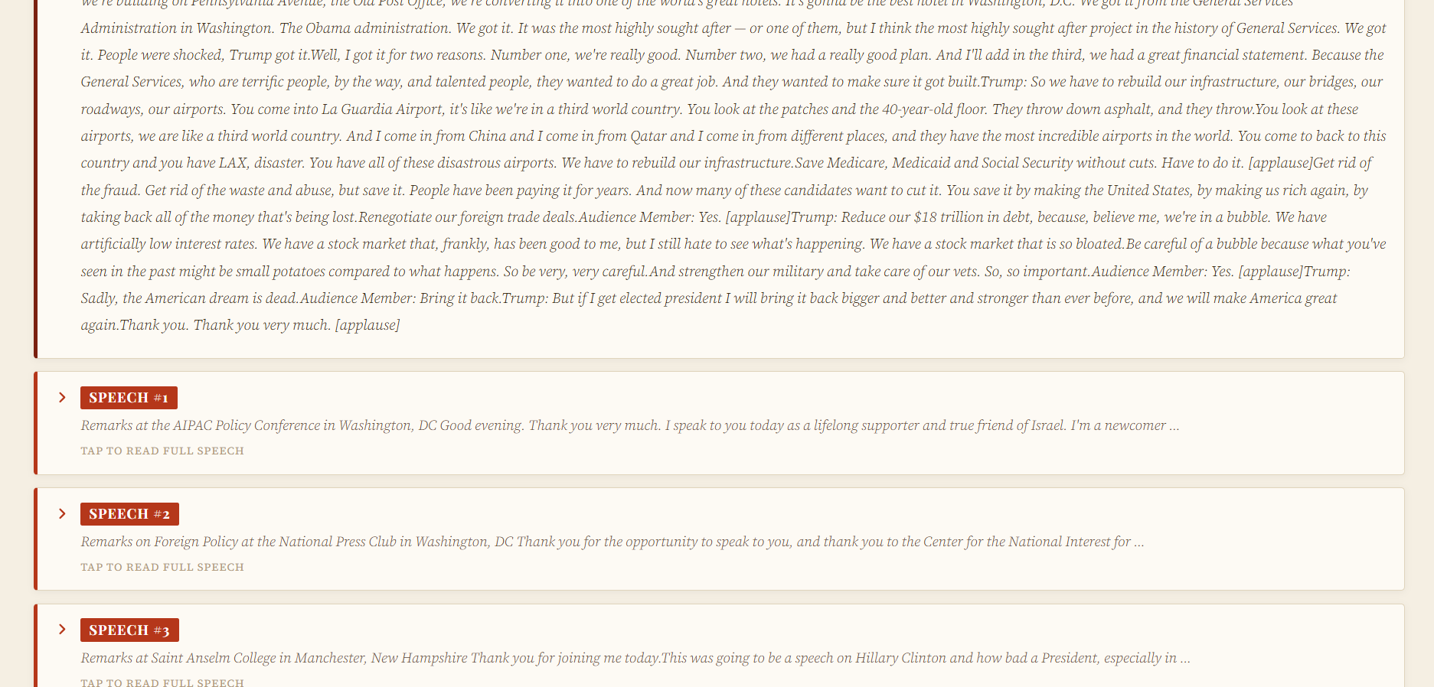

Query: running
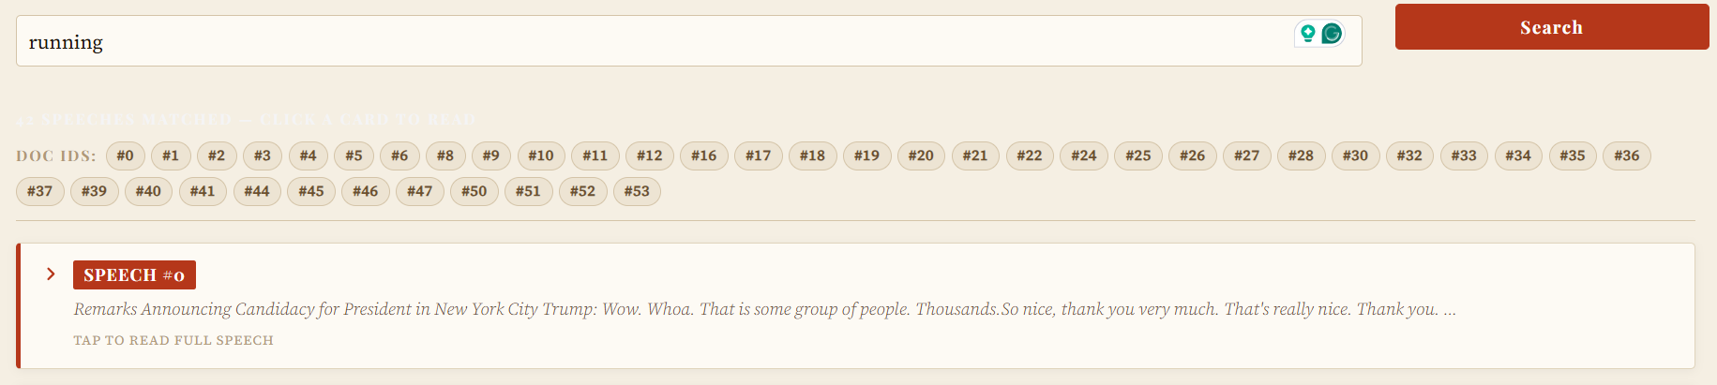
Query: not hammer
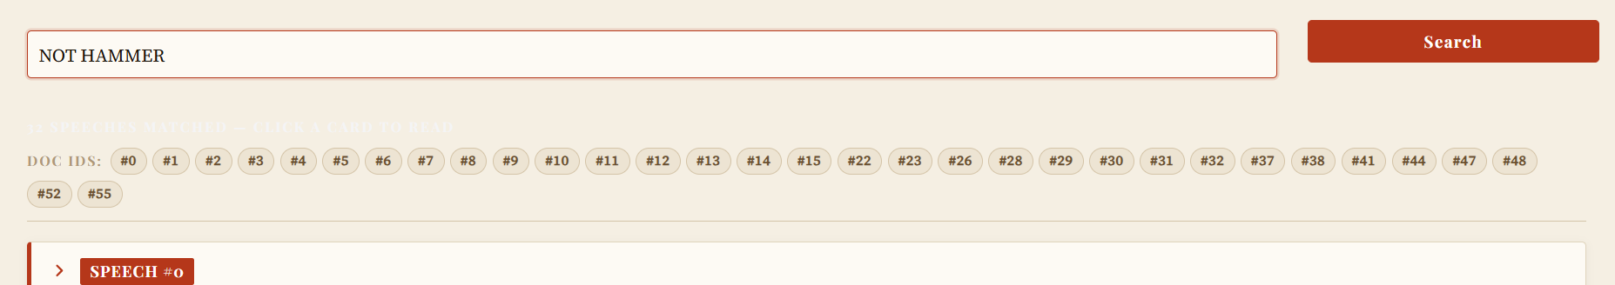
Query: actions AND wanted
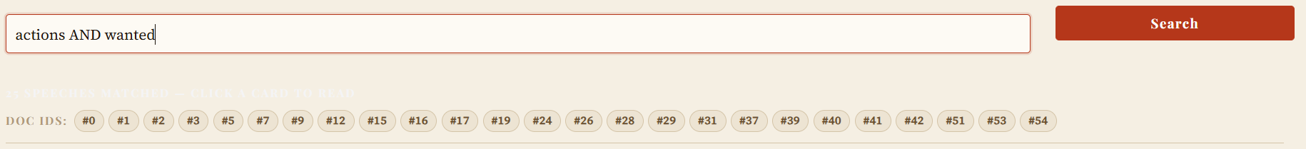
Query: united OR plane
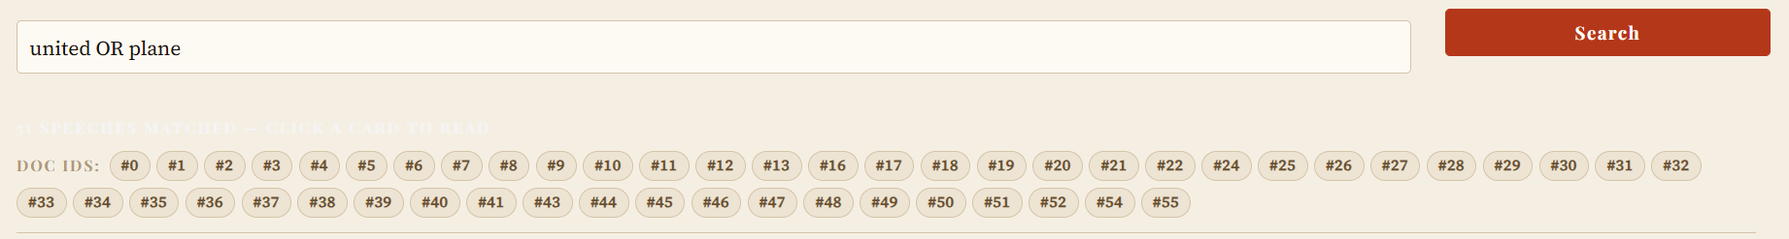

Query: pakistan OR afghanistan OR aid

Query: biggest AND ( near OR box )
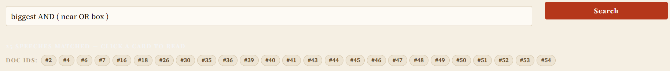

Query: box AND ( united OR year )
Query: biggest AND ( plane OR wanted OR hour)
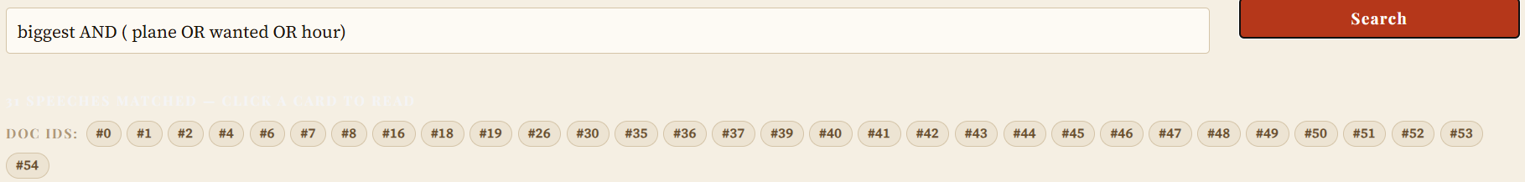Query: NOT (united_set AND plane_set)
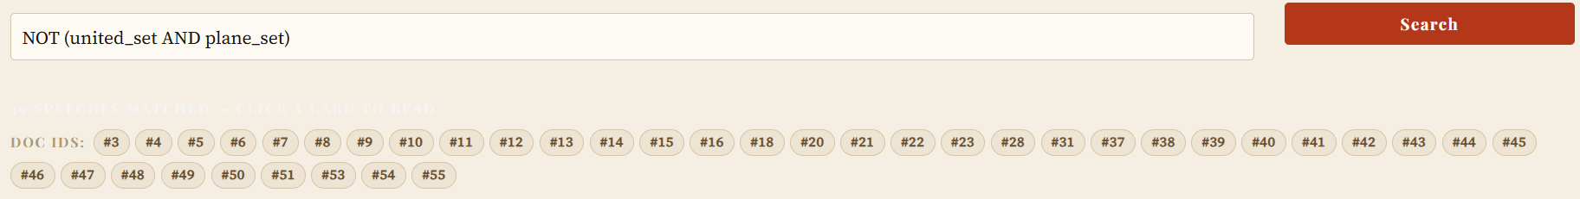
Query: Hillary Clinton
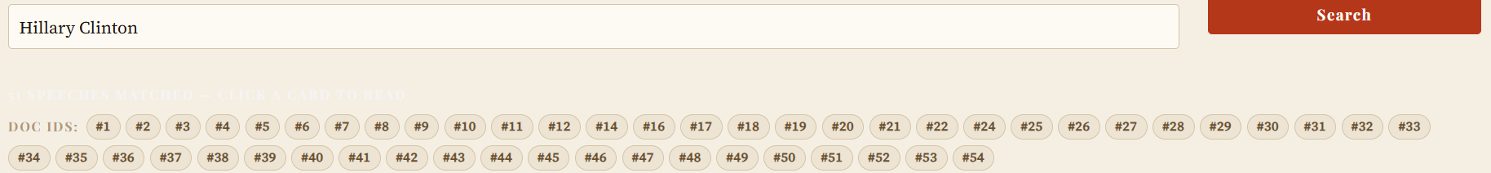
Query: after years /1
Query: develop solutions /1
Query: keep out /2

Proof of Errors:
In speech 38 “Hillary Clinton’s” exists yet the expected outcome in queries.txt file doesn’t have 38 in it.
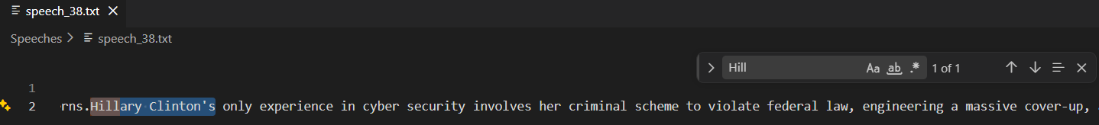

In Test 6, the extra doc ids (there were not in expected doc ids given in queries.txt ) retrieved are Extra : [2, 7, 16, 26, 30, 35, 36, 39, 40, 41, 48, 49, 52].
If we manually check speech 2 for query: biggest AND ( near OR box )
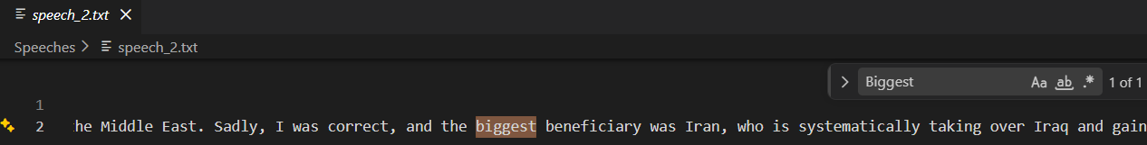
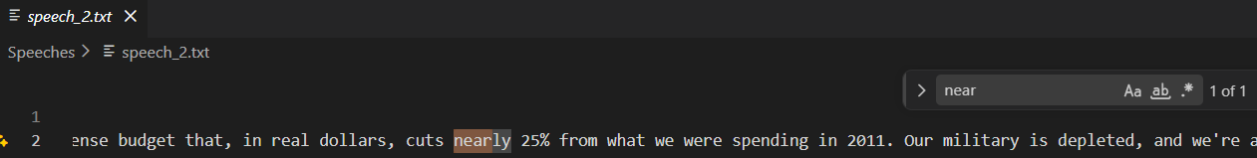
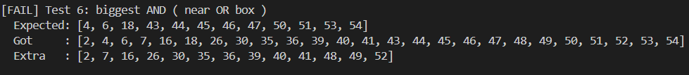
Biggest and near both exists in speech 2 so doc id 2 should be part of expected outcomes.

