Cairo University  
Faculty of Computers and Artificial Intelligent

**CS251**

**Software Engineering I**

**(Parking Garage application)**

Software Design

|  |  |  |  |
| --- | --- | --- | --- |
| **ID** | **Name** | **Email** | **Mobile** |
| **20200428** | **Mohamed Ashraf Ahmed** | **muhamedashref2002@gmail.com** | **01155043953** |
| **20200156** | **Hassan Mohamed Nafed** | **hassan20nafed@gmail.com** | **01126287900** |
| **20200655** | **Yousef Sherif Mohamed** | **yousefsherif979@gmail.com** | **01122661587** |
| **20200540** | **Mostafa Shaban Abd El Rasoul** | **mostfashaban.soudy@gmail.com** | **01097142871** |

**May 2022**

Contents

Team 3

Document Purpose and Audience 3

System Models 3

I. Class diagrams 3

Important Algorithm 4

II. Sequence diagrams 5

Class - Sequence Usage Table 6

Ownership Report 6

|  |  |  |  |
| --- | --- | --- | --- |
| **ID** | **Name** | **Email** | **Mobile** |
| **20200428** | **Mohamed Ashraf Ahmed** | **muhamedashref2002@gmail.com** | **01155043953** |
| **20200156** | **Hassan Mohamed Nafed** | **hassan20nafed@gmail.com** | **01126287900** |
| **20200655** | **Yousef Sherif Mohamed** | **yousefsherif979@gmail.com** | **01122661587** |
| **20200540** | **Mostafa Shaban Abd El Rasoul** | **mostfashaban.soudy@gmail.com** | **01097142871** |

# Document Purpose and Audience

1. This document includes Software Design Specifications for the Parking Garage application.
2. This document includes Parking Garage application has a Software that helps the driver to Park his vehicle in suitable slot in the garage.
3. It is specially meant for developers that will work on the project in order to be organized.

* This is a Parking application system.
* The main target of audience we focus on are the drivers or vehicle owner and garage owner.

# 

# System Models

## I. Class diagrams

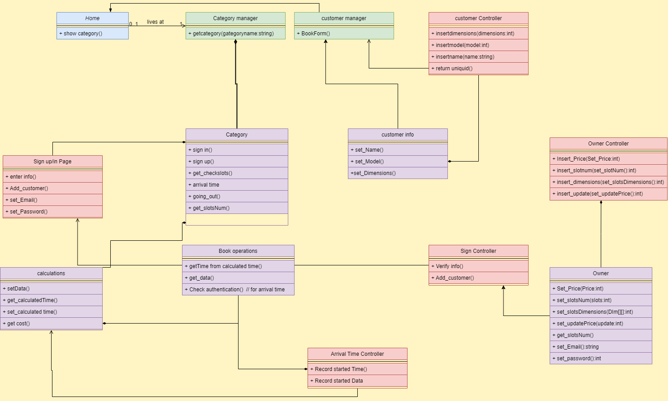

## Classes description

| **Class ID** | **Class Name** | **Description & Responsibility** |
| --- | --- | --- |
| 1 | Home | Show category of application. |
| 2 | Category Manager | Get category item. |
| 3 | Category | Category have all attributes that user need. |
| 4 | Customer manager | Contact with customer information class. |
| 5 | Customer information | Have all information that customer should to set. |
| 6 | Customer controller | Save customer data and return unique ID. |
| 7 | Sign up and sign in page | Responsible for getting access information. |
| 8 | Sign controller | Save data of access customer and adding new customer. |
| 9 | Calculation | Set date of time and calculate total time and return total cost. |
| 10 | Book operation | Get time from arrival time controller and calculate the first time and end time. |
| 11 | Arrival time controller | Record start time and date. |
| 12 | Owner | Set slots number, dimensions, price and update price. |
| 13 | Owner controller | Saving all info getting from owner class. |

## II. Sequence diagrams

Check empty slots.

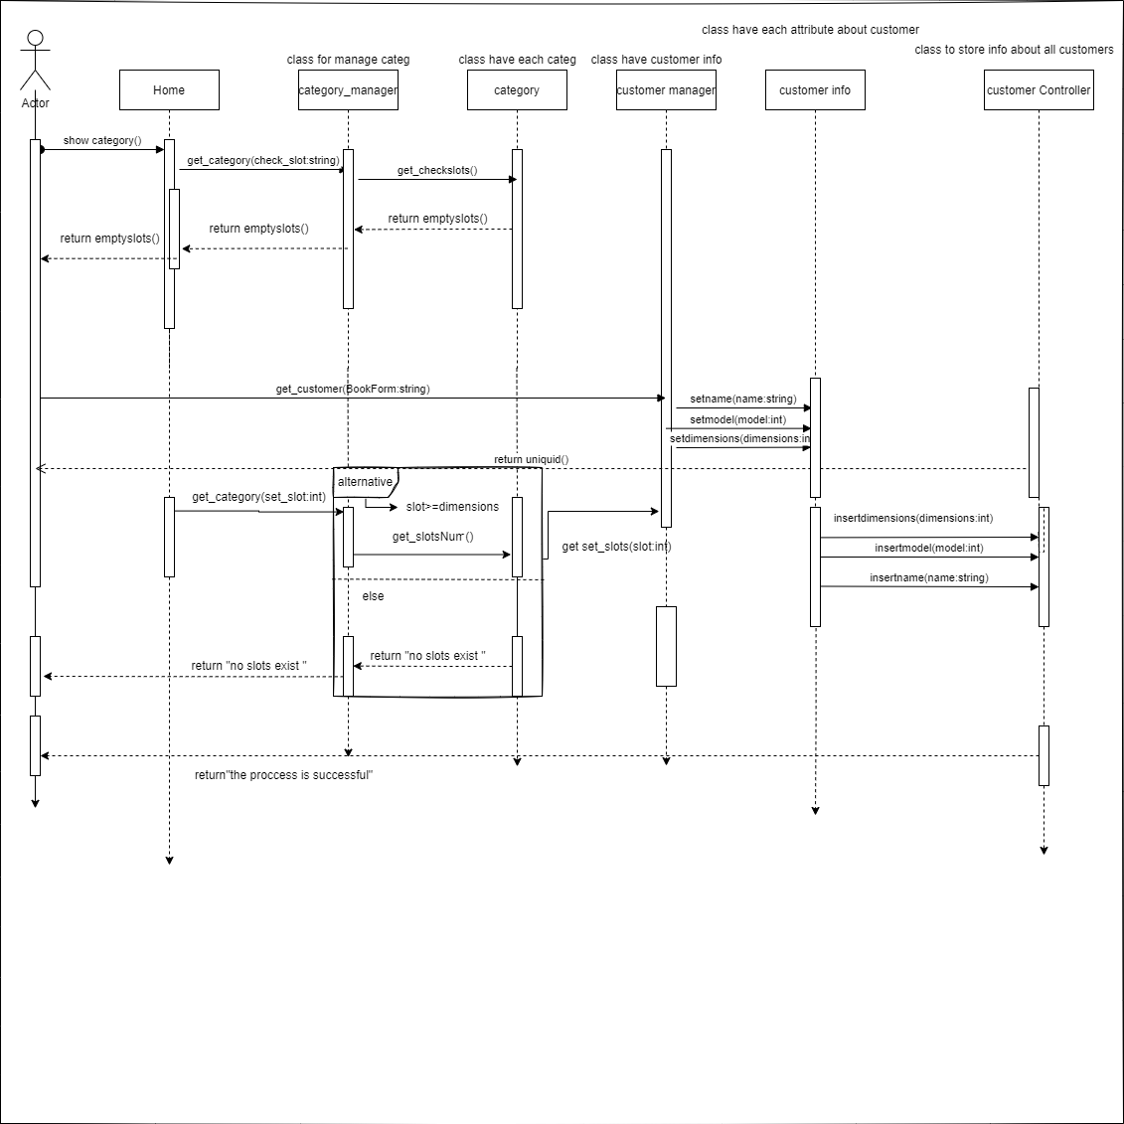

Sign up

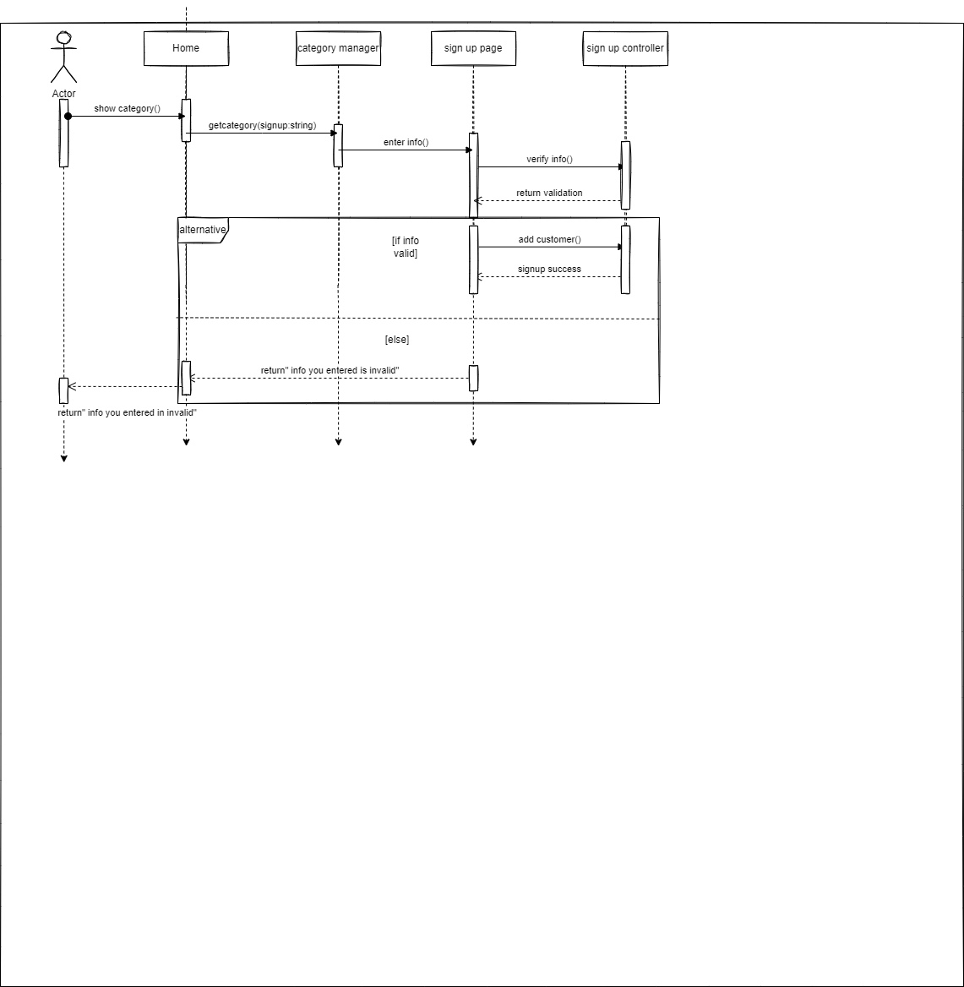

Going out and departure time

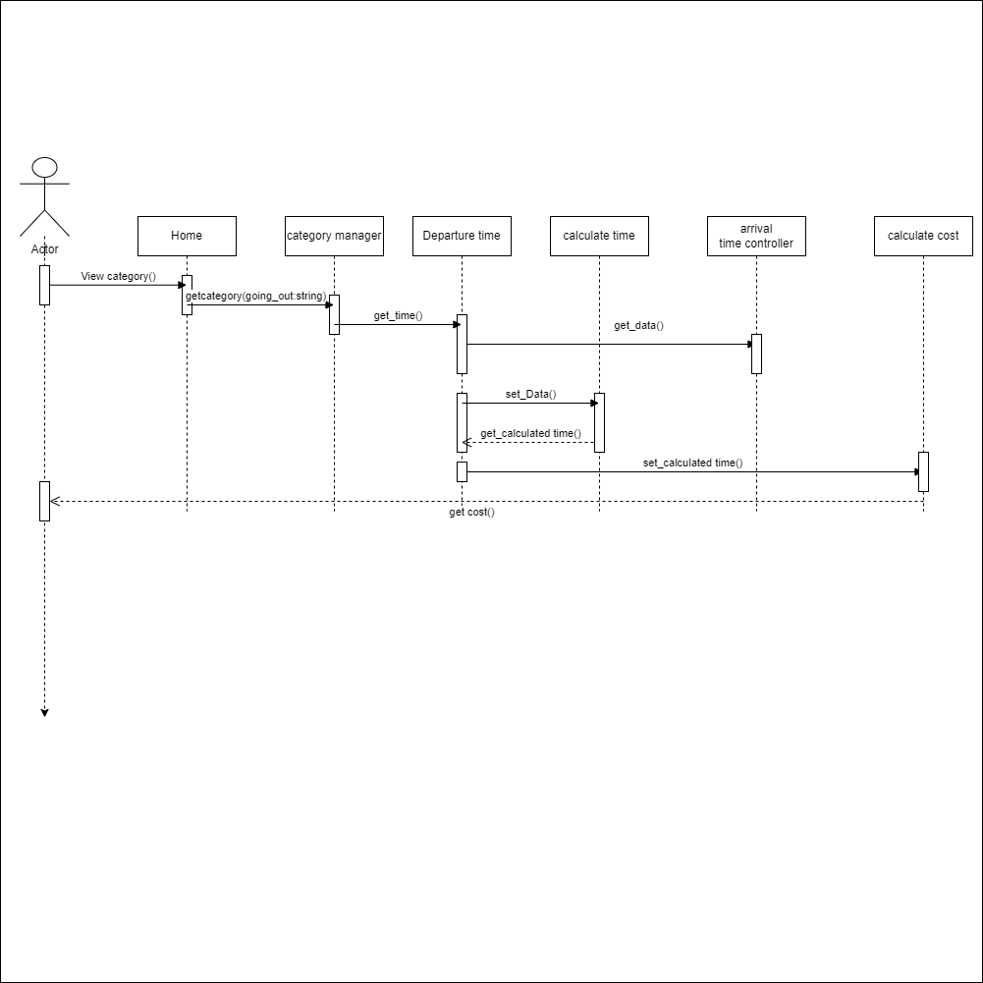

Uptade price and set slots data

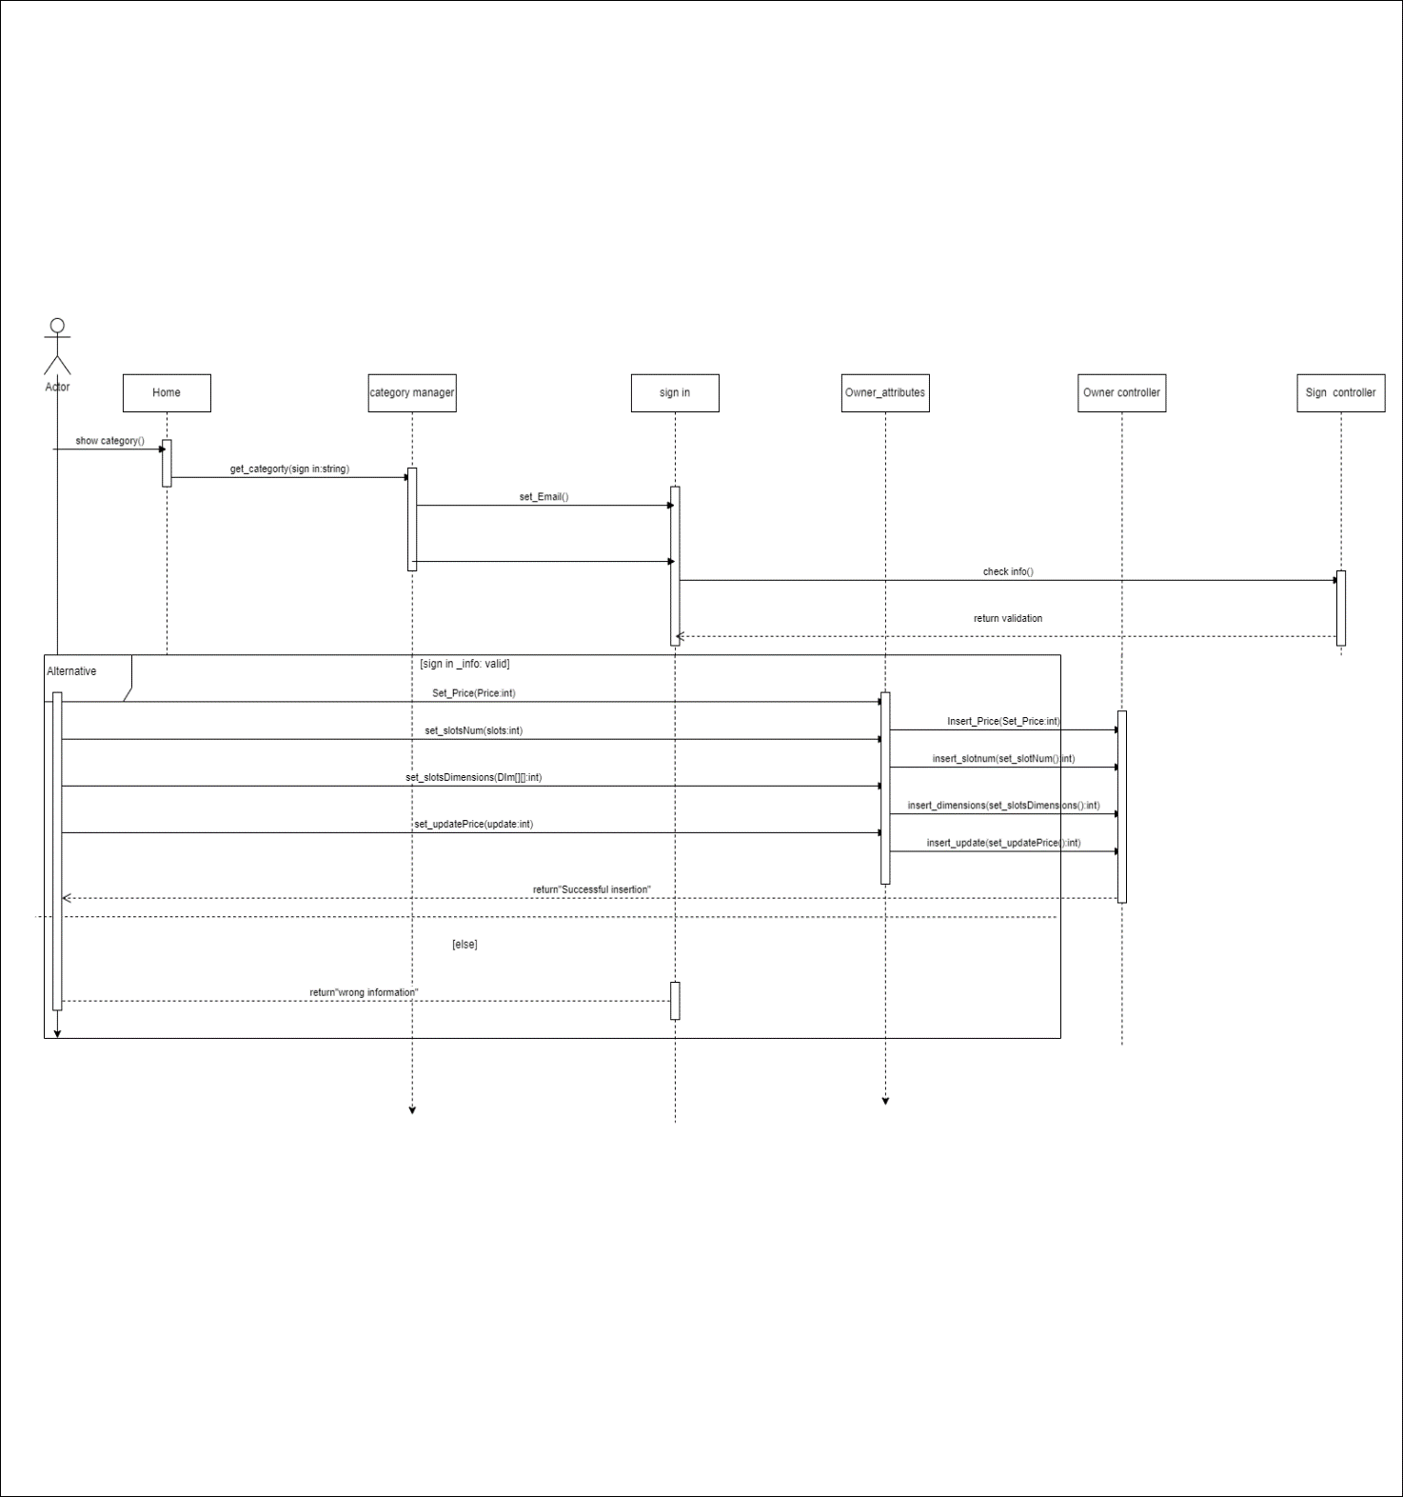

Arrival time

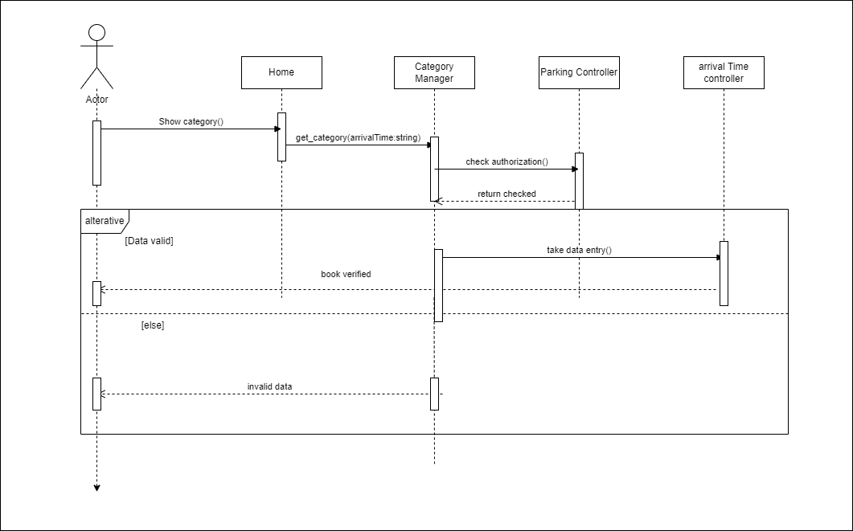

### Class - Sequence Usage Table

| **Class Name** | **Sequence Diagrams** | **Overall used methods** |
| --- | --- | --- |
| Home, category manager, category, customer manager, customer info and customer controller. | Check empty slots. | show category()  get_category()  get_checkslots()  get_customer()  setname()  setmodel()  setdimensions()  set_slot()  insertname()  insertmodel()  insertdimensions() |
| Home, category manager, sign up page and sign up controller. | Sign up | show category()  getcategory()  enterinfo()  verifyinfo()  add customer() |
| Home, category manager,  Departure time, calculate time, arrival time controller and calculate cost | Going out and departure time | View category()  getcategory()  get_time()  get_data()  set_time()  set_calcilated time() |
| Home, category manager,  Sign in, owner attributes, owner controller, sign controller. | Uptade price and set slots data | get_category()  set_Email()  check_info()  set_price()  set_slotsNum()  set_slotsDimensions()  set_updatePrice()  insert_slotnum()  insertdimensions()  insert_update() |
| Home, category manager, parking controller, arrival time controller | arrival time | show category()  get_category()  check_authrization()  take data entry() |

# 

# Ownership Report

|  |  |
| --- | --- |
| **Item** | **Owners** |
| The team member has worked on the whole project | *Mohamed Ashraf Ahmed* |
| The team member has worked on the whole project | *Hassan Mohamed Nafed* |
| The team member has worked on the whole project | *Yousef Sherif Mohamed* |
| The team member has worked on the whole project | *Mostafa Shaban Abd El Rasoul* |