RECEIPT KEEPER – IMPLEMENTATION OF RESTFUL API USING A LOOPBACK FRAMEWORK
C. Choi (cch.choi@gmail.com), H. Nahhal (nahhalhasan@gmail.com),
N.Collins (ncollins.pro@gmail.com), S. Kim (joe215.kim@gmail.com)
Supervisor: D. Dvorski (ddvorski@conestogac.on.ca)

School of Engineering & Information Technology

Conestoga College Institute of Technology and Advanced Learning

0. ABSTRACT

Keeping track of spending in daily life is the one of the tedious but important tasks people do. Many people are keeping financial ledgers with hand writing or with the help of spread sheet programs. However, it is very hard to keep track of spending and recognize overall trends with categories within a specific period. Moreover, if the receipt of an item needs to be kept for future reference such as a tax report or refunding, it is hard to find the receipt where it was used.

Receipt Keeper is a solution to keep track of spending with a mobile app and preserve the information by uploading the information to the server. Thus, users can keep track of their spending and check the statistics of their spending or search for the receipt when needed. Moreover, for business users it can collect or monitor their members’ receipts and spending by using of group features.

This report will explore the solution developed with covering the major aspects of development, such as methodologies, architectural decisions made, and technologies used. Finally, it shows how the app is created for scalable RESTful app on Loopback Framework.

I. INTRODUCTION

Receipt Keeper allows users to track how much money they spent in a certain category over a specific number of months, as well as start a group which others can be invited to join, and this will allow group admins to see reports for the group. Receipt Keeper is built to work on Android devices and also includes a web application. The mobile application will make it easier for people to manage categories, tags and reports while having the convenience of scanning receipts wherever they are. The web application provides the list of receipts and shows graphs to visualize users’ spending.

A. Challenges and objectives
The biggest challenge was to make a working product within limited time and limited resources. Thus, we started with implementing minimum viable product which has core features; REST API supporting server, OCR.

1) OCR engine to recognize numbers and characters on user’s receipt: due to limitation of resources, open source products were considered, which were OpenCV, Tesseract, etc.

2) Providing REST (Representational State Transfer) API for scalability: different kinds of devices should be connectable to the server such as web application, Android, iPhone, Tablet, even customized devices. Implementing a server which is connectable with API is another challenge.

3) Android Application using REST API to communicate with Server: To implement a working product within the limited time, the team is focusing on implementing core features, such as taking picture of receipt, recognizing characters on receipt, data persistence of receipt, and uploading receipt to the server.

II. METHODOLOGIES

A. Development Methodologies & Team Rules
- Agile Unified Process
To implement a working product with minimization of documentation, Agile Unified Process was used which has 2-week iteration period.

- Coding Standard
Coding Standard was minimized for every member to follow the standard easily and was updated after members are accustomed to the rule. Coding Standard also includes comment rule for Git, JavaScript, and Android.

B. Source Control & Change Management
- GitHub
Three GitHub projects were created, one each for managing document, web server and application, and Android application.

- Committing Rule
Direct commit to the server was discouraged, but making pull request was encouraged for peer review, and made a process for source code management.
- Sharing Information
To share the information such as coding rule, link information, and minutes, Wiki page at GitHub was used.

C. Issue Tracking
GitHub’s issue tracking function was used to minimize managing or learning new tools. Although it has not many functionalities compared other issue tracking tools such as Jira, it has the benefit of being seamlessly connectable to the GitHub.

D. Backend as a Service (BAAS)
LoopBack framework was used for implementing the server and will be stated in detail later.

E. Deployment
For supporting interoperation during the development, it was important to set up the server environment early so that every member can use it for development. HEROKU provides a free account for prototyping purpose. However, one of the drawbacks of a free account is the server will go into sleep mode after 30 minutes of inactivity, so it needs to be activated before using the server. However, it is not a big problem for prototyping. Moreover, HEROKU supports buildpacks for deploying LoopBack app, so after uploading source code with Git to the HEROKU environment, it will be compiled and deployed automatically.

To avoid the problem of breaking the operation of the server, the pipeline features at HEROKU was used. (Fig. 1.) After setting up, every pull request at project’s GitHub will trigger a build at HEROKU, and it will pull from GitHub, and build automatically. This result can be verified at Dashboard of HEROKU. Normally, the code will be submitted to the staging server for testing purpose, and if the submitted source code was stable and it was decided to publish, it was promoted to the production stage manually. This production server was a common server shared between members.
STAGING
PRODUCTION
REVIEW

Fig. 1. HEROKU Pipeline

F. Data as a Service (DAAS)
Instead of setting up an internal customized environment using a container such as Docker, to reduce time setting up the environment, it was decided to use a cloud database service. Among the providers, mLab provides Database-as-a Service with various types of plans and features for MongoDB. Among the plans, the Sandbox plan provides 500MB of space free which is enough for development and prototyping, although it is slow compared to non-free plans.

E. Sharing Issues and Communication
Because team members worked in separate places, although one day per week was allocated for Capstone project lab, it was necessary to set up communication channels other than phone. Slack is a widely used online app for professional collaboration on projects. Slack allows channels to be set up for a group to discuss a specific project. Channels were set up and have actively been used for the discussion of interoperation and sharing knowledge.
Additionally, to share the information such as meeting minutes, coding rules and documentation, GitHub’s Wiki was used.

III. ARCHITECTURAL DECISIONS

A. Architectural Drivers
- Functional Requirements
- User inputs receipt easily by minimizing typing of information
- Allow web application and mobile devices to connect to the server
- User searches receipt or check the trend of spending with visualization

- Quality Attributes
- Scalability: Extensible to other kind of client
- Modifiability: Easy to change API
- Performance: Quick to search the information
- Security: User can only view data for their own account or groups

- Constraints
- The system is delivered by Aug 10, 2016
- Current available OCR engines are mostly for mobile

- Architectural Decisions: Fig. 2.
- REST API
- NoSQL for the speed of search and Node.js
- Express middleware modules for security such as Helmet
- OCR processing is conducted at mobile

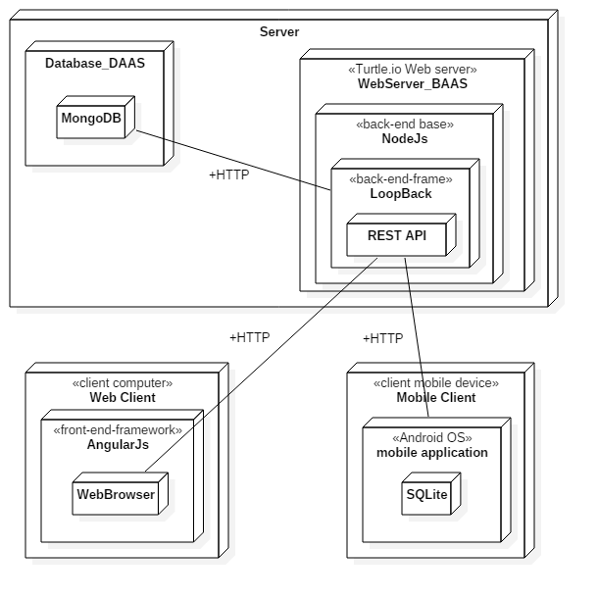
Fig. 2. Deployment Diagram (Server, Web Client and MobileClient)

IV. TECHNOLOGIES

Because one of the application’s main features is to help a user entering receipts by using Optical Character Recognition (OCR) technologies, OCR is the main technology that is used.

- Optical Character Recognition (OCR)
For implementing OCR within limited time, team decided to use open source for character recognition. OpenCV and Tesseract are the products considered. OpenCV is a famous computer vision open source product, and Tesseract is a famous OCR engine which was started in 2005 by HP and Google is a main contributor to the project. There are a lot of open source project subsidiaries based on Tesseract, and android-ocr is the project that was used for our project [1]. Although OpenCV was not used for this project, it can be used for pre-processing receipt images such as contrast enhancement, auto tilting of image to enhance recognition rate for OCR engine in the future project.

- LoopBack
Another main technology is a server to support REST API. Various platforms are considered, but due to lack of team’s skills and to minimize time to implement the server, LoopBack is chosen finally. Table 1 is the comparison of features between BAAS (Back end As a Service) solutions.

 | LoopBack | Express | Sails | Restify | Meteor
Type | API framework | HTTP server library | Web MVC framework | REST HTTP library | Full-stack JavaScript app platform
Top Features | Enterprise connectivity, API Explorer, generators, client SDKs, websocket microservices | HTTP routing, middleware | Rails familiarity, MVC | Simplicity, REST routing | Universal JavaScript, reactive rendering, websocket microservices
Suitable For | Web apps, APIs | Simple web apps | Web apps, APIs | Simple REST APIs | Web apps
Github Stars | 5k | 19k | 10k | 3k | 28k
Support | StrongLoop | StrongLoop | N/A | N/A | Meteor Development Group
Pure Node runtime | Yes | Yes | Yes | Yes | No
Client SDKs | Angular, Browser, Node.js, iOS, Android, Xamarin | N/A | None | None | JavaScript, Cordova for iOS and Android, React, AngularJS
Export API Definition | Yes | With strong-remoting | None | None | With meteor-rest
Tools | Visual API composer, Explorer, CLI code generators | CLI app generator | Yeoman generator | Yeoman generator | CLI tool
Visual API composition | Yes | No | Yes | Yes | Yes
StrongLoop Arc Build & Deploy, Monitoring, Profiling | Yes | Yes | No | No | Proprietary package system and repository, npm
Extensions | Push, File Storage, Passport, OAuth 2.0, Express Middleware | Express / Connect Middleware | In-memory, File, PostgreSQL, MySQL, MongoDB | None | MongoDB, MySQL and PostgreSQL via 3rd-party packages
Data sources | In-memory/file, MongoDB, MySQL, Oracle, PostgreSQL, SQL Server, ATG, Email, REST, SOAP | None | No | No | Basic allow/deny
ACLs | Yes | No

Table 1. COMPARISON OF BAAS (BACKEND AS A SERVICE)

LoopBack is an open source Node application framework based on Express which is supported by IBM and StrongLoop (Acquired by IBM on September, 2015). It makes it easy to create REST API platforms and managing REST API with provided tools (Fig. 3.), such as creating new API or apply access control list (ACL). Moreover, it has a built-in API explorer to test API which is useful to test the server operation before implementing web client or mobile application.

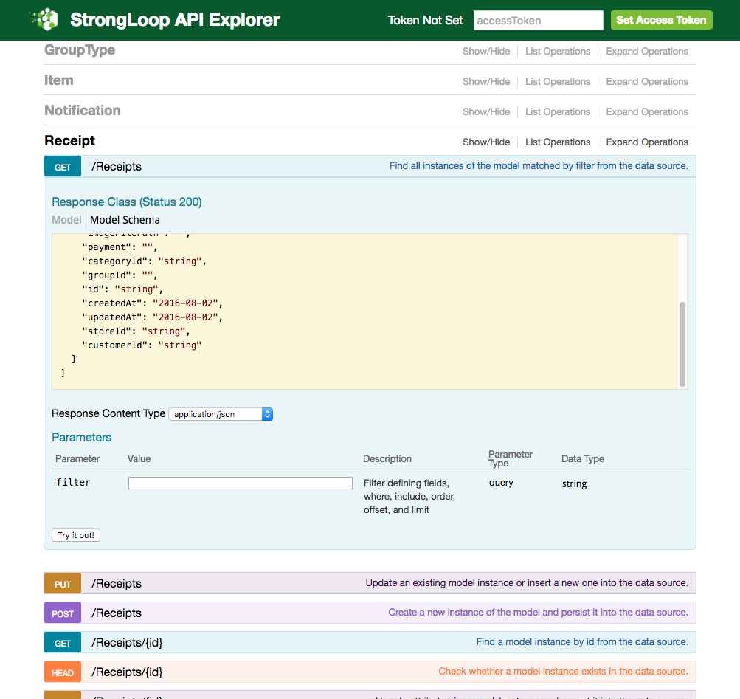

Fig. 3. LoopBack API Explorer

LoopBack supports a Yeoman-based scaffolding tool for generating new project skeletons, so it takes a few minutes to make skeletons for the project.

LoopBack helps with that further by providing a model generator for building your models quickly. Entity relationships are also very well supported. The security model is also complex with user roles, principals and ACLs

Authentication and authorization are important tasks for implementing a server, but it was easy to setup authentication and authorization by using LoopBack’s built-in role based access controls. Open Standard for Authorization (OAuth) user and registration models is baked in LoopBack, so it is also easy to embed third party logins such as Google and Facebook.

StrongLoop Arc is a graphical tool used to build, deploy, manage and monitor LoopBack applications and APIs.

Various database connectors are available for all major SQL databases and MongoDB. Moreover, it is easy and quick to generate models by using an embedded model generator. These can be validated with the built-in validation methods. Entity relationships are very well supported. The security model is complex with user roles, principals and ACLs.

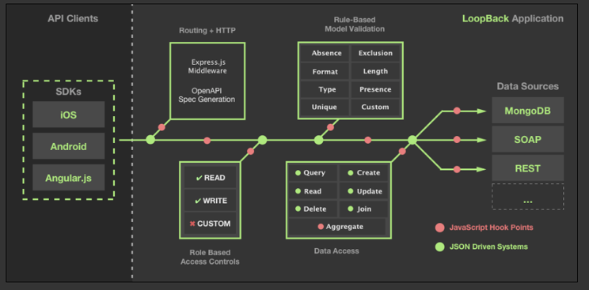

Fig. 4. LoopBack Application

Loopback also provides SDKs for Android, iOS, AngularJS (Fig. 4.). Android SDK was used for this project, and saves a lot of time for implementing http connection in background. However, to get the full benefit of using REST API, it would be proper to implement REST client using open source such as OkHttp or Volley (REST client) and GSON (for JSON). SDK for AngularJS is embedded with LoopBack module. It will be explained in detail later.

- OPEN SOURCE
Open source projects are helpful for implementing features in a short time, but a lot of points should be considered beforehand such as license, sustainability, and securities.

- Server
Open Source Mobile | License | Function
bunyan: ^1.8.1, | MIT | Logging
compression: ^1.0.3, | MIT | Compression middleware
cors: ^2.5.2, | MIT | Middleware for dynamically or statically enabling CORS in express/connect applications
errorhandler: ^1.1.1, | MIT | Error handler middleware
express-bunyan-logger: ^1.3.0, | BSD | A express logger middleware powered by bunyan
helmet: ^1.3.0, | MIT | Help secure Express/Connect apps with various HTTP headers
loopback: ^2.22.0, | MIT | Open Source Framework for Node.js
loopback-boot: ^2.6.5, | MIT | Convention-based bootstrapper for LoopBack applications
loopback-component-explorer: ^2.4.0, | MIT | Browse and test LoopBack app's APIs
loopback-component-storage: ^1.5.0, | MIT | Loopback Storage Service
loopback-connector-mongodb: ^1.15.2, | MIT | The official MongoDB connector for the LoopBack framework
loopback-datasource-juggler: ^2.39.0, | MIT | Loopback Datasource Juggler session store for Connect
loopback-ds-timestamp-mixin: ^3.2.4, | ISC | A mixin to automatically generate created and updated Date attributes for loopback Models
serve-favicon: ^2.0.1 | MIT | Favicon serving middleware with caching

- Web Client
Open Source | License | Function
json3: ~3.3.1, | MIT | JSON implenmentation
font-awesome: 4.3.0, | MIT | Scalable vector icons that can instantly be customized — size, color, drop shadow, and anything that can be done with the power of CSS
oclazyload: ~0.5.2, | MIT | Lazy loading with Angular 1.x
angular-loading-bar: ~0.7.0, | MIT | Automatic loading bar using angular interceptors
angular-chart.js: ~0.5.2, | MIT/X11 | Plugin for adding interactive charts to your website
angular-ui-router: ^0.3.0, | MIT | Client-side Single Page Application routing framework for AngularJS
angular-file-upload | MIT | Module for the AngularJS framework. Supports drag-n-drop upload, upload progress, validation filters and a file upload queue
angular-resource: ^1.5.6, | MIT | AngularJS module for interacting with RESTful server-side data sources
bootstrap: ^3.3.6, | MIT | The most popular HTML, CSS, and JS framework for developing responsive, mobile first projects on the web
eonasdan-bootstrap-datetimepicker: ^4.17.37 | MIT | Datetime picker
angular-bootstrap-multiselect | MIT | Multiselect dropdown list for AngularJS styled to fit the Twitter Bootstrap standard design
Chart.js | MIT | Simple HTML5 Charts using the <canvas> tag
jqcloud2 | MIT | jQCloud is a jQuery plugin that builds neat and pure HTML + CSS word clouds and tag clouds that are actually shaped like a cloud
jquery | MIT | jQuery is a fast, small, and feature-rich JavaScript library
moment | MIT | Parse, validate, manipulate, and display dates in JavaScript
moment-timezone | MIT | Parse and display dates in any timezone

- Android Mobile App
Open Source | License | Function
com.rmtheis:  tess-two:5.4.0 | Apache 2.0 | A fork of Tesseract Tools for Android
com.strongloop:  loopback-sdk-android:  1.5.+ | MIT | Android Java SDK for Accessing LoopBack Server
com.github.bumptech.glide:glide:3.6.0 | BSD, part MIT and Apache 2.0 | Supports fetching, decoding, and displaying video stills, images, and animated GIFs
Tesseract: https://github.com/tesseract-ocr/tesseract | Apache 2.0 | OCR Engine
com.toptoche.  searchablespinner:  searchablespinnerlibrary:1.3.1 | Apache 2.0 | Spinner with searchable items

V. Class Design & Database

Because most of server’s structure is already defined by LoopBack, we can focus on designing class and model.

A. Design Model
Because user model is defined by LoopBack which is related with pre-defined Role model and this can be connected with ACL (Access Control Logic), Customer model that is inherited pre-defined User model is added to add additional user information such as real name of the user. The following diagram (Fig. 5.) is a class diagram for our project.

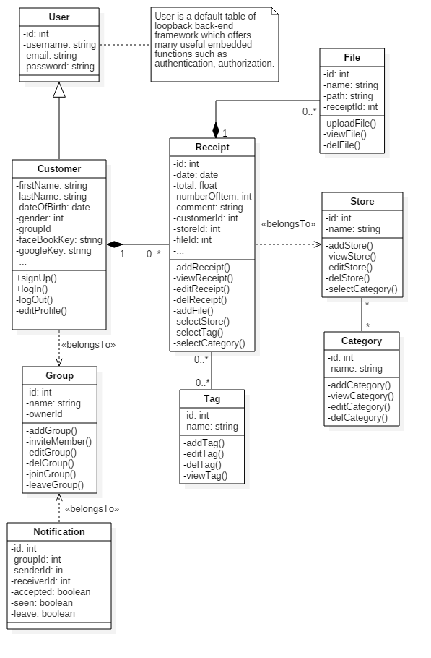

Fig. 5. Design Model Class Diagram

B. Entity Relationship Model
Based on class diagram generated above, Entity diagram is created (Fig. 6.). This diagram was used to create model at database.
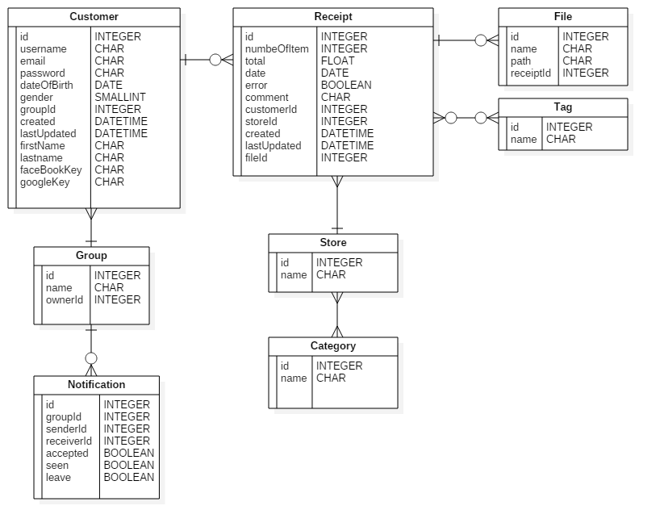

Fig. 6. Entity Diagram

VI. Generating Application with LoopBack

A. Creating Server with Loopback
- Creating Application
With the help of Yeoman, it is easy to create scaffolding for the application. This is done with a few commands, mkdir followed by specifying application name.

mkdir receiptkeeper && cd receiptkeeper && npm install strongloop
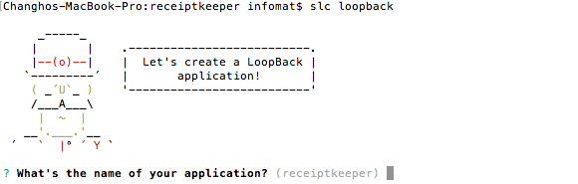

- Creating Model Based on Entity Diagram

With embedded model generator, it is easy to create scaffolding.
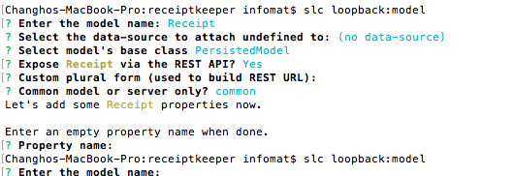

- Server run
Now, it is possible to run server. By accessing explorer with URI: http://0.0.0.0:3000/explorer, it is possible to check operation on API. Additionally, relation between model can be generated by slc loopback:relation. Also, it is possible to configure the control access level by slc loopback:acl
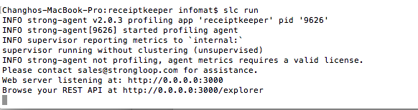
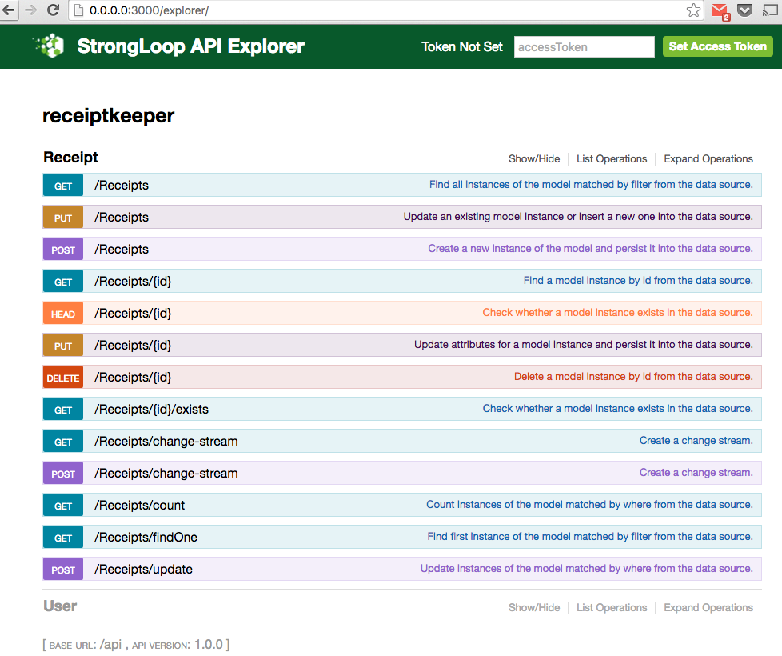

B. Creating Web Client
The LoopBack AngularJS SDK is packaged with the StrongLoop module. The AngularJS SDK builds AngularJS services on top of the $resource service for interacting with the LoopBack-generated REST API.
The lb-ng script is the CLI for the LoopBack AngularJS SDK. Running the above command generates a client/js/services.js file. This file contains an AngularJS service for each model defined in the LoopBack REST API. Additionally, to use AngularJS as client, changing server/middleware.json is needed to tell the LoopBack server to serve static files from the client directory.

C. Creating Android Application
It is possible to authenticate user, store data at server’s database, push notification, and uploading file to server’s storage is possible by using Android SDK [9]. Followings are the brief process of setting storing data at server’s database

i) Set up Gradle: add dependencies

dependencies {

compile 'com.strongloop:loopback-sdk-android:1.5.+'

}

ii) Define Adapter

RestAdapter adapter

= new RestAdapter (getApplicationContext (), "http://receipt- keeper.heroku.com/api");

iii) Define Repository

ModelRepository productRepository = adapter.createRepository("receipt");

Model receipt = productRepository.createObject (ImmutableMap.of

(“name”, “dem”));

iv) Save data

receipt.save (new VoidCallback()

VI. CONCLUSIONS

By using the Loopback framework, it is easy and quick to implement REST API for scalability. Server performance is also better than the server based on other frameworks such as PHP, because LoopBack is based on NodeJS [10]. It was also easy to implement a single page application with the help of AngularJS.

REFERENCES

[1] android-ocr, https://github.com/rmtheis/android-ocr
[2] HEROKU, https://www.heroku.com/pricing
[3] LoopBack,
https://docs.strongloop.com/display/public/LB/LoopBack
[4] OCR,
https://en.wikipedia.org/wiki/Optical_character_recognition
[5] OpenCV, https://en.wikipedia.org/wiki/OpenCV
[6] Tesseract OCR:
https://github.com/tesseract-ocr/tesseract
[7] Express, Production Best Practices: Security:
https://expressjs.com/en/advanced/
best-practice-security.html
[8] StrongLoop, Security considerations,
https://docs.strongloop.com/display/public/LB/
Security+considerations
[9] StrongLoop, Android SDK,
https://docs.strongloop.com/display/public/LB/Android+SDK
[10] Comparing Node.js vs PHP Performance, http://www.hostingadvice.com/blog/
comparing-node-js-vs-php-performance/

Glossary
A
ACL:
Access control list, a list associated with an object that identifies all the subjects that can access the object and their access rights. See Authentication, authorization, and permissions.
B
Build Packs:
Build packs are scripts that are run when the app is deployed. They are used to install dependencies for the app and configure the environment.
D
Data source:
A data source connects with specific database or other back-end system using a connector.
H
Helmet
Helmet is node module and it helps secure Express apps by setting various HTTP headers.

O
OCR (Optical character recognition):
Optical character recognition (optical character reader, OCR) is the mechanical or electronic conversion of images of typed, handwritten or printed text into machine-encoded text, whether from a scanned document, a photo of a document, a scene-photo (for example the text on signs and billboards in a landscape photo) or from subtitle text superimposed on an image (for example from a television broadcast) (Wikipiedia: https://en.wikipedia.org/wiki/Optical_character_recognition)

OpenCV:
OpenCV (Open Source Computer Vision) is a library of programming functions mainly aimed at real-time computer vision, originally developed by Intel's research center in Nizhny Novgorod (Russia), later supported by Willow Garage and now maintained by Itseez. The library is cross-platform and free for use under the open-source BSD license.
R
REST API:
Representational state transfer (REST) is an architectural style of application programming interfaces consisting of a coordinated set of components, connectors, and data elements within a distributed hypermedia system, where the focus is on component roles and a specific set of interactions between data elements rather than implementation details. Its purpose is to induce performance, scalability, simplicity, modifiability, visibility, portability, and reliability. REST is the software architectural style of the World Wide Web. To the extent that systems conform to the constraints of REST they can be called RESTful. RESTful system. Typically, but not always, communicate over Hypertext Transfer Protocol (HTTP) with the same HTTP verbs (GET: READ, POST: CREATE, PUT: UPDATE, DELETE: DELETE, etc.) that web browsers use to retrieve web pages and to send data to remote servers. REST systems interface with external systems as web resources identified by Uniform Resource Identifiers (URIs), for example /people/tom, which can be operated upon using standard verbs such as GET /people/tom. (Wikipedia: https://en.wikipedia.org/wiki/Representational_state_transfer)

