Receipt Keeper

Design Document

# Class Diagram

# 

# Entity Relationship Diagram

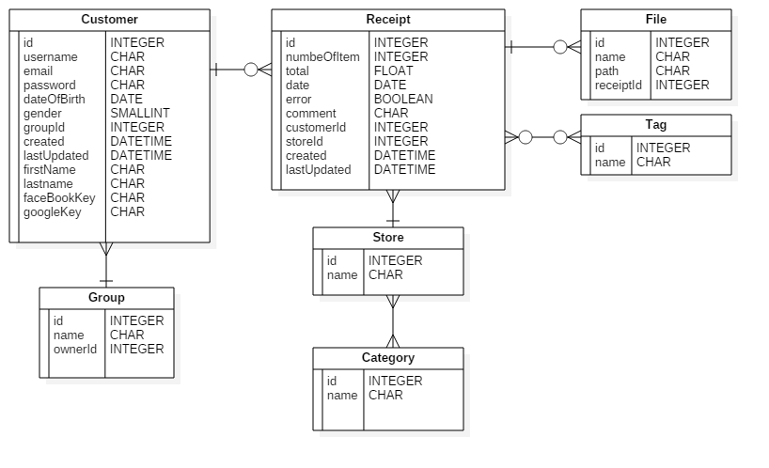

# Deployment Diagram

