Receipt Keeper

Design Specification

Changho Choi, Hassan Nahhal, Nicholas Collins, SungJoe Kim

# **Class Diagram**

# 

# **Entity Relationship Diagram**

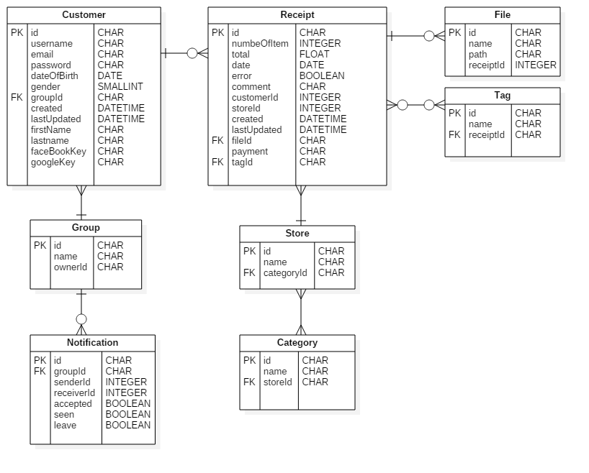

# **Deployment Diagram**

