ScreenShots

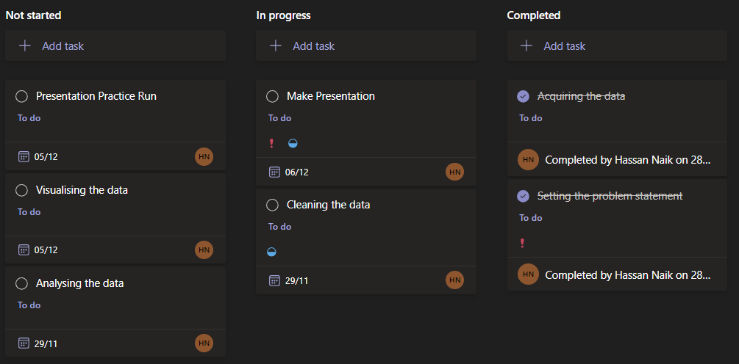

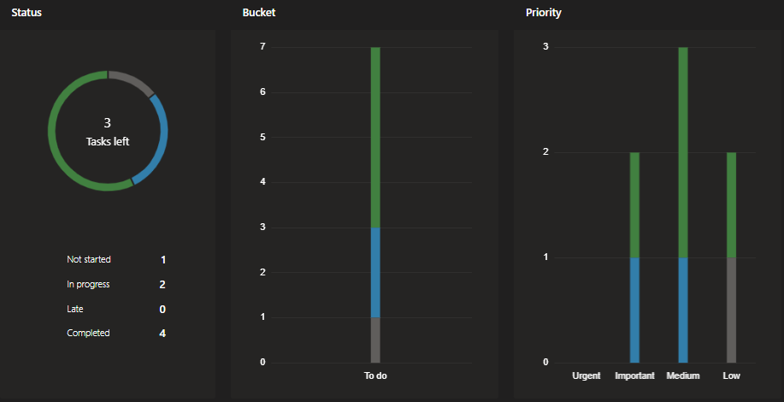

MinimumAttendance = MIN('Test'[Attendance])

FirstQuartileAttendance = PERCENTILE.INC('Test'[Attendance], 0.25)

MedianAttendance = PERCENTILE.INC('Test'[Attendance], 0.5)

ThirdQuartileAttendance = PERCENTILE.INC('Test'[Attendance], 0.75)

MaximumAttendance = MAX('Test'[Attendance])

<https://www.nuffic.nl/en/education-systems/united-kingdom-england-wales-and-northern-ireland/grades-and-study-results>

| **Letter grade** | **Percentage** | **Class** | **Meaning** |
| --- | --- | --- | --- |
| A | 70% en hoger | first class | good to very good (cum laude) |
| B | 60-69% | upper second class/second class division (abbreviated as 2:1) | more than sufficient to good |
| C | 50-59% | lower second class/second class division 2 (abbreviated as 2:2) | more than sufficient to sufficient |
| D | 40-49% | third class | just sufficien |