**Name: Hassan Nawaz**

**Username: HassanNawazBhatti**

**Roll no: BCS23042**

* **Printing something**

* **Commenting a statement:**

* **Multiple statements in a line:**

* **Tab and Space Identations:**

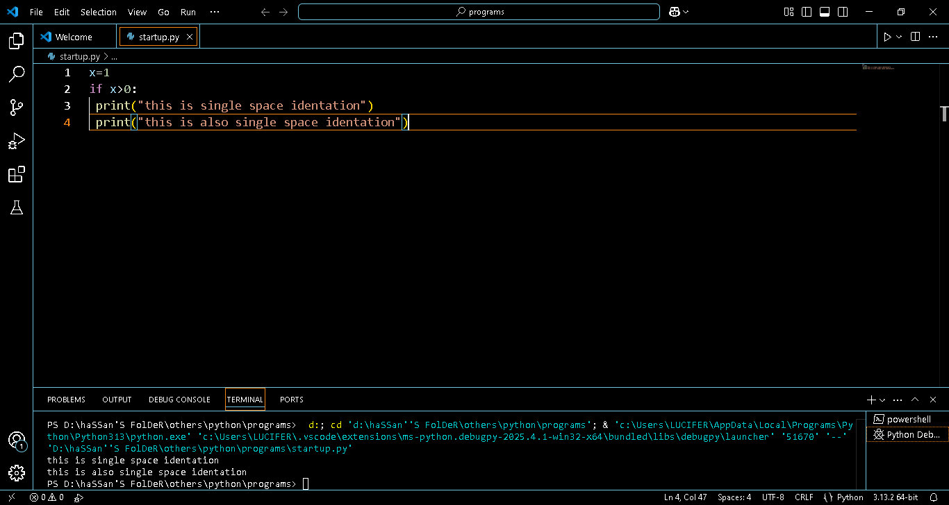

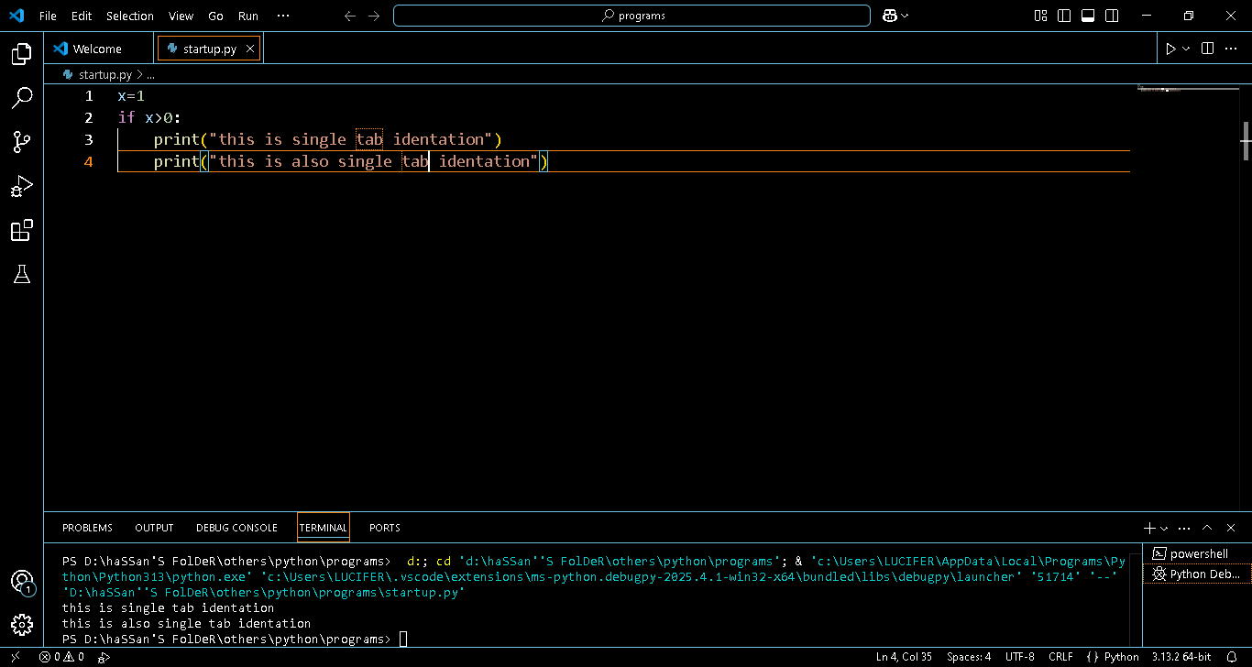

* **Data types:**

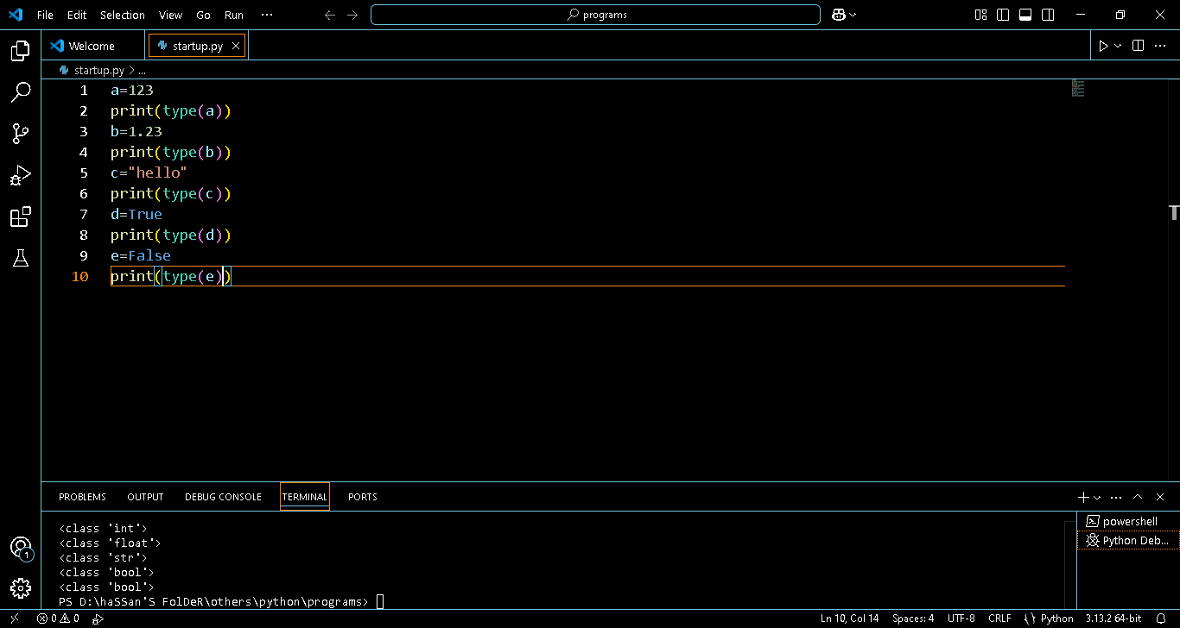

* **Complex function:**

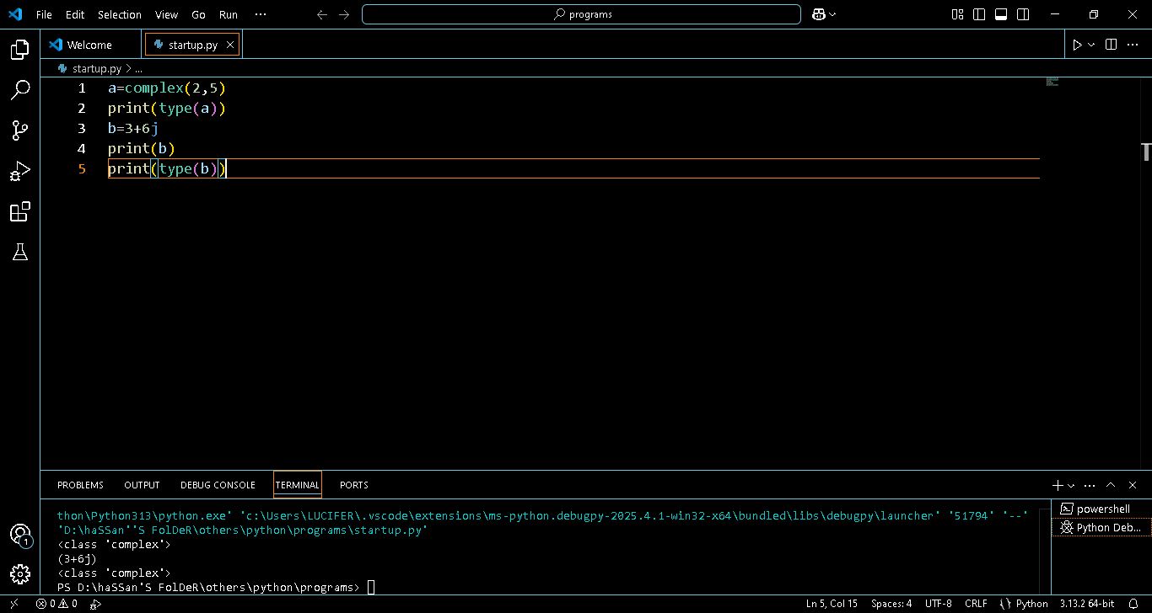

* **String using single and double quotes:**

* **Special characters in a string:**

* **String indices:**

* **Error in accessing element:**

* **Lists:**

* **List slicing:**

***-----THE END-----***