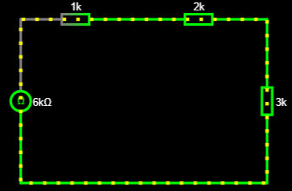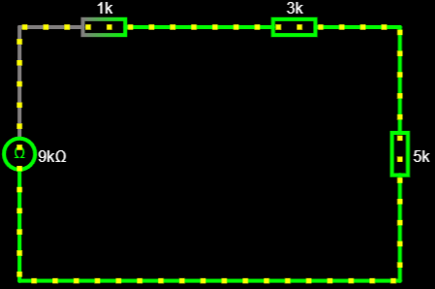
Reference : https://is.gd/5w4OmE

R= 6 | Ra=1kOhm | Rb=2kOhm | Rc=3kOhm | 6kOhm | 6kOhm
R=9 | Ra=1kOhm | Rb=3kOhm | Rc=5kOhm | 9kOhm | 9kOhm

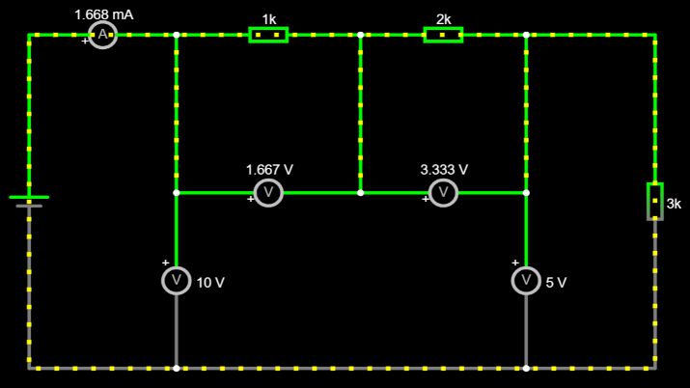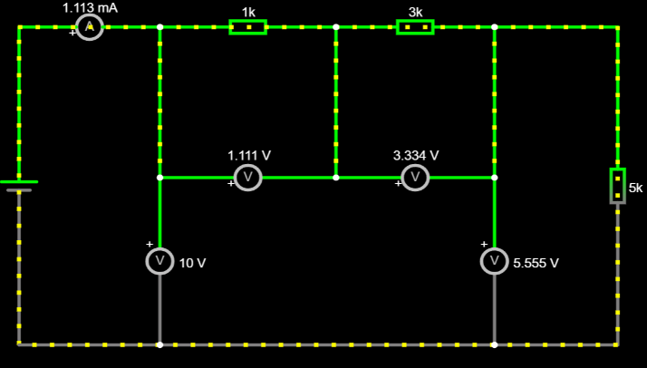

Reference : https://is.gd/LCB4Mf
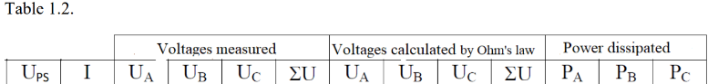
10 | 1.668 | 1.667 | 3.333 | 5.000 | 10.000 | 1.668 | 3.336 | 5.004 | 10.008 | 2.781 | 5.559 | 8.340
10 | 1.113 | 1.111 | 3.334 | 5.555 | 10.000 | 1.113 | 3.339 | 5.565 | 10.017 | 1.237 | 3.711 | 6.183

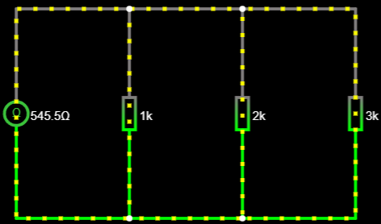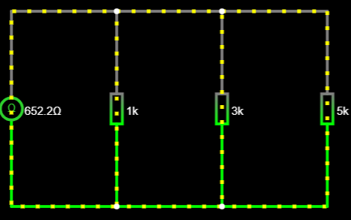

Reference : https://is.gd/VbUgEL

1K | 2K | 3K | 545.5Ω | 545.5Ω
1K | 3K | 5K | 652.2Ω | 652.2Ω

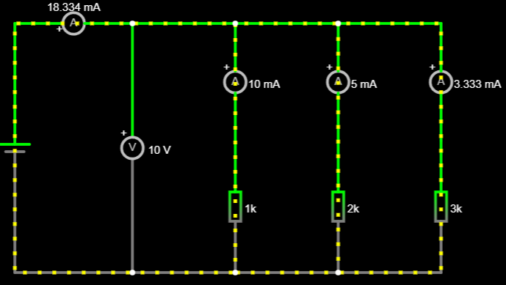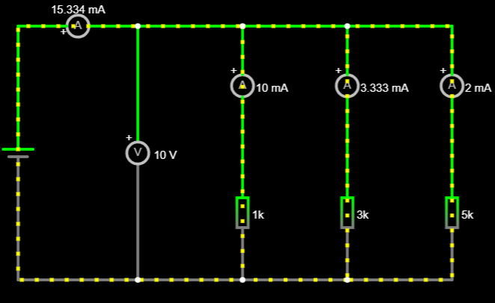
Reference : https://is.gd/8aOptf

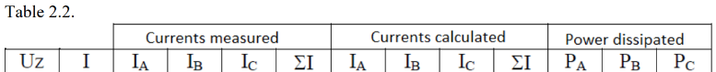
10 | 18.334 | 10 | 5 | 3.333 | 18.333 | 10 | 5 | 3.333 | 18.333 | 100 | 50 | 33.33
10 | 15.334 | 10 | 3.333 | 2 | 15.333 | 10 | 3.333 | 2 | 15.333 | 100 | 33.33 | 20

