|  |  |
| --- | --- |
|  | Final Project Report |
|  | Digital Image Processing |
|  | Hassan Raza i210465, Moiez Asif i212483 and Aasir Farrukh i210375  BS(CS)-A |



Contents

Glaucoma Diagnosis using Deep Learning Segmentation 2

Introduction and Scope: 2

Methodology Used: 2

Preprocessing: 2

Segmentation Approach: 2

Cup-to-Disc Ratio Calculation: 2

Chosen Architecture: U-net 2

Details of U-net Architecture: 3

Training Process Details: 3

GUI and Results: 4

Discussion / Improvements: 6

Conclusion: 6

# Glaucoma Diagnosis using Deep Learning Segmentation

## Introduction and Scope:

Glaucoma is a progressive eye disease that damages the optic nerve, leading to irreversible vision loss if left untreated. Early detection and monitoring of glaucoma are crucial for preventing further vision impairment. However, diagnosing glaucoma can be challenging, as it often develops gradually without noticeable symptoms in the early stages. This project aims to develop an automated system for glaucoma detection by leveraging deep learning techniques for optic disc and optic cup segmentation, enabling the calculation of the cup-to-disc ratio (CDR), a key indicator of glaucoma progression.

## Methodology Used:

### Preprocessing:

The input images are pre-processed before they are fed into the model. The images are read in grayscale, smoothed using a Gaussian filter to filter out the noise, resized to 256x256 pixels, and normalized to have pixel values between 0 and 1.

### Segmentation Approach:

The segmentation of the optic disc and optic cup from the retinal images is a crucial step in calculating the Cup-to-Disc Ratio (CDR), a key indicator of glaucoma. For this task, we used a U-Net, a type of Convolutional Neural Network (CNN) that is widely used for biomedical image segmentation.

### Cup-to-Disc Ratio Calculation:

The CDR is calculated as the ratio of the area of the optic cup to the area of the optic disc and we did it by counting the number of 1’s in optical disc mask and optical cup mask. A higher CDR indicates a larger cup, which is a common sign of glaucoma.

## Chosen Architecture: U-net

The chosen architecture for this task is the U-Net, which is a type of CNN. The U-Net was chosen for its ability to capture fine details in images, which is crucial for accurate segmentation. It also requires fewer training images and can predict on arbitrary-sized inputs, making it suitable for medical image segmentation tasks.

### Details of U-net Architecture:

The U-Net architecture consists of an encoder (downsampling path) and a decoder (upsampling path). The encoder captures the context in the image, while the decoder enables precise localization using transposed convolutions.

In this implementation, the encoder consists of **two Conv2D layers with 64 filters**, followed by a MaxPooling2D layer, and then **another two Conv2D layers with 128 filters** followed by a MaxPooling2D layer. The decoder consists of a concatenation of the upsampled output from the encoder and the corresponding encoder output, followed by **two Conv2D layers with 64 filters**. The final layer is a Conv2D layer with a sigmoid activation function to output the segmentation mask.

## Training Process Details:

The model is trained using the Adam optimizer with a learning rate of 1e-4. The loss function is binary cross-entropy, and the metric used is Mean Intersection over Union (MeanIoU), which is a common metric for evaluating the performance of image segmentation algorithms.

## GUI and Results:

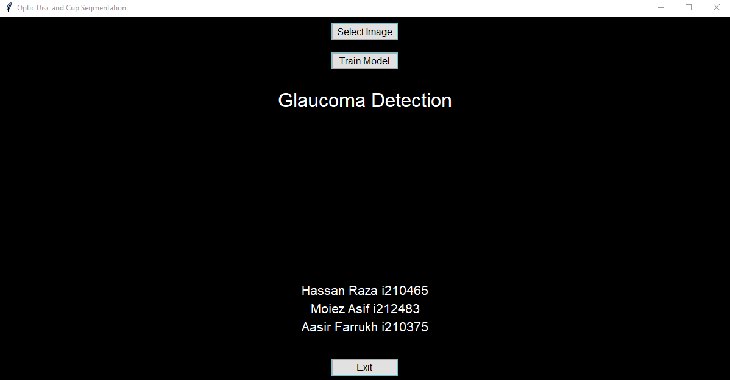

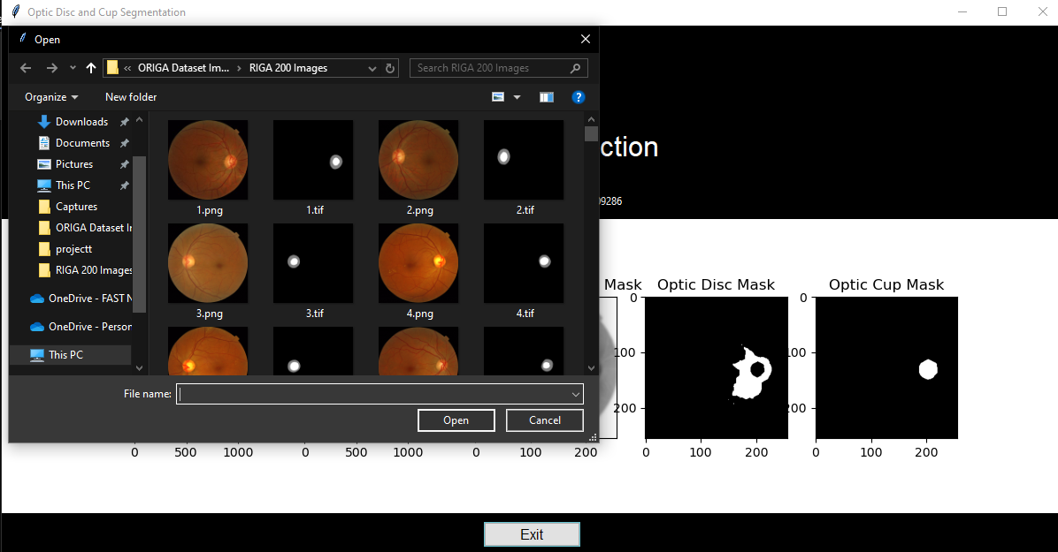

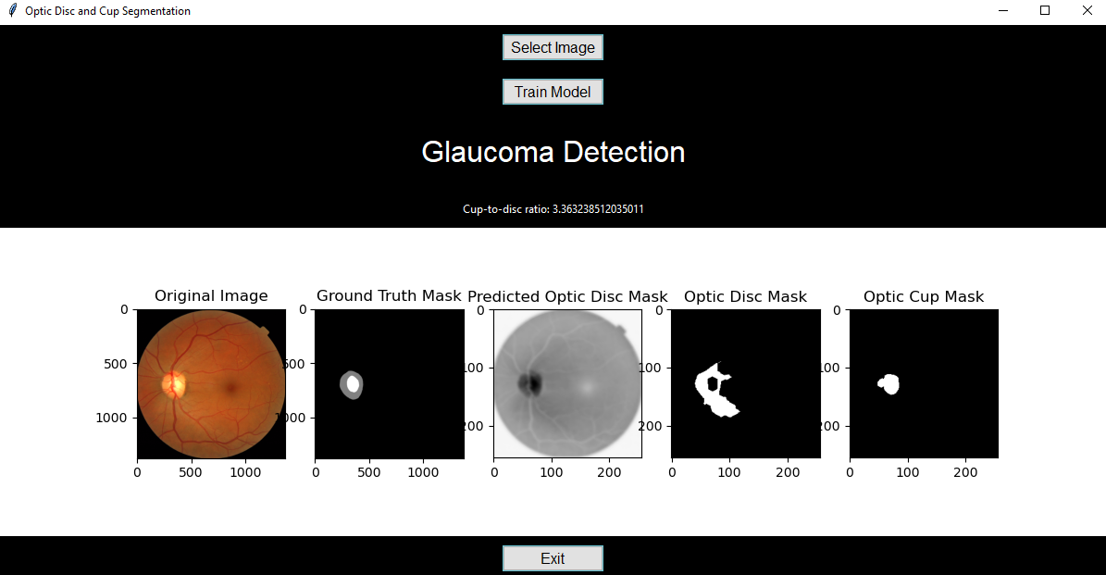

## Discussion / Improvements:

While the U-Net architecture is powerful for image segmentation tasks, there are several potential limitations and areas for improvement. For instance, the model might not perform well if there is a lot of variability in the images, such as different lighting conditions, angles, or quality of images. Additionally, the model currently does not incorporate any data augmentation techniques, which could help improve the model’s robustness and performance. Future work could explore the use of data augmentation, as well as other techniques to handle variability in the images.

## Conclusion:

This project presents an automated system for glaucoma detection using deep learning. The system uses a U-Net model for segmenting the optic disc and optic cup from retinal images and calculates the CDR for glaucoma diagnosis. This work contributes to the ongoing efforts in leveraging artificial intelligence for early and accurate detection of glaucoma, potentially helping prevent irreversible vision loss for many people.