***SMIU***

Answer no # 1

from random import randint as RI

data = list()

for i in range (1,RI(1,10)):

for j in range (1,RI(1,10)):

for k in range (1,RI(1,10)):

data.append(i*j*k * RI(1,[i,j,k][RI(0,2)]))

print(data)

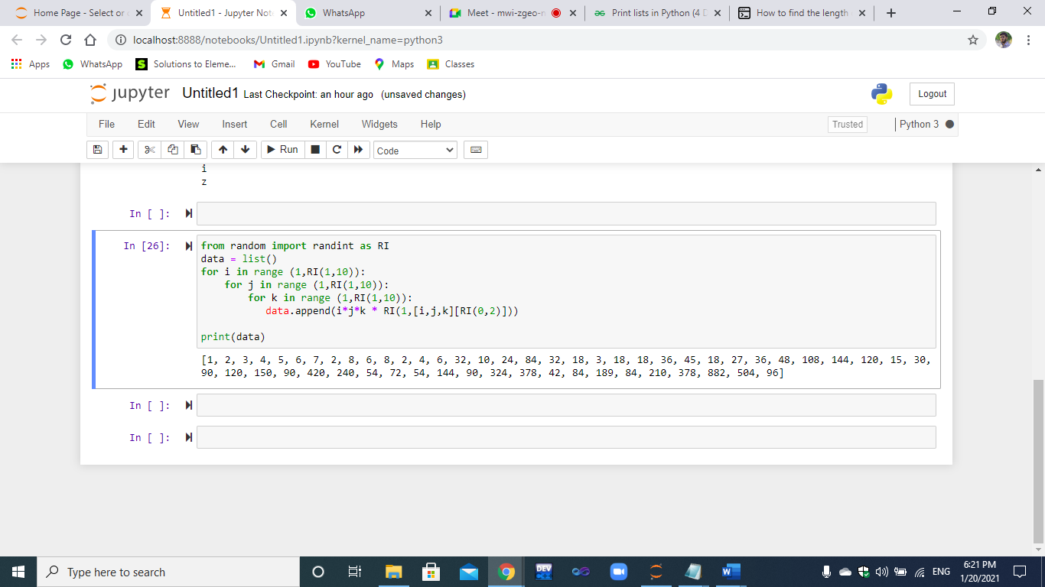

ANSWER NO 2 : PART A

import pandas as pd

df = pd.read_excel("Book1.xlsx", "Sheet1")

df

df_mean = df["GPA"].mean()

print (df_mean)

ANSWER NO 2 : PART B

MaFe_list = df['Gender'].tolist()

print(MaFe_list)

f_count = MaFe_list.count('F')

m_count = MaFe_list.count('M')

print("TOTAl no of Males are = " ,m_count)

print("TOTAl no of Females are = " ,f_count)

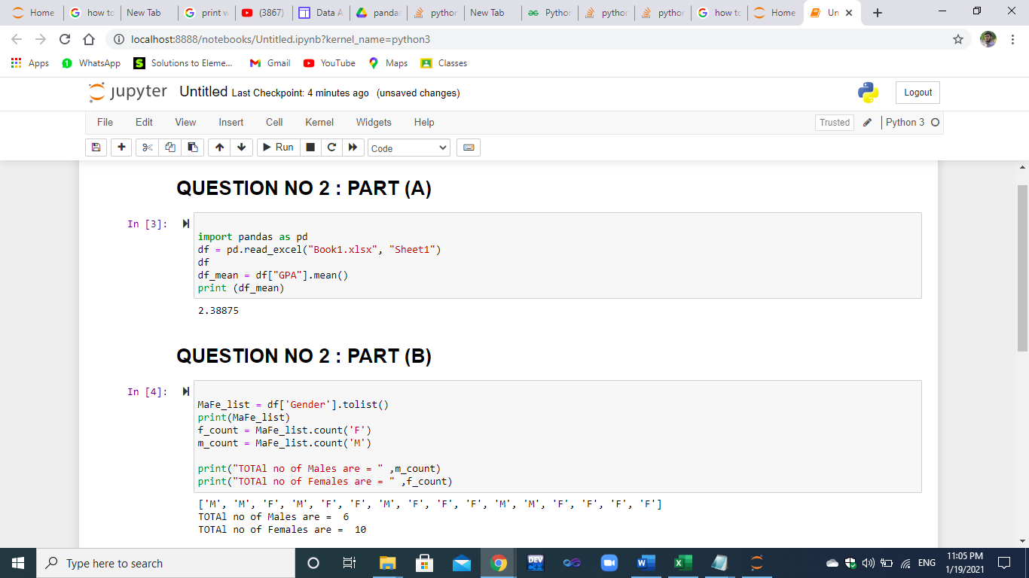

ANSWER NO : 2 (C)

agelist = df['Age'].tolist()

print(agelist)

df.loc[df['Age'] > 20]

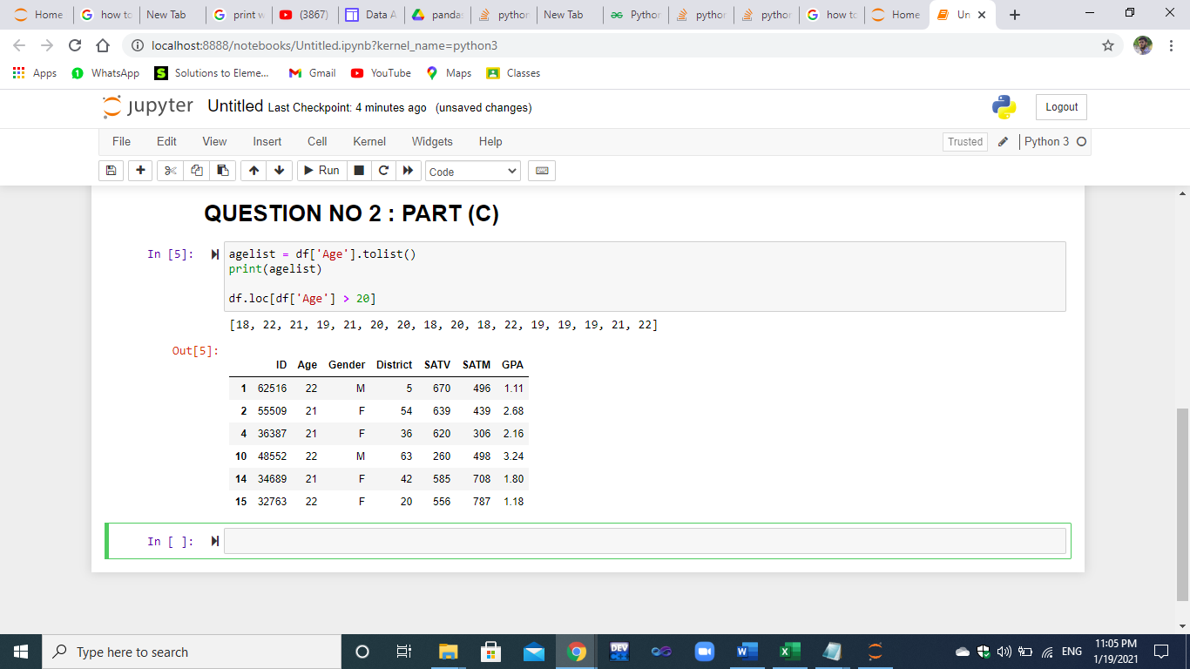

ANSWER NO 2 PART (D)

ID_new = 32763

Age = 32

Gender = 'M'

District = 33

SATV = 345

SATM = 787

GPA = 3.23

if any(df['ID'] == ID_new):

print('ID already exists.')

else:

df.loc[len(df)] = [ID_new, Age, Gender, District, SATV, SATM, GPA]

print('New ID added to dataframe.')

print(df)

**WHEN IDS ARE NOT DUPLICATE:**

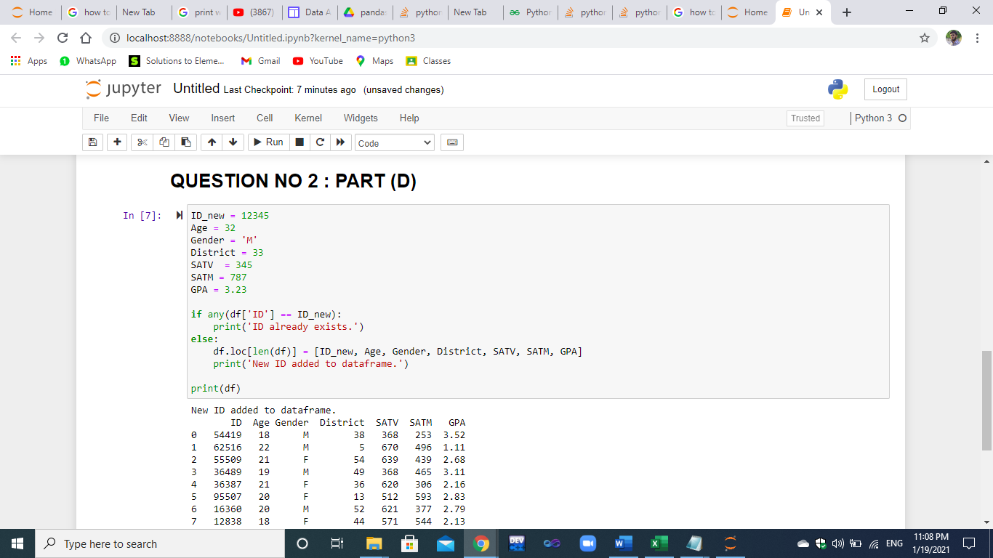

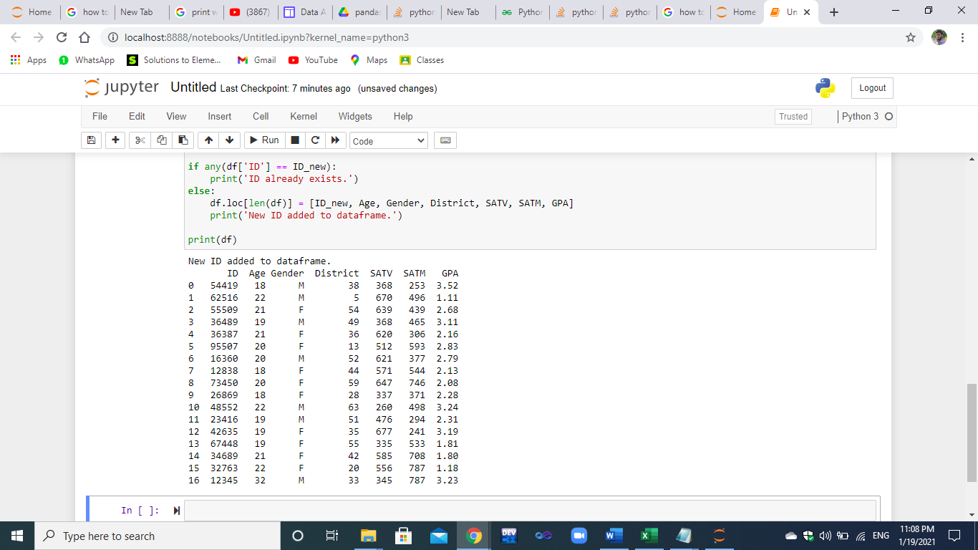

**WHEN IDS ARE DUPLICATE:**

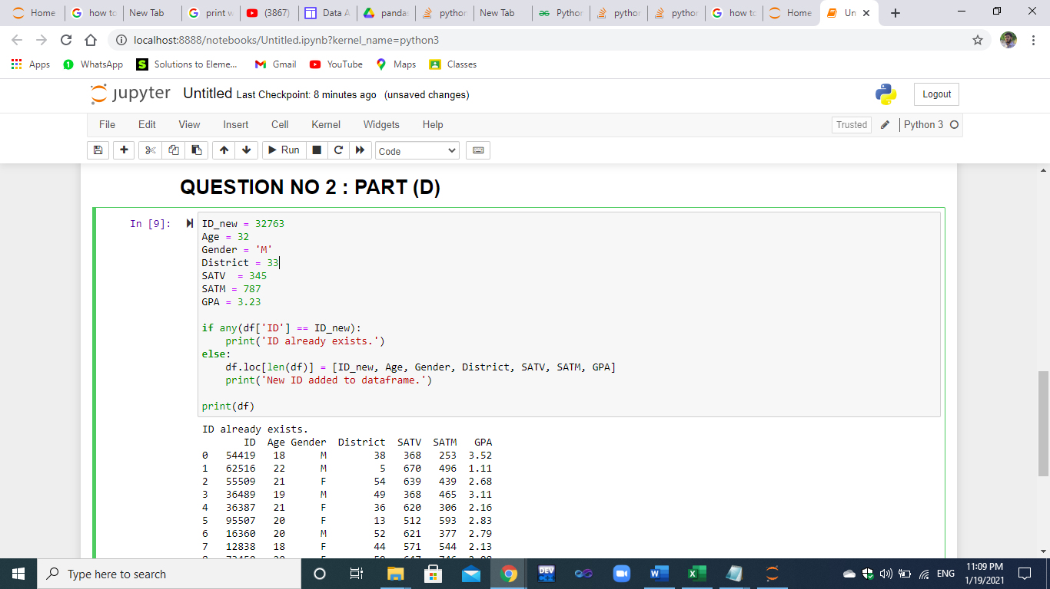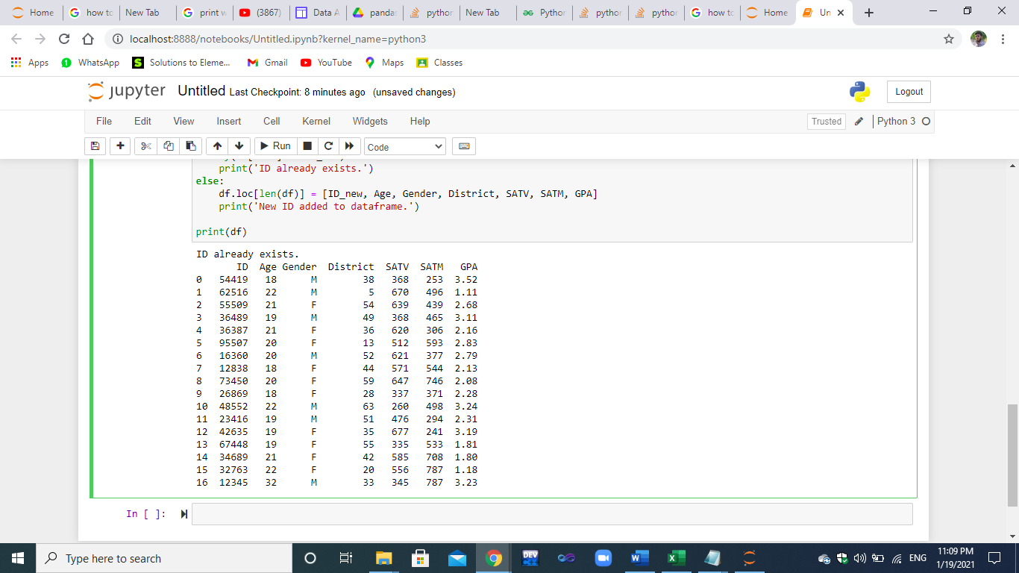

Answer No # 3

***# Declairing data and list***

list1 = [1234,"Acura" , " Honda Motor Company" ,

2011 , 25676 , "12 - 03 - 11" , "blue" ,

"Abdul Rehman" , "karachi" , 500]

list2 = [2378 ,"Bmw" , " Bmw groups " ,

2011 , 25676 , "12 - 04 - 11" , "red" ,

"hassan" , "lahore" , 700]

list3 = [8709 ,"toyota" , " toyota Company" ,

2011 , 25676 , "02 - 03 - 11" , "white" ,

"Ahmed" , "Peshawar" , 10000]

list4 = [1543 ,"Ferrari" , " My Company" ,

2011 , 25676 , "18 - 03 - 11" , "green" ,

"Faizan" , "Islamabad" , 4567]

list5 = [2309 ,"cultus" , " suzuki Company" ,

2011 , 25676 , "19 - 01 - 11" , "black" ,

"Bilal" , "Quetta" , 1324]

***# All the data writing in file***

f = open('abc.txt','w')

for i in list1:

f.write(str(i)+'\n')

f.close()

f = open('abc.txt','a+')

for i in list2:

f.write(str(i)+'\n')

f.close()

f = open('abc.txt','a+')

for i in list3:

f.write(str(i)+'\n')

f.close()

f = open('abc.txt','a+')

for i in list4:

f.write(str(i)+'\n')

f.close()

f = open('abc.txt','a+')

for i in list5:

f.write(str(i)+'\n')

f.close()

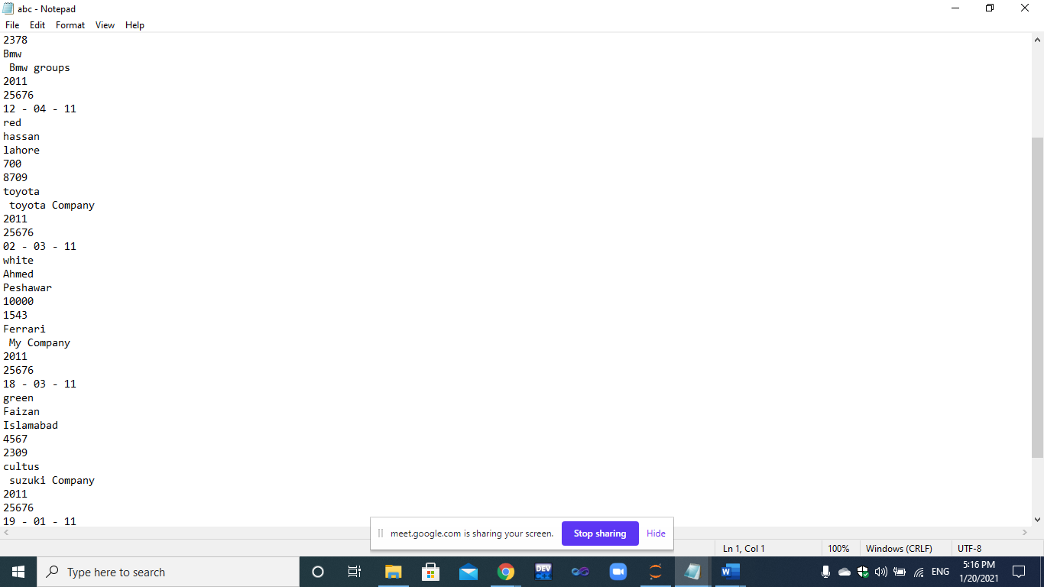

***#Calculation of discounted price***

val2 = input("enter how many cars you want to purchase:")

data = []

val2 = int(val2)

i = val2

while i!=0:

ids = input("enter ID of car you want to purchase:")

ids = int(ids)

data += [ids]

i = i-1

price = 0

for z in range(len(data)):

if data[z] == list1[0]:

price += ((list1[len(list1) -1]))

elif data[z] == list2[0]:

price += ((list2[len(list2) -1]))

elif data[z] == list3[0]:

price += ((list3[len(list3) -1]))

elif data[z] == list4[0]:

price += ((list4[len(list4) -1]))

elif data[z] == list5[0]:

price += ((list5[len(list5) -1]))

print(price)

discounted_price = 0

discount = 20

if val2 > 1:

discounted_price = price - (price * discount / 100)

print (discounted_price)

else:

discounted_price = price

print (discounted_price)

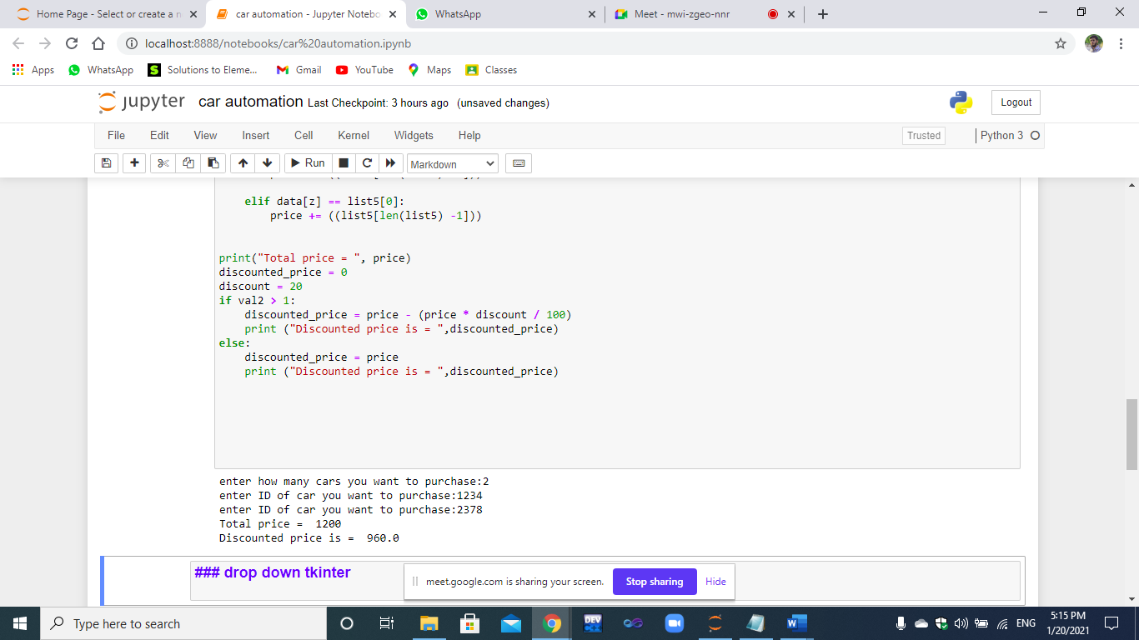

***#use of tinker and drop down***

from tkinter import *

root = Tk()

root.title('CAR AUTOMATION SYSTEM')

root.geometry("400x400")

def selected(event):

mylabel = Label(root, text = clicked.get()).pack()

if clicked.get() == "Acura":

mylabel = Label(root, text=list1).pack()

f = open('pqr.txt','a+')

for i in list1:

f.write(str(i)+'\n')

f.close()

elif clicked.get() == "Bmw":

mylabel = Label(root, text=list2).pack()

f = open('pqr.txt','a+')

for i in list2:

f.write(str(i)+'\n')

f.close()

elif clicked.get() == "Ferrari":

mylabel = Label(root, text=list3).pack()

f = open('pqr.txt','a+')

for i in list3:

f.write(str(i)+'\n')

f.close()

elif clicked.get() == "Toyota":

mylabel = Label(root, text=list4).pack()

f = open('pqr.txt','a+')

for i in list4:

f.write(str(i)+'\n')

f.close()

elif clicked.get() == "cultus":

mylabel = Label(root, text=list5).pack()

f = open('pqr.txt','a+')

for i in list5:

f.write(str(i)+'\n')

f.close()

options = [

"Acura",

"Bmw",

"Ferrari",

"Toyota",

"cultus",

]

clicked = StringVar()

clicked.set(options[0])

drop = OptionMenu(root, clicked, *options, command=selected)

drop.pack(pady=50)

root.mainloop()

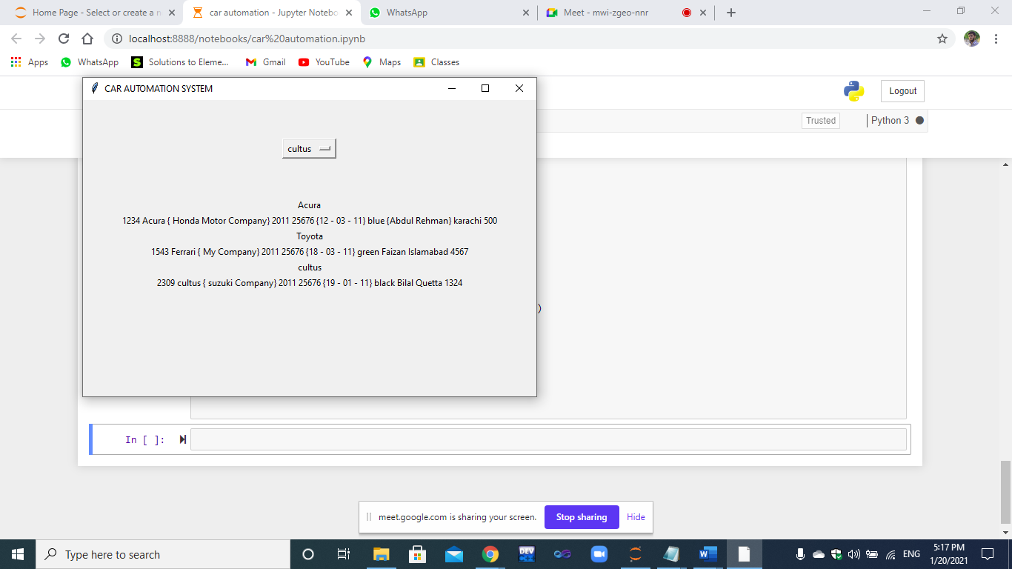

***Sheet 2 screenshot which contains data of those objects which you have selected during drop down***

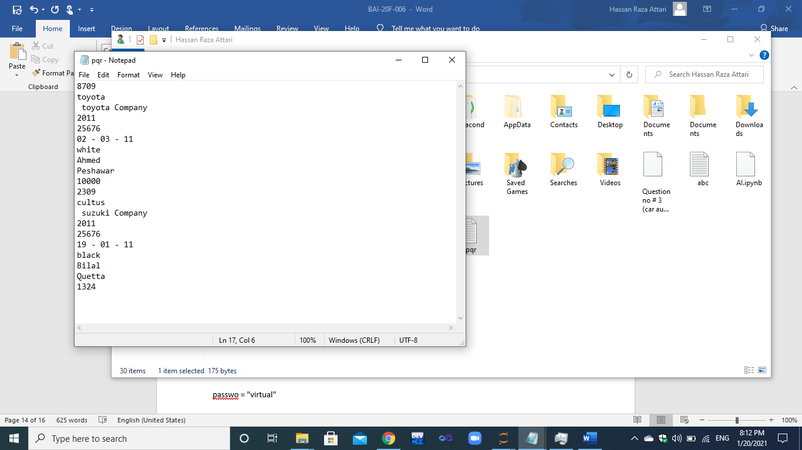

Answer no # 4

passwo = "virtual"

input_str =input("Enter Password: ")

if len(input_str) >= 10:

print ("Error! Only 10 characters allowed!")

data = []

data += input_str

abc = 4

if passwo == input_str:

print("Correct Password")

else:

print("length of string is = " , len(input_str))

print("First Four Characters are = ")

for x in range(4):

print(data[x])

