Project Analogue

DOUBLE SIDEBAND MODULATION

**Names:**

**Sherine Sameh Abdel Aziz 2141**

**Hassam Rezk Moustafa 2145**

**Myriam Reda Dimitry 2159**

**Ahmed Wael 2091**

**Emad Mohamed 2093**

1. **Use your PC to record a short (around 10-20 seconds in duration) audio signal. Use sampling frequency = 48 KHz. Find the spectrum of this signal. It’s important to record a short file or else your PC will take FOREVER to run the simulation.**

First set the sampling frequency ‘fs’ with 48 kHz then read the audio file using the command

[audioSignal, fs] = wavread('p.wav');

Then we can hear the audio signal clearly without any noise using the command ‘sound’

sound(audioSignal,fs)

this audio signal and its spectrum are plotted as shown in figure 1 and 2

**Figure 1 : represent the audio signal in the time domain with frequency 48kHz**

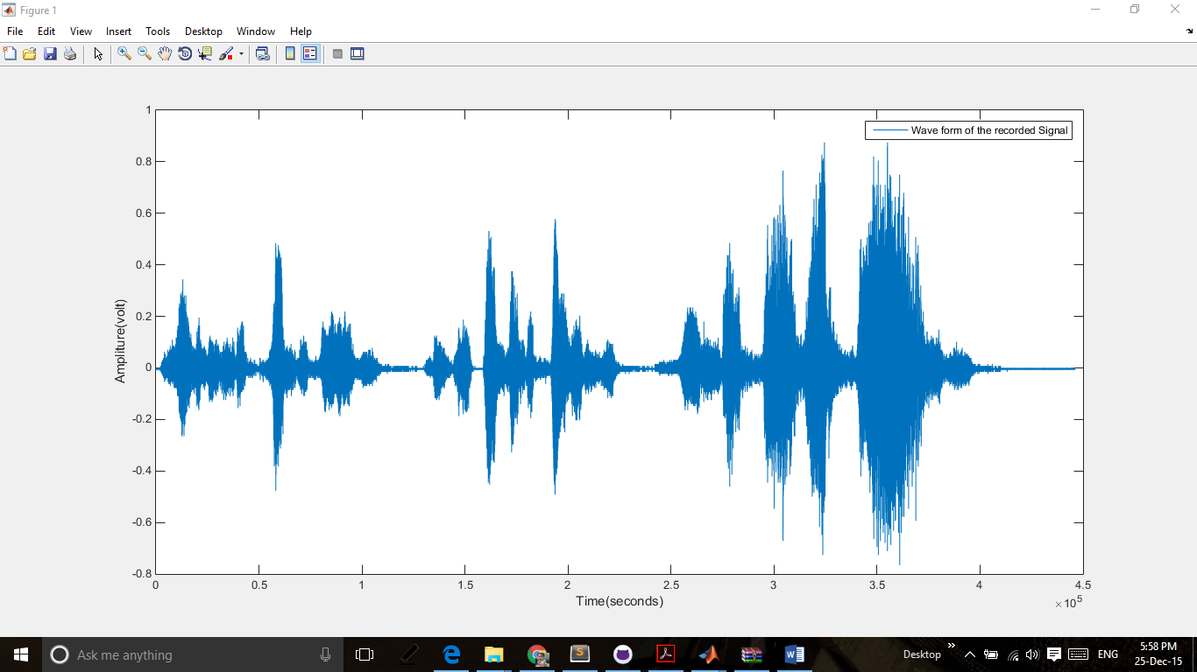

**Figure 2: represent the spectrum of the audio signal in the frequency domain**

We obtain this spectrum using Fourier transform

Signalspectrum =1/fs.*(fftshift(fft(audioSignal)))

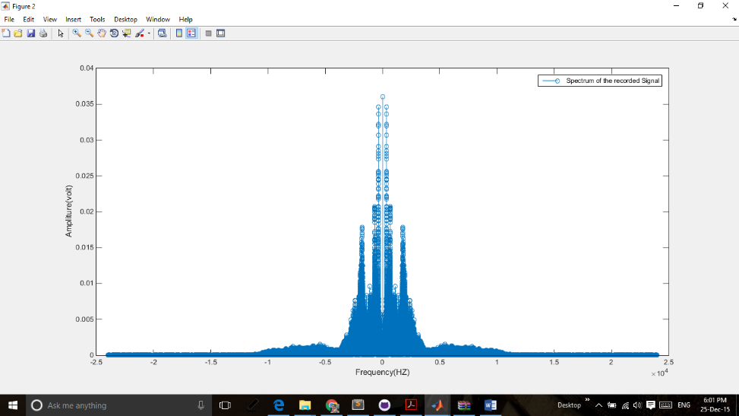

1. **Using an ideal Filter, remove all frequencies greater than 4 KHz.**

First create an ideal filter that will cut all frequencies > 4kHz using a unit step signal

filter = ones(1,length(Signalspectrum)).*(n1 >= -4000 & n1 <= 4000);

Then multiply the original audio signal with this filter to obtain only frequencies <4kHz

**Figure 3: represent the spectrum of the filtered signal**

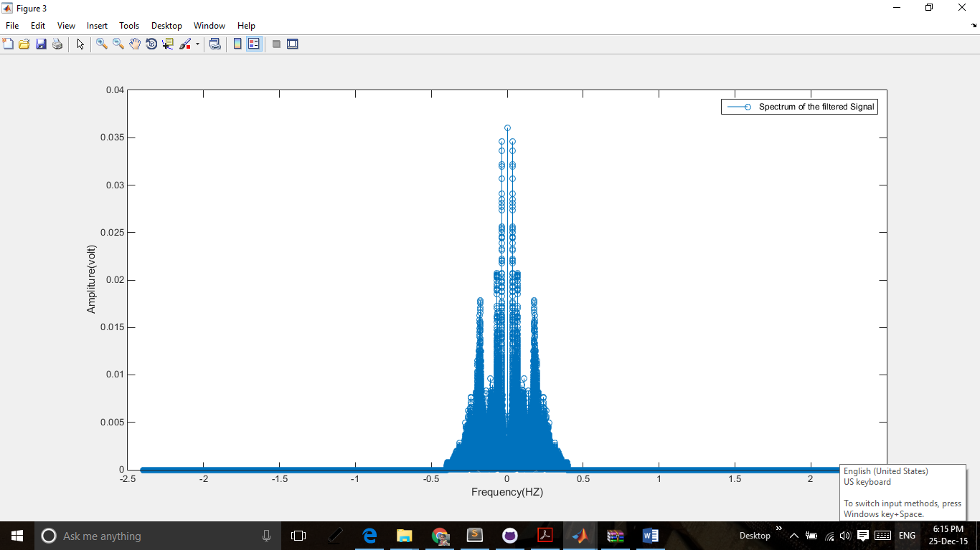

1. **Obtain the filtered signal in time domain, this is a band limited signal of BW=4 KHz.**

After obtaining the filtered signal in the frequency domain we return it to the time domain using inverse of Fourier transform, hear it and plot its absolute to observe the difference between this filtered signal and the original one

WaveFormOfFilteredSignal = fs*ifft(filteredSpectrum);

We observed that the sound was changed and become noisier and not clear because we reduce the frequencies

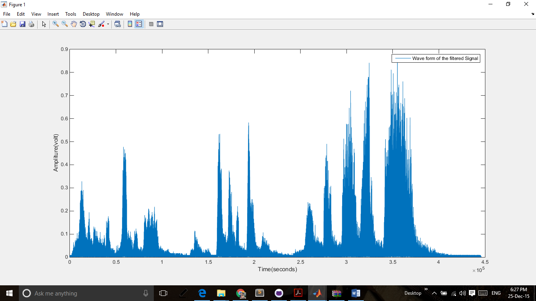**Figure 4: represent the absolute value of the filtered signal in the time domain**

1. **Find the mean square error (MSE) in the band limited signal.**

The mean square error represent the amount of distortion between the original signal and the filtered one after cutting all the frequencies > 4kHz

MSE = sqrt((WaveFormOfFilteredSignal.^2)-(audioSignal.^2));

After computing this error we hear the filtered sound and observed that there exist a small distortion so the sound not clear as the original one

1. **Modulate this carrier with the filtered signal you obtained, you are required to generate both types of modulation.**

Before modulation we resample the filtered signal using the command

WaveFormOfFilteredSignal = resample(WaveFormOfFilteredSignal, Fs, fs);

Where the new Fs = 10^6

1. **Double side band sc:**

After resampling we multiply the new signal by a carrier and then get the spectrum using Fourier transform

carrier = cos(2*pi*Fc*t); where Fc= 3* Fs

**Figure 5 : represent the spectrum of the modulated signal (DSB-SC)**

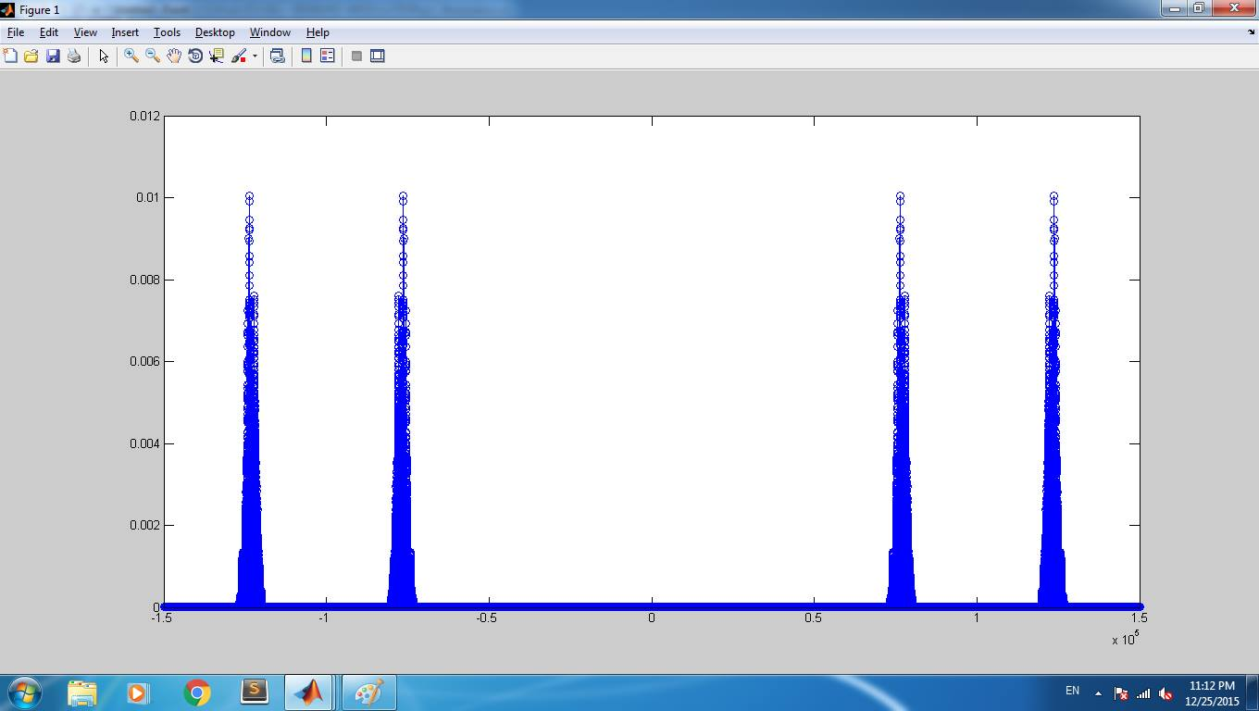

1. **Double side band tc:**

In this case the carrier will be

carrier = Vc * cos(2*pi*Fc*t);

where Vc = 2*max(real(WaveFormOfFilteredSignal))

**Figure 5 : represent the spectrum of the modulated signal (DSB-TC)**

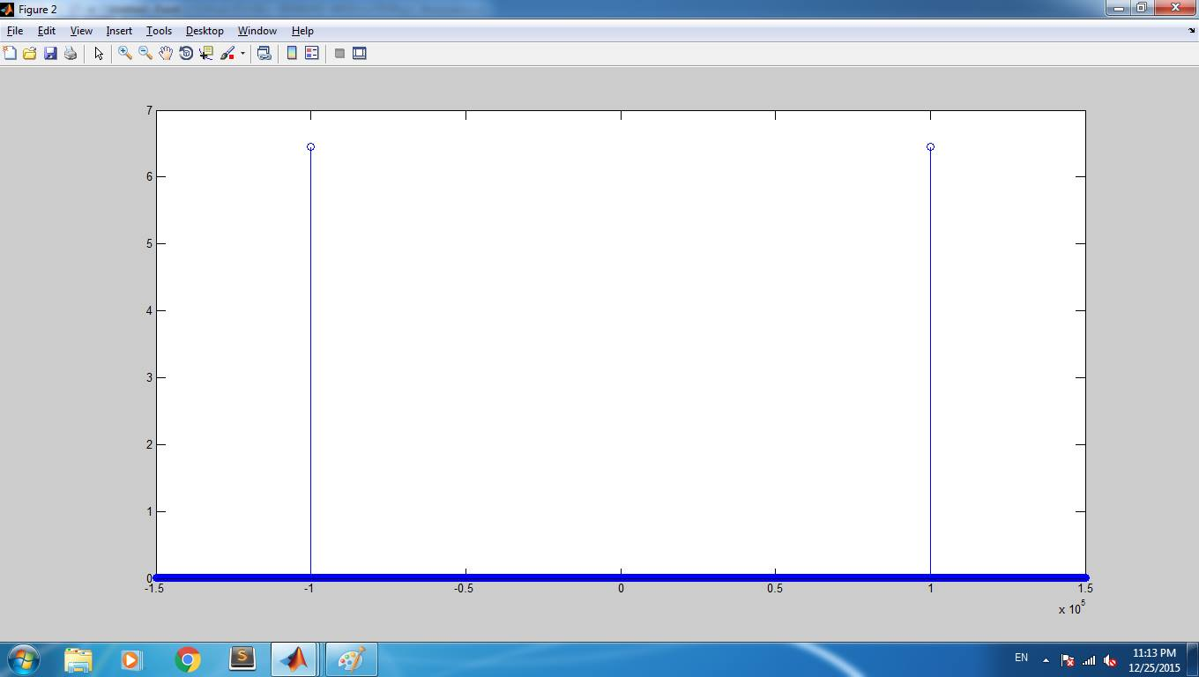

1. **For both types of modulations, use envelop detector to receive the message (assume no noise).**

After modulating the signal we assumed that this signal will be transmitted than received using an envelope with the command:

SC_received = abs(hilbert(SC_time));

The received signal in this case will have some distortion because of the data loss between the transmitter and the receiver and this distortion is shown in the difference between each 2 figures 6&7 for the SC and 8&9 for the TC

**Figure 6: transmitted signal after modulation (DSB-SC) in time domain**

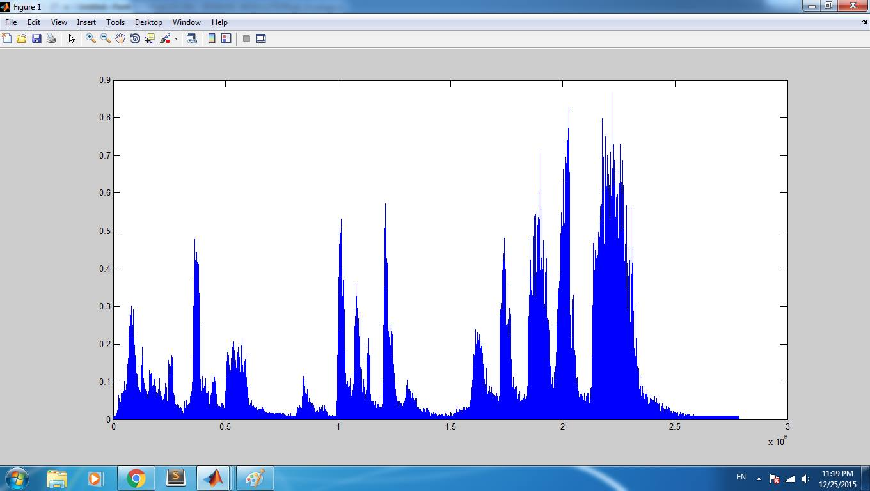

**Figure 7: Received signal after modulation (DSB-SC) in time domain**

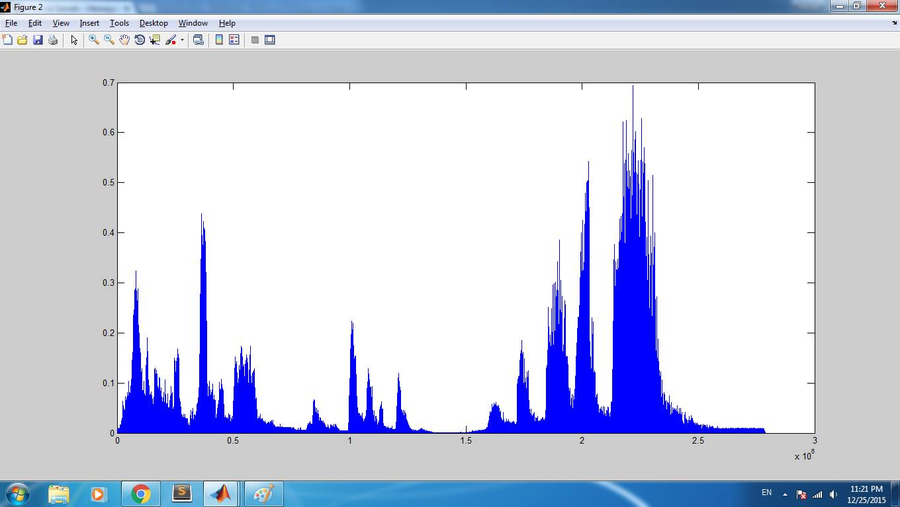

**Figure 8: transmitted signal after modulation (DSB-TC) in time domain**

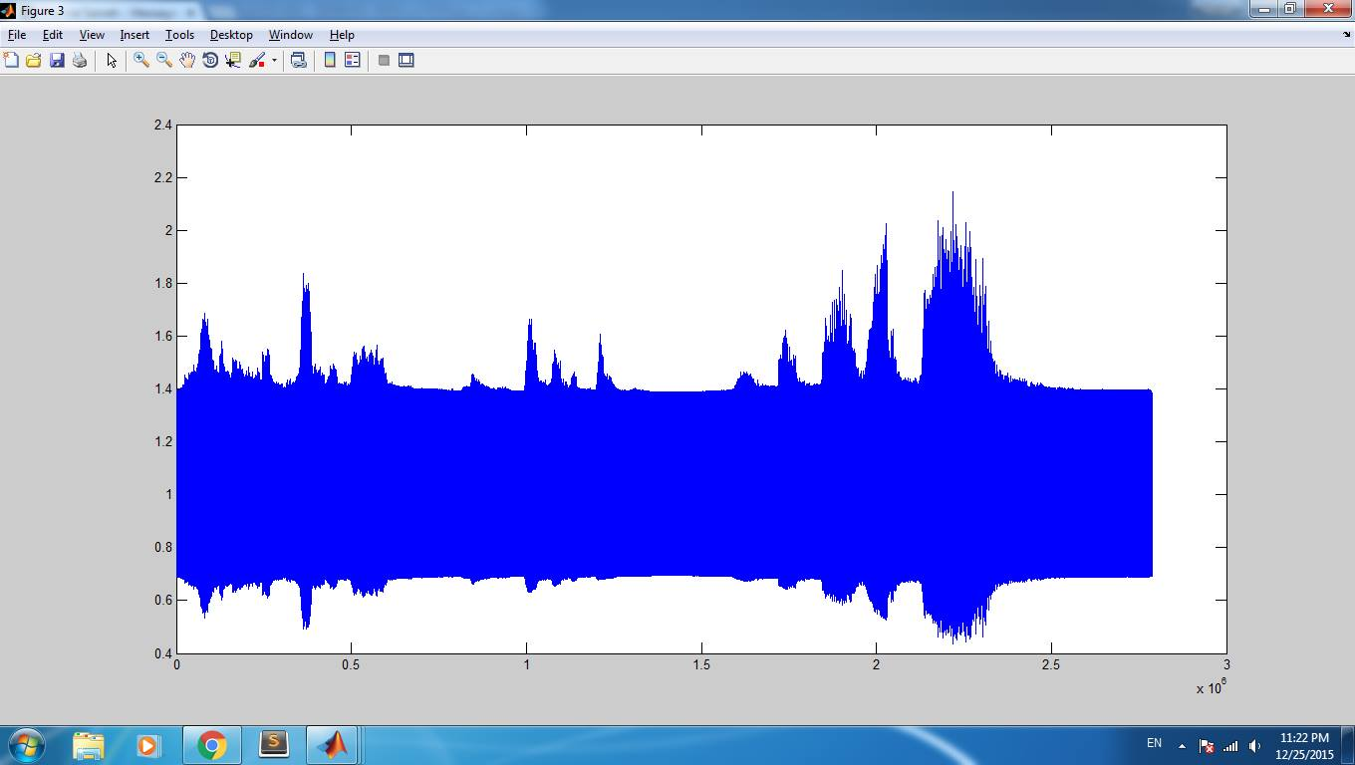

**Figure 9: Received signal after modulation (DSB-TC) in time domain**

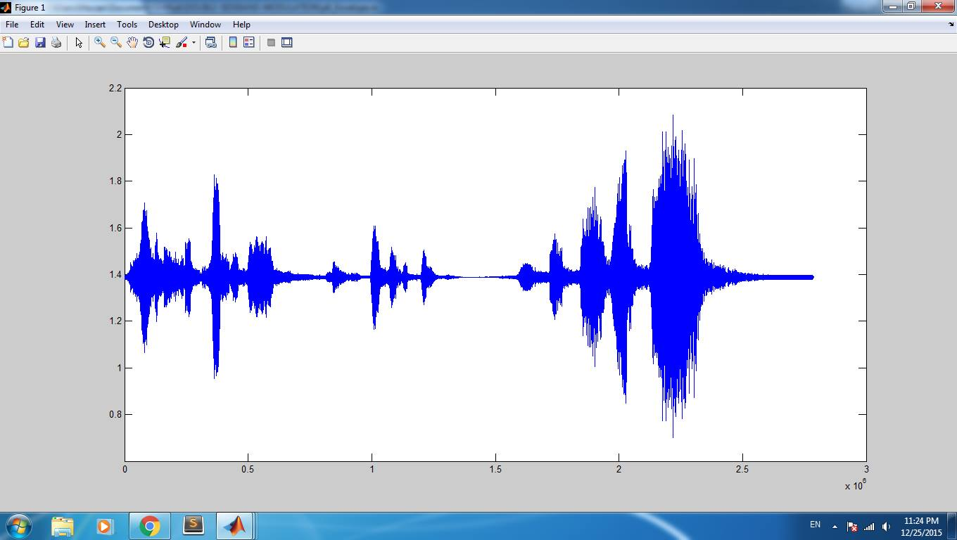

1. **For both modulation types, find the error between the received message and the transmitted message. Play the received signal back. What observation can you make of this?**

As we mention in number(6) there exist an error between the transmitted and the received signal and this error is clear in the figures also when we hear the sound after receiving the signals we observed this error

And to compute the value of this error we use this command

Error_sc = SC_time - SC_received;

And we can plot the value of this vector as shown in figure 10 & 11

**Figure 10: represent the error in case of DSB-SC**

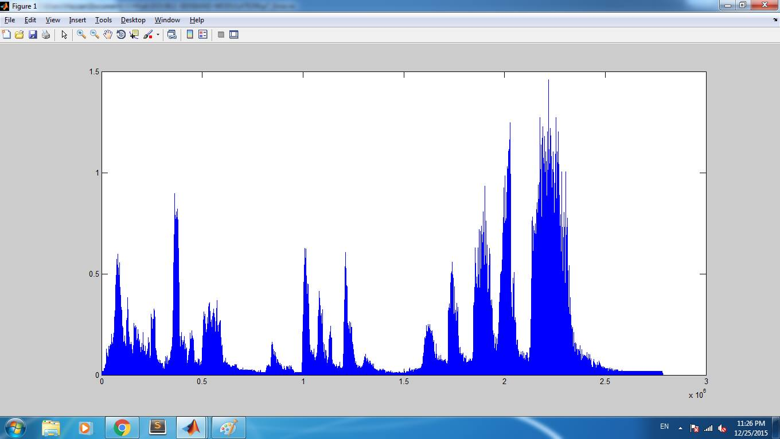

**Figure 11: represent the error in case of DSB-TC**

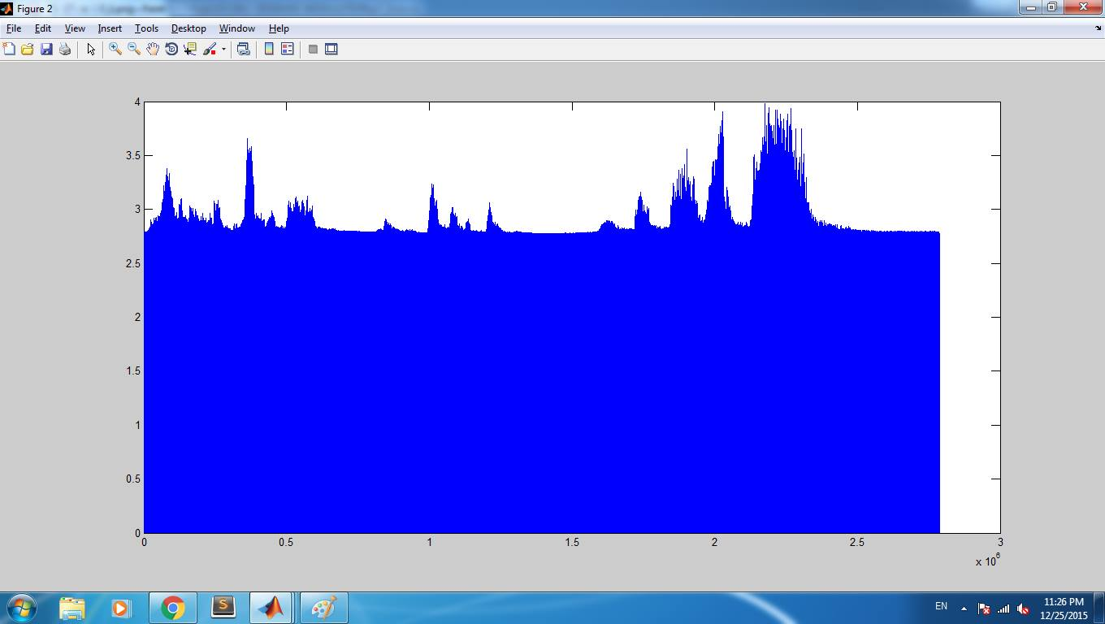

1. **For DSB-TC only, repeat steps 6-8 with SNR = 0, 10, and 20 dB. Play back the sound file each time after detection. What conclusions do you make of that?**

**Case 1- SNR = 0:**

**Case 2- SNR =10:**

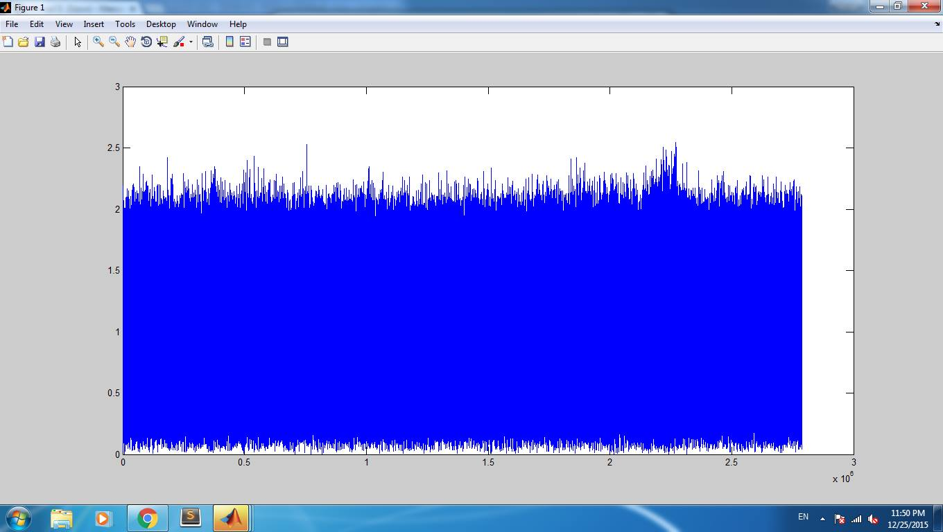

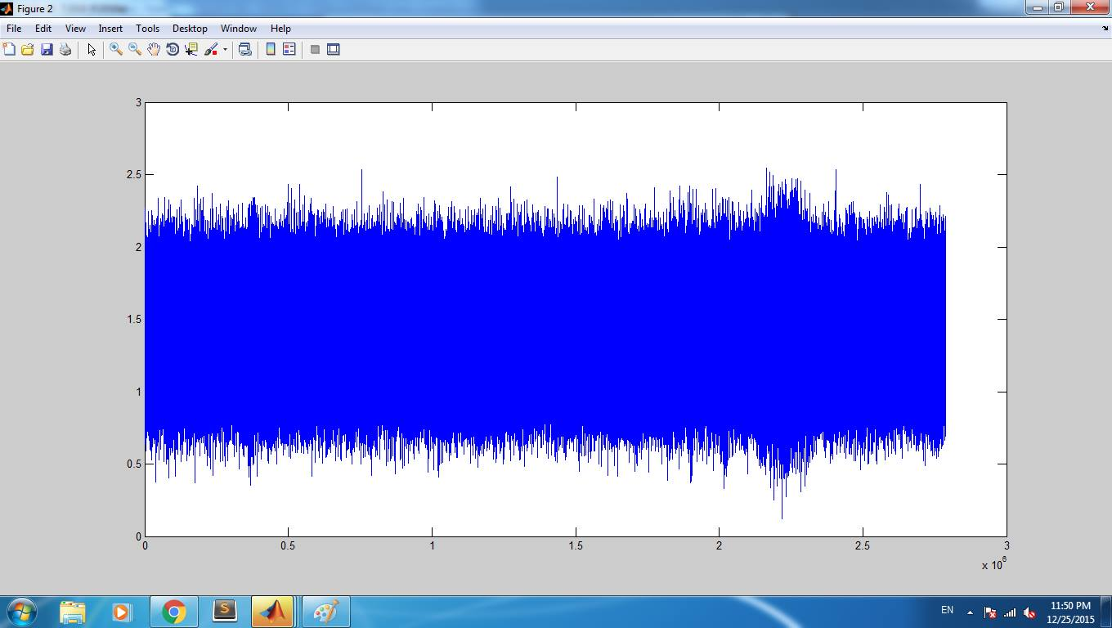

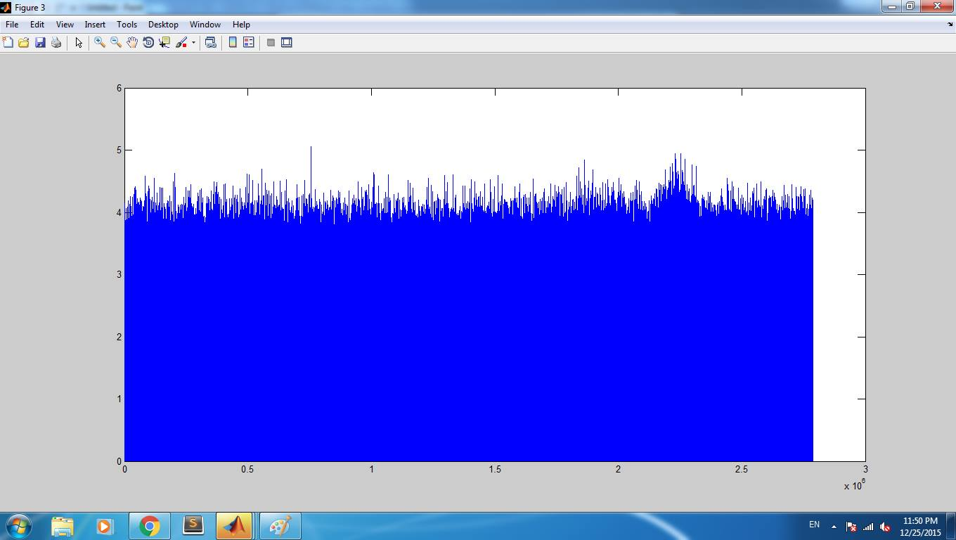

**Case 3- SNR = 20:**

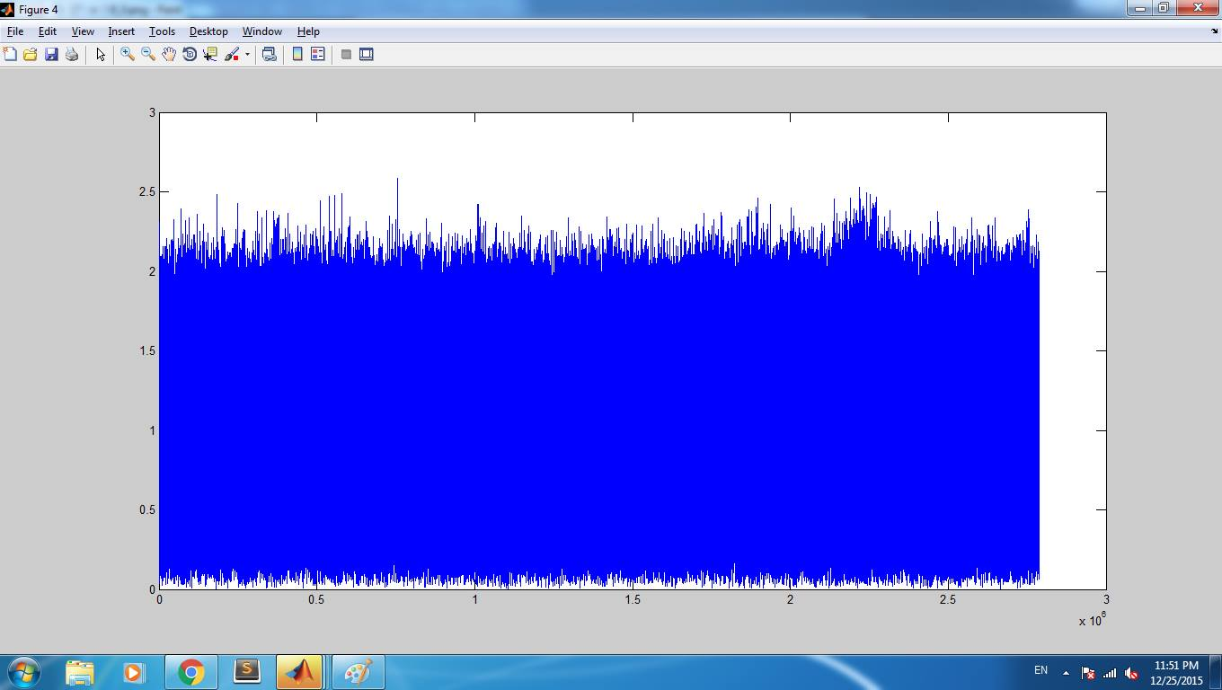

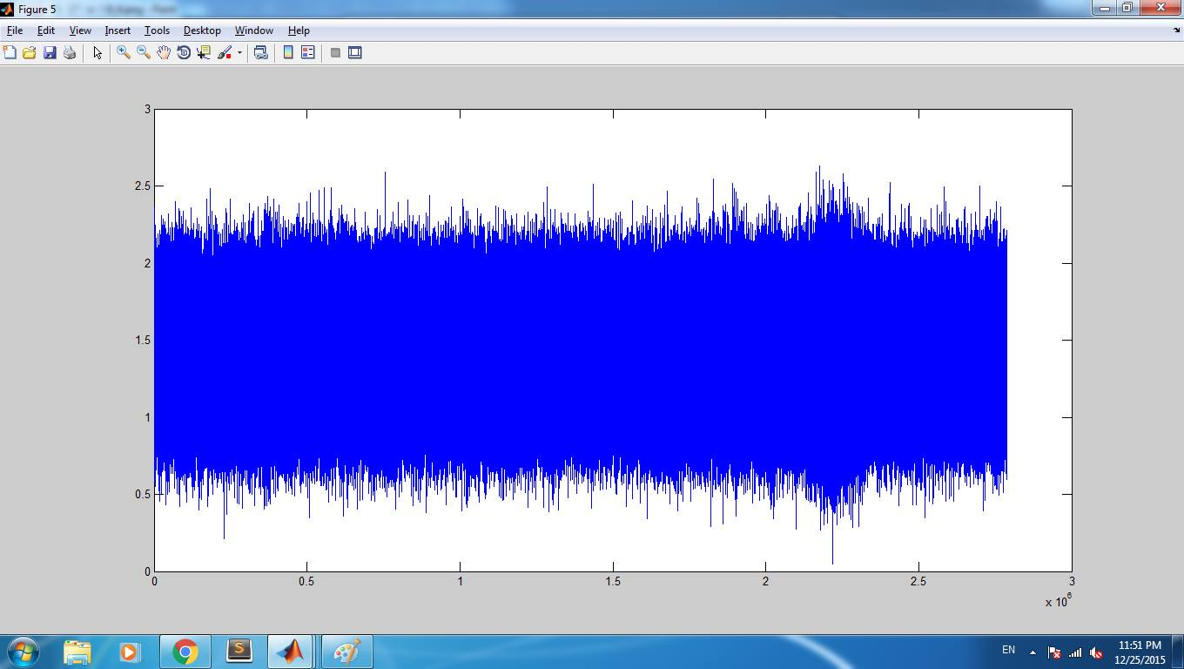

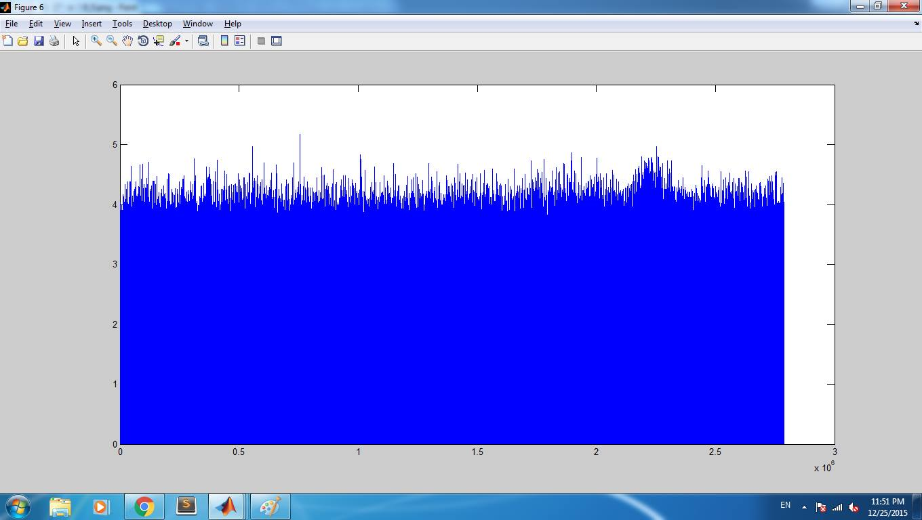

**Conclusion:**

**The error is directly proportional with the amount of noise**

**12. Calculate the power efficiency for both types of modulation. Comment**