

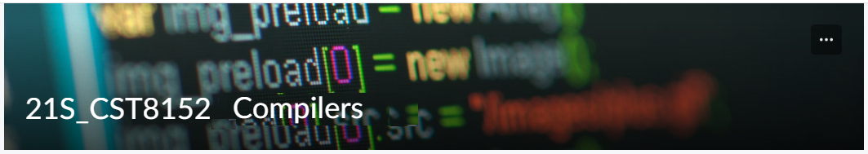

MODEL TASK FOR ASSIGNMENT 2.1 – Learn

Language: Learn
Team – Hassan Salem-041019357

- Note: This task is part of the Assignment 2 from Compilers Course. Any problem, contact your lab professor.

PART 1: RE – Regular Expression (1.5 mark)

Lexeme Classes: Define the classes to be used in your regular expression:

Answer:

(0) L = [A-Za-z] (Letters)
(1) D = [0-9] (Digits)
(2) U = _ (Underscore)
(3) O = [+-*/=<>(),.;:{}&|~^?] (Operators)
(4) S = [ \t\n\r] (Whitespace)
(5) Q = “ (String delimitator - double quotes)
(6) H = # (Hash symbol - used to start a comment)
(7) M = @ (Method delimitator)

ID = L(L|D|U)* (Identifier)
NUM = D+ (Integer number)
STR = Q[^Q]*Q (String literal)
KEY = { break, if, else, elseif, end, for, import, let, return, true, false, while }

Define the RE to be used for: variables, literals and keywords:

Answer:

* Comments: H .*$

* Variables: ID

* Methods: ID @

* Literals:
- Numbers: D+(\.D+)?([Ee][+\-]?D+)?
- Strings: STR (or as defined above): Q[^Q]*Q

* Keywords: (break|if|else(if)?|end|for|import|let|return|true|false|while)\b

PART 2: TD – Transition Diagram (1.5 marks)

Activity: Starting from the previous lexeme classes and obeying the RE, it is possible to define the automata for your language:

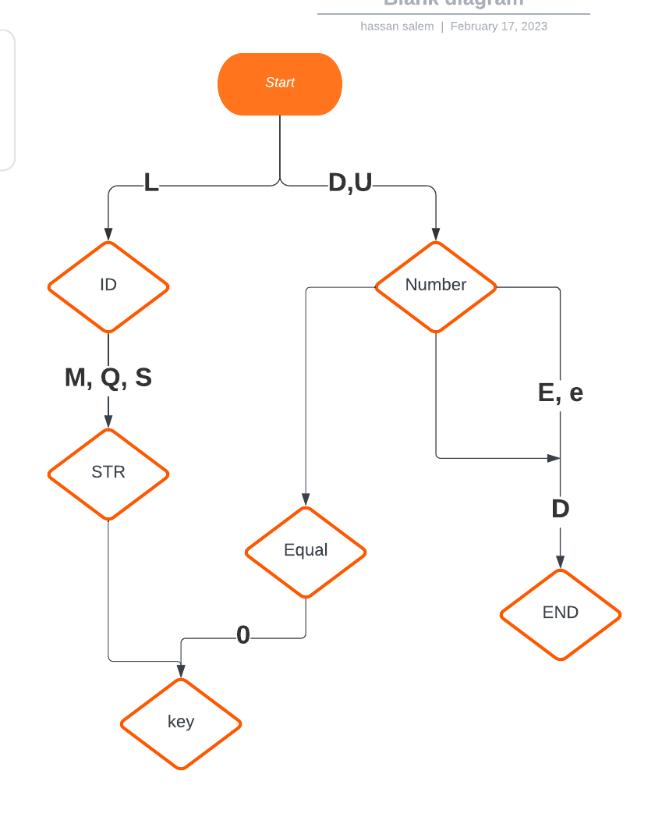

PART 3: TT – Transition Table (2 marks)

Activity: Now, it is possible to define the TT for these lexemes:

Answer (Transition Table):

L D U O S Q H M
S0 S1 S2 NOAS S3 S4 S5 S6 S7
S1 S1 S1 S1 ASWR ASWR ASWR ASWR ASWR
S2 NOAS S2 NOAS ASWR ASWR ASWR ASWR ASWR
S3 NOAS NOAS NOAS NOAS ASWR NOAS ASWR ASWR
S4 ASNR ASNR ASNR ASNR S4 ASNR ASNR ASNR
S5 S5 S5 S5 S5 ASWR S5 S5 S5
S6 NOAS NOAS NOAS NOAS S6 NOAS ASNR NOAS
S7 ASNR ASNR ASNR ASWR ASNR ASNR ASNR ASWR

S0: initial state
S1: identifier state
S2: number state
S3: operator state
S4: whitespace state
S5: string literal state
S6: comment state
S7: method delimitator state

Update: Feb 3rd 2023.

Adapted from resources developed by Prof. Svillen Ranev (Algonquin College, 2019)

