Lab 2 - AI

# Name: Hassan Shahzad

# Class: BSCS 7C

# CMS ID: 211798

## Code:

## Task 1:

import cv2

from google.colab.patches import cv2_imshow

img_grey = cv2.imread('lo.png', cv2.IMREAD_GRAYSCALE)

# define a threshold, 128 is the middle of black and white in grey scale

thresh = 128

# assign blue channel to zeros

img_binary = cv2.threshold(img_grey, thresh, 255, cv2.THRESH_BINARY)[1]

#save image

cv2.imwrite('loz.png',img_binary)

cv2_imshow(img_binary)

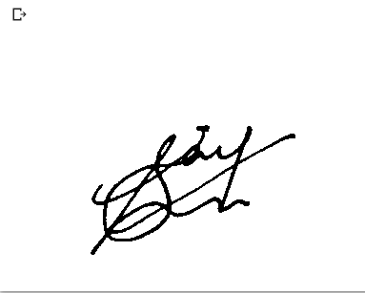

width, height = img_binary.shape

left = width

right = 0

top = height

bottom = 0

for x in range(height ):

  for y in range(width):

    color = img_binary[y, x]

    if color == 0:

      if x >right:

        right = x

      if x < left:

        left = x

      if y > bottom:

        bottom = y

      if y < top:

        top = y

print(left, right, top, bottom)

crop = img_binary[top:bottom, left:right]

cv2_imshow(crop)

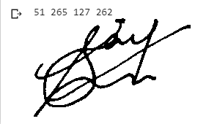

## Task 2:

height, width = crop.shape

cx = 0

cy = 0

n = 0

for x in range(height-1):

  for y in range(width-1):

    if crop[x, y] == 0:

      cx += x

      cy += y

      n += 1

cx /= n

cy /= n

print(cx, cy)

cv2.rectangle(crop_img,(0,0),(cx,cy),(0,255,0),1)

cv2.rectangle(crop_img,(cx,0),(crop_img.shape[1],0),(0,255,0),1)

cv2.rectangle(crop_img,(0,cy),(0,crop_img.shape[0]),(0,255,0),1)

cv2.rectangle(crop_img,(cx,cy),(crop_img.shape[1],crop_img.shape[0]),(0,255,0),1)

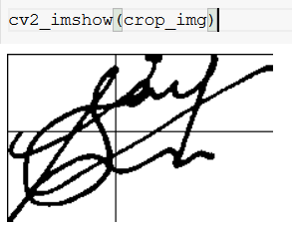



## Task 4:

prev = crop_img[0,0]

n = 0

for  x  in  range(1,crop_img.shape[1],1):

    for y  in  range(1,crop_img.shape[0],1):

      curr = crop_img[y, x]

      if(curr == 255  and  prev == 0):

         n =  n  +  1

      prev = curr

