National University of Sciences & Technology

School of Electrical Engineering and Computer Science

Department of Computing

EE353: Computer Networks, BSCS-7C Fall 2019

|  |  |  |
| --- | --- | --- |
| Home Assignment No 1  Covering the module ‘Introduction’ | | |
| CLO 1: Understand the fundamental building blocks of Computer Networks i.e., Layered approach and protocols that make networking possible | | |
| Maximum Marks: 20 | Instructor: Dr. Arsalan Ahmad | |
| Date: September 25, 2019 | Due Date: mid night 3rd October 2019 | |
| Your Name: Hassan Shahzad | **Your Regn No: 211798** |

**General:**

This is an individual assignment. Fill in your details as listed above. Each student will attempt all these questions in this document and upload the completed document to the course LMS site by the deadline. Submission of pdf is not allowed. Show your calculations in any numeric question (Simply stating the answer would not suffice). Please avoid plagiarism; any such case would result in award of zero marks both to the “sharer” and the “acquirer” for the whole assignment component. Maximum score is 20 points that would be scaled back to 10 marks.

**Q1.** Suppose each user requires 500 kbps and is active only for 25% of the time. How many users can we multiplex on an 8 Mbps link if we want to fulfill user requirements with probability at-least 0.9 using packet switching? What is the Statistical Multiplexing Gain in this case? (**4 points**)

If Circuit Switching then,

Users = 8Mbps/500

= 16 active users

For Packet Switching,

(nCx)px(1-p)(n-x)

N = 50;

X = 16;

=50C16 x (0.25)16x (0.74)34 + ……….. 50C0 x (0.25)0 x (0.75)50

**No. of Users = 0.9**

For SMG,

SMG = 50÷16

**SMG = 3.125**

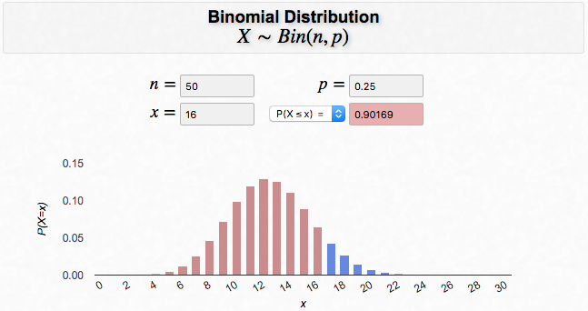

**And if we consider packet switching then**

**Q2.** Consider two hosts, A and B, connected by a single link of rate *R* bps. Suppose that the two hosts are separated by *m* meters, and the propagation speed along the link is *S* meters/sec. Host A is to send a packet of size *L* bits to Host B. (**4 points**)

1. Ignoring the processing and queuing delays, obtain an expression for the end-to-end delay.

Ans) Transmission Delay = L/R

Propagation Delay = m/S

End to End Delay = (L/R + m/S) secs

1. Suppose Host A begins to transmit the packet at time *t=0*. At time *t=dtrans*, where is the last bit of the packet?

Ans) The last bit packet of the packet is on the transmission line at point zero, which is m meters away from the target host B.

1. Suppose *dprop* is greater than *dtrans*. At time *t= dtrans*, where is the first bit of the packet?

Ans) Since Dprop > Dtrans, First bit might be somewhere between host A and B with m-n meters away from the host. (where n is integer in meters from A)

1. Suppose *dprop* is less than d*trans*. At time *t= dtrans*, where is the first bit of the packet?

Ans) Since, DProp < Dtrans, the first bit will already be at the destination which is Host B.

**Q3.** Provide feedback about this CN course/your instructor by suggesting any improvement that is required to enhance the quality and learning experience of this course. (**2 points**)

Ans) The instructor has great hold over the subject and teaches us concepts of Computer Networks very well. However regarding the learning experience, the labs must be a bit competitive, in accordance with the skill that is required in the market.

**Q4.** Consider the following scenario. Two groups Alpha and Bravo have measured RTT from their respective access networks through repeated request/reply to the same server.

Access Network for Bravo

Server

Access Network for Alpha

**Internet**

Bravo

Alpha

The Bravo group provided the following information about their experiment.

“We executed a series of periodic request/reply measurements towards the server. For every request packet k, we record the departure timestamp tk and start a timer. Every request carries a unique ID in the payload that is replicated in the reply packet, in order to correctly correlate the request and the corresponding reply. When the reply packet is received, we record the value of the timer rk. If the reply is not received within a maximum predefined timeout, we mark the request as “lost” and write “-1” in the output file. Consecutive measurements are spaced by 20 ms. The experiment started at 9:16 AM of 25/09/2019”.Alphagroup followed the same methodology except that their start time of the experiment was 9:21 AM of the same day 25/09/2019.

You have been provided with two log files dataAlpha.txt and dataBravo.txt. These files contain two columns, start time tk and the measured RTT. Your task is to process the data, and determine that out of Alpha and Bravo access networks which network has better performance. You have to substantiate your answer with quantitative performance metric values that you have chosen. Also provide any graphs that you made to support your analysis.

(**10 points**)

package com.company;

import java.util.List;

import java.util.Scanner;

import java.io.FileInputStream;

import java.io.FileReader;

import java.io.IOException;

import java.io.BufferedReader;

import java.io.File;

import java.io.InputStreamReader;

import java.lang.reflect.Array;

import java.nio.charset.Charset;

import java.nio.charset.StandardCharsets;

import java.nio.file.Files;

import java.nio.file.Path;

import java.nio.file.Paths;

public class Assignment {

public static void main(String[] args) throws IOException {

String fileName = "D:\NustSemester5\CN\Assignment\dataAlpha.txt";

//using Scanner class for large files, to read line by line

readingData(file_name);

}

public static void readingData(String file_name) throws IOException {

Path path = Paths.get(file_name);

Scanner scan = new Scanner(path);

System.out.println("Reading Text File.....");

int Nooflines =0;

int NegRTT=0;

float TotalTimeRTT=0;

//read line by line

while(scan.hasNextLine()){

Nooflines++;

String line = scan.nextLine();

String[] splitter = line.split("\\s\\s");

float timeRTT = Float.parseFloat(splitter[1]);

if(timeRTT>=0){

TotalTimeRTT += timeRTT;

}

if(timeRTT<0){

NegRTT++;

}

}

scan.close();

System.out.println("---- Data Analysis Program ----“);

System.out.println("Total RTT: "+Nooflines+" seconds");

System.out.println("Total Number of Negative RTT: "+NegRTT);

System.out.println("Total time taken: "+TotalTimeRTT +" seconds");

float negateRTT = (float)NegRTT;

float rateOfSucess= (1- negateRTT/Nooflines)*100;

System.out.printf("Success Rate: "+"%.7f", rateOfSucess + "%");

float AvgTimeRTT= TotalTimeRTT/Nooflines;

System.out.println("\nAverage Time for each Successful Transaction: "+ AvgTimeRTT+" Seconds");

}

}

# Alpha:

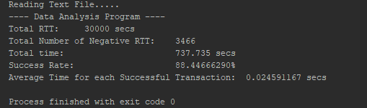

# Bravo:

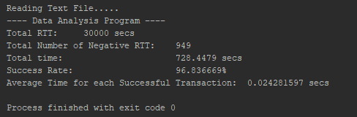

# Conclusion:

Since the success rate of RTT is lower in alpha than in bravo whereas the Average time is higher than in bravo which makes it less efficient. Therefore Bravo access network has better performance.

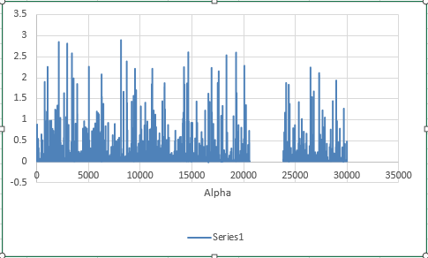

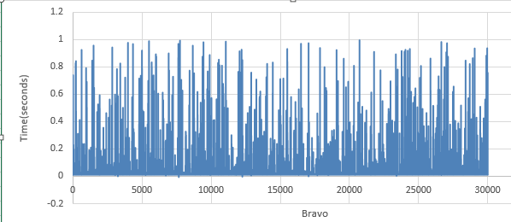

## Considering Graphs:

* The divergence in the data set of Alpha is huge which ranges from 0.0 to 2.8 and has 3466 negative RTT. Alpha has a greater avg time than bravo.
* The divergence in the data set of Bravo ranges from 0.0 to 1.00 and has 949 negative RTT. Bravo has a lesser avg time than Alpha.

## **Hence Bravo is more efficient than Alpha.**