Lab 01

# Name: Hassan Shahzad

# Class: BSCS 7C

# CMS ID: 211798

## Program 1:

**print "Welcome to My first Python Program"**name = raw_input(**"Enter your name: "**)  
age = raw_input(**"Enter your age: "**)  
byear = raw_input(**"Enter your birth year: "**)  
loc = raw_input(**"Enter your birthplace: "**)  
info = {**"Name"**: name, **"Age"**: age, **"Birth Year"**: byear, **"Birth Place"**: loc}  
**print** info  
a = 2  
**if** age > 19:  
 **for** i **in** range(a):  
 **print "You are an adult"  
elif** age <= 19:  
 **for** i **in** range(a):  
 **print "You are a teenager"**

## Output:

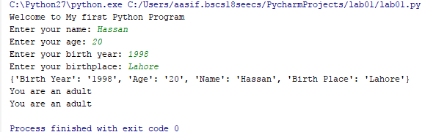

## Program 2:

f = open(**"D:\lab01.txt"**, **"rt"**)  
**print** f.read()  
f.close()

## Output:

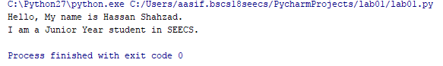

## Program 3:

f = open(**"D:\lab01.txt"**, **"a"**)  
f.write(**"Now the file will have more content"**)  
f.close()

## Output:



## Program 4:

f = open(**"D:\lab01.txt"**, **"w"**)  
f.write(**"Oh no, everything got removed"**)

## Output:

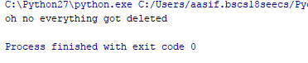

## Program 5:

**def** my_function(x):  
 **return** 10 * x  
  
**print**(my_function(13))  
**print**(my_function(15))  
**print**(my_function(19))

## Output:

