Lab 01

# Name: Hassan Shahzad

# Class: BSCS 7C

# CMS ID: 211798

## Task A)

### cat command to create a new file

### cp command to copy the contents from one file to another file.

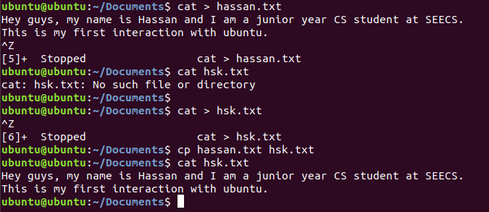

## Task B)

ps command lists all processes running on the pc

-ef switch provides a full format listing

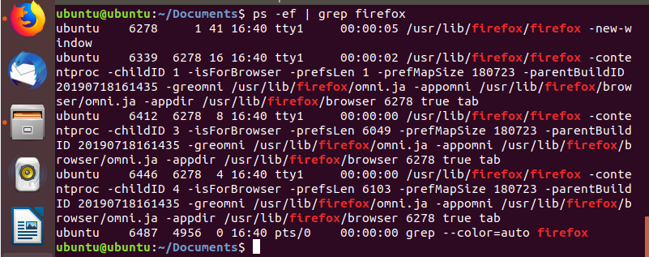

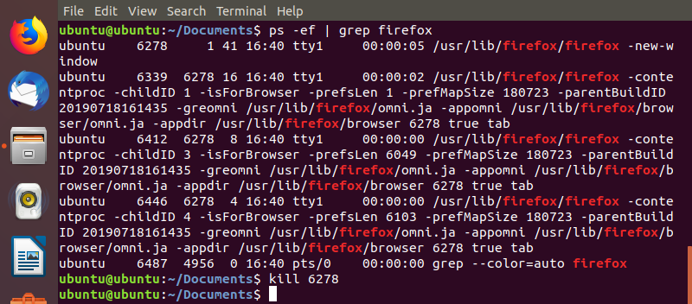

## Task C:

mkdir command is used to make directories

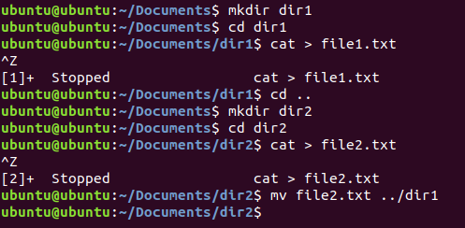

## Task D:

zip command is usedto zip directories and files

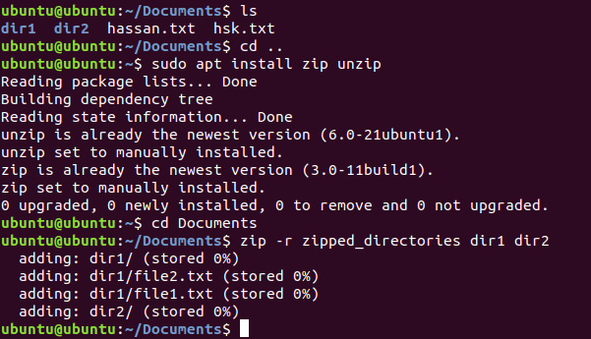

## Task e:

cd Desktop

unzip zip_Directories -d/home/Labs/Documents



## Output:

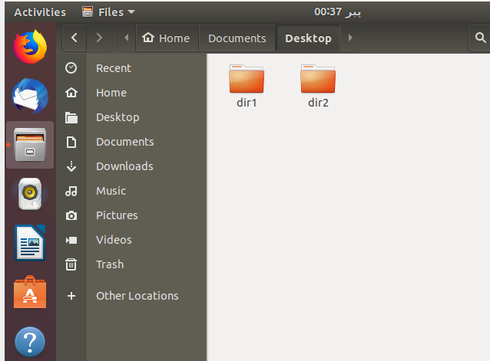

## Task f:

### Gedit command.sh

### Chmod u=rwx command.sh

### ./command.sh

**#!/bin/bash**

**This shows that the scripting would be with shell bash (an enhanced version of original Unix shell program,sh)**

**echo "hello world"**

**Prints hello world**

**for f in *.txt; do**

**f2=${f%%.*}**

**echo filename $f2**

**cat $f | sed 's/(.*)//g' > ${f2}_modified.txt**

**Here the for loop is printing the names of all the text files in the current directory.**

**The sed command shows the modified/edited version of the file without opening it.**

**This program creates an empty file named modified_file.txt**