Lab 05

# Name: Hassan Shahzad

# Class: BSCS 7C

# CMS ID: 211798

# Task 1:

echo "Enter the number: "

read a;

for i in 1 2 3 4 5 6 7 8 9 10

do

echo "$a * $i = `expr $a \* $b`"

done

## Output:

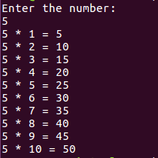

## Task 2:

|  |
| --- |
| #!/bin/bash |
|  | echo "simple calculator" |
|  | sum=0 |
|  | i="y"  while [ $i = "y" ]  do |
|  | echo "enter first number" |
|  | read n1 |
|  | echo "enter second number" |
|  | read n2 |
|  |  |
|  |  |
|  | echo "1.Addition" |
|  | echo "2.Subtraction" |
|  | echo "3.Multiplication" |
|  | echo "4.Division" |
|  | echo "Enter choice" |
|  | read ch |
|  | case $ch in |
|  | 1)sum=$(echo " $n1 + $n2" | bc -l) |
|  | echo "Addition is =" $sum;; |
|  | 2)sum=$(echo "$n1 - $n2" | bc -l) |
|  | echo "Sub is =" $sum;; |
|  | 3)sum=$(echo "$n1 * $n2" | bc -l) |
|  | echo "Mul is =" $sum;; |
|  | 4)sum=$(echo "$n1 / $n2" | bc -l) |
|  | echo "div is =" $sum;; |
|  | *)echo "invalid choice" |
|  | esac |
|  | echo "Do you want to continue" |
|  | read i |
|  | if [ $i != "y" ] |
|  | then |
|  | exit |
|  | fi |
|  | done |

## Output:

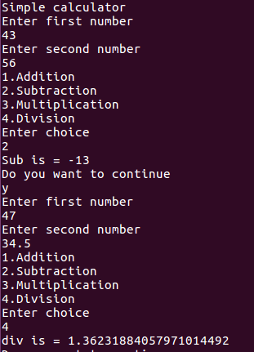

# Output:

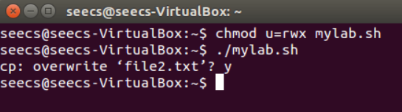

# CODE:

cp -i file.txt file2.txt

sed -i -e &#39;s/.*/\L&amp;/g&#39;

file2.txt

sed -i -e

&#39;s/&lt;[^&gt;]\+&gt;//g&#39; file2.txt

sed -i -e

&#39;s/nust/national

university of

sciences and

technology/g&#39; file2.txt

sed -i -e &#39;s/seecs/school of electrical engineering and computer sciences/g&#39; file2.txt

sed -i -e &#39;s/2134/two thousand one hundred and thirty four/g&#39; file2.txt

sed -i -e &#39;s/9,123/nine thousand one hundred and twenty three/g&#39;

file2.txt