**Lab 9:**

Hassan Shahzad – 211798

**Task 1:**

#include <stdio.h>

#include <pthread.h>

#include <time.h>

#define MAX 16

#define NTHREADS 4

void *thread_function(void *);

pthread_mutex_t mutex1 = PTHREAD_MUTEX_INITIALIZER;

int total_sum = 0;

int a[] = { 1, 5, 7, 10, 12, 14, 15, 18, 20, 22, 25, 27, 30, 64, 110, 220 };

int part = 0;

int main()

{

clock_t start_t, end_t, total_t;

pthread_t thread_id[NTHREADS];

int i, j;

start_t = clock();

for(i=0; i < NTHREADS; i++)

{

pthread_create( &thread_id[i], NULL, thread_function, NULL );

}

for(j=0; j < NTHREADS; j++)

{

pthread_join( thread_id[j], NULL);

}

/* Now that all threads are complete I can print the final result. */

/* Without the join I could be printing a value before all the threads */

/* have been completed. */

printf("Final counter value: %d\n", total_sum);

end_t = clock();

total_t = (double)(end_t - start_t);

printf("Total time taken by CPU: %ld\n", total_t );

return 0;

}

void *thread_function(void *dummyPtr)

{

//printf("Thread number %ld\n", pthread_self());

int thread_part = part++;

for (int i = thread_part * (MAX / 4); i < (thread_part + 1) * (MAX / 4); i++){

pthread_mutex_lock(&mutex1);

total_sum += a[i];

pthread_mutex_unlock( &mutex1 );

}

}

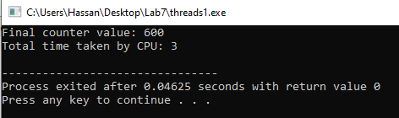

**Task 2:**

#include <stdio.h>

#include <pthread.h>

#include <time.h>

#define MAX 16

#define NTHREADS 4

void *thread_function(void *);

int total_sum = 0;

int a[] = { 1, 5, 7, 10, 12, 14, 15, 18, 20, 22, 25, 27, 30, 64, 110, 220 };

int part = 0;

int sum[4] = { 0 };

int main()

{

clock_t start_t, end_t, total_t;

pthread_t thread_id[NTHREADS];

int i, j;

start_t = clock();

for(i=0; i < NTHREADS; i++)

{

pthread_create( &thread_id[i], NULL, thread_function, NULL );

}

for(j=0; j < NTHREADS; j++)

{

pthread_join( thread_id[j], NULL);

}

/* Now that all threads are complete I can print the final result. */

/* Without the join I could be printing a value before all the threads */

/* have been completed. */

for(int abc= 0;abc<NTHREADS ; abc++){

total_sum +=sum[abc];

}

end_t = clock();

total_t = (double)(end_t - start_t);

printf("Final counter value: %d\n", total_sum);

printf("Total time taken by CPU: %ld\n", total_t );

return 0;

}

void *thread_function(void *dummyPtr)

{

//printf("Thread number %ld\n", pthread_self());

int thread_part = part++;

for (int i = thread_part * (MAX / 4); i < (thread_part + 1) * (MAX / 4); i++){

sum[thread_part] += a[i];

}

}

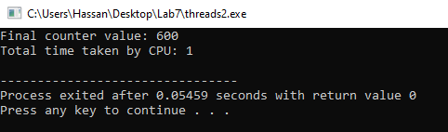

**Task 3:**

Which approach do you think would run faster, and why?

**Answer**:

The clock time also shows the time for the task to run. Task 2 takes less time than task 1 as in task 2, as threads are working concurrently whereas, in task 1 threads execute one by one. Plus in task 1, the threads excess a single global variable whereas, in task2 they access different sum array.