# **Top assignees of the vehicle-related patents**

|  |  |  |  |
| --- | --- | --- | --- |
| **Rank** | **Assignee** | **# of patents** | **Cumulative** |
| 1 | TOYOTA MOTOR CORP | 3602 | 0.052772 |
| 2 | Toyota Jidosha Kabushiki Kaisha | 2992 | 0.043835 |
| 3 | Robert Bosch GmbH | 2508 | 0.036744 |
| 4 | Hyundai Motor Company | 2228 | 0.032642 |
| 5 | HONDA MOTOR CO LTD | 1903 | 0.027880 |
| 6 | NISSAN MOTOR CO LTD | 1374 | 0.020130 |
| 7 | Ford Global Technologies, LLC | 1190 | 0.017434 |
| 8 | Nissan Motor Co., Ltd. | 818 | 0.011984 |
| 9 | Honda Motor Co., Ltd. | 782 | 0.011457 |
| 10 | Honda Giken Kogyo Kabushiki Kaisha | 611 | 0.008952 |
| 11 | DENSO CORP | 603 | 0.008834 |
| 12 | Peugeot Citroen Automobiles SA | 595 | 0.008717 |
| 13 | TOYOTA JIDOSHA KABUSHIKI KAISHA | 551 | 0.008073 |
| 14 | Toyota Motor Corporation | 474 | 0.006944 |
| 15 | MITSUBISHI MOTORS CORP | 457 | 0.006695 |
| 16 | HONDA MOTOR CO., LTD. | 407 | 0.005963 |
| 17 | Hitachi, Ltd. | 351 | 0.005142 |
| 18 | DaimlerChrysler AG | 335 | 0.004908 |
| 19 | NISSAN MOTOR CO., LTD. | 322 | 0.004718 |
| 20 | TOYOTA MOTOR CO., LTD. | 312 | 0.004571 |

# **Top assignees of the vehicle-related patents (Cleaned)**

|  |  |  |  |
| --- | --- | --- | --- |
| **Rank** | **Assignee** | **# of patents** | **Cumulative** |
| 1 | toyota motor corp | 8125 | 0.119037 |
| 2 | honda motor co ltd | 3977 | 0.058266 |
| 3 | nissan motor co ltd | 2885 | 0.042267 |
| 4 | bosch corp | 2770 | 0.040583 |
| 5 | hyundai motor co ltd | 2597 | 0.038048 |
| 6 | ford global technologies inc 1671 | 1671 | 0.024481 |
| 7 | denso corp | 1097 | 0.016072 |
| 8 | mitsubishi motors corp | 899 | 0.013171 |
| 9 | renault sas | 859 | 0.012585 |
| 10 | hitachi ltd | 759 | 0.011120 |
| 11 | peugeot citroen automobiles | 688 | 0.010080 |
| 12 | suzuki motor corp | 528 | 0.007736 |
| 13 | mitsubishi electric corp | 513 | 0.007516 |
| 14 | aisin aw co ltd | 458 | 0.006710 |
| 15 | volkswagen group | 375 | 0.005494 |
| 16 | daimlerchrysler ag | 338 | 0.004952 |
| 17 | continental automotive gmbh | 316 | 0.004630 |
| 18 | isuzu motors ltd | 300 | 0.004395 |
| 19 | gm global technology operations llc | 291 | 0.004263 |
| 20 | siemens aktiengesellschaft | 285 | 0.004175 |

**Distribution of the patent applications over application years**

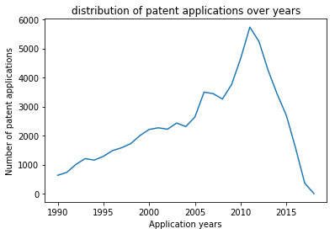

**Topics generated with labels**

|  |  |  |
| --- | --- | --- |
| **Topic #** | **Key terms/words** | **Labels** |
| 1 | mg,suspension,acquire,execution,master,connector,bracket ,cable,module,tooth | Plug-in Modules/ automotive connectors |
| 2 | hydrogen,fuel,water,tank,cell,diesel,oil,disclosure,gas,heat. | fuel cell technology |
| 3 | module,acquisition,suppression,friction,creep,resonance,alternator,slope,slow,traffic. | Automotive Disk Brake |
| 4 | egr,valve,intake,exhaust,open,sound,throttle,recirculation,passage,gas. | exhaust gas recirculation (EGR) system |
| 5 | Gear,shaft,first,transmission,motor,second,planetar,drive,input,mechanism | power branching transmission |
| 6 | Battery,power,voltage,electric,charge,energy,cell,circuit,system,supply. | Battery management system |
| 7 | Conditioner,cabin,compressor,purge,sub,refrigerant,air,cooperation,blower,conditioning | air conditioningsystem |
| 8 | Body,plate,support,fix,part,lock,member,portion,surface,end | Vehicle safety mechanism |
| 9 | Charge,information,electric,communication,station,battery,unit,wireless,user,power | electric vehicle charging station |
| 10 | Catalyst,exhaust,gas,powertrain,fuel,cell,temperature,purification,filter,electrode | Engine Emission Control |
| 11 | injection,fuel,pressure,cylinder,combustion,valve,internal,hev,air,injector | Port fuel injection |
| 12 | Torque,mode,speed,motor,control,hybrid,power,drive,clutch,start | Torque coordinated control in engine For hybrid vehicles |
| 13 | Coil,terminal,magnetic,module,panel,alarm,aspect,key,phase,remote | electronic security system in vehicles |
| 14 | Air,pipe,filter,fuel,cool,oil,inlet,flow,water,chamber | Intercooler*/* oilcoolers |
|  |  |  |

**Change in the number of patents over filing year**

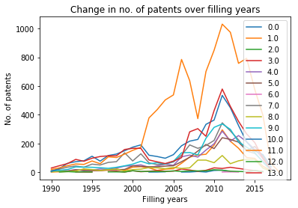

**Change in the share of patents over filing year**

