

**Graduation Project (1) Report**

**Department of Software Engineering**

**Faculty of Information Technology**

**Al-Ahliyya Amman University**

**Accreditation System**

*A project submitted**in partial fulfillment of the requirements for the degree of**Bachelor in Software Engineering*

**by:**

**Bashar Khouri (201710447)**

**Bashar Al-Nimri(201710183)**

**Rama Al-Hadeed(201720506)**

**Hassan Wael(201720593)**

**Supervised by:**

Dr. Faris Al-Taweel

2020/2021

Table of Contents

1. Proposal 4

1.1 Project idea 4

1.2 Project Goals 4

1.3 Provided Services 4

1.4 Stakeholders 4

1.5 Work Domain 5

2. Requirements 5

2.1 Functional Requirements 5

2.2 Non-Functional Requirements 6

2.3 Business goals & Utility tree 6

3. Use Case 7

List of Use Cases 8

3.1 Add Calendar Events 9

3.2 Add Learning Outcomes 9

3.3 Add Project Task 10

3.4 Assess Questions 10

3.5 Compile Course Report 11

3.6 Compile Project Meeting Report 11

3.7 Create Homework 12

3.8 Do Exams 13

3.9 Do Project 13

3.10 Grade Students 14

3.11 Grade Projects 15

3.12 Map Questions To Learning Outcome 16

3.13 Prepare Course Info 16

3.14 Prepare Course Syllabus 17

3.15 Prepare Exams 17

3.16 Provide Data 18

3.17 Track Progress In Projects 18

4. Sequence Diagram 19

4.1 Login 19

4.2 Prepare Course Info 19

4.3 Prepare syllabus 20

4.4 Create Homework 20

4.5 Track Homework 21

4.6 Prepare Exam 21

4.7 Do Exam 22

4.8 Set Students Grade 22

4.9 Compile Project Report 23

4.10 Add Project Task 23

4.11 Do Project 24

4.12 Grade Project 24

4.13 Add Calendar Events 25

4.14 Add Learning Outcomes 25

4.15 Assess Questions 26

5. Class Diagram 27

6. Context Diagram 28

7. Data Flow Diagram 28

8. Database 29-30

8.1 ERD 31

9. Architecture patterns 31

9.1 Architecture patterns in UML 32

10. Deployment Structure 33

11. Lecturer Suport System 34-36

11.1 LSS Module 37

12. Digital Prototyping 38-42

# Proposal

* 1. Project idea:

A workflow manager that follows the official rules of the Institute of Engineering and Technology for evaluating both students and lecturers, based on the following:

A System that tracks all students, lecturers and all materials needed, from student’s grades and Syllabus to the grades expected by the students from their exams, attendance, projects, and homework.

Studying plan should be unified along with the requirements for the IEE and IET to satisfy the needs of the university, thus all lecturers should follow the plan that has to be simplified and easily understood by both students and doctors so that keeping track of the studying plan during the semester can be more efficient and professional.

This system shall involve both students and lecturers for each subject taken by the student and given by the lecturer, with the lecturer keeping track of all his students, their exams, homework, projects, attendance and participation, the amount of material they can understand and apply, the expected results from said students and the actual results by the end of the semester for each subject taken that semester based on the official rules of evaluation of the IET.

* 1. Project Goals:
* Monitoring the progression of the students and lecturers.
* Keep an eye on the results from the students.
* Keep track of the studying plan given in that semester and its importance for the coming subjects
* Unifying all scientific and technical standards for all Doctors and Lecturers and their subjects given during the semester so that we achieve the IET ratings we hope for.
  1. Provided Services:
* Better teaching and more understanding of the IET system.
* Better and more progressive outcome by both students and Lecturers.
  1. Stakeholders:
* Faculty members
* Students
* Dr.Faris M. Taweel (Supervisor)
  1. Work Domain:
* Web App
* Windows Forms

# .

# Requirements:

* 1. **Functional Requirement:**
* The lecturer shall be able to import course data.
* The lecturer shall be able to alter the course syllabus.
* The lecturer shall be able to import the student data according to list of sections.
* The lecturer shall be able to compile Assessment report for graduation project.
* The lecturer shall be able to compile meeting report.
* The lecturer shall be able to compile lecture report.
* The lecturer shall be able to compile course report.
* Upon course completion the lecturer shall be able to compile course report.
* The lecturer shall be able to add new files to the course page.
* The lecturer shall be able to add course study plan.
* The lecturer shall be able to add new events to the course calendar.
* When any new event is available in a course, the students that are registered in the course shall be able to be notified with the event details.
* The lecturer shall be able to add new project tasks.
* The lecturer shall be able to add new CLO to the courses.
* The lecturer shall be able to map the exam questions to the learning outcome.

**2.2 Non-Functional Requirement:**

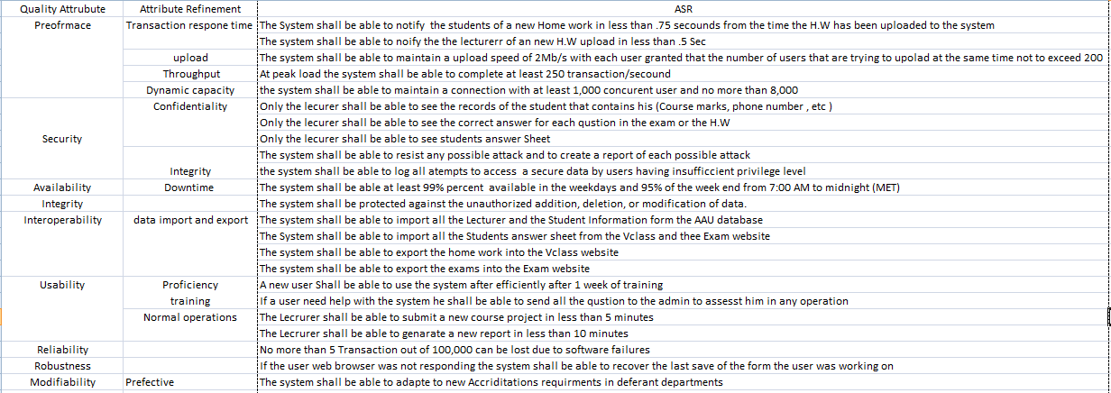

* 1. **Business goals :**
     1. For the system being developed,

<Client (supervisor)> desires that the

<Lecturers> achieve

<Monitoring the progress of students> in the context of

<Graduation Project I> and will be satisfied if

< - Number of iterations done - ?>.

* + 1. For the system being developed,

<Client (supervisor)> desires that the

<Lecturers> achieve

<Monitoring the progress of students> in the context of

<Graduation Project II> and will be satisfied if

< - The system that has been devolved met all the requirement

- ?>.

* + 1. For the system being developed,

<Client (supervisor)> desires that the

<System> achieve

<Tracks lecturer actions> in the context of

<Graduation Project I> and will be satisfied if

<- Lower limit on number of meetings (80%)

- Answer team questions (90%) - ? >.

* + 1. For the accreditation subsystem being developed

<IET Accreditation Scheme> desires that

<SO> achieves

<Assessment Result> in the context of

<Quality Assurance based IET> and will be satisfied if

< - Below standard: Below Basic achievement level of a SO, i.e., percentage attainment is below 54% in the selected main assessment components.

- Approaches standard: Basic achievement level of a SO, i.e. percentage attainment is from 54% up to 65% in the selected main assessment components.

- Meets standard: Proficient achievement level of a SO, i.e., percentage attainment is above 65% up to 80% in the selected main assessment components.

- Exceeds standard: Exemplary achievement level of a SO, i.e., percentage attainment is above 80% in the selected main assessment components >.

* + 1. For the system being developed,

<Client(Supervisor)> desires that

<The System > achieve

<Molecularity and flexibility > in the context of

<Accreditation requirement> and will be satisfied if

<The System adapts to the new requirement>.

* + 1. For the system being developed,

<Client(Supervisor)> desires that

<The Lecturer> achieve

<compile Project meeting report > in the context of

<Graduation project I & II> and will be satisfied if

<All the fields of the report were filed >.

* + 1. For the system being developed,

<Client(Supervisor)> desires that

<The Lecturer> achieve

<compile Assessment report> in the context of

<Course compilation> and will be satisfied if

<- All the Midterm and Final exam marks are registered.

- if the Course project marks are registered.

-IF the Course work marks are Registered

1. **Use Case:**

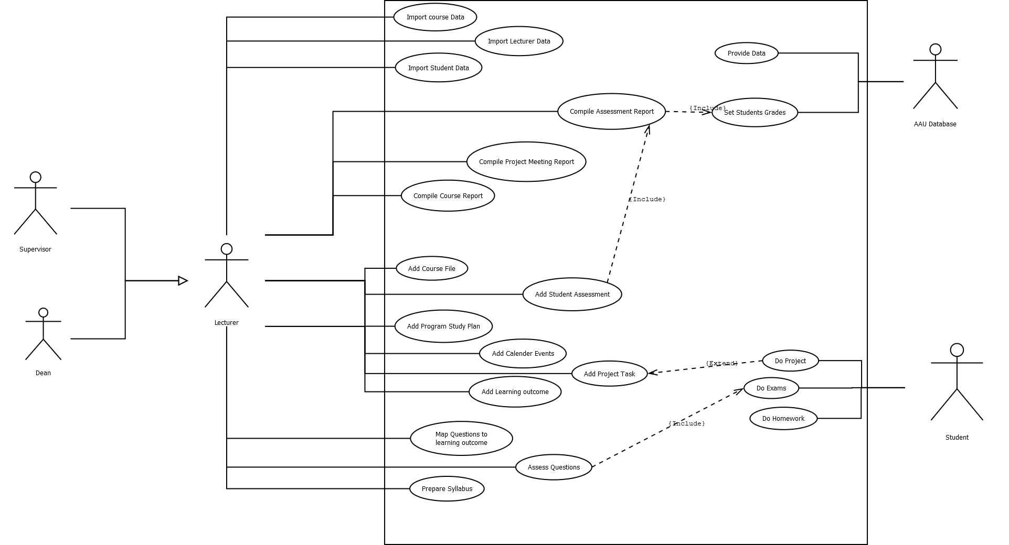

**List Of Use cases**

|  |  |
| --- | --- |
| Use case | Priority |
| Assess Learning outcome | High priority |
| Assess Questions | High priority |
| Add project Task | High priority |
| Add Calendar Events |  |
| Compile Course Report | High priority |
| Compile project Meeting Report | High priority |
| Create Homework | Low priority |
| Do exams | Low priority |
| Do Project | Low priority |
| Grade Projects | High priority |
| Map Questions to learning outcome | High priority |
| Prepare Course info | Low priority |
| Prepare Course syllabus | Low priority |
| Prepare exam | Low priority |
| Provide data | High priority |
| Set students grade | High priority |
| Track Homework | High priority |

**Use Case Description:**

* 1. **Add Calendar Events:**

|  |  |  |  |
| --- | --- | --- | --- |
| **USE CASE NAME:** | Add Calendar Events | | **USE CASE TYPE** |
| **USE CASE ID:** | 20 | | **Business Requirements: 🗹** |
| **PRIMARY BUSINESS ACTOR:** | Lecturer | | |
| **OTHER PARTICIPATING ACTORS:** | * Students | | |
| **OTHER INTERESTED STAKEHOLDERS:** | * none | | |
| **PRE-CONDITION:** | The Lecturer is the one who teach the subject. | | |
| **TYPICAL COURSE** | **Actor Action** | **System Response** | |
| **OF EVENTS:** | **Step 1**: The Lecturer set a Event date | **Step 2**: The System notify the Students of the date of the Event | |

* 1. **Add Learning Outcomes:**

|  |  |  |  |
| --- | --- | --- | --- |
| **USE CASE NAME:** | Add Learning Outcome | | **USE CASE TYPE** |
| **USE CASE ID:** | 22 | | **Business Requirements: 🗹** |
| **PRIORITY:** | High priority | |  |
| **PRIMARY BUSINESS ACTOR:** | Lecturer | | |
| **OTHER PARTICIPATING ACTORS:** | none | | |
| **OTHER INTERESTED STAKEHOLDERS:** | * none | | |
| **DESCRIPTION:** | Lecturer defines the quality after assessing the students, setting the quality average for the subject | | |
| **PRE-CONDITION:** | Finished all materials needed for said questions. | | |
| **TRIGGER:** | Due date for the semester | | |
| **TYPICAL COURSE** | **Actor Action** | **System Response** | |
| **OF EVENTS:** | **Step 1**: Lecturer reviews the material he had given during the lectures | **Step 2**: | |
|  | Lecturer defines the quality of the outcome by the students |  | |
| **POST-CONDITION:** | Learning outcome is now known and can be set as a standard | | |

* 1. **Add Project Task:**

|  |  |  |  |
| --- | --- | --- | --- |
| **USE CASE NAME:** | Add Project Task | | **USE CASE TYPE** |
| **USE CASE ID:** | 21 | | **Business Requirements: 🗹** |
| **PRIORITY:** | High priority | |  |
| **PRIMARY BUSINESS ACTOR:** | Lecturer | | |
| **OTHER PARTICIPATING ACTORS:** | none | | |
| **OTHER INTERESTED STAKEHOLDERS:** | * none | | |
| **DESCRIPTION:** | Lecturer sets a specific project for the students to do | | |
| **PRE-CONDITION:** | Finished all materials needed for said project. | | |
| **TRIGGER:** | Due date for the semester | | |
| **TYPICAL COURSE** | **Actor Action** | **System Response** | |
| **OF EVENTS:** | **Step 1**: Lecturer reviews the material he had given during the lectures | **Step 2**: | |
|  | Lecturer defines the project and the material students can use for the project |  | |
| **POST-CONDITION:** | Giving students a project to assess their understanding of the subject | | |

* 1. **Assess Questions:**

|  |  |  |  |
| --- | --- | --- | --- |
| **USE CASE NAME:** | Assess Questions | | **USE CASE TYPE** |
| **USE CASE ID:** | 24 | | **Business Requirements: 🗹** |
| **PRIORITY:** | High priority | |  |
| **PRIMARY BUSINESS ACTOR:** | Lecturer | | |
| **OTHER PARTICIPATING ACTORS:** | none | | |
| **OTHER INTERESTED STAKEHOLDERS:** | * none | | |
| **DESCRIPTION:** | Lecturer defines the quality of the questions given for the exam | | |
| **PRE-CONDITION:** | Finished all materials needed for said exam. | | |
| **TRIGGER:** | Due date for midterm and final exams | | |
| **TYPICAL COURSE** | **Actor Action** | **System Response** | |
| **OF EVENTS:** | **Step 1**: Lecturer reviews the material he had given during the lectures | **Step 2**: | |
|  | Specifies the nature of the questions that will be put for the exam |  | |
| **POST-CONDITION:** | Sets an exam with the right quality for the students based on their outcomes | | |

* 1. **Compile Course Report:**

|  |  |  |  |
| --- | --- | --- | --- |
| **USE CASE NAME:** | Compile Course Report | | **USE CASE TYPE** |
| **USE CASE ID:** | 3 | | **Business Requirements: 🗹** |
| **PRIMARY BUSINESS ACTOR:** | Teacher | | |
| **OTHER PARTICIPATING ACTORS:** | * none | | |
| **OTHER INTERESTED STAKEHOLDERS:** | * none | | |
| **PRE-CONDITION:** | Course must exist in the Major plan | | |
| **TRIGGER:** |  | | |
| **TYPICAL COURSE** | **Actor Action** | **System Response** | |
| **OF EVENTS:** | **Step 2**: Select Course | **Step 1**: Provide List Of Courses | |
|  | **Step 3**: Write the Report for the Course | **Step 5**: post report for evaluation | |
|  | **Step 4**: Submit report |  | |

* 1. **Compile Project Meeting Report:**

|  |  |  |  |
| --- | --- | --- | --- |
| **USE CASE NAME:** | Compile Project Meeting Report | | **USE CASE TYPE** |
| **USE CASE ID:** | 15 | | **Business Requirements: 🗹** |
| **PRIMARY BUSINESS ACTOR:** | Lecturer | | |
| **OTHER PARTICIPATING ACTORS:** | * none | | |
| **OTHER INTERESTED STAKEHOLDERS:** | * none | | |
| **TYPICAL COURSE** | **Actor Action** | **System Response** | |
| **OF EVENTS:** | **Step 1**: The Lecturer Choose to Compile The Project Meeting Report | **Step 2**: The System Provide the Report template prefilled with the participates names and the date of that meeting | |
|  | **Step 3**: The Lecturer Write fills the Template with the rest of the information. |  | |
|  | **Step 4**: The Lecturer submit the Report |  | |

* 1. **Create Homework:**

|  |  |  |  |
| --- | --- | --- | --- |
| **USE CASE NAME:** | Create Homework | | **USE CASE TYPE** |
| **USE CASE ID:** | 7 | | **Business Requirements: 🗹** |
| **PRIORITY:** | High priority | |  |
| **PRIMARY BUSINESS ACTOR:** | Teacher | | |
| **OTHER PARTICIPATING ACTORS:** | * none | | |
| **OTHER INTERESTED STAKEHOLDERS:** | * none | | |
| **DESCRIPTION:** | Homework based on the material taken during the lectures. | | |
| **PRE-CONDITION:** | Finishing the material needed for said homework during lectures. | | |
| **TRIGGER:** | Milestones in the subject | | |
| **TYPICAL COURSE** | **Actor Action** | **System Response** | |
| **OF EVENTS:** | **Step 1**: the Lecturer Select View Courses | **Step 2**: The system view all the Courses that that Lecturer teach | |
|  | **Step 3**: the lecturer select the desired Course | **Step 4**: the System view all the details about that course | |
|  | **Step 5**:The lecturer select add home work | **Step 6**: the System sends a form for the home work to the lecturer | |
|  | **Step 7**: the lecturer fill the form  Matching the questions with the desired learning outcome for the accreditation program |  | |
|  | **Step 8**: the lecturer submit the form | **Step 9**: the System notify all the students in that course about the Home work | |
| **POST-CONDITION:** | Collect homework and start grading | | |
| **OPEN ISSUES:** | 1. Students not doing the homework | | |

* 1. **Do Exams:**

|  |  |  |  |
| --- | --- | --- | --- |
| **USE CASE NAME:** | Do Exams | | **USE CASE TYPE** |
| **USE CASE ID:** | 26 | | **Business Requirements: 🗹** |
| **PRIORITY:** | High priority | |  |
| **SOURCE:** |  | |  |
| **PRIMARY BUSINESS ACTOR:** | Student | | |
| **OTHER PARTICIPATING ACTORS:** | Lecturer | | |
| **OTHER INTERESTED STAKEHOLDERS:** | * none | | |
| **DESCRIPTION:** | Student takes the midterm and final examinations | | |
| **PRE-CONDITION:** | Studied/Took the material included in said exams | | |
| **TRIGGER:** | Due date for midterms and final exams | | |
| **TYPICAL COURSE** | **Actor Action** | **System Response** | |
| **OF EVENTS:** | **Step 1**: Student takes lectures | **Step 2**: | |
|  | Takes specified material for the exam |  | |
|  | Takes the exam |  | |
| **POST-CONDITION:** | Handing in the exam | | |
| **OPEN ISSUES:** | 1. Not attending the exam | | |

* 1. **Do Project:**

|  |  |  |  |
| --- | --- | --- | --- |
| **USE CASE NAME:** | Do Project | | **USE CASE TYPE** |
| **USE CASE ID:** | 25 | | **Business Requirements: 🗹** |
| **PRIORITY:** | High priority | |  |
| **PRIMARY BUSINESS ACTOR:** | Student | | |
| **OTHER PARTICIPATING ACTORS:** | Lecturer | | |
| **OTHER INTERESTED STAKEHOLDERS:** | * none | | |
| **DESCRIPTION:** | Student creates his project and hands it in on due date | | |
| **PRE-CONDITION:** | Finished all materials needed for said project. | | |
| **TRIGGER:** | Due date for the semester | | |
| **TYPICAL COURSE** | **Actor Action** | **System Response** | |
| **OF EVENTS:** | **Step 1**: Student takes lectures | **Step 2**: | |
|  | Takes specified material for the project |  | |
|  | Creates the project and presents it |  | |
| **POST-CONDITION:** | Gets graded for the project | | |
| **OPEN ISSUES:** | 1. Not presenting the project | | |

* 1. **Grade Students:**

|  |  |  |  |
| --- | --- | --- | --- |
| **USE CASE NAME:** | Grade Students | | **USE CASE TYPE** |
| **USE CASE ID:** | 5 | | **Business Requirements: 🗹** |
| **SOURCE:** | Teacher | |  |
| **PRIMARY BUSINESS ACTOR:** | Teacher | | |
| **OTHER PARTICIPATING ACTORS:** | * Students | | |
| **OTHER INTERESTED STAKEHOLDERS:** | none | | |
| **DESCRIPTION:** | Check the answers and put marks for the questions | | |
| **PRE-CONDITION:** | The student should took the exam before | | |
| **TRIGGER:** | Teacher selects the option for Grade students | | |
| **TYPICAL COURSE** | **Actor Action** | **System Response** | |
| **OF EVENTS:** | **Step 1**: | **Step 2**: | |
|  | Teacher clicks grade students option | Open a new page | |
|  | Mark every question | Check if the mark doesn’t exceeds the full mark for the question | |
|  |  |  | |
|  | Select save | Compute the marks and save it for the student | |
|  |  | Go to home page | |
| **BUSINESS RULES** | * Finished the material needed for the exam * He is the assigned for this class | | |

* 1. **Grade Projects:**

|  |  |  |  |
| --- | --- | --- | --- |
| **USE CASE NAME:** | Grading students work | | **USE CASE TYPE** |
| **USE CASE ID:** | 9 | | **Business Requirements: 🗹** |
| **PRIORITY:** | High priority | |  |
| **PRIMARY BUSINESS ACTOR:** | Teacher | | |
| **OTHER PARTICIPATING ACTORS:** | * none | | |
| **OTHER INTERESTED STAKEHOLDERS:** | * none | | |
| **DESCRIPTION:** | Taking the student’s work from projects to homework, grading them and setting specific amount of marks to each category or topic covered in the project/homework. | | |
| **PRE-CONDITION:** | Finishing the material needed for said project during lectures. | | |
| **TRIGGER:** | Milestones in the subject | | |
| **TYPICAL COURSE** | **Actor Action** | **System Response** | |
| **OF EVENTS:** | **Step 1**: Hand in projects and homework on due time | **Step 2**: | |
|  | Go through the work and grade it based on the marks given to each category |  | |
|  | Hand in marks to accumulate total mark for each student |  | |
| **POST-CONDITION:** | Give out final marks to students | | |
| **OPEN ISSUES:** | 1. Not having a project or a homework to grade due to not having it handed in time | | |

* 1. **Map Questions To Learning Outcome:**

|  |  |  |  |
| --- | --- | --- | --- |
| **USE CASE NAME:** | Map Questions to learning outcome | | **USE CASE TYPE** |
| **USE CASE ID:** | 23 | | **Business Requirements: 🗹** |
| **PRIORITY:** | High priority | |  |
| **PRIMARY BUSINESS ACTOR:** | Lecturer | | |
| **OTHER PARTICIPATING ACTORS:** | none | | |
| **OTHER INTERESTED STAKEHOLDERS:** | * none | | |
| **DESCRIPTION:** | Defines the questions based on students average understanding of the material, based on the nature of the subject | | |
| **PRE-CONDITION:** | Finished all materials needed for said questions. | | |
| **TRIGGER:** | Due date for midterm and final exams | | |
| **TYPICAL COURSE** | **Actor Action** | **System Response** | |
| **OF EVENTS:** | **Step 1**: Lecturer reviews the material he had given during the lectures | **Step 2**: | |
|  | Lecturer defines the quality of the outcome by the students |  | |
|  | Lecturer puts questions based on the achieved quality by the students |  | |
| **POST-CONDITION:** | Sets an exam with the right quality for the students based on their outcomes | | |

**3.13 Prepare Course Info:**

|  |  |  |  |
| --- | --- | --- | --- |
| **USE CASE NAME:** | Prepare Course Info | | **USE CASE TYPE** |
| **USE CASE ID:** | 1 | | **Business Requirements: 🗹** |
| **PRIMARY BUSINESS ACTOR:** | Teacher | | |
| **OTHER PARTICIPATING ACTORS:** | * none | | |
| **OTHER INTERESTED STAKEHOLDERS:** | * none | | |
| **PRE-CONDITION:** | Course must exist in the Major plan | | |
| **TRIGGER:** |  | | |
| **TYPICAL COURSE** | **Actor Action** | **System Response** | |
| **OF EVENTS:** | **Step 1**: Select Course that the Teacher will Teach | **Step 4**: Save the Info into the Database | |
|  | **Step 2**:Write the needed Information about the Course | **Step 5**: Update course website with the new course information | |
|  | **Step 3**: publish the Course Info |  | |

* 1. **Prepare Course Syllabus:**

|  |  |  |  |
| --- | --- | --- | --- |
| **USE CASE NAME:** | Prepare Syllabus | | **USE CASE TYPE** |
| **USE CASE ID:** | 2 | | **Business Requirements: 🗹** |
| **SOURCE:** | Teacher , Text Book | |  |
| **PRIMARY BUSINESS ACTOR:** | Teacher | | |
| **OTHER PARTICIPATING ACTORS:** | * University Database | | |
| **OTHER INTERESTED STAKEHOLDERS:** | * none | | |
| **DESCRIPTION:** | The Teacher detail the selected topics and the course textbooks | | |
| **PRE-CONDITION:** | Course must exist in the Major plan | | |
| **TYPICAL COURSE** | **Actor Action** | **System Response** | |
| **OF EVENTS:** | **Step 2**: Select Course from the Major plan | **Step 1**: Provide Courses | |
|  | **Step 3:** Set Course Textbook(s) | **Step 6**: Save Changes to Course Info | |
|  | **Step 4:** Set selected Topics |  | |
|  | **Step 5**: Submit Changes |  | |

* 1. **Prepare Exams:**

|  |  |  |  |
| --- | --- | --- | --- |
| **USE CASE NAME:** | Prepare exam | | **USE CASE TYPE** |
| **USE CASE ID:** | 4 | | **Business Requirements: 🗹** |
| **SOURCE:** | Teacher | |  |
| **PRIMARY BUSINESS ACTOR:** | Teacher | | |
| **OTHER PARTICIPATING ACTORS:** | * none | | |
| **OTHER INTERESTED STAKEHOLDERS:** | * Students | | |
| **DESCRIPTION:** | Prepare exam helps the teacher with create an exam and put the marks for every question | | |
| **PRE-CONDITION:** | Finish the class material | | |
| **TRIGGER:** | Teacher selects the option for prepare an exam | | |
| **TYPICAL COURSE** | **Actor Action** | **System Response** | |
| **OF EVENTS:** | **Step 1**: Teacher clicks prepare exam option | **Step 2**: Open a new page | |
|  | Enter every question in his text field | Check coverage | |
|  | Put how many points for every question |  | |
|  | Select save | Save the exam in the database | |
|  |  | Go to home page | |
| **BUSINESS RULES** | * Finished the material needed for the exam * He is the assigned for this class | | |

* 1. **Provide Data:**

|  |  |  |  |
| --- | --- | --- | --- |
| **USE CASE NAME:** | Provide data | | **USE CASE TYPE** |
| **USE CASE ID:** | 9 | | **Business Requirements: 🗹** |
| **PRIMARY BUSINESS ACTOR:** | AAU Database | | |
| **OTHER PARTICIPATING ACTORS:** | * none | | |
| **OTHER INTERESTED STAKEHOLDERS:** | * none | | |
| **PRE-CONDITION:** | Logged in User is authenticated | | |
| **TRIGGER:** |  | | |
| **TYPICAL COURSE** | **Actor Action** | **System Response** | |
| **OF EVENTS:** | **Step 2**: send required data to the system | **Step 1**: send request to AAU database with required data (I.e Major Courses List , registered students in a course , course result …) | |

* 1. **Track Progress In Projects:**

|  |  |  |  |
| --- | --- | --- | --- |
| **USE CASE NAME:** | Track Progress in projects | | **USE CASE TYPE** |
| **USE CASE ID:** | 8 | | **Business Requirements: 🗹** |
| **PRIORITY:** | Medium priority | |  |
| **PRIMARY BUSINESS ACTOR:** | Teacher | | |
| **OTHER PARTICIPATING ACTORS:** | * Student | | |
| **OTHER INTERESTED STAKEHOLDERS:** | * none | | |
| **DESCRIPTION:** | Tracking the progress of the project that’s being worked on by the students, setting checkpoints and discussions throughout the project. | | |
| **PRE-CONDITION:** | Finishing the material needed for said project during lectures. | | |
| **TRIGGER:** | Milestones in the subject | | |
| **TYPICAL COURSE** | **Actor Action** | **System Response** | |
| **OF EVENTS:** | **Step 1**: Teach the project title or topic | **Step 2**: | |
|  | Set a due date and the material needed for the project |  | |
|  | Track progress done in the project |  | |
| **POST-CONDITION:** | Collect project and grade it | | |
| **OPEN ISSUES:** | 1. Students not doing the project or handing it in the due time. | | |

**4. Sequence Diagram:**

* 1. Login:

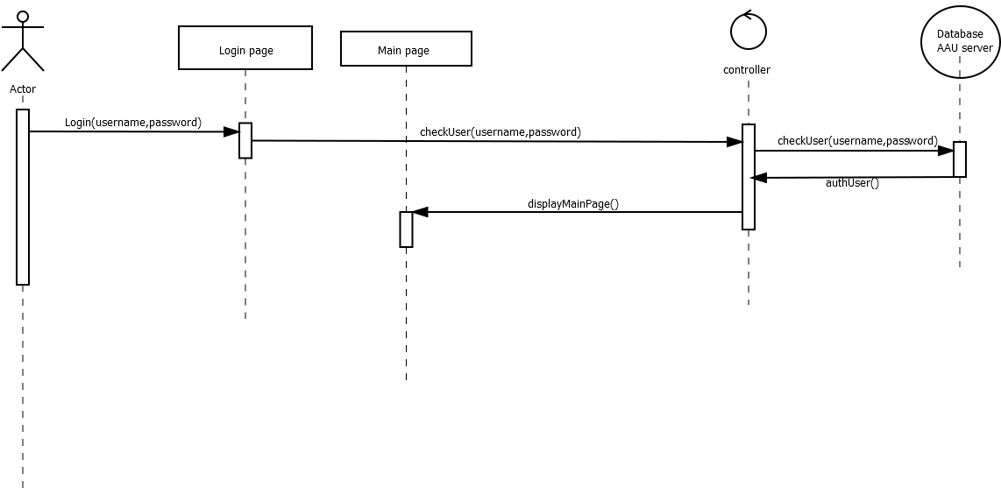

* 1. Prepare Course Info:

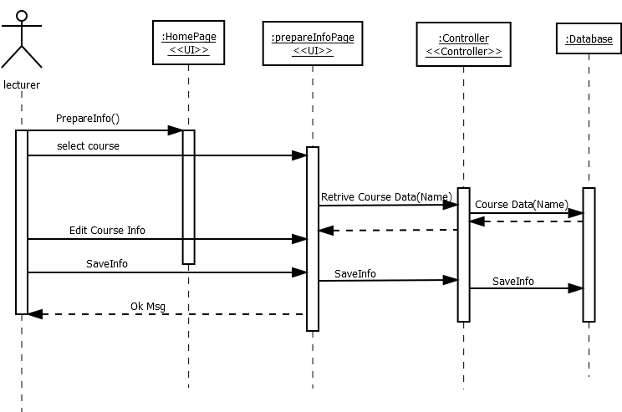

* 1. **Prepare Syllabus:**

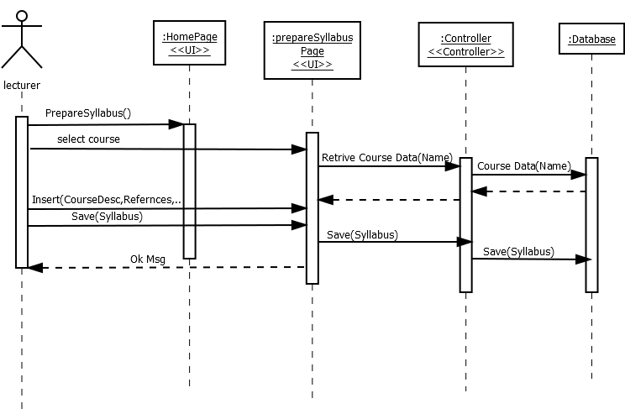

* 1. Create Homework:

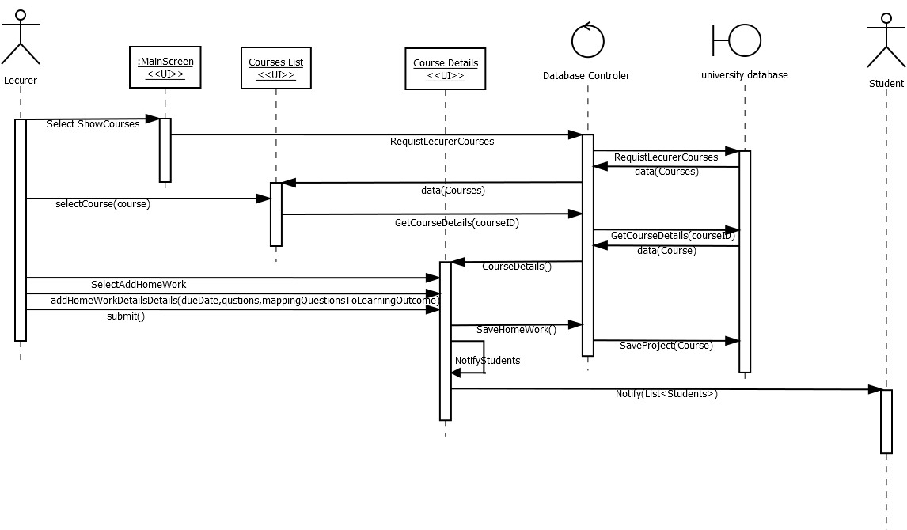

* 1. **Track Homework:**

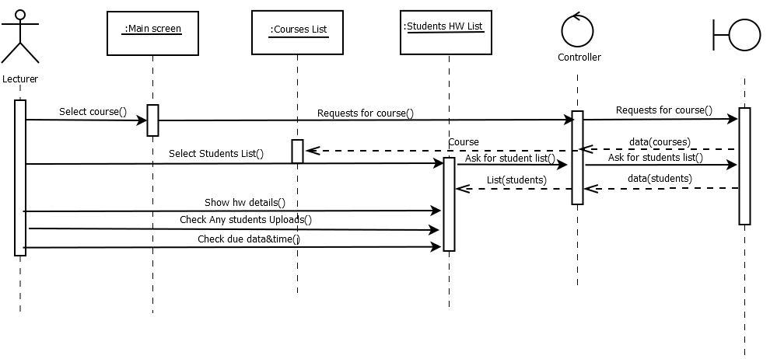

* 1. **Prepare Exam:**

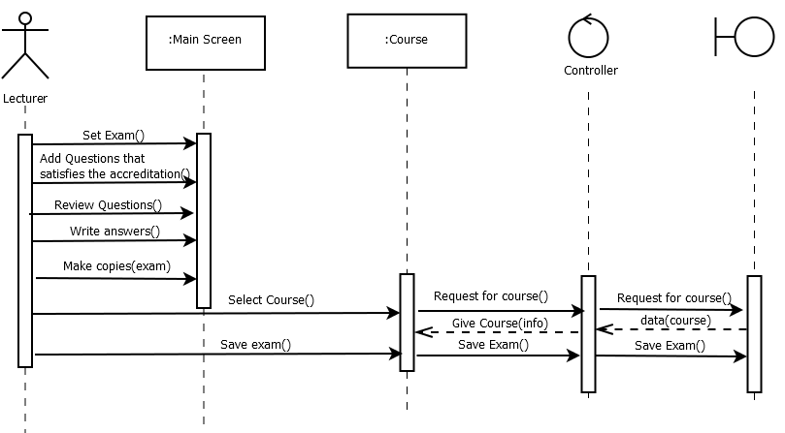

* 1. **Do Exam:**

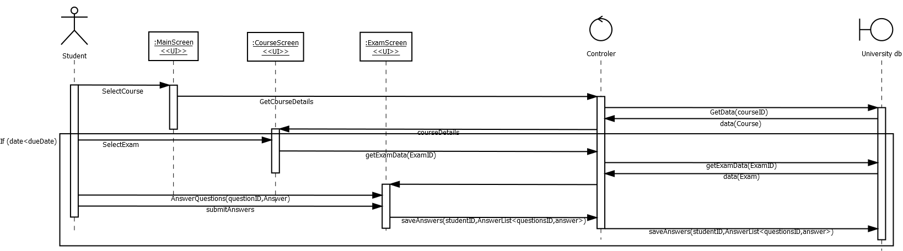

* 1. **Set Students Grade:**

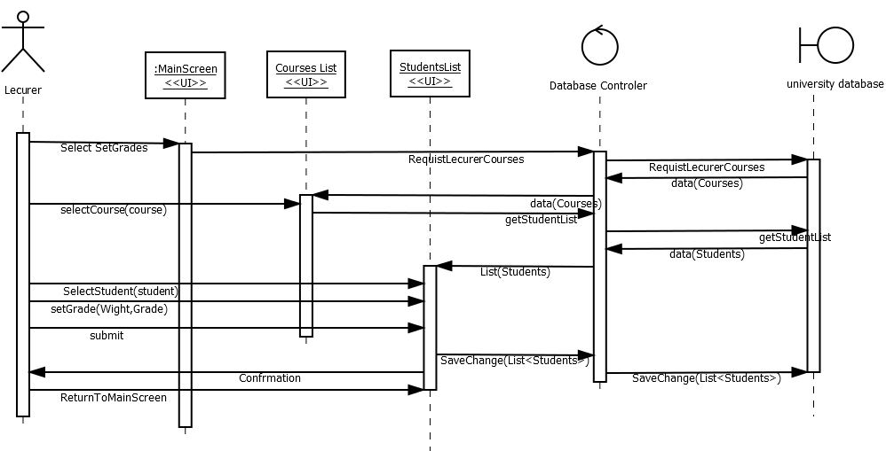

**4.9 Compile Project Report:**

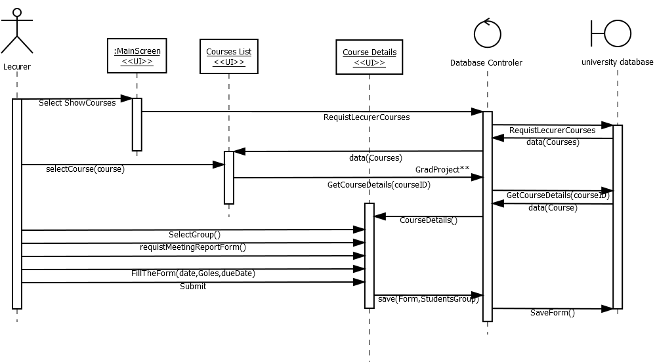

**4.10 Add Project Task:**

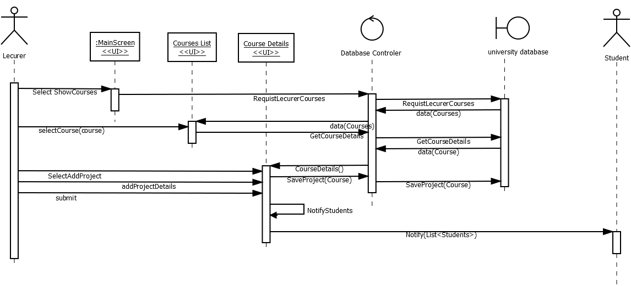

**4.11 Do Project:**

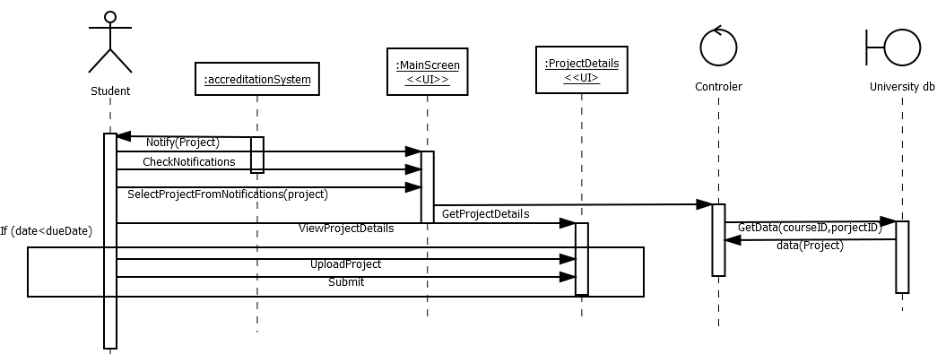

**4.12 Grade Project:**

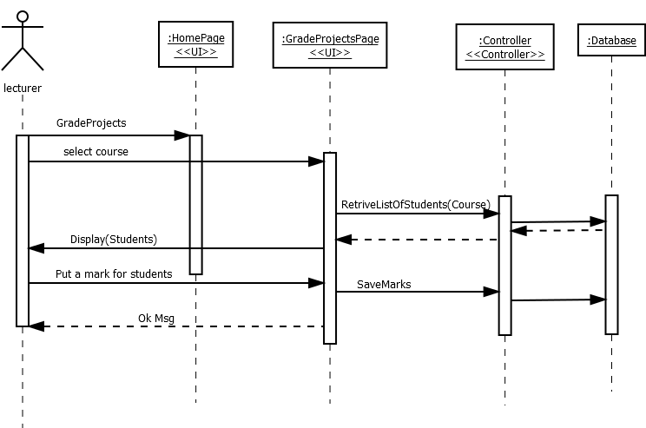

**4.13 Add Calendar Events:**

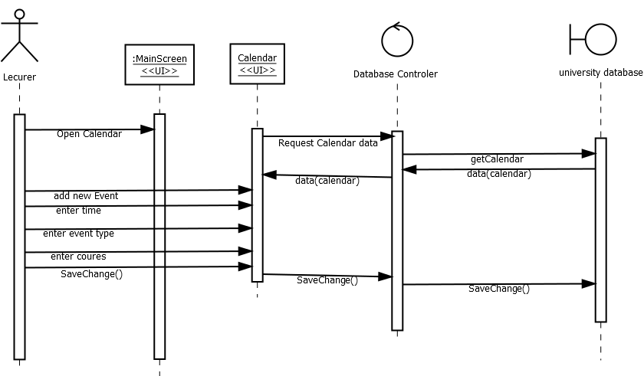

**4.14 Add Learning Outcomes:**

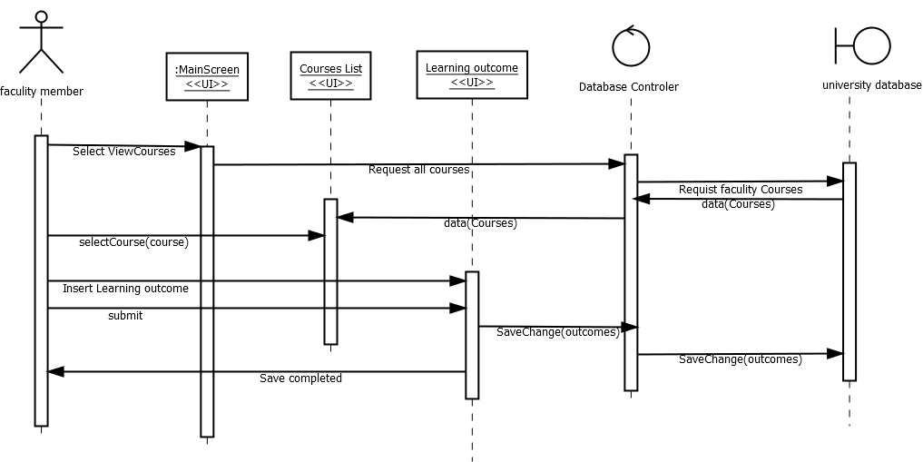

**4.15 Assess Questions:**

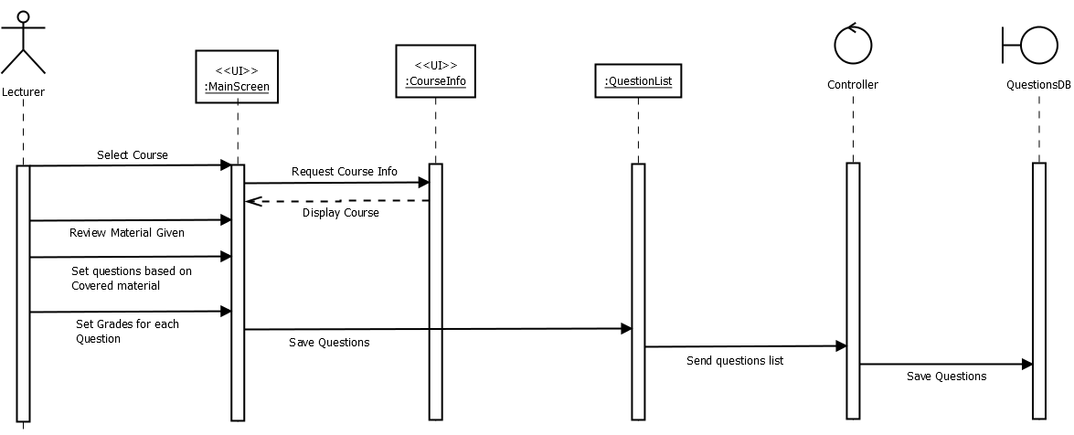

1. **Class Diagram (iteration_1):**

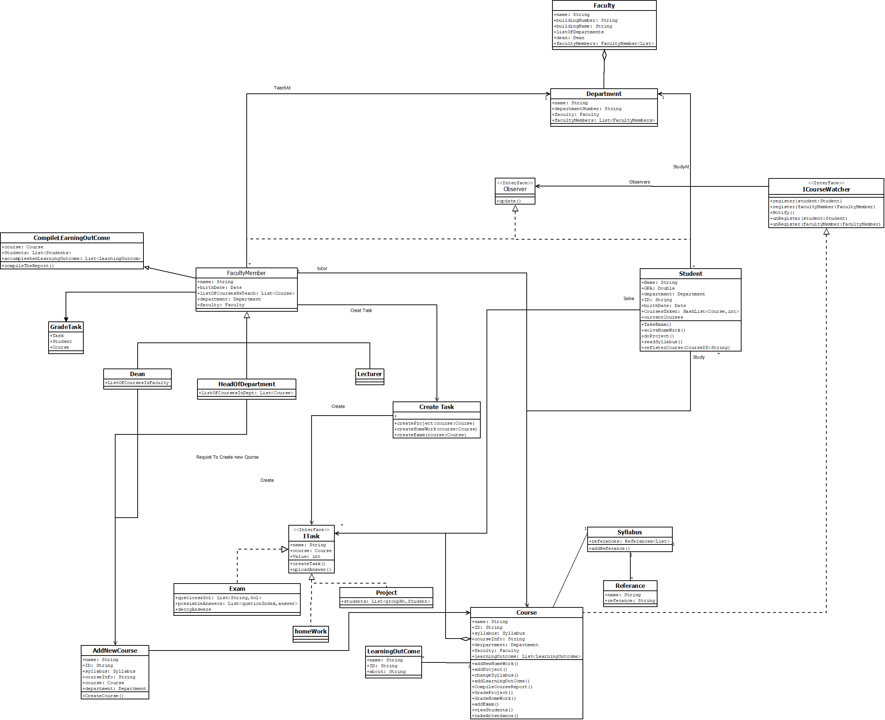

1. **Context Diagram:**

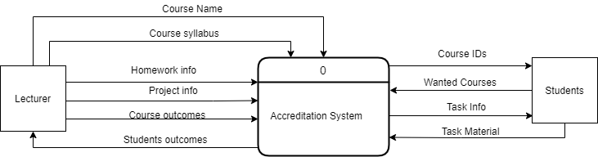

1. **Data Flow Diagram:**

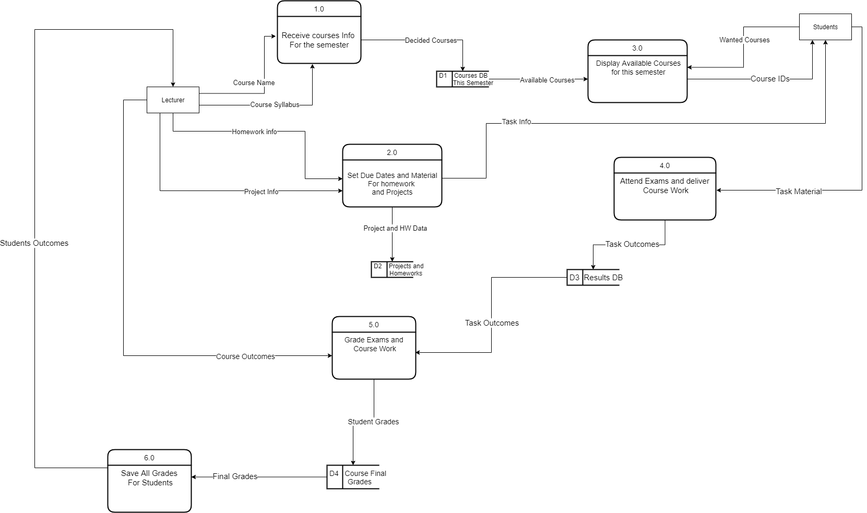

1. **Database:**

|  |  |  |  |  |  |  |  |  |
| --- | --- | --- | --- | --- | --- | --- | --- | --- |
| Student | | | | | | | | |
| ID | Name | Birth date | GPA | Credits | Email | Phone number | Education level | Dept ID |

|  |  |  |  |  |  |  |  |  |
| --- | --- | --- | --- | --- | --- | --- | --- | --- |
| Faculty members | | | | | | | | |
| ID | Name | Birth date | Education level | Position | Title | Phone number | Email | Office |

|  |  |  |  |
| --- | --- | --- | --- |
| Faculty | | | |
| ID | name | Building | Dean ID |

|  |  |  |  |  |
| --- | --- | --- | --- | --- |
| Department | | | | |
| ID | Faculty | Faculty ID | Name | Head of department ID |

|  |  |  |  |  |
| --- | --- | --- | --- | --- |
| Course | | | | |
| ID | Name | Department | prerequisite | Credits |

|  |  |  |  |  |  |  |  |  |
| --- | --- | --- | --- | --- | --- | --- | --- | --- |
| Student courses | | | | | | | | |
| Student ID | Course schedule ID | Midterm | Finale | Project | Home work | Class work | GPA | Time |
| No 2 courses form the same time can be added to the student | | | | | | | | |

|  |  |  |  |  |
| --- | --- | --- | --- | --- |
| Exams | | | | |
| ID | Course ID | Year | semester | Weight |

|  |  |  |  |
| --- | --- | --- | --- |
| Exam Questions | | | |
| ExamID | Question | SO | Weight |

|  |  |
| --- | --- |
| Learning outcome | |
| ID | description |

|  |  |
| --- | --- |
| Course learning outcome | |
| Course ID | Learning outcome ID |

|  |  |  |  |  |  |  |  |  |  |
| --- | --- | --- | --- | --- | --- | --- | --- | --- | --- |
| Student courses | | | | | | | | | |
| Student ID | Course ID | Year | semester | Midterm | Final | Project | Status | Class work | GPA |

|  |  |  |
| --- | --- | --- |
| Course schedule | | |
| ID | Faculty members ID | Room Reservation ID |

|  |  |
| --- | --- |
| Building | |
| Building No. | Name |

|  |  |
| --- | --- |
| Room | |
| Room Number | Building |

|  |  |  |  |  |
| --- | --- | --- | --- | --- |
| Room Reservation | | | | |
| RoomNo. | Time | Year | Semester | ID |

* 1. **ERD:**

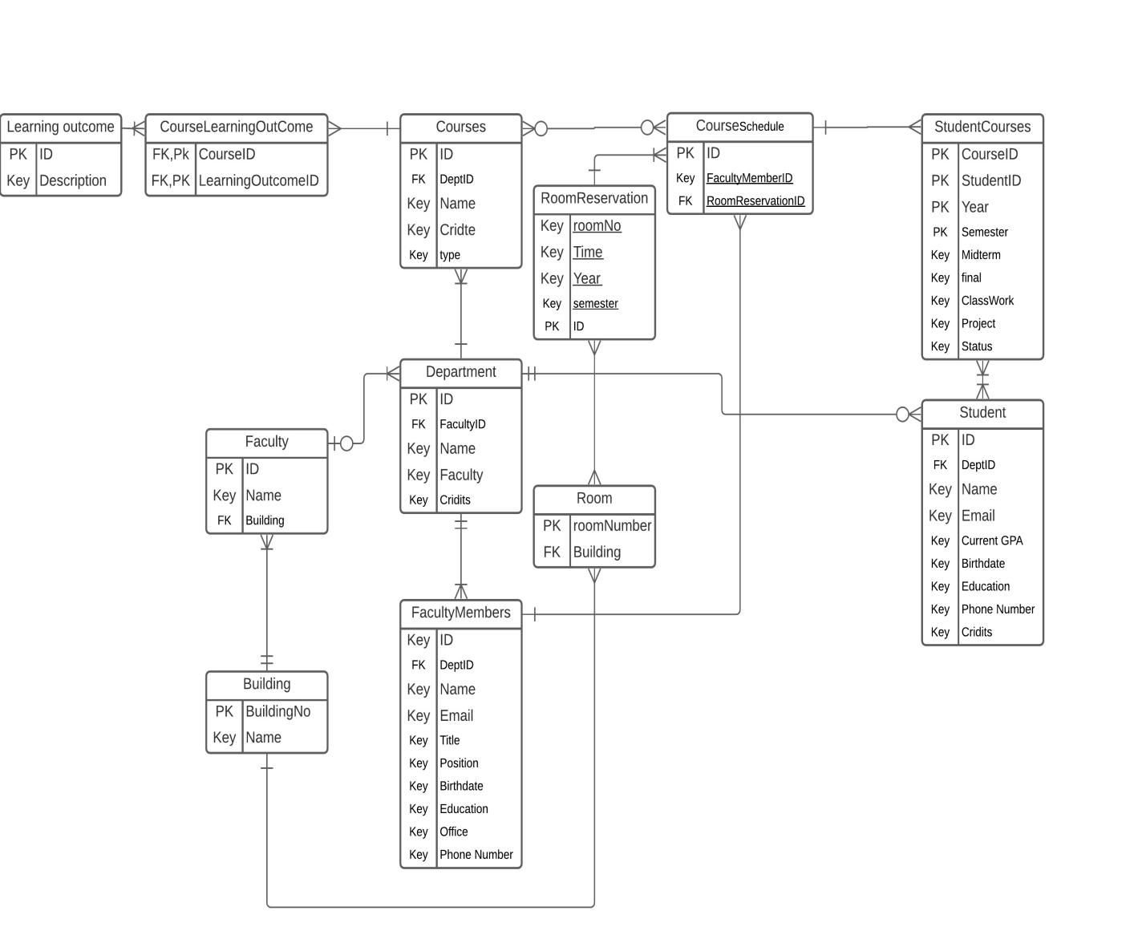

1. **Architecture Patterns:**

|  |  |
| --- | --- |
| Patterns | Specification |
| Model view controller | We want the user interface functionality be kept separate from application functionality and yet still be responsive to user input |
| SOA | We will use number of services that are offered by AAU service provider and our system needs to communicate without any detailed knowledge of their implementation.  The tactic that will be used to insure the interoperability is tailored interface.  Asynchronous connectors will be used in conjunction  With the publish-subscribe pattern. |
| Pipe filter | We will filter the data from the university database |

**9.1 Architecture Patterns in UML:**

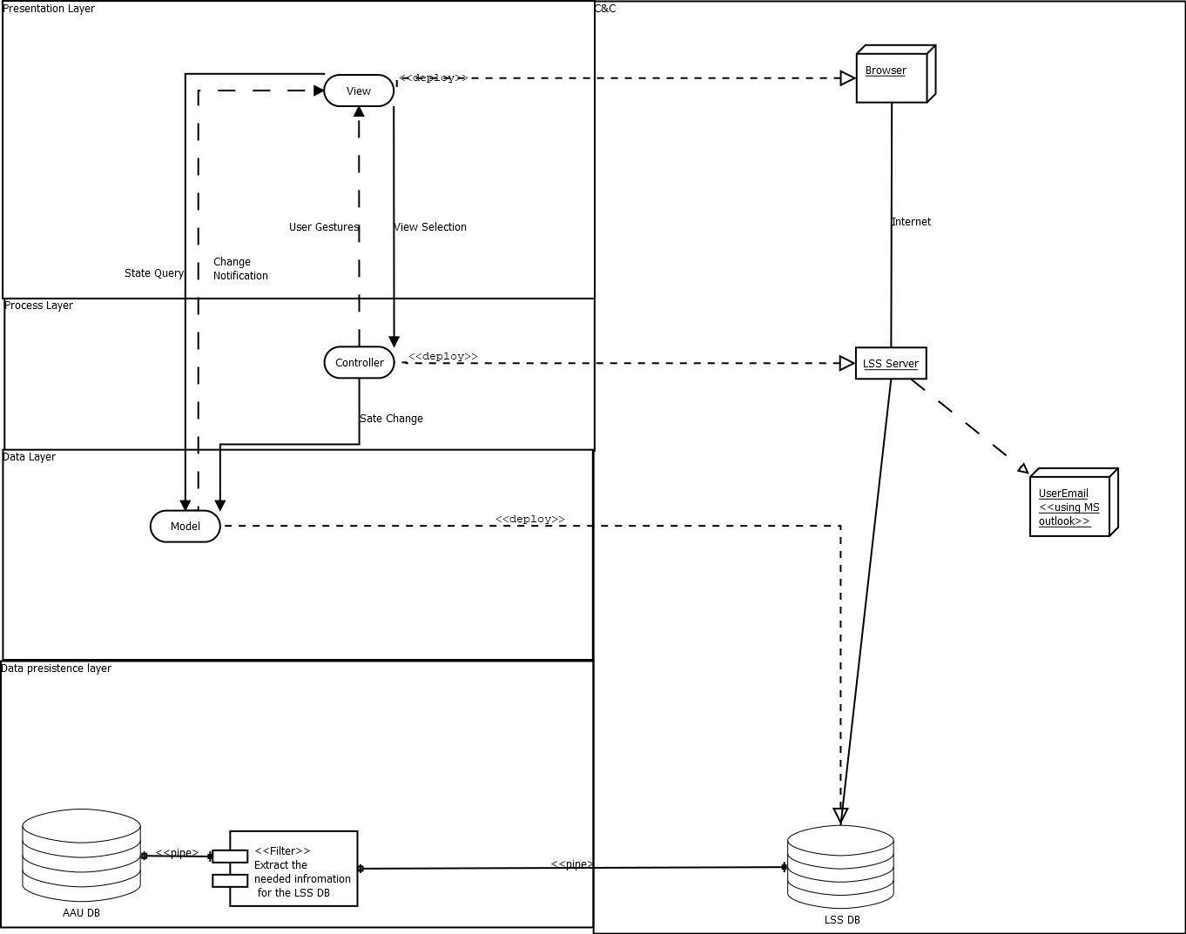



**10. Deployment Structure:**

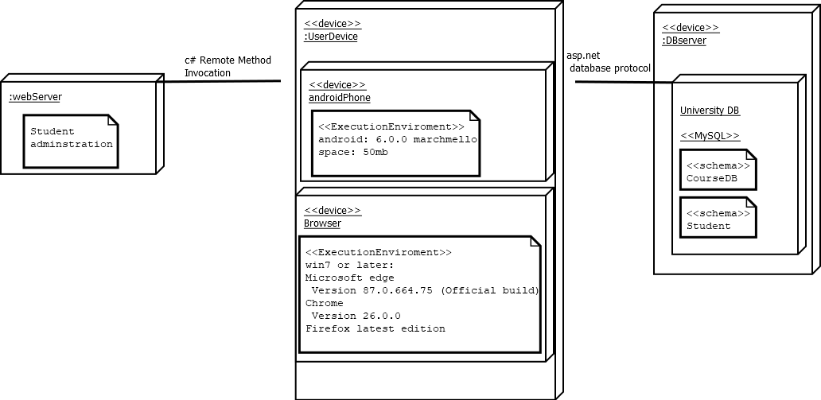

**11.1LSS Module:**

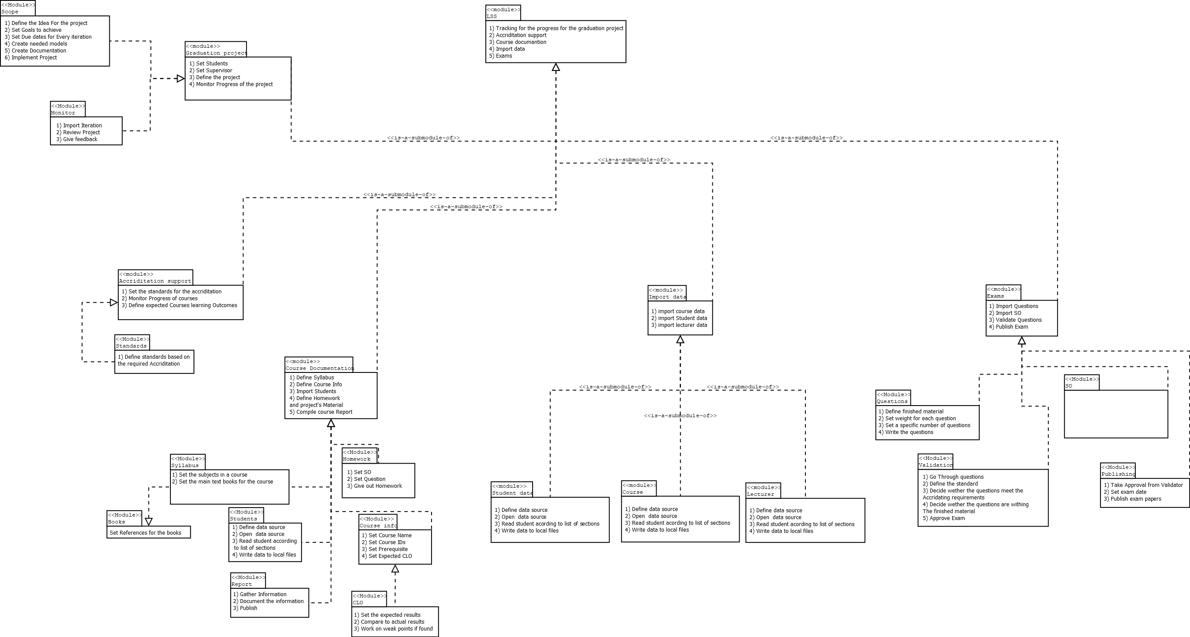

**12. Digital Prototyping:**

