AFRICAN LEADERSHIP UNIVERSITY
BSc (Hons) Software Engineering
FORMATIVE ASSIGNMENT
BorderBridge
A Consignment-Level Trade Planning Platform for Small-Scale Cross-Border Traders in the East African Community

Field | Detail
Student name | [INSERT YOUR FULL NAME]
Student email | [INSERT YOUR EMAIL]
Programme | BSc (Hons) Software Engineering
ALU Mission (GCGO) | Regional Integration (primary); Infrastructure, Job Creation and Empowerment of Women (supporting)
Software development model | Agile — Scrum, delivered on an incremental release roadmap
Document | Project Proposal and Software Requirements Specification
Version | 2.0
Date | [INSERT DATE — MM/DD/YYYY]
File naming convention: person_name[Assignment1]_[W4]_[MMDDYYYY]
Rename this file and complete the name and date fields above before submitting.

1. Description of the Concept of the Mission

1.1 The mission
My mission is Regional Integration: to reduce the practical cost of crossing an African border for the smallest traders, so that the African Continental Free Trade Area becomes usable by the people it was designed to serve, and not only by firms large enough to employ a customs clearing agent.
The African Leadership University (ALU) organises learning around missions rather than majors. Each student declares a real problem they intend to solve, anchored to one of ALU’s Global Challenges and Great Opportunities. ALU defines Regional Integration as fostering partnerships and the ideals of Pan-Africanism through cultural exchange, international movement and trade, towards an integrated continent with common values and a shared vision (ALU, 2026). BorderBridge is a direct instrument of that definition.

1.2 Relevance of the mission to Africa’s development
Africa has chosen trade as its route to industrialisation. The AfCFTA could raise income by USD 450 billion and lift 30 million from poverty by 2035 (World Bank, 2020), and 61 per cent of intra-African exports are processed goods, the value addition commodities lack (UNCTAD, 2024). Yet informal traders, 74 per cent of them women, remain excluded (ECA, 2023). An agreement only large firms can navigate integrates a corporate tier, not a continent.

1.3 Why this is a software problem
The rules that would benefit small traders already exist and are already published. The AfCFTA Phase I protocols on Trade in Goods, Trade in Services and Dispute Settlement are operational (tralac, 2026), and the East African Community Simplified Trade Regime exempts consignments valued under USD 2,000 from full customs declaration procedures. What does not exist is a way for a specific trader, holding a specific consignment, to find out what those rules mean for them before they travel. That is a computation and distribution problem, and it is tractable in software.

2. Problem Statement

2.1 Background
Consider a trader in Kigali with 200 kg of coffee to sell in Kampala. Her obstacle is rarely the tariff. It is that she cannot establish, before setting off, which documents she needs, what she will be charged, whether her consignment qualifies for simplified treatment, or which crossing to use. She may travel to a border and be turned back for a missing certificate. She may pay a charge she has no way to verify. Faced with unknowable requirements, the rational response is to route around the formal system entirely — which costs her legal protection and access to finance, costs the state revenue and data, and leaves informal cross-border trade invisible to the policy process meant to support it.
This is not a shortage of law. It is a shortage of legible, consignment-specific answers. Losses to business and government from delays, complex documentation and unpredictable border procedures already exceed tariff costs, and the average cost of non-tariff measures in intra-ECOWAS trade has been put at 241 per cent of the tariff cost of trade (tralac, 2019). The average time to import between member states of SADC and COMESA has been reported at 38 days, against 12 days within the European Union (tralac, 2019).

2.2 The problem statement
Small-scale and informal cross-border traders in the East African Community cannot determine, before they travel, which documents, duties, product-specific conditions and border procedures apply to a particular consignment on a particular route. Authoritative information exists but is fragmented across separate national systems, expressed as generic procedure rather than as an answer about a specific shipment, published in languages and formats that assume a desktop browser and a literate reader of English or French, and unaccompanied by any calculation of what the movement will actually cost. In the absence of a trustworthy pre-departure answer, traders depend on intermediaries, rumour or the discretion of individual officials, which produces avoidable cost, avoidable delay, exposure to arbitrary charges, and a persistent drift into informality. The instruments intended to make intra-African trade easier — the AfCFTA and the EAC Simplified Trade Regime — are therefore systematically under-used by the population they were designed to benefit.

2.3 The problem in WHO, WHAT, WHEN, WHERE, WHY and HOW
Question | Answer
WHO | Small-scale and informal cross-border traders in the East African Community — typically moving consignments valued under USD 2,000, frequently trading agricultural or light consumer goods, and predominantly women, who account for the substantial majority of informal cross-border trade transactions (ECA, 2023). Secondary sufferers are independent transport operators with unfilled capacity, and customs officers who process incomplete declarations.
WHAT | They cannot obtain a reliable, consignment-specific answer to a single question: what will this shipment require, and what will it cost, before I leave? The result is missing documents at the border, unbudgeted charges, rejected consignments, lost perishable stock, and avoidance of formal channels altogether.
WHEN | At the planning stage — the hours or days before travelling, which is the only point at which the problem is still cheap to fix. Once the trader is standing at the border with an incomplete document set, every remedy is expensive. The problem recurs on every trip, and again whenever a rule, rate or product list changes.
WHERE | At EAC land border crossings and in the trading towns that feed them. The pilot corridor is Rwanda–Uganda, principally Gatuna/Katuna and Kagitumba/Mirama Hills, chosen because both countries have recorded informal cross-border trade annually since 2014, which provides a measurement baseline.
WHY | Because trade knowledge is organised around institutions rather than around shipments. Each customs authority publishes its own procedures for its own jurisdiction; a single cross-border movement touches at least two such systems. Regulatory agencies operate in silos, applying inconsistent standards and rejecting one another’s certifications (tralac, 2026). Nothing joins the two halves of a corridor into one answer, computes what the trader will pay, or delivers it to a low-cost phone in a language she reads.
HOW | The consequences propagate: a trader who cannot predict requirements cannot budget, so she under-capitalises; she cannot prove which rule applies, so she cannot contest an arbitrary charge; she avoids the formal system, so she builds no transaction record and cannot access credit; and her trade goes unrecorded, so policy is designed without her. BorderBridge intervenes at the first link in that chain — the pre-departure answer.
Table 1. The problem expressed against the six framing questions.

3. Existing Solutions and the Gap
This section states honestly what already exists, because a proposal that ignores incumbents is not credible. Four categories of solution address adjacent parts of this problem. None of them closes it, and the reason each falls short is specific rather than general.

3.1 Trade information services for traders
Sauti East Africa is the closest existing solution and a genuinely capable one. Traders reach it by USSD, SMS or WhatsApp from a feature phone with no internet connection, and it returns verified trade procedures, market prices, official tax rates and exchange rates, with a facility for reporting bribery and harassment. It operates in five languages including Kinyarwanda and Kiswahili, has served over 27,000 traders and more than 85,000 information requests, and tracks 110 product prices across 82 markets in six EAC countries (Sauti East Africa, n.d.-a).
Sauti proves the channel works and that demand is real. Its limitation is architectural rather than a failure of execution: it is an information retrieval service. A trader asks a question and receives a published fact. It does not take the parameters of one shipment and compute an answer specific to it — it does not assemble a document checklist for that consignment, calculate its landed cost, determine whether it qualifies for the Simplified Trade Regime, or persist it as a trackable shipment.

3.2 National and regional trade information portals
The Rwanda Trade Portal and the Uganda Trade Portal, developed with TradeMark Africa, UNCTAD and ITC support, publish national trade procedures step by step in fulfilment of Article 1 of the WTO Trade Facilitation Agreement. For each step they state where to go, whom to see, which documents to bring, which forms to complete, what it costs, which law justifies the step, and where to complain (TradeMark Africa, n.d.). This is high-quality, authoritative content, and BorderBridge depends on such sources rather than competing with them.
Three properties nonetheless keep them out of reach of the trader described in Section 2:
- They are organised by country, not by corridor. A single Kigali-to-Kampala movement touches two portals, and neither reconciles with the other or presents a combined answer.
- They describe generic procedure, not a specific consignment. The portal explains how importing works; it does not tell this trader what her 200 kg of coffee requires, or compute what it will cost.
- They assume a desktop browser and a continuous internet connection, which is the wrong delivery assumption for a user on an entry-level handset and a metered 2G connection.

3.3 Digital freight and logistics platforms
Lori Systems, Kobo360 and Sendy have built substantial cargo-matching businesses, using algorithmic matching, GPS tracking and mobile-money payment to connect cargo owners with vetted trucks. Lori alone has more than 20,000 trucks connected and coordinates cargo across twelve countries, and a large share of key commodities moving between Kenya and Uganda runs through it (Lori Systems, n.d.).
These platforms solve transport matching well, but for a different customer. They are built around truckload-scale commodity cargo with a shipper who already knows the regulatory position. They do not serve a trader with 200 kg and an unanswered compliance question, and they offer no regulatory guidance at all.

3.4 Customs and single-window systems
National customs platforms and electronic single windows are the systems of record for declarations. They are designed for licensed clearing agents and registered importers submitting formal entries, not for a trader planning a trip. They begin where BorderBridge ends: at the point of declaration, after the trader already knows what to declare.

3.5 The gap, stated precisely
Capability | Sauti  East Africa | National  trade portals | Freight  platforms | Customs  systems | Border-  Bridge
Authoritative procedure content | Yes | Yes | No | Yes | Yes
Reaches low-cost phones offline | Yes | No | Partly | No | Yes
Local-language delivery | Yes | Partly | No | No | Yes
Answer specific to one consignment | No | No | No | No | Yes
Single answer spanning both sides of a corridor | Partly | No | Yes | No | Yes
Computed landed cost with itemised duties and fees | No | No | Partly | No | Yes
Automatic simplified-regime eligibility test | No | No | No | No | Yes
Transport matching for sub-tonne consignments | No | No | No | No | Yes
Persistent, trackable shipment record | No | No | Yes | Partly | Yes
Source citation and verification date on every rule | Partly | Yes | No | Yes | Yes
Table 2. Capability comparison against existing solutions.
What is unique in this solution
The gap is not a missing information source. It is the absence of a computational layer between published rules and an individual shipment. Every existing solution either publishes rules generically or moves cargo; none takes four parameters — origin, destination, product and quantity — and returns a single derived plan.
BorderBridge is therefore differentiated on four specific points:
- Consignment-level computation rather than information retrieval. The unit of output is not an article of procedure but a trade plan for one shipment: a document checklist, an itemised landed cost, and a recommended crossing, all derived from the consignment’s own parameters.
- Corridor-spanning answers. Rules from both the origin and the destination jurisdiction are resolved into one checklist, which is precisely the reconciliation no national portal performs.
- Automatic simplified-regime determination. The system tests the consignment against the USD 2,000 threshold and the qualifying product list and, where it qualifies, substitutes the reduced requirement set and states the basis of eligibility with a citation. Studies repeatedly find that traders do not use the Simplified Trade Regime because they do not know it applies to them; this converts a published entitlement into an automatic result.
- Planning through to execution in one record. The plan becomes a trackable shipment that connects to transport and to counterparties in the destination market, so the trader is not handed off between four disconnected tools.
A note on positioning. Sauti East Africa demonstrates that this user can be reached and that the demand exists — that is an argument for the concept, not against it. BorderBridge is complementary rather than adversarial: it consumes the same authoritative sources as the national trade portals, and the sensible long-term posture is integration with these services rather than duplication of them.

4. Software Development Model
BorderBridge will be developed using Agile (Scrum) on an incremental release roadmap. The choice follows from this project’s properties: the dominant risk is building the wrong thing, and a two-week sprint bounds how much effort goes into a wrong assumption before a trader corrects it; requirements cannot be specified before field research with low-literacy, multilingual users; and the regulatory domain is volatile (tralac, 2026), so change enters as backlog work rather than as a defect in the plan. Waterfall assumes stable requirements and would surface validation errors only at testing; Spiral’s overhead is disproportionate to a single-developer project, though its risk discipline is retained. In practice, a backlog of trader-facing user stories, each traced to an SRS requirement identifier, is grouped into four releases; each two-week sprint runs planning under a single sprint goal, a written daily standup log, and execution to a definition of done that includes updated SRS text, UML models and passing tests, closing with a review that demonstrates the increment to real traders and a retrospective. Risk is re-assessed at each release boundary, regulatory accuracy first, and the backlog is refined continuously.

4.1 Sprint schedule mapped to course deliverables
Sprint | Release | Focus | Deliverable produced
0 | — | Field research, stakeholder interviews, backlog creation, data-source feasibility | Project proposal
1–2 | R1 Core | Requirements elicitation and specification; registration; checklist engine | SRS Sections 1–4
3–4 | R1 Core | Cost estimation; currency conversion; architecture and data model | UML models (Appendix B)
5–6 | R2 Corridor | Border information, status reporting, crossing recommendation, shipment tracking | Software design document
7–8 | R3 Market | Transport matching; buyer and supplier discovery; multilingual support | Test plan and execution
9–10 | R4 Hardening  and reporting | Usability testing with traders, accessibility, offline behaviour, performance tuning, and administrative reporting | Working prototype; UAT report
Table 3. Sprint plan mapped to releases and course deliverables.

5. Hypothesis of the Solution
If small-scale traders are given a single authoritative, mobile-accessible answer — in a language they read — to what a specific consignment on a specific route will require and cost, then their pre-departure preparation should measurably improve, their unplanned costs and delays at the border should fall, and their use of formal and simplified trade channels should rise. The claim is falsifiable: it assumes the binding constraint is the absence of consignment-specific information rather than compliance cost, working capital or deliberate evasion, and field research in Sprint 0 tests that before any code is written. Once deployed, the system is anticipated to cut missing-document incidents by at least 30 per cent, hold cost estimates within 15 per cent of actual outcomes, and raise awareness of the Simplified Trade Regime by 40 percentage points among users — converting existing but invisible trade rights into usable ones.
ID | Anticipated outcome | Measure | Success threshold
H1 | Traders using BorderBridge arrive at the border with a more complete document set than those who do not | Missing-document incidents at first presentation, self-reported and spot-checked | ≥ 30% reduction against baseline
H2 | The cost estimate is close enough to actual cost to be decision-useful | Absolute percentage error between estimated and actual landed cost | Median error ≤ 15%
H3 | Crowdsourced border status is timely and accurate enough to inform crossing choice | Agreement with observed conditions; report age at point of use | ≥ 80% agreement; median age under 6 hours
H4 | Awareness of the EAC Simplified Trade Regime rises among users | Pre- and post-use survey on STR awareness and the USD 2,000 threshold | ≥ 40 percentage-point increase
H5 | The interface is usable unassisted by low-literacy and non-English-speaking traders | Task completion rate in unassisted think-aloud testing | ≥ 80% completion of the core task
H6 | Traders shift trips from informal to formal or simplified channels | Proportion of trips declared under STR or full procedure, before and after | Measurable increase on the pilot corridor
Table 4. Anticipated outcomes as falsifiable predictions.

6. References
Formatted in APA 7th edition.
African Leadership University. (2026). Mission-driven majors. https://www.alueducation.com/missions-not-majors/
Economic Commission for Africa. (2023, November 16). Rethinking informal cross-border trade in Africa. United Nations Economic Commission for Africa. https://www.uneca.org/stories/rethinking-informal-cross-border-trade-in-africa
GSMA. (2024). The mobile economy Sub-Saharan Africa 2024. GSMA Intelligence. https://www.gsma.com/solutions-and-impact/connectivity-for-good/mobile-economy/
Lori Systems. (n.d.). Transforming African logistics through technology. https://lorisystems.com/
Sauti East Africa. (n.d.-a). Sauti trade and market information platform. https://www.sautiafrica.org/services-products/trade-market-info-platform/
Sauti East Africa. (n.d.-b). The Simplified Trade Regime in the EAC and challenges to cross-border traders. https://www.sautiafrica.org/the-simplified-trade-regime-in-the-eac-and-challenges-to-cross-border-traders/
TradeMark Africa. (n.d.). Rwanda country programme: Trade information portal. https://trademarkafrica.com/rwanda/
tralac. (2019, March). The intra-Africa NTB dilemma: The challenges facing the AfCFTA approach. Trade Law Centre. https://www.tralac.org/
tralac. (2026, March 3). Seven non-tariff trade barriers in Africa and practical solutions to overcome them. Trade Law Centre. https://www.tralac.org/blog/article/17039-seven-non-tariff-trade-barriers-in-africa-and-practical-solutions-to-overcome-them.html
United Nations Conference on Trade and Development. (2024). Economic development in Africa report 2024: Unlocking Africa’s trade potential — Boosting regional markets and reducing risks. UNCTAD. https://unctad.org/publication/economic-development-africa-report-2024
World Bank. (2020). The African Continental Free Trade Area: Economic and distributional effects. World Bank Group. https://www.worldbank.org/en/topic/trade/publication/the-african-continental-free-trade-area

Document Control
Version | Date | Description | Author
0.1 | — | Initial outline derived from field research and the mission statement | [Your Name]
1.0 | — | Project proposal and first draft of the requirement specification completed for Assignment 1 | [Your Name]
1.1 | — | Appendix B added for Assignment 2: four UML diagram types | [Your Name]
2.0 | [INSERT DATE] | Restructured to the ALU proposal and SRS template. Added a competitive gap analysis against existing solutions; re-framed the problem statement against WHO/WHAT/WHEN/WHERE/WHY/HOW; re-angled the development model section to relevance and process steps; added Section 2 (Overall Description), Section 3 (External Interface Requirements), Section 4.1 (Stakeholder Requirements Specification), Section 5 (Other Nonfunctional Requirements) under the template’s four headings, and Section 6 (Appendix) | [Your Name]

Table of Contents
1. Description of the Concept of the Mission
1.1 The mission
1.2 Relevance of the mission to Africa’s development
1.3 Why this is a software problem
2. Problem Statement
2.1 Background
2.2 The problem statement
2.3 The problem in WHO, WHAT, WHEN, WHERE, WHY and HOW
3. Existing Solutions and the Gap
3.1 Trade information services for traders
3.2 National and regional trade information portals
3.3 Digital freight and logistics platforms
3.4 Customs and single-window systems
3.5 The gap, stated precisely
4. Software Development Model
4.1 Sprint schedule mapped to course deliverables
5. Hypothesis of the Solution
6. References
Document Control
Table of Contents
1. Introduction
1.1 Purpose
1.2 Document Conventions
1.3 Intended Audience and Reading Suggestions
1.4 Product Scope
1.4.1 Product name and identification
1.4.2 What the system will do
1.4.3 What the system will not do
1.4.4 Benefits, objectives and goals
2. Overall Description
2.1 Product Perspective
2.2 Product Functions
2.3 User Classes and Characteristics
2.4 Operating Environment
2.5 Design and Implementation Constraints
2.6 User Documentation
2.7 Assumptions and Dependencies
2.7.1 Assumptions
2.7.2 Dependencies
3. External Interface Requirements
3.1 User Interfaces
3.2 Hardware Interfaces
3.3 Software Interfaces
3.4 Communications Interfaces
4. Requirement Specification
5. Other Nonfunctional Requirements
5.1 Performance Requirements
5.1.1 Response time and efficiency
5.1.2 Capacity and scalability
5.2 Security Requirements
5.2.1 Authentication, authorisation and protection
5.2.2 Privacy and data protection
5.3 Software Quality Attributes
5.3.1 Reliability and availability
5.3.2 Usability and accessibility
5.3.3 Compatibility and portability
5.3.4 Maintainability
5.4 Business Rules
5.4.1 Accuracy and data integrity
5.4.2 Legal and regulatory compliance
5.4.3 Operating policies stated as business rules
5.5 Traceability of Non-Functional Requirements
6. Appendix
6.1 Appendix A — Glossary
6.2 Appendix B — UML Diagrams
B.1 Use Case Diagrams (Behavioural)
B.2 Class Diagrams (Structural)
B.3 Sequence Diagram (Behavioural)
B.4 Activity Diagram (Behavioural)
B.5 Diagram-to-Requirement Traceability
B.6 Diagram source files

To populate: open in Word or Google Docs, right-click the field and choose “Update field”.

1. Introduction

1.1 Purpose
This Software Requirements Specification (SRS) defines the functional and non-functional requirements for BorderBridge version 1.0 — a mobile-first platform that enables small-scale and informal cross-border traders in the East African Community to determine, before travelling, the documentation, costs, border conditions, transport options and market opportunities associated with a specific cross-border consignment.
The document serves four purposes:
- To establish a single, agreed and unambiguous statement of what BorderBridge must do, against which design, implementation and testing will be verified.
- To give the development team a specification precise enough to build from, and testers requirements specific enough to derive test cases from.
- To give stakeholders — traders, transport providers, customs contacts and the academic supervisor — a common reference for judging whether the delivered system meets the need identified in the project proposal.
- To serve as the controlled baseline for change management. Any proposed change of scope is assessed against this document.
Scope of this release. This SRS covers the whole of BorderBridge version 1.0. Section 4 specifies 20 functional requirements, Section 5 specifies 58 non-functional requirements, and Section 6 Appendix B contains the UML models. Where a requirement is scheduled for a later release rather than version 1.0, this is stated explicitly against that requirement.

1.2 Document Conventions
The following conventions apply throughout.
Convention | Meaning
“Shall” | Denotes a binding requirement. Every numbered requirement in Sections 4 and 5 uses “shall”.
“Should” | Denotes a desirable but non-binding property. It never appears inside a numbered requirement statement.
FR-XXX-nn | Functional requirement identifier. XXX is the three-letter module code (for example ACC for Account and Identity, REQ for Trade Requirements); nn is a sequence number within that module.
NFR-XXX-nn | Non-functional requirement identifier, using the same pattern with quality-attribute codes (for example PER for Performance, SEC for Security). Note that the code ACC denotes Account and Identity in a functional identifier (FR-ACC-nn) but Accuracy in a non-functional one (NFR-ACC-nn); the FR or NFR prefix disambiguates them and the two sets are unrelated.
Priority: Must / Should / Could | MoSCoW prioritisation. Must denotes a requirement without which version 1.0 cannot ship; Should denotes high value but deferrable; Could denotes desirable if capacity allows. Priorities are assigned per requirement and are not inherited from the parent module.
R1 – R4 | Release identifiers from the incremental roadmap defined in the project proposal: R1 Core, R2 Corridor, R3 Market, R4 Hardening and reporting.
Identifier stability | Requirement identifiers are permanent. A withdrawn requirement is marked withdrawn rather than deleted, and its identifier is never reused, so that references from the UML models, design and test artefacts remain valid.
Typography | Requirement identifiers appear in the form FR-ACC-01. Class names, attributes and operations appear in the form TradeIntention and generateChecklist(). Monetary thresholds are stated in the currency of the governing instrument, with USD used where the instrument does.
Table 1.1. Document conventions.
The document follows the structure of the IEEE 830 recommended practice for software requirements specifications, adapted to the course template. Requirement statements are written to be individually verifiable: each states a single testable obligation, and each non-functional requirement carries an explicit verification method.

1.3 Intended Audience and Reading Suggestions
This document has five audiences with different reasons to read it, and they need not read it in the same order.
Audience | Why they read it | Suggested reading path
Developers | To build the system correctly and to know what “done” means | Section 2 for context, then Sections 4 and 5 in full, then Appendix B in Section 6 for the models, then Section 3 for interface obligations
Testers and QA | To derive test cases and acceptance criteria | Section 5 first — every non-functional requirement names its verification method — then Section 4 for functional cases, then Appendix B.3 and B.4 in Section 6 for the flows to exercise
Project supervisor and assessors | To judge completeness, rigour and traceability | The project proposal, then Sections 1 and 2, then the traceability tables at Section 5.5 and Appendix B.5
Domain stakeholders (traders, cooperatives, transport operators, customs contacts) | To validate that the specified system matches how cross-border trade actually works | Section 2.2 Product Functions and Section 2.3 User Classes, then Appendix B.1 and B.4 in Section 6, which are the least technical views of the system
Future maintainers | To extend the system to new corridors or languages | Section 2.5 Design and Implementation Constraints, Section 2.7 Assumptions and Dependencies, then NFR-SCA-01 and NFR-SCA-04 in Section 5.1.2 on corridor and language extension
Table 1.2. Intended audiences and suggested reading paths.
Readers new to the problem should begin with the project proposal that precedes this specification, which establishes the mission, the problem statement and the gap in existing solutions that BorderBridge addresses. Readers who need only to understand what the system does, without the reasoning behind it, may read Section 2.2 and Appendix B.1 alone.

1.4 Product Scope

1.4.1 Product name and identification
The product is named BorderBridge. Version 1.0 targets the East African Community, with the Rwanda–Uganda corridor — principally Gatuna/Katuna and Kagitumba/Mirama Hills — as the pilot deployment.

1.4.2 What the system will do
BorderBridge accepts a trade intention expressed as an origin country, a destination country, a product and a quantity, and returns an integrated, corridor-specific trade plan. Specifically, the system will:
- Generate a personalised checklist of the identity, commercial and customs documents required for the stated consignment, including product-specific requirements such as phytosanitary certificates.
- Determine automatically whether the consignment qualifies for the EAC Simplified Trade Regime and, where it does, substitute the reduced requirement set and state the basis of eligibility.
- Estimate the total landed cost, decomposed into product value, transport, duties, taxes and administrative fees, with conversion between origin and destination currencies.
- Recommend a border crossing and present its official status, published hours and community-reported delay information.
- Match the trader with registered transport providers whose route and capacity fit the consignment.
- Surface potential buyers and suppliers in the destination market from a verified directory.
- Track a declared shipment through defined milestones and notify the trader of relevant events.
- Alert traders to changes in regulations, duties or border conditions affecting routes and products they follow.
- Present all trader-facing content in English, French, Kiswahili and Kinyarwanda.
- Allow authorised administrators to maintain the regulatory knowledge base under version control, with source attribution and verification dates.

1.4.3 What the system will not do
Exclusion | Rationale
Submitting customs declarations to national systems on the trader’s behalf | Requires formal accreditation and integration agreements with each revenue authority. BorderBridge prepares traders; it does not act as a clearing agent
Processing payments, escrow or settlement between parties | Financial licensing is out of scope for version 1.0. The platform introduces parties; it does not intermediate money
Issuing binding rulings on classification, valuation or duty liability | Only competent revenue authorities may do this. BorderBridge provides sourced guidance and states this limitation on every estimate
Providing physical logistics, warehousing or insurance | The platform is an information and matching layer, not an operator
Coverage beyond the EAC in version 1.0 | The data model supports continental extension, but only EAC corridors are populated and validated initially
Guaranteeing the conduct of third parties in the directory | The platform verifies registration data and publishes ratings; it does not warrant performance
Table 1.3. Explicit scope exclusions for version 1.0.

1.4.4 Benefits, objectives and goals
# | Objective | Success indicator
O1 | Reduce the incidence of traders arriving at a border with an incomplete document set | ≥ 30% reduction in missing-document incidents against baseline
O2 | Make the landed cost of a movement predictable before departure | Median absolute error of cost estimates ≤ 15%
O3 | Increase awareness and use of the EAC Simplified Trade Regime among eligible traders | ≥ 40 percentage-point increase in correct STR awareness responses
O4 | Reduce time lost to avoidable border delay through better crossing choice | Measurable reduction in self-reported waiting time on the pilot corridor
O5 | Be usable by low-literacy and non-English-speaking traders without assistance | ≥ 80% unassisted task completion in usability testing
Table 1.4. Product objectives and measurable success indicators.
These objectives align with recommendations arising from the ECA/Afreximbank/AUC/ECOWAS work on informal cross-border trade, which include establishing trader information services and operationalising simplified trade regimes (ECA, 2023).

2. Overall Description

2.1 Product Perspective
BorderBridge is a new, self-contained product rather than a component of a larger system, and it is not a replacement for any existing system. It occupies a position that is currently empty: between the institutions that publish trade rules and the small traders those rules govern.
As established in the project proposal, authoritative content already exists. National trade information portals in Rwanda and Uganda publish trade procedures step by step, and services such as Sauti East Africa deliver verified procedures and market prices to feature phones. What no existing system does is take the parameters of one shipment and compute an answer specific to it. BorderBridge is therefore best understood as a computational layer over existing authoritative sources rather than as a competing publisher of trade information.
Architecturally, the system is a client–server web application in four layers. A responsive, offline-capable Progressive Web Application serves as the trader-facing client. A server-side application layer hosts the domain logic — the requirements engine, cost engine, border service, matching engine and notification service — over a relational data store. External integrations are isolated behind adapters so that a data source can be replaced, or fall back to curated data, without altering domain logic.
Layer | Components | Responsibility
Presentation | Progressive Web App client; USSD/SMS gateway; localisation service | Task-oriented interface, offline caching, multilingual rendering, accessibility
Application | Requirements engine; cost engine; border service; matching engine; shipment service; notification service | All business logic: rule evaluation, cost computation, ranking, matching, state transitions, event dispatch
Administration | Regulation content management; moderation; reporting and analytics | Curation, versioning and audit of regulatory content; integrity of user-generated content
Data and integration | Relational data store; adapters for tariff schedules, exchange rates and border data | Persistence, integrity, and isolation of volatile external dependencies
Table 2.1. Architectural layers and their responsibilities.

2.2 Product Functions
The system provides eleven functional groups. This is a summary; the requirements specified for this release are set out in Section 4, with the identifiers shown against each group below.
Function group | What it does for the user | Requirements | Release
Account and identity | Lets a trader, transport provider or buyer register against a phone number, verify ownership by SMS code, sign in, recover access, and maintain a reusable profile | FR-ACC-01, 02 | R1
Trade requirements | Takes a stated consignment and returns a document checklist with issuing authority, source citation and verification date for every item, and determines simplified-regime eligibility automatically | FR-REQ-01, 02, 03, 05 | R1
Cost estimation | Computes an itemised landed cost — product value, transport, duties, taxes, fees — converts currency, and explains the rule behind each line | FR-CST-01…04 | R1
Border information | Recommends a crossing, presents its official status and hours, and collects community reports of current conditions with age-based expiry | FR-BRD-01, 03, 05 | R2
Transport matching | Lets providers publish capacity and traders search, request and engage transport, with mutual rating afterwards | FR-TRN-02 | R3
Marketplace discovery | Surfaces verified buyers and suppliers in the destination market and mediates first contact without exposing personal details | FR-MKT-02 | R3
Shipment tracking | Converts a plan into a trackable shipment with an immutable planning snapshot and a validated status lifecycle | FR-SHP-01 | R2
Notifications and alerts | Lets users subscribe to corridors, crossings and product categories, and delivers regulatory, border and shipment alerts | FR-NOT-02 | R2
Regulation management | Lets administrators create, version, attribute and publish regulatory rules, and flags rules overdue for re-verification | FR-ADM-01, 03 | R1
Localisation | Presents interface, notifications and exports in the user’s chosen language, marking untranslated content explicitly | FR-LOC-01 | R3
Reporting and analytics | Gives administrators operational metrics, estimate-accuracy analysis, and anonymised aggregate export for research | Deferred to R4 | R4
Table 2.2. Product functions summary.
The central function is the second one. Everything else either feeds it, extends it, or acts on its output. If the checklist and eligibility determination are wrong, no other function has value — which is why regulatory accuracy is treated as the dominant project risk and is given its own quality category in Section 5.4.

2.3 User Classes and Characteristics
Six user classes interact with the system. They differ substantially in frequency of use, technical confidence, device quality and privilege, and those differences drive concrete requirements rather than being descriptive colour.
User class | Characteristics | Frequency and context of use | Technical expertise | Privilege level
Trader  (primary) | Small-scale or informal trader, consignments typically under USD 2,000, frequently a woman, often trading agricultural or light consumer goods. Variable literacy; may read Kinyarwanda or Kiswahili rather than English. Entry-level Android handset on a metered, intermittent connection | Several times a month, in bursts around a trip. Often used while travelling or at a market, rarely at a desk | Low. Comfortable with WhatsApp and mobile money; not with forms, jargon or multi-step web flows | Standard user. Owns own data; no administrative rights
Transport provider | Independent operator of a truck, van or motorcycle with unused capacity on cross-border routes. Runs a small business | Daily to weekly, checking for matching loads and responding to requests | Low to medium. Familiar with logistics coordination by phone | Verified user. May publish listings only after verification
Buyer / supplier | Wholesaler, retailer or market trader in the destination market seeking counterparties across the border | Weekly or occasional, when seeking supply or offering stock | Low to medium | Verified user
Customs officer | Border post official. Uses the system in a read-oriented and authoritative capacity rather than as a trader | Occasional. Publishes status when conditions change; may view a trader’s prepared summary at the counter | Medium. Accustomed to formal customs systems | Elevated. May publish official border status that overrides community reports
Administrator | BorderBridge content and compliance staff maintaining the regulatory knowledge base and moderating content | Daily | High. Trained on the domain and the administrative interface, but not necessarily a developer | Full administrative rights, subject to audit logging
Scheduler  (automated) | Internal automated actor with no human operator | Continuous | Not applicable | System-level, non-interactive
Table 2.3. User classes and their characteristics.
The trader class is the one the product is designed for. Where a design decision would favour another class at the trader’s expense — for instance, richer administrative reporting at the cost of a heavier client payload — the trader takes precedence. Two characteristics of that class shape the whole specification: variable literacy in a language that may not be English, and a constrained device on a constrained connection. These give rise directly to the localisation requirements (FR-LOC-01…03), the accessibility and readability requirements (NFR-USA-03, NFR-USA-04), the payload budget (NFR-PER-04) and the offline and fallback requirements (NFR-REL-02, NFR-USA-07).

2.4 Operating Environment
Element | Specification
Client devices | Android smartphones from Android 8.0; iOS from version 14; desktop browsers (Chrome, Firefox, Safari, Edge — current and one prior major version). Entry-level Android on a small screen is the design reference, not a desktop browser
Client application | Responsive Progressive Web App with service-worker offline caching and installable home-screen behaviour. No app-store distribution is required
Fallback channel | USSD and SMS path for the checklist and cost-estimate functions, for users on feature phones or without a data connection
Server environment | Containerised application services on a cloud platform with an African or European region of presence, orchestrated so that services may be scaled horizontally
Data store | PostgreSQL relational database with full audit history on regulatory content
Network assumption | Intermittent 2G/3G connectivity with high latency and metered data is the design baseline. Continuous broadband is treated as a fortunate exception, not an assumption
Coexisting software | The system must coexist with, and where possible consume data from, national trade information portals and revenue authority publications. It does not require any software to be installed alongside it on the client device
Table 2.4. Operating environment.

2.5 Design and Implementation Constraints
The following constraints bound the design. They are obligations on the developer, not preferences.
# | Constraint | Explanation and consequence
C1 | Regulatory content must be data, not code | Rules change during and after development. Duty rates, document requirements, thresholds and product lists shall be stored as versioned data editable by a trained non-developer administrator. No rule may be hard-coded
C2 | Every rule must carry a source and a verification date | The system advises people who face real consequences at a border. No regulatory statement may be displayed without its governing instrument and the date it was last verified. This constrains the data model, not merely the interface
C3 | The system must not represent itself as a customs authority | BorderBridge may not issue binding determinations on classification, valuation or duty liability. Every cost estimate must carry a non-dismissible statement that it is guidance
C4 | Offline-first, not offline-tolerant | Cached content must remain readable with no connectivity, and actions taken offline must queue and synchronise without loss or duplication. This forecloses architectures that assume a live connection for read operations
C5 | Strict client payload budget | The initial payload shall not exceed 500 KB compressed. This rules out heavy client frameworks and large font or icon libraries, and constrains the choice of UI toolkit
C6 | Data protection compliance | The system processes personal data including national identification numbers, and must comply with Rwanda Law No. 058/2021 on the protection of personal data and privacy and equivalent obligations in each jurisdiction of operation
C7 | No enforcement-usable record of informal activity | The system must not be capable of reporting individually attributable information about undeclared trade to any authority. Traders must not be exposed to enforcement risk by using the platform. This is a design constraint on the data model, not a policy statement
C8 | External sources behind adapters | Tariff, exchange-rate and border data sources are unreliable and may change. All external access shall pass through adapter interfaces with a curated fallback dataset
C9 | Single-developer, single-semester capacity | The project is delivered by one developer across four releases. Anything outside the R1–R4 roadmap goes to the product backlog rather than into scope
C10 | Language set fixed for version 1.0 | English, French, Kiswahili and Kinyarwanda. Adding a language must require translation resources only, never code changes
Table 2.5. Design and implementation constraints.

2.6 User Documentation
Documentation is a deliverable of the product, not an afterthought, and its form is dictated by the user class it serves. A printed manual would be useless to the primary user; in-context guidance and a printable checklist are not.
Component | Audience | Description and delivery
In-app contextual help | Trader | Short explanations attached to each checklist item, cost line and border status, answering “what is this and why does it apply to me?” in the user’s selected language. Delivered inline; never a separate manual
First-use walkthrough | Trader | A three-step guided introduction on first launch, skippable and repeatable, covering how to state a consignment, read a checklist and read a cost estimate
Printable trade plan | Trader | The checklist and cost estimate exported as a one-page printable PDF and as a plain-text summary suitable for SMS or WhatsApp, so that the plan can be carried and presented on paper at the border (FR-REQ-05)
Illustrated quick-reference card | Trader | A single-page, largely pictorial guide in all four supported languages, distributed through trader cooperatives for users with limited literacy
Provider guide | Transport provider, buyer/supplier | A short guide to verification, publishing a listing and responding to requests, delivered in-app and as a downloadable PDF
Administrator handbook | Administrator | Procedures for creating, attributing, versioning and publishing regulatory rules, for handling re-verification queues, and for moderation. Includes the four-eyes review procedure for rule publication
Technical documentation | Developers, maintainers | OpenAPI specification for all public endpoints, kept current with the implementation (NFR-MNT-04), plus a repository README enabling a new developer to build and run the system locally within two hours (NFR-MNT-06)
Table 2.6. User documentation components.
All trader-facing documentation is subject to the same readability requirement as the interface: a reading level no higher than that appropriate to a twelve-year-old reader in each supported language (NFR-USA-03).

2.7 Assumptions and Dependencies

2.7.1 Assumptions
The following are believed true and are not verified by this project. If any proves false, the requirements that depend on it are affected as stated.
# | Assumption | Consequence if false
A1 | Target traders have access, directly or through a family member, to an internet-capable phone | The USSD/SMS fallback (NFR-USA-07) becomes the primary channel rather than a secondary one, and the PWA becomes a minority interface
A2 | Authoritative regulatory content for the pilot corridor can be obtained and kept reasonably current | The product cannot meet its accuracy obligations (NFR-ACC-01…06) and the core value proposition fails. This is the single most important assumption in the document
A3 | Traders will trust a third-party platform enough to act on its output | Adoption fails regardless of correctness. Mitigated by citing the source and verification date of every rule so that trust is not required, only verifiable
A4 | Border and customs authorities will tolerate a tool that makes their published rules more legible | Official status publication (FR-BRD-04) becomes unavailable and the system relies solely on community reports
A5 | Connectivity is intermittent rather than absent | Offline caching is insufficient and the fallback channel becomes essential. Note that telecommunications shutdowns have occurred around recent elections in the region (tralac, 2026)
A6 | A minimum population of verified providers and counterparties can be recruited | The matching and discovery modules (FR-TRN, FR-MKT) deliver no value. This is why they are sequenced into R3 rather than R1: the checklist and cost functions are useful with a single user
A7 | Regional trade rules will continue to change during and after development | Assumed true rather than false. This assumption is why constraint C1 exists
Table 2.7. Assumptions.

2.7.2 Dependencies
Dependency | Nature | Mitigation if unavailable
Tariff and duty schedules | External data, per jurisdiction | Curated manual dataset for the pilot corridor, maintained by an administrator under FR-ADM-01
EAC Simplified Trade Regime product lists | External data, per jurisdiction | Manually transcribed and version-controlled; the eligibility test degrades to “cannot determine” rather than guessing
Exchange rate source | External API | Cached rate with its age displayed, per NFR-REL-04 and NFR-ACC-03
SMS gateway | External service | Required for account verification (FR-ACC-02); no fallback exists, so gateway selection carries availability risk
Border operating information | External and crowdsourced | Community reports (FR-BRD-03) supply coverage where official publication is absent
Trader cooperatives and associations | Organisational | Required for recruitment, field research and usability testing. Engaged from Sprint 0 rather than at testing time
Cloud hosting and container orchestration | Infrastructure | Configuration is externalised so the system may be redeployed to another provider (NFR-CMP-04)
Table 2.8. External dependencies.

3. External Interface Requirements
This section specifies the boundaries across which BorderBridge exchanges information with people, devices, other software and networks.

3.1 User Interfaces
The trader interface is the product’s principal risk surface, because the user class it serves has low literacy tolerance, a small screen and an expensive connection. The following are obligations on that interface.
# | Interface requirement | Detail
UI-01 | Task-oriented structure | The interface shall be organised around the trade intention as the single entry point, not around a menu of features. The primary screen shall present one question: where from, where to, what, how much
UI-02 | Progressive disclosure | Each checklist item, cost line and border status shall present a short primary statement, with the governing rule, citation and verification date available on expansion rather than displayed by default
UI-03 | Language selection | A language selector shall be reachable from every screen, offering English, French, Kiswahili and Kinyarwanda, and the choice shall persist across sessions (FR-LOC-01)
UI-04 | Non-colour status encoding | Every status indicator shall carry an icon or text label in addition to colour, so that meaning survives greyscale rendering and colour vision deficiency (NFR-USA-05)
UI-05 | Touch targets and contrast | Interactive elements shall be at least 44 × 44 CSS pixels, and body text shall meet a contrast ratio of at least 4.5:1, per WCAG 2.2 Level AA (NFR-USA-04)
UI-06 | Offline state visibility | The interface shall indicate clearly when content is being served from cache and shall display the age of that content rather than presenting stale data as current
UI-07 | Error presentation | Every error message shall state what went wrong and what the user should do next, in the selected language, without exposing technical detail, stack traces or identifiers (NFR-USA-06)
UI-08 | Advisory statement | Every cost estimate screen shall carry a persistent, non-dismissible statement that the estimate is guidance and not a binding determination by a customs authority (FR-CST-04)
UI-09 | Printable and shareable output | The trade plan shall be exportable as a one-page printable PDF and as a plain-text summary suitable for SMS or messaging applications (FR-REQ-05)
UI-10 | Administrative interface | The administrative interface shall be a separate, desktop-oriented surface, and shall require server-side role verification on every action rather than relying on client-side restriction (NFR-SEC-04)
Table 3.1. User interface requirements.
A USSD and SMS interface shall provide the checklist and cost-estimate functions for users without a data connection or a smartphone (NFR-USA-07). Because USSD sessions are short and menu-driven, this interface presents a reduced flow: corridor, product category, approximate value, and a returned summary, with the full itemisation available by SMS on request.

3.2 Hardware Interfaces
BorderBridge requires no bespoke hardware and no peripheral device. Its hardware interfaces are those of a standard mobile handset, accessed through the browser’s device APIs, and each is optional.
Hardware | Interface and access method | Use and degradation
Mobile handset (primary) | Standard Android or iOS device running a modern browser. No native application, no app-store distribution | The full client. Minimum reference device is an entry-level Android handset on Android 8.0
Device storage | Browser storage APIs via the service worker | Offline caching of trade plans, checklists and border details (NFR-REL-02). Where storage is unavailable or full, the application shall continue to operate online-only and inform the user
Location sensor (GPS) | W3C Geolocation API, on explicit user permission only | Optional. Used to suggest the nearest border crossing and to pre-fill a border condition report. Where permission is refused or unavailable, the user selects the crossing manually. Location is never collected in the background
Camera | HTML media capture, on explicit user permission only | Optional, deferred beyond version 1.0. Intended for attaching a photograph of an obtained document to a checklist item. Where unavailable, checklist items are marked obtained without evidence
Feature phone | GSM network via USSD and SMS, with no browser involvement | The fallback channel. Provides checklist and cost estimation only; matching, tracking and discovery are unavailable on this channel
Server hardware | Virtualised compute in a container orchestration platform | No physical hardware dependency. Services are stateless so that capacity is added horizontally (NFR-SCA-02)
Table 3.2. Hardware interfaces.

3.3 Software Interfaces
All external software interfaces are accessed through adapter interfaces, so that a source may be replaced without change to domain logic (NFR-CMP-05). Each adapter defines its own degradation behaviour, because every one of these sources is expected to be unavailable at some point.
External system | Direction | Data exchanged | Interface and failure behaviour
Exchange rate service | Inbound | Currency pair rates with retrieval timestamp | Scheduled polling over HTTPS/JSON. On failure, the most recent cached rate is used and its age is displayed to the trader (NFR-REL-04, NFR-ACC-03). The estimate is still produced
Tariff and duty schedule sources | Inbound | HS-code-indexed duty, tax and fee rates | Where a machine-readable source exists, scheduled ingestion with validation; otherwise administrator-curated entry via FR-ADM-01. Ingested rates enter as draft rule versions and require publication (FR-ADM-02) before they affect trader output
National trade information portals | Inbound | Procedure and document requirement content, used as an authoritative source for rule authoring | Consumed as reference material by administrators rather than machine-ingested in version 1.0. Attribution is recorded against each derived rule (FR-ADM-03)
SMS gateway | Outbound | Verification codes, alerts, plain-text trade plan summaries | HTTPS/REST with delivery-receipt callbacks. On failure, verification cannot proceed; the system shall queue and retry, and shall inform the user rather than failing silently
USSD aggregator | Bidirectional | Session menu state and responses | Session-based HTTP callbacks. Sessions are short-lived and stateless between requests; session state is reconstructed server-side from the session identifier
Push notification service | Outbound | Border, regulatory and shipment alerts | Web Push over HTTPS. On failure, alerts degrade to in-app notification and, where the user has subscribed to it, SMS
Relational database | Bidirectional | All persistent application data | PostgreSQL over an encrypted connection, accessed through a data access layer with parameterised queries (NFR-SEC-06)
Object storage | Bidirectional | Generated PDF exports and, in later releases, document images | S3-compatible API over HTTPS. Not required for core checklist or cost functions
Table 3.3. Software interfaces.
BorderBridge exposes its own documented HTTP/JSON API, specified in OpenAPI and kept current with the implementation (NFR-MNT-04). No external party consumes this API in version 1.0; it exists to separate client from server and to make the system integrable later, for instance by a national trade portal wishing to embed the eligibility test.

3.4 Communications Interfaces
Interface | Protocol and standard | Requirement
Client to server | HTTPS over TLS 1.2 or higher, HTTP/2 where available | All traffic shall be encrypted in transit; plaintext HTTP shall be refused, not redirected silently (NFR-SEC-01). Request and response bodies shall be JSON and shall be compressed
Offline synchronisation | Service worker background sync over HTTPS | Actions taken offline shall be queued locally and synchronised when connectivity returns, without data loss and without duplicate submission. Each queued action shall carry an idempotency key so that a retried request cannot be applied twice (NFR-REL-03)
Data economy | HTTP compression and payload budgeting | The initial application payload shall not exceed 500 KB compressed and a typical checklist interaction shall not exceed 100 KB of transfer (NFR-PER-04). This is a communications obligation because the user pays per megabyte
SMS | SMPP or HTTPS/REST via the gateway, GSM 03.38 character set | Messages shall fit the character constraints of the destination network and shall be composed in the user’s selected language. Long content shall be truncated with a clear continuation indicator rather than silently cut
USSD | Session-based interaction via the aggregator | Menu depth shall be limited so that the core checklist flow completes within a standard session timeout. The interface shall not depend on session persistence between dial-ins
Push notifications | Web Push, VAPID authenticated | Notification payloads shall contain no personal data and no regulatory detail, only enough to prompt the user to open the application
Server to external services | HTTPS with certificate validation | All outbound integration traffic shall validate certificates, apply timeouts, and fail to a defined degradation path rather than blocking a user request indefinitely
Administrative access | HTTPS with role-based authorisation | Administrative endpoints shall verify role membership server-side on every request (NFR-SEC-04) and all actions shall be written to an append-only audit log (NFR-SEC-07)
Table 3.4. Communications interfaces.

4. Requirement Specification
Requirements were elicited from the needs of six user classes — traders, transport providers, buyers and suppliers, customs officers, administrators and the automated scheduler — and are specified below as twenty functional requirements across ten modules: account and identity, trade requirements, cost estimation, border information, transport matching, marketplace discovery, shipment tracking, notifications, regulation management and localisation. Each carries a permanent identifier, a MoSCoW priority and a primary actor, and is traced to the UML models in Section 6 and to the test specification. Seventeen are Must-priority and together constitute the minimum viable version 1.0; the remaining three are scheduled into releases R2 and R3. The UML models in Section 6 depict the wider product backlog as well as these twenty, and identify backlog items deferred beyond this release using the same identifier scheme. Quality attributes are specified separately in Section 5.
ID | The system shall… | Primary actor | Priority | Release
FR-ACC-01 | Allow a new user to register using a mobile phone number as the primary identifier, selecting the role Trader, Transport Provider or Buyer/Supplier | Trader, Provider, Buyer | Must | R1
FR-ACC-02 | Verify ownership of the registered phone number by one-time SMS code before the account may be used | Trader, Provider, Buyer | Must | R1
FR-REQ-01 | Allow a trader to specify a trade intention: origin country, destination country, product, and quantity or declared value | Trader | Must | R1
FR-REQ-02 | Generate a document checklist for the stated intention, distinguishing mandatory from conditional items, each with issuing authority, source citation and last-verified date | Trader | Must | R1
FR-REQ-03 | Determine whether the consignment qualifies for a simplified trade regime and present the reduced requirement set with the basis of eligibility | Trader | Must | R1
FR-REQ-05 | Export a checklist as a printable PDF and as a plain-text summary in the trader’s selected language | Trader | Should | R1
FR-CST-01 | Produce an itemised estimate of landed cost — product value, transport, duties, taxes and fees — with a confidence range | Trader | Must | R1
FR-CST-02 | Convert monetary values between origin, destination and preferred currencies, recording the rate applied and its timestamp | Trader | Must | R1
FR-CST-03 | Explain, for each cost line, the rule and rate from which it was derived | Trader | Must | R1
FR-CST-04 | State on every estimate that it is guidance and not a binding determination by a customs authority | Trader | Must | R1
FR-BRD-01 | Recommend the most suitable border crossing for a stated intention, stating the ranking rationale | Trader | Must | R2
FR-BRD-03 | Allow a user at or near a crossing to report current conditions and estimated waiting time | Trader, Provider | Must | R2
FR-BRD-05 | Decay and expire stale community reports so that they are never presented as current | Scheduler | Must | R2
FR-SHP-01 | Allow a trader to convert a trade plan into a trackable shipment with an immutable planning snapshot | Trader | Must | R2
FR-NOT-02 | Notify subscribed users when a regulation, duty rate or document requirement affecting them is published or amended | Scheduler | Must | R2
FR-TRN-02 | Present transport providers whose offering fits a stated shipment, ranked by rating, verification status and cost | Trader | Must | R3
FR-MKT-02 | Surface potential buyers or suppliers in the destination market relevant to a stated intention | Trader | Should | R3
FR-ADM-01 | Allow an administrator to create, amend and retire regulatory rules, stored as new versions rather than overwritten | Administrator | Must | R1
FR-ADM-03 | Require every rule to carry its governing instrument and last-verified date, rejecting any rule without a citation | Administrator | Must | R1
FR-LOC-01 | Allow a user to select English, French, Kiswahili or Kinyarwanda and persist the choice across sessions | All users | Should | R3
Table 4.1. Functional requirements — 20 requirements across 10 modules (17 Must, 3 Should).

5. Other Nonfunctional Requirements
This section specifies the quality attributes the system must exhibit — not what it does, but how well it must do it. Fifty-eight non-functional requirements are specified. Each carries a permanent identifier of the form NFR-XXX-nn and an explicit verification method, so that every one is testable rather than aspirational.
Non-functional requirements are unusually decisive for this system. The target user typically holds an entry-level device on an intermittent, metered 2G or 3G connection, may have limited literacy, may not read English, and will act on the system’s output at a border where being wrong carries a real cost. Performance, offline behaviour, accuracy and accessibility are therefore not refinements to be added late — they are conditions of the product working at all.
The requirements were derived against the quality characteristics of ISO/IEC 25010 and are presented here under the four headings of this document’s template. The mapping is as follows, so that no requirement is lost and none is filed arbitrarily:
Template subsection | ISO/IEC 25010 characteristics included | Count | Identifier prefixes
5.1 Performance Requirements | Performance efficiency; capacity and scalability | 10 | NFR-PER, NFR-SCA
5.2 Security Requirements | Security; privacy and data protection | 14 | NFR-SEC, NFR-PRI
5.3 Software Quality Attributes | Reliability; usability and accessibility; compatibility and portability; maintainability | 24 | NFR-REL, NFR-USA, NFR-CMP, NFR-MNT
5.4 Business Rules | Accuracy and data integrity; legal and regulatory compliance | 10 | NFR-ACC, NFR-LEG
Total |  | 58
Table 5.1. Mapping of quality characteristics to the template’s subsections.

5.1 Performance Requirements
Performance is a usability requirement in this context rather than a matter of polish. A trader on a metered connection pays for every kilobyte, and a slow response on a 2G link is functionally equivalent to no response at all.

5.1.1 Response time and efficiency
ID | Requirement | Verification method
NFR-PER-01 | The system shall return a generated document checklist within 3 seconds at the 95th percentile, measured server-side, for a corridor whose regulatory content is loaded. | Load testing with response-time percentile measurement
NFR-PER-02 | The system shall return a landed cost estimate within 3 seconds at the 95th percentile, including currency conversion using a cached exchange rate. | Load testing
NFR-PER-03 | The first contentful paint of the trader interface shall occur within 5 seconds on a simulated 3G connection on a mid-range Android device. | Lighthouse audit under network throttling on a reference device
NFR-PER-04 | The initial application payload shall not exceed 500 KB compressed, and a typical checklist interaction shall not exceed 100 KB of data transfer. | Bundle analysis and network trace inspection
NFR-PER-05 | The system shall support at least 500 concurrent active users with no more than 20% degradation of the response times in NFR-PER-01 and NFR-PER-02. | Sustained concurrency load test
NFR-PER-06 | Database queries supporting checklist generation and cost estimation shall complete within 200 ms at the 95th percentile. | Query profiling under representative data volume

5.1.2 Capacity and scalability
ID | Requirement | Verification method
NFR-SCA-01 | The system shall support the addition of a new corridor through configuration and regulatory content entry alone, without code modification. | Addition of a second corridor as a test case
NFR-SCA-02 | Application services shall be stateless, so that capacity may be increased by horizontal scaling. | Architecture review and multi-instance load test
NFR-SCA-03 | The system shall accommodate growth to 50,000 registered users and 10,000 shipments per month without architectural redesign. | Capacity modelling and volume testing
NFR-SCA-04 | The addition of a further interface language shall require only the provision of translation resources, not code modification. | Addition of a fifth language as a test case

5.2 Security Requirements
The system holds national identification numbers and, by implication, information about how individuals trade. Two distinct obligations follow: conventional security against attackers, and a specific obligation not to create a record that could be turned against the user. The second is unusual and is treated as a first-class requirement rather than a policy note.

5.2.1 Authentication, authorisation and protection
ID | Requirement | Verification method
NFR-SEC-01 | All data in transit shall be encrypted using TLS 1.2 or higher; plaintext HTTP shall be refused. | TLS configuration scan and penetration testing
NFR-SEC-02 | Credentials shall be stored using a memory-hard adaptive hashing algorithm (bcrypt, scrypt or Argon2) with a per-user salt. Plaintext or reversibly encrypted credentials are prohibited. | Code review and database inspection
NFR-SEC-03 | National identification and passport numbers shall be encrypted at rest and shall never be returned in full by any API response or written to any log. | Code review, log inspection and API response audit
NFR-SEC-04 | The system shall enforce role-based access control. Every administrative endpoint shall verify role membership server-side; client-side restriction alone is insufficient. | Authorisation testing including privilege-escalation attempts
NFR-SEC-05 | Authentication endpoints shall be rate-limited, with progressive lockout after five consecutive failed attempts from the same account or source. | Brute-force simulation
NFR-SEC-06 | All input shall be validated server-side and parameterised at the persistence layer; output shall be encoded on rendering, so as to prevent injection and cross-site scripting. | Static analysis and OWASP Top 10 penetration testing
NFR-SEC-07 | All administrative actions on regulatory content, account verification and moderation shall be recorded in an append-only audit log capturing actor, action, target, timestamp and reason. | Audit log completeness review
NFR-SEC-08 | Sessions shall expire after 30 days of inactivity, and all sessions shall be invalidated on credential change. | Session lifecycle testing

5.2.2 Privacy and data protection
ID | Requirement | Verification method
NFR-PRI-01 | The system shall collect only personal data necessary for a stated function, and shall state at the point of collection why each field is required. | Data inventory review against processing purposes
NFR-PRI-02 | The system shall comply with Rwanda Law No. 058/2021 relating to the protection of personal data and privacy, and with equivalent obligations in each jurisdiction of operation. | Legal compliance review
NFR-PRI-03 | A user shall be able to export all personal data held about them, and to request deletion of their account and personal data, subject to lawful retention obligations. | Functional testing of export and deletion paths
NFR-PRI-04 | Personal contact details shall not be disclosed to another user without the explicit consent of the data subject. | Access-control and data-flow review
NFR-PRI-05 | Data exported for research shall be aggregated, shall suppress any group smaller than the configured minimum, and shall be tested for re-identification risk before release. | Re-identification risk assessment
NFR-PRI-06 | The system shall not record, and shall not be capable of reporting, individually attributable information about undeclared or informal trade activity to any enforcement authority. | Data model review and threat modelling against user harm
NFR-PRI-06 is the requirement that makes the product usable by its intended population. Traders will not describe how they currently trade — or use a tool that observes it — if doing so creates evidence against them. It is expressed as a constraint on the data model, not as a promise in a privacy policy, because only the former is verifiable.

5.3 Software Quality Attributes
This subsection covers reliability, usability, compatibility and maintainability — the attributes that determine whether the system remains usable in the field and correctable over time.

5.3.1 Reliability and availability
ID | Requirement | Verification method
NFR-REL-01 | The system shall achieve at least 99.5% monthly availability, excluding scheduled maintenance announced at least 48 hours in advance. | Uptime monitoring and monthly availability reporting
NFR-REL-02 | The system shall remain usable without network connectivity for previously retrieved content: cached checklists, cost estimates, shipment records and border details shall be readable offline. | Offline functional testing with the network disabled
NFR-REL-03 | Actions taken offline shall be queued locally and synchronised automatically when connectivity is restored, without data loss and without duplicate submission. | Interrupted-connectivity test scenarios with conflict cases
NFR-REL-04 | Failure of any external data source shall not render the system unavailable. The system shall fall back to the most recent cached value and shall display its age to the user. | Fault injection on each external adapter
NFR-REL-05 | The system shall recover from an unplanned outage within 4 hours (RTO) with a maximum data loss of 15 minutes (RPO). | Documented and rehearsed disaster recovery test
NFR-REL-06 | Transactional data shall be backed up daily, with backups retained for 30 days and restoration verified monthly. | Backup log review and restoration drill

5.3.2 Usability and accessibility
ID | Requirement | Verification method
NFR-USA-01 | A first-time trader shall be able to complete the core task — from registration to a generated checklist — without external assistance in no more than 10 minutes. | Moderated usability testing with representative users
NFR-USA-02 | At least 80% of participants in unassisted usability testing, including low-literacy and non-English-speaking participants, shall complete the core checklist task successfully. | Task-based usability testing with completion-rate measurement
NFR-USA-03 | Trader-facing text shall be written at a reading level no higher than that appropriate to a 12-year-old reader in each supported language, and shall avoid untranslated legal terminology without explanation. | Readability assessment and native-speaker review
NFR-USA-04 | The interface shall conform to WCAG 2.2 Level AA, including a minimum contrast ratio of 4.5:1 for body text and touch targets of at least 44 by 44 CSS pixels. | Automated accessibility scan plus manual audit
NFR-USA-05 | Every checklist item, cost line and border status shall be accompanied by an icon or text indicator that does not rely on colour alone to convey meaning. | Design review and greyscale rendering check
NFR-USA-06 | All error messages shall state what went wrong and what the user should do next, in the user’s selected language, without exposing technical detail. | Error-path review across all failure modes
NFR-USA-07 | The core checklist and cost-estimate functions shall be obtainable through a USSD or SMS fallback for users without a data connection or a smartphone. | End-to-end testing of the fallback channel

5.3.3 Compatibility and portability
ID | Requirement | Verification method
NFR-CMP-01 | The trader interface shall function correctly on Android 8.0 and later, iOS 14 and later, and on the current and one prior major version of Chrome, Firefox, Safari and Edge. | Cross-browser and cross-device test matrix
NFR-CMP-02 | The interface shall render and remain fully operable at viewport widths from 320 px to 1920 px. | Responsive design testing at defined breakpoints
NFR-CMP-03 | The application shall be installable as a Progressive Web App with a service worker providing offline capability, and shall not require distribution through an app store. | PWA installability audit
NFR-CMP-04 | The system shall be deployable to any container-orchestration platform without modification to application code, with all environment-specific configuration externalised. | Deployment to a second, independent environment
NFR-CMP-05 | External data sources shall be accessed only through adapter interfaces, so that a source may be replaced without change to domain logic. | Architecture review and dependency analysis

5.3.4 Maintainability
ID | Requirement | Verification method
NFR-MNT-01 | Automated test coverage of domain logic — the requirements engine, cost engine and matching engine — shall be at least 80% of statements. | Coverage report generated in the continuous integration pipeline
NFR-MNT-02 | All code shall pass the agreed linting and formatting standard, enforced automatically before merge. | Continuous integration gate
NFR-MNT-03 | Regulatory rules shall be stored as data and shall be modifiable by a trained non-developer administrator through the administrative interface. | Administrative task walkthrough with a non-developer
NFR-MNT-04 | All public API endpoints shall be documented in an OpenAPI specification kept current with the implementation. | Specification-to-implementation conformance check
NFR-MNT-05 | The system shall emit structured, correlatable logs at appropriate severity levels, excluding all personal data. | Log review and privacy inspection
NFR-MNT-06 | A developer new to the project shall be able to build and run the system locally from documented instructions within 2 hours. | Onboarding trial with an independent developer

5.4 Business Rules
Business rules are the operating policies that constrain the system regardless of how it is implemented. For BorderBridge they fall into two groups: rules governing the accuracy and provenance of the advice the system gives, and rules governing the legal position it occupies. Both exist because the system advises people who face real consequences at a border, and both are stated as verifiable requirements rather than as intentions.

5.4.1 Accuracy and data integrity
ID | Requirement | Verification method
NFR-ACC-01 | Every regulatory statement presented to a trader shall display its source citation and its last-verified date. | Interface audit across all rule-derived output
NFR-ACC-02 | Content derived from a rule whose verification date exceeds the configured review interval shall be visibly marked as pending re-verification. | Functional testing with artificially aged rule data
NFR-ACC-03 | Exchange rates shall be no more than 24 hours old when applied; where a rate is older, the system shall display the rate’s age alongside the converted amount. | Integration testing of the exchange-rate adapter
NFR-ACC-04 | Every cost estimate shall be accompanied by a non-dismissible statement that it is guidance and not a binding determination by a customs authority. | Interface audit
NFR-ACC-05 | Regulatory content shall be versioned. No historical version shall be overwritten, and it shall be possible to reconstruct the exact rule set applied to any historical shipment. | Data model review and historical reconstruction test
NFR-ACC-06 | The median absolute percentage error of landed cost estimates against recorded actuals shall not exceed 15% on the pilot corridor. | Statistical analysis of variance records under FR-RPT-02

5.4.2 Legal and regulatory compliance
ID | Requirement | Verification method
NFR-LEG-01 | The system shall present terms of use and a privacy notice, in every supported language, and shall record the user’s acceptance with a timestamp and version reference. | Functional testing and record inspection
NFR-LEG-02 | The system shall not represent itself as a licensed customs clearing agent, and shall not purport to issue binding determinations on classification, valuation or duty liability. | Content and legal review of all trader-facing output
NFR-LEG-03 | Where regulatory content is reproduced from an official source, attribution shall be given and reproduction shall remain within the terms of use of that source. | Source licensing review
NFR-LEG-04 | The system shall provide a documented channel through which a user may report inaccurate regulatory content, and shall respond to such reports within 5 working days. | Process audit and response-time measurement

5.4.3 Operating policies stated as business rules
The following policies are enforced by the requirements above and are recorded here in plain terms, because they govern the product’s conduct rather than its implementation.
# | Business rule | Enforced by
BR-01 | No regulatory statement may be shown to a trader without its source and the date it was last verified. | NFR-ACC-01, FR-ADM-03
BR-02 | A rule that has not been verified within the review interval must be visibly flagged, not silently served. | NFR-ACC-02, FR-ADM-04
BR-03 | A cost estimate is guidance. The system never presents it as a determination by a customs authority. | NFR-ACC-04, NFR-LEG-02, FR-CST-04
BR-04 | Regulatory history is immutable. Any rule applied to a past shipment must remain reconstructable. | NFR-ACC-05, FR-ADM-01
BR-05 | A regulatory change takes effect for traders only after an explicit, audited publication step. | FR-ADM-02, NFR-SEC-07
BR-06 | A service provider’s listing is withheld from search until the account has been verified. | FR-ACC-06, FR-TRN-01, FR-MKT-01
BR-07 | Consignments below the simplified-regime threshold whose product qualifies must be offered the reduced requirement set, with the basis of eligibility stated. | FR-REQ-03
BR-08 | A user’s personal contact details are released to another user only on that user’s explicit consent. | NFR-PRI-04, FR-MKT-03
BR-09 | The platform must never become an instrument of enforcement against the traders it serves. | NFR-PRI-06, C7
BR-10 | Where an external data source fails, the system degrades to cached data with its age disclosed; it does not fail silently and does not present stale data as current. | NFR-REL-04, NFR-ACC-03
Table 5.2. Operating policies and the requirements that enforce them.

5.5 Traceability of Non-Functional Requirements
Each group traces to the product objectives of Section 1.4.4 and to the constraints and assumptions of Sections 2.5 and 2.7, so that quality attributes are justified rather than asserted.
NFR group | Traces to objective | Traces to constraint, assumption or risk
5.1.1 Performance | O5 — usable by the target user | C5 payload budget; low bandwidth and entry-level devices
5.1.2 Scalability | Continental extension beyond the pilot corridor | C10 fixed language set for v1.0
5.2.1 Security | All — trust is a precondition of use | Compromise of trader identity data
5.2.2 Privacy | O3 — willingness to engage with formal channels | C7 no enforcement-usable record; A3 trust
5.3.1 Reliability | O1, O4 — dependable preparation and crossing choice | C4 offline-first; A5 intermittent connectivity
5.3.2 Usability | O5 — unassisted use by low-literacy, multilingual traders | A1 device access; target users cannot use the product without assistance
5.3.3 Compatibility | O5 — reach across the actual device population | C8 external sources behind adapters
5.3.4 Maintainability | O1, O2 — sustained accuracy over time | C1 rules as data; A7 continuing regulatory change
5.4.1 Accuracy | O1, O2 — correct checklists and credible estimates | C2 source and verification date; A2 obtainable regulatory data
5.4.2 Legal | All — lawful and sustainable operation | C3 not a customs authority; C6 data protection
Table 5.3. Traceability of non-functional requirement groups to objectives and constraints.

6. Appendix
This section contains the supporting material referenced throughout the specification: a glossary of domain and technical terms (Appendix A) and the UML models of the system (Appendix B).

6.1 Appendix A — Glossary
Term | Definition
AfCFTA | African Continental Free Trade Area — the continental agreement establishing a single market for goods and services among participating African Union member states
Certificate of Origin | Document attesting the country in which goods were produced, used to establish eligibility for preferential tariff treatment
Corridor | An origin–destination country pair together with the border crossings that serve it
EAC | East African Community — the regional economic community comprising, among others, Rwanda, Uganda, Kenya, Tanzania and Burundi
HS Code | Harmonized System code — the international standard for classifying traded products, used to resolve duty rates and product-specific requirements
ICBT | Informal Cross-Border Trade — cross-border trade unrecorded in official statistics, estimated at roughly USD 40 billion annually across Africa (ECA, 2023)
Landed cost | The total cost of delivering a consignment to its destination, including product value, transport, duties, taxes and administrative fees
MoSCoW | A prioritisation scheme classifying requirements as Must have, Should have, Could have or Won’t have this time
NTB | Non-Tariff Barrier — a non-tariff obstacle to trade such as documentation complexity, inconsistent procedure or delay
PWA | Progressive Web Application — a web application that can be installed and can operate offline via a service worker
RPO / RTO | Recovery Point Objective (maximum tolerable data loss) and Recovery Time Objective (maximum tolerable outage duration)
Shipment | A persisted, trackable instance of a planned or executed cross-border movement within BorderBridge
SRS | Software Requirements Specification — this document
STR | Simplified Trade Regime — an EAC arrangement exempting qualifying consignments below USD 2,000 from full customs declaration procedures
Trade intention | A stated intent to move a specific product, in a specific quantity, along a specific corridor; the input from which a trade plan is derived
Trade plan | The composite output of the system for a trade intention: checklist, cost estimate, border recommendation and matched services
USSD | Unstructured Supplementary Service Data — a GSM protocol enabling menu-driven interaction from any mobile handset without an internet connection
WCAG | Web Content Accessibility Guidelines — the W3C standard for accessible web content

6.2 Appendix B — UML Diagrams
B.0 Purpose and selection of diagram types
This appendix models the BorderBridge system using four types of UML diagram. Every element is annotated with the functional requirement identifier it realises, so that traceability runs unbroken from the requirement statements in Section 4, through these models, to the design and test artefacts that follow.
The four types cover both halves of UML. Structural diagrams answer the question “what does the system consist of?”; behavioural diagrams answer “what does the system do, and in what order?”. A system whose value lies in a sequence of correct decisions about a consignment needs more behavioural modelling than structural, so the balance is deliberately weighted that way.
Figure | Diagram type | Category | Question it answers
B.1a, B.1b | Use case diagram | Behavioural | Who uses the system, what goals can they achieve, and how do those goals depend on one another?
B.2a, B.2b | Class diagram | Structural | What entities does the system hold, what data do they carry, and how are they related?
B.3 | Sequence diagram | Behavioural | In what order do system components exchange messages to produce a trade plan, and what happens when a step fails?
B.4a, B.4b | Activity diagram | Behavioural | What is the end-to-end workflow, including its decision points, parallel work and loops?
Table B.1. The four UML diagram types used, and the modelling question each answers.
Note on diagram count. Seven figures are presented, but they constitute four diagram types. Two use case diagrams, two class diagrams and two activity diagrams are each split purely for legibility — a single diagram covering all six actors, all twenty-four domain classes, or the full end-to-end workflow would be unreadable at page size. In accordance with the assignment specification, multiple diagrams of the same kind count as one type. The four types are: use case, class, sequence and activity.

B.1 Use Case Diagrams (Behavioural)
B.1.1 What a use case diagram represents
A use case diagram models the functional scope of a system from the outside in. It shows actors — the people, organisations or systems outside the system boundary — and use cases, which are the goals those actors achieve by using the system. It deliberately says nothing about internal structure or ordering; its job is to establish who the system serves and what it is for.
Three notations carry the meaning:
- A solid line between an actor and a use case is an association: that actor participates in that use case. The actor at the tail is the primary actor whose goal the use case serves.
- A dashed arrow labelled «include» means the source use case always invokes the target as part of its normal execution. Creating a trade intention, for example, always generates a checklist — it is not optional.
- A dashed arrow labelled «extend» means the source adds optional behaviour to the target under some condition. Exporting a checklist extends checklist generation: a trader may export, but need not.
The rectangle labelled BorderBridge is the system boundary. Everything inside it is the responsibility of the software; the actors outside it are not.
B.1.2 Figure B.1a — Trader-facing functions
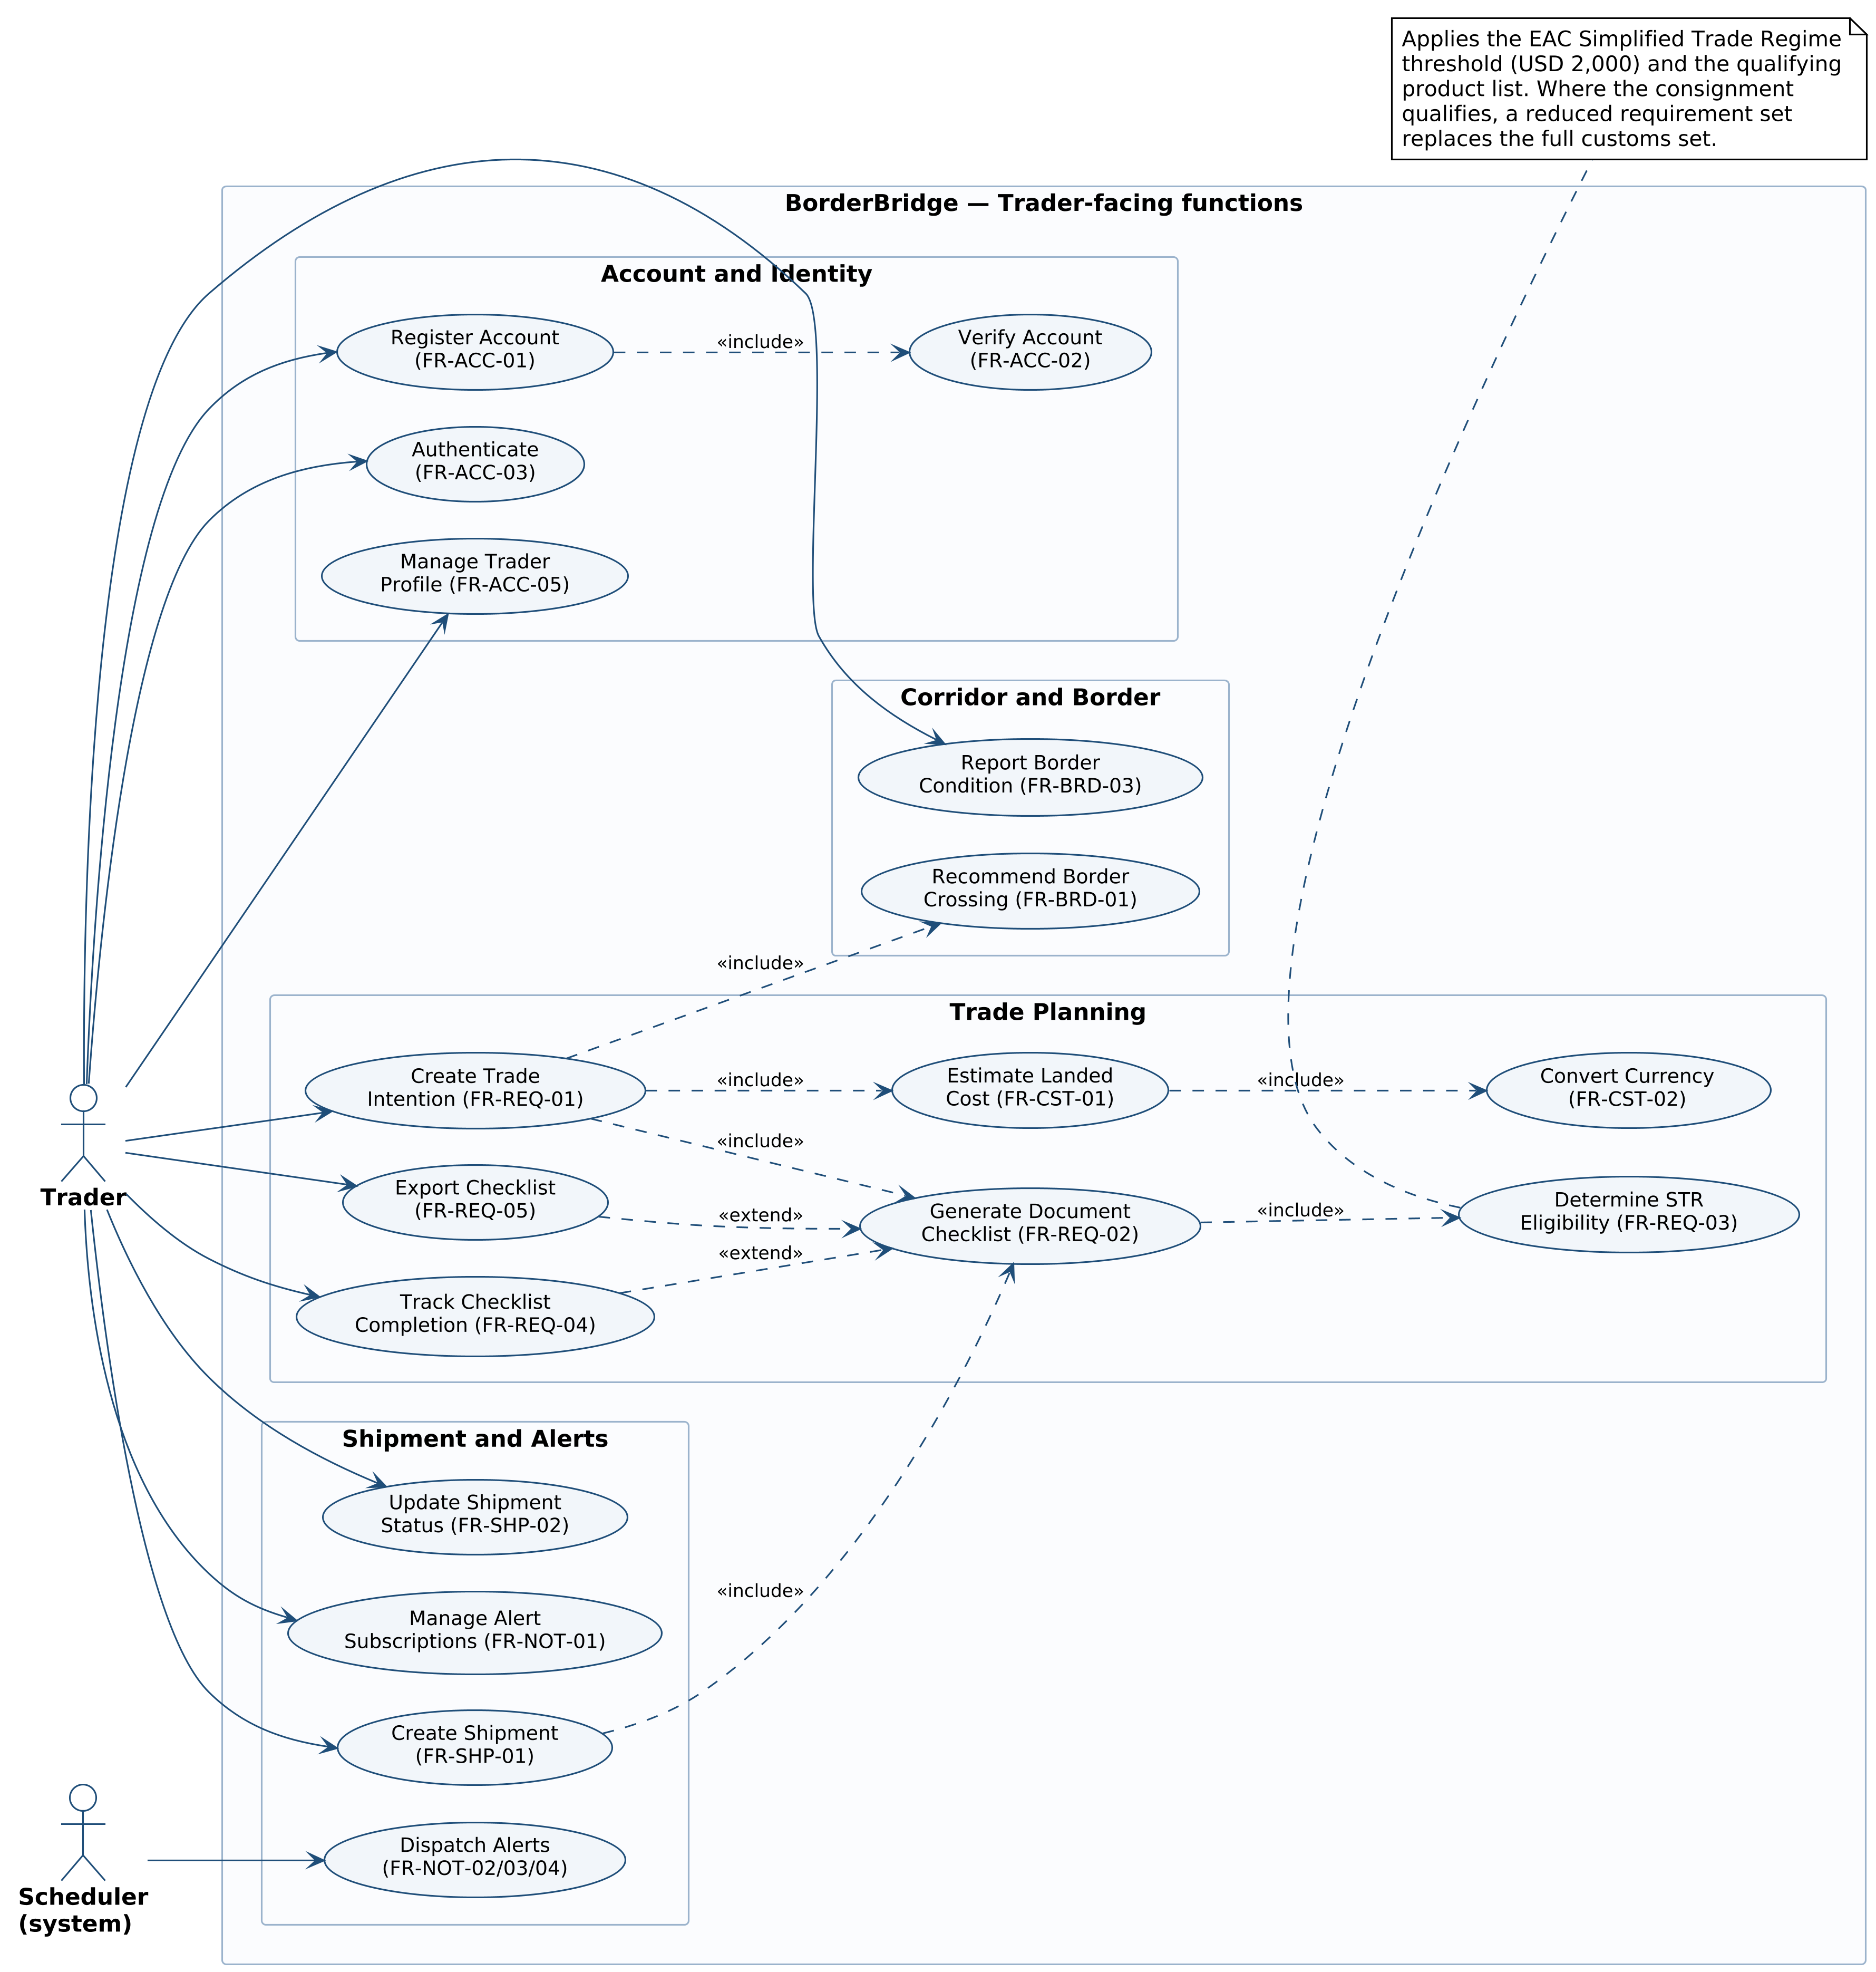
Figure B.1a. Use case diagram — functions available to the trader, the system’s primary actor.
Actors
Actor | Type | Goal in this diagram
Trader | Primary, human | To find out what a specific consignment on a specific route will require and cost, and to prepare for the crossing accordingly
Scheduler (system) | Secondary, automated | To dispatch regulatory, border and shipment alerts without human initiation; drawn as an actor because it triggers behaviour from outside any user session
Flow and connections represented
The diagram is organised into four packages corresponding to the module structure of Section 4.
- Account and Identity. The trader registers (FR-ACC-01), which always includes verification by one-time SMS code (FR-ACC-02) — hence the «include». Authentication (FR-ACC-03) and profile management (FR-ACC-05) are separate entry points for a returning trader.
- Trade Planning. This is the heart of the diagram. Create Trade Intention (FR-REQ-01) is the single entry point from which the entire plan derives, and it includes three things unconditionally: checklist generation (FR-REQ-02), cost estimation (FR-CST-01) and border recommendation (FR-BRD-01). Checklist generation in turn includes the simplified-regime eligibility test (FR-REQ-03), and cost estimation includes currency conversion (FR-CST-02). Export (FR-REQ-05) and completion tracking (FR-REQ-04) extend checklist generation, because a trader may or may not use them.
- Corridor and Border. Recommend Border Crossing (FR-BRD-01) is reached through the include from trade planning rather than as a standalone goal, whereas Report Border Condition (FR-BRD-03) is a direct trader action — the crowdsourcing loop that keeps border status current.
- Shipment and Alerts. Create Shipment (FR-SHP-01) includes checklist generation, because a shipment cannot exist without the plan it snapshots. Dispatch Alerts (FR-NOT-02/03/04) is driven by the Scheduler, not the trader, which is why that association originates outside the human actor.
Inputs and outputs
Use case | Input | Output
Create Trade Intention | Origin and destination country, product, quantity or declared value | A persisted trade intention with a unique reference
Generate Document Checklist | Trade intention, trader profile, active regulatory rule set | An ordered checklist with issuing authority, source citation and last-verified date per item
Determine STR Eligibility | Declared value, product classification, corridor, STR product list | An eligibility determination with a plain-language explanation and cited threshold
Estimate Landed Cost | Trade intention, duty and tax rates, transport rates | An itemised estimate with a confidence range
Recommend Border Crossing | Trade intention, crossing register, official status, community reports | A ranked list of crossings with the ranking rationale
Report Border Condition | Crossing, condition category, estimated waiting time | An updated aggregate community status visible to other traders
Table B.2. Inputs and outputs of the principal trader-facing use cases.

B.1.3 Figure B.1b — Providers, officials and administration
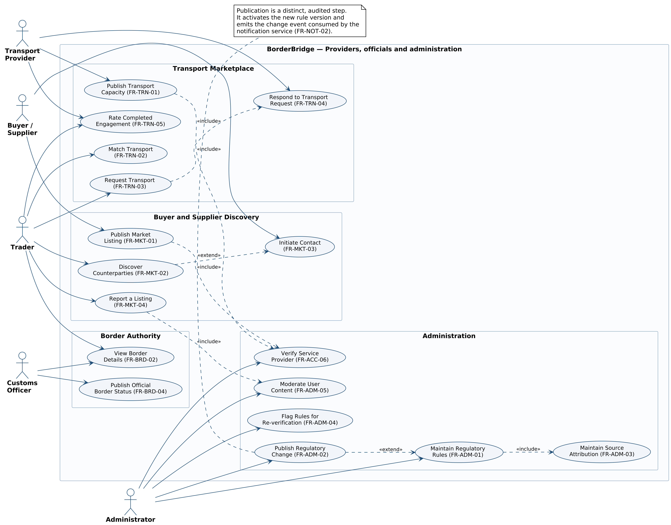
Figure B.1b. Use case diagram — the supply side of the marketplace, border authority functions, and administration.
Actors
Actor | Type | Goal in this diagram
Transport Provider | Primary, human | To fill unused capacity on cross-border routes by publishing availability and responding to requests
Buyer / Supplier | Primary, human | To be discoverable to traders in the neighbouring market and contacted about specific consignments
Trader | Primary, human | Appears here as the demand side: searching for transport, discovering counterparties, reporting bad listings
Customs Officer | Primary, human | To publish authoritative border status, which takes precedence over community reports
Administrator | Primary, human | To keep the regulatory knowledge base accurate and to police the integrity of user-generated content
Flow and connections represented
- Transport Marketplace. A provider publishes capacity (FR-TRN-01), which includes provider verification (FR-ACC-06) — an unverified listing is withheld from search, so verification is a precondition of publication rather than an optional extra. The trader searches (FR-TRN-02) and requests (FR-TRN-03); the request includes the provider’s response (FR-TRN-04), because a request is not complete until it is accepted, declined or countered. Both parties may rate the engagement afterwards (FR-TRN-05).
- Buyer and Supplier Discovery. Publishing a market listing (FR-MKT-01) likewise includes verification. Discovery (FR-MKT-02) is extended by Initiate Contact (FR-MKT-03), since a trader may browse without contacting anyone. Reporting a listing (FR-MKT-04) includes moderation (FR-ADM-05), the mechanism by which a report becomes an administrative decision.
- Border Authority. The Customs Officer publishes official status (FR-BRD-04). This is a separate actor and package because the officer is not a trader: their interaction is read-oriented and authoritative, and their published status overrides the crowdsourced aggregate.
- Administration. Maintaining a rule (FR-ADM-01) includes maintaining its source attribution (FR-ADM-03) — the system refuses to save a rule without a citation, so the two are inseparable. Publishing a change (FR-ADM-02) extends rule maintenance, marking the deliberate split between drafting and activating a rule. Re-verification flagging (FR-ADM-04) is scheduled work that keeps the knowledge base from silently going stale.
Why the actor split matters
Separating these actors is not cosmetic. Section 5.2 requires role-based access control enforced server-side (NFR-SEC-04), and this diagram is the source of that requirement: it establishes that publishing an official border status is a Customs Officer capability and publishing a regulatory change is an Administrator capability, neither of which any trader may perform regardless of what the client interface offers.

B.2 Class Diagrams (Structural)
B.2.1 What a class diagram represents
A class diagram models the static structure of the system: the classes of object it holds, the attributes and operations each carries, and the relationships between them. Unlike the behavioural diagrams it says nothing about time or order — it describes what is true of the system at any moment.
Notation | Meaning
Class box, three compartments | Name, then attributes (name : type), then operations (name(parameters) : return type)
Italic class name, marked {A} | An abstract class, which cannot itself be instantiated. User is abstract because every user is of a concrete role
Hollow triangle arrowhead | Generalisation, read as “is a”. Trader is a User and inherits its attributes and operations
Filled diamond | Composition, a strong whole–part relationship. The part cannot exist without its whole: deleting a Checklist deletes its ChecklistItems
Hollow diamond | Aggregation, a weaker whole–part relationship. A BorderCrossing belongs to a Corridor but has an independent existence
Plain arrow | A directed association — one class holds a reference to and can navigate to another
Dashed arrow | A dependency — one class uses another transiently, without holding a reference to it
1, 0..1, 0..*, 1..* | Multiplicity: exactly one, at most one, any number including none, at least one
- and + | Private and public visibility respectively
Table B.3. UML class diagram notation used in this appendix.

B.2.2 Figure B.2a — Users, trade planning and the regulatory knowledge base
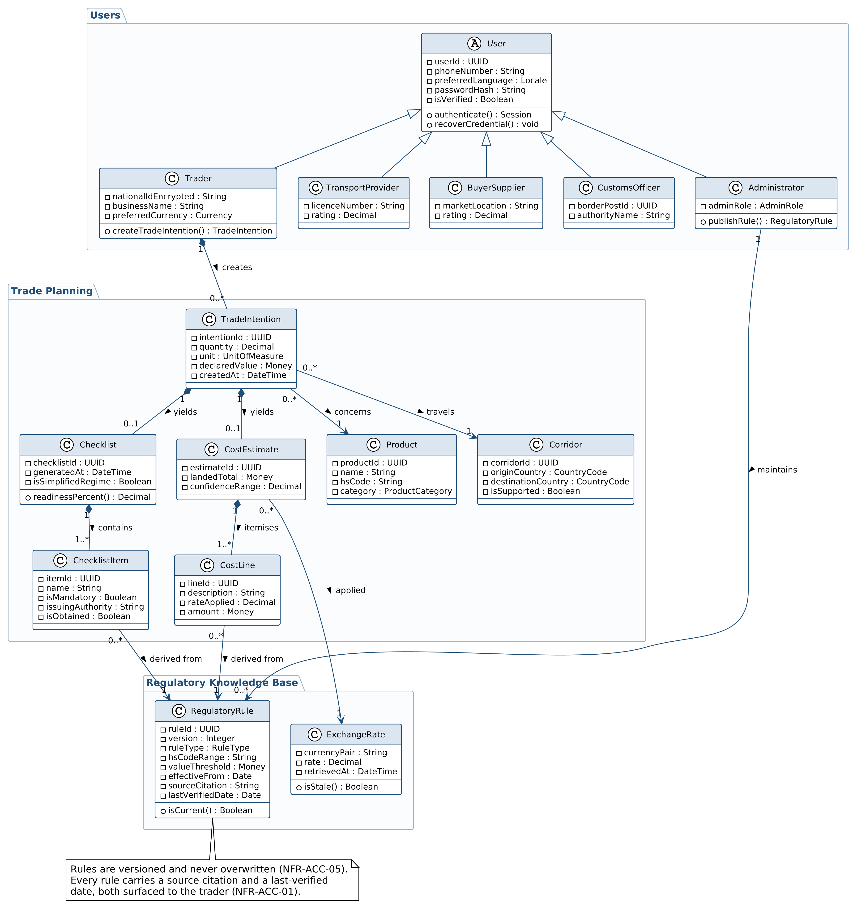
Figure B.2a. Class diagram — the core domain model.
Structure represented
The diagram is divided into three packages reflecting three different rates of change. User data changes when people join. Trade planning data is created fresh for every consignment. Regulatory data changes when the law does — independently of both — which is precisely why it is modelled as its own package rather than as attributes scattered across the others.
The user hierarchy
User is abstract and holds everything common to all roles: identity, credentials, verification state, language preference, and the operations for authentication and credential recovery (FR-ACC-03, FR-ACC-04). Five concrete subclasses inherit from it. This is a generalisation hierarchy rather than a role attribute because the roles carry genuinely different data and behaviour: only Trader holds an encrypted national identification number and can create a trade intention; only Administrator can publish a regulatory rule. Modelling roles as subclasses is what makes NFR-SEC-04 enforceable at the type level rather than by runtime string comparison.
The trade planning chain
The central relationship chain models the problem this system exists to solve, and reads as a single sentence:
A Trader creates zero or more TradeIntentions. Each TradeIntention concerns exactly one Product and travels exactly one Corridor, and yields at most one Checklist and at most one CostEstimate. A Checklist contains one or more ChecklistItems; a CostEstimate itemises one or more CostLines. Every ChecklistItem and every CostLine is derived from exactly one RegulatoryRule.
Three modelling decisions in that chain deserve explanation:
- Checklist and CostEstimate are compositions of TradeIntention (filled diamonds). They have no meaning apart from the intention that produced them, and deleting the intention must delete them. This also prevents a stale checklist from outliving the consignment it described.
- The multiplicity on Checklist is 0..1, not 1. A trade intention exists the moment the trader submits it, but the checklist is generated afterwards and may fail to generate if the corridor has no loaded rule content. The model must permit that intermediate state rather than pretending it cannot occur.
- ChecklistItem and CostLine both point to RegulatoryRule rather than copying its text. This single relationship is what makes NFR-ACC-01 achievable: because every item retains a live reference to the versioned rule it came from, the interface can always display the governing citation and its last-verified date, and FR-ADM-04 can identify exactly which trader-facing output is affected when a rule falls overdue for re-verification.
The regulatory knowledge base
RegulatoryRule carries a version number, an effective date, a source citation and a last-verified date, and exposes isCurrent(). It is modelled as versioned data rather than as application code because regulatory volatility is a certainty in this domain (constraint C1), and because NFR-ACC-05 requires that the exact rule set applied to any historical shipment can be reconstructed. ExchangeRate similarly records retrievedAt and exposes isStale(), which is the model-level basis for the 24-hour freshness requirement in NFR-ACC-03.

B.2.3 Figure B.2b — Fulfilment, corridor operations and notification
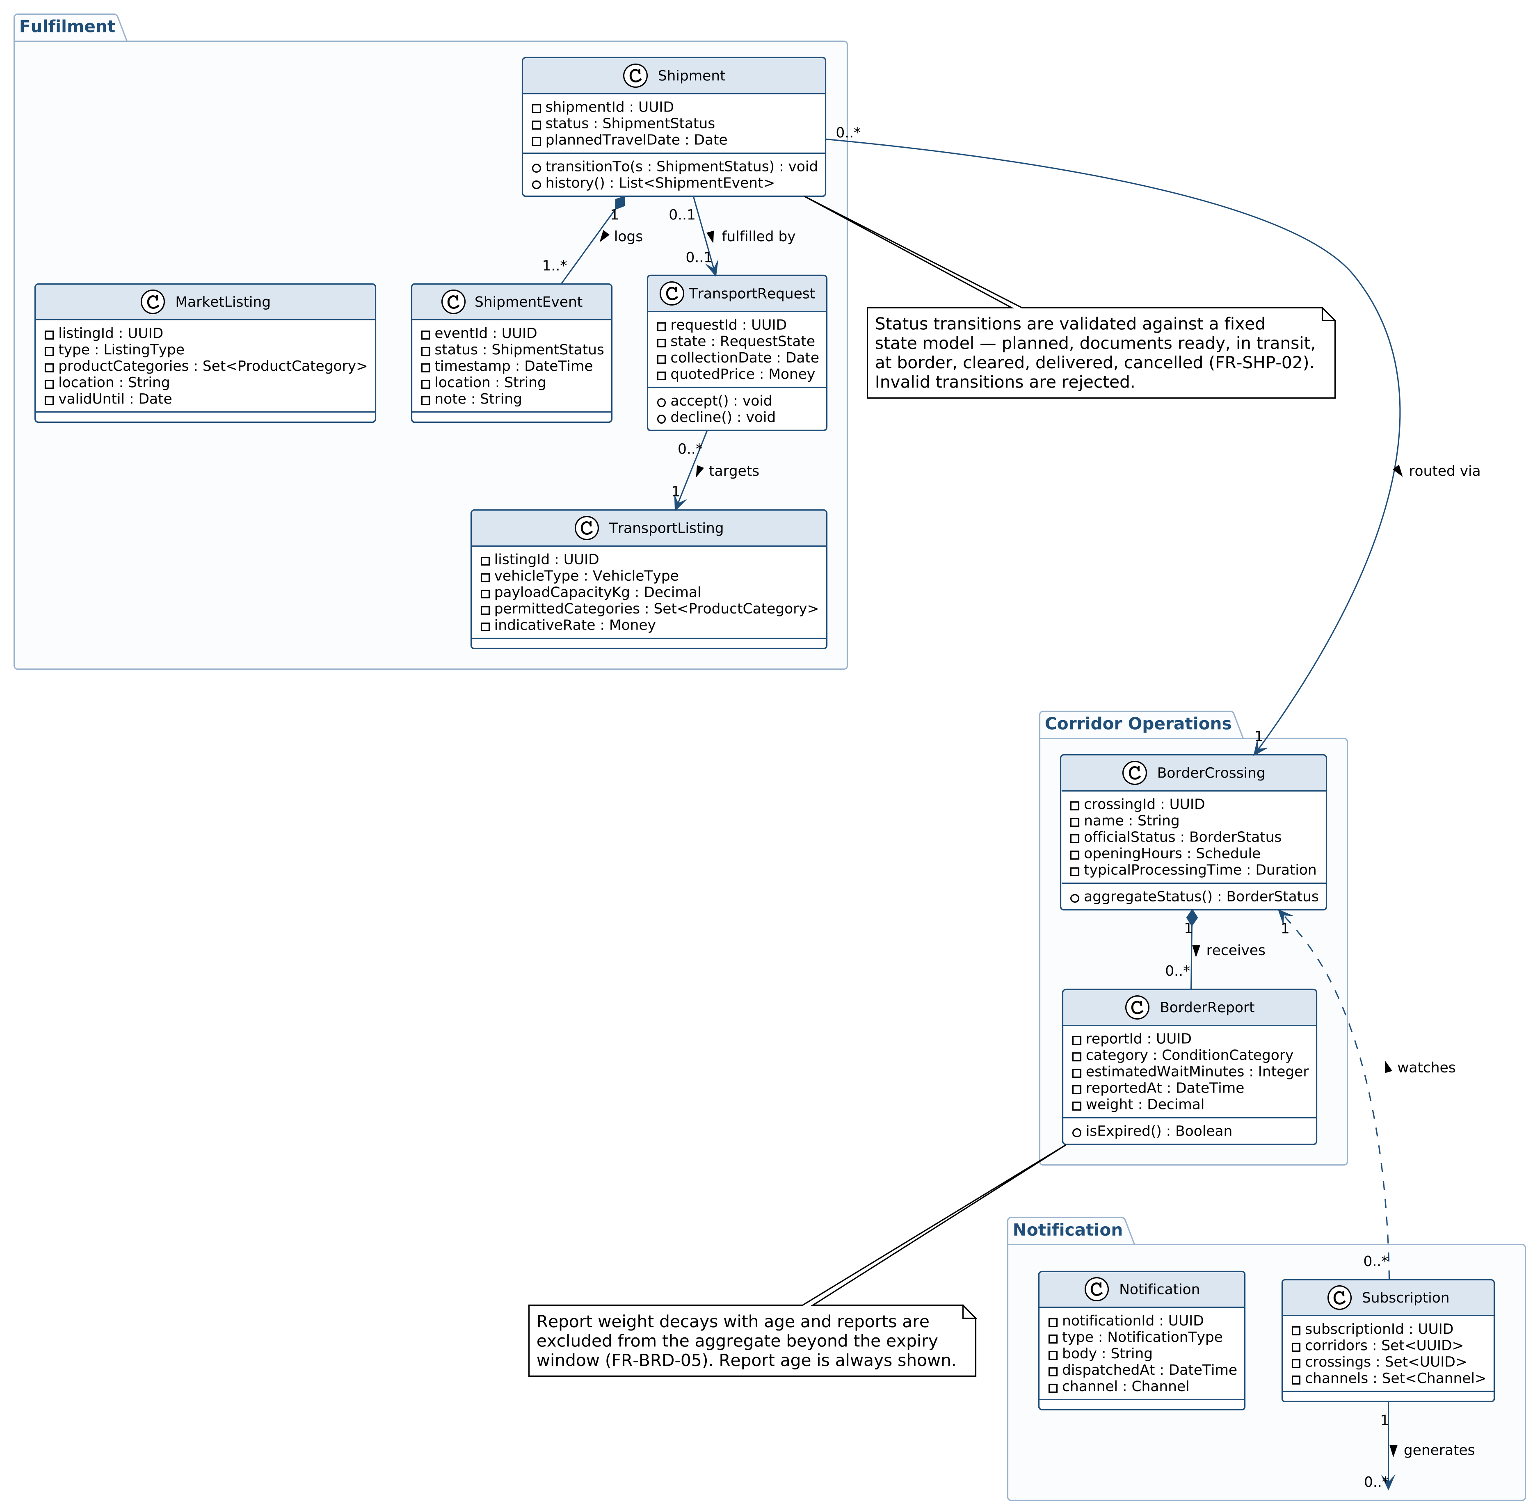
Figure B.2b. Class diagram — execution of a planned movement.
Structure represented
Where Figure B.2a models planning, this diagram models execution: what happens once a trader commits to a movement.
- Fulfilment. Shipment is the aggregate root. It composes one or more ShipmentEvents — an append-only history, which is why the relationship is a composition and the multiplicity is 1..* rather than 0..*: creating a shipment immediately writes its first event. Shipment exposes transitionTo(), the operation that enforces the state model in FR-SHP-02; invalid transitions are rejected at the domain layer, not merely hidden in the interface. A Shipment is optionally fulfilled by a TransportRequest, which targets exactly one TransportListing.
- Corridor Operations. BorderCrossing composes zero or more BorderReports and exposes aggregateStatus(), which computes the community view. BorderReport carries both reportedAt and weight, and exposes isExpired(). Putting decay and expiry in the model rather than in a query is what makes FR-BRD-05 a structural guarantee: a stale report cannot be presented as current, because the object itself knows it is stale.
- Notification. A Subscription records the corridors, crossings and delivery channels a user follows, and watches BorderCrossing — a dependency rather than an association, since a subscription references crossings by identifier without owning them. Each Subscription generates zero or more Notifications.
Cross-diagram relationships
For legibility, the User classes appear only in Figure B.2a. The relationships spanning the two diagrams are stated here for completeness, and are implemented as ordinary associations:
Relationship | Multiplicity | Meaning
Trader owns Shipment | 1 to 0..* | A shipment always belongs to exactly one trader; deleting the trader account cascades under NFR-PRI-03
TransportProvider publishes TransportListing | 1 to 0..* | Listings are withheld from search until the provider is verified (FR-ACC-06)
BuyerSupplier publishes MarketListing | 1 to 0..* | Listings expire automatically at the end of their validity period
Trader holds Subscription | 1 to 0..1 | One subscription set per trader, governing which events reach them (FR-NOT-01)
User reports BorderReport | 1 to 0..* | Report weight is influenced by the reporter’s history
CustomsOfficer publishes status on BorderCrossing | 1 to 0..* | Official status takes precedence over the community aggregate (FR-BRD-04)
Table B.4. Relationships spanning Figures B.2a and B.2b.
The application service classes that operate on this model — RequirementsEngine, CostEngine, BorderService, MatchingEngine and NotificationService — are deliberately omitted from both class diagrams, because they hold no state and therefore have no structural relationships worth drawing. They appear instead as lifelines in Figure B.3, which is where their behaviour belongs, and in the architectural decomposition in Table 2.1.

B.3 Sequence Diagram (Behavioural)
This section is set in landscape orientation. The sequence diagram spans nine participants, and landscape gives it the width it needs to remain legible at page size.
B.3.1 What a sequence diagram represents
A sequence diagram models one specific scenario as an ordered exchange of messages between participants. Time runs downwards. Each participant has a vertical lifeline; the narrow rectangles on a lifeline are activation bars, showing when that participant is doing work. Solid arrows are calls, dashed arrows are returns. Rectangular fragments labelled alt enclose alternative paths guarded by a condition — only one branch of an alt executes.
The scenario modelled is the system’s most important one: a trader submits a consignment and receives a complete trade plan. It realises FR-REQ-01, FR-REQ-02, FR-REQ-03, FR-CST-01, FR-CST-02 and FR-BRD-01 in a single interaction.
B.3.2 Figure B.3 — Generating a trade plan
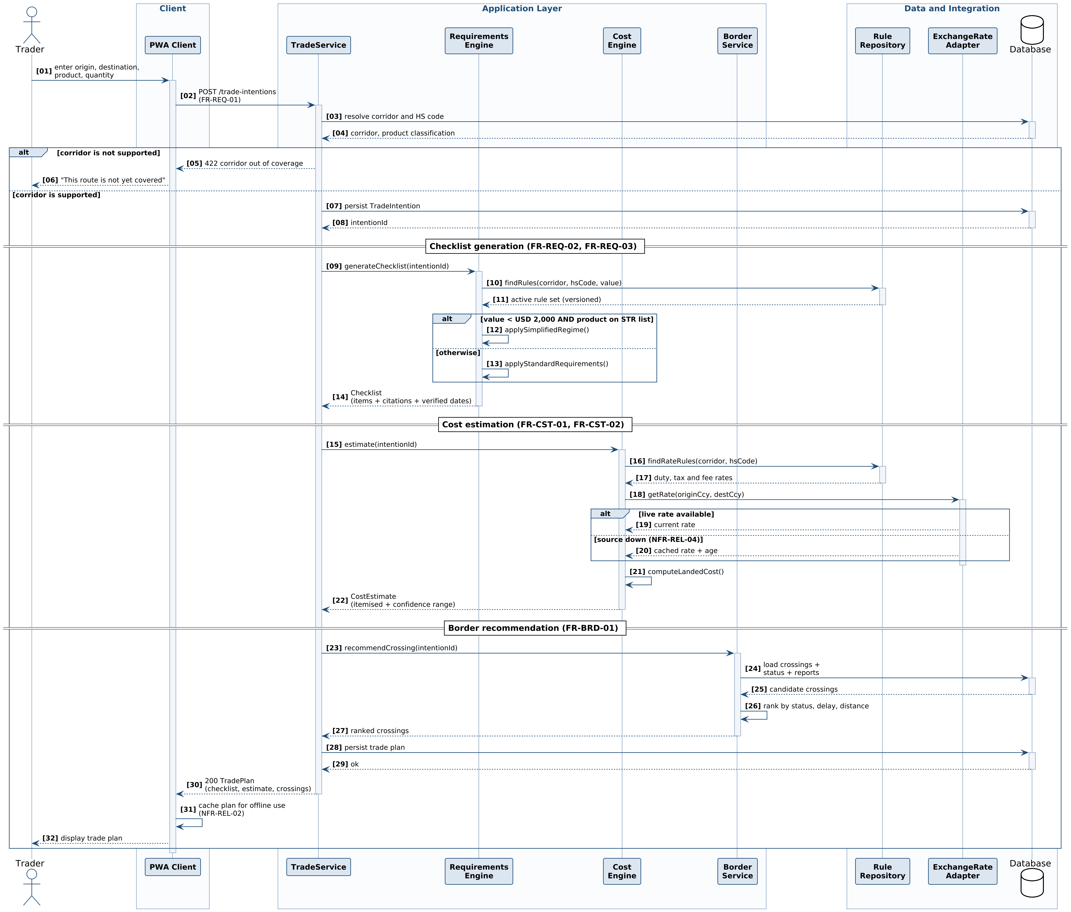
Figure B.3. Sequence diagram — trader requests a trade plan for a specific consignment.
Participants
Participant | Layer | Responsibility in this scenario
Trader | Actor | Supplies the consignment details and receives the plan
PWA Client | Presentation | Collects input, calls the API, and caches the returned plan for offline use
TradeService | Application | Orchestrates the scenario; owns the transaction and the ordering of the three engines
Requirements Engine | Application | Resolves the applicable rules and builds the checklist
Cost Engine | Application | Computes duties, taxes, fees and the converted landed total
Border Service | Application | Ranks candidate crossings
Rule Repository | Data | Returns the active, versioned rule set for a corridor and classification
ExchangeRate Adapter | Integration | Isolates the external rate source, and degrades to a cached rate
Database | Data | Persists the intention, the plan, and the reference data read along the way
Flow represented
Messages | Phase | What happens
01–08 | Intention capture | The trader submits the consignment; TradeService resolves the corridor and HS classification. An alt fragment handles the unsupported-corridor case: the scenario terminates with a 422 response and a plain-language message rather than a partial plan. Only in the supported branch is the TradeIntention persisted.
09–14 | Checklist generation | TradeService delegates to the Requirements Engine, which fetches the active versioned rule set. A nested alt implements FR-REQ-03: if the declared value is under USD 2,000 and the product appears on the qualifying list, the simplified requirement set is applied; otherwise the full customs set applies. Either way the returned checklist carries citations and verified dates.
15–22 | Cost estimation | The Cost Engine fetches rate rules, then requests an exchange rate. A second alt implements NFR-REL-04: if the external source is unavailable, the adapter returns a cached rate with its age and the estimate is still produced. The scenario degrades rather than failing — an important property for a user on an intermittent connection.
23–32 | Border recommendation and return | Border Service loads crossings with official status and current community reports, ranks them, and returns. The composed plan is persisted, returned to the client, and cached locally for offline access under NFR-REL-02 before being displayed.
Table B.5. Phases of the trade plan generation sequence.
Design decisions the diagram makes visible
- TradeService orchestrates; the engines do not call one another. This keeps the engines independently testable and supports the 80% domain coverage target in NFR-MNT-01.
- Both failure modes are modelled explicitly rather than left as exception handling. An unsupported corridor terminates cleanly; an unavailable rate source degrades to a cached value with its age disclosed. Neither produces a blank screen or a silent wrong answer.
- The exchange rate is read through an adapter, never directly. This is the structural expression of NFR-CMP-05 and constraint C8: the external source can be replaced without touching domain logic.
- Caching happens on the client after the response, not on the server. That placement is what makes the plan readable later with no connectivity at all.
Inputs and outputs of the scenario
Aspect | Detail
Trigger | Trader submits origin, destination, product and quantity
Inputs | Consignment details; trader profile; active regulatory rule set; duty, tax and fee schedules; exchange rate; border crossing register; current community reports
Primary output | A TradePlan comprising a document checklist, an itemised cost estimate with confidence range, and a ranked list of border crossings
Secondary outputs | A persisted TradeIntention; a client-side offline cache entry
Alternative outcome | HTTP 422 with an out-of-coverage message where the corridor is unsupported
Postconditions | The trade intention is durable and may be converted to a Shipment (FR-SHP-01); the plan is readable offline
Table B.6. Inputs, outputs and postconditions of the trade plan scenario.

B.4 Activity Diagram (Behavioural)
B.4.1 What an activity diagram represents
An activity diagram models a workflow as a flow of control through actions. Where the sequence diagram shows one scenario message by message, the activity diagram shows the whole process including every branch — which makes it the right tool for a workflow whose value lies in its decisions.
The workflow is presented in two parts, Figures B.4a and B.4b, which form one continuous flow. The notation used in both:
Notation | Meaning
Vertical swimlanes | Partitions showing which participant is responsible for each action
Filled circle / circled dot | Initial node (start) and final node (end) of the flow
Rounded rectangle | An action — a single step of work
Diamond | A decision node (branching) or a merge node (rejoining), with guard conditions on the outgoing edges
Thick horizontal bar | A fork, splitting control into parallel flows, or a join, synchronising them again
Loop back to a merge | Iteration — the flow repeats until the guard condition is satisfied
B.4.2 Figure B.4a — Planning: from trade intention to presented plan
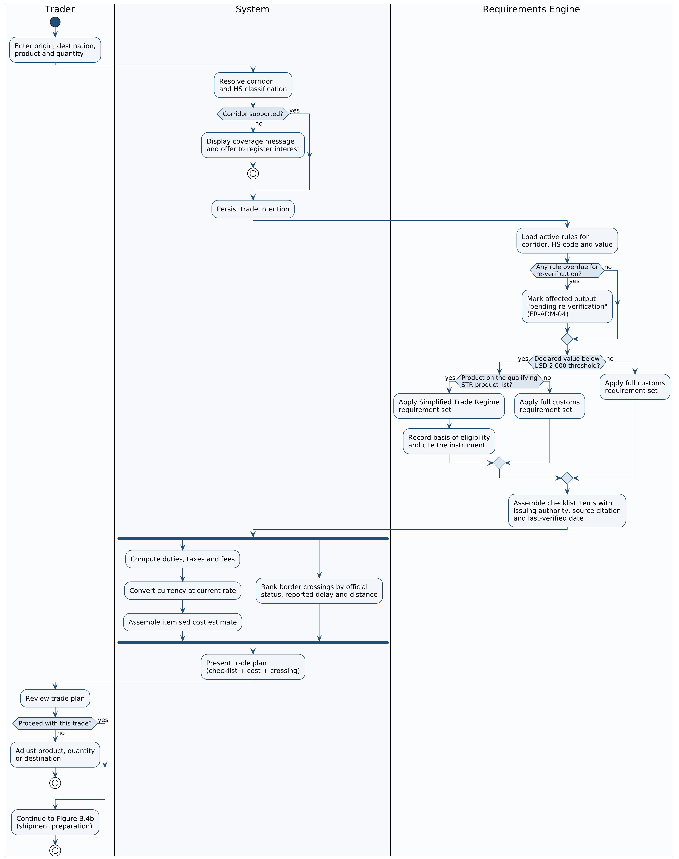
Figure B.4a. Activity diagram, part 1 — resolving the corridor, determining simplified-regime eligibility, assembling the checklist, and computing cost and crossing in parallel.
This first part covers everything that happens before the trader commits. It ends at one of three outcomes: the corridor is unsupported and the flow terminates; the trader reviews the plan and abandons or revises it; or the trader accepts and continues into Figure B.4b.

B.4.3 Figure B.4b — Preparation and fulfilment: from accepted plan to border-ready shipment
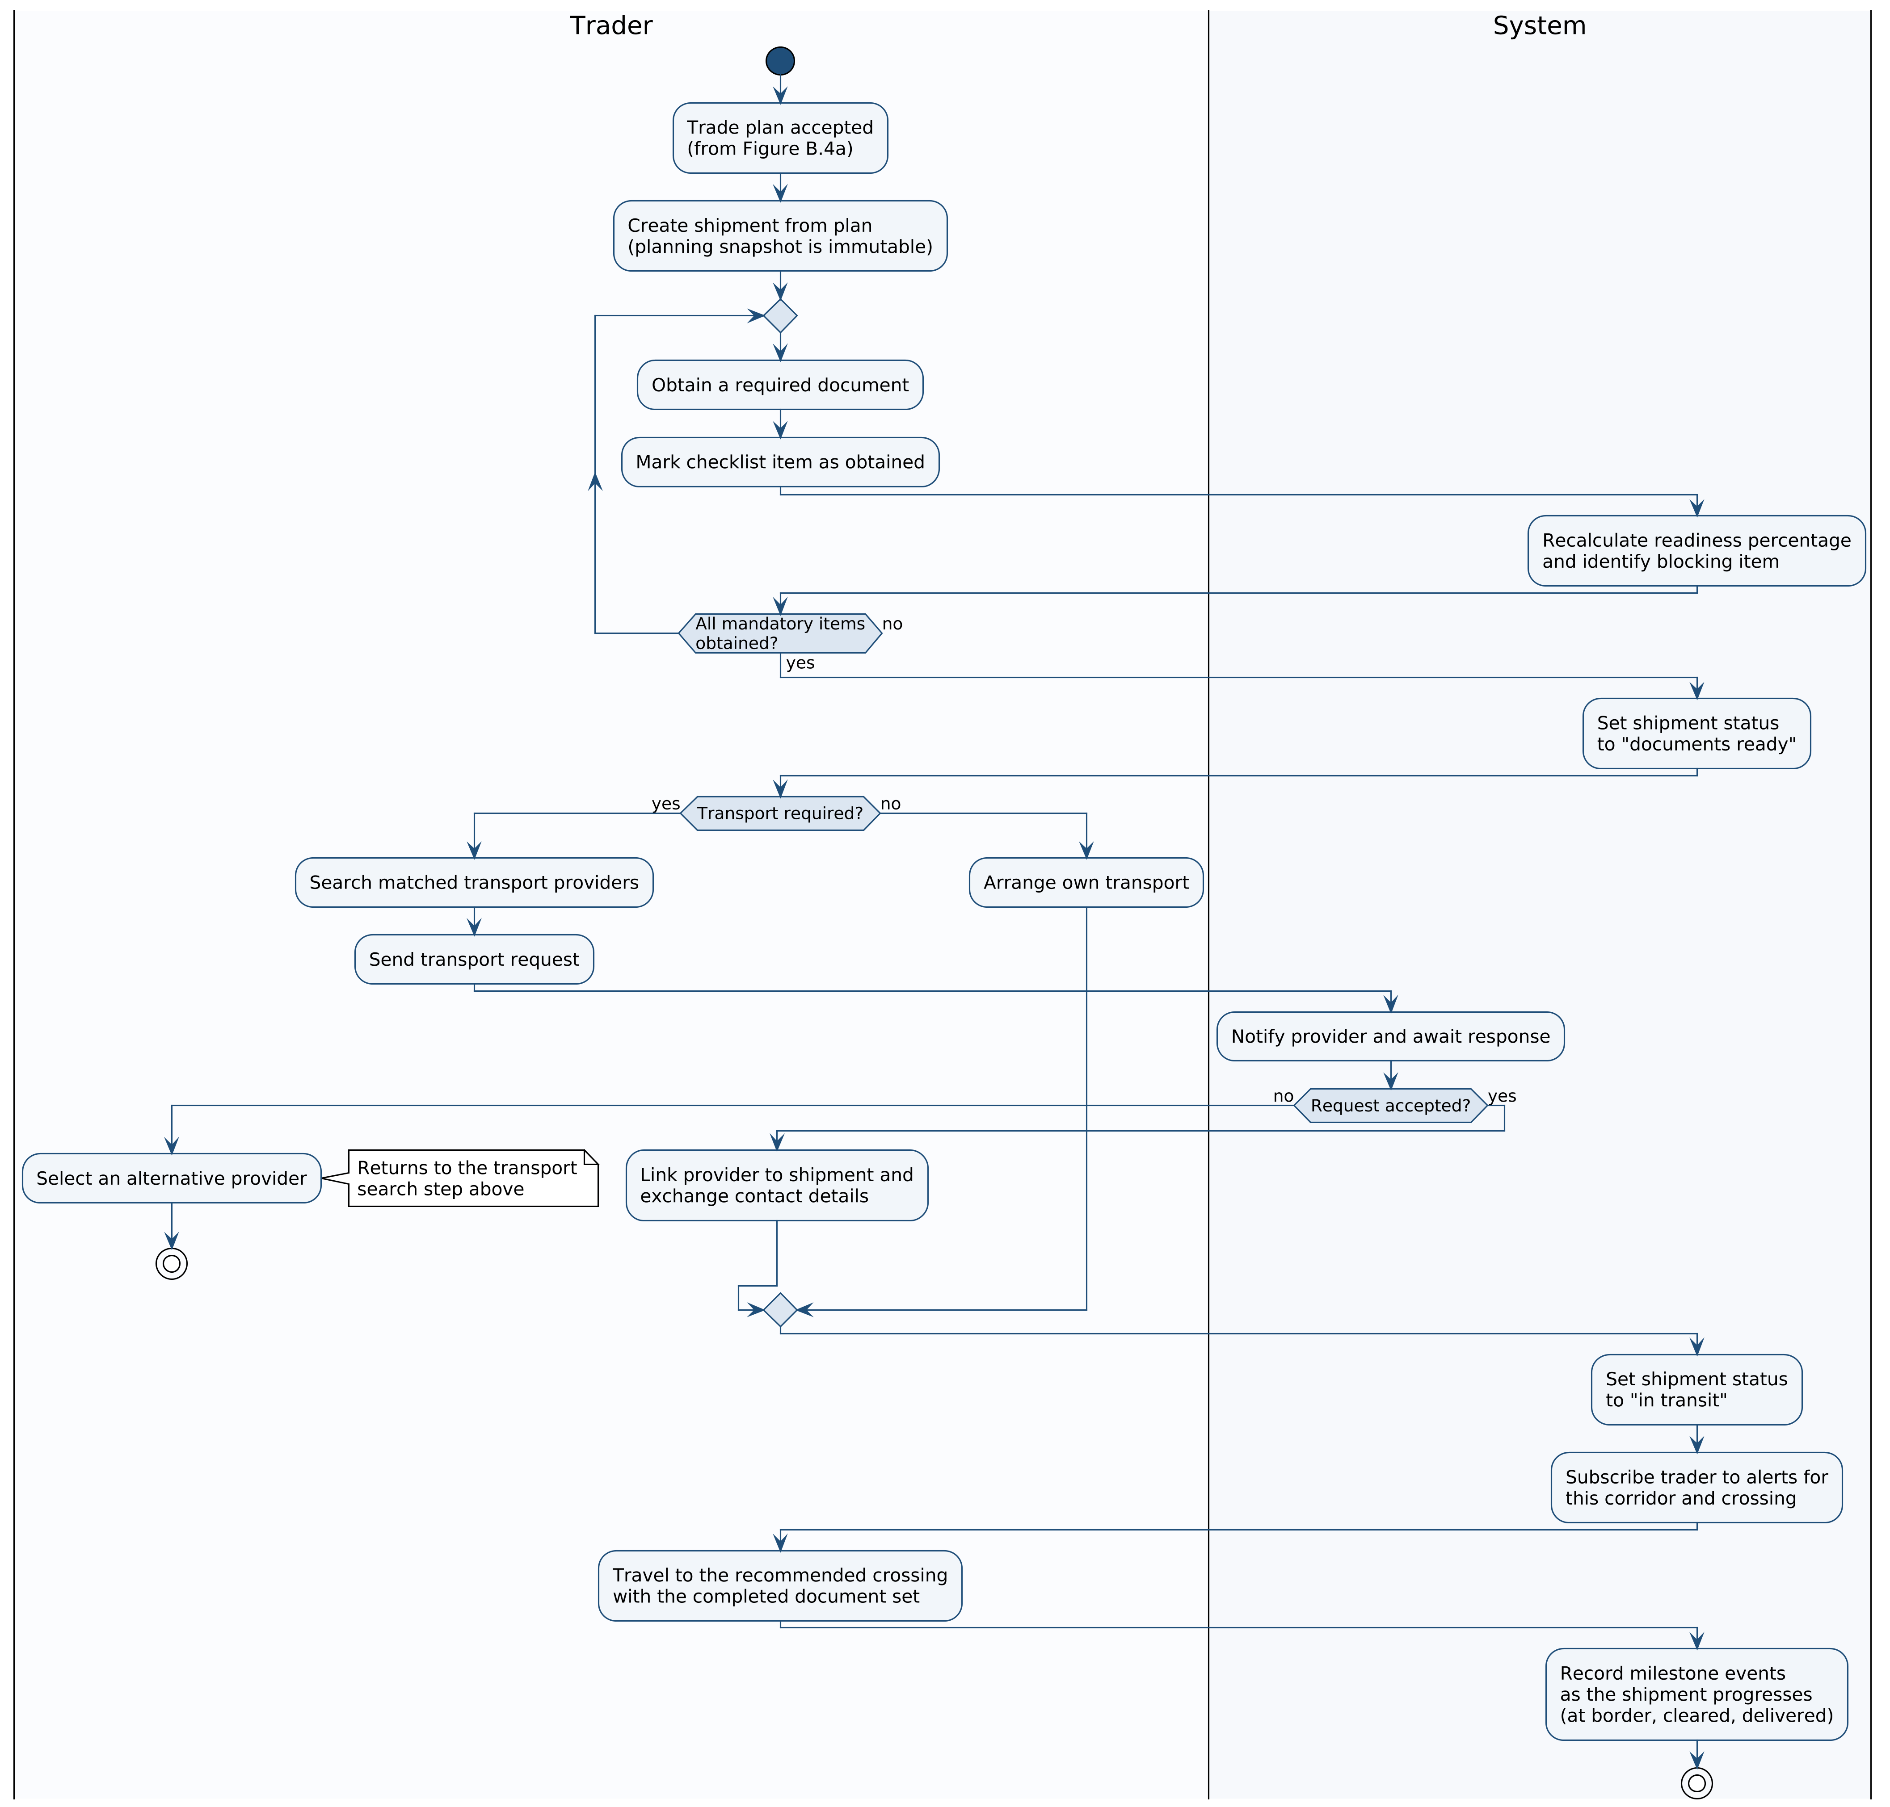
Figure B.4b. Activity diagram, part 2 — shipment creation, the iterative document-gathering loop, transport engagement, and departure.
The second part covers execution. Its dominant feature is the document-gathering loop, which in practice is where the trader spends the bulk of real-world elapsed time. The two parts form one continuous workflow and are split only for legibility at page size.
Swimlanes
Partition | Responsibility
Trader | All human judgement and physical action: stating the intention, reviewing the plan, obtaining documents, choosing transport, travelling
System | Orchestration, persistence, cost and border computation, status management and notification
Requirements Engine | Rule resolution and the simplified-regime determination — separated because this is the decision logic that carries the greatest consequence for the trader
Decision points
Seven decisions shape the workflow across the two parts. Each corresponds to a requirement in Section 4.
Decision | Requirement | Figure | Effect on the flow
Corridor supported? | FR-REQ-01 | B.4a | If not, the flow terminates immediately with a coverage message. No partial plan is produced
Any rule overdue for re-verification? | FR-ADM-04 | B.4a | Does not halt the flow, but marks the affected output as pending re-verification so the trader can judge its currency
Declared value below USD 2,000? | FR-REQ-03 | B.4a | First of the two simplified-regime gates
Product on the qualifying STR list? | FR-REQ-03 | B.4a | Second gate. Both must pass; either failing routes to the full customs requirement set
Proceed with this trade? | FR-SHP-01 | B.4a | The trader’s commitment point. Declining returns to adjust the product, quantity or destination rather than creating a shipment
All mandatory items obtained? | FR-REQ-04 | B.4b | Controls the document-gathering loop; the shipment cannot advance to “documents ready” until this is satisfied
Transport required? and Request accepted? | FR-TRN-03, FR-TRN-04 | B.4b | The first determines whether the trader enters the matching subflow at all; the second handles the declined-request path, which returns the trader to provider selection
Table B.7. Decision nodes and the requirements they realise.
Parallelism and iteration
The fork after checklist assembly is a substantive modelling claim, not decoration. Cost estimation and border ranking share the trade intention as input but neither depends on the other’s output, so they are genuinely concurrent; the join means the trade plan is presented only when both have completed. This is the model-level justification for the parallel service calls that make the 3-second response target in NFR-PER-01 and NFR-PER-02 achievable.
The document-gathering loop is the workflow’s principal iteration, and it is where the trader spends the most real-world time — often days, across multiple issuing authorities. Modelling it as a loop with a readiness recalculation on each pass is what makes FR-REQ-04 meaningful: the trader always knows how far from ready they are, and which item is blocking. Two further return paths exist but are drawn as terminations rather than as loops, to keep the diagrams readable: declining the plan at “Proceed with this trade?” returns the trader to adjust the intention, and a declined transport request returns them to provider selection.
Inputs, outputs and activities
Aspect | Detail
Trigger | A trader decides to move a consignment across a border
Inputs | Consignment details; regulatory rule set with verification dates; STR product list and threshold; duty, tax and fee schedules; exchange rate; border crossing register; transport listings
Key activities | Resolve corridor and classification · load and check rules · determine simplified-regime eligibility · assemble checklist with citations · compute cost and rank crossings in parallel · create shipment · gather documents iteratively · match and engage transport · transition shipment status · subscribe to alerts
Outputs | A trade plan; a shipment in the “in transit” state with an immutable planning snapshot; a completed document set; an engaged transport provider; an active alert subscription
Terminal states | Successful: the trader travels to the recommended crossing document-ready. Unsuccessful: the corridor is unsupported, or the trader abandons or revises the intention
Table B.8. Inputs, activities and outputs of the end-to-end workflow.

B.5 Diagram-to-Requirement Traceability
The table below records where each functional module of Section 4 is modelled. Nine of the eleven modules are represented in at least one diagram; the two that are not are identified beneath the table, with the reason. This is the check that the models describe the specified system rather than a different one.
Module | B.1a/b  Use case | B.2a/b  Class | B.3  Sequence | B.4a/b  Activity | Covered
Account & Identity | Yes | Yes | — | — | Yes
Trade Requirements | Yes | Yes | Yes | Yes | Yes
Cost Estimation | Yes | Yes | Yes | Yes | Yes
Border Information | Yes | Yes | Yes | Yes | Yes
Transport Matching | Yes | Yes | — | Yes | Yes
Marketplace Discovery | Yes | Yes | — | — | Yes
Shipment Tracking | Yes | Yes | — | Yes | Yes
Notifications & Alerts | Yes | Yes | — | Yes | Yes
Regulation Management | Yes | Yes | Yes | Yes | Yes
Localisation | — | — | — | — | Cross-cutting
Reporting & Analytics | — | — | — | — | Deferred to R4
Table B.9. Coverage of the Section 4 modules across the four diagram types.
Two modules are intentionally not modelled. Localisation is a cross-cutting presentation concern applying to every output rather than a distinct structure or flow; modelling it would add a language attribute to every diagram without clarifying anything. Reporting and Analytics consists entirely of Could-priority requirements scheduled for release R4, and is modelled once its scope is confirmed. Both omissions are recorded here rather than left silent, so that a reader can see they are decisions rather than oversights.

B.6 Diagram source files
All seven diagrams were authored as PlantUML source and rendered to PNG. The source files accompany this document, so that any diagram can be amended and re-rendered without redrawing:
Source file | Figure | Diagram type
B1a_use_case_trader.puml | B.1a | Use case (behavioural)
B1b_use_case_supply.puml | B.1b | Use case (behavioural)
B2a_class_core.puml | B.2a | Class (structural)
B2b_class_fulfilment.puml | B.2b | Class (structural)
B3_sequence.puml | B.3 | Sequence (behavioural)
B4a_activity_planning.puml | B.4a | Activity (behavioural)
B4b_activity_fulfilment.puml | B.4b | Activity (behavioural)
Each was rendered at 300 dpi, so the figures remain sharp when magnified on screen. Full-resolution PNG files are supplied alongside the source, for any diagram that warrants closer inspection than page size allows.

