PRODUCT & ENGINEERING PLAN
The White Board Revamp
From dark chalkboard to a clean, animated, hand-drawn explainer — for any subject
A full replacement of the current dark chalkboard AND the separate animation system with ONE unified, white-background, hand-drawn-style animated board — generalized beyond chemistry to any subject a student asks about.
SCOPE  Full revamp, not additive | STATUS  Planning | REFERENCE  10 screenshots (attached) | REPLACES  Blackboard + Animation beats

CONTENTS
1. What we're looking at (the reference)
2. What changes vs. today
3. The visual system — how it's actually built
4. Generalizing beyond chemistry
5. Merging blackboard + animation into one board type
6. The sketch primitive library
7. Prompt & generation pipeline
8. Fallback: AI-generated sketch images
9. Rendering engine changes
10. Migration plan & rollout
11. Cost & latency impact
12. Risks and how we cover them
13. Build order

1. What We're Looking At
The reference screenshots (a chemistry equation-balancing lesson from a study app) show a visual language that is a genuine departure from the current dark chalkboard. Four things define it, and all four are what this plan rebuilds:
Element | What the reference shows | What we have today
Background | Clean white, like a real whiteboard | Near-black chalkboard (#020617)
Typography | Rounded, hand-written marker font (e.g. Kalam / Patrick Hand style) | Clean sans-serif chalk-white text
Objects | Soft pastel rounded boxes, hand-drawn brackets/braces, simple flat-colored circle icons with thin connecting lines | Sparse label/note/arrow ops; separate photorealistic images
Motion | Elements draw themselves in, slide into grouped boxes, connecting lines animate — smooth, purposeful, synced to explanation | Static blackboard reveal OR a separate, fully custom-coded animation beat

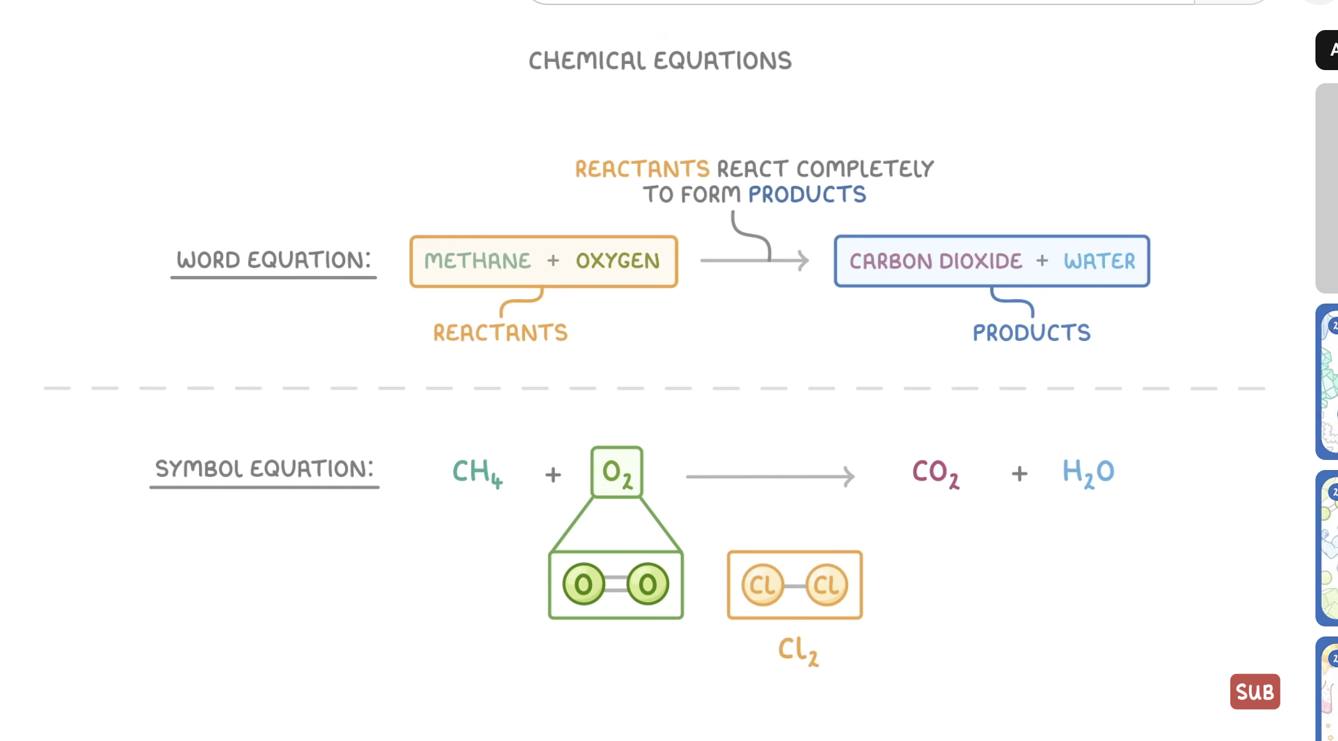
Reference: reactants/products grouped in soft rounded boxes with hand-drawn callout brackets, on white.
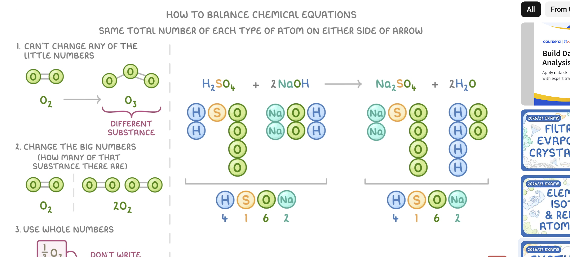
Reference: atoms as simple colored circles connected by thin bond lines, animating into new groupings to show a balanced equation — plus a live running atom-count tally.

2. What Changes vs. Today
This is a full revamp, not a new option alongside the old ones. Two systems that exist today as separate, differently-styled beat types get retired and merged into one.
Today | After the revamp
BLACKBOARD beat — dark background, chalk-style label/note/arrow ops, sentence-synced reveal, no motion | Gone as a separate type — folded into the new unified board
ANIMATION beat — separate React-component pipeline, custom code per beat, capped at 1 per lecture | Gone as a separate type — folded into the new unified board
IMAGE + CALLOUTS beat — photorealistic or technical-diagram AI images | Kept, restyled — becomes the fallback for subjects the sketch system can't represent (see §8)
Dark theme (#020617 background, bright accent colors) | White background, soft pastel palette, hand-drawn marker typography
Chemistry-specific hardcoded demo content | Fully general — the same engine composes atoms, timelines, math graphs, or any other subject's visual vocabulary

THE CORE DECISION
One board type replaces two. Every beat that used to be 'blackboard' or 'animation' becomes a single new kind — a hand-drawn scene that is ALWAYS capable of motion, not a static board that occasionally gets upgraded to a full animation. This matches what the reference actually shows: text, boxes, and diagrams that all animate in together as part of one continuous explanation.

3. The Visual System — How It's Actually Built
The reference could be approached two ways: generate a picture that looks like this for every board (an AI image model), or generate structured drawing instructions that render in this style (the same approach the current blackboard and animation systems already use, restyled). The second approach is the right one, for reasons grounded in what's already proven in this codebase:

Why not an AI-generated image for every board
- Latency — an image call is 3-8 seconds; a lecture has 10+ boards, that's minutes of dead air per lecture if every board is a fresh image.
- Cost — today only 2-3 beats per lecture use AI images. Making every board an image multiplies image spend by roughly 4-5x.
- No narration sync — a flat image can't reveal word-by-word or animate a specific element as the tutor reaches it; you'd get the whole board at once or nothing.
- No real animation — a generated PNG is a still frame; achieving the reference's actual motion (atoms sliding into new boxes) needs a sequence of frames or, better, a real component.

The chosen approach: a structured hand-drawn scene, LLM-composed
An LLM writes a JSON list of drawing instructions from a fixed vocabulary — a heading, a few grouped pastel boxes, some hand-drawn circles/nodes representing the subject's objects, connecting lines, brackets, and labels — exactly the same shape of system as today's blackboard ops (label/note/arrow/shape), just with a bigger vocabulary and white/pastel styling. Each instruction carries a reveal time AND an optional motion (slide-in, draw-on, move-to-position), so the renderer animates it in sync with narration — merging what used to be two separate pipelines into one call.
This is a restyle-and-extend of a system that already works reliably in this codebase — not a new invention. The risk profile is low because the LLM-writes-structured-JSON pattern, the sanitizer/validator pass, and the sentence-sync mechanism are all proven in production today.

4. Generalizing Beyond Chemistry
The reference is chemistry (atoms, bonds, molecular formulas). The product is not chemistry-specific, so the drawing vocabulary must cover any subject's visual language, not just atoms. The fix is to define primitives at the right level of abstraction — generic shapes that different subjects reuse with different labels and groupings, not chemistry-specific objects.
Generic primitive | Chemistry use | Other subject uses
node (colored circle + label) | An atom (C, H, O...) | A date on a timeline, a person in a family tree, a step in an algorithm, a country on a map
connector (thin line between nodes) | A chemical bond | A causal link, a historical relationship, a data-flow edge, a math function's mapping
grouped box (soft pastel rounded rect) | Reactants / Products | A category, a clause of an equation, a paragraph's main idea, a code block
bracket / brace callout | 'REACTANTS' label pointing at a group | Any 'this whole group is called X' annotation
axis / grid | (not shown, but a natural extension) | A math graph, a coordinate plane, a number line
figure silhouette | (not needed for chemistry) | A simple person/object icon for history, biology, economics scenes

The generation prompt asks the model to choose primitives from this fixed vocabulary and give them subject-appropriate labels/colors — it never needs a chemistry-specific instruction, because the vocabulary is already generic. This is the same principle the current image-beat prompt already uses (branching photorealistic vs. technical-diagram style by topic) applied one level more abstractly.

5. Merging Blackboard + Animation Into One Board Type
Today's pipeline treats a lecture beat as one of: blackboard (chalk text), image+callouts, or animation (one React component, capped at one per lecture). The new system replaces the first and third with a single kind:
sketchBoard — always capable of motion, chosen for EVERY teaching beat that isn't a photo/diagram.

New op shape (conceptual)
{ "kind": "sketchBoard", "elements": SketchElement[] }
Each SketchElement is one primitive from §6, with a position, an optional group (which pastel box it belongs to), a reveal time synced to the sentence being spoken, and an optional motion (where it animates FROM before settling into place). This one array replaces both the old chalk ops array and the old React component source.

What this removes
- The separate REACT_ANIMATION_SYSTEM_PROMPT + reactAnimationGen.ts code-generation pipeline (LLM writing raw React/JSX) — replaced by the same structured-JSON approach the blackboard already uses, which is more reliable and far cheaper to validate.
- The sandboxed iframe renderer (ReactAnimationSandbox.tsx) — no longer needed once nothing generates raw executable code; sketch elements render as plain SVG/DOM like the current LiveSketch does today.
- The 'exactly one animation per lecture' cap — since every board can now animate a little, there's no single expensive animation beat to ration.
WHY THIS IS A NET SIMPLIFICATION, NOT JUST A RE-SKIN
Generating a small JSON array of typed shapes is dramatically more reliable than generating raw React source code — validation is simpler (check shape types and coordinates, not parse and sandbox-execute arbitrary JS), cost is lower (smaller completions), and there's no security surface from executing model-written code in an iframe. The revamp is a quality and safety upgrade on top of being a visual upgrade.

6. The Sketch Primitive Library
This is the fixed, closed vocabulary the model is allowed to compose from — the same discipline the current chalk-op system already enforces (label/note/arrow/shape only), sized up to cover the reference's richer look.
Primitive | Renders as | Key fields
heading | Large hand-drawn-font title at the top | text, color
label | Hand-written word/phrase | text, x, y, size, color, group?
node | Filled colored circle with a short label inside | text, x, y, color, group?
connector | Thin curved/straight line between two nodes or points | from, to, color, style (solid/dashed)
groupBox | Soft pastel rounded rectangle enclosing a set of elements | elementIds[], color, label?
bracket | Hand-drawn curly brace + callout label pointing at a groupBox | targetGroupId, text, color
divider | Light dashed line separating two zones of the board (concept vs. example) | orientation, position
tally | A small live counter/table (e.g. atom counts) that updates as elements move | columns[], values, group?
arrow | A reaction/process arrow between two zones | from, to, label?

Every primitive carries a `revealAt` (0-1, matched to sentence progress — the exact mechanism already used by the current blackboard) and an optional `motion` object: `{ from: {x,y}, duration }` meaning "this element starts at this offset position/opacity and animates into its final place." That single optional field is what turns a static reveal into the reference's fluid slide-in-and-settle motion, for every element, without a separate "animation beat" concept.

7. Prompt & Generation Pipeline
Mirrors the existing two-step pattern already proven for blackboards and animations — a lightweight placeholder in the main lecture generation call, filled in by a focused follow-up call per beat, run in parallel across beats.
- Main lecture call (existing gpt-4o step) emits a lightweight placeholder per teaching beat: { kind: "sketchBoard", boardBrief } — one dense sentence naming what this board must show, exactly like today's chalkboard/animation placeholders.
- A new focused call, SKETCH_SYSTEM_PROMPT, receives the boardBrief + the beat's spoken script split into numbered sentences (reusing splitNarrationSentences, already exported from voice.ts) and returns the full elements[] array as JSON.
- The prompt states the primitive vocabulary from §6, the white/pastel color rules, the hand-drawn-font-implies-simple-shapes rule (no fine detail that a marker sketch couldn't show), and the same layout discipline already enforced today: no overlap, stay inside the frame, group related elements, reveal in narration order.
- A sanitizer (parallel to the existing sanitizeChalkBoardOps) validates: element types are in the closed vocabulary, coordinates are in-frame, connectors reference real node ids, groupBoxes reference real element ids, text length limits, and a NEW overlap+motion-collision check (two elements shouldn't animate through the same space at the same time).
- Runs in Promise.all across all sketch-board beats in the lecture, same parallelization pattern as today's image/animation/blackboard generation.

8. Fallback: AI-Generated Sketch Images
The structured primitive system covers most teaching content, but some subjects genuinely need a specific real visual the primitive vocabulary can't represent well — a particular historical figure's face, an actual piece of art, a specific real device's exact appearance.
For these cases, the existing IMAGE + CALLOUTS beat type is kept, but restyled: the image prompt now explicitly asks for a clean, white-background, hand-drawn/sketch illustration style (rather than the current photorealistic or technical-diagram styles) so it visually matches the new sketch boards instead of clashing with them. This keeps the existing image generation pipeline (imageGen.ts, fillImageOps) entirely intact — only the prompt's style instruction changes.
THE RULE FOR WHEN EACH PATH IS USED
Default to the structured sketch system for every teaching beat. Use the restyled AI image only when the boardBrief names a specific real-world visual subject a hand-drawn primitive genuinely can't represent (a named person, a specific real object/place) — the same branching logic the current image prompt already uses for photorealistic vs. technical-diagram style, just with a third, sketch-styled option added to that decision.

9. Rendering Engine Changes
LiveSketch.tsx already renders a typed op list with per-op reveal timing — the rendering MODEL doesn't need to be replaced, it needs to be extended and restyled.
Change | What it touches
New theme | White board background, pastel fill palette, hand-drawn-style webfont (e.g. a licensed 'Kalam'/'Patrick Hand'-family font) loaded for board text
New primitive renderers | node, groupBox, bracket, connector, divider, tally — new SVG renderers added alongside the existing label/note/arrow/shape renderers
Motion support on every element | Extend the existing draw-in timing logic so any element can carry a `from` offset that CSS/SVG-transitions into place, not just the dedicated old animation beats
Drop the sandbox path | ReactAnimationSandbox.tsx and its Babel-transpile-in-iframe machinery are no longer on the critical path once nothing generates raw component code
Accessibility modes | Dyslexia/ADHD/deaf/blind modes already consume beat data generically — they inherit the new visual style automatically, no separate work per mode

10. Migration Plan & Rollout
Phase | What ships | Risk
Phase 0 | Sketch primitive renderers built in LiveSketch, tested against hand-authored fixture data (no LLM yet) — proves the visual style before spending on generation | Low
Phase 1 | SKETCH_SYSTEM_PROMPT + generation pipeline behind a feature flag (mirrors existing BLACKBOARD_GEN_ENABLED pattern) — flag OFF is a full no-op, current dark chalkboard/animation stays live | Low
Phase 2 | Flag ON for internal testing across several non-chemistry topics (history, math, biology) to prove genuine generality before any user sees it | Medium
Phase 3 | Flip default on, old chalkboard/animation code paths kept dormant (not deleted) for one release as an instant rollback switch | Medium
Phase 4 | Remove the dormant old code paths once the new system has run cleanly in production for a full release cycle | Low

This mirrors exactly how blackboard-generation and React-animation were rolled out originally in this codebase — paired feature flags, dormant fallback code, flag-off is a true no-op. Nothing about this revamp needs a novel rollout mechanism.

11. Cost & Latency Impact
Replacing raw-React-code generation with structured JSON generation is a cost REDUCTION, not an increase, even though every beat now gets a sketch board instead of only some beats getting a full animation.
 | Today | After revamp
Animation beats/lecture | 1 (capped), large code completion (10-22KB source) | 0 — folded into sketch boards
Blackboard beats/lecture | 3-5, small JSON completion | Same count, slightly larger JSON (more primitive types)
Image beats/lecture | 2-3, photorealistic/technical-diagram | 2-3, same count, sketch-styled prompt (no cost change)
Est. cost delta | baseline | Roughly neutral to slightly lower — one large animation-code call is replaced by one more small JSON call, and the sandbox/transpile step disappears client-side

12. Risks and How We Cover Them

Risk: the model defaults back to chemistry-flavored output out of habit
Mitigation: the primitive vocabulary is generic by construction (§4) and the prompt includes worked examples from at least three different subjects (history, math, biology), not just chemistry — the same technique already used in the current lecture prompt to prevent topic bias.

Risk: hand-drawn font/style doesn't render consistently across browsers
Mitigation: self-host the chosen webfont (same approach the product already uses to avoid CDN dependency for other assets) and test rendering across the same browser matrix already covered for the current player.

Risk: motion-per-element adds real layout complexity and could regress the overlap/clipping quality already hard-won in the current chalkboard system
Mitigation: the sanitizer's existing overlap detector (built during the chalkboard-quality work) is extended to check motion paths, not just final resting positions — element collision during animation, not only at rest.

Risk: bigger scope, longer build than it looks
Mitigation: the phased rollout in §10 ships value incrementally and keeps the current system fully live behind a flag the entire time — there is no big-bang cutover moment where the product is worse than today.

13. Build Order
- Sketch primitive renderers in LiveSketch.tsx (§9), validated against 3-4 hand-written fixture boards covering different subjects — no LLM involved yet.
- SketchElement types + sanitizer/validator (§5, §7) — the data contract and quality gate, built and unit-tested before any prompt writing.
- SKETCH_SYSTEM_PROMPT + generation pipeline, behind a feature flag, wired into the existing Promise.all asset-generation step.
- Restyle the image-beat prompt for the sketch aesthetic (§8) so image and sketch boards look like one system.
- Retire the animation-beat code path (reactAnimationGen.ts, ReactAnimationSandbox.tsx) to dormant/flagged-off, not yet deleted.
- Internal testing across non-chemistry subjects (§10 Phase 2) before any default flip.
- Flip default on; monitor; remove dormant old code after one clean release cycle.

Internal planning draft — scope, cost, and timeline estimates should be revisited once Phase 0 primitive rendering is built and visually compared against the reference screenshots.

